3GPP TSG-SA5 Meeting #132e S5-204298

e-meeting 17th 28th August 2020

Source: Huawei

Title: Add concept and background

Document for: Approval
Agenda Item: 6.5.2

1 Decision/action requested
The group is asked to discuss and approval.

2 References
[1] 3GPP draft TS 28.312: “Management and orchestration; Intent driven management services for mobile networks v0.0.0”.
[2] 3GPP TR 28.812: “Study on scenarios for Intent driven management services for mobile networks v0.10.0”

3 Rationale
This contribution proposes to add following concept based on TR 28.812:
- Intent concept
- Intent driven MnS concept
- Intent driven close loop concept

4 Detailed proposal
It proposes to make the following changes to TS 28.312[1].

1st Change

3.1 Terms
For the purposes of the present document, the terms given in 3GPP TR 21.905 [1] and the following apply. A term defined in the present document takes precedence over the definition of the same term, if any, in 3GPP TR 21.905 [1].

Intent: A desire to reach a certain state for a specific service or network management workflow.

2nd Change

4.X Intent concept

4.X.1 Introduction
An intent is a desire to reach a certain state/position for a specific service or network management workflow. The intent expression information may include particular objective and possibly some related details. Intent can be categorized based on different user types or different management scenario types.

4.X.2 Intent categorizes based on user types
Based on roles related to 5G networks and network slicing management defined in clause 4.8 in TS 28.530[X], different kinds of intents are applicable for different kinds of standardized reference interfaces.
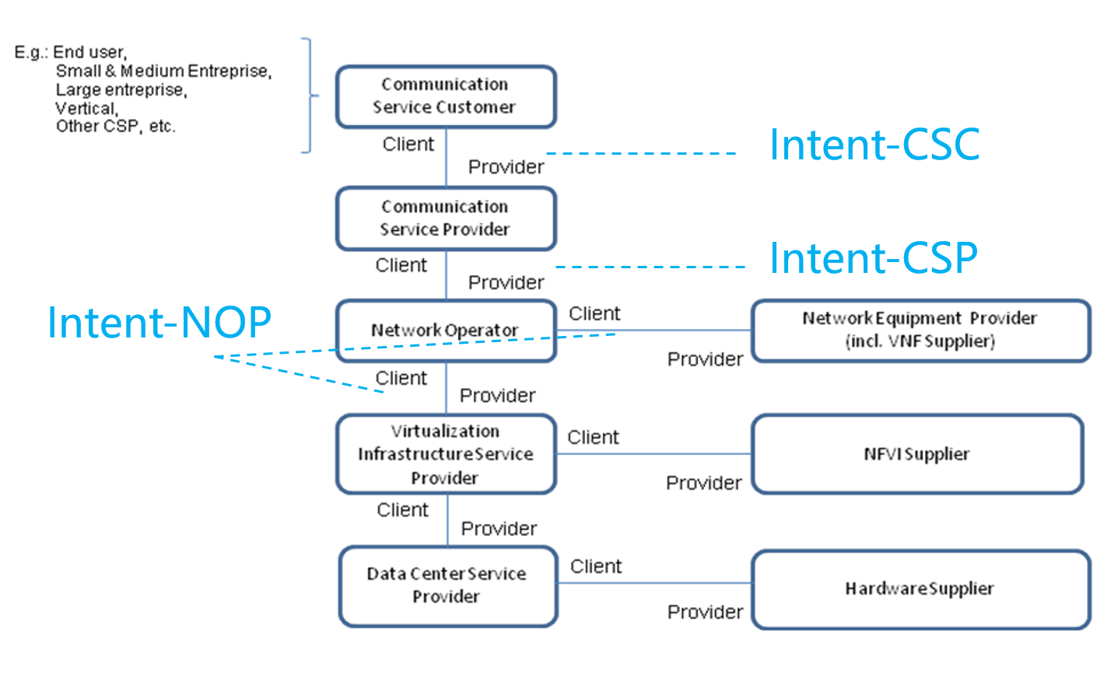
Figure 4.X.1.1-1: High-level model of different kind of intents expressed by different roles

- Intent from Communication Service Customer (Intent-CSC): Intent from Communication Service Customer enables Communication Service Customer (CSC) to provide what CSC would like to do for the communication service without knowing how to do the detailed management for communication service. For example, Intent-CSC can be 'Enable a V2X communication service for a group of vehicles in certain time'.

- Intent from Communication Service Provider (Intent-CSP): Intent from Communication Service Provider enables Communication Service Provider (CSP) to express an intent about what CSP would like to do for network without knowing how to do the detailed management for network. For example, Intent-CSP can be 'Provide a network service supporting V2X communications for highway-417 to support 500 vehicles simultaneously'.

- Intent from Network Operator(Intent-NOP): Intent from Network Operator enables Network Operator (NOP) to provide what NOP would like to do for group of network elements (i.e. subnetwork) management and control without knowing how to do the detailed management for the network elements. For example, Intent-NOP can be 'Provide a radio network service to satisfy the specified coverage requirements and UE throughput requirement in certain area'.

4.X.3 Intent categorizes based on management scenario types
Based on different the scenarios for network and service management, different kinds of intents are applicable for different kinds of management scenario types.
- Intent for network and service design/planning
- Intent for network and service deployment
- Intent for network and service maintenance
- Intent for network and service optimization/assurance
Editor’s Note: the detailed intent categorizes for different kinds of management scenario types need to be further discussed, for example, whether the Intent for network and service design/planning and Intent for network and service maintenance is needed.

4.Y Intent driven MnS
Introduction of service-based architecture for 5G, in combination with functional model of business roles, exceeds the level of complexity for managing network in different scenarios (including scenarios for design/planning, deployment, maintenance and optimization) both in a single and multivendor network. New/simpler ways of managing are needed.
An Intent driven MnS allows its consumer to express intents for managing the network and services and obtain the feedback of intent evaluation result. The Intent-driven MnS producer have the following capabilities:
- Translate the received intent to executable actions as follows:
- Performing service or network management tasks
- Identifying, formulating and activating service or network management policies
- Evaluate the result/information about the intent fulfilment (e.g. the intent is satisfied or not).
The following figure 4.Y-1 shows the model of Intent-driven MnS.
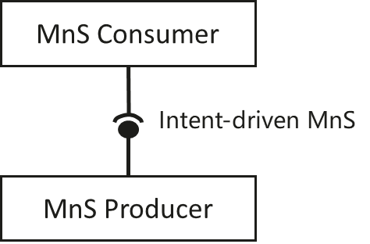
Figure 4.Y-1: Intent-driven MnS
The MnS of various kinds are specified for deployment over many standardized reference interfaces. So, the Intent-driven MnS could in principle, be specified for deployment over the same set of standardized reference interfaces, as a replacement of or as an addition to the deployed non-Intent driven MnS.

4.Z Intent driven closed-loop
Intent can be used for management and control of closed-loop automation (e.g. intent can be used as the goals for the closed-loop), which means the intent can be translated to policies and management tasks by MnS producer to execute the closed-loop automation. In the intent driven management approach, how MnS producer using closed-loop automation mechanisms to satisfy the intent is the implementation of the MnS producer and shall not be standardized. The closed-loop automation of Intent driven MnS producer is shown in the figure 4.Z-1.
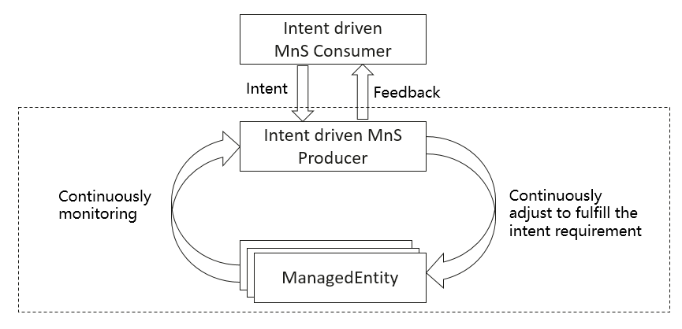
Figure 4.Z-1 Intent driven closed-loop

End of changes

