3GPP TSG-SA5 Meeting #132e S5-204292

e-meeting 17th 28th August 2020
CR-Form-v12.0
CHANGE REQUEST
 | TS 28.536 | CR | 001 | rev | <Rev#> | Current version: | <Version#>
For HELP on using this form: comprehensive instructions can be found at
http://www.3gpp.org/Change-Requests.

Proposed change affects: | UICC apps |  | ME |  | Radio Access Network | X | Core Network | X

Title: | Update control loop deployed in different layers with SLA decomposition
Source to WG: | SA5
Source to TSG: | S5
Work item code: | EMA5SLA |  |  |  |  |  | Date: |  |  | 2020-8-6
Category: | F |  |  |  |  |  | Release: |  |  | Rel-17
 | Use one of the following categories:  F (correction)  A (mirror corresponding to a change in an earlier release)  B (addition of feature),  C (functional modification of feature)  D (editorial modification)  Detailed explanations of the above categories can  be found in 3GPP TR 21.900. |  |  |  |  |  |  |  | Use one of the following releases:  Rel-8 (Release 8)  Rel-9 (Release 9)  Rel-10 (Release 10)  Rel-11 (Release 11)  Rel-12 (Release 12)  Rel-13 (Release 13)  Rel-14 (Release 14)  Rel-15 (Release 15)  Rel-16 (Release 16)
Reason for change: |  | The existing description of control loop in different layers doesn’t include the procedures and influnce of SLA decomposition.
Summary of change: |  | Add description of SLA decomposition into control loop deployed in different layers
Consequences if not approved: |  | The description of control loop deployed in different layers will be incomplete.
Clauses affected:
 |  | Y | N
Other specs |  |  | X | Other core specifications |  |  |  | TS/TR ... CR ...
affected: |  |  | X | Test specifications |  |  |  | TS/TR ... CR ...
(show related CRs) |  |  | X | O&M Specifications |  |  |  | TS/TR ... CR ...
Other comments:
This CR's revision history:

Annex A (informative):
Control loop deployed in different layers

A.1 Introduction
This example gives a high-level view of control loops deployed in different layers, which consists of control loop in communication service layer, control loop in network slice layer, control loop in network slice subnet layer and control loop in NF layer, as described as Figure A.1.1, where the analytic could be leverage MDAS, and different control loops can provide input (interact with) to other control loops (in the same layer or different layers) and obtain the output from other control loops (in the same layer or different layers).
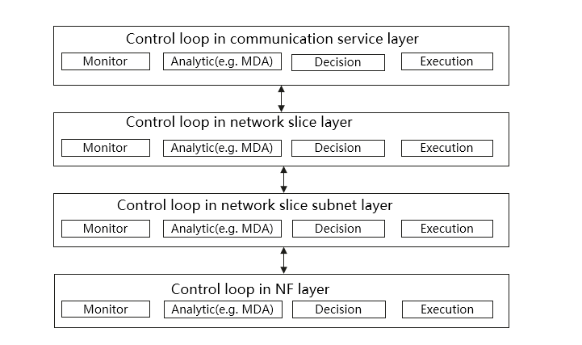
Figure A.1.1: Control loop in different layers

A.2 Control loop in communication service layer
SLA/SLS requirements provided from CSC are translated into serviceProfile, which represents the requirements for communication service assurance to the CSP. Coordination between control loop in communication service layer and control loop in network slice layer is needed to calculate the communication service resource requirements and to assure the communication service SLA/SLS requirements.
When the communication service is active, network slice performance is monitored and analysed for the communication service according to end user service experiences.
If service degradation occurs or it is predicted, the 3GPP management system could take actions, i.e. the allocated resources are scaled up or the SLS is adjusted based on pre-agreement/interaction between CSP and CSC.

A.3 Control loop in network slice layer
After receiving SLA/SLS requirements from service profile and completing the network slice provisioning, the network slice performance (e.g. KPI, QoE) are monitored and reported. Compared to the SLA/SLS requirements from service profile, when network slice performance is not met, the 3GPP management system identifies the root cause and may reconfigure the resources according to analytical report from MDAS producer. The network slice resources are also modified accordantly in case the network slice performance requirement needs to be changed based on communication service requirement adjustment.

A.4 Control loop in network slice subnet layer
After decomposing service profile to slice profile, the performance requirements for each network slice subnet are obtained. The 3GPP management system could have the capability of service observation (e.g., the supervision to the NSSI) based on MDAS. Based on such observation and comparison with initial subnet performance requirements, management actions on the NSSI might be performed if NSSI performance requirements fulfillment indicates a problem. Another possible scenario is that, when the NSSI performance requirement is changed because of the network slice modification management action, the NSSI resources might be also reconfigured.

A.5 Control loop in NF layer
Editor's note: the control loop in NF layer is FFS.

