3GPP TSG-SA5 Meeting #132e S5-204142

e-meeting 17th-28th August 2020
CR-Form-v12.0
CHANGE REQUEST
 | 28.533 | CR | 0072 | rev | 1 | Current version: | 16.4.0
For HELP on using this form: comprehensive instructions can be found at
http://www.3gpp.org/Change-Requests.

Proposed change affects: | UICC apps |  | ME |  | Radio Access Network | X | Core Network | X

Title: | Add missing definition
Source to WG: | Huawei
Source to TSG: | S5
Work item code: | TEI16 |  |  |  |  |  | Date: |  |  | 2020-08-03
Category: | F |  |  |  |  |  | Release: |  |  | Rel-16
 | Use one of the following categories:  F (correction)  A (mirror corresponding to a change in an earlier release)  B (addition of feature),  C (functional modification of feature)  D (editorial modification)  Detailed explanations of the above categories can  be found in 3GPP TR 21.900. |  |  |  |  |  |  |  | Use one of the following releases:  Rel-8 (Release 8)  Rel-9 (Release 9)  Rel-10 (Release 10)  Rel-11 (Release 11)  Rel-12 (Release 12)  Rel-13 (Release 13)  Rel-14 (Release 14)  Rel-15 (Release 15)  Rel-16 (Release 16)
Reason for change: |  | Some definitions related to service based management architecture are missing, e.g. MnS,Mn, NF
Summary of change: |  | Add definition for MnS,MnF,NF and SBMA
Consequences if not approved: |  | Some definitions related to service based management architecture are missing
Clauses affected: |  | 2, 3.1,4.2.3
 |  | Y | N
Other specs |  |  | X | Other core specifications |  |  |  | TS/TR ... CR ...
affected: |  |  | X | Test specifications |  |  |  | TS/TR ... CR ...
(show related CRs) |  |  | X | O&M Specifications |  |  |  | TS/TR ... CR ...
Other comments:
This CR's revision history: |  | Revision of S5-204142

1st Change

2 References
The following documents contain provisions which, through reference in this text, constitute provisions of the present document.
- References are either specific (identified by date of publication, edition number, version number, etc.) or non-specific.
- For a specific reference, subsequent revisions do not apply.
- For a non-specific reference, the latest version applies. In the case of a reference to a 3GPP document (including a GSM document), a non-specific reference implicitly refers to the latest version of that document in the same Release as the present document.
[1] 3GPP TR 21.905: "Vocabulary for 3GPP Specifications".
[2] 3GPP TS 32.101: "Telecommunication management; Principles and high level requirements".
[3] 3GPP TS 28.530: "Management and orchestration of networks and network slicing; Concepts, use cases and requirements".
[4] 3GPP TS 28.541: "Management and orchestration of 5G networks; Network Resource Model (NRM); Stage 2 and stage 3".
[5] 3GPP TS 28.552: "Management and orchestration of 5G networks; Performance measurements and assurance data".
[6] 3GPP TS 28.554: "Management and orchestration of 5G networks; 5G End to end Key Performance Indicators (KPI)".
[7] 3GPP TS 32.425: "Telecommunication management; Performance Management (PM); Performance measurements Evolved Universal Terrestrial Radio Access Network (E-UTRAN)".
[8] 3GPP TS 28.531: "Management and orchestration of 5G networks; Provisioning; Stage 1".
[9] 3GPP TS 28.532: "Management and orchestration; Management services".
[10] 3GPP TS 28.500: "Telecommunication management; Management concept, architecture and requirements for mobile networks that include virtualized network functions"
[11] 3GPP TS 28.510; "Telecommunication management; Configuration Management (CM) for mobile networks that include virtualized network functions; Requirements".
[12] 3GPP TS 28.511; "Telecommunication management; Configuration Management (CM) for mobile networks that include virtualized network functions; Procedures".
[13] 3GPP TS 28.512; "Telecommunication management; Configuration Management (CM) for mobile networks that include virtualized network functions; Stage 2".
[14] 3GPP TS 28.513: "Telecommunication management; Configuration Management (CM) for mobile networks that include virtualized network functions; Stage 3".
[15] 3GPP TS 28.515; "Telecommunication management; Fault Management (FM) for mobile networks that include virtualized network functions; Requirements".
[16] 3GPP TS 28.516: "Telecommunication management; Fault Management (FM) for mobile networks that include virtualized network functions; Procedures".
[17] 3GPP TS 28.517: "Telecommunication management; Fault Management (FM) for mobile networks that include virtualized network functions; Stage 2".
[18] 3GPP TS 28.518: "Telecommunication management; Fault Management (FM) for mobile networks that include virtualized network functions; Stage 3".
[19] 3GPP TS 28.520: "Telecommunication management; Performance Management (PM) for mobile networks that include virtualized network functions; Requirements".
[20] 3GPP TS 28.521: "Telecommunication management; Performance Management (PM) for mobile networks that include virtualized network functions; Procedures".
[21] 3GPP TS 28.522: "Telecommunication management; Performance Management (PM) for mobile networks that include virtualized network functions; Stage 2".
[22] 3GPP TS 28.523: "Telecommunication management; Performance Management (PM) for mobile networks that include virtualized network functions; Stage 3".
[23] 3GPP TS 28.525: "Telecommunication management; Life Cycle Management (LCM) for mobile networks that include virtualized network functions; Requirements".
[24] 3GPP TS 28.526: "Telecommunication management; Life Cycle Management (LCM) for mobile networks that include virtualized network functions; Procedures".
[25] 3GPP TS 28.527: "Telecommunication management; Life Cycle Management (LCM) for mobile networks that include virtualized network functions; Stage 2".
[26] 3GPP TS 28.528: "Telecommunication management; Life Cycle Management (LCM) for mobile networks that include virtualized network functions; Stage 3".
[27] ETSI GS NFV 003: "Network Functions Virtualisation (NFV); Terminology for Main Concepts in NFV V1.3.1 (2018-01)".
[28] 3GPP TS 28.545: "Management and orchestration; Fault Supervision (FS)".
[29] ETSI GS ZSM 002: "Zero-touch Network and Service Management (ZSM); Reference Architecture V.1.1 (2019-08)".
[30] 3GPP TS 23.288: "Architecture enhancements for 5G System (5GS) to support network data analytics services".
[X] 3GPP TS 23.501: "System Architecture for the 5G system".
[Y] 3GPP TS 28.622: "Telecommunication management; Generic Network Resource Model (NRM) Integration Reference Point (IRP); Information Service (IS)".

2nd Change

3.1 Definitions
For the purposes of the present document, the terms and definitions given in 3GPP TR 21.905 [1] and the following apply. A term defined in the present document takes precedence over the definition of the same term, if any, in 3GPP TR 21.905 [1] or NFV-MANO [27].
Exposure governance management function: Management Function entity with the role of management service exposure governance.
Management Service (MnS): set of offered management capabilities.
Management Function (MnF): Logical entity playing the roles of Management Service consumer and/or Management Service producer.
Network Function (NF): defined in TS 23.501[X].
NOTE: In 3GPP NRM, the Network Functions are modeled using ManagedFunction IOC and its sub-classes (e.g. AMFFunction)

3rd Change

3.2 Abbreviations
For the purposes of the present document, the abbreviations given in 3GPP TR 21.905 [1], in NFV-MANO [27] and the following apply. An abbreviation defined in the present document takes precedence over the definition of the same abbreviation, if any, in 3GPP TR 21.905 [1].
CM Configuration Management
LCM Lifecycle Management
MDAS Management Data Analytics Service
MnF Management Function
MnS Management Service
NF Network Function
NFV-MANO Network Functions Virtualisation Management and Orchestration
PM Performance Management
SBMA Service Based Management Architecture

4th Change

4 Service Based Management Architecture

4.1 Management Service (MnS)
The fundamental building block of the Service Based Management Architecture (SBMA) is the Management Service (MnS). A MnS is a set of offered capabilities for management and orchestration of networks and services. The entity producing an MnS is called MnS producer. The entity consuming an MnS is called MnS consumer. An MnS provided by an MnS producer can be consumed by any entity with appropriate authorisation and authentication.
An MnS producer offers its services via a standardized service interface composed of individually specified MnS components.
Figure 4.1-1: MnS producer and MnS consumer

5th Change

4.2.3 Management information

4.2.3.1 MnS component type B
MnS component type B refers to management information represented by information models representing the managed entities. A MnS component type B is also called Network Resource Model (NRM).
MnS component type B examples are:
1) Network resource models as defined in TS 28.622 [Y].
2) Network resource models as defined in TS 28.541 [4]

4.5 Management Function (MnF) concept
A Management Function (MnF) is a logical entity playing the roles of MnS consumer and/or MnS producer

A Management Service produced by MnF may have multiple consumers. The MnF may consume multiple Management Services from one or multiple Management Service producers. An example of a MnF playing both roles (Management Service producer and consumer) illustrated in the figure 4.5.1 below.
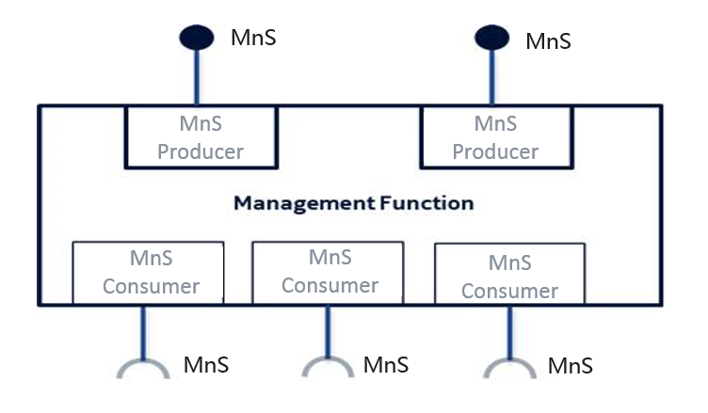
Figure 4.5.1: Example of Management Function and Management Services
Management Function can be deployed as a separate entity or embedded in Network Function to provide MnS(s). Following figure 4.5.2 shows an example (on the left) which MnF deployed as a separate entity to provide MnS(s) and another example (on the right) which MnF is embedded in Network Function to provide MnS(s):
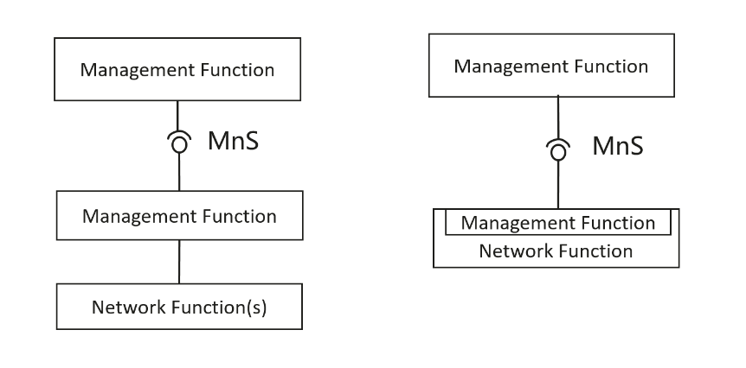
Figure 4.5.2 Examples of MnS deployment scenario
Management Functions may interact by consuming Management Services produced by other Management Functions. The figure 4.6.2 below illustrates multiple scenarios:
- MnF1 produces Management Service MnS-a;
- MnF2 consumes Management Service MnS-a produced by MnF1 and produces Management Services MnS-b and MnS-c;
- MnF3 produces Management Service MnS-c;
- MnF4 consumes Management Service MnS-b produced by the MnF2;
- MnF5 consumes Management Services MnS-c produced by the MnF2 and MnF3, and in turn produces the same Management Service MnS-c. The behaviour of MnF5 may be seen as aggregation of Management Services MnS-c.
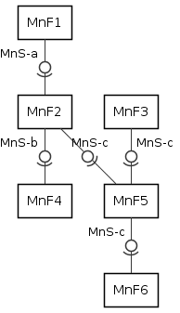
Figure 4.5.2: An example of interactions between Management Functions
NOTE: The specification of a MnF is out of scope of the present docucument.

End of Change

