3GPP TSG-SA5 Meeting #131e S5-203316

e-meeting 25th May-3rd June 2020
CR-Form-v12.0
CHANGE REQUEST
 | 28.541 | CR | 0291 | rev | 1 | Current version: | 16.4.1
For HELP on using this form: comprehensive instructions can be found at
http://www.3gpp.org/Change-Requests.

Proposed change affects: | UICC apps |  | ME |  | Radio Access Network | x | Core Network

Title: | CR TS 28.541 Add the NRM fragment for SON management
Source to WG: | Huawei, Orange, Ericsson, Intel
Source to TSG: | S5
Work item code: | SON_5G |  |  |  |  |  | Date: |  |  | 2020-05-15
Category: | B |  |  |  |  |  | Release: |  |  | Rel-16
 | Use one of the following categories:  F (correction)  A (mirror corresponding to a change in an earlier release)  B (addition of feature),  C (functional modification of feature)  D (editorial modification)  Detailed explanations of the above categories can  be found in 3GPP TR 21.900. |  |  |  |  |  |  |  | Use one of the following releases:  Rel-8 (Release 8)  Rel-9 (Release 9)  Rel-10 (Release 10)  Rel-11 (Release 11)  Rel-12 (Release 12)  Rel-13 (Release 13)  Rel-14 (Release 14)  Rel-15 (Release 15)  Rel-16 (Release 16)
Reason for change: |  | In order to enable the management of distributed SON functions and centralized SON functions, new IOC and attribute definitions for DANRManagementFunction, DESManagementFunction, CPCIConfigurationFunction, CESManagementFunction, DRACHOptimizationFunction, DMobilityRobustnessOptimizationFunction and DPCIConfigurationFunction IOCs are added.  The attributes isRemoveAllowed, isHOAllowed are defined in clause 4.3.2, therefore, the definition should be in clause 4.4.1.  The attributes x2BlackList, xnBlackList, x2WhiteList, xnWhiteList, x2xnHOBlackList are not related to ANR function.  According to the baseline CR R3-201610, RAN3 has added the following ranges and paramters to support MRO:  All automatic changes of the HO and/or reselection parameters for mobility robustness optimisation shall be within the range allowed by OAM.  - Maximum deviation of Handover Trigger  This parameter defines the maximum allowed absolute deviation of the Handover Trigger, from the default point of operation defined by the parameter values assigned by OAM. The detaied allowedValues is defined in baseline CR R3-201614.  - Minimum time between Handover Trigger changes  This parameter defines the minimum allowed time interval between two Handover Trigger change performed by MRO. This is used to control the stability and convergence of the algorithm.  In order to support the solutions for detection of mobility optimisation, the parameter Tstore_UE_cntxt shall be configurable by the OAM system.  In order to enable the MRO function, three attributes including maximumDeviationHoTrigger, minimumTimeBetweenHoTriggerChanges and tstoreUEcntxt should be added.  For “HO and/or reselection parameters ranges”, since the definition of the “HO and/or reselection parameters ranges” are unclear. Four attributes including a3OffsetRSRPrange，a3OffsetRSRQrange，a6OffsetRSRPrange and a6OffsetRSRQrange should be deleted.
Summary of change: |  | Add CPCIConfigurationFunction, CESManagementFunction, DANRManagementFunction, DESManagementFunction, DRACHOptimizationFunction, DMobilityRobustnessOptimizationFunction and DPCIConfigurationFunction IOC definitions.  The attributes isRemoveAllowed, isHOAllowed are moved from clause 5.4.1 to clause 4.4.1.  Delete the definition “condition:ANR function is supported” of attribute x2BlackList, xnBlackList, x2WhiteList, xnWhiteList, x2xnHOBlackList.  Add maximumDeviationHoTrigger,minimumTimeBetweenHoTriggerChanges, and tstoreUEcntxt attributes into DMROFunction.  Delete a3OffsetRSRPrange，a3OffsetRSRQrange，a6OffsetRSRPrange and a6OffsetRSRQrange attributes in DMROFunction.
Consequences if not approved: |  | The management of SON functions would not be possible.  The MRO function does not comply with RAN3’s requirements.
Clauses affected: |  | 2, 4.2.1.1, 4.2.1.2, 4.3.2.2, 4.3.2.3, 4.3.x (New), 4.3.y (New), 4.3.x1(New), 4.3.x2(New), 4.3.x3(New), 4.3.x4(New), 4.3.x5(New), 4.3.x6(New), 4.4.1, 5.4.1
 |  | Y | N
Other specs |  |  | x | Other core specifications |  |  |  | TS/TR ... CR ...
affected: |  |  | x | Test specifications |  |  |  | TS/TR ... CR ...
(show related CRs) |  |  | x | O&M Specifications |  |  |  | TS/TR ... CR ...
Other comments: |  | S5-203316 replaces S5-202330
This CR's revision history: |  | S5-202330

First change

2 References
The following documents contain provisions which, through reference in this text, constitute provisions of the present document.
- References are either specific (identified by date of publication, edition number, version number, etc.) or non-specific.
- For a specific reference, subsequent revisions do not apply.
- For a non-specific reference, the latest version applies. In the case of a reference to a 3GPP document (including a GSM document), a non-specific reference implicitly refers to the latest version of that document in the same Release as the present document.
[1] 3GPP TR 21.905: "Vocabulary for 3GPP Specifications".
[2] 3GPP TS 23.501: "System Architecture for the 5G System".
[3] 3GPP TS 38.300: "NR; Overall description; Stage-2".
[4] 3GPP TS 38.401: "NG-RAN; Architecture description".
[5] 3GPP TS 38.413: "NG-RAN; NG Application Protocol (NGAP)".
[6] 3GPP TS 38.420: "NG-RAN; Xn general aspects and principles".
[7] 3GPP TS 38.470: "NG-RAN; F1 general aspects and principles".
[8] 3GPP TS 38.473: "NG-RAN; F1 application protocol (F1AP)".
[9] 3GPP TS 37.340: "NR; Multi-connectivity; Overall description; Stage 2".
[10] 3GPP TS 28.540: "Management and orchestration; 5G Network Resource Model (NRM);Stage 1".
[11] 3GPP TS 28.662: "Telecommunication management; Generic Radio Access Network (RAN) Network Resource Model (NRM) Integration Reference Point (IRP); Information Service (IS) ".
[12] 3GPP TS 38.104: "NR; Base Station (BS) radio transmission and reception".
[13] 3GPP TS 23.003: "Numbering, Addressing and Identification".
[14] 3GPP TS 36.410: "Evolved Universal Terrestrial Radio Access Network (E-UTRAN); S1 general aspects and principles".
[15] 3GPP TS 36.423: "Evolved Universal Terrestrial Radio Access Network (E-UTRAN); X2 application protocol".
[16] 3GPP TS 36.425: "Evolved Universal Terrestrial Radio Access Network (E-UTRAN); X2 interface user plane protocol".
[17] 3GPP TS 28.625: "State Management Data Definition Integration Reference Point (IRP); Information Service (IS)".
[18] ITU-T Recommendation X.731: "Information technology - Open Systems Interconnection - Systems Management: State management function".
[19] 3GPP TS 28.658: "Telecommunications management; Evolved Universal Terrestrial Radio Access Network (E-UTRAN) Network Resource Model (NRM) Integration Reference Point (IRP): Information Service (IS)".
[20] 3GPP TS 28.702: "Core Network (CN) Network Resource Model (NRM) Integration Reference Point (IRP); Information Service (IS)".
[21] 3GPP TS 28.708: "Telecommunication management; Evolved Packet Core (EPC) Network Resource Model (NRM) Integration Reference Point (IRP): Information Service (IS)".
[22] 3GPP TS 23.040: "Technical realization of the Short Message Service (SMS)".
[23] 3GPP TS 29.510: "5G system; Network Function Repository Services; Stage 3".
[24] 3GPP TS 29.531: "5G System; Network Slice Selection Services Stage 3".
[25] Void.
[26] 3GPP TS 28.531: "Management and orchestration; Provisioning".
[27] 3GPP TS 28.554: "Management and orchestration; 5G End to end Key Performance Indicators (KPI)".
[28] 3GPP TS 22.261: "Service requirements for next generation new services and markets".
[29] ETSI GS NFV-IFA 013 V2.4.1 (2018-02) "Network Function Virtualisation (NFV); Management and Orchestration; Os-Ma-nfvo Reference Point - Interface and Information Model Specification".
[30] 3GPP TS 28.622: "Telecommunication management; Generic Network Resource Model (NRM) Integration Reference Point (IRP); Information Service (IS)".
[31] Void.
[32] 3GPP TS 38.211: "NR; Physical channels and modulation".
[33] 3GPP TS 32.616: "Telecommunication management; Configuration Management (CM); Bulk CM Integration Reference Point (IRP); Solution Set (SS) definitions".
[34] 3GPP TS 28.623: "Telecommunication management; Generic Network Resource Model (NRM) Integration Reference Point (IRP); Solution Set (SS) definitions".
[35] 3GPP TS 28.532: "Management and orchestration; Management services".
[36] Void.
[37] IETF RFC 791: "Internet Protocol".
[38] IETF RFC 2373: "IP Version 6 Addressing Architecture".
[39] IEEE 802.1Q: "Media Access Control Bridges and Virtual Bridged Local Area Networks".
[40] ETSI GR NFV-IFA 015 (V2.4.1): "Network Function Virtualisation (NFV) Release 2; Management and Orchestration; Report on NFV Information Model".
[41] 3GPP TS 38.213: "NR; Physical layer procedures for control".
[42] 3GPP TS 38.101-1: "NR; User Equipment (UE) radio transmission and reception; Part 1: Range 1 Standalone".
[43] 3GPP TS 32.156: "Telecommunication management; Fixed Mobile Convergence (FMC) model repertoire".
[44] IETF RFC 4122: "A Universally Unique IDentifier (UUID) URN Namespace".
[45] IETF RFC 8528: "YANG Schema Mount".
[46] IETF RFC 8340: "YANG Tree Diagrams".
[47] 3GPP TS 32.160: "Management and orchestration; Management Service Template".
[48] 3GPP TS 38.463: "NG-RAN; E1 application protocol (E1AP)".
[49] 3GPP TS 38.304: "NR; User Equipment (UE) procedures in Idle mode and RRC Inactive state".
[50] GSMA NG.116 - Generic Network Slice Template Version 2.0 (2019-10-16).
[51] 3GPP TS 22.104: "Service requirements for cyber-physical control applications in vertical domains; Stage 1".
[52] 3GPP TS 33.501: " Security architecture and procedures for the 5G System".
[53] 3GPP TS 38.901: "Study on channel model for frequencies from 0.5 to 100 GHz ".
[54] 3GPP TS 38.331: "NR; Radio Resource Control (RRC) protocol specification".
[55] 3GPP TS 38.215: "NR; Physical layer measurements".
[x] 3GPP TS 28.313: "Self-Organizing Networks (SON) for 5G networks".
[y] 3GPP TS 38.423: "NR; Xn application protocol (XnAP)".

Next change

4.2 Class diagram

4.2.1 Class diagram for gNB and en-gNB

4.2.1.1 Relationships
This clause depicts the set of classes (e.g. IOCs) that encapsulates the information relevant for this gNB and en-gNB. For the UML semantics, see 3GPP TS 32.156 [43]. Subsequent clauses provide more detailed specification of various aspects of these classes.
The model fragments are for management representation of gNB and en-gNB for all NG-RAN deployment scenario as listed below.
- Non-split NG-RAN deployment scenario, represents the gNB defined in TS 38.401[4].
- 2-split NG-RAN deployment scenario, represents the gNB consist of gNB-CU and gNB-DU defined in TS 38.401[4] clause 6.1.1.
- 3-split NG-RAN deployment scenario, represents the gNB consist of gNB-CU-CP, gNB-CU-UP and gNB-DU defined in TS 38.401[4] clause 6.1.2.

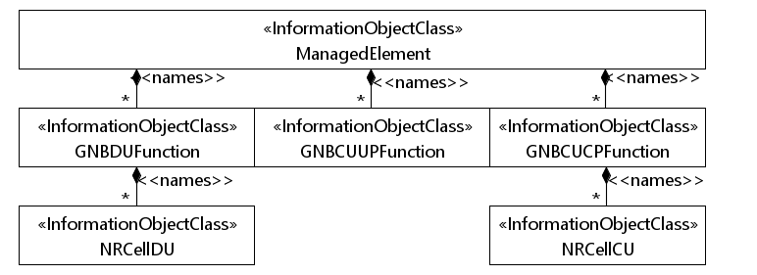
Figure 4.2.1.1-1: NRM for all deployment scenarios
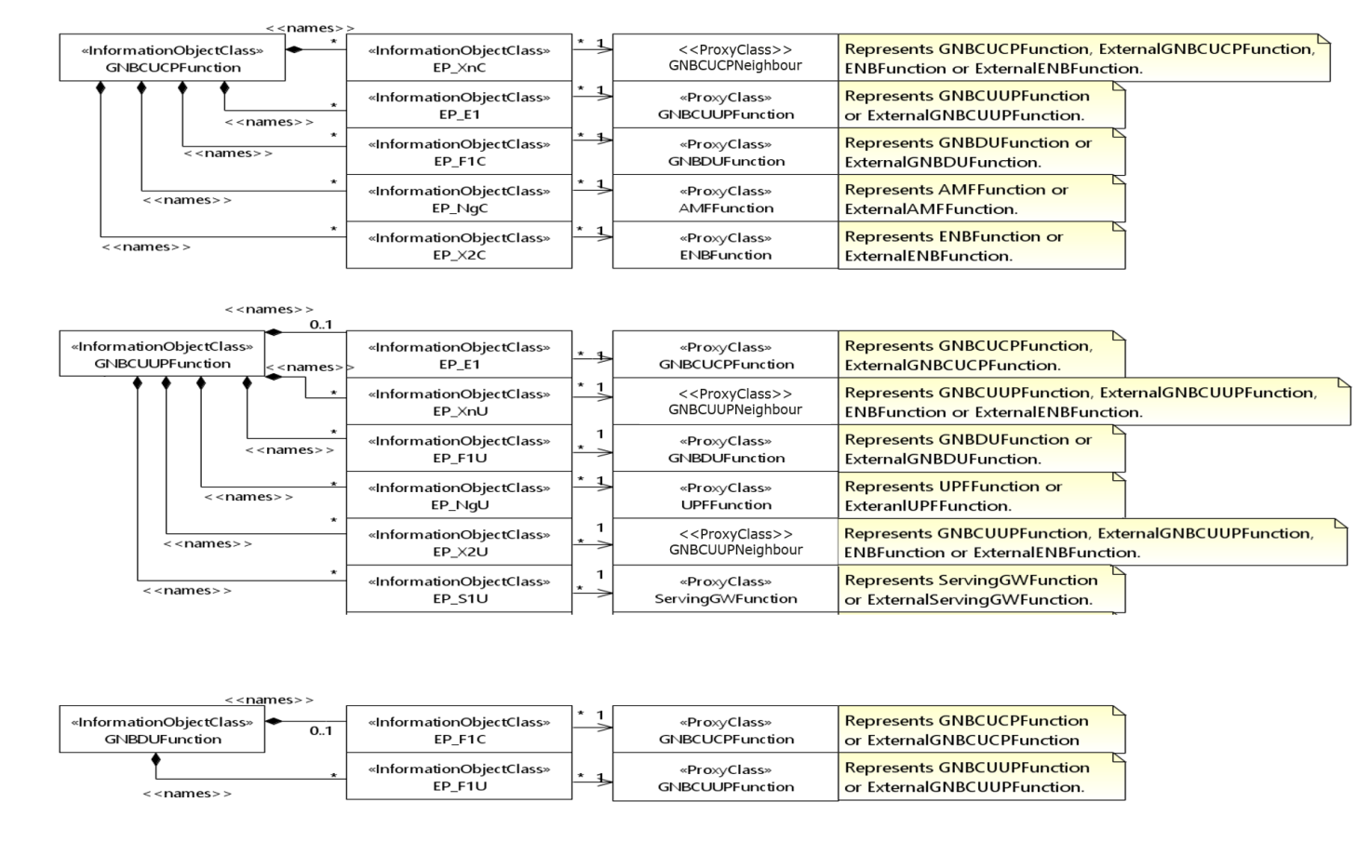
Figure 4.2.1.1-2: NRM for EPs for all deployment scenarios

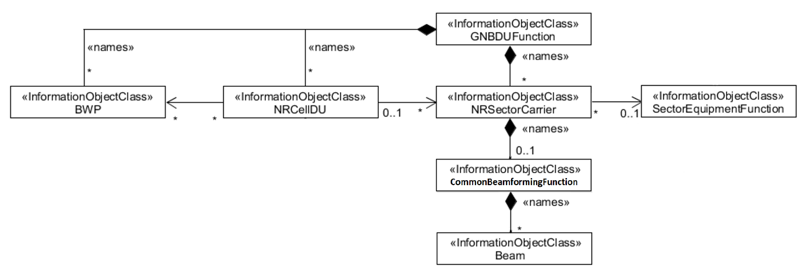
Figure 4.2.1.1-3: NRM for <<IOC>>NRSectorCarrier and <<IOC>>BWP for all deployment scenarios

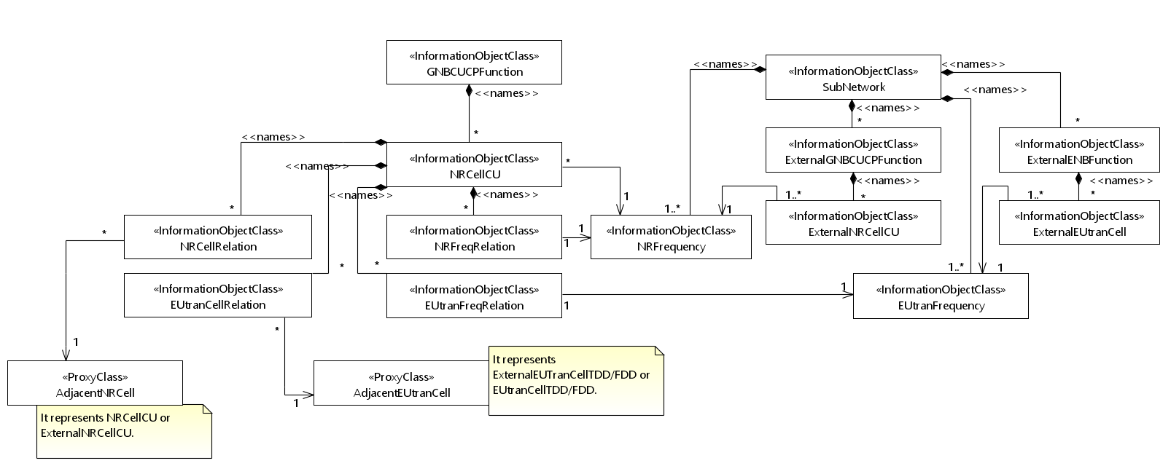
Figure 4.2.1.1-4: Cell Relation view for all deployment scenarios
NOTE 1: The above NRM fragment uses SubNetwork to hold both NR and LTE external entities and frequencies.
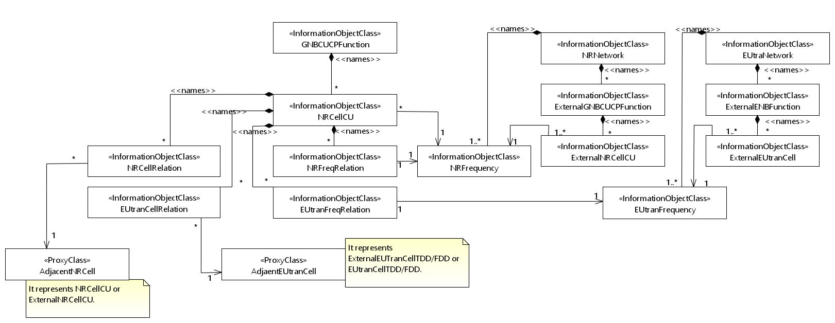
Figure 4.2.1.1-5: Cell Relation view for all deployment scenarios
NOTE 2: The above NRM fragment uses NRNetwork to hold NR external entities and frequency and using EUtraNetwork to hold LTE external entities and frequency. The NRNetwork and EUtraNetwork are subclasses of SubNetwork (defined in TS 28.622 [30]) with no additional attributes. The reason using NRNetwork and EUtraNetwork is for a clean separation of NR external entities and frequency and LTE external entities and frequency.
Figure 4.2.1.1-6: NRM fragment for RRM Policies

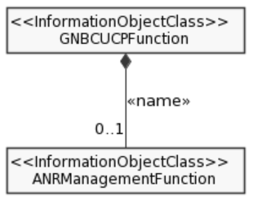
Figure 4.2.1.1-x1: NRM fragment for DANR Management
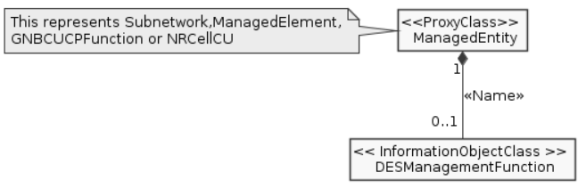
Figure 4.2.1.1-x2: NRM fragment for DES Management
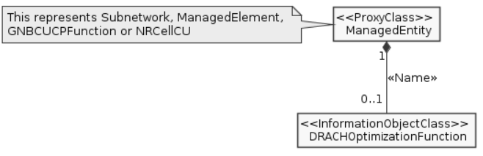
Figure 4.2.1.1-x3: NRM fragment for DRACH Management

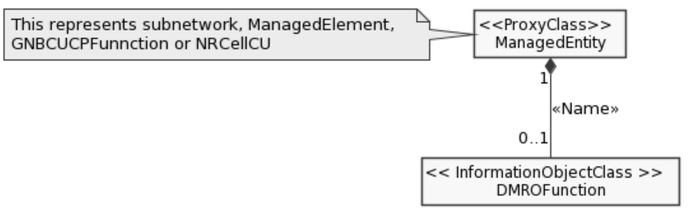
Figure 4.2.1.1-x4: NRM fragment for DMRO Management
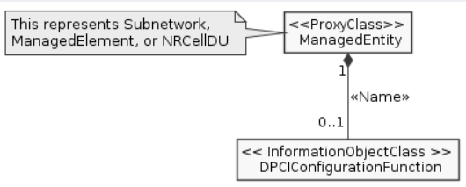
Figure 4.2.1.1-x5: NRM fragment for DPCI Management
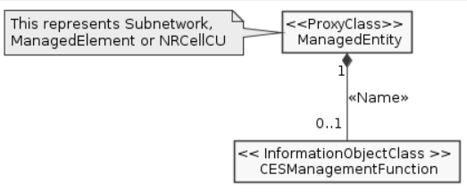
Figure 4.2.1.1-x6: NRM fragment for CES Management
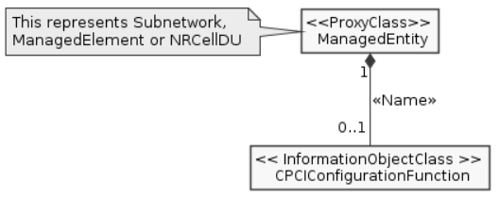
Figure 4.2.1.1-x7: NRM fragment for CPCI Management
Next change

4.2.1.2 Inheritance

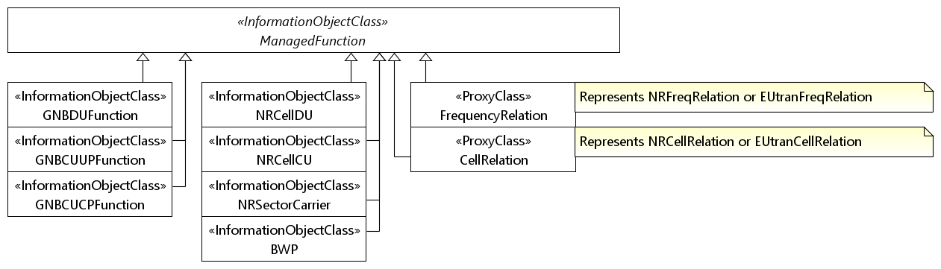
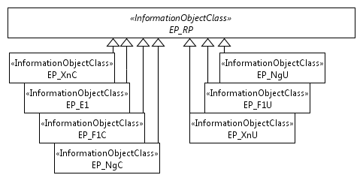
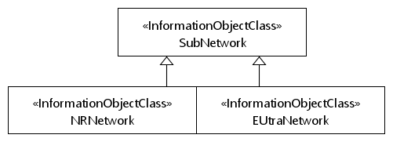

Figure 4.2.1.2-1: Inheritance Hierarchy
Next change

4.3.2 GNBCUCPFunction

4.3.2.1 Definition
For non-split NG-RAN deployment scenario, this IOC together with GNBCUUPFunction IOC and GNBDUFunction IOC provide the management representation of gNB defined in clause 6.1.1 in 3GPP TS 38.401 [4].
For 2-split NG-RAN deployment scenario, this IOC together with GNBCUUPFunction IOC provide management representation of the gNB-CU defined in clause 6.1.1 in 3GPP TS 38.401 [4].
For 3-split NG-RAN deployment scenario, this IOC provides management representation of gNB-CU-CP defined in clause 6.1.2 in 3GPP TS 38.401 [4].
The following table identifies the necessary end points required for the representation of gNB and en-gNB, of all deployment scenarios.
Req  Role | End point requirement for 3-split deployment scenario | End point requirement for 2-split deployment scenario | End point requirement for Non-split deployment scenario
gNB | <<IOC>>EP_XnC, <<IOC>>EP_NgC, <<IOC>>EP_F1C,  <<IOC>>EP_E1. | <<IOC>>EP_XnC, <<IOC>>EP_NgC, <<IOC>>EP_F1C  <<IOC>>EP_F1U. | <<IOC>>EP_XnC, <<IOC>>EP_NgC.
en-gNB | <<IOC>>EP_X2C, <<IOC>>EP_F1C, <<IOC>>EP_E1. | <<IOC>>EP_X2C, <<IOC>>EP_F1C. | <<IOC>>EP_X2C.

4.3.2.2 Attributes
The GNBCUCPFunction IOC includes attributes inherited from ManagedFunction IOC (defined in TS 28.622[30]) and the following attributes:
Attribute name | Support Qualifier | isReadable | isWritable | isInvariant | isNotifyable
gNBId | M | T | T | F | T
gNBIdLength | M | T | T | F | T
gNBCUName | O | T | T | F | T
pLMNId | M | T | T | T | T
x2BlackList | CM | T | T | F | T
x2WhiteList | CM | T | T | F | T
xnBlackList | M | T | T | F | T
xnWhiteList | M | T | T | F | T
x2XnHOBlackList | CM | T | T | F | T
mappingSetIDBackhaulAddressList | CM | T | T | F | T

4.3.2.3 Attribute constraints
Name | Definition
x2BlackList | Condition: Multi-Radio Dual Connectivity with the EPC (see TS 37.340 [9] clause 4.1.2) is supported.
x2WhiteList | Condition: Multi-Radio Dual Connectivity with the EPC (see TS 37.340 [9] clause 4.1.2) is supported.
mappingSetIDBackhaulAddressList | Condition: Remote Interference Management function is supported.

4.3.2.4 Notifications
The common notifications defined in subclause 4.5 are valid for this IOC, without exceptions or additions.

Next change

4.3.x DANRManagementFunction

4.3.x.1 Definition
This IOC contains attributes to support the D-SON function of ANR Management (See clause 6.4.1.3 in TS 28.313 [x]).

4.3.x.2 Attributes
The DANRManagementFunction IOC includes attributes inherited from Top IOC (defined in TS 28.622[30]) and the following attributes:
Attribute name | Support Qualifier | isReadable | isWritable | isInvariant | isNotifyable
intrasystemANRManagementSwitch | M | T | T | F | T
intersystemANRManagementSwitch | M | T | T | F | T

4.3.x.3 Attribute constraints
None.

4.3.x.4 Notifications
The common notifications defined in subclause 4.5 are valid for this IOC, without exceptions or additions.

4.3.x1 DESManagementFunction

4.3.x1.1 Definition
This IOC represents the management capabilities of Distributed SON or Domain-Centralized SON Energy Saving (ES) functions. This is provided for Energy Saving purposes.
NOTE: in the case where multiple DESManagement MOIs exist at different levels of the containment tree, the DESManagement MOI at the lower level overrides the DESManagement MOIs at higher level(s) of the same containment tree.

4.3.x1.2 Attributes
The DESManagementFunction IOC includes attributes inherited from Top IOC (defined in TS 28.622[30]) and the following attributes:
Attribute name | Support Qualifier | isReadable | isWritable | isInvariant | isNotifyable
desSwitch | M | T | T | F | T
intraRatEsActivationOriginalCellLoadParameters | CM | T | T | F | T
intraRatEsActivationCandidateCellsLoadParameters | CM | T | T | F | T
intraRatEsDeactivationCandidateCellsLoadParameters | CM | T | T | F | T
esNotAllowedTimePeriod | O | T | T | F | T
interRatEsActivationOriginalCellParameters | CM | T | T | F | T
interRatEsActivationCandidateCellParameters | CM | T | T | F | T
interRatEsDeactivationCandidateCellParameters | CM | T | T | F | T
energySavingState | M | T | F | F | T
isProbingCapable | O | T | F | F | T

4.3.x1.3 Attribute constraints
Name | Definition
intraRatEsActivationOriginalCellLoadParameters Support Qualifier | The condition is "Intra-RAT ESM is supported AND the cell acts as an original cell".
intraRatEsActivationCandidateCellsLoadParameters Support Qualifier | The condition is "Intra-RAT ESM is supported AND the cell acts as a candidate cell".
intraRatEsDeactivationCandidateCellsLoadParameters Support Qualifier | The condition is "Intra-RAT ESM is supported AND the cell acts as a candidate cell".
interRatEsActivationOriginalCellParameters CM Support Qualifier | The condition is "The cell acts as an original cell" AND inter-RAT ESM is supported.
interRatEsActivationCandidateCellParameters CM Support Qualifier | The condition is "The cell acts as a candidate cell" AND inter-RAT ESM is supported.
interRatEsDeactivationCandidateCellParameters CM Support Qualifier | The condition is "The cell acts as a candidate cell" AND inter-RAT ESM is supported.

4.3.x1.4 Notification
The common notifications defined in clause 4.5 are valid for this IOC, without exceptions or additions.

4.3.x2 DRACHOptimizationFunction

4.3.x2.1 Definition
This IOC contains attributes to support the D-SON function of RACH optimization (See clause 7.1.1 in TS 28.313 [x]).
NOTE: in the case where multiple DRACHOptimization MOIs exist at different levels of the containment tree, the DRACHOptimization MOI at the lower level overrides the DRACHOptimization MOIs at higher level(s) of the same containment tree.

4.3.x2.2 Attributes
The DRACHOptimizationFunction IOC includes attributes inherited from Top IOC (defined in TS 28.622[30]) and the following attributes:
Attribute name | Support Qualifier | isReadable | isWritable | isInvariant | isNotifyable
ueAccProbilityDistPerSSB | M | T | T | F | T
ueAccDelayProbilityDistPerSSB | M | T | T | F | T
drachOptimizationControl | M | T | T | F | T

4.3.x2.3 Attribute constraints
None.

4.3.x2.4 Notifications
The common notifications defined in subclause 4.5 are valid for this IOC, without exceptions or additions.

4.3.x3 DMROFunction

4.3.x3.1 Definition
This IOC contains attributes to support the D-SON function of MRO (See clause 7.1.2 in TS 28.313 [x]).
NOTE: in the case where multiple DMRO MOIs exist at different levels of the containment tree, the DMRO MOI at the lower level overrides the DMRO MOIs at higher level(s) of the same containment tree.

4.3.x3.2 Attributes
The DMROFunction IOC includes attributes inherited from Top IOC (defined in TS 28.622[30]) and the following attributes:
Attribute name | Support Qualifier | isReadable | isWritable | isInvariant | isNotifyable
dmroControl | M | T | T | F | T
maximumDeviationHoTrigger | M | T | T | F | T
minimumTimeBetweenHoTriggerChange | M | T | T | F | T
tstoreUEcntxt | M | T | T | F | T

4.3.x3.3 Attribute constraints
None.

4.3.x3.4 Notifications
The common notifications defined in subclause 4.5 are valid for this IOC, without exceptions or additions

4.3.x4 DPCIConfigurationFunction

4.3.x4.1 Definition
This IOC contains attributes to support the Distributed SON or Domain-Centralized SON function of PCI configuration (See clause 7.1.3 in TS 28.313 [x]).
NOTE: in the case where multiple DPCIConfiguration MOIs exist at different levels of the containment tree, the DPCIConfiguration MOI at the lower level overrides the DPCIConfiguration MOIs at higher level(s) of the same containment tree.

4.3.x4.2 Attributes
The DPCIConfigControlFunction IOC includes attributes inherited from Top IOC (defined in TS 28.622[30]) and the following attributes:
Attribute name | Support Qualifier | isReadable | isWritable | isInvariant | isNotifyable
dPciConfigurationControl | M | T | T | F | T
nRPciList | M | T | T | F | T

4.3.x4.3 Attribute constraints
None.

4.3.x4.4 Notifications
The common notifications defined in subclause 4.5 are valid for this IOC, without exceptions or additions.

4.3.x5 CPCIConfigurationFunction

4.3.x5.1 Definition
This IOC contains attributes to support the Cross Domain-Centralized SON function of PCI configuration (See clause 7.1.3 in TS 28.313 [x]).
NOTE: in the case where multiple CPCIConfiguration MOIs exist at different levels of the containment tree, the CPCIConfiguration MOI at the lower level overrides the CPCIConfiguration MOIs at higher level(s) of the same containment tree.

4.3.x5.2 Attributes
The CPCIConfigurationFunction IOC includes attributes inherited from Top IOC (defined in TS 28.622[30]) and the following attributes:
Attribute name | Support Qualifier | isReadable | isWritable | isInvariant | isNotifyable
cPciConfigurationControl | M | T | T | F | T
cSonPciList | M | T | T | F | T

4.3.x5.3 Attribute constraints
None.

4.3.x5.4 Notifications
The common notifications defined in subclause 4.5 are valid for this IOC, without exceptions or additions

4.3.x6 CESManagementFunction

4.3.x6.1 Definition
This IOC represents the management capabilities of Cross Domain-Centralized SON Energy Saving (ES) functions. This is provided for Energy Saving purposes.
NOTE: in the case where multiple CESManagement MOIs exist at different levels of the containment tree, the CESManagement MOI at the lower level overrides the ESManagement MOIs at higher level(s) of the same containment tree.

4.3.x6.2 Attributes
The CESManagementFunction IOC includes attributes inherited from Top IOC (defined in TS 28.622[30]) and the following attributes:
Attribute name | Support Qualifier | isReadable | isWritable | isInvariant | isNotifyable
cesSwitch | M | T | T | F | T
energySavingControl | M | T | T | F | T
energySavingState | M | T | T | F | T

4.3.x6.3 Attribute constraints
None.

4.3.x6.4 Notification
The common notifications defined in clause 4.5 are valid for this IOC, without exceptions or additions.
Next change

4.4.1 Attribute properties
Attribute Name | Documentation and Allowed Values | Properties
administrativeState | It indicates the administrative state of the NRCellDU. It describes the permission to use or prohibition against using the cell, imposed through the OAM services.  allowedValues: LOCKED, SHUTTING DOWN, UNLOCKED.  The meaning of these values is as defined in ITU-T Recommendation X.731 [18].  See Annex A for Relation between the "Pre-operation state of the gNB-DU Cell" and administrative state relevant in case of 2-split and 3-split deployment scenarios. | type: ENUM  multiplicity: 1  isOrdered: N/A  isUnique: N/A  defaultValue: LOCKED  isNullable: False
operationalState | It indicates the operational state of the NRCellDU instance. It describes whether the resource is installed and partially or fully operable (Enabled) or the resource is not installed or not operable (Disabled).  allowedValues: ENABLED, DISABLED. | type: ENUM  multiplicity: 1  isOrdered: N/A  isUnique: N/A  defaultValue: None  isNullable: False
cellState | It indicates the usage state of the NRCellDU instance. It describes whether the cell is not currently in use (Idle), or currently in use but not configured to carry traffic (Inactive) or is currently in use and is configured to carry traffic (Active).  The Inactive and Active definitions are in accordance with TS 38.401 [4]:  "Inactive: the cell is known by both the gNB-DU and the gNB-CU. The cell shall not serve UEs;  Active: the cell is known by both the gNB-DU and the gNB-CU. The cell should be able to serve UEs."  "allowedValues: IDLE, INACTIVE, ACTIVE. | type: ENUM  multiplicity: 1  isOrdered: N/A  isUnique: N/A  defaultValue: None  isNullable: False
arfcnDL | NR Absolute Radio Frequency Channel Number (NR-ARFCN) for downlink  allowedValues:  See TS 38.104 [12] subclause 5.4.2. Note that allowed values of NR-ARFCN are specified for each band in subclause 5.4.2.3. | type: Integer  multiplicity: 1  isOrdered: N/A  isUnique: N/A  defaultValue: None  isNullable: False
arfcnUL | NR Absolute Radio Frequency Channel Number (NR-ARFCN) for uplink  allowedValues:  See TS 38.104 [12] subclause 5.4.2. Note that allowed values of NR-ARFCN are specified for each band in subclause 5.4.2.3. | type: Integer  multiplicity: 1  isOrdered: N/A  isUnique: N/A  defaultValue: None  isNullable: False
arfcnSUL | NR Absolute Radio Frequency Channel Number (NR-ARFCN) for supplementary uplink  allowedValues:  See TS 38.104 [12] subclause 5.4.2. Note that allowed values of NR-ARFCN are specified for each band in subclause 5.4.2.3. | type: Integer  multiplicity: 1  isOrdered: N/A  isUnique: N/A  defaultValue: None  isNullable: False
beamAzimuth | The azimuth of a beam transmission, which means the horizontal beamforming pointing angle (beam peak direction) in the (Phi) φ-axis in 1/10th degree resolution. See subclauses 3.2 in TS 38.104 [12] and 7.3 in TS 38.901 [53] as well as TS 28.662 [11]. The pointing angle is the direction equal to the geometric centre of the half-power contour of the beam relative to the reference plane. Zero degree implies explicit antenna bearing (boresight). Positive angle implies clockwise from the antenna bearing.  allowedValues: [-1800 ..1800] 0.1 degree | type: Integer  multiplicity: 1  isOrdered: N/A  isUnique: N/A  defaultValue: Null  isNullable: True
beamHorizWidth | The Horizontal beamWidth of a beam transmission, which means the horizontal beamforming half-power (3dB down) beamwidth in the (Phi) φ-axis in 1/10th degree resolution. See subclauses 3.2 in TS 38.104 [12] and 7.3 in TS 38.901 [53].  allowedValues: [0..3599] 0.1 degree | type: Integer  multiplicity: 1  isOrdered: N/A  isUnique: N/A  defaultValue: Null  isNullable: True
beamIndex | Index of the beam.  For example, please see subclause 6.6.2 of TS 38.331 [54] where the ssb-Index in the rsIndexResults element of MeasResultNR is defined. | type: Integer  multiplicity: 1  isOrdered: N/A  isUnique: N/A  defaultValue: Null  isNullable: True
beamTilt | The tilt of a beam transmission, which means the vertical beamforming pointing angle (beam peak direction) in the (Theta) θ-axis in 1/10th degree resolution. See subclauses 3.2 in TS 38.104 [12] and 7.3 in TS 38.901 [53] as well as TS 28.662 [11]. The pointing angle is the direction equal to the geometric centre of the half-power contour of the beam relative to the reference plane. Positive value implies downtilt.  allowedValues: [-900..900] 0.1 degree | type: Integer  multiplicity: 1  isOrdered: N/A  isUnique: N/A  defaultValue: Null  isNullable: True
beamType | The type of the beam.  allowedValues: "SSB-BEAM" | type: string  multiplicity: 0..1  isOrdered: N/A  isUnique: N/A  defaultValue: Null  isNullable: True
beamVertWidth | The Vertical beamWidth of a beam transmission, which means the vertical beamforming half-power (3dB down) beamwidth in the (Theta) θ-axis in 1/10th degree resolution. See subclauses 3.2 in TS 38.104 [12] and 7.3 in TS 38.901 [53].  allowedValues: [0...1800] 0.1 degree | type: Integer  multiplicity: 1  isOrdered: N/A  isUnique: N/A  defaultValue: Null  isNullable: True
bSChannelBwDL | BS Channel BW in MHz. for downlink  allowedValues:  See BS Channel BW in TS 38.104 [12], subclause 5.3.​ | type: Integer  multiplicity: 1  isOrdered: N/A  isUnique: N/A  defaultValue: None  isNullable: False
bSChannelBwUL | BS Channel BW in MHz.for uplink  allowedValues:  See BS Channel BW in TS 38.104 [12], subclause 5.3.​ | type: Integer  multiplicity: 1  isOrdered: N/A  isUnique: N/A  defaultValue: None  isNullable: False
bSChannelBwSUL | BS Channel BW in MHz.for supplementary uplink  allowedValues:  See BS Channel BW in TS 38.104 [12], subclause 5.3.​ | type: Integer  multiplicity: 1  isOrdered: N/A  isUnique: N/A  defaultValue: None  isNullable: False
configuredMaxTxPower | This is the maximum possible for all downlink channels, used simultaneously in a cell, added together.  allowedValues:TBD | type: Integer  multiplicity: 1  isOrdered: N/A  isUnique: N/A  defaultValue: None  isNullable: False
coverageShape | Identifies the sector carrier coverage shape described by the envelope of the contained SSB beams. The coverage shape is implementation dependent.  allowedValues: 0 : 65535 | type: Integer  multiplicity: 1  isOrdered: N/A  isUnique: N/A  defaultValue: None  isNullable: False
digitalTilt | Digitally-controlled tilt through beamforming. It represents the vertical pointing direction of the antenna relative to the antenna bore sight, representing the total non-mechanical vertical tilt of the selected coverageShape. Positive value gives downwards tilt and negative value gives upwards tilt.  allowedValues: [-900..900] 0.1 degree | type: Integer  multiplicity: 1  isOrdered: N/A  isUnique: N/A  defaultValue: None  isNullable: False
digitalAzimuth | Digitally-controlled azimuth through beamforming. It represents the horizontal pointing direction of the antenna relative to the antenna bore sight, representing the total non-mechanical horizontal pan of the selected coverageShape. Positive value gives azimuth to the right and negative value gives an azimuth to the left.  allowedValues: [-1800 ..1800] 0.1 degree | type: Integer  multiplicity: 1  isOrdered: N/A  isUnique: N/A  defaultValue: None  isNullable: False
cyclicPrefix | Cyclic prefix as defined in TS 38.211 [32], subclause 4.2.  allowedValues:  NORMAL, EXTENDED. | type: ENUM  multiplicity: 1  isOrdered: N/A  isUnique: N/A  defaultValue: None  isNullable: False
localAddress | This parameter specifies the localAddress including IP address and VLAN ID used for initialization of the underlying transport.  First string is IP address, IP address can be an IPv4 address (See RFC 791 [37]) or an IPv6 address (See RFC 2373 [38]).  Second string is VLAN Id. (See IEEE 802.1Q [39]), | type: String  multiplicity: 2  isOrdered: True  isUnique: N/A  defaultValue: None  isNullable: False
remoteAddress | Remote address including IP address used for initialization of the underlying transport.  IP address can be an IPv4 address (See RFC 791 [37]) or an IPv6 address (See RFC 2373 [38]). | type: String  multiplicity: 1  isOrdered: N/A  isUnique: N/A  defaultValue: None  isNullable: False
gNBId | It identifies a gNB within a PLMN. The gNB ID is part of the NR Cell Identifier (NCI) of the gNB cells.  See "gNB Identifier (gNB ID)" of subclause 8.2 of TS 38.300 [3]). See "Global gNB ID" in subclause 9.3.1.6 of TS 38.413 [5].  allowedValues: 0..4294967295 | type: Integer  multiplicity: 1  isOrdered: N/A  isUnique: N/A  defaultValue: None  isNullable: False
gNBIdLength | This indicates the number of bits for encoding the gNB ID. See "Global gNB ID" in subclause 9.3.1.6 of TS 38.413 [5].  allowedValues: 22 .. 32. | type: Integer  multiplicity: 1  isOrdered: N/A  isUnique: N/A  defaultValue: None  isNullable: False
gNBDUId | It uniquely identifies the DU at least within a gNB-CU. See 'gNB-DU ID' in subclause 9.3.1.9 of 3GPP TS 38.473 [8].  allowedValues: 0..2³⁶-1 | type: Integer  multiplicity: 1  isOrdered: N/A  isUnique: N/A  defaultValue: None  isNullable: False
gNBCUUPId | It uniquely identifies the gNB-CU-UP at least within a gNB-CU-CP. See 'gNB-CU-UP ID' in subclause 9.3.1.15 of 3GPP TS 38.463 [48].  allowedValues: 0..2³⁶-1 | type: Integer  multiplicity: 1  isOrdered: N/A  isUnique: N/A  defaultValue: None  isNullable: False
gNBCUName | It identifies the Central Entity of a NR node, see subclause 9.2.1.4 of 3GPP TS 38.473 [8].  allowedValues: Not applicable | type: String  multiplicity: 1  isOrdered: N/A  isUnique: N/A  defaultValue: None  isNullable: False
gNBDUName | It identifies the Distributed Entity of a NR node, see subclause 9.2.1.5 of 3GPP TS 38.473 [8].  allowedValues: Not applicable | type: String  multiplicity: 1  isOrdered: N/A  isUnique: N/A  defaultValue: None  isNullable: False
cellLocalId | It identifies a NR cell of a gNB.  It, together with the gNB Identifier (using gNBId of the parent GNBCUCPFunction or GNBDUFunction or ExternalCUCPFunction), identifies a NR cell within a PLMN. This is the NR Cell Identity (NCI). See subclause 8.2 of TS 38.300 [3]),  The NCI can be constructed by encoding the gNB Identifier using gNBId (of the parent GNBCUCPFunction or GNBDUFunction or ExternalCUCPFunction) and cellLocalId where the gNB Identifier field is of length specified by gNBIdLength (of the parent GNBCUCPFunction or GNBDUFunction or ExternalCUCPFunction). See "Global gNB ID" in subclause 9.3.1.6 of TS 38.413 [5].  The NR Cell Global identifier (NCGI) is constructed from the PLMN identity the cell belongs to and the NR Cell Identifier (NCI) of the cell.  See relation between NCI and NCGI subclause 8.2 of TS 38.300 [3].  allowedValues: Not applicable | type: Integer  multiplicity: 1  isOrdered: N/A  isUnique: True  defaultValue: None  isNullable: False
nRPCI | This holds the Physical Cell Identity (PCI) of the NR cell.  allowedValues:  See 3GPP TS 36.211 subclause 6.11 for legal values of pci. | type: Integer  multiplicity: 1  isOrdered: N/A  isUnique: N/A  defaultValue: None  isNullable: False
nRTAC | This holds the identity of the common Tracking Area Code for the PLMNs.  allowedValues:  a) It is the TAC or Extended-TAC.  b) A cell can only broadcast one TAC or Extended-TAC. See TS 36.300, subclause 10.1.7 (PLMNID and TAC relation).  c) TAC is defined in subclause 19.4.2.3 of 3GPP TS 23.003  [13] and Extended-TAC is defined in subclause 9.3.1.29 of 3GPP TS 38.473 [8].  d) For a 5G SA (Stand Alone), it has a non-null value. | type: Integer  multiplicity: 1  isOrdered: N/A  isUnique: N/A  defaultValue: NULL  isNullable: True
GNBCUCPFunction.pLMNId | It specifies the PLMN identifier to be used as part of the global RAN node identity.  allowedValues: Not applicable. | Type: PLMNId  multiplicity: 1  isOrdered: N/A  isUnique: N/A  defaultValue: None  isNullable: False
GNBCUUPFunction.pLMNIdList | This is a list of PLMN identifiers. It defines from which set of PLMNs an UE must have as its serving PLMN to be allowed to use the GNB-CU-UP.  allowedValues: Not applicable. | type: PLMNId  multiplicity: 1..12  isOrdered: N/A  isUnique: True  defaultValue: None  isNullable: False
NRCellCU.pLMNInfoList | It defines which PLMNs that can be served by the NR cell,and which S-NSSAIs can be supported by the NR cell for corresponding PLMN in case of network slicing feature is supported  allowedValues: Not applicable. | type: PLMNInfo  multiplicity: 1..*  isOrdered: N/A  isUnique: True  defaultValue: None  isNullable: False
NRCellDU.pLMNInfoList | It defines which PLMNs that can be served by the NR cell, and which S-NSSAs can be supported by the NR cell for corresponding PLMN in case of network slicing feature is supported. The pLMNId of the first entry of the list is the PLMNId used to construct the nCGI for the NR cell.  allowedValues: Not applicable. | type: PLMNInfo  multiplicity: 1..*  isOrdered: N/A  isUnique: True  defaultValue: None  isNullable: False
ExternalNRCellCU.pLMNIdList | It defines which PLMNs that are assumed to be served by the NR Cell in another gNB-CU-CP. This list is either updated by the managed element itself (e.g. due to ANR, signalling over Xn etc) or by consumer over the standard interface.  allowedValues: Not applicable. | Type: PLMNId  multiplicity: 1..12  isOrdered: N/A  isUnique: True  defaultValue: None  isNullable: False
rRMPolicyMemberList | It represents the list of RRMPolicyMember (s) that the managed object is supporting. A RRMPolicyMember <<dataType>> include the PLMNId <<dataType>> and S-NSSAI <<dataType>>.  allowedValues: N/A | type: RRMPolicyMember  multiplicity: 1..*  isOrdered: N/A  isUnique: True  defaultValue: None  isNullable: False
resourceType | The resource type of interest for an RRM Policy.  allowedValues:  PRB (for NRCellDU)  RRC connected users (for NRCellCU)  DRB (for GNBCUUPFunction)  See NOTE 2, NOTE 3 and NOTE 4 | type: String  multiplicity: 1  isOrdered: N/A  isUnique: N/A  defaultValue: None  isNullable: False
sNSSAIList | It represents the list of S-NSSAI the managed object is supporting. The S-NSSAI is defined in 3GPP TS 23.003 [13].  allowedValues: See 3GPP TS 23.003 [13] | type: S-NSSAI  multiplicity: *  isOrdered: N/A  isUnique: N/A  defaultValue: None  allowedValues: N/A  isNullable: False
sST | This attribute specifies the Slice/Service type (SST) of the network slice.  See clause 5.15.2 of 3GPP TS 23.501 [2]. | type: Integer  multiplicity: 1  isOrdered: N/A  isUnique: N/A  defaultValue: None  allowedValues: N/A  isNullable: False
sD | This attribute specifies the Slice Differentiator (SD), which is optional information that complements the slice/service type(s) to differentiate amongst multiple Network Slices.  See clause 5.15.2 of 3GPP TS 23.501 [2]. | type: Integer  multiplicity: 1  isOrdered: N/A  isUnique: N/A  defaultValue: None  allowedValues: N/A  isNullable: False
quotaType | The attribute indicates the type of the quota which allows to allocate resource as strictly usable for defined rRMPolicyMemberList (“strict quota”) or allows that resource to be used by other rRMPolicyMemberList(s) when defined rRMPolicyMemberList do not need them ( “float quota”).  allowedValues: STRICT, FLOAT. | type: ENUM  multiplicity: 1  isOrdered: N/A  isUnique: N/A  defaultValue: None  isNullable: False
rRMPolicyMaxRatio | The RRM policy setting the maximum percentage of radio resources to be allocated to the corresponding rRMPolicyMemberList.  This quota can be strict or float quota :  - Strict quota means the defined rRMPolicyMemberList cannot be allocated resource if its used resource reached maxRatio.  - Float quota means the defined rRMPolicyMemberList can use quota from other rRMPolicyMemberList(s) even if its resource has reached maxRatio, if there’s free quota from other rRMPolicyMemberList. In addition, resource of the defined rRMPolicyMemberList can be used by other rRMPolicyMemberList(s) when the defined rRMPolicyMemberList do not need them.  Value 0 indicates that there is no maximum limit.  allowedValues:  0 : 100 | type: Integer  multiplicity: 0..1  isOrdered: N/A  isUnique: N/A  defaultValue: None  allowedValues: N/A  isNullable: False
rRMPolicyMarginMaxRatio | Maximum quota margin ratio is applicable when maximum quota policy ratio is of type “float quota”. It defines the resource quota within maximum quota to reserve buffers for new resource requirements for the defined rRMPolicyMemberList. With the margin ratio, unused resources of the maximum resource quota can be allocated to other rRMPolicyMemberList(s) when the free resources are more than resource amount indicated by the margin. The margin resource quota can only be used for the defined rRMPolicyMemberList.. Value 0 indicates that no margin is used.  allowedValues:  0 : 100 | type: Integer  multiplicity: 0..1  isOrdered: N/A  isUnique: N/A  defaultValue: None  allowedValues: N/A  isNullable: False
rRMPolicyMinRatio | The RRM policy setting the minimum percentage of radio resources to be allocated to the corresponding rRMPolicyMemberList, especially in congestion situation.  This quota can be strict or float quota:  - Strict quota means resources are not allowed for other rRMPolicyMemberList(s) even when they are not used by the defined rRMPolicyMemberList.  -Float quota resources can be used by other rRMPolicyMemberList(s) when the defined rRMPolicyMemberList do not need them.  Value 0 indicates that there is no minimum limit.  allowedValues:  0 : 100  NOTE: The averaging time interval is implementation dependent. | type: Integer  multiplicity: 0..1  isOrdered: N/A  isUnique: N/A  defaultValue: None  allowedValues: N/A  isNullable: False
rRMPolicyMarginMinRatio | Minimum quota margin ratio is applicable when minimum quota policy ratio is of type “float quota”. It defines the resource quota within minimum quota to reserve buffers for new resource requirements for the defined rRMPolicyMemberList. With the margin ratio, unused resources of the minimum resource quota can be allocated to other rRMPolicyMemberList(s) when the free resources are more than resource amount indicated by the margin. The margin resource quota can only be used for the defined rRMPolicyMemberList. Value 0 indicates that no margin is used.  allowedValues:  0 : 100 | type: Integer  multiplicity: 0..1  isOrdered: N/A  isUnique: N/A  defaultValue: None  allowedValues: N/A  isNullable: False
subCarrierSpacing | Subcarrier spacing configuration for a BWP. See subclause 5 in TS 38.104 [12].  AllowedValues: [15, 30, 60, 120] depending on the frequency range FR1 or FR2. | type: Integer  multiplicity: 1  isOrdered: N/A  isUnique: N/A  defaultValue: None  isNullable: False
txDirection | Indicates if the transmission direction is downlink (DL), uplink (UL) or both downlink and uplink (DL and UL).  allowedValues:  DL, UL, DL and UL | type: ENUM  multiplicity: 1  isOrdered: N/A  isUnique: N/A  defaultValue: None  isNullable: False
bwpContext | It identifies whether the object is used for downlink, uplink or supplementary uplink.  allowedValues:  DL, UL, SUL | type: ENUM  multiplicity: 1  isOrdered: N/A  isUnique: N/A  defaultValue: None  isNullable: False
isInitialBwp | It identifies whether the object is used for initial or other BWP.  allowedValues:  INITIAL, OTHER | type: ENUM  multiplicity: 1  isOrdered: N/A  isUnique: N/A  defaultValue: None  isNullable: False
startRB | Offset in common resource blocks to common resource block 0 for the applicable subcarrier spacing for a BWP. This corresponds to N_BWP_start, see subclause 4.4.5 in TS 38.211 [32].  allowedValues:  0 to N_grid_size – 1, where N_grid_size equals the number of resource blocks for the BS channel bandwidth, given the subcarrier spacing of the BWP. | type: Integer  multiplicity: 1  isOrdered: N/A  isUnique: N/A  defaultValue: None  isNullable: False
numberOfRBs | Number of physical resource blocks for a BWP. This corresponds to N_BWP_size, see subclause 4.4.5 in TS 38.211 [32].  allowedValues:  1 to N_grid_size – startRB of the BWP. Se startRB for definition of N_grid_size. | type: Integer  multiplicity: 1  isOrdered: N/A  isUnique: N/A  defaultValue: None  isNullable: False
nRTCI | This is the Target NR Cell Identifier. It consists of NR Cell Identifier (NCI) and Physical Cell Identifier of the target NR cell (nRPCI).  The NRRelation.nRTCI identifies the target cell from the perspective of the NRCell, the name-containing instance of the subject NRCellCU instance.  allowedValues: Not applicable. | type: Integer  multiplicity: 1  isOrdered: N/A  isUnique: N/A  defaultValue: None  isNullable: False
adjacentCellRef | This attribute contains the DN of an adjacentNRCell (NRCellCU or ExternalNRCellCU)  allowedValues: Not applicable. | type: DN  multiplicity: 1  isOrdered: N/A  isUnique: True  defaultValue: None  isNullable: False
ssbFrequency | Indicates cell defining SSB frequency domain position  Frequency of the cell defining SSB transmission. The frequency provided in this attribute identifies the position of resource element RE=#0 (subcarrier #0) of resource block RB#10 of the SS block. The frequency must be positioned on the NR global frequency raster, as defined in TS 38.101 [42] subclause 5.4.2. and within bSChannelBwDL.  allowedValues: 0..3279165 | type: Integer  multiplicity: 1  isOrdered: N/A  isUnique: N/A  defaultValue: None  isNullable: False
nRFrequencyRef | This attribute contains the DN of the referenced NRFrequency.  allowedValues: Not applicable. | type: DN  multiplicity: 1  isOrdered: N/A  isUnique: True  defaultValue: None  isNullable: False
nRSectorCarrierRef | This attribute contains the DN of the referenced NRSectorCarrier.  allowedValues: Not applicable. | type: DN  multiplicity: 1  isOrdered: N/A  isUnique: True  defaultValue: None  isNullable: False
bWPRef | This attribute contains the DN of the referenced BWP.  allowedValues: Not applicable. | type: DN  multiplicity: 1  isOrdered: N/A  isUnique: True  defaultValue: None  isNullable: False
sectorEquipmentFunctionRef | This attribute contains the DN of the referenced NSectorEquipmentFunction.  allowedValues: Not applicable. | type: DN  multiplicity: 1  isOrdered: N/A  isUnique: True  defaultValue: None  isNullable: False
offsetMO | It is a list of offset values applicable to all measured cells with reference signal(s) indicated in this MeasObjectNR. See offsetMO of subclause 5.5.4 of TS 38.331 [31].  allowedValues: Not applicable. | type: QOffsetRangeList  multiplicity: 1  isOrdered: N/A  isUnique: N/A  defaultValue: N/A  isNullable: False
cellIndividualOffset | It is a list of offset values for the neighbour cell. Used when UE is in connected mode. The unit is 1dB. It is defined for rsrpOffsetSSB, rsrqOffsetSSB, sinrOffsetSSB, rsrpOffsetCSI-RS, rsrqOffsetCSI-RS and sinrOffsetCSI-RS. See TS 38.331 [31].  allowedValues: Not applicable. | type: Integer  multiplicity: 6  isOrdered: True  isUnique: N/A  defaultValue: 0  isNullable: False
blackListEntry | It specifies a list of PCI (physical cell identity) that are blacklisted in EUTRAN measurements as described in 3GPP TS 38.331 [31].  allowedValues: { 0…1007 } | type: Integer  multiplicity: *  isOrdered: N/A  isUnique: N/A  defaultValue: None  isNullable: False
blackListEntryIdleMode | It specifies a list of PCI (physical cell identity) that are blacklisted in SIB4 and SIB5.  allowedValues: { 0…1007 } | type: Integer  multiplicity: 1  isOrdered: N/A  isUnique: N/A  defaultValue: None  isNullable: False
cellReselectionPriority | It is the absolute priority of the carrier frequency used by the cell reselection procedure. See CellReselectionPriority IE in TS 38.331 [31].  It corresponds to the parameter priority in 3GPP TS 38.304 [49].  Value 0 means lowest priority. The UE behaviour when no value is entered is specified in subclause 5.2.4.1 of 3GPP TS 38.304 [49].  The value must not already used by other RAT, i.e. equal priorities between RATs are not supported.  allowedValues: N/A | type: Integer  multiplicity: 1  isOrdered: N/A  isUnique: N/A  defaultValue: 0None  isNullable: False
cellReselectionSubPriority | It indicates a fractional value to be added to the value of cellReselectionPriority to obtain the absolute priority of the concerned carrier frequency for E-UTRA and NR. See CellReselectionSubPriority IE in TS 38.331 [31].  allowedValues: { 0.2, 0.4, 0.6, 0.8 }. | type: Short  multiplicity: 1  isOrdered: N/A  isUnique: N/A  defaultValue: None  isNullable: False
pMax | It calculates the parameter Pcompensation (defined in 3GPP TS 38.304 [49]), at cell reselection to an Cell. Its unit is 1 dBm. It corresponds to parameter PEMAX in 3GPP TS 38.101 [??].  allowedValues: { -30..33 }. | type: Integer  multiplicity: 1  isOrdered: N/A  isUnique: N/A  defaultValue: None  isNullable: False
qOffsetFreq | It is the frequency specific offset applied when evaluating candidates for cell reselection. See TS 38.331 [49]. Its unit is 1 dB.  allowedValues:  { -24, -22, -20, -18, -16, -14, -12, -10, -8, -6, -5, -4, -3, -2, -1, 0, 1, 2, 3, 4, 5, 6, 8, 10, 12, 14, 16, 20, 22, 24 } | type: Real  multiplicity: 1  isOrdered: N/A  isUnique: N/A  defaultValue: 0  isNullable: False
qOffsetRangeList | It is used to indicate a cell, beam or measurement object specific offset to be applied when evaluating candidates for cell re-selection or when evaluating triggering conditions for measurement reporting. The value in dB. Value dB-24 corresponds to -24 dB, dB-22 corresponds to -22 dB and so on.  This is a list of enum values representing, in sequence: rsrpOffsetSSB, rsrqOffsetSSB, sinrOffsetSSB, rsrpOffsetCSI-RS, srqOffsetCSI-RS, sinrOffsetCSI-RS.  See Q-OffsetRangeList in subclause of subclause 6.3.1 of TS 38.311 [31].  allowedValues:  { -24, -22, -20, -18, -16, -14, -12, -10, -8, -6, -5, -4, -3, -2, -1, 0, 1, 2, 3, 4, 5, 6, 8, 10, 12, 14, 16, 18, 20, 22, 24 } | type: ENUM  multiplicity: 6  isOrdered: True  isUnique: N/A  defaultValue: 0  isNullable: False
qQualMin | It indicates the minimum required quality level in the cell (dB). See qQualMin in TS 38.304 [49]. Unit is 1 dB.  Value 0 means that it is not sent and UE applies in such case the (default) value of negative infinity for Qqualmin. Sent in SIB3 or SIB5.  allowedValues: { -34..-3, 0 } | type: Real  multiplicity: 1  isOrdered: N/A  isUnique: N/A  defaultValue: None  isNullable: False
qRxLevMin | It indicates the required minimum received Reference Symbol Received Power (RSRP) level in the (E-UTRA) frequency for cell reselection. It corresponds to Qrxlevmin defined in 3GPP TS 38.304 [49]. It is broadcast in SIB3 or SIB5, depending on whether the related frequency is intra- or inter-frequency. Its unit is 1 dBm and resolution is 2.  allowedValues: { -140..-44 }. | type: Integer  multiplicity: 1  isOrdered: N/A  isUnique: N/A  defaultValue: None  isNullable: False
threshXHighP | This specifies the Srxlev threshold (in dB) used by the UE when reselecting towards a higher priority RAT/ frequency than the current serving frequency. Each frequency of NR and E-UTRAN might have a specific threshold. It corresponds to the Thresh_{X, HighP} in 3GPP TS 38.304 [49]. Its unit is 1 dB and resolution is 2.  allowedValues: { 0..62 } | type: Integer  multiplicity: 1  isOrdered: N/A  isUnique: N/A  defaultValue: None  isNullable: False
threshXHighQ | This specifies the Squal threshold (in dB) used by the UE when reselecting towards a higher priority RAT/ frequency than the current serving frequency. Each frequency of NR and E-UTRAN might have a specific threshold. It corresponds to the ThreshX, HighQ in TS 38.304 [49]. Its unit is 1 dB.  allowedValues: { 0..31 } | type: Integer  multiplicity: 1  isOrdered: N/A  isUnique: N/A  defaultValue: None  isNullable: False
threshXLowP | This specifies the Srxlev threshold (in dB) used by the UE when reselecting towards a lower priority RAT/ frequency than the current serving frequency. Each frequency of NR might have a specific threshold. It corresponds to ThreshX,LowP in 3GPP TS 38.304 [49]. Its unit is 1 dB. Its resolution is 2.  allowedValues: { 0..62 } | type: Integer  multiplicity: 1  isOrdered: N/A  isUnique: N/A  defaultValue: None  isNullable: False
threshXLowQ | This specifies the Squal threshold (in dB) used by the UE when reselecting towards a lower priority RAT/ frequency than the current serving frequency. Each frequency of NR might have a specific threshold. It corresponds to ThreshX,Low in TS 38.304 [49]. Its unit is 1 dB.  allowedValues: {0..31}. | type: Integer  multiplicity: 1  isOrdered: N/A  isUnique: N/A  defaultValue: None  isNullable: False
tReselectionNr | It is the cell reselection timer and corresponds to parameter TreselectionRAT for NR defined in 38.331 [4]. Its unit is in seconds.  allowedValues: {0..7}. | type: Integer  multiplicity: 1  isOrdered: N/A  isUnique: N/A  defaultValue: None  isNullable: False
tReselectionNRSfHigh | The attribute t-ReselectionNr (a parameter Treselection_{NR} in TS 38.304 [49]) is multiplied with this factor if the UE is in high mobility state. It corresponds to the parameter Speed dependent ScalingFactor for TreselectionNr for medium high state in 3GPP TS 38.304 [49]. The unit is one %.  Value mapping:  25 = 0.25  50 = 0.5  75 = 0.75  100 = 1.0  allowedValues: {25, 50, 75, 100}. | type: Integer  multiplicity: 1  isOrdered: N/A  isUnique: N/A  defaultValue: None  isNullable: False
tReselectionNRSfMedium | The attribute t-ReselectionNR (a parameter "Treselection_{NR} in TS 38.304 [49]”) is multiplied with this factor if the UE is in medium mobility state. It corresponds to the parameter Speed dependent ScalingFactor for TreselectionNr for medium mobility state in 3GPP TS 38.304 [49]. Its unit is one %.  Value mapping:  25 = 0.25  50 = 0.5  75 = 0.75  100 = 1.0  allowedValues: {25, 50, 75, 100}. | type: Integer  multiplicity: 1  isOrdered: N/A  isUnique: N/A  defaultValue: None  isNullable: False
absoluteFrequencySSB | The absolute frequency applicable for a downlink NR carrier frequency associated with the SSB.  allowedValues: {0.. 3279165}. | type: Integer  multiplicity: 1  isOrdered: N/A  isUnique: N/A  defaultValue: None  isNullable: False
sSBSubCarrierSpacing | This SSB is used for for synchronization. See subclause 5 in TS 38.104 [12]. Its units are in kHz.  allowedValues: {15, 30, 120, 240}.  Note that the allowed values of SSB used for representing data, by e.g. a BWP, are: 15, 30, 60 and 120 in units of kHz. | type: Integer  multiplicity: 1  isOrdered: N/A  isUnique: N/A  defaultValue: None  isNullable: False
multiFrequencyBandListNR | It is a list of additional frequency bands the frequency belongs to. The list is automatically set by the gNB.  allowedValues: {1..256 } | type: Integer  multiplicity: 1  isOrdered: N/A  isUnique: N/A  defaultValue: None  isNullable: False
ssbPeriodicity | Indicates cell defined SSB periodicity in number of subframes (ms).  The SSB periodicity in msec is used for the rate matching purpose.  allowedValues: 5, 10, 20, 40, 80, 160. | type: Integer  multiplicity: 1  isOrdered: N/A  isUnique: N/A  defaultValue: None  isNullable: False
ssbOffset | Indicates cell defining SSB time domain position. Defined as the offset of the measurement window, in number of subframes (ms), in which to receive SS/PBCH blocks, where allowed values depend on the ssbPeriodicity.  allowedValues:  ssbPeriodicity5 ms 0..4,  ssbPeriodicity10 ms 0..9,  ssbPeriodicity20 ms 0..19,  ssbPeriodicity40 ms 0..39,  ssbPeriodicity80 ms 0..79,  ssbPeriodicity160 ms 0..159. | type: Integer  multiplicity: 1  isOrdered: N/A  isUnique: N/A  defaultValue: None  isNullable: False
ssbDuration | Duration of the measurement window in which to receive SS/PBCH blocks. It is given in number of subframes (ms) (see 38.213 [41], subclause 4.1.  allowedValues: 1, 2, 3, 4, 5. | type: Integer  multiplicity: 1  isOrdered: N/A  isUnique: N/A  defaultValue: None  isNullable: False
rimRSMonitoringStartTime | This field configures the UTC time when the gNB attempts to start RIM-RS monitoring.  allowedValues: containing the information same with xsd: dateTime. | type: String  multiplicity: 1  isOrdered: N/A  isUnique: N/A  defaultValue: None  isNullable: False
rimRSMonitoringStopTime | This field configures the UTC time when the gNB stops RIM-RS monitoring.  allowedValues: containing the information same with xsd: dateTime. | type: String  multiplicity: 1  isOrdered: N/A  isUnique: N/A  defaultValue: None  isNullable: False
aggressorSetID | This attributer indicates the associated aggressor gNB Set ID of the cell. (See subclause 7.4.1.6 in TS 38.211 [32]).  Editor's Note: The definition of aggressorSetID needs further clarification with RAN1.  allowedValues:  The bit length of the set ID is maximum 22bit. | type: Integer  multiplicity: 1  isOrdered: N/A  isUnique: N/A  defaultValue: None  isNullable: False
victimSetID | This attributer indicates the associated Victim gNB Set ID of the cell. (See subclause 7.4.1.6 in TS 38.211 [32]).  Editor's Note: The definition of victimSetID needs further clarification with RAN1.  allowedValues:  The bit length of the set ID is maximum 22bit. | type: Integer  multiplicity: 1  isOrdered: N/A  isUnique: N/A  defaultValue: None  isNullable: False
mappingSetIDBackhaulAddressList | The attribute specifies a list of mappingSetIDBackhaulAddress which is defined as a datatype (see clause 4.3.47). Which is used to retrieve the backhaul address of the victim set.  allowedValues: Not applicable | type: MappingSetIDBackhaulAddress  multiplicity: 1..*  isOrdered: N/A  isUnique: N/A  defaultValue: None  isNullable: False
backhaulAddress | The attribute specifies backhaulAddress which is defined as a datatype (see clause 4.3.48).  allowedValues: Not applicable | type: BackhaulAddress  multiplicity: 1  isOrdered: N/A  isUnique: N/A  defaultValue: None  isNullable: False
setID | This specifies the set ID. (See subclause 7.4.1.6 in TS 38.211 [32]).  allowedValues:  The bit length of the set ID is maximum 22bit. | type: Integer  multiplicity: 1  isOrdered: N/A  isUnique: N/A  defaultValue: None  isNullable: False
tAI | Indicates the TAI (see subclause 9.3.3.11 in TS 38.413[5]), including PpLMNId ID and nRTAC. allowedValues: Not applicable | type: TAI  multiplicity: 1  isOrdered: N/A  isUnique: N/A  defaultValue: None  isNullable: False
isRemoveAllowed | This indicates if the subject NRCellRelation can be removed (deleted) or not.  If TRUE, the subject NRCellRelation instance can be removed (deleted).  If FALSE, the subject NRCellRelation instance shall not be removed (deleted) by any entity but an MnS consumer.  allowedValues: TRUE,FALSE | type: Boolean  multiplicity: 1  isOrdered: N/A  isUnique: N/A  defaultValue: None  isNullable: False
isHOAllowed | This indicates if HO is allowed or prohibited.  If TRUE, handover is allowed from source cell to target cell. The source cell is identified by the name-containing NRCellCU of the NRCellRelation that contains the isHOAllowed. The target cell is referenced by the NRCellRelation that contains this isHOAllowed.  If FALSE, handover shall not be allowed.  allowedValues: TRUE,FALSE | type: Boolean  multiplicity: 1  isOrdered: N/A  isUnique: N/A  defaultValue: None  isNullable: False
intrasystemANRManagementSwitch | This attribute determines whether the intra-system ANR function is activated or deactivated.  If “TRUE”, the intra-system ANR function may add or remove intra NG-RAN Neighbour Relations, i.e. add or remove NRCellRelation instances from NRCellCU of this GNBCUCPFunction.  If “FALSE”, the intra-system ANR Function must not add or remove Neighbour Relations, i.e. add or remove NRCellRelation instances from NRCellCU of this GNBCUCPFunction.  allowedValues: TRUE,FALSE | type: Boolean  multiplicity: 1  isOrdered: N/A  isUnique: N/A  defaultValue: None  isNullable: False
intersystemANRManagementSwitch | This attribute determines whether the inter-system ANR function is activated or deactivated.  If “TRUE”, the inter-system ANR function may add or remove inter-system Neighbour Relations, i.e. add or remove EUtranRelation instances from NRCellCU of this GNBCUCPFunction.  If “FALSE”, the inter-system ANR Function must not add or remove inter-system Neighbour Relations, i.e. add or remove EUtranRelation instances from NRCellCU of this GNBCUCPFunction.  allowedValues: TRUE,FALSE | type: Boolean  multiplicity: 1  isOrdered: N/A  isUnique: N/A  defaultValue: None  isNullable: False
desSwitch | This attribute determines whether the Distributed SON or Domain-Centralized SON energy saving function is enabled or disabled.  allowedValues: TRUE,FALSE | type: Boolean  multiplicity: 1  isOrdered: N/A  isUnique: N/A  defaultValue: None  isNullable: False
cesSwitch | This attribute determines whether the Cross Domain-Centralized SON energy saving function is enabled or disabled.  allowedValues: TRUE,FALSE | type: Boolean  multiplicity: 1  isOrdered: N/A  isUnique: N/A  defaultValue: None  isNullable: False
energySavingControl | This attribute allows the Cross Domain-Centralized SON energy saving function to initiate energy saving activation or deactivation.  allowedValues: toBeEnergySaving, toBeNotEnergySaving | type: enumeration  multiplicity: 1  isOrdered: N/A  isUnique: N/A  defaultValue: None  isNullable: True
energySavingState | Specifies the status regarding the energy saving in the cell.  If the value of energySavingControl is toBeEnergySaving, then it shall be tried to achieve the value isEnergySaving for the energySavingState.  If the value of energySavingControl is toBeNotEnergySaving, then it shall be tried to achieve the value isNotEnergySaving for the energySavingState.  allowedValues: isNotEnergySaving, isEnergySaving. | type: enumeration  multiplicity: 1  isOrdered: N/A  isUnique: N/A  defaultValue: None  isNullable: True
intraRatEsActivationOriginalCellLoadParameters | This attributes is relevant, if the cell acts as an original cell.  This attribute indicates the traffic load threshold and the time duration, which are used by distributed ES algorithms to allow a cell to enter the energySaving state. The time duration indicates how long the load needs to have been below the threshold.  allowedValues:  Threshold: Integer 0..100 (Percentage of PRB usage, see 3GPP TS 36.314 [13])  TimeDuration: Integer (in unit of seconds) | type: data type  multiplicity: 1  isOrdered: N/A  isUnique: N/A  defaultValue: None  isNullable: True
intraRatEsActivationCandidateCellsLoadParameters | This attributes is relevant, if the cell acts as a candidate cell.  This attribute indicates the traffic load threshold and the time duration, which are used by distributed ES algorithms level to allow a n ‘original’ cell to enter the energySaving state. Threshold and duration are applied to the candidate cell(s) which will provides coverage backup of an original cell when it is in the energySaving state. The threshold applies in the same way for a candidate cell, no matter for which original cell it will provide backup coverage.  The time duration indicates how long the traffic in the candidate cell needs to have been below the threshold before any original cells which will be provided backup coverage by the candidate cell enters energy saving state.  allowedValues: Threshold: Integer 0..100 (Percentage of PRB usage (see 3GPP TS 36.314 [13]) )  TimeDuration: Integer (in unit of seconds) | type: data type  multiplicity: 1  isOrdered: N/A  isUnique: N/A  defaultValue: None  isNullable: True
intraRatEsDeactivationCandidateCellsLoadParameters | This attributes is relevant, if the cell acts as a candidate cell.  This attribute indicates the traffic load threshold and the time duration which is used by distributed ES algorithms to allow a cell to leave the energySaving state. Threshold and time duration are applied to the candidate cell when it which provides coverage backup for the cell in energySaving state. The threshold applies in the same way for a candidate cell, no matter for which original cell it provides backup coverage.  The time duration indicates how long the traffic in the candidate cell needs to have been above the threshold to wake up one or more original cells which have been provided backup coverage by the candidate cell.  allowedValues: Threshold: Integer 0..100 (Percentage of PRB usage (see 3GPP TS 36.314 [13]) )  TimeDuration: Integer (in unit of seconds) | type: data type  multiplicity: 1  isOrdered: N/A  isUnique: N/A  defaultValue: None  isNullable: True
esNotAllowedTimePeriod | This attribute can be used to prevent a cell entering energySaving state.  This attribute indicates a list of time periods during which inter-RAT energy saving is not allowed.  Time period is valid on the specified day and time of every week.  allowedValues: The legal values are as follows:  startTime and endTime:  All values that indicate valid UTC time. endTime should be later than startTime.  periodOfDay: structure of startTime and endTime.  daysOfWeekList: list of weekday.  weekday: Monday, Tuesday, … Sunday.  List of time periods:  {{ daysOfWeek daysOfWeekList,  periodOfDay dailyPeriod}} | type: data type  multiplicity: 0..*  isOrdered: N/A  isUnique: N/A  defaultValue: None  isNullable: True
interRatEsActivationOriginalCellParameters | This attribute is relevant, if the cell acts as an original cell.  This attribute indicates the traffic load threshold and the time duration, which are used by distributed inter-RAT ES algorithms to allow an original cell to enter the energySaving state. The time duration indicates how long the traffic load (both for UL and DL) needs to have been below the threshold.  In case the original cell is an EUTRAN cell, the load information refers to Composite Available Capacity Group IE (see 3GPP TS 36.413 [12] Annex B.1.5) and the following applies:  Load = (100 - ‘Capacity Value’ ) * ‘Cell Capacity Class Value’, where ‘Capacity Value’ and ‘Cell Capacity Class Value’ are defined in 3GPP TS 36.423 [7].  In case the original cell is a UTRAN cell, the load information refers to Cell Load Information Group IE (see 3GPP TS 36.413 [12] Annex B.1.5) and the following applies:  Load= ‘Load Value’ * ‘Cell Capacity Class Value’, where ‘Load Value’ and ‘Cell Capacity Class Value’ are defined in 3GPP TS 25.413 [19].  If the ‘Cell Capacity Class Value’ is not known, then ‘Cell Capacity Class Value’ should be set to 1 when calculating the load, and the load threshold should be set in range of 0..100.  allowedValues:  LoadThreshold: Integer 0..10000  TimeDuration: Integer 0..900 (in unit of seconds) | type: data type  multiplicity: 1  isOrdered: N/A  isUnique: N/A  defaultValue: None  isNullable: True
interRatEsActivationCandidateCellParameters | This attribute is relevant, if the cell acts as a candidate cell.  This attribute indicates the traffic load threshold and the time duration, which are used by distributed inter-RAT ES algorithms to allow an original cell to enter the energySaving state. Threshold and time duration are applied to the candidate cell(s) which will provides coverage backup of an original cell when it is in the energySaving state.  The time duration indicates how long the traffic load (both for UL and DL) in the candidate cell needs to have been below the threshold before any original cells which will be provided backup coverage by the candidate cell enters energySaving state.  In case the candidate cell is a UTRAN or GERAN cell, the load information refers to Cell Load Information Group IE(see 3GPP TS 36.413 [12] Annex B.1.5) and the following applies:  Load= ‘Load Value’ * ‘Cell Capacity Class Value’, where ‘Load Value’ and ‘Cell Capacity Class Value’ are defined in 3GPP TS 25.413 [19] (for UTRAN) / TS 48.008 [20] (for GERAN).  If the ‘Cell Capacity Class Value’ is not known, then ‘Cell Capacity Class Value’ should be set to 1 when calculating the load, and the load threshold should be set in range of 0..100.  allowedValues:  LoadThreshold: Integer 0..10000  TimeDuration: Integer 0..900 (in unit of seconds) | type: data type  multiplicity: 1  isOrdered: N/A  isUnique: N/A  defaultValue: None  isNullable: True
interRatEsDeactivationCandidateCellParameters | This attribute is relevant, if the cell acts as a candidate cell.  This attribute indicates the traffic load threshold and the time duration which is used by distributed inter-RAT ES algorithms to allow an original cell to leave the energySaving state. Threshold and time duration are applied to the candidate cell which provides coverage backup for the cell in energySaving state.  The time duration indicates how long the traffic load (either for UL or DL) in the candidate cell needs to have been above the threshold to wake up one or more original cells which have been provided backup coverage by the candidate cell.  For the load see the definition of interRatEsActivationCandidateCellParameters.  allowedValues:  LoadThreshold: Integer 0..10000  TimeDuration: Integer 0..900 (in unit of seconds) | type: data type  multiplicity: 1  isOrdered: N/A  isUnique: N/A  defaultValue: None  isNullable: True
isProbingCapable | This attribute indicates whether this cell is capable of performing the ES probing procedure. During this procedure the eNB owning the cell indicates its presence to UEs for measurement purposes, but prevents idle mode UEs from camping on the cell and prevents incoming handovers to the same cell.  If this parameter is absent, then probing is not done.  allowedValues: yes, no | type: enumeration  multiplicity: 1  isOrdered: N/A  isUnique: N/A  defaultValue: None  isNullable: True
dmroControl | This attribute determines whether the MRO function is enabled or disabled.  allowedValues: TRUE,FALSE | type: Boolean  multiplicity: 1  isOrdered: N/A  isUnique: N/A  defaultValue: None  isNullable: False
cSonPciList | This holds a list of physical cell identities that can be assigned to the pci attribute by gNB. The assignment algorithm is not specified.  This attribute shall be supported if and only if the C-SON PCI configuration is supported. See TS 28.313, ref [X] subclause 7.1.3.  allowedValues: See TS 38.211 [32] subclause 7.4.2.1 for legal values of pci. The number of pci in the list is 1 to 100X. | type: Integer  multiplicity: 1..*  isOrdered: N/A  isUnique: N/A  defaultValue: None  isNullable: False
ueAccProbilityDistPerSSB | This is a list of target Access Probability (AP_{n}) for the RACH optimization function.  Each instance AP_{n} of the list is the probability that the UE gets access on the RACH channel per SSB within n number of preambles sent over an unspecified sampling period.  This target is suitable for RACH optimization.  allowedValues: Each element of the list, AP_{n,} is a pair (a, n) where a is the targetProbability (in %) and n is the number of preambles sent.  The legal values for a are 25, 50, 75, 90.  The legal values for n are 1 to 200.  The number of elements specified is 4. The number of elements supported is vendor specific. The choice of supported values for a and n is vendor-specific. | type: data type  multiplicity: 0..*  isOrdered: N/A  isUnique: N/A  defaultValue: None  isNullable: True
ueAccDelayProbilityDistPerSSB | This is a list of target Access Delay probability (AD_{P}) for the RACH optimization function.  Each instance AD_{P} of the list is the target time before the UE gets access on the RACH channel per SSB, for the P percent of the successful RACH Access attempts with lowest access delay, over an unspecified sampling period.  This target is suitable for RACH optimization.  allowedValues: Each element of the list, AD_{p,} is a pair (p, d) where p is the targetProbability (in %) and d is the access delay (in milliseconds).  The legal values for p are 25, 50, 75, 90.  The legal values for d are 10 to 560.  The number of elements specified is 4. The number of elements supported is vendor specific. The choice of supported values for a and b is vendor-specific. | type: data type  multiplicity: 0..*  isOrdered: N/A  isUnique: N/A  defaultValue: None  isNullable: True
drachOptimizationControl | This attribute determines whether the RACH Optimization function is enabled or disabled.  allowedValues: TRUE,FALSE | type: Boolean  multiplicity: 1  isOrdered: N/A  isUnique: N/A  defaultValue: None  isNullable: False
nRPciList | This holds a list of physical cell identities that can be assigned to the NR cells.  This attribute shall be supported if D-SON PCI configuration or domain Centralized SON PCI configuration function is supported. See subclause 8.2.3, 8.3.1 in TS 28.313 [x].  allowedValues: See TS 38.211 [32] subclause 7.4.2 for legal values of pci. The number of pci in the list is 0 to 1007. | type: Integer  multiplicity: 1..*  isOrdered: N/A  isUnique: N/A  defaultValue: None  isNullable: False
dPciConfigurationControl | This attribute determines whether the Distributed SON or Domain-Centralized SON PCI configuration Function is enabled or disabled.  allowedValues: TRUE,FALSE | type: Boolean  multiplicity: 1  isOrdered: N/A  isUnique: N/A  defaultValue: None  isNullable: False
cPciConfigurationControl | This attribute determines whether the Cross Domain-Centralized SON PCI configuration function is enabled or disabled.  allowedValues: TRUE,FALSE | type: Boolean  multiplicity: 1  isOrdered: N/A  isUnique: N/A  defaultValue: None  isNullable: False
maximumDeviationHoTrigger | This parameter defines the maximum allowed absolute deviation of the Handover Trigger, from the default point of operation (see TS 38.300 [3] and TS 38.423 [y]). NOTE: The subclause references to TS 38.300 and TS 38.423 will be added, when they are available.  allowedValues: -20..20  Unit: 0.5 dB | type: Integer  multiplicity: 1  isOrdered: N/A  isUnique: N/A  defaultValue: None  isNullable: True
minimumTimeBetweenHoTriggerChange | This parameter defines the minimum allowed time interval between two Handover Trigger change performed by MRO. This is used to control the stability and convergence of the algorithm (see TS 38.300 [3]). NOTE: The subclause references to TS 38.300 will be added, when they are available.  allowedValues: 0..604800  Unit: Seconds | type: Integer  multiplicity: 1  isOrdered: N/A  isUnique: N/A  defaultValue: None  isNullable: True
tstoreUEcntxt | The timer used for detection of too early HO, too late HO and HO to wrong cell. Corresponds to Tstore_UE_cntxt timer described in TS 38.300 [3]. NOTE: The subclause references to TS 38.300 will be added, when they are available.  This attribute is used for Mobility Robustness Optimization.  allowedValues: 0..1023  Unit: 100 milliseconds | type: Integer  multiplicity: 1  isOrdered: N/A  isUnique: N/A  defaultValue: None  isNullable: True
NOTE 1: Void
NOTE 2: The radio resource can be signaling resources (e.g. RRC connected users) or user plane resources (e.g. PRB, DRB).
NOTE 3: The averaging time interval is implementation dependent.
NOTE 4: A RRM Policy can make use of the defined policy RRMPolicyRatio or a vendor specific RRM Policy.

Next change

5.4.1 Attribute properties
The following table defines the attributes that are present in several Information Object Classes (IOCs) of the present document.
Attribute Name |  |  | Documentation and Allowed Values |  |  | Properties
aMFIdentifier |  |  | The AMFI is constructed from an AMF Region ID, an AMF Set ID and an AMF Pointer. The AMF Region ID identifies the region, the AMF Set ID uniquely identifies the AMF Set within the AMF Region, and the AMF Pointer uniquely identifies the AMF within the AMF Set. (Ref. 3GPP TS 23.003 [13]) |  |  | type: Integer  multiplicity: 1  isOrdered: N/A  isUnique: N/A  defaultValue: None  allowedValues: N/A  isNullable: False
aMFSetId |  |  | It represents the AMF Set ID, which is uniquely identifies the AMF Set within the AMF Region.  allowedValues: defined in subclause 2.10.1 of 3GPP TS 23.003 [13]. |  |  | type: Integer  multiplicity: 1  isOrdered: N/A  isUnique: N/A  defaultValue: None  allowedValues: N/A  isNullable: False
aMFSetMemberList |  |  | It is the list of DNs of AMFFunction instances of the AMFSet.  allowedValues: N/A |  |  | type: DN  multiplicity: 1  isOrdered: N/A  isUnique: True  defaultValue: None  isNullable: False
aMFRegionId |  |  | It represents the AMF Region ID, which identifies the region.  allowedValues: defined in subclause 2.10.1 of 3GPP TS 23.003 [13]. |  |  | type: Integer  multiplicity: 1  isOrdered: N/A  isUnique: N/A  defaultValue: None  allowedValues: N/A  isNullable: False
 |  | localAddress |  |  | This parameter specifies the localAddress including IP address and VLAN ID used for initialization of the underlying transport.  First string is IP address, IP address can be an IPv4 address (See RFC 791 [37]) or an IPv6 address (See RFC 2373 [38]).  Second string is VLAN Id (See IEEE 802.1Q [39]). |  |  | type: String  multiplicity: 2  isOrdered: True  isUnique: N/A  defaultValue: None  isNullable: False
 |  | remoteAddress |  |  | Remote address including IP address used for initialization of the underlying transport.  IP address can be an IPv4 address (See RFC 791 [37]) or an IPv6 address (See RFC 2373 [38]). |  |  | type: String  multiplicity: 1  isOrdered: N/A  isUnique: N/A  defaultValue: None  isNullable: False
nfProfileList |  |  | It is a set of NFProfile(s) to be registered in the NRF instance. NFProfile is defined in 3GPP TS 29.510 [23]. |  |  | type: <<dataType>>  multiplicity: *  isOrdered: N/A  isUnique: N/A  defaultValue: None  allowedValues: N/A  isNullable: False
nSIIdList |  |  | It is a set of NSI Id. The NSI ID is defined in subclause 6.1.6.2.8 of 3GPP TS 29.531 [24]. |  |  | type: String  multiplicity: *  isOrdered: N/A  isUnique: N/A  defaultValue: None  allowedValues: N/A  isNullable: False
sNSSAIList |  |  | See subclause 4.4.1.
sBIFQDN |  |  | It is used to indicate the FQDN of the registered NF instance in service-based interface, for example, NF instance FQDN structure is:  nftype<nfnum>.slicetype<sliceid>.mnc<MNC>.mcc<MCC>.3gppnetwork.org |  |  | type: String  multiplicity: 1  isOrdered: N/A  isUnique: N/A  defaultValue: None  allowedValues: N/A  isNullable: False
sBIServiceList |  |  | It is used to indicate the all supported NF services registered on service-based interface. |  |  | type: String  multiplicity: *  isOrdered: N/A  isUnique: N/A  defaultValue: None  allowedValues: N/A  isNullable: False
nRTACList |  |  | It is the list of Tracking Area Codes (either legacy TAC or extended TAC).  allowedValues:  Legacy TAC and Extended TAC are defined in clause 9.3.3.10 of TS 38.413 [5]. |  |  | type: Integer  multiplicity: 1..*  isOrdered: N/A  isUnique: N/A  defaultValue: None  allowedValues: N/A  isNullable: False
supportedBMOList |  |  | It is used to indicate the list of supported BMOs (Bridge Managed Objects) required for integration with TSN system. |  |  | type: String  multiplicity: *  isOrdered: N/A  isUnique: N/A  defaultValue: None  allowedValues: N/A  isNullable: False
 | managedNFProfile |  |  | This parameter defines profile for managed NF (See TS 23.501 [22]).  allowedValues: N/A |  |  | type: ManagedNFProfile  multiplicity: 1  isOrdered: N/A  isUnique: N/A  defaultValue: None  allowedValues: N/A  isNullable: False
 | nfInstanceID |  |  | This parameter defines unique identity of the NF Instance. The format of the NF Instance ID shall be a Universally Unique Identifier (UUID) version 4, as described in IETF RFC 4122 [44]  allowedValues: N/A |  |  | type: String  multiplicity: 1  isOrdered: F  isUnique: N/A  defaultValue: None  isNullable: False
 | nfType |  |  | This parameter defines type of Network Function  allowedValues: See TS 23.501[22] for NF types |  |  | type: ENUM  multiplicity: 1..*  isOrdered: N/A  isUnique: N/A  defaultValue: None  isNullable: False
 | fqdn |  |  | This parameter defines FQDN of the Network Function (See TS 23.003 [5])  allowedValues: N/A |  |  | type: String  multiplicity: 1  isOrdered: F  isUnique: N/A  defaultValue: None  isNullable: False
 | ipAddress |  |  | This parameter defines IP Address of the Network Function. It can be IPv4 address (See RFC 791 [24]) or IPv6 address (See RFC 2373 [25]).  allowedValues: N/A |  |  | type: String  multiplicity: 1  isOrdered: F  isUnique: N/A  defaultValue: None  isNullable: False
 | authzInfo |  |  | This parameter defines NF Specific Service authorization information. It shall include the NF type (s) and NF realms/origins allowed to consume NF Service(s) of NF Service Producer (See TS 23.501[22]).  allowedValues: N/A |  |  | type: String  multiplicity: 1  isOrdered: F  isUnique: N/A  defaultValue: None  isNullable: True
 | locality |  |  | The parameter defines information about the location of the NF instance (e.g. geographic location, data center) defined by operator (See TS 29.510[23]).  allowedValues: N/A |  |  | type: String  multiplicity: 1  isOrdered: F  isUnique: N/A  defaultValue: None  isNullable: True
 | capacity |  |  | This parameter defines static capacity information in the range of 0-65535, expressed as a weight relative to other NF instances of the same type; if capacity is also present in the nfServiceList parameters, those will have precedence over this value (See TS 29.510[23])  allowedValues: 0-65535 |  |  | type: Integer  multiplicity: 1  isOrdered: N/A  isUnique: N/A  defaultValue: None  allowedValues: N/A  isNullable: False
 | nFInfo |  |  | This parameter includes NF specific data in Managed NF profile  allowedValues: N/A |  |  | type: NFInfo  multiplicity: 1  isOrdered: N/A  isUnique: N/A  defaultValue: None  allowedValues: N/A  isNullable: False
 | hostAddr |  |  | This parameter defines host address of a NF  allowedValues: N/A |  |  | type: HostAddr  multiplicity: 1  isOrdered: N/A  isUnique: N/A  defaultValue: None  allowedValues: N/A  isNullable: False
 | priority |  |  | This parameter defines Priority (relative to other NFs of the same type) in the range of 0-65535, to be used for NF selection; lower values indicate a higher priority. If priority is also present in the nfServiceList parameters, those will have precedence over this value (See TS 29.510[23]).  allowedValues: 0-65535 |  |  | type: Integer  multiplicity: 1  isOrdered: N/A  isUnique: N/A  defaultValue: None  allowedValues: N/A  isNullable: False
 | supportedDataSetIds |  |  | This parameter defines list of supported data sets in the UDR instance (See TS 29.510[23]).  allowedValues: "SUBSCRIPTION", "POLICY", EXPOSURE", "APPLICATION" |  |  | type: ENUM  multiplicity: 1..*  isOrdered: N/A  isUnique: False  defaultValue: None  isNullable: False
 | nFSrvGroupId |  |  | This parameter defines identity of the group that is served by the NF instance (See TS 29.510[23]).  allowedValues: N/A |  |  | type: String  multiplicity: 1  isOrdered: F  isUnique: N/A  defaultValue: None  isNullable: False
 | smfServingAreas |  |  | This parameter defines the SMF service area(s) the UPF can serve (See TS 29.510[23]).  allowedValues: N/A |  |  | type: String  multiplicity: 1..*  isOrdered: F  isUnique: True  defaultValue: None  isNullable: False
 | x2BlackList |  |  | This is a list of DNs of NRCellCU and ExternalNRCellCU. If the target node DN is a member of the source node’s NRCellCU.x2BlackList, the source node is:  1) Prohibited from sending X2 connection request to target node;  2) Forced to tear down established X2 connection to target node  3) Not allowed to accept incoming X2 connection request from target node.  The same DN may appear here and in NRCellCU.x2WhiteList. In such case, the DN in x2WhiteList shall be treated as if it is absent. |  |  | type: DN  multiplicity: 1..*  isOrdered: False  isUnique: True  defaultValue: None  isNullable: False
 | xnBlackList |  |  | This is a list of DNs of NRCellCU and ExternalNRCellCU. If the target node DN is a member of the source node’s NRCellCU.xnBlackList, the source node is:  1) Prohibited from sending Xn connection request to target node;  2) Forced to tear down established Xn connection to target node  3) Not allowed to accept incoming Xn connection request from target node.  The same DN may appear here and in NRCellCU.xnWhiteList. In such case, the DN in xnWhiteList shall be treated as if it is absent. |  |  | type: DN  multiplicity: 1..*  isOrdered: False  isUnique: True  defaultValue: None  isNullable: False
 | x2WhiteList |  |  | This is a list of DNs of NRCellCU and ExternalNRCellCU. If the target node DN is a member of the source node’s NRCellCU.x2WhiteList, the source node:  - is allowed to request the establishment of X2 connection with the target node;  - is not allowed to initiate the tear down of established X2 connection to target node  The same DN may appear here and in NRCellCU.x2BlackList. In such case, the DN here shall be treated as if it is absent. |  |  | type: String  multiplicity: 1..*  isOrdered: False  isUnique: True  defaultValue: None  isNullable: False
 | xnWhiteList |  |  | This is a list of DNs of NRCellCU and ExternalNRCellCU. If the target node DN is a member of the source node’s NRCellCU.xnWhiteList, the source node:  - is allowed to request the establishment of Xn connection with the target node;  - is not allowed to initiate the tear down of established Xn connection to target node  The same DN may appear here and in NRCellCU.xnBlackList. In such case, the DN here shall be treated as if it is absent. |  |  | type: String  multiplicity: 1..*  isOrdered: False  isUnique: True  defaultValue: None  isNullable: False
 | x2XnHOBlackList |  |  | This is a list of DNs of any number and combination of cells represented by the following IoCs:  NRCellCU  ExternalNRCellCU.  ExternalEUtranCellTDD  ExternalEUtranCellFDD  EUtranCellTDD  EUtranCellFDD  For all the entries in NRCellCU.x2XnHOBlackList, the subject NRCellCU is prohibited to use the X2 or Xn interface for HOs even if an X2 or Xn interface exists to the target cell. |  |  | type: DN  multiplicity: 1..*  isOrdered: False  isUnique: True  defaultValue: None  isNullable: False
 | groupId |  |  | This parameter identiies a list of target NF services on which the same communication model is applied to.  allowedValues: N/A |  |  | type: Integer  multiplicity: 1  isOrdered: N/A  isUnique: False  defaultValue: None  isNullable: False
 | commModelType |  |  | This parameter defines communication model used by a NF to interact with NF service(s) (See TS 23.501 [2]).  allowedValues:”DIRECT_COMMUNICATION_WO_NRF”, “DIRECT_COMMUNICATION_WITH_NRF”, “INDIRECT_COMMUNICATION_WO_DEDICATED_DISCOVERY”, “INDIRECT_COMMUNICATION_WITH_DEDICATED_DISCOVERY” |  |  | type: ENUM  multiplicity: 1  isOrdered: N/A  isUnique: N/A  defaultValue: None  allowedValues: N/A  isNullable: False
 | targetNFServiceList |  |  | This parameter lists target NF services sharing same communication model and configuration.  allowedValues: N/A |  |  | type: DN  multiplicity: 1..*  isOrdered: F  isUnique: N/A  defaultValue: None  isNullable: False
 | commModelConfiguration |  |  | This parameter defines configuration parameters for specific communication model for a group of NF Services.  allowedValues: N/A |  |  | type: String  multiplicity: 1  isOrdered: N/A  isUnique: N/A  defaultValue: None  allowedValues: N/A  isNullable: False
 | supportedFuncList |  |  | This parameter lists functionalities supported by a SCP. Refer to TS 23.501 [2]. |  |  | type: SupportedFunction  multiplicity: 1..*  isOrdered: N/A  isUnique: False  defaultValue: None  isNullable: False
 | address |  |  | This parameter defines address of a SCP instance, it can be IP address (either IPv4 address (See RFC 791 [24]) or IPv6 address (See RFC 2373 [25])) or FQDN (See TS 23.003 [5]). |  |  | type: String  multiplicity: 1  isOrdered: N/A  isUnique: N/A  defaultValue: None  allowedValues: N/A  isNullable: False
 | function |  |  | This parameter defines name of a functionality supported by a SCP. |  |  | type: String  multiplicity: 1  isOrdered: F  isUnique: N/A  defaultValue: None  isNullable: False
 | policy |  |  | This parameter defines configuration policies of a functionality supported by a SCP. |  |  | type: String  multiplicity: 1  isOrdered: N/A  isUnique: N/A  defaultValue: None  allowedValues: N/A  isNullable: False
 | capabilityList |  |  | This parameter lists capabilities supported by a NEF. Refer to TS 23.501 [2].  allowedValues: N/A |  |  | type: String  multiplicity: 1..*  isOrdered: N/A  isUnique: False  defaultValue: None  isNullable: False
 | isINEF |  |  | This parameter defines if the NEF is an Intermediate NEF.  allowedValues: TRUE, FALSE |  |  | type: Boolean  multiplicity: 1  isOrdered: N/A  isUnique: N/A  defaultValue: None  allowedValues: N/A  isNullable: False
 | isCAPIFSup |  |  | This parameter defines if the NEF support Common API Framework.  allowedValues: TRUE, FALSE |  |  | type: Boolean  multiplicity: 1  isOrdered: F  isUnique: N/A  defaultValue: None  isNullable: False
 | sEPPType |  |  | This parameter defines the type of a SEPP entity. Refer to TS 33.501 [52].  allowedValues: “CSEPP”, “PSEPP” |  |  | type: ENUM  multiplicity: 1  isOrdered: N/A  isUnique: False  defaultValue: None  isNullable: False
 | sEPPId |  |  | This parameter is identifier of a SEPP, it is unique inside a PLMN.  allowedValues: N/A |  |  | type: Integer  multiplicity: 1  isOrdered: N/A  isUnique: N/A  defaultValue: None  allowedValues: N/A  isNullable: False
 | remotePlmnId |  |  | This parameter defines PLMNId of the remote SEPP.  allowedValues: N/A |  |  | Type: PLMNId  multiplicity: 1  isOrdered: N/A  isUnique: N/A  defaultValue: None  isNullable: False
 | remoteSeppAddress |  |  | This parameter defines address of the remote SEPP. It can be IP address (either IPv4 address (See RFC 791 [24]) or IPv6 address (See RFC 2373 [25])) or FQDN(See TS 23.003 [5]).  allowedValues: N/A |  |  | type: String  multiplicity: 1  isOrdered: F  isUnique: N/A  defaultValue: None  isNullable: False
 | remoteSeppId |  |  | This parameter defines identifier of the remote SEPP. it is unique inside a PLMN.  allowedValues: N/A |  |  | type: Integer  multiplicity: 1  isOrdered: N/A  isUnique: N/A  defaultValue: None  allowedValues: N/A  isNullable: False
 | n32cParas |  |  | This attribute is used to configure parameters to establish security link between two SEPPs.  allowedValues: N/A |  |  | type: String  multiplicity: 1  isOrdered: F  isUnique: N/A  defaultValue: None  isNullable: False
 | n32fPolicy |  |  | This attribute is used to configure policies to protect the messages exchanged between SEPPs.  allowedValues: N/A |  |  | type: String  multiplicity: 1  isOrdered: F  isUnique: N/A  defaultValue: None  isNullable: False
 | withIPX |  |  | This attribute defines if there’s an IPX interconnected between two SEPPs.  allowedValues: TRUE, FALSE |  |  | type: Boolean  multiplicity: 1  isOrdered: N/A  isUnique: N/A  defaultValue: None  allowedValues: N/A  isNullable: False

End of changes

