3GPP TSG-SA5 Meeting #130e S5-203259

e-meeting, 25 May – 3 June 2020
CR-Form-v11.4
CHANGE REQUEST
 | 28.541 | CR | 0310 | rev | - | Current version: | 16.4.1
For HELP on using this form: comprehensive instructions can be found at
http://www.3gpp.org/Change-Requests.

Proposed change affects: | UICC apps |  | ME |  | Radio Access Network | X | Core Network

Title: | Add RIM RS attributes stage 2
Source to WG: | Nokia, Nokia Shanghai Bell, China Mobile
Source to TSG: | S5
Work item code: | eNRM |  |  |  |  |  | Date: |  |  | 2020-05-14
Category: | B |  |  |  |  |  | Release: |  |  | Rel-16
 | Use one of the following categories:  F (correction)  A (mirror corresponding to a change in an earlier release)  B (addition of feature),  C (functional modification of feature)  D (editorial modification)  Detailed explanations of the above categories can  be found in 3GPP TR 21.900. |  |  |  |  |  |  |  | Use one of the following releases:  Rel-8 (Release 8)  Rel-9 (Release 9)  Rel-10 (Release 10)  Rel-11 (Release 11)  Rel-12 (Release 12)  Rel-13 (Release 13)  Rel-14 (Release 14)  Rel-15 (Release 15)  Rel-16 (Release 16)
Reason for change: |  | Remote Interference Management (RIM) WI was agreed and developed in RAN. RAN 1 and RAN 3 sent LS to SA5 to specify the OAM configurations for RIM Reference Signal (RS) and Victim/Aggressor Set to support RIM operation
Summary of change: |  | Add NRM fragment to support RIM RS and Sets and related configurations
Consequences if not approved: |  | RIM operation is not supported.
Clauses affected: |  | 4.2.1, 4.3.1, 4.3.5, 4.3.m (new clause), 4.3.x (new clause), 4.3.y (new clause), 4.3.z (new clause), 4.3.a (new clause), 4.3.b (new clause), 4.3.c (new clause), 4.4.1
 |  | Y | N
Other specs |  |  | X | Other core specifications |  |  |  | TS/TR ... CR ...
affected: |  |  | X | Test specifications |  |  |  | TS/TR ... CR ...
(show related CRs) |  |  | X | O&M Specifications |  |  |  | TS/TR ... CR ...
Other comments: |  | Merged CR S5-202370 agreed in last meeting

Start of 1st modification

4.2.1 Class diagram for gNB and en-gNB

4.2.1.1 Relationships
This clause depicts the set of classes (e.g. IOCs) that encapsulates the information relevant for this gNB and en-gNB. For the UML semantics, see 3GPP TS 32.156 [43]. Subsequent clauses provide more detailed specification of various aspects of these classes.
The model fragments are for management representation of gNB and en-gNB for all NG-RAN deployment scenario as listed below.
- Non-split NG-RAN deployment scenario, represents the gNB defined in TS 38.401[4].
- 2-split NG-RAN deployment scenario, represents the gNB consist of gNB-CU and gNB-DU defined in TS 38.401[4] clause 6.1.1.
- 3-split NG-RAN deployment scenario, represents the gNB consist of gNB-CU-CP, gNB-CU-UP and gNB-DU defined in TS 38.401[4] clause 6.1.2.

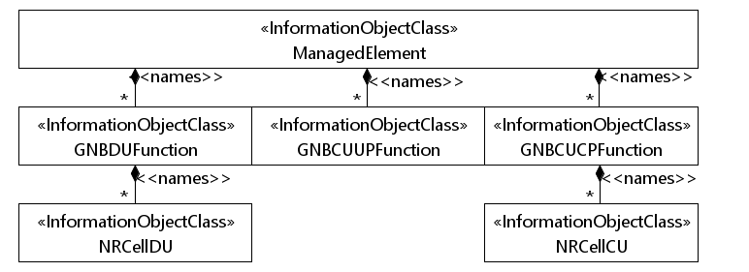
Figure 4.2.1.1-1: NRM for all deployment scenarios
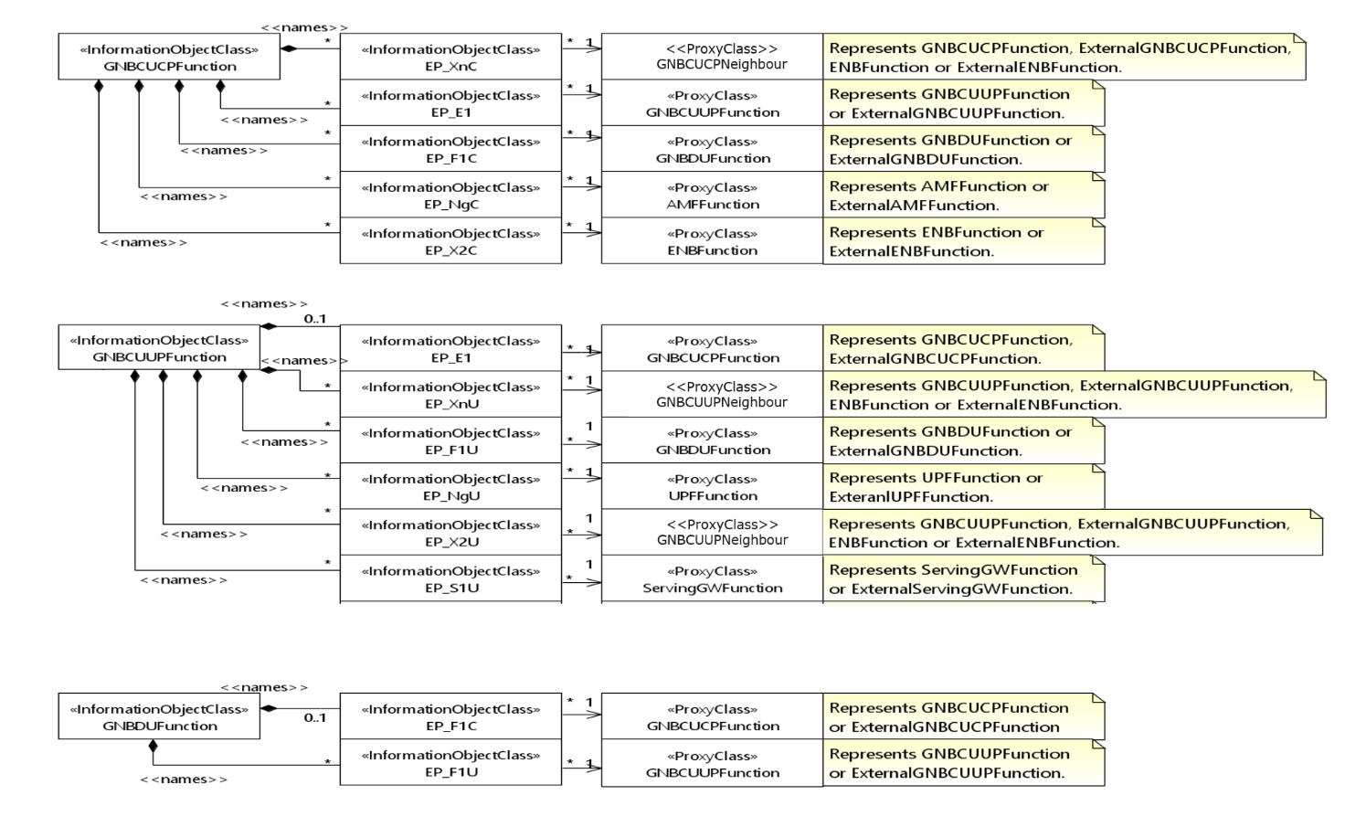
Figure 4.2.1.1-2: NRM for EPs for all deployment scenarios

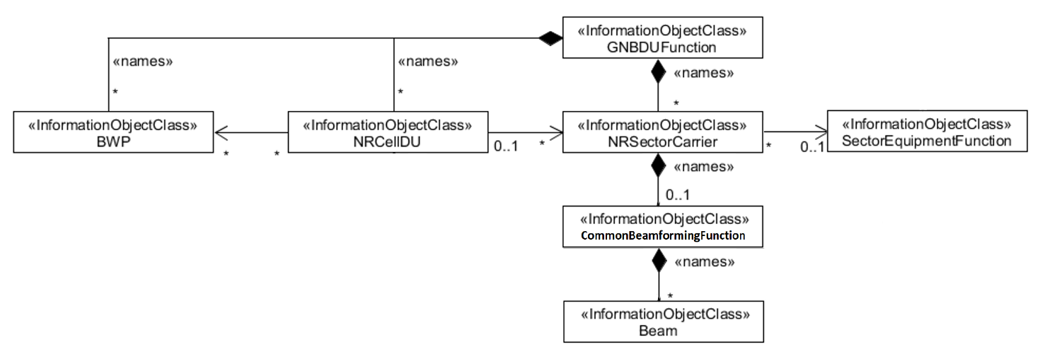
Figure 4.2.1.1-3: NRM for <<IOC>>NRSectorCarrier and <<IOC>>BWP for all deployment scenarios

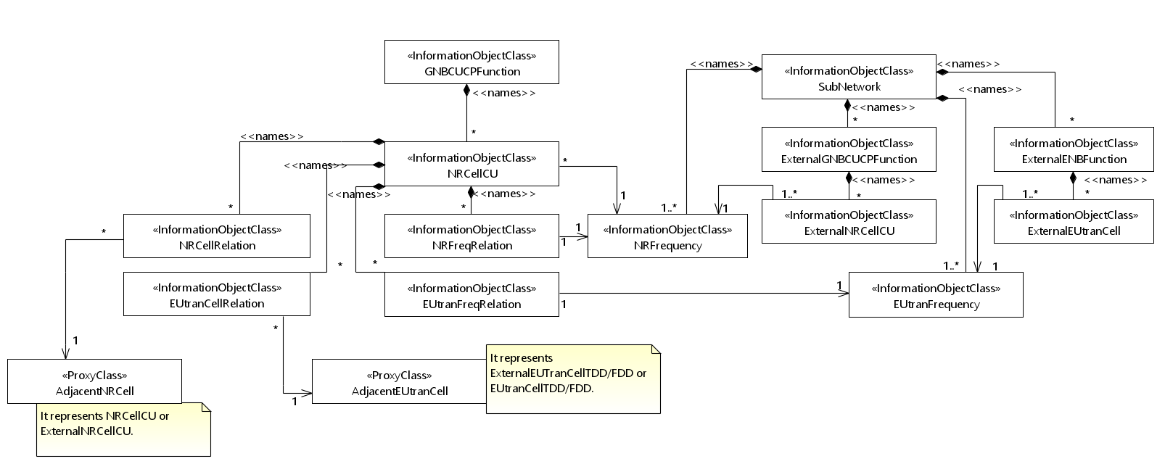
Figure 4.2.1.1-4: Cell Relation view for all deployment scenarios
NOTE 1: The above NRM fragment uses SubNetwork to hold both NR and LTE external entities and frequencies.
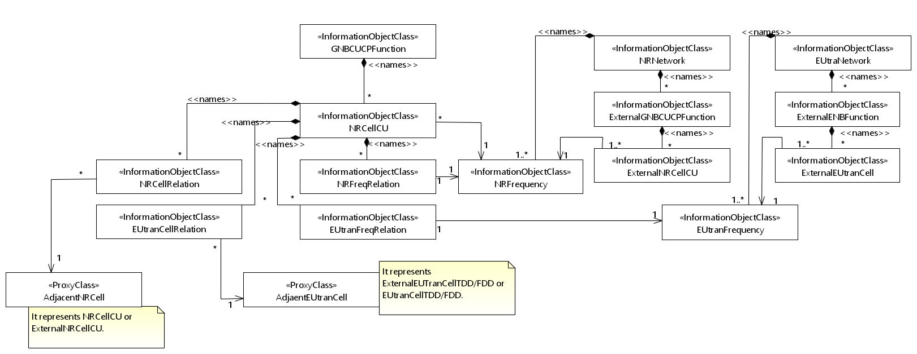
Figure 4.2.1.1-5: Cell Relation view for all deployment scenarios
NOTE 2: The above NRM fragment uses NRNetwork to hold NR external entities and frequency and using EUtraNetwork to hold LTE external entities and frequency. The NRNetwork and EUtraNetwork are subclasses of SubNetwork (defined in TS 28.622 [30]) with no additional attributes. The reason using NRNetwork and EUtraNetwork is for a clean separation of NR external entities and frequency and LTE external entities and frequency.
Figure 4.2.1.1-6: NRM fragement for RRM Policies

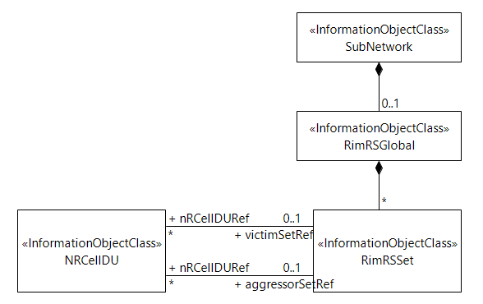
Figure 4.2.1.1-x: NRM fragment to support RIM

4.2.1.2 Inheritance

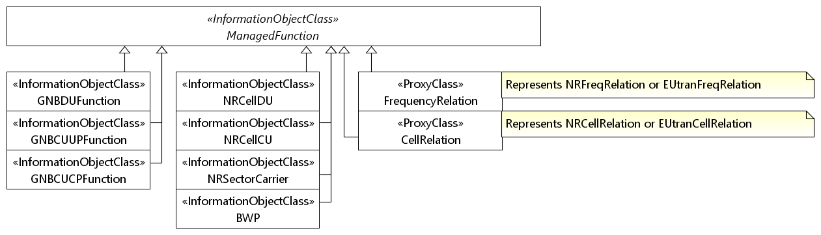
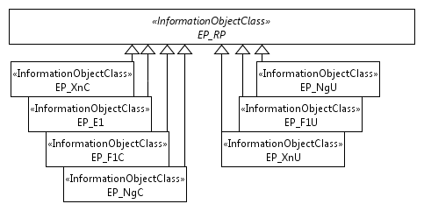
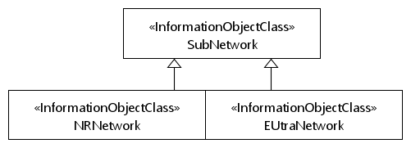
Figure 4.2.1.2-1: Inheritance Hierarchy

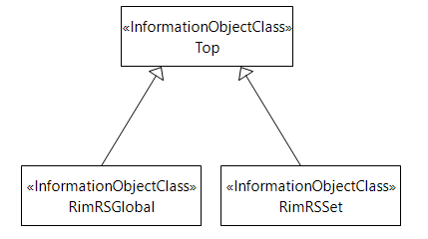
Figure 4.2.1.2-x: Inheritance Hierarchy

Start of 1st modification

Start of 2nd modification

4.3 Class definitions

4.3.1 GNBDUFunction

4.3.1.1 Definition
For non-split NG-RAN deployment scenario, this IOC together with GNBCUCPFunction IOC and GNBCUUPFunction IOC provide the management of gNB defined in clause 6.1.1 in 3GPP TS 38.401 [4].
For 2-split and 3-split NG-RAN architecture, this IOC provides the management representation of tgNB-DU defined in clause 6.1.1 in 3GPP TS 38.401 [4].
The following table identifies the necessary end points required for the representation of gNB and en-gNB, of all deployment scenarios.
Req  Role | End point requirement for 3-split deployment scenario | End point requirement for 2-split deployment scenario | End point requirement for Non-split deployment scenario
gNB | <<IOC>>EP_F1C, <<IOC>>EP_F1U | <<IOC>>EP_F1C, <<IOC>>EP_F1U | None.
en-gNB | <<IOC>>EP_F1C, <<IOC>>EP_F1U | <<IOC>>EP_F1C, <<IOC>>EP_F1U | None.

4.3.1.2 Attributes
The GNBDUFunction IOC includes attributes inherited from ManagedFunction IOC (defined in TS 28.622[30]) and the following attributes:
Attribute name | Support Qualifier | isReadable | isWritable | isInvariant | isNotifyable
gNBDUId | M | T | T | F | T
gNBDUName | O | T | T | F | T
gNBId | M | T | F | F | T
gNBIdLength | M | T | T | F | T
rimRSReportConf | O | T | F | T | T

4.3.1.3 Attribute constraints
None.

4.3.1.4 Notifications
The common notifications defined in subclause 4.5 are valid for this IOC, without exceptions or additions.

4.3.5 NRCellDU

4.3.5.1 Definition
This IOC represents the part of NR cell information that describes s the specific resources instances.
An NR cell transmits SS/PBCH block and always requires downlink transmission at a certain carrier frequency with a certain channel bandwidth. Transmission may be performed from multiple sector-carriers using different transmission points, and these may be configured with different carrier frequencies and channel bandwidths, as long as they are aligned to the cell's downlink resource grids as defined in subclause 4.4 in TS 38.211 [32]. The values of arfcnDL and bSChannelBwDL attributes define the resource grids which each sector-carrier needs to be aligned to. See subclauses 5.3 and 5.4.2 of TS 38.104 for definitions of BS channel bandwidth and NR-ARFCN, respectively.
An NR cell requires an uplink in order to provide initial access. In case of TDD, the values of arfcnUL and bSChannelBwUL have to always be set to the same values as for the corresponding DL attributes. For both FDD and TDD, the arfcnUL and bSChannelBwUL define uplink resource grids to which each sector-carrier needs to align to.
An NR cell can in addition be configured with a supplementary uplink, which has its own arfcnSUL and bSChannelBwSUL, which define resource grids for supplementary uplink sector-carriers.
Each of downlink, uplink and supplementary uplink (if configured) need an initial bandwidth part (BWP), which defines resources to be used by UEs during and immediately after initial access. Additional BWPs can be either configured or calculated by gNB internally and be applied to UEs dynamically by gNB based on e.g. UE capability and bandwidth need of each UE.
NOTE: Void

4.3.5.2 Attributes
The NRCellDU IOC includes attributes inherited from ManagedFunction IOC (defined in TS 28.622[30]) and the following attributes:
Attribute name | Support Qualifier | isReadable | isWritable | isInvariant | isNotifyable
cellLocalId | M | T | T | F | T
operationalState | M | T | F | F | T (see Note 2)
administrativeState | M | T | T | F | T (see Note 2)
cellState | M | T | F | F | T (see Note 2)
pLMNInfoList | M | T | T | F | T
nRPCI | M | T | T | F | T
nRTAC | CM | T | T | F | T
arfcnDL | M | T | T | F | T
arfcnUL | CM | T | T | F | T
arfcnSUL | CM | T | T | F | T
bSChannelBwDL | M | T | T | F | T
ssbFrequency | M | T | T | F | T
ssbPeriodicity | M | T | T | F | T
ssbSubCarrierSpacing | M | T | T | F | T
ssbOffset | M | T | T | F | T
ssbDuration | M | T | T | F | T
bSChannelBwUL | CM | T | T | F | T
bSChannelBwSUL | CM | T | T | F | T
Attribute related to role
nRSectorCarrierRef | M | T | T | F | T
bWPRef | M | T | T | F | T
nRFrequencyRef | CO | T | T | F | T
victimSetRef | CM | T | T | F | T
aggressorSetRef | O | T | T | F | T
Note 1: No state propagation is implied.
Note 2: The attribute value change is conveyed by the notifyStateChange notification.

4.3.5.3 Attribute constraints
Name | Definition
arfcnUL Support Qualifier | Condition: The cell has an uplink (FDD or TDD)
arfcnSUL Support Qualifier | Condition: The cell has a supplementary uplink
bSChannelBwUL Support Qualifier | Condition: The cell has an uplink (FDD or TDD)
bSChannelBwSUL Support Qualifier | Condition: The cell has a supplementary uplink
nRFrequencyRef Support Qualifier | Condition: Non-split deployment scenario is supported
ssbFrequency Support Qualifier | Condition: nRFrequencyRef is not used.
ssbSubCarrierSpacing Support Qualifier | Condition: nRFrequencyRef is not used.
victimSetRef Support Qualifier | Condition: RIM feature is supported

4.3.5.4 Notifications
The common notifications defined in subclause 4.5 are valid for this IOC, without exceptions or additions.

4.3.m RimRSGlobal

4.3.m.1 Definition
This IOC is used to represent global/common Remote Interference Management (RIM) Reference Signal (RS) resource allocated for the whole network. Resource for RIM-RS transmission is defined by Sequence domain resource, Time domain resource and Frequency resource. The configure parameters of the RIM RS resource are applied to all Sets of RIM RS Resource across gNBs/cells in the network.

4.3.m.2 Attributes
Attribute name | Support Qualifier | isReadable | isWritable | isInvariant | isNotifyable
frequencyDomainPara | M | T | T | F | T
sequenceDomainPara | M | T | T | F | T
timeDomainPara | M | T | T | F | T

4.3.m.3 Attribute constraints
None.

4.3.m.4 Notifications
The common notifications defined in subclause 4.5 are valid for this IOC, without exceptions or additions.

4.3.x FrequencyDomainPara <<dataType>>

4.3.x.1 Definition
This data type defines configuration parameters of frequency domain resource to support RIM RS.

4.3.x.2 Attributes
Attribute name | Support Qualifier | isReadable | isWritable | isInvariant | isNotifyable
rimRSSubcarrierSpacing | M | T | T | F | T
rIMRSBandwidth | M | T | T | F | T
nrofGlobalRIMRSFrequencyCandidates | M | T | T | F | T
rimRSCommonCarrierReferencePoint | M | T | T | F | T
rimRSStartingFrequencyOffsetIdList | M | T | T | F | T

4.3.x.3 Attribute constraints
None.

4.3.x.4 Notifications
The subclause 4.5 of the <<IOC>> using this <<dataType>> as one of its attributes, shall be applicable.

4.3.y SequenceDomainPara <<dataType>>

4.3.y.1 Definition
This data type defines configuration parameters of sequence domain resource to support RIM RS.

4.3.y.2 Attributes
Attribute name | Support Qualifier | isReadable | isWritable | isInvariant | isNotifyable
nrofRIMRSSequenceCandidatesofRS1 | M | T | T | F | T
rimRSScrambleIdListofRS1 | M | T | T | F | T
nrofRIMRSSequenceCandidatesofRS2 | O | T | T | F | T
rimRSScrambleIdListofRS2 | O | T | T | F | T
enableEnoughNotEnoughIndication | M | T | T | F | T
RIMRSScrambleTimerMultiplier | M | T | T | F | T
RIMRSScrambleTimerOffset | M | T | T | F | T

4.3.y.3 Attribute constraints
None.

4.3.u.4 Notifications
The subclause 4.5 of the <<IOC>> using this <<dataType>> as one of its attributes, shall be applicable.

4.3.z TimeDomainPara <<dataType>>

4.3.z.1 Definition
This data type defines configuration parameters of time domain resource to support RIM RS.

4.3.z.2 Attributes
Attribute name | Support Qualifier | isReadable | isWritable | isInvariant | isNotifyable
dlULSwitchingPeriod1 | M | T | T | F | T
symbolOffsetOfReferencePoint1 | M | T | T | F | T
dlULSwitchingPeriod2 | O | T | T | F | T
symbolOffsetOfReferencePoint2 | O | T | T | F | T
totalnrofSetIdofRS1 | M | T | T | F | T
totalnrofSetIdofRS2 | O | T | T | F | T
nrofConsecutiveRIMRS1 | M | T | T | F | T
nrofConsecutiveRIMRS2 | O | T | T | F | T
consecutiveRIMRS1List | M | T | T | F | T
consecutiveRIMRS2List | M | T | T | F | T
enablenearfarIndicationRS1 | O | T | T | F | T
enablenearfarIndicationRS2 | O | T | T | F | T

4.3.z.3 Attribute constraints
None.

4.3.z.4 Notifications
The subclause 4.5 of the <<IOC>> using this <<dataType>> as one of its attributes, shall be applicable.

4.3.a RimRSReportConf <<dataType>>

4.3.a.1 Definition
This data type defines RIM-RS reporting configuration.

4.3.a.2 Attributes
Attribute name | Support Qualifier | isReadable | isWritable | isInvariant | isNotifyable
reportIndicator | M | T | T | F | T
reportInterval | M | T | T | F | T
nrofRIMRSReportInfo | M | T | T | F | T
maxPropagationDelay | O | T | T | F | T
RimRSReportInfoList | M | T | T | F | T

4.3.a.3 Attribute constraints
None.

4.3.a.4 Notifications
The subclause 4.5 of the <<IOC>> using this <<dataType>> as one of its attributes, shall be applicable.

4.3.b RimRSReportInfo <<dataType>>

4.3.b.1 Definition
This data type defines necessary reporting information derived from the detected RIM-RS, including
1) The detected set ID;
2) Propagation delay in number of OFDM symbols
3) Functionality of the RS (RS-1 or RS-2, Enough or Not enough mitigation for RS-1).

4.3.b.2 Attributes
Attribute name | Support Qualifier | isReadable | isWritable | isInvariant | isNotifyable
detectedSetID | M | T | T | F | T
propagationDelay | O | T | T | F | T
functionalityOfRIMRS | M | T | T | F | T

4.3.b.3 Attribute constraints
None.

4.3.b.4 Notifications
The subclause 4.5 of the <<IOC>> using this <<dataType>> as one of its attributes, shall be applicable.

4.3.c RimRSSet

4.3.c.1 Definition
This IOC is used to represent aggressor or victim Set organized by OAM. The RIM RS Resource is assigned to each Set, which is identified by triple indices set of <Time domain index, Frequency domain index, and Sequence index >. The triple indices set can be derived by setId attribute (See subclause 7.4.1.6 in TS 38.211 [32]).

4.3.c.2 Attributes
Attribute name | Support Qualifier | isReadable | isWritable | isInvariant | isNotifyable
setId | M | T | T | F | T
setType | M | T | T | F | T
rimRSMonitoringStartTime | O | T | T | F | T
rimRSMonitoringStopTime | O | T | T | F | T
rimRSMonitoringWindowDuration | O | T | T | F | T
rimRSMonitoringWindowStartingOffset | O | T | T | F | T
rimRSMonitoringWindowPeriodicity | O | T | T | F | T
rimRSMonitoringOccasionInterval | O | T | T | F | T
rimRSMonitoringOccasionStartingOffset | O | T | T | F | T
Attribute related to role
nRCellDURef | M | T | F | F | T

4.3.c.3 Attribute constraints
None.

4.3.c.4 Notifications
The common notifications defined in subclause 4.5 are valid for this IOC, without exceptions or additions.

End of 2nd modification

Start of 3rd modification

4.4 Attribute definitions

4.4.1 Attribute properties

Attribute Name | Documentation and Allowed Values | Properties
administrativeState | It indicates the administrative state of the NRCellDU. It describes the permission to use or prohibition against using the cell, imposed through the OAM services.  allowedValues: LOCKED, SHUTTING DOWN, UNLOCKED.  The meaning of these values is as defined in ITU-T Recommendation X.731 [18].  See Annex A for Relation between the "Pre-operation state of the gNB-DU Cell" and administrative state relevant in case of 2-split and 3-split deployment scenarios. | type: ENUM  multiplicity: 1  isOrdered: N/A  isUnique: N/A  defaultValue: LOCKED  isNullable: False
operationalState | It indicates the operational state of the NRCellDU instance. It describes whether the resource is installed and partially or fully operable (Enabled) or the resource is not installed or not operable (Disabled).  allowedValues: ENABLED, DISABLED. | type: ENUM  multiplicity: 1  isOrdered: N/A  isUnique: N/A  defaultValue: None  isNullable: False
cellState | It indicates the usage state of the NRCellDU instance. It describes whether the cell is not currently in use (Idle), or currently in use but not configured to carry traffic (Inactive) or is currently in use and is configured to carry traffic (Active).  The Inactive and Active definitions are in accordance with TS 38.401 [4]:  "Inactive: the cell is known by both the gNB-DU and the gNB-CU. The cell shall not serve UEs;  Active: the cell is known by both the gNB-DU and the gNB-CU. The cell should be able to serve UEs."  "allowedValues: IDLE, INACTIVE, ACTIVE. | type: ENUM  multiplicity: 1  isOrdered: N/A  isUnique: N/A  defaultValue: None  isNullable: False
arfcnDL | NR Absolute Radio Frequency Channel Number (NR-ARFCN) for downlink  allowedValues:  See TS 38.104 [12] subclause 5.4.2. Note that allowed values of NR-ARFCN are specified for each band in subclause 5.4.2.3. | type: Integer  multiplicity: 1  isOrdered: N/A  isUnique: N/A  defaultValue: None  isNullable: False
arfcnUL | NR Absolute Radio Frequency Channel Number (NR-ARFCN) for uplink  allowedValues:  See TS 38.104 [12] subclause 5.4.2. Note that allowed values of NR-ARFCN are specified for each band in subclause 5.4.2.3. | type: Integer  multiplicity: 1  isOrdered: N/A  isUnique: N/A  defaultValue: None  isNullable: False
arfcnSUL | NR Absolute Radio Frequency Channel Number (NR-ARFCN) for supplementary uplink  allowedValues:  See TS 38.104 [12] subclause 5.4.2. Note that allowed values of NR-ARFCN are specified for each band in subclause 5.4.2.3. | type: Integer  multiplicity: 1  isOrdered: N/A  isUnique: N/A  defaultValue: None  isNullable: False
beamAzimuth | The azimuth of a beam transmission, which means the horizontal beamforming pointing angle (beam peak direction) in the (Phi) φ-axis in 1/10th degree resolution. See subclauses 3.2 in TS 38.104 [12] and 7.3 in TS 38.901 [53] as well as TS 28.662 [11]. The pointing angle is the direction equal to the geometric centre of the half-power contour of the beam relative to the reference plane. Zero degree implies explicit antenna bearing (boresight). Positive angle implies clockwise from the antenna bearing.  allowedValues: [-1800 ..1800] 0.1 degree | type: Integer  multiplicity: 1  isOrdered: N/A  isUnique: N/A  defaultValue: Null  isNullable: True
beamHorizWidth | The Horizontal beamWidth of a beam transmission, which means the horizontal beamforming half-power (3dB down) beamwidth in the (Phi) φ-axis in 1/10th degree resolution. See subclauses 3.2 in TS 38.104 [12] and 7.3 in TS 38.901 [53].  allowedValues: [0..3599] 0.1 degree | type: Integer  multiplicity: 1  isOrdered: N/A  isUnique: N/A  defaultValue: Null  isNullable: True
beamIndex | Index of the beam.  For example, please see subclause 6.6.2 of TS 38.331 [54] where the ssb-Index in the rsIndexResults element of MeasResultNR is defined. | type: Integer  multiplicity: 1  isOrdered: N/A  isUnique: N/A  defaultValue: Null  isNullable: True
beamTilt | The tilt of a beam transmission, which means the vertical beamforming pointing angle (beam peak direction) in the (Theta) θ-axis in 1/10th degree resolution. See subclauses 3.2 in TS 38.104 [12] and 7.3 in TS 38.901 [53] as well as TS 28.662 [11]. The pointing angle is the direction equal to the geometric centre of the half-power contour of the beam relative to the reference plane. Positive value implies downtilt.  allowedValues: [-900..900] 0.1 degree | type: Integer  multiplicity: 1  isOrdered: N/A  isUnique: N/A  defaultValue: Null  isNullable: True
beamType | The type of the beam.  allowedValues: "SSB-BEAM" | type: string  multiplicity: 0..1  isOrdered: N/A  isUnique: N/A  defaultValue: Null  isNullable: True
beamVertWidth | The Vertical beamWidth of a beam transmission, which means the vertical beamforming half-power (3dB down) beamwidth in the (Theta) θ-axis in 1/10th degree resolution. See subclauses 3.2 in TS 38.104 [12] and 7.3 in TS 38.901 [53].  allowedValues: [0...1800] 0.1 degree | type: Integer  multiplicity: 1  isOrdered: N/A  isUnique: N/A  defaultValue: Null  isNullable: True
bSChannelBwDL | BS Channel BW in MHz. for downlink  allowedValues:  See BS Channel BW in TS 38.104 [12], subclause 5.3.​ | type: Integer  multiplicity: 1  isOrdered: N/A  isUnique: N/A  defaultValue: None  isNullable: False
bSChannelBwUL | BS Channel BW in MHz.for uplink  allowedValues:  See BS Channel BW in TS 38.104 [12], subclause 5.3.​ | type: Integer  multiplicity: 1  isOrdered: N/A  isUnique: N/A  defaultValue: None  isNullable: False
bSChannelBwSUL | BS Channel BW in MHz.for supplementary uplink  allowedValues:  See BS Channel BW in TS 38.104 [12], subclause 5.3.​ | type: Integer  multiplicity: 1  isOrdered: N/A  isUnique: N/A  defaultValue: None  isNullable: False
configuredMaxTxPower | This is the maximum possible for all downlink channels, used simultaneously in a cell, added together.  allowedValues:TBD | type: Integer  multiplicity: 1  isOrdered: N/A  isUnique: N/A  defaultValue: None  isNullable: False
coverageShape | Identifies the sector carrier coverage shape described by the envelope of the contained SSB beams. The coverage shape is implementation dependent.  allowedValues: 0 : 65535 | type: Integer  multiplicity: 1  isOrdered: N/A  isUnique: N/A  defaultValue: None  isNullable: False
digitalTilt | Digitally-controlled tilt through beamforming. It represents the vertical pointing direction of the antenna relative to the antenna bore sight, representing the total non-mechanical vertical tilt of the selected coverageShape. Positive value gives downwards tilt and negative value gives upwards tilt.  allowedValues: [-900..900] 0.1 degree | type: Integer  multiplicity: 1  isOrdered: N/A  isUnique: N/A  defaultValue: None  isNullable: False
digitalAzimuth | Digitally-controlled azimuth through beamforming. It represents the horizontal pointing direction of the antenna relative to the antenna bore sight, representing the total non-mechanical horizontal pan of the selected coverageShape. Positive value gives azimuth to the right and negative value gives an azimuth to the left.  allowedValues: [-1800 ..1800] 0.1 degree | type: Integer  multiplicity: 1  isOrdered: N/A  isUnique: N/A  defaultValue: None  isNullable: False
cyclicPrefix | Cyclic prefix as defined in TS 38.211 [32], subclause 4.2.  allowedValues:  NORMAL, EXTENDED. | type: ENUM  multiplicity: 1  isOrdered: N/A  isUnique: N/A  defaultValue: None  isNullable: False
localAddress | This parameter specifies the localAddress including IP address and VLAN ID used for initialization of the underlying transport.  First string is IP address, IP address can be an IPv4 address (See RFC 791 [37]) or an IPv6 address (See RFC 2373 [38]).  Second string is VLAN Id. (See IEEE 802.1Q [39]), | type: String  multiplicity: 2  isOrdered: True  isUnique: N/A  defaultValue: None  isNullable: False
remoteAddress | Remote address including IP address used for initialization of the underlying transport.  IP address can be an IPv4 address (See RFC 791 [37]) or an IPv6 address (See RFC 2373 [38]). | type: String  multiplicity: 1  isOrdered: N/A  isUnique: N/A  defaultValue: None  isNullable: False
gNBId | It identifies a gNB within a PLMN. The gNB ID is part of the NR Cell Identifier (NCI) of the gNB cells.  See "gNB Identifier (gNB ID)" of subclause 8.2 of TS 38.300 [3]). See "Global gNB ID" in subclause 9.3.1.6 of TS 38.413 [5].  allowedValues: 0..4294967295 | type: Integer  multiplicity: 1  isOrdered: N/A  isUnique: N/A  defaultValue: None  isNullable: False
gNBIdLength | This indicates the number of bits for encoding the gNB ID. See "Global gNB ID" in subclause 9.3.1.6 of TS 38.413 [5].  allowedValues: 22 .. 32. | type: Integer  multiplicity: 1  isOrdered: N/A  isUnique: N/A  defaultValue: None  isNullable: False
gNBDUId | It uniquely identifies the DU at least within a gNB-CU. See 'gNB-DU ID' in subclause 9.3.1.9 of 3GPP TS 38.473 [8].  allowedValues: 0..2³⁶-1 | type: Integer  multiplicity: 1  isOrdered: N/A  isUnique: N/A  defaultValue: None  isNullable: False
gNBCUUPId | It uniquely identifies the gNB-CU-UP at least within a gNB-CU-CP. See 'gNB-CU-UP ID' in subclause 9.3.1.15 of 3GPP TS 38.463 [48].  allowedValues: 0..2³⁶-1 | type: Integer  multiplicity: 1  isOrdered: N/A  isUnique: N/A  defaultValue: None  isNullable: False
gNBCUName | It identifies the Central Entity of a NR node, see subclause 9.2.1.4 of 3GPP TS 38.473 [8].  allowedValues: Not applicable | type: String  multiplicity: 1  isOrdered: N/A  isUnique: N/A  defaultValue: None  isNullable: False
gNBDUName | It identifies the Distributed Entity of a NR node, see subclause 9.2.1.5 of 3GPP TS 38.473 [8].  allowedValues: Not applicable | type: String  multiplicity: 1  isOrdered: N/A  isUnique: N/A  defaultValue: None  isNullable: False
cellLocalId | It identifies a NR cell of a gNB.  It, together with the gNB Identifier (using gNBId of the parent GNBCUCPFunction or GNBDUFunction or ExternalCUCPFunction), identifies a NR cell within a PLMN. This is the NR Cell Identity (NCI). See subclause 8.2 of TS 38.300 [3]),  The NCI can be constructed by encoding the gNB Identifier using gNBId (of the parent GNBCUCPFunction or GNBDUFunction or ExternalCUCPFunction) and cellLocalId where the gNB Identifier field is of length specified by gNBIdLength (of the parent GNBCUCPFunction or GNBDUFunction or ExternalCUCPFunction). See "Global gNB ID" in subclause 9.3.1.6 of TS 38.413 [5].  The NR Cell Global identifier (NCGI) is constructed from the PLMN identity the cell belongs to and the NR Cell Identifier (NCI) of the cell.  See relation between NCI and NCGI subclause 8.2 of TS 38.300 [3].  allowedValues: Not applicable | type: Integer  multiplicity: 1  isOrdered: N/A  isUnique: True  defaultValue: None  isNullable: False
nRPCI | This holds the Physical Cell Identity (PCI) of the NR cell.  allowedValues:  See 3GPP TS 36.211 subclause 6.11 for legal values of pci. | type: Integer  multiplicity: 1  isOrdered: N/A  isUnique: N/A  defaultValue: None  isNullable: False
nRTAC | This holds the identity of the common Tracking Area Code for the PLMNs.  allowedValues:  a) It is the TAC or Extended-TAC.  b) A cell can only broadcast one TAC or Extended-TAC. See TS 36.300, subclause 10.1.7 (PLMNID and TAC relation).  c) TAC is defined in subclause 19.4.2.3 of 3GPP TS 23.003  [13] and Extended-TAC is defined in subclause 9.3.1.29 of 3GPP TS 38.473 [8].  d) For a 5G SA (Stand Alone), it has a non-null value. | type: Integer  multiplicity: 1  isOrdered: N/A  isUnique: N/A  defaultValue: NULL  isNullable: True
GNBCUCPFunction.pLMNId | It specifies the PLMN identifier to be used as part of the global RAN node identity.  allowedValues: Not applicable. | Type: PLMNId  multiplicity: 1  isOrdered: N/A  isUnique: N/A  defaultValue: None  isNullable: False
GNBCUUPFunction.pLMNIdList | This is a list of PLMN identifiers. It defines from which set of PLMNs an UE must have as its serving PLMN to be allowed to use the GNB-CU-UP.  allowedValues: Not applicable. | type: PLMNId  multiplicity: 1..12  isOrdered: N/A  isUnique: True  defaultValue: None  isNullable: False
NRCellCU.pLMNInfoList | It defines which PLMNs that can be served by the NR cell,and which S-NSSAIs can be supported by the NR cell for corresponding PLMN in case of network slicing feature is supported  allowedValues: Not applicable. | type: PLMNInfo  multiplicity: 1..*  isOrdered: N/A  isUnique: True  defaultValue: None  isNullable: False
NRCellDU.pLMNInfoList | It defines which PLMNs that can be served by the NR cell, and which S-NSSAs can be supported by the NR cell for corresponding PLMN in case of network slicing feature is supported. The pLMNId of the first entry of the list is the PLMNId used to construct the nCGI for the NR cell.  allowedValues: Not applicable. | type: PLMNInfo  multiplicity: 1..*  isOrdered: N/A  isUnique: True  defaultValue: None  isNullable: False
ExternalNRCellCU.pLMNIdList | It defines which PLMNs that are assumed to be served by the NR Cell in another gNB-CU-CP. This list is either updated by the managed element itself (e.g. due to ANR, signalling over Xn etc) or by consumer over the standard interface.  allowedValues: Not applicable. | Type: PLMNId  multiplicity: 1..12  isOrdered: N/A  isUnique: True  defaultValue: None  isNullable: False
rRMPolicyMemberList | It represents the list of RRMPolicyMember (s) that the managed object is supporting. A RRMPolicyMember <<dataType>> include the PLMNId <<dataType>> and S-NSSAI <<dataType>>.  allowedValues: N/A | type: RRMPolicyMember  multiplicity: 1..*  isOrdered: N/A  isUnique: True  defaultValue: None  isNullable: False
resourceType | The resource type of interest for an RRM Policy.  allowedValues:  PRB (for NRCellDU)  RRC connected users (for NRCellCU)  DRB (for GNBCUUPFunction)  See NOTE 2, NOTE 3 and NOTE 4 | type: String  multiplicity: 1  isOrdered: N/A  isUnique: N/A  defaultValue: None  isNullable: False
sNSSAIList | It represents the list of S-NSSAI the managed object is supporting. The S-NSSAI is defined in 3GPP TS 23.003 [13].  allowedValues: See 3GPP TS 23.003 [13] | type: S-NSSAI  multiplicity: *  isOrdered: N/A  isUnique: N/A  defaultValue: None  allowedValues: N/A  isNullable: False
sST | This attribute specifies the Slice/Service type (SST) of the network slice.  See clause 5.15.2 of 3GPP TS 23.501 [2]. | type: Integer  multiplicity: 1  isOrdered: N/A  isUnique: N/A  defaultValue: None  allowedValues: N/A  isNullable: False
sD | This attribute specifies the Slice Differentiator (SD), which is optional information that complements the slice/service type(s) to differentiate amongst multiple Network Slices.  See clause 5.15.2 of 3GPP TS 23.501 [2]. | type: Integer  multiplicity: 1  isOrdered: N/A  isUnique: N/A  defaultValue: None  allowedValues: N/A  isNullable: False
quotaType | The attribute indicates the type of the quota which allows to allocate resource as strictly usable for defined rRMPolicyMemberList (“strict quota”) or allows that resource to be used by other rRMPolicyMemberList(s) when defined rRMPolicyMemberList do not need them ( “float quota”).  allowedValues: STRICT, FLOAT. | type: ENUM  multiplicity: 1  isOrdered: N/A  isUnique: N/A  defaultValue: None  isNullable: False
rRMPolicyMaxRatio | The RRM policy setting the maximum percentage of radio resources to be allocated to the corresponding rRMPolicyMemberList.  This quota can be strict or float quota :  - Strict quota means the defined rRMPolicyMemberList cannot be allocated resource if its used resource reached maxRatio.  - Float quota means the defined rRMPolicyMemberList can use quota from other rRMPolicyMemberList(s) even if its resource has reached maxRatio, if there’s free quota from other rRMPolicyMemberList. In addition, resource of the defined rRMPolicyMemberList can be used by other rRMPolicyMemberList(s) when the defined rRMPolicyMemberList do not need them.  Value 0 indicates that there is no maximum limit.  allowedValues:  0 : 100 | type: Integer  multiplicity: 0..1  isOrdered: N/A  isUnique: N/A  defaultValue: None  allowedValues: N/A  isNullable: False
rRMPolicyMarginMaxRatio | Maximum quota margin ratio is applicable when maximum quota policy ratio is of type “float quota”. It defines the resource quota within maximum quota to reserve buffers for new resource requirements for the defined rRMPolicyMemberList. With the margin ratio, unused resources of the maximum resource quota can be allocated to other rRMPolicyMemberList(s) when the free resources are more than resource amount indicated by the margin. The margin resource quota can only be used for the defined rRMPolicyMemberList.. Value 0 indicates that no margin is used.  allowedValues:  0 : 100 | type: Integer  multiplicity: 0..1  isOrdered: N/A  isUnique: N/A  defaultValue: None  allowedValues: N/A  isNullable: False
rRMPolicyMinRatio | The RRM policy setting the minimum percentage of radio resources to be allocated to the corresponding rRMPolicyMemberList, especially in congestion situation.  This quota can be strict or float quota:  - Strict quota means resources are not allowed for other rRMPolicyMemberList(s) even when they are not used by the defined rRMPolicyMemberList.  -Float quota resources can be used by other rRMPolicyMemberList(s) when the defined rRMPolicyMemberList do not need them.  Value 0 indicates that there is no minimum limit.  allowedValues:  0 : 100  NOTE: The averaging time interval is implementation dependent. | type: Integer  multiplicity: 0..1  isOrdered: N/A  isUnique: N/A  defaultValue: None  allowedValues: N/A  isNullable: False
rRMPolicyMarginMinRatio | Minimum quota margin ratio is applicable when minimum quota policy ratio is of type “float quota”. It defines the resource quota within minimum quota to reserve buffers for new resource requirements for the defined rRMPolicyMemberList. With the margin ratio, unused resources of the minimum resource quota can be allocated to other rRMPolicyMemberList(s) when the free resources are more than resource amount indicated by the margin. The margin resource quota can only be used for the defined rRMPolicyMemberList. Value 0 indicates that no margin is used.  allowedValues:  0 : 100 | type: Integer  multiplicity: 0..1  isOrdered: N/A  isUnique: N/A  defaultValue: None  allowedValues: N/A  isNullable: False
subCarrierSpacing | Subcarrier spacing configuration for a BWP. See subclause 5 in TS 38.104 [12].  AllowedValues: [15, 30, 60, 120] depending on the frequency range FR1 or FR2. | type: Integer  multiplicity: 1  isOrdered: N/A  isUnique: N/A  defaultValue: None  isNullable: False
txDirection | Indicates if the transmission direction is downlink (DL), uplink (UL) or both downlink and uplink (DL and UL).  allowedValues:  DL, UL, DL and UL | type: ENUM  multiplicity: 1  isOrdered: N/A  isUnique: N/A  defaultValue: None  isNullable: False
bwpContext | It identifies whether the object is used for downlink, uplink or supplementary uplink.  allowedValues:  DL, UL, SUL | type: ENUM  multiplicity: 1  isOrdered: N/A  isUnique: N/A  defaultValue: None  isNullable: False
isInitialBwp | It identifies whether the object is used for initial or other BWP.  allowedValues:  INITIAL, OTHER | type: ENUM  multiplicity: 1  isOrdered: N/A  isUnique: N/A  defaultValue: None  isNullable: False
startRB | Offset in common resource blocks to common resource block 0 for the applicable subcarrier spacing for a BWP. This corresponds to N_BWP_start, see subclause 4.4.5 in TS 38.211 [32].  allowedValues:  0 to N_grid_size – 1, where N_grid_size equals the number of resource blocks for the BS channel bandwidth, given the subcarrier spacing of the BWP. | type: Integer  multiplicity: 1  isOrdered: N/A  isUnique: N/A  defaultValue: None  isNullable: False
numberOfRBs | Number of physical resource blocks for a BWP. This corresponds to N_BWP_size, see subclause 4.4.5 in TS 38.211 [32].  allowedValues:  1 to N_grid_size – startRB of the BWP. Se startRB for definition of N_grid_size. | type: Integer  multiplicity: 1  isOrdered: N/A  isUnique: N/A  defaultValue: None  isNullable: False
nRTCI | This is the Target NR Cell Identifier. It consists of NR Cell Identifier (NCI) and Physical Cell Identifier of the target NR cell (nRPCI).  The NRRelation.nRTCI identifies the target cell from the perspective of the NRCell, the name-containing instance of the subject NRCellCU instance.  allowedValues: Not applicable. | type: Integer  multiplicity: 1  isOrdered: N/A  isUnique: N/A  defaultValue: None  isNullable: False
adjacentCellRef | This attribute contains the DN of an adjacentNRCell (NRCellCU or ExternalNRCellCU)  allowedValues: Not applicable. | type: DN  multiplicity: 1  isOrdered: N/A  isUnique: True  defaultValue: None  isNullable: False
ssbFrequency | Indicates cell defining SSB frequency domain position  Frequency of the cell defining SSB transmission. The frequency provided in this attribute identifies the position of resource element RE=#0 (subcarrier #0) of resource block RB#10 of the SS block. The frequency must be positioned on the NR global frequency raster, as defined in TS 38.101 [42] subclause 5.4.2. and within bSChannelBwDL.  allowedValues: 0..3279165 | type: Integer  multiplicity: 1  isOrdered: N/A  isUnique: N/A  defaultValue: None  isNullable: False
nRFrequencyRef | This attribute contains the DN of the referenced NRFrequency.  allowedValues: Not applicable. | type: DN  multiplicity: 1  isOrdered: N/A  isUnique: True  defaultValue: None  isNullable: False
nRSectorCarrierRef | This attribute contains the DN of the referenced NRSectorCarrier.  allowedValues: Not applicable. | type: DN  multiplicity: 1  isOrdered: N/A  isUnique: True  defaultValue: None  isNullable: False
bWPRef | This attribute contains the DN of the referenced BWP.  allowedValues: Not applicable. | type: DN  multiplicity: 1  isOrdered: N/A  isUnique: True  defaultValue: None  isNullable: False
sectorEquipmentFunctionRef | This attribute contains the DN of the referenced NSectorEquipmentFunction.  allowedValues: Not applicable. | type: DN  multiplicity: 1  isOrdered: N/A  isUnique: True  defaultValue: None  isNullable: False
offsetMO | It is a list of offset values applicable to all measured cells with reference signal(s) indicated in this MeasObjectNR. See offsetMO of subclause 5.5.4 of TS 38.331 [31].  allowedValues: Not applicable. | type: QOffsetRangeList  multiplicity: 1  isOrdered: N/A  isUnique: N/A  defaultValue: N/A  isNullable: False
cellIndividualOffset | It is a list of offset values for the neighbour cell. Used when UE is in connected mode. The unit is 1dB. It is defined for rsrpOffsetSSB, rsrqOffsetSSB, sinrOffsetSSB, rsrpOffsetCSI-RS, rsrqOffsetCSI-RS and sinrOffsetCSI-RS. See TS 38.331 [31].  allowedValues: Not applicable. | type: Integer  multiplicity: 6  isOrdered: True  isUnique: N/A  defaultValue: 0  isNullable: False
blackListEntry | It specifies a list of PCI (physical cell identity) that are blacklisted in EUTRAN measurements as described in 3GPP TS 38.331 [31].  allowedValues: { 0…1007 } | type: Integer  multiplicity: *  isOrdered: N/A  isUnique: N/A  defaultValue: None  isNullable: False
blackListEntryIdleMode | It specifies a list of PCI (physical cell identity) that are blacklisted in SIB4 and SIB5.  allowedValues: { 0…1007 } | type: Integer  multiplicity: 1  isOrdered: N/A  isUnique: N/A  defaultValue: None  isNullable: False
cellReselectionPriority | It is the absolute priority of the carrier frequency used by the cell reselection procedure. See CellReselectionPriority IE in TS 38.331 [31].  It corresponds to the parameter priority in 3GPP TS 38.304 [49].  Value 0 means lowest priority. The UE behaviour when no value is entered is specified in subclause 5.2.4.1 of 3GPP TS 38.304 [49].  The value must not already used by other RAT, i.e. equal priorities between RATs are not supported.  allowedValues: N/A | type: Integer  multiplicity: 1  isOrdered: N/A  isUnique: N/A  defaultValue: 0None  isNullable: False
cellReselectionSubPriority | It indicates a fractional value to be added to the value of cellReselectionPriority to obtain the absolute priority of the concerned carrier frequency for E-UTRA and NR. See CellReselectionSubPriority IE in TS 38.331 [31].  allowedValues: { 0.2, 0.4, 0.6, 0.8 }. | type: Short  multiplicity: 1  isOrdered: N/A  isUnique: N/A  defaultValue: None  isNullable: False
pMax | It calculates the parameter Pcompensation (defined in 3GPP TS 38.304 [49]), at cell reselection to an Cell. Its unit is 1 dBm. It corresponds to parameter PEMAX in 3GPP TS 38.101 [??].  allowedValues: { -30..33 }. | type: Integer  multiplicity: 1  isOrdered: N/A  isUnique: N/A  defaultValue: None  isNullable: False
qOffsetFreq | It is the frequency specific offset applied when evaluating candidates for cell reselection. See TS 38.331 [49]. Its unit is 1 dB.  allowedValues:  { -24, -22, -20, -18, -16, -14, -12, -10, -8, -6, -5, -4, -3, -2, -1, 0, 1, 2, 3, 4, 5, 6, 8, 10, 12, 14, 16, 20, 22, 24 } | type: Real  multiplicity: 1  isOrdered: N/A  isUnique: N/A  defaultValue: 0  isNullable: False
qOffsetRangeList | It is used to indicate a cell, beam or measurement object specific offset to be applied when evaluating candidates for cell re-selection or when evaluating triggering conditions for measurement reporting. The value in dB. Value dB-24 corresponds to -24 dB, dB-22 corresponds to -22 dB and so on.  This is a list of enum values representing, in sequence: rsrpOffsetSSB, rsrqOffsetSSB, sinrOffsetSSB, rsrpOffsetCSI-RS, srqOffsetCSI-RS, sinrOffsetCSI-RS.  See Q-OffsetRangeList in subclause of subclause 6.3.1 of TS 38.311 [31].  allowedValues:  { -24, -22, -20, -18, -16, -14, -12, -10, -8, -6, -5, -4, -3, -2, -1, 0, 1, 2, 3, 4, 5, 6, 8, 10, 12, 14, 16, 18, 20, 22, 24 } | type: ENUM  multiplicity: 6  isOrdered: True  isUnique: N/A  defaultValue: 0  isNullable: False
qQualMin | It indicates the minimum required quality level in the cell (dB). See qQualMin in TS 38.304 [49]. Unit is 1 dB.  Value 0 means that it is not sent and UE applies in such case the (default) value of negative infinity for Qqualmin. Sent in SIB3 or SIB5.  allowedValues: { -34..-3, 0 } | type: Real  multiplicity: 1  isOrdered: N/A  isUnique: N/A  defaultValue: None  isNullable: False
qRxLevMin | It indicates the required minimum received Reference Symbol Received Power (RSRP) level in the (E-UTRA) frequency for cell reselection. It corresponds to Qrxlevmin defined in 3GPP TS 38.304 [49]. It is broadcast in SIB3 or SIB5, depending on whether the related frequency is intra- or inter-frequency. Its unit is 1 dBm and resolution is 2.  allowedValues: { -140..-44 }. | type: Integer  multiplicity: 1  isOrdered: N/A  isUnique: N/A  defaultValue: None  isNullable: False
threshXHighP | This specifies the Srxlev threshold (in dB) used by the UE when reselecting towards a higher priority RAT/ frequency than the current serving frequency. Each frequency of NR and E-UTRAN might have a specific threshold. It corresponds to the Thresh_{X, HighP} in 3GPP TS 38.304 [49]. Its unit is 1 dB and resolution is 2.  allowedValues: { 0..62 } | type: Integer  multiplicity: 1  isOrdered: N/A  isUnique: N/A  defaultValue: None  isNullable: False
threshXHighQ | This specifies the Squal threshold (in dB) used by the UE when reselecting towards a higher priority RAT/ frequency than the current serving frequency. Each frequency of NR and E-UTRAN might have a specific threshold. It corresponds to the ThreshX, HighQ in TS 38.304 [49]. Its unit is 1 dB.  allowedValues: { 0..31 } | type: Integer  multiplicity: 1  isOrdered: N/A  isUnique: N/A  defaultValue: None  isNullable: False
threshXLowP | This specifies the Srxlev threshold (in dB) used by the UE when reselecting towards a lower priority RAT/ frequency than the current serving frequency. Each frequency of NR might have a specific threshold. It corresponds to ThreshX,LowP in 3GPP TS 38.304 [49]. Its unit is 1 dB. Its resolution is 2.  allowedValues: { 0..62 } | type: Integer  multiplicity: 1  isOrdered: N/A  isUnique: N/A  defaultValue: None  isNullable: False
threshXLowQ | This specifies the Squal threshold (in dB) used by the UE when reselecting towards a lower priority RAT/ frequency than the current serving frequency. Each frequency of NR might have a specific threshold. It corresponds to ThreshX,Low in TS 38.304 [49]. Its unit is 1 dB.  allowedValues: {0..31}. | type: Integer  multiplicity: 1  isOrdered: N/A  isUnique: N/A  defaultValue: None  isNullable: False
tReselectionNr | It is the cell reselection timer and corresponds to parameter TreselectionRAT for NR defined in 38.331 [4]. Its unit is in seconds.  allowedValues: {0..7}. | type: Integer  multiplicity: 1  isOrdered: N/A  isUnique: N/A  defaultValue: None  isNullable: False
tReselectionNRSfHigh | The attribute t-ReselectionNr (a parameter Treselection_{NR} in TS 38.304 [49]) is multiplied with this factor if the UE is in high mobility state. It corresponds to the parameter Speed dependent ScalingFactor for TreselectionNr for medium high state in 3GPP TS 38.304 [49]. The unit is one %.  Value mapping:  25 = 0.25  50 = 0.5  75 = 0.75  100 = 1.0  allowedValues: {25, 50, 75, 100}. | type: Integer  multiplicity: 1  isOrdered: N/A  isUnique: N/A  defaultValue: None  isNullable: False
tReselectionNRSfMedium | The attribute t-ReselectionNR (a parameter "Treselection_{NR} in TS 38.304 [49]”) is multiplied with this factor if the UE is in medium mobility state. It corresponds to the parameter Speed dependent ScalingFactor for TreselectionNr for medium mobility state in 3GPP TS 38.304 [49]. Its unit is one %.  Value mapping:  25 = 0.25  50 = 0.5  75 = 0.75  100 = 1.0  allowedValues: {25, 50, 75, 100}. | type: Integer  multiplicity: 1  isOrdered: N/A  isUnique: N/A  defaultValue: None  isNullable: False
absoluteFrequencySSB | The absolute frequency applicable for a downlink NR carrier frequency associated with the SSB.  allowedValues: {0.. 3279165}. | type: Integer  multiplicity: 1  isOrdered: N/A  isUnique: N/A  defaultValue: None  isNullable: False
sSBSubCarrierSpacing | This SSB is used for for synchronization. See subclause 5 in TS 38.104 [12]. Its units are in kHz.  allowedValues: {15, 30, 120, 240}.  Note that the allowed values of SSB used for representing data, by e.g. a BWP, are: 15, 30, 60 and 120 in units of kHz. | type: Integer  multiplicity: 1  isOrdered: N/A  isUnique: N/A  defaultValue: None  isNullable: False
multiFrequencyBandListNR | It is a list of additional frequency bands the frequency belongs to. The list is automatically set by the gNB.  allowedValues: {1..256 } | type: Integer  multiplicity: 1  isOrdered: N/A  isUnique: N/A  defaultValue: None  isNullable: False
ssbPeriodicity | Indicates cell defined SSB periodicity in number of subframes (ms).  The SSB periodicity in msec is used for the rate matching purpose.  allowedValues: 5, 10, 20, 40, 80, 160. | type: Integer  multiplicity: 1  isOrdered: N/A  isUnique: N/A  defaultValue: None  isNullable: False
ssbOffset | Indicates cell defining SSB time domain position. Defined as the offset of the measurement window, in number of subframes (ms), in which to receive SS/PBCH blocks, where allowed values depend on the ssbPeriodicity.  allowedValues:  ssbPeriodicity5 ms 0..4,  ssbPeriodicity10 ms 0..9,  ssbPeriodicity20 ms 0..19,  ssbPeriodicity40 ms 0..39,  ssbPeriodicity80 ms 0..79,  ssbPeriodicity160 ms 0..159. | type: Integer  multiplicity: 1  isOrdered: N/A  isUnique: N/A  defaultValue: None  isNullable: False
ssbDuration | Duration of the measurement window in which to receive SS/PBCH blocks. It is given in number of subframes (ms) (see 38.213 [41], subclause 4.1.  allowedValues: 1, 2, 3, 4, 5. | type: Integer  multiplicity: 1  isOrdered: N/A  isUnique: N/A  defaultValue: None  isNullable: False
rimRSMonitoringStartTime | This field configures the UTC time when the gNB attempts to start RIM-RS monitoring.  allowedValues: containing the information same with xsd: dateTime. | type: String  multiplicity: 1  isOrdered: N/A  isUnique: N/A  defaultValue: None  isNullable: False
rimRSMonitoringStopTime | This field configures the UTC time when the gNB stops RIM-RS monitoring.  allowedValues: containing the information same with xsd: dateTime. | type: String  multiplicity: 1  isOrdered: N/A  isUnique: N/A  defaultValue: None  isNullable: False
mappingSetIDBackhaulAddressList | The attribute specifies a list of mappingSetIDBackhaulAddress which is defined as a datatype (see clause 4.3.47). Which is used to retrieve the backhaul address of the victim set.  allowedValues: Not applicable | type: MappingSetIDBackhaulAddress  multiplicity: 1..*  isOrdered: N/A  isUnique: N/A  defaultValue: None  isNullable: False
backhaulAddress | The attribute specifies backhaulAddress which is defined as a datatype (see clause 4.3.48).  allowedValues: Not applicable | type: BackhaulAddress  multiplicity: 1  isOrdered: N/A  isUnique: N/A  defaultValue: None  isNullable: False
setID | This specifies the set ID of a victim Set (RIM-RS1 Set) or aggressor Set (RIM-RS2 set).. (See subclause 7.4.1.6 in TS 38.211 [32]).  allowedValues:  The bit length of the set ID is maximum 22bit. | type: Integer  multiplicity: 1  isOrdered: N/A  isUnique: N/A  defaultValue: None  isNullable: False
tAI | Indicates the TAI (see subclause 9.3.3.11 in TS 38.413[5]), including pLMNId ID and nRTAC. allowedValues: Not applicable | type: TAI  multiplicity: 1  isOrdered: N/A  isUnique: N/A  defaultValue: None  isNullable: False
frequencyDomainPara | This attribute defines configuration parameters of frequency domain resource to support RIM RS.  allowedValues: Not applicable. | type: FrequencyDomainPara  multiplicity: 1  isOrdered: N/A  isUnique: N/A  defaultValue: None  isNullable: False
sequenceDomainPara | This attribute defines configuration parameters of sequence domain resource to support RIM RS.  allowedValues: Not applicable. | type: SequenceDomainPara  multiplicity: 1  isOrdered: N/A  isUnique: N/A  defaultValue: None  isNullable: False
timeDomainPara | This attribute defines configuration parameters of time domain resource to support RIM RS.  allowedValues: Not applicable. | type: TimeDomainPara  multiplicity: 1  isOrdered: N/A  isUnique: N/A  defaultValue: None  isNullable: False
rimRSSubcarrierSpacing | It is the subcarrier spacing configuration ($μ$) for the RIM-RS. Subcarrier spacing $Δf=2^{μ}∙15 kHz.$ (see 38.211 [32], subclause 5.3.3).  allowedValues: 0, 1 | type: Integer  multiplicity: 1  isOrdered: N/A  isUnique: N/A  defaultValue: None  isNullable: False
rIMRSBandwidth | It is RIM RS bandwidth configuration in number of PRBs (see 38.211 [32], subclause 5.3.3).  For carrier bandwidth larger than 20MHz, this attributer should be  - 96 if subcarrier spacing is15kHz;  - 48 or 96 if subcarrier spacing is 30kHz;  For carrier bandwidth smaller than or equal to 20MHz, this attributer should be  - Minimum of {96 , bandwidth of downlink carrier in number of PRBs} if subcarrier spacing is15kHz;  - Minimum of {48, bandwidth of downlink carrier in number of PRBs } if subcarrier spacing is 30kHz;  allowedValues: 1,2..96 | type: Integer  multiplicity: 1  isOrdered: N/A  isUnique: N/A  defaultValue: None  isNullable: False
nrofGlobalRIMRSFrequencyCandidates | It is the number of candidate frequency resources in the whole network ($N_{\text{f}}^{\text{RIM}}$) (see 38.211 [32], subclause 7.4.1.6).  allowedValues: 1,2,4 | type: Integer  multiplicity: 1  isOrdered: N/A  isUnique: N/A  defaultValue: None  isNullable: False
rimRSCommonCarrierReferencePoint | It is a configured reference point for RIM RS in NR-ARFCN (see 38.211 [32], subclause 5.4).  allowedValues: 0..maxNARFCN where maxNARFCN = 3279165 | type: Integer  multiplicity: 1  isOrdered: N/A  isUnique: N/A  defaultValue: None  isNullable: False
rimRSStartingFrequencyOffsetIdList | It is a list of configured frequency offsets in units of resource blocks, where each element is the frequency offset relative to a configured reference point for RIM-RS. The size of the list is nrofGlobalRIMRSFrequencyCandidates and the resulting frequency resource blocks of RIM-RS corresponding to different configured frequency offset have no overlapping bandwidth. (see 38.211 [32], subclause 7.4.1.6).  .  allowedValues: 0..maxNrofPhysicalResourceBlocks-1 where maxNrofPhysicalResourceBlocks = 550 | type: Integer  multiplicity: 1, 2, 4  isOrdered: N/A  isUnique: N/A  defaultValue: None  isNullable: False
nrofRIMRSSequenceCandidatesofRS1 | It is the number of candidate sequences assigned for RIM RS-1 ($N_{\text{s}}^{\text{RIM,1}}$) (see 38.211 [32], subclause 7.4.1.6). It should be even when enableEnoughNotEnoughIndication for RS-1 is ON  allowedValues: 1,2..8 | type: Integer  multiplicity: 1  isOrdered: N/A  isUnique: N/A  defaultValue: None  isNullable: False
rimRSScrambleIdListofRS1 | It is list of configured scrambling identities for RIM RS-1 (see 38.211 [32], subclause 7.4.1.6). The size of the list is nrofRIMRSSequenceCandidatesofRS1.  allowedValues: 0..2^10-1 | type: Integer  multiplicity: 1, 2..8  isOrdered: N/A  isUnique: N/A  defaultValue: None  isNullable: False
nrofRIMRSSequenceCandidatesofRS2 | It is the number of candidate sequences assigned for RIM RS-2 (see 38.211 [32], subclause 7.4.1.6).  allowedValues: 1,2..8 | type: Integer  multiplicity: 1  isOrdered: N/A  isUnique: N/A  defaultValue: None  isNullable: False
rimRSScrambleIdListofRS2 | It is list of configured scrambling identities for RIM RS-2 (see 38.211 [32], subclause 7.4.1.6).. The size of the list is nrofRIMRSSequenceCandidatesofRS2.  allowedValues: 0..2^10-1 | type: Integer  multiplicity: 1, 2..8  isOrdered: N/A  isUnique: N/A  defaultValue: None  isNullable: False
enableEnoughNotEnoughIndication | It is indication of whether “Enough” / “Not enough” indication functionality is enabled for RIM RS-1 (see 38.211 [32], subclause 7.4.1.6).  If the indication is “enable”,  - the first half of nrofRIMRSSequenceCandidatesofRS1 sequences indicates "Not enough mitigation", and the second half indicates "Enough mitigation", where,  - "Enough mitigation" indicates that IoT going back to certain level at victim side and/or no further interference mitigation actions are needed at aggressor side  - "Not enough mitigation" indicates that IoT exceeding certain level at victim side and/or further interference mitigation actions are needed at aggressor side  allowedValues: "ENABLE", "DISABLE"  see NOTE z | type: Enum  multiplicity: 1  isOrdered: N/A  isUnique: N/A  defaultValue: DISABLE  isNullable: False
RIMRSScrambleTimerMultiplier | It is parameter multiplier factor for initialization seed (see 38.211 [32], subclause 7.4.1.6).  allowedValues: 0,1,….2^31-1 | type: Integer  multiplicity: 1  isOrdered: N/A  isUnique: N/A  defaultValue: None  isNullable: False
RIMRSScrambleTimerOffset | It is parameter offset for initialization seed (see 38.211 [32], subclause 7.4.1.6).  allowedValues: 0,1,….2^31-1 | type: Integer  multiplicity: 1  isOrdered: N/A  isUnique: N/A  defaultValue: None  isNullable: False
dlULSwitchingPeriod1 | This attribute is used to configure the first uplink-downlink switching period (P1) for RIM RS transmission in the network, where one RIM RS is configured in one uplink-downlink switching period. (see 38.211 [32], subclause 7.4.1.6).  - When only one TDD-UL-DL-Pattern is configured, only dl-UL-SwitchingPeriod1 is configured, where P1 equals to the transmission periodicity of the TDD-UL-DL-Pattern.  - When two concatenated TDD-UL-DL-Patterns are configured, and RIM-RS resources is configured only in one of the TDD patterns, only dl-UL-SwitchingPeriod1 is configured, where P1 equals to the addition of the concatenated transmission periodicity of the two TDD-UL-DL-Patterns.  - When two concatenated TDD-UL-DL-Patterns are configured, and RIM-RS resources are configured in both TDD patterns, both dl-UL-SwitchingPeriod1 and dl-UL-SwitchingPeriod2 are configured, where P1 equals to the transmission periodicity of the first TDD-UL-DL-Pattern.  See NOTE x  allowedValues:  - MS0P5, MS0P625, MS1, MS1P25, MS2, MS2P5, MS4, MS5, MS10, MS20, if a single uplink-downlink period is configured for RIM-RS purposes;  - MS0P5, MS0P625, MS1, MS1P25, MS2, MS2P5, MS3, MS4, MS5, MS10, MS20, if two uplink-downlink periods are configured for RIM-RS purposes.  see NOTE a | type: Enum  multiplicity: 1  isOrdered: N/A  isUnique: N/A  defaultValue: None  isNullable: False
symbolOffsetOfReferencePoint1 | This attribute is used to configure the reference point in the first uplink-downlink switching period, which is the symbols offset of the reference point after the starting boundary of the first uplink-downlink switching period. It’s Configured together with dl-UL-SwitchingPeriod1 (see 38.211 [32], subclause 7.4.1.6).  - When only one TDD-UL-DL-Pattern is configured, the reference point configured for the first uplink-downlink switching period is the DL transmission boundary of the TDD-UL-DL-Pattern.  - When two concatenated TDD-UL-DL-Patterns are configured, and RIM-RS resources is configured only in one of the TDD patterns, the reference point configured for the first uplink-downlink switching period is the DL transmission boundary of the TDD-UL-DL-Pattern where the RIM-RS resource is configured.  - When two concatenated TDD-UL-DL-Patterns are configured, and RIM-RS resources are configured in both TDD patterns, the reference points configured for first uplink-downlink switching period is the DL transmission boundary of the first TDD-UL-DL-Pattern.  allowedValues: 2, 3..20*2*maxNrofSymbols-1, where maxNrofSymbols=14 | type: Integer  multiplicity: 1  isOrdered: N/A  isUnique: N/A  defaultValue: None  isNullable: False
dlULSwitchingPeriod2 | This attribute is used to configure the second uplink-downlink switching period (P2) for RIM RS transmission in the network, where one RIM RS is configured in one uplink-downlink switching period (see 38.211 [32], subclause 7.4.1.6).  - When two concatenated TDD-UL-DL-Patterns are configured, and RIM-RS resources are configured in both TDD patterns, both dl-UL-SwitchingPeriod1 and dl-UL-SwitchingPeriod2 are configured, where P2 equals to the transmission periodicity of the second TDD-UL-DL-Pattern, and where (P1 + P2) divides 20 ms.  allowedValues: MS0P5, MS0P625, MS1, MS1P25, MS2, MS2P5, MS3, MS4, MS5, MS10, MS20  See NOTE a | type: Enum  multiplicity: 1  isOrdered: N/A  isUnique: N/A  defaultValue: None  isNullable: False
symbolOffsetOfReferencePoint2 | This attribute is used to configure the reference point in the second uplink-downlink switching period, which is the symbol offset of the reference point after starting boundary of the second uplink-downlink switching period. Configured together with dl-UL-SwitchingPeriod2 (see 38.211 [32], subclause 7.4.1.6).  - When two concatenated TDD-UL-DL-Patterns are configured, and RIM-RS resources are configured in both TDD patterns, the reference points configured for second uplink-downlink switching period is the DL transmission boundary of the second TDD-UL-DL-Pattern.  .  allowedValues: 2, 3..20*2*maxNrofSymbols-1, where maxNrofSymbols=14 | type: Integer  multiplicity: 1  isOrdered: N/A  isUnique: N/A  defaultValue: None  isNullable: False
totalnrofSetIdofRS1 | It is the total number of set IDs for RIM RS-1 ($N_{\text{setID}}^{\text{RIM,1}}$) (see 38.211 [32], subclause 7.4.1.6).  allowedValues: 0,1...2^22-1 | type: Integer  multiplicity: 1  isOrdered: N/A  isUnique: N/A  defaultValue: None  isNullable: False
totalnrofSetIdofRS2 | It is the total number of set IDs for RIM RS-2 (see 38.211 [32], subclause 7.4.1.6).  allowedValues: 0,1...2^22-1 | type: Integer  multiplicity: 1  isOrdered: N/A  isUnique: N/A  defaultValue: None  isNullable: False
nrofConsecutiveRIMRS1 | It is number of consecutive uplink-downlink switching periods for RS-1 (R1) for repetition/near-far indication:. (see 38.211 [32], subclause 7.4.1.6).  allowedValues: 1,2,4,8  see NOTE y | type: Integer  multiplicity: 1  isOrdered: N/A  isUnique: N/A  defaultValue: None  isNullable: False
nrofConsecutiveRIMRS2 | It is number of consecutive uplink-downlink switching periods for RS-2 (R2) for repetition/near-far indication. (see 38.211 [32], subclause 7.4.1.6).  allowedValues: 1,2,4,8  see NOTE y | type: Integer  multiplicity: 1  isOrdered: N/A  isUnique: N/A  defaultValue: None  isNullable: False
consecutiveRIMRS1List | It is used to configure the OFDM symbol position(s) of RIM RS-1 within the uplink-downlink switching period. It is a list of symbol offset of RIM RS-1 before the reference point. The size of the list is nrofConsecutiveRIMRS1 (see 38.211 [32], subclause 7.4.1.6).  The resulting RIM RS-1 symbols and its reference point shall belong to the same 10ms frame.  .  allowedValues: 2,3..20*2*maxNrofSymbols-1, where maxNrofSymbols=14 | type: Integer  multiplicity: *  isOrdered: N/A  isUnique: N/A  defaultValue: None  isNullable: False
consecutiveRIMRS2List | It is used to configure the OFDM symbol position(s) of RIM RS-2 within the uplink-downlink switching period. It is a list of symbol offset of RIM RS-2 before the reference point. The size of the list is nrofConsecutiveRIMRS2 (see 38.211 [32], subclause 7.4.1.6).  The resulting RIM RS-2 symbols and its reference point shall belong to the same 10ms frame.  .  allowedValues: 2,3..20*2*maxNrofSymbols-1, where maxNrofSymbols=14 | type: Integer  multiplicity: *  isOrdered: N/A  isUnique: N/A  defaultValue: None  isNullable: False
enablenearfarIndicationRS1 | It is indication of whether near-far functionality is enabled for RIM RS1.  If the indication is “enable”,  - the first half of nrofConsecutiveRIMRS1 (R1) consecutive uplink-downlink switching period is for "Near" indication with R1/2 repetitions,  - the second half of R1 consecutive uplink-downlink switching period is for "Far" indication with R1/2 repetitions.  allowedValues: "ENABLE", "DISABLE" | type: ENUM  multiplicity: 1  isOrdered: N/A  isUnique: N/A  defaultValue: DISABLE  isNullable: False
enablenearfarIndicationRS2 | It is indication of whether near-far functionality is enabled for RIM RS2.  If the indication is “enable”,  - the first half of nrofConsecutiveRIMRS2 (R2) consecutive uplink-downlink switching period is for "Near" indication with R2/2 repetitions,  - the second half of R2 consecutive uplink-downlink switching period is for "Far" indication with R2/2 repetitions.  allowedValues: "ENABLE", "DISABLE" | type: ENUM  multiplicity: 1  isOrdered: N/A  isUnique: N/A  defaultValue: DISABLE  isNullable: False
rimRSReportConf | It is used to configure gNBs to report the all necessary information derived from the detected RIM-RS to OAM.  allowedValues: Not applicable | type: RimRSReportConf  multiplicity: 1  isOrdered: N/A  isUnique: N/A  defaultValue: N/A  isNullable: False
reportIndicator | It is used to enable or disable the RS report on a gNB.  If the indication is “enable”, the gNB starts to periodically report necessary information derived from the detected RIM-RS to OAM.  If the indication is “disable”, the gNB stops reporting.  allowedValues: ENABLE, DISABLE | type: ENUM  multiplicity: 1  isOrdered: N/A  isUnique: N/A  defaultValue: DISABLE  isNullable: False
reportInterval | It is used to define reporting interval of a gNB in ms.  allowedValues: Not applicable | type: Integer  multiplicity: 1  isOrdered: N/A  isUnique: N/A  defaultValue: None  isNullable: False
nrofRIMRSReportInfo | It is used to define the maximum number of RIMRSReportInfo in a single report.  allowedValues: Not applicable | type: Integer  multiplicity: 1  isOrdered: N/A  isUnique: N/A  defaultValue: None  isNullable: False
maxPropagationDelay | It is used to define the maximum reported OFDM symbol number for the propagation delay of the detected RIM-RS in each RIMRSReportInfo.  allowedValues: 0, 1..20*2*maxNrofSymbols-1, where maxNrofSymbols=14. | type: Integer  multiplicity: 1  isOrdered: N/A  isUnique: N/A  defaultValue: None  isNullable: False
rimRSReportInfoList | It represents a list (the length of the list is nrofRIMRSReportInfo) of necessary information derived from the detected RIM-RS.  allowedValues:  Not applicable | type: RimRSReportInfo  multiplicity:  isOrdered: N/A  isUnique: N/A  defaultValue: N/A  isNullable: False
detectedSetID | This attributer indicates the Set ID of the detected RIM-RS.  allowedValues: 0,1...max{totalnrofSetIdofRS1, totalnrofSetIdofRS2}. | type: Integer  multiplicity: 1  isOrdered: N/A  isUnique: N/A  defaultValue: None  isNullable: False
propagationDelay | This attributer indicates the propagation delay of the detected RIM-RS, in number of OFDM symbol.  allowedValues: 0, 1.. maxPropagationDelay. | type: Integer  multiplicity: 1  isOrdered: N/A  isUnique: N/A  defaultValue: None  isNullable: False
functionalityOfRIMRS | This attributer indicates the functionality of the detected RIM-RS.  - If the indication of enableEnoughNotEnoughIndication is “enable”, valid values are {RS2, RS1forEnoughMitigation, RS1forNotEnoughMitigation};  - If the indication of enableEnoughNotEnoughIndication is “disable”, valid values are {RS1, RS2}.  allowedValues: RS1, RS2, RS1forEnoughMitigation, RS1forNotEnoughMitigation | type: Enum  multiplicity: 1  isOrdered: N/A  isUnique: N/A  defaultValue: None  isNullable: False
rimRSMonitoringWindowDuration | This attributer configures a duration of the monitoring window in which gNB monitors the RIM-RS, in unit of $P_{\text{t}}$, where $P_{\text{t}}$ is the RIM-RS transmission periodicity in units of uplink-downlink switching period (see 38.211 [32], subclause 7.4.1.6).  - This field is configured together with rimRSMonitoringInterval, rimRSMonitoringWindowStartingOffset, rimRSMonitoringOccasionInterval and rimRSMonitoringOccasionStartingOffset.  - The duration of the monitoring window is expected to be larger than or equal to M*Pt, where M is the interval between adjacent monitoring occasions within the monitoring window (configured by rimRSMonitoringInterval).  - The absolute duration of the monitoring window is not expected to be larger than the periodicity of the monitoring window (configured by rimRSMonitoringWindowPeriodicity).  - Only the earliest NT consecutive detection durations in each RIM-RS transmission periodicity (Pt) in the monitoring window are taken as valid time for monitoring potential interference, and they are consecutively monitored in the monitoring window, while the residual part of each RIM-RS transmission periodicity is not used for discovering potential interference, where, a consecutive detection duration spans P1*R1 (if only P1 is configured) or P1+P22*R1 (if both P1 and P2 are configured), where,  - R1 is the number of consecutive uplink-downlinkswitching periods for RS-1 (configured by nrofConsecutiveRIMRS1),  - P1 is the first uplink-downlinkswitching period (configured by dlULSwitchingPeriod1),  - P2 is the second uplink-downlink switching period (configured by dlULSwitchingPeriod2), and  NT=NsetIDRIM,1NfRIMNsRIM,1if enableEnoughNotEnoughIndication is "disable"2NsetIDRIM,1NfRIMNsRIM,1if enableEnoughNotEnoughIndication is "enable"  - NsetIDRIM,1 is the total number of set IDs for RIM RS-1 (configured by totalnrofSetIdofRS1),  - NfRIM is the number of candidate frequency resources in the whole network (configured by nrofGlobalRIMRSFrequencyCandidates), and  - NsRIM,1 is the number of candidate sequences assigned for RIM RS-1 (configured by nrofRIMRSSequenceCandidatesofRS1).  allowedValues: 1,2,..2^14 | type: Integer  multiplicity: 1  isOrdered: N/A  isUnique: N/A  defaultValue: None  isNullable: False
rimRSMonitoringWindowPeriodicity | This attributer configures the periodicity of the monitoring window, in unit of hours.  allowedValues: 1, 2, 3, 4, 6, 8, 12, 24 | type: Integer  multiplicity: 1  isOrdered: N/A  isUnique: N/A  defaultValue: None  isNullable: False
rimRSMonitoringWindowStartingOffset | This attributer configures the start offset of the first monitoring window within one day, in unit of hours.  allowedValues: 0,1,2..23 | type: Integer  multiplicity: 1  isOrdered: N/A  isUnique: N/A  defaultValue: None  isNullable: False
rimRSMonitoringOccasionInterval | This attributer configures the interval between adjacent monitoring occasions (M) within the monitoring window, in unit of consecutive detection duration.  M is expected to be prime to $N_{T}$, where $N_{T}$ is given in above attribute rimRSMonitoringWindowDuration.  allowedValues: 1,2..$N_{T}$-1. | type: Integer  multiplicity: 1  isOrdered: N/A  isUnique: N/A  defaultValue: None  isNullable: False
rimRSMonitoringOccasionStartingOffset | This attributer configures the start offset of the first monitoring occasions within the monitoring window ($S_{M}$), in unit of consecutive detection duration.  gNB starts monitoring potential interference from the $S_{M}$-th consecutive detection duration in the first complete RIM-RS transmission periodicity ($P_{\text{t}}$) within the monitoring window.  allowedValues: 0,1,2..M-1  where M is the the interval between adjacent monitoring occasions within the monitoring window (configured by rimRSMonitoringOccasionInterval) | Integer  multiplicity: 1  isOrdered: N/A  isUnique: N/A  defaultValue: None  isNullable: False
victimSetRef | This attribute contains the DN of a victim Set (RimRSSet)  allowedValues: Not applicable. | type: DN  multiplicity: 1  isOrdered: N/A  isUnique: True  defaultValue: None  isNullable: False
aggressorSetRef | This attribute contains the DN of an aggressor Set (RimRSSet)  allowedValues: Not applicable. | type: DN  multiplicity: 1  isOrdered: N/A  isUnique: True  defaultValue: None  isNullable: False
setType | The attribute specifies type of a RIM-RS Set . RIM RS1 is transmitted by victim to indicate its suffering remote interference, and RIM RS2 is transmitted by aggressor to measure if Remote Interference still exist  allowedValues:  RS1, RS2. | type: ENUM  multiplicity: 1  isOrdered: N/A  isUnique: N/A  defaultValue: None  isNullable: False
nRCellDURef | This attribute contains the DN of a NR Cell (NRCellDU)  allowedValues: Not applicable. | type: DN  multiplicity: *  isOrdered: N/A  isUnique: True  defaultValue: None  isNullable: False
NOTE 1: Void
NOTE 2: The radio resource can be signaling resources (e.g. RRC connected users) or user plane resources (e.g. PRB, DRB).
NOTE 3: The averaging time interval is implementation dependent.
NOTE 4: A RRM Policy can make use of the defined policy RRMPolicyRatio or a vendor specific RRM Policy.
NOTE x: The maximum number of total RIM RS sequence within 10ms is 32 regardless single or two uplink-downlink period are configured in the 10ms..
NOTE y:
1. The maximum number of consecutive uplink-downlink switching periods for repetition/near-far-functionality is 8 (the number can be either 2, 4, or 8) with near-far functionality and with repetition.
2. The maximum number of consecutive uplink-downlink switching periods for repetition is 4 (the number can be either 1, 2, or 4) without near-far functionality and with repetition only.
3. The maximum number of consecutive uplink-downlink switching periods is 2 with near-far functionality only and without repetition.
NOTE z (for information): “Not enough mitigation” means aggressor gNB needs to increase the interference mitigation level (i.e., further interference mitigation actions) (e.g., further reducing the DL transmission power on DL symbols at aggressor side), while “Enough mitigation” means aggressor gNB keeping the current interference mitigation level unchanged (i.e., no further interference mitigation actions) (e.g., remaining the DL transmission power on DL symbols unchanged at aggressor side).
NOTE a: Value MS0P5 corresponds to 0.5 ms, MS0P625 corresponds to 0.625 ms, MS1 corresponds to 1 ms, MS1P25 corresponds to 1.25 ms, and so on.

End of 3rd modification

