3GPP TSG-SA5 Meeting #131e S5-203253

e-meeting, 25 May – 3 June 2020

Source: Nokia, Nokia Shanghai Bell

Title: TD proposal to add transport endpoint in NRM

Document for: Discussion and Endorsement
Agenda Item: 6.3

1 Decision/action requested
Please discuss and endorse

2 References
[1] 3GPP TS 23.501: "System Architecture for the 5G System".
[2] 3GPP TS 28.530: "Management and orchestration; Concepts, use cases and requirements".
[3] 3GPP TS 28.541: "Management and orchestration; 5G Network Resource Model (NRM); Stage 2 and Stage 3".
[4] IETF draft-nsdt-teas-ns-framework-03: “Framework for Transport Network Slices”.
[5] IETF draft-nsdt-transport-slice-definition-02: “IETF Definition of Transport Slice”.

3 Rationale
End-end network slicing is a general concept that extends across 3GPP core and access network domains, and also non-3GPP network domains, in particular for connectivity and wide area transport.
The management aspects of the network slice are represented by management of the CN part, and AN part which are directly managed by the 3GPP management system, and management of non-3GPP part which is not directly managed by the 3GPP management system. The non-3GPP part includes TN parts. The 3GPP management system provides the network slice requirements to the corresponding management systems of those non-3GPP parts, e.g. the TN part supports connectivity within and between CN and AN parts. For the TN part, the 3GPP management system provides the TN topology requirements and individual TN links' QoS attributes requirements to the TN management system.
The 3GPP management system maintains the network topology and the related QOS requirements. (see clause 4.4.1 of TS 28.530)
Figure 4.4.1.1: Example of a Network Slice
When providing an end to end communication service, the network may use non-3GPP parts (e.g. Data center network (DCN), Transport network (TN)) in addition to the network components defined in 3GPP. Therefore, in order to ensure the performance of a communication service according to the business requirements, the 3GPP management system has to coordinate with the management systems of the non-3GPP parts (e.g., MANO system, IETF defined transport system) when preparing a network slice instance for this service. This coordination may include obtaining capabilities of the non-3GPP parts and providing the slice specific requirements and other requirements on the non-3GPP parts. Figure 4.7.1 illustrates an example for the coordination with management of TN part (e.g., directly or via MANO system).
The 3GPP management system identifies the requirements on involved network domains, such as RAN, CN and non-3GPP parts of a slice by deriving them from the customer requirements to the services supported by the network slice. The derived requirements are sent to the corresponding management systems. The coordination may also include related management data exchange between those management systems and the 3GPP management system (see clause 4.7 of TS 28.530).
Figure 4.7.1: Example of coordination between 3GPP and TN management systems

The coordination may also include related management data exchange between those management systems and the 3GPP management system.
To provide the TN topology requirements and individual TN QoS attributes requirements to the TN management system, 3GPP management system needs to exchange TN related information between 3GPP management systems, as well as between 3GPP and TN management systems. For above picture as example, RAN/CN management system need to expose RAN/CN transport related information to E2E 3GPP management system, then 3GPP management system could exchange this information with TN management system.
For network slicing to work end-end, it will be necessary to provision the transport connectivity based on the end-end slice requirements expressed as service and slice profiles, as well as TN related requirements collected from other management systems.
- Topology of the TN NSS
The TN management system needs to know the transport termination/end points to determine the transport resources (physical or virtual nodes). 3GPP systems need to provide the transport endpoints of 3GPP managed functions that are part of the RAN/CN NSS, and if applicable further information such as the next-hop router IP address configured in a RAN or CN NSS. The TN management system should be able to correlate this with the transport network topology and derive the site or border routers connecting to 3GPP managed functions.
- Traffic segregation and mapping to S-NSSAI list
As network functions can be shared by many network slices, it will be necessary to segregate the traffic belonging to specific slices on transport interfaces. One option for traffic segregation is to assign application endpoints to specific sets of S-NSSAI values. While this will be the simplest concept in many cases (when there is no encryption using IPsec), it will not be a universal solution as the application endpoint addresses are not always visible to the site router.
An alternative solution is the concept of logical transport interfaces. A logical transport interface is a virtual interface separate from application endpoints, and it can be represented as a VLAN, or using other identifiers such as MPLS labels, Segment Id, that the transport network will recognize. When logical transport interfaces are used, it will also be useful to indicate to the transport network which traffic types are carried over an interface (e.g. N3 user plane packets, N2 control plane packets, etc).
- Reachability information
Each physical or logical transport interface will carry the traffic associated with some 3GPP application endpoints that may be using IP addresses separate from the transport interface. These IP addresses must be reachable within the TN NSS, and hence they need to be advertised to populate forwarding tables. A 3GPP network function can advertise such reachability information by running a dynamic routing protocol towards the next hop router. If that is not possible, create association between the reachability data with the logical transport interface and expose it towards the 3GPP and TN management system. This information can be derived from the IP addresses available for application and transport endpoints.
- QoS profiles
As a further option, each TN NSS may be bound to a specific QoS profile which includes the applicability and use of DSCPs and other QoS related slice properties. To enable this, each logical transport interface may have an associated QoS profile. The QoS profile is just a reference to the detailed profile parameters which are locally provisioned on both sides of a logical transport interface.
Summary of main observations:
- Application level EP (s) are defined in each Managed Function in exiting NRM, but they’re not associated to specific S-NSSAI. To enable TN Slicing between RAN NSS and CN NSS, and traffic separation and mapping to S-NSSAI list, S-NSSAI information (e.g. S-NSSAIList) needs to be included in the EPs of 3GPP defined Managed Function.
Figure 1 shows an example of E2E network slice including access network nodes (e.g. a gNB) and core network nodes (e.g. a UPF), as well as the transport nodes to which they are connected (e.g. site router and border router). 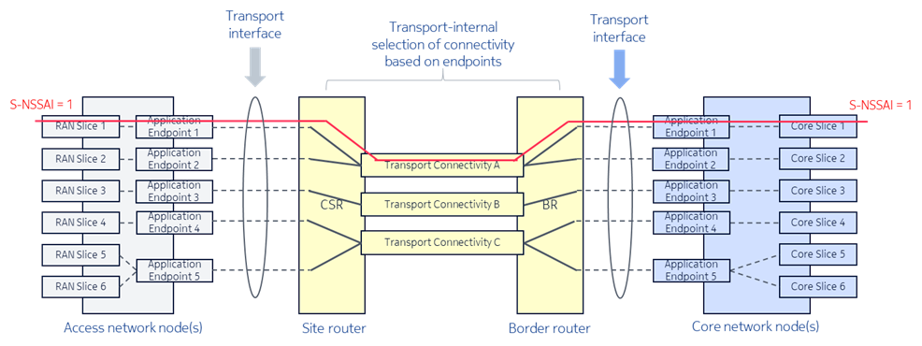
Figure 1. TN NSS examples connecting the access and core network
In this example, there is an end-end network slice with S-NSSAI = 1 which is mapped to specific application endpoints (e.g. N3 tunnel endpoint 1) by the access network node. The transport network can map packets to connectivity services based on local or remote endpoints, provided that the allocation of S-NSSAI to endpoints is known and exposed, and provided that the application endpoints are visible on the transport layer. The application endpoints visible in a slice subnet are already mapped to a specific set of S-NSSAI.
In this example, the TN management system decides to map application endpoints 1 and 2 to the same transport connectivity service A. This mapping is implemented by the site router connecting to the access network node. On the core network side, a similar mapping is done by the border router. Demultiplexing the packet streams belonging to different logical transport interfaces is based on regular routing and reachability of endpoint IP addresses.
- In some configurations, application endpoints may be encrypted by IPsec tunnels and so they are not visible in the transport network, and thus cannot be used for transport connectivity mappings. Also, in some configurations, the application endpoint is not 1:1 mapping to transport interfaces, e.g. for better redundancy. In those cases, logical transport interfaces need to be exposed from 3GPP management system to TN management system to allow TN management system to create transport network topology and determine the transport resources to support the E2E network slice.
A logical transport interface may be for example a specific IP address / VLAN combination that corresponds to an IPsec termination point, or it may be just a logical interface defined on top of a physical transport interface. As long as the interface identity can be derived from packet headers, the transport network nodes can perform the mapping to transport connectivity services.

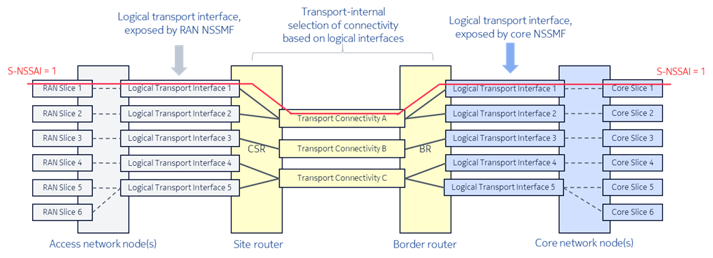
Figure 2 TN NSS example using logical transport interfaces
However, the current NRM does not expose logical transport interface in either Managed Function level or NSS level.
- Reachable and QoS information of either application EP or logical transport interface are not defined in existing NRM

4 Detailed proposal

4.1 change application level EP (e.g. EP_N3, EP_NgU) to add S-NSSAI information, remove VLAN ID, and optionally associate with transport EP.
Note: The benefit to link slice information in App EP because application layer is always aware of slice information , another advantage is the information can be reused by indirect TN integration scenario, e.g. TN supported by ETSI NFV MANO.

4.2 define transport EP which including transport topology related info, reachability info, QoS requirement, etc. The TN EP are contained by NSS and associate with related application level EPs
Note:
- The benefit to define transport EP in NSS instead of Managed Function is that transport related specification is not legacy 3GPP scope. However as rational described above, 3GPP needs to coordinate with non-3GPP SDOs, such as IETF, ETSI, for E2E network slice management and orchestration. By defining the transport EPs in NSSs , it can keep legacy ManagedFunction definition clean and transport solution agnostic. In addition, it can separate the concerns of network element management and transport network plan and management, as generally network element administrator/tool doesn’t take care of the transport configuration. The network planner/tool of RAN/CN network could configure and map logical transport interface to application level endpoint.
- S-NSSAI information could be get from application level EP (s) associated to the transport EP. The application level EP type can also be got from associated application level EP (e.g. based on DN).

4.3 Send LS to IETF and ETSI ZSM to inform them the concrete progress of 3GPP SA5 regarding cooperation with other SDOs to enable E2E network slice management automation.

