3GPP TSG-SA5 Meeting #131e S5-203159

e-meeting 25th May-3rd June 2020
CR-Form-v12.0
CHANGE REQUEST
 | 28.541 | CR | 0300 | rev | - | Current version: | 16.4.1
For HELP on using this form: comprehensive instructions can be found at
http://www.3gpp.org/Change-Requests.

Proposed change affects: | UICC apps |  | ME |  | Radio Access Network | X | Core Network | X

Title: | Clarification on the relation of GST, ServiceProfile and SliceProfile
Source to WG: | Huawei
Source to TSG: | S5
Work item code: | TEI16 |  |  |  |  |  | Date: |  |  | 2020-05-15
Category: | F |  |  |  |  |  | Release: |  |  | Rel-16
 | Use one of the following categories:  F (correction)  A (mirror corresponding to a change in an earlier release)  B (addition of feature),  C (functional modification of feature)  D (editorial modification)  Detailed explanations of the above categories can  be found in 3GPP TR 21.900. |  |  |  |  |  |  |  | Use one of the following releases:  Rel-8 (Release 8)  Rel-9 (Release 9)  Rel-10 (Release 10)  Rel-11 (Release 11)  Rel-12 (Release 12)  Rel-13 (Release 13)  Rel-14 (Release 14)  Rel-15 (Release 15)  Rel-16 (Release 16)
Reason for change: |  | There are some ambiguities in the clause annex L for the relation of GSMA GST, ServiceProfile and SliceProfile.
Summary of change: |  | Make clarification on the description text and change the figure L.2.1 to make it aligned with the text.
Consequences if not approved: |  | Ambiguities in the clause annex L may lead to wrong implementation.
Clauses affected: |  | Annex L.1, L.2
 |  | Y | N
Other specs |  |  | X | Other core specifications |  |  |  | TS/TR ... CR ...
affected: |  |  | X | Test specifications |  |  |  | TS/TR ... CR ...
(show related CRs) |  |  | X | O&M Specifications |  |  |  | TS/TR ... CR ...
Other comments:
This CR's revision history:

1st Change

Annex L (normative):
Relation of GSMA GST, ServiceProfile and SliceProfile

L.1 General
This annex describes the relation between GSMA GST [50] and information model ServiceProfile and SliceProfile.

L.2 GSMA GST, ServiceProfile and SliceProfile
The GSMA GST is used as the SLA information for the communication between the vertical industry and the communication service provider. The SLA requirements can be fulfilled from management aspect and control aspect in a coordinated way. The SLS includes ServiceProfile information model.
As shown in figure L.2.1, the GST [50] is translated and used as input to NRM ServiceProfile, the ServiceProfile can be translated to corresponding requirements for dedicated domains. For example, 5GC SliceProfile is used to carry 5GC domain requirements, NG-RAN SliceProfile is used to carry NG-RAN domain requirements, and TN requirements are translated and provided to TN domain. Some of the information in 5GC SliceProfile and NG-RAN SliceProfile is translated to configurable parameters of network function for the control plane SLA support purpose.
NOTE: how to do the translation is out of the scope of this document.

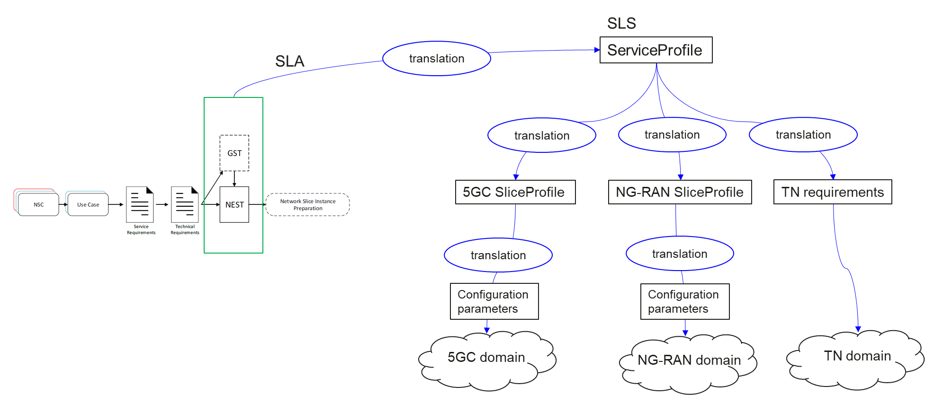
Figure L.2.1 Relation between GSMA GST, ServiceProfile and SliceProfile

End of Change

