3GPP TSG-SA5 Meeting #131-e S5-203151

Online, , 25th May 2020 - 3rd Jun 2020
CR-Form-v12.0
CHANGE REQUEST
 | 28.622 | CR | 0082 | rev | - | Current version: | 16.3.0
For HELP on using this form: comprehensive instructions can be found at
http://www.3gpp.org/Change-Requests.

Proposed change affects: | UICC apps |  | ME |  | Radio Access Network | x | Core Network | x

Title: | Rel-16 CR 28.622 Add analytics control NRM fragment stage 2
Source to WG: | Nokia Corporation
Source to TSG:
Work item code: | eNRM |  |  |  |  |  | Date: |  |  | 2020-05-15
Category: | B |  |  |  |  |  | Release: |  |  | Rel-16
 | Use one of the following categories:  F (correction)  A (mirror corresponding to a change in an earlier release)  B (addition of feature),  C (functional modification of feature)  D (editorial modification)  Detailed explanations of the above categories can  be found in 3GPP TR 21.900. |  |  |  |  |  |  |  | Use one of the following releases:  Rel-8 (Release 8)  Rel-9 (Release 9)  Rel-10 (Release 10)  Rel-11 (Release 11)  Rel-12 (Release 12)  Rel-13 (Release 13)  Rel-14 (Release 14)  Rel-15 (Release 15)  Rel-16 (Release 16)
Reason for change: |  | Addition of the SBMA Analytics control
Summary of change: |  | Added Analytics control NRM fragment (relationships, inheritance, IOC definition, attributes)
Consequences if not approved: |  | Lack of support for the MDAS in 3GPP Rel-16
Clauses affected: |  | 4.2.1, 4.2.2, 4.3.X (new), 4.4.1
 |  | Y | N
Other specs |  |  | x | Other core specifications |  |  |  | TS/TR ... CR ...
affected: |  |  | x | Test specifications |  |  |  | TS/TR ... CR ...
(show related CRs) |  | x |  | O&M Specifications |  |  |  | TS/TR ... CR ...
Other comments:
This CR's revision history:

1st Modified Section

4.2 Class diagrams

4.2.1 Relationships
This clause depicts the set of classes (e.g. IOCs) that encapsulates the information relevant for this IRP. This clause provides the overview of the relationships of relevant classes in UML. Subsequent clauses provide more detailed specification of various aspects of these classes.
The following figure shows the containment/naming hierarchy and the associations of the classes defined in the present document. See Annex A of a class diagram that combines this figure with Figure 1 of [2], the class diagram of UIM.
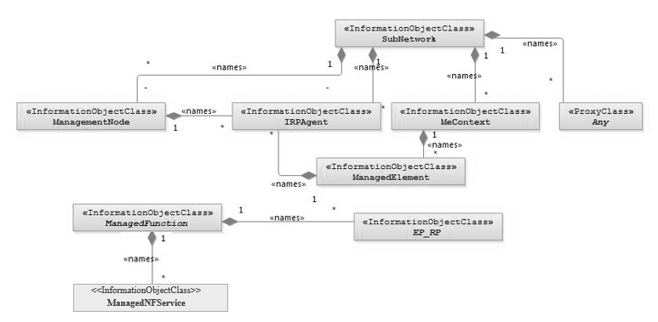
NOTE 1: ManagedElement may be contained either
- in a SubNetwork (since SubNetwork inherits from Domain_ and ManagedElement inherits from ManagedElement_ and Domain_ name-contained ManagedElement_ as observed in the figure of Annex A) or
- in a MeContext instance as observed by the above figure or in the figure of Annex A.
This either-or relation cannot be shown by using an {xor} constraint in the above figure.
ManagedElement may also have no parent instance at all.
NOTE 2: Each instance of the VsDataContainer shall only be contained under one IOC. The VsDataContainer can be contained under IOCs defined in other NRMs.
NOTE 3: If the configuration contains several instances of SubNetwork, exactly one SubNetwork instance shall directly or indirectly contain all the other SubNetwork instances.
NOTE 4: The SubNetwork instance not contained in any other instance of SubNetwork is referred to as "the root SubNetwork instance".
NOTE 5: ManagementNode shall be contained in the root SubNetwork instance.
NOTE 6: If contained in a SubNetwork instance, IRPAgent shall be contained in the root SubNetwork instance.
NOTE 7: For a clarification on the choice of containment of the IRPAgent (since it has three possible parents), see the def. of IRPAgent.
NOTE 8: Cardinality * is identical to multiplicity 0..*.

Figure 4.2.1-1: Containment/Naming and Association NRM fragment
Each Managed Object is identified with a Distinguished Name (DN) according to 3GPP TS 32.300 [13] that expresses its containment hierarchy. As an example, the DN of a ManagedElement instance could have a format like:
SubNetwork=Sweden,MeContext =MEC-Gbg-1, ManagedElement=RNC-Gbg-1.
NOTE 8: Each instance of the VsDataContainer shall only be contained under one IOC. The VsDataContainer can be contained under IOCs defined in other NRMs by virtue of inheritance from the GENERIC NRM.
NOTE 9: The VsDataContainer is only used for the Bulk CM IRP.

Figure 4.2.1-2: VsDataContainer Containment/Naming and Association in NRM fragment

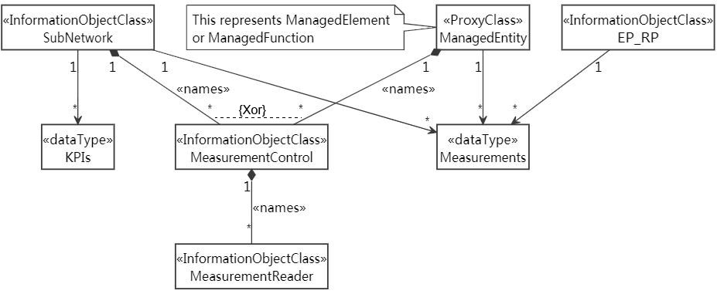
Figure 4.2.1-3: Performance measurement control NRM fragment
Figure 4.2.1-4: Measurement threshold monitoring control fragment
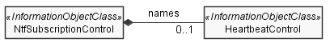
Figure 4.2.1-5: Heartbeat notification control fragment
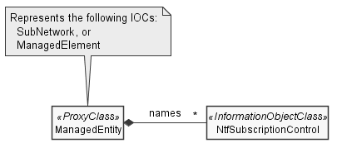
Figure 4.2.1-6: Notification subscription control fragment
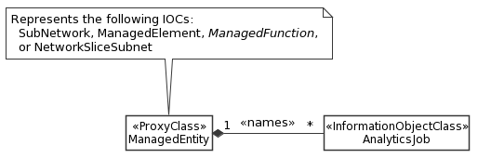
Figure 4.2.1-x: Analytics job control NRM fragment

2nd Modified Section

4.2.2 Inheritance

This clause depicts the inheritance relationships.

Figure 4.2.2-1: Inheritance Hierarchy NRM fragment
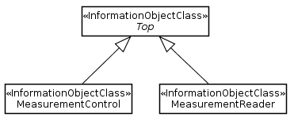

Figure 4.2.2-2: Performance measurement control NRM fragment

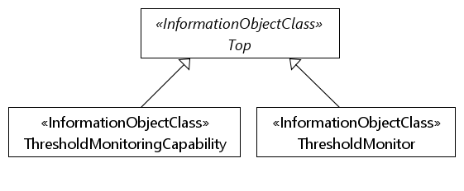

Figure 4.2.2-3: Measurement threshold monitoring NRM fragment

Figure 4.2.2-4: Heartbeat notification control fragment

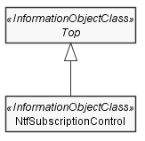
Figure 4.2.2-5: Notification subscription fragment
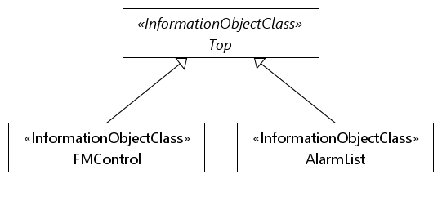
Figure 4.2.2-6: FM control NRM fragment
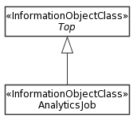
Figure 4.2.2-x: Analytics job control NRM fragment

2rd Modified Section

4.3 Class definitions

4.3.X AnalyticsJob

4.3.X.1 Definition
An AnalyticsJob instance represents an MDAS analytics activity of a particular analytics job.
To activate Analytics Jobs, a MnS consumer has to create AnalyticsJob object instances on the MnS producer.
When a MnS consumer wishes to deactivate an Analytics Job, the MnS consumer shall delete the corresponding AnalyticsJob instance.

4.3.X.2 Attributes
Attribute Name | Support Qualifier | isReadable | isWritable | isInvariant | isNotifyable
analyticsJobId | M | T | T | F | T
analyticsMethod | M | T | T | F | T
reportingCtrl | M | T | T | F | T

4.3.X.3 Attribute constraints
None

4.3.X.4 Notifications
The common notifications defined in clause 4.5 are valid for this IOC, without exceptions.

4th Modified Section

4.4 Attribute definitions

4.4.1 Attribute properties
The following table defines the properties of attributes specified in the present document.
Attribute Name |  | Documentation and Allowed Values |  | Properties
analyticsJobId |  | It specifies an identifier that assists in tracking the AnalyticsJob. |  | type: String  multiplicity: 1  isOrdered: N/A  isUnique: True  defaultValue: None  isNullable: False
analyticsMethod |  | Analytics method  AllowedValues STATISTICS, PREDICTION |  | type: Enum  multiplicity: 1  isOrdered: N/A  isUnique: N/A  defaultValue: STATISTICS  isNullable: False
heartbeatNtfPeriod |  | This attribute specifies the periodicity of heartbeat notification emission. The value of zero has the special meaning of stopping the heartbeat notification emission.  Unit is in minutes.  AllowedValues: non-negative integers |  | type: Integer  multiplicity: 1  isOrdered: N/A  isUnique: N/A  defaultValue: 0  isNullable: False
triggerHeartbeatNtf |  | Setting this attribute to TRUE triggers an immediate additional heartbeat notification emission. Setting the value to FALSE has no observable result.  The periodicity of notifyHeartbeat emission is not changed.  AllowedValues: TRUE, FALSE |  | type: ENUM  multiplicity: 1  isOrdered: N/A  isUnique: N/A  defaultValue: FALSE  isNullable: False
notificationRecipientAddress |  | This attribute defines the address of the notification recipient. |  | type: String  multiplicity: 1  isOrdered: N/A  isUnique: N/A  defaultValue: None  isNullable: False
notificationTypes |  | This attribute defines the types of notifications that are candidates for being forwarding to the notification recipient  If the notificationFilter attribute is not supported all candidate notifications are forwarded to the notification recipient, otherwise the candidate notifications are discriminated by the filter specified by the notificationFilter attribute.  AllowedValues:  - notifyMOICreation  - notifyMOIDeletion  - notifyMOIAttributeValueChanges  - notifyEvent  - notifyNewAlarm  - notifyChangedAlarm  - notifyAckStateChanged  - notifyComments  - notifyCorrelatedNotificationChanged  - notifyChangedAlarmGeneral  - notifyAlarmListRebuilt  - notifyPotentialFaultyAlarmList  - notifyFileReady  - notifyFilePreparationError  - notifyThresholdCrossing |  | type: string  multiplicity: 1..*  isOrdered: N/A  isUnique: N/A  defaultValue: NOne  isNullable: False
notificationFilter |  | This attribute defines a filter to be applied to candidate notifications identified by the notificationTypes attribute. Only notifications that pass the filter criteria are forwarded to the notification recipient. All other notifications are discarded.  The filter can be applied to any field of a notification. |  | type: String  multiplicity: 1  isOrdered: N/A  isUnique: N/A  defaultValue: None  isNullable: False
scope |  | This attribute defines the scope. It is a structured parameter with the data type Scope. |  | type: Scope  multiplicity: 1  isOrdered: N/A  isUnique: N/A  defaultValue: None  isNullable: False
scopeType |  | If the optional scopeLevel parameter is not supported or absent, allowed values of scopeType are BASE_ONLY and BASE_ALL.  The value BASE_ONLY indicates only the base object is selected.  The value BASE_ALL indicates the base object and all of its subordinate objects (incl. the leaf objects) are selected.  If the scopeLevel parameter is supported and present, allowed values of scopeType are BASE_ALL, BASE_ONLY, BASE_NTH_LEVEL and BASE_SUBTREE.  The value BASE_NTH_LEVEL indicates all objects on the level, which is specified by the scopeLevel parameter, below the base object are selected. The base object is at scopeLevel zero.  The value BASE_SUBTREE indicates the base object and all of its subordinate objects down to and including the objects on the level, which is specified by the scopeLevel parameter, are selected. The base object is at scopeLevel zero. |  | type: ENUM  multiplicity: 1  isOrdered: N/A  isUnique: N/A  defaultValue: None  isNullable: False
scopeLevel |  | See definition of scopeType parameter. |  | type: Integer  multiplicity: 1  isOrdered: N/A  isUnique: N/A  defaultValue: None  isNullable: False
farEndEntity |  | The value of this attribute shall be the Distinguished Name of the far end network entity to which the reference point is related.  As an example, with EP_Iucs, if the instance of EP_Iucs is contained by one RncFunction instance, the farEndEntity is the Distinguished Name of the MscServerFunction instance to which this Iucs reference point is related.  allowedValues: N/A |  | type: DN  multiplicity: 0..1  isOrdered: N/A  isUnique: N/A  defaultValue: No  isNullable: False
linkType |  | This attribute defines the type of the link.  allowedValues: Signalling, Bearer, OAM&P, Other or multiple combinations of this type. |  | type: String  multiplicity: 0..*  isOrdered: False  isUnique: True  defaultValue: No  isNullable: False
locationName |  | The physical location of this entity (e.g. an address).  allowedValues: N/A |  | type: String  multiplicity: 0..1  isOrdered: N/A  isUnique: N/A  defaultValue: No  isNullable: False
monitoringGP |  | This attribute defines the monitoring granularity period (in seconds).  allowedValues: see NOTE 5 |  | type: Integer  multiplicity: 1  isOrdered: False  isUnique: True  defaultValue: No  isNullable: False
monitoredIOCName |  | It specifies one object class name for which the threshold monitor is created. When this attribute take effective, the threshold monitor is created for all of its instances in the name-containment tree whose top (tree) node is the IOC instance name-containing the subject <<IOC>>ThresholdMonitor instance containing this attribute.  This attribute takes effective when the monitoredObjectDNs contained by the same <<IOC>>ThresholdMonitor instance is empty.  allowedValues: The IOC names defined in the NRMs specifications. |  | type: String  multiplicity: 1  isOrdered: False  isUnique: True  defaultValue: No  isNullable: False
monitoringNotifTarget |  | This identifies the target of the notifications when the monitored measurement crosses or reaches the threshold set by the subject threshold monitor.  allowedValues: N/A |  | type: String  multiplicity: 1  isOrdered: N/A  isUnique: N/A  defaultValue: None  isNullable: True
monitoredObjectDNs |  | It specifies the object instance(s) for threshold monitoring.  This attribute monitoredIOCName contained by the same <<IOC>>ThresholdMonitor instance does not take effective when this attribute is not empty.  allowedValues: list of DN |  | type: dataType  multiplicity: 1  isOrdered: False  isUnique: True  defaultValue: No default value  isNullable: False
objectClass |  | An attribute which captures the name of the class from which the object instance is an occurrence of.  allowedValues: N/A |  | type: String  multiplicity: 1  isOrdered: N/A  isUnique: N/A  defaultValue: No default value  isNullable: False
objectInstance |  | An information which captures the Distinguished Name of any object.  allowedValues: N/A |  | type: String  multiplicity: 1  isOrdered: N/A  isUnique: N/A  defaultValue: No default value  isNullable: False
peeParametersList |  | This attribute contains the parameter list for the control and monitoring of power, energy and environmental parameters of ManagedFunction instance(s). This list contains the following parameters:  - siteIdentification  - siteLatitude (optional)  - siteLongitude (optional)  - siteDescription  - equipmentType  - environmentType  - powerInterface  siteIdentification: The identification of the site where the ManagedFunction resides.  allowedValues: N/A  siteLatitude: The latitude of the site where the ManagedFunction instance resides, based on World Geodetic System (1984 version) global reference frame (WGS 84). Positive values correspond to the northern hemisphere. This attribute is optional in case of BTSFunction and RNCFunction instance(s).  allowedValues: -90.0000 to +90.0000  siteLongitude: The longitude of the site where the ManagedFunction instance resides, based on World Geodetic System (1984 version) global reference frame (WGS 84). Positive values correspond to degrees east of 0 degrees longitude. This attribute is optional in case of BTSFunction and RNCFunction instance(s).  allowedValues: -180.0000 to +180.0000  siteDescription: An operator defined description of the site where the ManagedFunction instance resides.  allowedValues: N/A  equipmentType: The type of equipment where the managedFunction instance resides.  allowedValues: see clause 4.4.1 of ETSI ES 202 336-12 [18].  environmentType: The type of environment where the managedFunction instance resides.  allowedValues: see clause 4.4.1 of ETSI ES 202 336-12 [18].  powerInterface: The type of power.  allowedValues: see clause 4.4.1 of ETSI ES 202 336-12 [18]. |  | type: String  multiplicity: 0..*  isOrdered: N/A  isUnique: True  defaultValue: No default value  isNullable: True
priorityLabel | This is a label that consumer would assign a value on a concrete instance of the managed object. The management system takes the value of this attribute into account. The effect of this attribute value to the subject managed entity is not standardized |  | type: Integer  multiplicity: 1  isOrdered: N/A  isUnique: N/A  defaultValue: No default value  isNullable: False
protocolVersion |  | Versions(s) and additional descriptive information for the protocol(s) used for the associated communication link. Syntax and semantic is not specified.  allowedValues: N/A |  | type: String  multiplicity: *  isOrdered: False  isUnique: True  defaultValue: no default value  isNullable: False
setOfMcc |  | Set of Mobile Country Code (MCC). The MCC uniquely identifies the country of domicile of the mobile subscriber. MCC is part of the IMSI (TS 23.003 [5])  This list contains all the MCC values in subordinate object instances to this SubNetwork instance.  allowedValues: See clause 2.3 of TS 23.003 [5] for MCC allocation principles. |  | type: Integer  multiplicity: 1..*  isOrdered: False  isUnique: True  defaultValue: No default value  isNullable: False
swVersion |  | The software version of the ManagementNode or ManagedElement (this is used for determining which version of the vendor specific information is valid for the ManagementNode or ManagedElement).  allowedValues: N/A |  | type: String  multiplicity: 0..1  isOrdered: N/A  isUnique: N/A  defaultValue: No default value  isNullable: False
systemDN |  | The Distinguished Name (DN) of IRPAgent (or consumer). Defined in 3GPP TS 32.300.  allowedValues: N/A |  | type: DN  multiplicity: 0..1  isOrdered: N/A  isUnique: N/A  defaultValue: No default value  isNullable: False
supportedMonitoringGPs |  | The monitoring granularity periods (in seconds) supported by the producer for the monitored entities.  AllowedValues: see NOTE 5. |  | type: integer  multiplicity: 1..*  isOrdered: N/A  isUnique: N/A  defaultValue: No default value  isNullable: False
thresholdInfoList |  | It specifies the list of threshold information.  It is list of  <  measurementType,  direction,  thresholdPack  >,  where thresholdPack is list of  <  thresholdLevel,  thresholdValue,  hysteresis (optional)  >  The measurementType shall be in one of the following form:  - "family.measurementName.subcounter" for monitoring the measurement types with subcounters defined.  - "family.measurementName" for monitoring the measurement types without subcounters defined.  The direction can be 'Increasing' or ‘Decreasing' of the measurement values.  - If it is "Increasing", the threshold crossing notification is triggered when the measurement value equals or exceeds a thresholdValue.  - If it is "Decreasing", the threshold crossing notification is triggered when the measurement value equals or below a thresholdValue.  The thresholdLevel indicates the level for the threshold. See NOTE 6 for the supported threshold levels.  The hysteresis has a threshold-high and a threshold-low value that are different from the threshold value.  A hysteresis, therefore, defines the threshold-high and threshold-low levels within which the measurementType value is allowed to oscillate without triggering the threshold crossing notification.  AllowedValues: N/A |  | type: dataType  multiplicity: 1s..*  isOrdered: N/A  isUnique: N/A  defaultValue: No default value  isNullable: False
userDefinedState |  | An operator defined state for operator specific usage.  allowedValues: N/A |  | type: String  multiplicity: 0..1  isOrdered: N/A  isUnique: N/A  defaultValue: No default value  isNullable: False
userLabel |  | A user-friendly (and user assignable) name of this object.  allowedValues: N/A |  | type: String  multiplicity: 0..1  isOrdered: N/A  isUnique: N/A  defaultValue: No default value  isNullable: False
vendorName |  | The name of the vendor.  allowedValues: N/A |  | type: String  multiplicity: 0..1  isOrdered: N/A  isUnique: N/A  defaultValue: None  isNullable: False
vnfParametersList |  | This attribute contains the parameter set of the VNF instance(s) corresponding to an NE. Each entry in the list contains:  - vnfInstanceId  - vnfdId (optional)  - flavourId (optional)  - autoScalable  vnfInstanceId: VNF instance identifier (vnfInstanceId, see section 9.4.2 of [16] and section B2.4.2.1.2.3 of [17]).  See Note 1.  vnfdId: Identifier of the VNFD on which the VNF instance is based, see section 9.4.2 of [16]. This attribute is optional.  Note: the value of this attribute is identical to that of the same attribute in clause 9.4.2 of ETSI GS NFV-IFA 008 [16].  flavourId: Identifier of the VNF Deployment Flavour applied to this VNF instance, see section 9.4.3 of [16]. This attribute is optional.  Note: the value of this attribute is identical to that of the same attribute in clause 9.4.3 of ETSI GS NFV-IFA 008 [16].  autoScalable: Indicator of whether the auto-scaling of this VNF instance is enabled or disabled. The type is Boolean.  See Note2.  The presence of this attribute indicates that the ManagedFunction represented by the MOI is a virtualized function.  See Note 3.  allowedValues: N/A  A string length of zero for vnfInstanceId means the VNF instance(s) corresponding to the MOI does not exist (e.g. has not been instantiated yet, has already been terminated). |  | type: String  multiplicity: *  isOrdered: N/A  isUnique: True  defaultValue: None  isNullable: True
vsData |  | Vendor specific attributes of the type vsDataType. The attribute definitions including constraints (value ranges, data types, etc.) are specified in a vendor specific data format file.  allowedValues: -- |  | type: --  multiplicity: --  isOrdered: --  isUnique: --  defaultValue: --  isNullable: False
vsDataFormatVersion |  | Name of the data format file, including version.  allowedValues: N/A |  | type: String  multiplicity: 1  isOrdered: N/A  isUnique: N/A  defaultValue: No  isNullable: False
vsDataType |  | Type of vendor specific data contained by this instance, e.g. relation specific algorithm parameters, cell specific parameters for power control or re-selection or a timer. The type itself is also vendor specific.  allowedValues: N/A |  | type: String  multiplicity: 1  isOrdered: N/A  isUnique: N/A  defaultValue: No  isNullable: False
pMAdministrativeState |  | It indicates the administrative state of MeasurementControl. It describes the permission to use or prohibition against using the capability of MeasurementControl, imposed through the consumer of OAM services produced by MeasurementControl,  The measurement or KPI report production would begin when pMadministrativeState is UNLOCKED and pMoperationalState is ENABLED.  The meaning of these values is as defined in 3GPP TS 28.625 [21] and ITU-T X.731 [19].  allowedValues: "LOCKED", "SHUTTING DOWN", "UNLOCKED". |  | type: ENUM  multiplicity: 1  isOrdered: N/A  isUnique: N/A  defaultValue: “LOCKED”  isNullable: False
pMOperationalState |  | It indicates the operational state of MeasurementControl. It describes if the resource is physically installed and working.  allowedValues: “ENABLED”, “DISABLED”.  The meaning of these values is as defined in 3GPP TS 28.625 [21] and ITU-T X.731 [19]. |  | type: ENUM  multiplicity: 1  isOrdered: N/A  isUnique: N/A  defaultValue: No  allowedValues: N/A  isNullable: False
managedObjectDNs |  | It identifies the managed entities whose Measurements or KPIs are required to be produced.  It identifies specific management entities say X, Y, Z. These are called the base.  In case the base is SubNetwork, it identifies all, including the base, managed entities that are subordinates, in the sense of name-containment, of the base.  In case the base is NetworkSliceSubnet, it identifies all, including the base, managed entities that has aggregation association relation with the base.  The identified entities are called a collection. It would mean Measurement types or KPI names specified in attribute MeasurementReader.measurementTypes, are required to be produced if the member (of the collection) is capable of supporting the Measurement type or KPI namess.  allowedValues: N/A |  | type: DN  multiplicity: *  isOrdered: N/A  isUnique: True  defaultValue: No  isNullable: False
managedObjectDNsBasic |  | It identifies the managed entities whose Measurements or KPIs are required to be produced.  It identifies specific managed entities (say X, Y, Z). It would mean Measurements type or KPI names specified in MeasurementReader.measurementTypes, are required to be produced if X, Y, Z are capable of supporting the Measurement types or KPI names.  If managedObjectDNs of the same MeasurementReader instance has valid information, the information of this attribute is ignored.  allowedValues: N/A |  | type: DN  multiplicity: *  isOrdered: N/A  isUnique: True  defaultValue: No  isNullable: False
streamBasedGP |  | It defines the frequency of producing and sending the Measurement or KPI to the consumer.  allowedValues: See Note 4. |  | type: Integer  multiplicity: 1  isOrdered: N/A  isUnique: N/A  defaultValue: None  isNullable: False
measurementsList |  | It specifies a list of supported measurements and their GPs. A NULL value indicates there is no measurement supported.  allowedValues: N/A |  | type: Measurements  multiplicity: *  isOrdered: N/A  isUnique: N/A  defaultValue: None  allowedValues: N/A  isNullable: True
measurementTypes |  | If the MeasurementControl is used for measurements collecting purpose, it identifies one or more Measurement types. The Measurement type can be those specified in TS 28.552 [20], TS 32.404 [21] and can be those specified by other SDOs or can be vendor-specific.  If the MeasurementControl is used for KPIs reporting purpose, it identifies one or more KPI names. The KPI name can be those specified in TS 28.554 [28] and can be those specified by other SDOs or can be vendor-specific.  allowedValues: N/A |  | type: String  multiplicity: *  isOrdered: N/A  isUnique: True  defaultValue: No  isNullable: False
streamTarget |  | This identifies the target of the notification carrying the content of the measurement or KPI report.  There are two delivery methods (i.e. file-based and stream-based) via which the consumer(s) can receive the Measurements or KPIs. This attribute is used for the stream-based delivery method.  allowedValues: N/A |  | type: String  multiplicity: 1  isOrdered: N/A  isUnique: N/A  defaultValue: None  isNullable: True
gPs |  | It identifies the supported GPs, see Note 4.  allowedValues: N/A |  | type: Integer  multiplicity: *  isOrdered: False  isUnique: True  defaultValue: No  isNullable: False
nFServiceType |  | The parameter defines the type of the managed NF service instance  allowedValues: See clause 7.2 of TS 23.501[22] |  | type: ENUM  multiplicity: 1  isOrdered: N/A  isUnique: True  defaultValue: No default value  isNullable: False
operations |  | This parameter defines set of operations supported by the managed NF service instance.  allowedValues: See TS 23.502[23] for supporting operations |  | type: Operation  multiplicity: 1..*  isOrdered: False  isUnique: False  defaultValue: No default value  isNullable: False
Operation.name |  | This parameter defines the name of the operation of the managed NF service instance.  allowedValues: N/A |  | type: String  multiplicity: 1  isOrdered: False  isUnique: False  defaultValue: no default value  isNullable: True
allowedNFTypes |  | This parameter identifies the type of network functions allowed to access the operation of the managed NF service instance.  allowedValues: See TS 23.501[22] for NF types |  | type: ENUM  multiplicity: 1..*  isOrdered: N/A  isUnique: N/A  defaultValue: None  isNullable: False
operationSemantics |  | This paramerter identifies the semantics type of the operation. See TS 23.502[23]  allowedValues: “Request/Response”, “Subscribe/Notify”. |  | type: ENUM  multiplicity: 1  isOrdered: N/A  isUnique: N/A  defaultValue: None  isNullable: False
sAP |  | This parameter specifies the service access point of the managed NF service instance.  allowedValues: N/A |  | type: SAP  multiplicity: 1  isOrdered: N/A  isUnique: N/A  defaultValue: No default value  isNullable: False
host |  | This parameter specifies the host address of the managed NF service instance. It can be FQDN (See TS 23.003 [5]) or an IPv4 address (See RFC 791 [24]) or an IPv6 address (See RFC 2373 [25]).  allowedValues: N/A |  | type: String  multiplicity: 1  isOrdered: False  isUnique: N/A  defaultValue: None  isNullable: False
port |  | This parameter specifies the transport port of the managed NF service instance.  allowedValues: 1 - 65535 |  | type: Integer  multiplicity: 1  isOrdered: False  isUnique: False  defaultValue: None  isNullable: False
ManagedNFService.operationalState |  | This parameter indicates the operational state of the managed NF service instance. It describes whether the resource is physically installed and working.  allowedValues: "ENABLED", "DISABLED".  The meaning of these values is as defined in 3GPP TS 28.625 [21] and ITU-T X.731 [19]. |  | type: ENUM  multiplicity: 1  isOrdered: N/A  isUnique: N/A  defaultValue: None  isNullable: False
ManagedNFService.administrativeState |  | This parameter indicates the administrative state of the manaed object instance. It describes the permission to use or prohibition against using the instance, imposed through the management services.  allowedValues: “LOCKED”, “UNLOCKED”, SHUTTINGDOWN”  The meaning of these values is as defined in 3GPP TS 28.625 [21] and ITU-T X.731 [19]. |  | type: ENUM  multiplicity: 1  isOrdered: N/A  isUnique: N/A  defaultValue: None  isNullable: False
ManagedNFService.usageStae |  | This parameter indicates the usage state of the object instance. It describes whether the resource is actively in use at a specific instant, and if so, whether or not it has spare capacity for additional users at that instant.  allowedValues: "IDLE", "ACTIVE", "BUSY".  The meaning of these values is as defined in 3GPP TS 28.625 [21] and ITU-T X.731 [19]. |  | type: ENUM  multiplicity: 1  isOrdered: N/A  isUnique: N/A  defaultValue: None  isNullable: False
registrationState |  | This parameter defines the registration status of the managed NF service instance.  allowedValues: "Registered", "Deregistered". |  | type: ENUM  multiplicity: 1  isOrdered: N/A  isUnique: N/A  defaultValue: Deregistered  isNullable: False
defaultFileBasedGP |  | This is a property of the file-based delivery method. See definition of fileBasedGP. This value is ignored in case the property captured in MeasurementReader is in use. GP unit is in minute. |  | Same as in fileBasedGP
defaultFileReportingPeriod |  | This is a property of the file-based delivery method. See definition of fileReportingGP. This value is ignored in case the property captured in MeasurementReader is in use. |  | Same as in fileReportingPeriod
defaultFileLocation |  | This is a property of the file-based delivery method. See definition of fileLocation. This value is ignored in case the property captured in MeasurementReader is in use. |  | Same as in fileLocation
defaultStreamBasedGP |  | This is a property of the stream-based delivery method. See definition of streamBasedGP. This value is ignored in case the property captured in MeasurementReader is in use. |  | Same as in streamBasedGP
defaultStreamTarget |  | This is a property of the stream-based delivery method. See definition of streamTarget. This value is ignored in case the property captured in MeasurementReader is in use. |  | Same as in  streamTarget
fileBasedGP |  | This defines the frequency of producing the performance data. The performance data would be produced immediately at the end of each fileBasedGP.A performance data report file contains multiple performance data. GP unit is in minute.  allowedValues: See Note 4. |  | type: Integer  multiplicity: 1  isOrdered: N/A  isUnique: N/A  defaultValue: No  isNullable: False
fileReportingPeriod |  | This defines the frequency of producing the performance data report files, in fileLocation, that hold the performance data reports.  allowedValues: Its value is a multiple of fileBasedGP. |  | type: Integer  multiplicity: 1  isOrdered: N/A  isUnique: N/A  defaultValue: No  isNullable: False
fileLocation |  | This is used for the file-based delivery method. It is the path to a location on either the producer’s file system or a URI to a network file location that is not part of the producer’s file system.  In case it points to a location on the producer’s file system, it is a relative path based on a vendor-specified root directory for performance data files.  The size of this fileLocation is decided by consumer and producer. The producer is expected to remove old files to make room for new files, when necessary.  allowedValues: Not applicable. |  | type: String  multiplicity: 1  isOrdered: N/A  isUnique: N/A  defaultValue: No  isNullable: True
kPINames |  | It identifies one or more KPIs. The KPI name can be those specified in TS 28.554 [28] and can be those specified by other SDOs or can be vendor-specific.  allowedValues: N/A |  | type: String  multiplicity: *  isOrdered: N/A  isUnique: True  defaultValue: No  isNullable: False
kPIsList |  | It specifies a list of supported KPIs and their GPs. A NULL value indicates there is no KPI supported.  allowedValues: N/A |  | type: KPIs  multiplicity: *  isOrdered: N/A  isUnique: N/A  defaultValue: None  allowedValues: N/A  isNullable: True
FMControl.administrativeState |  | The consumer sets this attribute to UNLOCKED instructing the producer to report and record alarm information. The consumer sets the attribute to LOCKED indicating detection, reporting and recording of alarm information are no longer needed.  allowedValues: LOCKED, UNLOCKED. |  | type: ENUM  multiplicity: 1  isOrdered: N/A  isUnique: N/A  defaultValue: LOCKED  isNullable: False
FMControl.operationalState |  | The producer sets this attribute to ENABLED, indicating that it has the resource and ability to record alarm in AlarmList and sending alarm notification to faultReportTarget (an attribute of NtfSubscriptionControl IOC); else, it sets the attribute to DISABLED.  allowedValues: ENABLED, DISABLED. |  | type: ENUM  multiplicity: 1  isOrdered: N/A  isUnique: N/A  defaultValue: DISABLED  isNullable: False
alarmRecordList |  | It contains a list of alarm information. It has the attributes defined at clause 11.2.2.1.3.1 AlarmInformation of TS 28.532 [x].  allowedValues: not applicable |  | type: AlarmRecord  multiplicity: *  isOrdered: N/A  isUnique: True  default value: NULL  isNullable: True
numOfAlarmRecords |  | It indicates the number of alarm records in the AlarmList.  allowedValues: 0 to x where x is vendor specific. |  | type: integer  multiplicity: 1  isOrdered: N/A  isUnique: N/A  defaultValue: 0  isNullable: False
NOTE 1: The value of this attribute is identical to that of the same attribute in clause 9.4.2 of ETSI GS NFV-IFA 008 [16].
NOTE 2: The value of this attribute is identical to that of the same attribute included in vnfConfigurableProperty in clause 9.4.2 of ETSI GS NFV-IFA 008 [16].
NOTE 3:The presence of the attribute vnfParametersList, whose vnfInstanceId with a string length of zero, in createMO operation can trigger the instantiation of the related VNF/VNFC instances.
NOTE 4: The GP defines the measurement data production rate. The supported rates are dependent on the capacity of the producer involved (e.g. the processing power of the producer, the complexity of the measurement type involved etc) and therefore, it cannot be standardized for all producers involved. The supported GPs reflects the agreement between producer and the consumer involved.
NOTE 5: The monitoring granularity period defines the measurements monitoring period. The supported monitoring periods are dependent on the capacity of the producer involved (e.g. the processing power of the producer, the complexity of the measurement type involved etc) and therefore, it cannot be standardized for all producers involved. The supported monitoring GPs reflect the agreement between producer and the consumer involved.
NOTE 6: The supported threshold levels are dependent on the capacity of the producer involved (e.g. the processing power of the producer, number of measurements being measured by the producer at the time, the complexity of the measurement type involved etc) and therefore, it cannot be standardized for all producers involved. The supported levels can only reflect the negotiated agreement between producer and the consumer involved.

4.4.2 Constraints
None

End of modifications

