3GPP TSG-SA5 Meeting #130e S5-202260

e-meeting 20-28 April 2020

Source: Huawei

Title: Add the procedure of NWDAF assisted SLA assurance

Document for: Approval
Agenda Item: 6.4.7

1 Decision/action requested
The group is asked to discuss and approve this document.

2 References
[1] 3GPP TS 28.535: "Management and orchestration; Management Services for Communication Service Assurance, requirements"

3 Rationale
Management control loop for CS assurance includes two scenarios, NetworkSlice ServiceProfile assurance and Network ServiceProfile assurance. Use cases related with CS SLA assurance have been captured in TS 28.535[1], including the NWDAF assisted communication service SLA assurance which utilized the analytic data from NWDAF to help the SLA assurance.
This contribution proposes the procedures of NetworkSlice ServiceProfile assurance assisted by NWDAF.

4 Detailed proposal
It is proposed to add the following text to the draft TS.
1st of Changes

2 References
The following documents contain provisions which, through reference in this text, constitute provisions of the present document.
- References are either specific (identified by date of publication, edition number, version number, etc.) or non-specific.
- For a specific reference, subsequent revisions do not apply.
- For a non-specific reference, the latest version applies. In the case of a reference to a 3GPP document (including a GSM document), a non-specific reference implicitly refers to the latest version of that document in the same Release as the present document.
[1] 3GPP TR 21.905: "Vocabulary for 3GPP Specifications".
[2] ETSI GS ZSM 002 V1.1.1 (2019-08): “Zero-touch network and Service Management (ZSM); Reference Architecture”
[3] 3GPP TS 28.550: "Management and orchestration; Performance assurance”
[4] 3GPP TS 28.545: "Management and orchestration; Fault Supervision (FS)"
[x] 3GPP TS 28.532: "Management and orchestration; Generic management services"
[y] 3GPP TS 29.520 "5G System; Network Data Analytics Services; Stage 3"
[z] 3GPP TS 32.442 "Trace Management; Integration Reference Point (IRP); Information Service (IS)"
2nd of Changes

4.1.X Solutions for closed-loop assurance

4.1.X.1 Solutions Network Slice ServiceProfile assurance

4.1.X.2 Procedures
Management control loop for CS assurance includes two scenarios, NetworkSlice ServiceProfile assurance and Network ServiceProfile assurance. Following figure illustrated the procedure for Network Slice ServiceProfile assurance to achieve CS assurance.
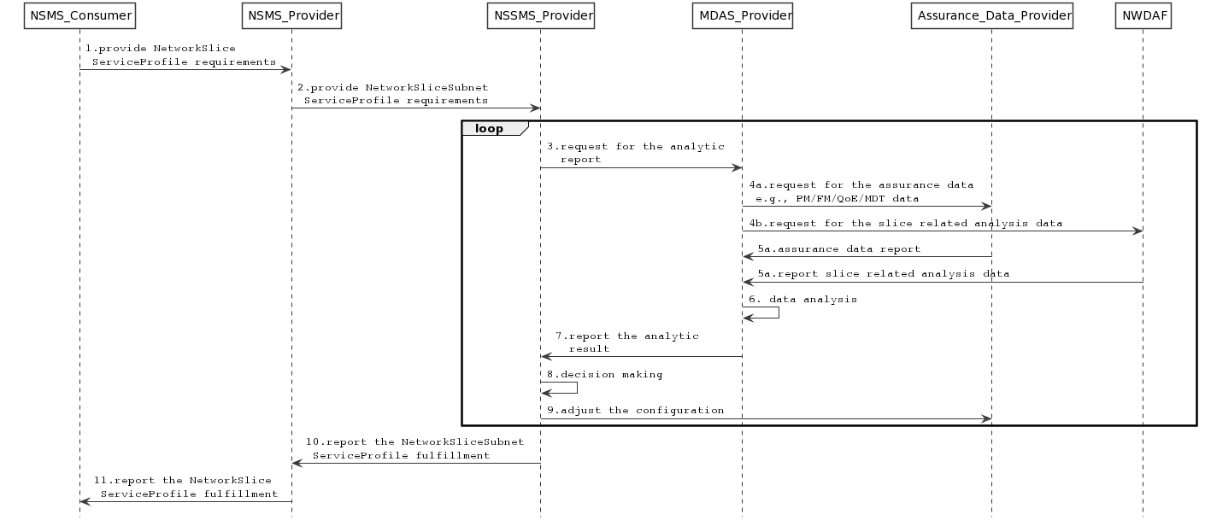
Step1. NSMS Consumer provides NetworkSlice ServiceProfile requirements to NSMS provider by utilizing the generic provisioning management service as defined in clause 11.1, TS 28.532[x], e.g., the requirements for packet delay and service experience.
Step2. NSMS provider decompose the NetworkSlice ServiceProfile requirements into NetworkSliceSubnet SliceProfile requirements then provides them to NSSMS provider, the generic provisioning management service as defined in clause 11.1, TS 28.532[x] is utilized.
Step3. NSSMS provider requests for the analytic report from MDAS provider by utilizing the management data analytic service.
Step4a. MDAS requests for the related performance data (e.g., the packet delay related measurements), fault data, QoE data (e.g., buffer level) and MDT data from Assurance Data Provider by utilizing the generic performance assurance management service as defined in clause 11.3, TS 28.532[x], fault supervision management service as defined in 11.2, TS 28.532[x], and the tracing reporting operations in TS 32.442 [z].
Step4b. MDAS provider request for the slice level related analysis (e.g., Slice load level related network data analytics, Observed Service Experience related network data analytics) from NWDAF by utilizing the Nnwdaf_EventsSubscription Service as defined in clause 4.2, TS 29.520[y].
Step5a. MDAS provider collects the required performance measurements, fault data, MDT data and QoE data by utilizing the generic performance assurance management service as defined in clause 11.3, TS 28.532[x], fault supervision management service as defined in 11.2, TS 28.532[x], and the tracing reporting operations in TS 32.442 [z].
Step5b. MDAS provider collects the required analytic data from NWDAF by utilizing Nnwdaf_AnalyticsInfo service defined in clause 4.3, TS 29.520[y].
Step6. MDAS provider performs the analysis and generates the analytic reports based on the collected data.
Step7. MDAS provider report the analytic reports to the NSSMS provider by utilizing the management data analytic services.
Step8. NSSMS provider decides to implement the NetworkSliceSubnet SliceProfile assurance according to the analytic report provided by MDAS provider.
Note: NSSMS provider may also take the role of the MDAS provider, the MDA service may be provided as an internal service.
Step9. NSSMS provider adjusts the configurations of the NetworkSliceSubnet, the generic provisioning management service as defined in clause 11.1, TS 28.532[x] is utilized.
Note: The NSSMS provider continues to monitor and analyse the performance and perform the adjustment until the NetworkSliceSubnet SliceProfile requirements are assured.
Step10. NSSMS provider sends the notification of NetworkSliceSubnet SliceProfile fulfilment to NSMS provider.
Step11. NSMS provider sends the notification of NetworkSlice ServiceProfile fulfilment to NSMS consumer.

End of Changes

