3GPP TSG-SA5 Meeting #130e S5-202238

e-meeting 20-28 April 2020

Source: Huawei,China Mobile

Title: Move and update Annex A management control loop in different layers from TS 28.535

Document for: Approval

Agenda Item: 6.4.7

1 Decision/action requested
The group is asked to discuss and approval.

2 References
[1] 3GPP TS 28.536: “Management and orchestration; Management services for communication service assurance; Stage2 and Stage3”.

3 Rationale
Firstly, the Annnex A in TS 28.535 described an example of management control loops in different layer, which is a deployment scenario of management control, however, TS 28.535 is the requirement specification, so it proposes to move to TS 28.536 stage2 and stage3 specification.
Secondly, Annex A use the term “Observation” which is not align with close loop step description in other places of TS 28.535 and TS 28.536. So it proposes to update Annex A.
Thirdly, add brief introduction for control loop deployed in different layers.

4 Detailed proposal
It proposes to make the following changes to TS 28.536[1].
1st Change

Annex A (informative):
Control loop deployed in different layers

A.1 Introduction

This example gives a high-level view of control loops deployed in different layers, which consists of control loop in communication service later, control loop in network slice layer, control loop in network slice subnet layer and control loop in NF layer, as described as Figure A.1-1, where the analytic could be leverage MDAS, and different control loops can provide input (interact with) to other control loops (in the same layer or different layers) and obtain the output from other control loops (in the same layer or different layers).

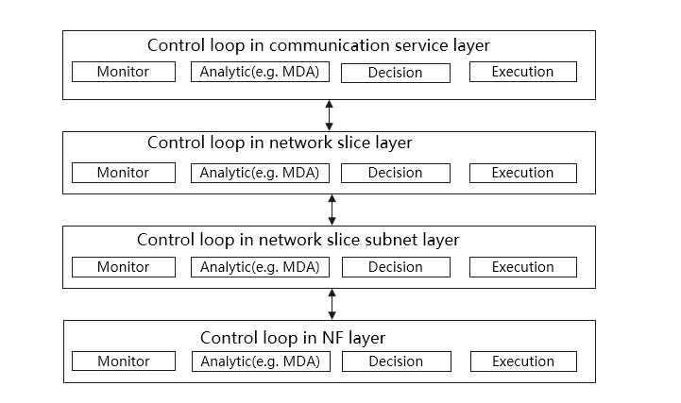
Figure A.1-1 Control loop in different layers

A.2 Control loop in CS layer
SLA requirements provided from CSC are translated into serviceProfile, which represents the requirements for communication service assurance to the CSP. Coordination between control loop in CS layer and control loop in NS layer is needed to calculate the CSI resource requirements and to assure the CSI SLA requirements.
When the CSI is active, Slice QoE is monitored and analysed for the CSI according to end user service experiences.
If service degradation occurs or it is predicted, the 3GPP management system could take actions, i.e. the allocated resources are scaled up or the SLS is adjusted based on pre-agreement/interaction between CSP and CSC.

A.3 Control loop in NS layer
After the network slice provisioning, the SLS related network slice KPIs and end user traffic level QoS/QoE parameters are monitored and reported. When NSI performance is not met, the 3GPP management system identifies the root cause and may reconfigure the resources according to analytical report from MDAS. The NSI resources are also modified accordantly in case the NSI performance requirement needs to be changed based on CSI service requirement adjustment.

A.4 Control loop in NSS layer
The 3GPP management system could have the capability of service observation (e.g., the supervision to the NSSI) based on MDAS. Based on such observation, management actions on the NSSI might be performed if NSSI performance requirements fulfillment indicates a problem. Another possible scenario is that, when the NSSI performance requirement is changed because of the NSI modification management action, the NSSI resources might be also reconfigured.

A.5 Control loop in NF layer
Editor’s note: the control loop in NF layer is FFS.

End of changes

