3GPP TSG-SA5 Meeting #129e S5-201382

e-meeting, 24 February – 4 March 2020

Source: Nokia, Nokia Shanghai Bell, China Mobile, Telefónica S.A

Title: TD proposal for network slice isolation attribute

Document for: Discussion and Endorsement
Agenda Item: 6.4.14

1 Decision/action requested
Please discuss and endorse

2 References
[1] 3GPP TS 28.541: "Management and orchestration; 5G Network Resource Model (NRM); Stage 2 and Stage 3".
[2] GSMA NG.116 - Generic Network Slice Template Version 2.0.
[3] ETSI GR NFV-IFA 030 (V3.3.4): "Network Function Virtualisation (NFV) Release 3; Management and Orchestration; Multiple Administrative Domain Aspect Interfaces Specification".
[4] ETSI GR NFV-IFA 005 (V3.3.1): "Network Function Virtualisation (NFV) Release 3; Management and Orchestration; Or-Vi reference point - Interface and Information Model Specification".
[5] ETSI GR NFV-EVE 018 (V0.0.4): "Network Function Virtualisation (NFV) Release 4; Evolution and Ecosystem;Report on Multi-tenancy in NFV ".
[6] ETSI GR NFV-SEC 012 (V3.1.1): "Network Function Virtualisation (NFV) Release 3; Security; System architecture specification for execution of sensitive NFV components ".

3 Rationale
Isolation Level is defined in GST/NEST to require 3GPP network to support network slice isolation in different levels. E.g. it requests Physical or Logical in high level, the physical islation includes processor, memory and network isolation, and logical isolation includes virtual resource, network function or service/tenant isolation.
To support network slice isolation requirement in network slice, network slice subnet and management function layers, 3gpp management function needs to further break down the requirement in more detail in each layer.
In addition, some network slices could be grouped together, and islated from other group of the network slices. Therefor the isolation requirement may not only apply to a single network slice, but also a group of slices. E.g. in below picture, NS-1-1 and NS-1-2 are belong to same Tenant, so they don’t need to isolate with each other. However NS-1-1 and NS-2-1 need to be isolated from each other.
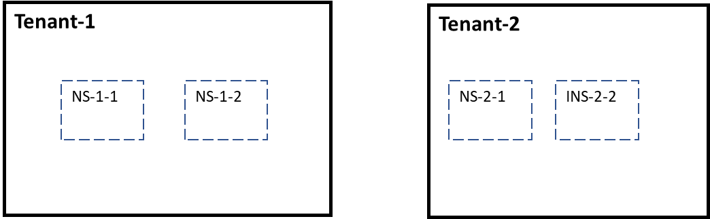
Therefor, the isolation could be based on slice group.

4 Detailed proposal

1. Define Isolation Group to gather a set of Network Slices which share same isolation requirements
The isolation group can be created based on tenant, SST, etc. The Isolation Group can be associated with Network Slice or Network Slice Subnet
IsolationGroup
The IsolationGroup IOC includes attributes inherited from Top IOC and the following attributes:
Attribute Name | Support Qualifier | isReadable | isWritable | isInvariant | isNotifyable
resourceType | M | T | F | T | F
groupType | M | T | F | T | F
Attributes related to roles
isolationProfile or isolationPolicy | M | T | T | F | T
- resourceType defines the type of resource will be allocated for the network slice or network slice subnet, it can be, e.g. management resource (e.g. FM/PM data, management service, etc.), managed resource (RAN or 5GC network function, NF service, etc.), or mixed types of resource. Each type of resource of a netework slice/NSS can be associated with one IsolationGroup
- groupType defines the scope of the IsolationGroup, e.g. it can be a tenant, service type, region, industry, or mixed, etc.

2. Define Isolation Profile to link to the Isolation Group
It defines the islation level and isolation/protection policies to isolate the Network Slices in the Isolation Group from other Network Slices. The isolation policies in different domains (e.g. RAN, CN, TN) and different layers (e.g. Network Slice layer, NSS layer, MF layers) could be different.

IsolationProfile
The IsolationProfile IOC includes attributes inherited from Top IOC and the following attributes:
Attribute Name | Support Qualifier | isReadable | isWritable | isInvariant | isNotifyable
isolationDomain | M | T | F | T | F
resourceType | M | T | F | T | F
isolationLevel | M | T | T | F | T
Attributes related to roles
isolationPolicy | M | T | T | F | T

- isolationDomain defines the domain of the network in which the related resource is isolated, it can be, e.g. E2E Network Slice domain, Core Network (CN) domain, Access Network (AN) domain, Transport Network (TN) Domain, virtualization domain, etc.
- Refer to GSMA NG.116 (Generic Network Slice Template) for definition of isolationLevel

Note:
- Isolation level and/or policy can be various for different isolation domains.

IsolationPolicy
The IsolationPolicy IOC includes attributes inherited from Top IOC and the following attributes:
Attribute Name | Support Qualifier | isReadable | isWritable | isInvariant | isNotifyable
isolationRules | M | T | T | F | T
- isolutionRules defines rules to isolate and protect specific resource in a specific layer and domain, e.g. rules to logically isolate general management data (FM, PM data, log, etc.) of a E2E network slice could be “protect the data with access control and encryption at rest, protect data with TLS/SLS by using slice specific credential in transmission”. Rules to logically isolate management service could be “dedicated management service instance should be created for the slice”. Rules to physically isolate radio access network subnet for a Network Slice could be “dedicated DUs/Cells should be allocated to the slice”. etc. Rules to logically isolate core network subnet of a Network Slice could be “separate NFs/NF Services of the subnetwork with robust implementations of the virtualization layer (e.g. hypervisor, container platform, etc.), and separate NF/NF Services’ traffics with dedicated virtual switches, VLANs, etc.”

3. Define Isolation Policy to link to the Isolation Group
It defines the islation level and isolation/protection rules to isolate the Network Slices in the Isolation Group from other Network Slices. The isolation policies in different domains (e.g. RAN, CN, TN) and different layers (e.g. Network Slice layer, NSS layer, MF layers) could be different.
IsolationPolicy
The IsolationPolicy IOC includes attributes inherited from Top IOC and the following attributes:
Attribute Name | Support Qualifier | isReadable | isWritable | isInvariant | isNotifyable
isolationDomain | M | T | F | T | F
resourceType | M | T | F | T | F
isolationLevel | M | T | T | F | T
isolationRules | M | T | T | F | T

- isolationDomain defines the domain of the network in which the related resource is isolated, it can be, e.g. E2E Network Slice domain, Core Network (CN) domain, Access Network (AN) domain, Transport Network (TN) Domain, virtualization domain, etc.
- Refer to GSMA NG.116 (Generic Network Slice Template) for definition of isolationLevel
- isolutionRules defines rules to isolate and protect specific resource in a specific layer and domain, e.g. rules to logically isolate general management data (FM, PM data, log, etc.) of a E2E network slice could be “protect the data with access control and encryption at rest, protect data with TLS/SLS by using slice specific credential in transmission”. Rules to logically isolate management service could be “dedicated management service instance should be created for the slice”. Rules to physically isolate radio access network subnet for a Network Slice could be “dedicated DUs/Cells should be allocated to the slice”. etc. Rules to logically isolate core network subnet of a Network Slice could be “separate NFs/NF Services of the subnetwork with robust implementations of the virtualization layer (e.g. hypervisor, container platform, etc.), and separate NF/NF Services’ traffics with dedicated virtual switches, VLANs, etc.”

5 Ask for endorsement
Network slice isolation in management view is critical for commercial deployment of 5G network and network slice, therefore it should be addressed in SA5. As isolation in different dimensions as described in this discussion paper is a little complicated, further study in SA5 Rel17 is required. Create new study item in SA5 for isolation management could be one option.

