3GPP TSG-SA5 Meeting #129e S5-201314rev3

e-meeting, 24 February – 4 March 2020
CR-Form-v12.0
CHANGE REQUEST
 | 28.533 | CR | 0060 | rev | - | Current version: | 16.2.0
For HELP on using this form: comprehensive instructions can be found at
http://www.3gpp.org/Change-Requests.

Proposed change affects: | UICC apps |  | ME |  | Radio Access Network | X | Core Network | X

Title: | Add the cooperation with CN and RAN
Source to WG: | Huawei, Ericsson
Source to TSG: | S5
Work item code: | COSLA |  |  |  |  |  | Date: |  |  | 2020-02-14
Category: | B |  |  |  |  |  | Release: |  |  | Rel-16
 | Use one of the following categories:  F (correction)  A (mirror corresponding to a change in an earlier release)  B (addition of feature),  C (functional modification of feature)  D (editorial modification)  Detailed explanations of the above categories can  be found in 3GPP TR 21.900. |  |  |  |  |  |  |  | Use one of the following releases:  Rel-8 (Release 8)  Rel-9 (Release 9)  Rel-10 (Release 10)  Rel-11 (Release 11)  Rel-12 (Release 12)  Rel-13 (Release 13)  Rel-14 (Release 14)  Rel-15 (Release 15)  Rel-16 (Release 16)
Reason for change: |  | Management system has the overall view of the network and the architecture should reflect the coordination with CN and RAN network.
Summary of change: |  | Add description of management cooperation with CN and RAN network.
Consequences if not approved: |  | The cooperation between management, CN and RAN network are missing in the specification.
Clauses affected: |  | 5.X (new)
 |  | Y | N
Other specs |  |  | X | Other core specifications |  |  |  | TS/TR ... CR ...
affected: |  |  | X | Test specifications |  |  |  | TS/TR ... CR ...
(show related CRs) |  |  | X | O&M Specifications |  |  |  | TS/TR ... CR ...
Other comments:
This CR's revision history:

1st Change

5.X Cooperation with Core network and RAN
Coordination may be needed between the 3GPP management system, Core network and RAN to provide closed loop assurance in a coordinated way as shown in figure 5.x-1. The 3GPP management system provides the closed loop assurance from the management perspective based on the collected management data. Core network and RAN contribute to the decision from the control plane and user plane perspective. The management loops may run independently from the signalling loops. There may be multiple loops according to operator needs.
Cross domain management
loop

Domain
management
loop
CN
RAN
Signaling control loop

Signaling control loop

Management control loop

Figure 5.x-1: Cooperation between 3GPP management system, CN and RAN
1) Management closed loops need interaction with Core network and RAN network.
2) Some assurance objectives can be delegated to be achieved by network element level control signalling loops as per operator need. For example, to handle the single UE behaviour which contributes to the overall network assurance or address the specific UE related CSI requirements.
3) In cases where assurance objectives are supported by the network element level loops, the 3GPP management system ensures network element loops actions are coordinated to achieve the desired effect.
4) Delegation scenarios may include RAN control loop and management control loop only scenario, Core control loop and management control loop only scenario, or RAN control loop, core control loop and management control loop scenario.

Second Change

Annex X (informative): Examples of hybrid Assurance solutions
This Annex provides two examples of hybrid Assurance solutions as shown in Figure X.1 and X.2. The management control loops are used for cross-domain assurance purposes and for domain assurance purpose, in the RAN and CN network there may have domain specific assurance loops in operation in the delegation scenario.
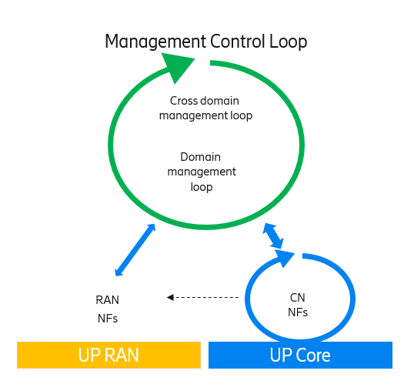
Figure X.1: Hybrid assurance solution with CN delegation
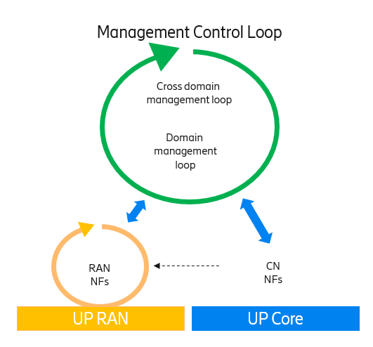
Figure X.2:Hybrid assurance solution with RAN delegation

End of Changes

