**3GPP TSG-SA5 Meeting #129e *S5-201314rev2***

**e-meeting, 24 February – 4 March 2020**

|  |  |  |  |  |  |  |  |  |
| --- | --- | --- | --- | --- | --- | --- | --- | --- |
| *CR-Form-v12.0* | | | | | | | | |
| **CHANGE REQUEST** | | | | | | | | |
|  | | | | | | | | |
|  |  | **CR** |  | **rev** | **-** | **Current version:** |  |  |
|  | | | | | | | | |
| *For* [***HE******LP***](http://www.3gpp.org/3G_Specs/CRs.htm#_blank)*on using this form: comprehensive instructions can be found at* [*http://www.3gpp.org/Change-Requests*](http://www.3gpp.org/Change-Requests)*.* | | | | | | | | |
|  | | | | | | | | |

|  |  |  |  |  |  |  |  |  |
| --- | --- | --- | --- | --- | --- | --- | --- | --- |
| ***Proposed change affects:*** | UICC apps |  | ME |  | Radio Access Network | **X** | Core Network | **X** |

|  |  |  |  |  |  |  |  |  |  |  |
| --- | --- | --- | --- | --- | --- | --- | --- | --- | --- | --- |
|  | | | | | | | | | | |
| ***Title:*** | Add the cooperation with CN and RAN | | | | | | | | | |
|  |  | | | | | | | | | |
| ***Source to WG:*** | , Ericsson | | | | | | | | | |
| ***Source to TSG:*** | S5 | | | | | | | | | |
|  |  | | | | | | | | | |
| ***Work item code:*** |  | | | | |  | ***Date:*** | | | 2020-02-14 |
|  |  | | | |  | |  | | |  |
| ***Category:*** | B |  | | | | | ***Release:*** | | | Rel-16 |
|  | *Use one of the following categories:* ***F*** *(correction)* ***A*** *(mirror corresponding to a change in an earlier release)* ***B*** *(addition of feature),* ***C*** *(functional modification of feature)* ***D*** *(editorial modification)*  Detailed explanations of the above categories can be found in 3GPP [TR 21.900](http://www.3gpp.org/ftp/Specs/html-info/21900.htm). | | | | | | | | *Use one of the following releases: Rel-8 (Release 8) Rel-9 (Release 9) Rel-10 (Release 10) Rel-11 (Release 11) Rel-12 (Release 12)* *Rel-13 (Release 13) Rel-14 (Release 14) Rel-15 (Release 15) Rel-16 (Release 16)* | |
|  |  | | | | | | | | | |
| ***Reason for change:*** | | Management system has the overall view of the network and the architecture should reflect the coordination with CN and RAN network. | | | | | | | | |
|  | |  | | | | | | | | |
| ***Summary of change:*** | | Add description of management cooperation with CN and RAN network. | | | | | | | | |
|  | |  | | | | | | | | |
| ***Consequences if not approved:*** | | The cooperation between management, CN and RAN network are missing in the specification. | | | | | | | | |
|  | |  | | | | | | | | |
| ***Clauses affected:*** | | 5.X (new) | | | | | | | | |
|  | |  | | | | | | | | |
|  | | **Y** | **N** |  | | | |  | | |
| ***Other specs*** | |  | **X** | Other core specifications | | | | TS/TR ... CR ... | | |
| ***affected:*** | |  | **X** | Test specifications | | | | TS/TR ... CR ... | | |
| ***(show related CRs)*** | |  | **X** | O&M Specifications | | | | TS/TR ... CR ... | | |
|  | |  | | | | | | | | |
| ***Other comments:*** | |  | | | | | | | | |
|  | |  | | | | | | | | |
| ***This CR's revision history:*** | |  | | | | | | | | |

|  |
| --- |
| **1st Change** |

## 5.X Cooperation with Core network and RAN

Coordination may be needed between the 3GPP management system, Core network and RAN to provide closed loop assurance in a coordinated way as shown in figure 5.x-1. The 3GPP management system provides the closed loop assurance from the management perspective based on the collected management data. Core network and RAN contribute to the decision from the control plane and user plane perspective. The management loops may run independently from the signalling loops. There may be multiple loops according to operator needs.

Cross domain management

loop

Domain

management

loop

CN

RAN

**Signaling control loop**

**Signaling control loop**

**Management control loop**

Figure 5.x-1: Cooperation between 3GPP management system, CN and RAN

1) Management closed loops need interaction with Core network and RAN network.

2) Some assurance objectives can be delegated to be achieved by network element level control signalling loops as per operator need. For example, to reduce the deployment complexity or address the specific CSI requirements.

3) In cases where assurance objectives are supported by the network element level loops, the 3GPP management system ensures network element loops actions are coordinated to achieve the desired effect.

4) Delegation scenarios may include RAN control loop and management control loop only scenario, Core control loop and management control loop only scenario, or RAN control loop, core control loop and management control loop scenario.

|  |
| --- |
| **Second Change** |

Annex X (informative): Examples of hybrid Assurance solutions

This Annex provides two examples of hybrid Assurance solutions as shown in Figure X.1 and X.2. The management control loops are used for cross-domain assurance purposes and for domain assurance (RAN and CN) purpose, in the RAN and CN domain there may or may not be domain specific assurance loops in operation,

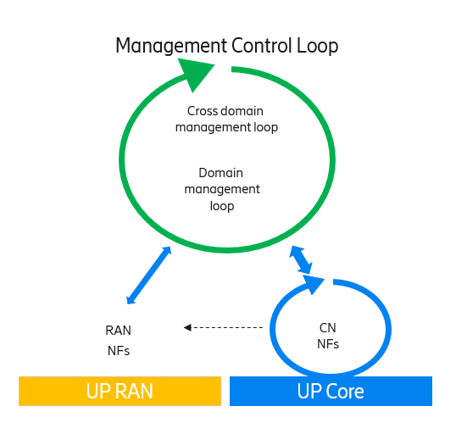

Figure X.1: Hybrid assurance solution with distributed CN assurance

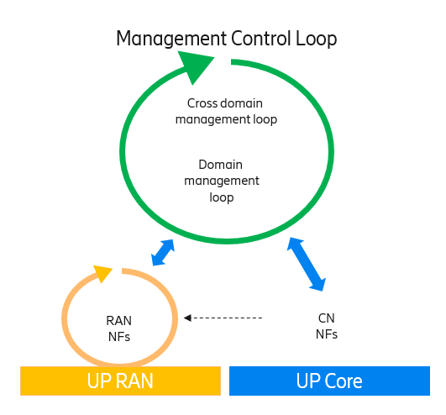

Figure X.2:Hybrid assurance solution with distribtued RAN assurance

|  |
| --- |
| **End of Changes** |