3GPP TSG-SA5 Meeting #129e S5-201194

e-meeting, 24 February – 4 March 2020
CR-Form-v11.4
CHANGE REQUEST
 | 28.533 | CR | 0057 | rev | - | Current version: | 16.2.0
For HELP on using this form: comprehensive instructions can be found at
http://www.3gpp.org/Change-Requests.

Proposed change affects: | UICC apps |  | ME |  | Radio Access Network | X | Core Network | X

Title: | Update Clause 5.3 Management service deployment based on ZSM framework
Source to WG: | Huawei
Source to TSG: | S5
Work item code: | COSLA |  |  |  |  |  | Date: |  |  | 2020-02-14
Category: | F |  |  |  |  |  | Release: |  |  | Rel-16
 | Use one of the following categories:  F (correction)  A (mirror corresponding to a change in an earlier release)  B (addition of feature),  C (functional modification of feature)  D (editorial modification)  Detailed explanations of the above categories can  be found in 3GPP TR 21.900. |  |  |  |  |  |  |  | Use one of the following releases:  Rel-8 (Release 8)  Rel-9 (Release 9)  Rel-10 (Release 10)  Rel-11 (Release 11)  Rel-12 (Release 12)  Rel-13 (Release 13)  Rel-14 (Release 14)  Rel-15 (Release 15)  Rel-16 (Release 16)
Reason for change: |  | Clause 5.3 Management service deployment based on ZSM framework is not align with ZSM 002 for the missing of data services.
Summary of change: |  | Update Clause 5.3 Management service deployment based on ZSM framework with data service description.
Consequences if not approved: |  | Clause 5.3 is not align with ZSM framework.
Clauses affected: |  | 5.3
 |  | Y | N
Other specs |  |  | X | Other core specifications |  |  |  | TS/TR ... CR ...
affected: |  |  | X | Test specifications |  |  |  | TS/TR ... CR ...
(show related CRs) |  |  | X | O&M Specifications |  |  |  | TS/TR ... CR ...
Other comments:

This CR's revision history:

1st Change

5.3 Management service deployment based on ZSM framework
ZSM framework reference architecture is described in ETSI GS ZSM 002 [29]. The ZSM framework reference architecture defines a set of architectural building blocks that collectively enable construction of more complex management services and management functions using a consistent set of composition and interoperation patterns. So it is important to show the 3GPP Management Service deployment based on ZSM Framework.Figure 5.3-1 shows an example of 3GPP Management Service deployment based on ZSM framework reference architecture. In this example:
- 3GPP Cross Management Domain (A bundle of Cross Domain MnFs) provides a set of MnS(s) for Cross Domain Network (including Network Slice) and consumes MnSs provided by the RAN Management Domain and the CN Management Domain. 3GPP Cross Management Domain can implement close loop (s) within the domain. 3GPP Cross Management Domain is a Management Domain in ETSI ZSM Framework.
- RAN Management Domain (A bundle of RAN MnFs) provides a set of MnS(s) for the RAN SubNetwork and NF. RAN Management Domain can implement close loop(s) within the domain. RAN Management Domain is a Management Domain in ETSI ZSM Framework.
- CN Management Domain (A bundle of CN MnFs) provides a set of MnS(s) for a CN SubNetwork and NF. CN Management Domain can implement the close loop(s) within the domain. CN Domain is a Management Domain in ETSI ZSM Framework.
- A 3GPP Management Framework Consumer (e.g. ZSM E2E Service Management Domain, vertical OT system, BSS) can consume MnS(s) provided by the 3GPP Cross Management Domain, RAN Management Domain,CN Management Domain. 3GPP Management Framework Consumer is E2E Service Management Domain or ZSM framework consumer in ETSI ZSM Framework.

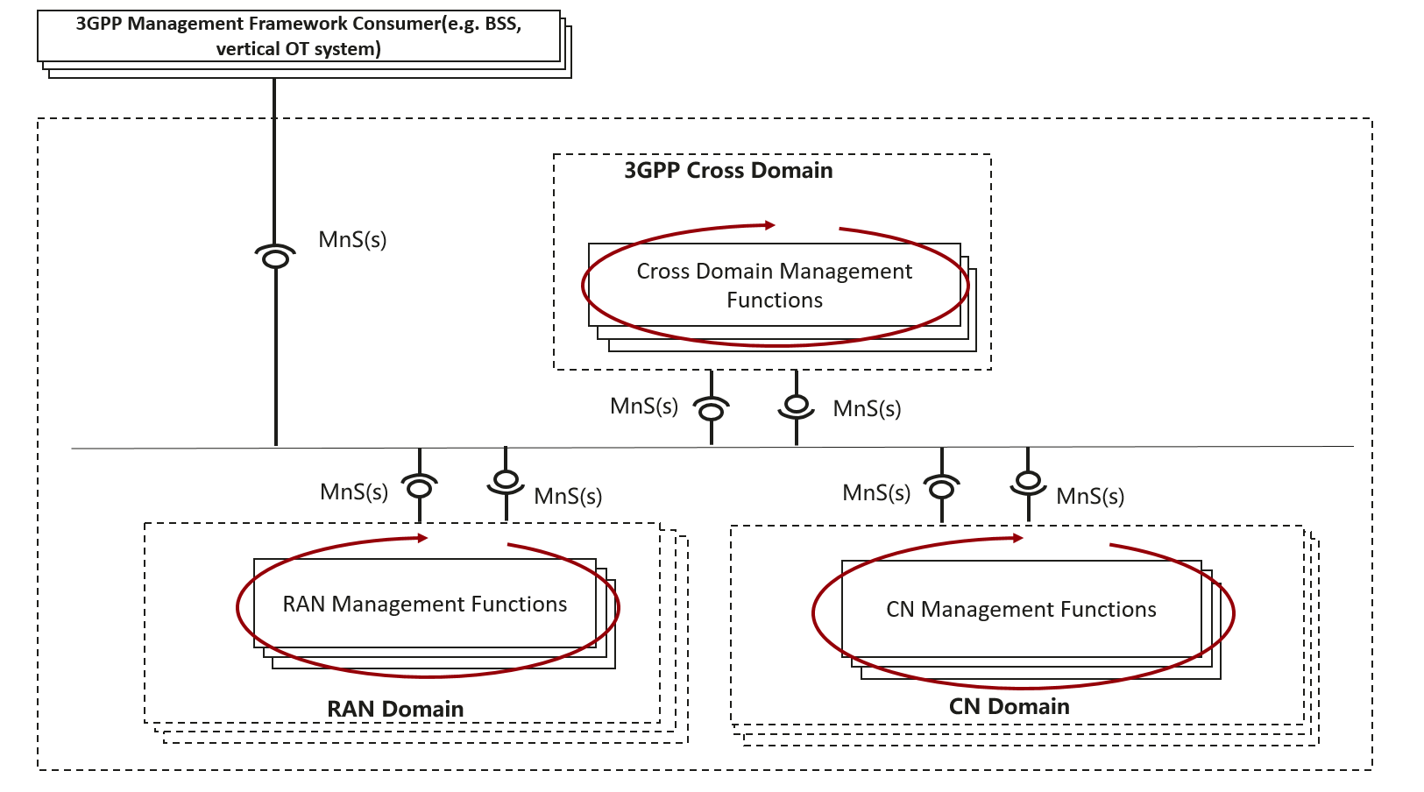
Figure 5.3-1: An example of Management Service deployment framework.

End of Change

