3GPP TSG-SA5 Meeting #129e S5-201919

e-meeting, 24 February – 4 March 2020
CR-Form-v11.4
CHANGE REQUEST
 | 28.541 | CR | 0239 | rev | - | Current version: | 16.3.0
For HELP on using this form: comprehensive instructions can be found at
http://www.3gpp.org/Change-Requests.

Proposed change affects: | UICC apps |  | ME |  | Radio Access Network | X | Core Network

Title: | Update the NR NRM to align with NG-RAN overview architecture
Source to WG: | Huawei
Source to TSG: | S5
Work item code: | eNRM |  |  |  |  |  | Date: |  |  | 2020-02-14
Category: | F |  |  |  |  |  | Release: |  |  | Rel-16
 | Use one of the following categories:  F (correction)  A (mirror corresponding to a change in an earlier release)  B (addition of feature),  C (functional modification of feature)  D (editorial modification)  Detailed explanations of the above categories can  be found in 3GPP TR 21.900. |  |  |  |  |  |  |  | Use one of the following releases:  Rel-8 (Release 8)  Rel-9 (Release 9)  Rel-10 (Release 10)  Rel-11 (Release 11)  Rel-12 (Release 12)  Rel-13 (Release 13)  Rel-14 (Release 14)  Rel-15 (Release 15)  Rel-16 (Release 16)
Reason for change: |  | In TS 38.300 NG-RAN overview architecture in clause 4.1, the gNB can connect to the ng-eNB via Xn interface, however, this interface can not be support by our NR NRM.
Summary of change: |  | - Update Figure 4.2.1.1-2: NRM for EPs for all deployment scenarios and EP_XnC definition to support Xn interface between gNB and en-gNB.The main change in the figure is:  - Replace the GNBCUCPFunction<<ProxyClass>> with GNBCUCPNeighbor<<ProxyClass>>;  - Replace the GNBCUUPFunction<<ProxyClass>> with GNBCUUPNeighbor<<ProxyClass>>;  - Combine two EP_X2U and replace it’s associated GNBCUUPFunction<<ProxyClass>> with GNBCUUPNeighbor<<ProxyClass>>;  - Update the EP_XnC YANG module description
Consequences if not approved: |  | The NR NRM is not align with NG-RAN defined in TS 38.300
Clauses affected: |  | 4.2.1.1, 4.3.17.1, 4.3.17.2, 4.3.X(new), 4.3.Y(new),E.5.2
 |  | Y | N
Other specs |  |  | X | Other core specifications |  |  |  | TS/TR ... CR ...
affected: |  |  | X | Test specifications |  |  |  | TS/TR ... CR ...
(show related CRs) |  |  | X | O&M Specifications |  |  |  | TS/TR ... CR ...
Other comments:

This CR's revision history:

1st Change

4.2.1.1 Relationships
This clause depicts the set of classes (e.g. IOCs) that encapsulates the information relevant for this gNB and en-gNB. For the UML semantics, see 3GPP TS 32.156 [43]. Subsequent clauses provide more detailed specification of various aspects of these classes.
The model fragments are for management representation of gNB and en-gNB for all NG-RAN deployment scenario as listed below.
- Non-split NG-RAN deployment scenario, represents the gNB defined in TS 38.401[4].
- 2-split NG-RAN deployment scenario, represents the gNB consist of gNB-CU and gNB-DU defined in TS 38.401[4] clause 6.1.1.
- 3-split NG-RAN deployment scenario, represents the gNB consist of gNB-CU-CP, gNB-CU-UP and gNB-DU defined in TS 38.401[4] clause 6.1.2.

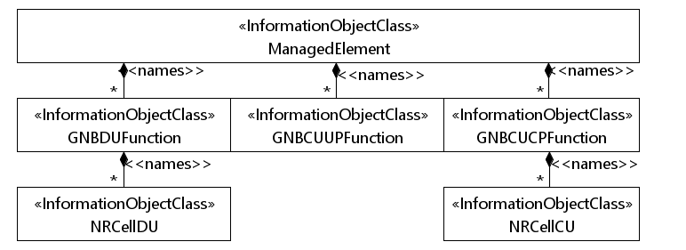
Figure 4.2.1.1-1: NRM for all deployment scenarios

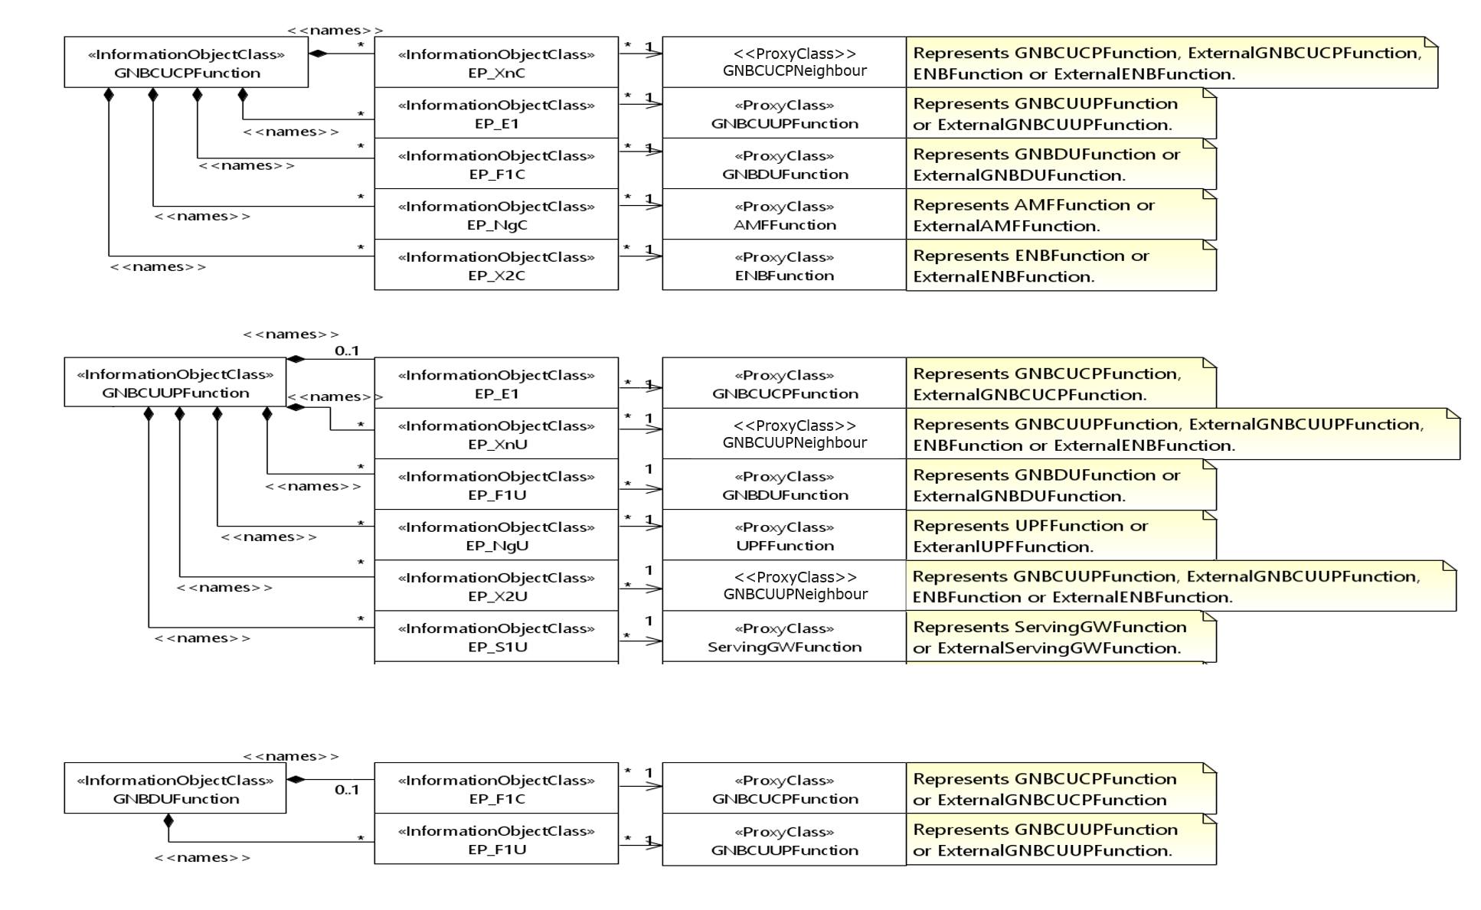
Figure 4.2.1.1-2: NRM for EPs for all deployment scenarios

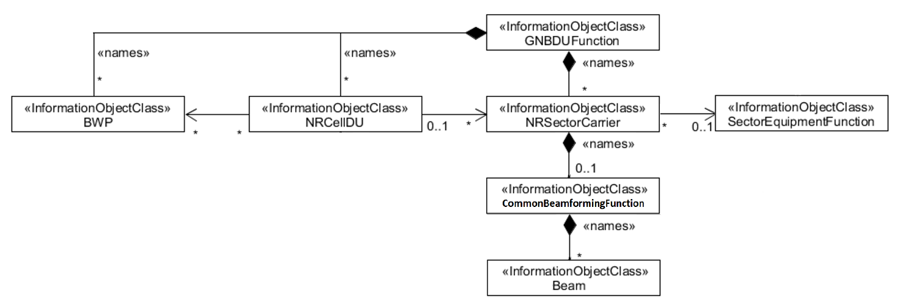
Figure 4.2.1.1-3: NRM for <<IOC>>NRSectorCarrier and <<IOC>>BWP for all deployment scenarios

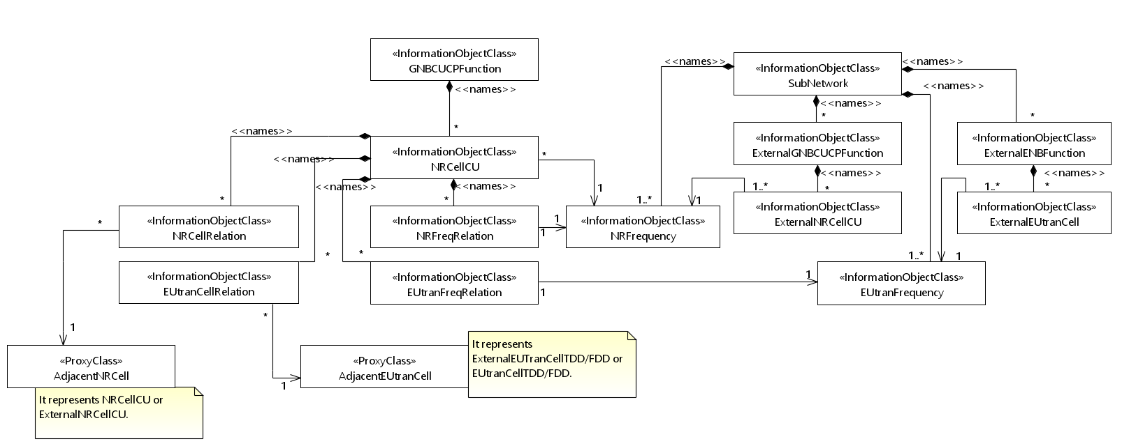
Figure 4.2.1.1-4: Cell Relation view for all deployment scenarios
NOTE 1: The above NRM fragment uses SubNetwork to hold both NR and LTE external entities and frequencies.
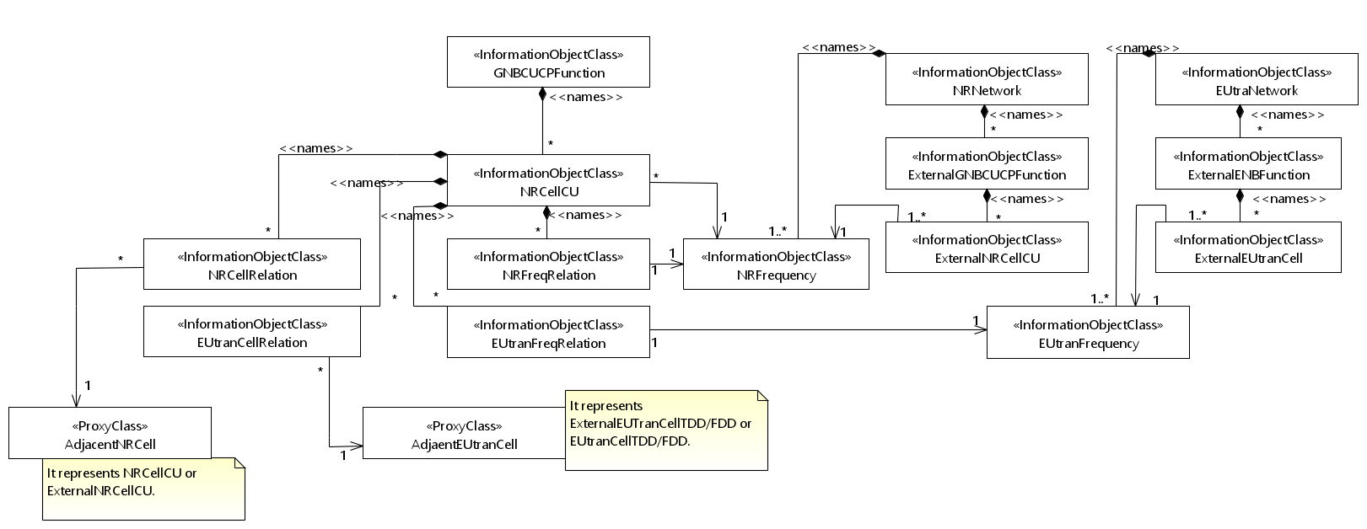
Figure 4.2.1.1-5: Cell Relation view for all deployment scenarios
NOTE 2: The above NRM fragment uses NRNetwork to hold NR external entities and frequency and using EUtraNetwork to hold LTE external entities and frequency. The NRNetwork and EUtraNetwork are subclasses of SubNetwork (defined in TS 28.622 [30]) with no additional attributes. The reason using NRNetwork and EUtraNetwork is for a clean separation of NR external entities and frequency and LTE external entities and frequency.

2nd Change

4.3.17 EP_XnC

4.3.17.1 Definition
This IOC represents the local gNB node end point of the logical link, supporting Xn Application protocols, to a neighbour NG-RAN node (including gNB and ng-eNB). The Xn Application PDUs are carried over SCTP/IP/Data link layer/Physical layer stack. See subclause 7 of 3GPP TS 38.420 [6].

4.3.17.2 Attributes
The EP_XnC IOC includes attributes inherited from EP_RP IOC (defined in TS 28.622[30]) and the following attributes:
Attribute name | Support Qualifier | isReadable | isWritable | isInvariant | isNotifyable
localAddress | O | T | T | F | T
remoteAddress | O | T | T | F | T

4.3.17.3 Attribute constraints
None

4.3.17.4 Notifications
The common notifications defined in subclause 4.5 are valid for this IOC, without exceptions or additions.

3rd Change

4.3.X GNBCUCPNeighbour <<ProxyClass>>

4.3.X.1 Definition
This IOC represents an <<IOC>>GNBCUCPFunction, <<IOC>>ExternalGNBCUCPFunction, <<IOC>>ENBFunction and <<IOC>>ExternalENBFunction.

4.3.X.2 Attributes
See that defined in <<IOC>>GNBCUCPFunction, <<IOC>>ExternalGNBCUCPFunction, <<IOC>>ENBFunction and <<IOC>>ExternalENBFunction.

4.3.X.3 Attribute constraints
See that defined in <<IOC>>GNBCUCPFunction, <<IOC>>ExternalGNBCUCPFunction, <<IOC>>ENBFunction and <<IOC>>ExternalENBFunction.

4.3.X.4 Notifications
See respective IOCs.

4.3.Y GNBCUUPNeighbour <<ProxyClass>>

4.3.Y.1 Definition
This IOC represents an <<IOC>>GNBCUUPFunction, <<IOC>>ExternalGNBCUUPFunction, <<IOC>>ENBFunction and <<IOC>>ExternalENBFunction.

4.3.Y.2 Attributes
See that defined in <<IOC>>GNBCUUPFunction, <<IOC>>ExternalGNBCUUPFunction, <<IOC>>ENBFunction and <<IOC>>ExternalENBFunction.

4.3.Y.3 Attribute constraints
See that defined in <<IOC>>GNBCUUPFunction, <<IOC>>ExternalGNBCUUPFunction, <<IOC>>ENBFunction and <<IOC>>ExternalENBFunction.

4.3.Y.4 Notifications
See respective IOCs.
4th Change

E.5.2 module_3gpp-nr-nrm-ep.yang

module _3gpp-nr-nrm-ep {
yang-version 1.1;
namespace "urn:3gpp:sa5:_3gpp-nr-nrm-ep";
prefix "ep3gpp";

import _3gpp-common-ep-rp { prefix eprp3gpp; }
import _3gpp-common-managed-element { prefix me3gpp; }
import _3gpp-common-top { prefix top3gpp; }
import _3gpp-nr-nrm-gnbcucpfunction { prefix gnbcucp3gpp; }
import _3gpp-nr-nrm-gnbcuupfunction { prefix gnbcuup3gpp; }
import _3gpp-nr-nrm-gnbdufunction { prefix gnbdu3gpp; }

organization "3GPP SA5";
description "Defines the YANG mapping of the NR related endpoint
Information Object Classes (IOCs) that are part of the NR Network
Resource Model (NRM).";
reference "3GPP TS 28.541 5G Network Resource Model (NRM)";

revision 2020-03-02 { reference S5-201191"; }

revision 2019-06-17 {
description "Initial revision";
}

grouping EP_E1Grp {
description "Represents the EP_E1 IOC.";
reference "3GPP TS 28.541, 3GPP TS 38.401";
uses eprp3gpp:EP_Common;
}

grouping EP_F1CGrp {
description "Represents the EP_F1C IOC.";
reference "3GPP TS 28.541, 3GPP TS 38.470";
uses eprp3gpp:EP_Common;
}

grouping EP_F1UGrp {
description "Represents the EP_F1U IOC.";
reference "3GPP TS 28.541, 3GPP TS 38.470";
uses eprp3gpp:EP_Common;
}

grouping EP_XnCGrp {
description "Represents the EP_XnC IOC.";
reference "3GPP TS 28.541, 3GPP TS 38.420";
uses eprp3gpp:EP_Common;
}

grouping EP_XnUGrp {
description "Represents the EP_XnU IOC.";
reference "3GPP TS 28.541, 3GPP TS 38.420";
uses eprp3gpp:EP_Common;
}

grouping EP_NgCGrp {
description "Represents the EP_NgC IOC.";
reference "3GPP TS 28.541, 3GPP TS 38.470";
uses eprp3gpp:EP_Common;
}

grouping EP_NgUGrp {
description "Represents the EP_NgU IOC.";
reference "3GPP TS 28.541, 3GPP TS 38.470";
uses eprp3gpp:EP_Common;
}

grouping EP_X2CGrp {
description "Represents the EP_X2C IOC.";
reference "3GPP TS 28.541, 3GPP TS 36.423";
uses eprp3gpp:EP_Common;
}

grouping EP_X2UGrp {
description "Represents the EP_X2U IOC.";
reference "3GPP TS 28.541, 3GPP TS 36.425";
uses eprp3gpp:EP_Common;
}

grouping EP_S1UGrp {
description "Represents the EP_S1U IOC.";
reference "3GPP TS 28.541, 3GPP TS 36.410";
uses eprp3gpp:EP_Common;
}

augment "/me3gpp:ManagedElement/gnbcucp3gpp:GNBCUCPFunction" {

list EP_E1 {
description "Represents the local end point of the logical link,
supporting E1 interface between gNB-CU-CP and gNB-CU-UP.";
reference "3GPP TS 28.541, 3GPP TS 38.401";
key id;
uses top3gpp:Top_Grp;
container attributes {
uses EP_E1Grp;
}
}

list EP_F1C {
description "Represents the local end point of the control plane
interface (F1-C) between the DU and CU or CU-CP.";
reference "3GPP TS 28.541, 3GPP TS 38.470";
key id;
uses top3gpp:Top_Grp;
container attributes {
uses EP_F1CGrp;
}
}

list EP_NgC {
description "Represents the local end point of the control plane
interface (NG-C) between the gNB and NG-Core entity.";
reference "3GPP TS 28.541, 3GPP TS 38.470";
key id;
uses top3gpp:Top_Grp;
container attributes {
uses EP_NgCGrp;
}
}

list EP_XnC {
description "Represents the local gNB node end point of the logical
link, supporting Xn application protocols, to a neighbour NG-RAN node
(including gNB and ng-eNB). The Xn Application PDUs are carried over
SCTP/IP/Data link layer/Physical layer stack.";
reference "3GPP TS 28.541, 3GPP TS 38.420 subclause 7";
key id;
uses top3gpp:Top_Grp;
container attributes {
uses EP_XnCGrp;
}
}

list EP_X2C {
description "Represents the local end point of the logical link,
supporting X2-C application protocols used in EN-DC, to a neighbour
eNB or en-gNB node.";
reference "3GPP TS 28.541, 3GPP TS 36.423";
key id;
uses top3gpp:Top_Grp;
container attributes {
uses EP_X2CGrp;
}
}
}

augment "/me3gpp:ManagedElement/gnbcuup3gpp:GNBCUUPFunction" {

list EP_E1 {
description "Represents the local end point of the logical link,
supporting E1 interface between gNB-CU-CP and gNB-CU-UP.";
reference "3GPP TS 28.541, 3GPP TS 38.401";
key id;
uses top3gpp:Top_Grp;
container attributes {
uses EP_E1Grp;
}
}

list EP_F1U {
description "Represents the local end point of the user plane
interface (F1-U) between the DU and CU or CU-UP.";
reference "3GPP TS 28.541, 3GPP TS 38.470";
key id;
uses top3gpp:Top_Grp;
container attributes {
uses EP_F1UGrp;
}
}

list EP_NgU {
description "Represents the local end point of the NG user plane
(NG-U) interface between the gNB and the UPGW.";
reference "3GPP TS 28.541, 3GPP TS 38.470";
key id;
uses top3gpp:Top_Grp;
container attributes {
uses EP_NgUGrp;
}
}

list EP_XnU {
description "Represents the one end-point of a logical link supporting
the Xn user plane (Xn-U) interface. The Xn-U interface provides
non-guaranteed delivery of user plane PDUs between two NG-RAN nodes.";
reference "3GPP TS 28.541, 3GPP TS 38.420";
key id;
uses top3gpp:Top_Grp;
container attributes {
uses EP_XnUGrp;
}
}

list EP_X2U {
description "Represents the local end-point of a logical link supporting
the X2 user plane (X2-U) interface used in EN-DC.";
reference "3GPP TS 28.541, 3GPP TS 36.425";
key id;
uses top3gpp:Top_Grp;
container attributes {
uses EP_X2UGrp;
}
}

list EP_S1U {
description "Represents the local end point of the logical link,
supporting S1-U interface towards a S-GW node.";
reference "3GPP TS 28.541, 3GPP TS 36.410";
key id;
uses top3gpp:Top_Grp;
container attributes {
uses EP_S1UGrp;
}
}
}

augment "/me3gpp:ManagedElement/gnbdu3gpp:GNBDUFunction" {

list EP_F1C {
description "Represents the local end point of the control plane
interface (F1-C) between the DU and CU or CU-CP.";
reference "3GPP TS 28.541, 3GPP TS 38.470";
key id;
uses top3gpp:Top_Grp;
container attributes {
uses EP_F1CGrp;
}
}

list EP_F1U {
description "Represents the local end point of the user plane
interface (F1-U) between the DU and CU or CU-UP.";
reference "3GPP TS 28.541, 3GPP TS 38.470";
key id;
uses top3gpp:Top_Grp;
container attributes {
uses EP_F1UGrp;
}
}
}
}

End of Change

