3GPP TSG-SA5 Meeting #129e S5-201919

e-meeting, 24 February – 4 March 2020
CR-Form-v11.4
CHANGE REQUEST
 | 28.541 | CR | 0239 | rev | - | Current version: | 16.3.0
For HELP on using this form: comprehensive instructions can be found at
http://www.3gpp.org/Change-Requests.

Proposed change affects: | UICC apps |  | ME |  | Radio Access Network | X | Core Network

Title: | Update the NR NRM to align with NG-RAN overview architecture
Source to WG: | Huawei
Source to TSG: | S5
Work item code: | eNRM |  |  |  |  |  | Date: |  |  | 2020-02-14
Category: | F |  |  |  |  |  | Release: |  |  | Rel-16
 | Use one of the following categories:  F (correction)  A (mirror corresponding to a change in an earlier release)  B (addition of feature),  C (functional modification of feature)  D (editorial modification)  Detailed explanations of the above categories can  be found in 3GPP TR 21.900. |  |  |  |  |  |  |  | Use one of the following releases:  Rel-8 (Release 8)  Rel-9 (Release 9)  Rel-10 (Release 10)  Rel-11 (Release 11)  Rel-12 (Release 12)  Rel-13 (Release 13)  Rel-14 (Release 14)  Rel-15 (Release 15)  Rel-16 (Release 16)
Reason for change: |  | In TS 38.300 NG-RAN overview architecture in clause 4.1, the gNB can connect to the ng-eNB via Xn interface, however, this interface can not be support by our NR NRM.
Summary of change: |  | Update Figure 4.2.1.1-2: NRM for EPs for all deployment scenarios and EP_XnC definition to support Xn interface between gNB and en-gNB.  The main change in the figure is:  - Replace the GNBCUCPFunction<<ProxyClass>> with CUCPNeighbor<<ProxyClass>>;  - Replace the GNBCUUPFunction<<ProxyClass>> with CUUPNeighbor<<ProxyClass>>;
Consequences if not approved: |  | The NR NRM is not align with NG-RAN defined in TS 38.300
Clauses affected: |  | 4.2.1.1, 4.3.17,4.3.X(new), 4.3.Y(new)
 |  | Y | N
Other specs |  |  | X | Other core specifications |  |  |  | TS/TR ... CR ...
affected: |  |  | X | Test specifications |  |  |  | TS/TR ... CR ...
(show related CRs) |  |  | X | O&M Specifications |  |  |  | TS/TR ... CR ...
Other comments:

This CR's revision history:

1st Change

4.2.1.1 Relationships
This clause depicts the set of classes (e.g. IOCs) that encapsulates the information relevant for this gNB and en-gNB. For the UML semantics, see 3GPP TS 32.156 [43]. Subsequent clauses provide more detailed specification of various aspects of these classes.
The model fragments are for management representation of gNB and en-gNB for all NG-RAN deployment scenario as listed below.
- Non-split NG-RAN deployment scenario, represents the gNB defined in TS 38.401[4].
- 2-split NG-RAN deployment scenario, represents the gNB consist of gNB-CU and gNB-DU defined in TS 38.401[4] clause 6.1.1.
- 3-split NG-RAN deployment scenario, represents the gNB consist of gNB-CU-CP, gNB-CU-UP and gNB-DU defined in TS 38.401[4] clause 6.1.2.

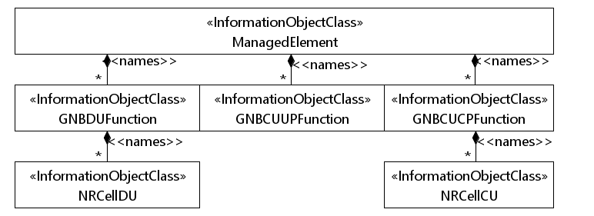
Figure 4.2.1.1-1: NRM for all deployment scenarios

c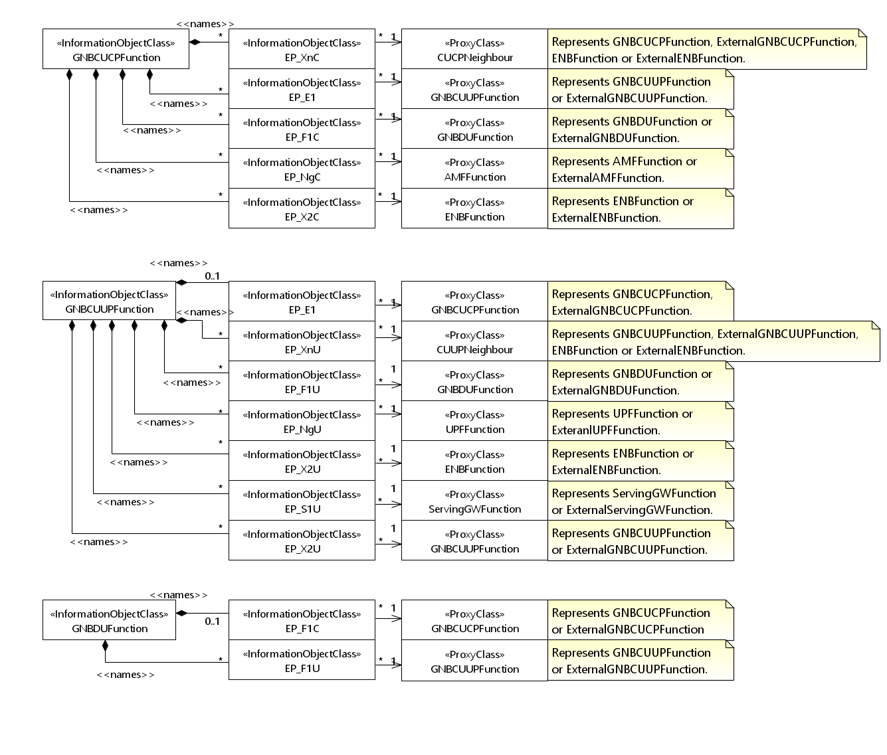
Figure 4.2.1.1-2: NRM for EPs for all deployment scenarios

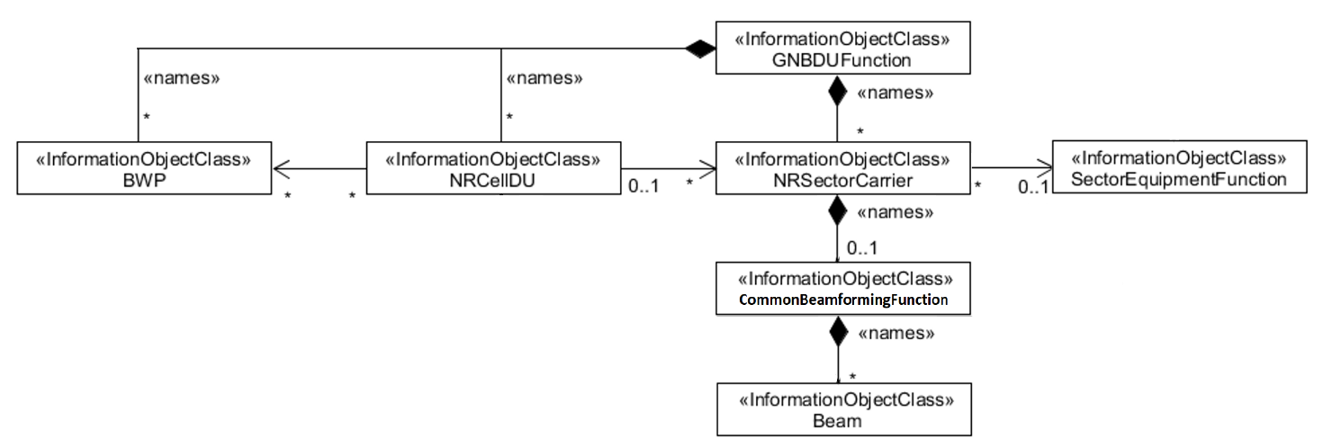
Figure 4.2.1.1-3: NRM for <<IOC>>NRSectorCarrier and <<IOC>>BWP for all deployment scenarios

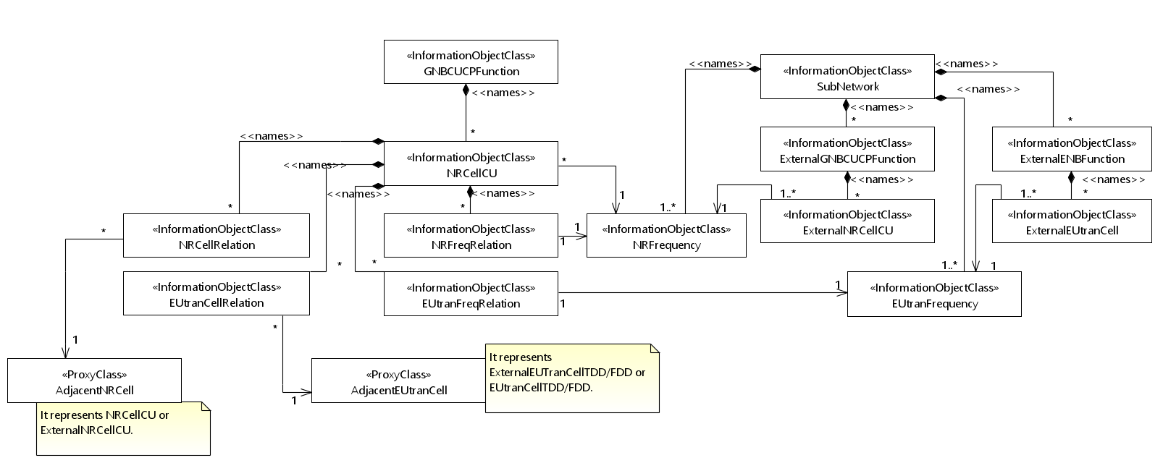
Figure 4.2.1.1-4: Cell Relation view for all deployment scenarios
NOTE 1: The above NRM fragment uses SubNetwork to hold both NR and LTE external entities and frequencies.
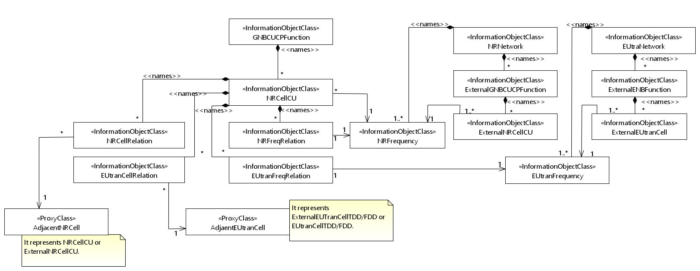
Figure 4.2.1.1-5: Cell Relation view for all deployment scenarios
NOTE 2: The above NRM fragment uses NRNetwork to hold NR external entities and frequency and using EUtraNetwork to hold LTE external entities and frequency. The NRNetwork and EUtraNetwork are subclasses of SubNetwork (defined in TS 28.622 [30]) with no additional attributes. The reason using NRNetwork and EUtraNetwork is for a clean separation of NR external entities and frequency and LTE external entities and frequency.

2nd Change

4.3.17 EP_XnC

4.3.17.1 Definition
This IOC represents the local gNB node end point of the logical link, supporting Xn Application protocols, to a neighbour NG-RAN node (including gNB and ng-eNB). The Xn Application PDUs are carried over SCTP/IP/Data link layer/Physical layer stack. See subclause 7 of 3GPP TS 38.420 [6].

4.3.17.2 Attributes
The EP_XnC IOC includes attributes inherited from EP_RP IOC (defined in TS 28.622[30]) and the following attributes:
Attribute name | Support Qualifier | isReadable | isWritable | isInvariant | isNotifyable
localAddress | O | T | T | F | T
remoteAddress | O | T | T | F | T

4.3.17.3 Attribute constraints
None

4.3.17.4 Notifications
The common notifications defined in subclause 4.5 are valid for this IOC, without exceptions or additions.

3rd Change

4.3.X CUCPNeighbor <<ProxyClass>>

4.3.X.1 Definition
This IOC represents an <<IOC>>GNBCUCPFunction, <<IOC>>ExternalGNBCUCPFunction, <<IOC>>ENBFunction and <<IOC>>ExternalENBFunction.

4.3.X.2 Attributes
See that defined in <<IOC>>GNBCUCPFunction, <<IOC>>ExternalGNBCUCPFunction, <<IOC>>ENBFunction and <<IOC>>ExternalENBFunction.

4.3.X.3 Attribute constraints
See that defined in <<IOC>>GNBCUCPFunction, <<IOC>>ExternalGNBCUCPFunction, <<IOC>>ENBFunction and <<IOC>>ExternalENBFunction.

4.3.X.4 Notifications
See respective IOCs.

4.3.Y CUUPNeighbor <<ProxyClass>>

4.3.Y.1 Definition
This IOC represents an <<IOC>>GNBCUUPFunction, <<IOC>>ExternalGNBCUUPFunction, <<IOC>>ENBFunction and <<IOC>>ExternalENBFunction.

4.3.Y.2 Attributes
See that defined in <<IOC>>GNBCUUPFunction, <<IOC>>ExternalGNBCUUPFunction, <<IOC>>ENBFunction and <<IOC>>ExternalENBFunction.

4.3.Y.3 Attribute constraints
See that defined in <<IOC>>GNBCUUPFunction, <<IOC>>ExternalGNBCUUPFunction, <<IOC>>ENBFunction and <<IOC>>ExternalENBFunction.

4.3.Y.4 Notifications
See respective IOCs.

End of Change

