3GPP TSG-SA5 Meeting #129 S5-201116

Hyderabad,India, 24-28 February 2020

Source: Orange

Title: Solution for distributed energy saving management

Document for: Approval
Agenda Item: 6.4.2

1 Decision/action requested
The group is asked to discuss and agree on the proposal.

2 References
[1] TS 28.310 1.2.0 Energy efficiency of 5G

3 Rationale

4 Detailed proposal
This document proposes the following changes in TS 28.310 [1].
1st Change

2 References
The following documents contain provisions which, through reference in this text, constitute provisions of the present document.
- References are either specific (identified by date of publication, edition number, version number, etc.) or non-specific.
- For a specific reference, subsequent revisions do not apply.
- For a non-specific reference, the latest version applies. In the case of a reference to a 3GPP document (including a GSM document), a non-specific reference implicitly refers to the latest version of that document in the same Release as the present document.
[1] 3GPP TR 21.905: "Vocabulary for 3GPP Specifications".
[2] ETSI ES 203 228: "Environmental Engineering (EE); Assessment of mobile network energy efficiency".
[3] ETSI ES 202 336-1 V1.2.1: "Environmental Engineering (EE); Monitoring and Control Interface for Infrastructure Equipment (Power, Cooling and Building Environment Systems used in Telecommunication Networks) Part 1: Generic Interface".
[4] ETSI ES 202 336-12 V1.1.1: "Environmental Engineering (EE); Monitoring and control interface for infrastructure equipment (power, cooling and building environment systems used in telecommunication networks); Part 12: ICT equipment power, energy and environmental parameters monitoring information model".
[5] 3GPP TS 28.550: "Management and orchestration; Performance assurance".
[6] 3GPP TS 28.531: "Management and orchestration; Provisioning".
[7] 3GPP TS 28.545: "Management and orchestration; Fault Supervision (FS)".
[8] 3GPP TS 32.432: "Telecommunication management; Performance measurement: File format definition".
[9] 3GPP TS 32.435: "Telecommunication management; Performance measurement; eXtensible Markup Language (XML) file format definition".
[10] 3GPP TS 32.436: "Telecommunication management; Performance measurement: Abstract Syntax Notation 1 (ASN.1) file format definition".
[11] 3GPP TS 28.541: "Management and orchestration; 5G Network Resource Model (NRM); Stage 2 and stage 3".
[12] 3GPP TS 38.401: "NG-RAN; Architecture description".
[13] 3GPP TS 38.300: "NR; Overall description; Stage-2 ".
[14] 3GPP TR 37.816: "Study on RAN-centric data collection and utilization for LTE and NR".
[15] 3GPP TS 28.552: "Management and orchestration; 5G performance measurements".
[16] 3GPP TS 28.532: "Management and orchestration; Generic management services”.
[x] 3GPP TS 28.622: "Telecommunication management; Generic Network Resource Model (NRM) Integration Reference Point (IRP); Information Service (IS)".

Next Change

6.2.3 Distributed energy saving solution

6.2.3.1 Management services

6.2.3.1.1 MnS component type A

MnS Component Type A | Note
Operations defined in clause 5 of TS 28.532 [16]:  - getMOIAttributes  - modifyMOIAttributes | Supported by the Provisioning MnS for NF, as defined in 28.531 [6].
Notifications defined in clause 5 of TS 28.532 [16]:  - notifyMOIAttributeValueChange | Supported by the Provisioning MnS for NF, as defined in 28.531 [6].

6.2.3.1.2 MnS Component Type B

6.2.3.1.2.1 Objective and targets
The objective of ES is to automatically set parameters so as to maximize NG-RAN data energy efficiency - see Table 6.2.3.1.2.1-1.
Table 6.2.3.1.2.1-1. Energy Saving targets
Targets | Definition | Legal Values
NG-RAN data Energy Efficiency | Data Volume (DV) divided by Energy Consumption (EC) of the considered network elements. | In bit/J.

6.2.3.1.2.2 Control information
The parameter in Table 6.2.3.1.2.2-1 is used to control the D-SON ES functionality.

Control parameter | Definition | Legal Values
ESswitch | This attribute allows authorized consumer to enable/disable the D-SON ES functionality. | on, off

6.2.3.1.3 MnS Component Type C

6.2.3.1.3.1 Parameters to be optimized
This is out of the scope of the present document.

6.2.3.1.3.2 Performance measurements
Performance measurements related to distributed energy saving are captured in Table 6.2.3.1.3.2-1:
Table 6.2.3.1.3.2-1. Energy saving management related performance measurements
Performance measurements | Description | Related targets
DRB.PdcpSduVolumeDL_Filter | Data Volume (amount of PDCP SDU bits) in the downlink delivered to PDCP layer – see clause 5.1.2.1.1.1 of TS 28.552 [15], per configured PLMN ID and per QoS level (mapped 5QI) and per S-NSSAI.  In case of non-split gNBs.
DRB.PdcpSduVolumeUL_Filter | Data Volume (amount of PDCP SDU bits) in the uplink delivered from PDCP layer to higher layers – see clause 5.1.2.1.2.1 of TS 28.552 [15], per configured PLMN ID and per QoS level (mapped 5QI) and per S-NSSAI.  In case of non-split gNBs.
DL Cell PDCP SDU Data Volume on X2 Interface | Data Volume (amount of PDCP SDU bits) in the downlink delivered on X2 interface in DC-scenarios – see clause 5.1.2.1.1.2 of TS 28.552 [15], per PLMN ID and per QoS level (mapped 5QI or QCI in NR option 3).  In case of split gNBs.
DL Cell PDCP SDU Data Volume on Xn Interface | Data Volume (amount of PDCP SDU bits) in the downlink delivered on Xn interface in DC-scenarios scenarios – see clause 5.1.2.1.1.3 of TS 28.552 [15], per PLMN ID and per QoS level (mapped 5QI) and per S-NSSAI.  In case of split gNBs.
UL Cell PDCP SDU Data Volume on X2 Interface | Data Volume (amount of PDCP SDU bits) in the uplink delivered on X2 interface in NSA scenarios – see clause 5.1.2.1.2.2 of TS 28.552 [15], per PLMN ID and per QoS level (mapped 5QI or QCI in NR option 3).  In case of split gNBs.
UL Cell PDCP SDU Data Volume on Xn Interface | Data Volume (amount of PDCP SDU bits) in the uplink delivered on Xn interface in SA scenarios – see clause 5.1.2.1.2.3 of TS 28.552 [15], per PLMN ID and per QoS level (mapped 5QI) and per S-NSSAI.  In case of split gNBs.
PNF Energy consumption | Energy consumed – see clause 5.1.1.19.3 of TS 28.552

6.2.3.2 Procedures

6.2.3.2.1 Energy saving activation
Figure 6.2.3.2.1-1 depicts a procedure that describes how MnS producer of Distributed ES management can activate the Distributed ES function.

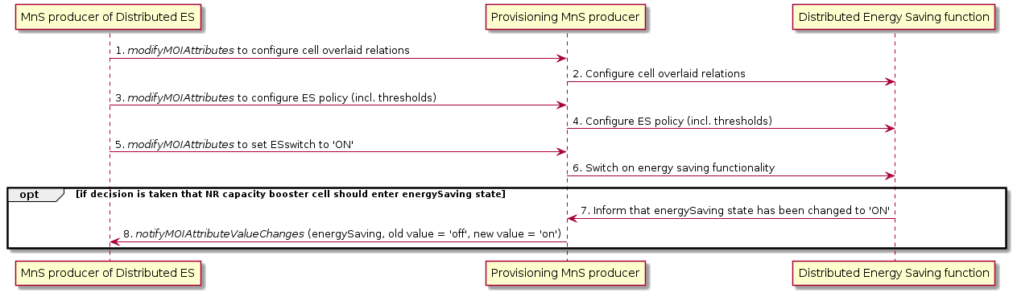
Figure 6.2.3.2.1-1: Distributed energy saving activation

It is assumed that all relevant MOIs have been created.
Energy saving activation:
The MnS producer for distributed ES management consumes the management service for NF provisioning with modifyMOIAttributes operation to:
- Configure the cell overlaid relations for NR capacity booster cells, and macro cells as candidate cells
- Configure the ES policy that includes the thresholds for the energy saving activation and deactivation for NR capacity booster cells and candidate cells
- Enable the distribute energy saving function for intra-RAT or inter-RAT.
NOTE: NRM may need to be enhanced to support cell overlaid relations, ES policy, and ES control. This is FFS.
The distributed ES function makes decision for the NR capacity booster cell to enter the energySaving state based on the cell traffic load information (see clause 15.4.2 in TS 38.300 [13]).
The distributed ES function changes to the energySaving state, leading to a notifyMOIAttributeValueChanges (see clause 5.1.9 in TS 28.532 [16]) being sent to the MnS producer for distributed ES management to indicate the NR capacity booster has entered the energySaving state.

6.2.3.2.2 Energy saving deactivation

Figure 6.2.3.2.2-1 depicts a procedure that describes how MnS producer of Distributed ES management can deactivate the Distributed ES function.

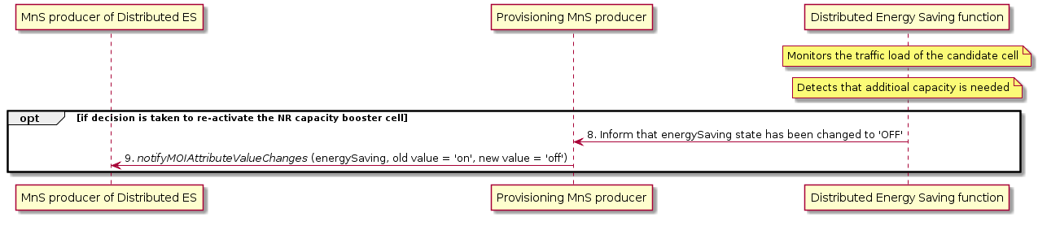
Figure 6.2.3.2.2-1: Distributed energy saving deactivation

Energy saving deactivation:
The distributed ES function monitors the traffic load of candidate cell, and decides to re-activate the NR capacity booster cell when it detects that additional capacity is needed (see clause 15.4.2 in TS 38.300 [13]).
The distributed ES function changes to the notEnergySaving state, leading to a notifyMOIAttributeValueChanges being sent to the MnS producer for distributed ES management to indicate the NR capacity booster has been re-activated.

Next Change

Annex <A> (informative):
Plant UML source code

A.1 Energy saving activation

@startuml

title Distributed energy saving activation Diagram

participant "MnS producer of Distributed ES" as MnSProdDSON
participant "Provisioning MnS producer" as MnSProdProv
participant "Distributed Energy Saving function" as DESFunction

MnSProdProv <- MnSProdDSON: 1. <i>modifyMOIAttributes</i> to configure cell overlaid relations
DESFunction <- MnSProdProv: 2. Configure cell overlaid relations
MnSProdProv <- MnSProdDSON: 3. <i>modifyMOIAttributes</i> to configure ES policy (incl. thresholds)
DESFunction <- MnSProdProv: 4. Configure ES policy (incl. thresholds)
MnSProdProv <- MnSProdDSON: 5. <i>modifyMOIAttributes</i> to set ESswitch to 'ON'
DESFunction <- MnSProdProv: 6. Switch on energy saving functionality

opt if decision is taken that NR capacity booster cell should enter energySaving state

DESFunction -> MnSProdProv: 7. Inform that energySaving state has been changed to 'ON'
MnSProdProv -> MnSProdDSON: 8. <i>notifyMOIAttributeValueChanges</i> (energySaving, old value = 'off', new value = 'on')
end

@enduml

A.2 Energy saving deactivation

@startuml

title Distributed energy saving deactivation Diagram

participant "MnS producer of Distributed ES" as MnSProdDSON
participant "Provisioning MnS producer" as MnSProdProv
participant "Distributed Energy Saving function" as DESFunction

note over DESFunction: Monitors the traffic load of the candidate cell
note over DESFunction: Detects that additioal capacity is needed

opt if decision is taken to re-activate the NR capacity booster cell

DESFunction -> MnSProdProv: 8. Inform that energySaving state has been changed to 'OFF'
MnSProdProv -> MnSProdDSON: 9. <i>notifyMOIAttributeValueChanges</i> (energySaving, old value = 'on', new value = 'off')
end

@enduml

Annex <B> (informative):
Change history

Change history
Date | Meeting | TDoc | CR | Rev | Cat | Subject/Comment | New version
2018-10 | SA5#121 | S5-186xxx |  |  |  | TS 28.310 Skeleton – before SA5#121 | 0.0.0
2018-10 |  | S5-186374 |  |  |  | Concepts and overview | 0.1.0
2018-11 | SA5#122 | S5-187377  S5-187378  S5-187379 |  |  |  | Management services  Use cases and requirements for DV measurement  Use cases and requirements for PEE measurement | 0.2.0
2019-01 | SA5#123 | S5-191038  S5-191364 |  |  |  | Add use cases and requirements on data streaming  pCR TS 28.310 – Add use case on PEE fault supervision, actor roles and telecommunication resources | 0.3.0
2019-04 | SA5#125 | S5-193366  S5-193367 |  |  |  | Add requirements of PEE measurement data collection for NG-RAN  Update EE concept | 0.4.0
2019-08 | SA5#126 | S5-195270  S5-195663  S5-195664  S5-195665  S5-195666 |  |  |  | Add references for gNB deployment scenarios  Add concept of energy saving management  Update scope  Add use case of gNB overlaid  Revise use cases for energy saving | 0.5.0
2019-09 | SA#85 | SP-190773 |  |  |  | Presented for information | 1.0.0
2019-10 | SA5#127 | S5-196053  S5-196347  S5-196350  S5-196349  S5-196649  S5-196769  S5-196647 |  |  |  | Edithelp comments  Cleanup proposal  Add solutions for energy efficiency  Add basic concepts related to energy saving  Add overview for various energy saving solutions  Solution for energy saving  Add requirements for energy saving cell overlaid cases | 1.1.0
2019-11 | SA5#128 | S5-197308  S5-197614 |  |  |  | Cleanup proposal  Terms correction for 5G energy saving | 1.2.0

End of change

