3GPP TR 28.806 V16.1.0 (2019-12)
Technical Specification
3rd Generation Partnership Project;
Technical Specification Group Services and System Aspects;
Study on non-file-based trace reporting;
(Release 16)

The present document has been developed within the 3rd Generation Partnership Project (3GPP TM) and may be further elaborated for the purposes of 3GPP..
The present document has not been subject to any approval process by the 3GPP Organizational Partners and shall not be implemented.
This Specification is provided for future development work within 3GPP only. The Organizational Partners accept no liability for any use of this Specification.
Specifications and Reports for implementation of the 3GPP TM system should be obtained via the 3GPP Organizational Partners' Publications Offices.

Keywords
Trace, management

3GPP
Postal address

3GPP support office address
650 Route des Lucioles - Sophia Antipolis
Valbonne - FRANCE
Tel.: +33 4 92 94 42 00 Fax: +33 4 93 65 47 16
Internet
http://www.3gpp.org

Copyright Notification
No part may be reproduced except as authorized by written permission.
The copyright and the foregoing restriction extend to reproduction in all media.

© 2019, 3GPP Organizational Partners (ARIB, ATIS, CCSA, ETSI, TSDSI, TTA, TTC).
All rights reserved.

UMTS™ is a Trade Mark of ETSI registered for the benefit of its members
3GPP™ is a Trade Mark of ETSI registered for the benefit of its Members and of the 3GPP Organizational Partners
LTE™ is a Trade Mark of ETSI registered for the benefit of its Members and of the 3GPP Organizational Partners
GSM® and the GSM logo are registered and owned by the GSM Association
Contents
Foreword 4
Introduction 5
1 Scope 6
2 References 6
3 Definitions of terms, symbols and abbreviations 6
3.1 Terms 6
3.2 Symbols 7
3.3 Abbreviations 7
4 Concepts and Background 7
4.1 Introduction 7
4.2 Cell Traffic Trace 7
4.3 MDT 8
4.4 RLF and RCEF reports collection 10
5 Use Cases 12
5.1 Collecting Cell and UE data for analytics 12
5.1.1 Goal 12
5.1.2 Pre-conditions 12
5.1.3 Description/steps 13
5.1.4 Post-conditions 13
5.2 Collecting subscriber and equipment trace data for near-real-time diagnostics and troubleshooting 14
5.2.1 Goal 14
5.2.2 Pre-conditions 14
5.2.3 Description/steps 14
5.2.4 Post-conditions 15
6 Potential Requirements 15
6.1 Introduction 15
6.2 General Trace requirements 15
6.3 Requirements for Trace data 16
6.4 Requirements for Trace activation 16
6.5 Requirements for Trace deactivation 16
6.6 Requirements for Trace data reporting 16
6.7 Requirements for Privacy and Security 17
6.8 Requirements for managing MDT 17
6.9 Requirements for managing RLF reports 17
7 Potential Solutions 17
7.1 Solution for non-file-based trace data reporting 17
7.1.1 Architectural considerations 17
7.1.2 Solution overview 19
7.1.3 Solution interactions 19
7.1.4 Solution protocol definition 22
7.1.5 Solution deployment examples 24
7.1.5.1 Example of 3GPP deployment with NWDAF 24
7.1.5.2 Example of ONAP deployment 26
8 Conclusions and recommendations 27
Annex A (informative): Change history 28

Foreword
This Technical Report has been produced by the 3rd Generation Partnership Project (3GPP).
The contents of the present document are subject to continuing work within the TSG and may change following formal TSG approval. Should the TSG modify the contents of the present document, it will be re-released by the TSG with an identifying change of release date and an increase in version number as follows:
Version x.y.z
where:
x the first digit:
1 presented to TSG for information;
2 presented to TSG for approval;
3 or greater indicates TSG approved document under change control.
y the second digit is incremented for all changes of substance, i.e. technical enhancements, corrections, updates, etc.
z the third digit is incremented when editorial only changes have been incorporated in the document.
In the present document, certain modal verbs have the following meanings:
shall indicates a mandatory requirement to do something
shall not indicates an interdiction (prohibition) to do something
The constructions "shall" and "shall not" are confined to the context of normative provisions, and do not appear in Technical Reports.
The constructions "must" and "must not" are not used as substitutes for "shall" and "shall not". Their use is avoided insofar as possible, and they are not used in a normative context except in a direct citation from an external, referenced, non-3GPP document, or so as to maintain continuity of style when extending or modifying the provisions of such a referenced document.
should indicates a recommendation to do something
should not indicates a recommendation not to do something
may indicates permission to do something
need not indicates permission not to do something
The construction "may not" is ambiguous and is not used in normative elements. The unambiguous constructions "might not" or "shall not" are used instead, depending upon the meaning intended.
can indicates that something is possible
cannot indicates that something is impossible
The constructions "can" and "cannot" shall not to be used as substitutes for "may" and "need not".
will indicates that something is certain or expected to happen as a result of action taken by an agency the behaviour of which is outside the scope of the present document
will not indicates that something is certain or expected not to happen as a result of action taken by an agency the behaviour of which is outside the scope of the present document
might indicates a likelihood that something will happen as a result of action taken by some agency the behaviour of which is outside the scope of the present document
might not indicates a likelihood that something will not happen as a result of action taken by some agency the behaviour of which is outside the scope of the present document
In addition:
is (or any other verb in the indicative mood) indicates a statement of fact
is not (or any other negative verb in the indicative mood) indicates a statement of fact
The constructions "is" and "is not" do not indicate requirements.

Introduction
Subscriber and Equipment Trace, standardized by 3GPP SA5 in the family of specifications TS 32.421 [2] / TS 32.422 [3] / TS 32.423 [4], was originally introduced for diagnostic and troubleshooting purposes. With the introduction of Self Organized Networks (SON) concepts in 3GPP Rel-8, the Trace was being considered as one of the data sources for Centralized SON (C-SON) algorithms. In addition to traditional Trace, other Trace job types such as collection of MDT measurements, Radio Link Failure (RLF) and Radio Connection Establishment Failure (RCEF) reports were added to trace specifications and used extensively for the NM centralized Coverage and Capacity Optimization (NM CCO TR 32.836 [5]).
Traditional trace reporting is file-based and therefore implies certain time restrictions on the availability of trace data preventing it from being used in fast control loop automation processes. In addition, file-based trace reporting may cause scalability issues in scenarios involving processing the records of multiple traces delivered at high rate.

1 Scope
The present document investigates the opportunities for new trace reporting methods. It identifies and documents use cases and potential requirements for non-file-based trace reporting, documents and evaluates potential solutions, and provides recommendations for the normative work aligned with 5G Services Based Management Architecture (SBMA).

2 References
The following documents contain provisions which, through reference in this text, constitute provisions of the present document.
- References are either specific (identified by date of publication, edition number, version number, etc.) or non-specific.
- For a specific reference, subsequent revisions do not apply.
- For a non-specific reference, the latest version applies. In the case of a reference to a 3GPP document (including a GSM document), a non-specific reference implicitly refers to the latest version of that document in the same Release as the present document.
[1] 3GPP TR 21.905: "Vocabulary for 3GPP Specifications".
[2] 3GPP TS 32.421: "Telecommunication management; Subscriber and equipment trace; Trace concepts and requirements".
[3] 3GPP TS 32.422: "Telecommunication management; Subscriber and equipment trace; Trace control and configuration management".
[4] 3GPP TS 32.423: "Telecommunication management; Subscriber and equipment trace; Trace data definition and management"
[5] 3GPP TR 32.836: "Telecommunication management; Study on Network Management (NM) centralized Coverage and Capacity Optimization (CCO) Self-Organizing Networks (SON) function".
[6] 3GPP TS 37.320: "Universal Terrestrial Radio Access (UTRA) and Evolved Universal Terrestrial Radio Access (E-UTRA); Radio measurement collection for Minimization of Drive Tests (MDT); Overall description; Stage 2".
[7] 3GPP TS 28.532: "Management and orchestration; Generic management services".
[8] 3GPP TS 28.533: "Management and orchestration; Architecture framework".
[9] IETF RFC 6455: "The WebSocket Protocol".
[10] IETF RFC 8446: "The Transport Layer Security (TLS) Protocol Version 1.3".
[11] 3GPP TS 38.413: "NG-RAN; NG Application Protocol (NGAP)".
[12] 3GPP TS 38.423: "NG-RAN; Xn Application Protocol (XnAP)".

3 Definitions of terms, symbols and abbreviations

3.1 Terms
For the purposes of the present document, the terms given in 3GPP TR 21.905 [1], TS 32.421 [2], TS 32.422 [3], TS 32.423 [4] and the following apply. A term defined in the present document takes precedence over the definition of the same term, if any, in 3GPP TR 21.905 [1].

3.2 Symbols
Void.

3.3 Abbreviations
For the purposes of the present document, the abbreviations given in 3GPP TR 21.905 [1], TS 32.421 [2], TS 32.422 [3], TS 32.423 [4] and the following apply. An abbreviation defined in the present document takes precedence over the definition of the same abbreviation, if any, in 3GPP TR 21.905 [1].

4 Concepts and Background

4.1 Introduction
The sub-clauses of clause 4 introduce relevant background information on the Cell Traffic Trace, MDT, RLF and RCEF reports collection concepts as a foundation for the use cases documented in clause 5 and for the reader's convenience.

4.2 Cell Traffic Trace
Cell Traffic Trace defined in TS 32.421 [2] as the ability to trace one or more active calls in one or more cells.
The high-level Trace Session activation requirements (specific to Management activation) state the following:
- In the case of a Cell Traffic Trace, Trace Session activation should be possible for all calls active in a cell or multiple cells without knowledge of the UEs' identification (IMEI or IMEISV).
- In the case of a Cell Traffic Trace, Trace Sessions should be activated for all the NEs where Cell Traffic Trace is specified.
- In the case of Cell Traffic Trace (in a shared network only), a Trace Session shall be started for UEs which are served by the Participating Operator that has made the request to the Master Operator.
The high-level requirements for starting a Trace Recording Session (specific to Management activation) state the following:
- In the case of a Cell Traffic Trace, the Trace Recording Session should start upon the Trace control and configuration parameters being received by the NEs in the Trace Session activation and the presence of call activity. Furthermore, the Core Network node that handles the traced session should be requested to:
- provide a trace log including Trace Reference, Trace Recording Session Reference and the identity of the UE (i.e. IMSI or IMEI(SV) to the Trace Collection Entity, or
- provide a notification including Trace Reference, Trace Recording Session Reference and the identity of the UE (i.e. IMSI or IMEI(SV)) to the Trace Collection Entity.
- In the case of a Cell Traffic Trace (in a shared network only), the Trace Recording Session shall only be started for UEs which are served by the Participating Operator that has made the request to the Master Operator.
The concept of Cell Traffic Trace was originally introduced to address the "checking radio coverage" legacy use case (see annex A.4 in TS 32.421 [2]) where it's used to collect trace data on all of the cells active in the area of interest.
Another legacy use case relying on Cell Traffic Trace is the "fine-tuning and optimization of algorithms/procedures" documented in the annex A.6 of TS 32.421 [2].
According to the TS 32.422 [3], the Cell Traffic Trace is supported for both UTRAN, E-UTRAN and NG-RAN. Using NG-RAN case as example, the Cell Traffic Trace starting mechanism is as following (see clause 4.2.2.10 of TS 32.422 [3] for additional details):
In NG-RAN, after the Cell Traffic Trace has been activated in the monitored cell(s), the NG-RAN node shall start a Trace Recording Session for new call(s)/session(s) and for already existing call(s)/session(s) (events for existing call(s)/session(s) are not required to be recorded prior to the activation of the cell traffic trace). When the NG-RAN node starts a Trace Recording Session it shall allocate a Trace Recording Session Reference (TRSR) for the given call or session. The NG-RAN node shall send the allocated Trace Recording Session Reference, and the Trace Reference and the Trace Collection Entity address in the CELL TRAFFIC TRACE message to the AMF via the NG connection.
When AMF receives this new NG signalling message containing the Trace Recording Session Reference (TRSR) and Trace Reference (TR), the AMF shall look up the SUPI/IMEI(SV) of the given call from its database and shall send the SUPI/IMEI(SV) numbers together with the Trace Recording Session Reference and Trace Reference to the Trace Collection Entity.
The figure below illustrates the procedure.
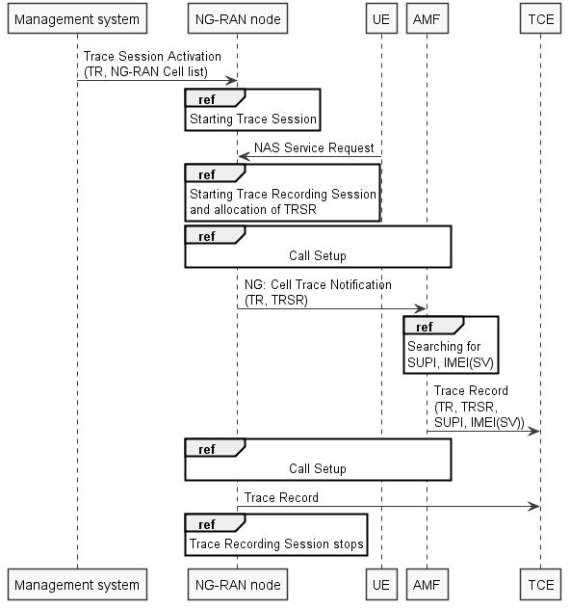
Figure 4.2.1: NG-RAN trace starting mechanism (figure 4.2.2.10.1 in TS 32.422 [3])

4.3 MDT
The collection of radio measurements for minimization of drive tests (MDT) feature has been introduced by 3GPP Rel-10 (see TS 37.320 [6] for stage 2 details) for UTRAN and E-UTRAN. The work on MDT for NG-RAN targeted for 3GPP Rel-16.
TS 37.320 [6] defines two modes of MDT (immediate and logged) as following:
- Immediate MDT: MDT functionality involving measurements performed by the UE in CONNECTED state and reporting of the measurements to eNB/RNC available at the time of reporting condition as well as measurements by the network for MDT purposes.
- Logged MDT: MDT functionality involving measurement logging by UE in IDLE mode, CELL_PCH, URA_PCH states and CELL_FACH state when second DRX cycle is used (when UE is in UTRA) for reporting to eNB/RNC at a later point in time, and logging of MBSFN measurements by E-UTRA UE in IDLE and CONNECTED modes.
The general principles and requirements guiding the definition of MDT functions include the following (see clause 4.1 in TS 37.320 [6] for additional details):
- There are two modes for the MDT measurements: Logged MDT and Immediate MDT. There are also cases of measurement collection not specified as either immediate or logged MDT, such as Accessibility measurements.
- It is possible to configure MDT measurements for the UE logging purpose independently from the network configurations for normal RRM purposes. However, in most cases, the availability of measurement results is conditionally dependent on the UE RRM configuration.
- UE MDT measurement logs consist of multiple events and measurements taken over time. The time interval for measurement collection and reporting is decoupled in order to limit the impact on the UE battery consumption and network signalling load.
- It is possible to configure the geographical area where the defined set of measurements will be collected.
- The measurements will be linked to available location information and/or other information or measurements that can be used to derive location information.
- The measurements in measurement logs will be linked to a time stamp.
- The network may use UE capabilities to select terminals for MDT measurements.
- The solutions for MDT are able to work independently from SON support in the network. Relation between measurements/solution for MDT and UE side SON functionswill be established in a way that re-use of functions is achieved where possible.
- The subscriber/cell trace functionality is reused and extended to support MDT. If the MDT is initiated toward to a specific UE (e.g. based on IMSI, IMEI-SV, etc.), the signalling-based trace procedure is used, otherwise the management-based trace procedure (or cell traffic trace procedure) is used. Network signalling and overall control of MDT is described in TS 32.422 [3].
According to the clause 5.2 in TS 37.320 [6], the E-UTRAN Immediate MDT measurements are not limited to those performed by the UE and do include measurements performed by the eNB (per cell or per UE):
- M1: RSRP and RSRQ measurement by UE.
- M2: Power Headroom measurement by UE.
- M3: Received Interference Power measurement by eNB. This is a cell measurement. One sample is logged each measurement collection period, where one sample corresponds to a measurement period.
- M4: Data Volume measurement separately for DL and UL, per QCI per UE, by eNB.
- M5: Scheduled IP Throughput for MDT measurement separately for DL and UL, per RAB per UE and per UE for the DL, per UE for the UL, by eNB.
- M6: Packet Delay measurement, separately for DL and UL, per QCI per UE, see UL PDCP Delay, by the UE, and Packet Delay in the DL per QCI, by the eNB.
- M7: Packet Loss rate measurement, separately for DL and UL per QCI per UE, by the eNB.
- M8: RSSI measurement by UE.
- M9: RTT measurement by UE.
The LTE trace use cases relevant to collection of MDT data are "periodical sampling of network performance", "differentiation of area-based MDT data by terminal type", "subscriber complaint about MBMS service in the eUTRAN network" and "check MBMS service quality and performance of the eUTRAN network" (see annexes A.12, A.13, A.14 and A.15 in TS 32.421 [2]).
TS 32.422 [3] defines several trace Job types including dedicated to MDT data collection only and combined with trace data collection (see clause 5.9a in TS 32.422 [3] for additional details).

4.4 RLF and RCEF reports collection
In addition to regular subscriber and equipment trace and MDT results collection, the trace mechanisms are used for collection of Radio Link Failure (RLF) and RRC Connection Establishment Failure (RCEF) reports.
The Radio Link Failure report contains information related to the latest connection failure experienced by the UE. The connection failure can be Radio Link Failure (RLF) or Handover Failure (HOF). Upon RLF/HOF detection in the UE, RLF report also includes available location information on where RLF occurred (see TS 37.320 [6] for additional details). RLF reports may also include available WLAN measurement results and/or Bluetooth measurement results for calculating UE location.
Example scenarios of RLF reporting using special Trace Session where the job type indicates RLF reporting only are illustrated on the following figures (see clause 4.3.1 in TS 32.422 [3] for additional details).
Figure 4.4.1: Example scenario for RLF reporting when UE reestablishment is successful at source eNB (figure 4.3.1.1 in TS 32.422 [3])
Figure 4.4.2: Example scenario for RLF reporting when the UE reestablishment is successful at target eNB when there is X2 Link between target eNB and source eNB (figure 4.3.1.2 in TS 32.422 [3])
Example scenarios of RCEF reporting using special Trace Session where the job type indicates RCEF reporting only are illustrated on the following figure (see clause 4.8.1 in TS 32.422 [3] for additional details).
Figure 4.4.3: Example scenario for RCEF reporting when the UE RRC establishment is successful to a different eNB (figure 4.8.1.2 in TS 32.422 [3])
The trace Job types "RLF reports only" and "RCEF reports only" are applicable only in management based trace activation in E-UTRAN (see clause 5.9a in TS 32.422 [3]).

5 Use Cases

5.1 Collecting Cell and UE data for analytics

5.1.1 Goal
Being able to analyse and optimize the mobility management and traffic handling behaviour for on-going sessions is important, as it offers an opportunity to address potential problems before it's "too late" (while something can be done to mitigate them or prevent the problem from happening).
Cell Traffic Trace, Immediate MDT, RLF reports and RCEF reports are the examples of RAN data relevant to this goal.

5.1.2 Pre-conditions
The consumers (e.g. specific instances of MDAS producers, NWDAF) and producers (e.g. specific E-UTRAN or NG-RAN nodes) of data have been identified and are operational.
The data to be collected (e.g. particular call processing events, relevant interfaces, signalling messages and IEs, MDT measurements, UE location information, failure reports) has been selected.

5.1.3 Description/steps
1. 3GPP Management System configures/activates the data producers with appropriate Trace measurement control and configuration parameters (e.g. those specified in sub-clauses of clause 5 in TS 32.422 [3]).
NOTE 1: For the illustrative purposes of this use case, it is assumed that Trace Job types "Immediate MDT and Trace", "RLF reports only" and "RCEF reports only" have been selected (see clause 5.9a in TS 32.422 [3]) and the information about data consumer (e.g. address, identity) has been provided.
2. The data producer establishes connection to the data consumer and exchanges the data collection session metadata (e.g. identity of the data producer, nature of the data being collected, Trace Reference).
3. While the Trace Session is active on the data producer, the data producer performs UE selection (see clauses 4.1.1.6a and 4.1.1.9 in TS 32.422 [3]), receives RLF and RCEF reports (see clauses 4.3 and 4.8 in TS 32.422 [3]), starts trace recording sessions (see clauses 4.2.2.5 and 4.2.2.10 in TS 32.422 [3]), enables MDT measurements (see clause 4.2.2.7 in TS 32.422 [3]).
4. Periodically, upon the data availability, the data producer sends the collected data to the data consumer. The periodicity and the amount of data in each burst sent from producer to consumer may be standardized, made configurable or left implementation-specific. But the key point here is that the data is being delivered to the consumer while it's still relevant to the analytical task performed by the consumer.
NOTE 2: The actions described by steps 3 and 4 repeated until the Trace Session is deactivated (e.g. via explicit configuration/deactivation by the 3GPP Management System or if Trace Session requirements such as amount of data or duration have been satisfied).
5. 3GPP Management System configures/deactivates the data producers.
6. The data producer terminates the connection to the data consumer and potentially informs it that the data collection task has been completed and no further data is expected.
The use case ends upon successful termination of the data collection task.

5.1.4 Post-conditions
The data consumer has the necessary data to perform the analytical tasks. The data (reported per UE) may include, but is not limited to:
- LTE MDT measurements (see TSs 37.320 [6] and 32.422 [3]) such as:
- M1: RSRP and RSRQ measurement by UE with Periodic, event A2 as reporting triggers;
- M2: Power Headroom (PH) measurement by UE;
- M3: Received Interference Power measurement by eNB;
- M4: Data Volume measurement separately for DL and UL by eNB;
- M5: Scheduled IP Throughput measurement separately for DL and UL by eNB.
NOTE: 5G MDT measurements are FFS (pending on-going work in RAN WG).
- Radio Link Failure reports;
- RRC Connection Establishment Failure reports;
- Raw signalling messages (see TS 32.423 clauses 4.13 and 4.29 for additional details);
- UE location information (see TS 32.423 clause 4.16.2 for additional details).
The specific methods for analysing and/or correlating the captured data, as well as any actions that may be triggered by such analysis are out of scope of the present use case.

5.2 Collecting subscriber and equipment trace data for near-real-time diagnostics and troubleshooting

5.2.1 Goal
Being able to diagnose and troubleshoot various problems reported by subscribers (e.g. as described in sub-clauses of Annex A in TS 32.421 [2]) for on-going sessions is important, as it offers an opportunity to investigate and address potential problems while they are happening, and to evaluate the corrective actions (e.g. based on subscriber's feedback or automated algorithms).
Subscriber and equipment Trace with Signalling Based Activation performed on RAN and Core NEs are the examples of trace data relevant to this goal.

5.2.2 Pre-conditions
The consumers (e.g. management applications and/or functions) and producers (e.g. specific NG-RAN and 5GC nodes) of data have been identified and are operational.
The subscriber or equipment to be traced has been identified.
The data to be collected (e.g. triggering events, trace depth, relevant NE types, relevant interfaces, signalling messages and IEs, MDT measurements, UE location information, failure reports) has been selected.

5.2.3 Description/steps
NOTE 1: For the illustrative purposes of this use case, the 5GC activation mechanism with UE attached to 5GC via NG-RAN (as described in the clause 4.1.2.15.1 of TS 32.422 [3]) has been selected. Other activation mechanisms involving E-UTRAN, NG-RAN, EPC and 5GC are possible, but are not conceptually different from the perspective of this use case.
1. Management system configures/activates the Trace Session to the UDM. UDM stores the trace control and configuration parameters.
2. As UE (to be traced) registers with the network, the AMF starts a new Trace Session according to the configuration parameters received from UDM (see steps 3-8 in clause 4.1.2.15.1 of TS 32.422 [3]).
3. AMF establishes connection to the Trace data consumer and exchanges the Trace data collection session metadata (e.g. identity of the AMF, nature of the data being collected, Trace Session Reference).
4. While the Trace Session is active on the AMF, AMF starts the Trace Recording Sessions and collects the Trace data prescribed by Trace configuration received from the UDM.
5. Periodically, upon the Trace data availability, the AMF sends the collected data to the data consumer. The periodicity and the amount of data in each burst sent from AMF to data consumer may be standardized, made configurable or left implementation-specific. But the key point here is that the data is being delivered to the consumer while it's still relevant to the diagnostic/troubleshooting task performed by the consumer.
6. In parallel to the step 5, AMF sends the Trace Start message to the NG-RAN node (see steps 9-11 in clause 4.1.2.15.1 of TS 32.422 [3] and additional details in TS 38.413 [11]). NG-RAN node starts the Trace Session and establishes connection to the Trace data consumer. NG-RAN node and Trace data consumer exchange the Trace data collection session metadata (e.g. identity of the NG-RAN node, nature of the data being collected, Trace Session Reference).
7. While the Trace Session is active on the NG-RAN node, NG-RAN node collects the Trace data prescribed by Trace configuration received from the AMF.
8. Periodically, upon the Trace data availability, the NG-RAN node sends the collected data to the data consumer. The periodicity and the amount of data in each burst sent from NG-RAN node to data consumer may be standardized, made configurable or left implementation-specific. But the key point here is that the data is being delivered to the consumer while it's still relevant to the diagnostic/troubleshooting task performed by the consumer.
9. In parallel with steps 3-5, AMF activates the Trace sessions on PCF and SMF (see steps 12-17 in clause 4.1.2.15.1 of TS 32.422 [3]). The PCF and SMF start Trace sessions and establish connections to the Trace data consumer. PCF and SMF exchange Trace data collection session metadata (e.g. identity of PCF or SMF, nature of the data being collected, Trace Session Reference).
10. Periodically, upon the Trace data availability, the PCF and SMF send the collected data to the data consumer. The data is being delivered to the consumer while it's still relevant to the diagnostic/troubleshooting task performed by the consumer.
11. When traced UE hands-over from one NG-RAN node to another (e.g. Xn handover), the Trace configuration is propagated in the Trace activation IE of the HANDOVER REQUEST message (see TS 38.423 [12]). The target NG-RAN node starts the Trace Session and establishes connection to the Trace data consumer. The target NG-RAN node and Trace data consumer exchange the Trace data collection session metadata (e.g. identity of the NG-RAN node, nature of the data being collected, Trace Session Reference).
12. While the Trace Session is active on the target NG-RAN node, target NG-RAN node collects the Trace data prescribed by Trace configuration received from the source NG-RAN node.
13. The target NG-RAN node reports the collected trace data to the data consumer (performs the actions described in the step 8 above).
NOTE 2: The steps 6-8 and 11-13 are repeated while the Trace session is active (Trace configuration is propagated to target NG-RAN nodes following the UE handovers). Each NG-RAN node where the Trace is active has an active connection to the Trace data consumer (establishes connection and exchanges trace session metadata upon Trace session activation, and reports trace data upon availability).
14. 3GPP Management System configures/deactivates the Trace session at the UDM. It triggers the Trace deactivation process on all NEs where the Trace session was active (see clause 4.1.4.11 in TS 32.422 [3] for additional details).
15. Upon the Trace session deactivation, the NEs / Trace data producers terminate the connection to the Trace data consumer and potentially inform it that the data collection tasks have been completed and no further data is expected.
The use case ends upon successful termination of the Trace session and of the data collection tasks on all NEs.

5.2.4 Post-conditions
The data consumer has the necessary data to perform the near-real-time diagnostics and troubleshooting tasks.
The specific methods for analysing and/or correlating the captured data, as well as any actions that may be triggered by such analysis are out of scope of the present use case.

6 Potential Requirements

6.1 Introduction
The following requirements are potential requirements to be used in the future normative work (as per recommendations clause). The usage of normative terminology should not be interpreted as mandatory in the present document.

6.2 General Trace requirements
The requirements for the Maximum Level and for the Maximum Without Vendor Specific Extension Level (as specified in TS 32.421 [2] clause 5.1) are applicable here.

6.3 Requirements for Trace data
The Trace record requirements (as specified in TS 32.421 [2] clause 5.2) for the following Network Elements and Traceable interfaces are applicable here:
- e-NodeB: S1-MME, X2, Uu
- NG-RAN node: NG-C, Xn-C, Uu, F1-C, E1-C
The requirement on Trace Recording Session Reference (as specified in TS 32.421 [2] clause 5.2) is applicable here.

6.4 Requirements for Trace activation
The requirements for Trace Session activation and for starting a Trace Recording Session (as specified in TS 32.421 [2] clause 5.3) are applicable here.
Potential new requirements are:
REQ-TA-001: It shall be possible to specify the trace reporting method (file-based vs. non-file based) during Trace Session Activation.
REQ-TA-002: In case of non-file-based trace reporting method being selected, the data producer shall establish the connection to the data consumer upon Trace Session Activation and provide data consumer with information about Trace Session.

6.5 Requirements for Trace deactivation
The requirements for Trace Session deactivation and for stopping a Trace Recording Session (as specified in TS 32.421 [2] clause 5.4) ae applicable here.
Potential new requirements are:
REQ-TD-001: In case of non-file-based trace reporting, upon the Trace Session deactivation and end of the currently open Trace Recording Sessions, the data producer shall terminate connection to the data consumer.

6.6 Requirements for Trace data reporting
The following requirements for Trace Data reporting (as specified in TS 32.421 [2] clause 5.5) are applicable in case of non-file-based trace reporting:
Trace records should be generated in each NE where a Trace Session has been activated and a Trace Recording Session has been started.
Potential new requirements are:
- REQ-TR-001: In case of non-file-based trace reporting, the same connection shall be used for the reporting of Trace data under all Trace Recording Sessions of the same Trace Session.
- REQ-TR-002: In case of non-file-based trace reporting, a connection from the data producer to the consumer shall be established and information about Trace Session shall be provided to the data consumer.
- REQ-TR-003: In case of non-file-based trace reporting, binary encoding shall be used for the transfer of all Trace data from data producer to the data consumer.
- REQ-TR-004: In case of non-file-based trace reporting, the periodicity and amount of data in each data burst from data producer to data consumer shall maintain the data relevance while minimizing the amount of transport overhead (e.g. buffering at the data producer no longer that 5 seconds).
- REQ-TR-005: In case of non-file-based trace reporting, the data producer shall re-establish connection to the data consumer and provide the information about Trace Session upon unexpected connection termination (e.g. in cases such as re-start of data producer).

6.7 Requirements for Privacy and Security
The following requirements for Privacy and Security (as specified in TS 32.421 [2] clause 5.6) are applicable in case of non-file-based trace reporting:
- [SET-SEC-1] Keys stored inside eNBs shall never leave a secure environment within the eNB. When security key(s) transported on control signalling messages are included in the trace file, the key value(s) shall be removed and replaced with the value "Unavailable".
- [SET-SEC-2] Keys stored inside NG-RAN node shall never leave a secure environment within the NG-RAN node. When security key(s) transported on control signalling messages are included in the trace file, the key value(s) shall be removed and replaced with the value "Unavailable".
Potential new requirements are:
- REQ-SEC-001: In case of non-file-based trace reporting, the connection between data producer and data consumer shall provide the data privacy.
- REQ-SEC-002: In case of non-file-based trace reporting, the connection between data producer and data consumer shall provide the data integrity.

6.8 Requirements for managing MDT
The requirements for managing MDT (as specified in TS 32.421 [2] clause 6) are applicable in case of non-file-based trace reporting.
Potential new requirements are:
- REQ-MDT-001: In case of non-file-based trace reporting, binary encoding shall be used for the transfer of all MDT data from data producer to the data consumer.

6.9 Requirements for managing RLF reports
The requirements for managing RLF and RCEF reports (as specified in TS 32.421 [2] clause 7) are applicable in case of non-file-based trace reporting.
Potential new requirements are:
- REQ-RLF-001: In case of non-file-based trace reporting, binary encoding shall be used for the transfer of all RLF and RCEF reports data from data producer to the data consumer.
NOTE: The format and the encoding details will be specified in TS 32.423 [4].

7 Potential Solutions

7.1 Solution for non-file-based trace data reporting

7.1.1 Architectural considerations
Existing architecture for Management Based and Signaling Based Trace Activation/Deactivation (as specified in TS 32.421 [2] clause 4.2, figures 4.2.1 and 4.2.2) is applicable in case of non-file-based trace data reporting.
The concept of Trace Collection Entity (as specified in TS 32.421 [2] clause 4.2, figure 4.2.3) may need to be revisited to either generalize the Trace Collection Entity as supporting both – file-based and non-file-based trace reporting or to introduce a new entity – non-file-based data consumer. In case of the non-file-based trace reporting, both – direct reporting by the NE and reporting via intermediate entity (e.g. Management Function) should be possible. In such case, the figure 4.2.3 in TS 32.421 [2] may need to be revised in the following way:
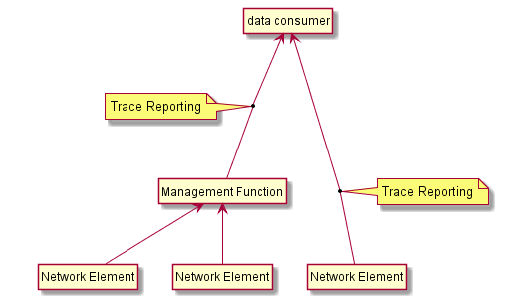
Figure 7.1.1.1: Revised architecture for High-level view of Trace Reporting in System Context A
As an option for alignment with the new Services Based Management Architecture (SBMA) introduced in TS 28.533 [8] and further specified in TS 28.532 [7], the relationship between Network Element as "non-file-based trace data reporting MnS" producer, Management Function as both producer and consumer of this MnS and data consumer as consumer of this MnS may be represented as:
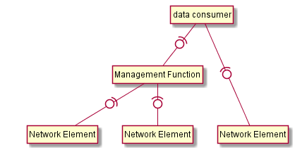
Figure 7.1.1.2: Example of interactions between producers and consumers of "non-file-based trace data reporting MnS"
Yet another option for alignment with SBMA is to represent the legacy Trace Collection Entity as a trace reporting MnS consumer supporting either file-based or non-file-based trace reporting. The following figure illustrates this option:
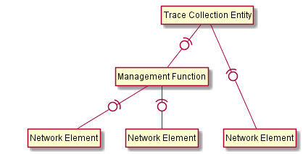
Figure 7.1.1.3: Example showing Trace Collection Entity and Management Function as consumers of "trace data reporting MnS"

7.1.2 Solution overview
Proposed solution focuses on the details of interactions between "non-file-based trace reporting MnS" producer and consumer. What entities play the roles of MnS consumer (e.g. Management Function, control plane function such as NWDAF or management plane MDAS producer) and MnS producer (e.g. Network Element or Management Function) is irrelevant and may be illustrated as various deployment options. Additional deployment options may illustrate non-3GPP consumers of the 3GPP MnS (e.g. ONAP DCAE).
For the non-file-based trace reporting solution it is proposed to use ASN.1 binary encoded data transmitted using WebSocket protocol [9] over TCP connection protected by TLS [10]. Figure below illustrates the proposed protocol stack:
Figure 7.1.2.1: Protocol stack for non-file-based trace reporting

7.1.3 Solution interactions
The sequence of interactions between producer and consumer of the "non-file-based trace reporting MnS" is illustrated by the following figure:
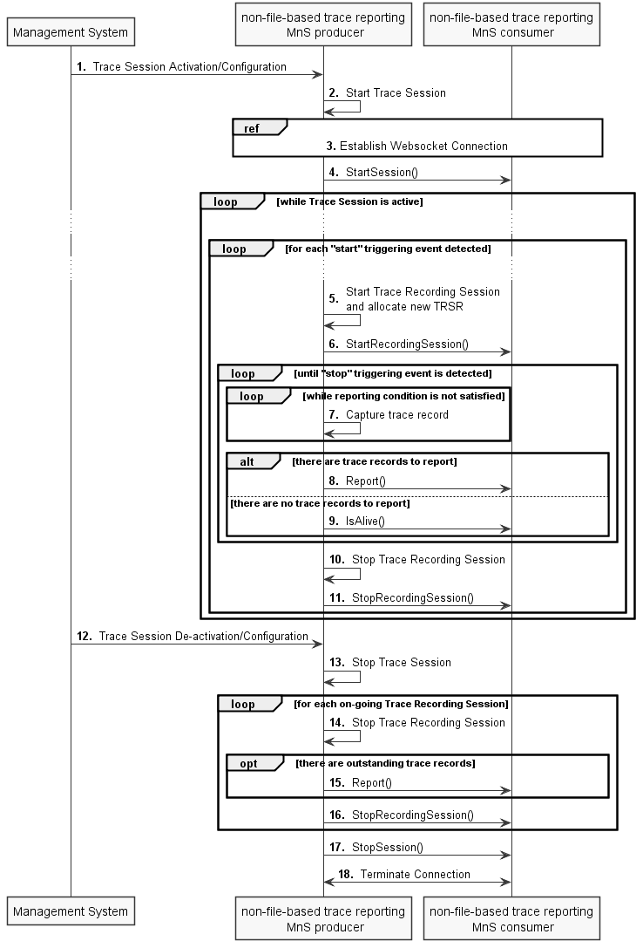
Figure 7.1.3.1: Sequence of interactions between producer and consumer of the non-file-based trace reporting MnS
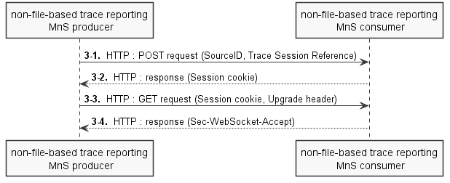
Figure 7.1.3.2: Detailed interactions of WebSocket connection establishment
1. The interactions between MnS producer and consumer begin when Management System activates (configures) the MnS producer with appropriate Trace measurement control and configuration parameters (e.g. similar to those specified in sub-clauses of clause 5 in TS 32.422 [3]). The specific details of this step depend on the outcome of the on-going work on Trace Management in the context of Services Based Management Architecture and may rely either on the capabilities of a new Trace Management MnS or re-use the capabilities of the Provisioning MnS specified in TS 28.532 [7]. An important aspect of this interaction is that the MnS producer is provided with the trace reporting method ("non-file-based trace reporting") and details of the connection to the MnS consumer (e.g. IP address, port, connection credentials, URI).
2. The MnS producer starts a new Trace Session (e.g. according to one of the sub-clauses of clause 4.1.1 in TS 32.422 [3]).
3. Upon the Trace Session activation, the MnS producer establishes a new connection to the MnS consumer (e.g. performs IP address look-up if necessary, connects to the specified TCP port, performs TLS handshake, starts WebSocket connection). The details of the WebSocket connection establishment are illustrated on the Figure 7.1.3.2. As part of the connection establishment the MnS producer informs MnS consumer about ASN.1 version to be used via Configure message. The WebSocket Ping frames (see clause 5.5.1 in [9]) may be used as a keepalive or as means to verify that remote endpoint is still responsive. In case of abnormal connection termination (e.g. if either MnS consumer or MnS producer restarts) the MnS producer re-establishes the connection to the MnS consumer.
3-1. The MnS producer uses the HTTP POST method to provide the MnS consumer with connection meta-data such as SourceID (MnS producer identifier) and Trace Session Reference facilitating MnS consumer actions.
3-2. The MnS consumer uses HTTP response to indicate successful reception of connection meta-data and includes session cookie allowing the connection meta-data to be associated with the WebSocket.
3-3. The MnS producer uses HTTP GET method to request connection upgrade to WebSocket. In the request it includes session cookie associating the requested WebSocket with previously provided connection meta-data, Upgrade header and WebSocket-specific headers.
3-4. The MnS consumer uses HTTP response to indicate successful upgrade of the connection to a WebSocket.
NOTE 1: Further communication between MnS producer and MnS consumer (steps 4, 6, 8, 9, 11, 15, 16 and 17 below) uses WebSocket protocol.
4. Upon establishment of connection between MnS producer and MnS consumer (either new connection or connection re-establishment), the MnS producer reports the Trace Session activation event via StartSession message including the information allowing the MnS consumer to associate the active connection to the MnS producer with the Trace Session information.
5. While the Traces Session is active at the MnS producer, it follows the procedures specified in TS 32.422 [3] clause 4.2 and starts new recording sessions once "start" triggering event (see TS 32.422 [3] clause 5.1) is detected. For each recording session a Trace Recording Session Reference (TRSR) is allocated.
6. Upon starting a new Trace Recording Session, the MnS producer reports this event to the MnS consumer via StartRecordingSession message.
7. The MnS producer captures traceable events (signalling messages, measurements, RLF reports, RCEF reports, UE location information) according the Trace Session configuration received in step 1. The captured trace records may be buffered until the reporting condition (e.g. amount of data or periodicity) is satisfied.
NOTE 2: Whether the reporting condition needs to be standardized, made configurable or left for implementation is FFS.
8. When the reporting condition is satisfied (e.g. desired amount of data is reached, buffer capacity exceeded or reporting timer expired), the MnS producer sends the captured trace records to the MnS consumer in ASN.1 binary encoding over the active WebSocket via Report message. The format of the ASN.1 encoded trace record follows the specification (e.g. new clauses in TS 32.423 [4]).
9. In cases where the reporting condition is satisfied (reporting timer expired), but there are no outstanding trace records to report, the MnS producer sends IsAlive message to the MnS consumer.
10. Once the "stop" triggering event (see TS 32.422 [3] clause 5.1) is detected by the MnS producer, it stops the Trace Recording Session following the procedures specified in TS 32.422 [3] clause 4.2.
11. Upon stopping a Trace Recording Session, the MnS producer reports this event to the MnS consumer via StopRecordingSession message.
12. The interaction between MnS producer and consumer ends when Management System de-activates (configures) the MnS producer. The specific details of this step depend on the outcome of the on-going work on Trace Management in the context of Services Based Management Architecture and may rely either on the capabilities of a new Trace Management MnS or re-use the capabilities of the Provisioning MnS specified in TS 28.532 [7].
13. The MnS producer stops the on-going Trace Session (e.g. according to one of the sub-clauses of clause 4.1.3 in TS 32.422 [3]).
14. If there are any on-going Trace Recording Sessions, the MnS producer stops them all.
15. If there are any outstanding (buffered) trace records, MnS producer reports them to the MnS consumer via Report message.
16. Upon stopping a Trace Recording Session, the MnS producer reports this event to the MnS consumer via StopRecordingSession message.
17. Upon stopping the Trace Session, the MnS producer reports this event to the MnS consumer via StopSession message.
18. MnS producer terminates the connection to MnS consumer (closes WebSocket, closes TLS and TCP connections).

7.1.4 Solution protocol definition
An example of ASN.1 encoded non-file-based trace reporting messages (partially addressing NG-RAN node trace reporting) is included below:
-- ****************************************************************************
-- Non-file-based trace reporting protocol definition
-- Draft ver. 0.0.1
-- Encoding: ASN1 aligned PER
-- ****************************************************************************

TraceProtocol DEFINITIONS AUTOMATIC TAGS ::=
BEGIN
TraceMessage ::= CHOICE {
configure Configure,
alive IsAlive,
startSession StartSession,
stopSession StopSession,
startRecordingSession StartRecordingSession,
stopRecordingSession StopRecordingSession,
report Report,
...
}

-- ****************************************************************************
-- Configure msg
-- Used to convey the ASN.1 protocol version
-- ****************************************************************************
Configure ::= SEQUENCE {
nodeType NodeTypeId,
version Version,
futureExtension SEQUENCE {}
}

-- ****************************************************************************
-- IsAlive msg
-- Used for periodic keepalive at the protocol level
-- ****************************************************************************
IsAlive ::= SEQUENCE {
nodeType NodeTypeId,
timestamp UTC-Timestamp,
futureExtension SEQUENCE {} OPTIONAL
}

-- ****************************************************************************
-- StartSession msg
-- Used for reporting the start of Trace Session event
-- ****************************************************************************
StartSession ::= SEQUENCE {
seqNum SequenceNumber,
sourceId SynchronizationSourceId,
nodeType NodeTypeId,
traceReference TraceReference,
cellId NRCGI OPTIONAL,
timestamp UTC-Timestamp,
sessionConfig SessionConfig,
futureExtension SEQUENCE {} OPTIONAL
}

-- ****************************************************************************
-- StopSession msg
-- Used for reporting the stop of Trace Session event
-- ****************************************************************************
StopSession ::= SEQUENCE {
seqNum SequenceNumber,
sourceId SynchronizationSourceId,
nodeType NodeTypeId,
traceReference TraceReference,
cellId NRCGI OPTIONAL,
timestamp UTC-Timestamp,
futureExtension SEQUENCE {} OPTIONAL
}

-- ****************************************************************************
-- StartRecordingSession msg
-- Used for reporting the start of Trace Recording Session event
-- ****************************************************************************
StartRecordingSession ::= SEQUENCE {
seqNum SequenceNumber,
sourceId SynchronizationSourceId,
nodeType NodeTypeId,
traceReference TraceReference,
traceRecordingSessionRef TraceRecordingSessionRef,
cellId NRCGI OPTIONAL,
recordInitSeqNum SequenceNumber,
timestamp UTC-Timestamp,
futureExtension SEQUENCE {} OPTIONAL
}

-- ****************************************************************************
-- StopRecordingSession msg
-- Used for reporting the stop of Trace Recording Session event
-- ****************************************************************************
StopRecordingSession ::= SEQUENCE {
seqNum SequenceNumber,
sourceId SynchronizationSourceId,
nodeType NodeTypeId,
traceReference TraceReference,
traceRecordingSessionRef TraceRecordingSessionRef,
cellId NRCGI OPTIONAL,
recordEndSeqNum SequenceNumber,
timestamp UTC-Timestamp,
futureExtension SEQUENCE {} OPTIONAL
}

-- ****************************************************************************
-- Report msg
-- Used for reporting the captured Trace records
-- ****************************************************************************
Report ::= SEQUENCE {
seqNum SequenceNumber,
sourceId SynchronizationSourceId,
nodeType NodeTypeId,
traceReference TraceReference,
cellId NRCGI OPTIONAL,
recordingSessionReportList RecordingSessionReportList OPTIONAL,
futureExtension SEQUENCE {} OPTIONAL
}

-- ****************************************************************************
-- Types
-- ****************************************************************************

NOTE: Further protocol details (e.g. such as type definitions) are FFS

7.1.5 Solution deployment examples

7.1.5.1 Example of 3GPP deployment with NWDAF
The following figure illustrates deployment scenario where NG-RAN node produces, and NWDAF consumes non-file-based trace reporting MnS under control of 3GPP Management System:
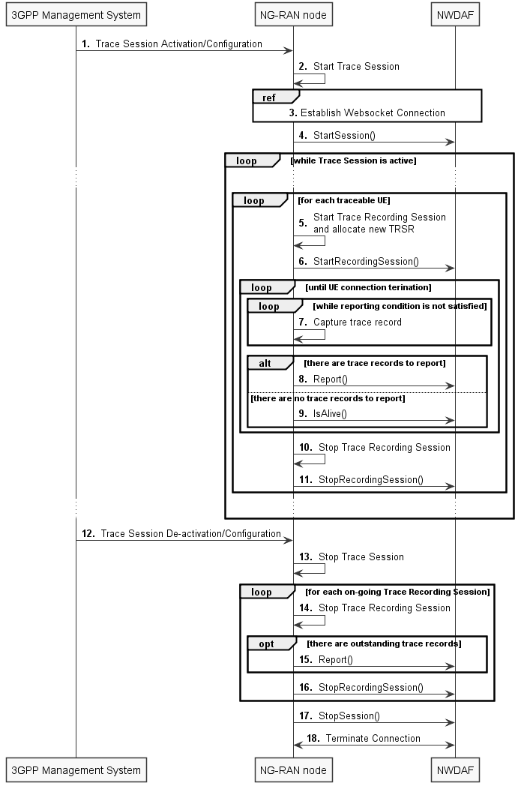
Figure 7.1.5.1.1: Example deployment scenario of NG-RAN node producing and NWDAF consuming non-file-based trace reporting MnS under control of 3GPP Management System

7.1.5.2 Example of ONAP deployment
The following figure illustrates ONAP deployment scenario where NG-RAN node produces, and ONAP DCAE consumes non-file-based trace reporting MnS under control of ONAP Controller:
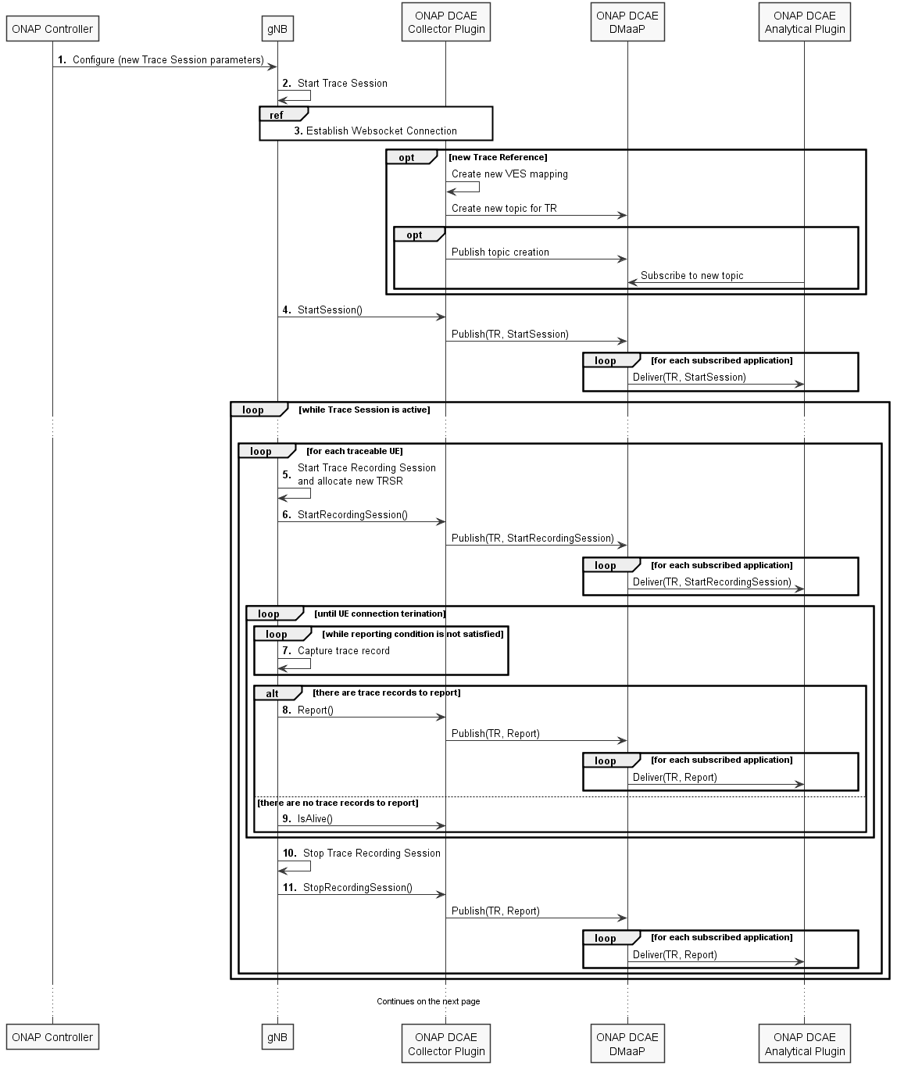
Figure 7.1.5.2.1: Example deployment scenario of NG-RAN node producing and ONAP DCAE consuming non-file-based trace reporting MnS under control of ONAP Controller (part 1)
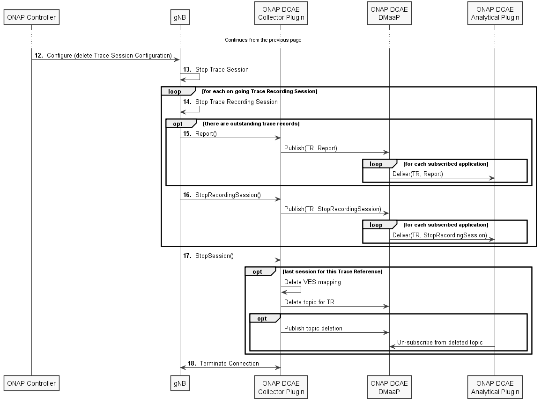
Figure 7.1.5.2.2: Example deployment scenario of NG-RAN node producing and ONAP DCAE consuming non-file-based trace reporting MnS under control of ONAP Controller (part 2)

8 Conclusions and recommendations
The study has investigated the opportunities for new trace reporting methods such as non-file-based Trace reporting, a.k.a. streaming Trace.
The study identified and documented use cases for collecting Cell and UE data for analytics, and for Collecting subscriber and equipment trace data for near-real-time diagnostics and troubleshooting. It established that enabling the capabilities for trace data to be delivered to the consumer(s) while it's still relevant to the analytics, diagnostics and troubleshooting tasks performed by the consumer is important.
The study derived and documented potential requirements to be considered in the normative work.
The study documented and evaluated potential solutions in various deployment scenarios.
It is recommended to do normative work enabling the use of non-file-based Trace reporting (a.k.a. streaming Trace) in 3GPP Rel-16 management.
It is recommended that the normative work includes documenting new requirements and use cases in TS 32.421 [2], new Trace control and configuration management aspects in TS 32.422 [3], and new Trace data encoding format in TS 32.423 [4].
It is recommended to consider the use of non-file-based Trace reporting (a.k.a. streaming Trace) for 5G MDT feature in collaboration with 3GPP RAN workgroups.

Annex A (informative):
Change history
Change history
Date | Meeting | TDoc | CR | Rev | Cat | Subject/Comment | New version
2019-09 | SA#85 | SP-190771 |  |  |  | Presented for information and approval | 1.0.0
2019-09 | SA#85 |  |  |  |  | Change control version | 16.0.0
2019-09 | SA#85 |  |  |  |  | EditHelp review | 16.0.1
2019-12 | SA#86 | SP-191169 | 0001 | 1 | F | Implementation of fixes for issues identified by EditHelp | 16.1.0

