Invitation and General information
on 3GPP SA5#128 meeting

from Monday 18 to Friday 22 of November 2019 in Zhuhai, China

Beijing, 20 August 2019

Dear Delegate,

The Chinese Friends of 3GPP (CF3) has the pleasure of inviting you to the 3GPP SA5#128 meetings in Zhuhai, China.

- SA5#128 Meeting will be held in Crowne Plaza: Zhuhai City Center.

We look forward to seeing you all in Zhuhai.

Yours sincerely,
the Chinese Friends of 3GPP

Accommodation
CF3 is not responsible for reservation confirmations, cancelled or changed reservations or no-shows. Please contact the hotel directly to make the reservation.

Meeting Venue for 3GPP SA5#128
Crowne Plaza: Zhuhai City Center
No.188 Jingshan Road,Jida, Zhuhai, 519015
Tel: +86-756-322 8888
Group Rates:
- CROWNE PLAZA SUPERIOR SINGLE ROOM: CNY 680 net per room per night with one daily breakfast
- CROWNE PLAZA SUPERIOR TWIN ROOM: CNY 780 net per room per night two daily breakfasts
* The above rate includes Service Charge and Estimated government taxes and fees. Broadband Internet access is complimentary in guest rooms.
* Cancellation Policy:
- Canceling your reservation above 30 days before your check-in date (local hotel time) will result in no charge. Canceling your reservation within 30 days before your check-in date (local hotel time) will result in a charge for 1 night per room to your credit card.
- Please contact the hotel by email (Reservation@cpzhuhai.com) if you want to change your reservation.
Hotel cut-off date, 31 October 2019
Hotel booking
Meeting Registration
Please register for the meetings online at:
on-line registration

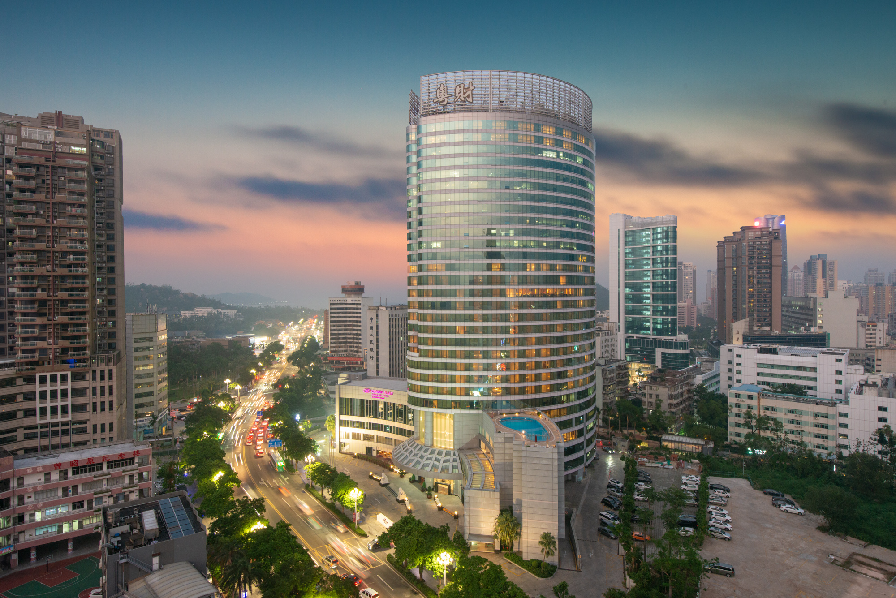

Visa letter
If you need an invitation letter for applying a VISA, complete the provided request form and send it to the person below no later than 4 November, 2019 (Beijing time, GMT+8). Late submission will not be accepted. It is recommended for each company to designate one delegate from your company to collect all the information of your delegates who need the invitation letter and to send one request e-mail by the designated person. Please contact the Chinese Embassy at your country for further information.
PLEASE NOTE THAT WE WILL BE ON HOLIDAY FOR THE NATIONAL DAY HOLIDAY FROM 1 TO 7 OCTOBER, 2019. YOUR VISA REQUEST WILL BE DEALT WITH ASAP AFTER THE HOLIDAY.

Contact person for invitation letter:
Mr. Xu Qi (CCSA)
E-mail: CCSAVISA@163.com
Tel: +86-10-6230-4200

Time Zone
GMT +8 hours

Voltage
Commercial power in China is 220V. Please be sure you have the correct adapter. Voltage converters will not be provided at the meeting.
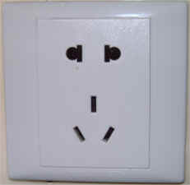

City Profile/ Area Attractions
http://www.cityofzhuhai.com/index.html

Host Contact
For any questions about anything relating to the meeting please contact:
Mr. Xu QI
Tel.: +86-10-6230 4200
E-mail: qixu@ccsa.org.cn

Attachment 1: Invitation letter request form for VISA
Attachment 2: Transport Information about the meeting venue
Attachment 1: Invitation letter request form for VISA

INVITATION LETTER REQUEST FORM

To enter China for the meetings indicated above, you may need a letter of invitation from the Chinese host, which you will need to present to the Chinese Embassy/Consulate in your area in order to obtain your visa. In order to obtain the invitation letter, please:

- fill out the form below
- Send it to ( please reference “Invitation letter request for 3GPP SA1 meeting” as the subject):

Mr. Xu Qi

China Communications Standards Association (CCSA)

CCSAVISA@163.com
(It’s recommended to scan your passport page and email to us so that it’s discernible and can be used.)
Fax number: +86-10-6230 1849-4200 (if your passport page is photocopied and enlarged)
Company
Applicant Information | [ Click and Type in your full name ] |  |  | Mr Ms Mrs
Applicant Information | [ Nationality ] |  |  | [ Passport No.]
Applicant Information | Date of birth : |  |  | [ Job Title ]
Applicant Information | Is this your first visit to China? |  |  | __ Yes ___ No
Applicant Information | If the country in which you'll obtain your visa is different from your nationality, please indicate it here:  [ Country to obtain your visa]
Applicant Information | The name and the address of the Chinese Embassy/Consulate, which you are going to apply your visa.  Name:  Address:
Your Address
Place to visit after entry | In this case, it is Zhuhai by default.
Date of arrival at China |  |  | Date of departure from China
End of form
(Please do not forget to attach a copy of your passport photograph page before sending.)
Your information should be sent out before 4 November, 2019

Attachment 2: Transport Information about Meeting Venue

A：Transportation from Zhuhai Airport (http://www.zhairport.com/)

Crowne Plaza: Zhuhai City Center is about 45 km and 90 mins by car from Zhuhai Airport.

The fare for taxi from Zhuhai Airport to our meeting hotel is around CNY 180 per way. (Please take the taxi which can provide the invoice for your trip)

B：Transportation from Macau International Airport (http://www.macau-airport.com/)

Crowne Plaza: Zhuhai City Center is about 22 km from Macau International Airport. You have to get to Gongbei Border Gate (拱北口岸) first and get entry there, and then you can take a taxi to our hotel.
- Cross-Border Coach: Macau International Airport → Gongbei Border Gate (Service hours: 09:00-19:30, Fare: HKD 40)
- Gongbei Border Gate is about 6 km and 15 mins by taxi from Crowne Plaza: Zhuhai City Center (Fare: CNY 25).

In case of taking a taxi, please print the following note which shows taxi driver the address of Crowne Plaza: Zhuhai City Center in both English and Chinese.
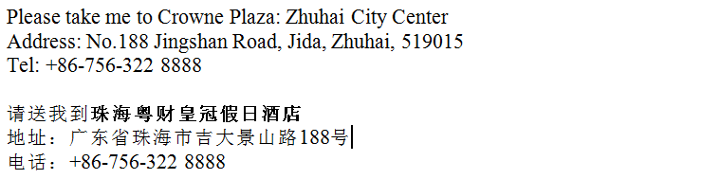

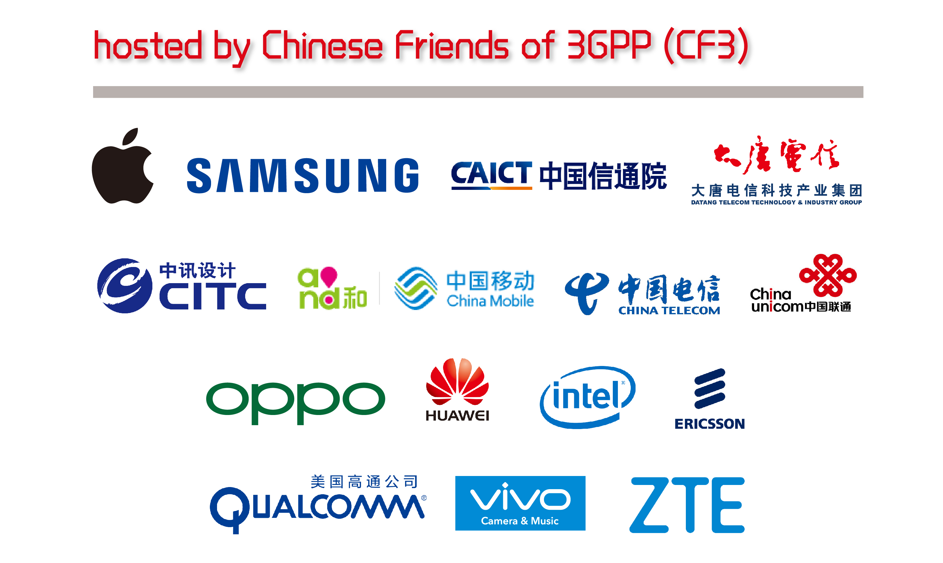

- Apple Computer Trading Co., Ltd.
- BEIJING SAMSUNG TELECOM R&D CENTER
- China Academy of Information and Communications Technology
- China Academy of Telecommunication Technology
- China Information Technology Design & Consulting Institute Co., Ltd.
- China Mobile Communications Corporation
- China Telecommunications Corporation
- China Unicom
- Guangdong OPPO Mobile Telecommunications Corp., Ltd.
- Huawei Technologies Co.,Ltd.
- Intel China Ltd.
- Nanjing Ericsson Panda Com Ltd.
- Qualcomm Wireless Communication Technologies (China) Limited.
- vivo Mobile Communication Co., Ltd.
- ZTE Corporation

Have a successful meeting and enjoy your stay in Zhuhai!

