



have the pleasure of inviting you to 3GPP SA2#134, SA3-Ad-Hoc, SA5-Ad Hoc

in Sapporo, Japan from Monday 24 to Friday 28 June 2019

|  |  |
| --- | --- |
| 3GPPSA2#134 | 24 - 28 June 2019 |
| 3GPPSA3-Ad-Hoc | 24 - 28 June 2019 |
| 3GPPSA5-Ad Hoc | **25 - 28 June 2019** |

3GPP Meetings ( SA2#134, SA3-Ad-Hoc, SA5-Ad Hoc)

The Japanese Friends of 3GPP**, Anritsu, Ericsson Japan, Fujitsu, Fujitsu Connected Technologies Limited, Huawei Technologies Japan, KDDI, KYOCERA, MITSUBISHI ELECTRIC, NEC, Nokia Networks Japan, NTT DOCOMO, OKI, Panasonic, Qualcomm Japan, Rakuten Mobile Network, Inc., SHARP, SoftBank, and Sony Mobile Communications Japan** have the pleasure of inviting you to the above-mentioned meeting.

We look forward to seeing you all in Sapporo.

Yours sincerely,

"Japanese Friends of 3GPP"

# Meeting Registration

Please register for the meeting online via 3GPP website at:

On-line registration

<https://webapp.etsi.org/3GPPRegistration/>

# Meeting Venue

**Hotel Emisia Sapporo**

*Address : (English / Japanese)*

5-25, Atsubetsu Chuo 2-Jo 5-Chome, Atsubetsu-Ku, Sapporo, 004-0052 Japan

Phone: +81-11-895-8811

ホテルエミシア札幌

札幌市厚別区厚別中央2条5丁目5-25

TEL：011-895-8811

Access to closest station:

6 minute walk from Shin Sapporo Station, JR (Japan Railways) Chitose line

3 minute walk from Shin Sapporo Station, Subway Tozai line

English: <http://www.hotel-emisia.com/index.en.html>

Japanese: <http://www.hotel-emisia.com/index.html>

Please refer also to ANNEX 3 for Transportation to the Venue.

# Host Contact

For any questions about the meeting, please contact our Meeting Coordinators.

ILCC Co., Ltd

E-mail: [jf3wgs_sec@ilcc.com](mailto:jf3wgs_sec@ilcc.com) Tel: +81-3-5562-3665

Note: Please note that there will be 10 days long national holiday in Japan, April 27(sat) through May 6(mon), including the enthronement ceremony of new emperor. Thank you very much in advance for your earlier communication, as we may not be able to respond you in a timely manner during the above period.

# Accommodation

Online Reservation:

**Hotel Emisia Sapporo** offers the special package for 3GPP SA2 / SA3 / SA5 meetings in Sapporo, Japan.

Please access the URL below for online reservations.

[**https://bit.ly/2RGrH0X**](https://bit.ly/2RGrH0X) **(Hotel Emisia Sapporo Reservation Site)**

## Please note that online reservation will be available on the website starting from Monday, February 4, 2019. (Japan Standard Time)

## Cut off date: Friday, June 7, 2019（Japan Standard Time）

If you want to reserve your accommodation by other means, we recommend that you reserve it at your earliest convenience.

Please refer to ANNEX 2 for Accommodation.

Please note that "Japanese Friends of 3GPP (JF3)" is not responsible for arranging accommodations such as confirmation, cancellation and changing of hotel reservation.

# Visa Request

To find out whether you need a visa for entry to Japan, please consult <http://www.mofa.go.jp/j_info/visit/visa/faq.html#q1-1> and click the link "[the List of Countries and Regions that have Visa Exemption Arrangements with Japan](http://www.mofa.go.jp/j_info/visit/visa/short/novisa.html#list)" in the Q&A No.1. The list shows "Arrangements of Exemption of Visas". If your home country’s name is not shown on the list, you need a visa.

If you need a visa, please fill out the attached invitation letter request form (ANNEX 1) and send it to[visa1@s.ttc.or.jp](mailto:visa1@s.ttc.or.jp) **by** **Friday, May 10, 2019.**

For any questions, please contact [visa1@s.ttc.or.jp](mailto:visa1@s.ttc.or.jp) (attn. JF3 visa support in TTC).

For members in a company who are in the same office facility, it is suggested that you make your requests as a group, if possible.

If you prefer, you can obtain a public key for e-mail encryption simply by sending an e-mail to [visa1@s.ttc.or.jp](mailto:visa1@s.ttc.or.jp) with the subject "Public Key request" BEFORE sending your personal information in an attachment.

# Other information

## Voltage

100V/50Hz. Japanese plugs are two flat pin type (A-type) plugs. Please make sure you have correct adapters. Voltage converters or adapters will NOT be provided at the meetings.

**Please bring your voltage converters and plug adapters! (100 volts/50 hertz)**

# (ANNEX 1)

**Visa support letter application form**

Please fill in the form below and e-mail it to [visa1@s.ttc.or.jp](mailto:visa1@s.ttc.or.jp) **by Friday, May 10, 2019.**

(Note: you can obtain a public key for e-mail encryption simply by sending an e-mail to [visa1@s.ttc.or.jp](mailto:visa1@s.ttc.or.jp%20) with the subject "Public Key request" BEFORE sending your personal information in an attachment.)

|  |  |  |  |
| --- | --- | --- | --- |
| Given name (First name) | | alphabetical |  |
| Family name (Last name) | | alphabetical |  |
| Date of Birth (dd/mm/yy) | | |  |
| Gender (Male/Female) | | |  |
| Nationality | | |  |
| Valid passport number | | |  |
| Passport Valid until (dd/mm/yy) | | |  |
| Country and/or Consulate to submit your visa application | | |  |
| Postal Address for your visa support documents to be shipped | Address | |  |
| Postal Code | |  |
| Country | |  |
| Telephone number | | + |
| The above address is: (please select one) | | | Office / home / other (specify: ) |
| Occupation and Job title | | |  |
| Name of Company/Organization | | |  |
| Company/Organization Address (fill in “same as above” if shipping address is your office) | | |  |
| Telephone number | | | + |
| Fax number | | | + |
| Email address | | |  |

Itinerary (refer to examples shown in the table.)

|  |  |  |  |
| --- | --- | --- | --- |
| D/M/Y | Schedule | Address and Phone number to reach | Hotel |
| ex) 23 / June / 2019 | Arrival from Paris to New Chitose, Flight xxx | *1 | *1 |
| ex) 24-28 / June / 2019 | Attending SA2 #134 meeting | *1 | *1 |
| ex) 29 / June / 2019 | Departure from New Chitose to Paris, Flight xxx |  |  |
| Fill in your Itinerary below | | | |
|  |  |  |  |
|  |  |  |  |
|  |  |  |  |
| *1 Hotel　Emisia Sapporo:  Address: 5-25,Atsubetsu Chuo 2-Jo 5-Chome, Atsubetsu-Ku, Sapporo, 004-0052 Japan  Phone: +81-11-895-8811  Fax: +81-11-895-8899 | | | |

# (ANNEX 2)

**Accommodation**

**Online Reservation**

**Hotel Emisia Sapporo: 3GPP meetings will take place in the hotel.**

Hotel Emishia offers the special package for 3GPP SA2 / SA3 / SA5 meetings in Sapporo, Japan.

Please access the URL below for online application to make your hotel reservations.

[**https://bit.ly/2RGrH0X**](https://bit.ly/2RGrH0X) **(Hotel Emisia Sapporo Reservation Site)**

## Please note that online reservation will be available on the website starting from Monday, February 4, 2019. (Japan Standard Time)

## Cut off date: Friday, June 7, 2019.（Japan Standard Time）

Website above will be closed as soon as reservation becomes full, while 200 rooms are blockedfor our participants.

We strongly recommend you booking through the above website, as early as possible, since the reservation will be made on first come, first serve basis.

* Package Details: Please check with the website above.

**Hotel Reservation Contact**

If you have any questions or requests, please feel free to contact Hotel Emisia Sapporo.

E-Mail: reservation.sapporo@hotel-emisia.com

**Cancellation Policy**

Upon cancellation of a reservation, the Customer will be charged a certain percentage

of the total price of accommodation (cancellation charge) as listed below.

・If the reservation is canceled the day before the intended check-in day: 20%

・If the reservation is canceled on the intended check-in day: 80%

・If no notice is received of cancellation; or no show: 100%

◆Access

5-25,Atsubetsu Chuo 2-Jo 5-Chome, Atsubetsu-Ku, Sapporo, 004-0052 Japan

TEL:+81-11-895-8811

Access to closest station:

6 minute walk from JR Shin Sapporo Station, JR Chitose line

3 minute walk from Shin Sapporo Station, Subway Tozai line

Hotel Emisia Sapporo, located in Shin Sapporo, which has direct access to JR(train), subway, bus, and all other means of transportation. It is also close to New Chitose Airport, the gateway to Hokkaido. Smooth and easy access is to be expected.

・ New Chitose Airport: JR "Rapid Airport" (28 minutes)

・ JR Sapporo Station: JR "Rapid Airport" (8 minutes)

・ Subway Odori Station: Subway Tozai Line (20 minutes)

・ Mitsui Outlet Park: Car (30 minutes)

・ Maruyama Zoo: Subway (30 minutes)

・ Otaru: JR “Rapid Airport” (47 minutes)

**Hotel Information**

**Other hotels**

For delegates who wish to reserve your accommodation on your own, we have listed the following hotels below for your reference. Please note that JF3 Secretariat are not responsible for arranging the hotels below.

**Hotel near JR Shin Sapporo Station**

**① Shin-Sapporo ARC CITY HOTEL**

2 minute walk to the venue

<http://www.arccityhotel.com/en/>

**Hotels near JR Sapporo Station**

**JR Sapporo Station is 8 minute train ride from JR Shin Sapporo Station where the venue is located.**

**② Hotel Gracery Sapporo**

<https://sapporo.gracery.com/>

**③ JR Tower Hotel Nikko Sapporo**

<https://www.jrhotels.co.jp/tower/english/accommodation/index.html>

**④ Keio Plaza Hotel Sapporo**

<https://www.keioplaza-sapporo.co.jp/english/>

**⑤ Mitsui Garden Hotel Sapporo**

<https://www.gardenhotels.co.jp/sapporo/eng/>

# (ANNEX 3)

**Transportation to the Venue**

**Meeting Venue:**

**Hotel Emisia Sapporo**

5-25,Atsubetsu Chuo 2-Jo 5-Chome, Atsubetsu-Ku, Sapporo, 004-0052 Japan

TEL:+81-11-895-8811

The Meeting Venue is 6 minute walk from the JR Shin Sapporo Station and 3 minute walk from the Subway Tozai Line’s Shin Sapporo Station. The JR Shin Sapporo Station and the Subway Tozai Line’s Shin Sapporo Station are connected.

New Chitose Airport (CTS) is the airport adjacent to Sapporo City and the most convenient to reach the Meeting Venue.

**[From New Chitose Airport (CTS)]**

**By Train:**

Take the JR "Rapid Airport" at New Chitose Airport to Shin Sapporo Station.

Travel time: approx. 30 minutes

Fee: 880 Yen

Operating Hours: 6:56 a.m. - 10:53 p.m. (including local train)

Time Table: <http://www.new-chitose-airport.jp/en/access/jr/timejr/>

Although Shin Sapporo Station is not written in the time table, “Rapid Airport” stops at Shin Sapporo Station in 28 minutes after leaving New Chitose Airport Station.

Please refer to the example shown below of “Rapid Airport” departing at 12:45.

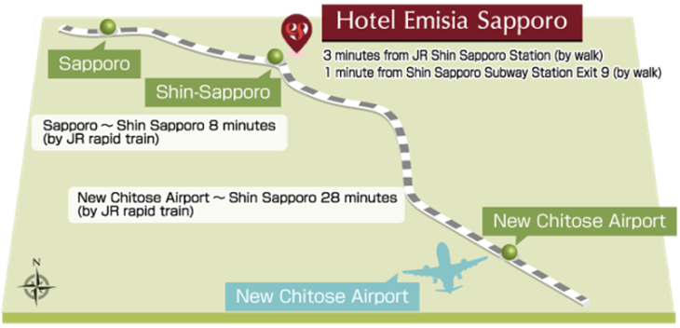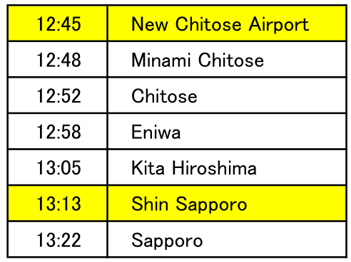

JR Hokkaido HP

<http://www2.jrhokkaido.co.jp/global/index.html>

How to use ticket vending machine

<http://www2.jrhokkaido.co.jp/global/pdf/e-ticketmachine.pdf>

Route guide from New Chitose Airport International Terminal to JR New Chitose Airport Station

<http://www2.jrhokkaido.co.jp/global/english/travel/airport.html>

**By Taxi:**

Travel time: approx. 60 minutes

Standard rate: JPY 12,000-14,400, late night rate: JPY 17000

Map of Sapporo and surrounding area

<http://www.sapporo.travel/learn/map/?lang=en>

