3GPP TR 32.899 V15.0.0 (2018-01)
Technical Report
3rd Generation Partnership Project;
Technical Specification Group Services and System Aspects;
Telecommunication management;
Charging management;
Study on charging aspects of 5G system architecture phase 1
(Release 15)


The present document has been developed within the 3rd Generation Partnership Project (3GPP TM) and may be further elaborated for the purposes of 3GPP.
The present document has not been subject to any approval process by the 3GPP Organizational Partners and shall not be implemented.
This Report is provided for future development work within 3GPP only. The Organizational Partners accept no liability for any use of this Specification.
Specifications and Reports for implementation of the 3GPP TM system should be obtained via the 3GPP Organizational Partners' Publications Offices.

Keywords
Charging, 5G, NextGen
3GPP
Postal address

3GPP support office address
650 Route des Lucioles - Sophia Antipolis
Valbonne - FRANCE
Tel.: +33 4 92 94 42 00 Fax: +33 4 93 65 47 16
Internet
http://www.3gpp.org
Copyright Notification
No part may be reproduced except as authorized by written permission.
The copyright and the foregoing restriction extend to reproduction in all media.

© 2018, 3GPP Organizational Partners (ARIB, ATIS, CCSA, ETSI, TSDSI, TTA, TTC).
All rights reserved.

UMTS™ is a Trade Mark of ETSI registered for the benefit of its members
3GPP™ is a Trade Mark of ETSI registered for the benefit of its Members and of the 3GPP Organizational Partners
LTE™ is a Trade Mark of ETSI registered for the benefit of its Members and of the 3GPP Organizational Partners
GSM® and the GSM logo are registered and owned by the GSM Association
Contents
Foreword 9
1 Scope 10
2 References 10
3 Definitions, symbols and abbreviations 11
3.1 Definitions 11
3.2 Symbols 11
3.3 Abbreviations 11
4 High-level description and potential requirements 12
4.1 Potential high-level charging requirements 12
4.2 Reference 5G system architectures 12
4.2.1 Non-roaming 5G system architecture 12
4.2.2 Roaming 5G system architecture 14
4.2.2.1 Roaming 5G system architecture - LBO scenario 14
4.2.2.2 Roaming 5G system architecture – Home routed scenario 15
4.3 Conventions 16
5 Topics 17
5.1 Session management and service continuity 17
5.1.1 Description and assumptions 17
5.1.2 Potential requirements 17
5.1.3 Key issues 17
5.1.3.1 Key issue #1.1: PDU session charging 17
5.1.3.2 Key issue #1.2: PDU session charging - SSC Mode 1 17
5.1.3.3 Key issue #1.3: PDU session charging - SSC Mode 2 18
5.1.3.4 Key issue #1.4: PDU session charging - SSC Mode 3 – parallel traffic 18
5.1.4 Solutions 18
5.1.4.1 Solution#1.1: PDU session charging from SMF 18
5.1.4.1.1 Architecture description 18
5.1.4.1.2 Procedure description 19
5.1.4.1.3 Solution evaluation 21
5.1.4.2 Solution#1.2: PDU session charging SSC Mode 1 from SMF 21
5.1.4.2.1 Architecture description 21
5.1.4.2.2 Procedure description 22
5.1.4.2.3 Solution evaluation 23
5.1.4.3 Solution#1.3: PDU session Charging SSC Mode 2 from SMF – CH session update 23
5.1.4.3.1 Architecture description 23
5.1.4.3.2 Procedure description 24
5.1.4.4 Solution#1.4: PDU session Charging SSC Mode 2 from SMF – new CH session 25
5.1.4.4.1 Architecture description 25
5.1.4.4.2 Procedure description 25
5.1.4.5 Solution#1.5: PDU session Charging SSC Mode 3 from SMF – CH session update 26
5.1.4.5.1 Architecture description 26
5.1.4.5.2 Procedure description 26
5.1.4.6 Solution#1.6: PDU session Charging SSC Mode 3 from SMF – New CH session 28
5.1.4.6.1 Architecture description 28
5.1.4.6.2 Procedure description 28
5.1.4.6.2.1 Scenario - no SMF reallocation 28
5.1.4.6.2.2 Scenario with SMF reallocation 29
5.1.4.7 Solution#1.7: PDU session Charging SSC Mode 3 Multi Homed from SMF – CH session update 30
5.1.4.7.1 Architecture description 30
5.1.4.7.2 Procedure description 30
5.1.4.8 Solution#1.8: PDU session Charging SSC Mode 3 Multi Homed from SMF – New CH session 32
5.1.4.8.1 Architecture description 32
5.1.4.8.2 Procedure description 32
5.1.5 Evaluation and conclusion 32
5.1.5.1 Architecture 32
5.1.5.2 Evaluation 33
5.1.5.2.1 Solutions evaluation for Key issue #1.3 33
5.1.5.2.2 Solutions evaluation for Key issue #1.4 33
5.1.5.3 Conclusion 34
5.2 QoS 34
5.2.1 Description and assumptions 34
5.2.2 Potential requirements 34
5.2.3 Key issues 34
5.2.3.1 Key issue#2.1 : QoS flow based charging 34
5.2.4 Solutions 35
5.2.4.1 Solution#2.1 QoS flow based charging - Reporting level per combination of the rating group and QFI 35
5.2.4.1.1 Architecture description 35
5.2.4.1.2 Procedure description 35
5.2.4.2 Solution#2.2 QoS flow based charging - Reporting level per combination of the rating group and QoS flow identifier and Service ID 36
5.2.4.2.1 Architecture description 36
5.2.4.2.2 Procedure description 36
5.2.4.3 Solution#2.3 QoS flow based charging - Reporting level per combination of the rating group and QoS flow identifier and Sponsor Id/Application service provider identity 36
5.2.4.3.1 Architecture description 36
5.2.4.3.2 Procedure description 36
5.2.5 Overall evaluation and conclusion 37
5.2.5.1 Solution evaluation 37
5.2.5.2 Conclusions 37
5.3 Interaction between SMF and UPF 37
5.3.1 Description and assumptions 37
5.3.1.0 General 37
5.3.1.1 Traffic monitoring, diversion, and blocking 38
5.3.1.1.1 Description and assumptions 38
5.3.1.2 Type of units for rating 38
5.3.1.2.1 Description and assumptions 38
5.3.2 Potential requirements 38
5.3.3 Key issues 39
5.3.3.1 Key issue #3.1: Traffic monitoring 39
5.3.3.2 Key issue #3.2: Blocking and diversion 39
5.3.3.3 Key issue #3.3: Support of duration 39
5.3.3.4 Key issue #3.4: Triggers and reporting in the separate SMF and UPF 39
5.3.3.5 Key issue #3.5: Quota management in the separate SMF and UPF 39
5.3.3.6 Key issue #3.6: PDU session Charging - Branching Point or UL Classifier 39
5.3.3.7 Key issue #3.7: Bytes counted as continuous and discrete time 40
5.3.4 Solutions 40
5.3.4.1 Solution#3.1: The reporting and quota management in the separation SMF and UPF 40
5.3.4.1.1 Architecture description 40
5.3.4.1.2 Offline Charging 41
5.3.4.1.3 Online charging 42
5.3.4.1.4 Solution evaluation 43
5.3.4.2 Solution#3.2: PDU session charging – counts in BP/UL CL UPF only 43
5.3.4.2.1 Architecture description 43
5.3.4.2.2 Procedure description - Addition of additional PDU Session Anchor and Branching Point or UL CL 43
5.3.4.2.3 Procedure description - Removal of additional PDU Session Anchor and Branching Point or UL CL 45
5.3.4.2.4 Procedure description - Additional PDU Session anchor relocation for UL CL 46
5.3.4.2.5 Procedure description - Relocation of UL CL for a PDU Session 47
5.3.4.3 Solution#3.3: PDU session charging – counts in two UPFs – single CH session 49
5.3.4.3.1 Architecture description 49
5.3.4.3.2 Procedure description - Addition of additional PDU Session Anchor and Branching Point or UL CL 49
5.3.4.3.3 Procedure description - Removal of additional PDU Session Anchor and Branching Point or UL CL 51
5.3.4.3.4 Procedure description - Additional PDU Session anchor relocation for UL CL 51
5.3.4.3.5 Procedure description - Relocation of UL CL for a PDU Session 51
5.3.4.4 Solution#3.4: The reporting and quota management SSC mode 2 – CH session update 51
5.3.4.4.1 Architecture description 51
5.3.4.4.2 Procedure description 51
5.3.4.4.2.0 General Description 51
5.3.4.4.2.1 Solution 3.4.1: The Charging system is aware of the UPF change 52
5.3.4.4.2.2 Solution 3.4.2: The Charging system is not aware of the UPF change 53
5.3.4.5 Solution#3.5: The reporting and quota management – in multiple UPFs (parallel traffic) 53
5.3.4.5.1 Architecture description 53
5.3.4.5.2 Procedure description 54
5.3.4.5.2.0 General Description 54
5.3.4.5.2.1 Solution 3.5.1 Charging system granted quota shared by UPFs 54
5.3.4.5.2.2 Solution 3.5.2 Charging System grants the quota for each UPF 57
5.3.4.6 Solution#3.6: Bytes counted as continuous time 58
5.3.4.6.1 Architecture description 58
5.3.4.6.2 Procedure description 58
5.3.4.6.3 Solution evaluation. 58
5.3.4.7 Void 58
5.3.4.8 Solution#3.8: Charging at SMF and usage monitoring over N4 58
5.3.4.8.1 Architecture description 58
5.3.4.8.2 Procedure description 58
5.3.4.8.3 Solution evaluation. 60
5.3.4.9 Solution#3.9: PDU session charging – counts in UPFs – single CH session 60
5.3.4.9.1 Architecture description 60
5.3.4.9.2 Procedure description- Addition of additional PDU Session Anchor and Branching Point or UL CL 60
5.3.4.9.3 Procedure description - Removal of additional PDU Session Anchor and Branching Point or UL CL 61
5.3.4.9.4 Procedure description - Additional PDU Session anchor relocation for UL CL 63
5.3.4.9.5 Procedure description - Relocation of UL CL for a PDU Session 64
5.3.4.10 Solution#3.10: The reporting and quota management SSC mode 2 – New CH session 65
5.3.4.10.1 Architecture description 65
5.3.4.10.2 Procedure description 65
5.3.5 Overall evaluation and conclusion 66
5.3.5.1 Evaluation 66
5.3.5.1.1 Solutions evaluation for Key issue #3.1 and #3.2 66
5.3.5.1.2 Solutions evaluation for Key issue #3.3 66
5.3.5.1.3 Solutions evaluation for Key issue #3.4 66
5.3.5.1.4 Solutions evaluation for Key issue #3.5 66
5.3.5.1.5 Solutions evaluation for Key issue #3.6 67
5.3.5.2 Conclusion 67
5.4 Network Slicing 67
5.4.1 Description and assumptions 67
5.4.2 Potential requirements 68
5.4.3 Key issues 68
5.4.3.1 Key issue #4.1: Charging for UE served by one or more Network Slice instances 68
5.4.3.2 Key issue #4.2: Charging for the CSP who utilizes a specific network slice instance 68
5.4.4 Solutions 69
5.4.4.1 Solution#4.1: Charging for UE - different architecture options 69
5.4.4.1.1 Offline charging 69
5.4.4.1.1.1 Option #1: The offline charging system with CDF and CGF in two separate physical elements 69
5.4.4.1.1.2 Option #2: The offline charging system with CDF integrated in the NE, CGF in a separate physical element 69
5.4.4.1.1.3 Option #3: The offline charging system with CDF and CGF integrated in the NE 70
5.4.4.1.2 Online charging 70
5.4.4.1.2.0 General Description 70
5.4.4.1.2.1 Option #1: The online charging system is shared by all the Network Slice instances per PLMN 71
5.4.4.1.2.2 Option #2: online charging by instantiating a slice-specific OCF/RF/CGF for each Network Slice instance 71
5.4.4.1.3 Solution evaluation 72
5.4.4.2 Solution#4.2: Charging for creating and modifying a Network Slice by a CSP 72
5.4.4.2.1 Offline charging 72
5.4.4.2.2 Online charging 73
5.4.4.3 Solution#4.3: Charging procedure for UE served by multiple network slice instances 74
5.4.4.3.1 Procedure description 74
5.4.4.3.2 Solution evaluation 74
5.4.5 Conclusions 75
5.5 Network Capability Exposure 75
5.5.1 Description and assumptions 75
5.5.2 Potential requirements 75
5.5.3 Key issues 76
5.5.3.1 Key issue #5.1: Charging for network capability exposure 76
5.5.3.2 Key issue #5.2: Exposure of Charging System as network capability 76
5.5.4 Solutions 76
5.5.4.1 Solution#5.1: Charging for network capability external exposure – Ro/Rf 76
5.5.4.1.1 Architecture description 76
5.5.4.1.2 Procedure description 76
5.5.4.2 Solution#5.2: Exposure of Charging System as network capability 77
5.5.4.2.1 Architecture description 77
5.5.4.3 Solution#5.3: Charging for internal network capability exposure 77
5.5.4.3.1 Architecture description 77
5.5.4.3.2 Procedure description 78
5.5.4.4 Solution#5.4: Charging for Event Exposure with bulk subscription 78
5.5.4.4.1 Architecture description 78
5.5.4.4.2 Procedure description 78
5.5.4.5 Solution#5.5: Charging for network capability external exposure – Nch 79
5.5.4.5.1 Architecture description 79
5.5.4.5.2 Procedure description 79
5.5.5 Evaluation and conclusion 79
5.5.5.1 Evaluation 79
5.5.5.2 Conclusion 79
5.6 Roaming 80
5.6.1 Description and assumption 80
5.6.1.0 General 80
5.6.1.1 PDU session – roaming LBO 80
5.6.1.2 PDU session - roaming Home Routed 80
5.6.2 Potential requirements 80
5.6.3 Key issues 80
5.6.3.1 Key issue #6.1: Online charging from HPLMN 80
5.6.4 Solutions 81
5.6.4.1 Solution #6.1: PDU session charging from SMF in roaming LBO – CH in VPLMN 81
5.6.4.1.1 Architecture description 81
5.6.4.1.2 Procedures description 81
5.6.4.1.3 Charging mode and objective 81
5.6.4.1.4 Charging architecture – additional considerations 82
5.6.4.1.5 Solution evaluation 82
5.6.4.2 Solution #6.2: PDU session charging from SMF in roaming LBO – CH in HPLMN 82
5.6.4.2.1 Architecture description 82
5.6.4.2.2 Procedures description 82
5.6.4.2.3 Charging mode and objective 83
5.6.4.2.4 Charging architecture – additional considerations 83
5.6.4.2.5 Solution evaluation 83
5.6.4.3 Solution #6.3: PDU session charging from SMFs in Home Routed 84
5.6.4.3.1 Architecture description 84
5.6.4.3.2 Procedures description 84
5.6.4.3.3 Charging mode and objective 86
5.6.4.3.4 Charging architecture – additional considerations 86
5.6.4.3.4.1 Description 86
5.6.4.3.4.2 Solution #6.3.1: solutions #9.1 (Combined online and offline charging) for VPLMN 86
5.6.4.3.4.3 Solution #6.3.2: solutions #9.2 (Partial combined online and offline charging) for VPLMN 86
5.6.4.3.4.4 Solution #6.3.3: solutions #9.3 (Online charging with unlimited quota for offline) for VPLMN 87
5.6.4.3.4.5 Solution #6.3.4: Rf solution for VPLMN 87
5.6.4.3.5 Solution evaluation 87
5.6.4.4 Solution #6.4: PDU session charging from SMF in roaming LBO – CH in HPLMN and VPLMN 88
5.6.4.4.1 Architecture description 88
5.6.4.4.2 Procedures description 88
5.6.4.4.3 Charging mode and objective 88
5.6.4.4.4 Additional considerations 89
5.6.4.4.5 Solution evaluation 89
5.6.5 Overall evaluation and conclusion 89
5.6.5.1 Overall evaluation 89
5.6.5.2 Conclusion 89
5.7 Service-based architecture 90
5.7.1 Description and assumptions 90
5.7.2 Potential requirements 90
5.7.3 Key issues 90
5.7.3.1 Key issue #7.1: The service interface for Charging Domain 90
5.7.4 Solutions 90
5.7.4.1 Solution#7.1: Service interface for SMF and Charging Domain 90
5.7.4.1.1 Architecture description 90
5.7.4.1.2 Service identification 90
5.7.4.2 Solution#7.2: Reference point representation for SMF and Charging Domain 91
5.7.4.3 Solution#7.3: Service interface for SMF and Charging Domain 92
5.7.4.4 Solution evaluation 92
5.7.5 Conclusions 92
5.8 Interworking between 5G System and existing systems 93
5.8.1 Description and assumptions 93
5.8.2 Potential requirements 93
5.8.3 Key issues 93
5.8.3.1 Key issue #8.1: <Charging for 5GS to EPS handover> 93
5.8.3.2 Key issue #8.2: <Charging for EPS to 5GS handover> 93
5.8.4 Solutions 94
5.8.4.1 Solution#8.1: 5GS to EPS handover using N26 interface 94
5.8.4.2 Solution#8.2: EPS to 5G handover using N26 interface 95
5.8.5 Evaluation and conclusion 97
5.8.5.1 Solution Evaluation 97
5.8.5.2 Conclusions 97
5.9 Online and offline charging evaluation 97
5.9.1 Description and assumption 97
5.9.1.1 Existing functionalities 97
5.9.1.2 Considerations for 5G 98
5.9.2 Potential requirements 98
5.9.3 Key issues 98
5.9.3.1 Key issue #9.1: CDRs generation for online 98
5.9.3.2 Key issue #9.2: Offline charging only 98
5.9.4 Solutions 99
5.9.4.1 Solution #9.1: Combined online and offline charging 99
5.9.4.1.1 Architecture description 99
5.9.4.1.2 Procedures description 99
5.9.4.1.3 Solution evaluation. 99
5.9.4.2 Solution #9.2: Partial combined online and offline charging 100
5.9.4.2.1 Architecture description 100
5.9.4.2.2 Procedures description 100
5.9.4.2.3 Solution evaluation. 100
5.9.4.3 Solution #9.3: Online charging with unlimited quota for offline 101
5.9.4.3.1 Architecture description 101
5.9.4.3.2 Procedures description 101
5.9.4.3.3 Solution evaluation. 101
5.9.5 Overall evaluation and conclusion. 101
5.9.5.1 Overall evaluation 101
5.9.5.2 Conclusion 102
5.10 Connection, registration and mobility management 102
5.10.1 Description and assumptions 102
5.10.2 Potential requirements 102
5.10.3 Key issues 102
5.10.4 Solutions 102
5.10.4.1 Solution#10.1: No charging for registration 102
5.10.4.1.1 Architecture description 102
5.10.4.1.2 Procedure description 102
5.10.4.1.3 Solution evaluation. 103
5.10.4 Conclusion 103
6. Conclusions and recommendations 103
6.1 Conclusions 103
6.2 Recommendations 103
Annex A: Change history 104

Foreword
This Technical Report has been produced by the 3rd Generation Partnership Project (3GPP).
The contents of the present document are subject to continuing work within the TSG and may change following formal TSG approval. Should the TSG modify the contents of the present document, it will be re-released by the TSG with an identifying change of release date and an increase in version number as follows:
Version x.y.z
where:
x the first digit:
1 presented to TSG for information;
2 presented to TSG for approval;
3 or greater indicates TSG approved document under change control.
y the second digit is incremented for all changes of substance, i.e. technical enhancements, corrections, updates, etc.
z the third digit is incremented when editorial only changes have been incorporated in the document.

1 Scope
The present document studies the charging architecture, principles and functionalities for a 5G System Phase 1 specified in TS 23.501 [201] and TS 23.502 [202], based on the TR 23.799 [200] conclusions.
The stage 1 requirements from TS 22.115 [101] and TS 22.261 [102] are also input for this study.
The charging architecture and functionalities are studied for the set of features and capabilities supported by the 5G System Phase 1, and for interworking scenarios between the 5G System and existing systems as well.
Evolution of charging mechanisms and charging models to support the Third Parties are investigated.
The study provides a prioritisation between the different features, if evaluated as necessary, to allow a potential phased approach for the normative work.

2 References
The following documents contain provisions which, through reference in this text, constitute provisions of the present document.
- References are either specific (identified by date of publication, edition number, version number, etc.) or non-specific.
- For a specific reference, subsequent revisions do not apply.
- For a non-specific reference, the latest version applies. In the case of a reference to a 3GPP document (including a GSM document), a non-specific reference implicitly refers to the latest version of that document in the same Release as the present document.
[1] 3GPP TS 32.240: "Telecommunication management; Charging management; Charging architecture and principles ".
[2] - [10] Void
[11] 3GPP TS 32.251: "Telecommunication management; Charging management; Packet Switched (PS) domain charging".
[12] - [13] Void.
[14] 3GPP TS 32.254: "Northbound Application Program Interfaces (APIs) for exposure function interworking charging".
[15] - [49] Void.
[50] 3GPP TS 32.299: "Telecommunication management; Charging management; Diameter charging application".
[51] - [99] Void.
[100] 3GPP TR 21.905: "Vocabulary for 3GPP Specifications".
[101] 3GPP TS 22.115: "Service aspects; Charging and billing".
[102] 3GPP TS 22.261: "Service requirements for next generation new services and markets; Stage 1".
[103] - [199] Void.
[200] 3GPP TR 23.799: "Study on Architecture for Next Generation System".
[201] 3GPP TS 23.501: "System Architecture for the 5G System; Stage 2".
[202] 3GPP TS 23.502: "Procedures for the 5G System; Stage 2".
[203] 3GPP TS 28.530 Telecommunication management; Management of network slicing in mobile networks; Concepts, use cases and requirements
[204] 3GPP TS 23.503: " Policy and Charging Control Framework for the 5G System; Stage 2".
[205] 3GPP TS 23.222: "Functional architecture and information flows to support Common API Framework for 3GPP Northbound APIs; Stage 2".
[206] - [400] Void.
[401] IETF RFC 6733 (2012): "Diameter Base Protocol".
[402] IETF RFC 4006 (2005): "Diameter Credit-Control Application".

3 Definitions, symbols and abbreviations

3.1 Definitions
For the purposes of the present document, the terms and definitions given in 3GPP TR 21.905 [100] and the following apply. A term defined in the present document takes precedence over the definition of the same term, if any, in 3GPP TR 21.905 [100].

3.2 Symbols
For the purposes of the present document, the following symbols apply:
NSI Id An identifier, which is used to uniquely identify a Network Slice Instance (NSI).
SD A Slice Differentiator (SD). which is optional information that complements the Slice/Service type(s) to allow further differentiation for selecting an Network Slice instance from the potentially multiple Network Slice instances that all comply with the indicated Slice/Service type.

3.3 Abbreviations
For the purposes of the present document, the abbreviations given in 3GPP TR 21.905 [100] and the following apply.
An abbreviation defined in the present document takes precedence over the definition of the same abbreviation, if any, in 3GPP TR 21.905 [100].
AMF Access and Mobility Management Function
AF Application Function
AN Access Network
DN Data Network
DNN Data Network Name
NEF Network Exposure Function
NRF NF Repository Function
NSI Network Slice Instance
NSSAI Network Slice Selection Assistance Information
PCF Policy Control Function
PDU Protocol Data Unit
SM Session Management
SMF Session Management Function
S-NSSAI Single Network Slice Selection Assistance Information
SSC Service and Session Continuity
UDM Unified Data Management
UPF User Plane Function

4 High-level description and potential requirements

4.1 Potential high-level charging requirements
Most of the High-level charging requirements specified in TS 22.115 [101], applicable to LTE, remain valid in 5G.
Some of them are summarized below so they can directly be used in the context of this study. The following should be supported:
- Volume, time, combined volume and time, and event based charging models;
- Session based charging;
- Application based charging model;
- Usage real-time control;
- capability for billing system support;
- capability for inter-operator charging;
- capability for Network operator to Third party providers charging.
A set of Charging requirements specific to 5G are specified in TS 22.261 [102], and copied below:
- "The 5G core network shall support collection of charging information for alternative authentication mechanisms.
- The 5G core network shall support collection of charging information associated with each serving MNO when multi-network connectivity is used under the control of the home operator.
- The 5G core network shall support charging for services/applications in an operator's Service Hosting Environment.
- The 5G core network shall support charging for content delivered from a content caching application.
- The 5G core network shall support collection of charging information based on the access type (e.g., 3GPP, non-3GPP).
- The 5G core network shall support collection of charging information based on the slice that the UE accesses.
- The 5G core network shall support collection of charging information based on the network performance metrics, when the information is available."
Editor's Note: the requirements for 5G charging are still to be completed, either at High-level by update of this clause, either under specific clauses of the TR when they correspond to dedicated topics.

4.2 Reference 5G system architectures

4.2.1 Non-roaming 5G system architecture
The 5G System architecture reference is per TS 23.501 [201], Service-based interfaces are used within the Control Plane.
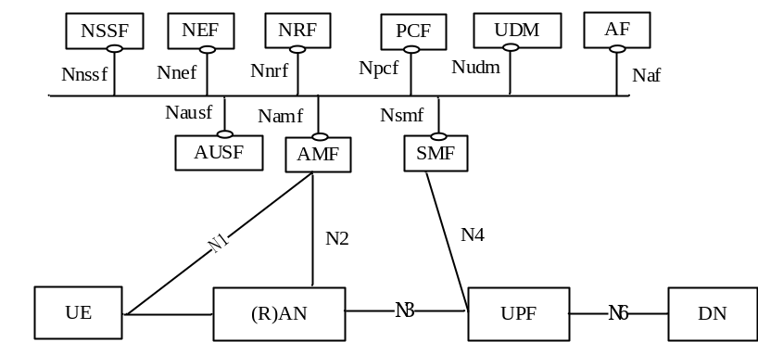
Figure 4.2.1.1: 5G System architecture
Figure 4.2.1.2 depicts the 5G System architecture in the non-roaming case, using the reference point representation showing how various network functions interact with each other.
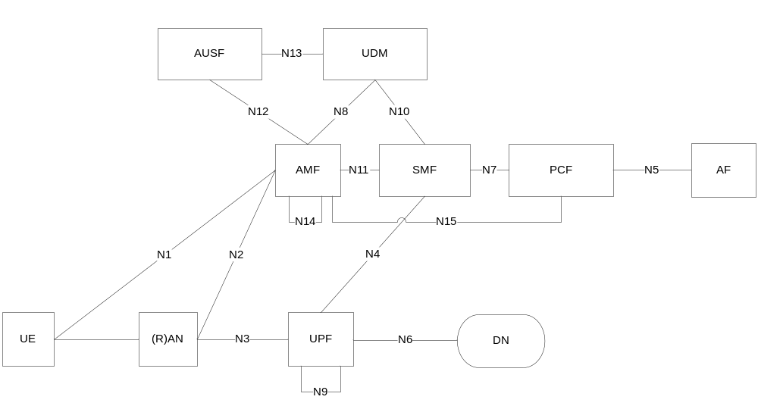
Figure 4.2.1.2: Non-Roaming 5G System Architecture in reference point representation
Figure 4.2.1.3 represents the non-roaming architecture for interworking between 5GS and EPC/E-UTRAN.
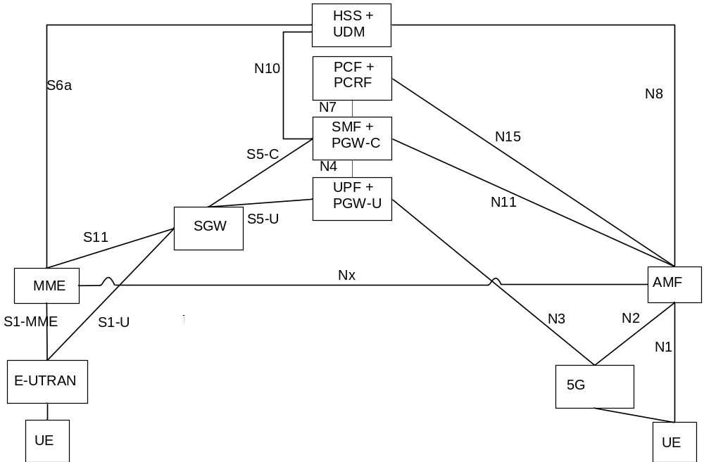
Figure 4.2.1.3: Non-roaming architecture for interworking between 5GS and EPC/E-UTRAN

4.2.2 Roaming 5G system architecture

4.2.2.1 Roaming 5G system architecture - LBO scenario
The 5G System architecture reference for Roaming -LBO is per TS 23.501 [201]:
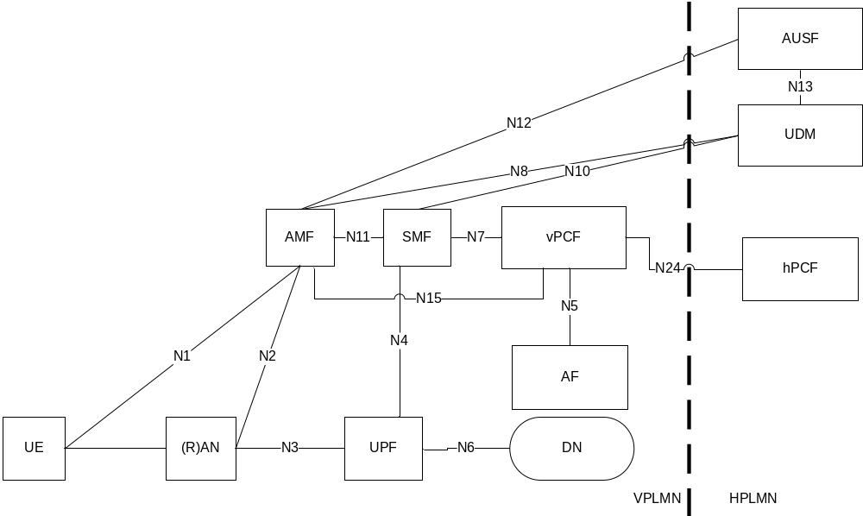
Figure 4.2.2.1.1: Roaming 5G System architecture - local breakout scenario with AF in VPLMN in reference point representation
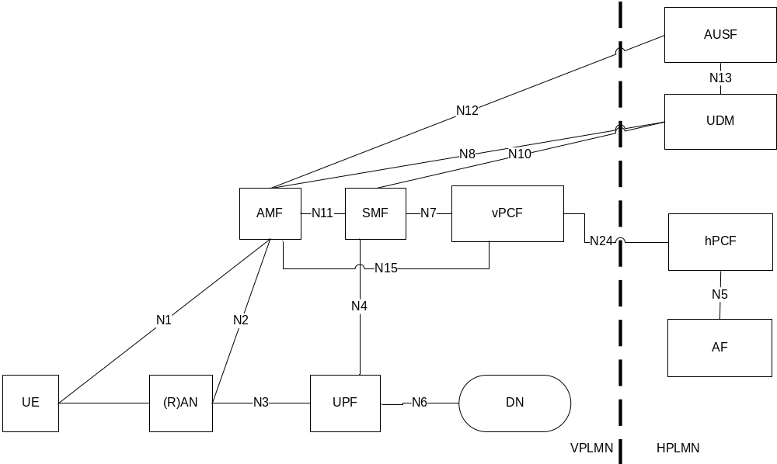
Figure 4.2.2.1.2: Roaming 5G System architecture -local breakout scenario with AF in the HPLMN in reference point representation

4.2.2.2 Roaming 5G system architecture – Home routed scenario
The 5G System architecture reference for Home Routed is per TS 23.501 [201]:
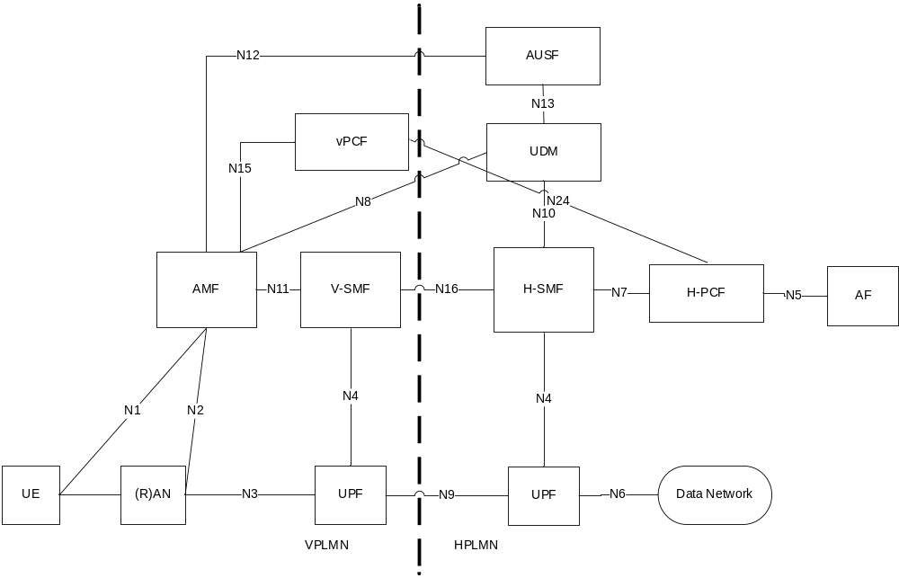
Figure 4.2.2.2.1: Roaming 5G System architecture-Home routed scenario in reference point representation

4.3 Conventions
In the present document, when flows are introduced for a given solution, to reflect the step in which the interaction between the 5G System Network Element and the Charging domain occurs, this interaction is indicated as step A in the following figure:
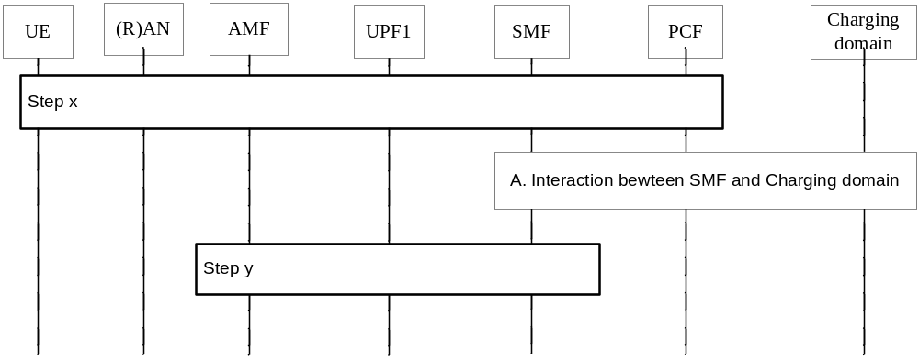
Figure 4.3.1: Flow example
Where step A is a direct interaction between the 5G System Network Element (SMF) and the Charging domain.
Other steps (x, y) may not indicate direct interaction.
All the flows included in the present document when referring to TS 23.502 [202] flows, may have differences with the corresponding TS 23.502 [202] flows: e.g. step numbering and names of the messages may differ.

5 Topics

5.1 Session management and service continuity

5.1.1 Description and assumptions
The PDU Connectivity Service towards different types of DNs (e.g. Internet, IMS, corporate/private) is provided by a PDU Session, managed by the Session Management functionality via procedures for establishing new PDU sessions and modifying/terminating established PDU sessions.
Based on PDU session definition in TS 23.501 [201] (i.e. Association between the UE and a Data Network that provides a PDU connectivity service), the PDU session is per DNN, similar as for EPC the PDN connection was per APN.Different PDU types (IP, Ethernet and non-IP PDU types) can be supported. For PDU IP type, the UE IP address allocation & management is also part of the Session Management.
This Session Management functionality is specified in TS 23.501 [201] clause 5.6.
The session and service continuity functionality enables various continuity scenarios of different applications/services for the UE, via session and service continuity (SSC) modes determined by the Session Management functionality. The SSC mode associated with a PDU session anchor does not change during the lifetime of a PDU session.
The session and service continuity functionality is specified in TS 23.501 [201] clause 5.6.9.
An unique identity number (i.e. the Charging Id) is assigned to the PDU session by the SMF to identify the Charging session belongs to the same PDU session.

5.1.2 Potential requirements
The following should be supported for the PDU connectivity service:
- session based charging;
- time based charging;
- charging based on different properties of the connectivity: destination, PDU type;
- charging based on usage of the external data network identified by a DNN;
- charging continuity for a PDU session in service continuity scenario, when the PDU session is served by a given SMF.

5.1.3 Key issues

5.1.3.1 Key issue #1.1: PDU session charging
This key issue is for investigating on how to support the session based and time based charging models, for PDN connectivity service provided by a PDU session, also considering the different properties of this PDU session.
This investigation covers the following:
- determination of which entity/entities in the 5G architecture is suitable to host the CTF(s);
- identification of the main interactions with the charging domain.

5.1.3.2 Key issue #1.2: PDU session charging - SSC Mode 1
This key issue is for investigating on how to support the PDU session Charging for an established PDU session during SSC Mode 1 scenario.
This investigation covers the following:
- determination of which entity/entities in the 5G architecture is suitable to host the CTF(s);
- identification of the main interactions with the charging domain.

5.1.3.3 Key issue #1.3: PDU session charging - SSC Mode 2
This key issue is for investigating on how to support the PDU session Charging for an established PDU session during PDU session anchor relocation in SSC Mode 2. This investigation covers the following:
- determination of which entity/entities in the 5G architecture is suitable to host the CTF(s);
- identification of the main interactions with the charging domain,

5.1.3.4 Key issue #1.4: PDU session charging - SSC Mode 3 – parallel traffic
This key issue is for investigating on how to support the PDU session Charging for an established PDU session during PDU session anchor relocation in SSC Mode 3. This investigation covers the following:
- determination of which entity/entities in the 5G architecture is suitable to host the CTF(s);
- identification of the main interactions with the charging domain;
- usage collection of traffic running simultaneously in two UPFs, upon UE PDU session anchor relocation in SSC mode 3 in a "make before break" model.

5.1.4 Solutions

5.1.4.1 Solution#1.1: PDU session charging from SMF

5.1.4.1.1 Architecture description
The charging information collection for the PDU session at "session management" level can be achieved by charging domain interfacing the SMF, as described in Figure 5.1.4.1.1.1.
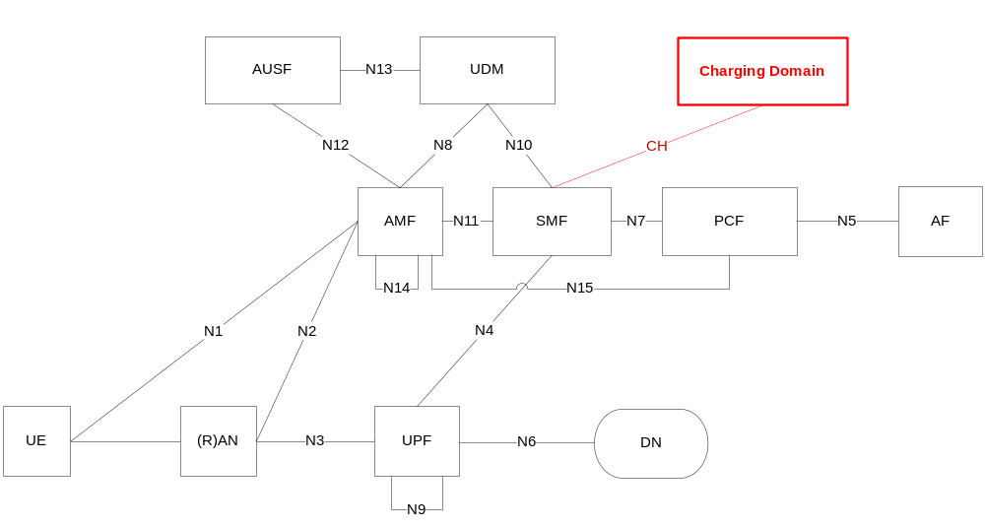
Figure 5.1.4.1.1.1: Charging domain interfacing the SMF

5.1.4.1.2 Procedure description
The following figure 5.1.4.1.2.1 describes a PDU session establishment, based on clause 4.3.2.2.1 TS 23.502 [202] description, for a non-roaming case.
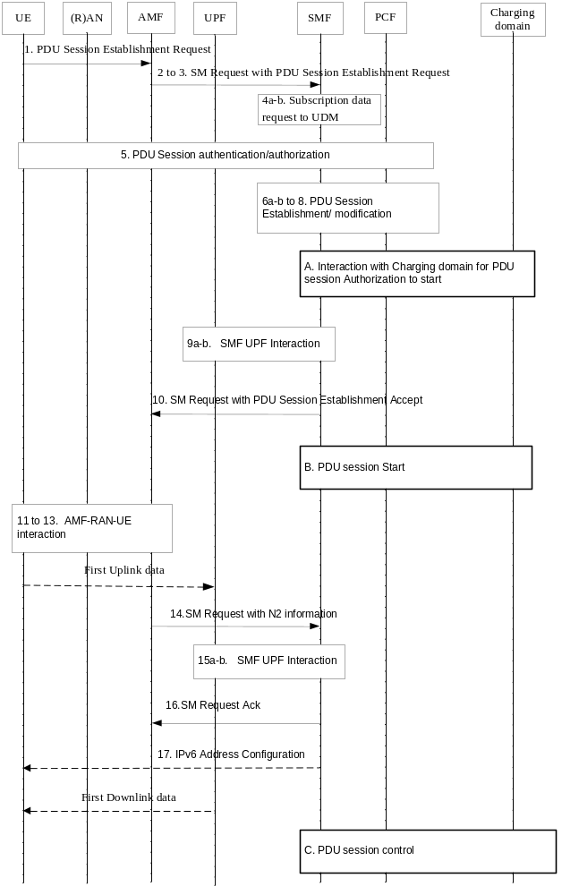
Figure 5.1.4.1.2.1: PDU session establishment
1. The UE initiates a PDU Session establishment procedure (PDU Session ID, PDU Type, SSC mode, User location information and Access Technology Type Information).
[2 to 3]. SMF selection by AMF, and sending of SM Request (PDU Session Establishment Request).
[4a-b]. Subscription Data Request to UDM, based on (Subscriber Permanent ID, DNN): Default QoS profile.
5. PDU session authentication/authorization.
[6a-b to 8]. If dynamic PCC is deployed, the SMF performs PCF selection, and requests for PCC Rules, and SMF selection of UPF.
A. The SMF performs Charging domain selection, creates a Charging Id for the PDU session, and seeks for authorization for the subscriber to start the PDU session based on information associated to this PDU session.
[9a-b]. SMF UPF interaction for Packet detection, enforcement and reporting rules installation.
10. SMF to AMF: SM Request Ack.
B. Start of the PDU session is reported to charging domain.
[11 to 13]. AMF-(R)AN-UE interaction: N2 SM information, AN resource setup, (R)AN tunnel information.
14. AMF to SMF: SM Request (N2 SM information).
[15a-b]. SMF UPF interaction for Modification procedure.
16. SM request Ack from SMF to AMF.
17. In case of PDU Type IPv6, IPv6 Address Configuration.
C. Control of the PDU session by the charging domain.
There may be additional interaction with the charging domain after or before step 15. This will be determined during the normative phase.

5.1.4.1.3 Solution evaluation
Solution#1.1 is the basic solution for PDU session charging solves Key issue #1.1. It is also the basis for solutions covering other clause 5.1.3 Key issues on service continuity.

5.1.4.2 Solution#1.2: PDU session charging SSC Mode 1 from SMF

5.1.4.2.1 Architecture description
The charging information collection for the PDU session continuity in SSC Mode 1 can be achieved by charging domain interfacing the SMF, as described per Figure 5.1.4.1.1.1, with the additional details of SSC mode 1 provided in Figure 5.1.4.2.1.1.
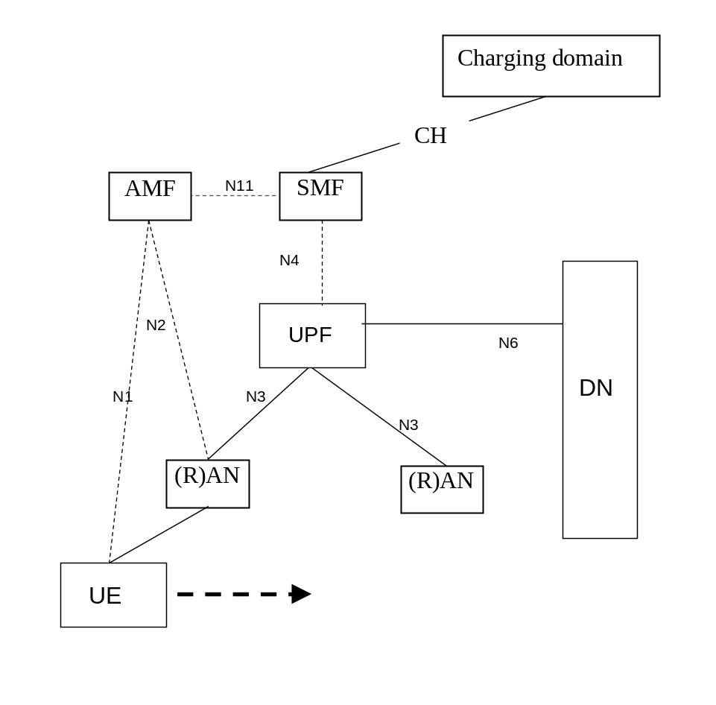
Figure 5.1.4.2.1.1: Charging domain interfacing the SMF – SSC Mode 1

5.1.4.2.2 Procedure description
PDU session continuity in SSC Mode 1 per TS 23.501 [201] clause 5.6.9.2.1:
- In case of a PDU session of IP type, IP continuity is supported regardless of UE mobility events (IP @ is preserved).
- UPF remains as the anchor.
The following figure 5.1.4.2.2.1 describes a PDU session anchor relocation in SSC mode 1.
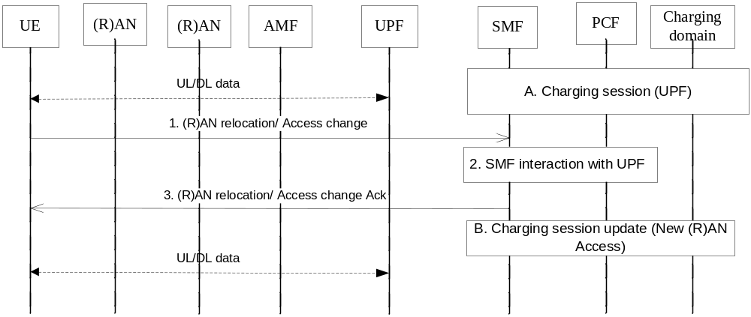
Figure 5.1.4.2.2.1: PDU session anchor relocation in SSC mode 1
A. Ongoing charging session associated with the established PDU session (UPF).
1. A (R)AN relocation is performed.
2. The SMF determines that the serving UPF needs to be maintained and interacts with the UPF for the path switch to the new (R)AN access.
3. the SMF acknowledges the path switch to the new (R)AN.
B. The Charging session is updated due to new User location information/ Access Technology Type Information.
In which step(s) of the scenario the SMF needs to interact with the charging domain will be determined during the normative phase.

5.1.4.2.3 Solution evaluation
Solution#1.2 solves Key issue #1.2 (PDU session charging - SSC Mode 1) and is aligned with existing principles of condition changes behaviour in charging.

5.1.4.3 Solution#1.3: PDU session Charging SSC Mode 2 from SMF – CH session update

5.1.4.3.1 Architecture description
The charging information collection for the PDU session anchor relocation in SSC Mode 2 with CH session update, can be achieved by charging domain interfacing the SMF, as described per Figure 5.1.4.1.1.1, with the additional details of SSC mode 2 provided in Figure 5.1.4.3.1.1.
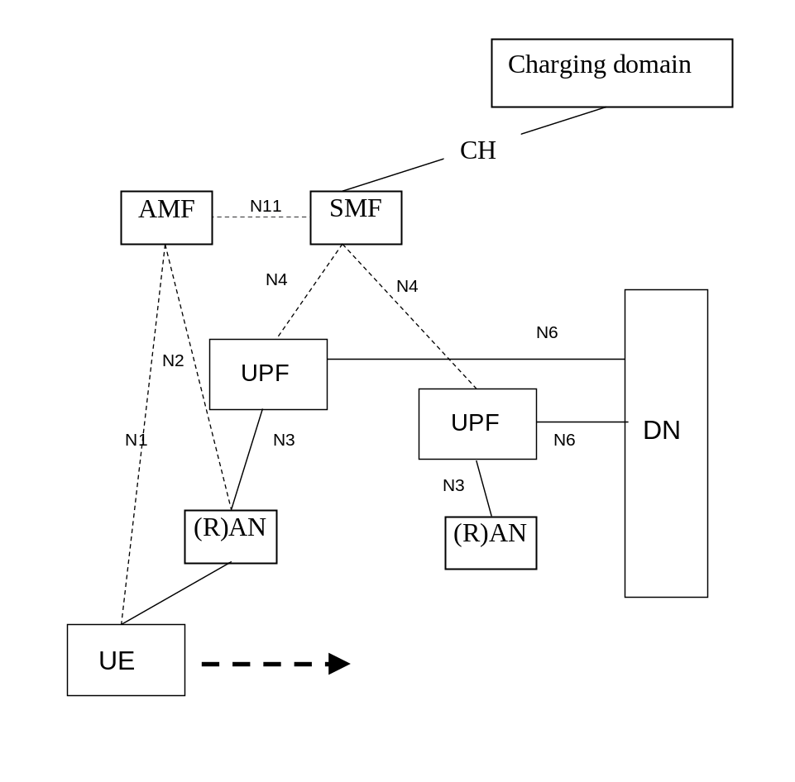
Figure 5.1.4.3.1.1: Charging domain interfacing the SMF – SSC Mode 2

5.1.4.3.2 Procedure description
Per TS 23.501 [201] clause 5.6.9.2.2, upon PDU session anchor relocation in SSC mode 2 with single PDU session anchor, the UPF is relocated, and new IP address/prefix is allocated for PDU session of IP Type. The SMF may be reallocated as per TS 23.501 [201] clause 6.3.2.
The PDU session anchor relocation in SSC mode 2 procedure is based on a "break before make" model.
The following figure 5.1.4.3.2.1 describes a PDU session anchor relocation in SSC mode 2 with single PDU session anchor, based on clause 4.3.5.1 TS 23.502 [202], with Charging session update, assuming the same SMF is selected.
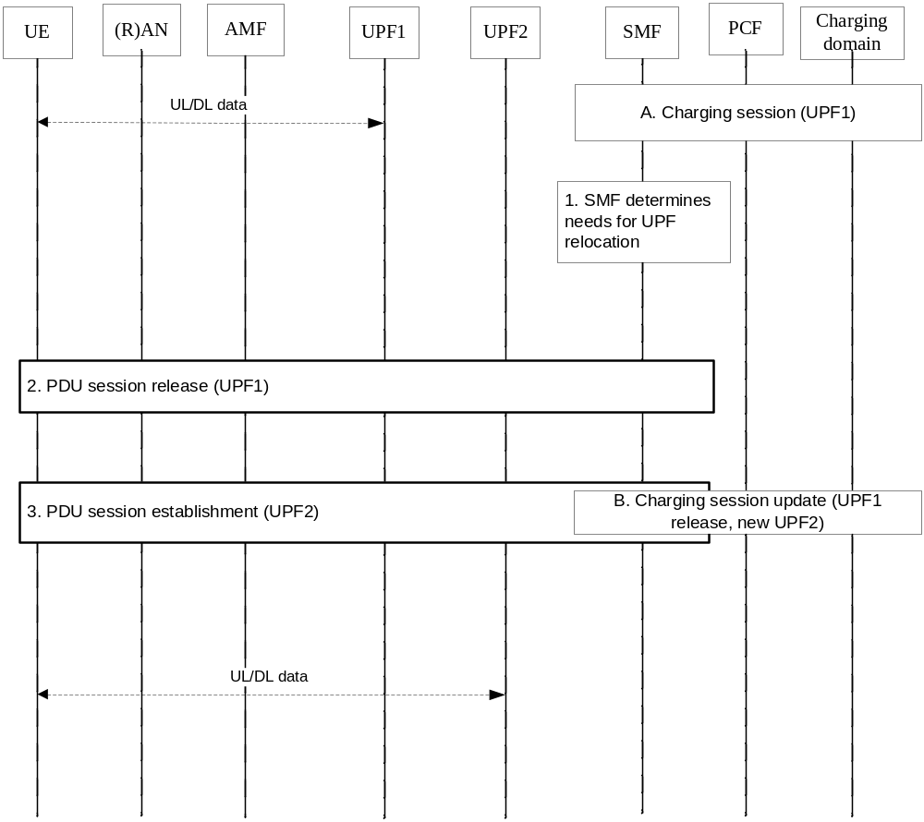
Figure 5.1.4.3.2.1: PDU session anchor relocation in SSC mode 2 with single PDU session anchor – CH session update
A. Ongoing charging session associated with the established PDU session (UPF1)
1. The SMF determines that the serving UPF needs to be relocated due to events that may benefit from UPF relocation.
2. PDU session release procedure. The SMF sends a NAS message to the UE via the AMF (contains the PDU Session ID that needs to be relocated and Cause indicating that a PDU Session re-establishment to the same DN is required).
3. PDU session establishment procedure (UPF2) with a new PDU Session ID generated by the UE, resulting in new IP @ allocation.
B. The Charging session is updated due to:
- the PDU session release (PDU session Id, UPF1), and UPF1 is removed from the data path;
- the PDU session establishment with the new PDU session Id, IP @, and new UPF2 in the data path (potentially new User location information and Access Technology Type Information).
In which step(s) of the scenario the SMF needs to interact with the charging domain will be determined during the normative phase.

5.1.4.4 Solution#1.4: PDU session Charging SSC Mode 2 from SMF – new CH session

5.1.4.4.1 Architecture description
The same architecture as per clause 5.1.4.3.1 applies.

5.1.4.4.2 Procedure description
Per TS 23.501 [201] clause 5.6.9.2.2, upon PDU session anchor relocation in SSC mode 2 with single PDU session anchor, the UPF is relocated, and new IP address/prefix is allocated for PDU session of IP Type. The SMF may be reallocated as per TS 23.501 [201] clause 6.3.2.
The PDU session anchor relocation in SSC mode 2 procedure is based on a "break before make" model.
The following figure 5.1.4.4.2.1 describes a PDU session anchor relocation in SSC mode 2 with single PDU session anchor, based on clause 4.3.5.1 of TS 23.502 [202], with new Charging session creation, assuming the same SMF is selected.
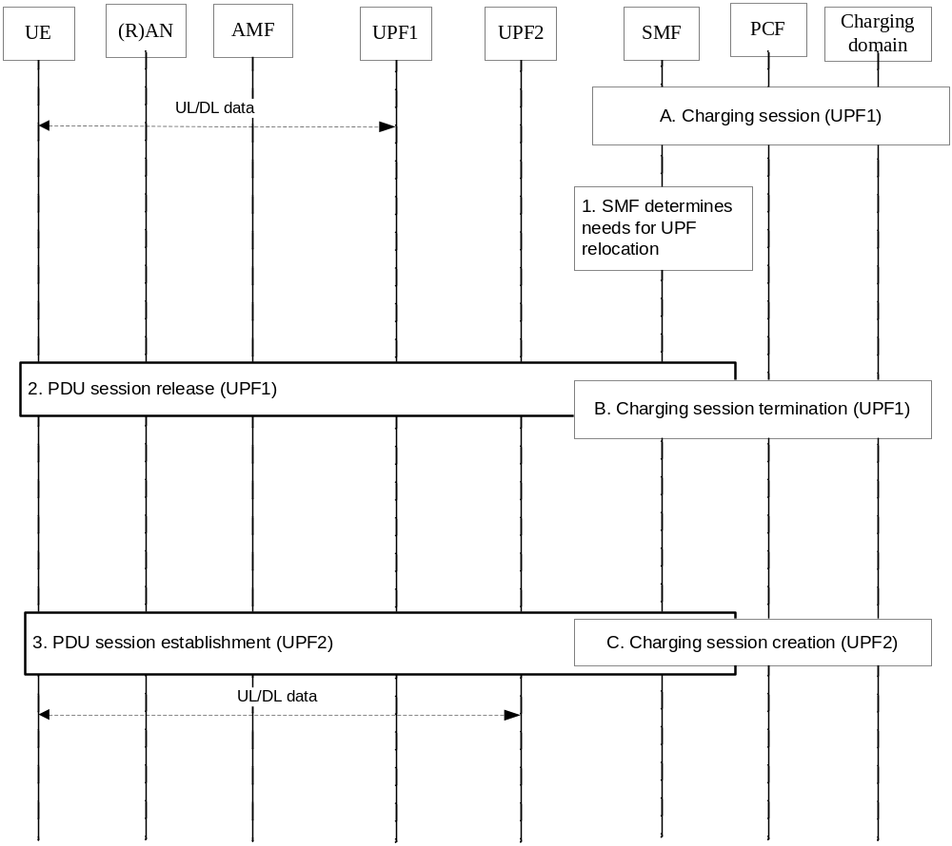
Figure 5.1.4.4.2.1: PDU session anchor relocation in SSC mode 2 with single PDU session anchor – new CH session
A. Ongoing charging session associated with the established PDU session (UPF1)
[1 to 2]. Same as step 1 to 2 in clause 5.1.4.3.2.
B. The Charging session with PDU session Id, UPF1 and corresponding IP @ is terminated.
3. Same as step 3 in clause 5.1.4.3.2.
C. New Charging session created with the Charging Id assigned to the previous PDU session Id, UPF2 new PDU session Id and new IP @ allocated, and potentially new User location information and Access Technology Type Information.
In which step(s) of the scenario the SMF needs to interact with the charging domain will be determined during the normative phase.

5.1.4.5 Solution#1.5: PDU session Charging SSC Mode 3 from SMF – CH session update

5.1.4.5.1 Architecture description
The charging information collection for the PDU session anchor relocation in SSC Mode 3 with CH session update, can be achieved by charging domain interfacing the SMF, as described per Figure 5.1.4.1.1.1, with the additional details of SSC mode 3 provided in Figure 5.1.4.5.1.1.
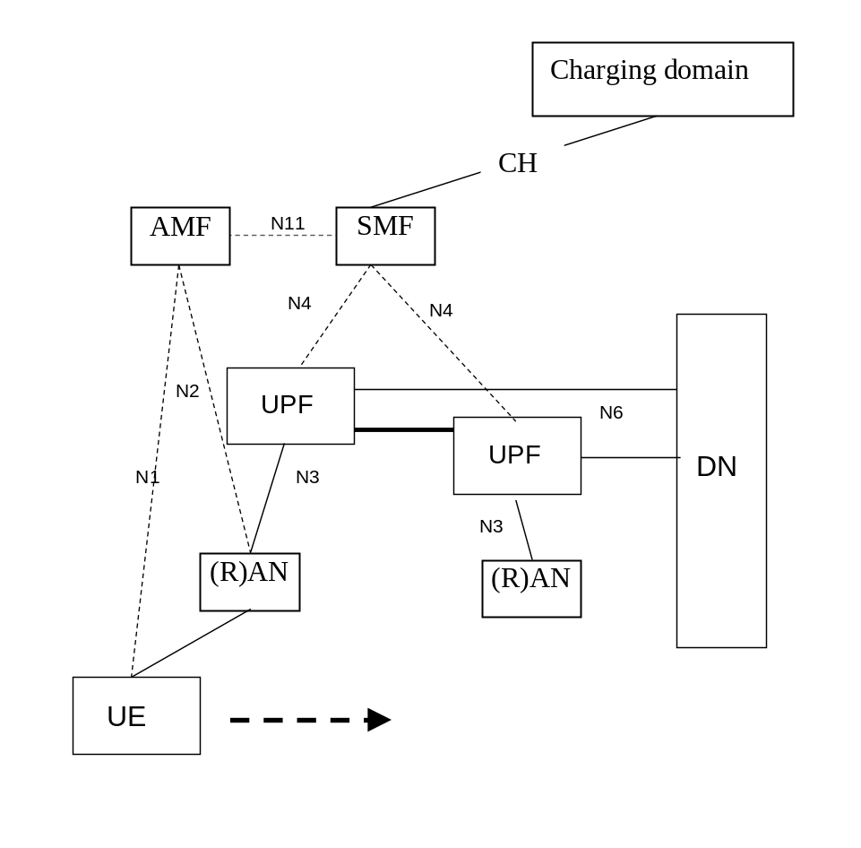
Figure 5.1.4.5.1.1: Charging domain interfacing the SMF – SSC Mode 3

5.1.4.5.2 Procedure description
Per TS 23.501 [201] clause 5.6.9.2.3, upon UE PDU session anchor relocation in SSC mode 3, UPF is relocated, a new IP address/prefix is allocated for PDU session of IP Type, and the old IP address/prefix is maintained during some time.
The PDU session anchor relocation in SSC mode 3 procedure is based on a "make before break" model.
The following figure 5.1.4.5.2.1 describes a PDU session anchor relocation in SSC with mode 3 multiple PDU sessions, based on clause 4.3.5.2 of TS 23.502 [202] and no SMF reallocation, with Charging session update.
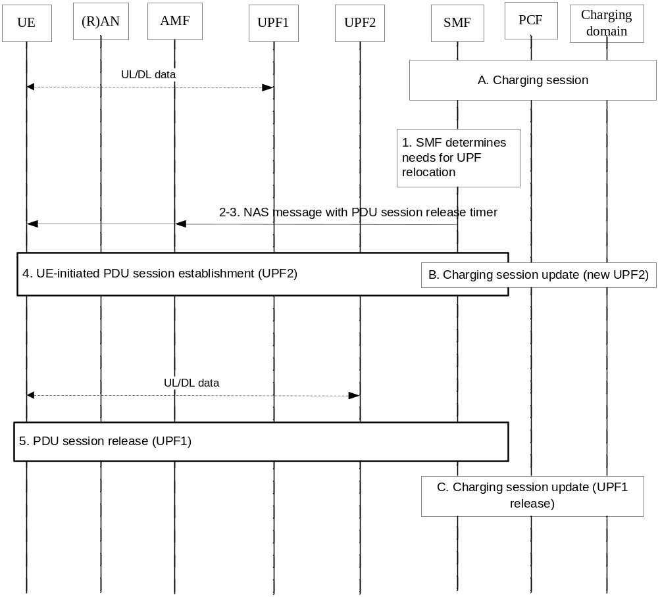
Figure 5.1.4.5.2.1: PDU session anchor relocation in SSC mode 3 with multiple PDU sessions - CH session update
A. Ongoing charging session associated with the established PDU session (UPF1).
1. The SMF determines that the serving UPF needs to be relocated due to events that may benefit from UPF relocation.
[2-3]. The SMF sends an NAS message to the UE via the AMF to notify that the PDU session will be released upon a timer, and to allow the UE to establish a new PDU Session to the same DN (PDU session ID, timer).
4. UE initiates PDU session establishment procedure (new PDU session ID, old PDU session ID). A new PDU session anchor (i.e. UPF2) is selected by the SMF based on new PDU session Id. This step may not occur.
B. The Charging session is updated due to PDU session establishment with the new UPF2 in the data path, if step 4 occurs.
5. PDU session release procedure either by UE, either by SMF upon timer expiry.
Between step 3 and step 4, both UPF1 (traffic associated to old IP address/prefix), and UPF2 (traffic associated to new IP address/prefix) traffic run is parallel.
C. The Charging session is updated due to the PDU session release (old PDU session Id, UPF1), and UPF1 removed from the data path.
In which step(s) of the scenario the SMF needs to interact with the charging domain will be determined during the normative phase.
In the scenario where there is a SMF reallocation, this solution is not relevant.

5.1.4.6 Solution#1.6: PDU session Charging SSC Mode 3 from SMF – New CH session

5.1.4.6.1 Architecture description
The same architecture as per clause 5.1.4.5.1 applies.

5.1.4.6.2 Procedure description

5.1.4.6.2.1 Scenario - no SMF reallocation
Per TS 23.501 [201] clause 5.6.9.2.3, upon UE PDU session anchor relocation in SSC mode 3, UPF is relocated, a new IP address/prefix is allocated for PDU session of IP Type, and the old IP address/prefix is maintained during some time.
The PDU session anchor relocation in SSC mode 3 procedure is based on a "make before break" model.
The following figure 5.1.4.6.2.1 describes a PDU session anchor relocation in SSC with mode 3 multiple PDU sessions, based on clause 4.3.5.2 TS 23.502 [202] and no SMF reallocation, with new charging session creation.
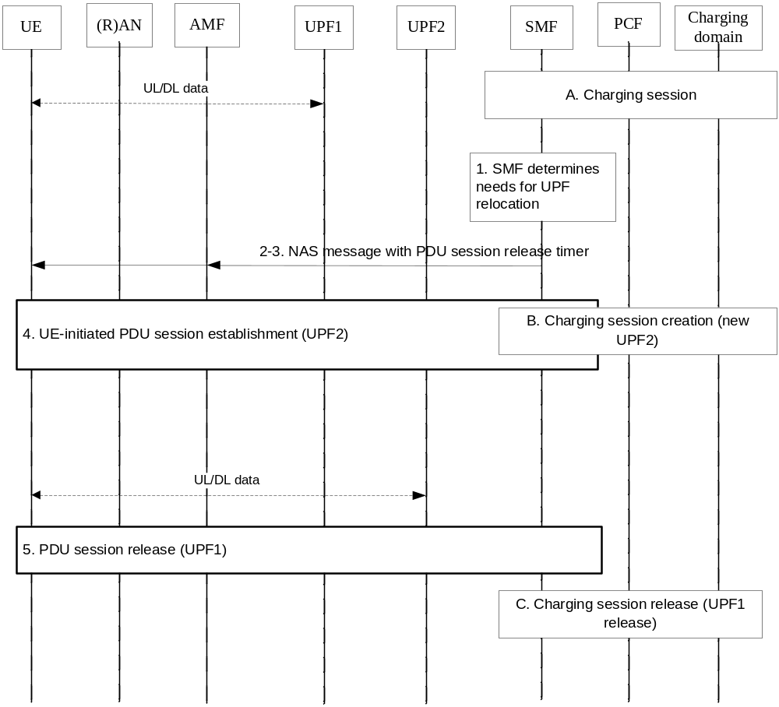
Figure 5.1.4.6.2.1.1: PDU session anchor relocation in SSC mode 3 with multiple PDU sessions - No SMF reallocation - New CH session
A. Ongoing charging session associated with the established PDU session (UPF1).
[1 to 4]. Same as step 1 to 4 in clause 5.1.4.5.2.
In step 2 SMF not requested to be reallocated.
B. New Charging session created with the existing Charging Id assigned to the PDU session, UPF2 and new IP @ allocated.
5. Same as step 5 in clause 5.1.4.5.2.
C. The Charging session with UPF1 is released due to PDU session release (old PDU session Id, UPF1), and UPF1 is removed from the data path.
Between step 3 and step 4, both UPF1 (traffic associated to old IP address/prefix), and UPF2 (traffic associated to new IP address/prefix) traffic run is parallel.
In which step(s) of the scenario the SMF needs to interact with the charging domain will be determined during the normative phase.

5.1.4.6.2.2 Scenario with SMF reallocation
The following figure 5.1.4.6.2.2.1 is based on scenario clause 4.3.5.2 TS 23.502 [202], with SMF reallocation.
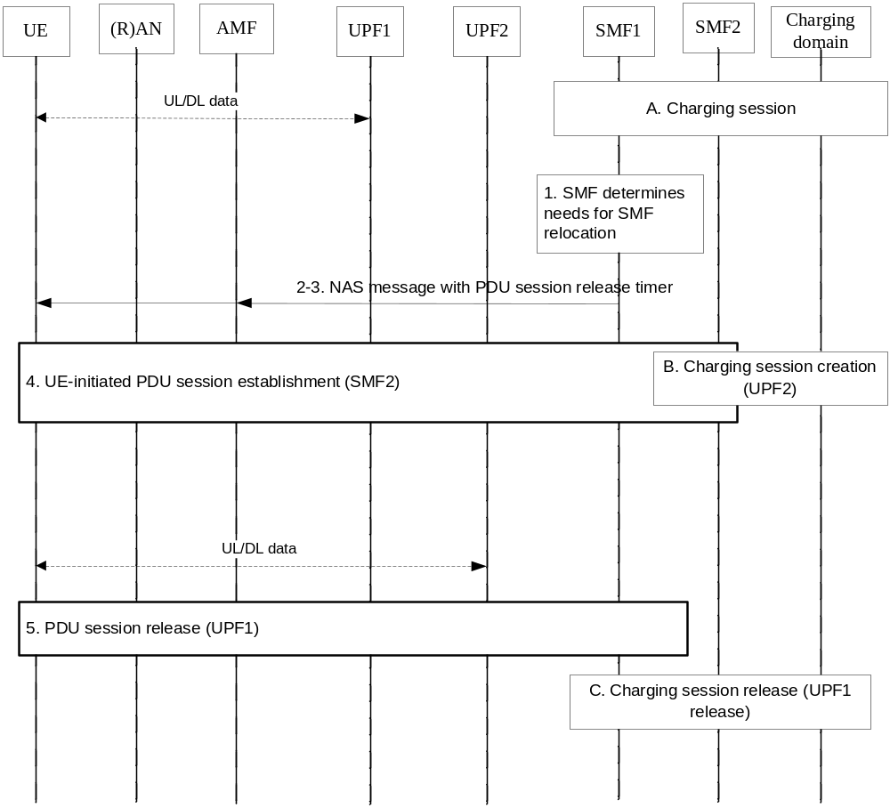
Figure 5.1.4.6.2.2.1: PDU session anchor relocation in SSC mode 3 with multiple PDU sessions – SMF reallocation - New CH session
A. Ongoing charging session associated with the established PDU session (UPF1).
1. The SMF determines that the SMF need to be reallocated due to events that may benefit from reallocation.
2-5. Same steps as 2-5 figure 4.3.5.2-1 of TS 23.502 [202], with the following:
The Reallocation requested indication indicates the SMF is requested to be reallocated in step2.
In step 4, UE initiates PDU session establishment procedure to SMF2 selected by the AMF (new PDU session Id), and UPF2 is selected by the SMF2.
B. A charging session is established from SMF2, a new charging Id is created.
C. The Charging session is released due to the PDU session release (old PDU session Id, UPF1, SMF1).
In which step(s) of the scenario the SMFs need to interact with the charging domain will be determined during the normative phase.

5.1.4.7 Solution#1.7: PDU session Charging SSC Mode 3 Multi Homed from SMF – CH session update

5.1.4.7.1 Architecture description
The same architecture as per clause 5.1.4.5.1 applies.

5.1.4.7.2 Procedure description
The following figure 5.1.4.7.2.1 describes a PDU session anchor relocation in SSC with mode 3 that uses the multi-homed PDU Session, based on clause 4.3.5.3 of TS 23.502 [202], with Charging session update.
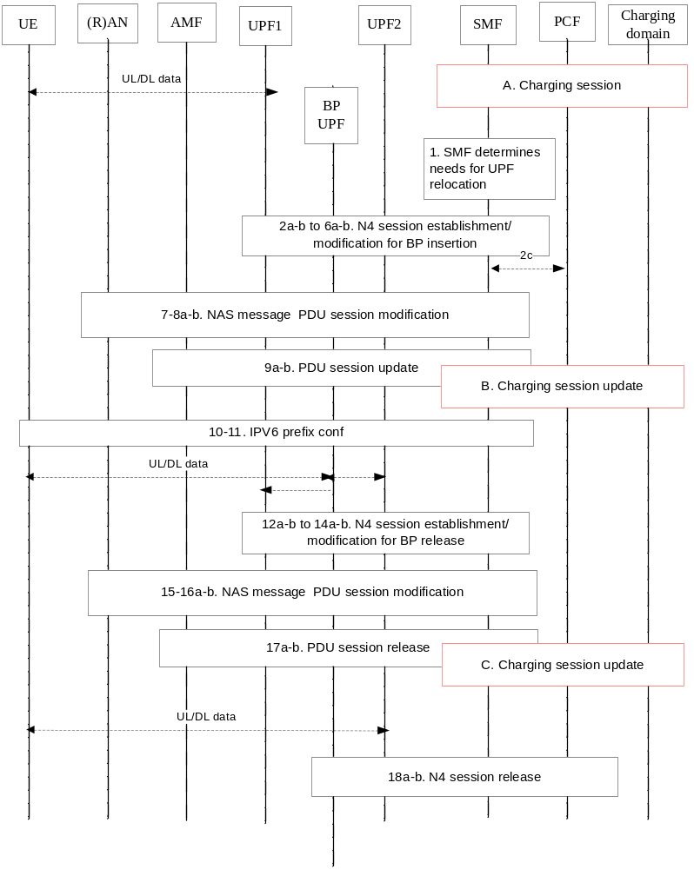
Figure 5.1.4.7.2.1: PDU session anchor relocation in SSC mode 3 with IPv6 Multi homed PDU Session - CH session update
A. Ongoing charging session associated with the established PDU session (UPF1).
1. The SMF to relocate the PDU Session with a new PDU Session Anchor UPF2.
[2a-b to 6a-b] The SMF exchange N4 messages to UPF2, BP UPF and UPF1 to insert BP UPF in the path with Tunnel Info exchange. A new IPv6 prefix is allocated.
[7-8a-b] The SMF sends NAS message to the UE via the AMF to update the PDU session with tunnel info.
[9a-b] The AMF sends the message from the R(AN) to the SMF.
B. The Charging session is updated due to the BP UPF is inserted and new IPv6 allocated.
[10-11] IPv6 configuration.
[12a-b to 14a-b] The SMF releases the UE's old IPv6 prefix (IP@1), and exchange N4 messages to release the path between BP UPF and UPF1.
[15-16a-b] The SMF sends NAS message to the UE via the AMF to update the PDU session with tunnel info to release the BP in the path.
[17a-b] PDU session release
C. The Charging session is updated due to the BP UPF is removed from the path and IPV6 prefix release.
[18a-b to 6a-b] N4 session release to release the BP UPF in the path.
In this scenario, the PDU session Id is maintained during the whole procedure.
In which step(s) of the scenario the SMF needs to interact with the charging domain will be determined during the normative phase.

5.1.4.8 Solution#1.8: PDU session Charging SSC Mode 3 Multi Homed from SMF – New CH session

5.1.4.8.1 Architecture description
The same architecture as per clause 5.1.4.5.1 applies.

5.1.4.8.2 Procedure description
The procedure is the same as clause 5.1.4.8.2 except for the following steps:
B. A new Charging session is created due to the new IPv6 prefix is allocated.
C. The previous Charging session is release due to IPv6 prefix release.
A charging Id is transferred from the original CH session to the new CH session.

5.1.5 Evaluation and conclusion

5.1.5.1 Architecture
Item "Determination of which entity/entities in the 5G architecture is suitable to host the CTF(s)" of Key issues:
- Key issue #1.1 (PDU session charging)
- Key issue #1.2 (PDU session charging - SSC Mode 1)
- Key issue #1.3 (PDU session charging - SSC Mode 2)
- Key issue #1.4 (PDU session charging - SSC Mode 3)
Is solved by the same architecture (Figure 5.1.4.1.1.1: Charging domain interfacing the SMF), whatever the solutions in clause 5.1.4.
It is concluded on the SMF as the entity to host the CTF, i.e.:
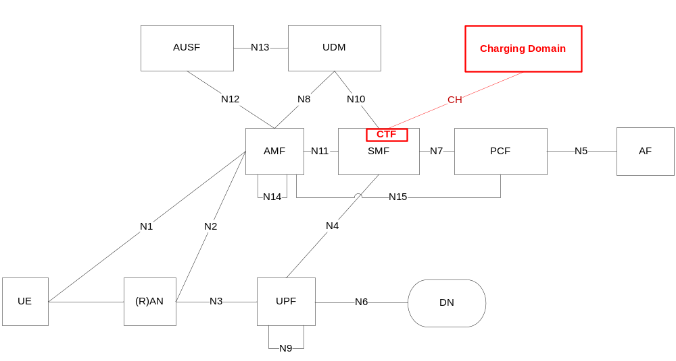
Figure 5.1.5.1.1: CTF in SMF

5.1.5.2 Evaluation

5.1.5.2.1 Solutions evaluation for Key issue #1.3
Both solutions #1.3 and #1.4 address Key issue #1.3, with the difference the CH session is updated in #1.3 and a new one is created in #1.4.
In this "break before make" scenario, a new PDU session (i.e. new PDU session Id) is created from the UE.
The benefits of solution #1.3, by preserving the CH session, are:
- it allows a single quota request instead of two quota requests;
- it avoids complex correlation process, if potentially needed between these two PDU sessions by post-processing systems (e.g. billing systems).
The solution #1.3 introduces a particular behavior of one CH session for multiple PDU sessions (i.e. each PDU session identified by one PDU session Id).
This solution #1.3 is not applicable in all circumstances of this scenario, e.g. when a new SMF is selected, it is not applicable.
In the solution #1.4 there is one to one mapping between the CH session and the PDU session, and the solution is always applicable in any SSC mode 2 scenarios.
The solution #1.4 allows correlation process, if potentially needed between these two PDU sessions by post-processing systems (e.g. billing systems), via the common "Charging Id".
The solution #1.4 is the best approach, compared to solution #1.3 which brings small benefits.

5.1.5.2.2 Solutions evaluation for Key issue #1.4
SSC mode 3 with multiple sessions:
Both solutions #1.5, and 1#6 solve Key issue #1.4, for SSC mode 3 with multiple sessions with the difference the CH session is updated in #1.5 and a new one is created in #1.6.
The benefits of solution #1.5 compared to #1.6, by preserving the CH session, are the same as benefits of solution #1.3 compared to #1.4.
In this "make before break" model scenarios, solution #1.5 has additional benefit to avoid two parallel CH sessions (during the make before break), however this occurs during a limited period.
For SSC mode 3 with multiple sessions, the solution #1.6 is the best approach, compared to solution #1.5 which brings small benefits.
SSC mode 3 Multi Homed PDU session:
Both solutions #1.7, and #1.8 solve Key issue #1.4, for SSC mode 3 Multi Homed PDU session with the difference the CH session is updated in #1.7 and a new one is created in #1.8.
The benefit of solution #1.7 compared to #1.8, by preserving the CH session, is to avoid re-creating a new CH session for the same PDU session.
For SSC mode 3 Multi Homed PDU session, the solution #1.7 is the best approach, compared to solution #1.8 which has no benefit.

5.1.5.3 Conclusion
It is concluded on:
- Solution#1.1 clause 5.1.4.1.2 procedure for Key issue #1.1 (PDU Session charging);
- Solution#1.2 clause 5.1.4.2.2 procedure for Key issue #1.2 (PDU session charging - SSC Mode 1);
- Solution #1.4 clause 5.1.4.4.2 procedure for Key issue #1.3 (PDU session charging - SSC Mode 2);
- Solution #1.6 clause 5.1.4.6.2 procedures for Key issue #1.4 (PDU session charging - SSC Mode 3) in SSC mode 3 with multiple sessions;
- Solution #1.7 clause 5.1.4.7.2 procedure for Key issue #1.4 (PDU session charging - SSC Mode 3) in SSC mode 3 Multi Homed PDU session.

5.2 QoS

5.2.1 Description and assumptions
The 5G QoS model supports a QoS flow based framework. The QoS flow is the finest granularity of QoS differentiation in the PDU session. A QoS Flow ID (QFI) is used to identify a QoS flow in the 5G system which is unique within a PDU session. A 5QI is a scalar that is used as a reference to 5G QoS characteristics specified in TS 23.501 [201] clause 5.7.4.

5.2.2 Potential requirements
The following should be supported:
- QoS flow based charging.
- Aggregative QoS flow based charging for 5QI.

5.2.3 Key issues

5.2.3.1 Key issue#2.1 : QoS flow based charging
This key issue is for investigating on how to support QoS flow based charging requirement. The investigation covers the following:
- Determination of reporting level for the charging information, to support QoS flow based charging, including:
- per combination of the rating group and QoS flow identifier,
- per combination of the rating group and QoS flow identifier and Service ID,
- per combination of the rating group and QoS flow identifier and Sponsor Id/Application service provider identity.
- Indication of whether separate usage reports should be generated for a certain QoS flow.

5.2.4 Solutions

5.2.4.1 Solution#2.1 QoS flow based charging - Reporting level per combination of the rating group and QFI

5.2.4.1.1 Architecture description
The same architecture as per clause 5.1.4.1.1 applies.

5.2.4.1.2 Procedure description
In order to support QoS flow based charging, the QoS flow identifier level reporting can be per combination of the rating group and QFI (QoS flow identifier). Reporting level is defined per PCC rule.
The following figure 5.2.4.1.2.1 describes the high-level charging procedure for QoS based charging.
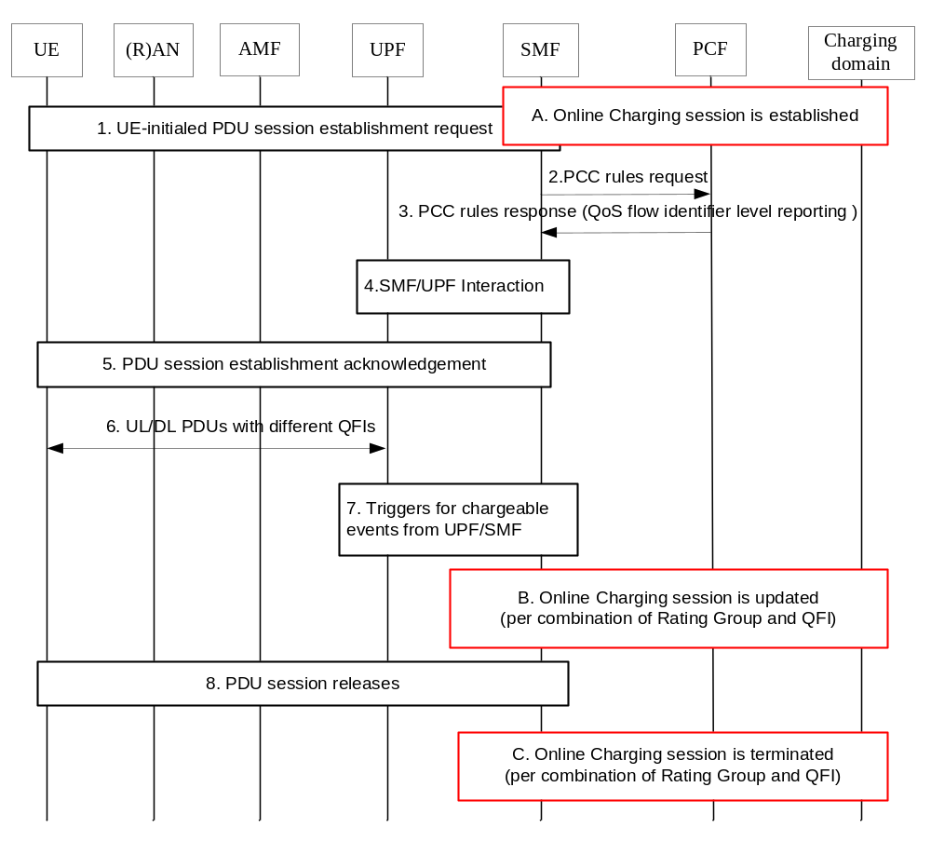
Figure 5.2.4.1.2.1: The charging procedure for QoS flow based charging
1. The UE requests to establish a PDU session towards the 5GC network.
A. The corresponding online charging session is established for this PDU session.
2. If dynamic PCC employed, the SMF performs the PCC request.
3. The PCF responses to the SMF for the PCC request. If a QoS flow identifier level reporting is defined in the PCC rule, QoS flow based charging provides the volume count per combination of the rating group and QFI.
4. SMF UPF interaction for Packet detection, enforcement and reporting rules installation.
5. The acknowledgement for the successful PDU session establishment.
6. The transmission of the downlink/uplink PDUs with different QFI values in the N3 encapsulation header.
7. The chargeable events are triggered by the SMF/ UPF.
B. If step 7 occurs, the online charging sessions is updated. The charging information for combination of Rating Group and QoS flow identifier is reported to charging system.
8. The PDU session releases.
C. The online charging session for this PDU session is terminated, the online charging information for combination of Rating Group and QoS flow identifier is reported to the charging system.
There may be additional interaction with the charging domain. This will be determined during the normative phase.

5.2.4.2 Solution#2.2 QoS flow based charging - Reporting level per combination of the rating group and QoS flow identifier and Service ID

5.2.4.2.1 Architecture description
The same architecture as per clause 5.1.4.1.1 applies.

5.2.4.2.2 Procedure description
In order to support QoS flow based charging, the reporting level can be per combination of the rating group and QFI (QoS flow identifier) and Service ID.
The steps are the same with the procedure in the clause 5.2.4.1.2, except the reporting level when the charging session is updated and terminated.

5.2.4.3 Solution#2.3 QoS flow based charging - Reporting level per combination of the rating group and QoS flow identifier and Sponsor Id/Application service provider identity

5.2.4.3.1 Architecture description
The same architecture as per clause 5.1.4.1.1 applies.

5.2.4.3.2 Procedure description
In order to support QoS flow based charging, the reporting level can be per combination of the rating group and QFI (QoS flow identifier) and Sponsor Id/Application service provider identity.
The steps are the same with the procedure in the clause 5.2.4.1.2, except the reporting level when the charging session is updated and terminated.

5.2.5 Overall evaluation and conclusion

5.2.5.1 Solution evaluation
- Solution#2.1 for key issue #2.1(QoS flow based charging)
- Solution 2.2 for key issue #2.1(QoS flow based charging)
- Solution 2.3 for key issue #2.1(QoS flow based charging)
The finest granularity for QoS forwarding treatment in the 5G System. All traffic mapped to the same 5G QoS Flow receive the same forwarding treatment (e.g. scheduling policy, queue management policy, rate shaping policy, RLC configuration, etc.).

5.2.5.2 Conclusions
The QoS flow based charging should be supported and the reporting level of combination of the rating group and QoS flow identifier specified in solution 2.1, solution 2.2 and solution 2.3 is to be determined in the normative work.
It is concluded on that there is no solution for the potential requirement of Aggregative QoS flow based charging for 5QI and this is for further study.
The reflective QoS will be considered in the normative work.

5.3 Interaction between SMF and UPF

5.3.1 Description and assumptions

5.3.1.0 General
The 5G System architecture separates the User Plane (UP) functions from the Control Plane (CP) functions, allowing independent scalability, evolution and flexible deployments e.g. centralized location or distributed (remote) location.
The Session Management function (SMF) is a Control Plane (CP) function. The SMF includes the following functionality. Some or all of the SMF functionalities may be supported in a single instance of a SMF:
- Session Management e.g. Session establishment, modify and release, including tunnel maintain between UPF and AN node.
- UE IP address allocation & management (including optional Authorization).
- Selection and control of UP function.
- Configures traffic steering at UPF to route traffic to proper destination.
- Downlink Data Notification.
- Initiator of AN specific SM information, sent via AMF over N2 to AN.
User Plane Function(s) (UPF(s)) handle the user plane path of PDU sessions. An UPF that provides the interface to a Data Network supports the functionality of a PDU session anchor. User Plane Function(s) capabilities are per TS 23.501 [201] clause 5.8.2.
UPF traffic detection capabilities may be used by the SMF in order to control at least following features of the UPF:
- Traffic reporting (e.g. allowing SMF support for charging).
- QoS enforcement.
- Traffic routing (e.g. as defined in clause 5.6.4. for UL CL or IPv6 multi-homing).
The detailed functionalities of the SMF and UPF are specified in TS 23.501 [201] clause 6.2.2 and 6.2.3 respectively.
The SMF may control the data path of a PDU session so that the PDU session may simultaneously correspond to multiple N6 interfaces: the single PDU session with multiple PDU session anchors is detailed in TS 23.501 [201] clause 5.6.4.

5.3.1.1 Traffic monitoring, diversion, and blocking

5.3.1.1.1 Description and assumptions
There are several aspects of the interaction between SMF and UPF that will impact the charging. Two main aspects are to which level it will be possible to control and monitor traffic and the other is what information will be available in the SMF for rating purposes.
For the Traffic control and monitoring the current description in TS 23.501 [201] of the UPF traffic detection capabilities is that it may be used by the SMF to control at least following features of the UPF over N4:
- Traffic reporting.
- QoS enforcement.
- Traffic routing.
Editor's Note: The information required for online and offline charging are for further study.

5.3.1.2 Type of units for rating

5.3.1.2.1 Description and assumptions
There are several aspects of the interaction between SMF and UPF that will impact the charging. Two main aspects are to with level it will be possible to control and monitor traffic and the other is what information will be available in the SMF for rating purposes.
The type of units to report traffic on supported by the SMF is currently unspecified but most of the documents seem to assume that the traffic is measured in bytes.
Editor's Note: Further studies on information required for online and offline charging are needed.

5.3.2 Potential requirements
The following requirements may be consideration under the separation architecture of SMF and UPF:
- Online and offline charging.
- Session based charging.
- Volume, time, combined volume and time, and event based charging.
- Data volumes on both the uplink and downlink directions are accounted separately.
- Quota management and consumption in SMF and UPF.
- Unused Quota timer for online charging optimization.
- The reporting mechanism from SMF and UPF.
- Usage of the radio interface: amount of data transmitted in DL and UL direction.
- Usage of the external data networks: amount of data sent and received to and from the external data network.
Editor's Note: Traffic monitoring, diversion, and blocking corresponding potential requirements are for further study.
Editor's Note: The type of units for rating corresponding potential requirement is for further study.

5.3.3 Key issues

5.3.3.1 Key issue #3.1: Traffic monitoring
The Traffic reporting can be interpreted that it mostly will report based on what has happened and it cannot be assumed that it will do monitoring of the traffic. For offline charging this is not an issue and is what is expected, i.e. that the traffic consumed is reported with high accuracy. For online it is different since here in many cases the traffic is not allowed until the OCS has granted the traffic, and here more than just reporting is needed if the current behaviour is to be preserved.
There is a need to decide on the level of accuracy needed for online charging and if it should be required that the traffic is buffered during the traffic reporting. To have the behaviour that only traffic granted by the online charging mechanism is allowed would mean that either the traffic would have to in some manner be pre-granted, i.e. granting some quota before any request for service has been performed, buffered during the reporting or introducing a new mechanism between the SMF and UPF for monitoring.

5.3.3.2 Key issue #3.2: Blocking and diversion
Online charging should be able to block or diverting the traffic in case the quota is exhausted to tell the subscriber that there is a need to do some action to continue using the service.

5.3.3.3 Key issue #3.3: Support of duration
Today there is a possibility to measure data traffic as duration, i.e. converting the bytes per second using the current Quota Consumption Time mechanism. This requires a definition of when the system is considered idle and a monitoring mechanism in the UPF.

5.3.3.4 Key issue #3.4: Triggers and reporting in the separate SMF and UPF
This key issue is for investigating on how to support the charging requirements in the non-roaming 5G System architecture.
This investigation covers the following:
- determination of which entity/entities in the separation architecture is suitable to host the CTF(s)/CDF for offline charging;
- determination of which entity/entities in the separation architecture is suitable to host the CTF(s) for online charging;
- determination of the reporting mechanism, including reporting conditions and the charging information reporting from SMF and UPF in the separate architecture.

5.3.3.5 Key issue #3.5: Quota management in the separate SMF and UPF
This key issue covers the following:
- determination of Quota management and consumption in the SMF and UPF in the separate architecture.

5.3.3.6 Key issue #3.6: PDU session Charging - Branching Point or UL Classifier
This key issue is for investigating on how to support the PDU session Charging in multiple PDU session anchors configuration with Branching Point or UL Classifier. This investigation covers the following:
- determination of which entity/entities in the 5G architecture is suitable to host the CTF(s);
- identification of the main interactions with the charging domain.
This Key issue addresses both UPF capabilities insertion controlled by the SMF, specified in TS 23.501 [201] clause 5.6.9.2:
- UPF BP (Branching Point) for multi-homed PDU session;
- UPF "UL CL" (Uplink classifier) in order to locally offload explicit set of flows.
The following text in TS 23.501 [201] clause 5.7.1 is considered during investigation for this Key issue:
"For UL Classifier PDU sessions, UL and DL Session-AMBR shall be enforced in the UPF that supports the UL Classifier functionality. In addition, the DL Session-AMBR shall be enforced separately in every UPF that terminates the N6 interface (i.e. without requiring interaction between the UPFs) (see clause 5.6.4).
For multi-homed PDU sessions, UL and DL Session-AMBR shall be enforced in the UPF that supports the Branching Point functionality. In addition, the DL Session-AMBR shall be enforced separately in every UPF that terminates the N6 interface (i.e. without requiring interaction between the UPFs) (see clause 5.6.4)."
NOTE: The DL Session-AMBR is enforced in every UPF terminating the N6 interface to reduce unnecessary transport of traffic which may be discarded by the UPF performing the UL Classifier/Branching Point functionality due to the amount of the downlink traffic for the PDU session exceeding the DL Session-AMBR."

5.3.3.7 Key issue #3.7: Bytes counted as continuous and discrete time
The current method for counting discrete time is imprecise since it will count time even when no bytes are transmitted and is therefore difficult for a UE to control and to optimize the usage of the interface. This means that from a UE perspective the counting may seem random at best this since how the bytes are transmitted to a large extent will depend on how the application is designed and the network is performing.

5.3.4 Solutions

5.3.4.1 Solution#3.1: The reporting and quota management in the separation SMF and UPF

5.3.4.1.1 Architecture description
In the non-roaming 5G System separation architecture, the CTF is divided into two functional blocks (AMC and ADF) as described in figure 5.3.4.1.1.1 and figure 5.3.4.1.1.2. The PDU session and flow information remains at the SMF function, and the UPF sends usage information collected, to SMF over the N4 reference point. The SMF interacts with OCS/OFCS based on information received from other nodes, function internal to SMF, as well as user-plane information received from the UPF.
For offline charging the SMF generates accounting metrics sets for CDR, as described in Figure 5.3.4.1.1.1.
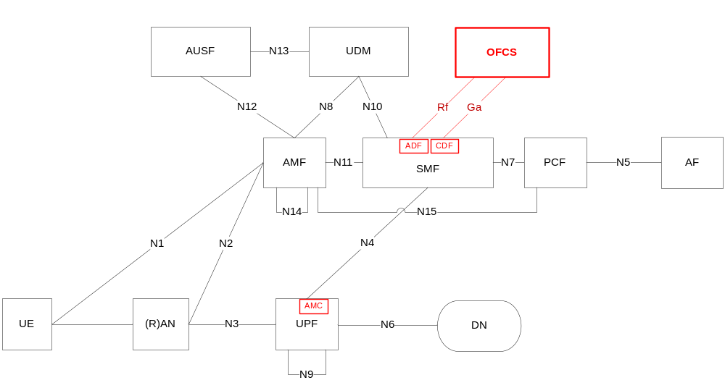
Figure 5.3.4.1.1.1: Offline charging architecture
Online charging architecture is depicted in Figure 5.3.4.1.1.2.
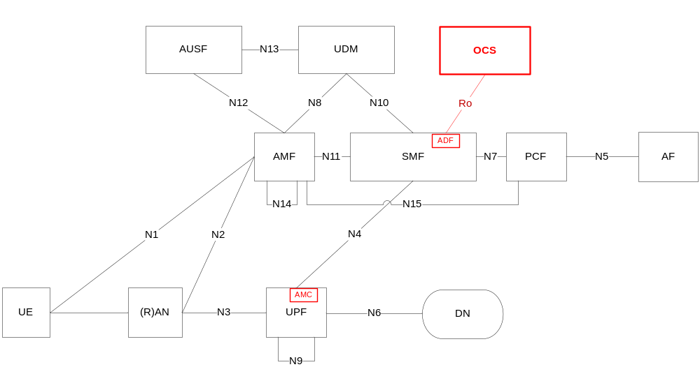
Figure 5.3.4.1.1.2: Online charging architecture

5.3.4.1.2 Offline Charging
The distributed Charging Trigger Function(CTF) is located in the SMF (ADF) and UPF (AMC). The SMF interacts with the UPF for collecting charging information, and reports charging information to charging domain. SMF Reporting is based on provisioned granularity, i.e. per charging key, per charging key and service identifier combination, or per Sponsor Identity and Application Service Provider Identity combination.
The policy from PCF, Charging characteristics from UDM and message received from UPF are provided to the SMF as reporting conditions for Control Plan triggers.
Time Limit and Volume Limit defined in the Charging characteristics are provided to the UPF as reporting conditions for User plan triggers.
After activation of usage reporting in UPF:
- Reporting triggered by reporting conditions.
- Reporting triggered by on demand request from the SMF, e.g. control plane triggers in the SMF are matched.
After activation of usage reporting in SMF:
- Reporting triggered by reporting conditions of Control Plan triggers in the SMF are matched.
- Reporting triggered by the reporting from UPF, e.g. reporting conditions of User Plan triggers in the UPF are matched.
SMF combines the charging information from the UPF and SMF when the usage reporting in SMF is active.

5.3.4.1.3 Online charging
The distributed Charging Trigger Function(CTF) is located in the SMF (ADF) and UPF(AMC). The SMF is in charge of enforcing policy activated by PCF and interaction with OCS for online charging based on the policy from PCF.
The SMF requests quota from the OCS according to policy activated by PCF. The SMF can request quota at PDU session establishment or during a PDU session. The Quota Management only operates on per charging key basis, i.e. the SMF requests a quota for each charging key.
For quota management and usage reporting, the SMF generates rules information for accounting and reporting, which indicates the flow sets counted for reporting, and generates measurement threshold based on the provision from the OCS.
The measurement threshold is created for each quota. The SMF associates the packet detection information and measurement threshold. And the SMF is responsible for the mapping between packet detection information and the policy. The SMF provides the packet detection information, measurement threshold and the association the UPF. Due to multiple policies from PCF may share the same charging key for which one quota is assigned, whereas reporting may be at higher granularity if serviced identifier level reporting is used, one measurement threshold may be associated with several packet detection information.
The following information is provided to the UPF with the measurement threshold:
- quota consumption time;
- quota holding time;
- quota threshold;
- tariff time change.
The UPF consumes quota according to the measurement threshold and collects the usage information. Data volumes on both the uplink and downlink directions can be counted separately based on requirement from the SMF.
The SMF reports quota usage information to the OCS when triggers are matched. The triggers provided by the OCS will be distributed between the SMF (Control Plan triggers) and UPF (user plan triggers).
After activation of usage reporting in UPF:
- Reporting triggered by the measurement threshold.
- Reporting triggered by on demand request from the SMF, e.g. control plane triggers are matched or re-authorization is triggered by the OCS.
After activation of usage reporting in SMF:
- Reporting triggered by reporting conditions of Control Plan triggers in the SMF are matched.
- Reporting triggered by the reporting from UPF.
SMF combines the charging information from the UPF and SMF when the usage reporting in SMF is active.
The SMF may provide the Unused Quota timer to the UPF for online charging session optimization.
Reporting for online from the UPF may block traffic because of no quota, otherwise, reporting for offline never block traffic. So, the SMF needs to provide indicator for the UPF to distinguish reporting between online and offline.

5.3.4.1.4 Solution evaluation
Solution#3.1 provides details on interaction between SMF and UPF, based on solution #1.1. It solves Key issue #3.4 and Key issue #3.5. It is also the basis for solutions covering other clause 5.3 Key issues.

5.3.4.2 Solution#3.2: PDU session charging – counts in BP/UL CL UPF only

5.3.4.2.1 Architecture description
The charging information collection for a PDU session with UPF Branching Point or UL Classifier inserted in the data path, and this UPF enforced for the whole traffic counts, can be achieved by charging domain interfacing the SMF, as described per Figure 5.1.4.1.1.1, with the additional details in Figure 5.3.4.2.1.1.
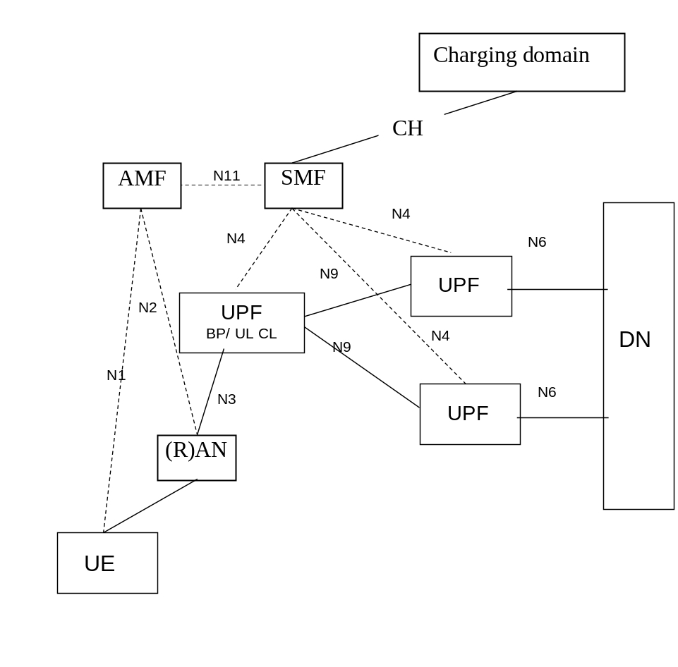
Figure 5.3.4.2.1.1: Charging domain interfacing the SMF - multiple PDU session anchors with BP or UL CL UPF

5.3.4.2.2 Procedure description - Addition of additional PDU Session Anchor and Branching Point or UL CL
The following figure 5.3.4.2.2.1 describes Branching Point (BP) or an Uplink Classifier (UL CL) UPF to an existing PDU session with this UPF selected as the single point of measurement for charging (i.e. counts for the whole traffic for this PDU session). The message flow is based on clause 4.3.5.4 TS 23.502 [202].
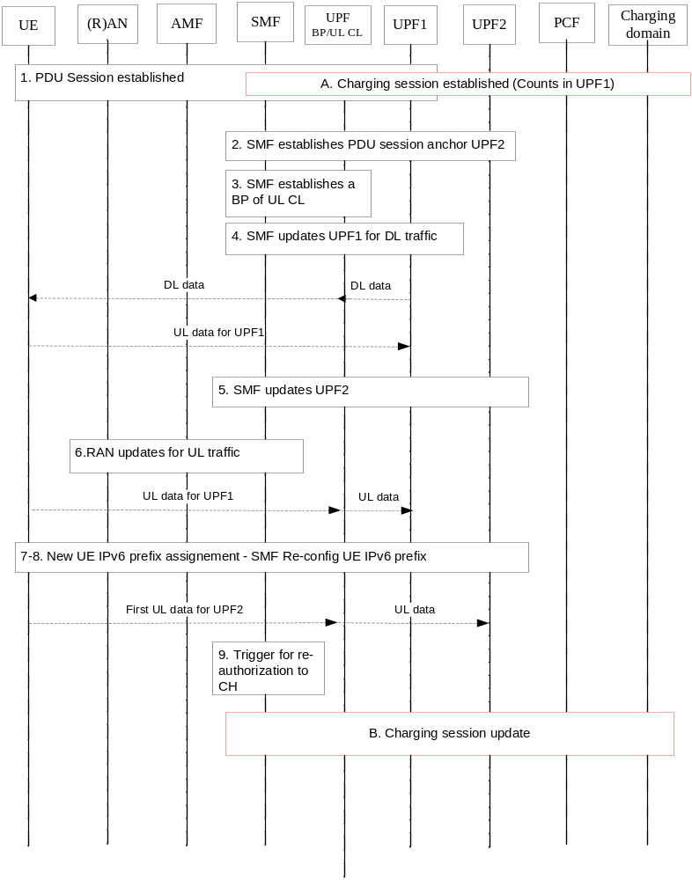
Figure 5.3.4.2.2.1: PDU session with BP or UL CL UPF as single point of traffic measurement
1. UE has an established PDU Session with PDU session anchor UPF1.
A. A charging session is established for this PDU session, and the UL/DL usage is collected from UPF1.
2. The SMF decides to add a new PDU session anchors UPF2.
3. The SMF selects a UPF and establishes the Branching Point or UL CL functionalities in the data path. In case UL CL the SMF provides traffic filters indicating what traffic should be forwarded towards UPF1 and UPF2 respectively. The SMF also decides this UPF as the single point of measurement for charging (i.e. counts for the whole traffic for this PDU session).
4. The SMF updates the UPF1 with UPF -UL CL CN Tunnel Info for the downlink traffic.
5. The SMF updates the UPF2 with UPF -UL CL CN Tunnel Info for the downlink traffic. The data path for DL traffic is established between UPF2 and UPF BP/CL UL, and the point of measurement for DL traffic in UPF2 is UPF BP/CL UL as already indicated in step 3.
6. The SMF updates (R)AN via AMF for AN resource setup, (R)AN and UPF BP/UL CL tunnels information exchange.
[7-8] In case of IPv6 multi-homing: New UE IPv6 prefix assignment and SMF reconfigures UE IPv6 prefix for UPF1.
9. At any time a Re-authorization triggers occurs.
B. The Charging session is updated and the SMF reports the usage collected from UPF BP/CL UL, for traffic to/from UPF1 and traffic to/from UPF2.
The last UL/DL counts collected from UPF1 are reported when the UPF1 is released later on.
In which step(s) of the scenario the SMF needs to interact with the charging domain will be determined during the normative phase.

5.3.4.2.3 Procedure description - Removal of additional PDU Session Anchor and Branching Point or UL CL
In this solution (counts in BP/UL CL for whole traffic), the scenario "Removal of additional PDU Session Anchor and Branching Point or UL CL" copied below per TS 23.502 [202] clause 4.3.5.5:
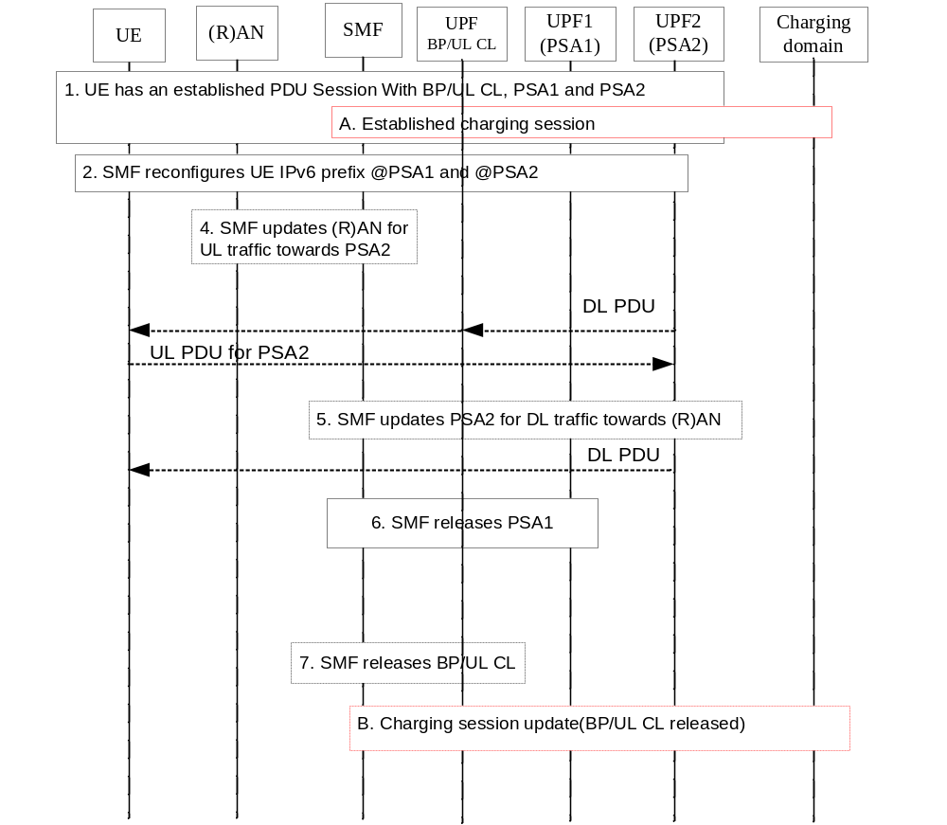
Figure 5.3.4.2.3.1: Removal of additional PDU Session Anchor and Branching Point or UL CL
The steps are per TS 23.502 [202] clause 4.3.5.5, and the following applies in addition:
Step 4: The data path is switched from UPF BP/CL UL to UPF2 for UL traffic from (R)AN towards UPF2, and UPF2 becomes the point of measurement for UL traffic towards UPF2.
Step 5: The data path is established between UPF2 and (R)AN for DL traffic, and UPF2 becomes the point of measurement for DL traffic in UPF2.
B: the CH session is updated to release UPF BP/CL UL and UPF1 from the path, and report the last UL/DL counts collected from UPF1 and from UPF BP/CL UL for traffic towards/from UPF2.
In case of IPv6 multi-homing, IPv6 prefix change (from the one corresponding to PSA1 to the one corresponding to PSA2) is also reported to the CH domain.
If the scenario does not correspond to IPv6 multi-homing, the step B may not be needed if "UPF change Not awareness": the SMF collects the usage from the UPFs without any interaction with the CH domain.
In which step(s) of the scenario the SMF needs to interact with the charging domain will be determined during the normative phase.

5.3.4.2.4 Procedure description - Additional PDU Session anchor relocation for UL CL
In this solution (counts in BP/UL CL for whole traffic), the scenario "Additional PDU Session anchor relocation for UL CL" copied below per TS 23.502 [202] clause 4.3.5.6:
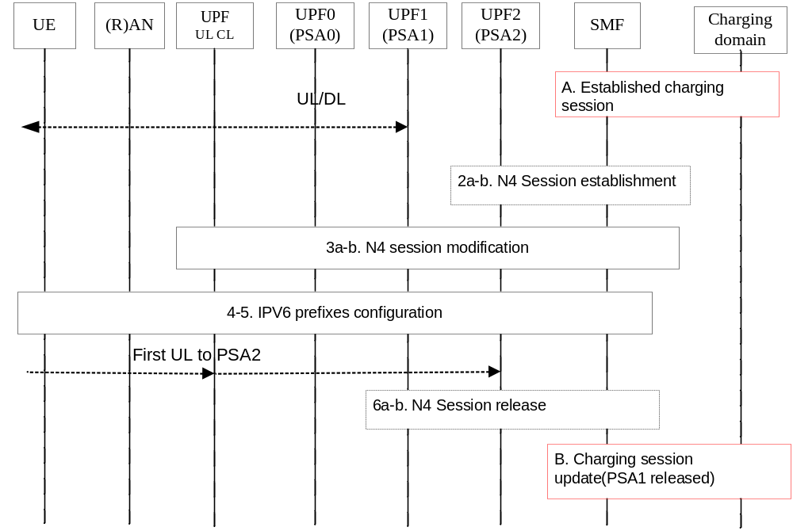
Figure 5.3.4.2.4.1: Additional PSA relocation for a PDU Session in UL CL case
The steps are per TS 23.502 [202] clause 4.3.5.6, and the following apply in addition:
After step 3a-b: the data path is switched from UPF1 to UPF BP/CL UL, for UL/DL set of traffic flows moved from UPF1 to UPF2. The UPF BP/CL UL remains the point of measurement for these moved traffic flows.
B: if 6a-b4 occurs, the CH session is updated due UPF1 release, and last UL/DL counts are reported.
In case of IPv6 multi-homing PDU Session, a new IP prefix @ PSA2 is notified at step 4, and in step 5 the SMF may re-configure the UE for the original IP prefix @ PSA0.This IPv6 prefix change is also reported to the CH domain.
If the scenario does not correspond to IPv6 multi-homing, the step B may not be needed if "UPF change Not awareness": the SMF collects the usage from the UPFs without any interaction with the CH domain.
In which step(s) of the scenario the SMF needs to interact with the charging domain will be determined during the normative phase.

5.3.4.2.5 Procedure description - Relocation of UL CL for a PDU Session
In this solution (counts in BP/UL CL for whole traffic), the scenario "Relocation of UL CL for a PDU Session" copied below per TS 23.502 [202] clause 4.3.5.7:
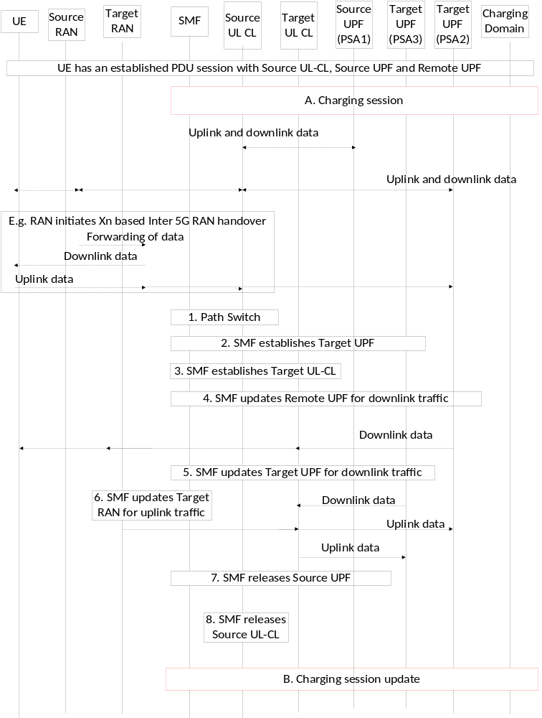
Figure 5.3.4.2.5.1: Relocation of UL CL for a PDU Session
UPF (PSA1) stands for UPF1, UPF (PSA2) for UPF2, and UPF (PSA3) for UPF3.
The steps are per TS 23.502 [202] clause 4.3.5.7, and the following applies in addition:
A. A charging session is established for this PDU session, and the UL/DL whole usage is collected from Source UL CL.
After step 4: the data path is switched from Source UL CL to Target UL CL, and the new point of measurement is Target UL CL for whole usage.
B. The Charging session is updated and last UL/DL counts from Source UL CL for whole traffic are reported.

5.3.4.3 Solution#3.3: PDU session charging – counts in two UPFs – single CH session

5.3.4.3.1 Architecture description
The same architecture as per clause 5.3.4.2.1 applies.

5.3.4.3.2 Procedure description - Addition of additional PDU Session Anchor and Branching Point or UL CL
The following figure 5.3.4.3.2.1 describes insertion by the SMF of additional Branching Point (BP) or an Uplink Classifier (UL CL) UPF to an existing PDU session, with two UPFs selected as points of measurement for charging: UPF BP/UL CL for UL/DL traffic to/from UPF1, and UPF2 for UL/DL traffic to/from UPF2. A single charging session is used for this scenario.
The message flow is based on clause 4.3.5.4 of TS 23.502 [202]:
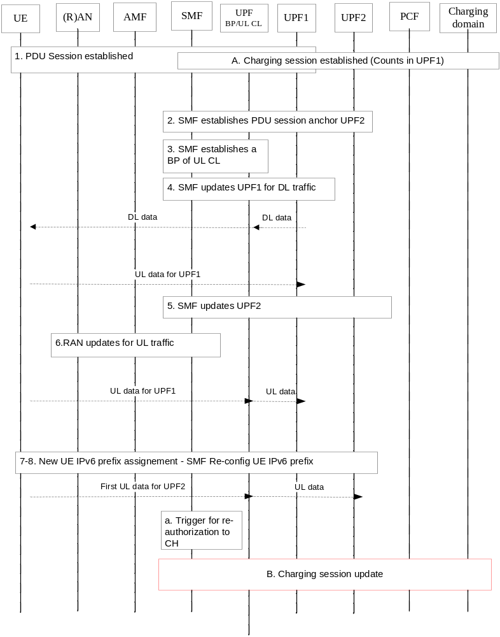
Figure 5.3.4.3.2.1: PDU session establishment with two UPFs for traffic measurement
1. UE has an established a PDU Session with PDU session anchor UPF1.
A. A charging session is established for this PDU session.
[2 to 8]. Same as step 2 to 8 in clause 5.3.4.2.2, except that in step 4 the SMF decides the UPF BP/UL as the point of measurement for charging for traffic through UPF1, and the UPF2 as the point of measurement for charging for traffic through UPF2.
Step 4. The data path for DL traffic is established between UPF1 and UPF BP/CL UL and the new point of measurement for DL traffic in UPF1, is UPF BP/CL UL. The point of measurement for UL/DL traffic in UPF2 is UPF2.
a. At any time a Re-authorization triggers occurs.
B. The Charging session is updated and the SMF reports the usage collected from UPF BP/UL CL, for traffic to/from UPF1 and the usage collected from UPF2 for traffic to/from UPF2.The last UL/DL counts collected from UPF1 are reported when the UPF1 is released later on.
In which step(s) of the scenario the SMF needs to interact with the charging domain will be determined during the normative phase.

5.3.4.3.3 Procedure description - Removal of additional PDU Session Anchor and Branching Point or UL CL
The same procedure as clause 5.3.4.2.3 applies, except:
After Step 4: the point of measurement for traffic via UPF2 remains in UPF2.
C. the CH session is updated to release UPF BP/CL UL and report the last UL/DL counts collected from UPF BP/CL UL for traffic via UPF1.

5.3.4.3.4 Procedure description - Additional PDU Session anchor relocation for UL CL
With the assumption before this anchor relocation, Source UL CL was the point of measurement for traffic via UPF1 and the UPF2 is the point of measurement for traffic via UPF2 after relocation, the procedure in clause 5.3.4.2.4 applies as follows:
After step 3a-b: the data path is switched from UPF1 to UPF BP/CL UL, for UL/DL set of traffic flows moved from UPF1 to UPF2. The UPF2 is the point of measurement for these moved traffic flows.

5.3.4.3.5 Procedure description - Relocation of UL CL for a PDU Session
With the assumption before this relocation, Source UL CL was the point of measurement for traffic via UPF1 and the UPF2 was the point of measurement for traffic via UPF2, the procedure in clause 5.3.4.2.5 applies as following steps:
A. A charging session is established for this PDU session, UL/DL usage via UPF1 is collected from Source UL CL, and UL/DL usage via UPF2 is collected from UPF2.
After step 4: the data path is switched from Source UL CL to Target UL CL, and the new point of measurement is Target UL CL for traffic via UPF (PSA1).
B. The Charging session is updated due to Source UL CL release, and last UL/DL counts from Source UL CL for traffic via UPF (PSA1) are reported.

5.3.4.4 Solution#3.4: The reporting and quota management SSC mode 2 – CH session update

5.3.4.4.1 Architecture description
The same architecture as clause 5.1.4.3.1 applies.

5.3.4.4.2 Procedure description

5.3.4.4.2.0 General Description
The procedure of a PDU session anchor relocation in SSC mode 2 with single PDU session anchor and charging session update applies as in clause 5.1.4.3.
This scenario assumes the same SMF is selected.
The following message flows are based on clause 4.3.5.1 of TS 23.502 [202] adapted to reflect the trigger and quota management in two optional ways:
- The Charging system is aware of the UPF change.
- The Charging system is not aware of the UPF change.

5.3.4.4.2.1 Solution 3.4.1: The Charging system is aware of the UPF change

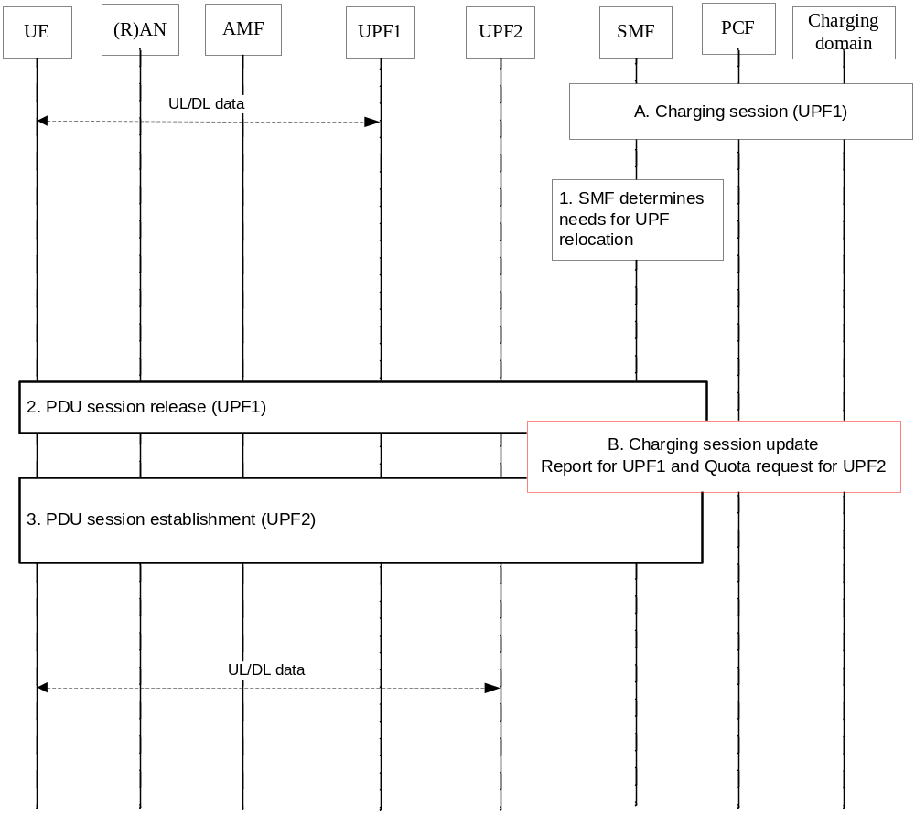
Figure 5.3.4.4.2.1: Quota management (UPF Change Awareness) – CH session update
- Ongoing charging session associated with the established PDU session (UPF1)
[1 to 3]. Same as step 1 to 3 in clause 5.1.4.3.2.
B. The Charging session is updated as per step B in clause 5.1.4.3.2. SMF triggers the reporting from UPF1 for consumed quota reporting to the charging system and request the charging system to allocate the new granted quota for UPF 2.
In which step(s) of the scenario the SMF needs to interact with the charging domain will be determined during the normative phase.

5.3.4.4.2.2 Solution 3.4.2: The Charging system is not aware of the UPF change
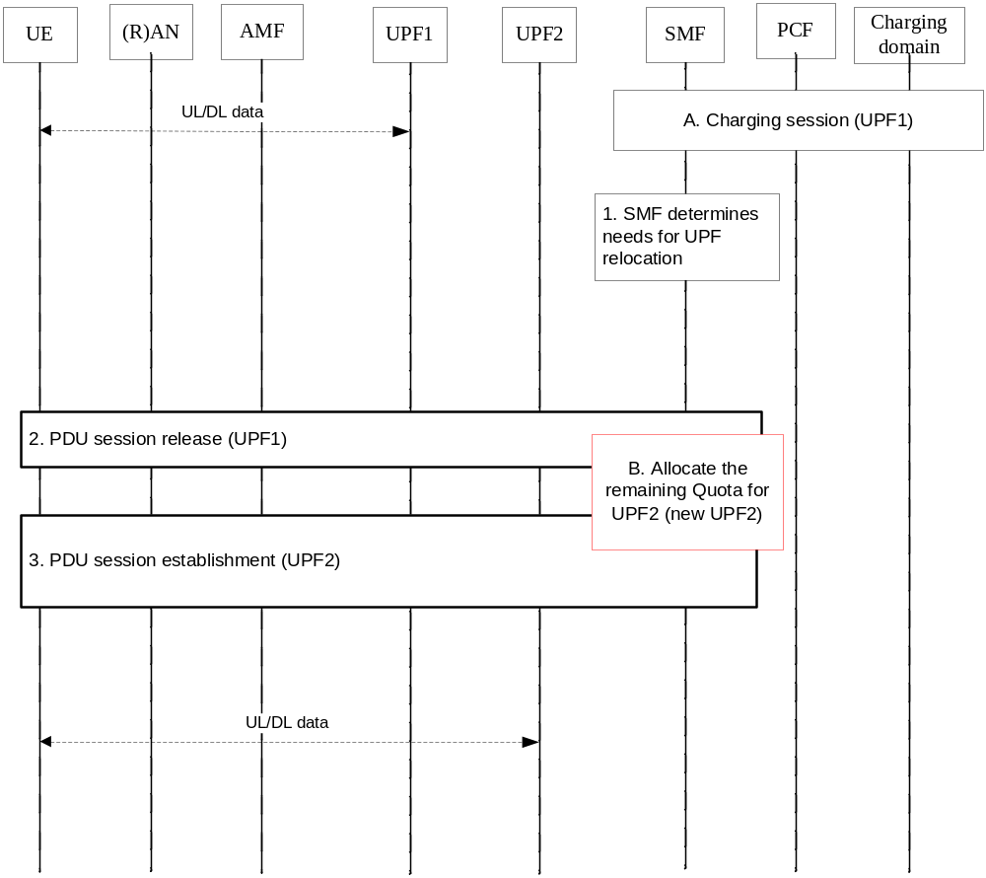
Figure 5.3.4.4.2.2: Quota management (UPF Change not Awareness) – CH session update
[1 to 3]. Same as step 1 to 3 in clause 5.1.4.3.2.
A. Ongoing charging session associated with the established PDU session (UPF1)
B. SMF triggers the reporting from the UPF1 for the consumed quota and allocates the remaining granted quota for UPF 2. When the granted quotas used up, SMF will request the new quota to Charging system.
In which step(s) of the scenario the SMF needs to interact with the charging domain will be determined during the normative phase.

5.3.4.5 Solution#3.5: The reporting and quota management – in multiple UPFs (parallel traffic)

5.3.4.5.1 Architecture description
The charging information collection in multiple UPFs with UPF Branching Point or UL Classifier inserted in the data path, and the quota allocation in the SMF, as described in Figure 5.3.4.5.1.1 to Figure 5.3.4.5.1.2. The parallel traffic is transferred in multiple UPFs at the same time.
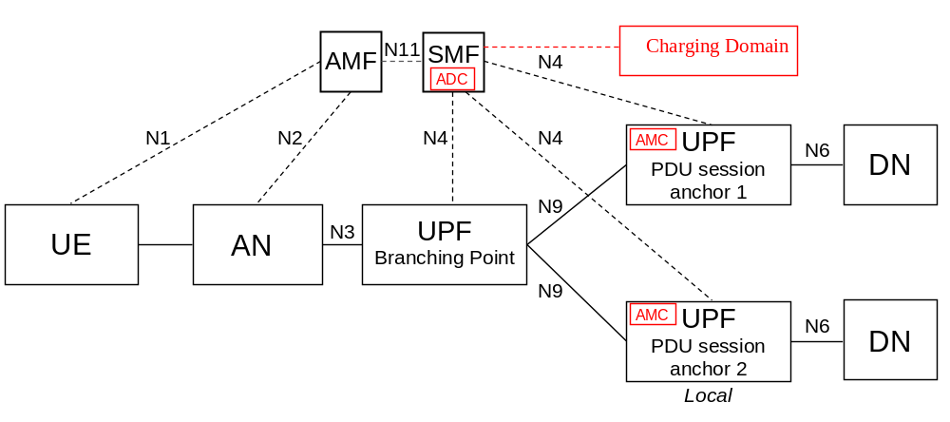
Figure 5.3.4.5.1.1: Charging architecture for multi-homed PDU Session (Access both a local service and a central service)
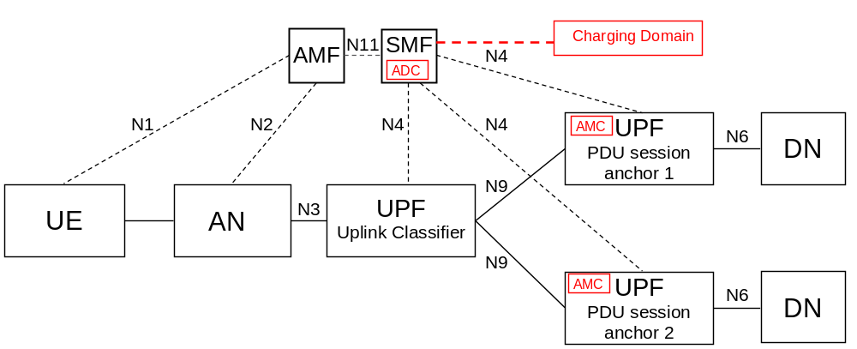
Figure 5.3.4.5.1.2: Charging architecture for usage of an UL Classifier

5.3.4.5.2 Procedure description

5.3.4.5.2.0 General Description
The following figure 5.3.4.5.2.1 describes a PDU session established with a Branching Point (BP) or an Uplink Classifier (UL CL) UPF inserted by the SMF, the charging information collection and reporting in the multiple UPFs at the same time. The SMF is responsible for the allocation the quota granted by charging system and reporting the quota usage to charging system.
When UE needs to access both a local service (e.g. local server) and a central service (e.g. the internet), the traffic is transferred in UPF1 and UPF2 in parallel. In the case, there are two optional ways to consider the quota management and reporting for one charging session per PDU session:
- Charging system granted quota shared by UPFs. SMF manages shared quota consumption in UPF1 and UPF2 and report the total quota consumed to Charging System.
- Charging System grants the quota for each UPF. The UPFs manages and report the quota consumption to SMF. SMF reports the usage of quota and/or requests the further quotas to Charging System.

5.3.4.5.2.1 Solution 3.5.1 Charging system granted quota shared by UPFs
The message flow is based on clause 4.3.5.4 of TS 23.502 [202] adapted to reflect the quota management and reporting during the PDU session:
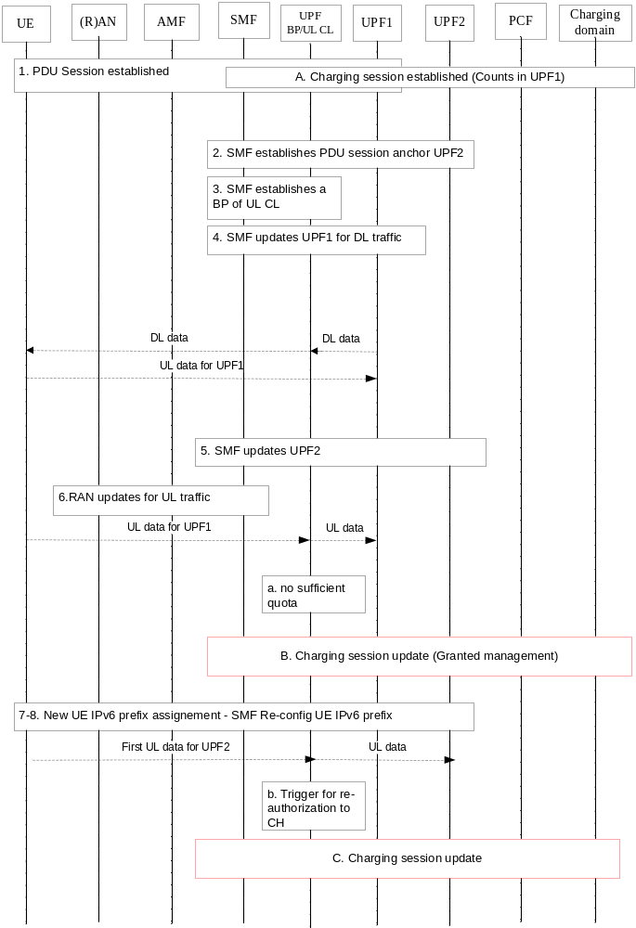
Figure 5.3.4.5.2.1: Shared Quota management for UPF1 and UPF2 (granted quota sharing)
Step 1-8: Same as step 1 to 8 in clause 5.3.4.2.2.
A. A charging session is established for this PDU session with PDU session anchor UPF1.The SMF has been granted quota by the OCS, this quota is shared by UPFs.
a. At any time the SMF runs out of quota for UPFs.
B. The Charging session is updated: the SMF reports quota consumed by both UPF1 and UPF2, and requests new Quota. The SMF manages the quota shared by UPF1 and UPF2.
b. At any time a Re-authorization triggers occurs.
C. SMF report the charging information (quota consumption) for UPF1 and UPF2 to Charging system.
Note: During B and C, SMF negotiates the shared quota consumption between UPF1 and UPF2. When the granted quota from OCS is used up, the SMF reports total usage of quota to OCS.
In which step(s) of the scenario the SMF needs to interact with the charging domain will be determined during the normative phase.

5.3.4.5.2.2 Solution 3.5.2 Charging System grants the quota for each UPF
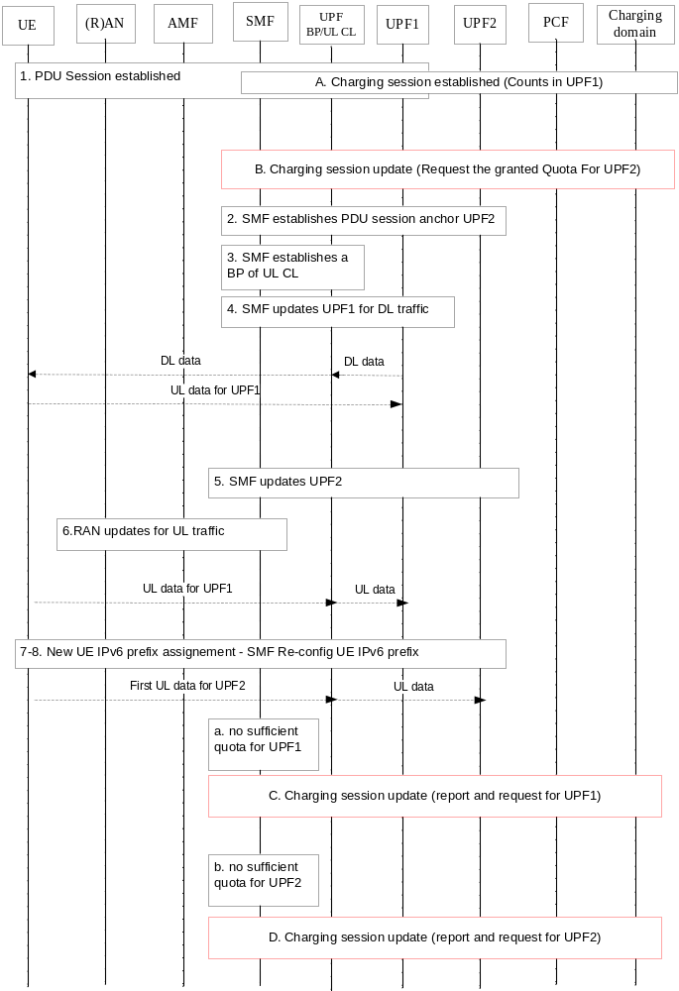
Figure 5.3.4.5.2.2: Separate Quota management for UPF1 and UPF2 (Granted Quota per UPF)
Step 1-8: Same as step 1 to 8 in clause 5.3.4.2.2.
A. A charging session is established for this PDU session with PDU session anchor UPF1. The SMF has been granted quota by the OCS, for UPF1.
B. The Charging session is updated due quota needs to be granted to the SMF for UPF2 separately.
C. When the granted quota for UPF 1 is used up, SMF reports the usage of quota to the charging system.
D. When the granted quota for UPF 2 is used up, SMF reports the usage of quota to the charging system.
In which step(s) of the scenario the SMF needs to interact with the charging domain will be determined during the normative phase.

5.3.4.6 Solution#3.6: Bytes counted as continuous time

5.3.4.6.1 Architecture description
The same architecture as per clause 5.3.4.2.1 applies.

5.3.4.6.2 Procedure description
A UE sends and receives data though the UPF to and from a DN, during this procedure the UPF interacts with usage reports to the SMF which are used at charging. In this case, the SMF monitors the granted units to be used for the traffic. The UPF monitors data traffic and reports at interval based on the SMF request. When there are no more granted units the SMF may request the UPF to take the appropriate action, e.g. stop all or selected traffic to DN, divert the traffic to another DN.
The flow will be the same as in clause 5.3.4.8 (Solution#3.8: Charging at SMF and usage monitoring over N4), with the exception that the UPF will not be requested to report when transmitted data equals the granted units.
Only allowing bytes counted as continuous time would limit the number of charging possibilities but at the same time lower the complexity in both the SMF and UPF interface as well as the inside the UPF.

5.3.4.6.3 Solution evaluation.
This solution describes that only charging based on continuous time should be applicable for reporting from the UPF and it would support the requirement to be able to change based on active time for the byte transmission.
The drawback of this solution is that the discrete time measurement for byte transmission will not be possible to support.

5.3.4.7 Void

5.3.4.8 Solution#3.8: Charging at SMF and usage monitoring over N4

5.3.4.8.1 Architecture description
The same architecture as per clause 5.3.4.2.1 applies.

5.3.4.8.2 Procedure description
A UE sends and receives data though the UPF to and from a DN, during this procedure the UPF interacts with usage reports to the SMF which are used at charging. In this case, the SMF monitors the granted units to be used for the traffic. The UPF monitors data traffic and reports the usage based on the SMF request. When there are no more granted units the SMF may request the UPF to take the appropriate action, e.g. stop all or selected traffic to DN, divert the traffic to another DN.
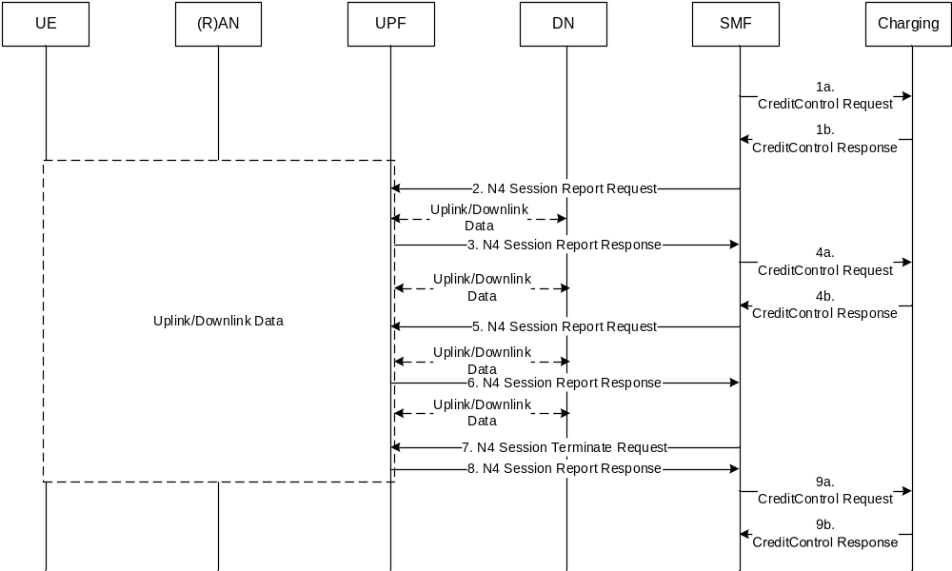
Figure 5.3.4.8.2.1: Charging at SMF and usage monitoring over N4
1a. SMF request units for the traffic from Charging.
1b. Charging responds with the granted units.
2. SMF request a report from the UPF when the transmitted data equals (or is close to, if the SMF decides to have some quota for the period during the reporting to Charging) the granted units or after a certain time equal to validity time from Charging.
3. For UPF the counter of data has reached the level that matches the granted units and reports this to SMF.
4a. SMF reports the usage from the UPF and requests more units.
4b. Charging responds with the granted units and an indication of last available units, it may include an action to be taken when the granted units are depleted.
5. SMF requests a report from the UPF when the transmitted data equals (or is close to, if the SMF decides to have some quota for the termination period) the granted units from Charging.
6. For UPF the counter of data has reached the level that matches the granted units and reports this to SMF.
7. SMF requests the UPF to modify the traffic, this may be based on the action requested by Charging (e.g. terminate part of the traffic, all of traffic, divert traffic).
8. UPF reports the last counted transmitted traffic to SMF, if SMF has requested the information.
9a. SMF reports the usage from the UPF.
9b. Charging responds with credit control closure for the specific service. Charging may also respond with request to close the control session together with the specific service.
This solution implies that the SMF coordinates measurements in relation to the limit by the granted units from the Charging.

5.3.4.8.3 Solution evaluation.
This solution describes that the N4 will be handling charging as report and termination requests. This will keep the requirements on the UPF to a minimum regarding charging, since the interaction between SMF and UPF will be based on two basic operations. The requirement on the SMF will be increased since there is a need for the SMF to have strategies to avoid having the UPF consuming more quota than has been granted. This can be done in a number of ways and are implementation specific, it should however be considered to have the Charging domain support to receive more used quota than granted to mitigate any issue should they arise.

5.3.4.9 Solution#3.9: PDU session charging – counts in UPFs – single CH session

5.3.4.9.1 Architecture description
The same architecture as per clause 5.3.4.2.1 applies.

5.3.4.9.2 Procedure description- Addition of additional PDU Session Anchor and Branching Point or UL CL
The following figure 5.3.4.9.2.1 describes a PDU session establishment with a Branching Point or an Uplink Classifier (UL CL) UPF inserted by SMF, with two UPF anchors that terminate the N6 interfaces selected as points of measurement for charging: UPF1 for UL/DL traffic to/from UPF1, and UPF2 for UL/DL traffic to/from UPF2. A single charging session is used for this scenario.
The message flow is based on clause 4.3.5.4 of TS 23.502 [202] that describes the procedure to add a PDU Session Anchor (PSA) and a Branching Point (BP) or Uplink Classifier (UL CL) for an established PDU session.
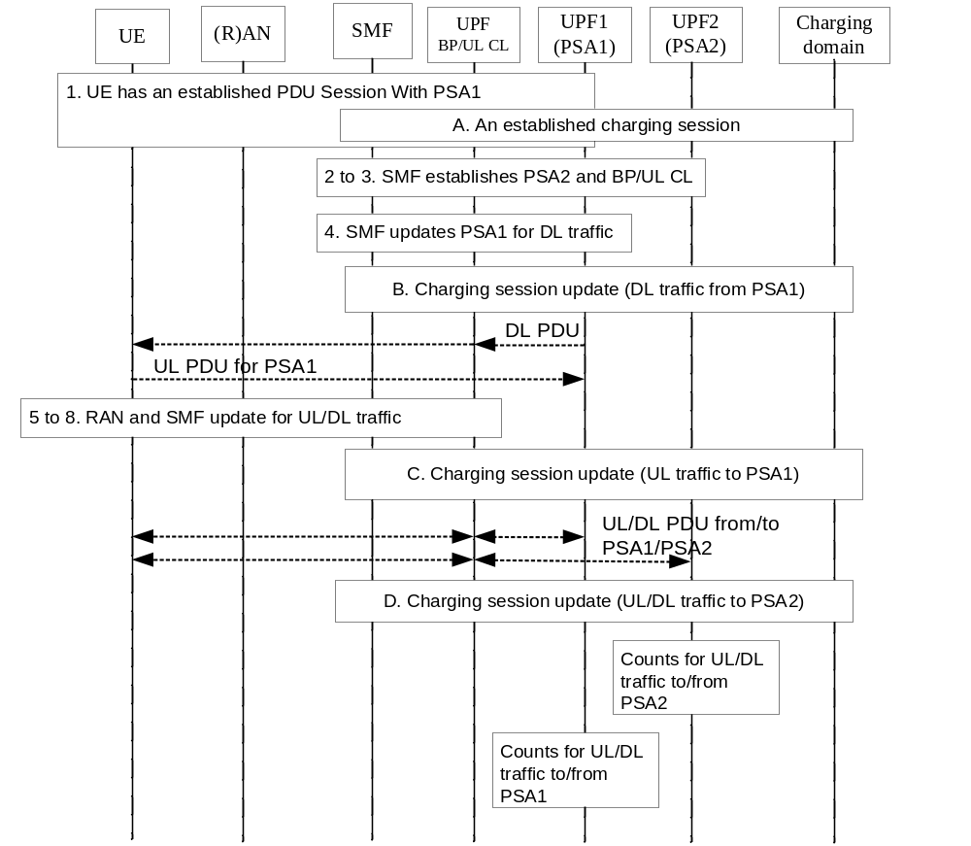
Figure 5.3.4.9.2.1: Charging procedure for a PDU session with two UPF anchors that terminate the N6 interface
1. UE has an established PDU session with a UPF including the PDU Session Anchor 1.
A. A charging session for the PDU session is established between the SMF and the charging Domain.
2-3. Same as step 2 and step 3 described in clause 4.3.5.4 of TS 23.502 [202]. Besides, the SMF decides the PSA1 as the point of measurement for charging for the traffic from/to UPF1, and the PSA2 as the point of measurement for charging for the traffic from/to UPF2.
4. The SMF update the PSA1 via N4 interface. It provides the BP or UL CL with the CN Tunnel Info for downlink traffic.
B. The charging session is updated due to the data path for DL traffic from PSA1 to BP/CL UL is established.
5-8. Same as step 5-8 described in clause 4.3.5.4 of TS 23.502 [202]. As a result, the Uplink and Downlink traffic can be routed through the right PSA.
C. The charging session is updated due to the data path for UL traffic to PSA1 is established.
D. The Charging session is updated due to the data path for DL/UL traffic through PSA2 is established.
In UPF1 counts associated to UL/DL traffic to/from PSA1, and in UPF2 counts associated to UL/DL traffic to/from PSA2.
In which step(s) of the scenario the SMF needs to interact with the charging domain will be determined during the normative phase.

5.3.4.9.3 Procedure description - Removal of additional PDU Session Anchor and Branching Point or UL CL
The following figure 5.3.4.9.3.1 describes the charging procedure for removing a PDU session Anchor and (optionally) removing Branching Point or UL CL for an established PDU session. In this case, the chargeable events for PDU session anchor removal or BP/UL CL removal are triggered and SMF sent the charging information to the charging system, with the Charging session update.
The message flow is based on clause 4.3.5.5 of TS 23.502 [202] that describes the procedure to remove a PDU Session Anchor (PSA) and optionally a Branching Point (BP) or Uplink Classifier (UL CL) for an established PDU session.

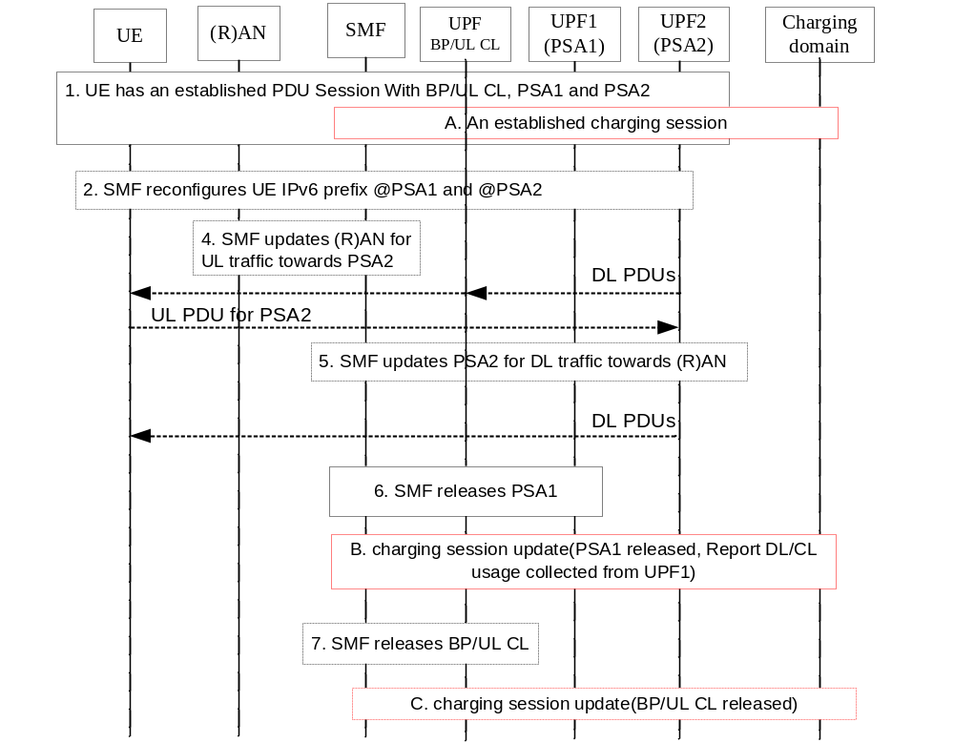
Figure 5.3.4.9.3.1: Charging procedure for a PDU session with two UPF anchors that terminate the N6 interface
1. UE has an established PDU Session with UPFs including the Branching Point or UL CL, the PDU Session Anchor 1 (PSA1 in Figure 5.3.4.9.3.1) and the PDU Session Anchor 2 (PSA2 in Figure 5.3.4.9.3.1).
A. A charging session for the PDU session with BP/UL CL is established between the SMF and the charging system. In PSA1 counts associated to UL/DL traffic to/from UPF1, and in PSA2 counts associated to UL/DL traffic to/from UPF2.
At some point the SMF decides to remove the PDU Session Anchor 1 e.g. due to UE mobility, flow terminated.
2-3. In case of IPv6 multi-homing, the SMF notifies the UE to stop using the IPv6 prefix corresponding to PSA1. The UE starts using the IPv6 prefix (corresponding to PSA2) for all the traffic.
4. If the Branching Point or UL CL is to be released, the SMF updates the (R)AN with the PSA2 CN Tunnel Info, and updates via N4 the PSA2 providing the (R)AN Tunnel Info.
5. If the Branching Point or UL CL is to be released, the SMF updates via N4 the PSA2 providing the (R)AN Tunnel Info.
6. The SMF releases via N4 the PSA1.
B. The charging session between SMF and the charging system is updated due to the chargeable event of the release of the PSA1.
7. If step 4 and 5 were executed, the SMF releases the BP or UL CL.
C. If step 7 was executed, the charging session is updated for the chargeable event of the release of BP/UL CL.

5.3.4.9.4 Procedure description - Additional PDU Session anchor relocation for UL CL
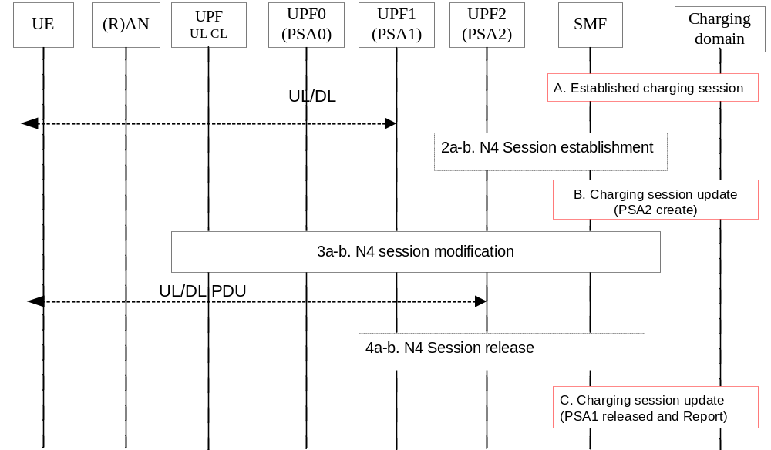
Figure 5.3.4.9.4.1: Charging procedure for the PDU session anchor in UPFs
The steps are per TS 23.502 [202] clause 4.3.5.6, and the following apply in addition:
A: A charging session is established for this PDU session.
B: The CH session is updated due the addition of UPF2, as the PDU Session anchor.
After step 3a-b: the data path is switched from UPF1 to UPF2, for UL/DL set of traffic flows moved from UPF1 to UPF2. The UPF2 is the point of measurement for these moved traffic flows.
C: if Step 4 occurs, the CH session is updated due UPF1 release, and last UL/DL counts of UPF1 are reported.
In which step(s) of the scenario the SMF needs to interact with the charging domain will be determined during the normative phase.

5.3.4.9.5 Procedure description - Relocation of UL CL for a PDU Session
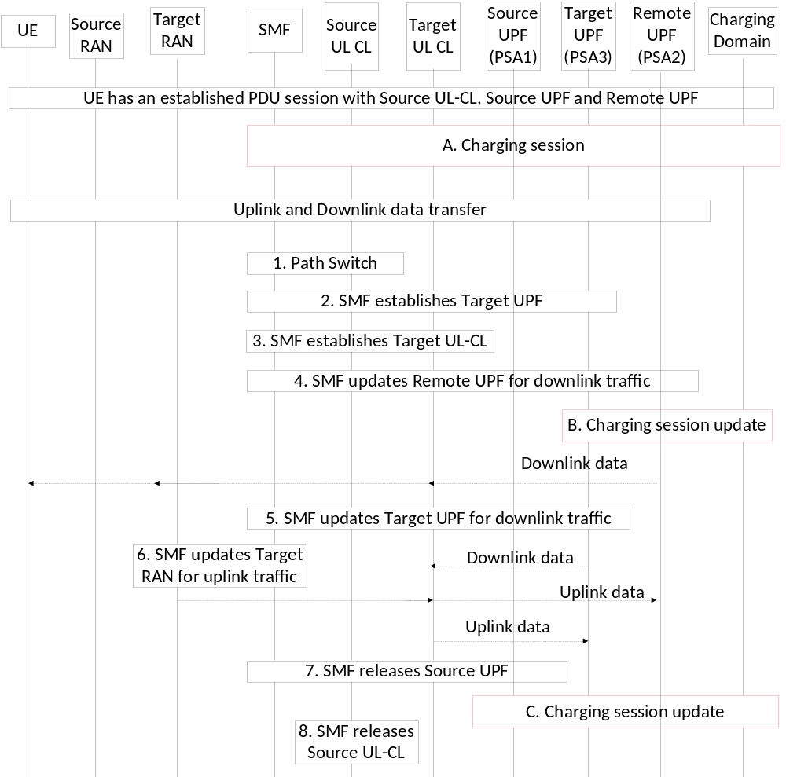
Figure 5.3.4.9.5.1: Charging procedure for the PDU session anchor in UPFs
The steps are per TS 23.502 [202] clause 4.3.5.7, and the following applies in addition:
A. A charging session is established for this PDU session, UL/DL usage via PSA1 is collected from Source UPF, and UL/DL usage via PSA2 is collected from Remote UPF.
After step 4: the data path is switched from Source UL CL to Target UL CL, and the new point of measurement is Target UPF for traffic via PSA3.
B. The Charging session is updated due to the data path from PSA3 to Target UPF is established.
C. The Charging session is updated due to Source UPF release, and last UL/DL counts from Source UPF for traffic via PSA1 are reported.
In which step(s) of the scenario the SMF needs to interact with the charging domain will be determined during the normative phase.

5.3.4.10 Solution#3.10: The reporting and quota management SSC mode 2 – New CH session

5.3.4.10.1 Architecture description
The same architecture as clause 5.1.4.3.1 applies.

5.3.4.10.2 Procedure description
The procedure of a PDU session anchor relocation in SSC mode 2 with single PDU session anchor and new charging session applies as per clause 5.1.4.4.
The following message flow is based on clause 4.3.5.1 of TS 23.502 [202] adapted to reflect the trigger and quota management, assuming the same SMF is selected:
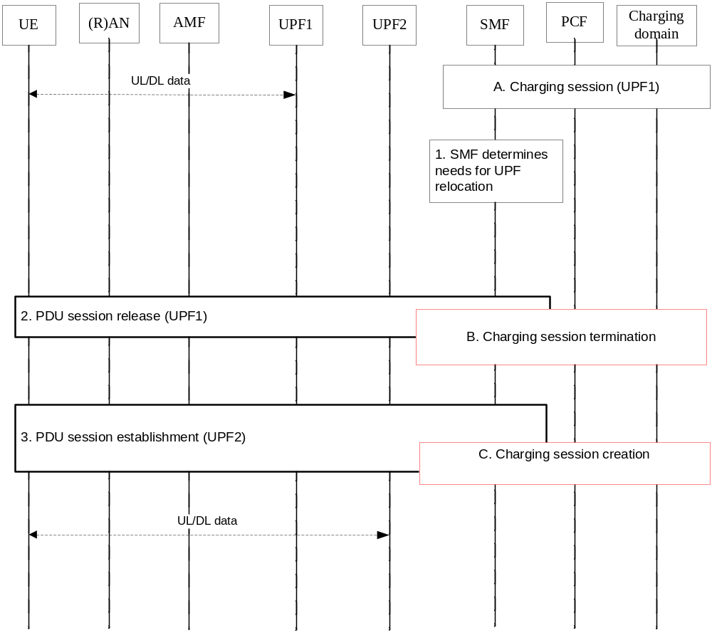
Figure 5.3.4.10.2.1: Quota management – New CH session
- Ongoing charging session associated with the established PDU session (UPF1)
[1 to 3]. Same as step 1 to 3 in clause 5.1.4.3.2.
B. same as step B in clause 5.1.4.4.2. The SMF triggers the reporting from UPF1 for consumed quota reporting to the charging system.
C. same as step C in clause 5.1.4.4.2. The SMF requests quota for UPF2.
In which step(s) of the scenario the SMF needs to interact with the charging domain will be determined during the normative phase.
An alternative with SMF re-allocation of remaining quota to UPF2 is not possible for this scenario.

5.3.5 Overall evaluation and conclusion

5.3.5.1 Evaluation

5.3.5.1.1 Solutions evaluation for Key issue #3.1 and #3.2
See clause 5.3.4.8.3.

5.3.5.1.2 Solutions evaluation for Key issue #3.3
See clause 5.3.4.6.3.

5.3.5.1.3 Solutions evaluation for Key issue #3.4
The 3 solutions #3.2, #3.3 and #3.9 solve the Key issue #3.4 and are evaluated under clause 5.3.5.1.4 and 5.3.5.1.5.

5.3.5.1.4 Solutions evaluation for Key issue #3.5
SSC mode 2:
Solutions #3.4.1, #3.4.2 and #3.10 address the Key issue #3.5 in SSC mode 2, with the difference the CH session is updated in #3.4.1, #3.4.2 and a new one is created in #3.10.
In this "break before make" scenario, a new PDU session (i.e. new PDU session Id) is created from the UE.
The benefit of solutions #3.4.1/#3.4.2, by preserving the CH session, is to avoid:
- two quota requests, by allowing a single quota request, especially in solution /#3.4.2 (No extra reporting for UPF change).
The solutions #3.4.1/#3.4.2 introduce a particular behavior of one CH session for multiple PDU sessions (i.e. each PDU session identified by one PDU session Id). They are not applicable in all circumstances of this scenario, e.g. when a new SMF is selected.
In the solution #3.10, there is one to one mapping between the CH session and the PDU session, and the solution is always applicable in any SSC mode 2 scenarios.
In the solution #3.10, it is not possible to achieve quota sharing between two UPFs as per "UPF change not awareness" of solution #3.4, however this does not bring high benefit.
The solution #3.10 is considered as the best approach to rely on associating a CH session to a PDU session, which is always applicable, compared to solutions #3.4.1/#3.4.2.
SSC mode 3 with multiple sessions:
The solutions #1.5 and #1.6 addresses the interaction with the CH domain, which includes the request for quota during this service continuity procedure. The selected solution applies.
As the result of this service continuity procedure, only one PDU session anchor (UPF) will remain: the solution#1.1 applies.
SSC mode 3 Multi Homed PDU session:
Both solutions #3.5.1 and #3.5.2 addressee Key issue #3.5 in scenarios with BP and UL CL, which are used to achieve SSC mode 3 Multi Homed session. and are possible solutions for Quota management in solution #3.3 and solution #3.9.
Solution 3.5.1 has the benefit to reduce the quota fragmentation and the number of transactions towards the charging server compared to solution 3.5.2, however there is no mean for the charging server to distinguish credit control between multiple UPFs. Both variants can be applicable. These solutions are based on a single CH session principle, which is the best approach, compared to another alternative (not described) with new CH session, since the PDU session (i.e. same PDU session Id) is maintained.
In solution #3.2, the Quota management is performed for the single BP/UL CL UPF.

5.3.5.1.5 Solutions evaluation for Key issue #3.6
The different solutions #3.2, #3.3, #3.9 are based on a single CH session principle, which is the best approach, compared to another alternative (not described) with new CH session, since the same PDU session (i.e. PDU session Id) is used.
The difference between these three solutions is which UPF(s) is (are) the one(s) used to count the traffic for charging purpose.
All solutions lead to the charging data collection point switch between two UPFs (e.g. PSA1 and BP/UL CL) if addition or removal of a third UPF (e.g. PSA2).
Based on the text in reference in clause 5.3.3.6, UL and DL Session-AMBR enforcement is in the UPF that supports BP and UL CL functionalities: therefore, the best approach is to select this UPF as the one to be used for counting the traffic for charging purpose, which is the solution #3.2. This will avoid counting packets dropped due to AMBR.
Although the solutions #3.3 and #3.9 imply complex coordination on the same quota consumption between two UPFs, it could also be possible to allow these solutions per Operator policy as optional variants.

5.3.5.2 Conclusion
It is concluded on:
- Solution#3.10 clause 5.3.4.10.2 procedure for Key issue #3.5 for SSC mode 2.
- Solutions #3.4.1 and #3.4.2 for SSC mode 2 are not applicable.
- Solutions #3.2, #3.3 and #3.9 are all possible solutions for Key issue #3.6 for Configurations with BP and UL CL. Which of them is to be selected as the preferred one will be considered during the normative work.
- Both solution #3.5.1 and solution #3.5.2 options for quota management in solutions #3.3 and #3.9.
- For the key issues #3.1 and #3.2 it is concluded to use the solution #3.8, which is supported by Sx, together with the other currently supported mechanisms over Sx.
- For the key issue #3.3 the solution #3.6 would suffice as a first step, and if there is more support needed this may be studied at a later step.

5.4 Network Slicing

5.4.1 Description and assumptions
A Network Slice is a logical network that provides specific network capabilities and network characteristics. Service-specific demands can be satisfied by mapping different services to separate Network Slices. A Network Slice instance (NSI) is a set of Network Function instances and the required resources (e.g. compute, storage and networking resources) which form a deployed Network Slice.
A single UE can be simultaneously served by one or more Network Slice instances via a 5G-AN. Some Network Function instances, e.g. the AMF instance, can be common to and shared by one or more Network Slice instances serving a UE. Some Network Function instances, e.g. the SMF instance, are tailored to a specific Network Slice instance.
A PDU session can belong to one and only one specific Network Slice instance per PLMN. Different Network Slice instances do not share a PDU session, though different slices may have slice-specific PDU sessions using the same DNN.
NSSAI is a collection of S-NSSAIs (Single Network Slice Selection Assistance Information). Each S-NSSAI identifies a Network Slice and assists the network in selecting a particular Network Slice instance. The establishment of User Plane connectivity to a Data Network via a Network Slice instance comprises the following two steps:
- Performing a Registration Management procedure to select a AMF that supports the required Network Slices.
- Establish one or more PDU sessions to the required Data Network via the Network Slice Instance(s).
For more detail of Network Slicing refer to TS 23.501 [201] clause 5.15.

5.4.2 Potential requirements
The following requirements should be supported for Network Slicing:
- Online and offline charging
- Capability for correlation within one slice.
- Charging for a single UE served by one or more Network Slice Instances could be:
- Session based
- Volume based
- Time based
- Volume and time based
- Event based
- Charging for a CSP who utilizes a specific Network Slice Instance:
- Connection based
- Volume based
- Time based
- Volume and time based
- Event based

5.4.3 Key issues

5.4.3.1 Key issue #4.1: Charging for UE served by one or more Network Slice instances
This key issue will look into solutions for charging for a UE served by one or more Network Slice instances
This study covers the following:
- Determination of the high-level common architecture to support charging for a UE simultaneously served by multiple NSIs, including the offline and online charging.
- Determination of which entity/entities are suitable to host the CTF(s)/CDF/CGF for offline charging.
- Determination of which entity/entities are suitable to host the CTFs for online charging.

5.4.3.2 Key issue #4.2: Charging for the CSP who utilizes a specific network slice instance
This key issue is for investigating on how to support the charging for the CSP who utilizes a specific network slice instance.
The present document covers the following:
- determination of chargeable party for tenant(CSP) based charging;
- identification of the main interactions with the charging domain.

5.4.4 Solutions

5.4.4.1 Solution#4.1: Charging for UE - different architecture options

5.4.4.1.1 Offline charging

5.4.4.1.1.1 Option #1: The offline charging system with CDF and CGF in two separate physical elements
The Charging Trigger Function (CTF) may be hosted in the NE (e.g. SMF) in each of the Network Slice Instance. The CTF(s) per PDU Session in each NSI are collecting the information pertaining to the chargeable events, assembling this information into matching charging events and sending these charging events towards the CDF. The CDF receives the charging events from the CTF(s) per PDU Session of each NSI via the Rf reference point. It then uses the charging information in the charging events to construct CDRs. Then the CDRs are forwarded to a billing domain for subsequent offline billing processes, through the CGF acting as a gateway between the CDF and the billing domain.
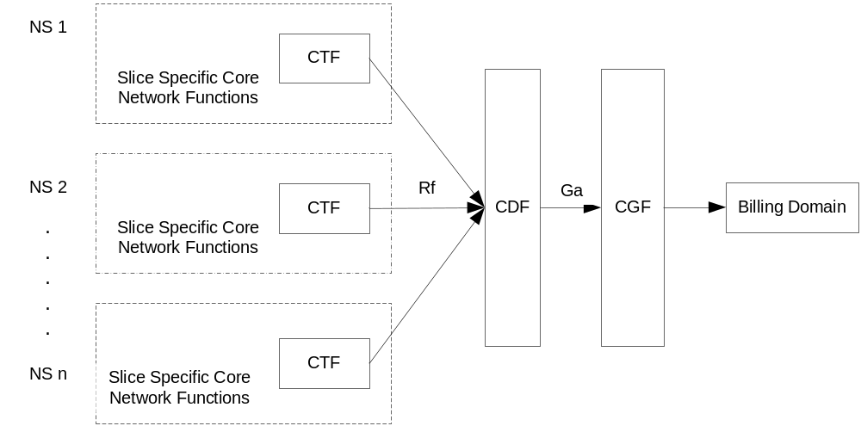
Figure 5.4.4.1.1.1: The offline charging architecture among multiple Network Slice instances-CTF Sliced

5.4.4.1.1.2 Option #2: The offline charging system with CDF integrated in the NE, CGF in a separate physical element
Both CTF(s) and CDF may be hosted in the NEs in each of the Network Slice Instance.
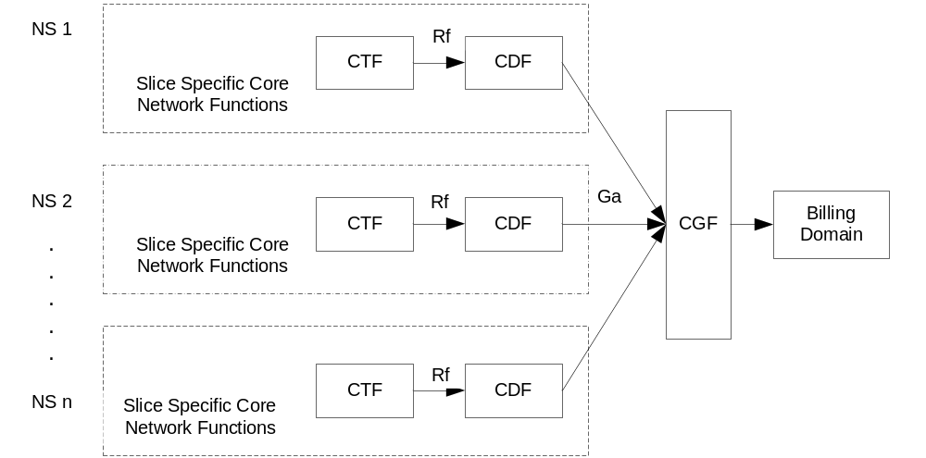
Figure 5.4.4.1.1.2: The offline charging architecture among multiple Network Slice instances- CTF/CDF Sliced

5.4.4.1.1.3 Option #3: The offline charging system with CDF and CGF integrated in the NE
The CTF(s) and CDF and CGF may be hosted in the NEs in each of the Network Slice Instance.
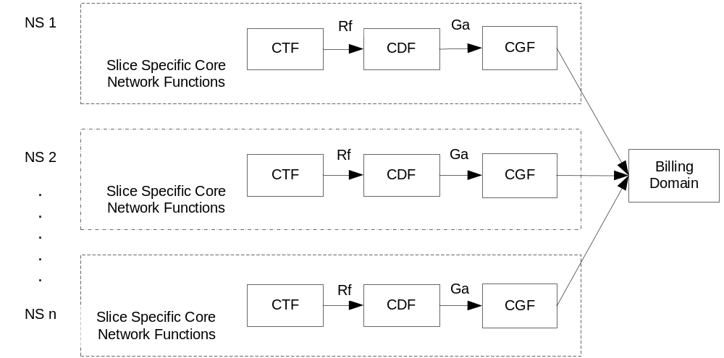
Figure 5.4.4.1.1.3: The offline charging architecture among multiple Network Slice instances-CTF/CDF/CTF Sliced
NOTE 1: The offline charging is performed separately on each NSI, i.e., the collection and report of the charging information in one NSI is independent of others.
NOTE 2: Charging for a UE served by only one NSI is a special case of a UE served by multiple NSIs.

5.4.4.1.2 Online charging

5.4.4.1.2.0 General Description
In the online charging process, the charging information for the network resource usage is collected concurrently with the resource usage in the same fashion as in offline charging. However, authorization for the network resource usage should be obtained by the network before the actual resource usage takes place. In case of a UE served by multiple Network Slice Instances, the credit management for each PDU session in different NSIs should be performed independently.

5.4.4.1.2.1 Option #1: The online charging system is shared by all the Network Slice instances per PLMN
In this solution, the online charging system is shared by all the network slice instances in a PLMN. Figure 5.4.4.1.2.1.1 depicts the high-level overview of the common online charging system over multiple NSIs without including the OCS in one of Network Slice instances. In this architecture, besides collecting the charging information and forwarding the charging events to the OCF, which is the same as the offline charging, the CTF also extends to support the online charging functions described as TS 32.240 [1]. In each NSI, there may be one or more CTFs for generating the charging information. The UE identity such as SUPI, and the NSI identity such as S-NSSAI should be forward to the OCS from CTF in the specific NSI.
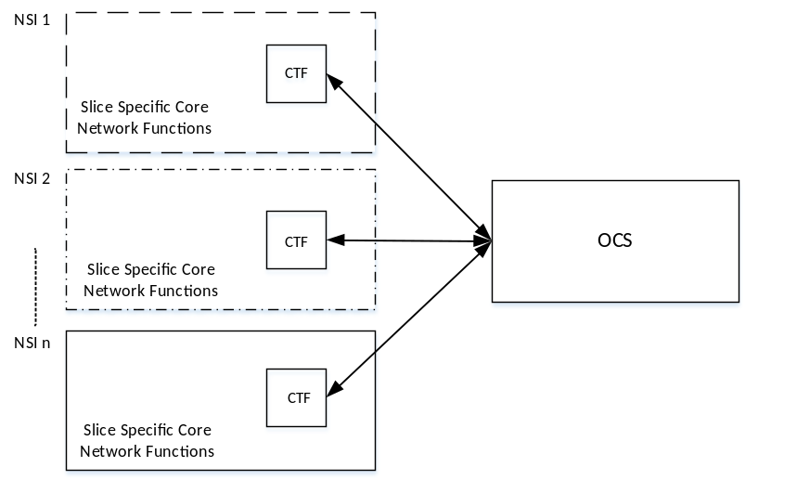
Figure 5.4.4.1.2.1.1: The online charging system shared by all the Network Slice instances per PLMN

5.4.4.1.2.2 Option #2: online charging by instantiating a slice-specific OCF/RF/CGF for each Network Slice instance
In this architecture, multiple OCF/RF/CGF are instantiated in each Network Slice instance serving the UE. The OCF/RF/CGF is slice-specific and designed based on the type of Network Slice. Figure 5.4.4.1.2.2.1 shows the general deployment architecture for online charging among multiple NSIs by implementing the OCF/RF/CGF in each NSI. The CTF(s) per PDU session are hosted by the NEs (e.g. SMF) in each NSI and the credit management applies for online charging operates on a per NSI basis. If the network operator provides the multiple network slices, the ABMF should be deployed to manage the one UE's account that shared among multiple NSIs, when the UE accesses the Network Slice Instances.
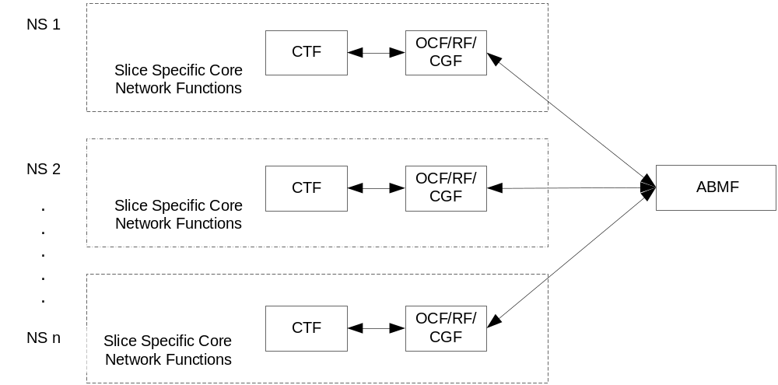
Figure 5.4.4.1.2.2.1: The online charging by instantiating a slice-specific OCF/RF/CGF for each Network Slice instance

5.4.4.1.3 Solution evaluation
Solution#4.1 solves Key issue #4.1 (Charging for UE served by one or more Network Slice instances) and is aligned with existing charging principles.
Compared to the option2 in clause 5.4.4.1.1.2 and option 3 in clause 5.4.4.1.1.3, the option 1 for offline charging in clause 5.4.4.1.1 is fully distributed implementation where all reference points are be implemented as physical interfaces on the NE, CDF and CGF, respectively, and re-use the existing charging mechanism.
Compared to the option2 in clause 5.4.4.1.2.2 and option 3 in clause 5.4.4.1.2.3, the option 1 for online in clause 5.4.4.1.1.2 can reuse the existing charging mechanism.

5.4.4.2 Solution#4.2: Charging for creating and modifying a Network Slice by a CSP

5.4.4.2.1 Offline charging
For offline charging for the creation, activation, de-activation, modification and termination of a Network Slice requires a trigger point in the management of the Network Slice since this is the place that holds together and authorize the creation etc. of the Network Slice. This would mean that the CTF could be placed in the Network Slice Management Function (NSMF).
Figure 5.4.4.4.1.1 depicts the high-level offline architectural options that exist for the above described option.
Editor's Notes: This solution is dependent on the Network Slice, NSMF and CSP together with the operations possible, and should be refined after TS 28.530 [203] has been updated.
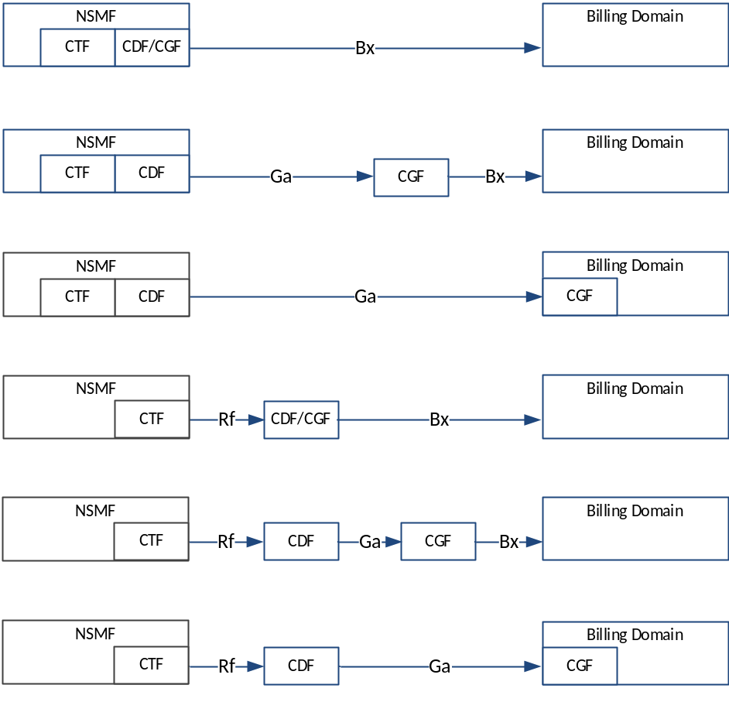
Figure 5.4.4.2.1.1: Network Slicing offline charging architecture options for NSMF

5.4.4.2.2 Online charging
For online charging for the creation, activation, de-activation, modification and termination of a Network Slice requires a trigger point in the management of the Network Slice since this is the place that holds together and authorize the creation etc. of the Network Slice. This would mean that the CTF could be placed in the Network Slice Management Function (NSMF). In the online charging case, it means that there is an extra step added at the provisioning of a Network Slice to be able to secure that there CSP has funds enough to cover the cost of the change.
Figure 5.4.4.4.2.2 depicts the high-level architectural options that exist for the above described option.
Editor's Notes: This solution is dependent on the Network Slice, NSMF and CSP together with the operations possible, and should be refined after TS 28.530 [203] has been updated.
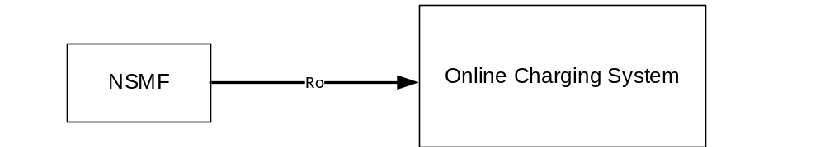
Figure 5.4.4.2.2.2: Network Slicing online charging architecture option for NSMF

5.4.4.3 Solution#4.3: Charging procedure for UE served by multiple network slice instances

5.4.4.3.1 Procedure description
According to TS 23.501 [200], a single UE can simultaneously be served by one or more Network Slice instances via a 5G-AN. The following figure 5.4.4.13.1 describes the high-level charging procedure for UE served by two network slice instances simultaneously as an example. For offline and online charging, the SMF hosts the CTF in each NSI. The UE can establish one or more PDU sessions in each NSI and a corresponding charging session is established for the each established PDU session. Different Network Slice instances do not share a PDU session, though different slices may have slice-specific PDU sessions using the same DNN.
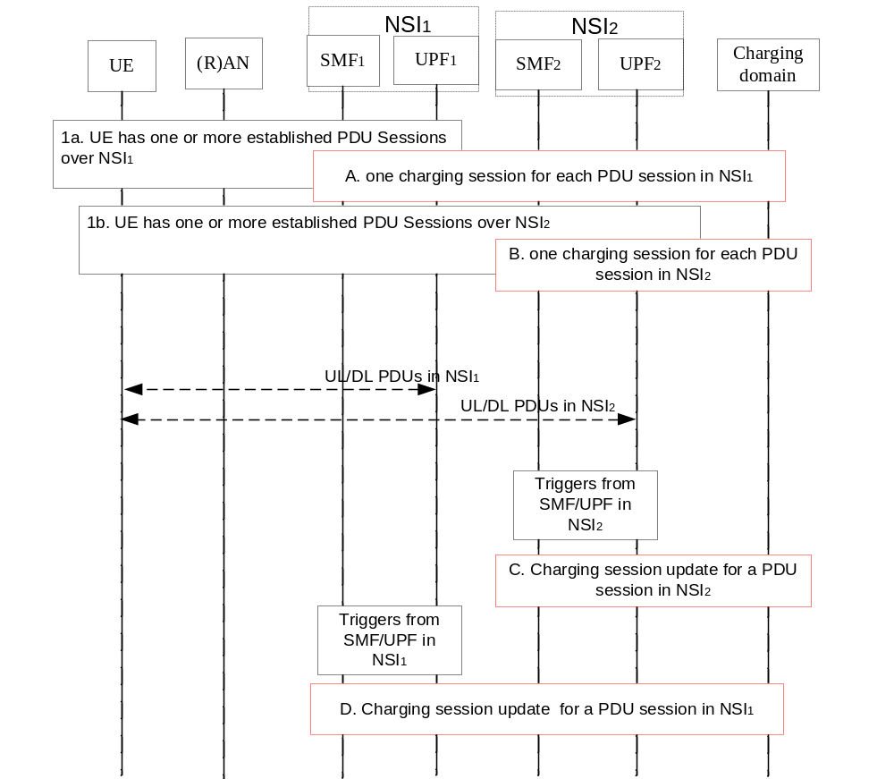
Figure 5.4.4.3.1 Charging procedure for UE served by multiple Network Slice Instances
1a-1b. UE has one or more established PDU sessions in NSI 1 and NSI 2, respectively.
A-B. If the establishment of a PDU session in a NSI succeeds, a corresponding charging session between the SMF and the charging system is established for this PDU session in this NSI. The S-NSSAI is sent to the charging domain.
C-D. if the chargeable events (from SMF or UPF) belonging to a PDU session is encountered, the corresponding charging session of this PDU session is updated.

5.4.4.3.2 Solution evaluation
Solution#4.3 solves Key issue #4.1 (Charging for UE served by one or more Network Slice instances) and is aligned with existing charging principles.

5.4.5 Conclusions
It is concluded on:
Solution#4.1 clause 5.4.4.1.1.1 option 1, for Key issue #4.1,
Solution#4.1 clause 5.4.4.1.2.1 option 1, for Key issue #4.1,
Solution # 4.3 clause 5.4.4.3 for Key issue #4.1 is selected. For the case of one UE served by multiple network slice instances, the Nch should support the charging per PDU session per network slice instance.
There is no solution for the potential requirement about charging for a CSP who utilizes a specific Network Slice instance and key issues 4.2 and it is for further study.
Solution#4.1 option 2 in clause 5.4.4.1.1.2 and option 3 in clause 5.4.4.1.1.3 are variants for later release consideration.
Solution#4.1 option 2 in clause 5.4.4.1.2.2 is a variant for later release consideration.

5.5 Network Capability Exposure

5.5.1 Description and assumptions
The services and network capabilities provided by 3GPP can be exposed to the external (e.g. 3rd party) and internal network functions. NEF (Network Exposure Function) is responsible for the network capability exposure and information receiving from other network functions (based on exposed capabilities of other network functions).
The functionalities of NEF are specified in TS 23.501 [201] clause 6.2.5:
- It provides a means to securely expose the services and capabilities provided by 3GPP network functions for e.g. 3rd party, internal exposure/re-exposure, Application Functions, Edge Computing. In addition, it provides a means for the Application Functions to securely provide information to 3GPP network, e.g. Mobility Pattern, communication pattern.
- It translates between information exchanged with the AF and information exchanged with the internal network function.
- The Network Exposure Function receives information from other network functions (based on exposed capabilities of other network functions). It may implement a Front End (NEF FE) to store the received information as structured data using a standardized interface to a Unified Data Repository (UDR).
The detailed description for the external exposure is specified in TS 23.501 [201] clause 5.20 and TS 23.502 [202] clause 4.15.
The NEF can start the charging for Event exposure, subscription/notification of network exposure, and external network exposure, triggered by Application, operator configuration and other network functions.
For Event exposure, the AMF service operations information flow, UDM service operations information flow, NEF service operations information flow and Exposure with bulk subscription are specified in TS 23.502 [200] clause 4.15.3.2.4.
For subscription/notification of network exposure for Analytics, is specified in TS 23.502 [200] clause 4.15.5.
For external network exposure, the Monitoring capability, Provisioning capability, and Policy/Charging capability exposure are specified in TS 23.502[200] clause 4.15.3.

5.5.2 Potential requirements
The following potential charging requirements should be supported for network capability exposure:
- Online and offline charging.
- Charging based on the network capability invocation or subscription for the network capabilities exposure.
The following potential charging requirements should be supported for the exposure of charging system:
- The external exposure of the charging system as the network capability.
- The internal exposure of the charging system as the network capability.

5.5.3 Key issues

5.5.3.1 Key issue #5.1: Charging for network capability exposure
This key issue is for study on how to support the external exposure charging for the 3rd parties.
Solutions for this key issue will study:
- Which entity/entities in the 5G architecture is suitable to host the CTF(s) for network capability exposure.
- The suitable charging models, e.g. API based, event based or session based charging models, for external network exposure and network internal exposure.
- The interaction with charging system including online charging and offline charging system.

5.5.3.2 Key issue #5.2: Exposure of Charging System as network capability
This key issue is for study on how to support the external exposure charging for the 3rd parties.
Solutions for this key issue will study:
- The possible of exposure of charging system as the network capability.
- The suitable charging models for the exposure of charging system as the network capability.

5.5.4 Solutions

5.5.4.1 Solution#5.1: Charging for network capability external exposure – Ro/Rf

5.5.4.1.1 Architecture description
The charging information for the network capability external exposure can be collected by NEF, interacting with the charging system, as described for one option in Figure 5.5.4.1.1.1:
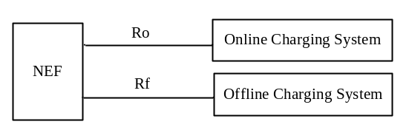
Figure 5.5.4.1.1.1: Architecture of Charging System interfacing the NEF
Other options for this architecture are described in TS 32.254 [14] clause 4.2, replacing the SCEF by NEF.

5.5.4.1.2 Procedure description
The following figure 5.5.4.1.2.1 describes the charging procedure of "Application Trigger" Service, based on clause 5.2.6.1 TS 23.502 [202] description, for External exposure.
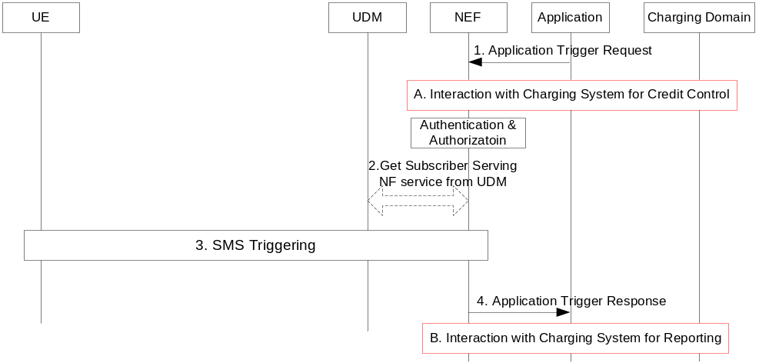
Figure 5.5.4.1.2.1: "Application Trigger" Service
1. The NEF (Network Exposure Function) receives an Application Trigger Request message and checks whether the Application is authorised to send the Application Trigger based on the requester Identifier.
A. The NEF requests the Online charging domain for checking whether the requester has enough quota or rate of trigger submission.
2. The NEF invokes the "Get Subscriber Serving NF (External Identifier or MSISDN, NF type)" service provided by the UDM.
3. The NEF acting as SCEF performs device triggering procedure.
4. The NEF sends the Application Trigger Response to the Application Server.
B. The NEF reports the charging information for the Application trigger to charging domain.

5.5.4.2 Solution#5.2: Exposure of Charging System as network capability

5.5.4.2.1 Architecture description
The charging information for the exposure of Charging System can be collected by NEF, interacting with the charging system by service interface Nch, as described in Figure 5.5.4.2.1.1:
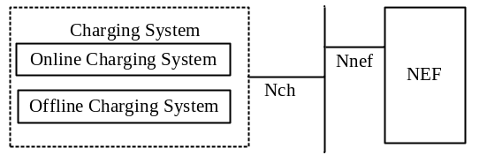
Figure 5.5.4.2.1.1: Architecture of Exposure of Charging System

5.5.4.3 Solution#5.3: Charging for internal network capability exposure

5.5.4.3.1 Architecture description
The same architecture as per clause 5.5.4.1.1 applies.

5.5.4.3.2 Procedure description
As per the clause 5.3 TS 23.502 [202], The NEF can subscribe the mobility statistics from AMF, session statistics from SMF and policy statistics from PCF for Analytics.
No charging for the internal Network Exposure for Analytics.

5.5.4.4 Solution#5.4: Charging for Event Exposure with bulk subscription

5.5.4.4.1 Architecture description
The same architecture as per clause 5.5.4.1.1 applies.

5.5.4.4.2 Procedure description
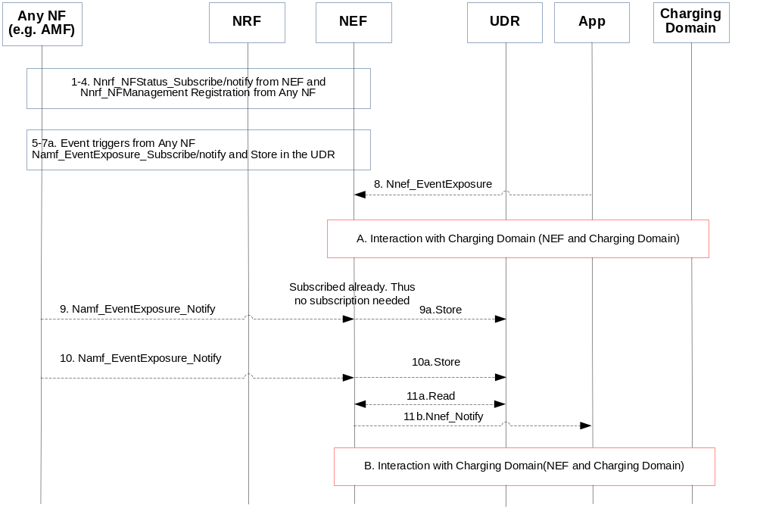
Figure 5.5.4.4.2.1: Charging for Exposure with bulk subscription
1. NEF registers with the NRF for any newly registered NF along with its NF services.
2. When an NF instantiates, it registers itself along with the supported NF services with the NRF.
3. NRF acknowledges the registration.
4. NRF notifies the NEF with the newly registered NF along with the supported NF services.
5. NEF evaluates the NF and NF services supported against the pre-configured events within NEF. Based on that, NEF subscribes with the corresponding NF either for a single UE, group of UE(s) (e.g. identifying a certain type of UEs such as IoT UEs), any UE. NF acknowledges the subscription with the NEF.
6 - 7. When the event trigger happens, NF notifies the requested information towards NEF. NEF may store the information in the UDR.
8. Application registers with the NEF for a certain event identified by event filters.
A. The NEF interacts with charging domain for the Nnef_EventExposure request from Application.
9 - 10. When the event trigger happens, NF notifies the requested information towards NEF. NEF may store the information in the UDR.
11a-b. NEF reads from UDR and notifies the application for the corresponding subscribed events.
B. The NEF reports the charging information for the Nnef_notify, including the notification is step 4, 6,7,8,9 to charging domain.
In which step(s) of the scenario the NEF needs to interact with the charging domain will be determined during the normative phase.

5.5.4.5 Solution#5.5: Charging for network capability external exposure – Nch

5.5.4.5.1 Architecture description
The charging information for the network capability external exposure can be collected by NEF, interacting with the charging system, as described in Figure 5.5.4.1.1.2.1:
Figure 5.5.4.5.1.1: Architecture of Charging System interfacing the NEF

5.5.4.5.2 Procedure description
The procedure is similar as procedure in clause 5.5.4.1.2, except the interaction with the Charging system is over Nch.

5.5.5 Evaluation and conclusion

5.5.5.1 Evaluation
The key issue #5.1 related to "Charging based on the network capability invocation or subscription for the network capabilities exposure" potential requirements in clause 5.5.2, is addressed under:
- solution #5.1, and solution#5.5. for "Application Trigger" Service with alternative architectures;
- solution #5.4 for "Event Exposure with bulk subscription".
Other network capabilities exposed by the NEF such as Monitoring capability, Provisioning capability, and Policy/Charging capability exposure, are needed to be studied, based on the progress of SA2 TS 23.501 [201], 23.502 [202] and 23.503 [203], in order to fully address the key issue #5.1.
The key issue #5.2 related to "The external exposure of the charging system as the network capability" potential requirements in clause 5.5.2, is addressed under the unique solution #5.2 alternative, which is not completely described, and may need further cooperation with other SDOs (e.g. OMA…).
The solution#5.3 is to exclude the charging for the internal Network Exposure for Analytics.

5.5.5.2 Conclusion
Solutions for key issues #5.1 and #5.2 are still FFS.

5.6 Roaming

5.6.1 Description and assumption

5.6.1.0 General
The architecture references for roaming are in clause 4.2.2.
The architecture references for the PCF in roaming is in TS 23.503 [204] clause 5.2.2.
For Roaming scenario, the Session Management functionality is specified in TS 23.501 [201] clause 5.6.3.
The UE may have simultaneous PDU sessions in LBO or Home Routed modes, they will be handled independently under the respective mode from charging's perspective.
The AMF determines if a PDU session is to be established in LBO or Home Routing mode per TS 23.501 [201] clause 6.3.2. (e.g. for this DNN per DN subscription).
The interaction between the V-PCF and H-PCF for roaming scenarios is specified in TS 23.503 [204] clause 5.3.4, with per informative Annex A.3.1.7:
"In the case of local breakout, an interface (N24) is supported between the V-PCF and H-PCF for providing mobility policy rules from HPLMN to VPLMN.
In the case of roaming, an interface (N24) is supported between the V-PCF and H-PCF for providing UE Route Selection Policy rules from HPLMN to VPLMN."

5.6.1.1 PDU session – roaming LBO
The User subscription is checked by the SMF in VPLMN at PDU session establishment.

5.6.1.2 PDU session - roaming Home Routed
In Home routed:
- User subscription check by the H-SMF at PDU session establishment.
- H-SMF checks whether VPLMN is allowed by HPLMN to locally offload traffic (based on roaming agreements).
- QoS requirements associated with a PDU session sent from H-SMF to V-SMF in VPLMN at PDU session establishment or modification, are checked by V-SMF per roaming agreements.

5.6.2 Potential requirements
The following should be supported:
- real-time resource usage control (online charging) from the HPLMN;
- CDRs generation by the VPLMN.

5.6.3 Key issues

5.6.3.1 Key issue #6.1: Online charging from HPLMN
This key issue is for investigating on how to support online charging from HPLMN.

5.6.4 Solutions

5.6.4.1 Solution #6.1: PDU session charging from SMF in roaming LBO – CH in VPLMN

5.6.4.1.1 Architecture description
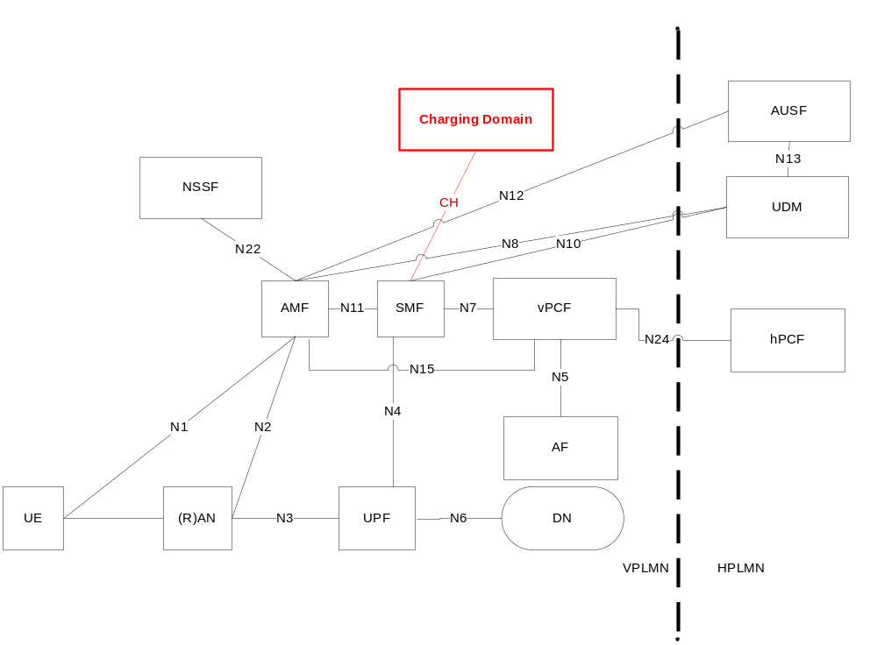
Figure 5.6.4.1.1.1: Charging domain interfacing the SMF in roaming LBO – CH in VPLMN

5.6.4.1.2 Procedures description
Based on clause 4.3.2.2.1 in TS 23.502 [202] message flows, the procedure described in figure 5.1.4.1.2.1 applies for PDU Session Establishment in roaming LBO, with the following differences:
- SMF in VPLMN interacts with UDM in HPLMN.
- PCF is split between hPCF in HPLMN and vPCF in VPLMN.
- the Charging Domain is in VPLMN.

5.6.4.1.3 Charging mode and objective
Interaction between the SMF and Charging domain in VPLMN, is offline charging only.
CDRs generated in VPLMN are used as basis for TAP files sent between the VPLMN Billing System and the HPLMN Billing system, which can be used for end user billing by the HPLMN or wholesale purpose.

5.6.4.1.4 Charging architecture – additional considerations
Any solution in clause 5.9 used in "offline only" mode, applies to the Network Architecture Figure 5.6.4.1.1.1, to serve the charging mode and objective in clause 5.6.4.1.3.

5.6.4.1.5 Solution evaluation
The benefit of this solution is have common behaviors for offline end-user charging, both "roamer-in" and HPLMN subscribers.
The drawback of this solution are:
- the HPLMN does not have any control on their subscriber's usage when roaming out.
- online charging is not possible for roamer-out.
- for offline charging, TAP files from VPLMN are needed by the HPLMN for their subscribers billing.
In case this solution is retained, clause 5.9 solutions need to be evaluated with additional considerations of clause 5.6.4.1.4.

5.6.4.2 Solution #6.2: PDU session charging from SMF in roaming LBO – CH in HPLMN

5.6.4.2.1 Architecture description
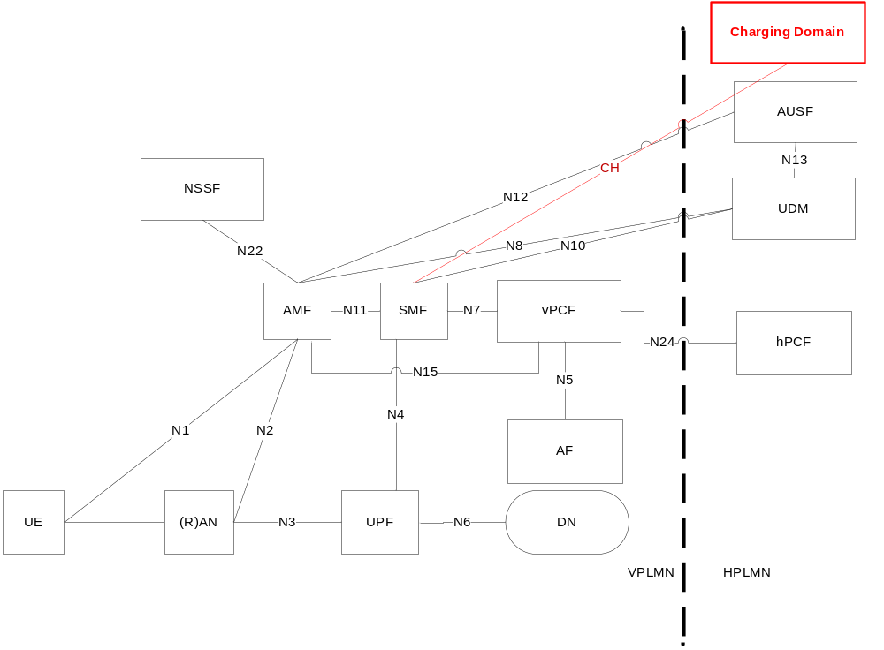
Figure 5.6.4.2.1.1: Charging domain interfacing the SMF in roaming LBO – CH in HPLMN

5.6.4.2.2 Procedures description
Based on clause 4.3.2.2.1 in TS 23.502 [202], the procedure described in figure 5.1.4.1.2.1 applies for PDU Session Establishment for roaming LBO, with the following differences:
- SMF in VPLMN interacts with UDM in HPLMN
- PCF is split between hPCF in HPLMN and vPCF in VPLMN
- the Charging Domain is in HPLMN

5.6.4.2.3 Charging mode and objective
Interaction between the SMF in VPLMN and Charging domain in HPLMN in offline or online charging.
In this solution, since the PDU session charging is under the control of HPLMN, CDRs generation in the VPLMN is not proposed.

5.6.4.2.4 Charging architecture – additional considerations
Any solution in clause 5.9 applied to the Network architecture in Figure 5.6.4.2.1.1 with the SMF in VPLMN and CH domain in HPLMN, to serve the charging mode and objective in clause 5.6.4.2.3, needs additional considerations to address CH inter-PLMN.

5.6.4.2.5 Solution evaluation
This solution solves the Key issue #6.1.
The drawbacks of this solution are:
- no CDRs generation in VPLMN (for wholesale).
- CH inter-PLMN: Quota management crossing the PLMNs needs additional considerations compared to intra-PLMN, as those considered for Gy inter-PLMN introduced in 3GPP Rel-13 (e.g. dedicated roaming agreement between Operators, additional parameters to be standardized by GSMA).
For the charging architecture, the recommendation is to adopt extension of clause 5.9 solution, to incorporate additional considerations of clause 5.6.4.2.4.

5.6.4.3 Solution #6.3: PDU session charging from SMFs in Home Routed

5.6.4.3.1 Architecture description
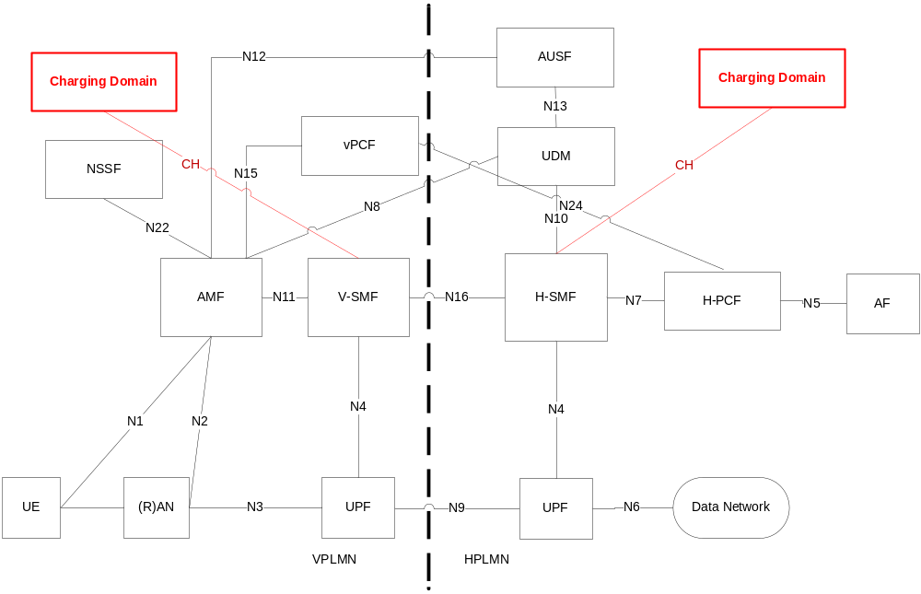
Figure 5.6.4. 3.1.1: Charging domain interfacing the SMFs in Home Routing

5.6.4.3.2 Procedures description
The following figure 5.6.4.3.2.1 describes a PDU session establishment for roaming in Home routed scenario based on clause 4.3.2.2.2 TS 23.502 [202] description:
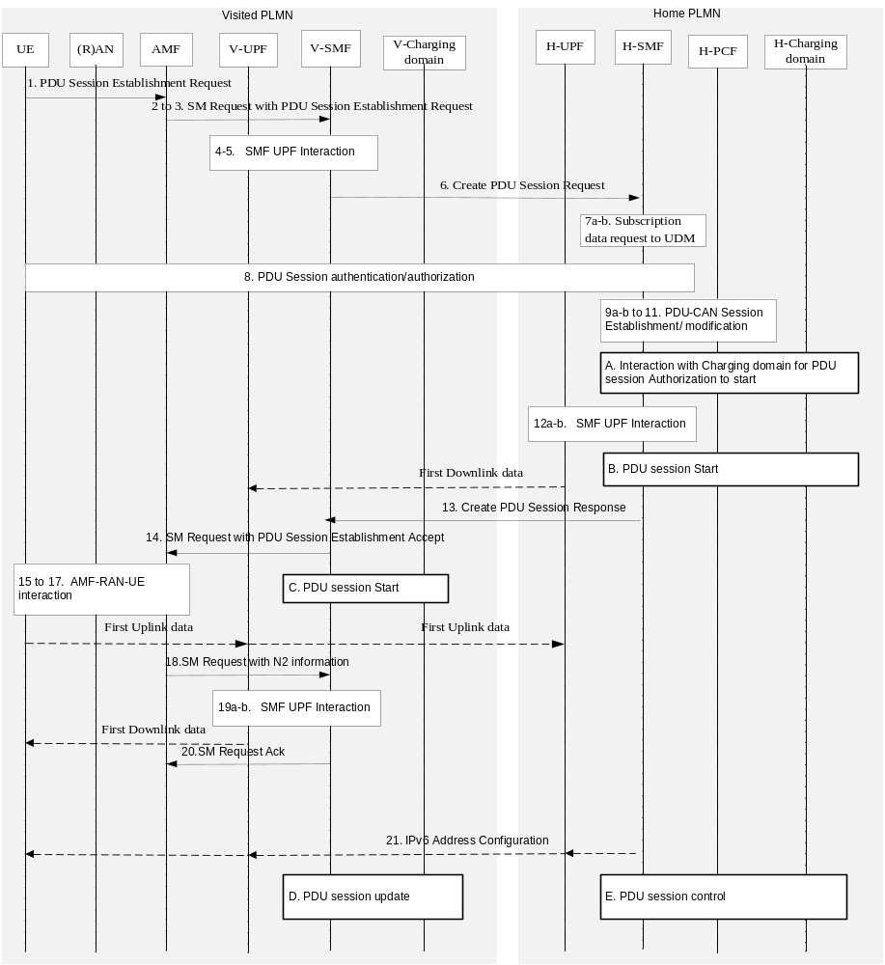
Figure 5.6.4.3.2.1: PDU session establishment – roaming Home Routed
All the steps are described in clause 4.3.2.2.2 TS 23.502 [202], and below part of description relevant for roaming, with also some additions:
1-2. The H-SMF is selected by the AMF.
[7a-b]. Subscription Data Request to UDM, based on (Subscriber Permanent ID, DNN, VPLMN): Default QoS profile.
[9a-b to 11]. If dynamic PCC is deployed, the SMF performs PCF selection, and requests for PCC Rules, and SMF selection of UPF.
A. The H-SMF performs the selection of the CH-Charging domain, and seeks for authorization for the subscriber to start the PDU session in the VPLMN.
B. Start of the PDU session is reported to charging domain in HPLMN.
13. H-SMF to V-SMF: Create PDU Session Response (Authorized QoS Rule(s), SSC mode, indication if VPLMN authorized to offload traffic (insert UL CL or Branching Point)).
C. Start of the PDU session is reported to charging domain in VPLMN.
D. PDU session update reported to the charging domain in VPLMN.
E. Control of the PDU session by the charging domain in HPLMN.
There may be additional interaction with the charging domain after or before step 15. This will be determined during the normative phase.

5.6.4.3.3 Charging mode and objective
Interaction between the SMF in VPLMN and Charging domain in VPLMN in offline charging: CDRs generated in VPLMN are used as basis for TAP files sent between the VPLMN Billing system and the HPLMN Billing system, which can be used for end user billing by the HPLMN or wholesale purpose.
Interaction between the SMF in HPLMN and Charging domain in HPLMN in offline charging: CDRs generation for end user billing, and for wholesale (i.e. for reconciliation with the TAP files received from VPLMN Billing system).
Interaction between the SMF in HPLMN and Charging domain in HPLMN in online charging.

5.6.4.3.4 Charging architecture – additional considerations

5.6.4.3.4.1 Description
In order to serve the Network architecture in Figure 5.6.4.3.1.1, charging mode and objective in clause 5.6.4.3.3, it is needed to investigate further on appropriate charging architecture.
Charging architecture to support interaction between the SMF in HPLMN and Charging domain in HPLMN in offline charging for end user billing, and in online charging, is addressed under the clause 5.9 "Online and offline charging evaluation".
This clause is for investigating on following additional considerations:
- Charging architecture to support interaction between the SMF in VPLMN and Charging domain in VPLMN in offline charging.
- Charging architecture to support interaction between the SMF in HPLMN and Charging domain in HPLMN in offline charging for wholesale.

5.6.4.3.4.2 Solution #6.3.1: solutions #9.1 (Combined online and offline charging) for VPLMN
The architecture is per Figure 5.9.4.1.1.1 of solutions #9.1 with the V-SMF as the 5G System Network Element.
The "offline only" mode is the unique mode needed with no quota management.
A dedicated behaviour needs to be defined compared to those generated for the subscribers in HPLMN.
Evaluation:
This solution uses a sub-functionality of solution#9.1 (i.e. offline), which in addition needs to be adapted to "roamer-in" scenario where the subscriber is not owned by the VPLMN.

5.6.4.3.4.3 Solution #6.3.2: solutions #9.2 (Partial combined online and offline charging) for VPLMN
The architecture is per Figure 5.9.4.2.1.1 of solutions #9.2 with the V-SMF as the 5G System Network Element.
The CTF always select Rf path.
A dedicated behaviour needs to be defined compared to those generated for the subscribers in HPLMN.
Evaluation:
This solution is similar as Rf-based solution in EPC, except that an additional module box is needed in the CH domain to route to the CDF (on/off in the charging architecture per Figure 5.9.4.2.1.1).

5.6.4.3.4.4 Solution #6.3.3: solutions #9.3 (Online charging with unlimited quota for offline) for VPLMN
The architecture is per Figure 5.9.4.1.1.1 of solutions #9.1 with the V-SMF as the 5G System Network Element.
A dedicated behaviour needs to be defined compared to those generated for the subscribers in HPLMN.
Evaluation:
This solution implies use of Ro-like interface and quota management which is over sized and not appropriate for this "roamer-in" scenario where the subscriber is not owned by the VPLMN.

5.6.4.3.4.5 Solution #6.3.4: Rf solution for VPLMN
The architecture is based on existing TS 32.240 [1] architecture for offline.
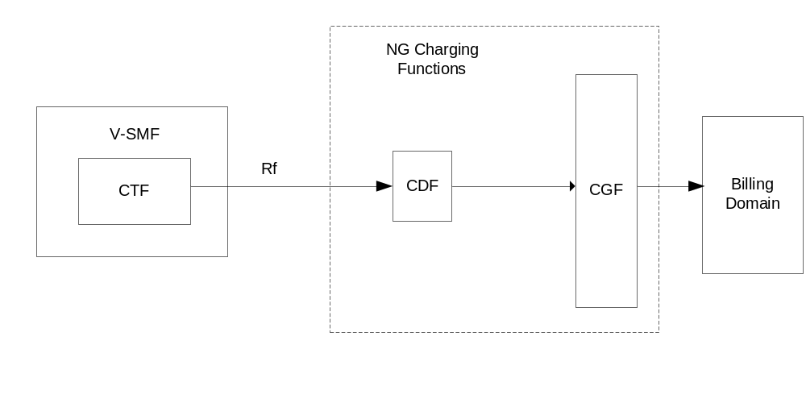
Figure 5.6.4.3.4.5.1: Offline charging architecture for 5G V-SMF
A dedicated behaviour needs to be defined compared to those generated for the subscribers in HPLMN.
Evaluation:
This solution is similar as Rf-based solution in EPC.

5.6.4.3.5 Solution evaluation
This solution solves the Key issue #6.1.
The benefits of this solution are:
- both online and offline charging are possible.
- CDRs generation in VPLMN for wholesale.
The charging architecture for "interaction between the SMF in HPLMN and Charging domain in HPLMN in offline charging for end user billing, and in online charging" is per clause 5.9 conclusion.
For "interaction between the SMF in VPLMN and Charging domain in VPLMN in offline charging", the best approach is to re-use the solution in HPLMN, and adapt it for additional roaming considerations of clause 5.6.4.3.4:
- solution #6.3.1 in VPLMN, if solution #9.1 in HPLMN;
- solution #6.3.2 in VPLMN, if solution #9.2 in HPLMN;
- solution #6.3.3 in VPLMN, if solution #9.3 in HPLMN.
Since the solution #6.3.4 is independent from any clause 5.9 solutions in HPLMN, it is not the best approach.

5.6.4.4 Solution #6.4: PDU session charging from SMF in roaming LBO – CH in HPLMN and VPLMN

5.6.4.4.1 Architecture description
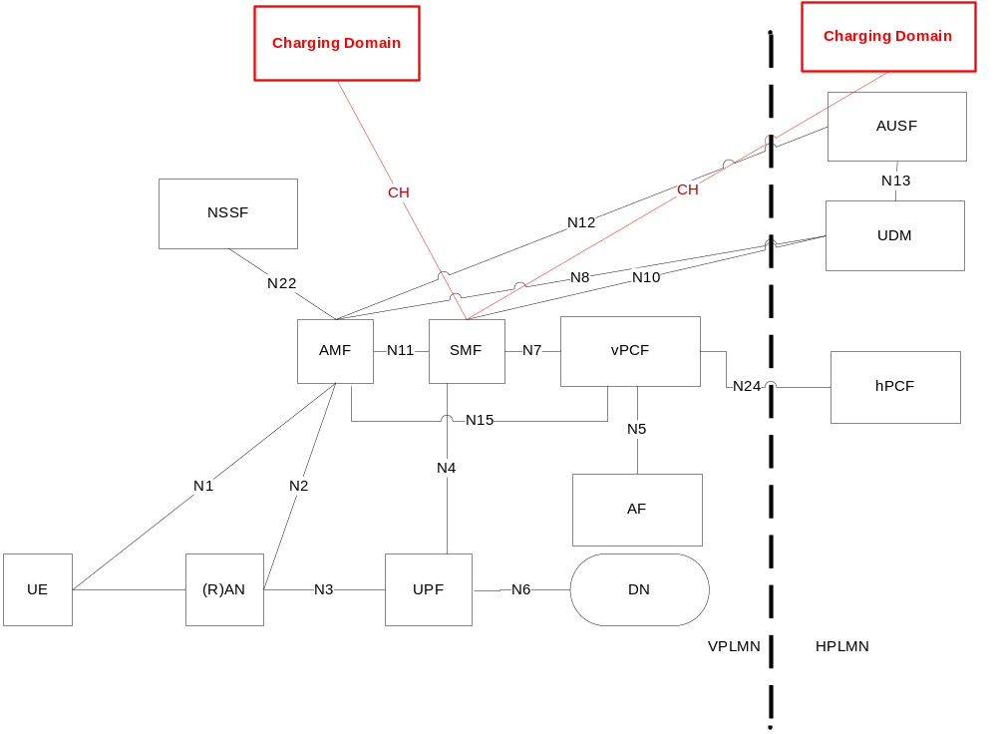
Figure 5.6.4.4.1.1: Charging domain interfacing the SMF in roaming LBO – CH in HPLMN and VPLMN

5.6.4.4.2 Procedures description
The same procedure applies as for solution #6.2 in clause 5.6.4.2.2 between SMF in VPLMN and CH domain in HPLMN.
The same procedure applies as for solution #6.3 in clause 5.6.4.3.2 between SMF in VPLMN and CH domain in VPLMN.

5.6.4.4.3 Charging mode and objective
Interaction between the SMF in VPLMN and Charging domain in HPLMN in offline or online charging.
Interaction between the SMF in VPLMN and Charging domain in VPLMN, is offline charging only.
CDRs generated in VPLMN are used as basis for TAP files sent between the VPLMN Billing System and the HPLMN Billing system, which can be used for wholesale purpose.

5.6.4.4.4 Additional considerations
Any solution in clause 5.9 applied to the Network architecture in Figure 5.6.4.4.1.1 with the SMF in VPLMN and CH domain in HPLMN, for "Interaction between the SMF in VPLMN and Charging domain in HPLMN in offline or online charging" of clause 5.6.4.4.3, needs additional considerations to address CH inter-PLMN.
Any solution in clause 5.6.4.3.4 applied to the Network architecture in Figure 5.6.4.4.1.1, for "Interaction between the SMF in VPLMN and Charging domain in VPLMN, is offline charging only" of clause 5.6.4.4.3 is applicable.

5.6.4.4.5 Solution evaluation
This solution solves the Key issue #6.1.
The benefits of this solution are:
- both online and offline charging are possible;
- CDRs generation in VPLMN for wholesale.
The drawbacks of the solution are:
- CH inter-PLMN (see clause 5.6.4.2.5).
- when "offline charging", two offline CH sessions as well as different triggers/information in parallel from the same SMF.
For the charging architecture, the recommendation is to adopt extension of clause 5.9 solution, to incorporate additional considerations of clause 5.6.4.4.4.

5.6.5 Overall evaluation and conclusion

5.6.5.1 Overall evaluation
All solutions solve Key issue #6.1, except solution #6.1.
For roaming Home Routed the solution #6.3 has no drawback.
For roaming LBO:
- The solution #6.1 has the limitation to be "offline charging" only, with some drawbacks identified in clause 5.6.4.1.5.
- Both solutions #6.2, and #6.4 have the benefit to allow both online and offline charging, and following drawbacks:
- solution #6.2: no CDRs generation in VPLMN (for wholesale).
- solution #6.4: two offline CH sessions from the same SMF for the same PDU session, and CH inter-PLMN in online which needs further resolutions as per clause 5.6.4.2.5.

5.6.5.2 Conclusion
It is concluded on solution #6.3 for roaming Home Routed, with charging architecture as per 5.9 conclusion incorporating adaptation for VPLMN as well.
Solutions for Roaming LBO are FFS.

5.7 Service-based architecture

5.7.1 Description and assumptions
As per the description about the architecture for the 5G system in TS 23.501 [201] clause 4.2, the 5G architecture is defined as service-based and the interaction between network functions is represented in two ways, including the service-based representation and the reference point representation.
There is one single 5G system architecture, using service-based interface for the interactions between the control plane functions (service-based). And the reference-point diagrams represents the interaction relationship between the CP NFs.

5.7.2 Potential requirements
The following should be supported for the service-based architecture:
- Online charging and offline charging.

5.7.3 Key issues

5.7.3.1 Key issue #7.1: The service interface for Charging Domain
This key issue is for investigating on how to support the service interface for charging domain, also considering the possible different feature between offline and online charging system.
This investigation covers the following:
- identification of the main interactions with the charging domain, such as SMF and charging domain;
- determination of which interface e.g. diameter or service based interface in the 5G architecture is suitable to charging system.

5.7.4 Solutions

5.7.4.1 Solution#7.1: Service interface for SMF and Charging Domain

5.7.4.1.1 Architecture description
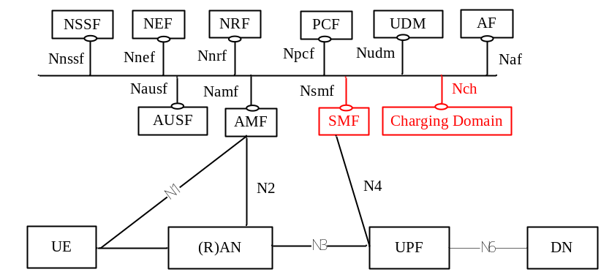
Figure 5.7.4.1.1.1: The service interface from Charging Domain for SMF
Nch is the Service-based interface exhibited by Charging Domain.

5.7.4.1.2 Service identification
The following scenarios and basic operations should be supported by corresponding services:
Table 5.7.4.1.2.1: Offline Charging scenarios
Offline charging scenarios | Basic operations
Event based charging | Charging Data Request  Charging Data Response
Session based charging | Charging Data Request  Charging Data Response

Table 5.7.4.1.2.2: Online Charging scenarios
Online charging scenarios | Basic operations
Immediate Event Charging | Debit Units Request  Debit Units Response
Event charging with Unit Reservation | Reserve Units Request  Reserve Units Response  Debit Units Request  Debit Units Response
Session charging with Unit Reservation | Reserve Units Request  Reserve Units Response  Debit Units Request  Debit Units Response
Re-authorization

The following capability from the charging server to terminate the PDU session should be supported by corresponding services:
- Termination action

5.7.4.2 Solution#7.2: Reference point representation for SMF and Charging Domain
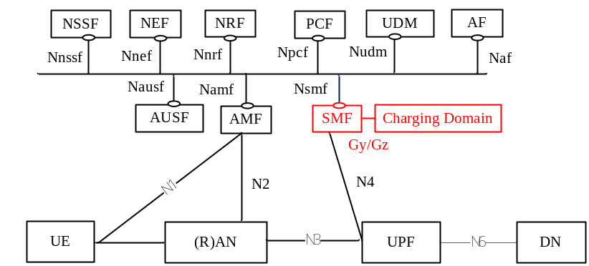
Figure 5.7.4.2.1: Reference point from Charging Domain for SMF
The interaction between the SMF and Charging Domain is Gy/Gz interface.

5.7.4.3 Solution#7.3: Service interface for SMF and Charging Domain
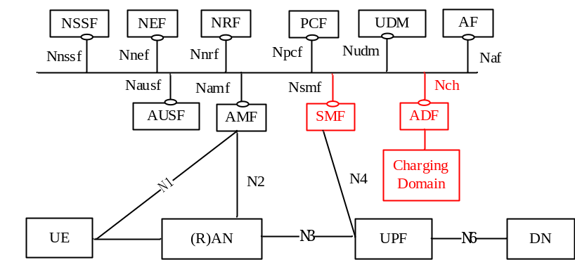
Figure 5.7.4.3.1: Basing the service interface from Charging Domain on the ADF
Nch is the Service-based interface exhibited by Charging Domain. In this case, instead of the Charging Domain exposing services required by a Charging Triggering Functions (CTF) it would expose services provided by Account Data Forwarding (ADF) function. This will allow the Charging Domain to receive reports or collected metrics from other functions that only have an Accounting Metrics Collection (AMC) function and that do not have a CTF.

5.7.4.4 Solution evaluation
Solution#7.1solves Key issue #7.1( The service interface for Charging Domain);
Solution#7.2 solves Key issue #7.1(The diameter interface for Charging Domain);
Solution#7.3 solves Key issue #7.1(The service interface for Charging Domain).
The following table 5.7.4.4.1 provide the benefits and drawback analysis for solutions of SBA.
Table 5.7.4.4.1: Solution Evaluation for SBI
Options | benefits | drawback
Solution 7.1 Service interface for SMF and Charging Domain | Unified interface for SMF  Benefit for the support of Industry services charging, e.g network slicing | New concept to realize
Solution 7.2 Gy/Gz for SMF and Charging Domain | Leverage from the existing solution | Current complex mechanism on Diameter protocol implementation.  Support the two protocols in NFs of 5GS, e.g SMF  Low Reusability, dedicated interface for the interaction between NFs and Charging System  Lack of deployment flexibility, especially for the Network orchestration of slicing
Solution 7.3 Service interface for SMF and Charging Domain (ADF) | Unified interface for SMF  Benefit for the support of Industry services charging, e.g network slicing | New concept to realize

5.7.5 Conclusions
The solution #7.1 is preferred solution which should include the backward compatibility consideration.

5.8 Interworking between 5G System and existing systems

5.8.1 Description and assumptions
In order to interwork with existing system EPC, the N26 interface is introduced as an inter-CN interface between the MME and 5GS AMF in order to enable interworking between EPC and the NG core. PCF + PCRF, PGW-C + SMF and UPF + PGW-U are dedicated for interworking between 5GS and EPC, which are optional and are based on UE and network capabilities in the clause 4.3 TS 23.501 [201].

5.8.2 Potential requirements
The following requirements may be considered:
- Online and offline charging.
- Session based charging.
- Volume, time, combined volume and time, and event based charging.
- Online charging session continuity.

5.8.3 Key issues

5.8.3.1 Key issue #8.1: <Charging for 5GS to EPS handover>
This key issue is for investigating on how to support the Charging for 5GS to EPS handover using N26 interface. This investigation covers the following:
- determination of which entity/entities in the 5G architecture is suitable to host the CTF(s);
- identification of the main interactions with the charging domain;
- charging information collection and correlation cause by the handover;
- determination of the charging session change handover from the 5G to EPS;
- the quota management and reporting mechanism caused by the handover.

5.8.3.2 Key issue #8.2: <Charging for EPS to 5GS handover>
This key issue is for investigating on how to support the Charging for EPS to 5GS handover using N26 interface. This investigation covers the following:
- determination of which entity/entities in the 5G architecture is suitable to host the CTF(s);
- identification of the main interactions with the charging domain;
- charging information collection and correlation cause by the handover;
- determination of the charging session change handover from EPS to 5G;
- the quota management and reporting mechanism caused by the handover.

5.8.4 Solutions

5.8.4.1 Solution#8.1: 5GS to EPS handover using N26 interface
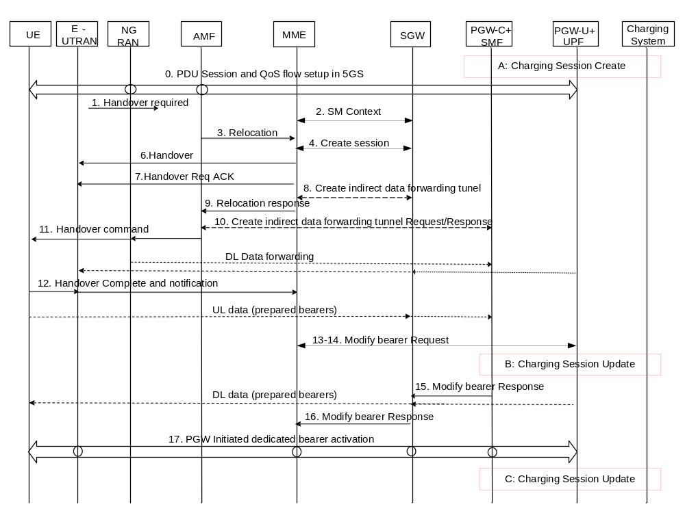
Figure 5.8.4.1.1: Charging procedure for 5GS to EPS handover
- Charging session create for PDU session.
1. 5G RAN decides that the UE should be handed over to the E-UTRAN.
2. The AMF requests the PGW-C+SMF to provide SM Context.
3. The AMF selects an MME and sends a Relocation Request for selecting a new SGW.
4. The MME selects the Serving GW and sends a Create Session Request message for each PDN connection to the Serving GW.
5. The Serving GW allocates its local resources and returns them in a Create Session Response message to the MME.
6. The MME requests the target eNodeB to establish the bearer(s) by sending the message Handover Request message.
7. The target eNB allocates the requested resources.
8. If the MME decides that indirect forwarding applies, it sends a Create Indirect Data Forwarding Tunnel Request message to the Serving GW.
9. The MME sends the message Relocation Response.
10. If indirect forwarding applies, the AMF forwards to the PGW-C+SMF the information related to data forwarding to the SGW. The PGW-C+SMF returns a Create Indirect Data Forwarding Tunnel Response.
11. The AMF sends the Handover Command to the source 5G RAN.
12. When the UE has successfully accessed the target eNodeB.
13. The target MME informs the Serving GW that the MME is responsible for all the bearers the UE have established.
14-15. The Serving GW informs the PGW-C+SMF of the relocation for each PDN connection.
B. Update the Charging session caused by handover. 16. The Serving GW acknowledges the User Plane switch to the MME.
17. The PGW-C+SMF initiates dedicated bearer activation procedure for non-GBR QoS flows.
C. The interaction with the charging system caused by the dedicated bearer.
In which step(s) of the scenario the PGW-C+SMF needs to interact with the charging domain will be determined during the normative phase.

5.8.4.2 Solution#8.2: EPS to 5G handover using N26 interface
N26 interface is used to provide seamless session continuity for single registration mode. Figure 5.8.4.2.1 and Figure 5.8.4.2.2 describes the charging procedure for handover from EPS to 5GS when N26 is supported, based on the Figure 4.11.2.2.2-1 and Figure 4.11.2.2.3-1 specified in TS 23.502 [202].
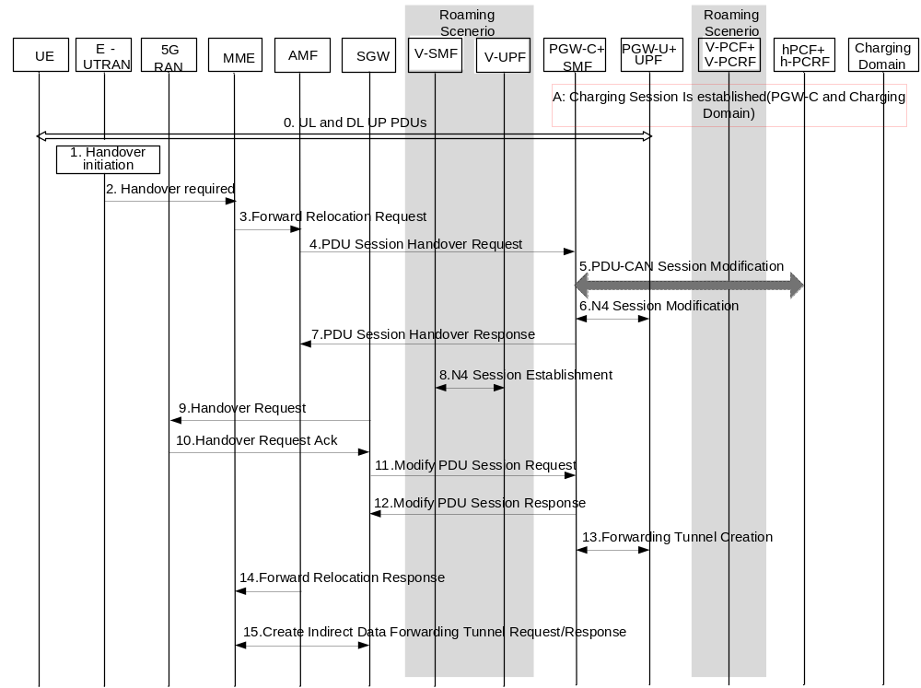
Figure 5.8.4.2.1: Charging procedure for EPS to 5G handover (Preparation phase)
A. Charging session is established for UL and DL UP PDUs.
1. The source E-UTRAN decides that the UE should be handed over to the NG-RAN.
2. The E-UTRAN sends a Handover Required to the MME.
3. The MME selects the target AMF and sends a Forward Relocation Request to the selected AMF.
4. The AMF sends a PDU Handover Request to the selected SMF.
5. If dynamic PCC is deployed, the SMF may initiate PDU Session Modification towards the h-PCF + h-PCRF to obtain the 5GS PCC Rules for the PDU Session.
6. The SMF+PGW-C modifies the PGW-U+UPF.
7. The SMF + PGW-C sends a PDU Session Modification Response to the AMF.
8. For home-routed roaming scenario only: The v-SMF selects a v-UPF and initiates an N4 Session Establishment procedure with the selected v-UPF.
9. The AMF sends a Handover Request to the NG-RAN.
10. The NG-RAN sends a Handover Request Acknowledge to the AMF.
11. The AMF sends an Modify PDU Session Request to the SMF for updating N3 tunnel information.
12. SMF+PGW-C to AMF: Modify PDU Response.
13. If indirect forwarding applies, the MME sends the Create Indirect Data Forwarding Tunnel Request/Response.
14. The AMF sends the message Forward Relocation Response.
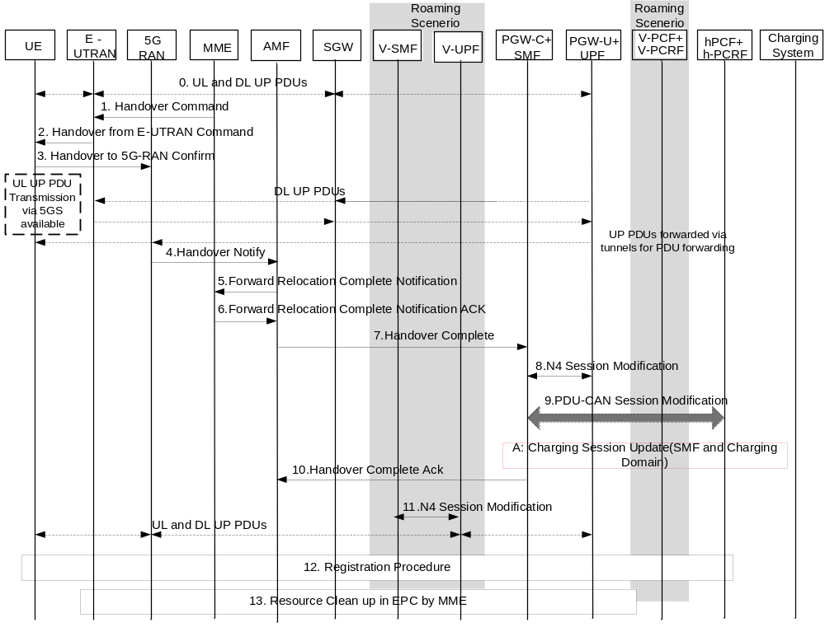
Figure 5.8.4.2.2: Charging procedure for EPS to 5G handover (Execution phase)
1. The MME sends a Handover Command to the E-UTRAN.
2. Towards the UE, the E-UTRAN commands handover to the NG-RAN.
3. Handover Confirm: the UE confirms handover to the NG-RAN.
4. Handover Notify: the NG-RAN notifies to the AMF that the UE is handed over to the NG-RAN.
5. Then the AMF knows that the UE has arrived to the target side and informs the MME by sending a Forward Relocation Complete Notification message.
6. The MME responds with a Forward Relocation Complete Notification Ack message.
7. AMF to PGW-C+SMF: Handover Complete (PDU Session ID).
8. The SMF + PGW-C updates the UPF + PGW-U with the V-CN Tunnel Info.
9. If PCC infrastructure is used, the SMF + PGW-C informs the h-PCF + h-PCRF about the change of, for example, the RAT type and the 5GS PCC Rules (created in step 6 of the preparation phase) should become active from this point.
A. Charging session is updated for the handover.
10. PGW-C+SMF to AMF: Handover Complete Ack (PDU Session ID).
11. For home-routed roaming scenario: The v-SMF provides to the v-UPF with the N3 DL Tunnel Info and the N9 UL Tunnel Info.
12. The UE registers in the target 5GS with "mobility registration update".
13. Resources in the source system and resources for PDU forwarding are released by the MME.
In which step(s) of the scenario the PGW-C+SMF needs to interact with the charging domain will be determined during the normative phase.

5.8.5 Evaluation and conclusion

5.8.5.1 Solution Evaluation
Solution#8.1 for key issue #8.1 for the charging of 5GS to EPS handover.
Solution #8.2 for key issue #8.2 for the charging of EPS to 5GS handover.

5.8.5.2 Conclusions
Interaction between the SMF/PGW-C and charging domain is using the same architecture as for interaction between SMF and the charging architecture.

5.9 Online and offline charging evaluation

5.9.1 Description and assumption

5.9.1.1 Existing functionalities
Offline charging functionality is specified in TS 32.240 [1] clause 4.1.1, and Online charging functionality in clause 4.1.2.
Both include resource usage collection mechanisms, with the difference that online charging can affect, in real-time, the service rendered (and also authorization is granted prior to resource usage), whereas offline charging cannot.
For each domain, they are specified separately for online and offline: charging information and chargeable event are not necessarily identical, less set of Nodes for online than for offline.
Offline charging is supported by Rf reference point, and online charging by Ro reference point, and the main differences between these 2 reference points are:
- Architecture: Rf from CTF to CDF, Ro from CTF to OCF (and further internal interactions with ABMF/RF).
- Both support "session" and "event" based scenario, but there are more scenario for Ro in "event" based (IEC and ECUR).
- Mechanism to support direct interaction with the control of network resource usage (prior to or during the session) specific to online.
- Quota management for online.
Rf and Ro are both specified as Diameter applications on top of the same Diameter Base protocol: Rf is based on IETF RFC 6733 [401], and Ro on IETF RFC 4006 [402].
In PS domain TS 32.251 [11], any EPC Nodes specified with online charging capability are specified with offline charging capability as well, they can both be activated.
According to TS 32.251 [11], a "tight interworking between online and offline charging mechanism i.e. only the specified quota re-authorisation triggers armed by OCS (including e.g. tariff time change, returned quotas, etc.) are used to close the service data flow containers " is specified for Nodes where both online and offline are activated.

5.9.1.2 Considerations for 5G
When both online (Ro) and offline (Rf) are activated, this implies two parallel sessions are active simultaneously from Network elements, although a set of common functionalities are invoked, and common charging information are used.
This topic is to evaluate a new CTF combining both online and offline charging functionalities and interfacing the charging domain via a single reference point, applicable to entity/entities in the 5G architecture which will be selected as suitable to host the CTF.
This topic addresses subscriber charging in HPLMN for both roaming and non roaming scenario.

5.9.2 Potential requirements
The following should be supported:
- Combined online and offline charging.
- Offline charging only.
- Single reference point from a CTF in 5G Architecture.

5.9.3 Key issues

5.9.3.1 Key issue #9.1: CDRs generation for online
This key issue is for investigating on how to support CDRs generation when online charging is activated.

5.9.3.2 Key issue #9.2: Offline charging only
This key issue is for investigating on how to support Offline charging (CDRs generation) only (i.e. no online charging).

5.9.4 Solutions

5.9.4.1 Solution #9.1: Combined online and offline charging

5.9.4.1.1 Architecture description
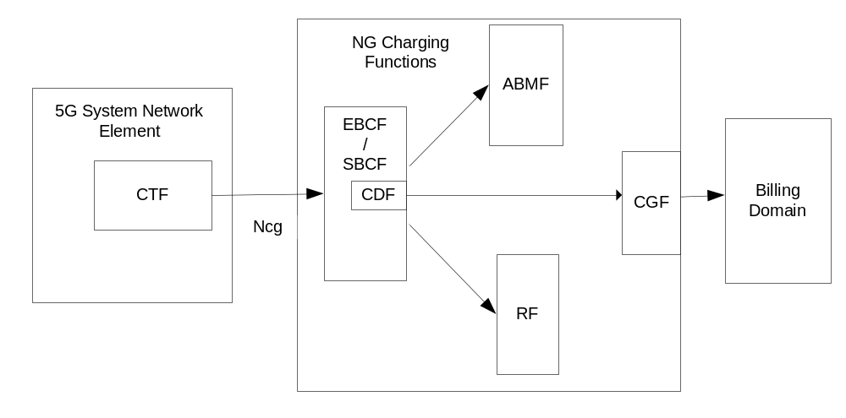
Figure 5.9.4.1.1.1: Combined online and offline Charging architecture
Ncg reference point similar as Ro and Rf reference points as per TS 32.240 [1] clause 4.4.2.1 and 4.4.1.1, with enhancement to also address CDRs generation for the Billing Domain.

5.9.4.1.2 Procedures description
In this solution, the commands, chargeable events, and charging information are specified commonly for online and offline charging for subscribers, and CDRs are constructed by EBCF/SBCF employing the CDF, based on charging events received over Ncg, and also additional internal information resulting from potential EBCF/SBCF interaction with RF, ABMF.
Both online and offline charging can be activated for the different service data flows in the same PDU session.
The existing "CDR generation for online charged subscribers" capability as per TS 32.240 [1] clause 4.3.2.3 is used: the CDF is employed by the OCF to construct CDRs.
The CDRs content is specified at similar level as for EPC CDRs, the internal information resulting from EBCF/SBCF interaction with RF, ABMF remain non-specified.
"Offline only" specified in Key issue#9.2 mode is supported through requests from the SMF to the Charging server without quota management.

5.9.4.1.3 Solution evaluation.
This solution allows support of a single interface to the Charging server for all the subscribers, whether they need to be served by online charging, or whether they need to be served by "offline only" charging, or whether both online and offline charging are activated.
This solution solves Key issue #9.1 and Key issue #9.2.
The benefits of this solution are:
- CDRs generated for subscribers in "offline only" have similar format as CDRs generated for subscribers in "online".
- quota management is avoided when "offline only" mode.
The drawback of this solution is the deviation from existing Ro/Rf specified for EPC (i.e. Gy/Gz), and also from generic Ro/Rf (applicable to all domains) online/offline charging TS 32.299 [50] functionalities.

5.9.4.2 Solution #9.2: Partial combined online and offline charging

5.9.4.2.1 Architecture description
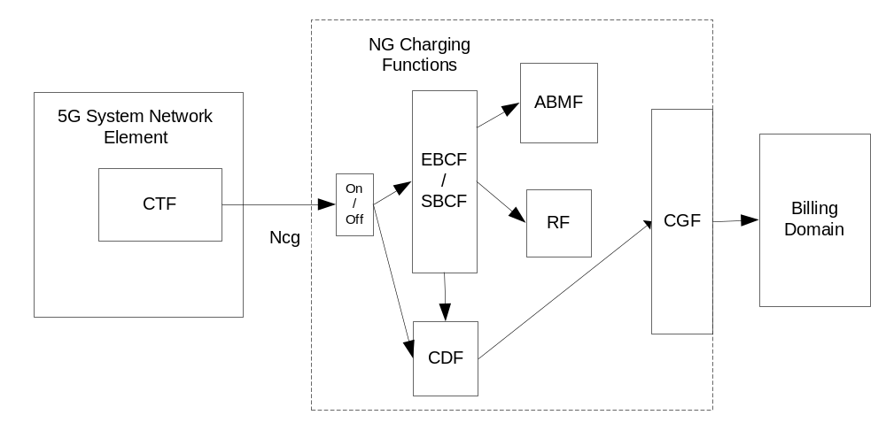
Figure 5.9.4.2.1.1: Partial Combined online and offline charging architecture
Ncg reference point includes both Ro and Rf reference points functionalities as per TS 32.240 [1] clauses 4.4.2.1 and 4.4.1.1 respectively.
At the session start, the CTF selects which of online functionality and offline functionality to apply for the lifetime of the session.

5.9.4.2.2 Procedures description
In this solution, a set of chargeable events, and charging information are specified for online charging and offline charging for subscribers: part of them are common between offline and online, and some are specific to online or specific to offline. Online is based on Ro and offline based on Rf.
The CTF indicates when starting a charging session which mode is used: offline (i.e. Rf) or online (i.e. Ro).
In offline mode, the CDRs are constructed similarly as for EPC CDRs by the CDF.
In online mode the CDRs are constructed similarly as in Solution #9.1, i.e. "CDR generation for online charged subscribers" capability as per TS 32.240 [1].
A common baseline CDRs format is defined for offline and online.

5.9.4.2.3 Solution evaluation.
This solution allows support of a single interface to the Charging server for all the subscribers served in online charging, i.e. Ro.
This solution allows support of a single interface to the Charging server for all the subscribers served in offline charging, i.e. Rf.
This solution solves Key issue #9.1 and Key issue #9.2.
The benefit of this solution is the re-use of generic Ro and Rf, and it also leverages from Ro/Rf as specified today for EPC.
The drawback for this solution is when "online mode" only, the "offline mode" cannot run simultaneously for the same session.

5.9.4.3 Solution #9.3: Online charging with unlimited quota for offline

5.9.4.3.1 Architecture description
Same architecture as per clause 5.9.4.1.1.
Ncg reference point is equivalent to Ro reference point as per TS 32.240 [1] clause 4.4.2.1.

5.9.4.3.2 Procedures description
In this solution, the commands, chargeable events, and charging information are specified as for online charging only, and CDRs are constructed as per existing "CDR generation for online charged subscribers" capability TS 32.240 [1] clause 4.3.2.3.
The CDRs content is specified at similar level as for EPC CDRs, the internal information resulting from potential EBCF/SBCF interaction with RF, ABMF remain non-specified.
The offline charging mode is handled as per online charging with unlimited quota.

5.9.4.3.3 Solution evaluation.
This solution allows support of a single interface to the Charging server for all the subscribers, whether they need to be served by online charging, or whether they need to be "offline only" charging.
This solution solves Key issue #9.1 and Key issue #9.2
The benefit of this solution is re-use of Ro and leverage on how it is specified today for EPC.
The drawback of this solution is the complexity introduced when "offline only" mode is needed, due to the use of quota management, and missing functionalities from Rf.

5.9.5 Overall evaluation and conclusion.

5.9.5.1 Overall evaluation
The 3 solutions #9.1, #9.2, and #9.3, solve both Key issue #9.1 and Key issue #9.2.
Table 5.9.5.1:Solutions evaluation for Online and offline charging
Aspect | Solution #9.1 | Solution #9.2 | Solution #9.3
Support of online and offline charging scenario | Yes | Cannot support the concurrent online and offline charging in same PDU Session | Yes
Complexity of implementation in SMF | Medium | Medium | Low
Complexity of implementation in charging server | Medium | Low | High  Support of specific processing for unlimited quota management for offline charging which is different the traditional quota management.
Leverage from existing EPC Ro/Rf | No | Yes | Yes
Allow consistent and synchronized reporting between online and offline | Yes | No | Yes

Solutions #9.2 and #9.3 have the benefit to leverage from existing EPC Ro/Rf, however:
- solution #9.2 does not address "Combined online and offline charging" clause 5.9.2 potential requirement.
- solutions #9.3 is artificial use of quota management to address CDRs generation.
Solution #9.1 benefits from a new unified reference point and CDR format, combining Ro/Rf functionalities for 5G System.

5.9.5.2 Conclusion
It is concluded on solution #9.1 for the combined online and offline solution.
This conclusion is dependent on the conclusion of clause 5.7 Service-based Architecture.
The combined online and offline charging includes the OCF, RF, ABMF, CDF and CGF.
The solution #9.3 is ffs.

5.10 Connection, registration and mobility management

5.10.1 Description and assumptions
The registration procedure is specified in TS 23.502 [202] clause 4.2.2.

5.10.2 Potential requirements
None.

5.10.3 Key issues
None.

5.10.4 Solutions

5.10.4.1 Solution#10.1: No charging for registration

5.10.4.1.1 Architecture description
The same architecture as per clause 5.3.4.2.1 applies.

5.10.4.1.2 Procedure description
The Registration procedure is used when the UE needs to perform:
- initial registration to the 5G system;
- mobility registration update upon changing to a new Tracking area (TA) outside the UE's registration area in idle mode;
- when the UE performs a periodic registration update (due to a predefined time period of inactivity);
- and additionally, when the UE needs to update its capabilities or protocol parameters that are negotiated in Registration procedure.
For more information on the registration procedure see TS 23.502 [202] clause 4.2.2.
A UE needs to register with the network to get authorised to receive services, to enable mobility tracking and to enable reachability. Even if there is an authorization of services there will not be any accounting or charging since this does not provide any specific service only the availability.

5.10.4.1.3 Solution evaluation.
This solution describes that no charging information will be generated for registration. There is currently no requirement to have any charging done for the registration and therefore generation of charging information is redundant.
The drawback of this solution is that there will be no record of the registration.

5.10.4 Conclusion
For the Connection, Registration and Mobility Management the solution #10.1 would suffice at as first step, and if there are more support needed this could be added at a later step.

6. Conclusions and recommendations

6.1 Conclusions
It is concluded on:
- Session management and service continuity: solutions as per clause 5.1.5.3 conclusion;
- QoS: solutions as per clause 5.2.5 conclusion;
- Interaction between SMF and UPF: solutions as per clause 5.3.5.2 conclusions;
- Network Slicing: solutions as per clause 5.4.5 conclusion;
- Roaming: Home Routed as per 5.6.5 conclusion;
- Service-based Architecture: as per 5.7.5 conclusion;
- Interworking between 5G System and Existing Systems: as per 5.8.5 conclusion;
- Online and offline charging evaluation: as per 5.9.5 conclusion.

6.2 Recommendations
The following are for further study:
- QoS: per clause 5.9.5 conclusion, Aggregative QoS flow based charging for 5QI;
- Network Slicing: per clause 5.4.5 conclusion:
- solutions for key issues #4.2;
- different options of Solution#4.1;
- solution #4.2;
- Network Capability Exposure: per clause 5.5.5.2 conclusion;
- Roaming LBO as per 5.6.5 conclusion;
- Connection, Registration and Mobility Management: as per clause 5.10.5 conclusion.

Annex A:
Change history
Change history
Date | Meeting | TDoc | CR | Rev | Cat | Subject/Comment | New version
2017-12 | SA#78 | SP-170976 |  |  |  | Presented for approval | 2.0.0
2018-01 |  |  |  |  |  | Change control version | 15.0.0
2018-03 | SA#79 | SP-180066 | 0001 | 1 | D | Correction on the format of TR 32.899 | 15.1.0

