Invitation to 3GPP SA5#111-Bis
February 13 - 17, 2017
Munich, Germany

Dear Colleagues,

On behalf of Huawei Technologies, we are pleased to invite you to the 3GPP SA5#111-Bis meeting in Munich, Germany.

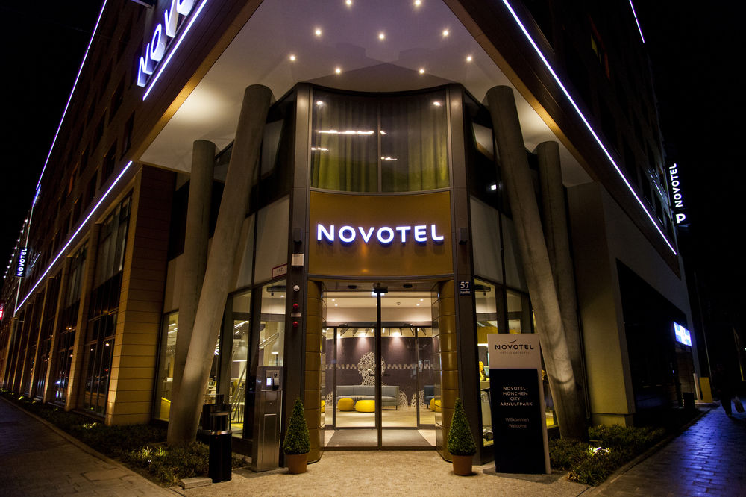

The meeting will be held at the Novotel München City Arnulfpark. A block of rooms has been reserved under the code HUA120217. The group rate is 123 Euros per night. Delegates are responsible for their own hotel reservations. Please fill out Appendix B and send the completed form to the host by email before the cutoff date, 13 January 2017 (Note that reservation beyond this point may be more expensive and subject to availability).

In addition to hotel reservation, it is important to perform the online meeting registration at SA5#111-Bis before 13 January 2017. This provides the meeting planner better vision to the meeting organization. Please be sure to print your name badge prior to the meeting. Name badges will no longer be provided at meetings.

Should you require a letter of invitation for your business visa application, please contact the host. Your email should attach Appendix A filled with all necessary information and be sent out before 13 January 2017.

More detailed information on the meeting itself will be found in the corresponding official documents. General information is provided in the following page.

We are looking forward to seeing you in Munich, Germany.

Sincerely yours,

Christian Toche
On behalf of Huawei Technologies

General Information

Meeting & Location & Date:
SA5#111-Bis, Munich, 13-17 February 2017

Contact from the host:
Ms. Wei Zhao
Tel: +49-89-1588344852
Email: wei.zhao2@huawei.com

Hotel Information:
Novotel München City Arnulfpark
Address: Arnulfstrasse 57 · 80636 Munich · Germany
Tel: +49(0)89 242078 165
Fax: +49(0)89 242078150
Website: http://www.novotel.com/gb/hotel-8866-novotel-muenchen-arnulfpark-open-since-september-2015/index.shtml

Wireless LAN:
This will be a paperless meeting.
MCC will provide and administer WLAN during the meeting.

Have a great meeting and enjoy your stay in Munich!
Appendix A

3GPP SA5#111-Bis

February 13-17, 2017
Munich, Germany

INVITATION LETTER REQUEST FORM

To enter Germany for the meeting indicated above, you may need a letter of invitation from the host. In order to obtain the invitation letter, please:

- fill out the form below;
- a copy of your passport (name, date of birth, nationality, passport number, validity date of passport, etc. must be seen clearly; to ensure readability, a scanned photograph page is preferred.);
- send all of the above to sa5_ah@huawei.com before 13 January 2017.

NOTE: please send your application form in WORD file.

Full name of Company
Surname |  | Given name
Gender | □ Male □ Female
Birthday (YYYY-MM-DD) |  | Nationality
Tel No. |  | Job Title
Passport No. |  | Place of Issue Passport
Expired Date of Passport (YYYY-MM-DD)
Destination Country/Area & City/ Places to visit after entry (In this case, it is Munich by default; if you want to visit other places than Munich, please indicate here)
Country |  | City
Visa Issued Country/Area & City (If the country in which you'll obtain your visa is different from your nationality, please indicate it here:[ Country to obtain your visa])
Country |  | City
Duration (YYYY-MM-DD)
From |  | To
Purpose
Address
Fax No.
E-mail

End of form

(Please do not forget to attach a copy of your passport photograph page before sending.)

Appendix B
3GPP Hotel Reservation Form

Please email the completed form to Ms. Wei Zhao (wei.zhao2@huawei.com) before the cut-off date, 13 January 2017. Contact Ms. Wei Zhao (wei.zhao2@huawei.com) or hotel meeting manager Katrin Miehlisch (T +49(0)89 242078 165 ·Katrin.Miehlisch@accor.com) if you need any help during hotel reservation.

Guest Name | Arrival Date | Departure Date | Room preference  (Twin/King  Smoking/Non-smoking) | No. Of Rooms | Room Rate | Breakfast
 |  |  |  |  | EURO 123 net | Including 1 breakfast

Payment
By Guest Individual, Need to provide the credit card guarantee

Credit Card Type: VISA American Express Diners Master JCB
Credit Card Number: _____________________________________________________
Expiration Date: _________________________________________________________
Billing Address of Credit Card Holder: _______________________________________
_____________________________________
Credit card holder signature: _________________________________________________

Remarks
Cancel before 23 January 2017 to avoid the penalty charge.

