3GPP TS 32.412 V14.0.0 (2016-12)
Technical Specification

3rd Generation Partnership Project;
Technical Specification Group Services and System Aspects;
Telecommunication management;
Performance Management (PM)
Integration Reference Point (IRP):
Information Service (IS)
(Release 14)


The present document has been developed within the 3rd Generation Partnership Project (3GPP TM) and may be further elaborated for the purposes of 3GPP.
The present document has not been subject to any approval process by the 3GPP Organizational Partners and shall not be implemented.
This Specification is provided for future development work within 3GPP only. The Organizational Partners accept no liability for any use of this Specification.
Specifications and reports for implementation of the 3GPP TM system should be obtained via the 3GPP Organizational Partners' Publications Offices.

Keywords
GSM, UMTS, management, performance
3GPP
Postal address

3GPP support office address
650 Route des Lucioles - Sophia Antipolis
Valbonne - FRANCE
Tel.: +33 4 92 94 42 00 Fax: +33 4 93 65 47 16
Internet
http://www.3gpp.org
Copyright Notification
No part may be reproduced except as authorized by written permission.
The copyright and the foregoing restriction extend to reproduction in all media.

© 2016, 3GPP Organizational Partners (ARIB, ATIS, CCSA, ETSI, TSDSI, TTA, TTC).
All rights reserved.
UMTS™ is a Trade Mark of ETSI registered for the benefit of its members
3GPP™ is a Trade Mark of ETSI registered for the benefit of its Members and of the 3GPP Organizational Partners
LTE™ is a Trade Mark of ETSI registered for the benefit of its Members and of the 3GPP Organizational Partners
GSM® and the GSM logo are registered and owned by the GSM Association

Contents
Foreword 7
Introduction 7
1 Scope 8
2 References 8
3 Definitions and abbreviations 9
3.1 Definitions 9
3.2 Abbreviations 9
4 System Overview 10
4.1 System Context 10
4.2 Compliance rules 10
5 Void 10
6 Information Object Classes (IOCs) 11
6.1 Information entities imported and local labels 11
6.2 Class diagram 11
6.2.1 Attributes and relationships 11
6.2.2 Inheritance 14
6.3 Information Object Class (IOCs) definitions 15
6.3.1 MeasurementJob 15
6.3.1.1 Definition 15
6.3.1.2 Attributes 15
6.3.1.3 State diagram 16
6.3.2 JobMeasurementSchedule 17
6.3.2.1 Definition 17
6.3.2.2 Attributes 17
6.3.3 PMIRP 17
6.3.3.1 Definition 17
6.3.3.2 Attribute 17
6.3.3.3 Notification 17
6.3.4 MeasurementJobList 17
6.3.4.1 Definition 17
6.3.4.2 Attributes 17
6.3.5 MeasuredAttribute 18
6.3.5.1 Definition 18
6.3.5.2 Attributes 18
6.3.6 MeasurementReader 18
6.3.6.1 Definition 18
6.3.6.2 Attributes 18
6.3.7 ManagedEntity 18
6.3.7.1 Definition 18
6.3.8 Monitor 19
6.3.8.1 Definition 19
6.3.8.2 Attributes 19
6.3.8.3 Notification 19
6.3.9 ThresholdMonitorList 19
6.3.9.1 Definition 19
6.3.9.2 Attributes 19
6.3.10 ThresholdMonitor 20
6.3.10.1 Definition 20
6.3.10.2 Attribute 20
6.3.11 ThresholdLevel 20
6.3.11.1 Definition 20
6.3.11.2 Attribute 20
6.4 Information relationship definitions 21
6.4.1 relation-pmIRP-measurementJobList (M) 21
6.4.1.1 Definition 21
6.4.1.2 Role 21
6.4.1.3 Constraint 21
6.4.2 relation-measurementJobList-measurementJob (M) 21
6.4.2.1 Definition 21
6.4.2.2 Role 21
6.4.2.3 Constraint 21
6.4.3 relation-measurementJob-jobMeasurementSchedule (M) 21
6.4.3.1 Definition 21
6.4.3.2 Role 21
6.4.4 relation-measurementJob-measurement (M) 22
6.4.4.1 Definition 22
6.4.4.2 Role 22
6.4.5 relation-measuredAttribute-managedEntity (M) 22
6.4.5.1 Definition 22
6.4.5.2 Role 22
6.4.5.3 Constraint 22
6.4.6 relation-pmIRP-thresholdMonitorList (M) 23
6.4.6.1 Definition 23
6.4.6.2 Role 23
6.4.6.3 Constraint 23
6.4.7 relation-thresholdMonitorList-thresholdMonitor (M) 23
6.4.7.1 Definition 23
6.4.7.2 Role 23
6.4.7.3 Constraint 23
6.4.8 relation-thresholdMonitor-measurement (M) 23
6.4.8.1 Definition 23
6.4.8.2 Role 23
6.4.9 relation-measuredAttribute-thresholdLevels (M) 24
6.4.9.1 Definition 24
6.4.9.2 Role 24
6.4.9.3 Constraint 24
6.5 Information attribute definition 25
6.5.1 Definition and legal values 25
6.5.2 Constraints 27
7 Interface definition 28
7.1 Class diagram 28
7.2 Generic rules 29
7.3 PMIRPOperations_1 Interface (M) 29
7.3.1 Operation createMeasurementJob (M) 29
7.3.1.1 Definition 29
7.3.1.2 Input parameters 30
7.3.1.3 Output parameters 31
7.3.1.4 Pre-condition 31
7.3.1.5 Post-condition 31
7.3.1.6 Exceptions 32
7.3.2 Operation stopMeasurementJob (M) 33
7.3.2.1 Definition 33
7.3.2.2 Input parameters 33
7.3.2.3 Output parameters 33
7.3.2.4 Pre-condition 33
7.3.2.5 Post-condition 33
7.3.2.6 Exceptions 33
7.3.3 Operation suspendMeasurementJob (O) 34
7.3.3.1 Definition 34
7.3.3.2 Input parameters 34
7.3.3.3 Output parameters 34
7.3.3.4 Pre-condition 34
7.3.3.5 Post-condition 35
7.3.3.6 Exceptions 35
7.3.4 Operation resumeMeasurementJob (O) 36
7.3.4.1 Definition 36
7.3.4.2 Input parameters 36
7.3.4.3 Output parameters 36
7.3.4.4 Pre-condition 36
7.3.4.5 Post-condition 36
7.3.4.6 Exceptions 37
7.3.5 Operation listMeasurementJobs (M) 38
7.3.5.1 Definition 38
7.3.5.2 Input parameters 38
7.3.5.3 Output parameters 38
7.3.5.4 Pre-condition 38
7.3.5.5 Post-condition 38
7.3.5.6 Exceptions 39
7.4 PMIRPOperations_2 Interface (O) 39
7.4.1 Operation createThresholdMonitor (M) 39
7.4.1.1 Definition 39
7.4.1.2 Input parameters 40
7.4.1.3 Output parameters 40
7.4.1.4 Pre-condition 41
7.4.1.5 Post-condition 41
7.4.1.6 Exceptions 41
7.4.2 Operation deleteThresholdMonitor (M) 42
7.4.2.1 Definition 42
7.4.2.2 Input parameters 42
7.4.2.3 Output parameters 42
7.4.2.4 Pre-condition 42
7.4.2.5 Post-condition 42
7.4.2.6 Exceptions 42
7.4.3 Operation listThresholdMonitors (M) 43
7.4.3.1 Definition 43
7.4.3.2 Input parameters 43
7.4.3.3 Output parameters 43
7.4.3.4 Pre-condition 43
7.4.3.5 Post-condition 43
7.4.3.6 Exceptions 44
7.5 PMIRPOperations_3 Interface (O) 45
7.5.1 Operation suspendThresholdMonitor (M) 45
7.5.1.1 Definition 45
7.5.1.2 Input parameters 45
7.5.1.3 Output parameters 45
7.5.1.4 Pre-condition 45
7.5.1.5 Post-condition 45
7.5.1.6 Exceptions 45
7.5.2 Operation resumeThresholdMonitor (M) 46
7.5.2.1 Definition 46
7.5.2.2 Input parameters 46
7.5.2.3 Output parameters 46
7.5.2.4 Pre-condition 46
7.5.2.5 Post-condition 46
7.5.2.6 Exceptions 46
7.6 PMIRPNotification_1 Interface (M) 47
7.6.1 notifyMeasurementJobStatusChanged (M) 47
7.6.1.1 Definition 47
7.6.1.2 Input parameters 47
7.6.1.3 Triggering Event 47
7.6.1.3.1 From-state 47
7.6.1.3.2 To-state 48
7.6.2 Void 48
7.7 PMIRPNotification_2 Interface (O) 49
7.7.1 notifyThresholdMonitorObjectCreation (M) 49
7.7.1.1 Definition 49
7.7.1.2 Input Parameters 49
7.7.1.3 Triggering Event 49
7.7.1.3.1 From-state 49
7.7.1.3.2 To-state 49
7.7.2 notifyThresholdMonitorObjectDeletion (M) 50
7.7.2.1 Definition 50
7.7.2.2 Input Parameters 50
7.7.2.3 Triggering Event 50
7.7.2.3.1 From-state 50
7.7.2.3.2 To-state 50
7.7.3 notifyThresholdMonitorStatusChanged (O) 51
7.7.3.1 Definition 51
7.7.3.2 Input Parameters 51
7.7.3.3 Triggering Event 51
7.7.3.3.1 From-state 51
7.7.3.3.2 To-state 51
8 Scenarios 52
8.1 createMeasurementJob 52
8.2 stopMeasurementJob 53
8.3 stopMeasurementJob/listMeasurementJobs/listFiles 54
8.4 suspendMeasurementJob/resumeMeasurementJob 55
Annex A (normative): Illustration of the state described in the state Diagram 56
A.1 Definition of state 56
A.1.1 Scheduled 56
A.1.2 Suspended 56
A.1.3 Active 56
A.1.4 Stopped 56
A.2 State transition scenarios 57
A.2.1 Scenario 1 57
A.2.2 Scenario 2 57
A.2.3 Scenario 3 58
A.2.4 Scenario 4 58
A.2.5 Scenario 5 59
A.2.6 Scenario 6 60
Annex B (normative): Threshold related performance alarms Triggering Events 61
B.1 IRPAgent supporting notifyChangedAlarm 62
B.2 IRPAgent not supporting notifyChangedAlarm 63
B.3 Examples 64
B.3.1 Example 1 64
B.3.2 Example 2 65
B.3.3 Example 3 66
Annex C (informative): Change history 67

Foreword
This Technical Specification (TS) has been produced by the 3rd Generation Partnership Project (3GPP).
The contents of the present document are subject to continuing work within the TSG and may change following formal TSG approval. Should the TSG modify the contents of the present document, it will be re-released by the TSG with an identifying change of release date and an increase in version number as follows:
Version x.y.z
where:
x the first digit:
1 presented to TSG for information;
2 presented to TSG for approval;
3 or greater indicates TSG approved document under change control.
y the second digit is incremented for all changes of substance, i.e. technical enhancements, corrections, updates, etc.
z the third digit is incremented when editorial only changes have been incorporated in the document.

Introduction
The present document is part of a TS-family covering the 3rd Generation Partnership Project: Technical Specification Group Services and System Aspects; Telecommunication management, as identified below:
32.411: "Performance Management (PM) Integration Reference Point (IRP): Requirements"
32.412: "Performance Management (PM) Integration Reference Point (IRP): Information Service (IS)"
32.416: "Performance Management (PM) Integration Reference Point (IRP); Solution Set (SS) definitions"
The present document is part of a set of TSs which describes the requirements and information model necessary for the Telecommunication Management (TM) of 3G systems. The TM principles and TM architecture are specified in 3GPP TS 32.101 [1] and 3GPP TS 32.102 [2].
A 3G system is composed of a multitude of Network Elements (NE) of various types and, typically, different vendors, which inter-operate in a co-ordinated manner in order to satisfy the network users' communication requirements. Any evaluation of PLMN-system behaviour will require performance data collected and recorded by its NEs according to a schedule established by the EM.
This aspect of the management environment is termed Performance Management. The purpose of any Performance Management activity is to collect performance related data, which can be used to locate potential problems in the network.

1 Scope
The present document specifies the Information Service for the Performance Management Integration Reference Point (PM IRP) as it applies to the Itf-N.
This IRP IS defines the semantics of operations (and their parameters) visible across the Itf-N in a protocol and technology neutral way. It does not define the syntax or encoding of the operations and their parameters.
This IRP IS is aligned with ITU-T M.3704 [16] in terms of the definitions of operations for Performance management.

2 References
The following documents contain provisions which, through reference in this text, constitute provisions of the present document.
- References are either specific (identified by date of publication, edition number, version number, etc.) or non-specific.
- For a specific reference, subsequent revisions do not apply.
- For a non-specific reference, the latest version applies. In the case of a reference to a 3GPP document (including a GSM document), a non-specific reference implicitly refers to the latest version of that document in the same Release as the present document.
[1] 3GPP TS 32.101: "Telecommunication management; Principles and high level requirements".
[2] 3GPP TS 32.102: "Telecommunication management; Architecture".
[3] ITU-T Recommendation X.721 (1992): "Information technology - Open Systems Interconnection - Structure of management information: Definition of management information".
[4] 3GPP TS 32.111-2: "Telecommunication management; Fault management; Part 2: Alarm Integration Reference Point (IRP): Information Service (IS)".
[5] 3GPP TS 32.312: "Telecommunication management; Generic Integration Reference Point (IRP) management: Information Service (IS)".
[6] Void.
[7] 3GPP TS 32.401: "Telecommunication management; Performance Management (PM); Concept and Requirements".
[8] 3GPP TS 32.411: "Telecommunication management; Performance Management (PM) Integration Reference Point (IRP): Requirements".
[9] 3GPP TS 32.602: "Telecommunication management; Configuration Management (CM); Basic CM Integration Reference Point (IRP): Information Service (IS)".
[10] 3GPP TS 32.342: "Telecommunication management; File Transfer (FT) Integration Reference Point (IRP): Information Service (IS)".
[11] 3GPP TS 32.300: "Telecommunication management; Configuration Management (CM); Name convention for Managed Objects".
[12] 3GPP TS 32.302: "Telecommunication management; Configuration Management (CM); Notification Integration Reference Point (IRP): Information Service (IS)".
[13] Void.
[14] Void.
[15] 3GPP TS 32.150: "Telecommunication management; Integration Reference Point (IRP) Concept and definitions".
[16] ITU-T M.3704 (01/2012): “Telecommunication Management, Including TMN and Network Maintenance; Integrated services digital networks; Common management services – Performance management – Protocol neutral requirements and analysis”.
[17] 3GPP TS 32.404: "Telecommunication management; Performance Management (PM); Performance measurements; Definitions and template".

3 Definitions and abbreviations

3.1 Definitions
For the purposes of the present document, the terms and definitions defined in 3GPP TS 32.411 [8] and 3GPP TS 32.401 [7] apply.

3.2 Abbreviations
For the purposes of the present document, the following abbreviations apply:
CM Configuration Management
CORBA Common Object Request Broker Architecture
EM Element Manager
IOC Information Object Class
IRP Integration Reference Point
NE Network Element
NM Network Manager
NRM Network Resource Model
PM Performance Management
PMIRP Performance Management Integration Reference Point
UML Unified Modelling Language

4 System Overview

4.1 System Context
The general definition of the System Context for the present IRP is found in 3GPP TS 32.150 [15] subclause 4.7.
In addition, the set of related IRP(s) relevant to the present IRP is shown in the two diagrams below.
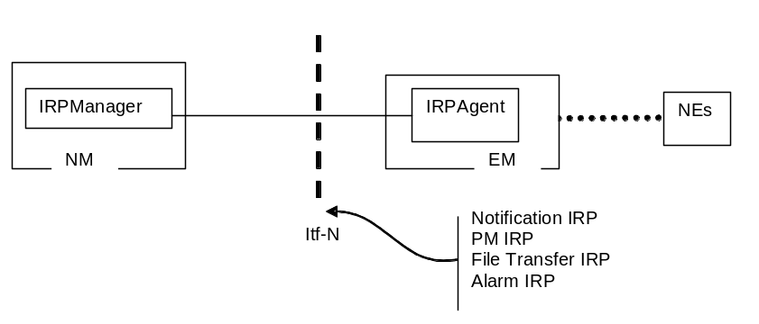
Figure 4.1: System Context A
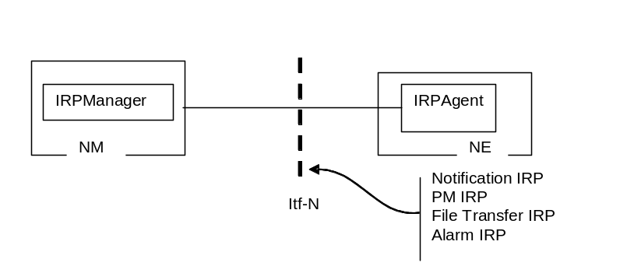
Figure 4.2: System Context B

4.2 Compliance rules
For general definitions of compliance rules related to qualifiers (Mandatory/Optional/Conditional) for operations, notifications and parameters (of operations and notifications) please refer to 3GPP TS 32.102 [2].

5 Void

6 Information Object Classes (IOCs)

6.1 Imported information entities and local labels
Label reference | Local label
3GPP TS 32.312 [5], information object class, ManagedGenericIRP | ManagedGenericIRP
3GPP TS 32.602 [9], information object class, ManagedEntity | ManagedEntity
3GPP TS 32.302 [12], information object class, NotificationIRP | NotificationIRP
3GPP TS 32.111-2 [4], information object class, AlarmIRP | AlarmIRP
3GPP TS 32.342 [10], information object class, FileTransferIRP | FileTransferIRP

6.2 Class diagram

6.2.1 Attributes and relationships
This clause introduces the set of Support Information Object Classes (Support IOCs) that encapsulate information within the IRPAgent. The intent is to identify the information required for the PMIRP Agent implementation of its operations and notification emission. This clause provides the overview of all Support IOCs in UML. Subsequent clauses provide more detailed specification of various aspects of these support object classes.
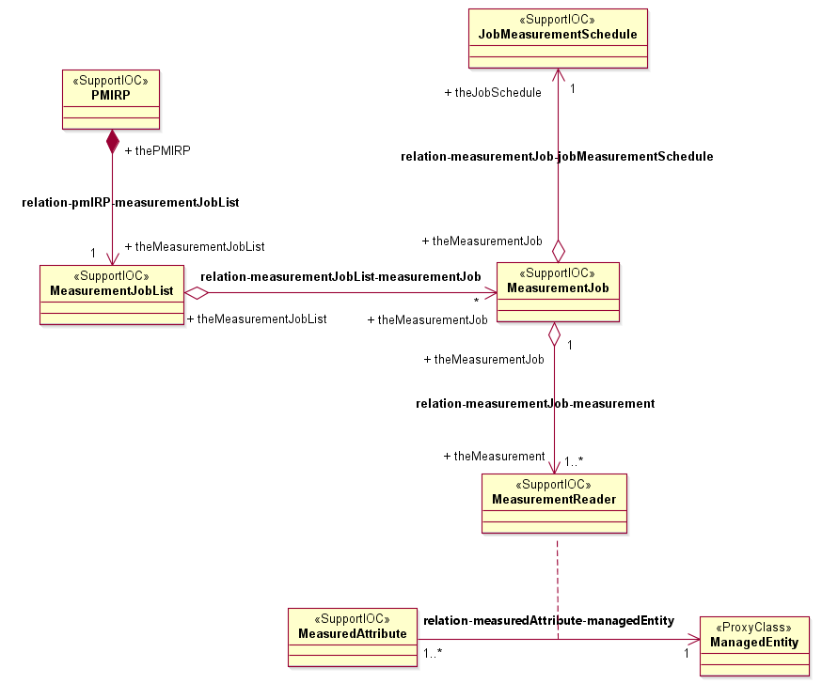
Figure 6.2.1(a): Information Object Class UML Diagram - Measurement
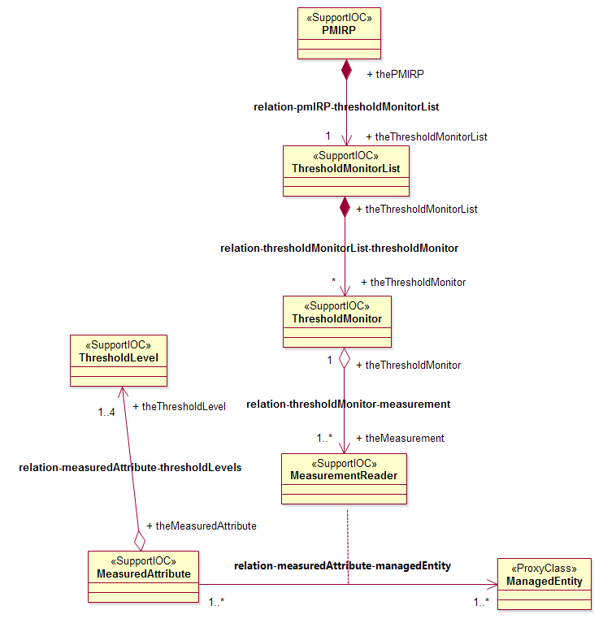
Figure 6.2.1(b): Information Object Class UML Diagram - Thresholding

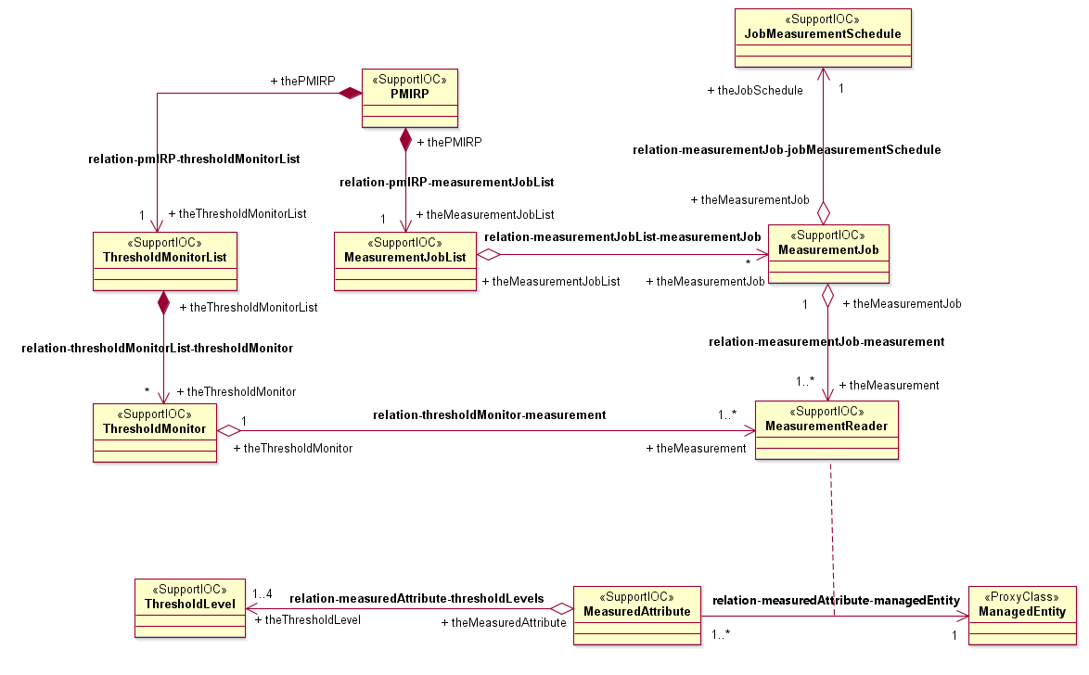
Figure 6.2.1(c): Information Object Class UML Diagram - Combined

6.2.2 Inheritance

This subclause depicts the inheritance relationships that exist between Support IOCs.
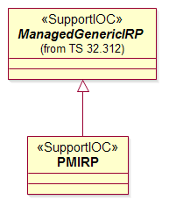
Figure 6.2.2: Information Object Class Inheritance UML Diagram

6.3 Information Object Class (IOCs) definitions

6.3.1 MeasurementJob

6.3.1.1 Definition
It represents a task that monitors and collects the performance measurement data, i.e. values of multiple measurementTypes of multiple ManagedEntity instances, at regular time intervals defined in JobMeasurementSchedule.
The target measurementTypes are those measurementTypes, whose names are in the related MeasuredAttribute. measurementTypeName, of the related ManagedEntity instances. The attributes of MeasurementJob, JobMeasurementSchedule and MeasuredAttribute can not be modified (except jobStatus) once a measurement job is created.
The MeasurementJob shall use its information and the information of the related JobMeasurementSchedule and the information of MeasuredAttribute(s) to perform measurement data collection during the MeasurementJob life-time. At the time of data collection, if MeasurementJob suspects the validity of the collected monitored values, the MeasurementJob should convey the fact to the IRPManager using the suspectFlag (3GPP TS 32.401 [7]) of the Report. The MeasurementJob will not emit any notification about this fact. Furthermore, the MeasurementJob shall continue to monitor the same target measurementTypes. Even in the worst possible case when the MeasurementJob cannot collect a single value from the target measurementTypes, the MeasurementJob must continue its activities according to the schedule created at MeasurementJob creation time.
The PMIRP Agent may decide to stop a MeasurementJob because of a PMIRP Agent internal problem or other problems such as in the case when the related managed resource is not accessible (e.g. uninstalled) or there exist a prolonged communication link problem between the PMIRP Agent and the related managed resource. In such case, the PMIRP Agent can stop the MeasurementJob resulting in the MeasurementJob.jobStatus == "Stopped". Additionally, " notifyMeasurementJobStatusChanged" notification shall be emitted to notify all subscribed IRPManagers about the stopping of a MeasurementJob.
The PMIRP Agent may also selectively suspend one or more MeasurementJobs without any operator’s action in case of overload. In such case, the PMIRP Agent suspends all the chosen MeasurementJob(s) resulting in the MeasurementJob.jobStatus == “Suspended” and emit “notifyMeasurementJobStatusChanged” notification for each MeasurementJob to notify all subscribed IRPManager(s) about the suspension. The behaviour on threshold monitors of PMIRP Agent after suspending is the same as the one after calling suspendMeasurementJob.
Then it should be possible, at any time, for the operator to resume a MeasurementJob suspended by the system. PMIRP agent may also resume the measurementJob by itself after detecting the end of the overload. When PMIRP Agent does not support the resumeMeasurementJob operation, PMIRP Agent shall resume the measurementJob automatically after detecting the end of overload. The behaviour of PMIRP Agent after resuming the measurementJob is the same as the one after calling resumeMeasurementJob. PMIRPAgent may suspend the corresponding measurementJob(s) when it can decide which one/ones cause(s) the overload; otherwise, PMIRP Agent can take jobPriority as a reference. The criterion for suspending one or another measurementJob of equal job priority is vendor specific.
The way to detect the beginning and the end of overload is out of the scope of the present document.

6.3.1.2 Attributes
Attribute name | Support Qualifier | Read Qualifier | Write Qualifier
jobId | M | M | -
jobGranularityPeriod | M | M | -
jobReportingPeriod | M | M | -
jobStatus | M | M | -
jobPriority | O | M | -
jobReliability | O | M | -

6.3.1.3 State diagram
Scheduled
Active
Stopped
Suspended
The measurement
job is visible via Itf-N
The measurement job is
visible via Itf-N and not
removed in IRPAgent
The measurement
job is removed in
IRPAgent
create
startTime reached
stopTime reached or
stopMeasurementJob or
stopped by system
stopMeasurementJob
or stopped by system
suspendMeasurementJob or suspended by system
suspendMeasurementJob
resumeMeasurementJob and
startTime not reached
resumeMeasurementJob
and startTime reached
stopTime reached or
stopMeasurementJob or
stopped by system

Figure 6.3.1.3.1: State Diagram for MeasurementJob
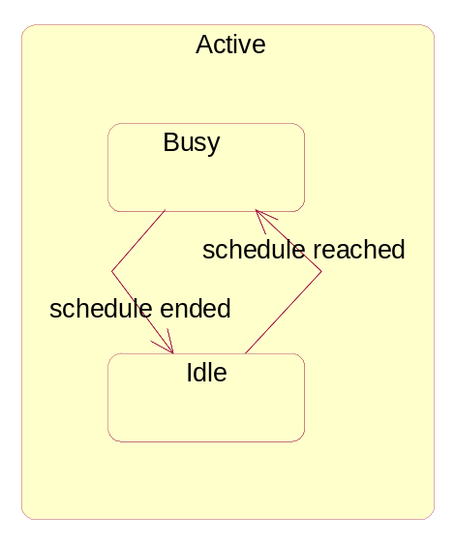
Figure 6.3.1.3.2: SubState Diagram of Active
The detailed description and state transition scenarios for MeasurementJob are in annex A.

6.3.2 JobMeasurementSchedule

6.3.2.1 Definition
JobMeasurementSchedule is the representation of the time intervals when the measurement job monitors and collects the performance measurement data. The attributes of JobMeasurementSchedule can not be modified once a measurement job is created.

6.3.2.2 Attributes
Attribute name | Support Qualifier | Read Qualifier | Write Qualifier
jobStartTime | M | M | -
jobStopTime | M | M | -
jobSchedule | M | M | -

6.3.3 PMIRP

6.3.3.1 Definition
PMIRP is the representation of the performance management capabilities specified by the present document. This Support IOC inherits from ManagedGenericIRP Support IOC specified in 3GPP TS 32.312 [5].

6.3.3.2 Attribute
There is no additional attribute defined for this Support IOC besides those inherited.

6.3.3.3 Notification
Name | Qualifier | Notes
notifyMeasurementJobStatusChanged | M | See clause 7.6.1.
notifyThresholdMonitorObjectCreation | M (see note) | See clause 7.7.1.
notifyThresholdMonitorObjectDeletion | M (see note) | See clause 7.7.2.
notifyThresholdMonitorStatusChanged | O (see note) | See clause 7.7.3.
NOTE: This notification is defined within the PMIRPNotification_2 Interface (see clause 7.7) which is qualified as optional.
If the Interface is supported, then the qualifier defined here is relevant.
Otherwise, the qualifier is irrelevant.

6.3.4 MeasurementJobList

6.3.4.1 Definition
MeasurementJobList is the representation of the list of MeasurementJobs.

6.3.4.2 Attributes
Attribute name | Support Qualifier | Read Qualifier | Write Qualifier
jobListId | M | M | -

6.3.5 MeasuredAttribute

6.3.5.1 Definition
It represents the name of the measurementType of the related ManagedEntity instance whose value is to be monitored and collected. The name of the monitored and collected measurementType is captured by measurementTypeName.

6.3.5.2 Attributes
Attribute name | Support Qualifier | Read Qualifier | Write Qualifier
measurementTypeName | M | M | -

6.3.6 MeasurementReader

6.3.6.1 Definition
It represents the capability to read the value of the measurementType of the related ManagedEntity instance.
The value of the monitored and collected measurementType is captured by measurementResultValue.

6.3.6.2 Attributes
Attribute name | Support Qualifier | Read Qualifier | Write Qualifier
measurementResultValue | M | M | -
probableCause | M | M | -
specificProblem | M | M | -
direction | M | M | -

6.3.7 ManagedEntity

6.3.7.1 Definition
The IOC ManagedEntity represents an IOC defined in Network Resources Models, e.g. Generic Network Resource Model, Core Network Resource Model, UTRAN Network Resource Model or GERAN Network Resource Model. It also can represent VSE subclass of 3GPP defined NRM IOCs or VSE defined NRM IOCs. Besides, it can also represent a “private Object Class” as defined in TS 32.404, e.g. RA. ManagedEntity is used in the specification of PMIRP operations to represent an IOC defined in these Network Resource Models and private Object Classes.

6.3.8 Monitor

6.3.8.1 Definition
It represents a capability to determine the (a) threshold-crossing or (b) threshold-reaching and the threshold-clearing. This class is abstract in that it cannot be instantiated. The ThresholdMonitor inherits this class.
It is the IRPAgent’s choice to support (a) or (b) (but not both). The support is on an IRPAgent system wide basis and is not on a per threshold basis. The IRPAgent’s behaviour regarding which approach (i.e., (a) or (b) above) to use, shall be the same for emitting alarms and for clearing alarms.
The instances of a class derived from this abstract class shall emit notifyThresholdMonitorObjectCreation when they are first created; and shall emit a notifyThresholdMonitorObjectDeletion when deleted.
The instances of a class derived from this abstract class shall also emit notifyNewAlarm, notifyChangedAlarm and notifyClearedAlarm according to the rules specified in Annex B: Threshold Alarm Triggering Events.
The objectClass and objectInstance parameter of these notifications carry the class and DN of the ManagedEntity whose measurementType is being monitored and whose threshold condition has been triggered. The eventType of these notifications carry "Quality of Service Alarm". See 3GPP TS 32.111-2 [4].

6.3.8.2 Attributes
Attribute name | Support Qualifier | Read Qualifier | Write Qualifier
monitorId | M | M | -
monitorGranularityPeriod | M | M | -

6.3.8.3 Notification
Notification name | Note
notifyThresholdMonitorCreation | See clause 7.1 (class diagram).
notifyThresholdMonitorDeletion | See clause 7.1 (class diagram).

6.3.9 ThresholdMonitorList

6.3.9.1 Definition
ThresholdMonitorList is the representation of the list of ThresholdMonitors.

6.3.9.2 Attributes
Attribute name | Support Qualifier | Read Qualifier | Write Qualifier
monitorListId | M | M | -

6.3.10 ThresholdMonitor

6.3.10.1 Definition
In order to monitor the overall health of the network, the thresholds are set by the authorized users to generate network performance related alarms. The ThresholdMonitor contains the values of the threshold settings for the PM parameters. If the threshold is (a) crossed or (b) reached (see 6.3.8.1 for clarification of the alternatives (a) and (b)), a performance alarm will be emitted (see 3GPP TS 32.401 [7]). The name of the monitored measurementType is captured by MeasuredAttribute.measurementTypeName and the value of it is captured by MeasurementReader.measurementResultValue.

6.3.10.2 Attribute
Attribute name | Support Qualifier | Read Qualifier | Write Qualifier
thresholdMonitorStatus | M | M | -

6.3.11 ThresholdLevel

6.3.11.1 Definition
It defines the thresholding criteria (via ThresholdLevel.thresholdValue and ThresholdLevel.hysteresis) for a measurementType. It also specifies the thresholdSeverity level (via ThresholdLevel.thresholdSeverity) carried in the alarm triggered by the (a) threshold crossing or (b) threshold reaching event. (See 6.3.8.1 for clarification of the alternatives (a) and (b)).

6.3.11.2 Attribute
Attribute name | Support Qualifier | Read Qualifier | Write Qualifier
thresholdValue | M | M | -
thresholdSeverity | M | M | -
hysteresis | M | M | -

6.4 Information relationship definitions

6.4.1 relation-pmIRP-measurementJobList (M)

6.4.1.1 Definition
This represents the relationship between PMIRP and MeasurementJobList.

6.4.1.2 Role
Name | Definition
theMeasurementJobList | It represents the MeasurementJobList.
thePMIRP | It represents the PMIRP.

6.4.1.3 Constraint
Name | Definition
uniqueJobListId | The jobListIds playing the role of theMeasurementJobList, are unique within a particular PMIRP.

6.4.2 relation-measurementJobList-measurementJob (M)

6.4.2.1 Definition
This represents the relationship between MeasurementJobList and MeasurementJob.

6.4.2.2 Role
Name | Definition
theMeasurementJob | It represents the MeasurementJob.
theMeasurementJobList | It represents the MeasurementJobList.

6.4.2.3 Constraint
Name | Definition
uniqueJobId | The jobIds of all MeasurementJobs, playing the role of theMeasurementJob, are unique within a particular PMIRP and MeasurementJobList.

6.4.3 relation-measurementJob-jobMeasurementSchedule (M)

6.4.3.1 Definition
This represents the relationship between MeasurementJob and JobMeasurementSchedule.

6.4.3.2 Role
Name | Definition
theJobSchedule | It represents the JobMeasurementSchedule.
theMeasurementJob | It represents the MeasurementJob.

6.4.4 relation-measurementJob-measurement (M)

6.4.4.1 Definition
This represents the relationship between MeasurementJob and MeasurementReader.

6.4.4.2 Role
Name | Definition
theMeasurement | It represents the MeasurementReader.
theMeasurementJob | It represents the MeasurementJob.

6.4.5 relation-measuredAttribute-managedEntity (M)

6.4.5.1 Definition
This represents the relationship between MeasuredAttribute and ManagedEntity.

6.4.5.2 Role
Name | Definition
theMeasuredAttribute | The MeasuredAttribute, when playing this role, reads the monitored measurement types of the related ManagedEntity instances. The names of measurement types are captured by the MeasuredAttribute.MeasurementTypeName . When playing this role, the MeasuredAttribute is aware of the class name and DN of the ManagedEntity.
theME | The ManagedEntity, when playing this role, represents the actual network resource instance under measurement or whose measurementTypes are being monitored for (a) threshold-crossing or (b) threshold-reaching and threshold-clearing. (See 6.3.8.1 for clarification of the alternatives (a) and (b))

6.4.5.3 Constraint
Name | Definition
applyToSameObjectClass | The MeasuredAttribute, which playing the role of "theMeasuredAttribute", can monitor the thresholds of the measurementTypes of one or multiple managed object instances of the same managed object class, which playing the role of "theME".

6.4.6 relation-pmIRP-thresholdMonitorList (M)

6.4.6.1 Definition
This represents the relationship between PMIRP and ThresholdMonitorList.

6.4.6.2 Role
Name | Definition
theThresholdMonitorList | It represents the ThresholdMonitorList.
thePMIRP | It represents the PMIRP.

6.4.6.3 Constraint
Name | Definition
uniqueMonitorListId | The monitorListIds playing the role of theThresholdMonitorList, are unique within a particular PMIRP.

6.4.7 relation-thresholdMonitorList-thresholdMonitor (M)

6.4.7.1 Definition
This represents the relationship between ThresholdMonitorList and ThresholdMonitor.

6.4.7.2 Role
Name | Definition
theThresholdMonitor | It represents the ThresholdMonitor.
theThresholdMonitorList | It represents the ThresholdMonitorList.

6.4.7.3 Constraint
Name | Definition
uniqueMonitorId | The monitorIds of all ThresholdMonitors, playing the role of theThresholdMonitor, are unique within a particular ThresholdMonitorList.

6.4.8 relation-thresholdMonitor-measurement (M)

6.4.8.1 Definition
This represents the relationship between ThresholdMonitor and MeasurementReader.

6.4.8.2 Role
Name | Definition
theMeasurement | It represents the MeasurementReader.
theThresholdMonitor | It represents the ThresholdMonitor.

6.4.9 relation-measuredAttribute-thresholdLevels (M)

6.4.9.1 Definition
This represents the relationship between MeasuredAttribute and ThresholdLevel.

6.4.9.2 Role
Name | Definition
theMeasuredAttribute | The MeasuredAttribute, when playing this role, can have 1..4 ThresholdLevel associates with it to set the (a) threshold-crossing or (b) threshold reaching and the clearing criteria (i.e. ThresholdLevel.thresholdValue, ThresholdLevel.hysteresis) and associated thresholdSeverity (i.e. ThresholdLevel.thresholdSeverity) of the monitored measurementType. (see 6.3.8.1 for clarification of the alternatives (a) and (b))
theThresholdLevel | When playing this role, the ThresholdLevel captures the (a) threshold-crossing or (b) threshold-reaching and the threshold-clearing criteria and its associated thresholdSeverity level. (see 6.3.8.1 for clarification of the alternatives (a) and (b))

6.4.9.3 Constraint
Name | Definition
noMoreThanFourLevels | A MeasuredAttribute may have no more than four ThresholdLevels associated with it.

6.5 Information attribute definition

6.5.1 Definition and legal values
Attribute Name | Definition | Legal Values
direction | For some measurementType, the higher its thresholdValue, the higher is the thresholdSeverity. For others, the lower its thresholdValue, the higher is its thresholdSeverity. This attribute identifies if the measurementType is of the former (i.e. "Increasing") or latter type (i.e. "Decreasing").  If it is "Increasing", the threshold event is triggered when the value first equals or exceeds (when compared against the last read value) a threshold value. The threshold is said to be cleared when the measurementType value falls below (when compared against the last read value) one or more threshold values.  If it is "Decreasing", the threshold event is triggered when the measurementType value first equals or falls below one or more threshold values. The threshold is said to be cleared when the measurementType value rises above the threshold value.  See annex B (Threshold Related Performance Alarm Triggering Events) for details of the behaviour of multiple thresholds. | Possible values are: "Increasing", "Decreasing"
hysteresis | A threshold has a value. It can have a hysteresis. A threshold with a hysteresis has a threshold-high and a threshold-low value that are different from the threshold value.  A hysteresis, therefore, defines the threshold-high and threshold-low levels within which the measurementType value is allowed to oscillate without triggering a (a) threshold-crossing or (b) threshold-reaching or a threshold-clearing condition. (See 6.3.8.1 for clarification of the alternatives (a) and (b))  threshold-high = threshold + hysteresis  threshold-low = threshold - hysteresis  See annex B (Threshold Related Performance Alarm Triggering Events). | Any positive value
jobGranularityPeriod | It specifies the period between two successive measurements. | The value can be 5 minutes, 15 minutes, 30 minutes, 1 hours, 12 hours and 24 hours.  The minimum granularity period is 5 minutes in most cases, but for some measurements it may only make sense to collect data in a larger granularity period.
jobId | It identifies the MeasurementJob instance (and distinguishes it from all other existing and stopped MeasurementJob instances of the PMIRP Agent). | Any identifier except:  - Those that identify MeasurementJob instances whose MeasurementJob.jobStatus(s)are Scheduled, Active, Suspended or Stopped; and  - Those that appear in filenames of files ready for IRPManager retrieval.
jobListId | It identifies the singleton MeasurementJobList of the PMIRP Agent. | Any identifier.
jobReportingPeriod | It specifies the period between two successive emissions of notifyFileReady or notifyFilePreparationError [10]. The two notifications are related to the same Job. See constraints reportTime in clause 6.5.2. | Its value should be one or multiple of jobGranularityPeriod.
jobSchedule | It specifies the detailed time frames during which the MeasurementJob.jobStatus = Active and its substate = Busy. | Its value is only one of the following, dailyScheduling or weeklyScheduling. The legal values for them refer to ITU-T Recommendation X.721 [3].  The legal values for them are as follows.  dailyScheduling:  {{ intervalStart {hour 0, minute 0},  intervalEnd {hour 23, minute 59}}}  weeklyScheduling:  {{ daysOfWeek '1111111'B,  intervalsOfDay dailyScheduling}}
jobStartTime | It specifies the begin time from which the MeasurementJob will be active. | All values that indicate valid timestamp.
jobStatus | It specifies the status of MeasurementJob. | Its value should be one of the following: Scheduled,  Active,  Suspended  Stopped
jobPriority | It specifies the priority of MeasurementJob | Its value should be one of the following:  Low,  Medium,  High
jobReliability | It specifies the reliability for a measurement job | Its value is vendor specific.
jobStopTime | It specifies the end time after which the MeasurementJob will be stopped. | All values that indicate valid timestamp and it should be later than jobStartTime.It's not necessary that jobStartTime and jobStopTime specifies time within the same day.  This attribute may carry the value "indefinitely".
measurementResultValue | It identifies the value of a measurement type. | Any valid measurement result value.
measurementTypeName | It identifies a name of one measurement type whose value is being collected and monitored. | Any valid measurement type name as defined by the measurement definition template in 3GPP TS 32.404 [17].
monitorGranularityPeriod | It specifies the period between two successive reading of the thresholdValue to determine (a) threshold-crossing or (b) threshold-reaching and threshold-clearing. (See 6.3.8.1 for clarification of the alternatives (a) and (b)) | It can be 5 minutes, 15 minutes, 30 minutes, 1 hour, 12 hours or 24 hours.  It has to be a multiple of the jobGranularityPeriod if the MeasurementJob monitoring the same measurementType exists.
monitorId | It identifies the ThresholdMonitor instance (and distinguishes it from all other existing ThresholdMonitor instances of the PMIRP Agent). | Any identifier except those that are currently used.
monitorListId | It identifies the singleton ThresholdMonitorList in the PMIRP Agent. | Any identifier.
probableCause | It identifies the probable cause (of the (a) threshold crossing or (b) threshold reaching) carried by the threshold crossing or reaching alarm. (See 6.3.8.1 for clarification of the alternatives (a) and (b)) | "Threshold Crossed"
thresholdSeverity | It identifies the thresholdSeverity of the (a) threshold crossing or (b) threshold reaching event. (See 6.3.8.1 for clarification of the alternatives (a) and (b)) | Warning, Minor, Major, Critical
specificProblem | It identifies the specific problem (causing the (a) threshold crossing or (b) threshold reaching) carried by the threshold crossing or reaching alarm. (See 6.3.8.1 for clarification of the alternatives (a) and (b)) | Any valid specificProblem as defined by 3GPP TS 32.111-2 [4].
thresholdMonitorStatus | It specifies the current status of the ThresholdMonitor. | Active - ThresholdMonitor is working;  Suspended - ThresholdMonitor is suspended.
thresholdValue | It defines the threshold value of the monitored measurementTypes. If the value is (a) crossed or (b) reached, the performance alarm shall be emitted depending on the value of the thresholdMonitorStatus. (See 6.3.8.1 for clarification of the alternatives (a) and (b)) | If the monitored measurementType is of Gauge type, this thresholdValue shall be of the same type.  If the monitored measurementType is of counter type, then this value should be expressed as a rate, i.e., the number of units of type of the monitored measurementType over unit of time.  Note this rate is independent from the monitorGranularityPeriod. This means that changes in the monitorGranularityPeriod should not impact the rate used for threshold monitoring.

6.5.2 Constraints
Name | Definition
firstReportTime | If the jobReportingPeriod is n times the jobGranularityPeriod, then the first report time shall be immediately after the completion of the n-th successful measurementType reading.
measurementTypeReadTimes | The measurementType reading times are determined by the following rules.  - If jobGranularityPeriod is 5 minutes, then read on every 5th minute of the hour.  - If jobGranularityPeriod is 15 minutes, then read on every 15th minute of the hour.  - If jobGranularityPeriod is 30 minutes, then read on every 30th minute of the hour  - If jobGranularityPeriod is 1 hour, then read on every hour of the day  - If jobGranularityPeriod is 12 hours, then the first read shall be as soon as possible on the hour and subsequent reads shall be at 12 hours interval.  - If jobGranularityPeriod is 24 hours, then the first read shall be as soon as possible on the hour and subsequent reads shall be at 24 hours interval.
multiLevelSeverity HysteresisOverlap | For each ThresholdLevel.thresholdSeverity, there may be a ThresholdLevel.hysteresis value corresponding to it. These multi-level values of ThresholdLevel.hysteresis, relating to one ThresholdMonitor, shall not overlap.
multiLevelSeverityOrder | The multiple ThresholdLevel(s), related to one ThresholdMonitor, shall be of the following order. If ThresholdLevel.thresholdSeverity of one instance is higher than that of the other instance and the direction is 'Increasing', then the ThresholdLevel.thresholdValue is higher than that of the other. If ThresholdLevel.thresholdSeverity of one instance is higher than that of the other instance and the direction is 'Decreasing', then the ThresholdLevel.thresholdValue is lower than that of the other.
numberOfThresholdLevelPerThresholdMonitor | In relation-tMonitor-tLevel, the multiplicity of theThresholdLevel is "1..4".  If PMIRP supports multi-level thresholdSeverity, then there are at most 4 ThresholdLevels relating to one ThresholdMonitor. All ThresholdLevel.thresholdSeverity instances shall hold a different value that is chosen from the following: 'Critical', 'Major', ‘Warning' and 'Minor'.  If PMIRP does not support multi-level thresholdSeverity, then there is only one ThresholdLevel relating to one ThresholdMonitor. The sole ThresholdLevel.thresholdSeverity shall hold one of the following: 'Critical', 'Major', ‘Warning' or 'Minor'.

7 Interface definition

7.1 Class diagram
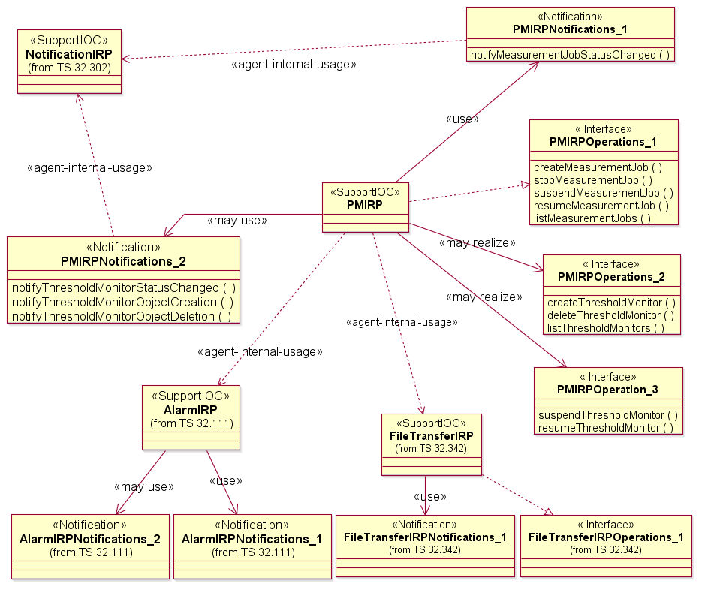
NOTE 1: PMIRPNotifications_2 is mandatory if PMIRPOperations_2 is supported.
NOTE 2: The suspendMeasurementJob and resumeMeasurementJob operations are optional.

Figure 7.1: Class Diagram

7.2 Generic rules
- Rule 1: each operation with at least one input parameter supports a pre-condition valid_input_parameter which indicates that all input parameters shall be valid with regards to their information type. Additionally, each such operation supports an exception operation_failed_invalid_input_parameter which is raised when pre-condition valid_input_parameter is false. The exception has the same entry and exit state.
- Rule 2: each operation with at least one optional input parameter supports a set of pre-conditions supported_optional_input_parameter_xxx where "xxx" is the name of the optional input parameter and the pre-condition indicates that the operation supports the named optional input parameter. Additionally, each such operation supports an exception operation_failed_unsupported_optional_input_parameter_xxx which is raised when (a) the pre-condition supported_optional_input_parameter_xxx is false and (b) the named optional input parameter is carrying information. The exception has the same entry and exit state.
- Rule 3: each operation shall support a generic exception operation_failed_internal_problem which is raised when an internal problem occurs and that the operation cannot be completed. The exception has the same entry and exit state.
NOTE: These rules are mapped at the solution set level. Pre-conditions and exceptions, generated by these rules, need not appear explicitly in the present document.

7.3 PMIRPOperations_1 Interface (M)

7.3.1 Operation createMeasurementJob (M)

7.3.1.1 Definition
This operation supports IRPManager's request to create a MeasurementJob through Itf-N.
Once created, the attributes of MeasurementJob (except MeasurementJob.jobStatus) and the related JobMeasurementSchedule and MeasuredAttribute will not be modified during the life-time of the MeasurementJob.
One MeasurementJob can collect the value of one or multiple measurementTypes.
When a measurementType is collected by one MeasurementJob for a given instance, another MeasurementJob which wants to collect the same measurementType for the same instance with different or the same jobGranularityPeriod may be rejected. This behaviour shall be consistent for a given implementation by a specific vendor.

7.3.1.2 Input parameters
Parameter Name | Qualifier | Information type | Comment
iOCName | M | ManagedEntity.objectClass | It specifies one Managed Entity class name. IRPManager requests that one or more measurementType(s) of the instances of this class to be monitored.
iOCInstanceList | M | List of <ManagedEntity.objectInstance> | It specifies the list of DNs of ManagedEntity instances whose measurementType(s) are to be collected.  ManagedEntity instance(s) can be added in the network regardless of whether a MeasurementJob exists or not.  An empty list means that all instances known by PMIRP shall be monitored.  The support of the use of empty list to indicate all instances is optional.  If the MeasurementJob is created using empty list, there are two possible implementations:  1) PMIRP shall monitor all instances known by PMIRP at the time of MeasurementJob creation, and it will not monitor instances added later.  2) PMIRP shall monitor all instances known by PMIRP at the time of MeasurementJob creation, and it shall monitor instances added later.
measurementCategoryList | M | List of <  MeasuredAttribute. measurementTypeName> | MeasuredAttribute. MeasurementTypeName specifies the corresponding name of measurementType to be measured.  The element of measurementCategoryList could be one of the following:  - The form "family.measurementName.subcounter" can be used in order to retrieve a specified subcounter of a MeasurementType.  - The form "family.measurementName" can be used in order to retrieve a specific MeasurementType. In case the MeasurementType includes subcounters, all subcounters will be retrieved.  - The form "family" can be used in order to retrieve all MeasurementTypes in this family.  At least, one element of measurementCategoryList shall be specified.
granularityPeriod | M | MeasurementJob.jobGranularityPeriod | See clause 6.5.1 (definition and legal values).
reportingPeriod | M | MeasurementJob.jobReportingPeriod | See clause 6.5.1 (definition and legal values).  PMIRP will periodically monitor the performance data according to the "reportingPeriod" parameter and produces an aggregated report in one or more files. These files shall be transferred through file transfer mechanism covered by the File Transfer IRP IS (see TS 32.342 [10]).
startTime | O | JobMeasurementSchedule.jobStartTime | See clause 6.5.1 (definition and legal values).  Default value is "start now". If startTime is in the past, the current time will be used and the job will start immediately.
stopTime | O | JobMeasurementSchedule.jobStopTime | See clause 6.5.1 (definition and legal values).  Default value for jobStopTime is to run indefinitely. StopTime shall be later than startTime and current time.
schedule | O | JobMeasurementSchedule.jobSchedule | See clause 6.5.1 (definition and legal values).  Default value is "daily".
priority | O | MeasurementJob.jobPriority | See clause 6.5.1 (definition and legal values).  Default value is “Medium”
reliability | O | MeasurementJob.jobReliability | See clause 6.5.1 (definition and legal values).

7.3.1.3 Output parameters
Parameter Name | Qualifier | Matching Information | Comment
jobId | M | MeasurementJob.jobId | Unique identifier of the MeasurementJob from all the existing and stopped MeasurementJobs in a PMIRP Agent.
unsupportedList | M | List of <  ManagedEntity.objectInstance,  MeasuredAttribute. measurementTypeName,  reason  > | To create a MeasurementJob, best-effort is required. The parameter of 'unsupportedList' must be returned if status = PartialSuccess.  The reason can be any of:  measurementTypeName is unknown to the PMIRP.  measurementTypeName is invalid.  measurementTypeName is not supported in the specific implementation.  The related IOC Instance is unknown (e.g. it does not exist at the time of this operation invocation) to the PMIRP.  Insufficient capacity to monitor the related IOC Instance(s).  measurementTypeName is already monitored for the IOC instance with the same or another granularity period.  When the input parameter iOCInstanceList is empty, the unsupportedList shall be empty.
status | M | ENUM (Success, Failure, PartialSuccess) | An operation may fail because of a specified or unspecified reason.

7.3.1.4 Pre-condition
atLeastOneValidMeasurementType AND validStartTime AND validStopTime AND validSchedule AND validGranularityPeriod AND validReportingPeriod AND sufficientCapacity AND validPriority AND validReliability.
Assertion Name | Definition
atLeastOneValidMeasurementType | At least one input measurementType is valid. The word valid means that the PMIRP is aware of this measurementType name, is aware of the ManagedEntity holding such measurementType and that the MeasurementJob created can monitor its value according to the monitoring criteria, e.g. granularity period, given in the input parameter.
validStartTime | The startTime is valid.
validStopTime | The stopTime is valid.
validSchedule | The schedule is valid.
validGranularityPeriod | The granularityPeriod is valid.
validReportingPeriod | The reportingPeriod is valid.
sufficentCapacity | The resource of EM and NE can support the requested measurement.
validPriority | The priority is valid.
validReliability | The reliability is valid.

7.3.1.5 Post-condition
someMeasurementTypeNamesMonitored AND notifyMeasurementJobStatusChangedMayBeEmitted.
Assertion Name | Definition
someMeasurementTypeNamesMonitored | At least one input measurementTypeName is monitored by the newly created MeasurementJob.
notifyMeasurementJobStatusChangedMayBeEmitted | If start time is "start now", the MeasurementJob.jobStatus turns "Active" and a notifyMeasurementJobStatusChanged is emitted.

7.3.1.6 Exceptions
Exception Name | Definition
invalidStartTime | Condition: validStartTime is false.  Returned Information: Name of the exception; status is set to 'Failure'.  Exit state: Entry state.
invalidStopTime | Condition: validStopTime is false.  Returned Information: Name of the exception; status is set to 'Failure'.  Exit state: Entry state.
invalidSchedule | Condition: validSchedule is false.  Returned Information: Name of the exception; status is set to 'Failure'.  Exit state: Entry state.
invalidGranularityPeriod | Condition: validGranularityPeriod is false.  Returned Information: Name of the exception; status is set to 'Failure'.  Exit state: Entry state.
invalidReportingPeriod | Condition: validReportingPeriod is false.  Returned Information: Name of the exception; status is set to 'Failure'.  Exit state: Entry state.
highWorkLoad | Condition: sufficientCapacity is false.  Returned Information: Name of the exception and the detailed reason which is one of: emCpuBusy; emHDShortage, emLowMemory, {neCpuBusy, neObjectInstList}, {neHDShortage neObjectInstList}, {neLowMemory, neObjectInstList}, maxJobReached, otherReason; status is set to 'Failure'.  Exit state: Entry state.
invalidPriority | Condition: validPriority is false.  Returned Information: Name of the exception; status is set to ‘Failure’.  Exit state: Entry state.
noValidMeasurementType | Condition: (atLeastOneValidMeasurementType) not verified.  Returned information: output parameter status is set to 'Failure'.  Exit state: Entry State.
invalidReliability | Condition: validReliability is false.  Returned Information: Name of the exception; status is set to ‘Failure’.  Exit state: Entry state.

7.3.2 Operation stopMeasurementJob (M)

7.3.2.1 Definition
This operation supports IRPManager's request to stop a MeasurementJob through Itf-N, after which, the MeasurementJob may still be visible via Itf-N. Whether the MeasurementJob is removed from the managed system is vendor specific and out of scope of the present document.
The behaviour of the IRPAgent when the job is stopped is vendor specific, which means the job could be stopped at the end of the GranularityPeriod or immediately.
After the job has been stopped, the notifyFileReady or notifyFilePreparationError notification shall be emitted immediately or when the next reporting period is reached.

7.3.2.2 Input parameters
Parameter Name | Qualifier | Information type | Comment
JobId | M | MeasurementJob.jobId | It specifies the MeasurementJob to be stopped.

7.3.2.3 Output parameters
Parameter Name | Qualifier | Matching Information | Comment
Status | M | ENUM (Success,Failure) | An operation may fail because of a specified or unspecified reason.

7.3.2.4 Pre-condition
measurementJobExists AND measurementJobCanBeStopped.
Assertion Name | Definition
measurementJobExists | MeasurementJob specified in the input parameter exists.
measurementJobCanBeStopped | MeasurementJob specified in the input parameter can be stopped now.

7.3.2.5 Post-condition
measurementJobIsStopped AND notifyMeasurementJobStatusChangedEmitted.
Assertion Name | Definition
measurementJobIsStopped. | The MeasurementJob identified by jobId is stopped but may still be visible via Itf-N. The Job state is "Stopped".
notifyMeasurementJobStatusChangedEmitted | The notifyMeasurementJobStatusChanged is emitted.

7.3.2.6 Exceptions
Exception Name | Definition
unknownJob | Condition: (MeasurementJobExists) not verified.  Returned information: output parameter status is set to 'Failure'.  Exit state: Entry State.
jobCannotBeStopped | Condition: (measurementJobCanBeStopped) not verified.  Returned information: output parameter status is set to 'Failure'.  Exit state: Entry State.

7.3.3 Operation suspendMeasurementJob (O)

7.3.3.1 Definition
This operation supports IRPManager's request to suspend a MeasurementJob through Itf-N. When the MeasurementJob is suspended, the collection of measurement result data by the MeasurementJob will stop, regardless of its schedule, but the MeasurementJob still exists. The suspend operation is necessary in following situation:
- High work load experienced by managed system.
- The specified measurement data is not needed in a specific duration.
- Other specific requirement.
After the job has been suspended, the notifyFileReady or notifyFilePreparationError notification shall be emitted immediately or when the next reporting period is reached.

7.3.3.2 Input parameters
Parameter Name | Qualifier | Information type | Comment
jobId | M | MeasurementJob.jobId | It specifies the MeasurementJob to be suspended.

7.3.3.3 Output parameters
Parameter Name | Qualifier | Matching Information | Comment
status | M | ENUM (Success,Failure) | An operation may fail because of a specified or unspecified reason.

7.3.3.4 Pre-condition
measurementJobExists AND measurementJobIsNotSuspended.
Assertion Name | Definition
measurementJobExists | The MeasurementJob specified in the input parameter exists.
measurementJobIsNotSuspended | The MeasurementJob specified in the input parameter is not suspended.

7.3.3.5 Post-condition
measurementJobIsSuspended AND notifyThresholdMonitorStatusChangedEmitted AND notifyMeasurementJobStatusChangedEmitted.
Assertion Name | Definition
MeasurementJobIsSuspended | The MeasurementJob identified by measurementJobId is suspended. It means the following.  (a) All files open for capturing measurement results are closed.  (b) If one of the files closed contain measurement data, a notifyFileReady is emitted indicating the availability of the file(s).  (c) No more reading of measurementType values.  - The MeasurementJob.jobStatus is set to 'Suspended'.  - For an IRPAgent using the measurement result data for threshold monitoring, the detection of the related performance alarm conditions is suspended.
notifyThresholdMonitorStatusChangedEmitted | The notifyThresholdMonitorStatusChanged is emitted, if the ThresholdMonitor behaviour is dependent on the availability of the measurement result.
notifyMeasurementJobStatusChangedEmitted | The notifyMeasurementJobStatusChanged is emitted.

7.3.3.6 Exceptions
Exception Name | Definition
unknownJob | Condition: (measurementJobExists) not verified.  Returned information: output parameter status is set to 'Failure'.  Exit state: Entry State.
jobAlreadySuspended | Condition: (measurementJobIsNotSuspended) not verified.  Returned information: output parameter status is set to 'Failure'.  Exit state: Entry State.

7.3.4 Operation resumeMeasurementJob (O)

7.3.4.1 Definition
This operation supports IRPManager's request to resume a suspended MeasurementJob. When the MeasurementJob is resumed, it will work according to criteria (e.g. granularity period, startTime, stopTime, schedule) set up by the corresponding createMeasurementJob operation.

7.3.4.2 Input parameters
Parameter Name | Qualifier | Information type | Comment
jobId | M | MeasurementJob.jobId | It specifies the MeasurementJob to be resumed.

7.3.4.3 Output parameters
Parameter Name | Qualifier | Matching Information | Comment
status | M | ENUM (Success, Failure) | An operation may fail because of a specified or unspecified reason.

7.3.4.4 Pre-condition
measurementJobExists AND measurementJobIsSuspended AND sufficientCapacity.
Assertion Name | Definition
measurementJobExists | MeasurementJob specified by the input parameter exists.
measurementJobIsSuspended | MeasurementJob specified by the input parameter is suspended.
sufficientCapacity | The resource of EM and NE can support the requested measurement.

7.3.4.5 Post-condition
measurementJobIsResumed AND notifyMeasurementJobStatusChangedEmitted.
Assertion Name | Definition
measurementJobIsResumed | The MeasurementJob identified by MeasurementJobId is resumed., It means the following. This resumed MeasurementJob shall behave as it did when it was first created by createMeasurementJob.  Depending on the current time and the JobMeasurementSchedule.startTime, the MeasurementJob.jobStatus will be set accordingly.
notifyMeasurementJobStatusChangedEmitted | The notifyMeasurementJobStatusChanged is emitted.

7.3.4.6 Exceptions
Exception Name | Definition
unknownJob | Condition: (measurementJobExists) not verified.  Returned information: output parameter status is set to 'Failure'.  Exit state: Entry State.
jobIsNotSuspended | Condition: (measurementJobIsSuspended) not verified.  Returned information: output parameter status is set to 'Failure'.  Exit state: Entry State.
highWorkLoad | Condition: sufficientCapacity is false.  Returned Information: Name of the exception and the detailed reason which is one of: emCpuBusy; emHDShortage, emLowMemory, {neCpuBusy, neObjectInstList}, {neHDShortage neObjectInstList}, {neLowMemory, neObjectInstList}, maxJobReached, otherReason; status is set to 'Failure'.  Exit state: Entry state.

7.3.5 Operation listMeasurementJobs (M)

7.3.5.1 Definition
This operation supports IRPManager's request to list the information of all or a set of specified current MeasurementJobs.

7.3.5.2 Input parameters
Parameter Name | Qualifier | Information type | Comment
jobIdList | M | List of <MeasurementJob.jobId> | This parameter specifies the criteria to list the MeasurementJobs.  If the parameter specifies the list of jobId to be retrieved, then the corresponding information of jobs will be returned.  If the parameter contains no information, all the MeasurementJobs are retrieved.

7.3.5.3 Output parameters
Parameter Name | Qualifier | Matching Information | Comment
jobInfoList | M | List of<  attributes of MeasurementJob,  attributes of JobMeasurementSchedule,  (refer to definition and legal values in clause 6.5.1)  iOCName,  iOCInstanceList,  measurementCategoryList  (refer to input parameter of createMeasurementJob in clause 7.3.1.2)  > | Returned information of corresponding MeasurementJobs matching the input criteria. If no match, then the length of the jobInfolist will be 0 (with status == Success).  Jobs are created by successful invocation of createMeasurementJob (see 7.3.1.2).  If the job is created using non-empty iOCInstanceList in createMeasurementJob, then iOCInstanceList here shall contain the DNs of the supported IOC instances.  If the job is created using empty iOCInstanceList, then iOCInstanceList here shall be empty as well. This case is valid only if IRPAgent support the use of empty list. (see clause 7.3.1.2)
status | M | ENUM (Success, Failure) | An operation may fail because of a specified or unspecified reason.

7.3.5.4 Pre-condition
jobIdListIsValid.
Assertion Name | Definition
jobIdListIsValid | jobIdList specified in the input parameter is valid.

7.3.5.5 Post-condition
measurementJobsAreReturned AND measurementJobNotAffected.
Assertion Name | Definition
measurementJobsAreReturned | The information of required MeasurementJobs are returned in the output parameters.
measurementJobNotAffected | The current MeasurementJob(s) are not affected by the operation.

7.3.5.6 Exceptions
Exception Name | Definition
invalidJobIdList | Condition: (jobIdListIsValid) not verified.  Returned information: output parameter status is set to 'Failure'.  Exit state: Entry State.

7.4 PMIRPOperations_2 Interface (O)

7.4.1 Operation createThresholdMonitor (M)

7.4.1.1 Definition
This operation supports IRPManager's request to create a ThresholdMonitor that defines the thresholds for some specific measurementTypes. If the threshold defined is (a) crossed or (b) reached, the related performance alarms will be emitted to subscribed IRPManager(s).
Two cases are allowed:
- One case only accepts threshold monitoring of measurementType(s) that are already under monitoring by an existing MeasurementJob. This kind of PMIRP will not monitor a measurementType for (a) threshold-crossing or (b) threshold reaching or for clearing if that measurementType is not already subject to a MeasurementJob monitoring. This kind of PMIRP will only determine the (a) threshold crossing or (b) threshold reaching and clearing events when the related MeasurementJob(s) are in Active states. The IRPManager, when interacting with this kind of PMIRP, must first start a MeasurementJob to monitor the measurementTypes and then invoke this operation for the same measurementTypes.
- The other case is that it can accept threshold monitoring of measurementType(s) regardless if they are already under monitoring by existing MeasurementJob(s). ThresholdMonitor is independent of any existing MeasurementJob(s) and no new MeasurementJob(s) are created for threshold monitoring purposes.
(See 6.3.8.1 for clarification of the alternatives (a) and (b))

7.4.1.2 Input parameters
Parameter Name | Qualifier | Information type | Comment
iOCName | M | ManagedEntity.objectClass | It specifies the ManagedEntity class name of the instances specified by iOCInstanceList.
iOCInstanceList | M | List of <ManagedEntity.objectInstance> | It specifies the DNs of ManagedEntity instances whose measurementTypes are to be monitored.  At least, one instance shall be specified.
thresholdInfoList | M | List of  < MeasuredAttribute.measurementTypeName,  MeasurementReader.probableCause,  MeasurementReader .specificProblem,  MeasurementReader .direction,  thresholdPack  >  where thresholdPack is list of thresholdPackElement.  The thresholdPackElement is STRUCT  <  ThresholdLevel.thresholdValue,  ThresholdLevel.thresholdSeverity,  ThresholdLevel.hysteresis,  > | It specifies the thresholds to specific measurementTypes.  See clause 6.5.1 (definition and legal values).  The number of ThresholdLevel in thresholdLevelList must be 1, 2, 3 or 4.
monitorGranularityPeriod | M | Monitor.monitorGranularityPeriod | See clause 6.5.1 (definition and legal values).

7.4.1.3 Output parameters
Parameter Name | Qualifier | Matching Information | Comment
monitorId | M | ThresholdMonitor.monitorId. | It specifies the unique identifier of the ThresholdMonitor in the PMIRP Agent.
unsupportedList | M | List of <  ManagedEntity.objectClass,  ManagedEntity.objectInstance,  MeasuredAttribute. measurementTypeName,  reason  > | To create a ThresholdMonitor, best-effort is required. This parameter identifies the unsupported but requested measurementType(s).  The reason can be:  (a) The PMIRP has trouble starting monitoring the threshold of this measurementType.  (b) The measurementType is illegal.  (c) The measurementType exists but it is not currently under monitoring by any MeasurementJob and that the PMIRP requires that it be under monitoring by MeasurementJob (before it can be monitored for thresholding).  (d) Hysteresis is overlapped.  This parameter is used only when the operation returns 'PartialSuccess'.
status | M | ENUM (Success,Failure, PartialSuccess) | An operation may fail because of a specified or unspecified reason.

7.4.1.4 Pre-condition
validGranularityPeriod AND someValidMeasurementType AND validDirection AND validNumberOfThresholdPackElements AND validOrderOfThresholdPackElements.
Assertion Name | Definition
validGranularityPeriod | The monitorGranularityPeriod is valid.
someValidMeasurementType | At least one requested measurementType can be monitored for thresholding.
validDirection | The direction is valid.
validNumberOfThresholdPackElements | If PMIRP supports multi-level thresholdSeverity, it is valid if the number of elements in thresholdPack is 1, 2, 3 or 4.  If PMIRP does not support multi-level thresholdSeverity, it is valid if the number is 1.
validOrderOfThresholdPackElements | This assertion is applicable if PMIRP supports multi-level thresholdSeverity. It is valid if it satisfies the constraint defined by multiLevelSeverityOrder of clause 6.5.2 (constrains).

7.4.1.5 Post-condition
thresholdMonitorIsCreated AND notifyObjectCreationEmitted.
Assertion Name | Definition
thresholdMonitorIsCreated | The ThresholdMonitor identified by monitorId exists. And the performance alarm shall be emitted if the thresholds are (a) crossed or (b) reached and the thresholdMonitorStatus is "Active". (See 6.3.8.1 for clarification of the alternatives (a) and (b))  The ThresholdMonitor.thresholdMonitorStatus will be Active.
notifyObjectCreationEmitted. | The notifyObjectCreation is emitted to indicate the creation of a ThresholdMonitor.

7.4.1.6 Exceptions
Exception Name | Definition
invalidClassOrInstances | Condition: (validClassAndInstances) not verified.  Returned information: output parameter status is set to 'Failure'.  Exit state: Entry State.
invalidGranularityPeriod | Condition: (validGranularityPeriod) not verified.  Returned Information: Name of the exception; status is set to 'Failure'.  Exit state: Entry state.
noValidMeasurementType | Condition: (someValidMeasurementType) not verified.  Returned information: output parameter status is set to 'Failure'.  Exit state: Entry State.
invalidNumberOfThresholdPackElements | Condition: 4(validNumberOfThresholdPackElements) not verified.  Returned information: output parameter status is set to 'Failure'.  Exit state: Entry State.
invalidOrderOfThresholdPackElements | Condition: (validOrderOfThresholdPackElements) not verified.  Returned information: output parameter status is set to 'Failure'.  Exit state: Entry State.
invalidDirection | Condition: (validDirection) not verified.  Returned information: output parameter status is set to 'Failure'.  Exit state: Entry State.

7.4.2 Operation deleteThresholdMonitor (M)

7.4.2.1 Definition
This operation supports IRPManager's request to delete a specified ThresholdMonitor.
At the time of the removal, all outstanding (a) threshold-crossing or (b) threshold reaching alarms will stay (i.e. the FMIRP Agent's AlarmList will contain an AlarmInformation indicating (a) threshold-crossing or (b) threshold reaching). The IRPManager needs to use other means to remove the AlarmInformation in the FMIRP AlarmList. (See 6.3.8.1 for clarification of the alternatives (a) and (b))

7.4.2.2 Input parameters
Parameter Name | Qualifier | Information type | Comment
monitorId | M | ThresholdMonitor.monitorId | It specifies the ThresholdMonitor to be stopped and removed.

7.4.2.3 Output parameters
Parameter Name | Qualifier | Matching Information | Comment
status | M | ENUM (Success, Failure) | An operation may fail because of a specified or unspecified reason.

7.4.2.4 Pre-condition
thresholdMonitorExists.
Assertion Name | Definition
thresholdMonitorExists | ThresholdMonitor specified in the input parameters exists.

7.4.2.5 Post-condition
thresholdMonitorIsDeleted AND notifyObjectDeletionEmitted..
Assertion Name | Definition
thresholdMonitorIsDeleted | ThresholdMonitor identified by monitorId ceases to exist.
notifyObjectDeletionEmitted | The notifyObjectDeletion is emitted to indicate the deletion of a ThresholdMonitor.

7.4.2.6 Exceptions
Exception Name | Definition
unknownThresholdMonitor | Condition: (thresholdMonitorExists) not verified.  Returned information: output parameter status is set to 'Failure'.  Exit state: Entry State.

7.4.3 Operation listThresholdMonitors (M)

7.4.3.1 Definition
This operation supports IRPManager's request to list detailed information about all or specified ThresholdMonitors.

7.4.3.2 Input parameters
Parameter Name | Qualifier | Information type | Comment
monitorIdList | M | List of <ThresholdMonitor.monitorId> | This parameter specifies the ThresholdMonitors to be listed.  If the parameter specifies the list of monitorIds, then the corresponding information of ThresholdMonitors will be returned.  If the parameter contains no information, all the ThresholdMonitors in the PMIRP Agent will be returned.

7.4.3.3 Output parameters
Parameter Name | Qualifier | Matching Information | Comment
monitorInfoList | M | List of <  attributes of ThresholdMonitor (see definition and legal values in clause 6.5.1),  iOCName,  iOCInstanceList,  thresholdInfoList (See clause 7.4.1.2 input parameters of create thresholdMonitor operation)  > | Returned information of corresponding ThresholdMonitors matching the input criteria. If no match, then the length of the monitorInfolist will be 0 (with status == Success).
status | M | ENUM (Success, Failure) | An operation may fail because of a specified or unspecified reason.

7.4.3.4 Pre-condition
monitorIdListIsValid.
Assertion Name | Definition
monitorIdListIsValid | monitorIdList specified in the input parameter is valid.

7.4.3.5 Post-condition
thresholdMonitorsAreReturned AND thresholdsAreUnaffected.
Assertion Name | Definition
thresholdMonitorsAre  Returned | The information of required ThresholdMonitors are returned in the output parameters.
thresholdsAreUnaffected | The ThresholdMonitors are not affected.

7.4.3.6 Exceptions
Exception Name | Definition
invalidMonitorIdList | Condition: (monitorIdListIsValid) not verified.  Returned information: output parameter status is set to 'Failure'.  Exit state: Entry State.

7.5 PMIRPOperations_3 Interface (O)

7.5.1 Operation suspendThresholdMonitor (M)

7.5.1.1 Definition
This operation supports IRPManager's request to suspend the ThresholdMonitor. If the operation succeed, its thresholdMonitorStatus shall be set to "Suspended". PMIRP shall not emit performance alarms related to this ThresholdMonitor. The ThresholdMonitor shall still exist.

7.5.1.2 Input parameters
Parameter Name | Qualifier | Information type | Comment
monitorId | M | ThresholdMonitor.monitorId | It specifies the ThresholdMonitor to be suspended.

7.5.1.3 Output parameters
Parameter Name | Qualifier | Matching Information | Comment
status | M | ENUM (Success, Failure) | An operation may fail because of a specified or unspecified reason.

7.5.1.4 Pre-condition
thresholdMonitorExists AND thresholdMonitorIsNotSuspended.
Assertion Name | Definition
thresholdMonitorExists | ThresholdMonitor specified in the input parameter exists.
thresholdMonitorIsNotSuspended | ThresholdMonitor specified in the input parameter is not suspended.

7.5.1.5 Post-condition
thresholdMonitorIsSuspended AND notifyThresholdMonitorStatusChangedEmitted.
Assertion Name | Definition
thresholdMonitorIsSuspended | The ThresholdMonitor identified by monitorId is suspended, that means it will not work until it is resumed.  The ThresholdMonitor.thresholdMonitorStatus will be 'Suspended'.
notifyThresholdMonitorStatusChangedEmitted | The notifyThresholdMonitorStatusChanged is emitted.

7.5.1.6 Exceptions
Exception Name | Definition
unknownThresholdMonitor | Condition: (thresholdMonitorExists) not verified.  Returned information: output parameter status is set to 'Failure'.  Exit state: Entry State.
thresholdMonitorAlreadySuspended | Condition: (thresholdMonitorIsNotSuspended) not verified.  Returned information: output parameter status is set to 'Failure'.  Exit state: Entry State.

7.5.2 Operation resumeThresholdMonitor (M)

7.5.2.1 Definition
This operation supports IRPManager's request to resume a suspended ThresholdMonitor.

7.5.2.2 Input parameters
Parameter Name | Qualifier | Information type | Comment
monitorId | M | ThresholdMonitor.monitorId | It specifies the ThresholdMonitor to be resumed.

7.5.2.3 Output parameters
Parameter Name | Qualifier | Matching Information | Comment
status | M | ENUM (Success, Failure) | An operation may fail because of a specified or unspecified reason.

7.5.2.4 Pre-condition
thresholdMonitorExists AND thresholdMonitorIsSuspended.
Assertion Name | Definition
thresholdMonitorExists | ThresholdMonitor specified in the input parameter exists.
thresholdMonitorIsSuspended | ThresholdMonitor specified in the input parameter is suspended.

7.5.2.5 Post-condition
thresholdMonitorIsResumed AND notifyThresholdMonitorStatusChangedEmitted.
Assertion Name | Definition
thresholdMonitorIsResumed. | The ThresholdMonitor identified by monitorId is resumed, that means it will work again. The ThresholdMonitor.thresholdMonitorStatus will be ‘Active'.
notifyThresholdMonitorStatusChangedEmitted | The notifyThresholdMonitorStatusChanged is emitted.

7.5.2.6 Exceptions
Exception Name | Definition
unknownThresholdMonitor | Condition: (thresholdMonitorExists) not verified.  Returned information: output parameter status is set to 'Failure'.  Exit state: Entry State.
thresholdMonitorIsNotSuspended | Condition: (thresholdMonitorIsSuspended) not verified.  Returned information: output parameter status is set to 'Failure'.  Exit state: Entry State.

7.6 PMIRPNotification_1 Interface (M)

7.6.1 notifyMeasurementJobStatusChanged (M)

7.6.1.1 Definition
The PMIRP Agent notifies all subscribed IRPManagers about the status changes of a MeasurementJob. The status changes in that case include Suspended=>Scheduled, Active=>Suspended, Scheduled=>Suspended, Suspended=>Active, Scheduled=>Active, Active=>Stopped, Suspended=>Stopped, Scheduled=>Stopped.

7.6.1.2 Input parameters
Parameter Name | Qualifier | Matching Information | Comment
objectClass | M, Y | PMIRP.objectClass | Notification header - see [12]. It shall carry the PMIRP class name.
objectInstance | M, Y | PMIRP.objectInstance | Notification header - see [12]. It shall carry the DN of the PMIRP.
eventTime | M, Y | -- | Notification header - see [12].
notificationType | M, Y | "notifyMeasurementJobStatusChanged" | Notification header - see [12].
systemDN | C, Y | -- | Notification header - see [12].
notificationId | M, N | -- | Notification header - see [12].
jobId | M, Y | MeasurementJob.jobId
jobStatus | M, N | MeasurementJob.jobStatus | The new status of the MeasurementJob.
reason | O, N | -- | It carries one or several of the assertion names of the From-state of Triggering Event.

7.6.1.3 Triggering Event

7.6.1.3.1 From-state
failToReadMeasurementTypesForExtendedProlongPeriod OR internalProblem OR stopMeasurementJob OR stopTimeReached OR resumeMeasurementJob OR suspendMeasurementJob OR startTimeReached OR suspendMeasurementJobBySystem
Assertion Name | Definition
failToReadMeasurementTypesForExtendedProlongPeriod | Because the PMIRP Agent have failed to read the monitored measurementType (s) from managed resources for one or more times, the PMIRP Agent decides that it will not try to read in the future and place the MeasurementJob in "Stopped" state.
internalProblem | Because of an unspecified internal problem, PMIRP Agent decides that it no longer can maintain the MeasurementJob in any jobStatus but "Stopped".
stopMeasurementJob | The stopMeasurementJob returns success.
stopTimeReached | The stop time for MeasurementJob has been reached.
resumeMeasurementJob | The resumeMeasurementJob returns success.
suspendMeasurementJob | The suspendMeasurementJob returns success.
startTimeReached | The start time for MeasurementJob has been reached.
suspendMeasurementJobBySystem | The MeasurementJob has been suspended by the system in case of overload

7.6.1.3.2 To-state
measurementJobStatusChanged
Assertion Name | Definition
measurementJobStatusChanged | The MeasurementJob.jobStatus changed to a new value.

7.6.2 Void

7.7 PMIRPNotification_2 Interface (O)

7.7.1 notifyThresholdMonitorObjectCreation (M)

7.7.1.1 Definition
IRPAgent notifies the subscribed IRPManager that a new Monitor instance has been created and that the notification satisfies the filter constraint expressed in IRPManager’s subscribe operation (see TS 32.302 [12]).

7.7.1.2 Input Parameters
Parameter Name | Qualifier | Matching Information | Comment
objectClass | M, Y | PMIRP.objectClass | See Table 7.6.1.2.
objectInstance | M, Y | PMIRP.objectInstance | See Table 7.6.1.2.
notificationId | M. N | -- | See Table 7.6.1.2.
eventTime | M, Y | ManagedEntity.creationTime | See Table 7.6.1.2.
systemDN | C, Y | -- | See Table 7.6.1.2.
notificationType | M, Y | ”notifyThresholdMonitorObjectCreation” | Notification header - see [12].
monitorId | M, N | Monitor.monitored | See monitorId definition in clause 6.5.1.
monitorGranularityPeriod | M, N | Monitor.monitorGranularityPeriod | See monitorGranularityPeriod definition in clause 6.5.1.
thresholdMonitorStatus | M, N | ThresholdMonitor.thresholdMonitorStatus | See thresholdMonitorStatus definition in clause 6.5.1.

7.7.1.3 Triggering Event

7.7.1.3.1 From-state
stateBeforeObjectCreation.
Assertion Name | Definition
stateBeforeObjectCreation | The number of instances of the IOC ManagedEntity is equal to N.

7.7.1.3.2 To-state
stateAfterObjectCreation.
Assertion Name | Definition
stateAfterObjectCreation | The number of instances of the IOC ManagedEntity is equal to N + 1.

7.7.2 notifyThresholdMonitorObjectDeletion (M)

7.7.2.1 Definition
IRPAgent notifies the subscribed IRPManager of a deleted Monitor instance. The IRPAgent invokes this notification because the subject notification satisfies the filter constraint expressed in the IRPManager subscribe operation (see TS 32.302 [12]).

7.7.2.2 Input Parameters
Parameter Name | Qualifier | Matching Information | Comment
objectClass | M, Y | PMIRP.objectClass | See Table 7.6.1.2.
objectInstance | M, Y | PMIRP.objectInstance | See Table 7.6.1.2.
notificationId | M, N | -- | See Table 7.6.1.2.
eventTime | M, Y | ManagedEntity.deletionTime | See Table 7.6.1.2.
systemDN | C, Y | -- | See Table 7.6.1.2.
notificationType | M, Y | ”notifyThresholdMonitorObjectDeletion” | Notification header - see [12].
monitorId | M, Y | Monitor.monitored | See monitorId definition in clause 6.5.1.

7.7.2.3 Triggering Event

7.7.2.3.1 From-state
stateBeforeObjectDeletion.
Assertion Name | Definition
stateBeforeObjectDeletion | The number of instances of the IOC ManagedEntity is equal to N.

7.7.2.3.2 To-state
stateAfterObjectDeletion.
Assertion Name | Definition
stateAfterObjectDeletion | The number of instances of the IOC ManagedEntity is equal to N - 1.

7.7.3 notifyThresholdMonitorStatusChanged (O)

7.7.3.1 Definition
The PMIRP Agent notifies all subscribed IRPManagers about the status changes of a ThresholdMonitor.
The status changes in that case include Suspended=>Active, Active=>Suspended.
NOTE: The notifyThresholdMonitorStatusChanged notification is mandatory if PMIRPOperations_2 is supported.

7.7.3.2 Input Parameters
Parameter Name | Qualifier | Matching Information | Comment
objectClass | M, Y | PMIRP.objectClass | See Table 7.6.1.2.
objectInstance | M, Y | PMIRP.objectInstance | See Table 7.6.1.2.
eventTime | M, Y | -- | See Table 7.6.1.2.
notificationType | M, Y | "notifyThresholdMonitorStatusChanged". | See Table 7.6.1.2.
systemDN | C, Y | -- | See Table 7.6.1.2.
notificationId | M, N | -- | See Table 7.6.1.2.
monitorId | M, Y | Monitor.monitorId
monitorStatus | M, N | ThresholdMonitor.thresholdMonitorStatus | The new status of the ThresholdMonitor.
reason | O, N | -- | It carries one or several of the assertion names of the From-state of Triggering Event.

7.7.3.3 Triggering Event

7.7.3.3.1 From-state
resumeThresholdMonitor OR suspendThresholdMonitor
Assertion Name | Definition
resumeThresholdMonitor | The resumeThresholdMonitor returns success.
suspendThresholdMonitor | The suspendThresholdMonitor returns success.

7.7.3.3.2 To-state
thresholdMonitorStatusChanged
Assertion Name | Definition
thresholdMonitorStatusChanged | The ThresholdMonitor.thresholdMonitorStatus changed to a new value.

8 Scenarios

8.1 createMeasurementJob
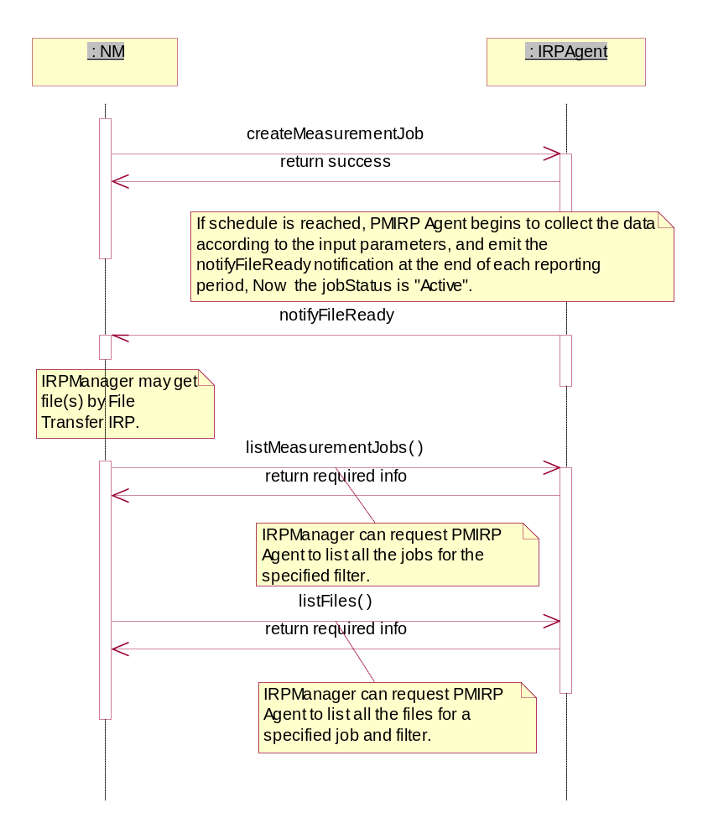
Figure 8.1: Scenario1 of Performance Management

8.2 stopMeasurementJob
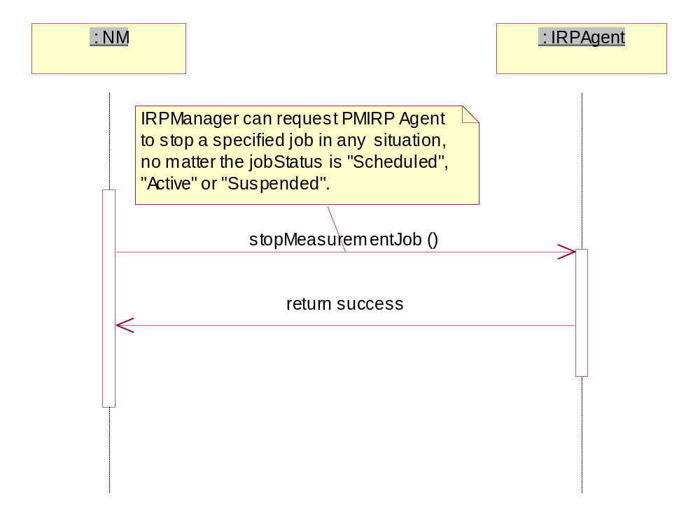
Figure 8.2: Scenario2 of Performance Management

8.3 stopMeasurementJob/listMeasurementJobs/listFiles
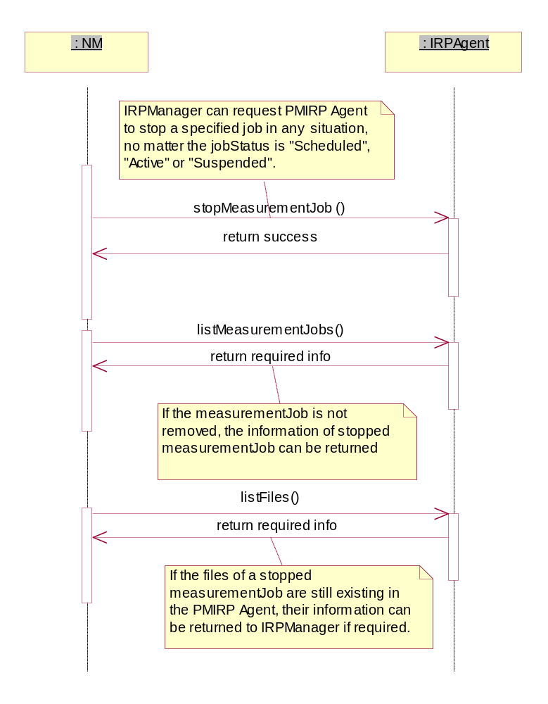
Figure 8.3: Scenario3 of Performance Management

8.4 suspendMeasurementJob/resumeMeasurementJob
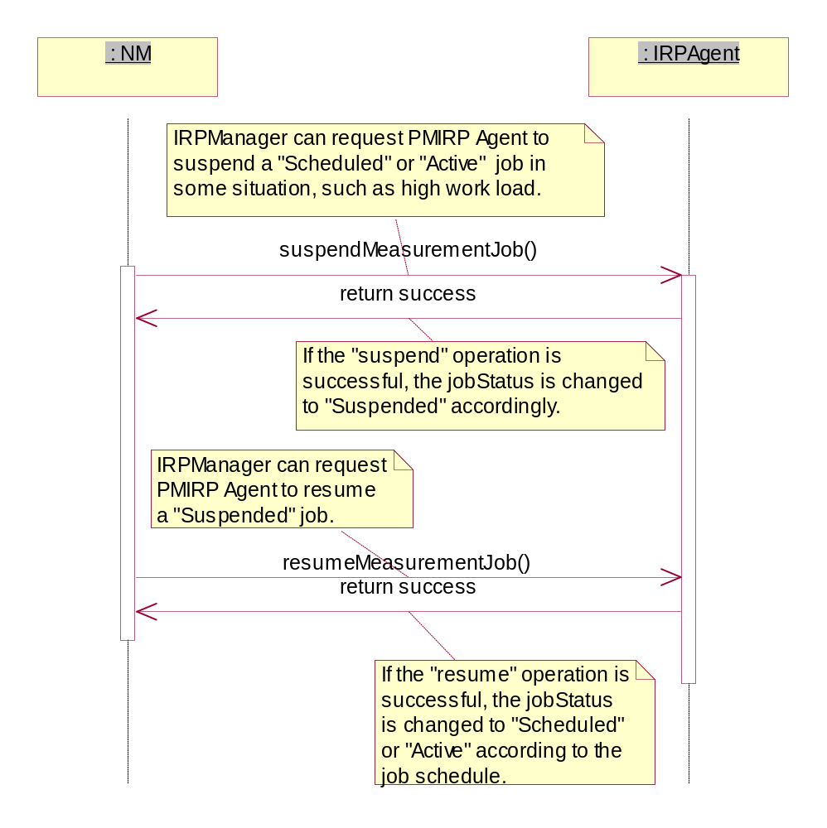
Figure 8.4: Scenario4 of Performance Management

Annex A (normative):
Illustration of the state described in the state Diagram

A.1 Definition of state

A.1.1 Scheduled
"Scheduled" means that the job has been created and the start time has not been reached.

A.1.2 Suspended
"Suspended" means that the job has been suspended for some reason.

A.1.3 Active
"Active" means that the start time of a MeasurementJob has been reached.
There are two sub-states: "Busy" and "Idle".
"Busy" means that the MeasurementJob is monitoring the measurementTypes.
"Idle" means that the MeasurementJob is not monitoring the measurementTypes.
When a MeasurementJob becomes active, it does not mean that the job is immediately busy. IRPManager can set the detailed time frame (e.g. dailySchedule or weeklySchedule) for a MeasurementJob to be busy. If there is no time frame schedule for a job, it immediately monitors the measurement types when it becomes active.

A.1.4 Stopped
"Stopped" means that the MeasurementJob is deleted via the Itf-N. Whether the managed system removes the MeasurementJob immediately or later is vendor specific.

A.2 State transition scenarios
The following scenarios give examples of state transitions.

A.2.1 Scenario 1
A MeasurementJob is created at 11:00, and the startTime is 14:00, stopTime is 18:00. At 12:00, the MeasurementJob is suspended, and at 13:00, the MeasurementJob is resumed.
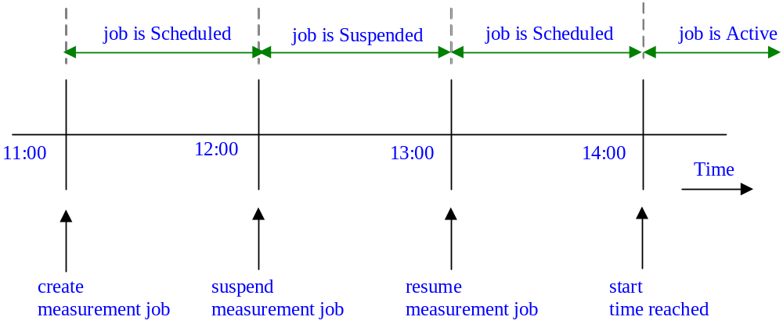
At 11:00: the MeasurementJob becomes scheduled after it was created.
At 12:00: the MeasurementJob is suspended and the jobStatus is "Suspended".
At 13:00: the MeasurementJob is resumed, and the jobStatus is "Scheduled" because the start time has not been reached.
At 14:00: the MeasurementJob becomes active because start time has been reached.

Figure A.2.1: Scenario 1

A.2.2 Scenario 2
A MeasurementJob is created at 11:00, and the startTime is 12:00, stopTime is 18:00. At 13:00, the MeasurementJob is suspended, and at 14:00, the MeasurementJob is resumed.
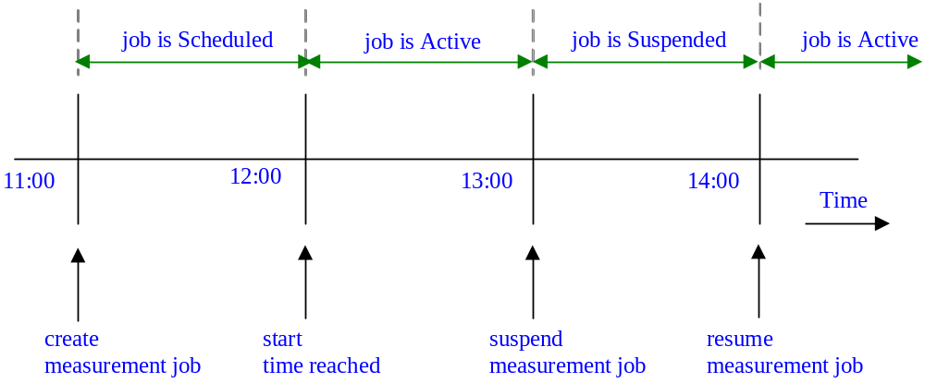
At 11:00: the MeasurementJob becomes scheduled after it was created.
At 12:00: the start time is reached, and the jobStatus is "Active".
At 13:00: the MeasurementJob is suspended, and the jobStatus is "Suspended".
At 14:00: the MeasurementJob is resumed, and the jobStatus is "Active".

Figure A.2.2: Scenario 2

A.2.3 Scenario 3
A MeasurementJob is created at 11:00 and the startTime is 12:00, stopTime is never stop. There is no other schedule defined. IRPManager stops the job at 14:00.
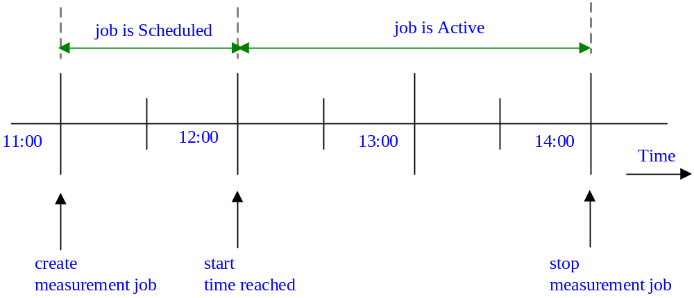
At 12:00: the MeasurementJob becomes active when start time is reached. Since there is no schedule for the job, it starts monitoring measurement types immediately.
At 14:00: the MeasurementJob is stopped when IRPManager stops the job.

Figure A.2.3: Scenario 3

A.2.4 Scenario 4
A MeasurementJob is created at 11:00 and the startTime is 12:00, stopTime is 14:00. There is no other schedule defined.
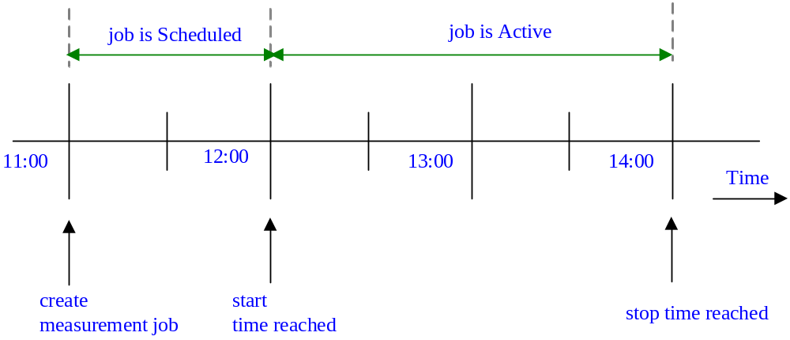
At 12:00: the MeasurementJob becomes active when start time is reached. Since there is no schedule for the job, it starts monitoring measurement types immediately.
At 14:00: the MeasurementJob is stopped automatically when stop time is reached.

Figure A.2.4: Scenario 4

A.2.5 Scenario 5
A MeasurementJob is created at 11:00 and the startTime is 12:00, stopTime is "never stop". There is a dailySchedule defined, which is 13:00~14:00 and 15:00~16:00 every day.
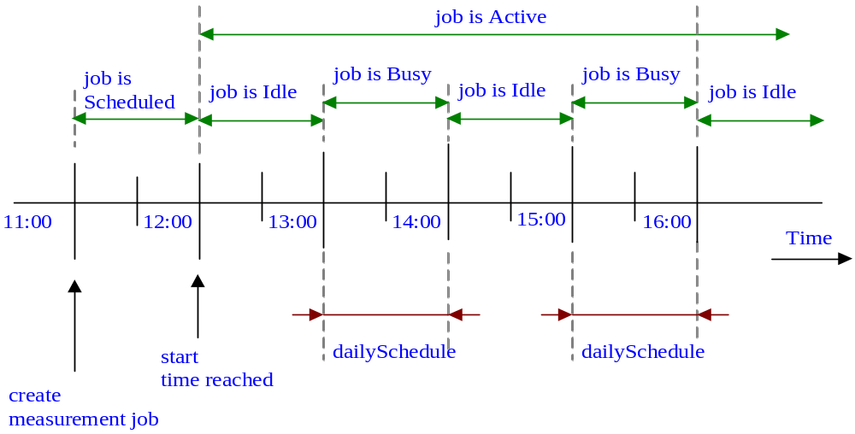
At 12:00: the MeasurementJob becomes active when start time has been reached. Since there is a schedule for the job, the job monitors measurement types only during the specified schedule. During other times, the job is idle.
At 13:00 and 15:00: the MeasurementJob becomes busy when the daily schedule has been reached.

Figure A.2.5: Scenario 5

A.2.6 Scenario 6
A MeasurementJob is created at 11:00 and the startTime is 12:00, stopTime is 13:30. The MeasurementJob.granularityPeriod is 30 minutes and the MeasurementJob.reportingPeriod is 1 hour. There is no other schedule defined.
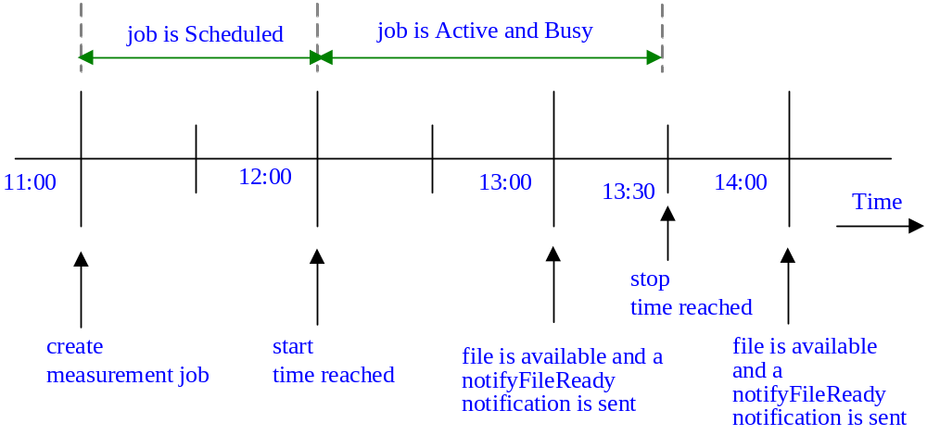
At 12:00: the MeasurementJob becomes active when start time is reached. Since there is no detailed time frame for the job, the job begins to work at the same time.
At 13:00: the file(s) of the MeasurementJob are available, and PMIRP emits the notifyFileReady notification to subscripted IRPManager.
At 13:30: the MeasurementJob is automatically stopped when stop time is reached.
At 14:00: PMIRP will emit the last notifyFileReady notification.

Figure A.2.6: Scenario 6

Annex B (normative):
Threshold related performance alarms Triggering Events
This annex defines the Triggering Events for the various performance alarms. The Triggering Events normally are defined by each notification type, such as notifyChangedAlarm, under the clause "Triggering Events". The Triggering Events related to thresholding are defined here collectively for ease of reference.
The Triggering Events are defined in a state transition table. The column labels (e.g. 0, 1, 2, 3 of table in clause B.1) denote the to-state while the row labels denote the from-state. The cell denotes the emission action.
There are two clauses. Clause B.1 defines the Triggering Events for IRPAgent that supports notifyChangedAlarm. Clause B.2 defines those for IRPAgent that does not support notifyChangedAlarm.
Clause B.3 provides samples of triggering events.

B.1 IRPAgent supporting notifyChangedAlarm
Table B.1
 | To State-0 | To State-1 | To State-2 | To State-3 | To State-4
From State-0 | no emission | 1 notifyNewAlarm | 1 notifyNewAlarm | 1 notifyNewAlarm | 1 notifyNewAlarm
From State-1 | 1 notifyClearedAlarm | no emission | 1 notifyChangedAlarm | 1 notifyChangedAlarm | 1 notifyChangedAlarm
From State-2 | 1 notifyClearedAlarm | 1 notifyChangedAlarm | no emission | 1 notifyChangedAlarm | 1 notifyChangedAlarm
From State-3 | 1 notifyClearedAlarm | 1 notifyChangedAlarm | 1 notifyChangedAlarm | no emission | 1 notifyChangedAlarm
From State-4 | 1 notifyClearedAlarm | 1 notifyChangedAlarm | 1 notifyChangedAlarm | 1 notifyChangedAlarm | no emission

The horizontal '0', '1', '2', '3' and '4' are the to-states indicating the current measurementType value with respect to the different threshold levels. Threshold levels are associated with severity level (thresholdSeverity). Higher threshold level associates with higher severity level (thresholdSeverity).
EXAMPLE: If direction = 'Increasing', state-0 means the measurementType value is below all thresholds. State-2 means that the measurementType value is above threshold level 2 but below threshold level 3. If direction = 'Decreasing', state-0 means the measurementType value is above all thresholds. State-2 means that the measurementType value is below threshold level 2 but above threshold level 3.
The vertical '0', '1', '2'', '3' and '4' are the from-states indicating the last-read measurementType value with respect to the threshold levels.
A threshold has a value and may have a hysteresis. A threshold with hysteresis has a threshold-high value and a threshold-low value that are different from the threshold value. A threshold without hysteresis can be considered as a threshold whose threshold-high and threshold-low values are equal to the threshold value.
For the direction = 'Increasing', the shaded cells indicate transitions caused by measurementType values (a) rising across or (b) reach one or more threshold-high values. The non-shaded cells indicate transition caused by measurementType values falling across one or more threshold-low values.
For the direction = 'Decreasing', the shaded cells indicate transitions caused by measurementType values (a) falling across or (b) reach one or more threshold-low values. The non-shaded cells indicate transition caused by measurementType values rising across one or more threshold-high values.
Each cell indicates the performance alarm emission when from-state transits to to-state. The notifyNewAlarm and notifyChangedAlarm shall carry the severity level (perceivedSeverity) associated with the to-state (thresholdSeverity).
The ThresholdMonitor determines, at monitorGP=X, if a threshold has been (a) crossed or (b) reached by comparing the value read at monitorGP==X with the value read at monitorGP==X-1. In initial condition (i.e. when the ThresholdMonitor reads the value at monitorGP=1), the (hypothetical) value read at monitorGP==X-1 is assumed to be at state-0.
(See 6.3.8.1 for clarification of the alternatives (a) and (b))

B.2 IRPAgent not supporting notifyChangedAlarm
Table B.2
 | To State-0 | To State-1 | To State-2 | To State-3 | To State-4
From State-0 | no emission | 1 notifyNewAlarm | 1 notifyNewAlarm | 1 notifyNewAlarm | 1 notifyNewAlarm
From State-1 | 1 notifyClearedAlarm | no emission | 1 notifyClearedAlarm  1 notifyNewAlarm | 1 notifyClearedAlarm  1 notifyNewAlarm | 1 notifyClearedAlarm  1 notifyNewAlarm
From State-2 | 1 notifyClearedAlarm | 1 notifyClearedAlarm  1 notifyNewAlarm | no emission | 1 notifyClearedAlarm  1 notifyNewAlarm | 1 notifyClearedAlarm  1 notifyNewAlarm
From State-3 | 1 notifyClearedAlarm | 1 notifyClearedAlarm  1 notifyNewAlarm | 1 notifyClearedAlarm  1 notifyNewAlarm | no emission | 1 notifyClearedAlarm  1 notifyNewAlarm
To State-4 | 1 notifyClearedAlarm | 1 notifyClearedAlarm  1 notifyNewAlarm | 1 notifyClearedAlarm  1 notifyNewAlarm | 1 notifyClearedAlarm  1 notifyNewAlarm | no emission

The Monitor determines, at monitorGP=X, if a threshold has been crossed by comparing the value read at monitorGP ==X with the value read at monitorGP ==X-1. In initial condition (i.e. when the Monitor reads the value at monitorGP =1), the (hypothetical) value read at monitorGP ==X-1 is assumed to be at state-0.

B.3 Examples

B.3.1 Example 1
Figure B.3.1 illustrates multi-level thresholdSeverity thresholding behaviour. The horizontal axis indicates the time intervals specified by the Monitor.monitorGranularityPeriod (monitorGP). The vertical axis indicates the monitored measurementType values. The measurementType of this example is of type gauge. The Monitor.direction is set to "Increasing".
Further suppose that the measurementType is monitored for a (a) two-level-severity-threshold-crossings or (b) two-level-severity-threshold reaching. (See 6.3.8.1 for clarification of the alternatives (a) and (b))
The threshold for the lower-level-severity is set to 3 with a hysteresis low and high levels set to 2 and 4 respectively (i.e. hysteresis value = 1). The thresholdSeverity level is Minor.
The threshold for the higher-level-severity is set to 7 with a hysteresis low and high levels set to 6 and 8 respectively (i.e. hysteresis value = 1). The thresholdSeverity level is Major.
The performance alarm triggering events are:
1. At monitorGP interval 3, trigger a notifyNewAlarm with perceivedSeverity (ps) = Minor.
2. At monitorGP interval 5, if the IRPAgent supports notifyChangedAlarm, trigger a notifyChangedAlarm with ps = Major; else a notifyClearAlarm and a notifyNewAlarm with ps = Major.
3. At monitorGP interval 8, if the IRPAgent supports notifyChangedAlarm, trigger a notifyChangedAlarm with ps = Minor; else a notifyClearAlarm and a notifyNewAlarm with ps = Minor.
4. At monitorGP interval 15, trigger a notifyClearedAlarm clearing the last emitted Minor alarm.
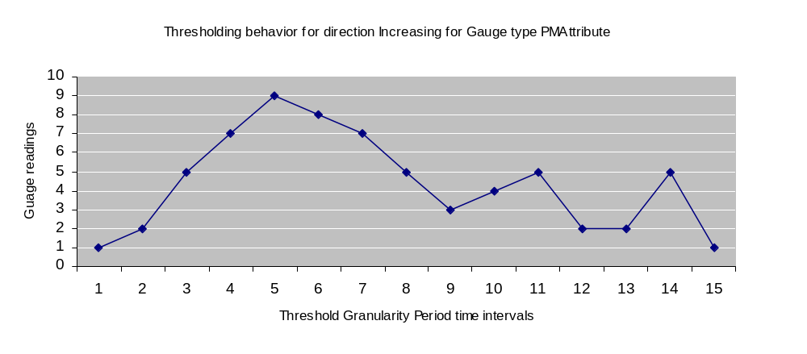
Figure B.3.1

B.3.2 Example 2
Figure B.3.2 illustrates another multi-level thresholdSeverity thresholding behaviour for IRPAgent supporting notifyChangedAlarm. The horizontal axis indicates the time intervals specified by the GP. The vertical axis indicates the monitored measurementType values. The measurementType of this example is of type gauge. The Monitor.direction is set to "Decreasing".
Further suppose that the measurementType is monitored for a two-level thresholdSeverity (a) threshold-crossing or (b) threshold reaching. (See 6.3.8.1 for clarification of the alternatives (a) and (b))
The threshold for the major-level thresholdSeverity is set to 7 with a hysteresis high and low levels set to 6 and 8 respectively.
The threshold for the minor-level thresholdSeverity is set to 9 with a hysteresis high and low levels set to 8 and 10 respectively.
The performance alarm triggering events are:
1. At monitorGP interval 1, trigger a notifyNewAlarm with ps = Major. See table B.1 table for transition State-0 to State-2.
2. At monitorGP interval 5, trigger a notifyChangedAlarm with ps = Minor. See table B.1 for transition State-2 to State-1.
3. At monitorGP interval 8, trigger a notifyChangedAlarm with ps = Major. See table B.1 for transition State-1 to State-2.
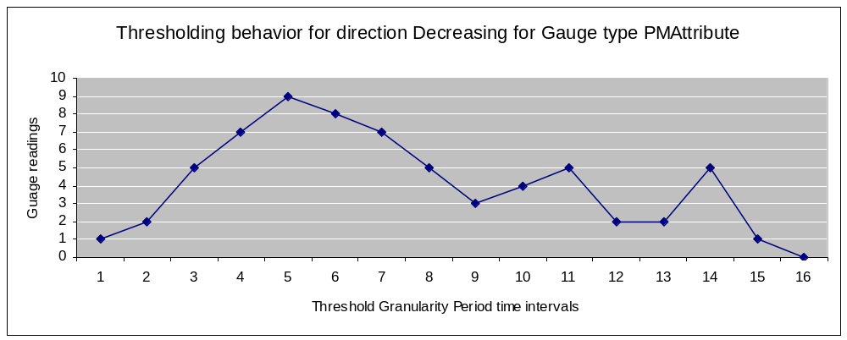
Figure B.3.2

B.3.3 Example 3
Figure B.3.3 illustrates a single-level thresholding behaviour. The horizontal axis indicates the time intervals specified by the monitorGP. The vertical axis indicates the monitored measurementType values. The measurementType of this example is of type gauge. The Monitor.direction is set to "Increasing".
The threshold is set to 4 with a hysteresis high and low levels set to 5 and 3 respectively. The thresholdSeverity level is Critical.
The performance alarm triggering events are:
1. At monitorGP interval 3, trigger a notifyNewAlarm with ps = Critical.
2. At monitorGP interval 11, trigger a notifyClearedAlarm with ps = Cleared.
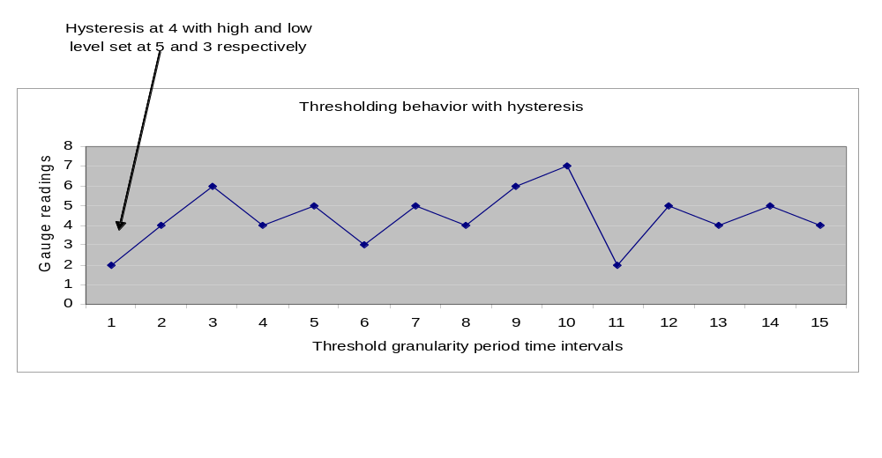
Figure B.3.3

Annex C (informative):
Change history
Change history
Date | TSG # | TSG Doc. | CR | Rev | Subject/Comment | Cat | Old | New
Jun 2003 | SA_20 | SP-030295 | -- | -- | Submitted to TSG SA#20 for Information | -- | 1.0.0
Dec 2003 | SA_22 | SP-030650 | -- | -- | Submitted to TSG SA#22 for Approval | -- | 2.0.0 | 6.0.0
Jun 2004 | SA_24 | SP-040272 | 0001 | -- | Clarify and correct the specification of notifications of Monitor | F | 6.0.0 | 6.1.0
Jun 2004 | SA_24 | SP-040272 | 0002 | -- | Add constraint that PM threshold hysteresis must be positive | F | 6.0.0 | 6.1.0
Sep 2004 | SA_25 | SP-040558 | 0003 | -- | Add Measurement Job Overload Management function | B | 6.1.0 | 6.2.0
Sep 2004 | SA_25 | SP-040557 | 0004 | -- | Align threshold alarm trigger to the definition in 32.411 | F | 6.1.0 | 6.2.0
Sep 2004 | SA_25 | SP-040556 | 0005 | -- | Extend the scope of ManagedEntity IOC to support collecting and monitoring measurement types related to vendor specific IOCs | B | 6.1.0 | 6.2.0
Sep 2004 | SA_25 | SP-040556 | 0006 | -- | Add definition of post condition for operation suspendMeasurementJob | F | 6.1.0 | 6.2.0
Dec 2004 | SA_26 | SP-040784 | 0007 | -- | Correct ambiguous precondition statement related to createThresholdMonitor operation | F | 6.2.0 | 6.3.0
Dec 2004 | SA_26 | SP-040784 | 0008 | -- | Correct definition of ObjectClass and ObjectInstance in “notifyMeasurementJobStatusChanged” and “notifyThresholdMonitorStatusChanged” | F | 6.2.0 | 6.3.0
Mar 2005 | SA_27 | SP-050041 | 0009 | -- | Remove the ambiguity that a PM IRP compliant system necessarily contains functionalities defined in Kernel CM IRP | F | 6.3.0 | 6.4.0
Mar 2005 | SA_27 | SP-050041 | 0010 | -- | Apply the Generic System Context – Align with TS 32.150 | F | 6.3.0 | 6.4.0
Jun 2005 | SA_28 | SP-050293 | 0011 | -- | Correct the matching information of monitorId attribute | F | 6.4.0 | 6.5.0
Mar 2006 | SA_31 | SP-060089 | 0012 | -- | Correct the misleading 'matching information' for object class and object instance in notifications | F | 6.5.0 | 6.6.0
Jun 2006 | SA_32 | SP-060251 | 0013 | -- | Add in PM IRP IS the missing use of "empty list" to denote all known instances - Align with 32.401 | F | 6.6.0 | 6.7.0
Jun 2006 | SA_32 | SP-060251 | 0014 | -- | Correct parameter usage in notifyThresholdMonitorCreation | F | 6.6.0 | 6.7.0
Sep 2006 | SA_33 | SP-060532 | 0015 | -- | Correct matching info of notificationType | F | 6.7.0 | 6.8.0
Dec 2006 | SA_34 | SP-060710 | 0016 | -- | Add missing Notification Table for PMIRP | F | 6.8.0 | 6.9.0
Dec 2006 | SA_34 | SP-060710 | 0017 | -- | Correction of the use of empty string in listMeasurementJob output parameter | F | 6.8.0 | 6.9.0
Jun 2007 | SA_36 | -- | -- | -- | Automatic upgrade to Rel-7 (no CR) at freeze of Rel-7. Deleted reference to CMIP SS, discontinued from R7 onwards. | -- | 6.3.0 | 7.0.0
Sep 2007 | SA_37 | SP-070613 | 0018 | -- | Align the definition of ManagedEntity in PM IRP with private objects classes defined in 32.404 | F | 7.0.0 | 7.1.0
Mar 2009 | SA_43 | SP-090207 | 0019 | -- | Include reference to SOAP Solution Set specification | D | 7.1.0 | 8.0.0
Dec 2009 | - | - | - | - | Update to Rel-9 version (MCC) | -- | 8.0.0 | 9.0.0
Jun 2010 | SA_48 | SP-100412 | 0020 | - | Correct the information type of input parameter thresholdInfoList | F | 9.0.0 | 9.1.0
Mar 2011 | SA_51 | SP-110095 | 0026 | 1 | Add the missing exception in create measurement operation | F | 9.1.0 | 10.0.0
2012-09 | - | - | - | - | Update to Rel-11 version (MCC) |  | 10.0.0 | 11.0.0
2012-12 | SA_58 | SP-120783 | 0027 | 1 | Align usage of SupportIOC with repertoire and TS 32.152 | F | 11.0.0 | 11.1.0
2012-12 | SA_58 | SP-120783 | 0028 | - | add reference to ITU-T Rec | F | 11.0.0 | 11.1.0
2014-10 | - | - | - | - | Update to Rel-12 version (MCC) |  | 11.1.0 | 12.0.0
2016-01 | - | - | - | - | Update to Rel-13 version (MCC) |  | 12.0.0 | 13.0.0

Change history
Date | Meeting | TDoc | CR | Rev | Cat | Subject/Comment | New version
2016-12 | SA#74 | SP-160852 | 0034 | - | A | Correction of the information type for input parameter priority of the operation “Create measurement job” | 13.1.0
2016-12 | SA#74 | SP-160854 | 0035 | 1 | B | Add parameters for operation “Create measurement job” related to measurement filtering and measurement job reliability level | 14.0.0

