3GPP TS 26.501 V19.3.0 (2025-12)
Technical Specification

3rd Generation Partnership Project;
Technical Specification Group Services and System Aspects;
5G Media Streaming (5GMS);
General description and architecture
(Release 19)
The present document has been developed within the 3rd Generation Partnership Project (3GPP TM) and may be further elaborated for the purposes of 3GPP.
The present document has not been subject to any approval process by the 3GPP Organizational Partners and shall not be implemented.
This Specification is provided for future development work within 3GPP only. The Organizational Partners accept no liability for any use of this Specification.
Specifications and Reports for implementation of the 3GPP TM system should be obtained via the 3GPP Organizational Partners' Publications Offices.

3GPP
Postal address

3GPP support office address
650 Route des Lucioles - Sophia Antipolis
Valbonne - FRANCE
Tel.: +33 4 92 94 42 00 Fax: +33 4 93 65 47 16
Internet
https://www.3gpp.org

Copyright Notification
No part may be reproduced except as authorized by written permission.
The copyright and the foregoing restriction extend to reproduction in all media.

© 2025, 3GPP Organizational Partners (ARIB, ATIS, CCSA, ETSI, TSDSI, TTA, TTC).
All rights reserved.

UMTS™ is a Trade Mark of ETSI registered for the benefit of its members
3GPP™ is a Trade Mark of ETSI registered for the benefit of its Members and of the 3GPP Organizational Partners
LTE™ is a Trade Mark of ETSI registered for the benefit of its Members and of the 3GPP Organizational Partners
GSM® and the GSM logo are registered and owned by the GSM Association

Contents
Foreword 10
1 Scope 11
2 References 11
3 Definition of terms, symbols and abbreviations 13
3.1 Terms 13
3.2 Symbols 15
3.3 Abbreviations 15
4 Media Streaming architecture 16
4.0 Media Streaming features (informative) 16
4.0.1 Introduction 16
4.0.2 Content hosting 18
4.0.3 Content publishing 19
4.0.4 Content preparation 20
4.0.5 Network assistance 20
4.0.6 Dynamic policies 21
4.0.7 Remote control 24
4.0.8 Consumption reporting 24
4.0.9 QoE metrics reporting 24
4.0.10 Edge processing 25
4.0.11 eMBMS delivery 25
4.0.12 Data collection, reporting and exposure 25
4.0.13 Service URL handling 25
4.0.14 MBS delivery 25
4.1 General service architecture 26
4.1.1 Definition of 5G Media Streaming architecture 26
4.1.2 Generalized Media Delivery architecture 28
4.1.2.1 Generalized Media Delivery in the 5G System 28
4.1.2.2 Reference architecture for Media Delivery 29
4.1.2.3 Network Functions and UE entities 29
4.1.2.4 Reference points 30
4.1.2.5 Interfaces and APIs 31
4.1.2.5.1 Interfaces and APIs supporting media session handling 31
4.1.2.5.2 Interfaces and APIs supporting media transport 31
4.1.2.5.3 Interfaces and APIs supporting application functionality 32
4.1.3 Media delivery session identification 32
4.2 5G unicast downlink Media Streaming architecture 32
4.2.1 Standalone – Non-Roaming 32
4.2.2 5GMSd UE functions 37
4.2.3 Service Access Information for downlink media streaming 40
4.3 Uplink 5G Media Streaming architecture 43
4.3.1 Media architecture 43
4.3.2 UE 5GMSu functions 45
4.3.3 Service Access Information for uplink media streaming 47
4.4 Network Slicing for downlink media streaming 49
4.5 5G Media Streaming architecture extensions for Edge Computing 50
4.5.1 Introduction 50
4.5.2 5G Media Streaming combined with Edge Computing 50
4.5.3 Provisioning and Service Information 51
4.5.4 Edge application context for 5GMS functions 52
4.5.4.1 5GMS AF context 52
4.5.4.2 5GMS AS context 52
4.6 5G Downlink Media Streaming via eMBMS 53
4.6.1 Architecture for 5G Downlink Media Streaming over eMBMS 53
4.6.2 Usage of 5GMS reference points for eMBMS-based delivery 54
4.6.2.1 Usage of M1d 54
4.6.2.2 Usage of M2d 54
4.6.2.3 Usage of M3d 54
4.6.2.4 Usage of M4d 54
4.6.2.5 Usage of M5d 54
4.6.2.6 Usage of M6d 55
4.6.2.7 Usage of M7d 55
4.6.2.8 Usage of M8d 55
4.6.3 Usage of MBMS reference points and interfaces 55
4.6.3.1 Usage of xMB-C 55
4.6.3.2 Usage of xMB-U 55
4.6.3.3 Usage of MBMS User Services and Delivery Methods 55
4.6.3.4 Usage of MBMS-API-C 55
4.6.3.5 Usage of MBMS-API-U 56
4.7 Data collection, reporting and exposure for 5GMS 56
4.7.1 Reference architecture instantiation 56
4.7.2 UE data reporting for 5GMS 57
4.7.2.1 UE data reporting procedures for downlink media streaming 57
4.7.2.2 UE data reporting procedures for uplink media streaming 58
4.7.2.3 Common baseline parameters for UE data reporting 58
4.7.2.4 UE data reporting parameters for media streaming access activity 59
4.7.2.5 UE data reporting of ANBR-based Network Assistance invocations 61
4.7.3 UE data processing for 5GMS 62
4.7.3.1 UE data processing procedures for downlink media streaming 62
4.7.3.2 UE data processing procedures for uplink media streaming 63
4.7.4 Event exposure of 5GMS UE data 63
4.7.4.1 Event exposure of UE data for downlink media streaming 63
4.7.4.2 Event exposure of UE data for uplink media streaming 63
4.7.4.3 Common baseline parameters for event exposure 64
4.7.4.4 Event exposure of QoE metrics UE data 66
4.7.4.5 Event exposure of consumption reporting UE data 68
4.7.4.6 Event exposure of dynamic policy invocation UE data 69
4.7.4.7 Event exposure of Network Assistance UE data 71
4.7.4.8 Event exposure of media streaming access activity UE data 74
4.9 Downlink 5G Media Streaming via MBS 76
4.9.1 Architecture for downlink 5G Media Streaming over MBS 76
4.9.2 Usage of 5GMS reference points for MBS-based delivery 78
4.9.2.1 Usage of M1 78
4.9.2.2 Usage of M2d 78
4.9.2.3 Usage of M3d 78
4.9.2.4 Usage of M4d 78
4.9.2.5 Usage of M5 78
4.9.2.6 Usage of M6d 79
4.9.2.7 Usage of M7d 79
4.9.2.8 Usage of M8d 79
4.9.3 Usage of MBS reference points and interfaces 79
4.9.3.1 Usage of Nmbsf service at Nmb10 and Nmb5+N33 79
4.9.3.2 Usage of Nmb8 79
4.9.3.3 Usage of MBS User Services and Distribution Methods 79
4.9.3.4 Usage of MBS-6 79
4.9.3.5 Usage of MBS-7 79
4.10 3GPP Service URL handling 80
4.10.1 General 80
4.10.2 Baseline parameters of 3GPP Service URL for 5G Media Streaming 80
4.11 Security architecture 81
4.11.1 General 81
4.11.2 Mapping of CAPIF to 5GMS architecture 81
4.11.2.1 Provisioning a trusted 5GMS AF from a 5GMS Application Provider in the Trusted or External DN at reference point M1 81
4.11.2.2 Configuring a trusted 5GMS AS from a 5GMS AF in the Trusted or External DN at reference point M3 82
4.11.2.3 Invoking a 5GMS AF in the Trusted DN from a Media Session Handler at reference point M5 83
4.11.2.4 Invoking a trusted 5GMS AF from a 5GMS AS in the Trusted or External DN at reference point M3 84
5 Procedures for downlink media streaming 85
5.1 General 85
5.2 Baseline procedure for unicast downlink media streaming session establishment 88
5.2.1 General 88
5.2.2 Progressive download of on-demand content 88
5.2.3 DASH streaming 90
5.2.4 Procedures for downlink streaming to Media Players with different presentation manifests 92
5.2.5 Procedures for downlink media streaming with per-application authorisation of media session handling operations 93
5.2.5.1 Overview 93
5.2.5.3 Authorisation of media session handling at M5d based on redirection 95
5.2.6 Procedures for downlink streaming from multiple service locations 97
5.3 Provisioning Session for media streaming 100
5.3.1 Domain model 100
5.3.2 Baseline provisioning procedure 103
5.3.3 Baseline provisioning procedure with authorisation of 5GMSd Application Provider 105
5.4 Content Hosting Configuration for downlink Media Streaming 108
5.4.1 General 108
5.4.2 Media ingest and distribution procedure 109
5.4.3 Configuration of 5GMSd AS by 5GMSd AF with authorisation 110
5.4.4 Media ingest and distribution procedure with multiple service locations 112
5.5 Metrics collection and reporting 114
5.5.1 General 114
5.5.3 5GMSd AF-based reporting procedure 118
5.5.4 Metrics reporting configuration parameters 120
5.5.5 Metrics reporting by 5GMSd AS to 5GMSd AF with authorisation 121
5.6 Consumption reporting 124
5.6.1 Consumption reporting procedure 124
5.6.2 Consumption reporting parameters 126
5.6.3 Triggering consumption reporting 126
5.7 Establishing a unicast downlink media streaming session with 5GMSd AF interactions for dynamic policy updates 126
5.7.1 General 126
5.7.2 Provisioning 127
5.7.3 Progressive Download of on-demand content 128
5.7.4 DASH streaming 131
5.7.6 Dynamic Policy selection for downlink media streaming based on Service Operation Point signalling 134
5.7.7 Use of Service Operation Point signalling to optimise delivery of low-latency live media streaming services (informative) 135
5.7.7.1 5GMS System acts as a CDN 135
5.7.7.2 5GMSd AS deployed in an external DN 136
5.7.8 Downlink Background Data Transfer using dynamic policy invocation 137
5.7.9 ECN marking for L4S for downlink media streaming based on Dynamic Policy 141
5.7.10 QoS monitoring of downlink media streaming based on Dynamic Policy 144
5.8 Dynamic Policy based on Network Slicing for downlink media streaming 146
5.8.1 Procedure 146
5.9 Downlink Network Assistance 147
5.9.1 Introduction 147
5.9.2 5GMSd AF-based downlink Network Assistance 148
5.9.3 ANBR-based downlink Network Assistance 149
5.10 5GMS via eMBMS 149
5.10.1 General 149
5.10.2 Procedures for 5GMS content delivered exclusively via eMBMS 150
5.10.3 5GMS Consumption Reporting procedures for eMBMS 152
5.10.4 5GMS Metrics Reporting procedures for eMBMS 154
5.10.5 Procedures for Hybrid Services: 5GMS content delivery via 5G System and eMBMS 156
5.10.5.2 Interactive service 159
5.10.5.3 Session continuity 159
5.10.5.4 Time-shifted viewing 159
5.10.5.5 Content or component replacement 159
5.10.6 Procedures for dynamic provisioning of 5GMS content delivery via eMBMS 160
5.10.6.1 General 160
5.10.6.2 Operation modes 163
5.10.7 Service URL handling procedures for 5GMSd via eMBMS in Receive-Only Mode (ROM) 163
5.11 Procedures for downlink media streaming data collection, reporting and exposure 165
5.11.1 Configuration of 5GMSd AS data collection client for downlink media streaming access reporting 165
5.11.2 Downlink media streaming access activity reporting by 5GMSd AS 165
5.11.2A Configuration of Direct Data Collection Client for data reporting 166
5.11.2B Direct Data Collection Client reporting for downlink media streaming 166
5.11.3 Downlink media streaming event exposure 167
5.11.4 Void 167
5.11.5 Void 167
5.12 5GMS via MBS 168
5.12.1 General 168
5.12.2 Procedures for 5GMS content delivered exclusively via MBS 168
5.12.4 5GMS content delivery via 5G System and MBS 173
5.12.4.3 Session continuity 176
5.12.4.4 Time-shifted viewing 176
5.12.4.5 Content or component replacement 176
5.12.5 Procedures for dynamic provisioning of 5GMS content delivery via MBS 177
5.12.5.1 General 177
5.12.5.2 Operation modes 179
6 Procedures for uplink media streaming 187
6.1 General 187
6.2 Preparing for uplink media streaming 189
6.2.1 Introduction 189
6.2.2 Provisioning session for uplink streaming 189
6.2.2.1 Domain model 189
6.2.2.2 Baseline provisioning procedure 193
6.2.2.3 Baseline provisioning procedure with authorisation 195
6.2.3 Content Publishing Configuration for uplink streaming 198
6.2.3.1 General 198
6.2.3.2 Media contribution and egest procedure 199
6.2.3.3 Configuration of 5GMSu AS by 5GMSu AF with authorisation 200
6.3 Establishment of an uplink Media Streaming session 202
6.3.1 Overview 202
6.3.2 Baseline procedure for establishment of an uplink media streaming session 202
6.3.3 Baseline procedure for establishment of an uplink media streaming session with per-application authorisation of media session handling operations 203
6.3.3.1 Overview 203
6.3.3.2 Authorisation of media session handling at M5u based on access token 203
6.3.3.3 Authorisation of media session handling at M5u based on redirection 204
6.4 Termination of an uplink Media Streaming session 206
6.5 Providing 5GMSu AF-based Network Assistance 207
6.6 Providing Remote Control 208
6.7 RAN Signalling based Support for Uplink Network Assistance 209
6.8 Procedures for uplink media streaming data collection, reporting and exposure 210
6.8.1 Configuration of 5GMSu AS data collection client for uplink media streaming access reporting 210
6.8.2 Uplink media streaming access reporting by 5GMSu AS 211
6.8.2A Configuration of Direct Data Collection Client for data reporting 211
6.8.2B Direct Data Collection Client reporting for uplink media streaming 212
6.8.3 Uplink media streaming access event exposure 212
6.8.4 Void 213
6.8.5 Void 213
6.9 Establishing an uplink streaming session with 5GMSu AF interactions for dynamic policy invocation and updates 213
6.9.1 General 213
6.9.2 Provisioning 213
6.9.3 Uplink streaming with dynamic policy invocation 215
6.9.5 Dynamic Policy selection for uplink media streaming based on Service Operation Point signalling 217
6.9.6 Dynamic Policy based on Network Slicing for uplink media streaming 218
6.9.7 Uplink Background Data Transfer using dynamic policy invocation 220
6.9.8 Dynamic Policy of ECN marking for L4S for uplink media streaming 224
6.9.9 QoS monitoring of uplink media streaming based on Dynamic Policy 227
7 5GMS network media processing 228
7.1 General 228
8 Procedures for 5GMS Edge Processing 231
8.1 Procedure for client-driven management of 5GMS Edge Processing 231
8.2 Procedure for AF-driven management of 5GMS Edge Processing 234
9 Procedures for Service URL handling 236
9.1 Baseline procedure 236
Annex A (informative): Usage Guidelines for collaboration scenarios 238
A.0 General 238
A.1 Downlink media streaming with AS deployed in an external Data Network (OTT) 238
A.2 Downlink media streaming with both AF and AS deployed in the trusted Data Network 239
A.3 Downlink media streaming with both AF and AS deployed in an external Data Network (OTT) 240
A.4 Downlink media streaming with AF deployed in the trusted Data Network and AS deployed in an external Data Network 240
A.5 Downlink media streaming with AS deployed in an external Data Network, provisioned by AF deployed in the trusted Data Network 241
A.6 Downlink media streaming with AS deployed in the trusted Data Network, provisioned by AF deployed in an external Data Network 242
A.7 Downlink media streaming with both AF and AS deployed in the trusted Data Network and AF interaction with PCF 242
A.8 Downlink media streaming with AFs deployed in two separate trusted Data Networks sharing AS in an external Data Network 243
A.9 Downlink media streaming with both AF and AS deployed in external Data Network and AS delivering content through two trusted Data Networks (OTT) 243
A.10 Uplink media streaming using content preparation with both AF and AS deployed in the trusted Data Network 244
A.11 Uplink media streaming using content preparation (media plane only) with both AF and AS deployed in the trusted Data Network 247
A.12 Uplink media streaming using content preparation (media plane only) with provisioning and AS in the external domain 249
A.13 Uplink media streaming using content preparation with AF in the trusted Data Network and AS in the external domain 251
A.14 Uplink media streaming using content preparation with AF and AS in the external domain 253
A.15 Cascaded uplink and downlink media streaming using content preparation 256
A.15.1 Introduction 256
A.15.2 Cascaded uplink and downlink media streaming using content preparation with external content re-ingestion 256
A.15.3 Cascaded uplink and downlink media streaming using content preparation with direct content re-ingestion 259
A.15.4 Cascaded uplink and downlink media streaming using content preparation with internal content re-ingestion 262
A.16 Media ingest for downlink media streaming using multiple service locations 263
A.16.1 Introduction 263
A.16.2 5GMSd Application Provider content preparation and ingest 264
A.16.3 Centralized 5GMSd AS content preparation and ingest 265
A.16.4 Decentralized 5GMSd AS content preparation and ingest 267
Annex B (informative): MNO-specific Service Access Information acquisition 270
B.1 General 270
B.2 Deployment with DNS-based resolution 270
B.3 Deployment with HTTPS-based resolution 272
Annex C (informative): Collaboration Models for 5GMS via eMBMS 274
C.1 Introduction 274
C.2 Collaboration 5GMS-MBMS 1: 5GMS Content Provider uses different delivery networks 274
C.3 Collaboration 5GMS-MBMS 2: 5GMS Network Operator offloads to 5G Broadcast Network Operator 275
C.4 Collaboration 5GMS-MBMS 3: 5GMS Service Operator includes MBMS network 276
C.5 Collaboration 5GMS-MBMS 4: 5G Broadcast Service Provider offloads to 5G MNO 277
Annex D (informative): Use Cases for 5GMS event exposure 278
D.1 Introduction 278
D.2 Controlling Event exposure 278
D.2.1 Data exposure restrictions 278
D.2.2 Event subscription filters 278
D.3 QoE metrics for downlink media streaming 278
D.4 Consumption of downlink media streaming 279
D.5 Invocation of dynamic policies 279
D.6 Invocation of Network Assistance 279
D.7 Media streaming access activity 280
D.7.1 Downlink media streaming access activity 280
Annex E (informative): Collaboration models for per-application authorisation 281
E.1 Introduction 281
E.2 UE hosting multiple applications 281
E.2 Applications with multiple subscription levels 282
Annex F (informative): Network Slice selection for 5GMS 283
F.1 Introduction 283
F.2 Network Slice selection based on Application Descriptor in URSP rules 283
Annex G (informative): Collaboration scenarios for network slicing 286
G.1 Collaboration scenarios for network slicing based on 5G Media Streaming scenarios 286
G.1.1 Introduction 286
G.1.2 Media streaming with both AF and AS deployed in the trusted Data Network 286
G.1.3 Media streaming with both AF and AS deployed in an external Data Network (OTT) 287
G.1.4 Media streaming with AFs deployed in two separate trusted Data Networks sharing AS in an external Data Network 288
G.2 Collaboration scenarios for network slicing with multiple slices or Data Networks 288
G.2.1 Introduction 288
G.2.2 Media streaming with AS deployed in external Data Network and AS delivering content through two different network slices 289
G.2.3 Media streaming with AS deployed in multiple trusted Data Networks 290
G.3 Collaboration options based on network slicing scenarios 292
G.3.1 Introduction 292
G.3.2 Scenario #1: Slice serving a set of enterprise services/applications 293
G.3.3 Scenario #2: Slice serving a specific application of an enterprise 295
G.3.4 Scenario #3: Slice optimised for a specific service/application 296
G.3.5 Scenario #4: Slice serving a virtual operator 297
Annex H (informative): Multi-access media delivery 298
H.1 Introduction 298
H.2 ATSSS mapping into 5GMS architecture 299
Annex I (informative): Change history 301

Foreword
This Technical Specification has been produced by the 3rd Generation Partnership Project (3GPP).
The contents of the present document are subject to continuing work within the TSG and may change following formal TSG approval. Should the TSG modify the contents of the present document, it will be re-released by the TSG with an identifying change of release date and an increase in version number as follows:
Version x.y.z
where:
x the first digit:
1 presented to TSG for information;
2 presented to TSG for approval;
3 or greater indicates TSG approved document under change control.
y the second digit is incremented for all changes of substance, i.e. technical enhancements, corrections, updates, etc.
z the third digit is incremented when editorial only changes have been incorporated in the document.

1 Scope
The present document specifies the 5G Media Streaming (5GMS) architecture. The 5GMS supported services include MNO and third-party Downlink Media Streaming Services, and MNO and third-party Uplink Media Streaming Services. The 5GMS architecture supports related network and UE functions and APIs, backwards compatible functions for EUTRAN deployments (with and without MBMS) and 5G specific features.
NOTE: Support of 5G Media Streaming over MBMS with 5GC is not considered in the current version of the present document.
The 5GMS architecture is functionally divided into independent components enabling different deployments with various degrees of integration between 5G MNOs and Content Providers. It is specified as a set of extensions to TS 23.501 "System Architecture for the 5G System".
Many of the features defined in this document are motivated by the conclusions of TR 26.804 [36].

2 References
The following documents contain provisions which, through reference in this text, constitute provisions of the present document.
- References are either specific (identified by date of publication, edition number, version number, etc.) or non-specific.
- For a specific reference, subsequent revisions do not apply.
- For a non-specific reference, the latest version applies. In the case of a reference to a 3GPP document (including a GSM document), a non-specific reference implicitly refers to the latest version of that document in the same Release as the present document.
[1] 3GPP TR 21.905: "Vocabulary for 3GPP Specifications".
[2] 3GPP TS 23.501: "System architecture for the 5G System (5GS)".
[3] 3GPP TS 23.502: "Procedures for the 5G System (5GS)".
[4] 3GPP TS 23.503: "Policy and charging control framework for the 5G System (5GS); Stage 2".
[5] Void
[6] 3GPP TS 26.307: "Presentation layer for 3GPP services".
[7] 3GPP TS 26.247: "Transparent end-to-end Packet-switched Streaming Service (PSS); Progressive Download and Dynamic Adaptive Streaming over HTTP (3GP-DASH)".
[8] 3GPP TS 26.234: "Transparent end-to-end Packet-switched Streaming Service (PSS); Protocols and codecs".
[9] 3GPP TS 23.003: "Technical Specification Group Core Network and Terminals; Numbering, addressing and identification".
[10] 3GPP TS 28.530: "Management and orchestration; Concepts, use cases and requirements".
[11] 3GPP TS 28.531: "Management and orchestration; Provisioning".
[12] 3GPP TS 28.541: "Management and orchestration; 5G Network Resource Model (NRM); Stage 2 and stage 3".
[13] 3GPP TS 23.222: "Common API Framework for 3GPP Northbound APIs".
[14] IETF RFC 1034: "Domain names - concepts and facilities".
[15] 3GPP TS 23.548: "5G System Enhancements for Edge Computing; Stage 2".
[16] 3GPP TS 23.558: "Architecture for enabling Edge Applications".
[17] 3GPP TS 28.538: "Management and orchestration; Edge Computing Management".
[18] 3GPP TS 23.246: "Multimedia Broadcast/Multicast Service (MBMS); Architecture and functional description".
[19] 3GPP TS 26.346: "Multimedia Broadcast/Multicast Service (MBMS); Protocols and codecs".
[20] 3GPP TS 26.347: "Multimedia Broadcast/Multicast Service (MBMS); Application Programming Interface and URL".
[21] 3GPP TS 26.348: "Northbound Application Programming Interface (API) for Multimedia Broadcast/Multicast Service (MBMS) at the xMB reference point".
[22] 3GPP TS 26.531: "Data collection and reporting; General description and architecture".
[23] 3GPP TS 23.288: "Architecture enhancements for 5G System (5GS) to support network data analytics services".
[24] 3GPP TS 27.007: "AT command set for User Equipment (UE)".
[25] CTA-5005: "Web Application Video Ecosystem – DASH-HLS Interoperability Specification".
[26] 3GPP TS 26.511: "5G Media Streaming (5GMS); Profiles, Codecs and Formats".
[27] ISO/IEC 23000-19: "Information Technology Multimedia Application Format (MPEG-A) – Part 19: Common Media Application Format (CMAF) for segmented media".
[28] IETF RFC 8216: "HTTP Live Streaming".
[29] ISO/IEC 23009-1: "Information Technology – Dynamic Adaptive Streaming Over HTTP (DASH) – Part 1: Media Presentation Description and Segment Formats".
[30] 3GPP TS 26.502: "5G Multicast-Broadcast User Service Architecture".
[31] Void.
[32] 3GPP TS 26.506: "5G Real-time Media Communication Architecture".
[33] 3GPP TS 23.222: "Common API Framework for 3GPP Northbound APIs".
[34] 3GPP TS 33.122: "Security aspects of Common API Framework (CAPIF) for 3GPP northbound APIs".
[35] IETF RFC 6749: "The OAuth 2.0 Authorization Framework", October 2012.
[36] 3GPP TR 26.804: "Study on 5G media streaming extensions".
[37] 3GPP TS 29.591: "Network Exposure Function Southbound Services; Stage 3".
[38] IETF RFC 9330:"Low Latency, Low Loss, Scalable Throughput (L4S) Internet Service: Architecture".
[39] IETF RFC 9331: "Explicit Congestion Notification (ECN) Protocol for Very Low Queuing Delay (L4S)".
[40] IETF RFC 9332: "Dual-Queue Coupled Active Queue Management (AQM) for Low Latency, Low Loss, and Scalable Throughput (L4S)".
[41] IETF RFC 3168: "The Addition of Explicit Congestion Notification (ECN) to IP".
[42] GSM Association: "5G Network Slicing", https://www.gsma.com/futurenetworks/ip_services/understanding-5g/network-slicing/
[43] 5G Network Slicing: Android documentation, https://source.android.com/docs/core/connect/5g-slicing.
[44] Apple device support for private 5G and LTE networks: https://support.apple.com/guide/deployment/support-for-private-5g-and-lte-networks-depac6747317/web
[45] GSM Association: "Network Slicing: North America’s Perspective (Current) Version 1.0", https://www.gsma.com/newsroom/wp-content/uploads//NG.130-White-Paper-Network-Slicing-NA-Perspective.pdf, August 2021.
[46] IETF RFC 6897: "Multipath TCP (MPTCP) Application Interface Considerations", March 2013.
[47] IETF Internet Draft: "Multipath Extension for QUIC", draft-ietf-quic-multipath-12, January 2025.

3 Definition of terms, symbols and abbreviations

3.1 Terms
For the purposes of the present document, the terms given in TR 21.905 [1] and the following apply. A term defined in the present document takes precedence over the definition of the same term, if any, in TR 21.905 [1].
5GMS System: An assembly of Application Functions, Application Servers and interfaces from the 5G Media Streaming architecture that support either downlink media streaming services or uplink media streaming services, or both.
NOTE 1: The components of a 5GMS System may be provided by an MNO as part of a 5GS and/or by a 5GMS Application Provider.
5GMS Application Provider: A party that interacts with functions of the 5GMS System and supplies a 5GMS-Aware Application that interacts with functions of the 5GMS System.
5GMS AS instance: An identifiable instance of the 5GMS AS for the purposes of decomposing the logical 5GMS AS into deployable entities.
5GMS-Aware Application: Application in the UE, provided by the 5GMS Application Provider, that contains the service logic of the 5GMS application service, and interacts with other 5GMS Client and Network functions via the interfaces and APIs defined in the 5GMS architecture.
NOTE 2: Functionality of the 5GMS-Aware Application is outside the scope of this specification.
NOTE 3: A 5GMS-Aware Application associated with the delivery of either a downlink or uplink related 5GMS service is referred to as a 5GMSd-Aware Application or a 5GMSu-Aware Application, respectively.
5GMS Client: A UE function that is either a 5GMSd Client or a 5GMSu Client, or both.
5G Media Streaming Client for downlink (5GMSd Client): UE function that includes at least a 5G Media Streaming Player and a Media Session Handler for downlink streaming and that may be accessed through well-defined interfaces/APIs.
5G Media Streaming Client for uplink (5GMSu Client): Originator of 5GMSu service that includes at least a Media Streamer and a Media Session Handler for uplink streaming and that may be accessed through well-defined interfaces/APIs.
5GMSu Media Streamer: UE function that enables uplink delivery of streaming media content to an Application Server function of the 5GMS Application Provider, and which interacts with both the 5GMSu-Aware Application for media capture and subsequent streaming, and the Media Session Handler for media session control.
NOTE 4: The 5GMSu Media Streamer receives a Media Streamer Entry to initiate an uplink streaming session.
NOTE 5: The 5GMSu Media Streamer captures the media on the provided input devices. The 5GMSu Media Streamer exposes some basic controls such as capture, pause, and stop to the 5GMSu-Aware Application.
affinity group: A set of service locations that are intended to be deployed with each other and not with members of other affinity groups.
client data: Static or dynamic data available in the 5GMS Client that may be of value to the 5GMS Application Provider for operational and/or analytics purposes.
Dynamic policy: A Dynamic PCC Rule (c.f. TS 23.503 [4]) for an uplink or downlink application flow during a media session.
Egest Session: An uplink media streaming session from the 5GMSu AS towards the 5GMSu Application Provider.
Ingest Session: A session to upload the media content into a 5GMSd AS.
Policy Template: A collection of (semi-static) PCF/NEF API parameters which are specific to the 5GMS Application Provider and also the resulting PCC Rule.
Policy Template Id: Identifies the desired policy template, which is used by 5GMSd AF to select the appropriate PCF/NEF API towards the 5G System so that the PCF can compile the desired PCC Rule.
Media Entry Point: A Media Player Entry for downlink media streaming or a Media Streamer Entry for uplink media streaming intended to be consumed by a 5GMS Media Stream Handler.
Media Player Entry: A document or a pointer to a document that defines a downlink media streaming presentation (e.g. MPD for DASH content or URL to a video clip file) and, optionally, a downlink media streaming configuration (e.g. service location and configuration information for the purposes of accessing content from one or more service locations whether internal or external to the 5GMS System) intended to be consumed by a 5GMSd Media Player.
Media Session Handler: UE function that communicates with the 5GMS AF in order to establish and control the delivery of a streaming media session in the downlink or uplink direction, and which also exposes APIs to the 5GMS-Aware Application and to the Media Player (for downlink streaming) or the Media Streamer (for uplink streaming).
Media Streamer Entry: A pointer (e.g. in the form of a URL) that defines an entry point of an uplink media streaming session and, optionally, an uplink media streaming configuration (e.g. service location and configuration information for the purposes of accessing content from one or more service locations whether internal or external to the 5GMS System) intended to be consumed by a 5GMSu Media Streamer.
media delivery session identifier: A unique identifier assigned by the Media Session Handler to a media streaming session for the purpose of correlating UE data exposed as events.
media streaming session: A session initiated by a 5GMS-Aware Application that involves one or more media streams being delivered between the 5GMS AS and the 5GMS Client via reference point M4.
presentation entry: A document or a pointer to a document that defines an application presentation e.g. an HTML5 document as defined in e.g. TS 26.307 [6].
Provisioning Session: A data structure supplied at interface M1 by a 5GMS Application Provider that configures the 5GMS features relevant to a set of 5GMS-Aware Applications.
5GMSd Media Player: UE function that enables playback and rendering of a media presentation based on a Media Player Entry and exposing some basic controls such as play, pause, seek, stop to the 5GMSd-Aware Application.
NOTE 6: A 5GMSd Media Player is expected to include a Media Access Client, Media Decoders, Media rendering/presentation, and possibly also a DRM Client a Consumption Measurement and Logging Client and a Metrics Measurement and Logging Client. The 5GMSd Media Player's Media Access Client receives a Media Player Entry. The 5GMSd Media Player renders the media on the provided output devices, such as a display in case of video.
NOTE 7: The 5GMSd Media Player is functionally similar to the combination of a TS 26.247 [7] 3GP-DASH client and a TS 26.234 [8] PSS media decoder and renderer.
Service Access Information: Set of parameters and addresses that are needed by a 5GMS Client to activate the reception of a downlink media streaming session or the transmission on an uplink media streaming session, perform dynamic policy invocation, consumption reporting and/or metrics reporting, and request AF-based network assistance.
Service and Content Discovery: Functionality and procedures provided by a 5GMSd Application Provider to a 5GMS-Aware Application that enables the end user to discover the available streaming service and content offerings and select a specific service or content item for access.
NOTE 8: The Service and Content Discovery functionality and procedures are outside the scope of this specification.
Service Announcement: Procedures conducted between the 5GMS-Aware Application and the 5GMS Application Provider such that the 5GMS-Aware Application is able to obtain 5GMS Service Access Information, either directly or in the form of a reference to that information.
Service Data Flow: As defined in TS 23.503 [4] ("An aggregate set of packet flows carried through the UPF that matches a service data flow template").
Service Data Flow Description: A set of parameters and/or parameter ranges used by the 5GMS AF to create a Service Data Flow Template.
Service Description: A set of parameters and/or parameter ranges describing the requirements of the streaming service, used by the Media Stream Handler to follow the service requirements and associated with a Service Operation Point.
service location: An identifiable endpoint where 5GMS AS functionality is exposed to a 5GMS Client at reference point M4.
Service Operation Point: An abstract set of parameters and/or parameter ranges defining service requirements for media streaming that may be supported by a Dynamic Policy in the 5GMS System and described as part of a Service Description or provided as information to the Media Stream Handler.
third party player: Part of an application that uses APIs to exercise selected 5GMSd functions to play back media content.
NOTE 9: Such APIs are for example defined in TS 26.307 [6] when using the Media Source Extensions for media playback. This type of player is downloaded by or built into an application, or it is downloaded with the Presentation Entry (e.g. as a JavaScript library).
third party uplink streamer: Part of an application that uses APIs to exercise selected 5GMSu functions to capture and stream media content.
NOTE 10: This type of streamer is typically implemented as downloadable software.

3.2 Symbols
Void.

3.3 Abbreviations
For the purposes of the present document, the abbreviations given in TR 21.905 [1] and the following apply. An abbreviation defined in the present document takes precedence over the definition of the same abbreviation, if any, in TR 21.905 [1].
5GC 5G Core Network
5GMS 5G Media Streaming
5GMSd 5G Media Streaming downlink
5GMSu 5G Media Streaming uplink
5GS 5G Systems
AF Application Function
ABR Adaptive Bit Rate
AMF Access and Mobility Function
ANBR Access Network Bit rate Recommendation
API Application Programming Interface
App Application
AS Application Server
CAPIF Common API Framework
CDN Content Delivery Network
DASH Dynamic and Adaptive Streaming over HTTP
DN Data Network
DNAI Data Network Application Identifier
DNN Data Network Name
DRM Digital Rights Management
ECN Explicit Congestion Notification
EPC Evolved Packet Core
EPS Evolved Packet System
EUTRAN Evolved Universal Terrestrial Radio Access Network
FLUS Framework for Live Uplink Streaming
FQDN Fully-Qualified Domain Name
GPU Graphics Processing Unit
GSM Global System for Mobile communication
HPLMN Home Public Land Mobile Network
HTTP HyperText Transfer Protocol
HTTPS HyperText Transfer Protocol Secure
L4S Low Latency, Low Loss and Scalable Throughput
LTE Long-Term Evolution
MBMS Multimedia Broadcast Multicast System
MNO Mobile Network Operator
MPD Media Presentation Description
MSISDN Mobile Station International Subscriber Directory Number
NA Network Assistance
NEF Network Exposure Function
NR New Radio
NSMF Network Slice Management Function
NSSAI Network Slice Selection Assistance Information
NSSP Network Slice Selection Policy
OAM Operations, Administration and Maintenance
OTT Over-The-Top
PCC Policy and Charging Control
PCF Policy and Charging Function
PDU Protocol Data Unit
PSS Packet-switched Streaming Service
RAN Radio Access Network
RTC Real-Time media Communication
SBA Service based Architecture
SLA Service Level Agreement
TCP Transmission Control Protocol
UPF User Plane Function
URL Unique Resource Identifier
URSP UE Route Selection Policy

4 Media Streaming architecture

4.0 Media Streaming features (informative)

4.0.1 Introduction
This clause defines a set of high-level features for supporting enhanced media streaming in the 5G System. The functional architecture of this 5G Media Streaming (5GMS) System is defined in clause 4.1 and is further specialised for downlink media streaming (clause 4.2) and uplink media streaming (clause 4.3). Procedures for downlink media streaming are defined in clause 5 and those for uplink media streaming in clause 6.
In the context of the present document, streaming is defined as the delivery of time-continuous media as the predominant application traffic. Streaming points to the fact that the media is predominantly sent only in a single direction and is consumed as it is received. Additionally, the media content may be streamed as it is produced, referred to as live streaming. If content is streamed that is already produced, it is referred to as on-demand streaming. Streaming content may also be delivered in non-real time and stored for later consumption on demand.
References to Dynamic Adaptive Streaming over HTTP (MPEG-DASH) [29] in the present document apply equally to HTTP Live Streaming (HLS) [28] except where noted otherwise. The term Media Entry Point is used to refer generically to an MPEG-DASH Media Presentation Description (MPD) but, unless noted otherwise, it may be taken to apply equally to alternative media presentation description formats such as an HLS master playlist or to a document that supplements a media presentation description by providing additional information necessary to access and stream media.
Table 4.0.1-1 lists the principal features of the 5GMS architecture along with cross-references to relevant clauses defining its functions and procedures.
Table 4.0.1-1: 5G Media Streaming feature index
Feature | Feature description clause | Procedure definition clause(s)
Feature | Feature description clause | Downlink media streaming | Uplink media streaming
Content hosting | 4.0.2 | 5.4 | Not applicable
Content publishing | 4.0.3 | Not applicable | 6.2.3
Content preparation | 4.0.4 | Not defined | Not defined
Network assistance | 4.0.5 | 5.9 | 6.5, 6.7
Dynamic policies | 4.0.6 | 5.8, 5.7.6 | 6.9
Remote control | 4.0.7 | Not applicable | 6.6
Consumption reporting | 4.0.8 | 5.6 | Not applicable
QoE metrics reporting | 4.0.9 | 5.5 | Not applicable
Edge processing | 4.0.10 | 8
eMBMS delivery | 4.0.11 | 5.10 | Not applicable
Data collection, reporting and exposure | 4.0.12 | 5.11 | 6.8
Service URL handling | 4.0.13 | 9, 5.10.7 | 9
MBS delivery | 4.0.14 | 5.12 | Not applicable

The following clauses introduce these features in terms of network-side components ("5GMS network services") and a UE-side client component referred to variously as the 5GMSd Client (for downlink media streaming), 5GMSu Client (for uplink media streaming), or simply 5GMS Client (in the case of features applicable to either downlink media streaming or uplink media streaming).
Media delivery occurs in the context of a time-bound media streaming session initiated by the 5GMS Client and supported by the media session handling features of the 5GMS System. Each media streaming session is uniquely identified in the 5GMS System by a media delivery session identifier for the purposes of logging and audit. A single media streaming session may involve the delivery of more than one item of media content, each one identified by a different Media Entry Point.
Before the required features of the 5GMS System can be used by 5GMS Clients, they are first provisioned by a 5GMS Application Provider creating one or more Provisioning Sessions in a particular 5GMS System. Each such Provisioning Session is uniquely identified in the target 5GMS System by an external service identifier that is also made known to 5GMS Clients for the purpose of initiating media session handling in the context of a media streaming session. The external service identifier is intended to be system-independent and global in scope: a 5GMS Application Provider may create Provisioning Sessions in different 5GMS Systems that have the same external service identifier so that a common UE application can be deployed in all of them without system-specific knowledge.

4.0.2 Content hosting
The content hosting feature is applicable to downlink media streaming only. It provides a service equivalent to a Content Delivery Network (CDN) deployed inside or outside the Trusted DN. High-level procedures for this feature are defined in clause 5.4.
Figure 4.0.2-1: High-level arrangement for content hosting feature
When a 5GMSd Application Provider has provisioned the content hosting feature for downlink media streaming:
1. Media content is either retrieved by a network-side component of the 5GMS System from a media origin at the 5GMSd Application Provider (pull-based content ingest) or else it is published to a network-side component of the 5GMS System by the 5GMSd Application Provider (push-based content ingest).
2. Network-side components of the 5GMS System may cache this content for a configurable period of time across one or more service locations.
3. Network-side components of the 5GMS System may manipulate the content according to rules provisioned in Content Preparation Templates (see clause 4.0.4).
4. The 5GMSd Client in the UE subsequently retrieves the (possibly manipulated) media content as part of a downlink media streaming session. The security of the content served to the 5GMSd Client by network-side components of the 5GMS System may be guaranteed by a provisioned Server Certificate.
In addition, the use of content hosting by 5GMSd Clients is logged by the 5GMS System and, if suitably provisioned, is exposed by it to subscribing 5GMSd Application Providers in the form of events. This information is equivalent to that contained in CDN access logs (see also clause 4.0.12).
In addition, the 5GMSd Client may be configured to report client data to the 5GMS network services in band with media requests. This allows a media player to communicate mutually beneficial media-related information to a content serving endpoint as part of regular media requests. A media player may be instructed through a configuration API on how exactly to report. The reported client data may be used by the 5GMS network services for several purposes as described in clause 5.16.1.2 of TR 26.804 [36]. The use cases which in-band client data reporting enables are broad – including robust pre-fetching of content, analytics solutions, forensic debugging, delivery optimisation, alerting and monitoring systems, low latency optimisations, server-side switching, research analytics and content steering decision-making.
Client data reporting can be considered as a supplementary reporting mechanism for media client data, operating alongside consumption reporting (see clause 4.0.8) and QoE metrics reporting (clause 4.0.9).
Figure 4.0.2-2 provides a high-level arrangement for in-band client data reporting in the context of the content hosting feature; procedures and call flows are defined in clause 5.13.
Figure 4.0.2-2: High-level arrangement for client data in-band reporting feature

4.0.3 Content publishing
The content publication feature is applicable to uplink media streaming only. High-level procedures for this feature are defined in clause 6.2.3.
Figure 4.0.3-1: High-level arrangement for content publishing feature
When a 5GMSu Application Provider has provisioned the content publishing feature for uplink media streaming:
1. Media content is published by the 5GMSu Client in the UE to a network-side component of the 5GMS System as part of an uplink media streaming session. The security of the content published to the 5GMS System may be guaranteed by a provisioned Server Certificate.
2. The network-side component of the 5GMS System may cache this content for a configurable period of time.
3. Network-side components of the 5GMS System may manipulate the content according to rules provisioned in Content Preparation Templates (see clause 4.0.4).
4. A network-side component of the 5GMS System makes the media content available for retrieval by the 5GMSu Application Provider (pull-based content egest) or publishes it directly to the 5GMSu Application Provider (push-based content egest).

4.0.4 Content preparation
The content preparation feature is applicable to both downlink media streaming (where it is provisioned as part of the content hosting feature introduced in clause 4.0.2) and uplink media streaming (where it is provisioned as part of the content publishing feature introduced in clause 4.0.3). The content preparation feature enables a 5GMS Application Provider to specify content manipulation by network-side components of the 5GMS System according to provisioned Content Preparation Templates. Content preparation may include encoding, transcoding, packaging, encryption and protecting content using DRM.
When a 5GMSd Application Provider has provisioned the content preparation feature for downlink media streaming:
1. Network-side components of the 5GMS System may manipulate ingested media content and may cache the manipulated content prior to serving it to the 5GMSd Client in the UE.
When a 5GMSu Application Provider has provisioned the content preparation feature for uplink media streaming:
1. Network-side components of the 5GMS System may manipulate the media content ingested from the 5GMSu Client in the UE and may cache the manipulated content prior to egesting it to the 5GMSu Application Provider.

4.0.5 Network assistance
The network assistance feature is applicable to both downlink media streaming and uplink media streaming. It enables the 5GMS Client in the UE to interrogate or manipulate the network Quality of Service for an ongoing media streaming session.
High-level procedures for this feature are defined in clause 5.9 (downlink media streaming) and in clauses 6.1, 6.5 and 6.7 (uplink media streaming). The network assistance feature is not explicitly provisioned by the 5GMS Application Provider. It is either available for a particular media streaming session or not, depending on system pre-configuration and/or policy.
Two mechanisms for obtaining network assistance are defined in the present document: one based on interactions with the PCF via network-based components of the 5GMS System (AF-based network assistance), the other based on ANBR signalling interactions between the UE modem and the RAN (ANBR-based network assistance).
Figure 4.0.5-1: High-level arrangement for network assistance feature
The following network assistance sub-features are defined in this release for both the AF-based and ANBR-based mechanisms:
1. Bit rate recommendation (or throughput estimation). The 5GMS Client requests an estimate from a network-side component of the 5GMS System of the bit rate that can currently be offered by a media streaming session. The network-side component interrogates the PCF on behalf of the 5GMS Client to obtain this information about the PDU session corresponding to the media streaming session.
The 5GMS Client uses this information to adjust its own streaming bit rate to fit within the Quality of Service (QoS) envelope that the network is able to offer, for example by switching to a different representation listed in its Media Entry Point, or by adjusting the encoding bit rate for uplink streaming to fit within this bit rate budget. The media streaming Quality of Experience (QoE) is more stable and consistent as a consequence.
2. Delivery boost. The 5GMS Client speculatively requests a temporary boost to the bit rate of a media streaming session from a network-side component of the 5GMS System. The network-side component requests a modification to the PDU session corresponding to the media streaming session from the PCF on behalf of the 5GMS Client. If there is sufficient spare network capacity to accommodate the requested bit rate, it is granted by the 5GMS System on a temporary basis.
The 5GMS Client uses this temporary boost to speed up media streaming data transfer, for example to replenish a depleted downlink streaming buffer or to complete a download/upload faster than would otherwise be possible.
In addition, the use of network assistance by 5GMS Clients is logged by the 5GMS System and, if suitably provisioned, is exposed by it to subscribing 5GMS Application Providers in the form of events (see also clause 4.0.12).

4.0.6 Dynamic policies
The dynamic policies feature is applicable to both downlink media streaming and uplink media streaming. It enables the 5GMS Client in the UE to manipulate the network traffic handling policies for an ongoing media streaming session.
NOTE: The PCF is accessed via the NEF when the 5GMS network services are deployed outside the Trusted DN.
Figure 4.0.6-1: High-level arrangement for dynamic policies
Figure 4.0.6-2: Domain model for dynamic policies
With reference to figure 4.0.6-2, dynamic policies work as follows:
1. A conceptual Service Operation Point is an abstract set of requirements that support a media streaming service (e.g., SD, HD, UHD). It is identified by an External reference that is used to tag Policy Template resources provisioned in the 5GMS System and Service Descriptions included in Media Entry Point documents.
2. The Service Operation Point is embodied in the 5G System by a Policy Template which is provisioned in the 5GMS network services by the 5GMS Application Provider within the scope of an umbrella Provisioning Session. A Policy Template may be defined as being applicable to one or more application session contexts, each identifying a particular Data Network and/or Network Slice. The Policy Template carries the External reference and Network QoS parameters corresponding to a single Service Operation Point. (Any number of Policy Templates provisioned for different Data Networks and/or Network Slices may reference the same Service Operation Point.) The 5GMS network services may reject attempts to provision a Policy Template that specifies Network QoS parameters outside acceptable bounds imposed by local system configuration.
In addition, the Policy Template may include a reference to an existing Background Data Transfer policy. If no previously defined Background Data Transfer policy exists, the Policy Template may instead include the parameters that are used by the 5GMS network services to provision a Background Data Transfer policy for the current Provisioning Session. These parameters may include desired time windows when Background Data Transfer may be advertised to 5GMS Clients, a quota representing the maximum number of 5GMS Clients that are permitted to take advantage of Background Data Transfers in each such time window and a quota representing a ceiling for the aggregate volume of data that all 5GMS Clients are permitted to transfer in each Background Data Transfer window. Hence, an advertised time window is not a guarantee that a request for Background Data Transfer will actually be granted by the 5GMS System.
The Policy Template may include an L4S enablement preference flag which indicates a preference to enable ECN marking for L4S in the 5G System (as described in clause 5.37.3 of TS 23.501 [2]). If set, this flag directs the 5GMS Client to select and activate ECN marking for L4S when it instantiates the Policy Template with an L4S required flag set in the Dynamic Policy request. The 5GMS network services accept the provisioning of such a Policy Template only if the underlying 5G System supports the detection of congestion and reaction to it.
NOTE: As described in RFC 9330 [38], RFC 9331 [39] and RFC 9332 [40], the purpose of ECN marking for L4S (Low Latency, Low Loss and Scalable Throughput) is to inform a recipient host at the earliest opportunity that an IP packet has experienced network congestion at some point in its routing path. It exposes congestion information by marking ECN bits in the IP header of the user IP packets between the UE and the Application Server.
The Policy Template may include a QoS monitoring configuration which indicates a preference to enable QoS monitoring in the 5G System (as described in clause 5.45 of TS 23.501 [2]) for measurement and reporting of QoS parameters when this Policy Template is instantiated with a QoS monitoring required flag set in the Dynamic Policy request. The QoS monitoring configuration indicates the trigger for reporting (event or periodic), the set of QoS parameters that are to be monitored when this Policy Template is instantiated and, optionally, an indication that notifications are to be sent via the UPF. The resulting Service Access Information for the Policy Template includes a QoS monitoring enablement preference flag indicating that QoS monitoring is preferred to be enabled by the 5GMS Client when the Policy Template is instantiated. Based on its own knowledge of the intended media delivery session, or based on input from an application, the 5GMS Client decides whether to enable QoS monitoring when it instantiates the Policy Template. QoS monitoring is then activated by the 5GMS network services and the 5GMS network services notify the 5GMS Client about significant changes to these QoS parameters during the media delivery session.
3. The 5GMS Application Provider makes one or more Media Entry Point documents (e.g., DASH MPDs) available for use by the 5GMS Client. To take advantage of the dynamic policies feature, a Media Entry Point document includes one or more Service Descriptions, each identifying the streaming requirements of a presentation that correspond to a single Service Operation Point (e.g., SD, HD, UHD) and identified by means of an External reference. The same Service Description may be included in more than one Media Entry Point document in case a common Service Operation Point is applicable to multiple media presentations.
4. When a Media Entry Point is selected by the 5GMS Client at the start of a media streaming session, the 5GMS Client retrieves Service Access Information from a network-side component of the 5GMS System describing the set of available Policy Templates provisioned in step 2 and exposes this to a controlling application on the UE.
4a. If Background Data Transfer was provisioned as part of any Policy Templates in step 2 above, the Service Access Information includes details of the advertised time windows when Background Data Transfers are available and the data volume quota (if any). Maximum bit rates for the 5GMS Client in either or both the uplink and downlink direction may also be nominated by the 5G System and signalled to the 5GMS Client in the Service Access Information. Finally, an endpoint in the 5GMS network services may be provided allowing the 5GMS Client to subscribe to receive real-time notifications of Background Data Transfer warning notifications.
5. At the start of a media streaming session, the controlling application on the UE selects one of the Service Descriptions listed in the Media Entry Point document that realises its preferred Service Operation Point. Either the Media Player (when the Service Descriptions are within the Media Entry Point document) or the controlling application (when the Service Descriptions are not within the Media Entry Point document) informs the 5GMS Client of its choice by passing the corresponding External reference to it.
6. If there is a Policy Template available for the current media streaming session with the indicated External reference, the 5GMS Client instantiates this Policy Template by interacting with a network-side component of the 5GMS System in order to realise the Service Operation Point described by the Policy Template and the Service Description. The effect of this is that the corresponding network Quality of Service is applied to the media streaming session.
7. At any point during one of the advertised Background Data Transfer time windows the 5GMS Client may request a Background Data Transfer by instantiating a Policy Template with a Background Data Transfer specification in the 5GMS network services, including an estimate of the data volume it intends to transfer. The 5GMS network services may grant the request for the Background Data Transfer if the data volume estimate is acceptable and if the quota of requests for the time window in question has not already been exceeded. If the request is granted, the 5GMS network services apply the appropriate Background Data Transfer Quality of Service policy to the media streaming session from the Policy Template in question. The Background Data Transfer grant returned to the 5GMS Client includes an estimate of the time period for which Background Data Transfer is available for the 5GMS Client to use. After this period has expired, the 5GMS network services automatically revert the network Quality of Service back to its state before the grant.
8. The 5GMS media services also subscribe to receive Background Data Transfer warning notifications from the PCF related to the individual Background Data Transfer policy as defined in clause 4.16.7.3 of TS 23 502 [3]. The 5GMS media services shall notify the 5GMS Client when the network performance of that particular media streaming session degrades below the Background Data Transfer policy currently in force or when the aggregate data volume for all data transfers during the current Background Data Transfer time window has been reached.
In addition, the use of dynamic policies by 5GMS Clients is logged by the 5GMS System and, if suitably provisioned, is exposed by it to subscribing 5GMS Application Providers in the form of events (see also clause 4.0.12).

4.0.7 Remote control
The remote control feature is applicable to uplink media streaming only. While high-level procedures for integrating this feature into 5G Media Streaming are specified in clause 6.6 of the present document, it is not further defined in this release.

4.0.8 Consumption reporting
The consumption reporting feature is applicable to downlink media streaming only in this release. It allows consumption of downlink media streaming to be logged by the 5GMS System and exposed for analysis.
Figure 4.0.8-1: High-level arrangement for consumption reporting feature
When a 5GMSd Application Provider has provisioned the consumption reporting feature for downlink media streaming:
1. The 5GMSd Client reports consumption of media that is part of downlink media streaming sessions to a network-side component of the 5GMS System.
In addition, the data contained in consumption reports may be exposed by the 5GMS System in the form of events to subscribing 5GMS Application Providers (see also clause 4.0.12).

4.0.9 QoE metrics reporting
The QoE metrics reporting feature is applicable to downlink media streaming only in this release. It allows the Quality of Experience of media streaming sessions to be logged by the 5GMS System and exposed for analysis.
Two mechanisms for reporting downlink QoE metrics are defined in the present document: one that involves reports being sent to the OAM via the RAN (RAN-based QoE metrics reporting, see clause 5.5.2), the other involving reports sent to the network-based components of the 5GMS System (AF-based QoE metrics reporting, see clause 5.5.3).
Figure 4.0.9-1: High-level arrangement for QoE metrics reporting feature
When a 5GMS Application Provider has provisioned the QoE metrics reporting feature for media streaming:
1. The 5GMS Client reports QoE metrics that it has collected during media streaming sessions to a network-side component of the 5GMS System.
In addition, the data contained in AF-based QoE metrics reports may be exposed by the 5GMS System to subscribing 5GMS Application Providers in the form of events (see also clause 4.0.12).

4.0.10 Edge processing
The edge processing feature is applicable to both downlink media streaming and uplink media streaming. It enables the 5GMS Client in the UE to take advantage of edge computing capabilities in the 5GMS System to support media streaming. This feature is defined in clause 4.5 and high-level procedures are defined in clause 8.

4.0.11 eMBMS delivery
The eMBMS delivery feature is applicable to downlink media streaming only. It enables the 5GMS System to provision the delivery of downlink media streaming content via eMBMS User Services sessions. This feature is defined in clause 4.6 and high-level procedures are defined in clause 5.10.

4.0.12 Data collection, reporting and exposure
The data collection, reporting and exposure feature is applicable to both downlink media streaming and uplink media streaming. It enables the 5GMS System to log data relating to media streaming sessions and to expose this to subscribers in the form of Events. This feature is defined in clause 4.7 and high-level procedures are defined in clause 5.11 (for downlink media streaming) and clause 6.8 (for uplink media streaming).

4.0.13 Service URL handling
Service URL handling is applicable to downlink and uplink media streaming. This feature is defined in clause 4.10 and high-level procedures are defined in clause 9.
The intent of 3GPP Service URL handling is to launch UE functions based on the execution of a URL. This enables 5G Media Streaming services to be announced within a third-party application, a general web page, a messaging service or shared via social messages using a 3GPP Service URL for 5GMS. When a service is launched using a 3GPP Service URL for 5GMS, a 5GMS Client function for media session handling is expected to be launched implicitly alongside, for example, a primary media stream handling function.

4.0.14 MBS delivery
The MBS delivery feature is applicable to downlink media streaming only. It enables the 5GMS System to provision the delivery of downlink media streaming content via MBS User Services sessions. This feature is defined in clause 4.9 and high-level procedures are defined in clause 5.12.

4.1 General service architecture

4.1.1 Definition of 5G Media Streaming architecture
The overall 5G Media Streaming architecture is shown in figure 4.1.1-1 below.
NOTE: The functions indicated by the yellow filled boxes are in scope of stage 3 specifications for 5GMS. The functions indicated by the grey boxes are defined in 5G System specifications. The functions indicated by the blue boxes are neither in scope of 5G Media Streaming nor 5G System specifications.

Figure 4.1.1-1: 5G Media Streaming within the 5G System
The 5GMS Application Provider uses 5GMS for streaming services. It provides a 5GMS Aware-Application on the UE to make use of 5GMS Client and network functions using interfaces and APIs defined in 5GMS.
The architecture in figure 4.1.1-1 represents the specified 5GMS functions within the 5G System (5GS) as defined in TS 23.501 [2]. Three main functions are defined:
- 5GMS AF: An Application Function as defined in TS 23.501 [2] clause 6.2.10, dedicated to 5G Media Streaming.
- 5GMS AS: An Application Server dedicated to 5G Media Streaming.
- 5GMS Client: A UE internal function dedicated to 5G Media Streaming. The 5GMS Client is a logical function and its subfunctions may be distributed within the UE according to implementation choice.
5GMS AF and 5GMS AS are Data Network (DN) functions and communicate with the UE via N6 as defined in TS 23.501 [2].
Functions in trusted DNs, e.g. a 5GMS AF in the Trusted DN, are trusted by the operator's network as illustrated in figure 4.2.3-5 of TS 23.501 [2]. Therefore, such AFs may directly communicate with the relevant 5G Core functions.
Functions in external DNs, e.g. a 5GMS AF in the External DN, may only communicate with 5G Core functions via the NEF using N33.
The present document specifies the according network architectures for 5GS. The 5GMS architecture may be applied to an EPS although such an application is not specified in the present document and is left to the discretion of deployments and implementations.
The 5G Media Streaming architecture maps the overall high-level architecture shown in figure 4.1-1 above to the general architecture shown in figure 4.1-2 below.
NOTE: The 5GMS Client in the UE is depicted in the form of Media Session Handler and Media Stream Handler constituent functions which expose APIs to one another in the same way that those APIs are exposed to 5GMS-Aware Applications. This UE architecture is not applicable generally; it is just as valid to implement a 5GMS Client that does not expose APIs at reference point M11 within the 5GMS Client. It is also valid for a 5GMS Client inside a UE to be completely self-contained, such that all functionality typically implemented in the 5GMS-Aware Application is embedded in the UE and thus interfaces at reference points M6, M7, and M11 are not exposed at all.
Figure 4.1.1-2: 5G Media Streaming general architecture
The remainder of the present document specifies stage 2 aspects of the media streaming functional entities shown in the general architecture of figure 4.1.1-2.
This architecture specification addresses two main scenarios as concerns each individual media streaming operation:
- Downlink streaming: The network is the origin of the media and the UE acts as the consumption device.
- Uplink streaming: The UE is the origin of the media and the network acts as the consumption entity.
The functional entities and interfaces of the media streaming general architecture need to be elaborated with specificities relating to downlink and uplink streaming. For this purpose, corresponding descriptions add the suffix "d" for downlink and "u" for uplink functionality as appropriate in each case.
Clause 4.2 introduces the 5G Unicast Downlink Media Streaming architecture.
Clause 4.3 introduces the 5G Unicast Uplink Media Streaming architecture.

4.1.2 Generalized Media Delivery architecture

4.1.2.1 Generalized Media Delivery in the 5G System
This clause and subsequent subclauses of clause 4.1.2 define a generalized Media Delivery architecture of which the architecture for 5G Media Streaming (5GMS) defined elsewhere in the present document is one possible realisation. In case of any misalignment between the two, the 5GMS architecture has precedence over this generalised architecture.
Due to the similarity of the 5GMS architecture (as defined in the present document) to the architecture for Real-Time media Communication (RTC) defined in TS 26.506 [32], the RTC functions and 5GMS functions may share or may make use of many common functionalities for both media session handling and media delivery. A generalized Media Delivery architecture that integrates 5GMS and RTC functionality in the 5G System is defined in figure 4.1.2.1-1.
NOTE: Full integration of 5GMS and RTC is not addressed in the present document.
Figure 4.1.2.1-1: Generalized Media Delivery architecture within the 5G System
In this representation:
- The Media Application Provider plays the role of the 5GMS Application Provider.
- The Media-aware Application plays the role of the 5GMS-Aware Application.
- The 5GMS AF is one possible realisation of the general Media AF.
- The 5GMS AS is one possible realisation of the general Media AS.
- The 5GMS Client is part of the general Media Client.

4.1.2.2 Reference architecture for Media Delivery
A functional description with additional details as well as reference points is provided below, as illustrated in figure 4.1.2.2-1.
NOTE 1: Exposed APIs are named in italics.
NOTE 2: If the Media Client is deployed as a monolithic functional block, it may choose not to expose interfaces externally at reference point M11.
Figure 4.1.2.2-1: Generalized Media Delivery architecture

4.1.2.3 Network Functions and UE entities
Functional definitions may be generalized as follows:
- Media AF: An Application Function as defined in clause 6.2.10 of TS 23.501 [2] dedicated to Media Delivery.
- Media AS: An Application Server dedicated to Media Delivery.
- Media Client: A UE internal function dedicated to Media Delivery comprising:
- Media Session Handler: An entity on the UE that communicates with the Media AF in order to establish, control and support the delivery of a media session.
- Media Access Function: An entity on the UE that communicates with the Media AS in order to access and deliver media content. The media access function for example may be further sub-divided into content delivery protocols, codecs, media types and metadata representation.
- Media-aware Application: An application entity on the UE that makes use of 3GPP-defined APIs to invoke the Media Session Handler and/or the Media Access Function in order to support Media Delivery.
NOTE: An application (e.g., a web browser application) that does not invoke either the Media Session Handler or the Media Access Function using 3GPP-defined APIs is not considered a Media-aware Application and is not mapped into the generalized Media Delivery reference architecture.
Table 4.1.2.3-1 Mapping of 5GMS functions to generalized Media Delivery architecture
Generalized media architecture function |  | 5GMSd function | 5GMSu function
Media AF |  | 5GMSd AF | 5GMSu AF
Media AS |  | 5GMSd AS | 5GMSu AS
Media Client |  | 5GMSd Client | 5GMSu Client
 | Media Session Handler | Media Session Handler
 | Media Access Function | Media Stream Handler (Media Player) | Media Stream Handler (Media Streamer)
Media Application Provider |  | 5GMSd Application Provider | 5GMSu Application Provider
Media-aware Application |  | 5GMSd-Aware Application | 5GMSu-Aware Application

4.1.2.4 Reference points
The following reference points are defined for Media Delivery:
M1: Reference point between the Media Application Provider and the Media AF for the provisioning of Media Delivery.
M2: Reference point between the Media Application Provider and the Media AS for the purposes of ingesting media into the Media AS or egesting media from the Media AS.
M3: Reference point between the Media AF and the Media AS for the purposes of Media AS configuration and/or for media session handling in relation to Media Delivery.
M4: Reference point between the Media AS and the Media Access Function in the UE for the purpose of downlink transport of media from the Media AS to the Media Access Function ("content distribution") or uplink transport of media from the Media Access Function to the Media AS ("content contribution").
M5: Reference point between the Media AF and the Media Session Handler in the Media Client for the purpose of media session handling in relation to Media Delivery.
M6: Reference point between the Media-aware Application and the Media Session Handler for the purpose of configuring the Media Session Handler.
M7: Reference point between the Media-aware Application and the Media Access Function for the purpose of media access control.
M8: Reference point between the Media-aware Application and the Media Application Provider.
NOTE 1: Reference point M8 is private and therefore beyond the scope of standardisation.
M9: Reference point between one instance of the Media AF and another for the purpose of Media AF instance chaining.
NOTE 2: Reference point M9 is not defined by the 5GMS architecture.
M10: Reference point between one instance of the Media AS and another for the purpose of distributed service chaining of Media AS instances.
NOTE 3: Void.
M11: Reference point between the Media Session Handler and the Media Access Function (both in the Media Client) for the purpose of configuring the Media Session Handler and/or media access control.
M12: Reference point between one Media Access Function and another for the purpose of peer-to-peer media transport between different Media Clients when this is permitted by the 5G System.
NOTE 4: Reference point M12 is not defined by the 5GMS architecture.
M13: Reference point between the Media Access Function and Media Application Provider for the purpose of accessing media functions and/or resources in the Media Application Provider domain.
NOTE 5: Reference point M13 is private and therefore beyond the scope of standardisation.
Table 4.1.2.4-1 Mapping of 5GMS reference points to generalized Media Delivery architecture
Generalized Media Delivery architecture reference point | 5GMSd reference point | 5GMSu reference point
M1 | M1d | M1u
M2 | M2d | M2u
M3 | M3d | M3u
M4 | M4d | M4u
M5 | M5d | M5u
M6 | M6d | M6u
M7 | M7d | M7u
M8 | M8d | M8u
M9 | Not defined | Not defined
M10 | M10d | M10u
M11 | M11d | M11u
M12 | Not defined | Not defined
M13 | M13d | M13u

4.1.2.5 Interfaces and APIs

4.1.2.5.1 Interfaces and APIs supporting media session handling
The Media AF exposes the following network service interfaces for media session handling:
- Provisioning API (Maf_Provisioning): External API, exposed to the Media Application Provider by the Media AF at reference point M1 to provision the usage of the Media Delivery and to obtain feedback.
- Media Session Handling API (Maf_SessionHandling) exposed by a Media AF to the Media Session Handler at reference point M5 and/or to the Media AS at reference point M3 for media session handling, control, reporting and assistance that also include appropriate security mechanisms, e.g. authorization and authentication.
The Media Session Handler exposes the following UE APIs for media session handling:
- Media Session Handling Client API: exposed by the Media Session Handler to the Media-aware Application at reference point M6 and to the Media Access Function at reference point M11, for configuring media session handling, including service launch.

4.1.2.5.2 Interfaces and APIs supporting media transport
The Media AS exposes the following network service interfaces to support media transport:
- Media Application Server Configuration API (Mas_Configuration) used by the Media AF at reference point M3 to configure the Media AS.
The Media AS exposes the following media transport interfaces:
- Application Provider media transport interface between the Media AS and the Media Application Provider, used to exchange media data using a media transport protocol at reference point M2.
- Client-facing media transport interface between the Media Access Function and the Media AS, used to exchange media data using a media transport protocol at reference point M4.
- Media AS-facing transport interface between one instance of the Media AS and another, used to exchange media data using a media transport protocol at reference point M10.
The Media Access Client exposes the following UE APIs for media access control:
- Media Access Control API exposed by the Media Access Function to the Media-aware Application at reference point M7 and to the Media Session Handler at reference point M11, in order to configure and communicate with the Media Access Function.
The Media Application Provider exposes the following media transport interfaces:
- Media Application Provider media interface between the Media Access Function and the Media Application Provider, used to exchange media and other information at reference point M13.

4.1.2.5.3 Interfaces and APIs supporting application functionality
The Media Application Provider exposes the following network service interfaces to support application functionality:
- Application-private API used for information exchange between the Media-aware Application and the Media Application Provider at reference point M8.

4.1.3 Media delivery session identification
Every media streaming session shall be identified by a media delivery session identifier. The value of this identifier shall be different for every media streaming session within the scope of the 5GMS System.
All interactions between the Media Session Handler and the 5GMS AF at reference point M5 shall cite the relevant media delivery session identifier for logging and audit purposes.
All media accesses by the Media Stream Handler (Media Player or Media Streamer) on the 5GMS AS at reference point M4 shall be associated with the relevant media delivery session identifier for logging and audit purposes.
The media delivery session identifier shall be assigned by the Media Session Handler and shall be passed between the UE-side functions as follows:
1. If the media streaming session is initiated by the 5GMS-Aware Application invoking the Media Session Handler at reference point M6, the media delivery session identifier shall be assigned by the Media Session Handler and shall be included as a parameter when initialising the Media Stream Handler (Media Player or Media Streamer) at reference point M11. The assigned media delivery session identifier shall also be returned to the 5GMS-Aware Application at reference point M6 for use in subsequent interactions at this reference point.
2. If the media streaming session is initiated by a UE application (such as a web browser) requesting a 3GPP Service URL at reference point M6 (see clause 4.10), the media delivery session identifier shall be assigned by the Media Session Handler acting as the 3GPP Service URL handler for 5G Media Streaming, and shall be included as a parameter when initialising the Media Stream Handler (Media Player or Media Streamer) at reference point M11. The assigned media delivery session identifier should be returned to the UE application for reference, if technically feasible.
3. If the media streaming session is initiated by the 5GMS-Aware Application invoking the Media Stream Handler (Media Player or Media Streamer) at reference point M7 (which, consequently, invokes the Media Session Handler at reference point M11), the media delivery session identifier shall be assigned by the Media Session Handler and the assigned media delivery session identifier shall be returned to the Media Stream Handler at reference point M11 for use in subsequent interactions at this reference point.

4.2 5G unicast downlink Media Streaming architecture

4.2.1 Standalone – Non-Roaming
The 5GMSd Application Provider uses 5GMSd functions for downlink streaming services. It provides a 5GMSd-Aware Application on the UE the ability to make use of 5GMSd Client and network functions using 5GMSd interfaces and APIs.
The architecture in figure 4.2.1-1 below represents the specified 5GMSd functions within the 5G System (5GS) as defined in TS 23.501 [2]. Three main functions are defined:
- 5GMSd AF: An Application Function similar to that defined in TS 23.501 [2] clause 6.2.10, dedicated to 5G Downlink Media Streaming.
- 5GMSd AS: An Application Server dedicated to 5G Downlink Media Streaming.
NOTE 0: When a 5GMSd AS ingests content directly from a 5GMSu AS, the 5GMSd AS plays the role of a 5GMSu Application Provider. For more details of this scenario, see clause A.15.3.
- 5GMSd Client: A UE internal function dedicated to 5G Downlink Media Streaming. The 5GMSd Client is a logical function and its subfunctions may be distributed within the UE according to implementation choice.
5GMSd AF and 5GMSd AS are Data Network (DN) functions and communicate with the UE via the User Plane Function (UPF) using the N6 reference point as defined in TS 23.501 [2].
Functions in trusted DNs are trusted by the operator's network as illustrated in Ffigure 4.2.3-5 of TS 23.501 [2]. Therefore, AFs in trusted DNs may directly communicate with relevant 5G Core functions.
Functions in external DNs, i.e. 5GMSd AFs in external DNs, may only communicate with 5G Core functions via the NEF using reference point N33.
NOTE 1: The 5GMS architecture may be applied to an EPS although such an application is not specified in the present document and is left to the discretion of deployments and implementations.
Figure 4.2.1-1: Downlink 5G Media Streaming within 5G System
NOTE 2: The functions indicated by the yellow filled boxes are in scope of stage 3 specifications for 5GMS. The functions indicated by the grey boxes are defined in 5G System specifications. The functions indicated by the blue boxes are neither in scope of 5G Media Streaming nor 5G System specifications.
The architecture in Figure 4.2.1-2 below represents the media architecture connecting UE internal functions and related network functions.
Figure 4.2.1-2: Media architecture for unicast downlink media streaming
NOTE 3: As described in the NOTE of Figure 4.1-2, the functions indicated by the yellow filled boxes are in scope of stage 3 for 5GMSd. The functions indicated by the grey boxes are defined in 5GS. The interfaces indicated by solid lines are in scope of stage 3 for 5GMSd. The interfaces indicated by dashed lines are defined in 5GS. The interfaces indicated by dotted lines are neither in scope of 5GS nor 5GMSd, but are considered as part of informative call flows.
NOTE 4: Red ovals indicate API provider functions.
NOTE 5: The 5GMSd AF may also interact with the NEF for NEF-enabled API access. However, within Release 16, the NEF is only used by the 5GMSd AF to interact with the Policy and Charging Function (PCF) in 5GMS specifications.
NOTE 6: Some information might also be exchanged between 5GMSd entities and the OAM, although the OAM is not explicitly shown in the architecture.
The following functions are defined:
- 5G Media Streaming Client for downlink (5GMSd Client) on the UE: Receiver of 5GMS downlink media streaming service that may be accessed through well-defined interfaces/APIs. Alternatively, the UE may be implemented in a self-contained manner such that interfaces M6d and M7d are not exposed at all.
- The 5GMSd Client contains two subfunctions:
- Media Session Handler: A function on the UE that communicates with the 5GMSd AF in order to establish, control and support the delivery of a media session, and may perform additional functions such as consumption and QoE metrics collection and reporting. The Media Session Handler may expose APIs that can be used by the 5GMSd-Aware Application. The Media Session Handler may be launched by a 3GPP-defined Service URL (see clause 4.10).
- Media Player: A function on the UE that communicates with the 5GMSd AS in order to stream media content in real time or download media content in non-real time (e.g., for later consumption) and that may provide APIs to the 5GMSd-Aware Application for media playback and to the Media Session Handler for media session control. The Media Player supports the following features:
- Handling of Media Player Entries (and relevant auxiliary documents referenced by Media Player Entries) describing a media streaming presentation (e.g. MPD for DASH content, URL to a video clip file, etc.); and, if necessary, supplementary information describing a downlink media streaming configuration that should be used to access content (i.e., information needed by the Media Player to access content referenced by the media streaming presentation, but auxiliary to the media streaming presentation itself).
- Functionality to access media using the downlink streaming configuration indicated by a Media Player Entry (and any relevant auxiliary documents referenced by that Media Player Entry). This may include the functionality to decrypt DRM encrypted media, switch between service locations, utilize a network-side function for the purposes of guiding or steering access to different service locations, use of multiple service locations in parallel, etc.
- 5GMSd-Aware Application: The 5GMSd Client is typically controlled by an external media application, e.g. an App, which implements external application or content service provider specific logic and enables a media session to be established. The 5GMSd-Aware Application is not defined within the 5G Media Streaming specifications, but the function makes use of 5GMSd Client and network functions using 5GMSd interfaces and APIs.
- 5GMSd AS: An Application Server which hosts 5G media functions. Note that there may be different realizations of the 5GMSd AS, including the distribution of 5GMSd AS functionality between different physical hosts, for example in a Content Delivery Network (CDN).
The 5GMSd AS supports the following features:
i. Content Hosting, including:
- Ingesting media content from a 5GMSd Application Provider at reference point M2d.
- Redistributing media content at reference point M10d to support exposure of M4d service locations from different client-facing instances of the logical 5GMSd AS in a deployed 5MGS System, reducing the need to ingest the same content repeatedly at reference point M2d.
- Caching media content to reduce the need to ingest the same content repeatedly at reference point M2d.
- A generic framework for content preparation, including the capability to (re-)encode media objects that have been ingested at reference point M2d.
- Geographic restrictions on content access by the Media Player at reference point M4d ("geofencing").
- Domain Name aliasing at reference point M4d.
- Support for server certificates at reference point M4d.
- URL path rewriting at reference point M4d.
- URL signing at reference point M4d.
ii. Processing of client data received from the Media Player at reference point M4d, including:
- Reformatting and aggregation of the received information and reporting it to the 5GMSd AF via reference point M3d.
- Proactively requesting media segments from the 5GMSd Application Provider at reference point M2d based on the received information, if this optional feature is supported.
NOTE 6a: The features of the 5GMSd AS cater primarily for media streaming content. However, many of these features may also be used to support the delivery of other types of content, for example web content.
- 5GMSd Application Provider: External application or content-specific media functionality, e.g., media creation, encoding and formatting that uses 5GMSd interfaces to stream media to 5GMSd-Aware Applications. The 5GMSd Application Provider may also host media streaming content (e.g. content hosting, DRM server, etc.) for the purpose of streaming to the Media Player outside the scope of the 5GMS System via reference point M13d.
- 5GMSd AF: An Application Function that provides various control functions to the Media Session Handler on the UE and/or to the 5GMSd Application Provider. It may relay or initiate a request for different Policy or Charging Function (PCF) treatment or interact with other network functions via the NEF. If configured, it may also handle aggregated client data submitted by the 5GMSd AS at reference point M3d.
NOTE 7: There may be multiple 5GMSd AFs present in a deployment and residing within the Data Network, each exposing one or more APIs.
The following interfaces are defined for 5G Downlink Media Streaming:
- M1d (5GMSd Provisioning API): External API, exposed by the 5GMSd AF which enables the 5GMSd Application Provider to provision the usage of the 5G Media Streaming System for downlink media streaming and to obtain feedback.
- M2d (5GMSd Ingest API): Optional External API exposed by the 5GMSd AS used when the 5GMSd AS in the trusted DN is selected to host content for the streaming service.
- M3d: Internal API used by a 5GMSd AF to configure and manage a 5GMSd AS instance.
- M4d (Media Streaming APIs): APIs exposed by a 5GMSd AS to the Media Player to stream media content in real time or download media content in non-real time.
- M5d (Media Session Handling API): APIs exposed by a 5GMSd AF to the Media Session Handler for media session handling, control, reporting and assistance that also include appropriate security mechanisms, e.g. authorization and authentication.
- M6d (UE Media Session Handling APIs): APIs exposed by a Media Session Handler to the Media Player for client-internal communication, and exposed to the 5GMSd-Aware Application enabling it to make use of 5GMS functions. This API may be supported by a 3GPP-defined Service URL (see clause 4.10).
- M7d (UE Media Player APIs): APIs exposed by a Media Player to the 5GMSd-Aware Application and Media Session Handler to make use of the Media Player.
- M8d: (Application API): application interface used for information exchange between the 5GMSd-Aware Application and the 5GMSd Application Provider, for example to provide Service Access Information to the 5GMSd-Aware Application. This API is external to the 5G System and not specified by 5GMS.
NOTE 8: Non-Standalone, Roaming, Non-3GPP Access and EPC-5GC interworking aspects are FFS.
- M10d (Service Chaining interface): Interface between one instance of the 5GMSd AS and another for the purpose of distributed service chaining.
- M11d (UE Media Session Handling and Media Player APIs): APIs exposed by the Media Session Handler and Media Player to each other for the purpose of client-internal communication.
- M13d (External downlink Media Streaming interface): Interface exposed by the 5GMSd Application Provider to the Media Player offering access to media content and/or related resources. This reference point is not further defined by the present document.
The following subfunctions are identified as a part of a more detailed breakdown of the 5GMSd AS for stage 3 specifications:
- Adaptive Bit Rate (ABR) Encoder, Encryption and Encapsulator.
- Manifest (e.g. MPD) Generator and Segment (e.g. DASH) Packager.
- Origin Server hosting content at one or more service locations, each of which may be assigned to an affinity group.
- CDN Server (e.g. Edge Servers).
- DRM Server (e.g. DRM License Server).
- Service Directory.
- Content Guide Server.
- Replacement content server (e.g. Ad content server).
- Manifest Proxy, i.e. MPD modification server.
- App Server.
- Session Management Server.
- Media object encoding and/or packaging.
A breakdown of 5GMSd functions in the UE is provided in clause 4.2.2 below.

4.2.2 5GMSd UE functions
The UE may include many detailed subfunctions that can be used individually or controlled individually by the 5GMSd-Aware Application. This clause breaks down several relevant identified subfunctions for which stage 3 specification is available.
NOTE: This UE architecture is logical; the realization of reference points M6, M7 and M11 inside the logical 5GMS Client is subject to implementation choice.
The 5GMSd-Aware Application itself may include many functions that are not provided by the 5GMSd Client or by the 5G UE. Examples include service and content discovery, notifications and social network integration. The 5GMSd-Aware Application may also include functions that are equivalent to ones provided by the 5GMSd Client and may only use a subset of the 5GMSd client functions. The 5GMSd-Aware Application may act based on user input or may for example also receive remote control commands from the 5GMSd Application Provider through M8d.
With respect to Media Player functions, figure 4.2.2-1 below shows more detailed functional components of a UE for media player functions to access the 5GMSd AS.
Figure 4.2.2-1: Downlink 5G Media Streaming UE functions (Media Player centric)
The following subfunctions are identified as part of a more detailed breakdown of the Media Player function:
- Media Access Client: Accesses media content, such as DASH-formatted media segments, for immediate or delayed consumption.
- Application Provider Access Client (optional): When present, accesses resources and data, possibly including media content, such as DASH-formatted media segments, from the 5GMSd Application Provider for immediate or delayed consumption. This function is not defined within the present document.
- Media Decapsulation: Extracts the elementary media streams for decoding and provides media system related functions such as time synchronization, capability signalling, accessibility signalling, etc.
- Consumption Measurement and Logging Client: Performs the measurement and logging of content consumption-related information in accordance with the Consumption Reporting Configuration part of provisioning data, supplied by the 5GMSd Application Provider to the 5GMSd AF, and forwarded by the 5GMSd AF to the Media Player via the Media Session Handler.
- Metrics Measurement and Logging Client: Performs the measurement and logging of QoE metrics in accordance with the Metrics Reporting Configuration part of provisioning data, supplied by the 5GMSd Application Provider to the 5GMSd AF, and forwarded by the 5GMSd AF to the Media Player via the Media Session Handler.
- In-band client data reporting client (not depicted): Functionalities in the Media Player to report client data to the 5GMSd AS as part of media requests the Media Player makes at reference point M4d.
- DRM Client (optional): When present, the DRM client might or might not be a part of the Media Player. It provides a content protection mechanism with its unique key management and key delivery system, authentication/‌authorization, policy enforcement and entitlement check. The DRM Client is not defined within 5G Media Streaming specifications.
- Media Decryption (optional): When present, media decryption is responsible to decrypt the media samples using the keys provided in the DRM license, and further passing to the Media Decoder to enable playback of encrypted media. The media decryption and media decoding could be implemented on a general-purpose processor in software or hardware or, for a more secure and robust architecture, the decryption, decoding and rendering could be implemented on the hardware of secure processors.
- Media Decoder: Decodes the media, such as audio or video.
- Media Presentation and Rendering: Presents the media using an appropriate output device and enables possible interaction with the media.
With respect to the Media Session Handler, figure 4.2.2-2 below shows more detailed functional components of a UE to access the 5GMSd AF.
Figure 4.2.2-2: Downlink 5G Media Streaming UE functions (control-centric)
NOTE 1: The yellow colour indicates here that the 3GPP has created specifications for the function.
NOTE 2: A UE is a logical device which may correspond to the tethering of multiple physical devices or other types of realizations.
The following subfunctions are identified as part of a more detailed breakdown of Media Session Handler:
- Core Functions: Realization of a "session" concept for media communications, optionally spanning multiple stateless sessions. May optionally interact with a network-based 5GMSd AF.
- Metrics Collection and Reporting: executes the collection of QoE metrics measurement logs from the Media Player and sending of metrics reports to the 5GMSd AF for the purpose of metrics analysis or to enable potential transport optimizations by the network.
- Consumption Collection and Reporting: executes the collection of content consumption measurement logs from the Media Player and sending of consumption reports to a 5GMSd AF about the currently consumed media within the available presentation, about the UE capabilities and about the environment of the media session for potential transport optimizations by the network or consumption report analysis.
- Dynamic Policy: involves interacting with the 5GMSd AF to instantiate Policy Templates that change the network Quality of Service for a media streaming session. Policy Templates may be selected based on interactions with the Media Player.
- When the L4S enablement flag is present on a Policy Template, the 5GMSd Client assumes that 5GMSd AS supports the detection of congestion and reaction to it.
- When a QoS monitoring configuration is present in the Policy Template, the 5GMSd Client may enable the monitoring of the QoS parameters listed in that configuration.
- Network Assistance: downlink streaming delivery assisting functions provided by the network to the 5GMSd Client and Media Player in the form of bit rate recommendation (or throughput estimation) and/or delivery boost. Network Assistance functionality may be supported by 5GMSd AF or ANBR-based RAN signalling mechanisms. This function also includes the logging of ANBR-based Network Assistance invocations and their reporting via reference point R2, as defined in clause 4.7.1.
- Service URL Handling: a UE function that handles 3GPP Service URLs (see clause 4.10) to support the launch of 5GMSd services and associated functions in the UE and in the network.
- In-band client data reporting configuration: Configuration of Media Player via reference point M11d, based on information received via M5d, instructing it to initiate client data collection and in-band reporting at reference point M4d.
NOTE 2a: While this function may not be exclusive to 5GMS, this specification only defines Service URL handling for 5GMS.
NOTE 3: Based on such a decomposition, additional interfaces and APIs may exist in inside the UE:
- Media control interface(s) to configure and interact with the different UE media functions.
- Media control interface for media session management.
- Control interface for collection of logged QoE metrics measurements.
- Control interface for collection of logged content consumption measurements.
- Decoded media samples are handed over to the media renderer.
- Decrypted, compressed media samples are handed over to a trusted media decoder.
- In the case of encryption, the encrypted, compressed media samples are handed over to the DRM Client.
NOTE 4: Non-Standalone, Roaming, Non-3GPP Access and EPC-5GC interworking aspects are FFS.

4.2.3 Service Access Information for downlink media streaming
The Service Access Information is the set of parameters and addresses which are needed by the 5GMSd Client to activate and control the reception of a downlink streaming session, and to report service/content consumption and/or QoE metrics.
The Service Access Information may be provided together with other service announcement information using M8d. Alternatively, the 5GMSd Client fetches the Service Access Information from the 5GMSd AF. The Service Access Information may be provided as, or may be accessed via, a 3GPP-defined Service URL that provides a unique resolvable identifier to the 5GMSd Provisioning Session and that may also include a reference to the Media Player Entry. Regardless of how it is provided, the Service Access Information contains different information, depending on the collaboration model between the 5GMS System and the 5GMSd Application Provider, and also depending on offered features. Baseline parameters are listed in table 4.2.3-1 below:
Table 4.2.3-1: Parameters of baseline Service Access Information
Parameters | Description
Provisioning Session identifier | Unique identification of the M1d Provisioning Session.

When the content hosting feature is activated for a downlink streaming session, the parameters from table 4.2.3-1a below can additionally be present.
Table 4.2.3-1a: Streaming Access parameters
Parameters | Description
Media Entry Points  (Media Player Entries) | A set of pointers to documents that provide additional details for different downlink streaming session configurations and/or define equivalent media presentations (see NOTE), e.g. MPD for DASH content or URL to a video clip file.  Each member of the set may specify additional details to aid selection by the 5GMS Client, including content type, profile indicators and precedence.  A Media Player Entry document may additionally include:  - Service Descriptions, each one identified by an External reference that enables it to be matched with a Policy Template, and each describing the set of media streaming parameters (e.g., bit rate, target latency) that realise a Service Operation Point.  - Service configuration information (e.g. location and configuration information for the purposes of accessing content from multiple service locations either internal or external to the 5GMS System).  A Media Player Entry URL may be embedded in a 3GPP Service URL.
NOTE: An equivalent media presentation is one which has the same content but may result in a different Quality of Experience.

When the consumption reporting feature is activated for a downlink streaming session, the parameters from table 4.2.3-2 below are additionally present.
Table 4.2.3-2: Parameters for consumption reporting configuration
Parameters | Description
Reporting interval | Identifies the interval between consumption reports being sent by the Media Session Handler.
Server address | A list of 5GMSd AF addresses where the consumption reports are sent by the Media Session Handler.
Sample percentage | The proportion of clients that shall report media consumption.  If not specified, all clients shall send reports.
Location reporting | Identify whether the Media Session Handler provides location data to the 5GMSd AF (in case of MNO or trusted third parties)

When the dynamic policy invocation feature is activated for a downlink streaming session the parameters from table 4.2.3-3 below are additionally present.
Table 4.2.3-3: Parameters for dynamic policy invocation configuration
Parameters | Description
Server address | A list of 5GMSd AF addresses (in the form of opaque URLs) which offer the APIs for dynamic policy invocation sent by the 5GMS Media Session Handler.
Valid Policy Template Ids | A list of Policy Template identifiers which the 5GMSd Client is authorized to use.
Service Data Flow Methods | A list of recommended Service Data Flow description methods (descriptors), e.g. 5-Tuple, ToS, 2-Tuple, etc, which should be used by the Media Session Handler to describe the Service Data Flows for the traffic to be policed.
External reference | Additional identifier for this Policy Template that can be cross-referenced with external metadata about the streaming session.  The same external reference may appear on more than one dynamic policy invocation configuration within the scope of the same Provisioning Session provided the parameters below differ in the underlying Policy Template.
L4S enablement preference | A flag indicating a preference that ECN marking for L4S functionality is enabled for Dynamic Policies instantiating this Policy Template.  The 5GMSd Client should not instantiate this Policy Template unless it supports L4S.
QoS monitoring enablement preference | A flag indicating a preference that QoS monitoring functionality is enabled for Dynamic Policies instantiating this Policy Template.

When the metrics collection and reporting feature is activated for a downlink streaming session, one or more parameter sets for metrics configuration, according to table 4.2.3-4, are additionally present. Each metrics configuration set contains specific settings valid for that configuration, which is typically metric scheme dependent, and collection and reporting shall be done separately for each set.
Table 4.2.3-4: Parameters for each metrics configuration set
Parameters | Description
Scheme | The scheme associated with this metrics configuration set. A scheme may be associated with 3GPP or with a non-3GPP entity. If not specified, a default 3GPP metrics scheme shall apply.  Metrics schemes shall be uniquely identified by URIs.
Server address | A list of 5GMSd AF addresses to which metric reports shall be sent for this metrics configuration set.
DNN | The Data Network Name (DNN) which shall be used when sending metrics report for this metrics configuration set.  If not specified, the default DNN shall be used.
Slice scope | A list of network slice(s) for which metrics collection and reporting shall be executed for this metrics configuration set.  If not specified, the metrics collection and reporting shall be done for all network slices.
Reporting interval | The sending interval between metrics reports for this metrics configuration set.  If not specified, a single final report shall be sent after the streaming session has ended.
Sample percentage | The proportion of streaming sessions that shall report metrics for this metrics configuration set.  If not specified, reports shall be sent for all sessions.
Streaming source filter | A list of content URL patterns for which metrics reporting shall be done for this metrics configuration set.  If not specified, reporting shall be done for all URLs.
Communication Service type | The type of Communication Service (Unicast and/or MBS broadcast and/or MBS multicast) for which metrics collection and reporting is requested.  If not specified, metrics collection and reporting shall be performed for all communication service types.
Metrics | A list of metrics which shall be collected and reported for this metrics configuration set.  For progressive download and DASH streaming services, the listed metrics are associated with the 3GPP metrics scheme and shall correspond to one or more of the metrics as specified in clauses 10.3 and 10.4, respectively, of TS 26.247 [7].  In addition, for the 3GPP metrics scheme as applied to DASH streaming, the quality reporting scheme and quality reporting protocol as defined in clauses 10.5 and 10.6, respectively, of [7] shall be used.  If not specified, a complete (or default if applicable) set of metrics will be collected and reported.

When in-band client data reporting is activated for a downlink streaming session the parameters defined in clause K.3.7 of ISO/IEC 23009-1 [29] may be present as part of the relevant metrics configuration set. (These parameters are used to activate in-band client data reporting in case the Media Player Entry does not include in-band client data reporting configuration information.)
When 5GMSd AF-based Network Assistance is activated for a downlink streaming session the parameters from Table 4.2.3-5 below shall be additionally present.
Table 4.2.3-5: Parameters for 5GMSd AF-based Network Assistance configuration
Parameters | Description
Server address | 5GMSd AF address that offers the APIs for 5GMSd AF-based Network Assistance, accessed by the 5GMSd Media Session Handler. The server address shall be an opaque URL, following the 5GMS URL format.

4.3 Uplink 5G Media Streaming architecture

4.3.1 Media architecture
The 5GMSu Application Provider uses 5GMSu functions for uplink streaming services. It provides a 5GMSu-Aware Application on the UE the ability to make use of 5GMSu Client and network functions using 5GMSu interfaces and APIs.
Figure 4.3.1-1: Media architecture for unicast uplink media streaming
NOTE 1: The functions indicated by the yellow filled boxes are in scope of stage 3 specifications for 5GMS. The functions indicated by the grey boxes are defined in 5G System specifications. The functions indicated by the blue boxes are neither in scope of 5G Media Streaming nor 5G System specifications.
The architecture in figure 4.3.1-1 above represents the specified 5GMSu functions within the 5G System (5GS) as defined in TS 23.501 [2]. Three main functions are defined:
- 5GMSu AF: An Application Function similar to that defined in TS 23.501 [2] clause 6.2.10, dedicated to 5G Uplink Media Streaming.
- 5GMSu AS: An Application Server dedicated to 5G Uplink Media Streaming.
NOTE 2: When a 5GMSd AS ingests content directly from a 5GMSu AS, the 5GMSu AS plays the role of a 5GMSd Application Provider. For more details of this scenario, see clause A.15.3.
- 5GMSu Client: A UE-internal function dedicated to 5G Uplink Media Streaming.
5GMSu AF and 5GMSu AS are Data Network (DN) functions and communicate with the UE via reference point N6 as defined in TS 23.501 [2].
Functions in trusted DNs, e.g., a 5GMSu AF in the Trusted DN, are trusted by the operator's network as illustrated in figure 4.2.3-5 of TS 23.501 [2]. Therefore, such AFs may directly communicate with relevant 5G Core functions.
Functions in external DNs, e.g., a 5GMSu AF in the External DN, may only communicate with 5G Core functions via the NEF using reference point N33.
The architecture in figure 4.3.1-2 below represents the media architecture connecting UE internal functions and related network functions for 5G Uplink Media Streaming.
Figure 4.3.1-2: Media architecture for unicast uplink media streaming
NOTE 2: The functions indicated by the yellow filled boxes are in scope of stage 3 for 5GMSu. The functions indicated by the grey boxes are defined in 5GS. The interfaces indicated by solid lines are in scope of stage 3 for 5GMSu. The interfaces indicated by dashed lines are defined in 5GS. The interfaces indicated by dotted lines are neither in scope of 5GS nor 5GMSu, but are considered as part of informative call flows.
NOTE 3: Red ovals indicate API provider functions.
NOTE 4: The 5GMSu AF may also interact with the NEF for NEF-enabled API access. However, within Release 16, the NEF is only used by the 5GMSu AF to interact with the Policy and Charging Function (PCF) in 5GMS specifications.
NOTE 5: Some information might also be exchanged between 5GMSu entities and the OAM, although the OAM is not explicitly shown in the architecture.
The following functions are defined:
- 5G Media Streaming Client for uplink (5GMSu Client) on UE: Originator of 5GMSu service that may be accessed through well-defined interfaces/APIs. The UE may also be implemented in a self-contained manner such that interfaces M6u and M7u are not exposed at all.
- The 5GMSu Client contains two subfunctions:
- Media Session Handler: A function on the UE that communicates with the 5GMSu AF in order to establish, control and support the delivery of a media session, and that may perform QoE metrics reporting. The Media Session Handler exposes APIs that can be used by the 5GMSu-Aware Application. The Media Session Handler may be launched by a 3GPP-defined Service URL (see clause 4.10).
- Media Streamer: A function on the UE that communicates with the 5GMSu AS in order to perform real-time or non-real-time uplink streaming of media content and provides a service to both the 5GMSu-Aware Application for media capturing and uplink streaming and the Media Session Handler for media session control.
- 5GMSu-Aware Application: The 5GMSu Client is typically controlled by an external media application, e.g. an App, which implements external application or content service provider specific logic and enables a media session to be established. The 5GMSu-Aware Application is not defined within the 5G Media Streaming specifications, but the function makes use of 5GMSu Client and network functions using 5GMSu interfaces and APIs.
- 5GMSu AS: An Application Server which hosts 5G media functions. Note that there may be different realizations of a 5GMSu AS, for example a Content Delivery Network (CDN) server.
- 5GMSu Application Provider: External application or content-specific media functionality, e.g., media storage, consumption, transcoding and redistribution that uses 5GMSu interfaces to receive streaming media from 5GMSu Aware Applications.
- 5GMSu AF: An Application Function that provides various control functions to the Media Session Handler on the UE and/or to the 5GMSu Application Provider. It may relay or initiate a request for different Policy or Charging Function (PCF) treatment or interact with other network functions via the NEF.
NOTE 6: There may be multiple 5GMSu AFs present in a deployment and residing within the Data Network, each exposing one or more APIs.
The following interfaces are defined for 5G Uplink Media Streaming:
- M1u (5GMSu Provisioning API): External API, exposed by the 5GMSu AF and which enables the 5GMSu Application Provider to provision the usage of the 5G Media Streaming system for uplink media streaming and to obtain feedback.
- M2u (5GMSu Publish API): Optional External API exposed by the 5GMSu AS used when the 5GMSu AS in the trusted DN is selected to receive the content for the streaming service.
- M3u: Internal API used by a 5GMSu AF to configure and manage a 5GMSu AS instance.
- M4u (Uplink Media Streaming APIs): APIs exposed by a 5GMSu AS to the Media Streamer to stream media content.
- M5u (Media Session Handling API): APIs exposed by a 5GMSu AF to the Media Session Handler for media session handling, control and assistance that also include appropriate security mechanisms e.g. authorization and authentication, and QoE metrics reporting.
- M6u (UE Media Session Handling APIs): APIs that may be exposed by a Media Session Handler to the Media Streamer for client-internal communication, and to the 5GMSu-Aware Application to make use of 5GMSu functions. This API may be supported by a 3GPP-defined Service URL (see clause 4.10).
- M7u (UE Media Streamer APIs): APIs that may be exposed by a Media Streamer to the 5GMSu-Aware Application and Media Session Handler to make use of the Media Streamer, including configuration of QoE metrics to be measured and logged, and the collection of metrics measurement logs.
- M8u: (Application API): application interface used for information exchange between the 5GMSu-Aware Application and the 5GMSu Application Provider, for example to provide Service Access Information to the 5GMSu-Aware Application. This API is external and not specified in the 5GMS architecture.
- M10u: (Service Chaining Interface): Interface between one instance of the 5GMSu AS and another for the purposes of distributed service chaining.
- M11u (UE Media Session Handling and Media Streamer APIs): APIs exposed by the Media Session Handler and Media Streamer to each other for the purpose of client-internal communication.
- M13u (External uplink Media Streaming interface): Interface exposed by the 5GMSu Application Provider to the Media Streamer to stream media. This reference point is not further defined by the present document.
NOTE 7: Non-Standalone, Roaming, Non-3GPP Access and EPC-5GC interworking aspects are FFS.

4.3.2 UE 5GMSu functions
The UE may include many detailed subfunctions that can be used individually or controlled individually by the 5GMSu-Aware Application. This clause breaks down several relevant identified subfunctions for which stage 3 specification is available.
The 5GMSu-Aware Application itself may include many functions that are not provided by the 5GMSu Client or to the 5G UE. Examples include peripheral discovery, notifications and social network integration. The 5GMSu-Aware Application may also include functions that are equivalent to ones provided by the 5GMSu Client and may only use a subset of the 5GMSu Client functions.
With respect to the Media Streamer and Media Handler functions, figure 4.3.2-1 shows more detailed functional components of a 5GMSu Client.
Figure 4.3.2-1: Uplink 5G Media Streaming UE functions
NOTE 1: A UE is a logical device which may correspond to the tethering of multiple physical devices or other types of realizations.
The following subfunctions are identified as part of a more detailed breakdown of the UE 5G Uplink Media Streaming functions:
- 5GMSu-Aware Application: application which is out of scope of the present specification, and which uses the UE uplink media streaming functions and APIs.
- Media Capturing: Devices such as video cameras or microphones that transform an analogue media signal into digital media data.
- Media Encoder(s): Compresses the media data.
- Media Upstream Client: encapsulates encoded media data and pushes it upstream to the 5GMSu AS in real time or non-real time.
- Network Assistance: uplink streaming delivery assisting functions provided by the network to the 5GMSu Client and Media Streamer in the form of bit rate recommendation (or throughput estimation) and/or delivery boost. Network Assistance functionality may be supported by 5GMSu AF or ANBR-based RAN signalling mechanisms.
- Dynamic Policy: involves interacting with the 5GMSu AF to instantiate Policy Templates that change the network Quality of Service for an uplink media streaming session. Policy Templates may be selected based on interactions with the Media Streamer.
- When the L4S enablement flag is present on a Policy Template, the 5GMSu Client assumes that 5GMSu AS supports the detection of congestion and reaction to it.
- When a QoS monitoring configuration is present in the Policy Template, the 5GMSu Client may enable the monitoring of the QoS parameters listed in that configuration.
- Core Functions: configures the 5GMSu AS for uplink streaming reception.
- Service URL Handling: a UE function that handles 3GPP Service URLs (see clause 4.10) to support the launch of 5GMSu services and associated functions in the UE and in the network.
NOTE 2: While this function may not be exclusive to 5GMS, the present document only defines Service URL handling for 5GMS.
Here are the roles of the different client APIs of the UE uplink media streaming functions:
- Media session handling client API used by the 5GMSu-Aware Application (at reference point M6u) and by the Media Streamer (at reference point M11d) to control the Media Session Handler.
- Media stream handling client API used by the 5GMSu-Aware Application (at reference point M7d) and by the Media Session Handler (at reference point M11d) to configure, activate and stop the Media Capturing, Media Encoding(s) and Media Upstream Client functions, and also to support metrics configuration and collection functionality.

4.3.3 Service Access Information for uplink media streaming
The Service Access Information is the set of parameters and addresses which are needed by the 5GMSu Client to activate and control the uplink streaming session.
The Service Access Information may be provided by the 5GMSu Application Provider to the 5GMSu-Aware Application together with other service announcement information using M8u. Alternatively, the 5GMSu Client fetches the Service Access Information from the 5GMSu AF at reference point M5u. Regardless of how it is provided, the Service Access Information contains different information, depending on the collaboration model between the 5GMS System and the 5GMSu Application Provider (which are assumed to be independent entities), and also depending on offered features. The Service Access Information may be provided as, or may be accessed via, a 3GPP-defined Service URL that provides a unique resolvable identifier to the 5GMSu media session and that may also include a reference to the Media Entry Point.
Baseline parameters are listed in table 4.3.3-1 below:
Table 4.3.3-1: Parameters of baseline Service Access Information
Parameters | Description
Provisioning Session identifier | Unique identification of the M1u Provisioning Session.

The parameters from table 4.3.3-2 below shall also be present.
Table 4.3.3-2: Streaming Access parameters
Parameters | Description
Media Entry Points  (Media Streamer Entries) | A set of entry points. Each entry point consists of one of the following:  a. A URL endpoint on the 5GMSu AS to which media can be streamed directly at M4u and its associated data, or  b. The URL of a document that can be downloaded from the 5GMSu AS which contains the parameters for uplink media streaming at M4u.  A Media Streamer Entry document may additionally include Service Descriptions, each one identified by an External reference that enables it to be matched with a Policy Template, and each describing the set of media streaming parameters (e.g., bit rate, target latency) that realise a Service Operation Point.  A Media Streamer Entry URL may be embedded in a 3GPP Service URL.

Each entry point is defined by its parameters and identifiers. The set shall have at least one member.
When the dynamic policy invocation feature is activated for an uplink streaming session the parameters from table 4.3.3-3 below are additionally present.
Table 4.3.3-3: Parameters for dynamic policy invocation configuration
Parameters | Description
Server address | A list of 5GMSu AF addresses (in the form of opaque URLs) which offer the APIs for dynamic policy invocation sent by the 5GMS Media Session Handler.
Valid Policy Template Ids | A list of Policy Template identifiers which the 5GMSu Client is authorized to use.
Service Data Flow Methods | A list of recommended Service Data Flow description methods (descriptors), e.g. 5-Tuple, ToS, 2-Tuple, etc, which should be used by the Media Session Handler to describe the Service Data Flows for the traffic to be policed.
External reference | Additional identifier for this Policy Template that can be cross-referenced with external metadata about the streaming session.  The same external reference may appear on more than one dynamic policy invocation configuration within the scope of the same Provisioning Session provided the parameters below differ in the underlying Policy Template.
L4S enablement preference | A flag indicating a preference that ECN marking for L4S functionality is enabled for Dynamic Policies instantiating this Policy Template.  The 5GMSu Client should not instantiate this Policy Template unless it supports L4S.
QoS monitoring enablement preference | A flag indicating a preference that QoS monitoring functionality is enabled for Dynamic Policies instantiating this Policy Template.

When 5GMSu AF-based Network Assistance is activated for an uplink streaming session the parameters from table 4.3.3-4 below shall be additionally present.
Table 4.3.3-4: Parameters for 5GMSu AF-based Network Assistance configuration
Parameters | Description
Server address | 5GMSu AF address that offers the APIs for 5GMSu AF-based Network Assistance, accessed by the 5GMSu Media Session Handler. The server address shall be an opaque URL, following the 5GMS URL format.

4.4 Network Slicing for downlink media streaming
The 5GMS architecture offers the option to create aContent Hosting Configuration for external 5GMSd AS(s) through a provisioning interface, as described in clause 5.4. A Content Hosting Configuration is a 5GMS-optimized configuration that is tailored to a third-party content or service provider to leverage the capabilities of the 5G System to achieve optimized delivery of media content.
Upon successful setup of a Content Hosting Configuration, the 5GMSd AF uses the NSaaS to create or use an existing corresponding network slice, and assigns the Content Hosting Configuration domain as the network slice selection assistance information rule. This allows any traffic to and from the Content Hosting Configuration domain to be mapped to the correct network slice instance.
The concept of Network Slice as a Service (NSaaS) is defined in TS 28.530 [10]. NSaaS can be offered by an MNO to third-party providers in the form of a service. This service allows the providers to use the network slice instance as the end user and to manage the network slice instance via a management interface exposed by the MNO. In turn, these providers offer their own services, e.g. OTT service, on top of the network slice instance obtained from the MNO.
The NSaaS offered by the MNO can be characterized by certain properties (capabilities to satisfy service level requirements), e.g.
- radio access technology,
- bandwidth,
- end-to-end latency,
- reliability,
- mobility,
- density,
- guaranteed / non-guaranteed QoS,
- security level, etc.
The interface that is used for the creation and management of network slices is defined in TS 28.531 [11] and the information elements are defined in TS 28.541 [12].
The network (HPLMN) may provision the UE with Network Slice Selection Policy (NSSP) as part of the UE Route Selection Policy rules as described in TS 23.503 [4]. This ensures that the UE will request a particular network slice when establishing the PDU session. Note that this mapping can also be established through associating an Application with the Content Hosting Configuration and the network slice, which in turn will be associated with a PDU session that includes the Content Hosting Configuration domain as a matching domain.
Once the PDU session is established using the network slice instance that corresponds to the Content Hosting Configuration, the media distribution to the UE may start. The network slice instance may be provisioned to support processing and edge computing in addition to the appropriate QoS allocation. The 5GMSd AF is responsible for ensuring appropriate traffic routing, e.g. request the routing of traffic to a local access to a Data Network (identified by a DNAI) that hosts the media processing compute instances.

4.5 5G Media Streaming architecture extensions for Edge Computing

4.5.1 Introduction
This clause defines an architecture that enables a 5GMS Application Provider to provision resources in the Edge DN for an application through the M1 interface by configuring an edge processing resource template.
Media processing in the edge may be achieved in one of two different ways at the application layer:
1. Client-driven management. 5GMS-Aware Applications that are aware of the edge processing can directly request an edge resource and discover the EAS that is best suited to serve the application.
2. AF-driven management. The 5GMS AF automatically allocates edge resources for new media streaming sessions on behalf of the application using information in the 5GMS Provisioning Session.
An Edge-enabled 5GMS Client as defined in this clause leverages the SA6 Edge Computing capabilities defined in TS 23.558 [16]. Other realizations are possible, but are outside the scope of the present document.

4.5.2 5G Media Streaming combined with Edge Computing
The 5GMS architecture is extended to add support for media processing in the edge. The extended architecture is an integration of the 5GMS architecture defined in the present document with the architecture for enabling Edge Applications defined in TS 23.558 [16], and the Edge Computing management architecture defined in TS 28.538 [17]. The extended architecture is depicted in figure 8.2-1.
Figure 4.5.2-1: Reference edge-enabled 5GMS media architecture
Based on the extended architecture, the following assumptions shall apply:
1. A 5GMS AF that is edge-enabled shall support EES functionality including:
- EDGE-1 API for supporting registration and provisioning of EEC functions, and discovery by them of EAS instances.
- EDGE-3 API towards the EAS function of 5GMS AS instances.
- EDGE-6 API for registering with an ECS function.
- EDGE-9 API for media session relocation.
2. A 5GMS AF that is edge-enabled shall be capable of determining (using information in the 5GMS Provisioning Session) whether a media streaming session meets the eligibility criteria for using edge resources.
3. A 5GMS AF that is edge-enabled may perform compute resource allocation using the MnS-C interface.
4. A 5GMS AS that is edge-enabled shall support EAS functionality including the EDGE-3 API for registration with the EES.
5. A Media Session Handler that is edge-enabled should support EEC functionality including:
- Invoking the EES function using the EDGE-1 API.
- Invoking the ECS function using the EDGE-4 API.
- EDGE-5 API exposed to the Application Client.
6. A Media Session Handler that is edge-enabled shall be capable of determining (using 5GMS Service Access Information) whether a media streaming session meets the eligibility criteria for requesting edge resources.
7. A 5GMS-Aware Application that is edge-enabled shall support Application Client functionality and should invoke the ECS function using the EDGE-5 API.
The extended 5GMS architecture supports both client-driven as well as AF-driven management of the edge processing session.
The 5GMS Application Provider may request the deployment of edge resources as part of the Provisioning Session.
- In the client-driven approach, the 5GMS-Aware Application and/or the Media Session Handler discover and locate a suitable 5GMS AS instance in the Edge DN. The 5GMS-Aware Application is aware of the support of edge processing in the network and takes steps, such as using the EDGE-5 APIs, to discover and locate a suitable 5GMS AS instance in the Edge DN.
- In the AF-driven approach, the 5GMS Application Provider configures the 5GMS AF to automatically deploy edge processing for the media sessions of the corresponding Provisioning Session based on the provisioned edge processing resource template. The 5GMS-Aware Application may not be aware of the edge deployment and the EAS is discovered through other means, such as DNS resolution with support from the EASDF as specified in [15].

4.5.3 Provisioning and Service Information
The provisioning step allows a 5GMS Application Provider to configure information about its edge processing requirements for media streaming sessions.
The following information shall be configurable by the 5GMS Application Provider over reference point M1:
- Condition for activation of edge processing, e.g. the traffic descriptors, application identifier, geographic location of the UE, etc.
- Selection of client-driven or AF-driven management.
- EAS profile information for each EAS that will serve the application, such as the service KPIs, geographical location, and service continuity support. The EAS profile is defined in clause 8.2.4 of TS 23.558 [16].
- Application context relocation tolerance and requirements.
For client-driven edge processing, an edge-enabled 5GMS AF shall support sharing any required configuration information about edge processing with the Media Session Handler through Service Access Information at reference point M5, and the EEC embedded in the Media Session Handler shall support processing this configuration information. This enables the EEC embedded in the Media Session Handler to request edge processing for a streaming session from the EES embedded in the 5GMS AF, realising reference point EDGE-1.

4.5.4 Edge application context for 5GMS functions

4.5.4.1 5GMS AF context
The following application state may be subject to transfer during the application context relocation of an edge-deployed 5GMS AF instance:
- The EEC context maintained by the EES, as defined in clause 8.2.8 of TS 23.558 [16].
- The session context maintained by the 5GMS AF, including the currently selected dynamic QoS and charging policy, any associated event subscriptions, the associated edge configuration, the consumption reporting configuration, QoE reporting configuration.
- Other internal context information such as traffic identification and steering information to support dynamic QoS and charging policies, history of network assistance and dynamic policy.
NOTE: Not all context data needs to be transferred during every context relocation operation.

4.5.4.2 5GMS AS context
The following application state may be subject to transfer during the application context relocation of an edge-deployed 5GMS AS instance:
- The media stream context maintained by the 5GMS AS, which includes configuration for uplink streaming endpoint and any collected QoE reports.

4.6 5G Downlink Media Streaming via eMBMS

4.6.1 Architecture for 5G Downlink Media Streaming over eMBMS
Figure 4.6.1-1 below depicts an architecture for downlink 5G Media Streaming via eMBMS that combines the functions and reference points of the 5GMS System with those of the MBMS System.
Figure 4.6.1-1: Architecture for downlink 5G Media Streaming over eMBMS
This arrangement allows 5GMS-based downlink media streaming to be deployed as an MBMS-aware Application on top of eMBMS as defined in TS 23.246 [18], TS 26.346 [19], TS 26.347 [20] and TS 26.348 [21].
In this case:
1. The 5GMSd AF configures the delivery of 5GMSd content to an MBMS Client in the UE by creating a Service as defined in TS 26.348 [21], clause 5.3. In order to additionally deliver this content over an MBMS User Service, the 5GMSd AF invokes xMB-C control plane procedures on the BM SC as specified in clauses 5.3 and 5.4 of TS 26.348 [21] and, as a result, content is ingested by the BM-SC from the 5GMSd AS using the xMB-U File Distribution procedures specified in clause 5.5.2 of TS 26.348 [21] to allow xMB-C Session types Application and Files.
2. The 5GMSd Client acts as eMBMS-Aware Application (as defined in TS 26.347 [20]) for the MBMS Client. Thus, the MBMS Client is controlled by the 5GMSd Client via the Media Streaming Service API specified in clause 6.3 of TS 26.347 [20] or via the File Delivery Application Service API specified in clause 6.2 of TS 26.347 [20]. (This interaction is labelled MBMS-API-C in figure 4.6.1-1 above.)
3. The MBMS Client receives media and other objects from the BM-SC according to the MBMS Download Delivery Method specified in clause 7 of TS 26.346 [19]. If an uplink is available to the MBMS Client, and if associated delivery procedures as specified in clause 9.3 of TS 26.346 [19] are activated, the MBMS Client uses the associated delivery procedures to recover damaged media objects received from the BM-SC for xMB-C Session type Files.
4. The Media Server function interfaces with the MBMS Client per figure 5.1 of TS 26.347 [20], and shall expose the content received (and possibly repaired) by the MBMS Client to the 5GMSd Client via the HTTP client-to-application interface specified in clause 7.2 of TS 26.347 [20]. (This interaction is labelled MBMS-API-U in figure 4.6.1-1 above.)
5. The media player sends requests according to the signalled object availability times in the manifest. In case a media object transmitted via the MBMS User Service is not received by the MBMS Client by the object availability times, or if it cannot be repaired in time for consumption by the 5GMS Client, the Media Server returns an error or a partial object in response to the Media Player's request for the media object, and the Media Player may instead attempt to retrieve the media object, or ranges of it, from the 5GMSd AS at reference point M4d, if available. The object shall be available for the application for a well-defined time duration.
NOTE: Details on determining the availability time requirements of the application are deferred to stage-3.
The usage of existing reference points to support these scenarios is documented in the following clauses. Procedures for 5GMS via eMBMS are defined in clause 5.10.

4.6.2 Usage of 5GMS reference points for eMBMS-based delivery

4.6.2.1 Usage of M1d
Reference point M1d is used as defined in clauses 4.1 to 4.4.
In addition, the content provider shall authorize via M1d that 5GMS content may be distributed via eMBMS.
The translation of M1d information to eMBMS delivery provisioning is left to implementation.
NOTE: The 5GMS Application Provider may provision specific use-cases (high velocity, specific reception area, indoor/outdoor/mobile users) at reference point M1d. These service requirements are translated by the 5GMSd AF into specific xMB-C calls to provision the BM-SC with a service that has the correct parameters for a specific location.

4.6.2.2 Usage of M2d
Reference point M2d is be used as defined in clauses 4.1 to 4.4.

4.6.2.3 Usage of M3d
Reference point M3d is used as defined in clauses 4.1 to 4.4.

4.6.2.4 Usage of M4d
Reference point M4d is used as defined in clauses 4.1 to4.4.

4.6.2.5 Usage of M5d
Reference point M5d is used as defined in sub-clauses 4.1 to 4.4.
In addition, for 5GMS content to be distributed via eMBMS:
- The 5GMS Service Access Information shall include the relevant information of the eMBMS Service Announcement in order to bootstrap reception of the MBMS service, typically via a service identifier (i.e., the serviceId attribute of the bundleDescription.userServiceDescription element of the USD – see TS 26.346 [19]). This is passed by the Media Session Handler to the MBMS Client via reference point MBMS-API-C [20].
When this information is present in the Service Access Information and when the UE is MBMS-capable, the 5GMSd Client shall invoke the MBMS Client to initiate reception of the corresponding MBMS User Service.
- The 5GMS Service Access Information shall include relevant information from the eMBMS Service Announcement in order for the Media Session Handler to:
i) Collect metrics of the MBMS service from the MBMS Client and report them to the 5GMSd AF using an appropriate metrics reporting scheme.
ii) Collect media consumption information from the MBMS Client and submit it to the 5GMSd AF in 5GMS consumption reports..

4.6.2.6 Usage of M6d
Reference point M6d is used as defined in clauses 4.1 to 4.4.

4.6.2.7 Usage of M7d
Reference point M7d is used as defined in clauses 4.1 to 4.4.

4.6.2.8 Usage of M8d
Reference point M8d is used as defined in clauses 4.1 to 4.4.

4.6.3 Usage of MBMS reference points and interfaces

4.6.3.1 Usage of xMB-C
The 5GMSd AF provisions MBMS User Services in the BM-SC as defined in clauses 5.3 and 5.4 of TS 26.348 [21].

4.6.3.2 Usage of xMB-U
The BM-SC ingests content from the 5GMSd AS using the push-based ingest method.

4.6.3.3 Usage of MBMS User Services and Delivery Methods
The MBMS User Service Announcement as defined in TS 26.346 is used to advertise the availability of 5GMS content delivered via eMBMS.
A Generic application service (as defined in clause 5.7 of TS 26.346 [19]) is provisioned in the BM-SC and the application service entry point instance is a downlink 5GMS streaming manifest, for example a DASH MPD or HLS playlist.
NOTE: The support of multiple manifests for the same media streaming session is not covered in 5GMS. Hybrid DASH/HLS is supported in eMBMS. Usage together with 5GMS is left to implementation.

4.6.3.4 Usage of MBMS-API-C
The MBMS Client operates according to the procedures defined in clause 6.3 of TS 26.347 [20] at reference point MBMS-API-C when communicating with the 5GMSd Client.
The MBMS Client exposes information to the Media Session Handler to manage the reception of MBMS User Services.
The Media Session Handler configures the MBMS Client for consumption and QoE metrics reporting.
The MBMS Client provides consumption and QoE metrics reports to the Media Session Handler.

4.6.3.5 Usage of MBMS-API-U
The MBMS Client operates according to the procedures defined in clause 7 of TS 26.347 [20] at reference point MBMS-API-U when communicating with the 5GMSd Client.
The MBMS Client provides the streaming manifest, as well as updates of the manifest, to the 5GMSd Client and implements policies for hybrid services based on clause 7 of TS 26.347 [20].
The MBMS Client exposes fully- and partially-received media objects to the Media Player in the 5GMSd Client.

4.7 Data collection, reporting and exposure for 5GMS

4.7.1 Reference architecture instantiation
The abstract data collection and reporting architecture defined in clause 4 of TS 26.531 [22] and depicted in figure 4.2-1 of TS 26.531 [22] is instantiated in the 5G Media Streaming architecture as shown in figure 4.7.1-1 and as defined below.
Figure 4.7.1-1: Data collection and reporting architecture instantiation for 5G Media Streaming
The functional elements in this instantiation are defined as follows:
- The role of the Application Service Provider in the abstract architecture is played by the 5GMS Application Provider.
- The Data Collection AF for 5G Media Streaming is instantiated in the 5GMS AF.
- The Direct Data Collection Client for 5G Media Streaming is instantiated in the Media Session Handler. This takes logical responsibility for the UE data collection activities of the Metrics Collection & Reporting and Consumption Collection & Reporting subfunctions and the subsequent reporting of this UE data via reference point M5. It also takes logical responsibility for the logging of ANBR-based Network Assistance invocations by the Network Assistance subfunction and their subsequent reporting to the Data Collection AF instantiated in the 5GMS AF via reference point R2.
- The Provisioning AF of the Application Service Provider is not instantiated in the 5GMS architecture. Data collection and reporting is instead provisioned using the procedures defined in the present document.
- The Indirect Data Collection Client is not instantiated in the 5GMS architecture. Indirect reporting of UE data is outside the scope of 5G Media Streaming.
- The role of the AS data collection client in the abstract reference architecture is played by 5GMS AS. This may be deployed as a trusted AS within the 5G System or deployed externally.
- The Event Consumer AF is instantiated in the 5GMS Application Provider as a consumer of 5G Media Streaming events from the Data Collection AF.
The reference points as defined as follows in this instantiation:
R1 This reference point is not instantiated in the 5GMS architecture.
M1 Provisioning of data collection and reporting features in the Data Collection AF.
R2 Direct data reporting by the Direct Data Collection Client to the Data Collection AF of ANBR-based Network Assistance invocations.
For the provision of QoE metrics and consumption reports, R2 is instead logically realised by the combination of the following components:
- Internal interfaces between the Direct Data Reporting Client and its subordinate functions, namely Metrics Collection & Reporting and Consumption Reporting & Reporting.,
- Internal interface between the Media Session Handler and its subordinate Direct Data Collection Client function.
- Reference point M5, as defined below.
- Internal interface between the 5GMS AF and its subordinate Data Collection AF function.
M5 Direct data reporting by the Direct Data Collection Client to the Data Collection AF, via the Media Session Handler and 5GMS AF.
R3 This reference point is not instantiated in the 5GMS architecture.
R4 Media streaming access reporting by the 5GMS AS to the Data Collection AF.
R5 Event exposure by the Data Collection AF to subscribing NWDAF [23] instances.
R6 Event exposure by the Data Collection AF to subscribing Event Consumer AF instances in the 5GMS Application Provider.
R7 This reference point is not instantiated in the 5GMS architecture.
M6 Configuration of 5GMS-related data reporting by the 5GMS-Aware Application.
R8 This reference point is not instantiated in the 5GMS architecture.

4.7.2 UE data reporting for 5GMS

4.7.2.1 UE data reporting procedures for downlink media streaming
The following UE data reporting procedures are in scope for the instantiation of the abstract data collection and reporting architecture in the downlink 5GMS architecture:
1. The procedures defined in clause 5.5 shall be used by the Direct Data Collection Client instantiated in the Media Session Handler to report QoE metrics for downlink media streaming to the Data Collection AF instantiated in the 5GMSd AF.
2. The procedures defined in clause 5.6 shall be used by the Direct Data Collection Client instantiated in the Media Session Handler to report consumption of downlink media streaming to the Data Collection AF instantiated in the 5GMSd AF.
3. Invocations of the downlink dynamic policy procedures defined in clause 5.8 shall be logged by the 5GMSd AF and reported to its subordinate Data Collection AF.
4. Invocations of the AF-based downlink Network Assistance procedures defined in clause 5.9.2 shall be logged by the 5GMSd AF and reported to its subordinate Data Collection AF during active AF-based Network Assistance sessions.
5. The procedures defined in clauses 5.11.1 and 5.11.2 shall be used by the 5GMSd AS to report downlink media streaming access activity to the Data Collection AF instantiated in the 5GMSd AF via reference point R4. The UE data reports in this case shall include the parameters defined in clause 4.7.2.4.
6. The procedures defined in clauses 5.11.2A and 5.11.2B shall be used by the Direct Data Collection Client instantiated in the Media Session Handler to report invocations of the ANBR-based downlink Network Assistance procedures to the Data Collection AF instantiated in the 5GMSd AF via reference point R2. The UE data reports in this case shall include the parameters defined in clause 4.7.2.5.

4.7.2.2 UE data reporting procedures for uplink media streaming
The following UE data reporting procedures are in scope for the instantiation of the abstract data collection and reporting architecture in the uplink 5GMS architecture:
1. Invocations of the AF-based uplink Network Assistance procedures defined in clause 6.5 shall be logged by the 5GMSu AF and reported to its subordinate Data Collection AF during active AF-based Network Assistance sessions.
2. The procedures defined in clauses 6.8.2A and 6.8.2B shall be used by the Direct Data Collection Client instantiated in the Media Session Handler to report invocations of the ANBR-based uplink Network Assistance procedures to the Data Collection AF instantiated in the 5GMSu AF via reference point R2. The UE data reports in this case shall include the parameters defined in clause 4.7.2.5.
3. The procedures defined in clause 6.8.1 and 6.8.2 shall be used by the 5GMSu AS to report uplink media streaming access activity to the Data Collection AF instantiated in the 5GMSu AF via reference point R4. The UE data reports in this case shall include the parameters defined in clause 4.7.2.4.

4.7.2.3 Common baseline parameters for UE data reporting
The parameters defined in table 4.7.2.3-1 below shall be included in UE data reports submitted by data collection clients to the Data Collection AF instantiated in the 5GMS AF in addition to the baseline parameters defined in clause 4.6.4 of TS 26.531 [22] that are marked below with a grey background.
Table 4.7.2.3-1: Common baseline parameters for UE data reporting
Parameter | Cardinality | Description
External Application Identifier | 1..1 | Identifying the application to which the UE data report pertains.
Expedite directive | 0..1 | An indication that the report contains UE data requiring expedited processing by the Data Collection AF instantiated in the 5GMS AF.
Date-time | 1..1 | The date and time of the media streaming interaction.
UE identity | 1..1 | A unique identifier of the UE accessing the 5GMSd AS, such as its GPSI or the source IP address and port number of the Media Stream Handler at reference point M4.
Media delivery session identifier | 1..1 | A value, preferably nominated by the Media Session Handler, that uniquely identifies the media streaming session.
Data Network Name | 0..1 | Identifying the Data Network of the M4 media streaming session.
Slice identification | 0..1 | The S-NSSAI identifying the Network Slice of the M4 media streaming session.
UE location | 0..1 | The location of the UE for the data sample described by this record.

4.7.2.4 UE data reporting parameters for media streaming access activity
UE data reports for downlink media streaming access activity shall include the parameters specified in table 4.7.2.4-1 below in addition to the baseline parameters defined in clause 4.7.2.3 that are marked below with a grey background.
Table 4.7.2.4-1: Downlink media streaming access activity reporting parameters
Parameter | Cardinality | Description
External Application Identifier | 1..1 | Identifying the application to which the UE data report pertains.
Expedite directive | 0..1 | An indication that the report contains UE data requiring expedited processing by the Data Collection AF instantiated in the 5GMSd AF.
Date-time | 1..1 | The date and time of the downlink media streaming access.
UE identity | 1..1 | A unique identifier of the UE accessing the 5GMSd AS, such as its GPSI or the source IP address and port number of the Media Player at reference point M4d.
Media delivery session identifier | 1..1 | A value nominated by the Media Session Handler and indicated by the Media Player in the M4d request that uniquely identifies the media streaming session, or otherwise an identifier nominated by the 5GMSd AS for the HTTP session on which the Media Player request was received for this downlink media streaming access.
Data Network Name | 0..1 | Identifying the Data Network of the M4d downlink media streaming session.
Slice identification | 0..1 | The S-NSSAI identifying the Network Slice of the M4d downlink media streaming session.
UE location | 0..1 | The location of the UE when media was downloaded from the 5GMSd AS.
5GMSd AS service endpoint | 1..1 | The service endpoint on the 5GMSd AS to which the Media Player is connected for this access, such as the server IP address and port number.
HTTP request method | 1..1 | The HTTP method used for this access.
HTTP request URL | 1..1 | The URL requested by the Media Player for this access.
HTTP request version | 1..1 | The HTTP version requested by the Media Player for this access.
HTTP request range | 0..1 | The value of the Range HTTP request header, if present for this access.
HTTP request size | 1..1 | The total number of bytes in the HTTP client request message from the Media Player for this access.
HTTP User Agent | 0..1 | A string describing the Media Player that made this access.
User identity | 0..1 | A string identifying the user that made the access.
Referrer URL | 0..1 | The URL that the Media Player reports being referred from.
Cache status | 0..1 | An indication of whether the 5GMSd AS is able to serve the requested URL from cache for this access (a hit) or whether there is a stale object cached (expired) or the requested URL is not present in cache (miss).  For non-caching implementations of the 5GMSd AS, the status is miss for all accesses.
HTTP response code | 1..1 | The HTTP response code issued by the 5GMSd AS for this access.
HTTP response size | 1..1 | The total number of bytes returned by the 5GMSd AS in the HTTP response message for this access.
HTTP response body size | 1..1 | The number of bytes returned by the 5GMSd AS in the HTTP response body for this access.
HTTP response content type | 0..1 | The MIME content type of the HTTP response message returned by the 5GMSd AS for this access.
Processing latency | 1..1 | The time taken by the 5GMSd AS to respond to the Media Player request, measured from the first byte of the HTTP request being processed by the 5GMSd AS to the last byte of the response being sent.
Mean network round-trip time | 1..1 | A rolling mean average of the network round-trip time for the HTTP session on which the access was received.
Network round-trip time variance | 1..1 | The variance in the average network round-trip time for the HTTP session on which the access was received.
Transport congestion window size | 1..1 | The current size (in bytes) of the congestion window for the transport connection supporting the HTTP session on which the access was received.

UE data reports for uplink media streaming access activity shall include the parameters specified in table 4.7.2.4-2 below in addition to the baseline parameters defined in clause 4.7.2.3 that are marked below with a grey background.
Table 4.7.2.4-1: Uplink media streaming access activity reporting parameters
Parameter | Cardinality | Description
External Application Identifier | 1..1 | Identifying the application to which the UE data report pertains.
Expedite directive | 0..1 | An indication that the report contains UE data requiring expedited processing by the Data Collection AF instantiated in the 5GMSu AF.
Date-time | 1..1 | The date and time of the uplink media streaming access.
UE identity | 1..1 | A unique identifier of the UE accessing the 5GMSu AS, such as its GPSI or the source IP address and port number of the Media Streamer at reference point M4u.
Media delivery session identifier | 1..1 | A value nominated by the Media Session Handler and indicated by the Media Streamer in the M4u request that uniquely identifies the media streaming session, or otherwise an identifier nominated by the 5GMSu AS for the HTTP session on which the Media Streamer request was received for this uplink media streaming access.
Data Network Name | 0..1 | Identifying the Data Network of the M4u uplink media streaming session.
Slice identification | 0..1 | The S-NSSAI identifying the Network Slice of the M4u uplink media streaming session.
UE location | 0..1 | The location of the UE when media was uploaded to the 5GMSu AS.
5GMSu AS service endpoint | 1..1 | The service endpoint on the 5GMSu AS to which the Media Streamer is connected for this access, such as the server IP address and port number.
HTTP request method | 1..1 | The HTTP method used for this access.
HTTP request URL | 1..1 | The URL requested by the Media Streamer for this access.
HTTP request version | 1..1 | The HTTP version requested by the Media Streamer for this access.
HTTP request range | 0..1 | The value of the Range HTTP request header, if present for this access.
HTTP request size | 1..1 | The total number of bytes in the HTTP client request message from the Media Streamer for this access.
HTTP request body size | 1..1 | The number of bytes supplied by the Media Streamer in the HTTP request body for this access.
HTTP request content type | 0..1 | The MIME content type of the HTTP request message supplied by the Media Streamer for this access.
HTTP User Agent | 0..1 | A string describing the Media Streamer that made this access.
User identity | 0..1 | A string identifying the user that made the access.
Referrer URL | 0..1 | The URL that the Media Streamer reports being referred from.
HTTP response code | 1..1 | The HTTP response code issued by the 5GMSu AS for this access.
HTTP response size | 1..1 | The total number of bytes returned by the 5GMSu AS in the HTTP response message for this access.
HTTP response body size | 1..1 | The number of bytes returned by the 5GMSu AS in the HTTP response body for this access.
HTTP response content type | 0..1 | The MIME content type of the HTTP response message returned by the 5GMSu AS for this access.
Processing latency | 1..1 | The time taken by the 5GMSu AS to respond to the Media Streamer request, measured from the first byte of the HTTP request being processed by the 5GMSu AS to the last byte of the response being sent.
Mean network round-trip time | 1..1 | A rolling mean average of the network round-trip time for the HTTP session on which the access was received.
Network round-trip time variance | 1..1 | The variance in the average network round-trip time for the HTTP session on which the access was received.
Transport congestion window size | 1..1 | The current size (in bytes) of the congestion window for the transport connection supporting the HTTP session on which the access was received.

4.7.2.5 UE data reporting of ANBR-based Network Assistance invocations
UE data reports for ANBR-based Network Assistance invocations shall include the parameters specified in table 4.7.2.5-1 below in addition to the baseline parameters defined in clause 4.7.2.3 that are marked below with a grey background.
Table 4.7.2.4-1: ANBR-based Network Assistance reporting parameters
Parameter | Cardinality | Description
External Application Identifier | 1..1 | Identifying the application to which the UE data report pertains.
Expedite directive | 0..1 | An indication that the report contains UE data requiring expedited processing by the Data Collection AF instantiated in the 5GMS AF.
Date-time | 1..1 | The date and time of the Network Assistance invocation.
UE identity | 1..1 | A unique identifier of the UE accessing the 5GMSu AS, such as its GPSI or the source IP address and port number of the Media Stream Handler at reference point M4.
Media delivery session identifier | 1..1 | A value, preferably nominated by the Media Session Handler, that uniquely identifies the media streaming session.
Data Network Name | 0..1 | Identifying the Data Network of the M4 media streaming session.
Slice identification | 0..1 | The S-NSSAI identifying the Network Slice of the M4 media streaming session.
UE location | 0..1 | The location of the UE when Network Assistance was sought.
Recommended bit rate | 1..1 | The bit rate recommended by the RAN via the UE modem.

4.7.3 UE data processing for 5GMS

4.7.3.1 UE data processing procedures for downlink media streaming
The following restriction dimensions and aggregation functions defined in clause 4.5.2 of TS 26.531 [22] may be provisioned in a Data Access Profile as part of a 5GMSd Provisioning Session and shall, as a consequence, be applied to reported UE data prior to exposing it to event consumers.
Table 4.7.3.1-1: Valid processing of downlink media streaming UE data by the Data Collection AF
 | Restriction dimension |  |  | Aggregation function
 | Time | User | Location | None | Count | Mean | Maximum | Minimum | Sum
QoE metrics for downlink media streaming | Yes | Yes | Yes | Yes | Yes  (NOTE 1) | Yes  (NOTE 1) | Yes  (NOTE 1) | Yes  (NOTE 1) | Yes  (NOTE 1)
Consumption of downlink media streaming | Yes | Yes | Yes | Yes | Yes  (NOTE 2) | No | No | No | No
Downlink dynamic policy invocations | Yes | Yes | Yes | Yes | Yes  (NOTE 3) | No | No | No | No
AF-based downlink Network Assistance invocations | Yes | Yes | Yes | Yes | Yes  (NOTE 3) | Yes  (NOTE 4) | Yes  (NOTE 4) | Yes  (NOTE 4) | No
ANBR-based downlink Network Assistance invocations | Yes | Yes | Yes | Yes | Yes  (NOTE 3) | Yes  (NOTE 4) | Yes  (NOTE 4) | Yes  (NOTE 4) | No
Downlink media streaming access activity | Yes | Yes | Yes | Yes | Yes  (NOTE 2) | No | No | No | No
NOTE 1: Aggregation functions applied individually to all exposed metrics within the scope of the applicable restriction dimension(s).
NOTE 2: Number of downlink media streaming sessions within the scope of the applicable restriction dimension(s).
NOTE 3: Number of invocations within the scope of the applicable restriction dimension(s).
NOTE 4: Aggregation functions applied to bit rate recommendations within the scope of the applicable restriction dimension(s).

4.7.3.2 UE data processing procedures for uplink media streaming
The following restriction dimensions and aggregation functions defined in clause 4.5.2 of TS 26.531 [22] may be provisioned in a Data Access Profile as part of a 5GMSu Provisioning Session and shall, as a consequence, be applied to reported UE data prior to exposing it to event consumers.
Table 4.7.3.2-1: Valid processing of uplink media streaming UE data by the Data Collection AF
 | Restriction dimension |  |  | Aggregation function
 | Time | User | Location | None | Count | Mean | Maximum | Minimum | Sum
AF-based uplink Network Assistance invocations | Yes | Yes | Yes | Yes | Yes  (NOTE 1) | Yes  (NOTE 2) | Yes  (NOTE 2) | Yes  (NOTE 2) | No
ANBR-based uplink Network Assistance invocations | Yes | Yes | Yes | Yes | Yes  (NOTE 1) | Yes  (NOTE 2) | Yes  (NOTE 2) | Yes  (NOTE 2) | No
Uplink media streaming access activity | Yes | Yes | Yes | Yes | Yes  (NOTE 3) | No | No | No | No
NOTE 1: Number of invocations within the scope of the applicable restriction dimension(s).
NOTE 2: Aggregation functions applied to bit rate recommendations within the scope of the applicable restriction dimension(s).
NOTE 3: Number of uplink media streaming sessions within the scope of the applicable restriction dimension(s).

4.7.4 Event exposure of 5GMS UE data

4.7.4.1 Event exposure of UE data for downlink media streaming
The following types of events are exposed by the Data Collection AF instantiated in the 5GMSd AF:
1. QoE metrics for downlink media streaming reported by the Media Session Handler to the Data Collection AF instantiated in the 5GMSd AF, as defined in clauses 4.7.4.3 and 4.7.4.4.
2. Consumption of downlink media streaming reported by the Media Session Handler to the Data Collection AF instantiated in the 5GMSd AF, as defined in clauses 4.7.4.3 and 4.7.4.5.
3. Invocations of downlink dynamic policies in the 5GMSd AF by the Media Session Handler, as defined in clauses 4.7.4.3 and 4.7.4.6.
4. Invocations of AF-based downlink Network Assistance in the 5GMSd AF by the Media Session Handler, as defined in clauses 4.7.4.3 and 4.7.4.7.
5. Downlink media streaming access activity reported by the 5GMSd AS to the Data Collection AF instantiated in the 5GMSd AF, as defined in clauses 4.7.4.3 and 4.7.4.8.
6. Invocations of ANBR-based downlink Network Assistance reported by the Direct Data Collection Client instantiated in the Media Session Handler to the Data Collection AF instantiated in the 5GMSd AF, as defined in clauses 4.7.4.3 and 4.7.4.7.
High-level procedures for downlink media streaming event exposure are defined in clause 5.11.3.

4.7.4.2 Event exposure of UE data for uplink media streaming
The following types of events are exposed by the Data Collection AF instantiated in the 5GMSd AF:
1. Invocations of AF-based uplink Network Assistance in the 5GMSd AF by the Media Session Handler, as defined in clauses 4.7.4.3 and 4.7.4.7.
2. Invocations of ANBR-based uplink Network Assistance reported by the Direct Data Collection Client instantiated in the Media Session Handler to the Data Collection AF instantiated in the 5GMSu AF, as defined in clauses 4.7.4.3 and 4.7.4.7.
3. Uplink media streaming access activity reported by the 5GMSu AS to the Data Collection AF instantiated in the 5GMSu AF, as defined in clauses 4.7.4.3 and 4.7.4.8.
High-level procedures for uplink media streaming event exposure are defined in clause 6.8.3.

4.7.4.3 Common baseline parameters for event exposure
The Data Collection AF shall include the following common baseline parameters in each event it exposes to event consumers:
Table 4.7.4.3-1: Common baseline parameters for event collections
Parameter | Cardinality | Description
Collection timestamp | 1..1 | The date–time at which this collection was exposed by the Data Collection AF as an event to its subscribed event consumers.
Start timestamp | 1..1 | Date–time of earliest data sample included in or summarised by this collection.
End timestamp | 1..1 | Date–time of latest data sample included in or summarised by this collection.
Sample count | 1..1 | The number of data samples included in or summarised by this collection.  (Where summary records are included in the collection, the number of records in the collection differs from this number.)
Media streaming direction | 1..1 | Indicating whether this collection relates to downlink media streaming sessions or to uplink media streaming sessions.
Record summarisation descriptor | 1..* | Nature of the records included in this collection. One or more of the following aggregation functions are used to generate records:  - None: Collection includes a separate record for each data sample.  - Count: collection describes only the number of data samples between Start timestamp and End timestamp with no individual records provided.  - Mean: Collection includes a record summarising the mean average value of data samples over a certain time period.  - Minimum: Collection includes a record summarising the smallest value of data samples over a certain time period.  - Maximum: Collection includes a record summarising the largest value of data samples over a certain time period.  - Sum: Collection includes a record summarising the sum of data sample values over a certain time period.  As specified in the following clauses, not all aggregation functions are applicable to all types of media streaming event.
Records | 0..* | A set of records, each one describing a UE data sample or summarising a set of UE data samples.

And for each record in the collection:
Table 4.7.4.3-2: Common baseline parameters for event records
Parameter | Cardinality | Description
Record type | 1..1 | Indicating the nature of information carried in this record:  - Individual data sample record.  - Mean parameter values summary record.  - Minimum parameter values summary record.  - Maximum parameter values summary record.  - Sum parameter values summary record.  Not all record types are applicable to all types of media streaming event.
Record timestamp | 1..1 | The date–time at which the UE data carried in this record was sampled or summarised.
Application Identifier | 1..1 | The Application Identifier to which this record pertains.
Provisioning Session identifier | 0..1 | The Provisioning Session to which this record pertains.  Present only for individual data sample record type.
Media delivery session identifier | 0..1 | A value synthesised by the 5GMS System that uniquely identifies the media streaming session to which this record pertains.  Present only for individual data sample record type.
UE identification | 0..1 | GPSI of the requesting UE or a stable globally unique string identifying the requesting Media Session Handler.  Present only for individual data sample record type and only when exposure is permitted by the data exposure restrictions in force for the event type in question.
Data Network Name | 0..1 | Identifying the Data Network of the M4 media streaming session.  Present only for individual data sample record type.
Slice identification | 0..1 | The S-NSSAI identifying the Network Slice of the M4 media streaming session.  Present only for individual data sample record type.
UE location | 0..1 | The location of the UE for the data sample described by this record.  Present only for individual data sample record type and only when exposure is permitted by the data exposure restrictions in force for the event type in question.

4.7.4.4 Event exposure of QoE metrics UE data
For QoE metrics reported to the 5GMSd AF by the Media Session Handler, the Data Collection AF shall include the following parameters (derived from the baseline parameters defined in table 4.7.4.3-1) in each event it exposes to event consumers:
Table 4.7.4.4-1: Parameters for QoE metrics collection
Parameter | Cardinality | Description
Collection timestamp | 1..1 | The date–time at which the collection was exposed by the Data Collection AF as an event to its subscribed event consumers.
Start timestamp | 1..1 | Date–time of the earliest QoE metrics report included in or summarised by this collection.
End timestamp | 1..1 | Date–time of the latest QoE metrics report included in or summarised by this collection.
Sample count | 1..1 | The number of QoE metrics reports included in or summarised by this collection.  (Where summary records are included in the collection, the number of records in the collection differs from this number.)
Media streaming direction | 1..1 | Collections of QoE metrics records only apply to downlink media streaming.
Record summarisation descriptor | 1..* | Nature of the records included in this collection. One or more of the following aggregation functions are used to generate records:  - None: Collection includes a separate record for each QoE metrics report.  - Count: Collection describes only the number of QoE metrics reports between Start timestamp and End timestamp with no individual records provided.  - Mean: Collection includes a record summarising the mean average value of each QoE metric over a certain time period.  - Minimum: Collection includes a record summarising the smallest value of each QoE metric over a certain time period.  - Maximum: Collection includes a record summarising the largest value of each QoE metric over a certain time period.  - Sum: Collection includes a record summarising the sum of the QoE metric values over a certain time period.
Records | 0..* | A set of QoE metrics events, each one describing a QoE metrics report or summarising a set of QoE metrics reports.

And for each record in the collection the following parameters shall be included, extending the baseline parameter set defined in table 4.7.4.3-2:
Table 4.7.4.4-2: Parameters for QoE metrics event
Parameter |  |  | Cardinality | Description
Record type |  |  | 1..1 | Indicating the nature of information carried in this QoE metrics event:  - Individual QoE metrics report record.  - Mean parameter values summary record.  - Minimum parameter values summary record.  - Maximum parameter values summary record.  - Sum parameter values summary record.
Record timestamp |  |  | 1..1 | For individual QoE metrics report records, the date–time at which the parent QoE metrics report was generated by the Media Session Handler.  Otherwise, the date–time at which the summary record was generated by the Data Collection AF instantiated in the 5GMS AF.
Application Identifier |  |  | 1..1 | The Application Identifier to which this record pertains.
Provisioning Session identifier |  |  | 0..1 | The Provisioning Session to which this QoE metrics record pertains.  Present only for individual QoE metrics report record type.
Media delivery session identifier |  |  | 0..1 | A value synthesised by the 5GMS System that uniquely identifies the media streaming session to which this QoE metrics record pertains.  Present only for individual QoE metrics report record type.
UE identification |  |  | 0..1 | GPSI of the UE or a stable globally unique string identifying the Media Session Handler that reported QoE metrics, corresponding to the reporting client identifier described in clause 4.7.5.  Present only for individual QoE metrics report record type, and only when exposure is permitted by the data exposure restrictions in force.
Data Network Name |  |  | 0..1 | Identifying the Data Network of the M4 media streaming session for which the QoE metrics were reported.  Present only for individual QoE metrics report record type.
Slice identification |  |  | 0..1 | The S-NSSAI identifying the Network Slice of the M4 media streaming session for which the QoE metrics were reported.  Present only for individual QoE metrics report record type.
UE location |  |  | 0..1 | The location of the UE when the QoE metrics were collected.  Present only for individual QoE metrics report record type, and only when exposure is permitted by the data exposure restrictions in force.
Record subtype |  |  | 1..1 | A fully-qualified URI that uniquely identifies the QoE metrics reporting scheme and QoE metrics event described by this record. This is formed by concatenating a metrics reporting scheme identifier (such as the URN specified in clause 10.5 of TS 26.247 [7]) with a term identifier discriminating the type of QoE metric.
QoE metrics list |  |  | 1..1 | A list of QoE metrics of a single type derived from a single UE data report.
 | Sample timestamp |  | 0..1 | The moment in time at which this QoE metric was sampled.
 | Sample duration |  | 0..1 | The time duration over which this QoE metric was sampled.
 | Media timestamp |  | 0..1 | The time point in the media at which this QoE metric was sampled.
 | QoE metrics |  | 1..1 | A set of name–value pairs associated with this QoE metric.
 |  | Metric key | 1..1 | A token that uniquely identifies the type of metric within the scope of the Record subtype.
 |  | Metric value | 0..1 | The value of the metric.

4.7.4.5 Event exposure of consumption reporting UE data
For media consumption reported to the 5GMSd AF by the Media Session Handler, the Data Collection AF shall include the following parameters (derived from the baseline parameters defined in table 4.7.4.3-1) in each event it exposes to event consumers:
Table 4.7.4.5-1: Parameters for consumption reporting units collection
Parameter | Cardinality | Description
Collection timestamp | 1..1 | The date–time at which the collection was exposed by the Data Collection AF as an event to its subscribed event consumers.
Start timestamp | 1..1 | Date–time of the earliest consumption reporting unit included in or summarised by this collection.
End timestamp | 1..1 | Date–time of the latest consumption reporting unit included in or summarised by this collection.
Sample count | 1..1 | The number of consumption reporting unit records included in or summarised by this collection.  (Where summary records are included in the collection, the number of records in the collection differs from this number.)
Media streaming direction | 1..1 | Collections of consumption reporting units only apply to downlink media streaming.
Record summarisation descriptor | 1..* | Nature of the records included in this collection. One or more of the following aggregation functions are used to generate records:  - None: Collection includes a separate record for each consumption reporting unit.  - Count: Collection describes only the number of consumption reporting units between Start timestamp and End timestamp with no individual records provided.  - Mean: Not applicable to consumption reporting.  - Minimum: Not applicable to consumption reporting.  - Maximum: Not applicable to consumption reporting.  - Sum: Not applicable to consumption reporting.
Records | 0..* | A set of consumption reporting events, each one describing a consumption reporting unit.

And for each record in the collection the following parameters shall be included, extending the baseline parameter set defined in table 4.7.4.3-2:
Table 4.7.4.5-2: Parameters for consumption reporting event
Parameter | Cardinality | Description
Record type | 1..1 | Indicating the nature of information carried in this consumption reporting event:  - Individual consumption reporting unit record.
Record timestamp | 1..1 | The date–time at which this consumption reporting unit began.
Application Identifier | 1..1 | The Application Identifier to which this record pertains.
Provisioning Session identifier | 0..1 | The Provisioning Session to which this consumption reporting unit record pertains.  Present only for individual consumption reporting unit record type.
Media delivery session identifier | 0..1 | A value synthesised by the 5GMS System that uniquely identifies the media streaming session to which this consumption reporting unit record pertains.  Present only for individual consumption reporting unit record type.
UE identification | 0..1 | GPSI of the UE or a stable globally unique string identifying the Media Session Handler that reported media consumption, corresponding to the reporting client identifier described in clause 4.7.4.  Present only for individual consumption reporting unit record type, and only when exposure is permitted by the data exposure restrictions in force.
Data Network Name | 0..1 | Identifying the Data Network of the M4 media streaming session for which media consumption was reported.  Present only for individual consumption reporting unit record type.
Slice identification | 0..1 | The S-NSSAI identifying the Network Slice of the M4 media streaming session for which media consumption was reported.  Present only for individual consumption reporting unit record type.
UE location | 0..1 | The location of the UE when media was consumed.  Present only for individual consumption reporting unit record type, and only when exposure is permitted by the data exposure restrictions in force.
Duration | 1..1 | The duration of this consumption reporting unit.
Media endpoint identifier | 0..1 | The IP address and port number of the M4d endpoint used to access the media during this consumption reporting unit.  Present only when exposure is permitted by the data exposure restrictions in force for the event in question.
Media Player Entry URL | 1..1 | The Media Player Entry URL to which this consumption reporting unit pertains.
Media component identifier | 1..1 | A token (e.g., an MPEG-DASH representation identifier) identifying the media component of the Media Player Entry that was consumed during this consumption reporting unit.

4.7.4.6 Event exposure of dynamic policy invocation UE data
For dynamic policy invocations on the 5GMS AF by the Media Session Handler, the Data Collection AF shall include the following parameters (derived from the baseline parameters defined in table 4.7.4.3-1) in each event it exposes to event consumers:
Table 4.7.4.6-1: Parameters for dynamic policy invocations collection
Parameter | Cardinality | Description
Collection timestamp | 1..1 | The date–time at which the collection was exposed by the Data Collection AF as an event to its subscribed event consumers.
Start timestamp | 1..1 | Date–time of the earliest dynamic policy invocation included in or summarised by this collection.
End timestamp | 1..1 | Date–time of the latest dynamic policy invocation included in or summarised by this collection.
Sample count | 1..1 | The number of dynamic policy invocations included in or summarised by this collection.  (Where summary records are included in the collection, the number of records in the collection differs from this number.)
Media streaming direction | 1..1 | Indicating whether this collection of dynamic policy invocations relates to downlink media streaming sessions or to uplink media streaming sessions.
Record summarisation descriptor | 1..* | Nature of the records included in this collection. One or more of the following aggregation functions are used to generate records:  - None: Collection includes a separate record for each dynamic policy invocation.  - Count: Collection describes only the number of dynamic policy invocations between Start timestamp and End timestamp with no individual records provided.  - Mean: Not applicable to dynamic policy invocations.  - Minimum: Not applicable to dynamic policy invocations.  - Maximum: Not applicable to dynamic policy invocations.  - Sum: Not applicable to dynamic policy invocations.
Records | 0..* | A set of dynamic policy invocation events, each one describing a dynamic policy invocation.

And for each record in the collection the following parameters shall be included, extending the baseline parameter set defined in table 4.7.4.3-2:
Table 4.7.4.6-2: Parameters for dynamic policy invocation event
Parameter |  |  | Cardinality | Description
Record type |  |  | 1..1 | Indicating the nature of information carried in this dynamic policy invocation event:  - Individual dynamic policy invocation record.
Record timestamp |  |  | 1..1 | The date–time at which the dynamic policy was invoked by the Media Session Handler.
Application Identifier |  |  | 1..1 | The Application Identifier to which this record pertains.
Provisioning Session identifier |  |  | 0..1 | The Provisioning Session to which this record pertains.  Present only for individual dynamic policy invocation record type.
Media delivery session identifier |  |  | 0..1 | A value synthesised by the 5GMS System that uniquely identifies the media streaming session to which this record pertains.  Present only for individual dynamic policy invocation record type.
UE identification |  |  | 0..1 | GPSI of the UE or a stable globally unique string identifying the Media Session Handler that instantiated the dynamic policy.  Present only for individual dynamic policy invocation record type and only when exposure is permitted by the data exposure restrictions in force.
Data Network Name |  |  | 0..1 | Identifying the Data Network of the M4 media streaming session for which the dynamic policy was instantiated.  Present only for individual dynamic policy invocation record type.
Slice identification |  |  | 0..1 | The S-NSSAI identifying the Network Slice of the M4 media streaming session on which the dynamic policy was instantiated.  Present only for individual dynamic policy invocation record type.
UE location |  |  | 0..1 | The location of the UE when the dynamic policy was instantiated.  Present only for individual dynamic policy invocation record type and only when exposure is permitted by the data exposure restrictions in force.
Policy Template identifier |  |  | 1..1 | Identifying the Policy Template instantiated by the Media Session Handler.
Service Data Flow descriptions |  |  | 0..* | The set of Service Data Flows to which the Media Session Handler requested that the Policy Template be applied.  Present only for individual dynamic policy invocation record type and only when exposure is permitted by the data exposure restrictions in force.  If present, at least a domain name or one packet filter shall be populated.
 | Domain name |  | 0..1 | A set of Service Data Flows described in terms of a target 5GMS AS host name at reference point M4.
 | Packet filters |  | 0..* | A set of Service Data Flows identified in terms of their layer 3 and/or layer 4 protocol parameters at reference point M4.
 |  | Source IP address | 0..1 | An IP address from which layer 3 packets are sent.
 |  | Destination IP address | 0..1 | An IP address to which layer 3 packets are addressed.
 |  | Protocol number | 0..1 | A layer 4 protocol number encapsulated by IP packets (e.g., TCP, UDP).
 |  | Source port | 0..1 | A source port of layer 4 protocol data units (e.g., TCP segments, UDP datagrams).
 |  | Destination port | 0..1 | A destination port of layer 4 protocol data units (e.g., TCP segments, UDP datagrams).
 |  | Type of Service or Traffic Class | 0..1 | An IPv4 Type of Service or IPv6 Traffic Class, including mask.
 |  | Flow label | 0..1 | An IPv6 flow label.
 |  | Security Parameter Index | 0..1 | An IPsec Security Parameter Index.
Requested QoS parameters |  |  | 0..1 | The network QoS parameters (if any) requested by the Media Session Handler.
 | Maximum requested bit rate |  | 1..1 | The maximum bit rate requested.
 | Minimum desired bit rate |  | 0..1 | The minimum bit rate desired.
 | Minimum requested bit rate |  | 1..1 | The minimum bit rate requested.
 | Desired packet latency |  | 0..1 | The packet latency requested.
 | Desired packet loss rate |  | 0..1 | The packet loss rate requested.
Enforcement method |  |  | 0..1 | The policy enforcement method indicated by the 5GMS AF.
Enforcement bit rate |  |  | 0..1 | The enforcement bit rate (if any) indicated by the 5GMS AF.

4.7.4.7 Event exposure of Network Assistance UE data
For invocations of both AF-based Network Assistance and ANBR-based Network Assistance on the 5GMS AF by the Media Session Handler, the Data Collection AF shall include the following parameters (derived from the baseline parameters defined in table 4.7.4.3-1) in each event it exposes to event consumers:
Table 4.7.4.7-1: Parameters for Network Assistance invocations collection
Parameter | Cardinality | Description
Collection timestamp | 1..1 | The date–time at which the collection was exposed by the Data Collection AF as an event to its subscribed event consumers.
Start timestamp | 1..1 | Date–time of the earliest Network Assistance invocation included in or summarised by this collection.
End timestamp | 1..1 | Date–time of the latest Network Assistance invocation included in or summarised by this collection.
Sample count | 1..1 | The number of Network Assistance invocations included in or summarised by this collection.  (Where summary records are included in the collection, the number of records in the collection differs from this number.)
Media streaming direction | 1..1 | Indicating whether this collection of Network Assistance invocations relates to downlink media streaming sessions or to uplink media streaming sessions.
Record summarisation descriptor | 1..* | Nature of the records included in this collection. One or more of the following aggregation functions are used to generate records:  - None: Collection includes a separate record for each Network Assistance invocation.  - Count: Collection describes only the number of Network Assistance invocations between Start timestamp and End timestamp with no individual records provided.  - Mean: Collection includes a record summarising the mean average value of each QoS parameter over a certain time period.  - Minimum: Collection includes a record summarising the smallest value of each QoS parameter over a certain time period.  - Maximum: Collection includes a record summarising the largest value of each QoS parameter over a certain time period.  - Sum: Not applicable to Network Assistance invocations.
Records | 0..* | A set of Network Assistance invocation events, each one describing a Network Assistance invocation or summarising a set of Network Assistance invocations.

And for each record in the collection the following parameters shall be included, extending the baseline parameter set defined in table 4.7.4.3-2:
Table 4.7.4.7-2: Parameters for Network Assistance invocation event
Parameter |  |  | Cardinality | Description
Record type |  |  | 1..1 | Indicating the nature of information carried in this Network Assistance invocation event:  - Individual Network Assistance invocation record.  - Mean parameter values summary record.  - Minimum parameter values summary record.  - Maximum parameter values summary record.
Record timestamp |  |  | 1..1 | For individual records, the date–time at which Network Assistance was invoked by the Media Session Handler.  Otherwise, the date–time at which the summary record was generated by the Data Collection AF instantiated in the 5GMS AF.
Application Identifier |  |  | 1..1 | The Application Identifier to which this record pertains.
Provisioning Session identifier |  |  | 0..1 | The Provisioning Session to which this record pertains.  Present only for individual Network Assistance invocation record type.
Media delivery session identifier |  |  | 0..1 | A value synthesised by the 5GMS System that uniquely identifies the media streaming session to which this record pertains.  Present only for individual Network Assistance invocation record type.
UE identification |  |  | 0..1 | GPSI of the UE or a stable globally unique string identifying the Media Session Handler that requested Network Assistance..  Present only for individual Network Assistance invocation record type and only when exposure is permitted by the data exposure restrictions in force.
Data Network Name |  |  | 0..1 | Identifying the Data Network of the M4 media streaming session for which Network Assistance was sought.  Present only for individual Network Assistance invocation record type.
Slice identification |  |  | 0..1 | The S-NSSAI identifying the Network Slice of the M4 media streaming session on which Network Assistance was sought.  Present only for individual Network Assistance invocation record type.
UE location |  |  | 0..1 | The location of the UE when Network Assistance was sought.  Present only for individual Network Assistance invocation record type and only when exposure is permitted by the data exposure restrictions in force.
Record subtype |  |  | 1..1 | Indicating which of the following Network Assistance features was invoked by the UE:  - Bit rate recommendation solicited from 5GMS AF by Media Session Handler.  - Delivery boost requested from 5GMS AF by Media Session Handler.  - Bit rate recommendation solicited from RAN modem by Media Session Handler.  - Delivery boost requested from RAN modem by Media Session Handler.
Policy Template identifier |  |  | 0..1 | Identifying the Policy Template (if any) referenced by the Media Session Handler in the Network Assistance Session.
Service Data Flow descriptions |  |  | 1..* | The set of Service Data Flows for which the Media Session Handler sought Network Assistance.  Present only for individual Network Assistance invocation record type and only when exposure is permitted by the data exposure restrictions in force.  If present, at least a domain name or one packet filter shall be populated.
 | Domain name |  | 0..1 | A set of Service Data Flows described in terms of a target 5GMS AS host name at reference point M4.
 | Packet filters |  | 0..* | A set of Service Data Flows identified in terms of their layer 3 and/or layer 4 protocol parameters at reference point M4.
 |  | Source IP address | 0..1 | An IP address from which layer 3 packets are sent.
 |  | Destination IP address | 0..1 | An IP address to which layer 3 packets are addressed.
 |  | Protocol number | 0..1 | A layer 4 protocol number encapsulated by IP packets (e.g., TCP, UDP).
 |  | Source port | 0..1 | A source port of layer 4 protocol data units (e.g., TCP segments, UDP datagrams).
 |  | Destination port | 0..1 | A destination port of layer 4 protocol data units (e.g., TCP segments, UDP datagrams).
 |  | Type of Service or Traffic Class | 0..1 | An IPv4 Type of Service or IPv6 Traffic Class, including mask.
 |  | Flow label | 0..1 | An IPv6 flow label.
 |  | Security Parameter Index | 0..1 | An IPsec Security Parameter Index.
Requested QoS parameters |  |  | 0..1 | The network QoS parameters (if any) requested from the 5GMS AF or RAN by the Media Session Handler.
 | Maximum requested bit rate |  | 1..1 | The maximum bit rate requested.
 | Minimum desired bit rate |  | 0..1 | The minimum bit rate desired.
 | Minimum requested bit rate |  | 1..1 | The minimum bit rate requested.
 | Desired packet latency |  | 0..1 | The packet latency requested.
 | Desired packet loss rate |  | 0..1 | The packet loss rate requested.
Recommended QoS parameters |  |  | 0..1 | The network QoS parameters (if any) recommended by the 5GMS AF or RAN to the Media Session Handler.
 | Maximum recommended bit rate |  | 1..1 | The maximum bit rate recommended by the 5GMS AF or RAN.
 | Minimum recommended bit rate |  | 1..1 | The minimum bit rate recommended by the 5GMS AF or RAN.

4.7.4.8 Event exposure of media streaming access activity UE data
For media streaming access reported by the 5GMS AS, the Data Collection AF shall include the following parameters (derived from the baseline parameters defined in table 4.7.4.3-1) in each event it exposes to event consumers:
Table 4.7.4.8-1: Parameters for media streaming accesses collection
Parameter | Cardinality | Description
Collection timestamp | 1..1 | The date–time at which the collection was exposed by the Data Collection AF as an event to its subscribed event consumers.
Start timestamp | 1..1 | Date–time of the earliest media streaming access record included in or summarised by this collection.
End timestamp | 1..1 | Date–time of the latest media streaming access record included in or summarised by this collection.
Sample count | 1..1 | The number of media streaming access records included in or summarised by this collection.  (Where summary records are included in the collection, the number of records in the collection differs from this number.)
Media streaming direction | 1..1 | Indicating whether this collection of media access records relates to downlink media streaming sessions or to uplink media streaming sessions.
Record summarisation descriptor | 1..* | Nature of the records included in this collection. One or more of the following aggregation functions are used to generate records:  - None: Collection includes a separate record for each media streaming access.  - Count: Collection describes only the number of media streaming accesses between Start timestamp and End timestamp with no individual records provided.  - Mean: Not applicable to media streaming access.  - Minimum: Not applicable to media streaming access.  - Maximum: Not applicable to media streaming access.  - Sum: Not applicable to media streaming access.
Records | 0..* | A set of media streaming access events, each one describing a media streaming access.

And for each record in the collection the following parameters shall be included, extending the baseline parameter set defined in table 4.7.4.3-2:
Table 4.7.4.8-2: Parameters for media streaming access event
Parameter |  | Cardinality | Description
Record type |  | 1..1 | Indicating the nature of information carried in this media streaming access event:  - Individual media streaming access record.
Record timestamp |  | 1..1 | The date–time at which media was accessed by the Media Stream Handler (Media Player or Media Streamer).
Application Identifier |  | 1..1 | The Application Identifier to which this record pertains.
Provisioning Session identifier |  | 0..1 | The Provisioning Session to which this media streaming access record pertains.  Present only for individual media streaming access record type.
Media delivery session identifier |  | 0..1 | A value synthesised by the 5GMS System that uniquely identifies the media streaming session to which this media streaming access record pertains.  Present only for individual media streaming access record type.
UE identification |  | 0..1 | GPSI of the UE or a stable globally unique string identifying the 5GMS Client that accessed media.  Present only for individual media streaming access record type, and only when exposure is permitted by the data exposure restrictions in force.
Data Network Name |  | 0..1 | Identifying the Data Network of the M4 media streaming session for which media streaming access was reported.  Present only for individual media streaming access record type.
Slice identification |  | 0..1 | The S-NSSAI identifying the Network Slice of the M4 media streaming session for which media streaming access was reported.  Present only for individual media streaming access record type.
UE location |  | 0..1 | The location of the UE when media was accessed.  Present only for individual media streaming access record type, and only when exposure is permitted by the data exposure restrictions in force.
Media Stream Handler endpoint address |  | 1..1 | The endpoint address of the Media Stream Handler that accessed the 5GMS AS.
Application Server endpoint address |  | 1..1 | The endpoint address of the 5GMS AS that was accessed.
Request message |  | 1..1 | Details of the Media Stream Handler request message for this media access.
 | Request method | 1..1 | The request method.
 | Request URL | 1..1 | The URL of the requested resource representation.
 | Protocol version | 1..1 | The protocol version.
 | Range | 0..1 | The range of the resource representation requested, if any.
 | Size | 1..1 | The total size of the request message.
 | Body size | 1..1 | The size of the request message body, which may be zero.
 | Media content type | 0..1 | The media content type of the request message body, if any.
 | User agent | 0..1 | The user agent identifying the requesting Media Stream Handler, if any.
 | User identity | 0..1 | A token identifying the user that made the request, if any.
 | Referer | 0..1 | A URL that the Media Stream Handler reported being referred from, if any.
Cache status |  | 0..1 | An indication of whether the response was present in the 5GMS AS cache (if implemented) and, if so, whether the cache item was fresh or stale.  Applicable to downlink media streaming only.
Response message |  | 1..1 | Details of the 5GMS AS response message for this media access.
 | Response code | 1..1 | The response code.
 | Size | 1..1 | The total size of the response message.
 | Body size | 1..1 | The size of the response message body, which may be zero.
 | Media content type | 0..1 | The media content type of the response message body, if any.
Processing latency |  | 1..1 | The time that was taken for the 5GMS AS to service the request and send the response message.
Connection metrics |  | 0..1 | Cumulative metrics about the performance of the transport connection at reference point M4.
 | Mean network round-trip time | 1..1 | A rolling mean average of the network round-trip time measured for media accesses at reference point M4.
 | Network round-trip time variation | 1..1 | The variation in Mean network round-trip time during its averaging period.
 | Congestion window size | 1..1 | The sampled size of the connection window for the underlying transport connection at reference point M4 when the request was processed by the 5GMS AS.

4.8 Downlink media streaming to Media Players with multiple formats
This clause considers downlink streaming in which a 5GMSd Application Provider publishes the same service in different media formats, all to be ingested by the same logical 5GMSd AS. The different media formats of the service are described by different presentation manifests (e.g. Dynamic Adaptive Streaming over HTTP [29] and HTTP Live Streaming [28]) but are described by a common Content Hosting Configuration (see clause 5.4) under a single Provisioning Session (see clause 5.3). The different media formats may or may not share the media resources described by their respective presentation manifests.
Where the different media formats do share the same media objects (for example, an ISO MPEG Common Media Application Format (CMAF) presentation [27] according to the content format specified in TS 26.511 [26]) the same CMAF content may then be provided to different kinds of Media Player, for example HTTP Live Streaming [28] and Dynamic Adaptive Streaming over HTTP [29], requiring different presentation manifest formats. This approach is aligned with CTA-5005 [25], which primarily focusses on creating interoperable CMAF content such that it can be used at the same time with DASH and HLS to the greatest possible extent.
The deployment architecture for this scenario is documented in figure 4.8-1. In this case, the 5GMSd Application Provider provisions a single downlink media streaming session and triggers the content to be served to 5GMS Clients that consume different media formats, indicated in the figure with an asterisk.
- Provisioning and content ingest shall support the ability to serve different formats.
- Provisioning and content ingest shall support the possibility that different formats may share common media files, for example CMAF to be used for DASH and HLS.
Figure 4.8-1: Deployment architecture for downlink media streaming to Media Players with different formats

4.9 Downlink 5G Media Streaming via MBS

4.9.1 Architecture for downlink 5G Media Streaming over MBS
Figure 4.9.1-1 below depicts an architecture for downlink 5G Media Streaming via MBS as defined in TS 26.502 [30] that combines the functions and reference points of the 5GMS System with those of the MBS System. In the simple case, the 5GMSd AF is deployed in a Trusted DN together with the MBS System according to the collaboration model in clause A.3 of [30] and Nmbsf service operations on the MBSF are invoked by the 5GMSd AF directly at reference point Nmb10. In other deployments, as for example shown in clauses A.4 and A.5 of [30], the 5GMS System may be external to the MBS System. In this case, the service operations on the MBSF are instead invoked on the NEF at reference point N33, and the NEF then communicates with the MBSF at reference point Nmb5.
Figure 4.9.1-1: Architecture for 5G Media Streaming over MBS
This arrangement allows 5GMS-based downlink media streaming to be deployed as an MBS-Aware Application on top of the MBS System as defined in TS 26.502 [30].
In this case:
1. The 5GMSd AF configures the delivery of 5GMSd content to an MBS Client in the UE by provisioning an MBS User Service as defined in clause 4.5.1 of TS 26.502 [30]. In order to additionally deliver this content over one or more MBS Distribution Session, the 5GMSd AF invokes control plane procedures on the MBSF as specified in clause 7.2 of [30] and, as a result, content is ingested by the MBSTF from the 5GMSd AS using the pull-based object ingest procedures at reference point Nmb8 specified in clause 6.1 of [30].
NOTE 1: Push-based ingest of 5GMS content by the MBSTF at reference point Nmb8 is not enabled in the current release. 5GMS only supports pull based content acquisition at reference point M4.
NOTE 2: 5GMSd AS and MBS AS share similar functions and may be deployed in a single physical node.
2. The 5GMSd Client acts as MBS-Aware Application (as defined in TS 26.502 [30]) for the MBS Client. Thus, the MBS Client is controlled by the 5GMSd Client via the MBS-6 API.
3. The MBSTF Client receives media and other objects from the MBSTF according to the Object Distribution Method specified in clause 6.1 of TS 26.502 [30]. If Object Repair as specified in clause 4.2.6 of TS 26.502 [30] is available in the MBS System, the MBS Client uses the unicast repair delivery procedures to recover damaged objects received from the MBSTF by interacting at reference point MBS-4-UC.
4. The Media Server subfunction of the MBSTF Client provides a media server interface and shall expose the content received (and possibly repaired) by the MBS Client to the Media Player in the 5GMSd Client via reference point MBS-7 using interactions equivalent to those defined at reference point M4d.
5. The Media Player sends requests according to the signalled object availability times in the manifest. In case a media object transmitted via an MBS Distribution Session is not received by the MBS Client by the object availability times, or if it cannot be repaired in time for consumption by the 5GMSd Client, the Media Server in the MBS Client returns either an error or else a partial object in response to the Media Player's request for the media object. In this case, the Media Player may instead attempt to retrieve the media object, or ranges of it, from the 5GMSd AS at reference point M4d, if available. The object shall be available for download from the 5GMSd AS for a well-defined time period.
NOTE 3: Details on determining the availability time requirements of the application are deferred to stage 3.
The usage of existing reference points to support these scenarios is documented in the following clauses. Procedures for 5GMS via MBS are defined in clause 5.12.

4.9.2 Usage of 5GMS reference points for MBS-based delivery

4.9.2.1 Usage of M1
Reference point M1 is used as defined in clauses 4.1 to 4.4.
In addition, the 5GMSd Application Provider shall authorize via M1 that 5GMS content may be distributed via MBS.
The translation of M1 information to MBS delivery provisioning by the 5GMSd AF is left to implementation.
NOTE: The 5GMS Application Provider may provision specific use-cases (high velocity, specific reception area, indoor/outdoor/mobile users) at reference point M1d. These service requirements are translated by the 5GMSd AF into specific Nmbsf service operations to provision the MBSF with a service that has the correct parameters for a specific location.

4.9.2.2 Usage of M2d
Reference point M2d is be used as defined in clauses 4.1 to 4.4.

4.9.2.3 Usage of M3d
Reference point M3d is used as defined in clauses 4.1 to 4.4.

4.9.2.4 Usage of M4d
Reference point M4d is used as defined in clauses 4.1 to 4.4.

4.9.2.5 Usage of M5
Reference point M5 is used as defined in clauses 4.1 to 4.4.
When 5GMS content is distributed via MBS, the 5GMSd Service Access Information shall additionally include:
1. Relevant information of the MBS Service Announcement in order to bootstrap reception of the MBS service, typically via an external service identifier. This is passed by the Media Session Handler to the MBS Client via reference point MBS-6.
When this information is present in the Service Access Information and when the UE is MBS-capable, the 5GMSd Client shall invoke the MBS Client to initiate reception of the corresponding MBS User Service.
2. Relevant information from the MBS Service Announcement in order for the Media Session Handler to:
a) Collect metrics of the MBS User Service from the MBS Client and report them to the 5GMSd AF using an appropriate metrics reporting scheme.
b) Collect media consumption information from the MBS Client and submit it to the 5GMSd AF in 5GMS consumption reports.

4.9.2.6 Usage of M6d
Reference point M6d is used as defined in clauses 4.1 to 4.4.

4.9.2.7 Usage of M7d
Reference point M7d is used as defined in clauses 4.1 to 4.4.

4.9.2.8 Usage of M8d
Reference point M8d is used as defined in clauses 4.1 to 4.4.

4.9.3 Usage of MBS reference points and interfaces

4.9.3.1 Usage of Nmbsf service at Nmb10 and Nmb5+N33
The 5GMSd AF provisions MBS User Services in the MBSF as defined in clauses 5.3 of TS 26.502 [30]. In case the 5GMSd AF is in a Trusted DN together with the MBS System according to the collaboration model in clause A.3 of [30], Nmbsf service operations shall be invoked directly at reference point Nmb10. Where the 5GMSd AF is deployed outside the Trusted DN, as for example shown in Nmbsf service operations shall instead be invoked via the NEF at reference points N33+Nmb5.

4.9.3.2 Usage of Nmb8
The MBSTF ingests content from the 5GMSd AS using the pull-based ingest method at reference point Nmb8.

4.9.3.3 Usage of MBS User Services and Distribution Methods
Real-time object streaming as defined in clause 6.1 of TS 26.502 [30] is provisioned in the MBSTF by the MBSF acting on the provisioning instructions of the 5GMSd AF. The application service entry point instance is a downlink 5GMS streaming manifest, for example a DASH MPD or HLS playlist.
The MBS User Service Announcement as defined in clause 4.2.4 of TS 26.502 [30] is used to advertise the availability of 5GMS content delivered via MBS.

4.9.3.4 Usage of MBS-6
The 5GMSd Client plays the role of an MBS-Aware Application and operates according to the procedures defined in clauses 5.2 and 5.5 of TS 26.502 [30] when communicating with the MBSF Client at reference point MBS-6.
The MBSF Client exposes information to the Media Session Handler at this reference point to manage the reception of MBS User Services.
The Media Session Handler configures the MBSF Client for reception reporting.
The MBSF Client provides reception reports to the Media Session Handler.

4.9.3.5 Usage of MBS-7
The 5GMSd Client plays the role of an MBS-Aware Application and operates according to the procedures defined in clause 5.2 of TS 26.502 [30] when communicating with the MBSTF Client at reference point MBS-7.
The MBSTF Client provides the entry point document, as well as updates of the entry point document, to the 5GMSd Client at this reference point.
The MBSTF Client exposes fully- and partially-received media objects to the Media Player in the 5GMSd Client.

4.10 3GPP Service URL handling

4.10.1 General
Where there is a facility for an application or service to launch a UE function on the same UE via a URL request, it is convenient to use such a mechanism to launch media session handling for a 5G Media Streaming session. In this case, the Media Session Handler can be launched implicitly as a result of a request for a URL with a prefix that matches a value previously registered with the UE Operating System by the Media Session Handler. Media streaming may also be launched as a by-product of the URL request by embedding a Media Entry Point in the URL. This enables 5G Media Streaming sessions to be launched by any UE application (not just a 5GMS-Aware Application), or from a link in a web page.
If the Media Session Handler is not available on the UE, or if the Media Session Handler is not able to resolve the service, then the 3GPP Service URL shall resolve to an endpoint on the 5GMS AF which may respond to the URL request, for example by redirecting the application to a Media Entry Point.
This clause defines the baseline requirements for a 3GPP Service URL that can be used to activate a 5G Media Streaming session in line with step 5 of clause 5.1 (for downlink Media Streaming), and steps 4 and 6 of clause 6.1 (for uplink Media Streaming). The detailed baseline procedure for handling these 3GPP Service URLs is defined in clause 9.

4.10.2 Baseline parameters of 3GPP Service URL for 5G Media Streaming
The parameters in table 4.10.2-1 may be included explicitly or implicitly in the 3GPP Service URL when it is used to launch a 5G Media Streaming session:
Table 4.10.2-1: Baseline parameters of 3GPP Service URL for 5G Media Streaming
Parameter | Use | Description
Service type | M | Uniquely indicating either downlink 5G Media Streaming or uplink 5G Media Streaming.
External service identifier | M | A globally unique service identifier nominated by the 5GMS Application Provider that resolves to a Provisioning Session in the 5GMS System.
5GMS AF endpoint addresses | 0..N | Endpoint address(es) for 5GMS AF instance(s) to be used by the Media Session Handler at reference point M5. Any of the provided addresses may be used for media session handling of this 3GPP Service URL.  Present only in the case where the 5GMS AF is deployed outside the Trusted DN.
5GMS AF access token | 0..1 | A token that is presented by the Media Session Handler to the 5GMS AF at reference point M5 that asserts its right to invoke the media session handling operations exposed by the 5GMS AF.
Media Entry Point URLs | 0..N | URLs of Media Entry Points on a 5GMS AS to be launched by the Media Session Handler after successful initiation of media session handling and establishment of communication with the Media Stream Handler (Media Player or Media Streamer).
Acceptable media types | C | Indicating a set of media types acceptable to the 5GMS-Aware Application for a 5G Media Streaming session.  Present if no Media Entry Point is provided. This value is used by the Media Session Handler to select the appropriate Media Entry Point provided by the 5GMS AF.
Acceptable media profiles | C | Indicating a set of acceptable conformance profiles for a 5G Media Streaming session.  Present if no Media Entry Point is provided. This value is used by the Media Session Handler to select the appropriate Media Entry Point provided by the 5GMS AF.
Service Operation Point | 0..1 | Indicating the invoker's preferred Service Operation Point for the duration of the media streaming session.  If present, this parameter shall take precedence over any default Service Operation Point indicated in the selected Media Entry Point resource.
Estimated data transfer volume | C | Indicates the invoker's estimate of the volume of media data to be transferred between the 5GMS Client and the 5GMS AS at reference point M4 during the lifetime of the media streaming session.  This parameter is required when the Service Operation Point (indicated explicitly using the Service Operation Point parameter above, or encoded implicitly in the Media Entry Point) refers to a Policy Template with an associated Background Data Transfer policy.

The 3GPP Service URL for 5G Media Streaming may also include information to support handling of eMBMS or MBS delivery.

4.11 Security architecture

4.11.1 General
The 5GMS architecture may support the Common API Framework (CAPIF) as specified in TS 23.222 [33] for the interactions across security trust boundaries defined in clause 4.11.2.

4.11.2 Mapping of CAPIF to 5GMS architecture

4.11.2.1 Provisioning a trusted 5GMS AF from a 5GMS Application Provider in the Trusted or External DN at reference point M1
Aligned with the provisions for securing northbound APIs defined in TS 33.122 [34], access to the provisioning operations of the 5GMS AF at reference point M1 may be authorised by means of the OAuth 2.0 framework defined in RFC 6749 [35]. In this case, the CAPIF core function defined in TS 23.222 [33] plays the role of authorization server, the 5GMS AF plays the role of resource server and the 5GMS Application Provider plays the role of client.
When CAPIF is supported at reference point M1, the 5GMS Application Provider in the Trusted or External DN shall be authenticated and authorised by the CAPIF core function before it is permitted to create, modify or remove the provisioned services in the trusted 5GMS AF at reference point M1. To successfully invoke provisioning operations at reference point M1, the 5GMS Application Provider is required to present a valid access token that has previously been issued to it by the CAPIF core function at CAPIF-1/1e.
Figure 4.11.2.1-1: Mapping of 5G Media Streaming architecture to CAPIF
for 5GMS Application Provider provisioning trusted 5GMS AF
When CAPIF is supported at reference point M1, then:
- The 5GMS AF shall support the CAPIF API provider domain functions (i.e. CAPIF-2/2e, CAPIF-3, CAPIF-4 and CAPIF-5 as specified in TS 23.222 [33]).
- The Maf_Provisioning service shall be exposed to the 5GMS Application Provider at reference point CAPIF-2/2e, realising reference point M1.
Procedures for provisioning access to the 5GMS AF are defined in clause 5.3.3 (downlink media streaming) and 6.2.2.3 (uplink media streaming).

4.11.2.2 Configuring a trusted 5GMS AS from a 5GMS AF in the Trusted or External DN at reference point M3
Aligned with the provisions for securing northbound APIs defined in TS 33.122 [34], access to the configuration operations of the 5GMS AS at reference point M3 may be authorised by means of the OAuth 2.0 framework defined in RFC 6749 [35]. In this case, the CAPIF core function defined in TS 23.222 [33] plays the role of authorization server, the 5GMS AS plays the role of resource server and the 5GMS AF plays the role of client.
When CAPIF is supported at reference point M3, the 5GMS AF in the Trusted or External DN shall be authenticated and authorised by the CAPIF core function before it is permitted to create, modify or remove the configurations in the trusted 5GMS AS at reference point M3. To successfully invoke configuration operations at reference point M3, the 5GMS AF is required to present a valid access token that has previously been issued to it by the CAPIF core function at CAPIF-1/1e.
Figure 4.11.2.2-1: Mapping of 5G Media Streaming architecture to CAPIF
for 5GMS AF provisioning trusted 5GMS AS
When CAPIF is supported at reference point M3, then:
- The 5GMS AS shall support the CAPIF API provider domain functions (i.e. CAPIF-2/2e, CAPIF-3, CAPIF-4 and CAPIF-5 as specified in TS 23.222 [33]).
- The Mas_Configuration service shall be exposed to the 5GMS AF at reference point CAPIF-2/2e, realising reference point M3.
Procedures for configuring the 5GMS AS with authorisation are defined in clause 5.4.2 (downlink media streaming) and 6.2.3.3 (uplink media streaming).

4.11.2.3 Invoking a 5GMS AF in the Trusted DN from a Media Session Handler at reference point M5
Aligned with the provisions for securing southbound APIs defined in TS 23.222 [33] access to the media session handling operations of the 5GMS AF at reference point M5 may be authorised by means of the OAuth 2.0 framework defined in RFC 6749 [35]. In this case, either the CAPIF core function defined in TS 23.222 [33] or the 5GMS Application Provider plays the role of authorization server, the 5GMS AF plays the role of resource server and the Media Session Handler plays the role of client.
When CAPIF is supported at reference point M5, the Resource owner-aware Northbound API Access (RNAA) model is recommended as defined in clause 6.2.3 of TS 23.222 [33]. The Media Session Handler in the 5GMS Client shall be authenticated and authorised by the CAPIF core function before it is permitted to invoke media session handling operations on the 5GMS AF at reference point M5. To successfully invoke media session handling operations at reference point M5, the Media Session Handler in the 5GMS Client is required to present a valid access token that has previously been issued to it by the CAPIF core function at CAPIF-1e.
Figure 4.11.2.3-1: Mapping of 5G Media Streaming architecture to CAPIF
for a 5GMS Client accessing the 5GMS AF
When CAPIF is supported at reference point M5, then:
- The 5GMS AF shall support the CAPIF API provider domain functions (i.e. CAPIF-2e, CAPIF-3, CAPIF-4 and CAPIF-5 as specified in TS 23.222 [33]).
- The Maf_SessionHandling service shall be exposed to the Media Session Handler in the 5GMS Client at reference point CAPIF-2e, realising reference point M5.
Procedures used by the 5GMS Application Provider to provision future access to the 5GMS AF by Media Session Handlers are defined in clause 5.3.3 (downlink media streaming) and 6.2.2.3 (uplink media streaming).
Procedures for authorising access to the 5GMS AF by the Media Session Handler under the control of the 5GMS-Aware Application are defined in clause 5.2.5 (downlink media streaming) and 6.3.3 (uplink media streaming).

4.11.2.4 Invoking a trusted 5GMS AF from a 5GMS AS in the Trusted or External DN at reference point M3
Aligned with the provisions for securing northbound APIs defined in TS 33.122 [34], access to the media session handling operations of the 5GMS AF at reference point M3 may be authorised by means of the OAuth 2.0 framework defined in RFC 6749 [35]. In this case, the CAPIF core function defined in TS 23.222 [33] plays the role of authorization server, the 5GMS AF plays the role of resource server and the 5GMS AS plays the role of client.
When CAPIF is supported at reference point M3, the 5GMS AS in the Trusted or External DN shall be authenticated and authorised by the CAPIF core function before it is permitted to invoke media session handling operations on the 5GMS AF at reference point M5. To successfully invoke configuration operations at reference point M3, the 5GMS AS is required to present a valid access token that has previously been issued to it by the CAPIF core function at CAPIF-1/1e.
Figure 4.11.2.4-1: Mapping of 5G Media Streaming architecture to CAPIF
for 5GMS AF provisioning trusted 5GMS AS
When CAPIF is supported at reference point M3, then:
- The 5GMS AF shall support the CAPIF API provider domain functions (i.e. CAPIF-2/2e, CAPIF-3, CAPIF-4 and CAPIF-5 as specified in TS 23.222 [33]).
- The Maf_SessionHandling service shall be exposed to the 5GMS AS at reference point CAPIF-2/2e, realising reference point M3.
Procedures for authorising access to the 5GMS AF by the 5GMS AS in the context of metrics reporting are defined in clause 5.5.5 (downlink media streaming). Metrics reporting for uplink media streaming is out of scope in this release.

5 Procedures for downlink media streaming

5.1 General
The downlink streaming procedures follow the general high-level workflow depicted in Figure 5.1-1 below, starting from provisioning and ingest session preparation to the actual content streaming sessions. The Ingest Session refers to the time interval during which media content is uploaded to the 5GMSd AS. The Provisioning Session refers to the time interval during which the 5GMSd Client can access the media content and the 5GMSd Application Provider can control and monitor the media content and its delivery. Interactions between the 5GMSd AF and the 5GMSd Application Provider may occur at any time while the Provisioning Session is active.
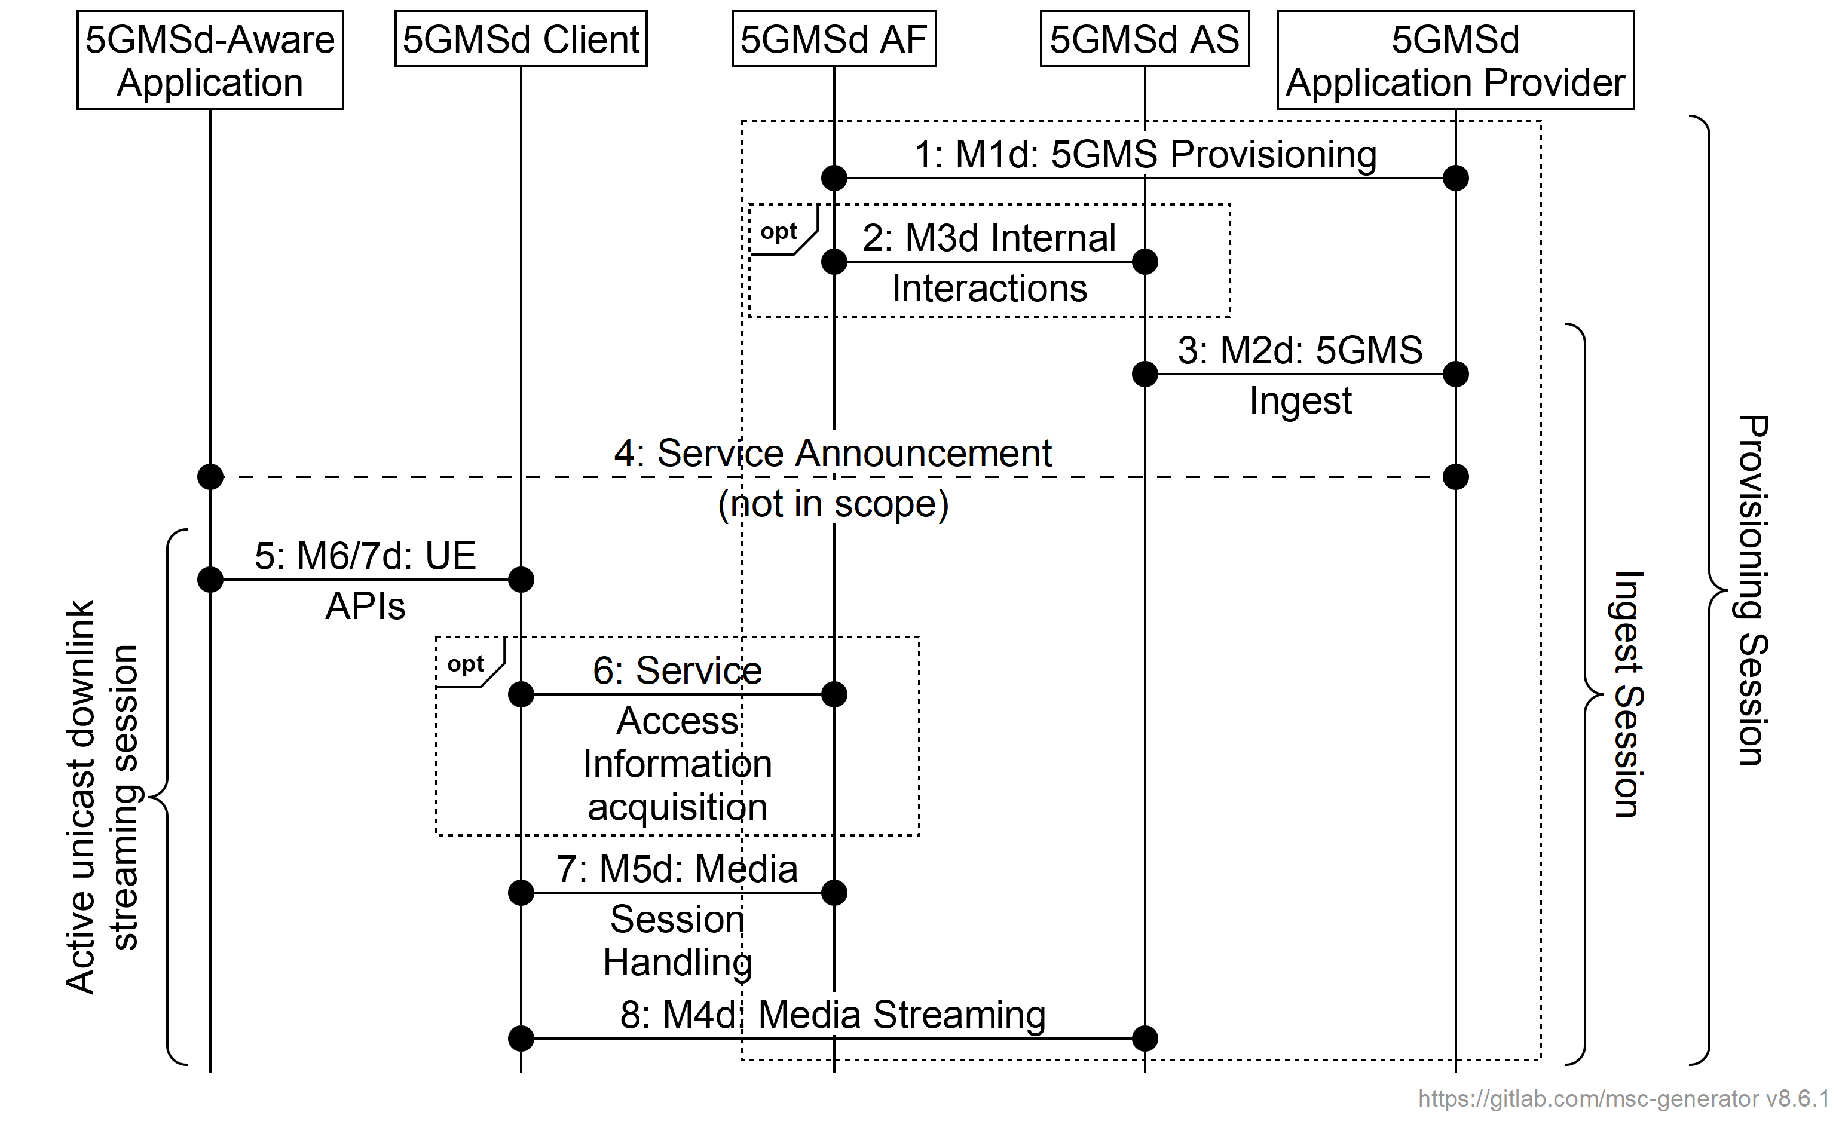
Figure 5.1-1: High-level procedure for downlink media streaming
The 5GMSd provisioning API at M1d allows selection of media session handling (M5d) and media streaming (M4d) options, including whether the media content is hosted on trusted 5GMSd AS instances. of provisioned 5GMSd features is captured in a Provisioning Session (see clause 5.3) that is uniquely identified in the 5GMS System by a Provisioning Session identifier. The Provisioning Session information may include Content Hosting Configurations, Content Preparation Templates, Server Certificates, Policy Templates, a Consumption Reporting Configuration, Metrics Reporting Configurations, Edge Resources Configurations and Event Data Processing Configurations.
The Consumption Reporting and/or Metrics Reporting Configuration information provisioned over M1d and passed to the 5GMSd Client by the 5GMSd AF over M5d determines the UE data to be collected by the 5GMSd Client and subsequently reported to the 5GMSd AF. The 5GMSd Application Provider is additionally able to provision Event Data Processing Configurations that specify data processing instructions for subsequent manipulation by the 5GMSd AF of UE data, whether reported by the 5GMSd Client or otherwise obtained, and rules for restricting the subsequent exposure by the 5GMSd AF of UE data to event consumers including the NWDAF defined in TS 23.288 [23] and/or the 5GMSd Application Provider.
The 5GMSd AF selects the M5d interface features according to the provisioning option. The Media Session Handling interface exposed by the 5GMSd AF can be used for core session handling; configuring content consumption measurement, logging, collection and reporting; configuring QoE metrics measurement, logging collection and reporting; requesting different policy and charging treatments; or 5GMSd AF-based Network Assistance.
When the media content is hosted by trusted 5GMSd AS instances, then the 5GMSd AF selects and configures the 5GMSd AS. Interactions between a 5GMSd AF and a 5GMSd AS (M3d interactions) take place for content hosting configuration, including 5GMS Ingest (M2d) and Media Streaming (M4d) resource reservations. The 5GMSd AS allocates M2d and M4d resources and communicates resource identifiers back to the 5GMSd AF. The 5GMSd AF provides information about the provisioned resources (in form of resource identifiers) for Media Session Handling (M5d), the 5GMSd Ingest (M2d) and the Media Streaming (M4d), to the 5GMSd Application Provider. The resource identifiers for Media Session Handling and Media Streaming are needed by the 5GMSd Client to access the 5GMSd functions.
When Content Hosting is provided by a 5GMSd AS in the external DN, then the M3d interface is not used and the 5GMSd AF does not provide 5GMS Ingest (M2d) and Media Streaming (M4d) resource reservations. M3d procedures are not standardized.
5GMSd Clients can (in principle) start streaming media as soon as the corresponding content is ingested by activating a unicast downlink streaming session. However, it may take some time until the media content is available for Media Streaming (via the Media Streaming API) or the distribution availability might be based on a provisioned schedule. The unicast downlink streaming session for a given UE (or "for each UE") is active from the time at which the 5GMSd-Aware Application activates the reception of a streaming service until its termination.
The 5GMSd-Aware Application receives application data from the 5GMSd Application Provider before receiving the downlink streaming media. The application data contains Service Access Information, which acts as an entry point for the 5GMSd Client to start the downlink streaming session. The 5GMSd Client may either receive a reference to that Service Access Information or the full Service Access Information from the 5GMSd Application Provider.
Steps:
1. The 5GMSd Application Provider creates a Provisioning Session with the 5GMSd AF and starts provisioning the usage of the 5G Media Streaming System. During the establishment phase, the used features are negotiated and detailed configurations are exchanged. The 5GMSd AF receives Service Access Information for M5d (Media Session Handling) and, where media content hosting is negotiated, Service Access Information for M2d (Ingestion) and M4d (Media Streaming) as well. This information is needed by the 5GMSd Client to access the service. Depending on the provisioning, only a reference to the Service Access Information might be supplied.
2. When Content Hosting is offered and selected there may be interactions between the 5GMSd AF and the 5GMSd AS at reference point M3d, e.g., to configure Server Certificates and/or Content Preparation Templates and to allocate 5GMSd content ingest and distribution resources by providing a Content Hosting Configuration. The 5GMSd AS provides resource identifiers for the allocated resources to the 5GMSd AF, which then provides the information to the 5GMSd Application Provider.
3. The 5GMSd Application Provider starts the Ingest Session by ingesting content. In case of live services, the content is continuously ingested. In case of on-demand streaming services, the content may be uploaded once and then updated later on.
NOTE 1: A 5GMSd AS in the external Data Network may provide the Content Hosting.
4. The 5GMSd Application Provider provides the Service Announcement Information to the 5GMSd-Aware Application. The service announcement includes either the whole Service Access Information (i.e. details for Media Session Handling (M5d) and for Media Streaming access (M4d)) or a reference to the Service Access Information or pre-configured information. When only a reference is included, the 5GMSd Client fetches (in step 6) the Services Access Information when needed. In a specific case, the 5GMSd service may be announced using a 3GPP Service URL (see clause 4.10) that will launch the service as defined in clause 9.
5. When the 5GMSd-Aware Application decides to begin streaming, the Service Access Information (all or a reference) is provided to the 5GMSd Client. The 5GMSd Client activates the unicast downlink streaming session.
6. (Optional) In case the 5GMSd Client received only a reference to the Service Access Information, then it acquires the Service Access Information from the 5GMSd AF.
NOTE 2: Pre-caching of Service Access Information may also be supported by the 5GMS Client to speed up the activation of the service.
7. The 5GMSd Client uses the Media Session Handling API exposed by the 5GMSd AF at M5d. The Media Session Handling API is used for configuring content consumption measurement, logging, collection and reporting; configuring QoE metrics measurement, logging, collection and reporting; requesting different policy and charging treatments; or 5GMSd AF-based Network Assistance. The actual time of API usage depends on the feature and interactions that may be used during the media content reception.
8. The 5GMSd Client activates reception of the media content.

5.2 Baseline procedure for unicast downlink media streaming session establishment

5.2.1 General
This clause describes the baseline procedure for establishing a unicast downlink media streaming session. This baseline procedure assumes that the 5GMSd AF and the 5GMSd AS both reside in the external DN and that there are no interactions between the 5GMSd AF and the 5G System.

5.2.2 Progressive download of on-demand content
This baseline procedure describes the establishment of a unicast downlink streaming session. A streaming session may use 3GP File Format (Progressive Download), 3GP Timed Text or other (potentially non-3GPP defined) formats.
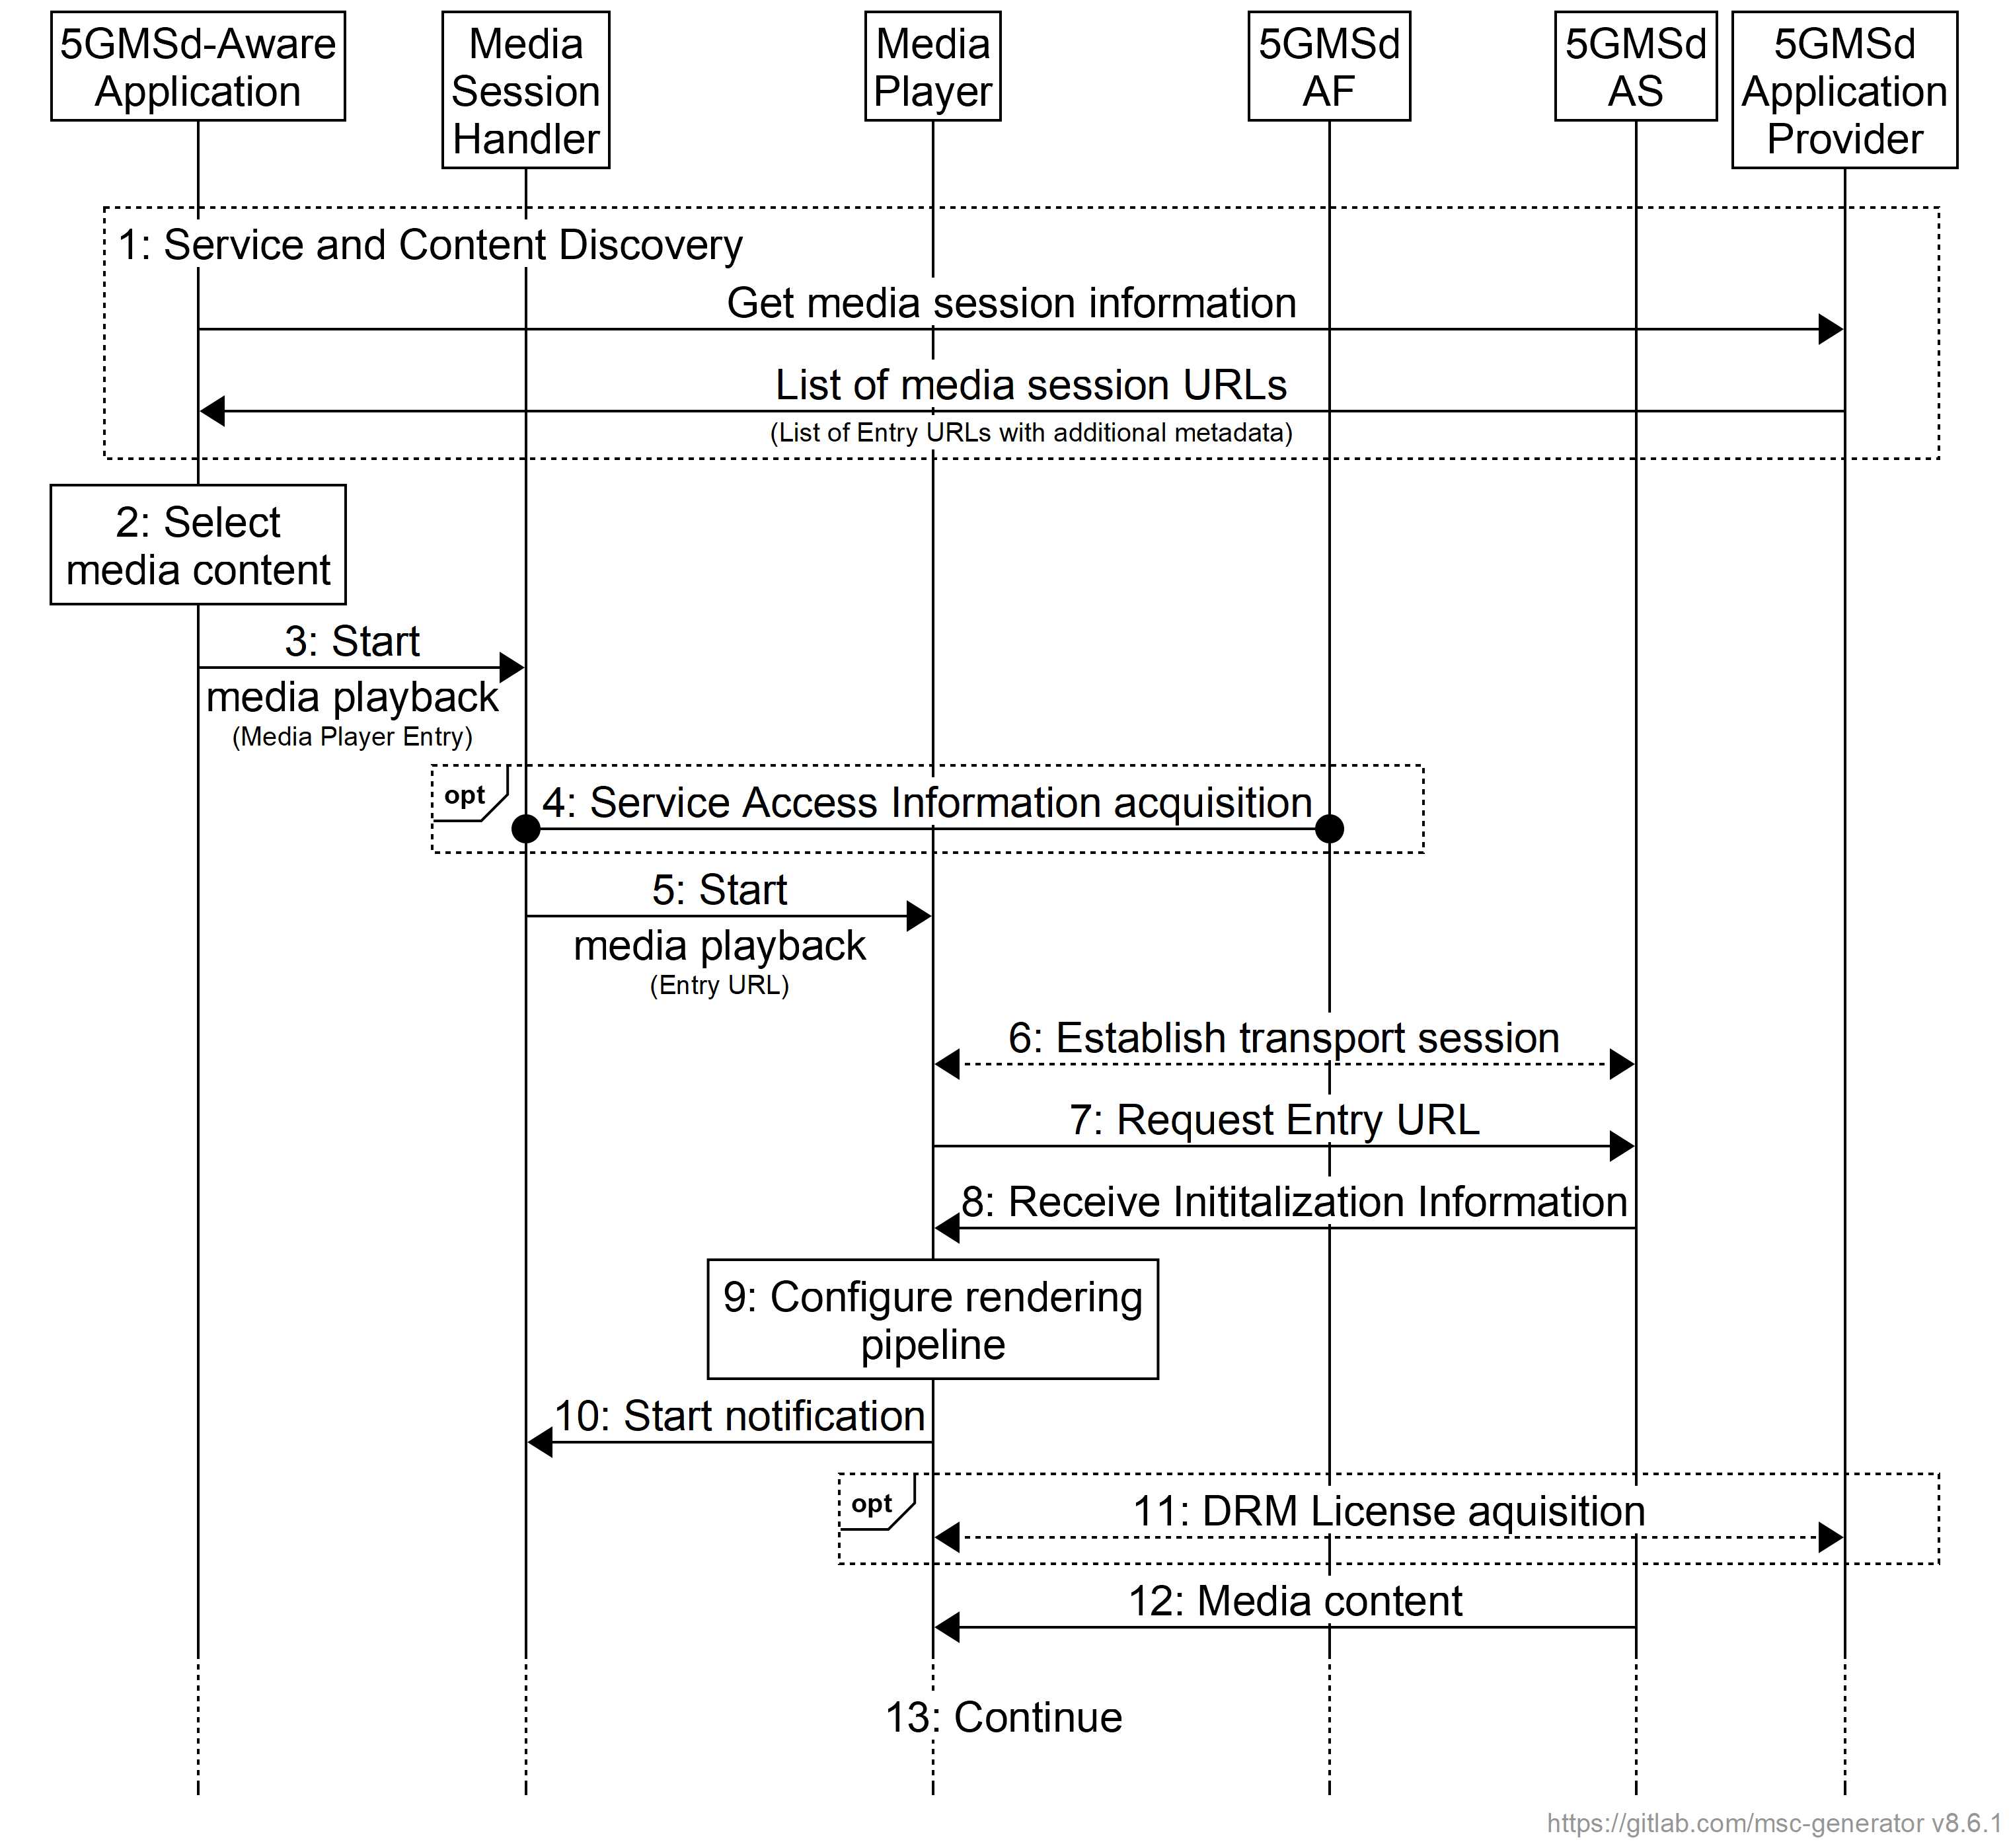
Figure 5.2-1: High-level procedure for progressive download for on-demand media
Prerequisites:
- The 5GMSd Application Provider has provisioned the 5G Media Streaming System and has set up content ingest.
- The 5GMSd-Aware Application has received the service announcement from the 5GMSd Application Provider.
Steps:
1: The 5GMSd-Aware Application triggers the Service Announcement and Service and Content Discovery procedure. The Service Announcement includes either the whole Service Access Information (i.e. details for Media Session Handling (M5d) and for Media Streaming access (M4d)) or a reference to the Service Access Information.
NOTE: The Service and Content Discovery procedure only involves the 5GMSd-Aware Application and the 5GMSd Application Provider and hence is out of scope of the present document.
2: A Media Player Entry is selected.
3: The 5GMSd-Aware Application triggers the Media Session Handler to start the playback. The Media Player Entry is provided to the Media Session Handler.
4: When the 5GMS-Aware Application has received only a reference to the Service Access Information (see step 1), the Media Session Handler interacts with the 5GMSd AF to acquire the whole Service Access Information.
5: The Media Session Handler triggers the Media Player to start the session.
6: The Media Player establishes the transport session.
7: The Media Player sends the request for the progressive download content.
8: The Media Player receives the initialization information of the progressive download content. The initialization information contains configuration parameters for reception of the media and, optionally, also DRM information.
9: The Media Player configures the rendering pipeline for media playback.
10: The Media Player notifies the Media Session Handler, providing the transport session information and some media content related information.
11: Optional: The Media Player acquires a DRM License from the 5GMSd Application Provider.
12: The Media Player receives media content and puts it into the rendering pipeline.
13: The Media Player continuously receives and plays back the media content.

5.2.3 DASH streaming
It is assumed here that the key information to initialize the media decoding and rendering pipeline is present in the Media Player Entry (or referenced by the Media Player Entry). The intention is to provide the 5GMSd Client with information to set up the media decoding and rendering pipeline in such a way that no pipeline reset is needed during the session. Implementations need to consider that parts of the information are provided with the initialization segments.
It is assumed that the client is enabled to use the same media decoding and rendering pipeline during the session.
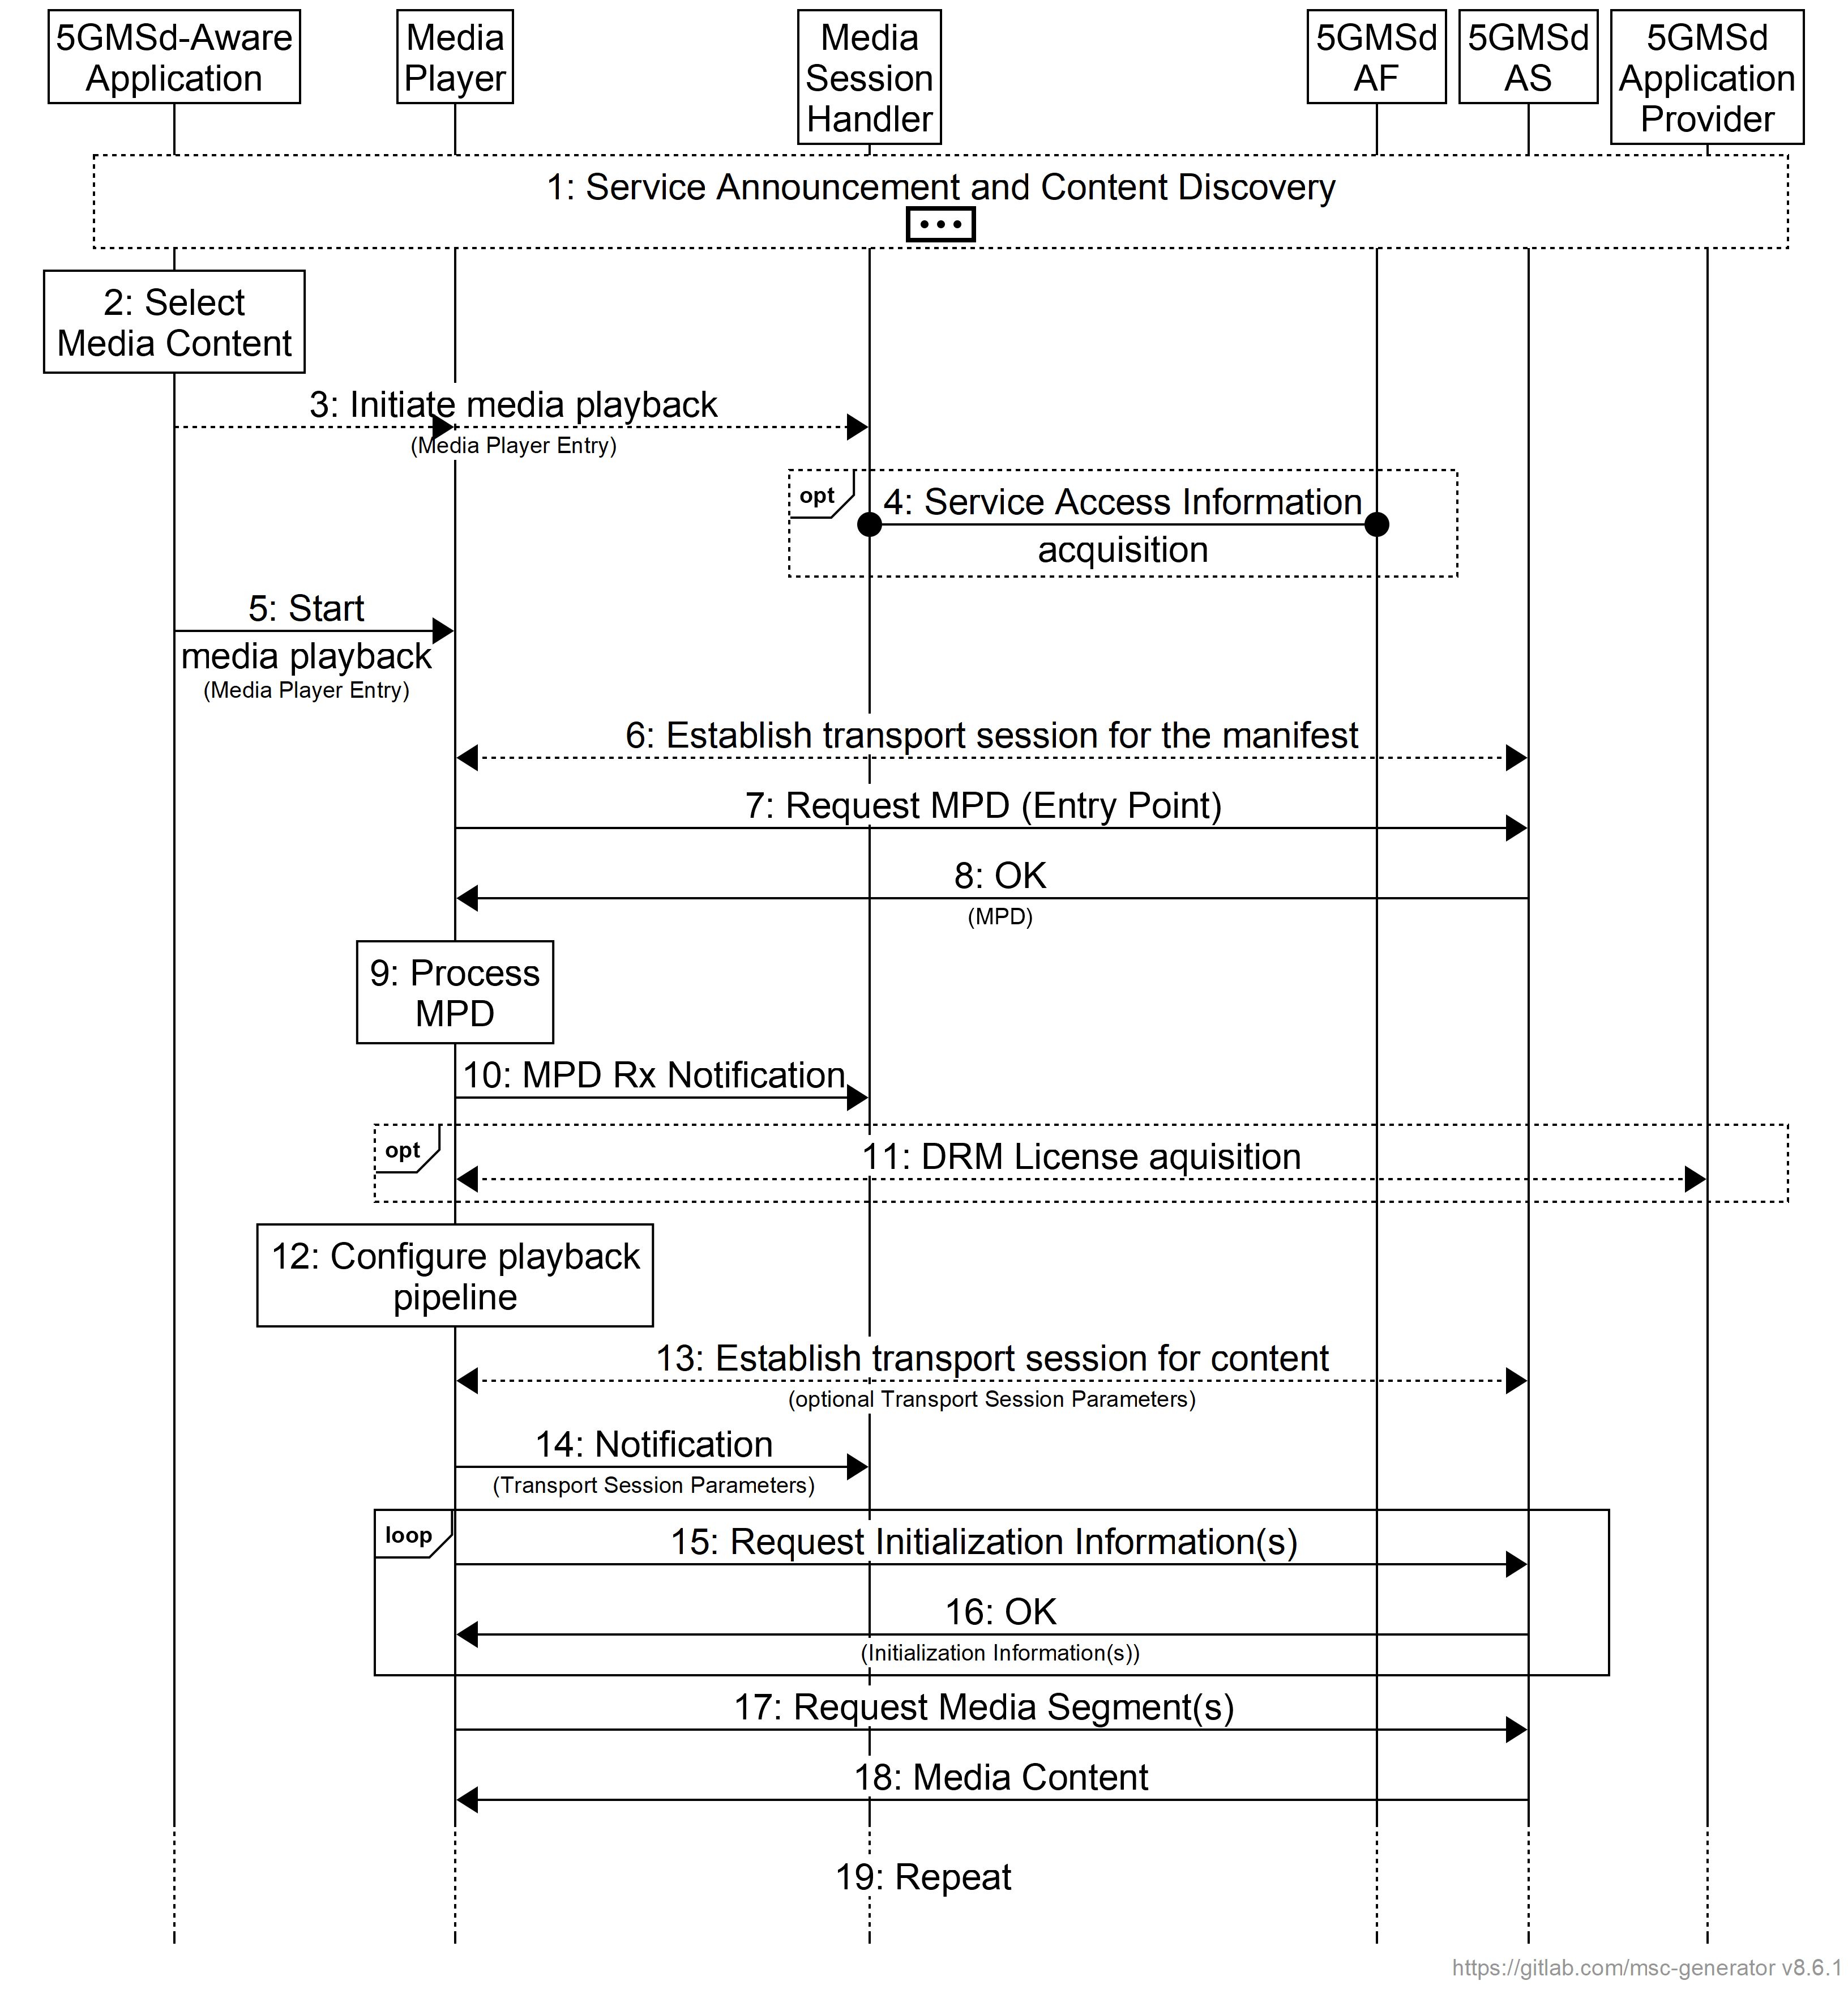
Figure 5.2-2: High-level procedure for DASH content
Prerequisites:
- The 5GMSd Application Provider has provisioned the 5G Media Streaming System and has setup content ingest.
- The 5GMSd Aware Application has received the service announcement from the 5GMS Application Provider.
Steps:
1: The 5GMSd Aware Application triggers the Service Announcement and Service and Content Discovery procedure. The Service and Content Discovery procedure only involves the App and the external Application Server. The Service Announcement includes either the whole Service Access Information (i.e. details for Media Session Handling (M5d) and for Media Streaming access (M4d)) or a reference to the service access information.
2: A media content item is selected.
3: The 5GMSd-Aware Application triggers the 5GMSd Client to start media playback. The Media Player Entry is provided to the 5GMSd Client.
4: When the 5GMS-Aware Application has received only a reference to the Service Access Information (see step 1), the Media Session Handler interacts with the 5GMSd AF to acquire the whole Service Access Information.
5: In parallel, the Media Player is invoked to start media access and playback.
6: The Media Player establishes the transport session for acquiring the MPD referenced by the Media Player Entry.
7: The Media Player requests the MPD.
8: The Media Player receives the MPD.
9: The Media Player processes the MPD. It determines for example the number of needed transport sessions for media acquisition. The Media Player should be able to use the MPD information to initialize the media pipelines for each media stream. The MPD should also contain information to initialize the DRM client, when DRM is used.
10: The Media Player notifies the Media Session Handler about the MPD. The notification may contain parameters from the MPD.
11: Optional: the Media Player acquires the necessary DRM information, for example a DRM License.
12: The Media Player configures the media playback pipeline.
13: The Media Player establishes the necessary transport sessions for the content. For example, the Media Player may establish one transport session for each media component (audio, video, etc) and possibly additional transport sessions for other media representations.
14: The Media Player notifies the Media Session Handler that it is ready to commence playback and optionally provides transport session parameters.
15: The Media Player requests initialization information. The Media Player repeats this step for each required initialization segment.
16: The Media Player receives the initialization information.
17: The Media Player requests media segments according to the MPD.
18: the Media Player receives media segments and puts the information into the appropriate media rendering pipeline.
19: Previous steps are repeated according to the MPD information.
NOTE: The Media Player can interact with multiple instances of the 5GMSd AS. The Media Player can be made aware of the 5GMSd AS instances via the manifest.

5.2.4 Procedures for downlink streaming to Media Players with different presentation manifests
Figure 5.2.4-1 illustrates a high-level procedure for downlink streaming to Media Players with different presentation manifests. The extensions compared to the DASH streaming in clause 5.2.3 are indicated in bold.
The procedure makes the following assumptions:
- Common media segments (e.g. based on CMAF [27]) are shared between multiple Media Players requiring different presentation formats (see clause 4.8).
- Key information to initialize the media decoding and rendering pipeline is present in the Media Player Entries (or referenced by the Media Player Entries).
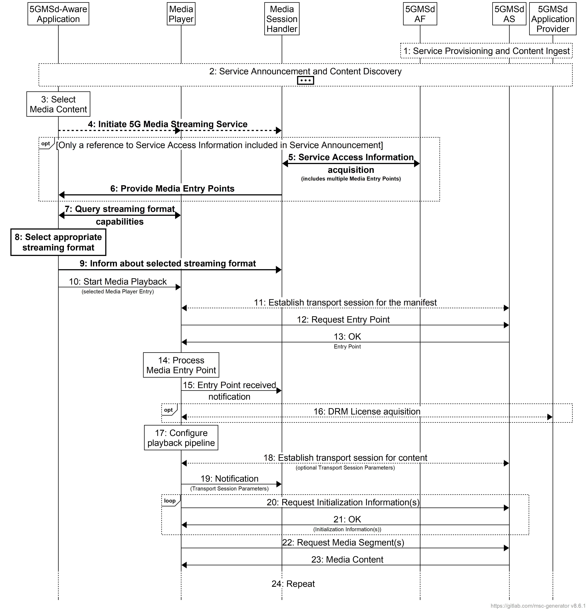
Figure 5.2.4-1: High-level procedure for CMAF content shared by different Media Players
Steps:
1: The 5GMSd Application Provider provisions the 5G Media Streaming System, including content hosting.
2: The 5GMSd-Aware Application triggers the Service Announcement and Service and Content Discovery procedure with the 5GMSd Application Provider. The Service Announcement includes either the whole Service Access Information (i.e. details for Media Session Handling (M5d) and for Media Streaming access (M4d) which may include a Media Entry Point URL for each of the different available presentation manifests, or a reference to the Service Access Information.
3: A media content item is selected.
4: The 5GMSd-Aware Application triggers the 5GMSd Client to initiate the 5G Media Streaming Service.
When the 5GMS-Aware Application has received only a reference to the Service Access Information (see step 1):
5: The Media Session Handler interacts with the 5GMSd AF to acquire the whole Service Access Information. The Service Access Information may include a Media Entry Point URL for each of the different available presentation manifests.
6: The Media Session Handler provides the Media Entry Points to the 5GMS-Aware Application. The information may indicate a precedence order for these Media Entry Points.
Then:
7: The 5GMSd-Aware Application queries the Media Player capabilities for different manifests. If multiple streaming formats are supported, a preferred one may be indicated in the response.
8: The 5GMSd-Aware Application selects one of the Media Entry Points based on the information provided in steps 5 and 6 above.
9: The 5GMSd-Aware Application informs the Media Session Handler about the streaming format of the chosen Media Entry Point, for example for Consumption Reporting purposes.
10: In parallel, the Media Player is invoked with the selected Media Entry Point to start media access and playback.
Steps 11 to 24 are identical to steps 6 to 19, respectively, in clause 5.2.3.

5.2.5 Procedures for downlink media streaming with per-application authorisation of media session handling operations

5.2.5.1 Overview
This clause defines procedures by which a 5GMSd Application Provider authorises a 5GMSd-Aware Application to invoke media session handling operations on the 5GMSd AF at reference point M5d.

5.2.5.2 Authorisation of media session handling at M5d based on access token
The 5GMSd Application Provider provides a different access token (e.g. a random string) via M8 to each 5GMSd-Aware Application, so that each application instance can identify itself uniquely to the 5GMSd AF. The access token is provided, for example, during the login procedure or is requested at a later stage. The validity of access tokens is often limited in time. The 5GMSd-Aware Application may need to refresh the access token depending on the token validity.
The 5GMSd-Aware Application passes the access token (via an M6 API call) to the Media Session Handler. When the Media Session Handler invokes a media session handling operation at reference point M5, it presents the access token to the 5GMSd AF. Upon receipt of such an access token, the 5GMSd AF verifies whether the access token is valid. If the token is valid, the 5GMSd-Aware Application is authorised to invoke the operation.
When the OAuth 2.0 architecture [35] is used, the 5GMSd Application Provider acts as authorization server, the 5GMSd-Aware Application acts as client and the 5GMSd AF acts as resource server.
The call flow is depicted below.
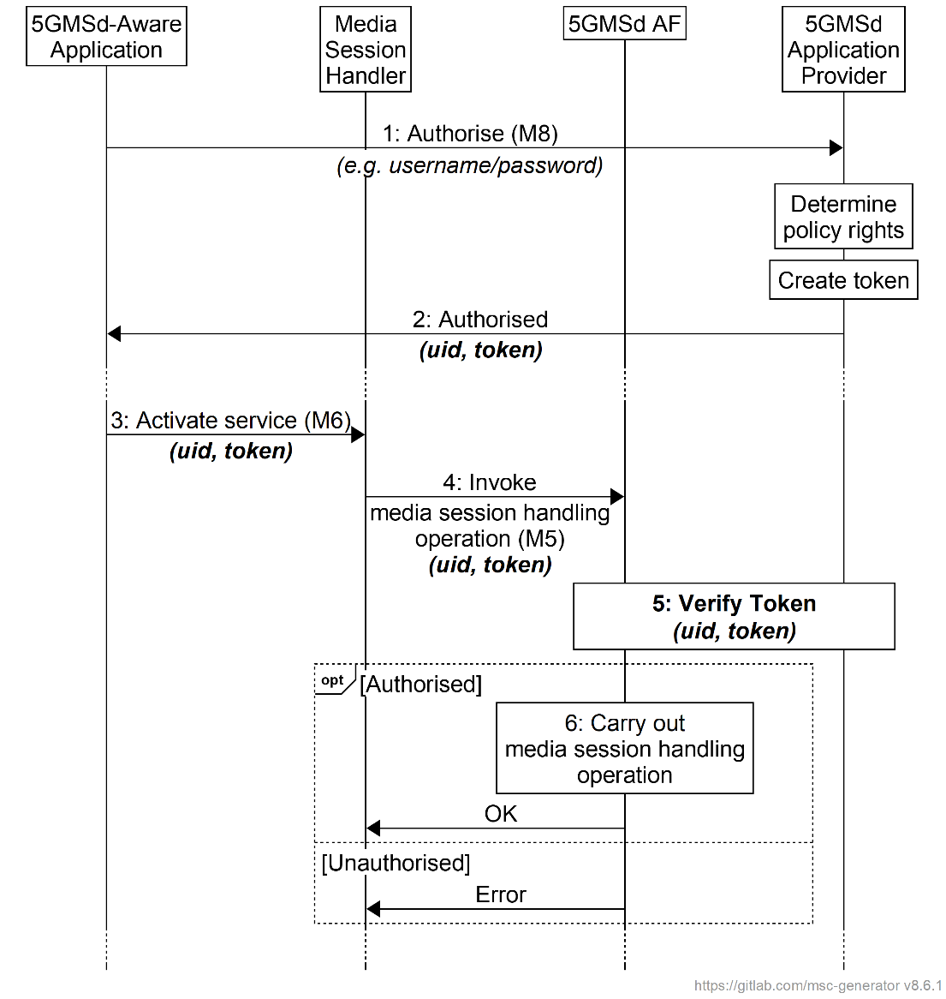
Figure 5.2.5.2-1: Call flow for authorisation based on access token
The steps are as follows:
1. When the user wants to use the 5GMSd-Aware Application to consume e.g. video content, the user needs to authenticate with the application and the 5GMSd Application Provider at reference point M8. (In some cases, this authorisation may be cached/stored by the application, so that the user is not always challenged to provide the login credentials.)
NOTE 1: The application may be a native application (e.g. an Android application) or a browser application.
2. Based on the login credentials supplied in the previous step, the 5GMSd Application Provider determines the policy rights to which this application service subscription is entitled (e.g. the user may have subscribed to an SD quality video service or a 4K quality video service). According to the subscription entitlement level, the 5GMSd Application Provider creates an access token and passes this token back to the application with the login response.
NOTE 2: Access tokens may be long-lived. The 5GMSd-Aware Application may need to refresh the access token, depending on its validity period.
3. When the 5GMSd-Aware Application (immediately or later) invokes the Media Session Handler to activate media session handling for a media delivery session, the application passes the access token to the Media Session Handler. The access token may embed a user identifier, or the user identifier may be passed as separate (anonymised) parameter.
NOTE 3: The access token may be included as a parameter of the 3GPP Service URL used to launch media session handling (see table 4.10.2-1).
4. When the Media Session Handler invokes a media session handling operation on the 5GMSd AF at reference point M5, it provides the access token, e.g. as an HTTP request header.
5. The 5GMSd AF verifies the access token with the 5GMSd Application Provider.
6. If the 5GMSd AF has verified that the 5GMSd-Aware Application is authorised to invoke the media session handling operation (based on the token), the 5GMSd AF carries out the requested operation. (This may involve further interaction with the PCF or NEF.)

5.2.5.3 Authorisation of media session handling at M5d based on redirection
When the OAuth 2.0 [35] Authorization Code grant type is used, either the 5GMSd Application Provider or the 5GMSd AF acts as authorization server, as shown in figure 5.2.5.3-1. The Media Session Handler acts as client and the 5GMSd AF acts as resource server.
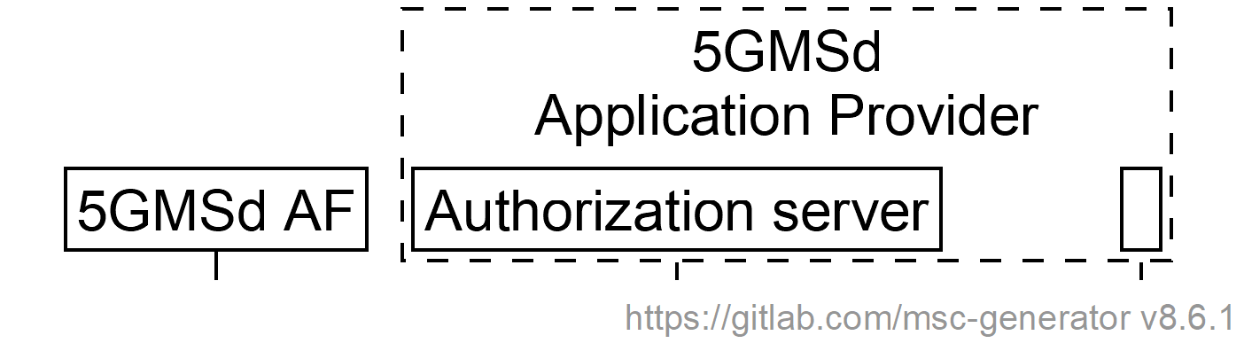 | 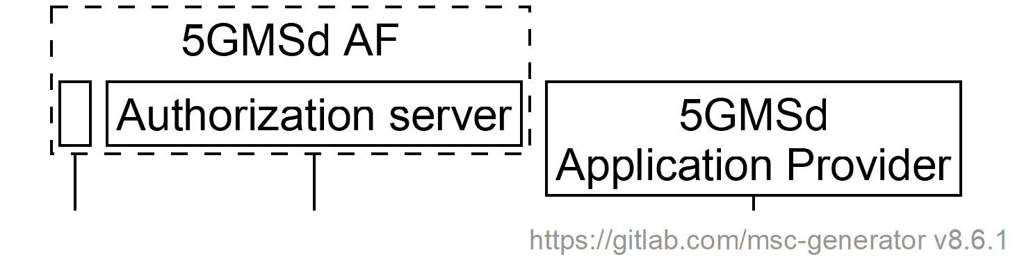
a. 5GMSd Application Provider acts as authorization server | b. 5GMSd AF acts as authorization server
Figure 5.2.5.3-1: Alternative deployments of authorization server
The call flow is depicted below.
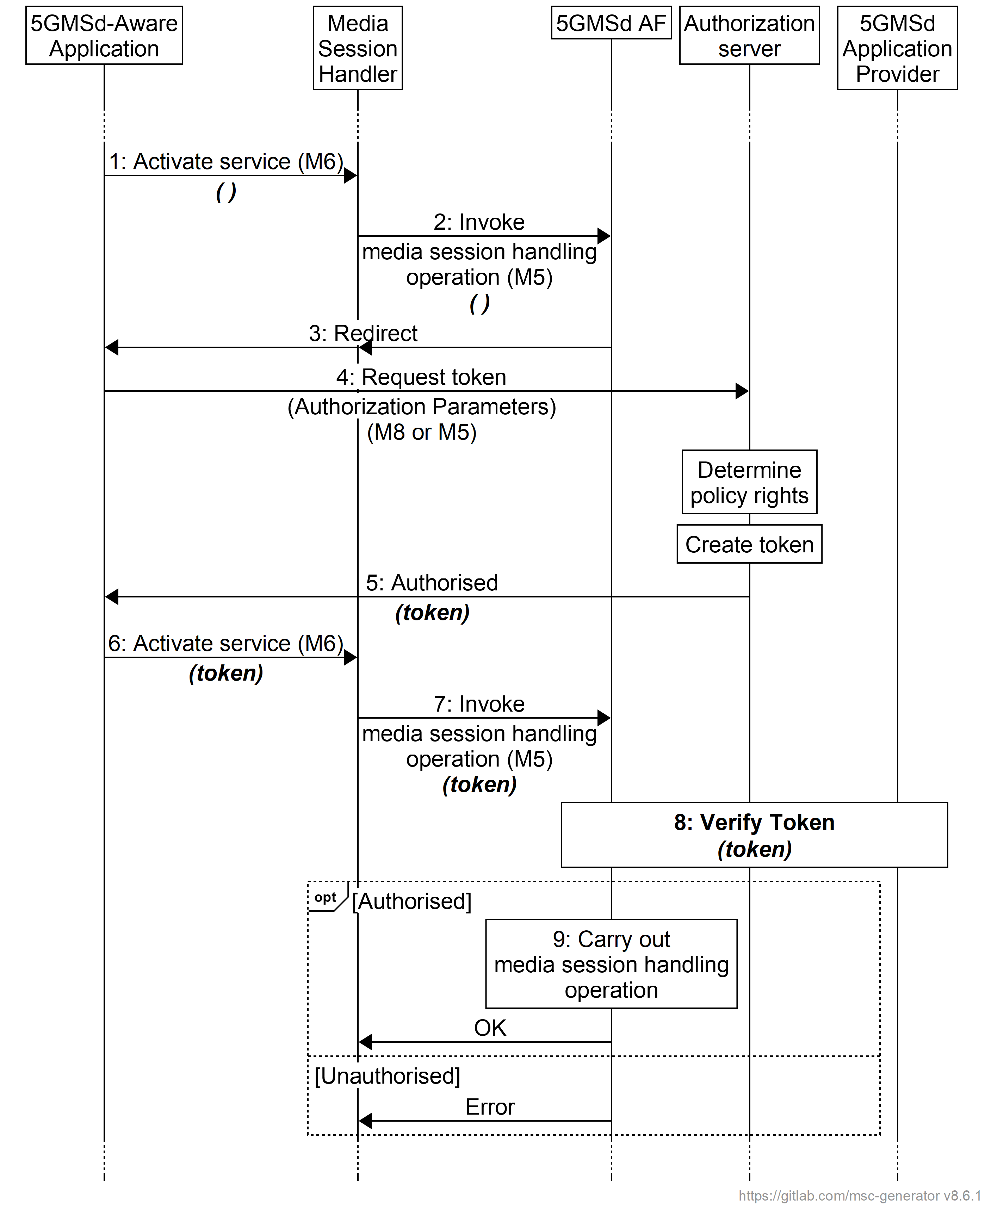
NOTE: The AuthZ function is realised by the 5GMSd Application Provider or by the 5GMSd AF.

Figure 5.2.5.3-2: Call flow for authorisation based on access token
1. When the 5GMSd-Aware Application (immediately or later) invokes the Media Session Handler to activate media session handling for a media delivery session, the application passes only the session access information.
2. When the Media Session Handler invokes a media session handling operation on the 5GMSd AF (M5 Service) at reference point M5...
3. ...the 5GMSd AF identifies that authorisation is required for accessing the requested service. The 5GMSd AF sends a redirect to the Media Session Handler, which is forwarded to the 5GMSd-Aware Application.
4. The 5GMSd-Aware Application requests an access token from the authorization server, which is realised either by the 5GMSd Application Provider (at reference point M8u) or by the 5GMSd AF (at reference point M5u).
5. After determining the policy rights of the requesting 5GMSd-Aware Application, the Authorization Service creates an access token and provides it to the 5GMSd-Aware Application.
6. The 5GMSd-Aware Application attempts to activate the media session handling operation again, this time providing the access token obtained in the previous step as an additional input paramrter.
7. The Media Session Handler invokes the media session handling operation again, this time providing the obtained access token.
5. The 5GMSd AF verifies the access token with the 5GMSd Application Provider.
6. If the 5GMSd AF is satisfied that the 5GMSd-Aware Application is authorised to invoke the media session handling operation (based on the presented access token), the 5GMSd AF carries out the requested operation. (This may involve further interaction with the PCF or NEF.)

5.2.6 Procedures for downlink streaming from multiple service locations
Figure 5.2.6-1 illustrates a variant of the high-level procedure for DASH streaming defined in clause 5.2.3 that permits downlink streaming from multiple service locations. Differences from the baseline procedure in clause 5.2.3 are highlighted in boldface.
The procedure makes the following assumptions:
- The Media Player has the necessary functionality to stream media content from multiple service locations. This may include the functionality needed to switch between service locations, for example by client decision, or based on steering information from the network, or the use of multiple service locations concurrently, etc.
- Multiple service location configuration information required to access content across multiple service locations is available within the Media Player Entry (or available alongside the Media Player Entry such as within a document referenced by the Media Player Entry). This configuration information may be:
- Embedded in a Media Player Entry document (e.g., MPD),
- Provided alongside the Media Player Entry document, such as in a separate document referenced by a Media Player Entry document (e.g., MPD), or
- Provided as the Media Player Entry document with a reference to a document containing the media streaming presentation information (e.g., MPD).
- Content is hosted at two or more service locations. These service locations may be located inside the 5GMS System (i.e., hosted by the 5GMSd AS) or outside (i.e., hosted by the 5GMSd Application Provider).
NOTE: It is the responsibility of the 5GMSd Application Provider to configure and provision service locations hosted outside of the 5GMS System. In such cases, the 5GMSd Application Provider is also responsible for updating the Media Player Entry to include the necessary multiple service location configuration information to access content from these service locations.
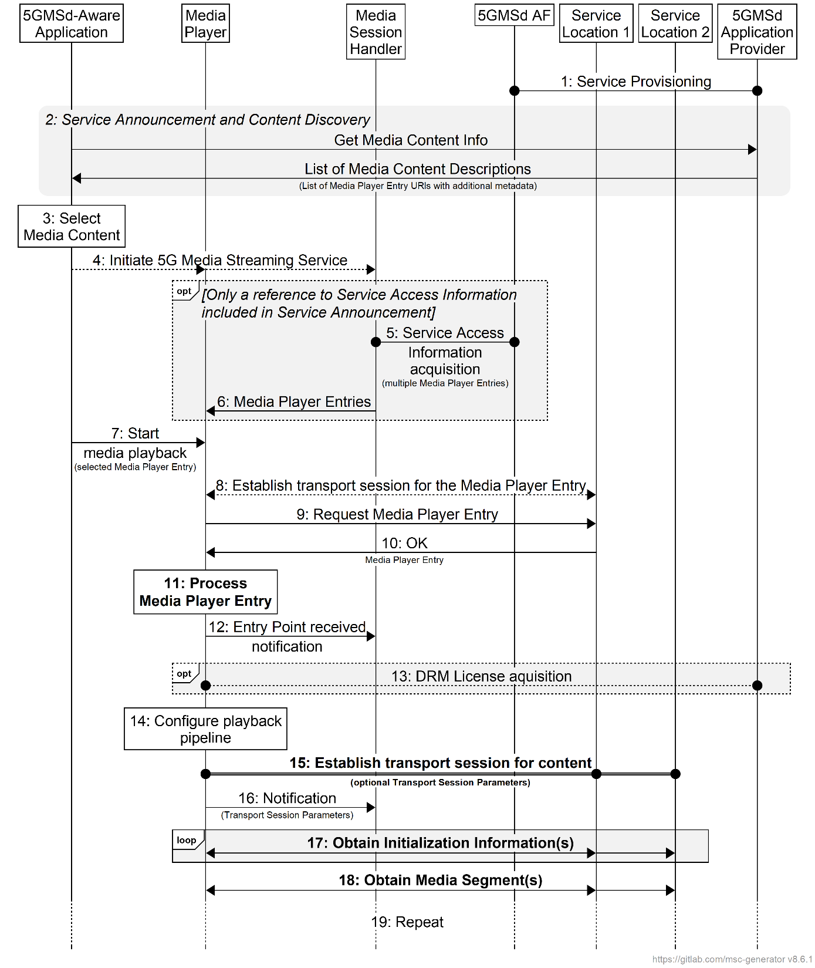
Figure 5.2.6-1: High-level procedure for downlink streaming from multiple service locations
within the 5GMS System
Steps:
1. The 5GMSd Application Provider provisions the 5G Media Streaming System, including content hosting and ingest, such that content is available from two or more service locations (labelled Service Location 1 and Service Location 2). Upon successful provisioning and content ingest (see clause 5.4.4), either the 5GMSd Application Provider or the 5GMSd AS may create or update Media Player Entry documents (or documents pointed to by each Media Player Entry document) to include any necessary multiple service location configuration information required by the 5GMSd Client to access media content from multiple service locations.
2. The 5GMSd-Aware Application triggers the Service Announcement and Service and Content Discovery procedure. The Service and Content Discovery procedure only involves the 5GMSd-Aware Application and the 5GMSd Application Provider. The Service Announcement includes either the whole Service Access Information (i.e. details for Media Session Handling at reference point M5d and for Media Streaming access at reference point M4d) or a reference to the whole Service Access Information.
3. A media content item is selected.
4. The 5GMSd-Aware Application triggers the 5GMSd Client to initiate the 5G Media Streaming Service.
When the 5GMS-Aware Application has received only a reference to the Service Access Information (see step 1):
5. The Media Session Handler interacts with the 5GMSd AF to acquire the whole Service Access Information. The Service Access Information may include Media Player Entry URLs.
6. The Media Session Handler provides the Media Player Entries to the 5GMS-Aware Application. The information may indicate a precedence order for these Media Player Entries.
Then:
7. The Media Player is invoked with the selected Media Player Entry to start media access and playback.
8. The Media Player establishes the transport session for acquiring the Media Player Entry.
9. The Media Player requests the Media Player Entry.
10. The Media Player receives the Media Player Entry.
11. The Media Player processes the Media Player Entry. From the Media Player Entry, the Media Player determines the multiple service location configuration, including the locations of the available service locations where content can be accessed and the method in which it should access this content (e.g., switch between service locations, use of a content steering to guide access to service locations, simultaneous use of service locations, etc.). It further determines, for example, the number of needed transport sessions for media acquisition to each service location. The Media Player should be able to use the Media Player Entry information to initialize the media pipelines for each media stream. The Media Player Entry should also contain information to initialize the DRM client, when DRM is used.
12. The Media Player notifies the Media Session Handler about the Media Player Entry.
13. Optional: the Media Player acquires the necessary DRM information, for example a DRM License.
14. The Media Player configures the media playback pipeline.
15. The Media Player establishes the necessary transport sessions for the content according to the multiple service location strategy and configuration information indicated by the Media Player Entry. These transport sessions may be established between the Media Player and any one or more of the available service locations. For example, the Media Player may establish one transport session for each media component (audio, video, etc) and possibly additional transport sessions for other media representations to each service location.
16. The Media Player notifies the Media Session Handler that it is ready to commence playback and optionally provides transport session parameters for those transport sessions terminating at the 5GMSd AS.
17. The Media Player requests and obtains the initialization information according to the multiple service location strategy in use. This initialization information may be obtained from any one service location or a combination of service locations. The Media Player repeats this step for each required initialization segment.
18. The Media Player requests and obtains the media segments according to the multiple service location strategy in use. These media segments may be obtained from any one service location or a combination of service locations. The received information is put into the appropriate media rendering pipeline.
19. Previous steps are repeated according to the Media Player Entry information.

5.3 Provisioning Session for media streaming

5.3.1 Domain model
The M1d baseline domain model is depicted in figure 5.3.1-1 overleaf. It consists of a Provisioning Session, which contains at least one of the following:
- A Content Hosting Configuration,
- A Consumption Reporting Configuration which defines consumption measurement, logging, collection and reporting functionality,
- A Policy Template,
- A Metrics Reporting Configuration which defines QoE metrics measurement, logging, collection and reporting functionality,
- An Edge Resources Configuration specifying the requirements for edge processing as defined in TS 23.548 [15] and TS 23.558 [16] in support of the Provisioning Session, including eligibility criteria that indicate the circumstances in which edge computing is to be used for Media Streaming sessions associated with this Provisioning Session and parameters indicating the tolerance of the application for relocation of the Edge AS, or
- An Event Data Processing Configuration which contains data manipulation instructions to be performed on UE data by the Data Collection AF including, but not limited to, reporting format conversion, data normalisation, domain-specific anonymisation of data and (dis)aggregation of data into exposed events. This entity includes one or more Data Access Profiles, each one defining a specific access level for controlling the event information exposed to an event consumer.
Each Provisioning Session is uniquely identified within the 5GMS System by a Provisioning Session identifier.
When a certain 5GMS feature is selected, the 5GMSd AF compiles the resulting Service Access Information so that the 5GMSd Client can access the services via M4d and/or M5d.

Figure 5.3.1-1: M1d provisioning domain model

The M3d baseline domain model used by the 5GMSd AF to configure Content Hosting in the 5GMSd AS is depicted in figure 5.3.1-2 below. It comprises a set of Content Hosting Configurations, each containing one Ingest Configuration and one or more Distribution Configurations. A Distribution Configuration may reference Server Certificates for presentation at reference point M4d and/or Content Preparation Templates specifying media manipulation by the 5GMSd AS between media ingest at reference point M2d and media distribution at reference point M4d.
Figure 5.3.1-2: M3d configuration domain model

5.3.2 Baseline provisioning procedure
The present clause describes the baseline procedure to provision the features using the 5GMS System.
NOTE 1: SLA negotiations between the 5GMSd Application Provider and the 5GMS System provider are outside the scope of the present specification and are included in the figure below for illustrative purposes only.
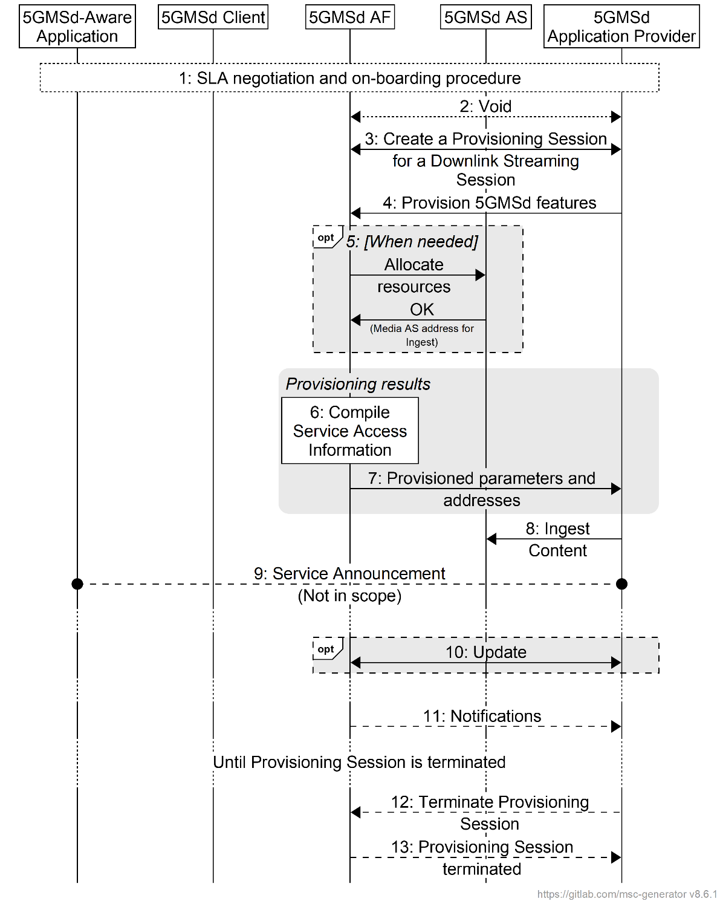
Figure 5.3.2-1: High-level procedure for provisioning the 5GMS System
for downlink media streaming sessions
Steps:
1. The 5GMSd Application Provider discovers the address (URL) of the 5GMSd AF (M1d) for Session Provisioning.
2. Void.
3. The 5GMSd Application Provider creates a Provisioning Session, providing its 5GMSd Application Provider identifier as input. 5GMSd Application Provider queries the capabilities and authorized features.
4. The 5GMSd Application Provider specifies one or more 5GMSd features in the Provisioning Session. A set of authorized features is activated, such as content consumption measurement, logging, collection and reporting; QoE metrics measurement, logging, collection and reporting; dynamic policy; network assistance; and content hosting (including ingest).
One or more External service identifiers are supplied by the 5GMSd Application Provider to support the later retrieval of Service Access Information from the 5GMSd AF by the Media Session Handler.
When the content hosting feature is offered and selected, the 5GMS Application Provider configures the content hosting behaviour of the 5GMSd AS. This Content Hosting Configuration is specified in clause 5.4 and includes selecting the ingest protocol and format, caching and proxying of media objects, content preparation, access protection (e.g. URL signing) and indicating a target distribution area (e.g. through geofencing).
When the dynamic policy feature is offered and selected, the 5GMSd Application Provider specifies a set of policies which can be invoked for the unicast downlink streaming session. This may include an L4S enablement flag indicating whether ECN marking is a requirement of the Policy Template. It may also include a QoS monitoring configuration indicating that QoS monitoring may be required when this Policy Template is instantiated by the 5GMSd Client, and which QoS parameters are to be monitored in that case. The UE becomes aware of the selected policies in the form of a list of valid Policy Template Ids.
When the content consumption measurement, logging, collection and reporting feature is offered and selected, the 5GMSd Application Provider indicates the desired reporting interval. When the 5GMSd Application Provider has delegated Service Access Information handling to the 5GMS System, then location reporting is also selected or de-selected.
When the QoE metrics measurement, logging, collection and reporting feature is offered and selected, the 5GMSd Application Provider provides configuration input on the QoE post processing. When the 5GMSd Application Provider has delegated Service Access Information handling to the 5GMS System, then more detailed metrics reporting is configured.
When the edge computing feature is offered and selected, the 5GMSd Application Provider provides one or more Edge Resources Configurations that can be used to support either client-driven management or Application Provider-driven management of edge resources associated with the Provisioning Session.
When the event data processing feature is offered and selected, the 5GMSd Application Provider provides one or more Event Data Processing Configurations that determine how, in the scope of the Provisioning Session, content consumption and QoE metrics collected from the UE and application logs collected from the 5GMSd AS are processed into events and exposed to subscribers.
5. When content hosting is desired, the 5GMSd AF interacts with the 5GMSd AS at reference point M3d to allocate M2d resources and to configure the ingest format by means of a Content Hosting Configuration (defined in clause 5.4) which may reference Server Certificates and Content Preparation Templates, as required. The 5GMSd AS responds with the M2d content ingest address.
6. The 5GMSd AF compiles the Service Access Information. The Service Access Information contains access details and options such as the Provisioning Session identifier, M5d (Media Session Handling) addresses for content consumption reporting, QoE metrics reporting, dynamic policy, network assistance, etc. When content hosting is offered and has been selected in step 4, then also M4d (Media Streaming) information such as the DASH MPD is included.
7. The 5GMSd AF provides the results to the 5GMSd Application Provider.
a. When the 5GMSd Application Provider has selected full Service Access Information, then the results are provided in the form of addresses and configurations for M2d (Ingest), M5d (Media Session Handling) and M4d (Media Streaming).
b. When the 5GMSd Application Provider delegated the Service Access Information handling to the 5GMS System, then a reference to the Service Access Information (e.g., a URL) is provided. The Media Session Handler fetches the full Service Access Information later from the 5GMSd AF.
8. When content hosting is offered and has been selected in step 4, the 5GMSd Application Provider can start supplying content at the M2d ingest interface. In the case of progressive download or on-demand DASH sessions, the 5GMSd Application Provider makes the content assets available. In the case of Live DASH streaming sessions, the 5GMSd Application Provider starts supplying the live content.
9. The 5GMSd Application Provider executes Service Announcement and updates the UEs (during the lifetime of the Provisioning Session).
Optional:
10. The 5GMSd Application Provider may update the Provisioning Session.
Depending on the parameters of the Provisioning Session:
11. The 5GMSd AF may send event-related or periodic notifications to the 5GMSd Application Provider.
According to schedule, or upon request:
12. The 5GMSd Application Provider may manually terminate the Provisioning Session (at any time). All associated resources are released. Content may be removed from the 5GMSd AS. The 5GMSd Application Provider may configure a schedule for Provisioning Session termination.
13. The 5GMSd AF sends a notification upon Provisioning Session termination.
The 5GMSd AF may request the creation or reuse of one or more network slices for distributing the content of the provisioned session. If more than one network slice is provisioned for the distribution of the content of a session, the list of allowed S-NSSAIs shall be conveyed to the target UEs (e.g. through URSP or through M5d or M8d).
NOTE 2: The 5GMSd AS(s) serving the content are only accessible through the DNN(s) used by the network slice(s) provisioned for the distribution of that content.

5.3.3 Baseline provisioning procedure with authorisation of 5GMSd Application Provider
This clause describes the baseline procedure to provision the features using the 5GMS System with authorisation of the 5GMSd Application Provider to support subsequent authorisation of media session handling for downlink media streaming per clause 5.2.5. When CAPIF is used, the authorization server is realised by the CAPIF core function, as shown in figure 5.2.5.3-1a. Otherwise, it is realised by the 5GMSd AF, as shown in figure 5.2.5.3-1b.
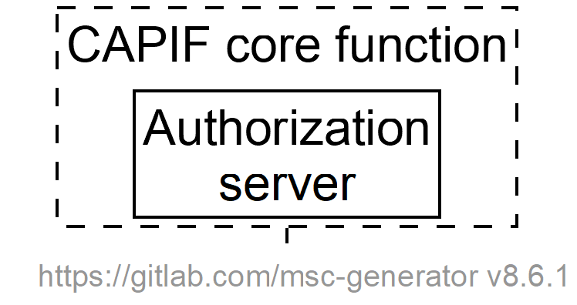  a. CAPIF core function acts as authorization server | 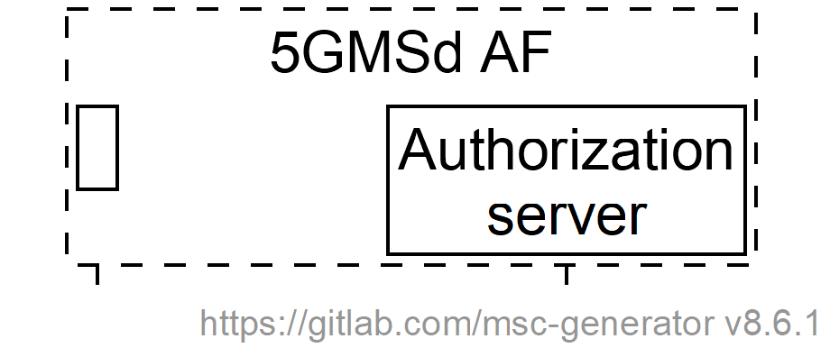  b. 5GMSd AF acts as  authorization server
Figure 5.3.3-1: Alternative deployments of authorization server
The steps in the call flow sequence are as follows with differences from the baseline call flow in clause 5.3.2 highlighted in bold.
NOTE 1: Service Level Agreement (SLA) negotiations between the 5GMSd Application Provider and the 5GMS System provider are outside the scope of the present specification and are included in the figure below for illustrative purposes only.
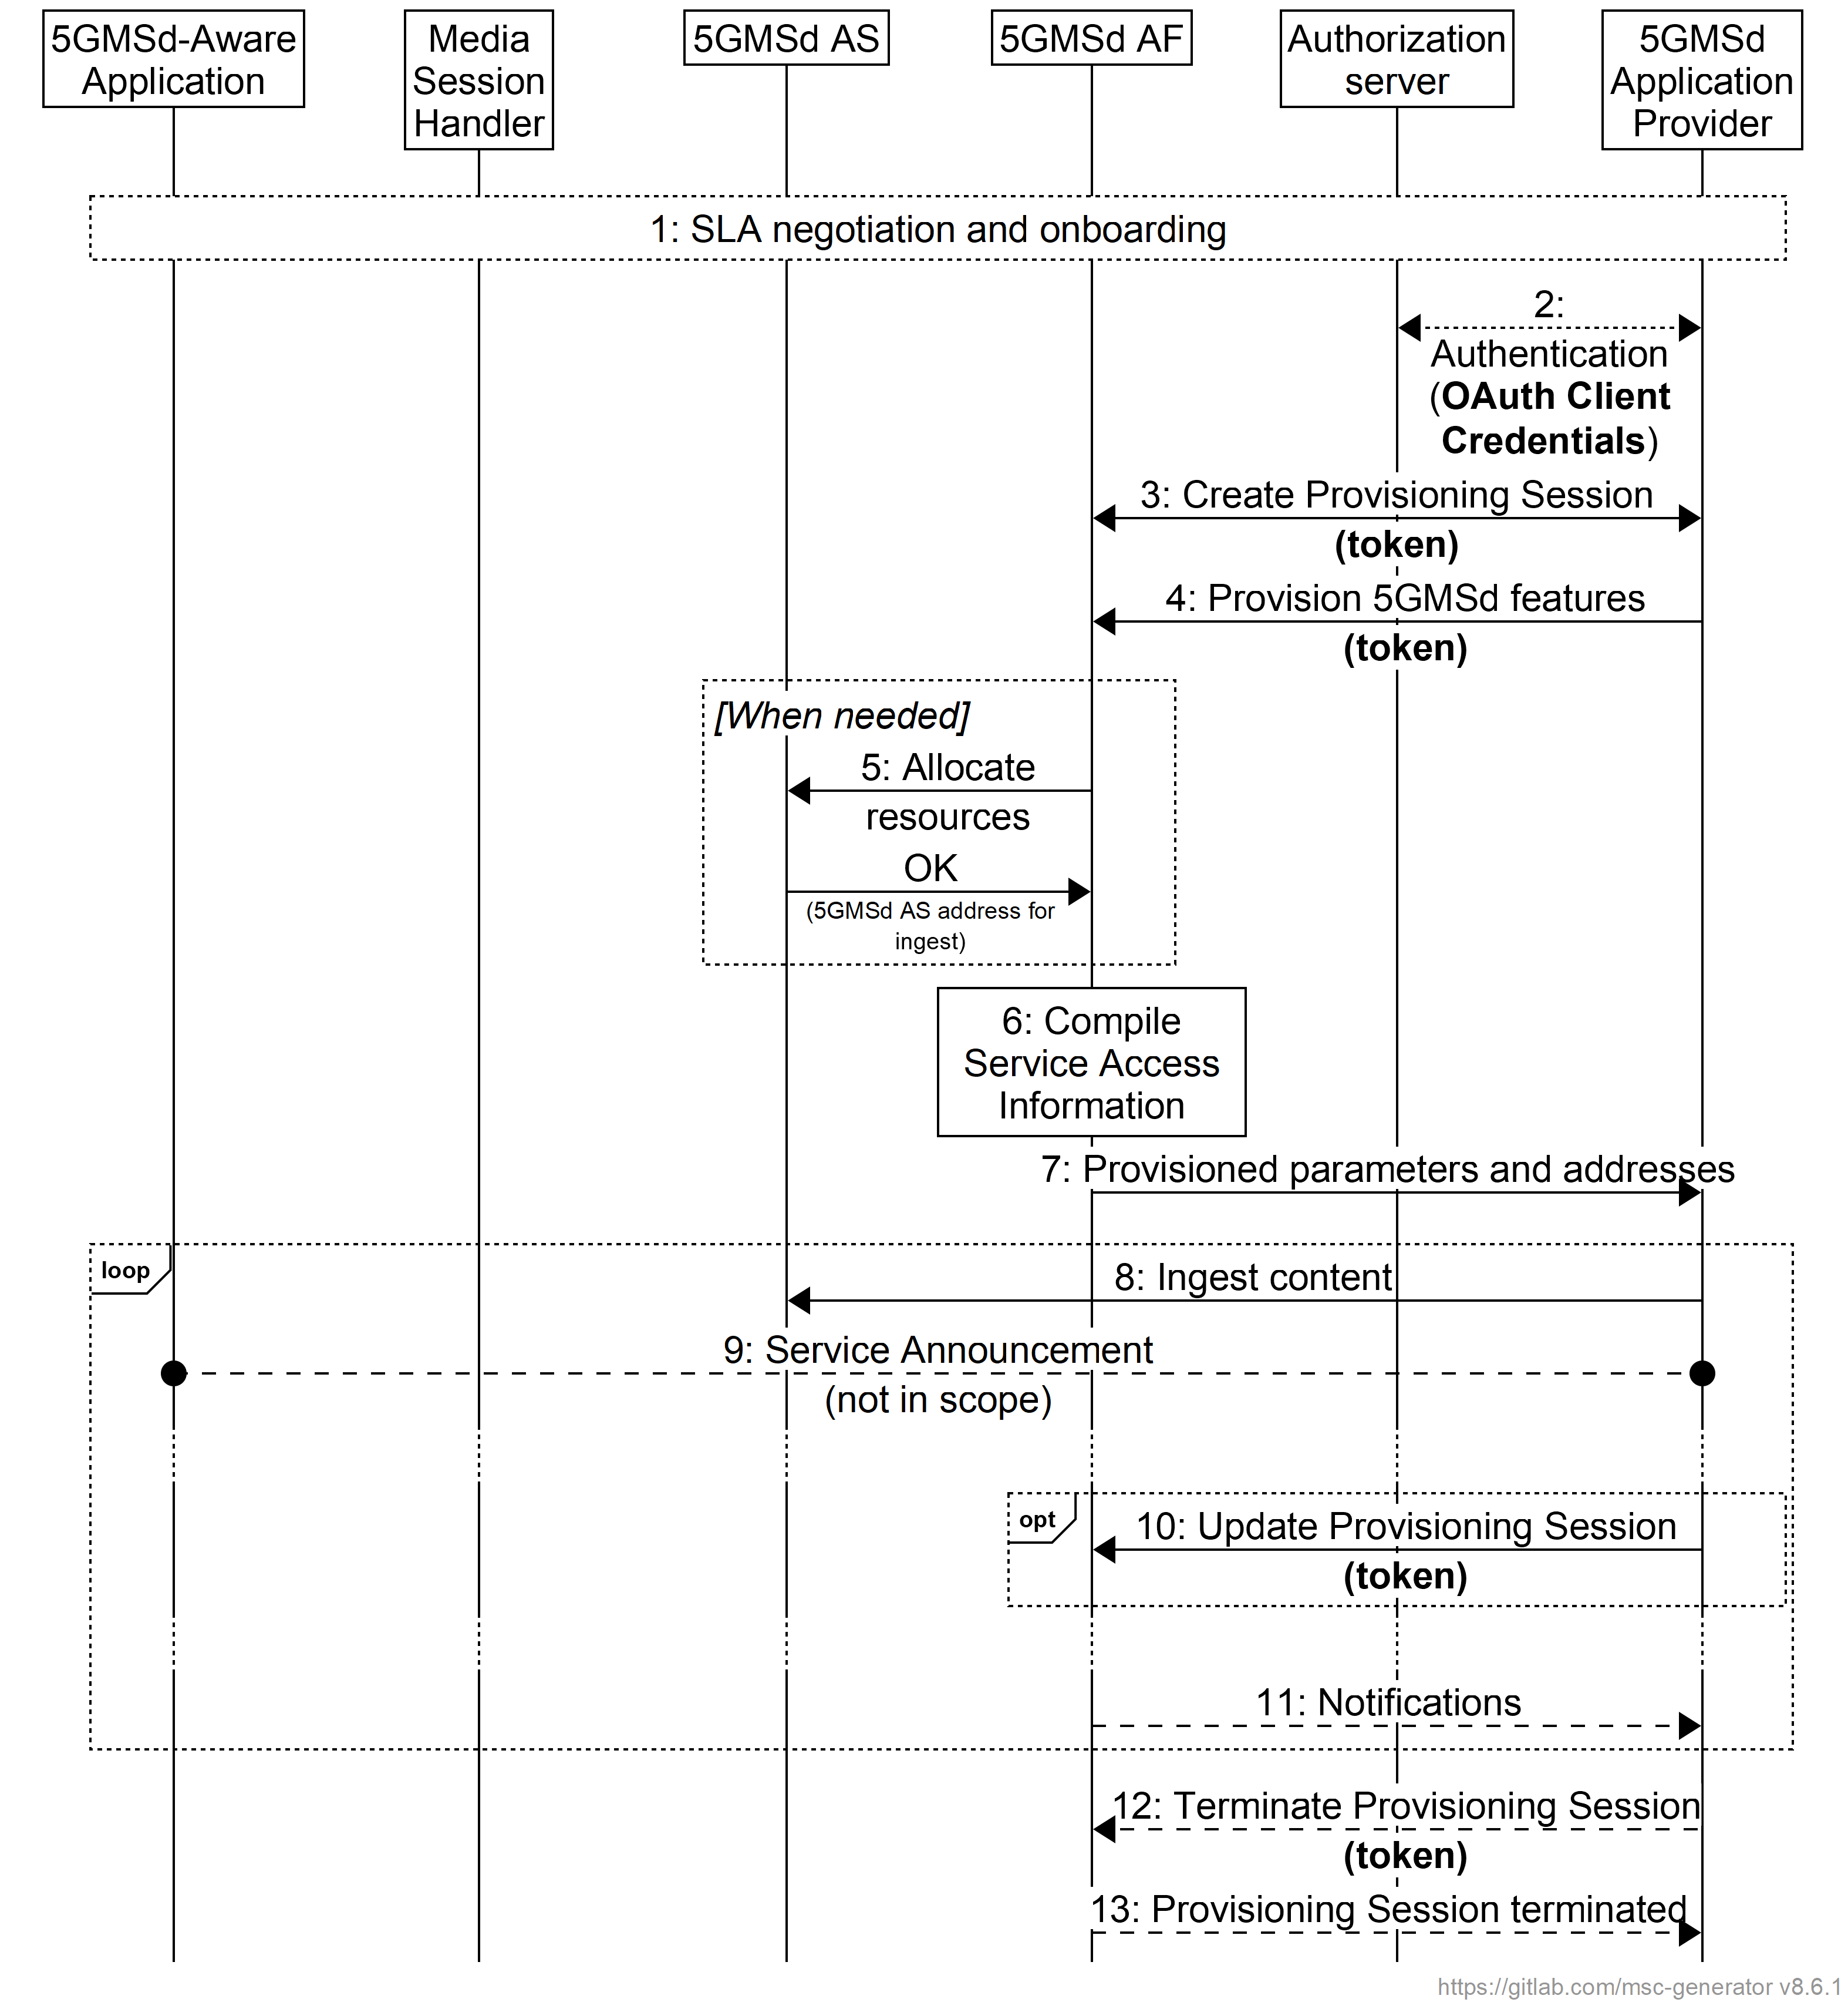
NOTE: When CAPIF is used, the AuthZ function is realised by the Authorizaton Service of CAPIF Core Function. Otherwise, the AuthZ function is realised by the 5GMSd AF.

Figure 5.3.3-2: High-level procedure for provisioning the 5GMS System
for downlink media streaming sessions
Steps:
1. The 5GMSd Application Provider discovers the address (URL) of the 5GMSd AF (M1d) for Session Provisioning. During the self-onboarding procedure, the 5GMSd Application Provider obtains the API access credentials.
2. The 5GMSd Application Provider authenticates itself with the system. This procedure reuses existing authentication/authorisation procedures, e.g. leveraging CAPIF 1/1e [13]. The AuthZ subfunction of the5GMSd AF acts here as OAuth authorization server. The 5GMSd AF acts as OAuth resource server. The 5GMSd Application Provider obtains an access token which is used for any subsequent operation invocations at reference point M1.
3. The 5GMSd Application Provider creates a Provisioning Session, providing its 5GMSd Application Provider identifier as input. 5GMSd Application Provider queries the capabilities and authorised features.
4. The 5GMSd Application Provider specifies one or more 5GMSd features in the Provisioning Session. A set of authorised features is activated, such as content consumption measurement, logging, collection and reporting; QoE metrics measurement, logging, collection and reporting; dynamic policy; network assistance; and content hosting (including ingest).
One or more External service identifiers are supplied by the 5GMSd Application Provider to support the later retrieval of Service Access Information from the 5GMSd AF by the Media Session Handler.
When the content hosting feature is offered and selected, the 5GMS Application Provider configures the content hosting behaviour of the 5GMSd AS. This Content Hosting Configuration is specified in clause 5.4 and includes selecting the ingest protocol and format, caching and proxying of media objects, content preparation, access protection (e.g. URL signing) and indicating a target distribution area (e.g. through geofencing).
When the dynamic policy feature is offered and selected, the 5GMSd Application Provider specifies a set of policies which can be invoked for the unicast downlink streaming session. The UE becomes aware of the selected policies in the form of a list of valid Policy Template Ids.
When the content consumption measurement, logging, collection and reporting feature is offered and selected, the 5GMSd Application Provider indicates the desired reporting interval. When the 5GMSd Application Provider has delegated Service Access Information handling to the 5GMS System, then location reporting is also selected or de-selected.
When the QoE metrics measurement, logging, collection and reporting feature is offered and selected, the 5GMSd Application Provider provides configuration input on the QoE post processing. When the 5GMSd Application Provider has delegated Service Access Information handling to the 5GMS System, then more detailed metrics reporting is configured.
When the edge computing feature is offered and selected, the 5GMSd Application Provider provides one or more Edge Resources Configurations that can be used to support either client-driven management or Application Provider-driven management of edge resources associated with the Provisioning Session.
When the event data processing feature is offered and selected, the 5GMSd Application Provider provides one or more Event Data Processing Configurations that determine how, in the scope of the Provisioning Session, content consumption and QoE metrics collected from the UE and application logs collected from the 5GMSd AS are processed into events and exposed to subscribers.
5. When content hosting is desired, the 5GMSd AF interacts with the 5GMSd AS at reference point M3d to allocate M2d resources and to configure the ingest format by means of a Content Hosting Configuration (defined in clause 5.4) which may reference Server Certificates and Content Preparation Templates, as required. The 5GMSd AS responds with the M2d content ingest address.
6. The 5GMSd AF compiles the Service Access Information. The Service Access Information contains access details and options such as the Provisioning Session identifier, M5d (Media Session Handling) addresses for content consumption reporting, QoE metrics reporting, dynamic policy, network assistance, etc. When content hosting is offered and has been selected in step 4, then also M4d (Media Streaming) information such as the DASH MPD is included.
7. The 5GMSd AF provides the results to the 5GMSd Application Provider.
a. When the 5GMSd Application Provider has selected full Service Access Information, then the results are provided in the form of addresses and configurations for M2d (Ingest), M5d (Media Session Handling) and M4d (Media Streaming).
b. When the 5GMSd Application Provider delegated the Service Access Information handling to the 5GMS System, then a reference to the Service Access Information (e.g., a URL) is provided. The Media Session Handler fetches the full Service Access Information later from the 5GMSd AF.
8. When content hosting is offered and has been selected in step 4, the 5GMSd Application Provider can start supplying content at the M2d ingest interface. In the case of progressive download or on-demand DASH sessions, the 5GMSd Application Provider makes the content assets available. In the case of Live DASH streaming sessions, the 5GMSd Application Provider starts supplying the live content.
9. The 5GMSd Application Provider executes Service Announcement and updates the UEs (during the lifetime of the Provisioning Session).
Optional:
10. The 5GMSd Application Provider may update the Provisioning Session.
Depending on the parameters of the Provisioning Session:
11. The 5GMSd AF may send event-related or periodic notifications to the 5GMSd Application Provider.
According to schedule, or upon request:
12. The 5GMSd Application Provider may manually terminate the Provisioning Session (at any time). All associated resources are released. Content may be removed from the 5GMSd AS. The 5GMSd Application Provider may configure a schedule for Provisioning Session termination.
13. The 5GMSd AF sends a notification upon Provisioning Session termination.
The 5GMSd AF may request the creation or reuse of one or more network slices for distributing the content of the provisioned session. If more than one network slice is provisioned for the distribution of the content of a session, the list of allowed S-NSSAIs shall be conveyed to the target UEs (e.g. through URSP or through M5d or M8d).
NOTE 2: The 5GMSd AS(s) serving the content are only accessible through the DNN(s) used by the network slice(s) provisioned for the distribution of that content.

5.4 Content Hosting Configuration for downlink Media Streaming

5.4.1 General
The 5G Media Streaming architecture defines an interface (M1d) for provisioning which offers the procedures to configure content ingest for downlink media streaming over 5G. Once a Provisioning Session is established using the API at interface M1d, content hosting can be configured. The control part of the ingest interface may be performed through the NEF. Ingested content is accessible from the 5GMSd AS at interface M4d through a new location identifier.
The M2d interface supports the ingest of the following types of content:
- Live streaming content.
- On-demand streaming content.
- Static files such as images, scene descriptions, etc.
The 5GMSd AF provides an API at interface M1d that allows a 5GMSd Application Provider to create/update/delete a Content Hosting Configuration. A Content Hosting Configuration contains all the parameters for a particular content ingest and distribution setup.
NOTE: In the current version of the present document, the M2d ingest interface only supports unicast downlink streaming.

5.4.2 Media ingest and distribution procedure
The media ingest procedure is illustrated in figure 5.4-1:
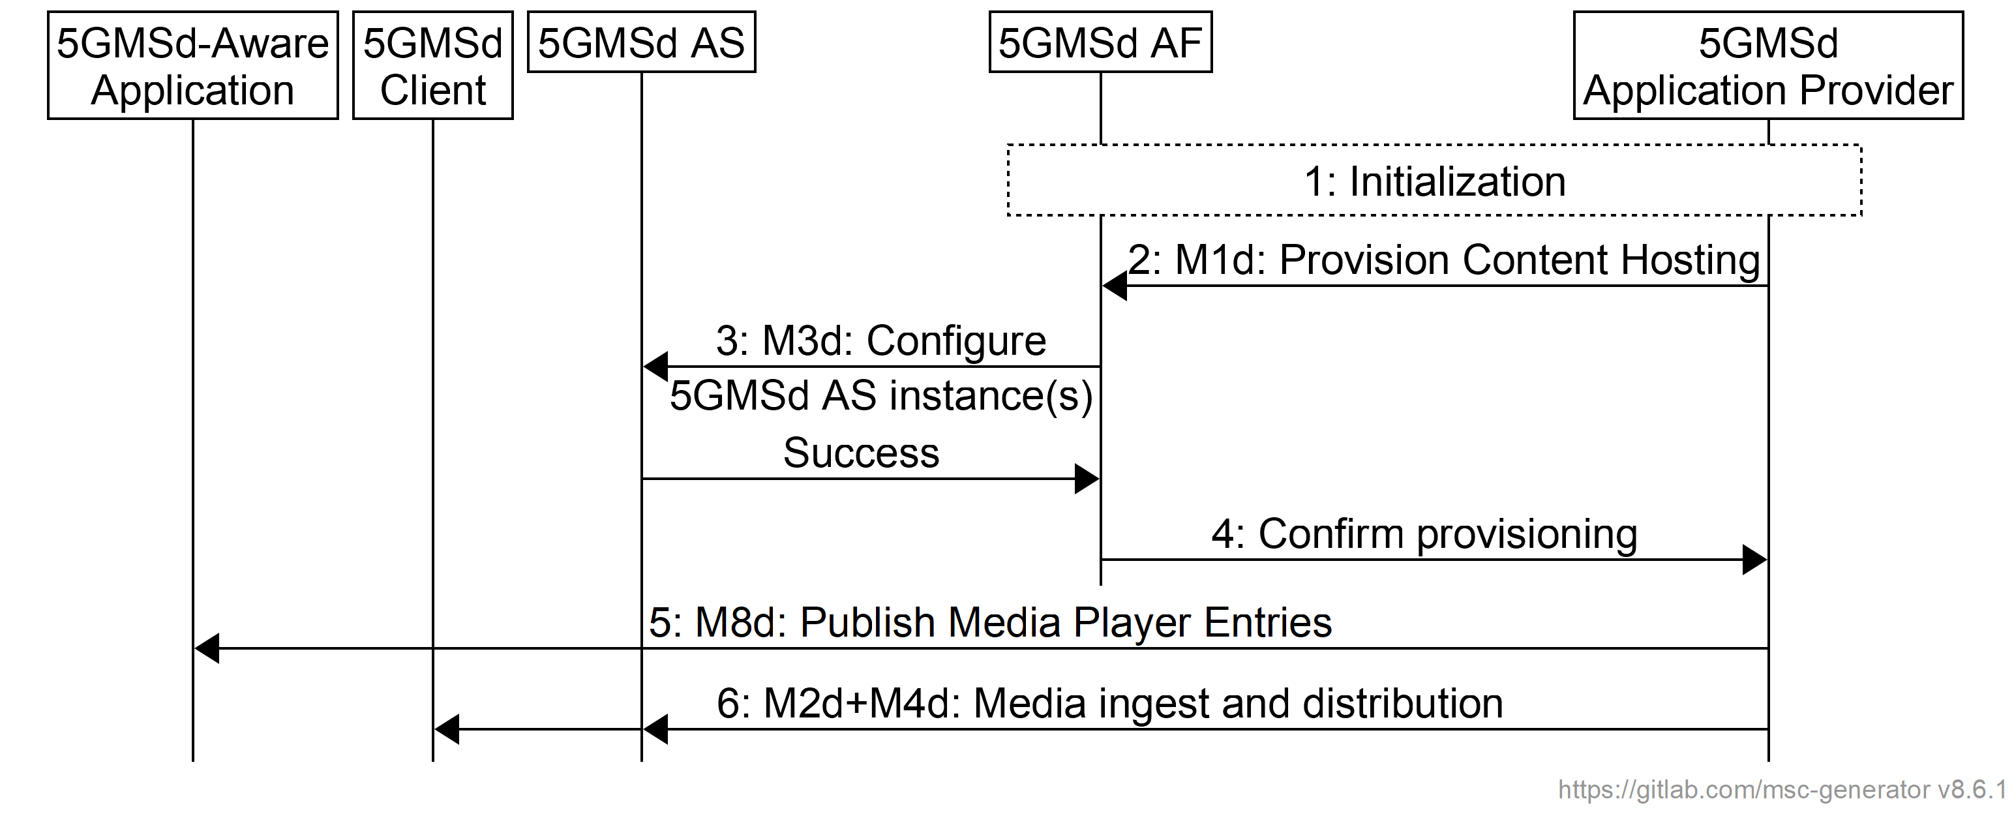
Figure 5.4.2-1: Media ingest and distribution procedure
The steps are as follows:
1: Initialization: The 5GMSd Application Provider discovers the M1d endpoint address and authenticates itself with the 5GMSd AF.
2: Provision Content Hosting: The 5GMSd Application Provider creates a new Content Hosting Configuration for all media formats of its content through the 5GMSd AF at reference point M1d. The configuration specifies a domain name, supplies a certificate for HTTPS access to the content, sets the caching rules per media type, indicates the distribution area (e.g. through geofencing), distribution protocol, the desired content preparation, URL signing, etc. Upon successful configuration, the 5GMSd AF responds with a Content Hosting Configuration identifier, and the location of the 5GMSd AS to which to send the content (if using the push mode).
3: Configure 5GMSd AS instance(s): The 5GMSd AF configures the related 5GMSd AS instance(s) via reference point M3d to prepare for media ingest for that particular Content Hosting Configuration. As well as configuring any necessary Server Certificates and/or Content Preparation Templates, this step may involve instructing the 5GMSd AS instance(s) to set appropriate caching rules, to perform URL signature validation and to limit access through geofencing. The 5GMSd AS(s) responds indicating whether the configuration was successful or not.
In case of partial failure, the configuration shall be removed from all 5GMSd AS instance(s) that succeeded.
4: Confirm provisioning: The 5GMSd AF communicates the Content Hosting Configuration of the 5GMSd AS instance(s) back to the 5GMSd Application Provider for further media push or pull.
In the case where not all requested media formats could be accommodated during the previous step, the 5GMSd AF shall indicate these in the failure response.
5: Publish Media Player Entries: The 5GMSd Application Provider shall then publish the Media Player Entries to the 5GMSd-Aware Application via reference point M8d to enable access to the content, possibly in different formats.
6: Media ingest and distribution: The 5GMSd AS(s) may start pulling or receiving content (if using push mode) from the 5GMSd Application Provider at reference point M4d. The 5GMSd AS performs the requested content preparation prior to providing access to the content.
NOTE: Pull of media content from the external 5GMSd AS(s) may be triggered by a request from the 5MGSd Client.
The 5GMSd Application Provider may update a Content Hosting Configuration subsequently to modify some of its parameters. The subset of parameters that can be updated may be limited by the 5GMSd AF.

5.4.3 Configuration of 5GMSd AS by 5GMSd AF with authorisation
Figure 5.4.3-1 shows a variant of the high-level call flow for downlink media ingest and distribution in clause 5.4.2 in which a 5GMSd AF deployed, for example, in an External DN configures Content Hosting in a 5GMSd AS deployed inside the Trusted DN. This corresponds to the collaboration scenario depicted in clause A.6 in which reference point M3d crosses the trust boundary. Differences from the baseline procedure in clause 5.4.2 are highlighted in boldface.
In the context of the OAuth 2.0 architecture [35], the 5GMSd AS acts as resource server and the 5GMSd AF acts as client. When deployed outside the scope of the CAPIF framework [33], the 5GMSd AS may provide the authorization server functionality.
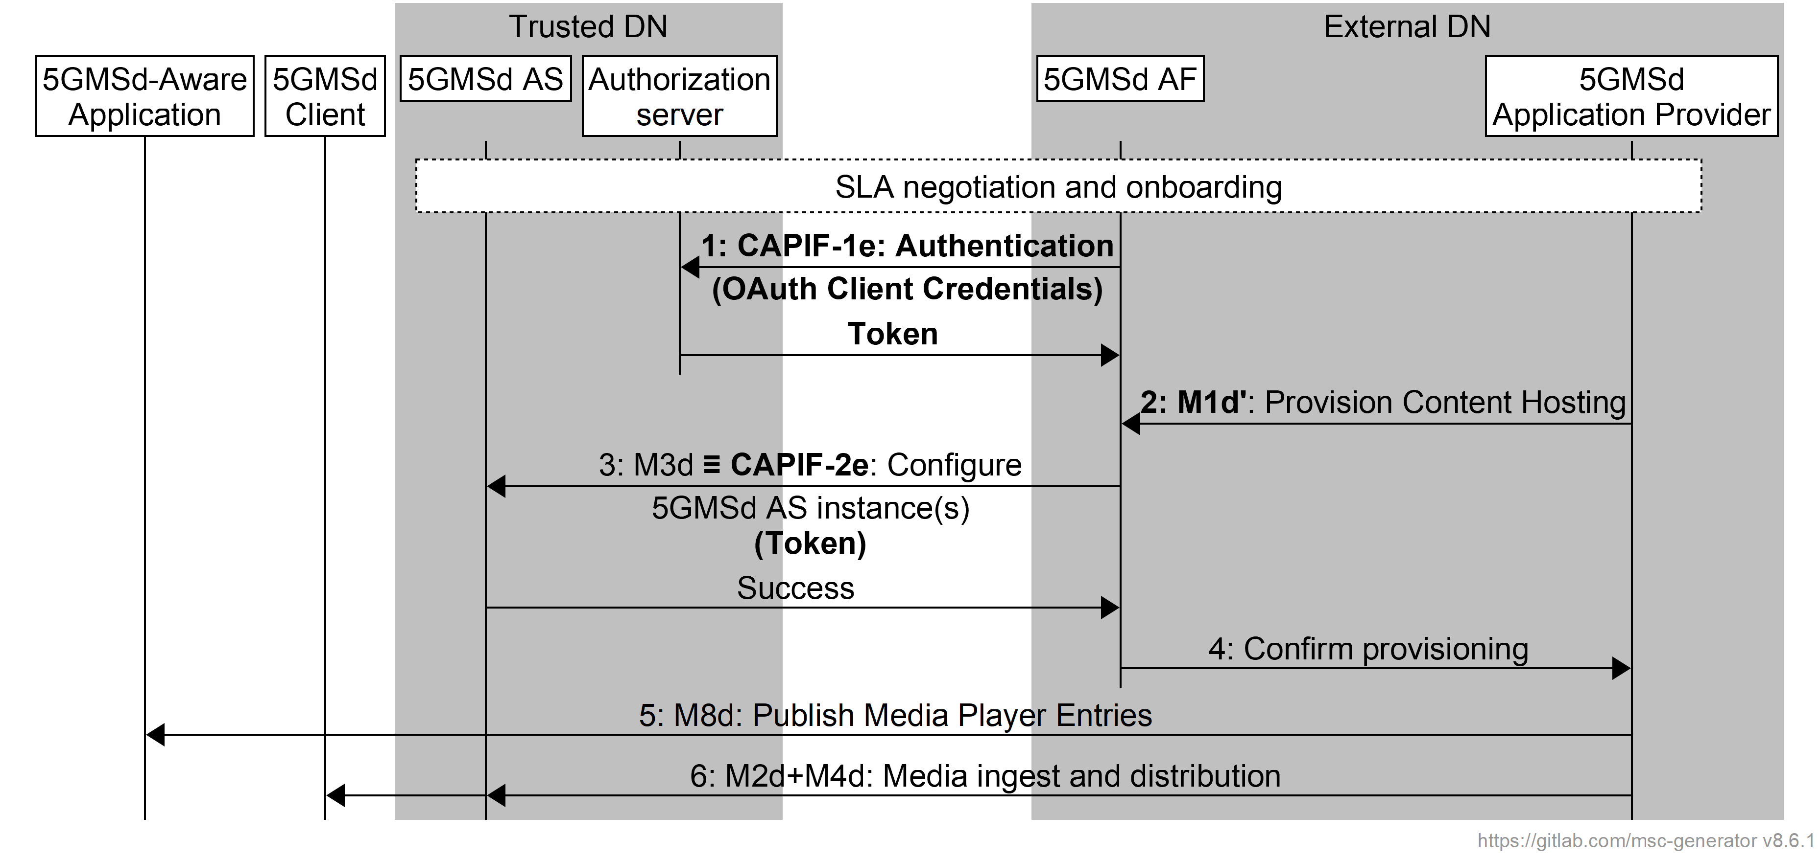
Figure 5.4.3-1: Media ingest and distribution procedure with authorisation of 5GMS AF
Pre-requisites:
- The endpoint address(es) of relevant 5GMSd AS instance(s), as well as the endpoint address and access credentials of the Authorization server are configured in the 5GMSd AF by the 5GMSd Application Provider as part of the onboarding procedure.
NOTE 1: Service Level Agreement (SLA) negotiations between the 5GMSd Application Provider and the 5GMS System provider are outside the scope of the present specification.
The steps are largely identical to those in clause 5.4.2 with differences highlighted in boldface:
1: Initialization: Using its access credentials, the 5GMSd AF authenticates itself with the Authorization server (provided by the CAPIF core function [33], if deployed, or possibly by the 5GMSu AS itself) and obtains an API access token for use at reference point M3d.
2: Provision Content Hosting: The 5GMSd Application Provider creates a new Content Hosting Configuration for all media formats of its content through the 5GMSd AF at reference point M1d′. The configuration specifies a domain name, supplies a certificate for HTTPS access to the content, sets the caching rules per media type, indicates the distribution area (e.g. through geofencing), distribution protocol, the desired content preparation, URL signing, etc. Upon successful configuration, the 5GMSd AF responds with a Content Hosting Configuration identifier, and the location of the 5GMSd AS to which to send the content (if using the push mode).
3: Configure 5GMSd AS instance(s): The 5GMSd AF configures the related 5GMSd AS instance(s) via reference point M3d (which may realise CAPIF-2e) to prepare for media ingest for that particular Content Hosting Configuration. The access token obtained in step 1 is presented in the request by way of authorisation. As well as configuring any necessary Server Certificates and/or Content Preparation Templates, this step may involve instructing the 5GMSd AS instance(s) to set appropriate caching rules, to perform URL signature validation and to limit access through geofencing. The 5GMSd AS(s) responds indicating whether the configuration was successful or not.
In case of partial failure, the configuration shall be removed from all 5GMS AS(s) that succeeded.
4: Confirm configuration information: The 5GMSd AF communicates the Content Hosting Configuration of the 5GMSd AS instance(s) back to the 5GMSd Application Provider for further media push or pull.
In the case where not all requested media formats could be accommodated during the previous step, the 5GMSd AF shall indicate these in the failure response.
5: Publish Media Player Entries: The 5GMSd Application Provider shall then publish the Media Player Entries to the 5GMSd-Aware Application via reference point M8d to enable access to the content, possibly in different formats.
6: Media ingest: The 5GMSd AS(s) may start pulling or receiving content (if using push mode) from the 5GMSd Application Provider at reference point M4d. The 5GMSd AS performs the requested content preparation prior to providing access to the content.
NOTE 2: Pull of media content from the external 5GMSd AS(s) may be triggered by a request from the 5MGSd Client.
The 5GMSd Application Provider may update a Content Hosting Configuration subsequently to modify some of its parameters. The subset of parameters that can be updated may be limited by the 5GMSd AF.

5.4.4 Media ingest and distribution procedure with multiple service locations
Figure 5.4.4-1 shows a variant of the high-level call flow for downlink media ingest, processing, and distribution in clauses 5.2.2, 5.4.2, and 7.2 where the 5GMSd AS is configured to host multiple service locations. Differences from the baseline procedure in clauses 5.4.2 and 7.2 are highlighted in boldface.
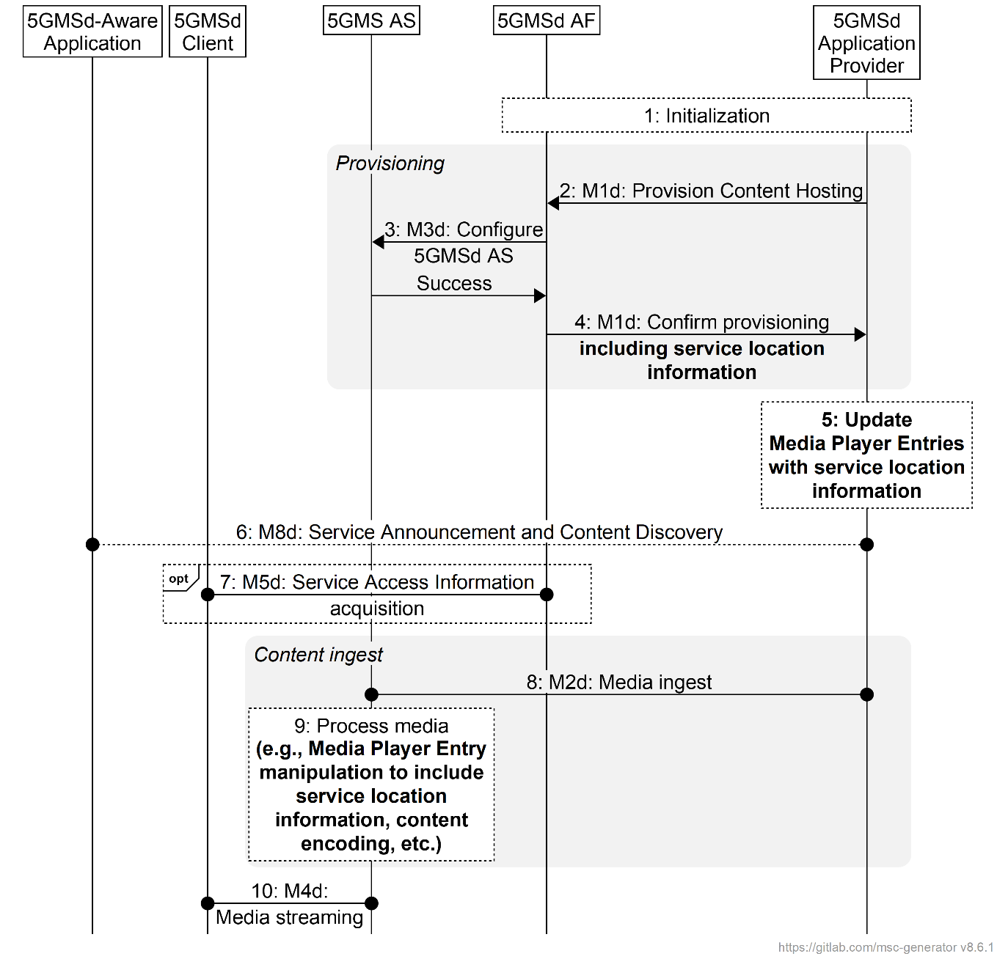
Figure 5.4.4-1: Media ingest and distribution procedure with multiple service locations
The steps are as follows:
1: Initialization: The 5GMSd Application Provider discovers the M1d endpoint address and authenticates itself with the 5GMSd AF.
2: Provision Content Hosting: The 5GMSd Application Provider creates a new Content Hosting Configuration for all media formats of its content through the 5GMSd AF at reference point M1d. The configuration specifies a domain name, supplies a certificate for HTTPS access to the content, sets the caching rules per media type, describes the number of 5GMSd AS service locations to expose at reference point M4d, indicates the distribution area (e.g. through geofencing), distribution protocol, the desired content preparation (e.g., manifest manipulation, media object encoding, etc.), URL signing, etc. The configuration may also specify affinity groups that guide deployment of 5GMSd AS service locations within the 5GMS System. Upon successful configuration, the 5GMSd AF responds with a Content Hosting Configuration identifier, the base URL of each configured 5GMSd AS service location that will be used to deliver content, and the location of the 5GMSd AS service location(s) where to send content (if using the push mode).
NOTE 1: Service locations may also be hosted outside the 5GMS System by the 5GMSd Application Provider. This process for provisioning and hosting these is outside the scope of the present document.
3: Configure 5GMSd AS instance(s): The 5GMSd AF configures the related 5GMSd AS instance(s) via reference point M3d to prepare for media ingest for that particular Content Hosting Configuration. As well as configuring any necessary Server Certificates and/or Content Preparation Templates, this step may involve instructing the 5GMSd AS instance(s) to set appropriate caching rules, to perform URL signature validation, limit access through geofencing, expose service locations from 5GMSd AS instances according to the defined affinity group(s), and configure media ingest at reference point M2d or M10d. The 5GMSd AS instance(s) respond(s) indicating whether the configuration was successful or not.
In case of partial failure, the configuration shall be removed from all 5GMSd AS instance(s) that succeeded.
4: Confirm provisioning: The 5GMSd AF communicates the Content Hosting Configuration of the 5GMSd AS back to the 5GMSd Application Provider for further media push or pull. This communication may also include multiple service location information such as the base URL for each provisioned service location, content steering configuration information, multiple service location strategy-specific configuration information, etc.
In the case where not all requested media formats could be accommodated during the previous step, the 5GMSd AF shall indicate these in the failure response.
5: Update Media Player Entry documents: Based on the information provided in the previous step, the 5GMSd Application Provider may update the Media Player Entry documents, at a minimum with the necessary multiple service location information needed to access content from service locations hosted outside the 5GMS System (e.g., by the 5GMSd Application Provider). The 5GMSd Application Provider may also update the Media Player Entry documents for those service locations hosted by the 5GMSd AS using configuration information obtained from the 5GMSd AF upon confirmation of successful 5GMSd AS provisioning.
6. Service Announcement and Content Discovery: The 5GMSd Aware Application triggers the Service Announcement and Service and Content Discovery procedure. The Service and Content Discovery procedure only involves the 5GMS-Aware Application and the 5GMSd Application Provider. The Service Announcement includes either the whole Service Access Information (i.e. details for Media Session Handling (M5d) and for Media Streaming access (M4d)) or a reference to the Service Access Information.
7: Service Access Information acquisition: When the 5GMS-Aware Application has received only a reference to the Service Access Information (see step 6), the Media Session Handler interacts with the 5GMSd AF to acquire the whole Service Access Information.
8: Media ingest and distribution: Content for the configured service locations is ingested by the 5GMSd AS from the 5GMSd Application Provider at reference point M2d. Depending on the Content Hosting Configuration, this may involve 5GMSd AS service chaining via reference point M10d.
9. Media processing: The 5GMSd AS may perform any configured content preparation required for each exposed service location prior to providing access to the content at reference point M4d. This may include manifest manipulation, providing further updates to the Media Player Entry documents, media object encoding, etc.
NOTE 2: Pull of media content from the 5GMSd Application Provider or an external 5GMSd AS may be triggered by a request from the 5MGSd Client.
10. Media Streaming: The media is streamed to a 5GMSd Client via reference point M4d.
The 5GMSd Application Provider may update a Content Hosting Configuration subsequently to modify some of its parameters. The subset of parameters that can be updated may be limited by the 5GMSd AF.

5.5 Metrics collection and reporting

5.5.1 General
Metrics collection and reporting can be done in different ways, depending on the relationship between the Application Provider and the 5GMS System operator. The following clauses show simplified signalling examples for two different use-cases.

5.5.2 RAN-based reporting procedure
In the first use-case, shown in figure 5.5.2-1 below, the 5GMS System operator controls the metrics collection and reporting using the RAN-based configuration method. In this case the metrics are configured via the RAN and the control plane, independent of 5GMS functional support.
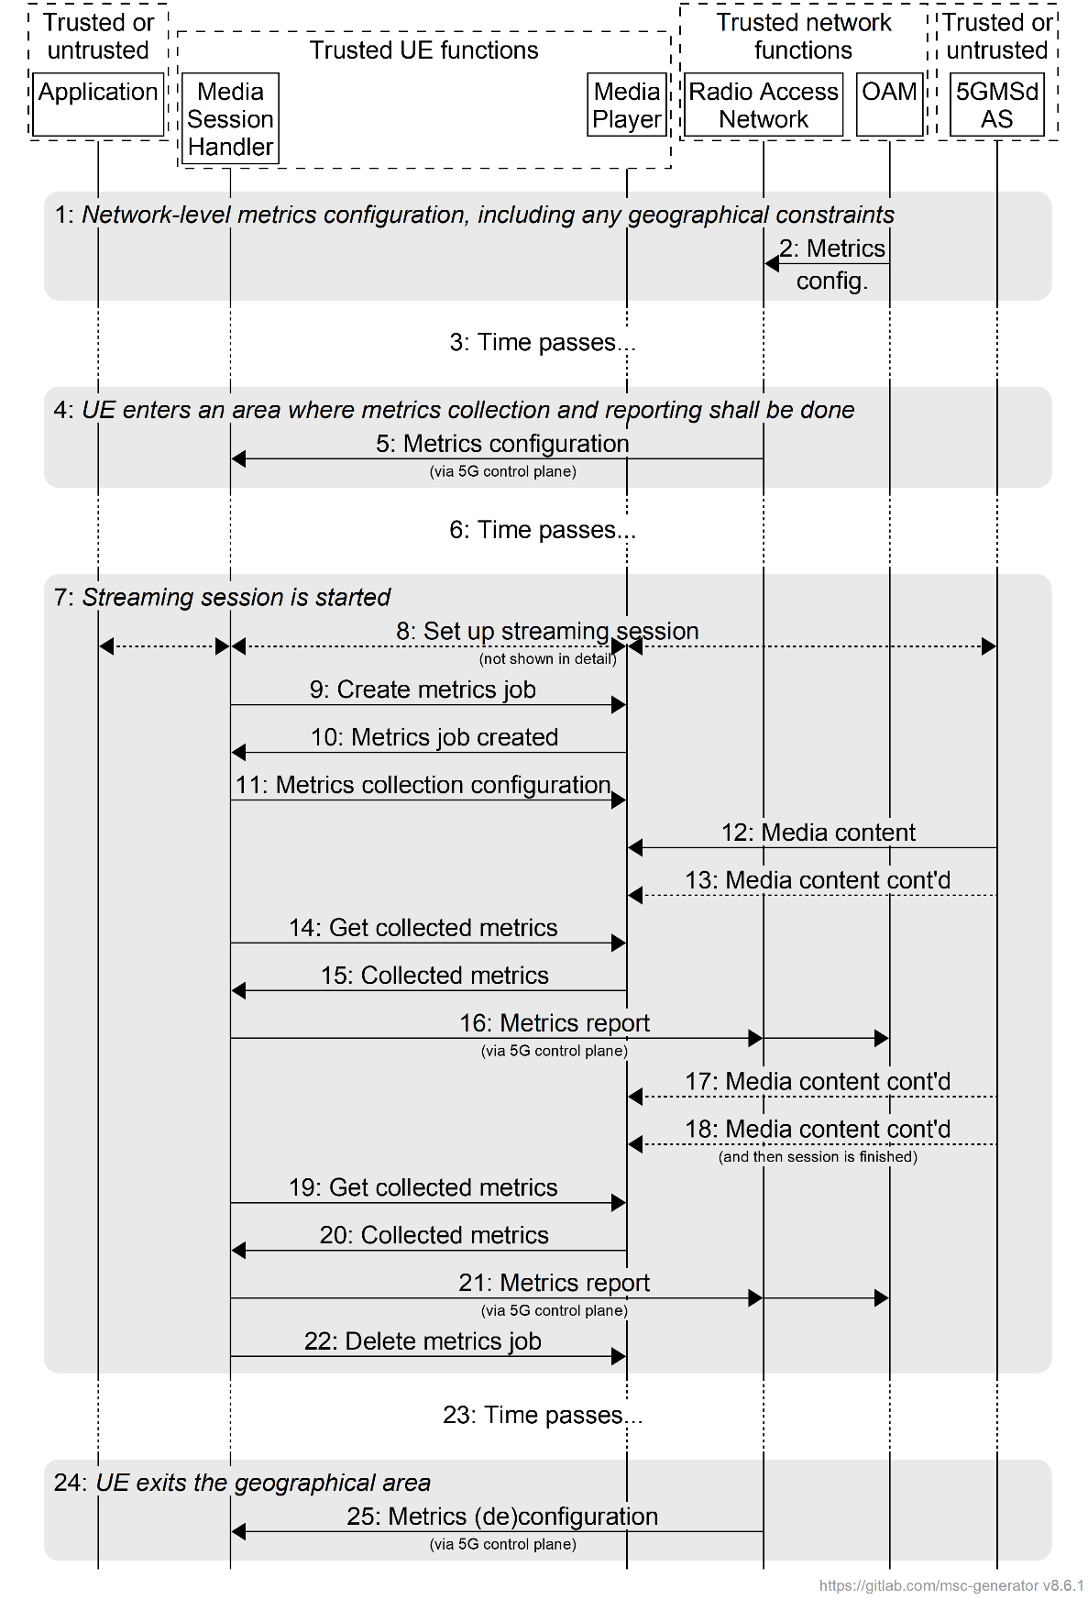
Figure 5.5.2-1: Metrics collection and reporting via RAN-based configuration
The different steps are explained below:
1: Overall metrics configuration is done on the network level, for instance defining which geographical areas that shall have metrics collection active, which metrics to collect, and how metrics shall be reported. If per-slice metrics collection and reporting is supported, a slice scope may be present in the metrics configuration, indicating the specific slice instance(s) for metrics collection and reporting.
2: The metrics configuration(s) is/are sent from the OAM to the RAN, which does not forward that information to the UE at this stage.
3: Time passes, and it is assumed that the UE moves around during that period.
4: The UE enters an area (cell, location area, etc.,) which is inside the geographical constraint. This is discovered by the RAN, and it now needs to activate metrics collection and reporting for the UE.
5: The actual metrics configuration is sent from the RAN to the Media Session Handler, via the control plane.
6: Additional time passes, and the UE has a metrics configuration, but no streaming session has started.
7: A streaming session is started.
8: The session setup is done in conjunction with signalling transactions (not shown here).
8a: When the Communication Service type parameter is included in the metrics configuration set (see table 4.2.3-4), the Media Session Handler shall collect and report metrics depending on whether the current media streaming session is running over unicast, MBS multicast and/or MBS broadcast.
If a slice scope is included in the metrics configuration set, the Media Session Handler shall check the running slice which is carrying the current media streaming (e.g. via the AT Command +CGDCONT [24] or the specific traffic mapping with URSP [4]). If the running slice is within the slice scope, the metrics collection and reporting shall be executed. Additionally, the running slice shall also be included into the metrics reports.
9: A new metrics collection job is created in the Media Player.
10: A reference to the new metrics collection job is returned.
11: The configuration for the metrics collection job is sent to the Media Player (i.e. which metrics should be measured) along with the measurement resolution interval). The metrics reporting interval timer is activated in the Media Session Handler.
12: Media is delivered and rendered, and...
13: ...more media is delivered...
14: The configured metrics reporting interval has elapsed, and the Media Session Handler now requests the collected metrics from the Media Player.
15: The Media Player returns the collected metrics.
16: The metrics are reported via the control plane.
17: The session continues...
18: more media is delivered, and then the session is finished.
19: The Media Session Handler requests the final metrics collected.
20: The Media Player returns the final collected metrics.
21: The metrics are reported to the OAM via the control plane.
21a: The OAM may determine the per-slice QoE metrics based on the metrics reports and the slice scope.
22: The metrics collection job is deleted.
23: Time passes; the UE moves around.
24: The UE leaves the geographical area specified by the metrics configuration.
25: The RAN sends metrics (de)configuration to the UE, to stop future metrics collection.

5.5.3 5GMSd AF-based reporting procedure
The second use-case, shown in figure 5.5.3-1 below, illustrates a scenario where the metrics collection and reporting is configured by the 5GMSd AF. In this example, it is assumed that the metrics configuration provided by the 5GMSd AF comprises instructions/rules regarding metrics collection (i.e. measurement and logging) and reporting for two different schemes - one that is non-3GPP-defined and initially sourced from the 5GMSd AS, and the other scheme that is defined by 3GPP and initially sourced from an OAM Server belonging to the 5GMS System operator. Each metrics scheme requires the 5GMSd Client to perform metrics collection and subsequent metrics reporting to the 5GMSd AF according to the configuration rules of that scheme. Furthermore, it is assumed that the 5GMSd AF is required to deliver metrics reports obtained from the 5GMSd Client to separate destination entities, upon optionally having performed post-processing of the original report information, according to the configuration rules of each metrics scheme. The 5GMSd AF and 5GMSd AS functions can be either trusted or untrusted.
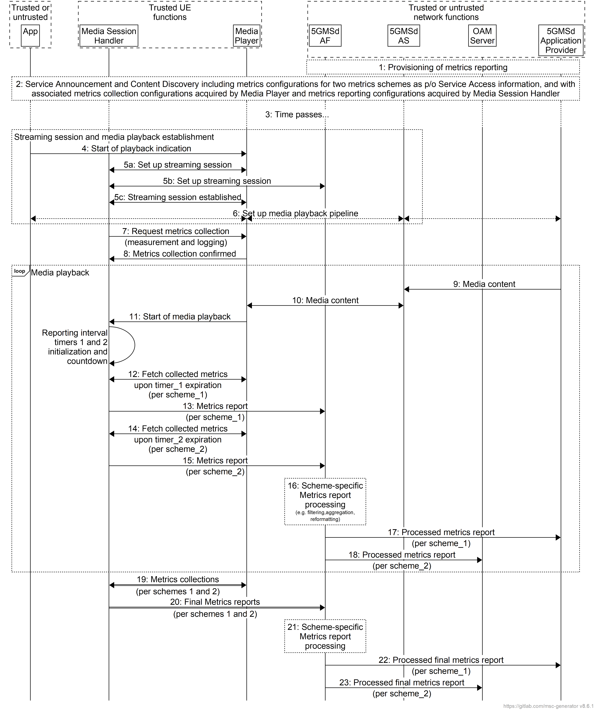
Figure 5.5.3-1: Metrics collection and reporting via 5GMSd AF-based configuration
The message sequence steps are described below:
1: The 5GMSd AF is provisioned with two separate sets of metrics reporting configuration information - metrics scheme_1 as defined by the 5GMSd Application Provider and metrics scheme_2 as defined by 3GPP, each pertaining to metrics collection by the Media Player, retrieval of those collected metrics from the Media Player by the Media Session Handler, and the generation and delivery of metrics reports from the Media Session Handler to the 5GMSd AF. The 5GMSd AF is similarly provisioned with two separate sets of metrics reporting configuration information, associated with the metrics schemes 1 and 2, regarding required post-processing functionality and subsequent and separate delivery of processed metrics reports to the 5GMSd Application Provider and to the OAM Server.
2: The 5GMSd-Aware Application triggers the Service Announcement and Content Discovery procedure. The Service Announcement includes the whole Service Access Information that contains metric configuration info for metrics schemes 1 and 2, with their associated metrics collection configurations acquired by the Media Player and metrics collection configurations acquired by the Media Session Handler.
3: Time passes until the 5GMSd UE initiates session establishment and media playback.
4: The 5GMSd-Aware Application informs the Media Player of impending media playback.
5a: The Media Player requests the establishment of a streaming session with the Media Session Handler which acknowledges the request.
5b: The Media Session Handler requests the establishment of a streaming session with the 5GMSd AF which confirms the streaming session establishment.
5c: The Media Session Handler informs the Media Player the successful set-up of the streaming session.
6: Media playback pipeline is set up between the Media Player, the 5GMSd AS and the 5GMSd Application Provider.
7: The Media Session Handler queries the Media Player on its capability to perform metrics collection (measurement and logging function) in accordance with both schemes 1 and 2 as defined by its metrics configuration.
8: The Media Player acknowledges its support for the collection of the required metrics of all configured schemes.
During the course of media playback, steps 9-18 below may be repeated, depending on the duration of the playback and the frequency of metrics reporting as set by the metrics configuration for each of the two schemes.
9: Assuming a live streaming service, media content is delivered via push ingest from the 5GMSd Application Provider to the 5GMSd AS.
10: The Media Player fetches media content from the 5GMSd AS and begins media playback.
11: The Media Player notifies the Media Session Handler of the start of media playback, causing the Media Session Handler to initialize and begin countdown of separate metrics reporting interval timers for schemes 1 and 2.
12: Upon expiration of timer_1 (associated with scheme_1), the Media Session Handler retrieves the logged metrics measurements from the Media Player according to scheme_1.
13: In accordance with its metrics reporting configuration as provisioned in step 2, a metrics report for scheme_1 is sent from the Media Session Handler to the 5GMSd AF.
14: Upon expiration of timer_2 (associated with scheme_2), the Media Session Handler retrieves the logged metrics measurements from the Media Player according to scheme_2.
15: In accordance with its metrics reporting configuration as provisioned in step 2, a metrics report for scheme_2 is sent from the Media Session Handler to the 5GMSd AF.
16: In accordance with its metrics reporting configuration as provisioned in step 1, the 5GMSd AF performs separate post-processing in accordance with schemes 1 and 2 (e.g. filtering, aggregation, reformatting) of the received types of metrics reports.
Furthermore, in accordance with its metrics reporting configuration as provisioned in step 1:
17: The 5GMSd AF sends a processed metrics report in accordance with scheme_1 to the 5GMSd Application Provider.
18: The 5GMSd AF sends a processed metrics report in accordance with scheme_2 to the OAM Server.
Upon the termination of media playback (as notified by the 5GMSd-Aware Application to the Media Player) a final round of metrics collection and reporting is performed:
19: The Media Session Handler obtains the latest metrics measurements from the Media Player in accordance with schemes 1 and 2. These procedures might occur prior to the nominal expiration of the metrics reporting interval timers.
20: Final metrics reports, in accordance with schemes 1 and 2 are sent by the Media Session Handler to the 5GMSd AF. These procedures might occur prior to the expiration of the nominal metrics reporting intervals.
21: The 5GMSd AF performs post-processing of the received final metrics reports in accordance with schemes 1 and 2.
22: Same as step 17.
23: Same as step 18.
NOTE: Although not explicitly shown or described in Figure 5.3.3-1, should the 5GMSd AF represent an untrusted network entity and the OAM Server represent a trusted network entity, the delivery of processed metrics reports from the 5GMSd AF to the OAM Server, as depicted in steps 18 and 23, must be mediated by the NEF (Network Exposure Function).

5.5.4 Metrics reporting configuration parameters
Table 4.2.3-4 in clause 4.2.3 describes the metrics reporting configuration parameters used in step 5 of Figure 5.5.2-1 and step 3a of Figure 5.5.3-1. Note that some of the parameters are only relevant for a specific reporting option, as shown in Table 5.5.4-1 below.
Table 5.5.4-1: Metrics reporting configuration parameters and options
Parameters | Relevance in RAN-based reporting? | Relevance in 5GMSd AF-based reporting?
Server address | No | Yes
Scheme | No (default 3GPP) | Yes
DNN | No | Yes
Reporting interval | Yes | Yes
Sample percentage | Yes | Yes
Streaming source filter | Yes | Yes
Slice scope | Yes | No
Communication Service type | Yes | No
Metrics | Yes (3GPP-defined) | Yes (3GPP-defined or non-3GPP defined)

5.5.5 Metrics reporting by 5GMSd AS to 5GMSd AF with authorisation
Figure 5.5.51 shows a variant of the high-level call flow for AF-based downlink metrics reporting in clause 5.5.3 in which a 5GMSd AS deployed, for example, in an External DN reports QoE metrics via reference point M3d to a 5GMSd AF deployed inside the Trusted DN. (The QoE metrics may, for example, be relayed from in-band client data reports received from the 5GMSd Client in the UE, per clause 5.13.) This arrangement corresponds to the collaboration scenario depicted in clause A.5 in which reference point M3d crosses the trust boundary. Differences from the baseline procedure in clause 5.5.3 are highlighted in boldface. In addition, to enable the 5GMSd AS to report QoE metrics to the 5GMSd AF via reference point M3d per the collaboration scenario in clause A.5, aspects of the procedure in clause 5.4.3 also need to be incorporated into this procedure.
In the context of the OAuth 2.0 architecture [35]:
- For configuration of content hosting the 5GMSd AS via reference point M3d, the 5GMSd AS acts as resource server and the 5GMSd AF acts as client. When deployed outside the scope of the CAPIF framework [33], the 5GMSd AS may itself provide the authorization server functionality.
- For metrics reporting by the 5GMSd AS to the 5GMSd AF at reference point M3d, the 5GMSd AF acts as resource server and the 5GMSd AS acts as client. When deployed outside the scope of the CAPIF framework [33], the 5GMSd AF may itself provide the authorization server functionality.
Hence, there is a requirement for the 5GMSd AF and 5GMSd AS to mutually authenticate in this procedure.
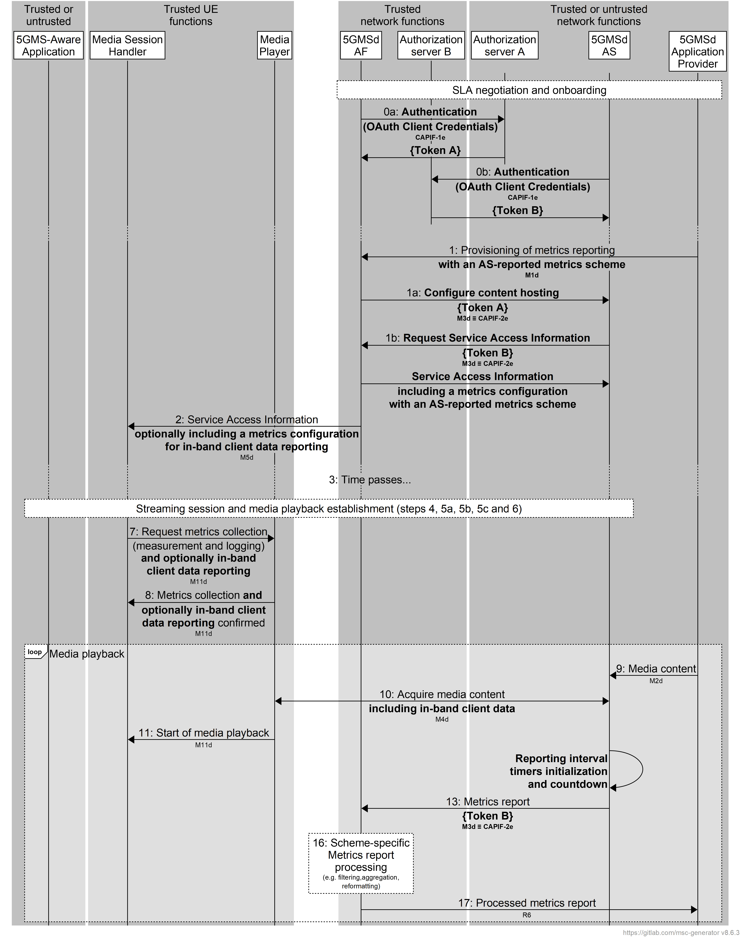
Figure 5.5.5-1: Metrics reporting by 5GMSd AS to 5GMSd AF with authorisation
Pre-requisites:
- The endpoint address and access credentials of Authorization server A are configured in the 5GMSd AF by the 5GMSd Application Provider as part of the onboarding procedure.
- The endpoint address and access credentials of Authorization server B are configured in the 5GMSd AS by the 5GMSd Application Provider as part of the onboarding procedure.
NOTE 1: Service Level Agreement (SLA) negotiations between the 5GMSd Application Provider and the 5GMS System provider are outside the scope of the present specification.
NOTE 2 When the 5GMSd AF and 5GMSd AS are deployed in the same trust domain, the functions of Authorization Server A and Authorization Server B may be co-located for reasons of efficiency.
The steps of the call flow that differ from that defined in clause 5.5.3 are as follows:
0a: Using its configured access credentials, the 5GMSd AF authenticates itself with Authorization server A (provided by the CAPIF core function [33], if deployed, or possibly by the 5GMSd AS itself) and obtains an API access token for use at reference point M3d. An authorization token "Token A" is yielded.
NOTE 3: The above step corresponds to step 1 in clause 5.4.3.
0b: Using its configured access credentials, the 5GMSd AS authenticates itself with Authorization server B (provided by the CAPIF core function [33], if deployed, or possibly by the 5GMSd AF itself) and obtains an API access token for use at reference point M3d. An authorization token "Token B" is yielded.
1: The 5GMSd AF is provisioned with a metrics reporting configuration that requires data reporting by the 5GMSd AS at reference point M3d. This could, for example, be a metrics scheme involving in-band client data reporting.
1a: The 5GMSd AF configures content hosting in the 5GMSd AS at reference point M3d per step 3 of clause 5.4.3. Token A obtained in step 0a is presented to authorise the request.
1b: The receipt of a content hosting configuration triggers the Service Announcement and Content Discovery procedure by the 5GMSd AS. The Service Announcement includes the whole Service Access Information that contains metrics configuration(s) relevant to the 5GMSd AS for data reporting by the 5GMSd AS at reference point M3d. Token B obtained in step 0b above is presented in the request to the 5GMSd AF for Service Access Information.
2: The 5GMSd-Aware Application triggers the Service Announcement and Content Discovery procedure. The Service Announcement includes the whole Service Access Information that contains metric configuration info. The metrics configuration corresponding to the AS-reported metrics scheme provisioned in step 1 above may additionally indicate a requirement for in-band client data reporting by the 5GMSd Client.
7: The Media Session Handler queries the Media Player on its capability to perform metrics collection (measurement and logging function) as defined by its metrics configuration. If the AS-reported metrics scheme provisioned in step 1 additionally requires in-band client data reporting, support for this by the Media Player also needs to be established per step 4 of clause 5.13.
10: The Media Player fetches media content from the 5GMSd AS and begins media playback. Depending on the requirements of the metrics configuration received in step 7 above, the media fetch requests may include in-band client data.
Upon expiration of the timer associated with the metrics scheme configuration for client data reporting at reference point M5d:
13: In accordance with its metrics configuration as provisioned in step 1b, a metrics report is sent from the 5GMSd AS to the 5GMSd AF. Token B obtained in step 0b above is presented to the 5GMSd AF to authorise the report submission request.
NOTE 4: The above step corresponds, for example, to step 5f in the procedure for the reporting of in-band client data by the 5GMSd AS to the 5GMSd AF at reference point M5d that is defined in clause 5.13.
14: (Step omitted.)
15: (Step omitted.)
18: (Step omitted.)
Steps 19−23 are omitted because there is no explicit signal to instruct the 5GMSd AS to submit a final metrics report to the 5GMSd AS. Instead, the final metrics report is submitted as a result of the reporting interval timer expiring in the previous loop.

5.6 Consumption reporting

5.6.1 Consumption reporting procedure
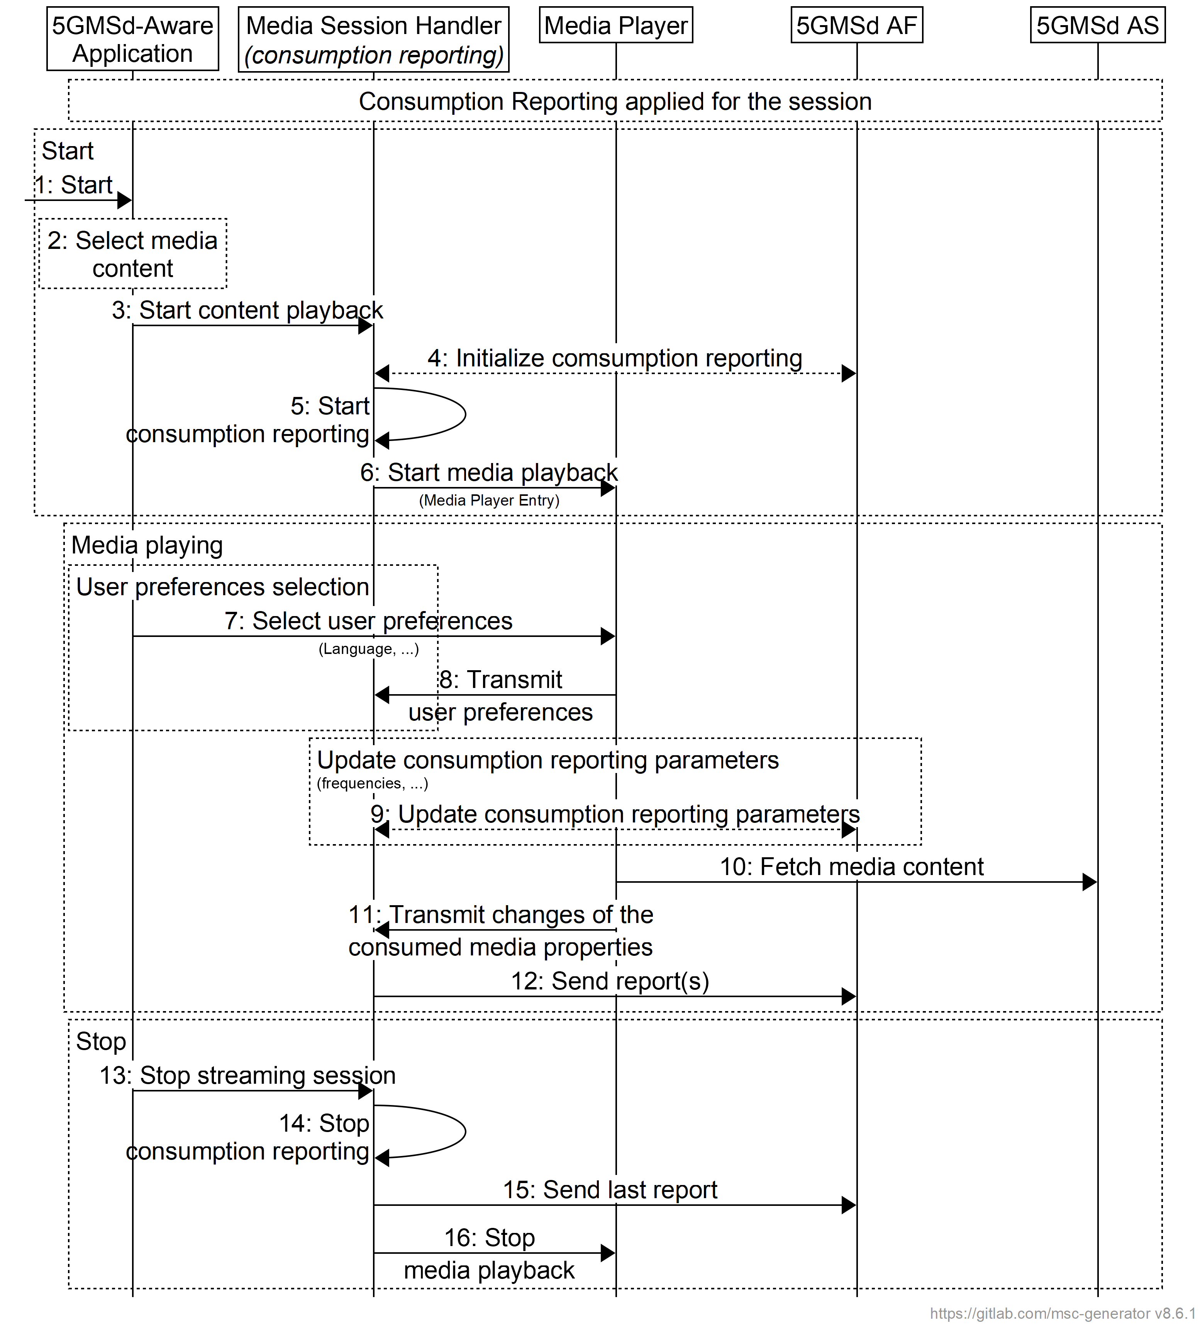
Figure 5.6-1: Consumption reporting
Steps:
The first phase is the initialisation phase:
1: The 5GMSd-Aware Application is started.
2: A media content item is selected.
3: The 5GMSd-Aware Application triggers the Media Session Handler to start content playback. The Media Player Entry is provided.
4: The 5GMSd AF initializes the parameters for the consumption reporting configuration (e.g. frequency).
5: The Media Session Handler triggers consumption reporting.
6: The Media Session Handler starts the Media Player with the Media Player Entry.
The second phase is media playback:
The user preferences may be changed:
7: The 5GMSd-Aware Application selects/changes the user preferences.
8: The Media Player transmits consumption reporting user preferences to the Media Session Handler.
When media is playing, the consumption reporting parameters may be updated.
9: The 5GMSd AF updates the consumption reporting parameters.
When media is playing:
10: The Media Player regularly accesses to the media content.
11: In case of changes to the consumed media properties, the Media Player transmits the changes to the Media Session Handler.
12: The Media Session Handler regularly sends report(s) to the 5GMSd AF.
The last phase is to stop the media:
13: The 5GMSd-Aware Application triggers the Media Session Handler to stop content playback.
14: The Media Session Handler stops consumption reporting.
15: The Media Session Handler may send final consumption report(s) to the 5GMSd AF.
17: The Media Session Handler stops the Media Player.

5.6.2 Consumption reporting parameters
Table 4.2.3-2 describes the parameters used in step 4 of clause 5.6.1.
Table 5.6.2-2 below describes the additional parameters used in steps 13 or 16 of clause 5.6.1.
Table 5.6.2-2: Additional consumption reporting parameters
Parameters | Description
Media Player Entry pointer | Identify the Media Player Entry.  In the case of DASH, the Media Player Entry pointer can be a URL of the MPD.
Consumption reporting client ID | Identify the identifier of the UE that consumes the data.
Location type | Identify the UE location type.  This parameter is only used when the location reporting is enabled for the UE or for the Downlink Streaming session with a condition that the UE allows to share its location within operator's trust domain.  The location type can be CGI, ECGI or NCGI as defined in TS 23.003 [9].
Location | Identify the UE location.  This parameter is only used when location reporting is enabled for the UE or for the Downlink Streaming session, and when the UE allows its location to be shared within the Network Operator's trust domain.
Media consumed | Identifies the media consumed.  In the case of DASH, the AdaptationSet@id may be used.
Start time | The time when media consumption started.
Duration | The duration of media consumption relative to the start time.

5.6.3 Triggering consumption reporting
If consumption reporting is supported and activated, the 5GMSd Client shall send a consumption report when any of the following conditions is met:
- Start of 5GMS consumption of a Downlink Streaming session;
- Stop of 5GMS consumption of a Downlink Streaming session;
- Upon determining the need to report ongoing 5GMS consumption
- Reports are sent at periodic intervals determined by the reporting interval attribute of the consumption reporting configuration specified in table 4.2.3-2.
- Upon determining a location change if location reporting is requested by the 5GMSd AF and is allowed to be reported by the UE.
NOTE: Whenever a consumption report is sent, the 5GMSd Client is expected to reset its corresponding reporting interval timer to the value of that attribute and begin countdown of the timer. Whenever the 5GMSd Client stops consumption of the same session, it is expected to disable its corresponding reporting interval timer.

5.7 Establishing a unicast downlink media streaming session with 5GMSd AF interactions for dynamic policy updates

5.7.1 General
This clause describes the provisioning for dynamic policy invocation and the establishment of a unicast downlink streaming session using the dynamic policy API. The establishment of the unicast downlink media streaming session uses 5GMSd AF interactions, as described in steps 4 to 8 of clause 5.1. The dynamic policy API allows separate handling of Service Data Flows within the same PDU Session. The Media Session Handler provides a Policy Template Id together with Service Data Flow Descriptions when requesting a dynamic policy. An example Policy Template Id value is "background_data".
The Media Session Handler provides needed information to the 5GMSd AF, so that the 5GMSd AF can combine the semi-static parameters from a Policy Template (which is associated with the Policy Template Id) with the API parameters to trigger a dynamic PCC rule update using the NEF or PCF.
The 5GMSd AF may trigger, for example, the "AF session with required QoS procedure" (see TS 23.502 [3] clause 4.15.6.6) for updating QoS related dynamic PCC rules. For changing charging related rules, the 5GMSd AF may trigger the "Change the chargeable party during the session" procedure (see TS 23.502 [3] clause 4.15.6.5).

5.7.2 Provisioning
The provisioning for the dynamic policy procedure follows generally the procedure from clause 5.3. Specifically, the Dynamic Policy feature is activated and, as result, the 5GMSd Application Provider is able to provision one or more Policy Templates.
The domain model of M1d and M5d APIs is depicted in figure 5.7.2-1. Realization of the dependencies between M1d and M5d data entries are up to implementation.
NOTE: Multiple M5d 5GMSd AF nodes may reference the same M1d resource.
Figure 5.7.2-1: Domain model for dynamic policies
A Policy Template is identified by a Policy Template Id and contains semi-static parameters, including the API entry for the PCF/NEF interactions. The list of provisioned Policy Template Ids is communicated as valid Policy Template Ids to the Media Session Handler. The Media Session Handler uses one of the valid Policy Template Ids when invoking a dynamic policy.

5.7.3 Progressive Download of on-demand content
This procedure describes the establishment of a unicast downlink media streaming session with 5GMSd AF interactions for dynamic policy updates. A streaming session may use 3GP File Format (Progressive Download), 3GP Timed Text or other (potentially non-3GPP defined) formats.
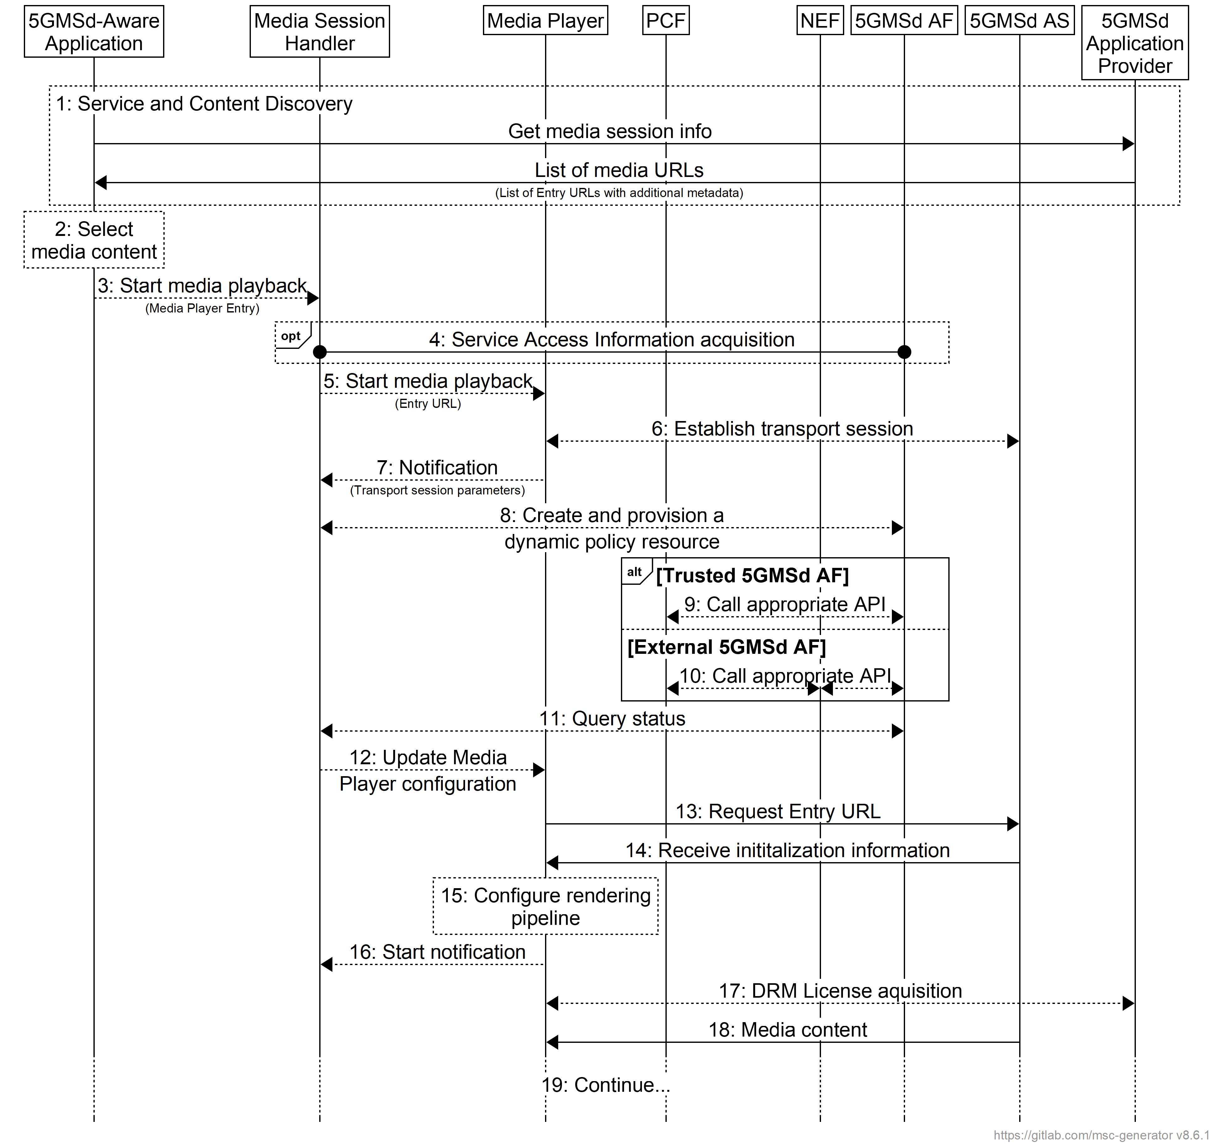
Figure 5.7-1: High-level procedure for progressive download for on-demand media
Prerequisites:
- The 5GMSd Application Provider has provisioned the 5G Media Streaming System and has set up content ingest.
- The 5GMSd-Aware Application has received the Service Announcement from the 5GMSd Application Provider.
- The Service Access Information contains detailed information for the policy related interactions. Specifically, the information includes URL(s) for the 5GMSd AF, an identifier of the 5GMS Provisioning Session and a list of authorized Policy Type indications for that specific application.
- The 5GMSd Application Provider has agreed an SLA with the Network Operator defining the possible QoS levels and their charging rates (see TS 23.503 [4] clause 6.1.3.22). The PCF is configured with the corresponding QoS parameters and charging information.
Steps:
1: The 5GMSd-Aware Application triggers the Service Announcement and Content Discovery procedure. The Service Announcement includes either the whole Service Access Information (i.e. details for Media Session Handling (M5d) and for Media Streaming access (M4d)) or a reference to the Service Access Information. The configuration parameters are listed in table 5.7.4-1.
NOTE: The Service and Content Discovery procedure only involves the 5GMSd-Aware Application and the external Application Server, and hence is out of scope of the present document.
2: A Media Player Entry is selected.
3: The 5GMSd-Aware Application triggers the Media Session Handler to start media playback. The Media Player Entry is provided to the Media Session Handler.
4: When the 5GMSd-Aware Application has received a reference to the Service Access Information (see step 1), the Media Session Handler interacts with the 5GMSd AF to acquire the whole Service Access Information.
5: The Media Session Handler triggers the Media Player to start the session.
6: The Media Player establishes the transport session, e.g. a TCP connection.
7: The Media Player notifies the Media Session Handler about the Service Data Flow Description(s) of the transport session established in the previous step (see TS 23.502 [3]), as defined in the Service Access Information. This can be for example 5-tuples.
8: The Media Session Handler requests that a dynamic policy be applied to the media session. The request includes at least the Provisioning Session identifier, the Service Data Flow Description(s) and the Policy Template identifier (see table 5.7.4-1) to be applied to the described transport session. In some cases, a QoS specification is also provided, containing desired QoS information. The 5GMSd AF uses the Policy Template indication for the related procedure and to identify the related network function.
9: This step applies when the 5GMSd AF resides in the trusted Data Network. Depending on the Policy Template, the step is executed either:
a. When the Policy Template relates to QoS, the 5GMSd AF may either directly interact with the PCF or may use a NEF service:
- when directly interacting with the PCF, the 5GMSd AF uses the Npcf_PolicyAuthorization Service as defined in TS 23.502 [3] clause 5.2.5.3).
- when interacting via the NEF with the PCF, continue at step 10a.
b. When the Policy Template relates to a different charging scheme, the 5GMSd AF may either directly interact with the PCF or may use a NEF service:
- when directly interacting with the PCF, the 5GMSd AF uses the Npcf_PolicyAuthorization Service as defined in TS 23.502 [3] clause 5.2.5.3).
- when interacting via the NEF with the PCF, continue at step 10b.
10: This step applies when the 5GMSd AF resides in the external Data Network. Depending on the Policy Template, the step is executed either:
a. When the Policy Template relates to QoS, the 5GMSd AF may use the Nnef_AFsessionWithQoS service as defined in TS 23.502 [3] clause 5.2.6.9. (The complete call flow is described in TS 23.502 [3] clause 4.15.6.6.)
b. When the Policy Template relates to a different charging scheme, the 5GMSd AF may use the Nnef_ChargeableParty service as defined in TS 23.502 [3] clause 5.2.6.8. (The complete call flow is described in TS 23.502 [3] clause 4.15.6.4 and clause 4.15.6.5.) The Policy Template may contain the Sponsor Information (values, based on SLA negotiation) and Background Data Transfer Reference ID. The Flow description is provided by the Media Session Handler at API invocation.
11: The Media Session Handler queries the status of the dynamic policy invocation. The response contains status information (policy accepted, rejected, etc) and information on policy enforcement such as the enforcement method and enforcement bit rate.
12: The Media Session Handler notifies the Media Player according to the response from the 5GMSd AF (see table 5.6.4-2).
13: The Media Player sends the request for the progressive download content.
14: The Media Player receives the initialization information of the progressive download content. The initialization information contains configuration parameters for reception of the media, and optionally also DRM information.
15: The Media Player configures the rendering pipeline for media playback.
16: The Media Player notifies the Media Session Handler, providing the transport session information and some media content related information.
17: Optional: Media Player acquires a DRM License from as the 5GMSd Application Provider.
18: The Media Player receives media content and puts it into the rendering pipeline.
19: The Media Player continues to receive and play back the media content.

5.7.4 DASH streaming
It is assumed here that the key information to initialize the media decoding and rendering pipeline is present in the Media Player Entry (or referenced by the Media Player Entry). The intention is to provide the client with information to setup the media decoding and rendering pipeline in such a way that no pipeline reset is needed during the session. Implementations need to consider that parts of the information are provided with the initialization segments.
It is assumed that the client is enabled to use the same media decoding and rendering pipeline during the session.
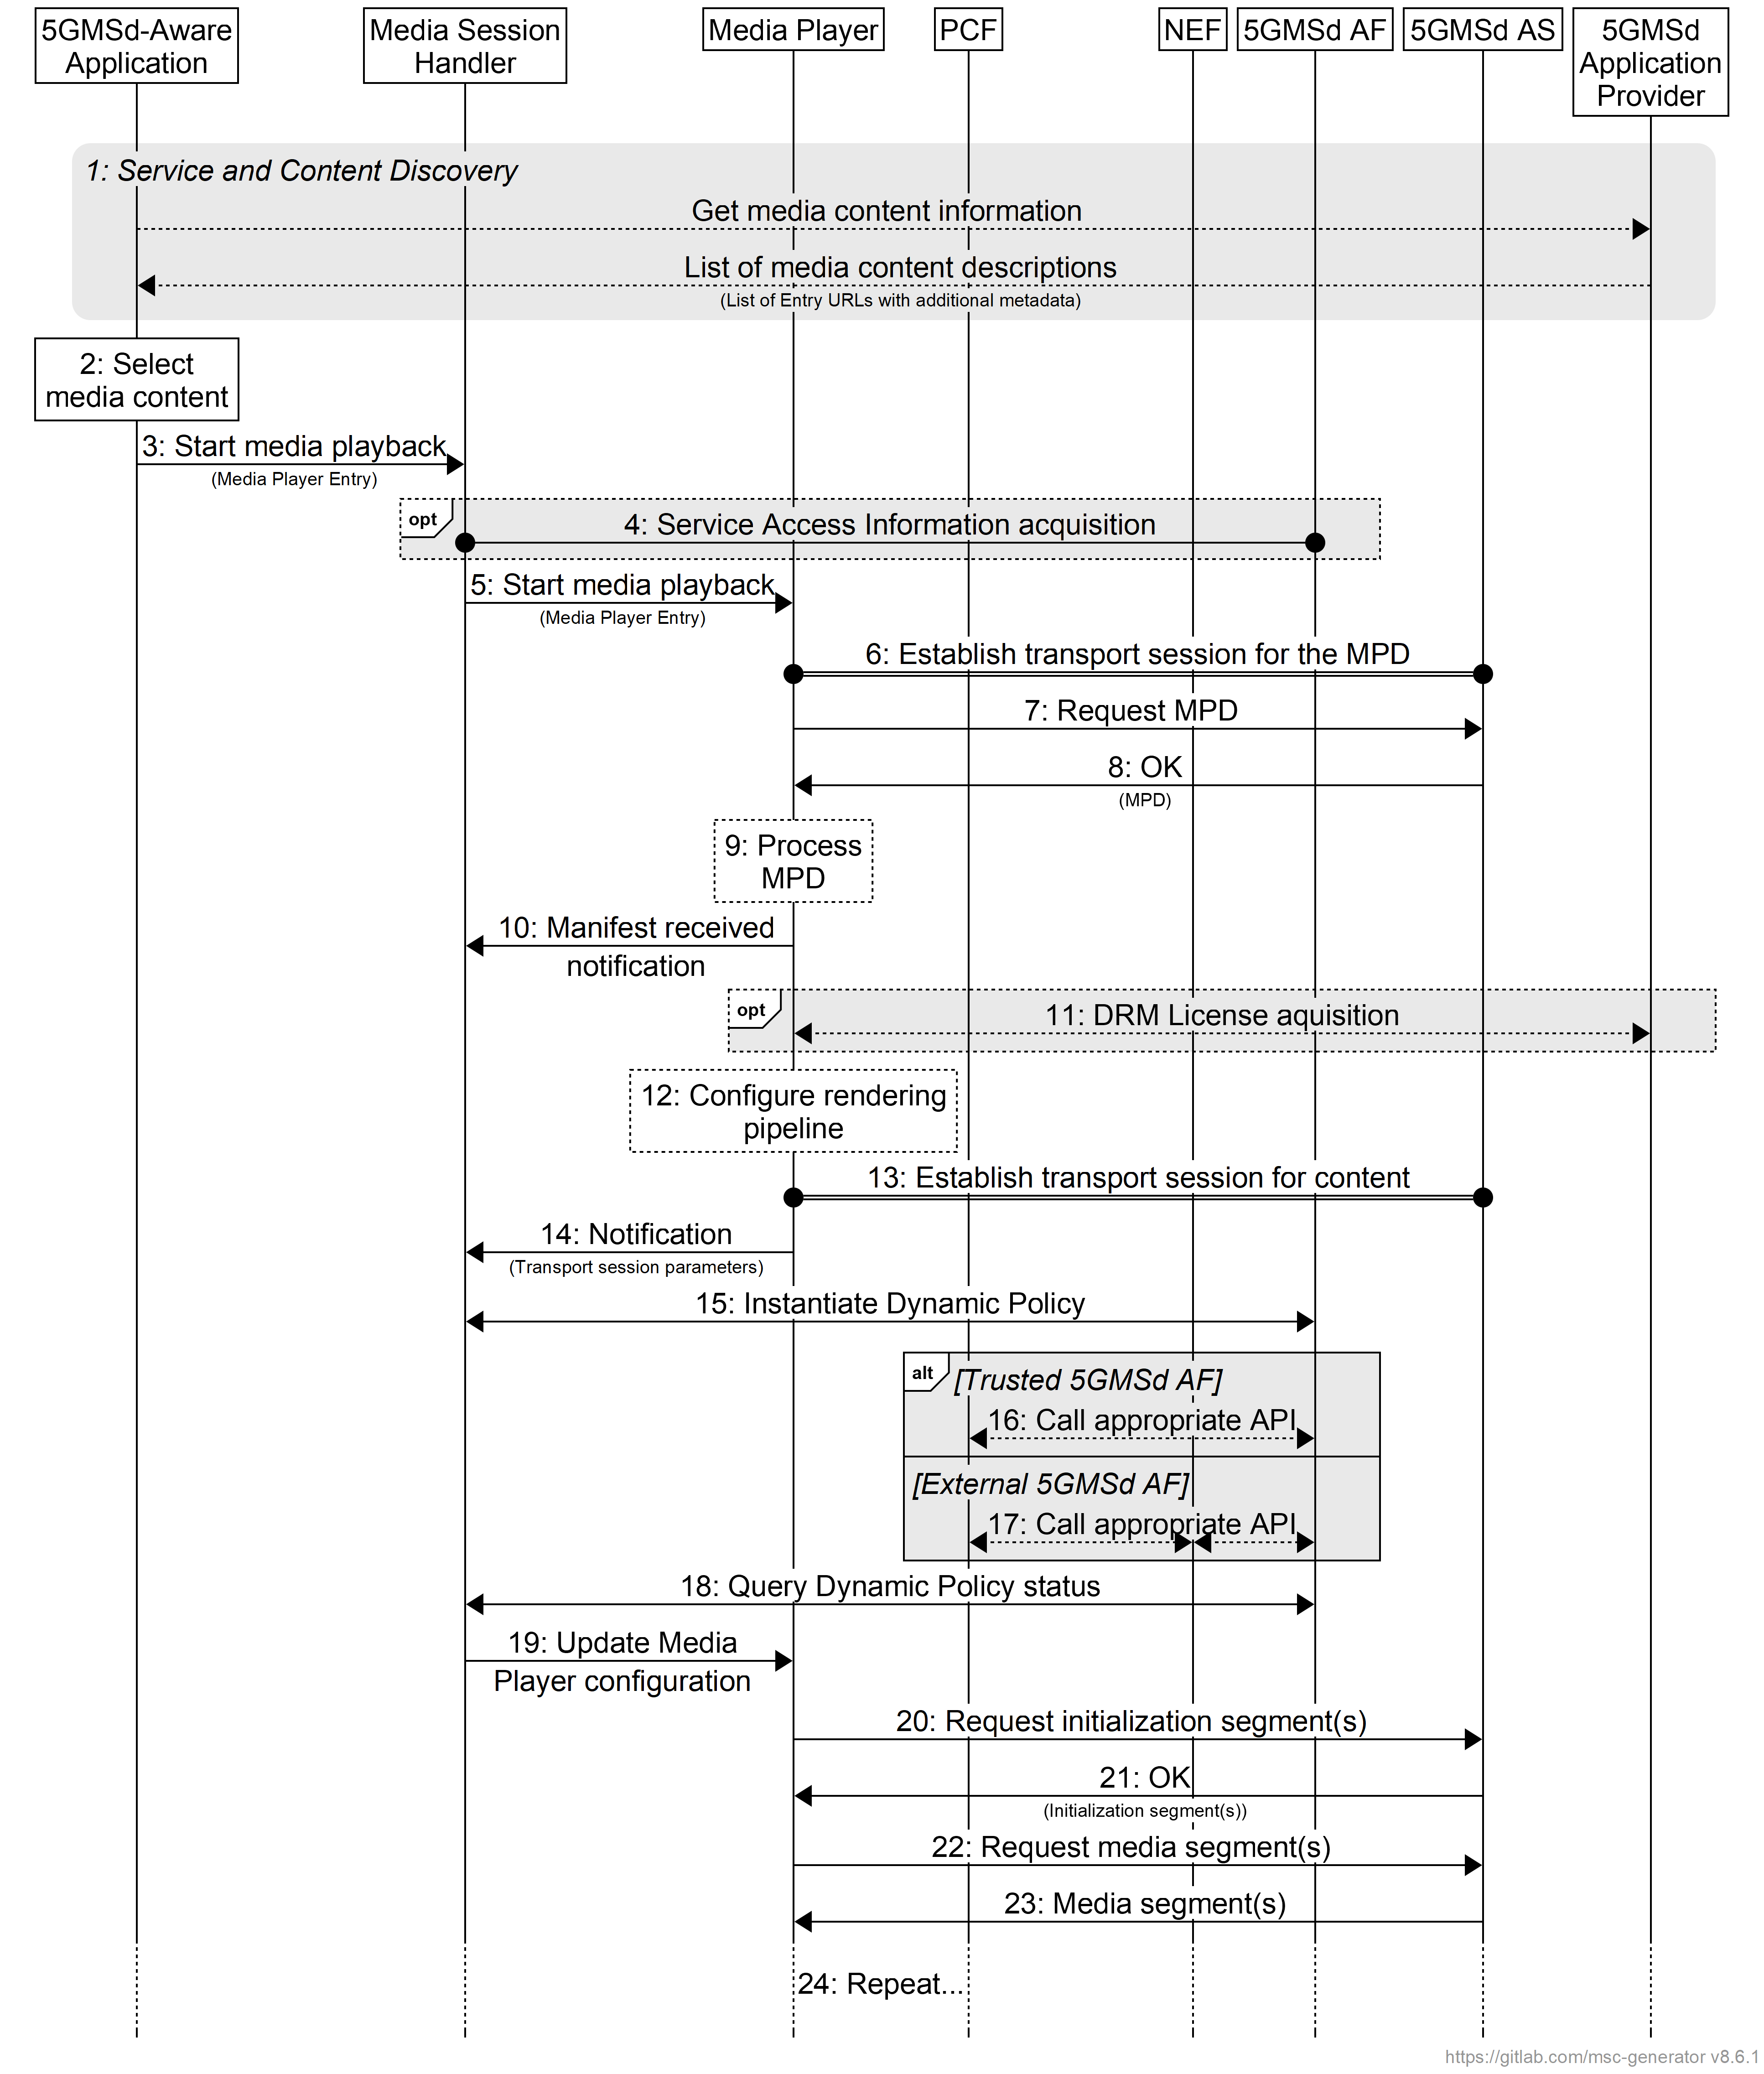
Figure 5.7-2: High Level Procedure for DASH content
Prerequisites:
- The 5GMSd Application Provider has provisioned the 5G Media Streaming System and has set up content ingest.
- The 5GMSd-Aware Application has received the service announcement from the 5GMSd Application Provider.
- The Service Announcement Information contains detailed information for the policy related interactions. Specifically, the information includes URLs for the 5GMSd AF, an identifier of the Provisioning Session and a list of authorized Policy Type indications for that specific application.
- The 5GMSd Application Provider has agreed an SLA with the Network Operator defining the possible QoS levels and their charging rates (see clause 6.1.3.22 of TS 23.503 [4]). The PCF is configured with the corresponding QoS parameters and charging information.
Steps:
1: The 5GMSd-Aware Application triggers the Service Announcement and Content Discovery procedure. The Content Discovery procedure only involves the 5GMSd-Aware Application and the 5GMSd Application Provider. The Service Announcement includes either the whole Service Access Information (i.e. details for Media Session Handling (M5d) and for Media Streaming access (M4d)) or a reference to the Service Access Information.
2: A media content item is selected.
3: The 5GMSd-Aware Application triggers the Media Session Handler to start media playback. The Media Player Entry is provided to the Media Session Handler.
4: When the 5GMS-Aware Application has received only a reference to the Service Access Information (see step 1), the Media Session Handler interacts with the 5GMSd AF to acquire the whole Service Access Information.
5: The Media Session Handler triggers the Media Player to start the session.
6: The Media Player establishes a transport session for acquiring the MPD referenced by the Media Player Entry.
7: The Media Player requests the MPD.
8: The Media Player receives the MPD.
9: The Media Player processes the MPD. It determines, for example, the number of needed transport sessions for media acquisition. The Media Player should be able to use the MPD information to initialize the media pipelines for each media stream. The MPD should also contain information to start the DRM client initialization, when DRM is used.
10: The Media Player notifies the Media Session Handler about the MPD. The notification may contain parameters from the MPD.
11: (Optional) the Media Player acquires the necessary DRM information, for example a DRM License.
12: The Media Player configures the media rendering pipeline.
13: The Media Player establishes the necessary transport session(s) for acquiring the content. For example, the Media Player may establish one transport session for each media component (audio, video, etc) and possibly additional transport sessions for other media representations.
14: The Media Session Handler is notified about the established transport session(s) for the content by providing the Service Data Flow Description of the application flows as defined in the Service Access Information. This can be for example 5-tuples.
15: The Media Session Handler requests that a dynamic policy be applied to the media session. The request includes at least the Provisioning Session identifier, the Service Data Flow Description(s) and the Policy Template identifier (see table 5.7.4-1), to be applied to the described transport session. In some cases, a QoS specification is also provided, containing desired QoS information. The 5GMSd AF uses the Policy Template for the related procedure and to identify the related network function. The status parameters for dynamic policy instances returned to the 5GMSd Client are listed in table 5.7.5-1.
NOTE: The Media Session Handler may add and remove Service Data Flow description(s) from the dynamic policy resource during the lifetime of the Media Streaming Session.
16: This step applies when the 5GMSd AF resides in the trusted Data Network. Depending on the Policy Template, the step is executed either:
a. When the Policy Template relates to QoS, the 5GMSd AF may either directly interact with the PCF or may use a NEF service:
- when directly interacting with the PCF, the 5GMSd AF uses the Npcf_PolicyAuthorization service as defined in clause 5.2.5.3 of TS 23.502 [3]).
- when interacting via the NEF with the PCF, continue at step 17a.
b. When the Policy Template relates to a different charging scheme, the 5GMSd AF may either directly interact with the PCF or may use a NEF service:
- when directly interacting with the PCF, the 5GMSd AF uses the Npcf_PolicyAuthorization service as defined in clause 5.2.5.3 of TS 23.502 [3]).
- when interacting via the NEF with the PCF, continue at step 17b.
17: This step applies when the 5GMSd AF resides in the external Data Network. Depending on the Policy Template, the step is executed either:
a. When the Policy Template relates to QoS, the 5GMSd AF may use the Nnef_AFsessionWithQoS service as defined in clause 5.2.6.9 of TS 23.502 [3]. (The complete call flow is described in clause 4.15.6.6 of TS 23.502.)
b. When the Policy Template relates to a different charging scheme, the 5GMSd AF may use the Nnef_ChargeableParty service as defined in clause 5.2.6.8 of TS 23.502 [3]. (The complete call flow is described in clauses 4.15.6.4 and 4.15.6.5 of TS 23.502.) The Policy Template may contain the Sponsor Information (values, based on SLA negotiation) and Background Data Transfer Reference ID. The Flow Description is provided by the Media Session Handler at API invocation.
18: The Media Session Handler queries the status of the Dynamic Policy invocation. The response contains status information (policy accepted, rejected, etc) and information on policy enforcement such as the enforcement method and enforcement bit rate.
19: The Media Session Handler updates the configuration of the Media Player according to the response from the 5GMSd AF (see table 5.6.4-2).
20: The Media Player requests a DASH initialization segment. The Media Player repeats this step for each required initialization segment.
21: The Media Player receives the initialization segments.
22: The Media Player requests DASH media segments according to the MPD.
23: The Media Player receives media segments and feeds them into the appropriate media rendering pipeline.
24: Previous steps are repeated according to the MPD information.

5.7.5 Status information for dynamic policy instance
Table 5.7.5-1: Status information for dynamic policy instance
Parameters | Description
Policy Enforcement | Information about the policy enforcement system.
L4S enabled | A flag indicating that ECN marking for L4S is in force for this Dynamic Policy instance.
QoS monitoring enabled | A flag indicating that QoS monitoring is currently enabled for this Dynamic Poilicy instance.

5.7.6 Dynamic Policy selection for downlink media streaming based on Service Operation Point signalling
This clause provides an extension to the general call flow in clause 5.2.3 in order to address the usage of Service Descriptions to select a Dynamic Policy in downlink 5G Media Streaming services that supports the requirements of an abstract Service Operation Point. Details are shown in figure 5.7.6-1.
Figure 5.7.6-1: High-level procedure for DASH content streaming
with Service Operation Point handling
Prerequisites:
- The 5GMSd Application Provider has provisioned the content hosting feature in the 5G Media Streaming System.
- The 5GMSd-Aware Application has received the Service Announcement from the 5GMSd Application Provider.
Extended Steps:
1. Policy Templates are provisioned in the 5GMSd AF.
12. The Media Player informs the 5GMS-Aware Application about the set of Service Descriptions associated with the Media Player Entry document for the content selected in step 3. Each Service Description is identified by a different External reference.
13. The 5GMSd-Aware Application selects one of the available Service Descriptions.
14. The Media Player provides the External reference of the selected Service Description to the Media Session Handler.
15. The Media Session Handler selects a Dynamic Policy with a matching External reference.
21. The Media Player provides Operation Point metrics to the Media Session Handler.
22. The Media Session Handler sends Service Operation Point measurements and events to the 5GMSd AF.

5.7.7 Use of Service Operation Point signalling to optimise delivery of low-latency live media streaming services (informative)

5.7.7.1 5GMS System acts as a CDN
In this case, the specific aspects are as follows:
1. A provisioning agreement is struck between the 5GMSd Application Provider and the operator of the 5GMS System in the form of one or several Service Operation Points expressed as Service Descriptions and/or Policy Templates. (Service Descriptions may be derived from Policy Templates if the latter are omitted, or vice versa.)
2. DASH or HLS content is provided externally. Media Entry Point documents are annotated with Service Descriptions. The content is published to the 5GMS System for distribution over downlink media streaming.
3. Content is ingested by the 5GMSd AS at reference point M2d such that the latency requirements can be met.
4. The 5GMS System distributes the ingested content according to the provisioning agreement, i.e. meeting bit rate and latency requirements of the agreed Service Operation Point.
NOTE: The path between an (external) 5GMS Application Provider and the 5GMSd AS is subject to a separate transport-level agreement.
5. The Service Operation Point metrics collated by the 5GMSd AF are used by the 5GMS System to determine whether the agreed Service Operation Point has been satisfied, or whether the Policy Templates need to be adjusted so that it can be satisfied.
For low-latency streaming where the 5GMS System acts as a CDN, the basic call flow documented in clause 5.7.6 is extended as follows.
Extended steps:
1. Policy Templates suitable for supporting low-latency media streaming are provisioned in the 5GMSd AF.
2. Media ingest supports a low-latency protocol, e.g. segment content is provided in chunks.
14. 5GMSd-Aware Application selects a low-latency Service Description and provides its External reference to the Media Session Handler.
17. The Media Player configures itself for low-latency playback based on the low-latency Service Description selected in step 14.
21. The Media Player operates in a low-latency media delivery mode.

5.7.7.2 5GMSd AS deployed in an external DN
In this case, the specific aspects are as follows:
1. A provisioning agreement is struck between the 5GMS Application Provider and the operator of the 5GMS System in the form of one or several Service Operation Points expressed as Service Descriptions and/or Policy Templates. (Service Descriptions may be derived from Policy Templates if the latter are omitted, or vice versa.)
NOTE: The path between the externally deployed 5GMSd AS and the 5G System may be subject to a separate transport-level agreement.
2. The 5GMSd AS external.
3. Content ingest by the 5GMSd AS is out of scope.
4. The 5GMS System distributes the content according to the agreed provisioning agreement, i.e. meeting bit rate and latency requirements of the agreed Service Operation Point.
5. The Service Operation Point metrics collated by the 5GMSd AF are used by the 5GMS System to determine whether the agreed Service Operation Point has been satisfied, or whether the Policy Templates need to be adjusted so that it can be satisfied.
For low-latency streaming where the 5GMSd AS is deployed in an external DN, the basic call flow documented in clause 5.7.6 is extended as follows.
Extended steps:
1. Policy Templates suitable for supporting low-latency media streaming are provisioned in the 5GMSd AF.
14. 5GMSd-Aware Application selects a low-latency Service Description.
17. The Media Player configures itself for low-latency playback based on the low-latency Service Description selected in step 14.
21. The Media Player operates in a low-latency media delivery mode.

5.7.8 Downlink Background Data Transfer using dynamic policy invocation
Figure 5.7.8-1 shows a high-level call flow for the configuration and usage of a Background Data Transfer session in downlink 5G Media Streaming:
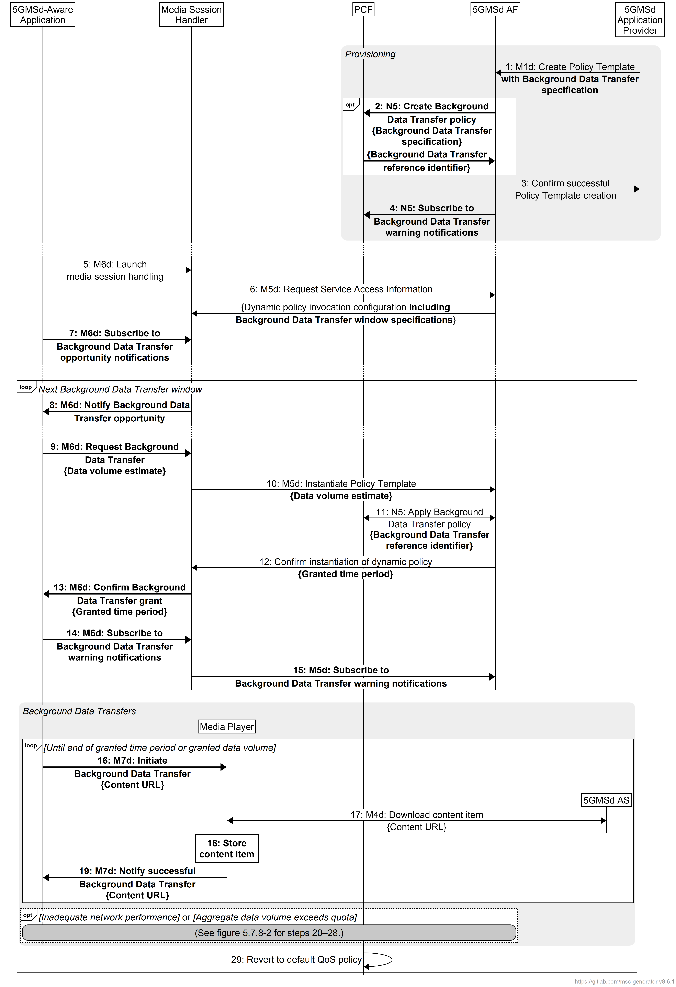
Figure 5.7.8-1: Call flow for Background Data Transfer session configuration and establishment
Pre-requisites:
1. The 5GMSd Application Provider has negotiated a Service Level Agreement with the 5GMS System operator that includes all or some of the following:
a. Time window(s) when Background Data Transfers are available. These may recur on a regular pattern (e.g., daily, weekly, monthly, etc.).
b. A quota for the maximum number of 5GMS Clients that may avail themselves of a Background Data Transfer during each such time window.
c. A quota for the maximum aggregate volume of data that may be transferred by all 5GMS Clients during each Background Data Transfer window.
2. The 5GMS System operator may have provisioned a Background Data Transfer Policy in the PCF based on the Service Level Agreement, in which case it may share the corresponding Background Data Transfer reference identifier directly with the 5GMSd Application Provider. The steps in the call flow sequence are as follows with differences from the baseline call flow highlighted in bold:
1. The 5GMSd Application Provider provisions a Policy Template in the 5GMSd AF at reference point M1d including network QoS parameters that either references an existing Background Data Transfer policy already provisioned in the PCF that embodies the aforementioned Service Level Agreement or else directly specifies Background Data Transfer parameters in line with the aforementioned Service Level Agreement.
2. If the supplied Policy Template explicitly declares new Background Data Transfer parameters, the 5GMSd AF creates a corresponding new Background Data Transfer policy in the PCF based on them using the Npcf_BDTPolicyControl service (or, if the 5GMSd AF is deployed outside the Trusted DN, the Nnef_BDTPNegotiation service (see clause 4.16.7.2 of TS 23.502 [3]). The PCF may interact with the UDR as a consequence. The procedure yields a Background Data Transfer reference identifier.
3. The 5GMSd AF acknowledges successful creation of the Policy Template to the 5GMSd Application Provider. This confirms that the parameters of the Policy Template (including the Background Data Transfer parameters) are acceptable to the 5GMS System.
4. If it has not already done so, the 5GMSd AF subscribes to receive Background Data Transfer warning notifications from the PCF as defined in clause 4.16.7 of TS 23.502 [3].
At some later point in time:
5. The 5GMSd-Aware Application launches media session handling using an appropriate service launch mechanism at reference point M6d.
6. In response, the Media Session Handler fetches Service Access Information from the 5GMSd AF for the relevant Provisioning Session via reference point M5d. A client dynamic policy invocation configuration is provided that describes the Policy Templates applicable to the requesting 5GMSd Client, including information about Background Data Transfer windows and endpoint(s) that the Media Session Handler may subscribe to in order to receive Background Data Transfer warning notifications from the 5GMSd AF.
7. The 5GMSd-Aware Application also subscribes to receive notifications of Background Data Transfer opportunities from the Media Session Handler by invoking a client API on the latter at reference point M6d.
At the start of the next Background Data Transfer window:
8. According to its list of current subscriptions (see step 7), the Media Session Handler notifies its 5GMSd-Aware Application subscriber(s) of the Background Data Transfer opportunity by sending a notification to each one via reference point M6d. The notification indicates the time window of the Background Data Transfer opportunity.
9. If it wishes to avail itself of the Background Data Transfer opportunity (immediately or at some later point during the time window indicated in the previous step) a 5GMSd-Aware Application that has received such a notification invokes a suitable client API on the Media Session Handler at reference point M6d. The invocation includes an estimate of the data volume the 5GMSd Client intends to transfer in the background.
10: The Media Session Handler instantiates a dynamic policy resource on the 5GMSd AF based on one of the Policy Templates advertised in the Service Access Information that includes Background Data Transfer parameters. The request includes an estimate of the data volume the 5GMSd Client intends to transfer in the background.
11. If the request falls within a time window for Background Data Transfers advertised in the Service Access Information and if the quota for the number of Background Data Transfers within the current time window has not been exceeded, the Media Session Handler requests a change to the network QoS of the appropriate PDU Session by invoking the Npcf_PolicyAuthorization_Create operation (either directly or via the NEF) according to clause 4.16.7.1 of TS 23.502 [3] based on the Background Data Transfer parameters described in the appropriate Policy Template and citing the reference identifier of the Background Data Transfer referenced in step 1 or created in step 2.
12. The 5GMSd AF responds to the Media Session Handler to grant the Background Data Transfer request. The grant response includes a recommendation from the 5GMSd AF of the maximum time period for which the Background Data Transfer is available.
13. The Media Session Handler informs the 5GMSd-Aware Application of the Background Data Transfer grant by sending a synchronous response or asynchronous notification to the latter at reference point M7d. This conveys the maximum time period recommendation indicated by the 5GMSd AF in the previous step.
14: The 5GMSd-Aware Application subscribes to receive Background Data Transfer warning notifications from the Media Session Handler by invoking a client API on the latter at reference point M6d.
15. As a consequence, the Media Session Handler subscribes to receive Background Data Transfer warning notifications from the 5GMSd AF by invoking a network API on the latter at reference point M5d. The subscription endpoint(s) are indicated in the Service Access Information obtained in step 6.
The following steps are repeated for each content item the 5GMSd-Aware Application would like to download during the granted time period for Background Data Transfers:
16. The 5GMSd-Aware Application initiates download of a content item in the background by invoking a suitable client API on the Media Player at reference point M7u. The content is identified by a URL that is available on a 5GMSd AS.
17. The Media Player acquires the content item from the 5GMSd AS at reference point M4d using the content item URL supplied in the previous step.
18. The Media Player stores the acquired content item for later playback.
NOTE: Ownership of the content store and protection of stored content is out of scope.
19. The Media Player confirms that the content item has been successfully acquired by sending a notification to the 5GMSd-Aware Application at reference point M7d.
(Steps 20–28 are described below.)
When the granted time period for Background Data Transfers subsequently expires:
29. The PCF automatically reverts the network QoS of the media streaming session to its state prior to the Background Data Transfer grant without intervention from the 5GMS System.
At any time during a Background Data Transfer window the PCF may detect that the network cannot satisfy the requirements of the Background Data Transfer policy at the UE’s current location (as defined in clause 6.1.2.4 of TS 23.503 [4]) or that the volume of data transferred by all UEs in the current Background Data Transfer window has exceeded the quota provisioned in the Background Data Transfer policy. The procedures in this case are summarised in figure 5.7.8-2.
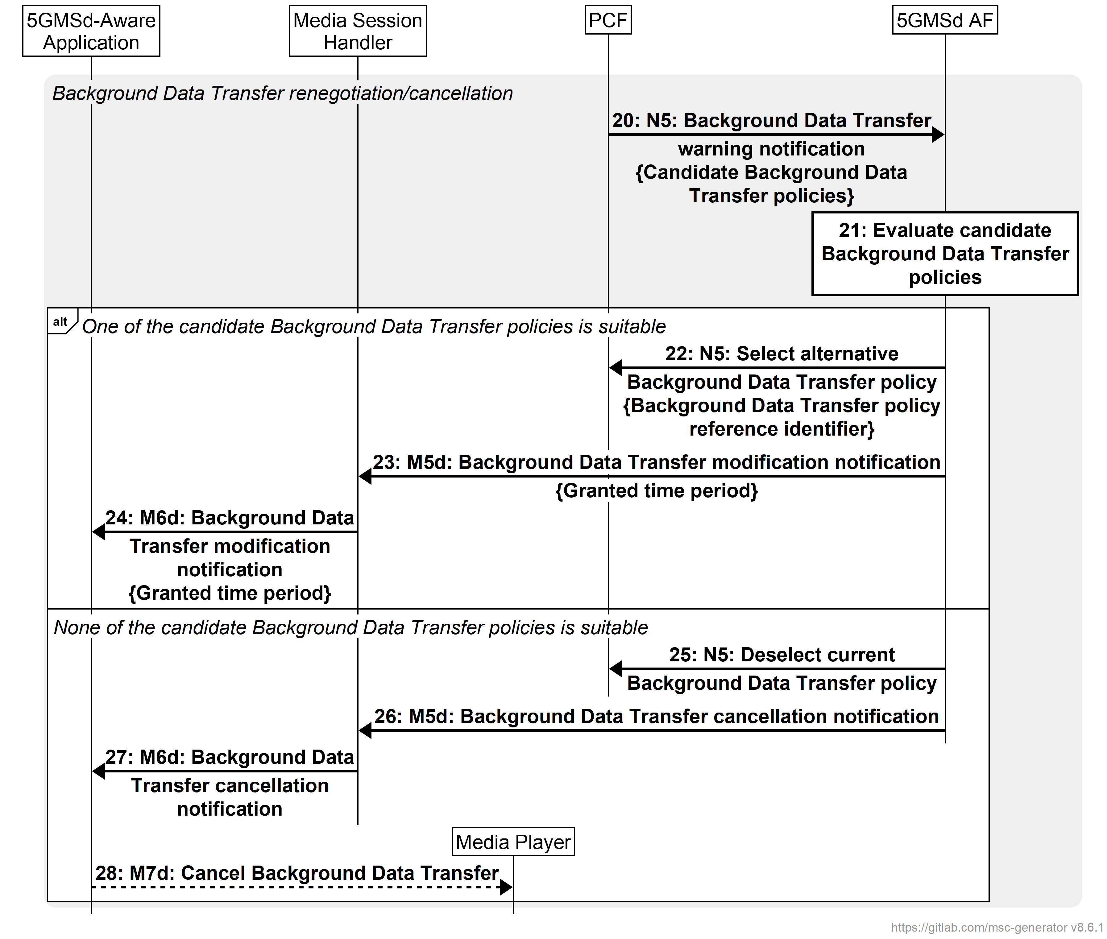
Figure 5.7.8-2: Call flow for Background Data Transfer session renegotiation/cancellation
The steps are as follows:
20: If it is able to identify alternative Background Data Transfer policies, the PCF sends a Background Data Transfer warning notification with these candidates to the 5GMSd AF as defined in clause 4.16.7.3 of TS 23.502 [3].
21: The 5GMSd AF evaluates the candidate alternative Background Data Transfer policies for suitability.
If the 5GMSd AF determines that one of the candidate alternative Background Data Transfer policies suggested by the PCF is suitable for the media streaming session in question:
22: The 5GMSd AF requests that its chosen alternative Background Data Transfer policy is applied, according to step 12 in clause 4.16.7.3 of TS 23.502 [13]. As defined in clause 6.1.2.4 of TS 23.503 [4], in this case the current Background Data Transfer policy remains in force until its natural end (see step 29 above).
23. Using an asynchronous notification mechanism at reference point M5d, the 5GMSd AF notifies the Media Session Handler of the modified Background Data Transfer grant, including the new maximum time period for which the Background Data Transfer is available.
24: The Media Session Handler informs the 5GMSd-Aware Application of the Background Data Transfer grant by sending an asynchronous notification to the latter at reference point M6d. This conveys the maximum time period recommendation indicated by the 5GMSd AF in the previous step.
Otherwise, if none of the candidate Background Data Transfer policies suggested by the PCF deemed suitable by the 5GMSd AF:
25: The 5GMSd AF informs the PCF that none of the candidate Background Data Transfer policies is suitable, according to step 13 in clause 4.16.7.3 of TS 23.502 [13].
26: Using an asynchronous notification mechanism at reference point M5d, the 5GMSd AF notifies the Media Session Handler that the Background Data Transfer window has ended prematurely.
27: Using an asynchronous notification mechanism at reference point M6d, the Media Session Handler notifies the 5GMSd-Aware Application that the Background Data Transfer window has ended prematurely.
28: As a consequence, the 5GMSd-Aware Application may choose to cancel an in-progress Background Data Transfer by invoking a suitable client API method on the Media Player at reference point M7d.

5.7.9 ECN marking for L4S for downlink media streaming based on Dynamic Policy
Figure 5.7.9-1 below shows a high-level call flow for downlink media streaming for configuration and usage of ECN marking for L4S. Differences from the procedure for downlink media streaming with dynamic policies defined in clause 5.7 are indicated in boldface.
The following is assumed:
- The service here is a unicast downlink media streaming service with dynamic policy support.
- As an example, the Layer 4 protocol used for application flows is TCP and the TCP stack used supports ECN marking for L4S.
- The network supports ECN marking for L4S packet marking.
- The application has specifically requested ECN marking for L4S for its media delivery session.
- NG-RAN manipulates the ECN bits (per clause 5.37.3.2 of TS 23.501 [2]). It is equally possible that the PDU Session Anchor UPF (PSA-UPF) manipulates the ECN bits (per clause 5.37.3.3 of [2]).
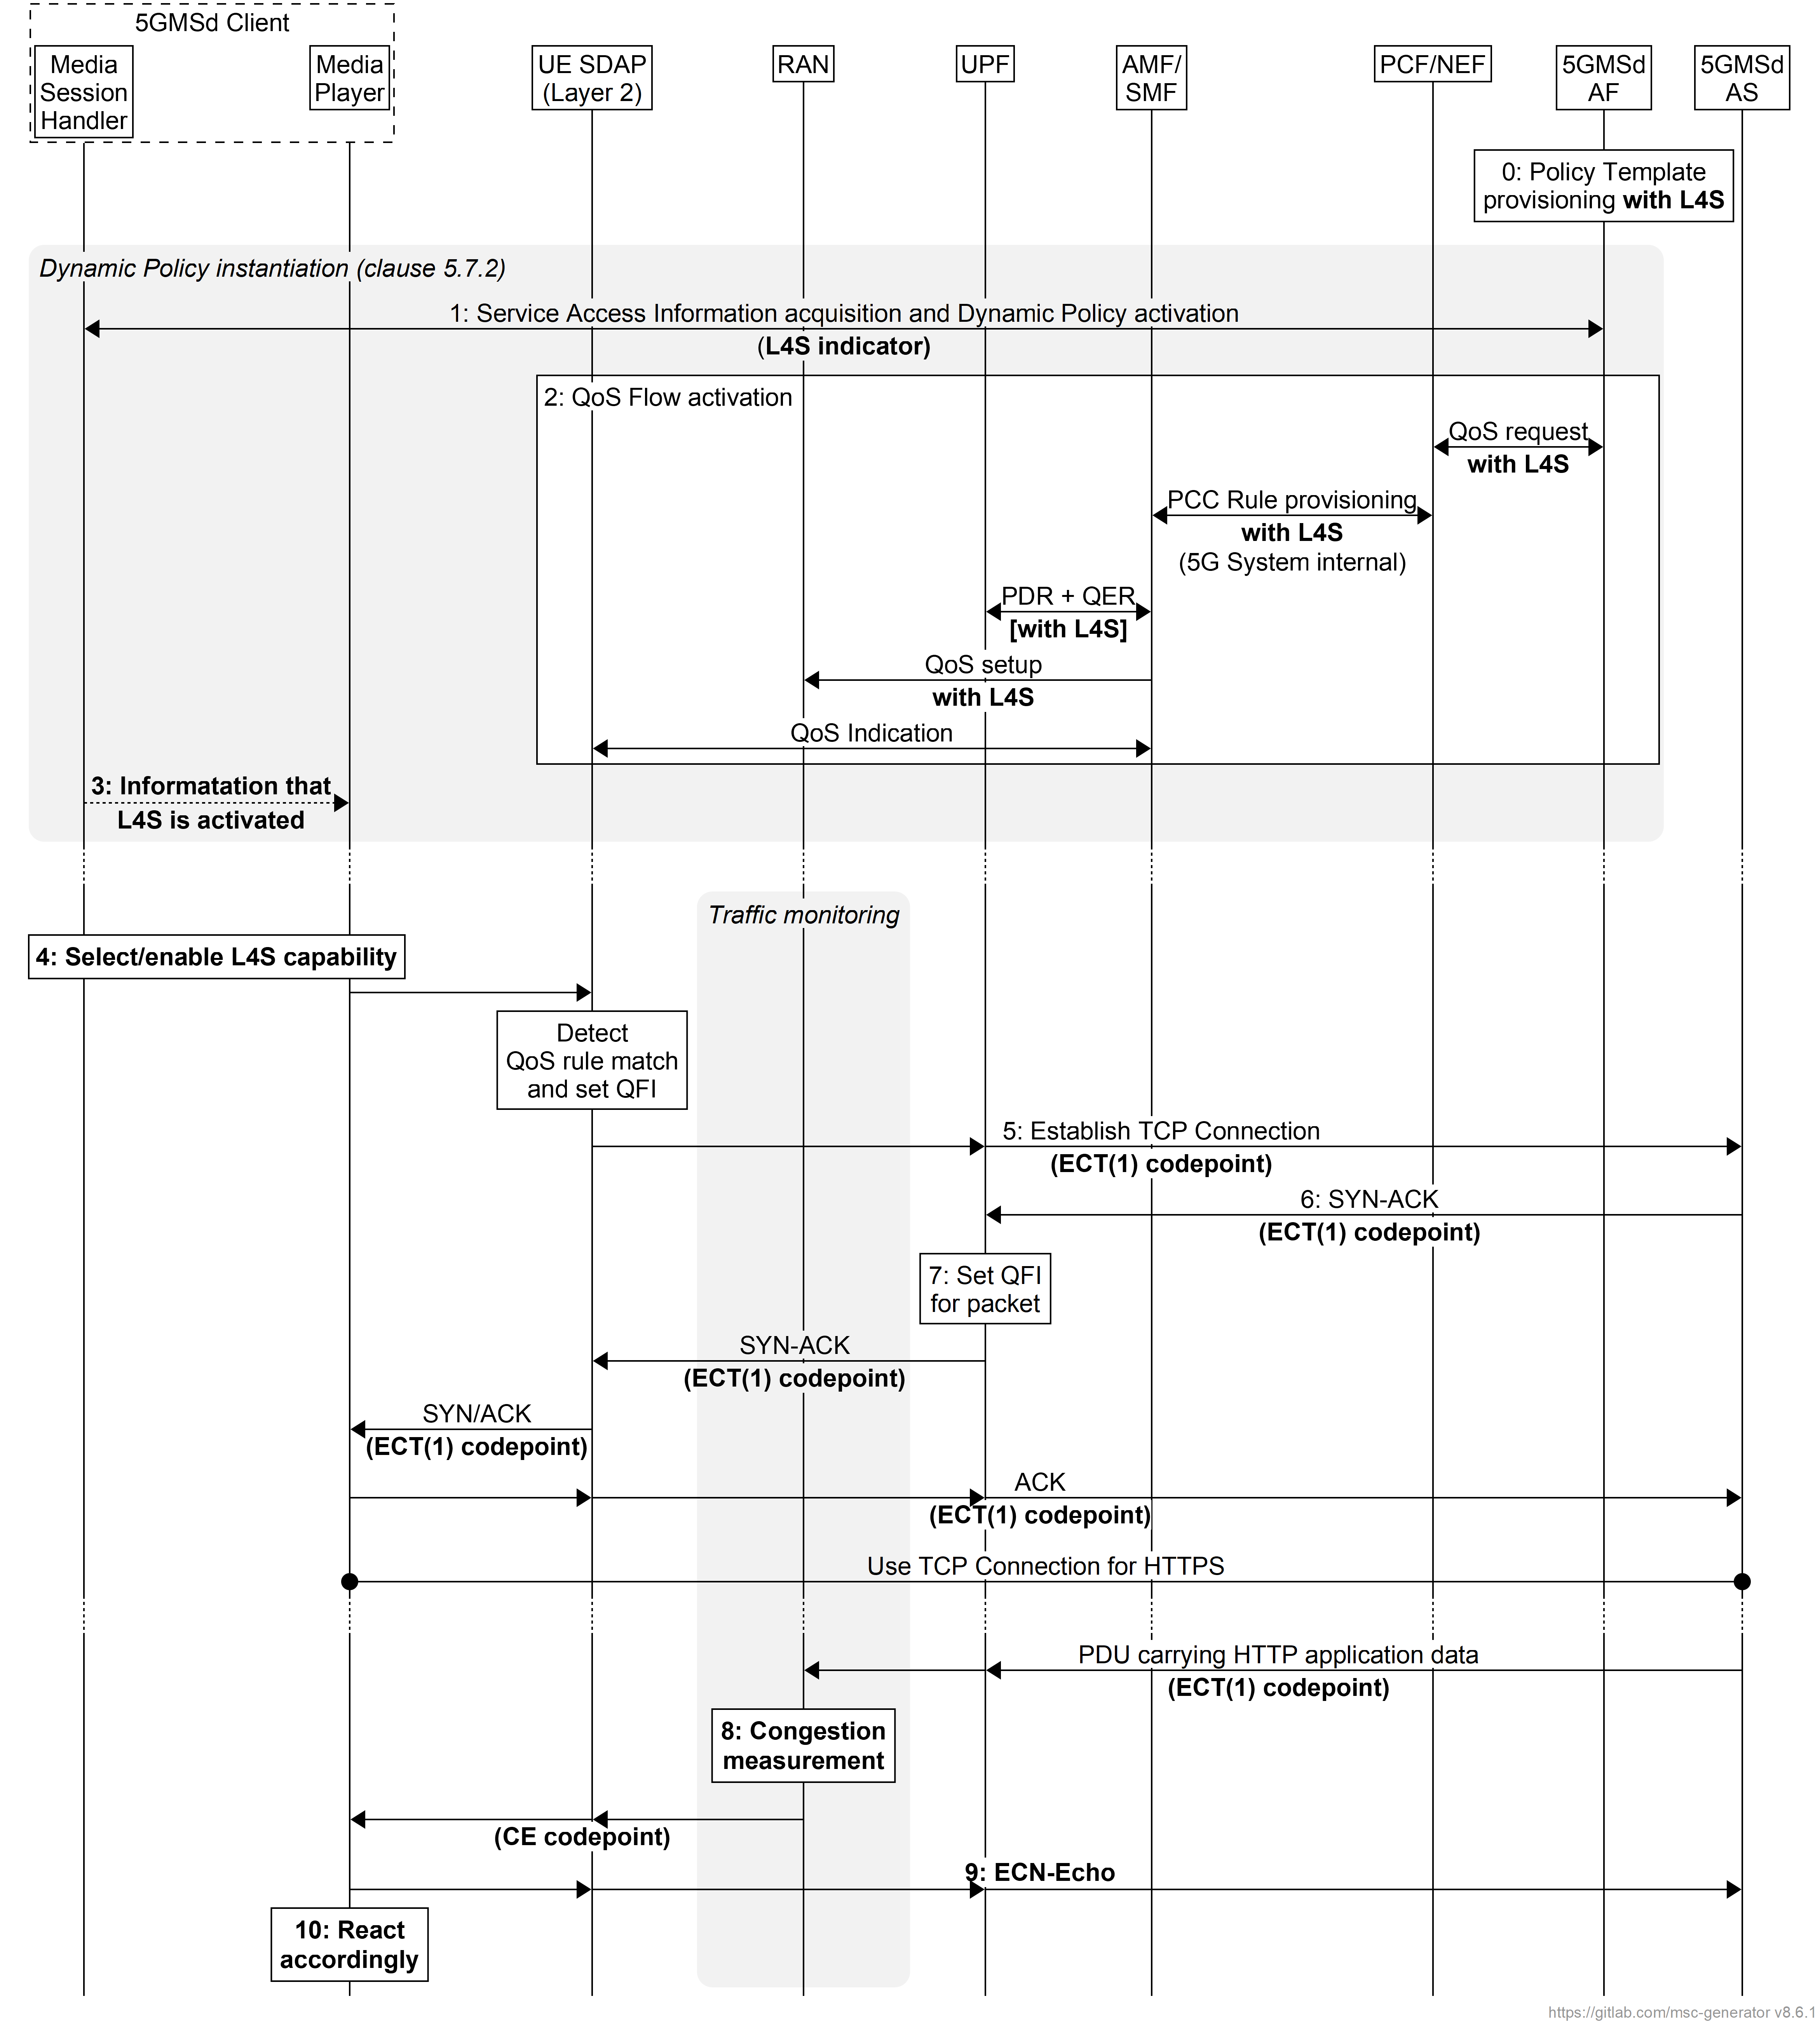
Figure 5.7.9-1: Downlink media streaming call flow for ECN marking for L4S
The steps are as follows:
0: Policy Template Provisioning. A Policy Template is provisioned with the L4S enablement preference flag set, indicating a preference for enabling ECN marking for L4S functionality.
1: Service Access Information acquisition and Dynamic Policy activation. The Media Session Handler within the 5GMSd Client obtains Service Access Information and triggers a dynamic policy activation. A Policy Template Binding is present within the Service Access Information for each provisioned Policy Template. Policy Template Bindings suitable for L4S are indicated by an L4S enablement preference flag being set. When instantiating the Dynamic Policy, the Media Session Handler only sets the L4S required flag in the Dynamic Policy request when the Media Player supports an L4S-capable media transport stack.
2: QoS request. The 5GMSd AF requests QoS handling using e.g. the Nnef_AfSessionWithQoS service or the Npcf_PolicyAuthorization service. If the L4S required flag is set in the Dynamic Policy request from the Media Session Handler, this indicates that the new QoS flow is required to be L4S-enabled. The new QoS flow with the ECN marking for L4S indication setting propagates through the 5G System.
3: The Media Session Handler may inform the Media Player about the successful activation of the L4S-enabled Dynamic Policy via the client API at reference point M11d. Subject to availability of API access, the Media Player may use congestion notifications to perform early bit rate adaptation.
4: If the L4S enablement Dynamic Policy is successfully activated, the 5GMSd Client selects/enables the L4S capability of the used transport protocol.
NOTE 1: This step may happen implicitly by selecting an L4S-supporting transport protocol stack in case of availability of API access.
5: The Media Player within the 5GMSd Client triggers the establishment of a TCP connection. The ECT(1) codepoint is set in the IP header, indicating an L4S-Capable Transport, and the SDAP entity ensures that the packet is forwarded via the matching QoS flow.
6: The 5GMSd AS responds to the TCP connection establishment request. The 5GMSd AS sets ECT(1) in the IP headers, indicating an L4S-Capable Transport.
7: The UPF finds the matching QoS Flow Identifier for the downlink packet and sends the packet via the corresponding QoS flow to the UE. TCP Connection setup continues, with one ECT bit set in all packets.
8: When the RAN detects an upcoming congestion event according to the congestion measurement (based on continuous congestion monitoring), the 5G System sets the CE (Congestion Experienced) codepoint in the IP header of the downlink packet.
9. The TCP protocol stack used by the Media Player in the 5GMSd Client reflects the Early Congestion Notification to the TCP sender by setting the ECN-Echo (ECE) flag in the TCP header of an uplink PDU of the same TCP connection. The TCP sender reacts to the ECN-Echo accordingly (i.e., by reducing its sending congestion window).
NOTE 2: The ECN-Echo flag is also acknowledged by the TCP sender setting the Congestion Window Reduced (CWR) flag in an outgoing TCP frame, but this acknowledgement is not illustrated in this call flow.
NOTE 3: Classic ECN as specified in RFC 3168 [41] requires an ECN signal to be treated as equivalent to a packet drop. L4S as specified in RFC 9330 [38] specifies a more fine-grained response and an early congestion signal triggers a less severe reaction. How a TCP sender behaves "accordingly" is beyond the scope of the present document.
10. Based on the CE indication received in step 8, or by detecting a reduced bit rate in the downlink application flow, the Media Player in the 5GMSd Client reacts by, for example, changing the requested representation.

5.7.10 QoS monitoring of downlink media streaming based on Dynamic Policy
Figure 5.7.10-1 below shows a high-level call flow for the configuration and usage of QoS monitoring with downlink media streaming.
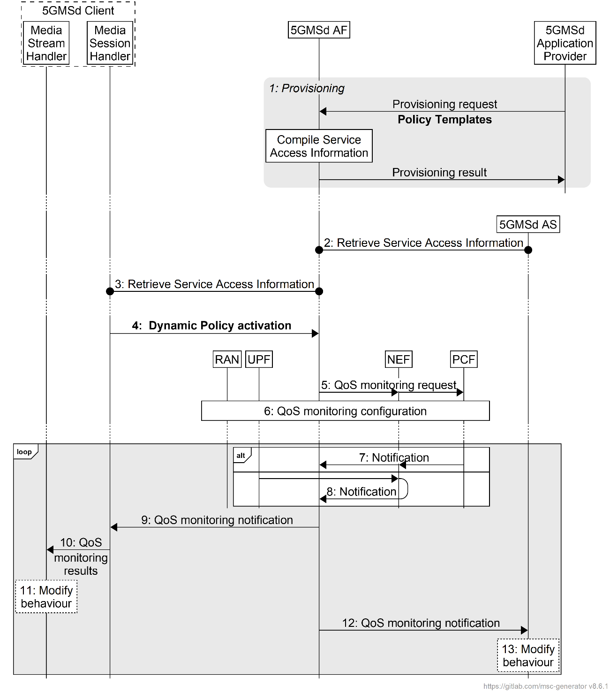
Figure 5.7.10-1: High-level call flow for QoS monitoring for downlink Media Streaming
The steps are as follows:
1. Policy Template Provisioning. A Policy Template is provisioned with a QoS monitoring configuration, indicating a preference for enabling QoS monitoring functionality. The QoS monitoring configuration includes the parameters to be monitored, the reporting frequency (event triggered, periodic), and optionally the notification via local UPF.
NOTE: In case the 5GMSd AS is deployed as an EAS instance in the Edge DN, a local UPF can also be inserted for local access to the 5GMSd EAS. In order to reduce the latency used for exposure of the QoS monitoring results, the local UPF is expected to provide the notifications of network status directly to the 5GMSd AF and 5GMSd AS, or via a locally deployed NEF as defined in clause 5.8.2.17 of TS 23.501 [2].
2. Service Access Information retrieval by 5GMSd AS. The 5GMSd AS retrieves Service Access Information from 5GMSd AF via reference point M3d. The 5GMSd AS subscribes to receive notifications from the 5GMSd AF about changes to the monitored QoS parameters for all relevant Dynamic Policies.
3. Service Access Information retrieval by Media Session Handler. The Media Session Handler retrieves Service Access Information from the 5GMSd AF via reference point M5d. A Policy Template Binding is present within the Service Access Information for each provisioned Policy Template. Policy Template Bindings include a QoS monitoring enablement preference flag indicating a preference that QoS monitoring is enabled when instantiating the corresponding Policy Template.
4. Dynamic Policy activation. The Media Session Handler within the 5GMSd Client obtains Service Access Information and triggers a dynamic policy activation. If the Media Session Handler determines that the Media Access Function is capable of consuming QoS monitoring results (based on interrogating the capabilities of the Media Access Function) it shall set a QoS monitoring required flag accordingly in the Dynamic Policy activation. If successful, the Media Session Handler subscribes to receive notifications from the 5GMSd AF about QoS monitoring results for this Dynamic Policy.
5. QoS monitoring request. The 5GMSd AF invokes the Npcf_PolicyAuthorization service or the Nnef_AFsessionWithQoS service with the requested QoS monitoring configurations if the QoS monitoring required flag is set to true in the Dynamic Policy request from the Media Session Handler. In the case where the 5GMSd AS is deployed in the Edge DN, the 5GMSd AF may additionally enable the exposure of QoS monitoring results via the local UPF or local NEF in this step.
6. The PCF accepts the request and enables QoS monitoring within the 5G System, i.e., by configuring the RAN and/or the (local) UPF for monitoring and reporting of target QoS parameters for the downlink media streaming.
Following the QoS monitoring request(s):
7. The PCF may expose QoS monitoring results to the 5GMSd AF periodically or by event triggers using the Npcf_PolicyAuthorization_Notify service operation directly at reference point N5, or else using the Nnef_EventExposure_Notify service operation via the NEF at reference point N33.
8. Alternatively, the QoS monitoring results may be exposed to the 5GMSd AF by the UPF directly using the Nupf_EventExposure_Notify service or via a locally deployed NEF using the Nnef_EventExposure_Notify service at reference point N33.
9. If QoS monitoring was requested by the Media Session Handler, the 5GMSd AF sends the notifications of the QoS monitoring results to the Media Session Handler via reference point M5d.
10. The Media Session Handler provides the QoS monitoring results to the Media Stream Handler at reference point M11d.
11. The Media Stream Handler may use the notified QoS monitoring results to modify its behaviour. For example, in the case of downlink media streaming, the Media Player may use the monitored packet latency to determine when to request the next media segment, and/or to change the bit rate of the next media segment based on the monitored congestion status.
12. The 5GMSd AF may provide the QoS monitoring results to the 5GMSd AS at reference point M3d.
13. The 5GMSd AS may use the notified QoS monitoring results to modify its behaviour.

5.8 Dynamic Policy based on Network Slicing for downlink media streaming

5.8.1 Procedure
The 5GMSd Application Provider requests the assignment of more than one network slice for the distribution of the service. The 5GMSd Application Provider indicates the desired network slice features that correspond to the Service Access Information. Upon successful assignment of the network slices for the service, the 5GMSd AF shall respond with the list of allowed S-NSSAIs to the 5GMSd Application Provider.
Figure 5.8.1-1 is the flowchart diagram for this procedure.
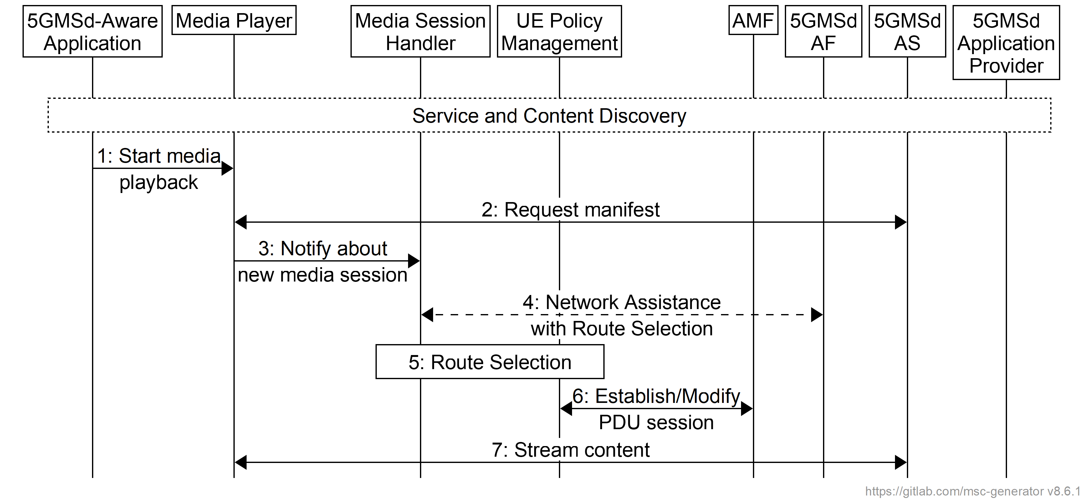
Figure 5.8.1-1: Dynamic Policy based on Network Slicing for Downlink Streaming
Pre-requisites:
1. The UE knows how to access the network slice(s) associated with a particular Provisioning Session.
2. The 5GMSd AS(s) serving the content for the particular Provisioning Session shall be accessible through the DNN(s) associated to the network slice(s) provisioned for the distribution of that content.
3. The 5GMSd Application Provider may identify the Network Slice(s) and/or Data Network(s) applicable to each Policy Template it provisions in the 5GMSd AF in step 4 of the baseline provisioning procedure defined in clause 5.3.2 of the present document.
NOTE: The 5GMSd AF may map the external slice identifier and DNN to operator-internal identifiers.
4. The 5GMSd AF has been preconfigured by the 5G System operator with a mapping from IP subnet range(s) to slice identifiers/DNN duples so that it can select an appropriate network slice and/or Data Network when manipulating the network QoS of the application flows described by a Network Assistance session or Dynamic Policy invocation. The 5GMSd AF may use information about the selected network slice and/or Data Network to filter viable Policy Templates before including them in Service Access Information provided to the 5GMSd Client described in clause 4.3.2 of the present document.
The steps are as follows:
1. The 5GMSd-Aware Application triggers media playback by invoking the Media Player with the Media Player Entry for the selected content.
2. The Media Player requests the manifest from the 5GMSd AS.
3. The Media Player notifies the Media Session Handler about the upcoming media session and may request specific 5GMSd AF-based Network Assistance for that session, when not already established.
4. The Media Session Handler retrieves information from the 5GMSd AF to assist with the route selection for the session. This may include information about the network slices, the DNNs, any pre-authorized QoS guarantees for that Provisioning Session. The Media Session Handler gets information about the operation point selection from the Media Player as described in step 4.
5. The Media Session Handler and the UE Policy Management in the UE perform the route selection procedure using information such as the playback operation point, the traffic descriptors. The UE Policy Management will use the matching filter to retrieve the Route Selection descriptor, which provides the DNN, and the S-NSSAI(s), identifying the network slice(s) to be used for this Provisioning Session.
6. The UE reuses an existing PDU session with the selected S-NSSAI and DNN from step 5, or requests the establishment of a new PDU session with the identified parameters, if one doesn't exist already.
7. The streaming of the media content at the target operation point starts.

5.9 Downlink Network Assistance

5.9.1 Introduction
The Network Assistance (NA) feature enables a UE that is receiving a downlink media stream to improve the QoE of the media streaming session, by being able to make use of two distinct facilities.
The first facility is bit rate recommendation (throughput estimation). This enables the UE to start a downlink streaming session at the most appropriate bit rate for the network conditions at hand, or to obtain a recommendation from the network which will remain valid until further notice during a media streaming session. The recommended bit rate is based on network estimations or predictions of available link bandwidth. This function is provided as an additional tool to support the UE, in addition to the common approach of the UE performing its own estimation based on measurement of the downlink traffic in the past.
The second facility is the delivery boost. The 5GMSd Client uses this function to indicate to the network that a temporary boost, i.e., a temporary increase of network throughput for this client is needed in order to avoid the risk of media playback stalling due to buffer under-run, which could otherwise occur during the next media segment or soon after. Throughput boosting may also be used at the start of a playback session to shorten the time to start media playback, giving a better experience for the user.
Network Assistance for downlink media streaming may be offered to the UE in one of two ways:
- Based on interaction between the UE and the 5GMSd AF, with a subsequent interaction between the 5GMSd AF and the PCF (or the NEF);
- Based on interaction between the UE and the RAN, re-using the ANBR-based RAN signalling.
The UE shall not use both approaches on the same Network Assistance session.
Figure 5.9.1-1 depicts the Network Assistance feature in the context of the 5GMS architecture, showing the scope of both approaches.
Figure 5.9.1-1: Downlink Network Assistance alternative approaches

5.9.2 5GMSd AF-based downlink Network Assistance
The Network Assistance (NA) feature enables a UE to receive a bit rate recommendation from the 5GMSd AF that provides the NA server function. The 5GMSd AF provides the response with an estimation of throughput, or the recommendation of a bit rate which will remain valid until further notice. The UE uses this estimation to derive the most suitable bit rate for its downlink content session from the versions that might be available. The network is expected to commit resources to be able to fulfil the recommendation, although no guarantee for the bandwidth estimation can be assumed. The 5GMSd Client may provide additional information, such as available media versions, in terms of the required bit rates, to the 5GMSd AF.
The second facility is the delivery boost. The 5GMSd Client uses this function to indicate to the network that a temporary boost, i.e. a temporary increase of network throughput for this client, is needed.
Each interaction for the 5GMSd AF-based downlink Network Assistance procedures consists of two steps in sequence:
1. Between the UE (Media Session Handler) and the 5GMSd AF using a 5GMS API at interface M5d;
2. Between the 5GMSd AF and the PCF (or the NEF):
- using the Npcf_PolicyAuthorization procedure or Nnef_AFSessionWithQoS procedure to request modification of the PDU session with the requested QoS information.
- using the Npcf_PolicyAuthorization notification service or Nnef Monitoring Event procedure to receive QoS changes. The 5GMSd AF receives these policy change notifications asynchronously.
Network Assistance is performed within dedicated NA sessions that are a part of the Media Session Handler procedures. Only 5GMSd Clients that have been granted an NA session by the 5GMSd AF may execute the NA bit rate recommendation and boost request procedures. This enables the 5GMSd AF to enforce policies that could include the access to NA by certain 5GMSd Clients only, such that authorisation to use NA facilities can be verified once at the granting of an NA session, and does not need to be verified for each NA request from the 5GMSd Client.
The procedures for 5GMSd AF-based downlink Network Assistance are:
1. NA session initiation. The 5GMSd Client requests to initiate an NA session with the 5GMSd AF. If the request fulfils any pre-requisites for access to NA functionality, for example policy and charging, then the 5GMSd AF responds with a confirmation that the NA session has been established.
2. NA throughput estimation. The 5GMSd Client requests a throughput estimation for a downlink media session from the 5GMSd AF. A unique identifier for the downlink media session is provided by the 5GMSd Client.
If the set of available bit rates in the downlink media session is provided with the request, then the 5GMSd AF responds with the recommended bit rate based on its throughput estimation. If the throughput estimation is lower than the lowest value from the set of available bit rates, then the actual throughput estimation is provided.
If no set of available bit rates is provided with the request, then the 5GMSd AF responds with the throughput estimation.
3. NA delivery boost. The 5GMSd Client requests from the AF a downlink delivery boost. A unique identifier for the downlink media session is provided by the 5GMSd Client.
4. NA session termination. The 5GMSd Client requests to terminate an NA session with the 5GMSd AF. The unique identifier of the NA session to be terminated is provided by the 5GMSd Client.
The AF responds positively if the indicated session could be terminated, and negatively otherwise.

5.9.3 ANBR-based downlink Network Assistance
This approach for the downlink Network Assistance feature is based upon the exchange of the bit rate recommendation message and bit rate recommendation query message between the RAN and UE as described in TS 38.321 [9]. In this case the Network Assistance function in the 5GMSd Client utilises a UE-internal facility to access the RAN modem driver to access ANBR signalling operations and to receive corresponding responses from the network. Hence, this control interface is outside the scope of the 5GMS architecture.
The RAN in this architecture contains control plane and user plane entities that interact with peer control plane and user plane entities in the UE.
- The control plane interactions involve the sending by the RAN of downlink bit rate recommendations to the UE, which may occur either independently, or in response to a boost request from the UE, via the exchange of the bit rate recommendation message and bit rate recommendation query message between the RAN and UE as described in TS 38.321 [9]. This control interface is outside the scope of the 5GMS architecture.
- The user plane interaction pertains to downlink streaming media transport over interface M4d.

5.10 5GMS via eMBMS

5.10.1 General
This clause defines procedures for different use cases and scenarios when 5GMS is using eMBMS for delivery as introduced in clause 4.6.

5.10.2 Procedures for 5GMS content delivered exclusively via eMBMS
In this case, 5GMS media data is exclusively delivered via eMBMS, i.e. media content is not delivered via reference point M4d, but only via MBMS User Services. The 5GMSd Client acts as an MBMS-Aware Application.
The call flow in figure 5.10.2 1 extends the call flow defined in clause 5.3.2 to address the delivery of 5GMS media data exclusively via eMBMS. Aspects specific to this use-case are indicated in bold.
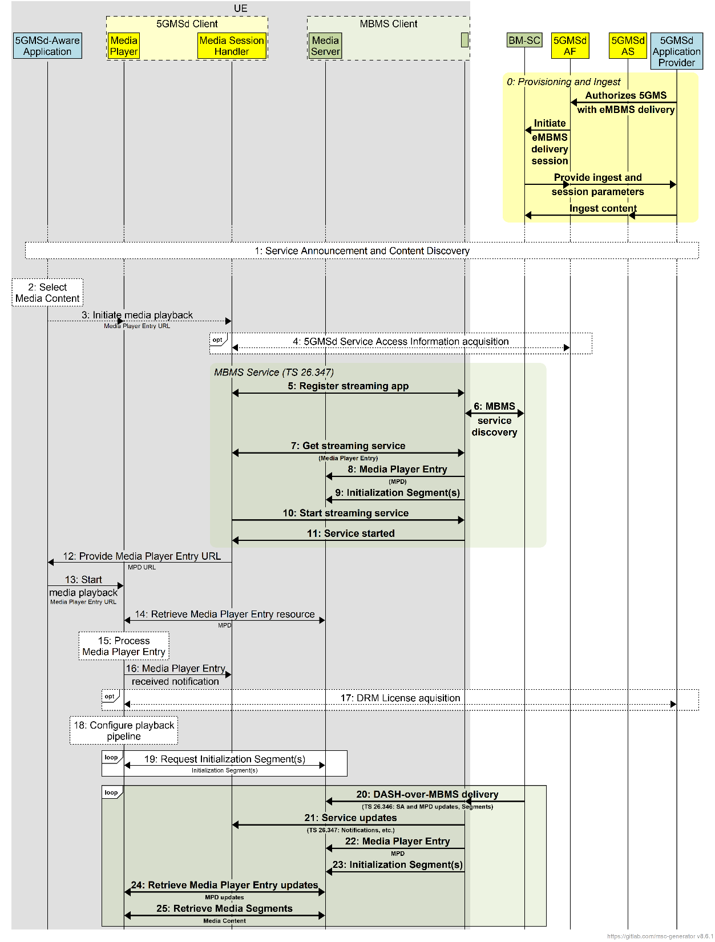
Figure 5.10.2-1: High-level procedure for DASH content delivery via eMBMS
Prerequisites (step 0):
- The 5GMSd Application Provider has provisioned the 5G Media Streaming System, including content ingest and the authorization to distribute 5GMS content via eMBMS.
- The 5GMS AF has informed the BM-SC about the availability of 5GMS content by provisioning an MBMS service and has obtained relevant information from the eMBMS Service Announcement (such as the MBMS service identifier).
- The BM-SC is ingesting content from the 5GMS AS, using either pull mode or push mode.
- The BM-SC has broadcast the MBMS Service Announcement, including an indication that the content is 5GMS content.
Steps:
1: The 5GMSd-Aware Application triggers the Service Announcement procedure and the 5GMS Service and Content Discovery procedure at reference point M8.
2: A media content item is selected.
3: The 5GMSd-Aware Application triggers the 5GMSd Client to start media playback. The Media Player Entry is provided to the 5GMSd Client.
4: If the 5GMS-Aware Application has received only a reference to the Service Access Information (see step 1), the Media Session Handler interacts with the 5GMSd AF to acquire the whole Service Access Information. This includes relevant information from the eMBMS Service Announcement (such as the MBMS service identifier) in order to bootstrap reception of the MBMS service.
5-11: The Media Session Handler acts as an MBMS-Aware Application and initiates service acquisition. For details, see TS 26.347 [18]. This establishes a transport session for the MPD and the Content.
NOTE: The MPD and Initialization Segment(s) are forwarded by the MBMS Client to the Media Server to enable their subsequent delivery to the Media Player upon request.
12: The Media Session Handler provides the MPD URL to the Media Player either directly or through the 5GMSd-Aware Application.
13: The Media Player is invoked to start media access and playback.
14: The Media Player retrieves the Media Player Entry resource (an MPD) from the proxy Media Server.
15: The Media Player processes the retrieved MPD. It determines, for example, the number of transport sessions needed for media acquisition. The Media Player should be able to use the MPD information to initialize the media pipelines for each media stream (see step 18). When DRM is used (see step 17) the MPD should also contain sufficient information to initialize the DRM client.
16: The Media Player notifies the Media Session Handler about the start of a new downlink media streaming session. The notification may include parameters from the MPD.
17: Optional: The Media Player acquires any necessary DRM information, for example a DRM License.
18: The Media Player configures the media playback pipeline.
19: The Media Player retrieves initialization segment(s) referenced by the MPD.
20-25: Content is delivered using DASH-over-MBMS. Session Announcement updates are provided to the MBMS Client as necessary. MPD updates and Segments are pushed to the media server. The Media Player retrieves media segments from the proxy Media Server according to the MPD and forwards them to the appropriate media rendering pipeline.

5.10.3 5GMS Consumption Reporting procedures for eMBMS
In this case, 5GMS consumption reporting is used to report consumption of 5GMSd content via an eMBMS service.
NOTE: eMBMS consumption reporting is disabled in this case.
The call flow in Figure 5.10.3-1 extends the call flow defined in clause 5.6.1 to address consumption reporting. Aspects specific to this use-case are indicated in bold.
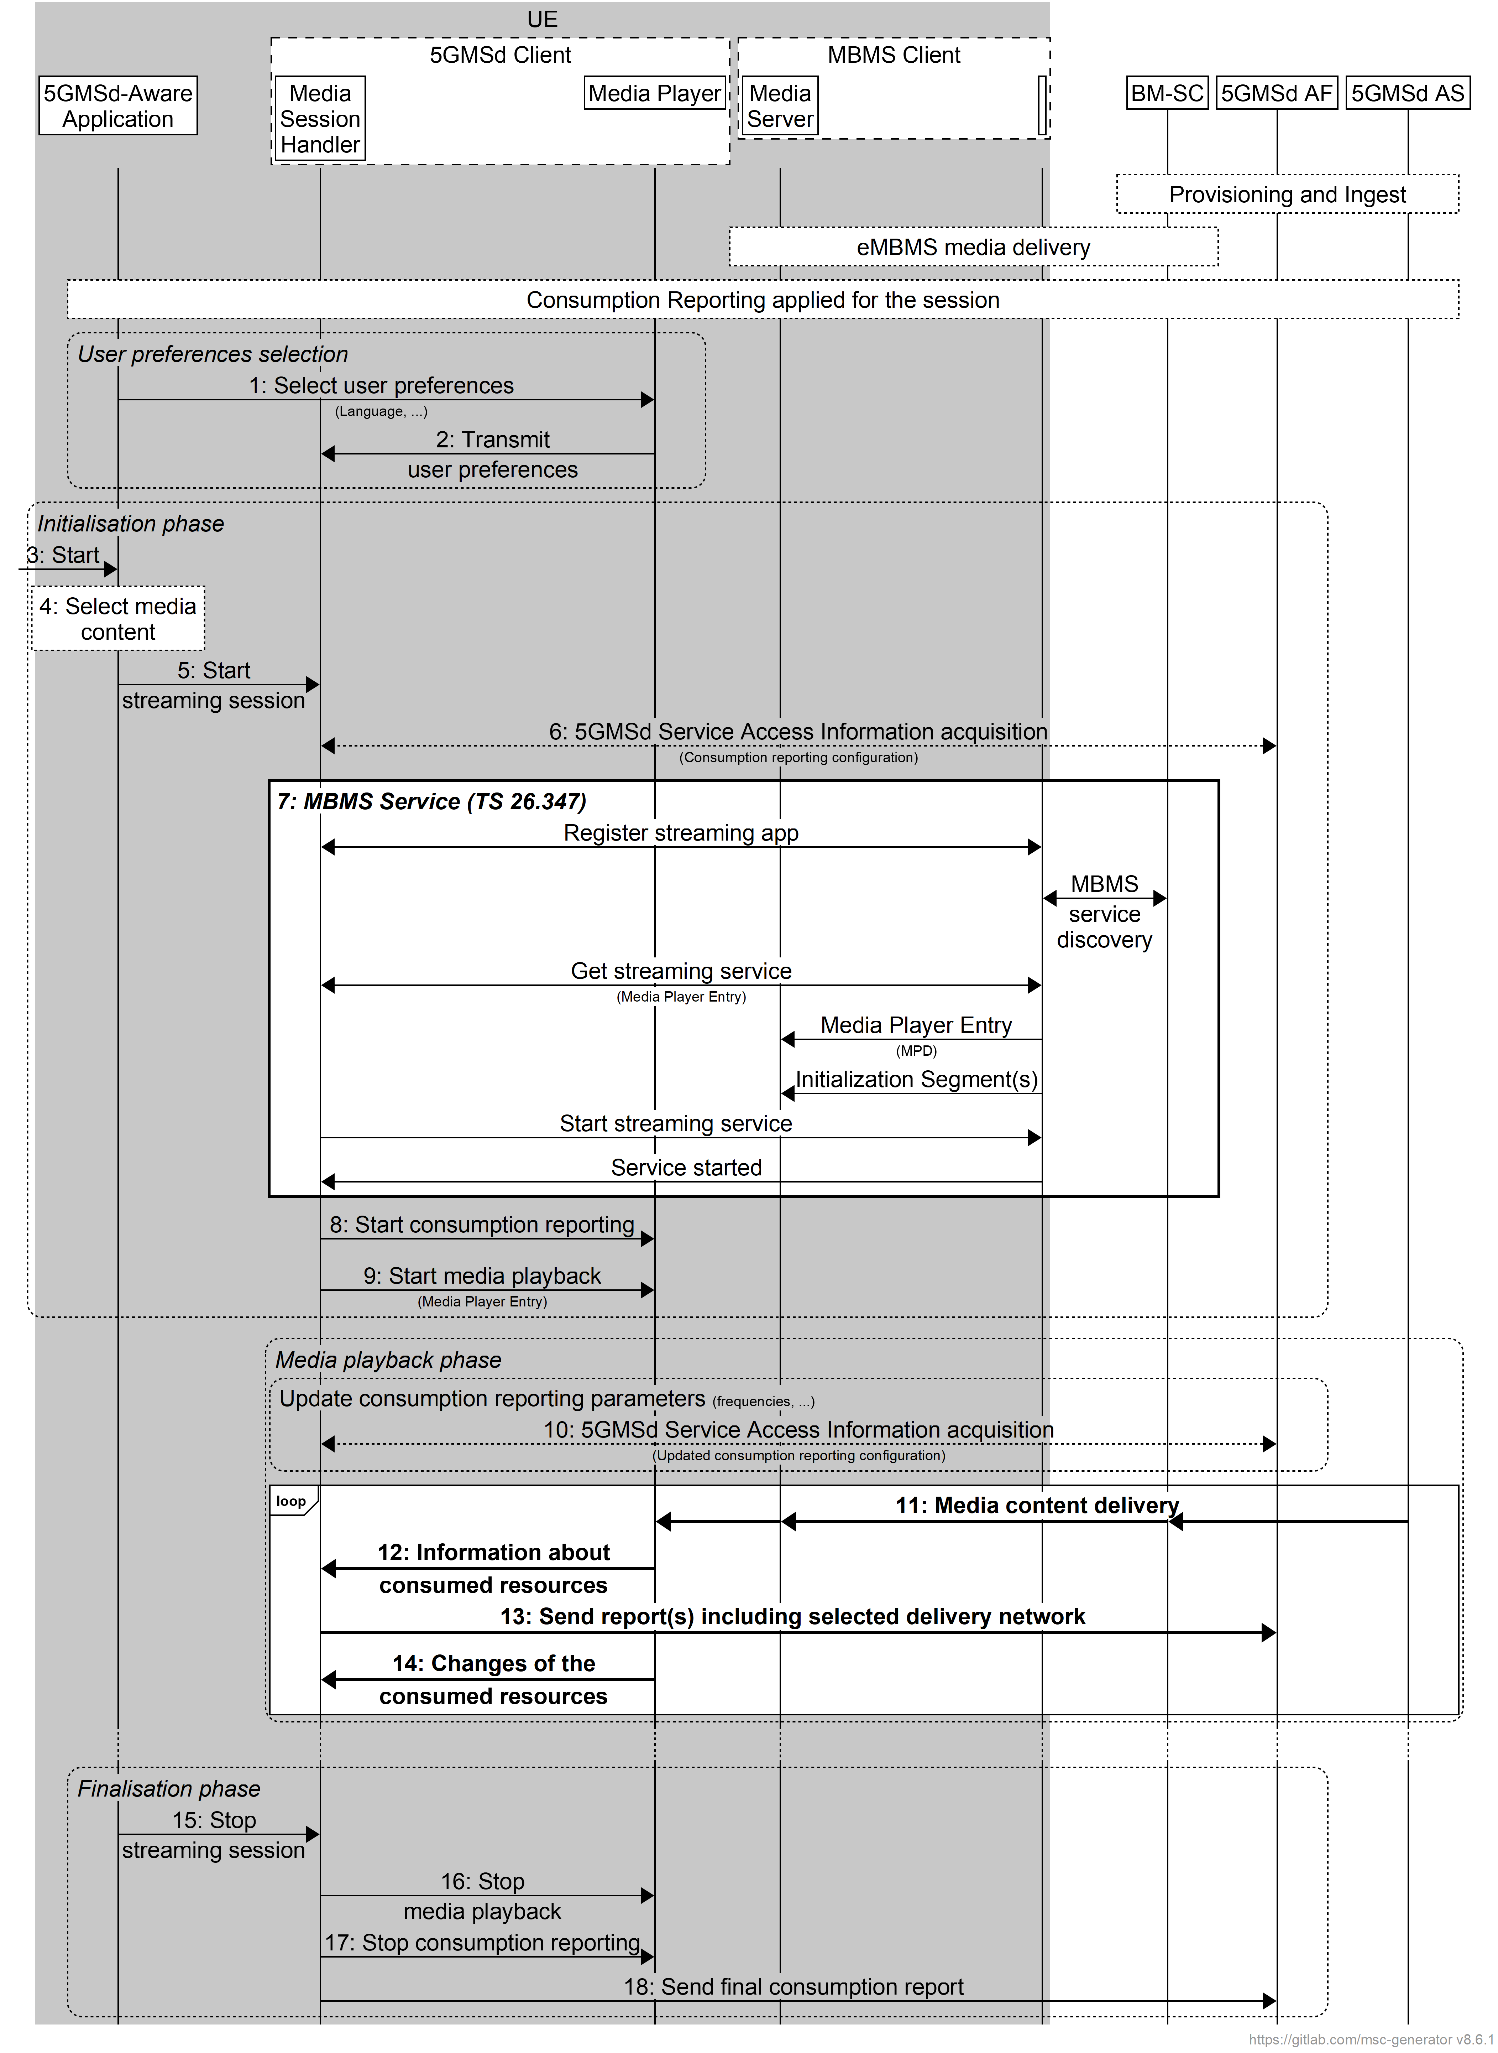
Figure 5.10.3-1: Consumption reporting for 5GMS via eMBMS
Prerequisites (step 0):
- The 5GMSd Application Provider has provisioned the 5G Media Streaming System, including content ingest, consumption reporting and the permission to distribute 5GMS content via eMBMS.
- The BM-SC is ingesting content from the 5GMS AS, using either pull mode or push mode.
- eMBMS media delivery is established.
- Consumption reporting is established.
Steps:
The user preferences relating to consumption reporting may be changed:
1: The 5GMSd-Aware Application selects/changes the user preferences.
2: The Media Player transmits consumption reporting user preferences to the Media Session Handler.
The first phase is initialisation.
3: The 5GMSd-Aware Application is started.
4: A media content item is selected.
5: The 5GMSd-Aware Application triggers the Media Session Handler to start content playback. The Media Player Entry is provided.
6: If the 5GMS-Aware Application has received only a reference to the Service Access Information, the Media Session Handler interacts with the 5GMSd AF to acquire the whole Service Access Information. This includes a client consumption reporting configuration including parameters such as reporting frequency.
7: The MBMS service is initiated.
8: The Media Session Handler triggers consumption reporting in the Media Player.
9: The Media Session Handler starts the Media Player with the Media Player Entry.
The second phase is media playback.
When media is playing, the consumption reporting parameters may be updated by the 5GMSd AF.
10: The Media Session Handler acquires updated Service Access Information from the 5GMSd AF including updated consumption reporting parameters.
When media is playing:
11: Media content is accessed through different networks, possibly via eMBMS or unicast.
12: The Media Player transmits information about the media streaming resources consumed to the Media Session Handler, including the source of the media.
13: The Media Session Handler regularly sends consumption report(s) to the 5GMSd AF, including information about the delivery network from which the media was acquired.
14: The Media Player provides an update to the Media Session Handler about the consumed media streaming resources, for example a change in the delivery network.
The last phase is to stop the media:
15: The 5GMSd-Aware Application triggers the Media Session Handler to stop content playback.
16: The Media Session Handler stops the Media Player.
17: The Media Session Handler stops consumption reporting in the Media Player.
18: The Media Session Handler may send final consumption report(s) to the 5GMSd AF.

5.10.4 5GMS Metrics Reporting procedures for eMBMS
In this case, 5GMS metrics reporting is used to report 5GMS and eMBMS metrics to the 5GMSd AF.
NOTE: eMBMS metrics reporting is disabled in this case.
The call flow in figure 5.10.4-1 extends the call flow defined in clause 5.5.3 to address metrics reporting. Aspects specific to this use-case are indicated in bold.
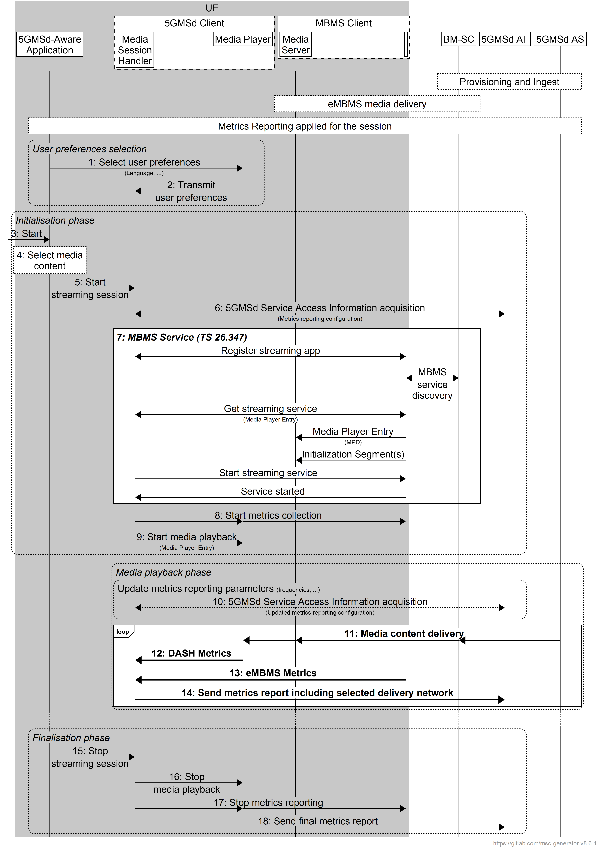
Figure 5.10.4-1: Metrics reporting for 5GMS via eMBMS
Prerequisites (step 0):
- The 5GMSd Application Provider has provisioned the 5G Media Streaming System, including content ingest, metrics reporting and the permission to distribute 5GMS content via eMBMS.
- The BM-SC is ingesting content from the 5GMS AS, using either pull mode or push mode.
- eMBMS media delivery is established.
- Metrics reporting is established.
Steps:
The user preferences relating to metrics reporting may be changed:
1: The 5GMSd-Aware Application selects/changes the user preferences.
2: The Media Player transmits metrics reporting user preferences to the Media Session Handler.
The first phase is initialisation.
3: The 5GMSd-Aware Application is started.
4: A media content item is selected.
5: The 5GMSd-Aware Application triggers the Media Session Handler to start content playback. The Media Player Entry is provided.
6: If the 5GMS-Aware Application has received only a reference to the Service Access Information, the Media Session Handler interacts with the 5GMSd AF to acquire the whole Service Access Information. This includes a client metrics reporting configuration including parameters such as reporting frequency.
7: The MBMS service is initiated.
8: The Media Session Handler triggers metrics collection by the MBMS Client and by the Media Player.
9: The Media Session Handler starts the Media Player with the Media Player Entry.
The second phase is media playback.
When media is playing, the metrics reporting parameters may be updated by the 5GMSd AF.
10: The Media Session Handler acquires updated Service Access Information from the 5GMSd AF including updated metrics reporting parameters.
When media is playing:
11: Media content is accessed through different networks, possibly via eMBMS or unicast.
12: The Media Player provides DASH metrics to the Media Session Handler.
13: The MBMS Client provides MBMS metrics to the Media Session Handler using MBMS-API-C.
14: The Media Session Handler regularly sends metrics report(s) to the 5GMSd AF, including information about the delivery network from which the media was acquired.
The last phase is to stop the media:
15: The 5GMSd-Aware Application triggers the Media Session Handler to stop content playback.
16: The Media Session Handler stops metrics collection in the MBMS Client and the Media Player.
17: The Media Session Handler stops metrics reporting.
18: The Media Session Handler may send final metrics report(s) to the 5GMSd AF.

5.10.5 Procedures for Hybrid Services: 5GMS content delivery via 5G System and eMBMS

5.10.5.1 General
Hybrid services refer to the case for which a basic service is available on eMBMS and at the same time on unicast. The service on unicast may be richer and extended and may provide additional user experiences. For the hybrid use cases, the content is statically provisioned on different delivery networks.
Hybrid services predominantly refer to the case for which the delivery manifest differentiates between resources accessible on unicast via M4d and resources accessible through eMBMS, in this case through MBMS-API-U.
These resources are differentiated in the delivery manifest through different DNs, for example different Base URLs in DASH MPDs, or in HLS by providing different pathways. The 5GMS Client, in particular the Media Player in collaboration with the Media Session Handler and the MBMS Client, dynamically selects the delivery network from which to acquire media content according to reception conditions, user preferences or other policies. Content is provisioned such that the 5GMS Client is able to provide a seamless user experience when switching between different delivery networks.
The call flow in figures 5.10.5-1, 5.10.5 2 and 5.10.5 3 extends that defined in clause 5.6.1 to address generic hybrid use cases. Specific additional use cases are presented in the remainder of clause 5.10.5.
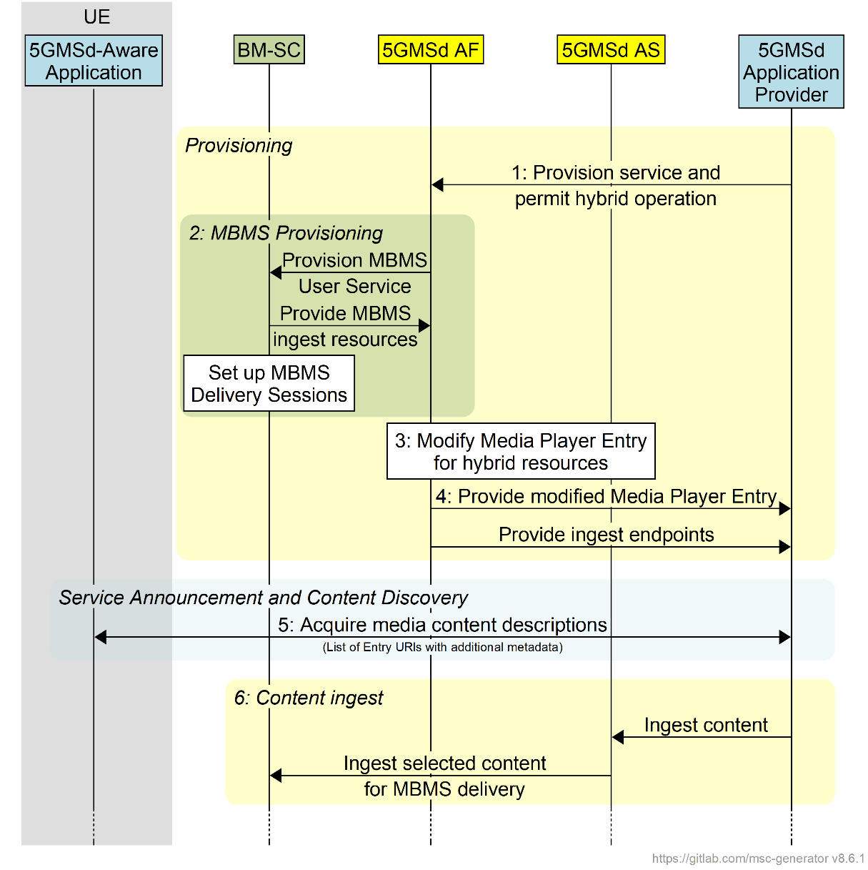
Figure 5.10.5-1: High-level procedure for hybrid delivery of DASH content
Steps:
1: The 5GMSd Application Provider triggers 5GMS provisioning and permits hybrid distribution of the media content.
2: As a consequence, the 5GMSd AF provisions MBMS delivery. The MBMS Delivery Session is set up and the BM SC informs the 5GMS AF about the content ingest endpoints.
3: The 5GMSd AS modifies the Media Player Entry (typically a media presentation manifest) under the direction of the 5GMSd AF to indicate that content is available either on the MBMS Client's local Media Server or on 5GMSd AS.
4: The modified presentation manifest and the ingest endpoints are provided to the 5GMSd Application Provider. The manifest may also be updated by the 5GMSd Application Service Provider.
5: The media content is announced to the 5GMSd-Aware Application and the application requests the entry points for the service.
6: The 5GMSd AS begins ingesting content from the 5GMSd Application Provider and the BM-SC may, in turn, begin ingesting this content from the 5GMSd AS.
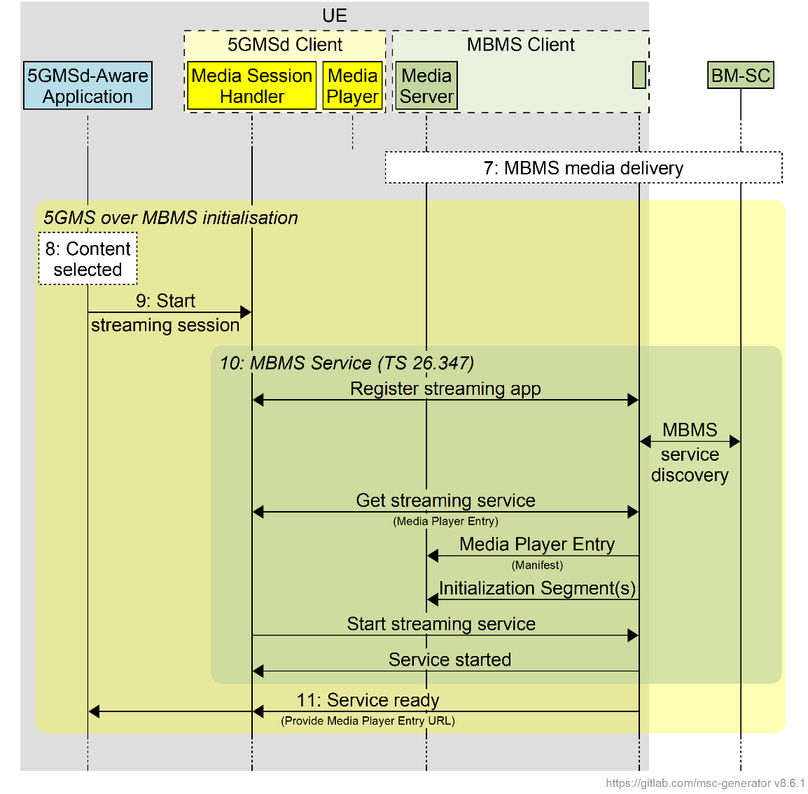
Figure 5.10.5-2: High-level procedure for hybrid delivery of DASH content (continued)
7: The BM-SC starts one or more MBMS Delivery Sessions.
8: The media content is selected by the 5GMSd-Aware Application.
9: The application initiates the media streaming session through the Media Session Handler.
10: The Media Session Handler initiates the MBMS streaming services.
11: The media session handler through the information from the MBMS Client informs the 5GMSd-Aware Application that the service is ready.
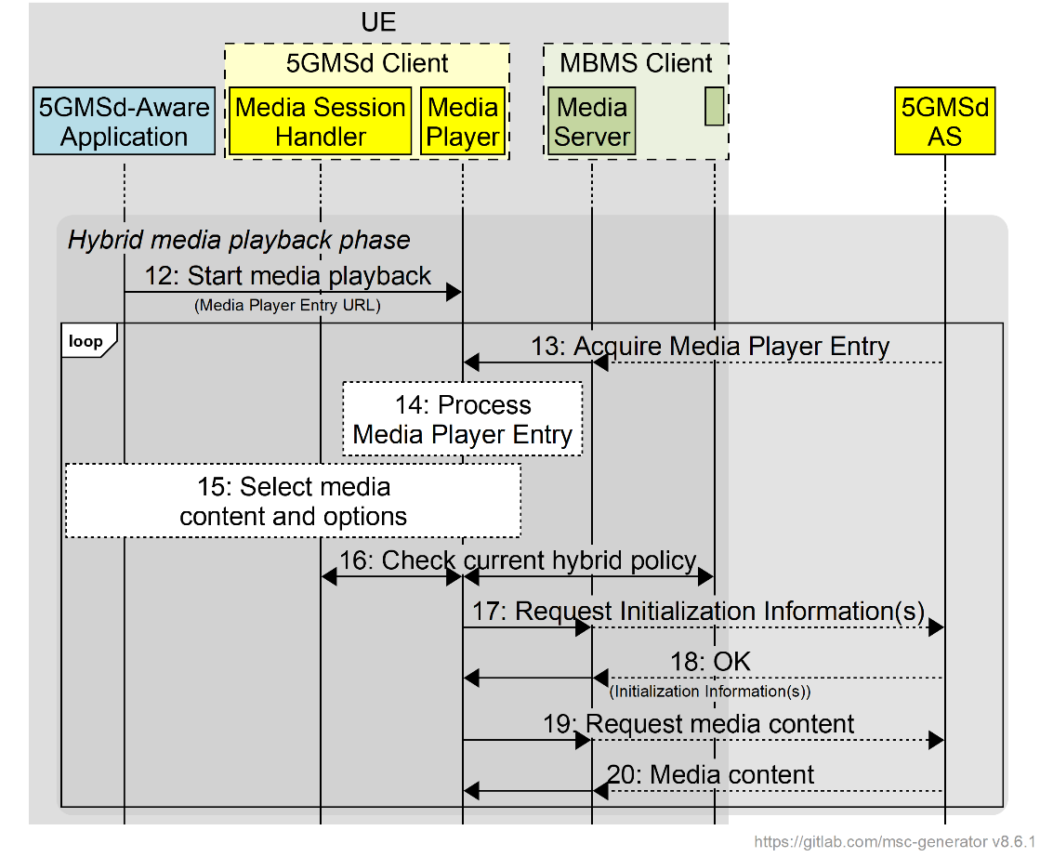
Figure 5.10.5-3: High-level procedure for hybrid delivery of DASH content (continued)
12: The 5GMSd-Aware Application starts media playback.
13: The Media Player Entry (typically a media presentation manifest) is acquired by the Media Player. It may be available from the local Media Server (populated by the MBMS Client) or from the 5GMSd AS, or even from both.
14: The Media Player processes the Media Player Entry and identifies that content is available from different data networks (the local Media Server and the 5GMSd AS).
15: Under the control of the 5GMSd-Aware Application, the Media Player selects the content and different content options.
16: The Media Player continuously checks with the Media Session Handler - and possibly forwarded to the MBMS Client if the MBMS User Service data is available - how to use the different content. This depends on the hybrid scenario. Different policies may be considered.
17: The Media Player requests initialization information either from the local Media Server or from the 5GMSd AS. The Media Player repeats this step for each required initialization segment.
18: The Media Player receives the initialization information.
19: The Media Player requests media segments according to the Media Player Entry, either from the local Media Server or from the 5GMSd AS.
20: The Media Player receives media segments and puts the information into the appropriate media rendering pipeline.
Steps 13–20 are repeated according to the Media Player Entry information.

5.10.5.2 Interactive service
In a specific hybrid scenario, an interactive service may be provided via 5GMS while the main media content resources are delivered via eMBMS exclusively. In this case, the following instantiations apply:
- In step 2, the media presentation manifest (MPD) only points to content in the local Media Server.
- Step 13 as well as steps 17-20 are all terminated on the local Media Server.

5.10.5.3 Session continuity
In a specific hybrid scenario, the service is made available via both 5GMS and eMBMS delivery networks, but only one Representation of each Adaptation Set is provided via eMBMS. In this case, the following instantiations apply:
- In step 2, one Representation of each Adaptation Set is distributed via eMBMS.
- As long as the streaming service is accessible over eMBMS, the Media Player selects the media content in step 13 as well as steps 17–20 from the local Media Server; content is not available from the 5GMSd AS.
- If the streaming service becomes unavailable via eMBMS, the Media Player switches to accessing the media content in step 13 as well as steps 17–20 from the 5GMSd AS.
- Once the streaming service becomes available again via eMBMS, the Media Player switches back to accessing the media content in step 13 as well as steps 17–20 from the local Media Server.

5.10.5.4 Time-shifted viewing
In a specific hybrid scenario, the service is made available via both 5GMS and eMBMS delivery networks, but only one Representation of each Adaptation Set is provided via eMBMS. The content is retained by the 5GMSd AS for a period of time to support time shifted access. In this case, the following instantiations apply:
- In step 2, one Representation is of each Adaptation Set is distributed via eMBMS.
- If the streaming service is accessible via eMBMS and the user is consuming content at the live edge, the Media Player selects the media content in the step 13 as well as steps 17–20 from the local Media Server; content is not available from the 5GMSd AS.
- If the user switches to time-shift viewing mode or streaming service becomes unavailable via eMBMS, the Media Player switches to accessing the media content in the step 13 as well as steps 17–20 from the 5GMSd AS.
- Once the streaming service becomes available again via eMBMS and the user returns to the live edge, the Media Player switches back to accessing the media content in the step 13 as well as steps 17–20 from the local Media Server.

5.10.5.5 Content or component replacement
In a specific hybrid scenario, the service is made available via both 5GMS and eMBMS delivery networks, but only one Representation of selected Adaptation Sets is provided via eMBMS. Some Adaptation Sets are only available via 5GMS. In another case, two or more content alternatives may exist for a period of time, but only one alternative is provided over eMBMS.
In this case, the following instantiations apply:
- In step 2, the MPD is generated to define the different content alternatives.
- If the streaming service is accessible over eMBMS and the user watches content available on broadcast, the Media Player selects the media content in step 13 as well as steps 17-20 from the local Media Server; content is not available from the 5GMSd AS.
- If the user switches content or content components, the Media Player switches to accessing the media content in the step 13 as well as steps 17–20 from the 5GMSd AS. If only a component is replaced, the Media Player accesses media content from the local Media Server and the 5GMSd AS at the same time.

5.10.6 Procedures for dynamic provisioning of 5GMS content delivery via eMBMS

5.10.6.1 General
In this scenario the same content is distributed via eMBMS (for example using a broadcast network in receive-only mode) and via a 5GMS System. The resources of the broadcast system are statically configured. eMBMS-based distribution may, for example, be used only for services in high demand, and the resources and quality of the service distributed through broadcast may be adjusted according to demand. Demand may be identified through 5GMS Consumption Reporting.
The call flow in figures 5.10.6 1 and 5.10.6 2 extends that defined in clause 5.6.1 to address generic use cases for broadcast-on-demand. Specific additional use cases are presented in the remainder of clause 5.10.6.
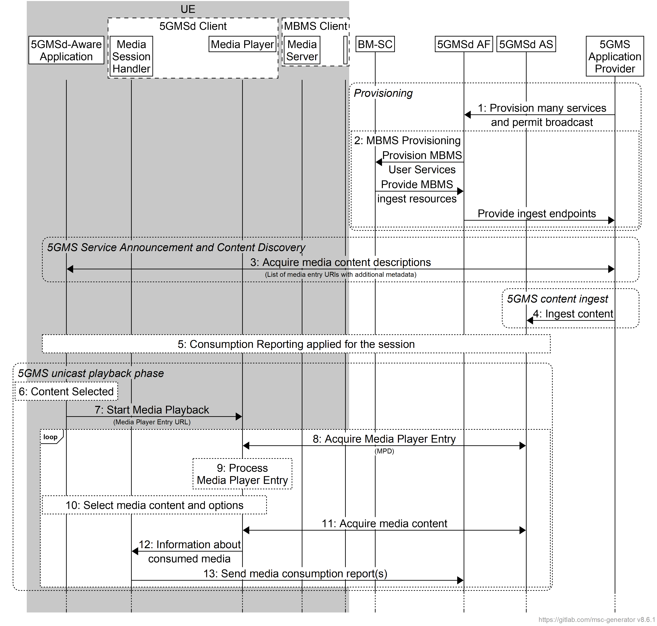
Figure 5.10.6.1-1: High-level procedure for DASH content delivered via eMBMS broadcast-on-demand
Steps:
1: The 5GMS Application Provider provisions one or more MBMS services and permits broadcast distribution of the media content.
2: As a consequence, the 5GMSd AF provisions MBMS delivery and the BM SC informs the 5GMS AF about the resources it will use to ingest media content.
NOTE: This step may happen later, up to (and possibly as part of) step 15, for example only when demand is identified.
3: The media content is announced to the 5GMSd-Aware Application and the application request the entry points for the service.
4: The 5GMSd AS starts to ingest content from the 5GMSd Application Provider.
5: Consumption Reporting is applied for the 5GMSd session.
Media playback initially uses unicast 5G Media Streaming:
6: The media content is selected by the 5GMSd-Aware Application.
7: The 5GMSd-Aware Application triggers the start of media playback by the Media Player.
8: The media presentation manifest (e.g. DASH MPD) is requested by the Media Player from the 5GMSd AS.
9: The Media Player processes the media presentation manifest and identifies that the media content is available on the 5GMS AS
10: The Media Player, under the control of the application, selects the media content and different content options.
11: Media content is received from the 5GMSd AS via reference point M4d.
12: The Media Player informs the Media Session Handler about the consumed media content.
13: The Media Session Handler sends consumption reports to the 5GMSd AF.
Subsequently, media playback switches to eMBMS:
14: By analysing the consumption reports submitted to it in the previous step, the 5GMSd AF identifies a high level of demand for the service.
15: Additional MBMS delivery sessions are provisioned to add delivery of the service via eMBMS.
16: The BM-SC starts ingesting media content from the 5GMSd AS.
17: MBMS delivery starts.
18: The 5GMSd AF informs the Media Session Handler that MBMS delivery is initiated and provides the Service Success Information.
19: MBMS content reception is initiated by the Media Session Handler.
20: Once the service is ready, the content delivered on MBMS is used by the Media Player. Consumption reporting continues. Specific cases may use different policies, similar to the hybrid case in clause 5.10.5.
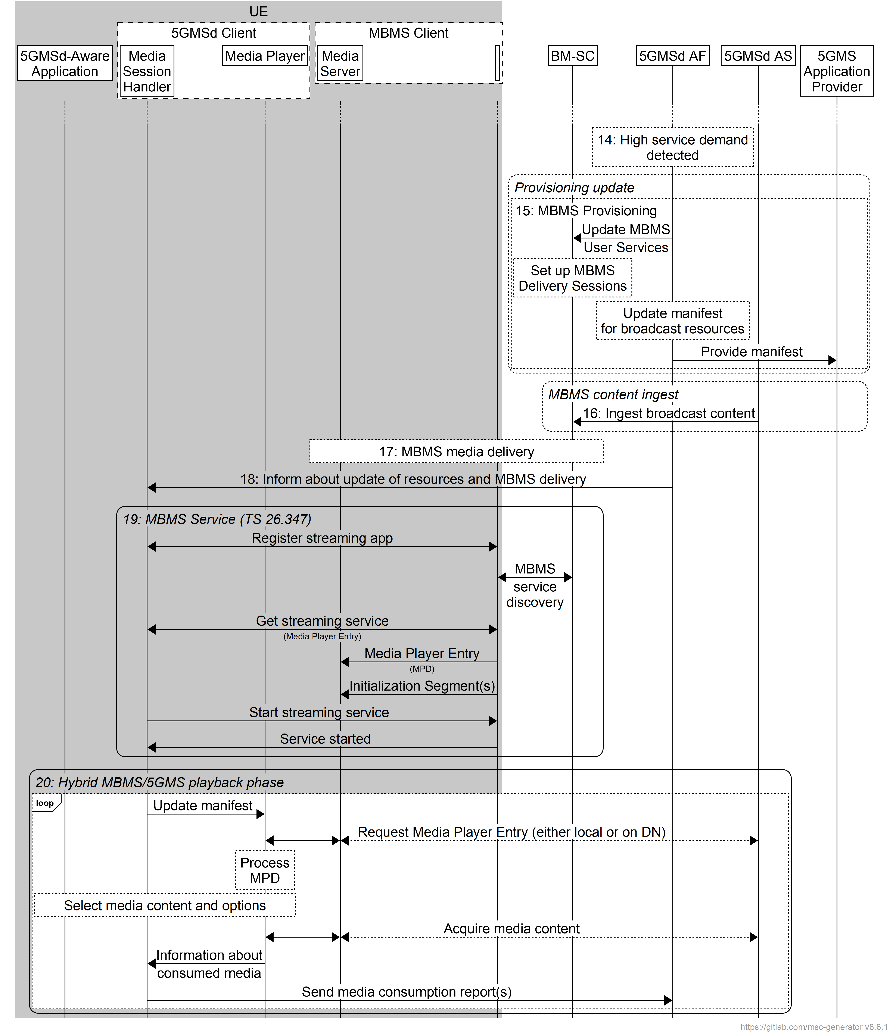
Figure 5.10.6.1-2: High-level procedure for DASH content delivered via eMBMS broadcast-on-demand (continued)

5.10.6.2 Operation modes
At least the following operation modes are supported based on the general procedures in clause 5.10.6.1:
1. Every 5GMS media service is mapped to exactly one MBMS User Service. Whether the MBMS User Service is announced and delivered or not depends on service demand. The MBMS Delivery Session is adjusted dynamically - for example the Delivery Session is disabled, or the bit rate is changed - depending on service demand and/or content requirements.
2. A set of MBMS User Services and MBMS Delivery Sessions is defined in the initial provisioning. 5GMS media services are dynamically mapped to statically configured MBMS User Services based on demand and content requirements.
3. Components of the 5GMS User Service, for example audio service components for different languages, are assigned dynamically to MBMS delivery depending on demand.

5.10.7 Service URL handling procedures for 5GMSd via eMBMS in Receive-Only Mode (ROM)
In an extension to the procedures provided in clauses 5.10.2 and 9.1, this clause defines a call flow in order to initiate a 5GMSd streaming session delivered via eMBMS without needing to contact the network, for example as done in Receive-Only Mode (ROM).
The call flow in figure 5.13.2-1 extends those defined in clauses 5.10.2 and 9.1 to address 3GPP Service URL handling. Aspects specific to this use-case are indicated in bold.
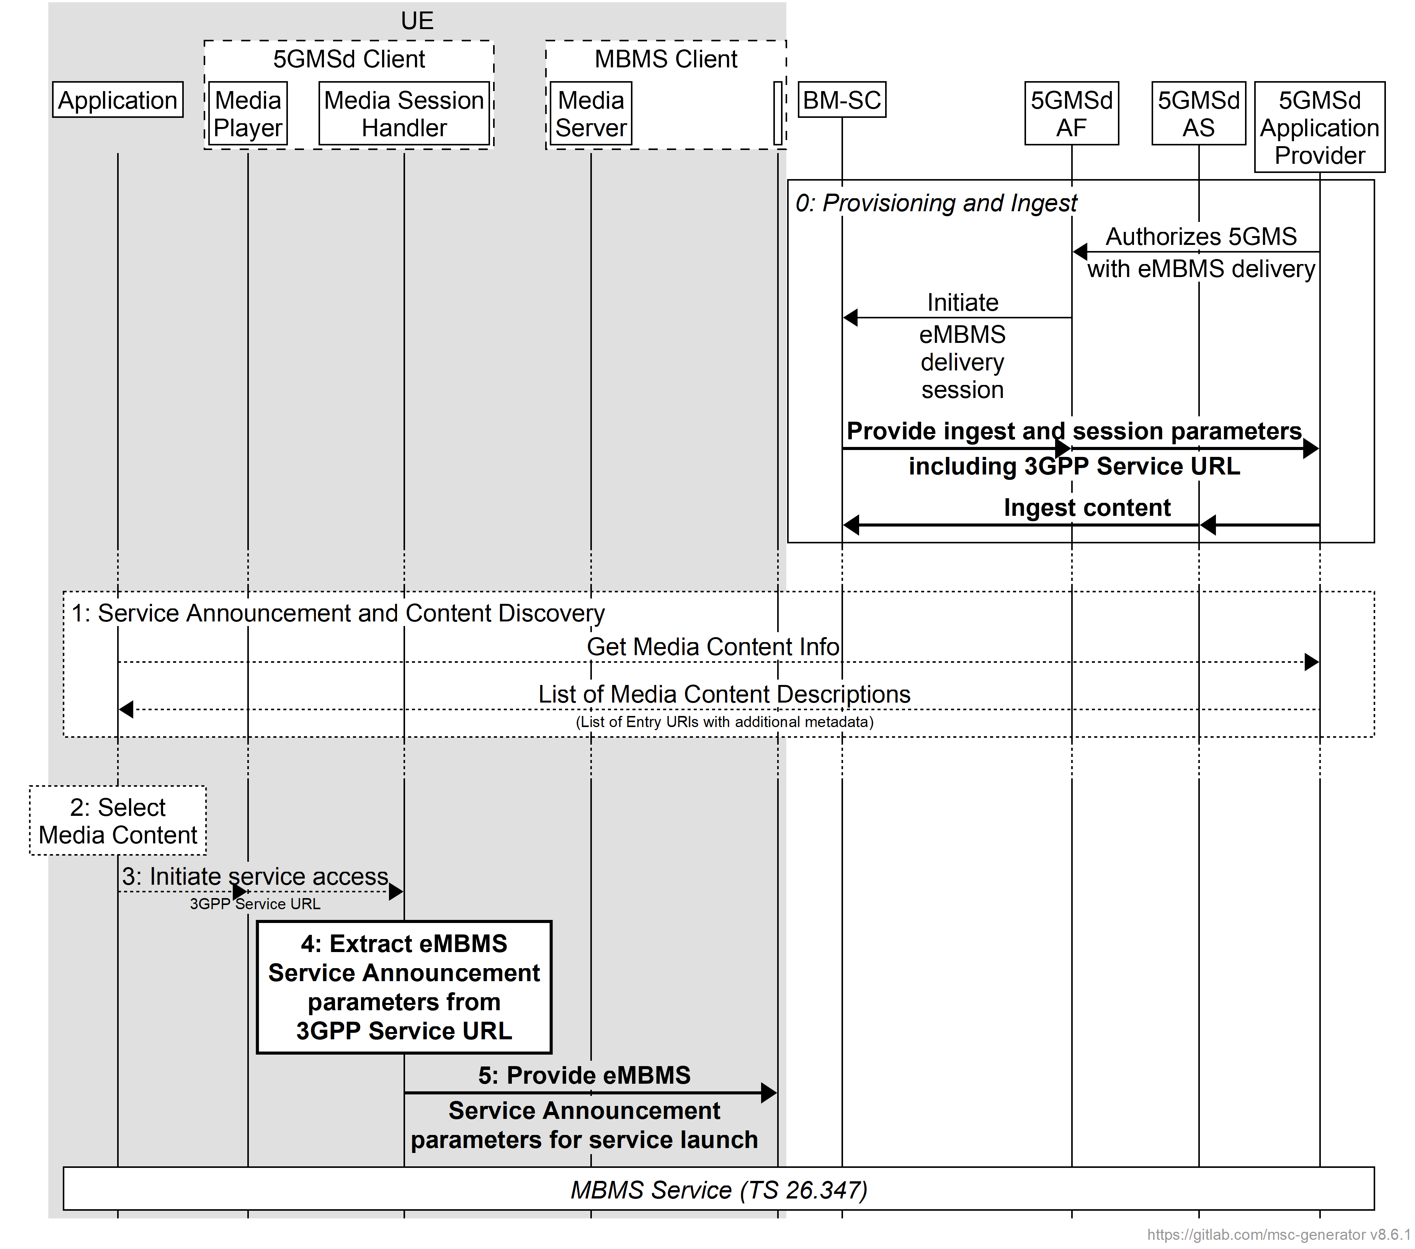
Figure 5.10.2-1: High-level procedure for DASH content delivery via eMBMS with 3GPP Service URL
Prerequisites (step 0):
- The 5GMSd Application Provider has provisioned the 5GMSd System, including content ingest and the authorization to distribute 5GMSd content via eMBMS.
- The 5GMSd AF has informed the BM-SC about the availability of 5GMSd content by provisioning an MBMS service and has obtained relevant information from the eMBMS Service Announcement (such as the MBMS service identifier).
- Based on the information, the 5GMSd Application Provider has generated a 3GPP Service URL with sufficient information for the Media Session Handler and MBMS Client to access the service.
- The BM-SC is ingesting content from the 5GMSd AS.
- The BM-SC has broadcast the MBMS Service Announcement, including an indication that the content is 5GMSd content.
Steps:
1: The 5GMSd-Aware Application triggers the Service Announcement procedure and the 5GMS Service and Content Discovery procedure at reference point M8. The information returned to the 5GMSd-Aware Application includes a 3GPP Service URL indicating a 5GMS-based service and also includes relevant information from the eMBMS Service Announcement (such as the MBMS service identifier).
2: A media content item is selected.
3: The 5GMSd-Aware Application triggers the 5GMSd Client to start media playback. The 3GPP Service URL describing the service is requested and the Media Session Handler handles it.
4: The Media Session Handler uses the Service URL information to extract relevant information from the eMBMS Service Announcement (such as the MBMS service identifier) in order to bootstrap reception of the MBMS service.
5: The Media Session Handler provides the Service Access information to the MBMS Client.
Finally, the MBMS Service is launched as defined in steps 5–25 of clause 5.10.2.

5.11 Procedures for downlink media streaming data collection, reporting and exposure

5.11.1 Configuration of 5GMSd AS data collection client for downlink media streaming access reporting
The 5GMSd AS obtains its data collection client configuration at reference point R4 as part of its initialisation procedure, as shown in figure 5.11.1-1.
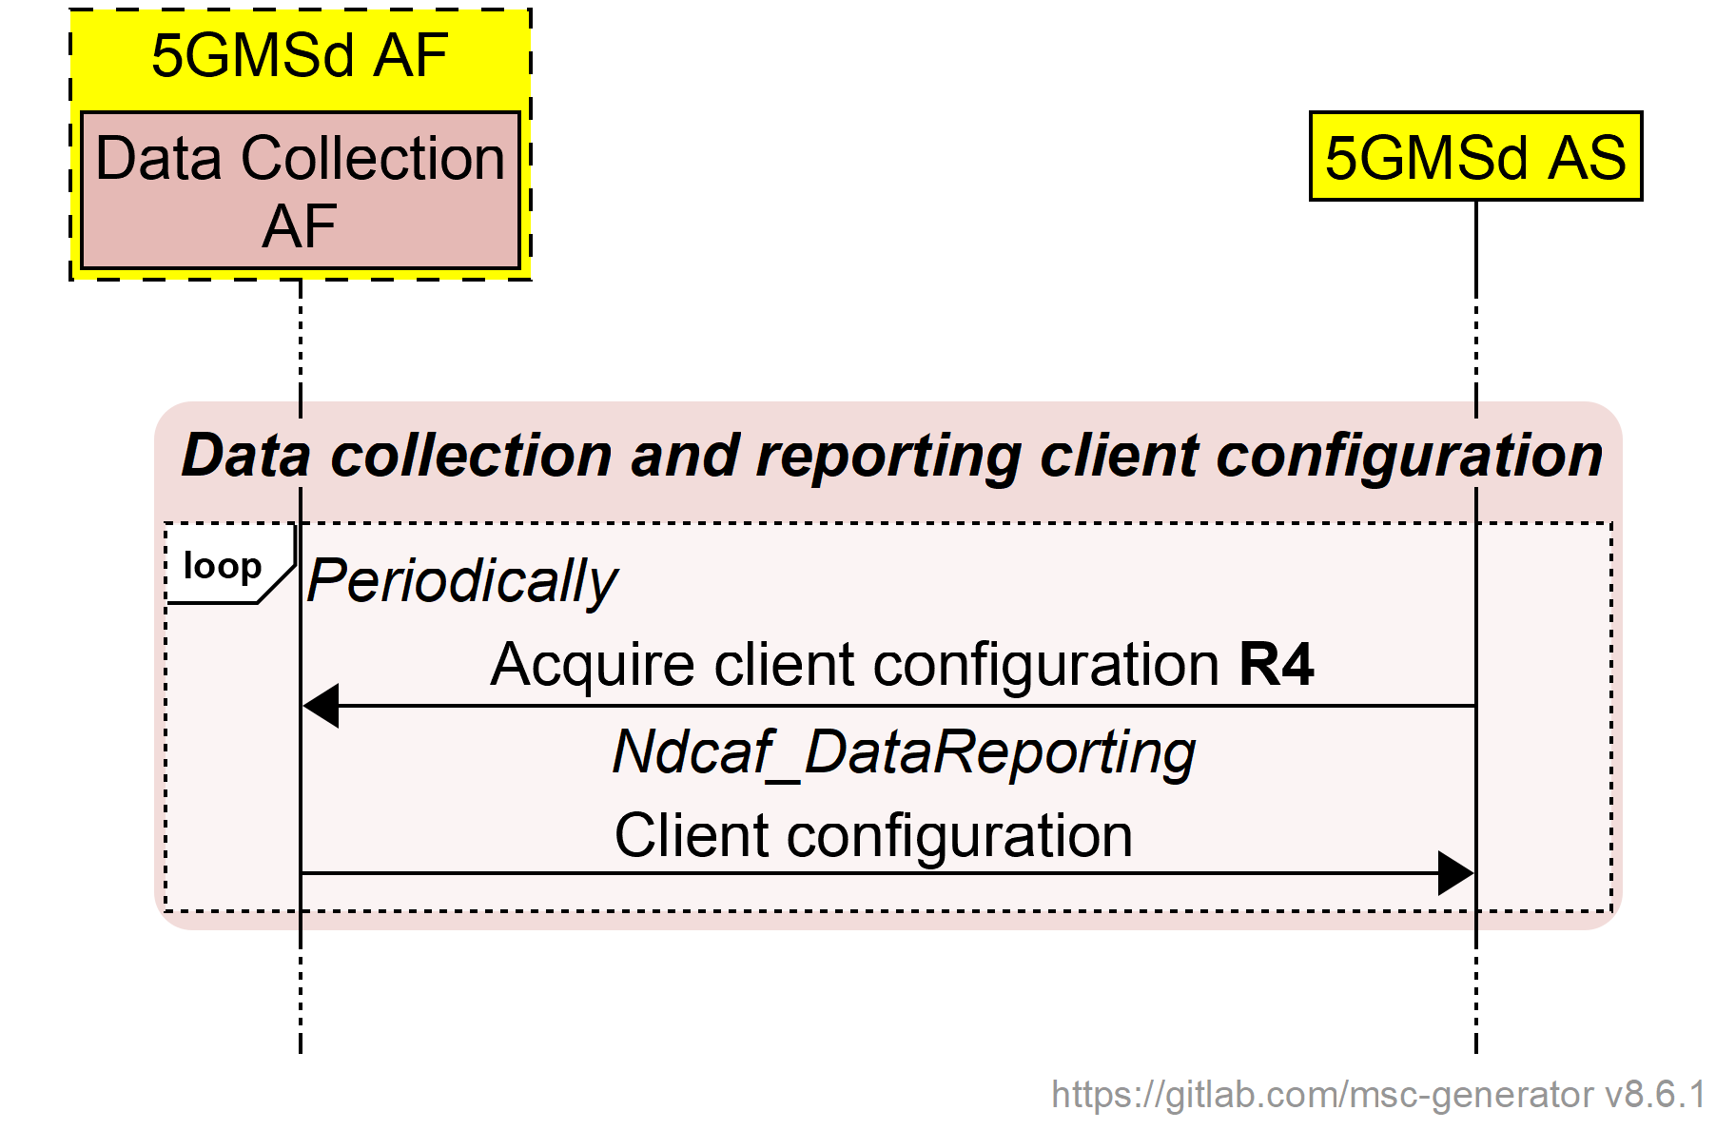
Figure 5.11.1-1: Data collection client configuration
for downlink media streaming access reporting
The 5GMSd AS shall periodically refresh its data collection client configuration and act appropriately on any changes in the configuration.

5.11.2 Downlink media streaming access activity reporting by 5GMSd AS
The 5GMSd AS shall use the procedure shown in figure 5.11.2-1 to report downlink media streaming access to the Data Collection AF instantiated in the 5GMSd AF when the data collection client configuration obtained using the procedure in clause 5.11.1 indicates that it should do so.
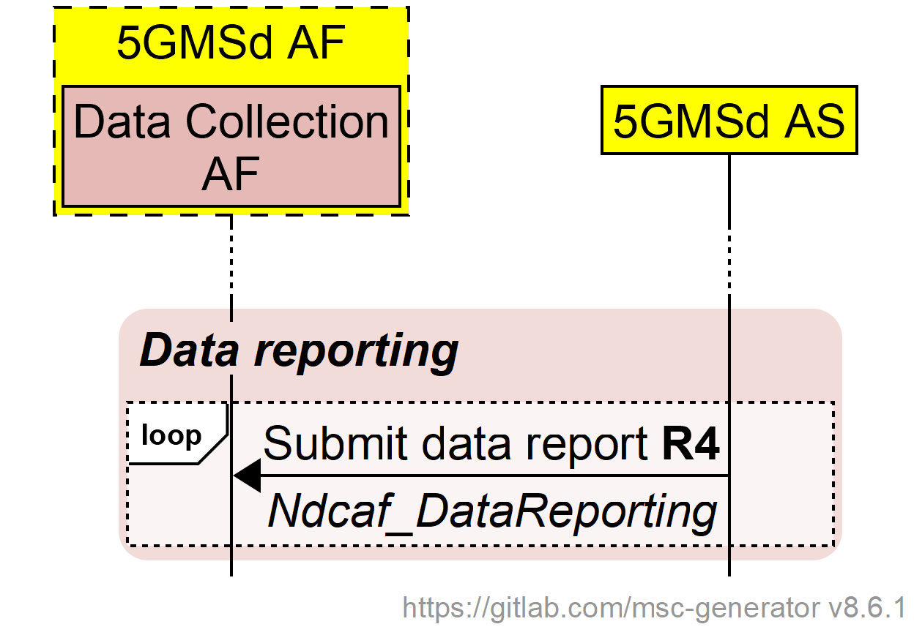
Figure 5.11.2-1: Downlink media streaming access reporting
The data report defined in clause 4.6.4 of TS 26.531 [22] shall be used by the 5GMSd AS to report the activity of downlink media streaming access by the Media Player. Each downlink access logged by the 5GMSd AS in relation to such activity shall be reported as a single record in a report submitted to the Data Collection AF at reference point R4.
The parameters included in the data report are defined in clause 4.7.2.4.

5.11.2A Configuration of Direct Data Collection Client for data reporting
The Direct Data Collection Client instantiated in the 5GMSd Client obtains its data collection client configuration at reference point R2 as part of its initialisation procedure, as shown in figure 5.11.2A-1.
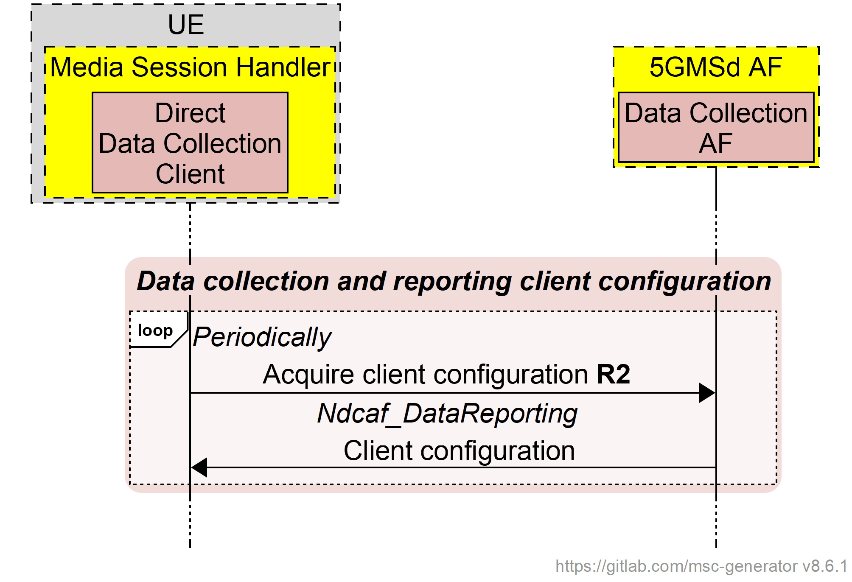
Figure 5.11.2A-1: Direct Data Collection Client configuration
for downlink media streaming
The Direct Data Collection Client shall periodically refresh its data collection client configuration and act appropriately on any changes in the configuration.

5.11.2B Direct Data Collection Client reporting for downlink media streaming
The Direct Data Collection Client shall use the procedure shown in figure 5.10.2B-1 to report to the Data Collection AF instantiated in the 5GMSd AF when the data collection client configuration obtained using the procedure in clause 5.11.2A indicates that it should do so.
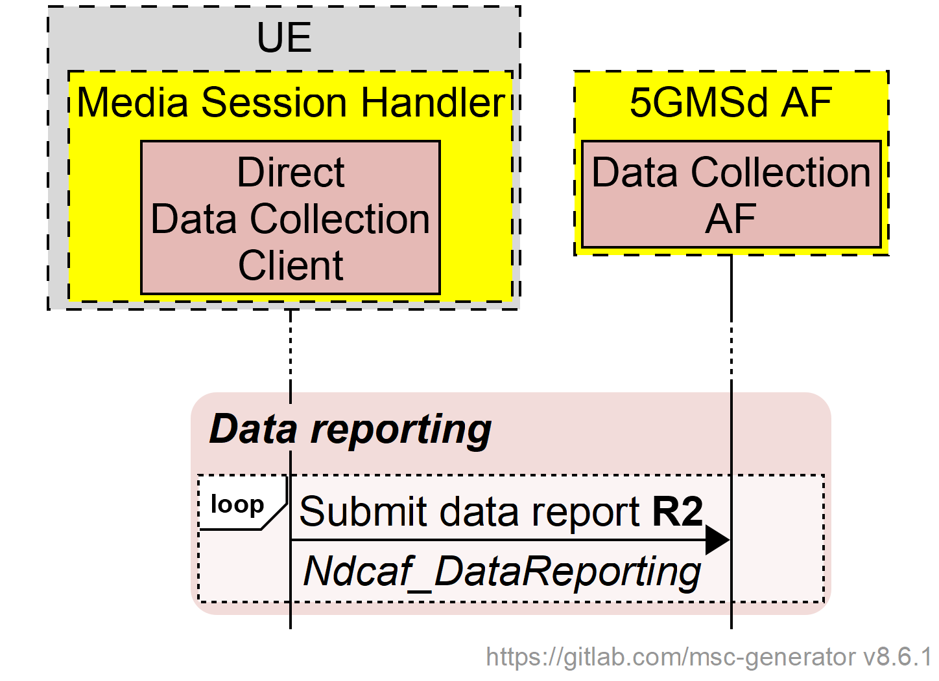
Figure 5.11.2B-1: Direct Data Collection Client reporting for downlink media streaming
The parameters included in UE data reports of downlink ANBR-based Network Assistance invocations are specified in clause 4.7.2.5.

5.11.3 Downlink media streaming event exposure
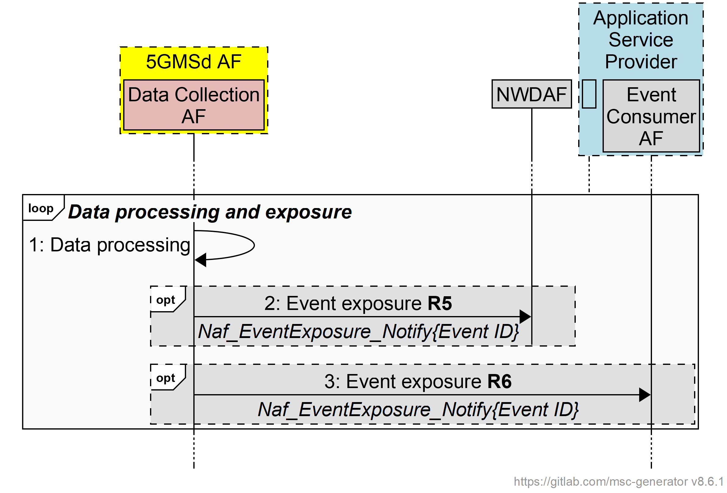
Figure 5.11.3-1: Downlink media streaming access event exposure
The 5GMS System shall follow the procedures for event reporting defined in clause 4.15.1 of TS 23.502 [3]. In the context of downlink media streaming:
- The role of event provider NF (also referred to in [3] as event provider NF, event provider, or NF producer) is performed by the 5GMSd AF and its subordinate Data Collection AF or the NEF.
- The role of event consumer NF (also referred to in [3] as consumer NF, NF service consumer, or NF consumer) is performed by the NWDAF, the NEF and/or the Event Consumer AF of the 5GMSd Application Provider.
When one of the abovementioned event consumer entities subscribes to event reporting at the 5GMSd AF:
- Event subscription parameters contained in Event Reporting Information (such as maximum number of reports, maximum duration of reporting, sampling ratio, partitioning criteria, etc. as defined in clause 4.15.1 of [3]) shall be limited or superseded by similar or identical rules optionally set by a 5GMSd Application Provider in the Event Data Processing Configuration of the 5GMSd AF Provisioning Session, as defined in clause 5.3.1 of the present document.
- UE targeting rules contained in the Target of Event Reporting (see clause 4.15.1 of [3]) shall be limited or superseded by similar or identical rules optionally set by a 5GMSd Application Provider in Data Access Profiles in the Event Data Processing Configuration of the 5GMSd AF Provisioning Session, as defined in clause 5.3.1 of the present document.

5.11.4 Void

5.11.5 Void

5.12 5GMS via MBS

5.12.1 General
This clause defines procedures for different use cases and scenarios when 5GMS uses MBS for delivery as introduced in clause 4.9. In all scenarios, the 5GMSd Client acts as an MBS-Aware Application.
The scenarios presented are not considered to be comprehensive and complete for all possible functionalities. For example, while MBS defines its own metrics reporting, the MBS Client may also provide information to the Media Session Handler that integrates relevant data in 5GMS metrics reporting. MBS and 5GMS metrics reporting may run in parallel. Based on the Communication Service type metrics configuration parameter defined in table 4.2.3-4, the Media Session Handler determines whether to collect metrics and report them via the RAN-based reporting mechanism as described in step 8a of clause 5.5.2.
The MBSTF terminates the MBS Distribution Session and includes a proxy Media Server that it is assumed can be accessed by the Media Player using common methods, typically HTTP GET requests.

5.12.2 Procedures for 5GMS content delivered exclusively via MBS
In this scenario, 5GMS content is delivered exclusively via the MBS System, i.e. content is not delivered via reference point M4d, but only via MBS User Services. However, the MBSTF Client may perform unicast object repair operations via reference point MBS-4-UC, if available.
The call flow in figure 5.12.2 1 extends that defined in clause 5.3.2 to address the delivery of 5GMS content exclusively via MBS. Aspects specific to this use-case are indicated in bold.
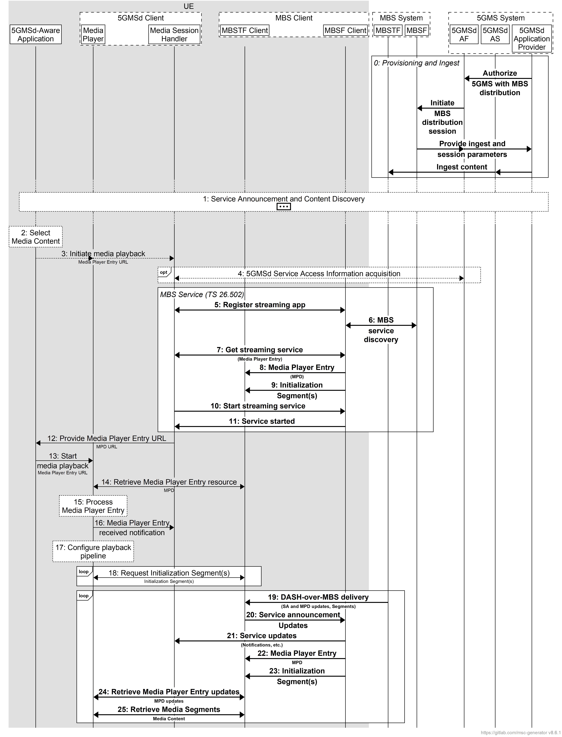
Figure 5.12.2-1: High-level procedure for DASH content delivery via MBS
Prerequisites (step 0):
- The 5GMSd Application Provider has provisioned the 5G Media Streaming System, including content ingest and the authorization to distribute 5GMS content via MBS.
- The 5GMSd AF has informed the MBSF about the availability of 5GMS content by provisioning an MBS service and has obtained relevant information from the MBS Service Announcement (such as the MBS service identifier).
- The MBSTF is ingesting content from the 5GMSd AS, using pull-based object acquisition.
- The MBSTF distributes the MBS User Service Announcement via the MBS User Service Announcement Channel at reference point MBS-4-MC, possibly including an indication that the content is 5GMS content.
Steps:
1: The 5GMSd-Aware Application triggers the Service Announcement procedure and the 5GMS Service and Content Discovery procedure at reference point M8.
2: A media content item is selected.
3: The 5GMSd-Aware Application triggers the 5GMSd Client to start media playback. The Media Player Entry documents are provided to the 5GMSd Client.
4: If the 5GMS-Aware Application has received only a reference to the Service Access Information (see step 1), the Media Session Handler interacts with the 5GMSd AF to acquire the whole Service Access Information. This includes relevant information from the MBS Service Announcement (such as the MBS service identifier) in order to bootstrap reception of the MBS service.
5–11: The 5GMSd Client acts as an MBS-Aware Application and its Media Session Handler initiates service acquisition per TS 26.502 [30]. This establishes a transport session for the Media Player Entry and the Content.
NOTE: The Media Player Entry and Initialization Segment(s) are made available by the MBSTF Client's proxy Media Server for subsequent request by the Media Player.
12: The Media Session Handler provides the Media Player Entry URL to the Media Player either directly or through the 5GMSd-Aware Application.
13: The Media Player is invoked by the 5GMSd-Aware Application to start media access and playback.
14: The Media Player retrieves the Media Player Entry resource (e.g. MPD) from the proxy Media Server.
15: The Media Player processes the retrieved Media Player Entry. It determines, for example, the number of transport sessions needed for media acquisition. The Media Player should be able to use the Media Player Entry information to initialize the media rendering pipeline(s) for each media stream (see step 17).
16: The Media Player notifies the Media Session Handler about the start of a new downlink media streaming session. The notification may include parameters from the Media Player Entry.
17: The Media Player configures the media rendering pipeline(s).
18: The Media Player retrieves initialization segment(s) referenced by the Media Player Entry.
19–25: Content is delivered using Object Streaming (see clause 6.1 of TS 26.502 [30]). Session Announcement updates are provided to the MBS Client as necessary. The MBSTF receives the MBS User Service Announcement via reference point MBS-4-MC and hands it to the MBSF for processing. MPD updates and media segments received from the MBSTF are made available by the MBSTF Client's proxy Media Server. The Media Player retrieves media segments from the proxy Media Server in the MBSTF Client according to the Media Player Entry and forwards them to the appropriate media rendering pipeline.

5.12.3 5GMS consumption reporting procedures for MBS
In this scenario, 5GMS consumption reporting is used to report consumption of 5GMSd content via an MBS service.
NOTE: MBS User Services Reception Reporting (see clause 4.2.5 of TS 26.502 [30]) may continue in parallel with 5GMS consumption reporting.
The call flow in figure 5.12.3-1 extends that defined in clause 5.6.1 to address consumption reporting. Aspects specific to this use-case are indicated in bold.
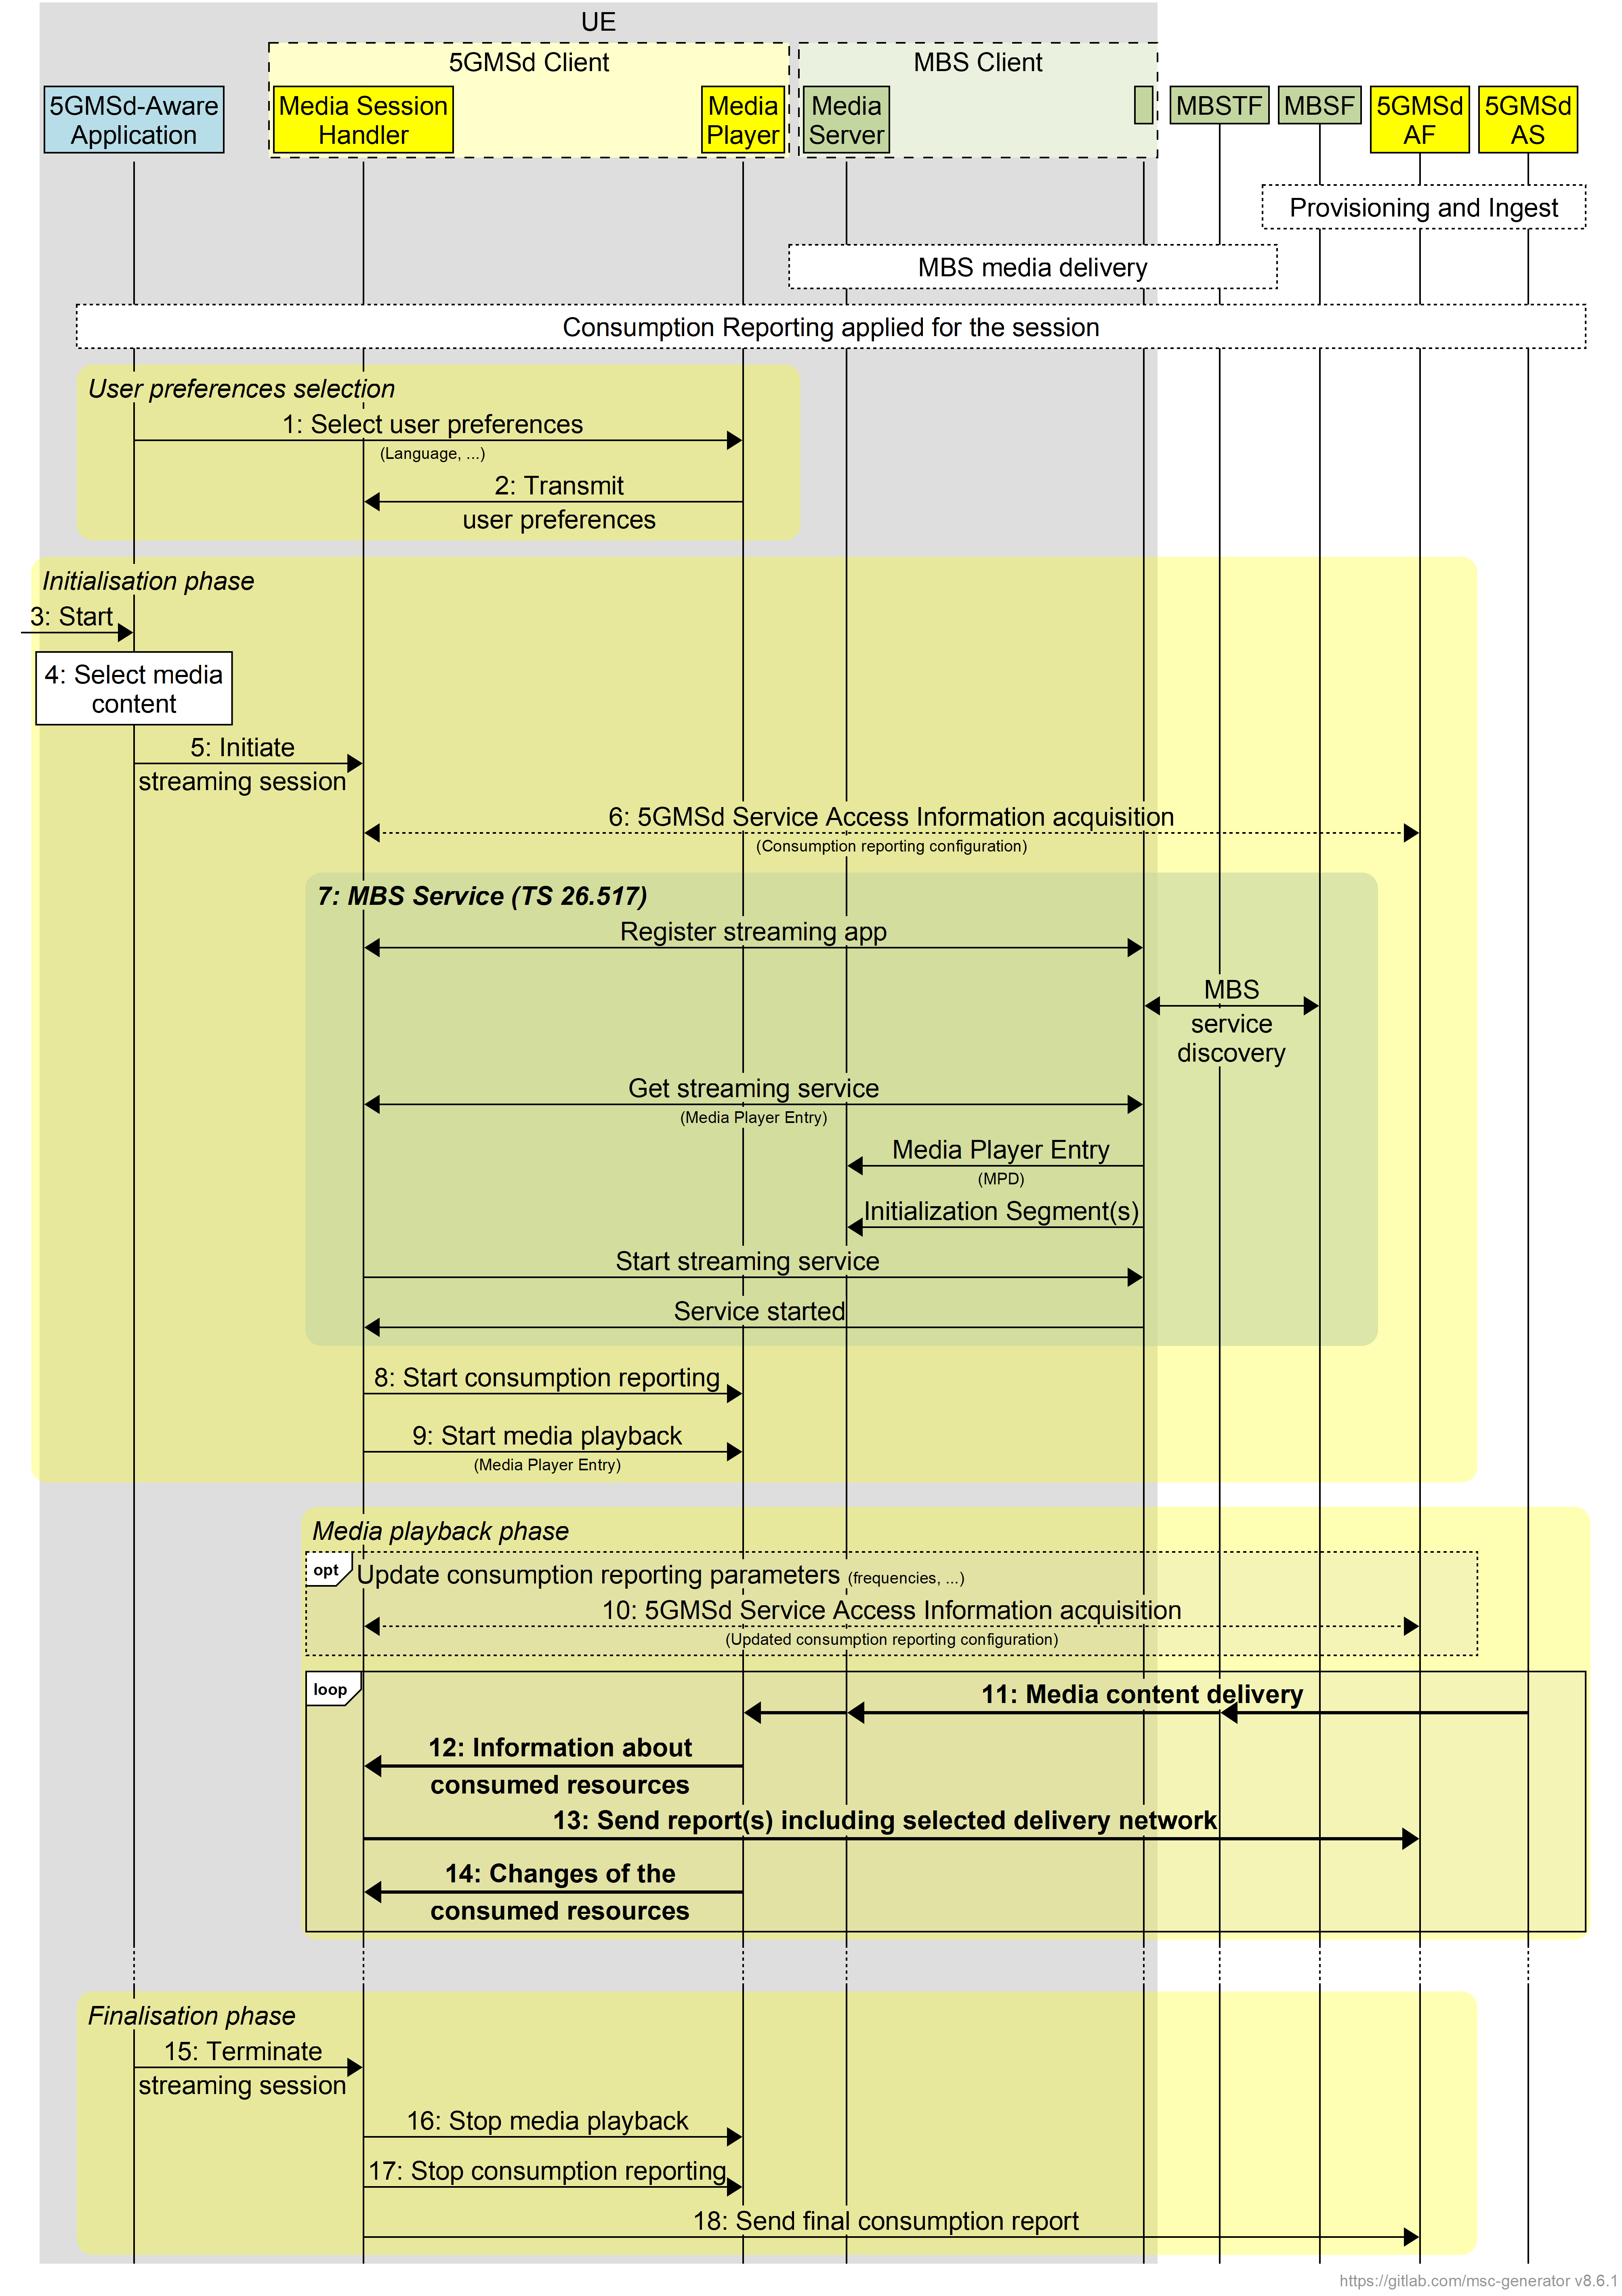
Figure 5.12.3-1: Consumption reporting for 5GMS via MBS
Prerequisites (step 0):
- The 5GMSd Application Provider has provisioned the 5G Media Streaming System, including content ingest, consumption reporting and the permission to distribute 5GMS content via MBS.
- The MBSTF is ingesting content from the 5GMSd AS, using either pull mode or push mode.
- MBS media delivery is established.
- Consumption reporting is established.
Steps:
The user preferences relating to consumption reporting may be changed:
1: The 5GMSd-Aware Application selects/changes the user preferences.
2: The Media Player transmits consumption reporting user preferences to the Media Session Handler.
The first phase is initialisation.
3: The 5GMSd-Aware Application is started.
4: A media content item is selected.
5: The 5GMSd-Aware Application triggers the Media Session Handler to initiate media session handling and content playback. The Media Player Entry is provided.
6: If the 5GMS-Aware Application has received only a reference to the Service Access Information, the Media Session Handler interacts with the 5GMSd AF to acquire the whole Service Access Information. This includes a client consumption reporting configuration including parameters such as reporting frequency.
7: The MBS service reception is initiated by the Media Session Handler.
8: The Media Session Handler triggers consumption reporting in the Media Player.
9: The Media Player is invoked by the 5GMSd-Aware Application to start media access and playback.
The second phase is media playback.
When media is playing, the consumption reporting parameters may be updated by the 5GMSd AF.
10: The Media Session Handler acquires updated Service Access Information from the 5GMSd AF including updated consumption reporting parameters.
When media is playing:
11: Media content is accessed through different networks, possibly via MBS or unicast.
12: The Media Player transmits information about the media streaming resources consumed to the Media Session Handler, including the source of the media.
13: The Media Session Handler regularly sends consumption report(s) to the 5GMSd AF, including information about the delivery network from which the media was acquired.
14: The Media Player provides an update to the Media Session Handler about the consumed media streaming resources, for example a change in the delivery network.
The last phase is to terminate the media streaming session:
15: The 5GMSd-Aware Application triggers the Media Session Handler to stop content playback.
16: The Media Session Handler stops the Media Player.
17: The Media Session Handler stops consumption reporting in the Media Player.
18: The Media Session Handler may send final consumption report(s) to the 5GMSd AF.

5.12.4 5GMS content delivery via 5G System and MBS

5.12.4.1 General
This clause addresses cases for which a 5GMS service is available on MBS and at the same time on unicast. The service on unicast may be richer and extended and may provide additional user experiences. It is assumed that the content is statically provisioned on either MBS or on unicast.
Services addressed in this clause predominantly refer to the case for which the delivery manifest differentiates between resources accessible via unicast downlink media streaming at reference point M4d and resources accessible through MBS, in this case through MBS-API-U.
These resources are differentiated in the delivery manifest through different Data Networks, for example different Base URLs in DASH MPDs, or in HLS by providing different pathways. The 5GMSd Client, in particular the Media Player in collaboration with the Media Session Handler and the MBS Client, dynamically selects the delivery network from which to acquire media content according to reception conditions, user preferences or other policies. Content is provisioned such that the 5GMSd Client is able to provide a seamless user experience when switching between different delivery networks.
The call flow in figures 5.12.4-1, 5.12.4-2 and 5.12.4- 3 extends that defined in clause 5.6.1 to address generic hybrid use cases. Specific additional use cases are presented in the remainder of clause 5.12.4.
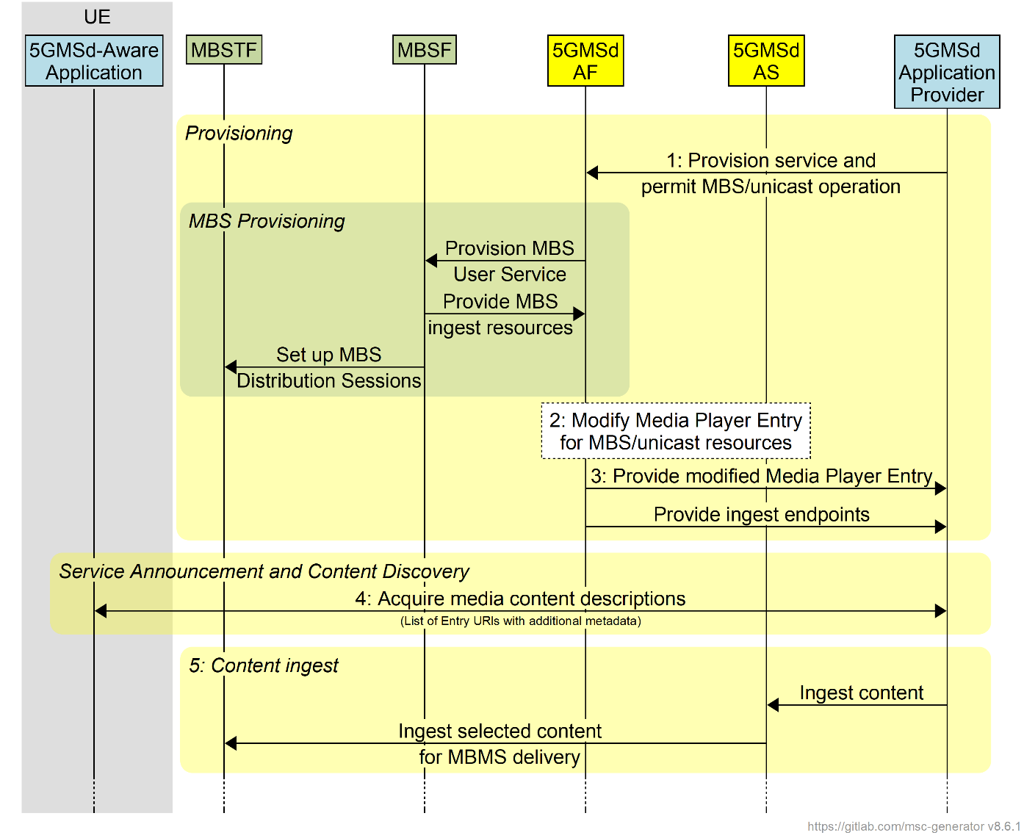
Figure 5.12.4-1: High-level procedure 5GMS content delivery via 5G System and MBS
Steps:
1: The 5GMSd Application Provider triggers 5GMS provisioning and permits concurrent 5GMS and MBS distribution of the media content.
2: As a consequence, the 5GMSd AF provisions MBS delivery. The MBS Distribution Session is set up and the MBSF informs the 5GMSd AF about the content ingest endpoints.
3: The 5GMSd AS modifies the Media Player Entry (typically a media presentation manifest) under the direction of the 5GMSd AF to indicate that content is available either on the MBS Client's local Media Server or on 5GMSd AS.
4: The modified presentation manifest and the ingest endpoints are provided to the 5GMSd Application Provider. The manifest may also be updated by the 5GMSd Application Service Provider.
5: The media content is announced to the 5GMSd-Aware Application and the application requests the entry points for the service.
6: The 5GMSd AS begins ingesting content from the 5GMSd Application Provider and the MBSTF may, in turn, begin ingesting this content from the 5GMSd AS.
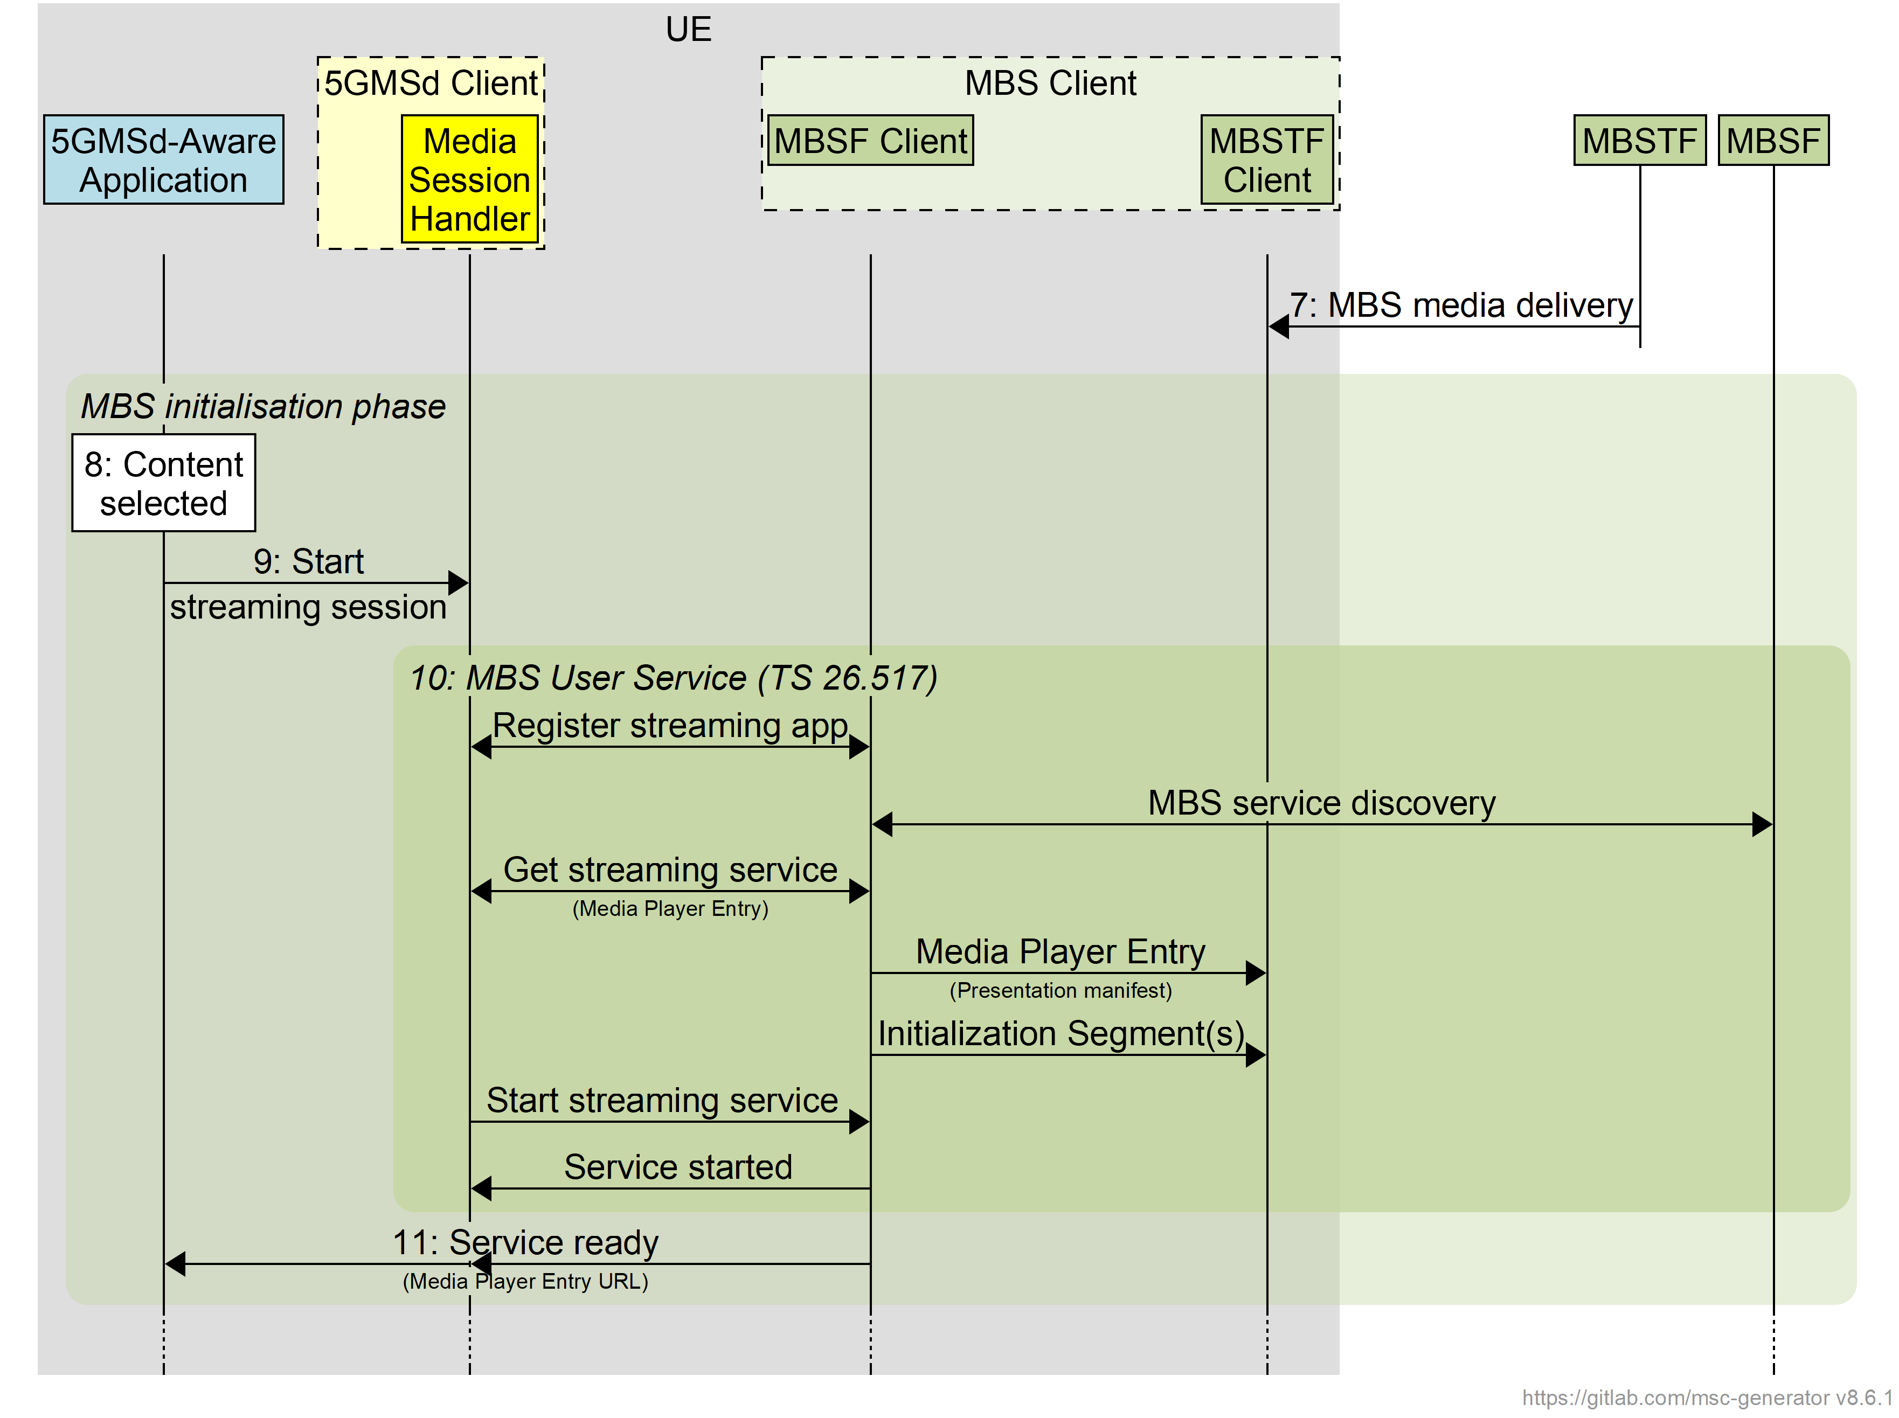
Figure 5.12.4-2: High-level procedure 5GMS content delivery via 5G System and MBS (continued)
7: The MBSTF starts one or more MBS Distribution Sessions.
8: The media content is selected by the 5GMSd-Aware Application.
9: The application initiates the media streaming session through Media Session Handler.
10: The Media Session Handler initiates MBS User Service streaming.
11: The media session handler through the information from the MBS Client informs the 5GMSd-Aware Application that the service is ready.
Figure 5.12.4-3: High-level procedure for 5GMS content delivery via 5G System and MBS (continued)
12: The 5GMSd-Aware Application starts media playback.
13: The Media Player Entry (typically a media presentation manifest) is acquired by the Media Player. It may be available from the local Media Server (populated by the MBS Client) or from the 5GMSd AS, or even from both.
14: The Media Player processes the Media Player Entry and identifies that content is available from different data networks (the local Media Server and the 5GMSd AS).
15: Under the control of the 5GMSd-Aware Application, the Media Player selects the content and different content options.
16: The Media Player continuously checks with the Media Session Handler - and possibly forwarded to the MBS Client if the MBS User Service data is available - how to use the different content. This depends on the hybrid scenario. Different policies may be considered.
17: The Media Player requests initialization information either from the local Media Server or from the 5GMSd AS. The Media Player repeats this step for each required initialization segment.
18: The Media Player receives the initialization information.
19: The Media Player requests media segments according to the Media Player Entry, either from the local Media Server or from the 5GMSd AS.
20: The Media Player receives media segments and puts the information into the appropriate media rendering pipeline.
Steps 13-20 are repeated according to the Media Player Entry information.

5.12.4.2 Interactive service
In a specific scenario for 5GMS content delivery via 5G System and MBS, an interactive service may be provided via 5GMS while the main media content resources are delivered via MBS exclusively. In this case, the following instantiations apply:
- In step 2, the Media Entry Point document (e.g. MPD) only points to content in the local proxy Media Server.
- Step 13 as well as steps 17–20 are all terminated on the local proxy Media Server.

5.12.4.3 Session continuity
In a specific 5GMS content delivery via 5G System and MBS scenario, the service is made available via both 5GMS and MBS delivery networks, but only one Representation of each Adaptation Set is provided via MBS. In this case, the following instantiations apply:
- In step 2, one Representation of each Adaptation Set is distributed via MBS.
- As long as the streaming service is accessible over MBS, the Media Player selects the media content in step 13 as well as steps 17–20 from the local proxy Media Server; content is not available from the 5GMSd AS.
- If the streaming service becomes unavailable via MBS, the Media Player switches to accessing the media content in step 13 as well as steps 17–20 from the 5GMSd AS.
- Once the streaming service becomes available again via MBS, the Media Player switches back to accessing the media content in step 13 as well as steps 17–20 from the local proxy Media Server.

5.12.4.4 Time-shifted viewing
In a specific 5GMS content delivery via 5G System and MBS scenario, the service is made available via both 5GMS and MBS delivery networks, but only one Representation of each Adaptation Set is provided via MBS. The content is retained by the 5GMSd AS for a period of time to support time shifted access. In this case, the following instantiations apply:
- In step 2, one Representation is of each Adaptation Set is distributed via MBS.
- If the streaming service is accessible via MBS and the user is consuming content at the live edge, the Media Player selects the media content in the step 13 as well as steps 17–20 from the local proxy Media Server; content is not available from the 5GMSd AS.
- If the user switches to time-shift viewing mode or streaming service becomes unavailable via MBS, the Media Player switches to accessing the media content in the step 13 as well as steps 17–20 from the 5GMSd AS.
- Once the streaming service becomes available again via MBS and the user returns to the live edge, the Media Player switches back to accessing the media content in the step 13 as well as steps 17–20 from the local proxy Media Server.

5.12.4.5 Content or component replacement
In a specific 5GMS content delivery via 5G System and MBS scenario, the service is made available via both 5GMS and MBS delivery networks, but only one Representation of selected Adaptation Sets is provided via MBS. Some Adaptation Sets are only available via 5GMS. In another case, two or more content alternatives may exist for a period of time, but only one alternative is provided over MBS.
In this case, the following instantiations apply:
- In step 2, the MPD is generated to define the different content alternatives.
- If the streaming service is accessible over MBS and the user watches content available on broadcast, the Media Player selects the media content in step 13 as well as steps 17–20 from the local proxy Media Server; content is not available from the 5GMSd AS.
- If the user switches content or content components, the Media Player switches to accessing the media content in the step 13 as well as steps 17–20 from the 5GMSd AS. If only a component is replaced, the Media Player accesses media content from the local proxy Media Server and the 5GMSd AS at the same time.

5.12.5 Procedures for dynamic provisioning of 5GMS content delivery via MBS

5.12.5.1 General
In this scenario the same content is distributed via MBS and via a 5GMS System. The resources of the MBS System are statically configured. MBS-based distribution may, for example, be used only for services in high demand, and the resources and quality of the service distributed through broadcast may be adjusted according to demand. Demand may be identified through 5GMS Consumption Reporting.
The call flow in figures 5.12.5.1-1 and 5.12.5.1-2 extends that defined in clause 5.12.1 to address generic use cases for MBS-on-demand. Specific additional use cases are presented in the remainder of clause 5.12.5.
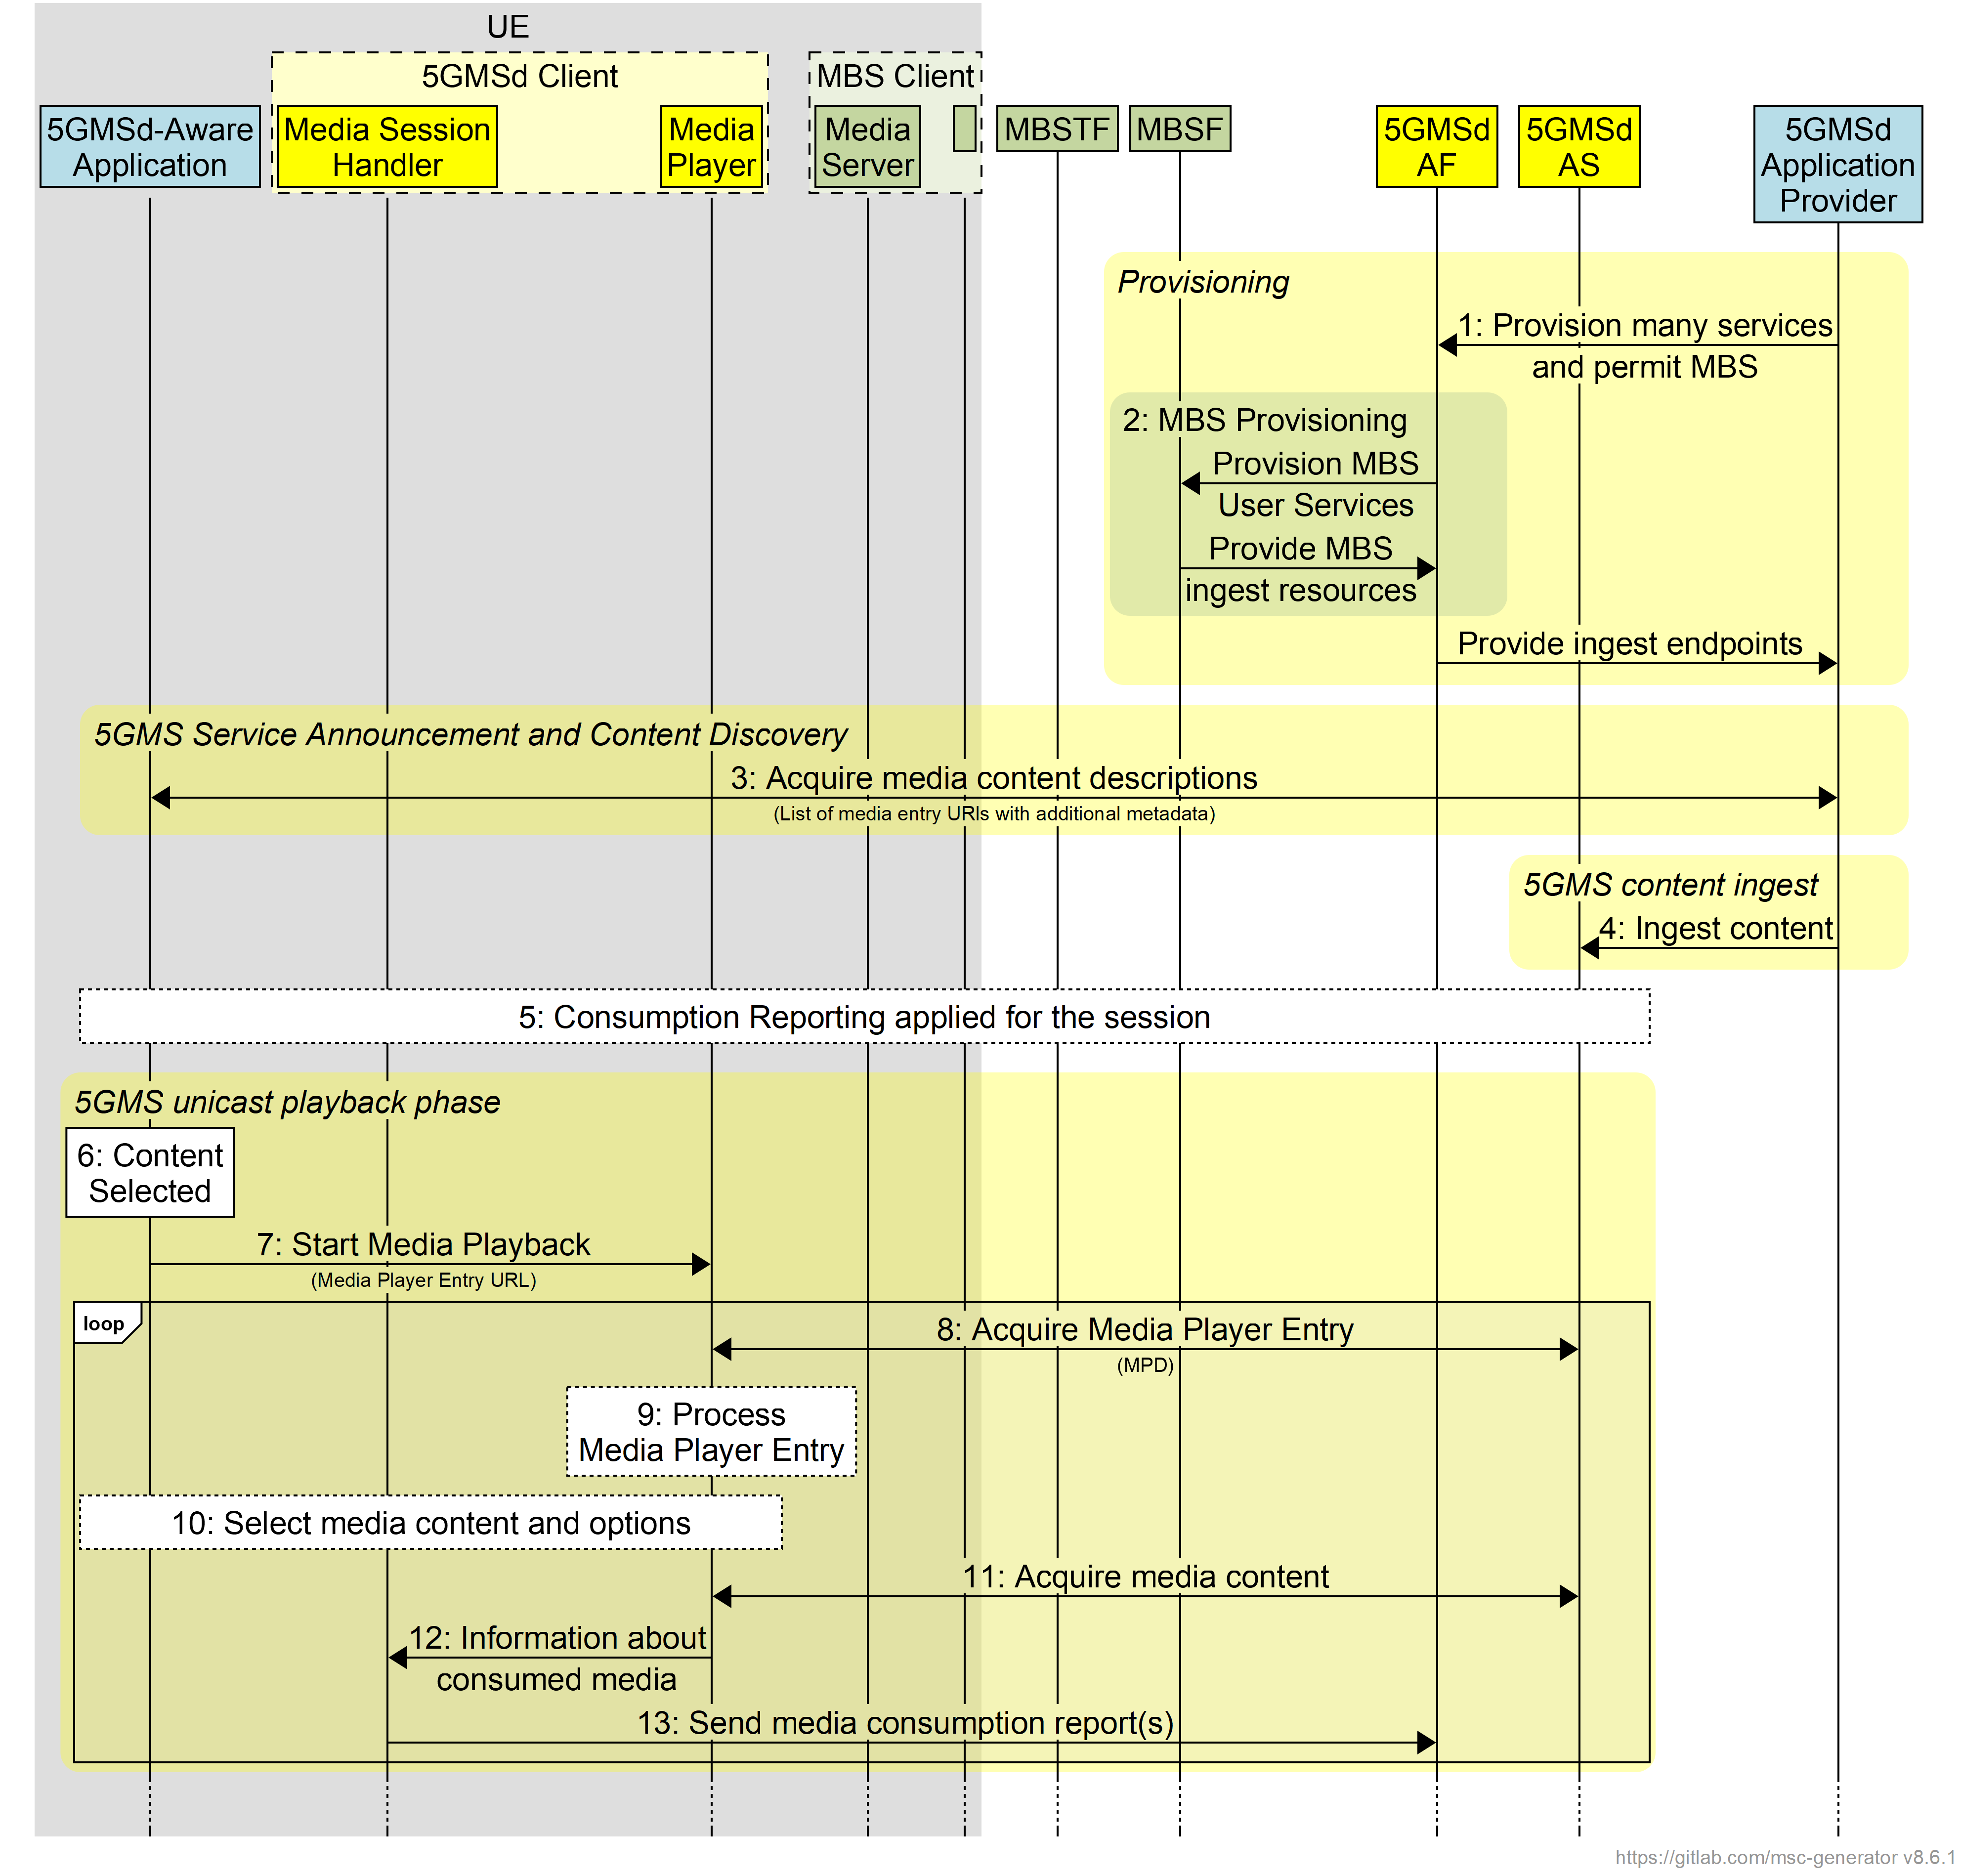
Figure 5.12.5.1-1: High-level procedure for DASH content delivered via MBS-on-demand
Steps:
1: The 5GMS Application Provider provisions one or more 5GMSd services and permits broadcast distribution of the media content.
2: As a consequence, the 5GMSd AF provisions MBS delivery and the MBSF informs the 5GMSd AF about the resources it will use to ingest media content.
NOTE: This step may happen later, up to (and possibly as part of) step 15, for example only when demand is identified.
3: The media content is announced to the 5GMSd-Aware Application and the application request the entry points for the service.
4: The 5GMSd AS starts to ingest content from the 5GMSd Application Provider.
5: Consumption Reporting is applied for the downlink media streaming session.
Media playback initially uses unicast 5G Media Streaming:
6: The media content is selected by the 5GMSd-Aware Application.
7: The 5GMSd-Aware Application triggers the start of media playback by the Media Player.
8: The Media Entry Point document (e.g. DASH MPD) is requested by the Media Player from the 5GMSd AS.
9: The Media Player processes the media presentation manifest and identifies that the media content is available on the 5GMSd AS
10: The Media Player, under the control of the application, selects the media content and different content options.
11: Media content is received from the 5GMSd AS via reference point M4d.
12: The Media Player informs the Media Session Handler about the consumed media content.
13: The Media Session Handler sends consumption reports to the 5GMSd AF.
Subsequently, media playback switches to MBS:
14: By analysing the consumption reports submitted to it in the previous step, the 5GMSd AF identifies a high level of demand for the service.
15: Additional MBS Distribution Sessions are provisioned to add delivery of the service via MBS.
16: The MBSTF starts ingesting media content from the 5GMSd AS.
17: MBS media distribution starts.
18: The 5GMSd AF informs the Media Session Handler that MBS media distribution is initiated by providing updated Service Access Information.
19: MBS content reception is initiated by the Media Session Handler.
20: Once the service is ready, the content delivered on MBS is used by the Media Player. Consumption reporting continues. Specific cases may use different policies, similar to the hybrid case in clause 5.12.5.
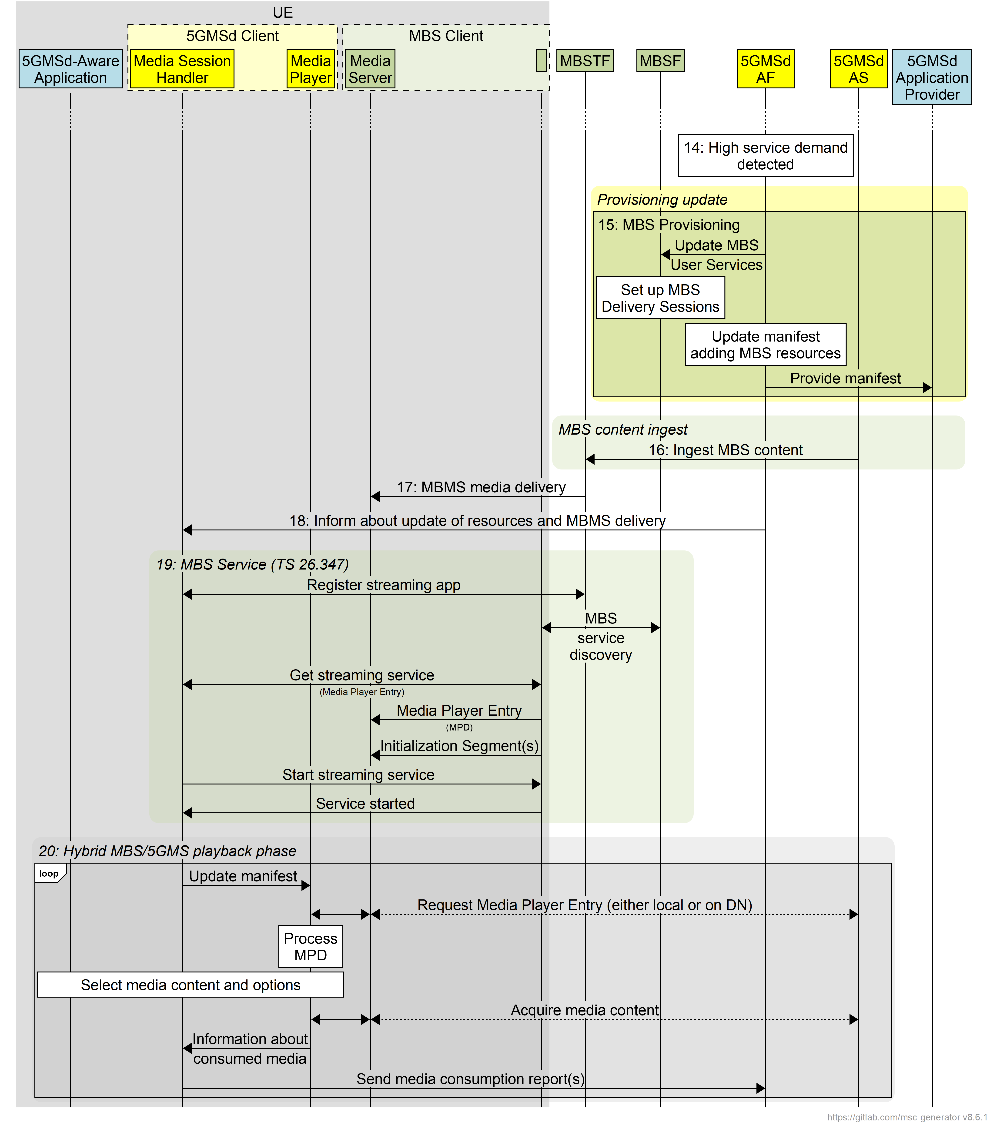
Figure 5.12.5.1-2: High-level procedure for DASH content delivered via MBS-on-demand (continued)

5.12.5.2 Operation modes
At least the following operation modes are supported based on the general procedures in clause 5.12.5.1:
1. Every 5GMS media service is mapped to exactly one MBS User Service. Whether the MBS User Service is announced and delivered or not depends on service demand. The MBS Distribution Session is adjusted dynamically – for example the MBS Distribution Session is disabled, or the bit rate is changed – depending on service demand and/or content requirements.
2. A set of MBS User Services and MBS Distribution Sessions is defined in the initial provisioning. Downlink media streaming components are dynamically mapped to statically configured MBS Distribution Services based on demand and content requirements.
3. Components of the downlink media streaming session, for example audio service components for different languages, are assigned dynamically to MBS Distribution Sessions depending on demand.

5.13 In-band client data reporting

5.13.1 Scenario
In the considered scenario, client data is reported in band with media requests at reference point M4d. Client data is initially sent to the 5GMSd AS via reference point M4d, and from there provided to the 5GMSd AF using the QoE metrics reporting mechanism at reference point M3d. The call flow is aligned with QoE metrics collection and reporting as defined in clause 5.5.

5.13.2 Procedure
Figure 5.13.2-1 illustrates a scenario where client data collection and in-band reporting by the 5GMSd AS is configured by the 5GMSd AF via reference point M3d. In this example, it is assumed that the client data collection information provided by the 5GMSd AF comprises instructions/rules regarding client data reporting. It is further assumed that the 5GMSd AF is required to expose client data events to separate destination entities, upon optionally having performed post-processing on the collected report information. The 5GMSd AF and 5GMSd AS may be either trusted or untrusted.
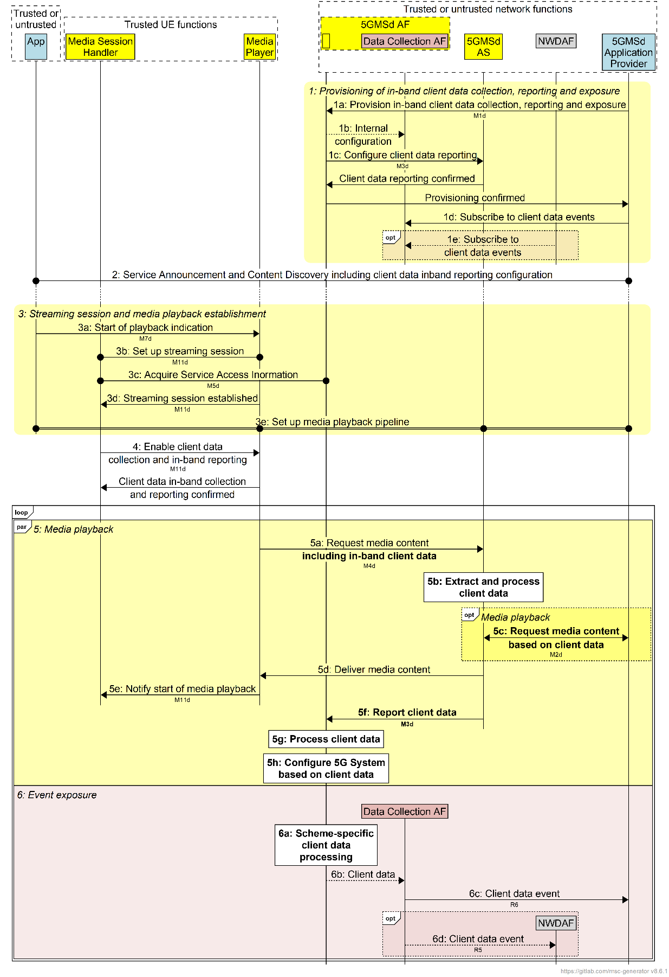
Figure 5.13.2-1: Client data collection in 5GMSd reported in band via M4d and M3d
The message sequence steps are described below. Extensions to the basic 5G Media Streaming call flow are highlighted in bold:
1: The 5GMS System is provisioned to collect, report and expose client data to interested event consumers.
1a: The 5GMSd AF is provisioned at reference point M1d with in-band client data reporting configuration information pertaining to client data collection by the Media Player and reporting of it to the 5GMSd AF via the 5GMSd AS. This includes different client data collection, in-band reporting and data processing instructions regarding required post-processing functionality and subsequent exposure of processed client data to the 5GMSd Application Provider and/or to the NWDAF.
1b: The 5GMSd AF configures the Data Collection AF instantiated inside it to receive client data reports from the 5GMSd AS and to make the client data available for exposure to event consumers.
1c: The 5GMSd AF also configures the 5GMSd AS to extract client data from media requests at reference point M4d and report it to the 5GMSd AF via reference point M3d.
1d: The 5GMSd Application Provider subscribes to receive events containing client data information.
1e: The NWDAF may also subscribe to receive events containing client data information.
2: The 5GMSd-Aware Application triggers the Service Announcement and Content Discovery procedure at reference point M8d. The Service Announcement may include the whole Service Access Information that includes a client data collection and in-band reporting configuration to be used by the Media Player.
Time passes until the 5GMSd Client initiates session establishment and media playback.
3: Streaming Session and media playback is established.
3a: The 5GMSd-Aware Application informs the Media Player of impending media playback by invoking a suitable method at reference point M7d.
3b: The Media Player requests the establishment of a streaming session by invoking a suitable method at reference point M11d on the Media Session Handler, which acknowledges the request.
3c: The Media Session Handler requests may acquire whole Service Access Information from the 5GMSd AF via reference point M5d if did not already receive this in step 2 above.
3d: The Media Session Handler informs the Media Player about the successful set-up of the streaming session by means of a suitable notification at reference point M11d.
3e: The media playback pipeline is set up between the Media Player, the 5GMSd AS at reference point M4d and with the 5GMSd Application Provider at reference point M2d.
4: Using a suitable interaction at reference point M11d, the Media Session Handler interrogates the Media Player at reference point M11d on its capability to perform client data collection and in-band reporting at reference point M4d and instructs the player to enable client data collection and in-band reporting, including a session identifier. In response the Media Player acknowledges its support for the collection of the required client data.
During the course of media playback, steps 6a to 6f below may be repeated, depending on the duration of the playback.
5a: The Media Player requests media content from the 5GMSd AS via reference point M4d and includes configured client data in the request according to the configuration obtained in step 4 above.
5b: The 5GMSd AS extracts and processes client data from this request.
5c: In the case of a live streaming service, media content may have already been published by the 5GMSd Application Provider to the 5GMSd AS at reference point M2d. However, in this case it is considered that the 5GMSd AS ingests media from the 5GMSd Application Provider in pull mode. The 5GMSd AS checks if the requested data is already cached and if not, requests the data from the upstream 5GMSd Application Provider. The 5GMSd AS may also use information in the client data to request future segments in advance of a request at reference point M4d.
5d: The 5GMSd AS delivers the requested media data to the Media Player at reference point M4d.
5e: The Media Player starts playback and informs the Media Session Handler by means of a suitable notification at reference point M11d.
5f: The 5GMSd AS reports the requested client data to the 5GMSd AF via reference point M3d.
5g: The 5GMSd AF extracts the relevant client data from the report and processes it.
5h: Based on reported client data the 5GMSd AF may decide to communicate with the 5G System to initiate media handling functions such as Network Assistance.
In parallel with the media streaming session, the client data received by the 5GMSd AF is prepared for exposure:
6a: In accordance with its in-band client data reporting configuration as provisioned in step 1, the 5GMSd AF performs separate post-processing in accordance with the received types of client data reports.
6b: The client data is shared with the Data Collection AF instantiated in the 5GMSd AF.
6c: The Data Collection AF instantiated in the 5GMSd AF exposes an event containing processed client data to the 5GMSd Application Provider at reference point R6 in accordance with the Event Data Processing Configuration provisioned in step 1.
6d: The Data Collection AF instantiated in the 5GMSd AF may expose an event containing processed client data to the NWDAF at reference point R6 in accordance with the Event Data Processing Configuration provisioned in step 1.
NOTE 2: Although not explicitly shown or described in figure 5.13.2-1, should the 5GMSd AF represent an untrusted network entity and the NWDAF represent a trusted network entity, the NWDAF’s subscription to receive processed client data events from the 5GMSd AF is mediated in the southbound direction by the NEF (Network Exposure Function) through the Nnef_EventExposure service as specified in TS 29.591 [37] to enable event notifications as described in step 10.

5.14 Content preparation of DRM-protected content

5.14.1 Scenario
A typical scenario is the following: The 5GMSd Application Server runs a content encoding and/or packaging service. However, in many cases, the content provider requires that the content is distributed with specific content and usage rights, referred to a Digital Rights Management (DRM). The DRM system is an implementation of content key management cooperating with the device’s media platform to enable playback of encrypted content while protecting the decrypted samples and content keys against potential attacks. The DRM system is comprised of two main components: a DRM server and a DRM client.
In a typical deployment scenario, the DRM server –including both key server and license server – is deployed externally to the 5GMS System in the 5GMSd Application Provider domain, but the encoding, encryption and packaging is assigned to the 5GMSd AS. This may, for example, be the case to adapt the content to the needs of mobile distribution, in combination with Content Preparation.
In order to complete the encryption tasks and presentation manifest generation, the 5GMSd AS needs to communicate with the DRM server to obtain all information for manifest generation, content encoding and packaging. In this case Content Protection Information is exchanged across 5GMSd reference points.
NOTE 1: The scenario is not addressing key rotation, i.e. updating keys during an ongoing media streaming session. This aspect is for further study.
In order to address the scenario above, the following sub-functions of the 5GMSd Application Provider, the 5GMSd Application Server and the 5GMSd Client are defined:
- 5GMSd Application Provider:
- Content Provider: a content provider providing content for distribution via 5GMSd with the provided content having assigned specific content and usage rights.
- Authorization Server: provides authorization tokens that may be required for requesting a license from a license server.
- DRM Server: a component of the DRM system that manages and enforces the access and usage rights of digital content. It typically includes a License Server and a Key Server. In certain cases, the DRM System can have embedded entitlement logic to decide for which request to grant a license and for which not, supported by an Authorization Server.
- License Server: Provides data structures in a DRM system-specific format that includes one or more content keys and associates them with a policy that governs the usage of these content keys.
NOTE 2: Multiple License Servers may be deployed in case of a multi-DRM system with common encryption.
- Key Server: Responsible for generating, storing and managing encryption keys used to encrypt the content. Provides the encryption keys to the Encryptor during the content encryption process.
- 5GMSd Application Server:
- Encoder: Converts ingested media content into a format suitable for 5GMSd distrbution. Typically generates multiple versions of the content at different bit rates to support adaptive streaming. May also produce different variants of the content, for example an HD version, a UHD version, and HDR version, etc.
- Encryptor: Applies encryption to the encoded content using encryption keys. This ensures that the content is protected and can only be accessed by authorized users. Communicates with the Key Server to obtain the encryption keys needed to encrypt the content.
- Packager: Receives encrypted content from the Encryptor and formats it to comply with streaming protocols like DASH [29] and HLS [28]. Also inserts DRM metadata into the packaged media segments.
- Media Entry Point creator: Generates presentation manifest documents (e.g., DASH MPD, HLS M3U8) that describe how the content is organized and how it should be accessed at reference point M4d and played back. Those presentation manifests include DRM metadata that informs the Media Player about the encryption and how to obtain the decryption keys.
- Content Hosting Server: A server hosting downlink media streaming resources, i.e. primarily Media Entry Points and media segments, and which includes information on the used DRM system.
- 5GMSd Client:
- Media Platform: Enables playback of encrypted content while protecting the decrypted samples and content keys against potential attacks. Summarises the functions of media decapsulation, media decryption, media decoding and media rendering as defined in clause 4.2.2.
- DRM Client: Processes licenses and enforcing the associated policies. Either handles the decryption of samples or interacts with hardware decryption elements.
- Media Player: A function using the Media Platform and the DRM system to play back encrypted content.
NOTE 3: In many DRM workflows, only the key identifiers (KIDs) are exchanged rather than the actual encryption keys. This approach enhances security by minimising the exposure of the actual keys.

5.14.2 Procedure
A typical example workflow for the scenario described in clause 5.14.1 is shown in figure 5.14.2-1.
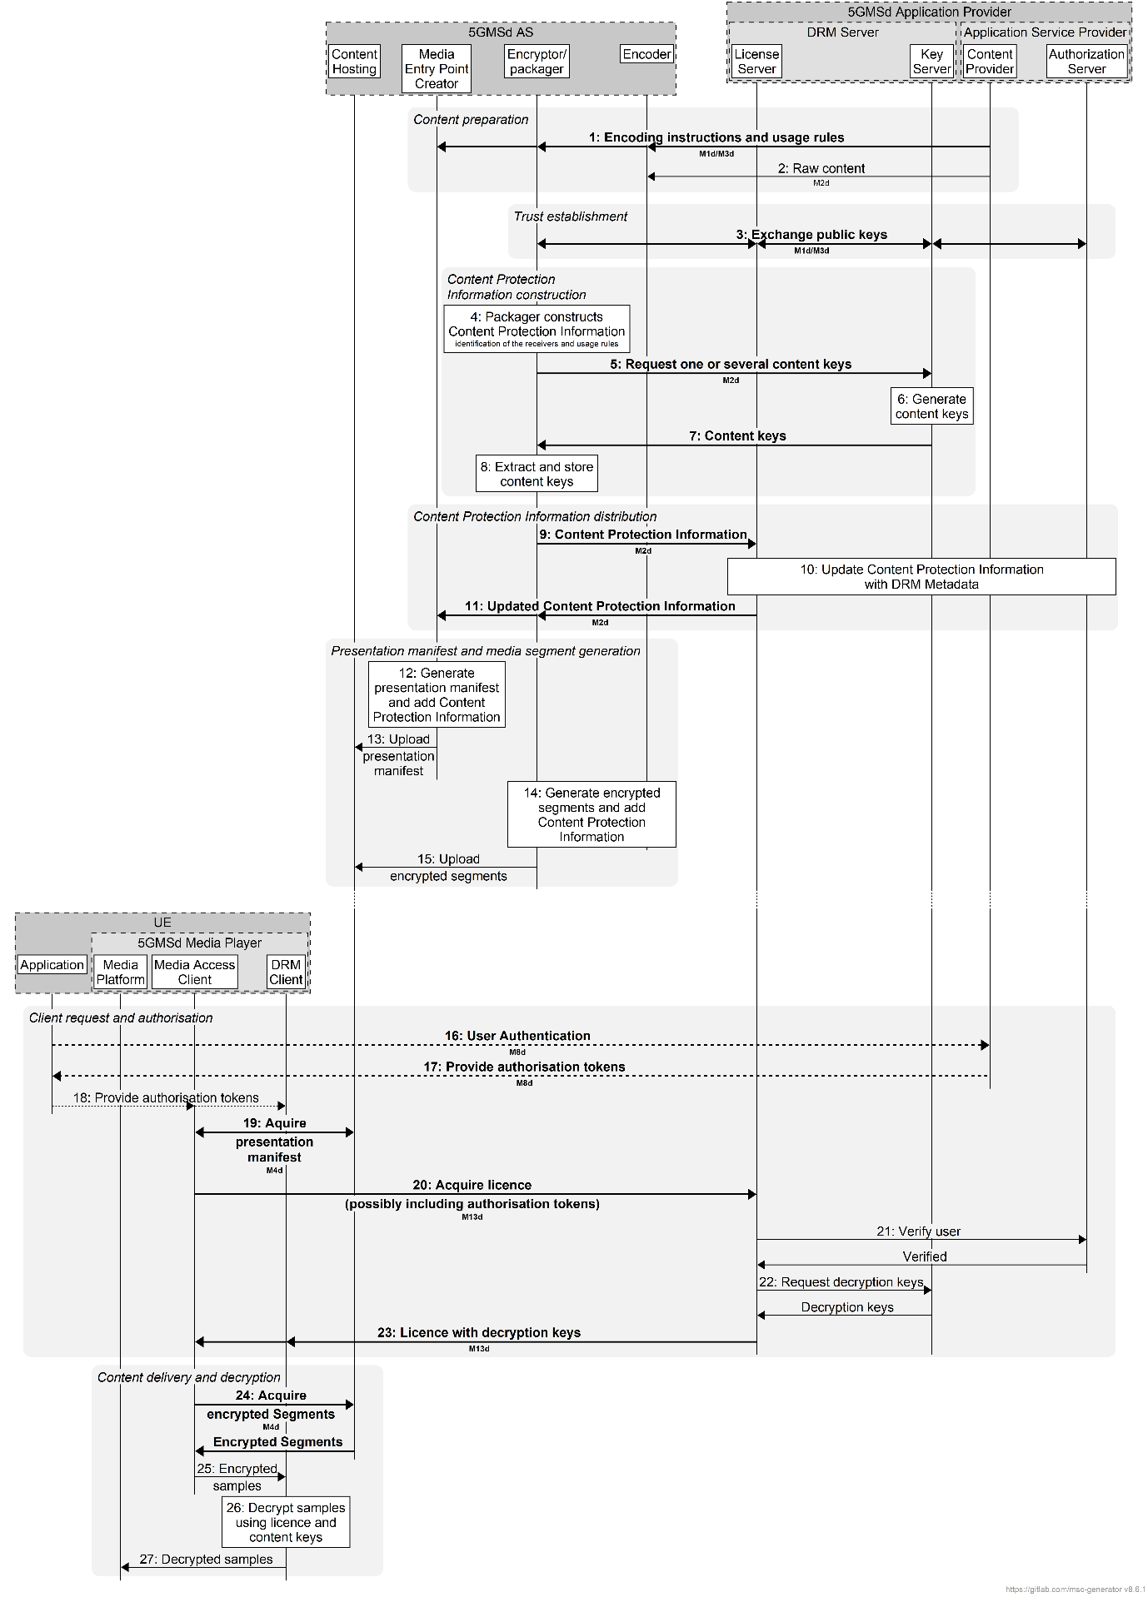
Figure 5.14.2-1: Procedure for encoding, packaging and encrypting content
The steps are as follows, highlighting in bold relevant information exchanged via 5GMSd reference points:
Content preparation phase:
1. A content provider provides encoding instructions and rules for using the content to the content preparation and hosting system via reference points M1d/M3d as part of Content Preparation Template.
2. The content provider provides raw content to the content preparation and hosting system via reference point M2d.
Trust establishment phase:
3. The Encryptor/Packager and the DRM Server (typically the License and Authorization Server as well as the Key Server) exchange public signing keys to establish a trusted communication via reference points M1d/M3d as part of Content Preparation Template.
Content Protection Information construction phase:
4. The Packager generates initial Content Protection Information that includes identification of the receivers and the various stream encoding criteria (usage rules).
5. The Encryptor retrieves this information from the packager and requests one or several content keys from the key server by sending the signed Content Protection Information to a key server via reference point M2d.
6. The Key Server generates content keys according to the request.
7. The Key Server adds these content keys to the Content Protection Information, signs the Content Protection Information and sends it back to the encoder/packager via reference point M2d.
8. The encryptor/packager extracts the content keys and stores them.
Content Protection Information distribution phase:
9. The Encryptor/Packager sends the Content Protection Information to the DRM Server via reference point M2d.
10. The License Server verifies the Content Protection Information and imports keys or key identifiers into its database.
11. The License Server sends the updated Content Protection Information to the Encryptor/Packager and the Manifest Creator including associated DRM System information via reference point M2d.
Presentation manifest and media segment generation phase:
12. The Manifest Creator generates the presentation manifest (e.g. DASH MPD) and adds the Content Protection Information (DRM System specific information, key identifiers, etc.).
13. The Manifest Creator uploads the presentation manifest to the Content Hosting.
14. The Encryptor/Packager generates encrypted segments and adds the Content Protection Information (e.g. DRM System specific information).
15. The Encryptor/Packager provides the encrypted segments to the Content Hosting.
Client requests and authorisation phase:
16. The Application requests an authentication for the user with the content provider via M8d.
17. The Application provider providers authorisation tokens via M8d.
18. The Application provides the tokens to the Media Access Client and the DRM Client.
19. The Media Access Client requests the presentation manifest including Content Protection Information from the Content Hosting function on the 5GMSd AS via reference point M4d.
20. The Media Access Client requests one or several licenses from the licensing server using key identifiers, possibly including authorization tokens via reference point M13d.
21. The License Servers asks for user verification to the Authorisation Server and the user is verified by the Authorisation Server.
22. The License Server requests the decryption keys from the key server based on the key identifiers and the Key Server provides the relevant content keys in response.
23. The License Server provides a DRM license with one or multiple keys to the Media Access Client and DRM Client via reference point M13d.
Content delivery and decryption phase:
24. The Media Access Client requests encrypted segments from the Content Hosting function of the 5GMSd AS via reference point M4d and the Media Access Client provides the encrypted segments in response.
25. The Media Access Client extracts encrypted samples from the encrypted segments and provides them to the DRM Client.
26. The DRM Client decrypts the samples using the DRM licence and content keys.
27. The DRM Client provides the decrypted samples to the Media Platform for playback.

6 Procedures for uplink media streaming

6.1 General
The procedures for uplink media streaming allow a 5GMSu Application Provider to create, modify, establish and delete sessions. Uplink media streaming sessions exist between a 5GMSu Client and a 5GMSu AS.
The uplink streaming procedures follow a general high-level workflow, starting from provisioning to the actual uplink streaming sessions. The Egest Session refers to the time period during which media content is uplink streamed to the 5GMSu AS and optionally egested from there to the 5GMS Application Provider. The Provisioning Session refers to the time period during which the 5GMSu Client is permitted to upload stream media content. Interactions between the 5GMSu AF and the 5GMSu Application Provider may occur at any time while the Provisioning Session is active.
The 5GMSu Provisioning API allows the selection of Media Session Handling (M5u) and Uplink Streaming (M4u) options, including whether the media content is published to trusted 5GMSu ASs. The 5GMSu AF selects the M5u interface according to the provisioning option. The Media Session Handling interface exposed by the 5GMSu AF can be used for metrics reporting, requesting different policy and charging treatments, or 5GMSu AF-based Network Assistance.
When the 5GMSu AF and 5GMSu AS reside in the same DN, then the 5GMSu AF selects the 5GMSu AS. Interactions between a 5GMSu AF and a 5GMSu AS (M3u interactions) take place for Content Egest (M2u) and Uplink Streaming (M4u) resource reservations. The 5GMSu AS allocates M2u and M4u resources and communicates resource identifiers back to the 5GMSu AF. The 5GMSu AF provides information about the provisioned resources (in the form of resource identifiers) for Media Session Handling, Content Egest, and Uplink Streaming to the 5GMSu Application Provider. The resource identifiers for Media Session Handling and Uplink Streaming are needed by the 5GMSu Client to access the selected features.
5GMSu Client can (in principle) start the uplink streaming by activating its uplink streaming session. The uplink streaming session for a given UE (or for each UE) is active from the time at which the 5GMSu-Aware Application activates the transmission of an uplink streaming service until its termination.
The 5GMSu-Aware Application receives application metadata from the 5GMSu Application Provider before transmitting the uplink streaming media. The application metadata contains Service Access Information, which acts as an entry point for the 5GMSu Client to start the uplink streaming session. The 5GMSu Client may either receive the Service Access Information from the 5GMSu Application Provider (using a not standardized interface) or instructions for a remote-control session through the 5GMS-Aware Application.
The Network Assistance (NA) feature enables a UE that is receiving an uplink media stream to improve the QoE of the media streaming session, by being able to make use of two distinct facilities.
The first facility is bit rate recommendation (throughput estimation). This enables the UE to start an uplink streaming session at the most appropriate bit rate for the network conditions at hand, or to obtain a recommendation from the network which will remain valid until further notice during a media streaming session. The recommended bit rate is based on network estimations or predictions of available link bandwidth. This function is provided as an additional tool to support the UE, in addition to the common approach of the UE performing its own estimation based on measurement of the uplink traffic in the past.
The second facility is the delivery boost. The 5GMSu Client uses this function to indicate to the network that a temporary boost, i.e., a temporary increase of network throughput for this client is needed, for example in order to prevent the uplink media streaming buffer in the Media Streamer from overflowing.
Network Assistance may be offered to the UE in one of two ways:
- Based on interaction between the UE and the 5GMSu AF, with a subsequent interaction between the 5GMSu AF and the PCF (or the NEF), as defined in clause 6.5.
- Based on interaction between the UE and the RAN, re-using the ANBR-based RAN signalling as defined in clause 6.7.
The UE shall not use both approaches on the same Network Assistance session.
Figure 6.1-1 provides a basic high-level call flow for uplink streaming. The corresponding collaboration scenario is defined in clause A.10.
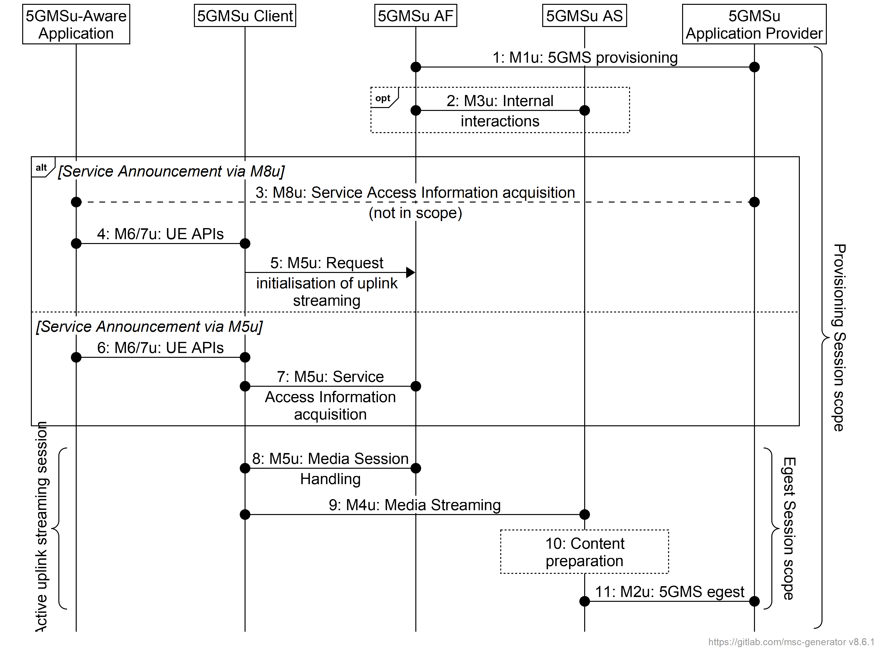
Figure 6.1-1: High-level call flow for uplink media streaming
Steps:
1. The 5GMSu Application Provider provisions the 5GMSu AF at reference point M1u, including a Content Publishing Configuration for content egest and, optionally, Content Preparation Templates.
2. When Content Publishing is offered and selected, there may be interactions between the 5GMSu AF and the 5GMSu AS at reference point M3u, e.g., to configure Server Certificates and/or Content Preparation Templates and to confirm the availability of resources for Content Preparation and Content Egest by providing a Content Publishing Configuration (defined in clause 6.2.3). The 5GMSu AS provides resource identifiers for the allocated resources to the 5GMSu AF, which then provides the information to the 5GMSu Application Provider.
At some later point in time:
3. The 5GMSu Application Provider provides Service Access Information to the 5GMS-Aware Application at reference point M8u.
4. When the 5GMSu-Aware Application decides to activate an uplink media streaming session, the Service Access Information is provided to the 5GMSu Client.
5. The 5GMSu Client requests the 5GMSu AF to initialise uplink media streaming (M5u).
Alternatively:
6. The 5GMS-Aware Application requests the 5GMSu Client to start an uplink streaming session (M6u/M7u).
7. The 5GMSu Client requests Service Access Information from the 5GSMu AF at reference point M5u.
Then:
8. The 5GMSu Client starts the Egest Session by activating the uplink streaming session.
9. Uplink media streaming starts from the 5GMSu Client to the 5GMSu AS via reference point M4u.
10. If content preparation was provisioned in step 1, the uplinked media may be manipulated by the 5GMSu AS prior to egest.
11. Media streaming egest starts from the 5GMSu AS to the 5GMSu Application Provider at reference point M2u.
NOTE: Media may be egested from one 5GMSu AS instance to another at reference point M10u prior to egest to the 5GMSu Application Provider at reference point M2u.
Clauses A.11 to A.15 define additional collaboration scenarios for uplink streaming. The call flow for each collaboration scenario is also included in each clause.

6.2 Preparing for uplink media streaming

6.2.1 Introduction
Before streaming media data in the uplink direction, a set of parameters are provisioned at the 5GMSu AF/AS and at the 5GMSu Client. On the 5GMSu AF/AS, the M1u API is used for session provisioning. On the UE side, the M8u or M5u API is used for provisioning.

6.2.2 Provisioning session for uplink streaming

6.2.2.1 Domain model
The M1u baseline domain model is depicted in figure 6.2.2.1-1 overleaf. It consists of a Provisioning Session, which contains at least one of the following:
- A Content Publishing Configuration,
- A Policy Template,
- One or more Content Preparation Templates,
- An Edge Resources Configuration specifying the requirements for edge processing as defined in TS 23.548 [15] and TS 23.558 [16] in support of the Provisioning Session, including eligibility criteria that indicate the circumstances in which edge computing is to be used for Media Streaming sessions associated with this Provisioning Session and parameters indicating the tolerance of the application for relocation of the Edge AS, or
Each Provisioning Session is uniquely identified within the 5GMS System by a Provisioning Session identifier.
When a certain 5GMS feature (such as content publishing configuration, policy template, content preparation template or edge resource configuration) is selected, the 5GMSu AF compiles the resulting Service Access Information that the 5GMSu Client needs to have to access the services via M5u.

Figure 6.2.2.1-1: M1u provisioning domain model
The M3u baseline domain model used by the 5GMSu AF to configure Content Publishing in the 5GMSu AS is depicted in figure 6.2.2.1-2 below. It comprises a set of Content Publishing Configurations, each containing one or more Contribution Configurations and one Publishing Configuration. A Contribution Configuration may reference Server Certificates for presentation at reference point M4u and/or Content Preparation Templates specifying media manipulation by the 5GMSu AS between media contribution at reference point M2u and media egest at reference point M4u.
Figure 6.2.2.1-2: M3u configuration domain model

6.2.2.2 Baseline provisioning procedure
This clause describes the baseline procedure to provision the features using the 5GMS System.
NOTE 1: SLA negotiations between the 5GMSu Application Provider and the 5GMS System provider are outside the scope of the present specification and are included in the figure below for illustrative purposes only.
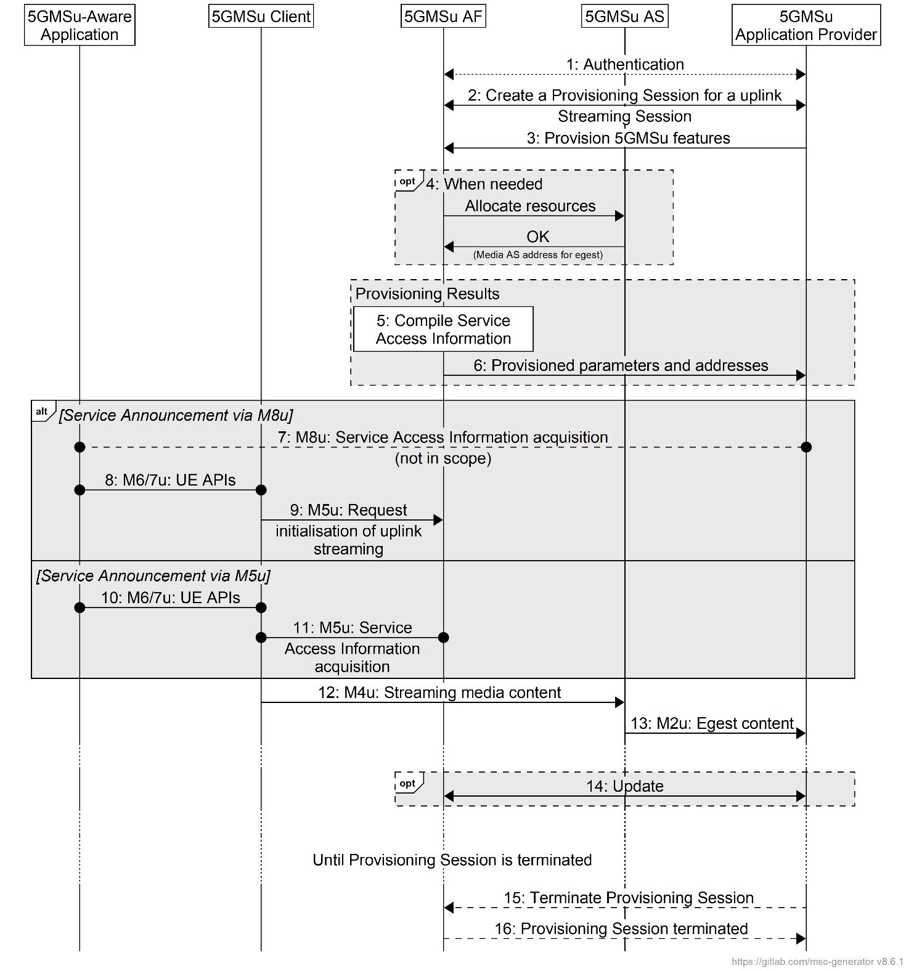
Figure 6.2.2.2-1: High-level procedure for provisioning the 5GMS System
for uplink media streaming sessions
Steps:
1. The 5GMSu Application Provider authenticates itself with the system. This procedure reuses existing authentication/authorization procedures, e.g., as defined for CAPIF [13].
2. The 5GMSu Application Provider creates a Provisioning Session, providing its 5GMSu Application Provider identifier as input. 5GMSu Application Provider queries the capabilities and authorized features.
3. The 5GMSuApplication Provider specifies one or more 5GMSu features in the Provisioning Session. A set of authorized features is activated, such as content dynamic policy; network assistance; and content publishing (including egest).
When the content publishing feature is offered and selected, the 5GMS Application Provider provides a Content Publishing Configuration to configure the content publishing behaviour of the 5GMSu AS (see next step), including selecting the uplink ingest protocol and format, content preparation and egest protocol and format.
When the dynamic policy feature is offered and selected, the 5GMSu Application Provider specifies a set of policies which can be invoked for the uplink streaming session. This may include an L4S enablement flag indicating whether ECN marking is a requirement of the Policy Template. It may also include a QoS monitoring configuration indicating that QoS monitoring may be required when this Policy Template is instantiated by the 5GMSu Client, and which QoS parameters are to be monitored in that case. The UE becomes aware of the selected policies in the form of a list of valid Policy Template Ids.
When the edge computing feature is offered and selected, the 5GMSu Application Provider provides one or more Edge Resources Configurations that can be used to support either client-driven management or Application Provider-driven management of edge resources associated with the Provisioning Session.
4. When content publication is desired, the 5GMSu AF interacts with the 5GMSu AS at reference point M3u to configure any necessary Server Certificates and/or Content Publishing Templates and to allocate resources for M2u egest protocol and format by means of a Content Publishing Configuration. The 5GMSu AS responds to the 5GMSu AF with the M2u content egest address.
5. The 5GMSu AF compiles the Service Access Information. The Service Access Information contains access details and options such as the Provisioning Session identifier, M5u (Media Session Handling) addresses for uplink entry point, dynamic policy, network assistance, etc.
6. The 5GMSu AF provides the results to the 5GMSu Application Provider.
The following steps:
7. When the 5GMSu Application Provider has selected full Service Access Information, the results are provided in the form of addresses and configurations for M2u (content egest), M5u (Media Session Handling) and M4u (Media Uplink Streaming). The 5GMSu Application Provider provides a subset of this information to the 5GMSu-Aware Application through M8u.
8. When the 5GMSu-Aware Application decides to activate the streaming service transmission, the Service Access Information is provided to the 5GMSu Client.
9. The 5GMSu Client requests the 5GMSu AF to initialise uplink media streaming (M5u), including reservation of any resources required for content preparation.
Or, alternatively:
10. The 5GMS-Aware Application requests the 5GMSu Client to start an uplink streaming session (M6u/M7u).
11. When the 5GMSu Application Provider has delegated Service Access Information handling to the 5GMS System, a reference to the Service Access Information (e.g. an URL) is provided. The Media Session Handler fetches the full Service Access Information later from the 5GMSu AF.
Then:
12. The 5GMSu Client streams the content to the 5GMSu AS.
13. When content publishing is offered and has been selected in step 4, the 5GMSu Application Provider can start retrieving the content from the M2u egest interface.
Optionally:
14. The 5GMSu Application Provider may update the Provisioning Session.
According to schedule, or upon request by the 5GMSu-Aware Application:
15. The 5GMSu Application Provider may manually terminate the Provisioning Session (at any time). All associated resources are released. Content may be removed from the 5GMSu AS. The 5GMSd Application Provider may configure a schedule for Provisioning Session termination.
16. The 5GMSu AF sends a notification to the 5GMSu Client upon Provisioning Session termination.
The 5GMSu AF may request the creation or reuse of one or more network slices for ingesting the content of the provisioned session. If more than one network slice is provisioned for the ingest of the content of a session, the list of allowed S-NSSAIs shall be conveyed to the target UE (e.g. through URSP or through M8u, step 7, or M5u, step 10).
NOTE 2: The 5GMSu AS receiving the content is only accessible through the DNN(s) used by the network slice(s) provisioned for the distribution of that content.

6.2.2.3 Baseline provisioning procedure with authorisation
This clause describes the baseline procedure to provision the features using the 5GMS System with authorisation of the 5GMSu Application Provider to support subsequent authorisation of media session handling for uplink media streaming per clause 5.2.5.When CAPIF is used, the authorization server is realised by the CAPIF core function, as shown in figure 6.2.2.3-1a. Otherwise, the authorization server is realised by the 5GMSu AF, as shown in figure 6.2.2.3-1b.
a. CAPIF core function acts as authorization server | b. 5GMSd AF acts as  authorization server
Figure 6.2.2.3-1: Alternative deployments of authorization server
NOTE 1: Service Level Agreement (SLA) negotiations between the 5GMSd Application Provider and the 5GMS System provider are outside the scope of the present specification and are included in the figure below for illustrative purposes only.
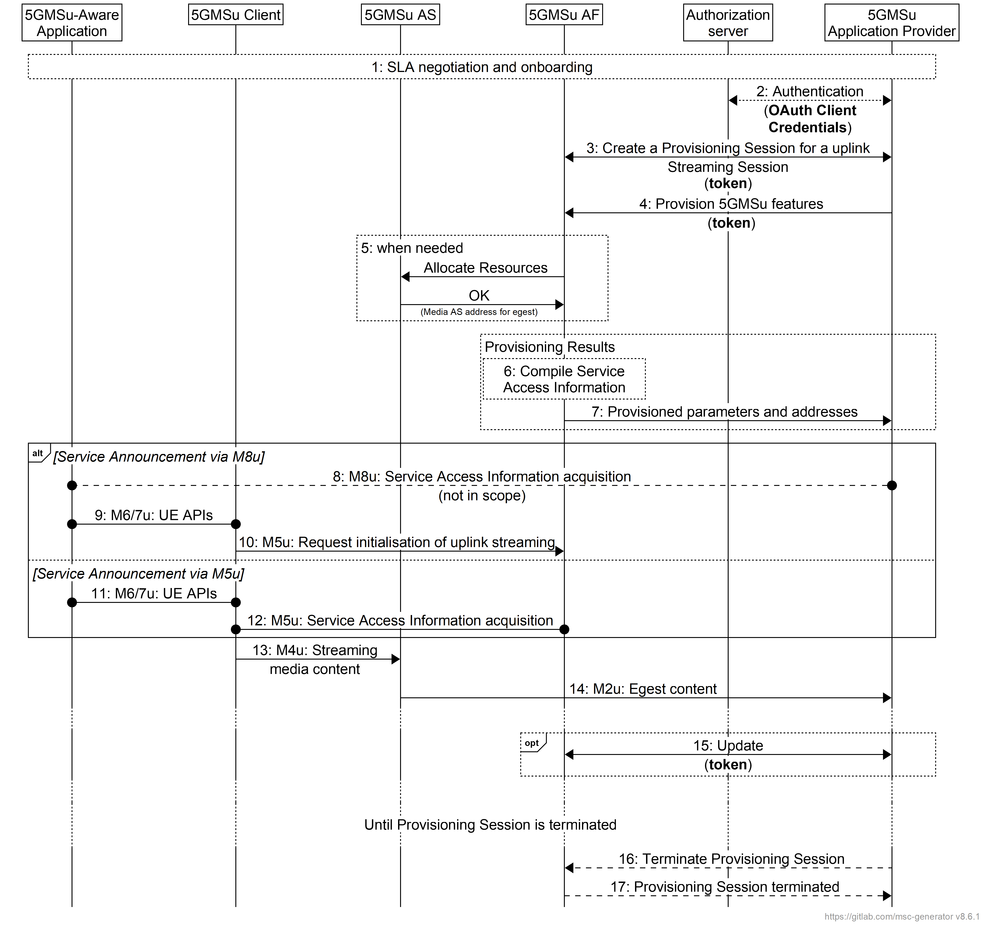
Figure 6.2.2.3-1: High-level procedure for provisioning the 5GMS System
for uplink media streaming sessions
Steps:
1. The 5GMSu Application Provider discovers the address (URL) of the 5GMSu AF (M1) for Session Provisioning. During the self-onboarding procedure, the 5GMSu Application Provider obtains the API access credentials.
2. The 5GMSu Application Provider authenticates itself with the system. This procedure reuses existing authentication/authorisation procedures, e.g., leveraging CAPIF-1/1e [13] or by the 5GMSu AF acting as OAuth authorization server. The 5GMSu AF acts as OAuth resource server. The 5GMSu Application Provider obtains an access token which is used for any subsequent operation invocations at reference point M1.
2. The 5GMSu Application Provider creates a Provisioning Session, providing its 5GMSu Application Provider identifier as input. 5GMSu Application Provider queries the capabilities and authorised features.
3. The 5GMSuApplication Provider specifies one or more 5GMSu features in the Provisioning Session. A set of authorised features is activated, such as content dynamic policy; network assistance; and content publishing (including egest).
When the content publishing feature is offered and selected, the 5GMS Application Provider provides a Content Publishing Configuration to configure the content publishing behaviour of the 5GMSu AS (see next step), including selecting the uplink ingest protocol and format, content preparation and egest protocol and format.
When the dynamic policy feature is offered and selected, the 5GMSu Application Provider specifies a set of policies which can be invoked for the uplink streaming session. The UE becomes aware of the selected policies in the form of a list of valid Policy Template Ids.
When the edge computing feature is offered and selected, the 5GMSu Application Provider provides one or more Edge Resources Configurations that can be used to support either client-driven management or Application Provider-driven management of edge resources associated with the Provisioning Session.
4. When content publication is desired, the 5GMSu AF interacts with the 5GMSu AS at reference point M3u to configure any necessary Server Certificates and/or Content Publishing Templates and to allocate resources for M2u egest protocol and format by means of a Content Publishing Configuration. The 5GMSu AS responds to the 5GMSu AF with the M2u content egest address.
5. The 5GMSu AF compiles the Service Access Information. The Service Access Information contains access details and options such as the Provisioning Session identifier, M5u (Media Session Handling) addresses for uplink entry point, dynamic policy, network assistance, etc.
6. The 5GMSu AF provides the results to the 5GMSu Application Provider.
The following steps:
7. When the 5GMSu Application Provider has selected full Service Access Information, the results are provided in the form of addresses and configurations for M2u (content egest), M5u (Media Session Handling) and M4u (Media Uplink Streaming). The 5GMSu Application Provider provides a subset of this information to the 5GMSu-Aware Application through M8u.
8. When the 5GMSu-Aware Application decides to activate the streaming service transmission, the Service Access Information is provided to the 5GMSu Client.
9. The 5GMSu Client requests the 5GMSu AF to initialise uplink media streaming (M5u), including reservation of any resources required for content preparation.
Or, alternatively:
10. The 5GMS-Aware Application requests the 5GMSu Client to start an uplink streaming session (M6u/M7u).
11. When the 5GMSu Application Provider has delegated Service Access Information handling to the 5GMS System, a reference to the Service Access Information (e.g. an URL) is provided. The Media Session Handler fetches the full Service Access Information later from the 5GMSu AF.
Then:
12. The 5GMSu Client streams the content to the 5GMSu AS.
13. When content publishing is offered and has been selected in step 4, the 5GMSu Application Provider can start retrieving the content from the M2u egest interface.
Optionally:
14. The 5GMSu Application Provider may update the Provisioning Session.
According to schedule, or upon request by the 5GMSu-Aware Application:
15. The 5GMSu Application Provider may manually terminate the Provisioning Session (at any time). All associated resources are released. Content may be removed from the 5GMSu AS. The 5GMSd Application Provider may configure a schedule for Provisioning Session termination.
16. The 5GMSu AF sends a notification to the 5GMSu Client upon Provisioning Session termination.
The 5GMSu AF may request the creation or reuse of one or more network slices for ingesting the content of the provisioned session. If more than one network slice is provisioned for the ingest of the content of a session, the list of allowed S-NSSAIs shall be conveyed to the target UE (e.g. through URSP or through M8u, step 7, or M5u, step 10).
NOTE 2: The 5GMSu AS receiving the content is only accessible through the DNN(s) used by the network slice(s) provisioned for the distribution of that content.

6.2.3 Content Publishing Configuration for uplink streaming

6.2.3.1 General
The 5G Media Streaming architecture defines a reference point (M1u) for provisioning which offers the procedures to configure content egest for uplink media streaming over a 5GMS System. Once a Provisioning Session is established using the API at reference point M1u, content publishing may be configured. Content can then be uplink streamed by the Media Streamer in the 5GMSu Client to the 5GMSu AS through reference point M4u. The uploaded (and possibly processed) content is accessible via reference point M2u for egest.
Reference point M2u supports the egest of the following types of content:
- Live streaming content.
- On-demand streaming content. i.e. the content that previously streamed from the UE to 5GMSu AS and is stored in 5GMSu AS.
- Static files such as images, scene descriptions, etc. associated with the uplink streaming content.
The 5GMSu AF provides an API at reference point M1u that allows a 5GMSu Application Provider to create/update/delete a Content Publishing Configuration. A Content Publishing Configuration contains all the parameters for a particular content ingest uplink and egest setup, and optionally references one or more Content Preparation Templates.

6.2.3.2 Media contribution and egest procedure
The media contribution and egest procedure is as follows:
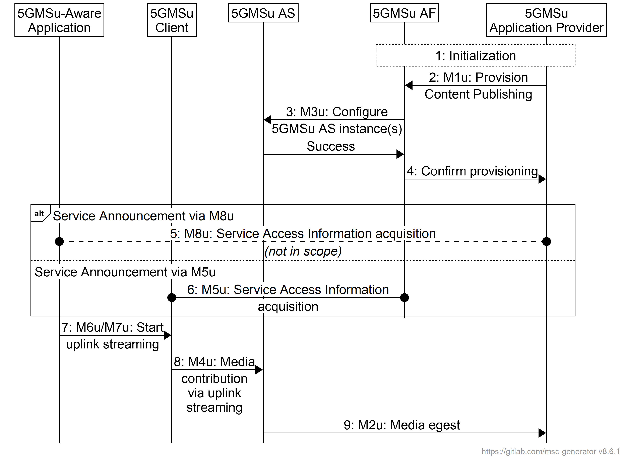
Figure 6.2.3-1: Media contribution and egest procedure
The steps are as follows:
1: Initialization: The 5GMSu Application Provider discovers the M1u endpoint address and authenticates itself with the 5GMSu AF.
2: Provision Content Publishing: The 5GMSu Application Provider creates a new Content Publishing Configuration through the 5GMSu AF at reference point M1u. The configuration specifies path, protocol, entry point, the egest push/pull mode, and possibly one or more content preparation templates. Upon successful configuration, the 5GMSu AF responds with a Content Publishing Configuration identifier, and the location of the 5GMSu AS from which to pull the content (if using the pull mode).
3: Configure 5GMSu AS instance(s): The 5GMSu AF configures the related 5GMSu AS instance(s) via reference point M3u for a particular Content Publishing Configuration via reference point M3u. This step may involve instructing the 5GMSu AS to establish one or more content preparation processes declared in Content Preparation Templates. The 5GMSu AS instance(s) respond whether the configuration was successful or not.
In case of partial failure, the configuration shall be removed from all 5GMSu AS instance(s) that succeeded.
4: Confirm provisioning: Upon successful provisioning, the 5GMSu AF responds with a Content Publishing Configuration identifier, and the location of the 5GMSu AS instance(s) from which to pull the content (if using the pull mode).
One of the following steps:
5: Provide the uplink entry point: The 5GMSu Application Provider publishes the uplink entry point to the 5GMSu-Aware Application through reference point M8u to enable it to begin uplink streaming to the 5GMSu AS.
or:
6: The 5GMSu Client acquires the uplink entry point as part of Service Access Information through reference point M5u.
Then:
7: The 5GMSu-Aware Application requests the 5GMSu Client to start the uplink streaming via reference point M6u or M7u.
8: Media contribution: The 5GMSu Client starts uplink streaming of the content to the 5GMSu AS via reference point M4u.
9: Media egest: The 5GMSu Application Provider may start pulling or receiving content (if using push mode) from the 5GMSu AS at reference point M2u. The 5GMSu AS performs the requested content preparation prior to making the uplink content ready for being pulled by or pushed to the 5GMSu Application Provider.
NOTE: Pulling media content from the 5GMSu AS may be triggered by a request from the 5MGSu Client through M8u.
The 5GMSu Application Provider may update a Content Publishing Configuration subsequently to modify some of its parameters. The subset of parameters that can be updated may be limited by the 5GMSu AF.

6.2.3.3 Configuration of 5GMSu AS by 5GMSu AF with authorisation
Figure 6.2.3.3-1 shows a variant of the high-level call flow for uplink media contribution and egest in clause 6.2.3.2 in which a 5GMSu AF deployed, for example, in an External DN configures Content Publishing in a 5GMSu AS deployed inside the Trusted DN. This corresponds to a collaboration scenario similar to that depicted in clause A.6 in which reference point M3u crosses the trust boundary. Differences from the baseline procedure in clause 6.2.2.3 are highlighted in boldface.
In the context of the OAuth 2.0 architecture [35], the 5GMSu AS acts as resource server and the 5GMSu AF acts as client. When deployed outside the scope of the CAPIF framework [33], the 5GMSu AS may provide the authorization server functionality.
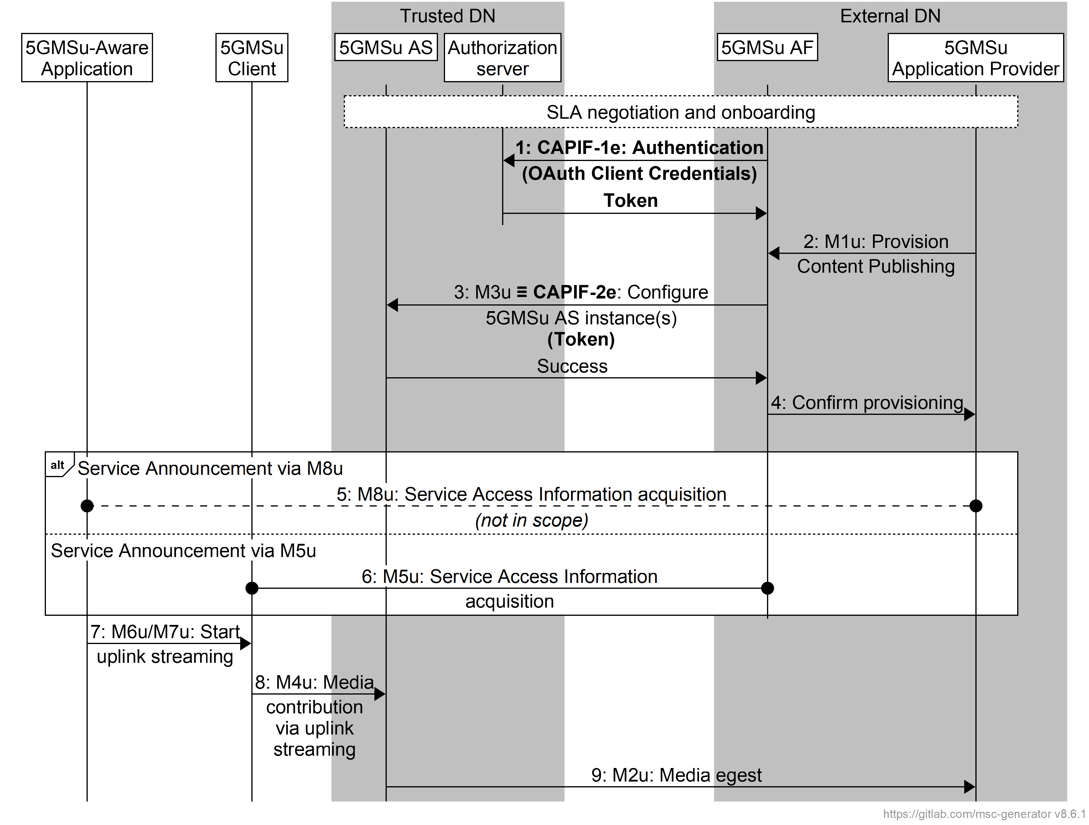
Figure 6.2.3-1: Media contribution and egest procedure with authorisation of 5GMSu AF
Pre-requisites:
- The endpoint address(es) of relevant 5GMSu AS instance(s), as well as the endpoint address and access credentials of the Authorization server are configured in the 5GMSu AF by the 5GMSu Application Provider as part of the onboarding procedure.
NOTE 1: Service Level Agreement (SLA) negotiations between the 5GMSu Application Provider and the 5GMS System provider are outside the scope of the present specification.
The steps are largely identical to those in clause 6.2.3.2 with differences highlighted in boldface:
1: Initialization: Using its access credentials, the 5GMSd AF authenticates itself with the Authorization server (provided by the CAPIF core function [33], if deployed, or possibly by the 5GMSu AS itself) and obtains an API access token for use at reference point M3u.
2: Provision Content Publishing: the 5GMSu Application Provider creates a new Content Publishing Configuration through the 5GMSu AF at reference point M1u′. The configuration specifies path, protocol, entry point, the egest push/pull mode, and possibly one or more content preparation templates. Upon successful configuration, the 5GMSu AF responds with a Content Publishing Configuration identifier, and the location of the 5GMSu AS from which to pull the content (if using the pull mode).
3: Configure 5GMSu AS instance(s): The 5GMSu AF configures the related 5GMSu AS instance(s) via reference point M3u (which realises CAPIF-2e) for a particular Content Publishing Configuration via reference point M3u. The access token obtained in step 1 is presented in the request by way of authorisation. This step may involve instructing the 5GMSu AS to establish one or more content preparation processes declared in Content Preparation Templates. The 5GMSu AS instance(s) respond whether the configuration was successful or not.
In case of partial failure, the configuration shall be removed from all 5GMSu AS instance(s) that succeeded.
4: Confirm provisioning: Upon successful provisioning, the 5GMSu AF responds with a Content Publishing Configuration identifier, and the location of the 5GMSu AS instance(s) from which to pull the content (if using the pull mode).
One of the following steps:
5: Provide the uplink entry point: The 5GMSu Application Provider publishes the uplink entry point to the 5GMSu-Aware Application through reference point M8u to enable it to begin uplink streaming to the 5GMSu AS.
or:
6: The 5GMSu Client acquires the uplink entry point as part of Service Access Information through reference point M5u.
Then:
7: The 5GMSu-Aware Application requests the 5GMSu Client to start the uplink streaming via reference point M6u or M7u.
8: Media contribution: The 5GMSu Client starts uplink streaming of the content to the 5GMSu AS via reference point M4u.
9: Media egest: The 5GMSu Application Provider may start pulling or receiving content (if using push mode) from the 5GMSu AS at reference point M2u. The 5GMSu AS performs the requested content preparation prior to making the uplink content ready for being pulled by or pushed to the 5GMSu Application Provider.
NOTE: Pulling media content from the 5GMSu AS may be triggered by a request from the 5MGSu Client through M8u.
The 5GMSu Application Provider may update a Content Publishing Configuration subsequently to modify some of its parameters. The subset of parameters that can be updated may be limited by the 5GMSu AF.

6.3 Establishment of an uplink Media Streaming session

6.3.1 Overview
This clause describes the baseline procedure for establishing a unicast uplink media streaming session. This baseline procedure assumes that the 5GMSu AF and the 5GMSu AS both reside in the external DN and that there are no interactions between the 5GMSu AF and the 5G System.

6.3.2 Baseline procedure for establishment of an uplink media streaming session
The procedure allows a Media Streamer to establish an uplink streaming session with a 5GMSu AS.
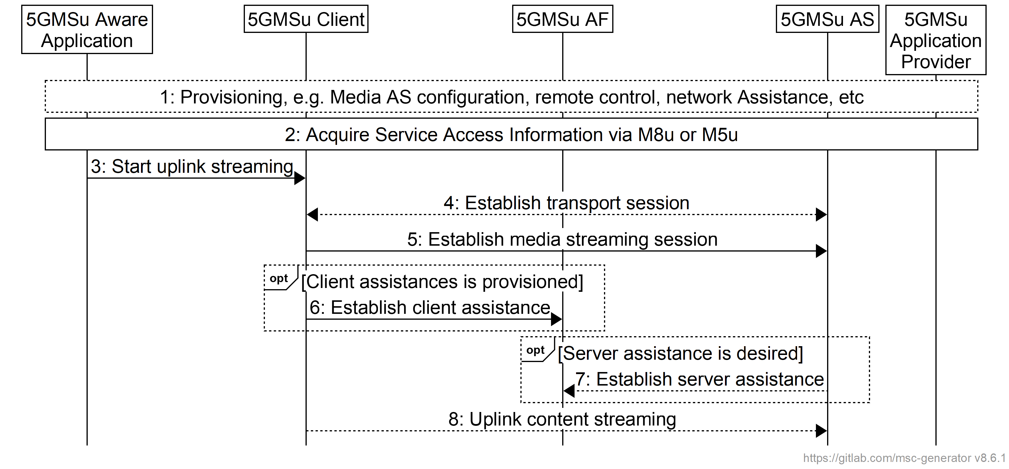
Figure 6.3.2-1: Uplink media streaming session establishment
Steps:
1: During provisioning, the Media Streamer component of the 5GMSu Client is provisioned with basic information, such as the 5GMSu AF and 5GMSu AS addresses.
2: The 5GMSu-Aware Application acquires Service Access Information via reference point M8u or M5u according to the one of the procedures defined in clause 6.2.2.2.
3: The 5GMSu-Aware Application instructs the 5GMSu Client to start uplink media streaming according to one of the procedures defined in clause 6.2.2.2.
4: The 5GMSu Client establishes the uplink transport session.
5: The 5GMSu Client establishes the uplink media streaming session.
When client assistance is provisioned:
6: The 5GMSu Client establishes the assistance channel to the provisioned 5GMSu AF(s).
When server assistance is desired (e.g. for QoS or charging):
7: The 5GMSu AS establishes an assistance session with the 5GMSu AF.
8: The 5GMSu Client streams the content up to the 5GMSu AS.

6.3.3 Baseline procedure for establishment of an uplink media streaming session with per-application authorisation of media session handling operations

6.3.3.1 Overview
This clause defines procedures by which a 5GMSu Application Provider authorises a 5GMSu-Aware Application to invoke media streaming operations on the 5GMSu AF at reference point M5u.

6.3.3.2 Authorisation of media session handling at M5u based on access token
The 5GMSu Application Provider provides a different access token (e.g. a random string) via M8 to each 5GMSu-Aware Application, so that each application instance can identify itself uniquely to the 5GMSu AF. The access token is provided, for example, during the login procedure or is requested at a later stage. The validity of access tokens is often limited in time. The 5GMSu-Aware Application may need to refresh the access token depending on the token validity.
The 5GMSu-Aware Application passes the access token (via an M6 API call) to the Media Session Handler. When the Media Session Handler invokes a media session handling operation at reference point M5, it presents the access token to the 5GMSu AF. Upon receipt of such an access token, the 5GMSu AF verifies whether the access token is valid. If the token is valid, the 5GMSu-Aware Application is authorised to invoke the operation.
When the OAuth 2.0 architecture [35] is used, the 5GMSu Application provider acts as authorization server, the 5GMSu-Aware Application acts as client and the 5GMSu AF acts as resource server.
The procedure allows a Media Streamer to establish an uplink streaming session with a 5GMSu AS.
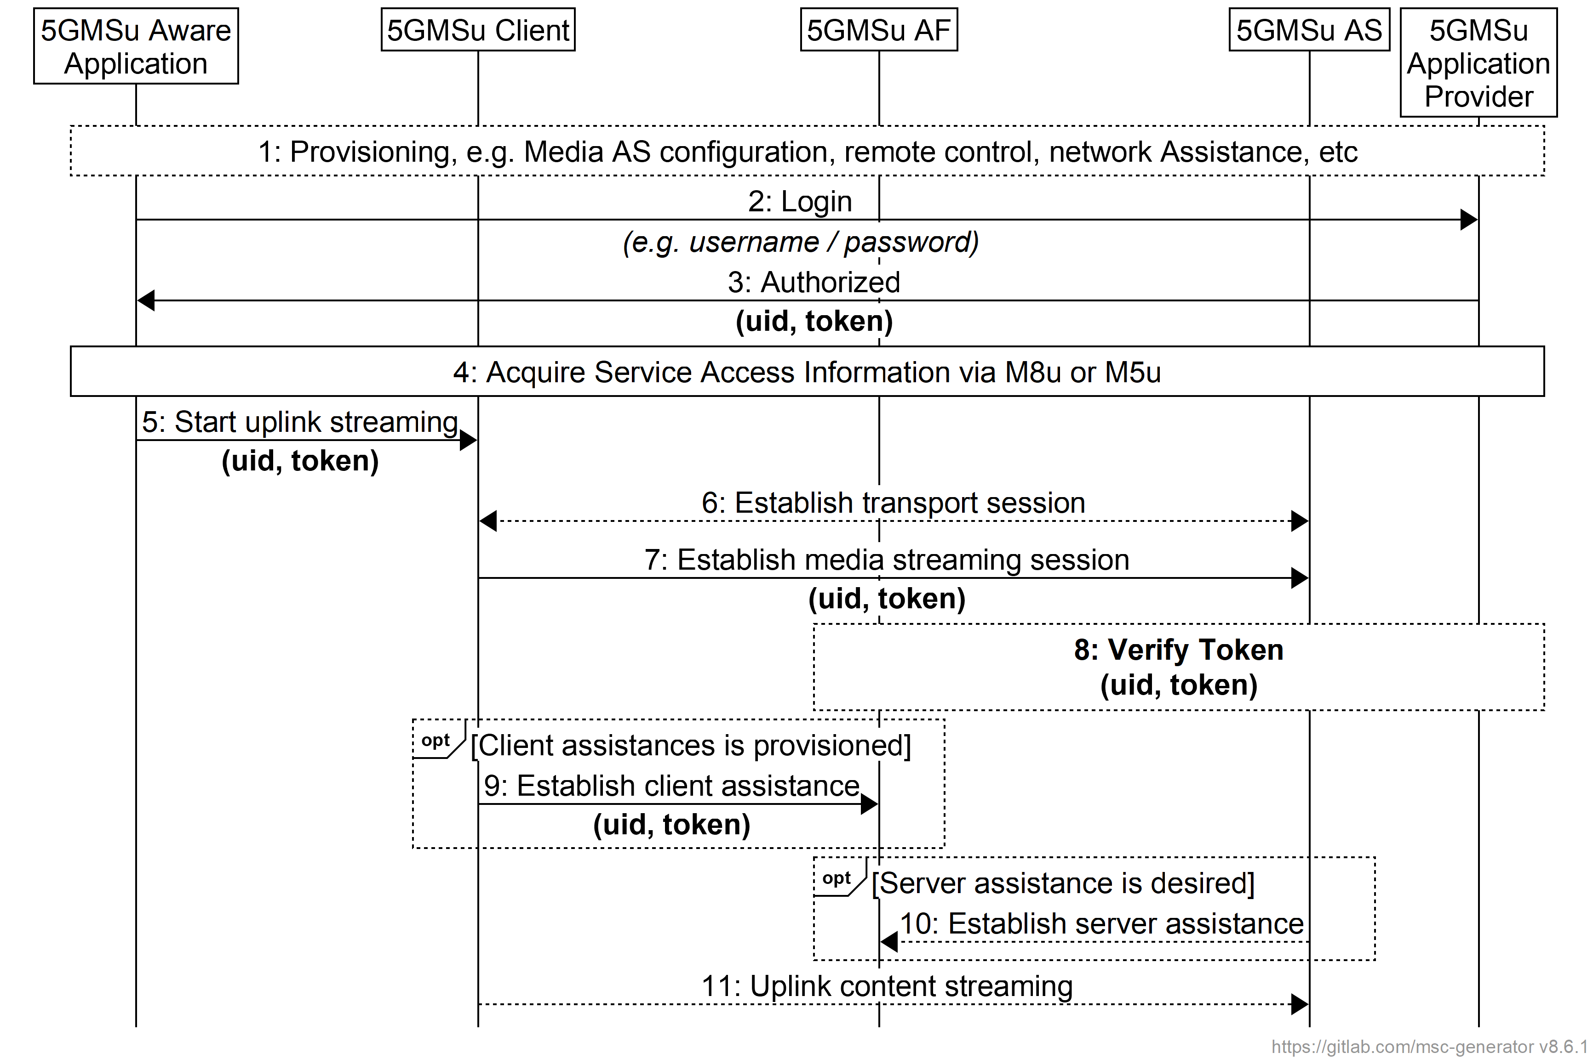
Figure 6.3.3-1: Uplink Streaming Session Establishment
Steps:
1: During provisioning, the Media Streamer component of the 5GMSu Client is provisioned with basic information, such as the 5GMSu AF and 5GMSu AS addresses.
2: 5GMSu-Aware Application seeks authorisation from the 5GMSd Application Provider providing, for example, a username and a password.
3: Upon successful authorisation, the 5GMSu-Aware Application obtains an uid and a token.
NOTE: Access tokens may not be long-lived. The 5GMSu-Aware Application may need to refresh the access token periodically, depending on its validity lifetime.
4: The 5GMSu-Aware Application acquires Service Access Information via reference point M8u or M5u according to the one of the procedures defined in clause 6.2.2.2.
5: The 5GMSu-Aware Application instructs the 5GMSu Client to start uplink media streaming according to one of the procedures defined in clause 6.2.2.2.
6: The 5GMSu Client establishes the uplink transport session.
7: The 5GMSu Client establishes the uplink media streaming session.
8: The provided access token is verified.
When client assistance is provisioned:
9: The 5GMSu Client establishes the assistance channel to the provisioned 5GMSu AF(s).
When server assistance is desired (e.g. for QoS or charging):
10: The 5GMSu AS establishes an assistance session with the 5GMSu AF.
11: The 5GMSu Client streams the content up to the 5GMSu AS.

6.3.3.3 Authorisation of media session handling at M5u based on redirection
When the OAuth 2.0 [35] Authorization Code grant type is used, either the 5GMSu Application Provider or the 5GMSu AF acts as authorization server, as shown in figure 6.3.3.3-1. The Media Session Handler acts as client and the 5GMSu AF acts as resource server.
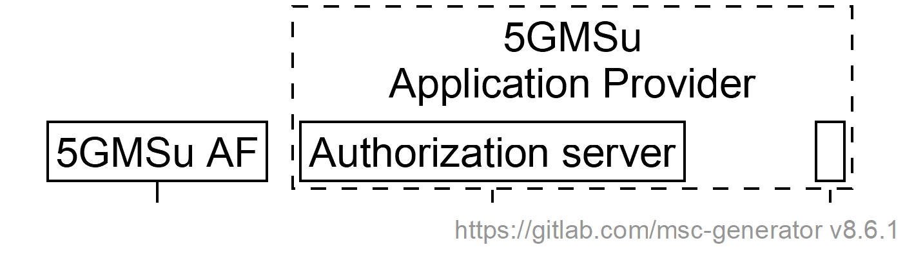 | 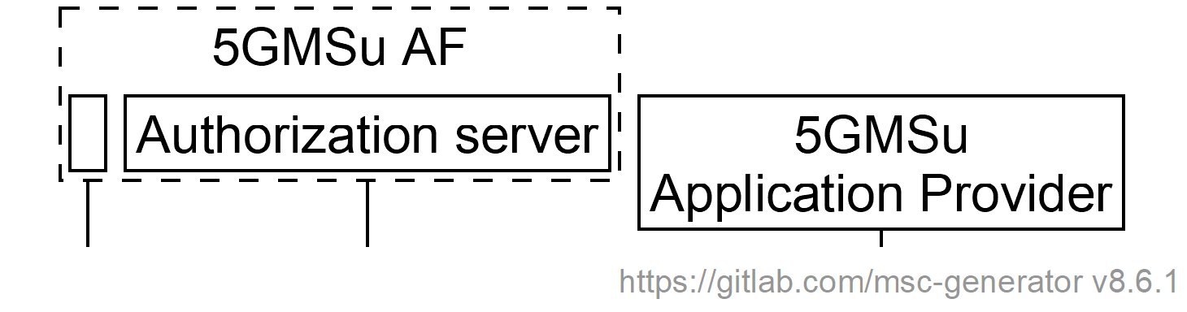
a. 5GMSu Application Provider acts as authorization server | b. 5GMSu AF acts as authorization server
Figure 6.3.3.3-1: Alternative deployments of authorization server
The call flow is depicted below.
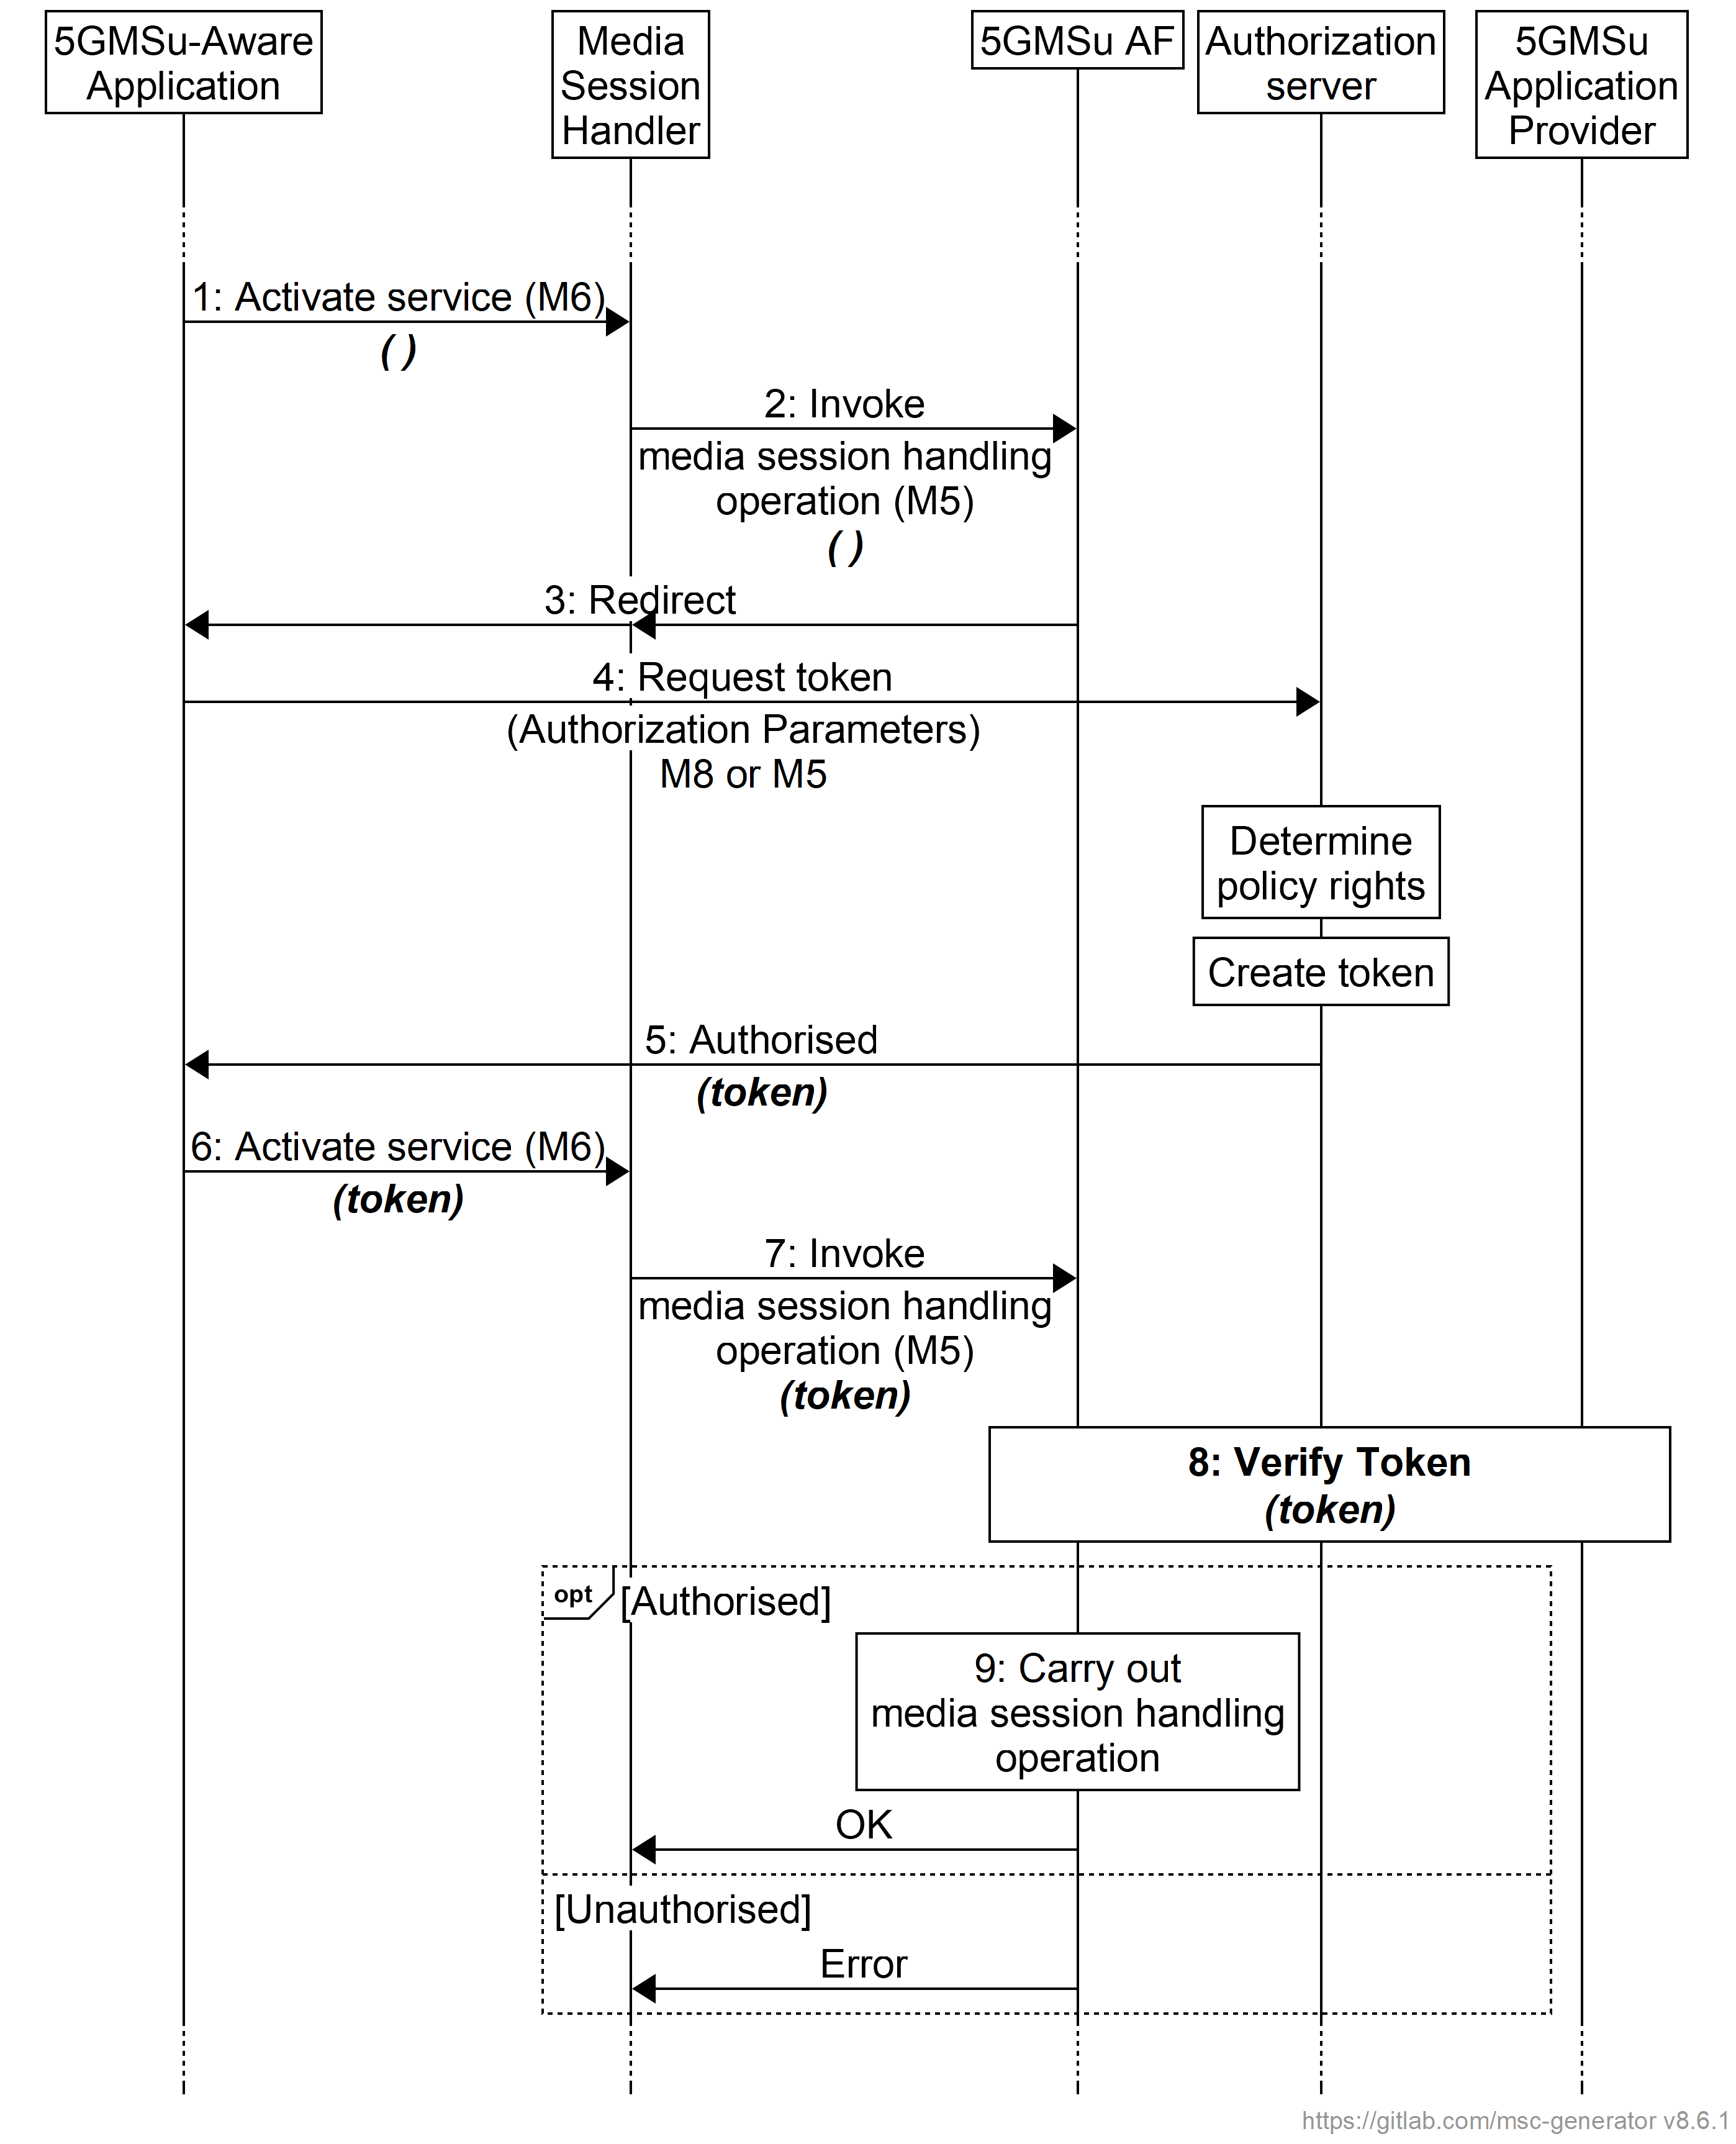
Figure 5.2.5.3-1: Call flow for authorisation based on access token
1. When the 5GMSu-Aware Application (immediately or later) invokes the Media Session Handler to activate media session handling for a media delivery session, the application passes only the session access information.
2. When the Media Session Handler invokes a media session handling operation on the 5GMSu AF at reference point M5u.
3. The 5GMSu AF identifies that authorization is required for accessing the requested service. The 5GMSu AF sends a redirect to the Media Session Handler, which is forwarded to the 5GMSu-Aware Application.
4. The 5GMSu-Aware Application requests an access token from the authorization server, which is realised either by the 5GMSu Application Provider (at reference point M8u) or by the 5GMSu AF (at reference point M5u).
5. After determining the policy rights of the requesting 5GMSu-Aware Application, the authorization server creates an access token and provides it to the 5GMSu-Aware Application.
6. The 5GMSu-Aware Application attempts to activate the service again, this time providing the access token obtained in the previous step as an additional input parameter.
7. The Media Session Handler invokes the media session handling operation again, this time providing the obtained access token.
5. The 5GMSu AF verifies the access token with the 5GMSu Application Provider.
6. If the 5GMSu AF is satisfied that the 5GMSu-Aware Application is authorised to invoke the media session handling operation (based on the presented access token), the 5GMSu AF carries out the requested operation. (This may involve further interaction with the PCF or NEF.)

6.4 Termination of an uplink Media Streaming session
The procedure defines the termination of an uplink media streaming session.
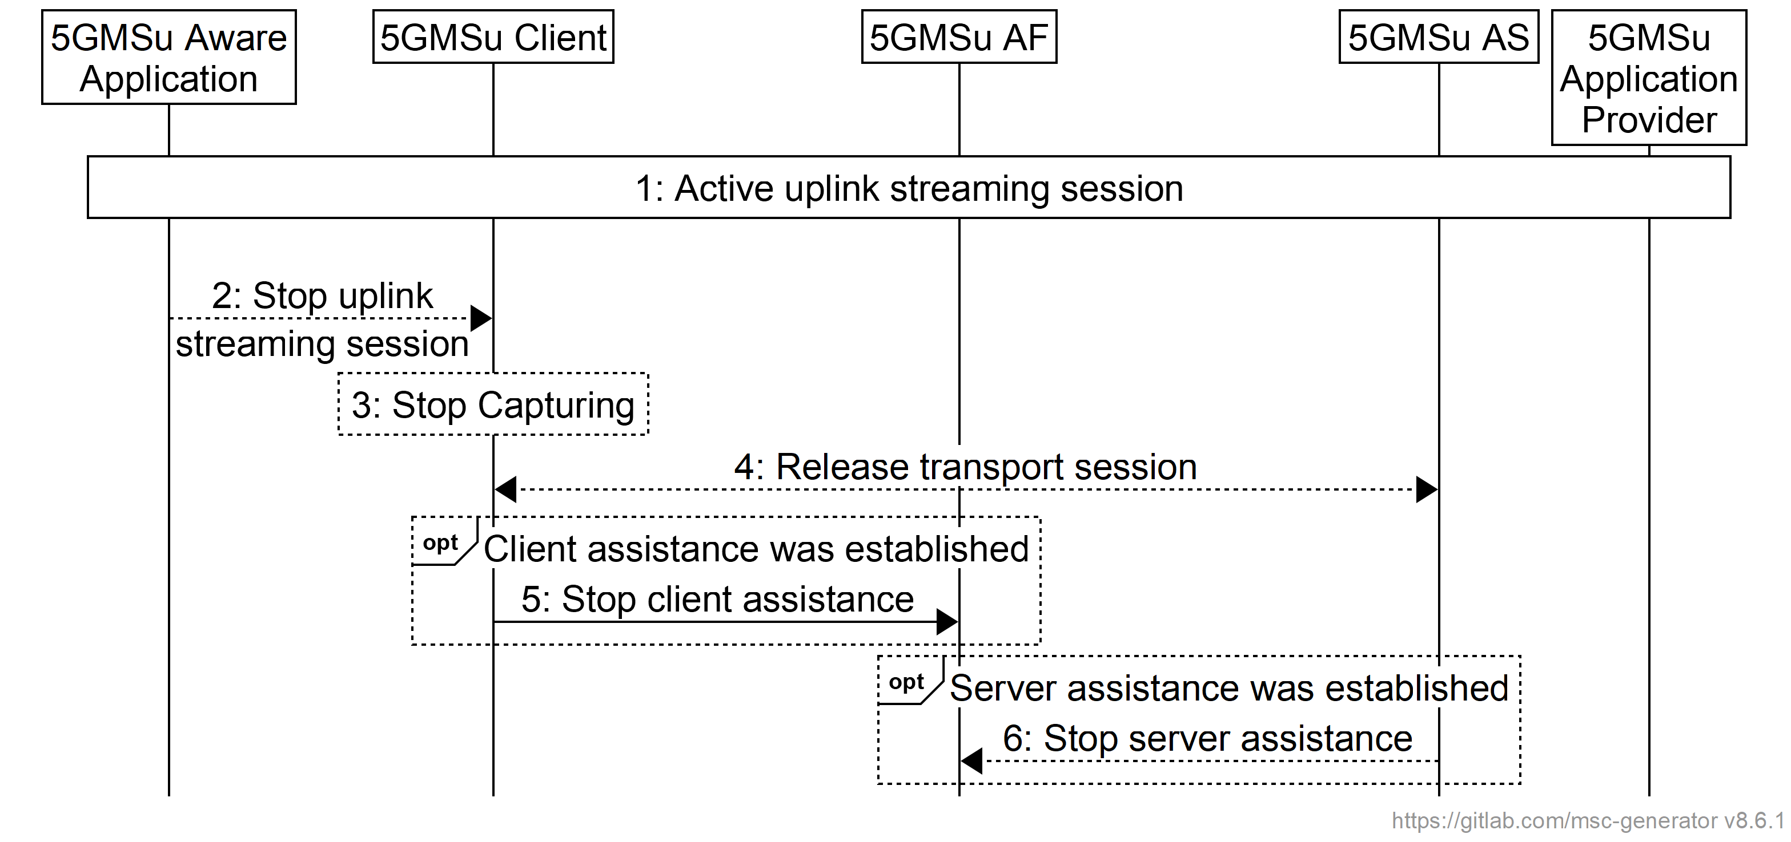
Figure 6.4-1: Uplink streaming session teardown
Steps:
1. An uplink media streaming session is active and should be terminated.
2. The 5GMSu-Aware Application sends a Stop command to the 5GMSu Client.
3. The 5GMSu Client stops the capturing process.
4. The uplink transport session is released.
When client assistance was established:
5. The 5GMSu AF is notified that the uplink media streaming session is terminated.
When server assistance was established:
6. The 5GMSu AS is notified the 5GMSu AF that the uplink media streaming session is terminated.

6.5 Providing 5GMSu AF-based Network Assistance
The procedure a 5GMSu Client uses to obtain network assistance from a 5GMSu AF is defined in figure 6.5-1 below.
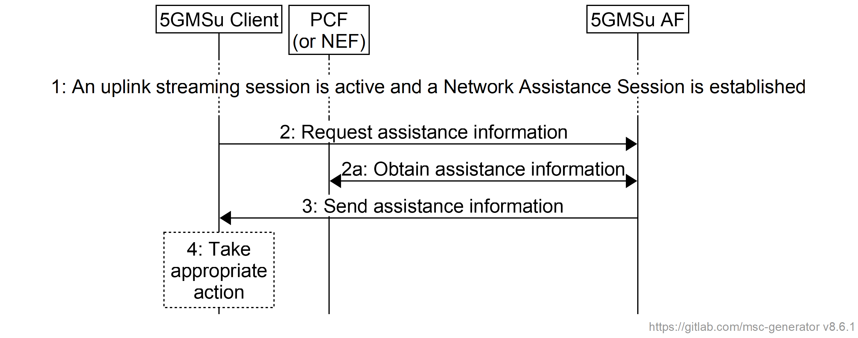
Figure 6.5-1: Providing 5GMSu AF-based Network Assistance
Steps:
1: An uplink streaming session is active. A Network Assistance Session is established with the 5GMSu AF.
2: The Media Session Handler in the 5GMSu Client requests assistance information from the 5GMSu AF.
2a: The 5GMSu AF interacts with the PCF (or, if the AF is deployed outside the Trusted DN, with the PCF via the NEF) to obtain the requested assistance information.
3: The assistance information is returned to the Media Session Handler in the 5GMSu Client.
4: The Media Streamer in the 5GMSu Client takes an appropriate action based on the information received.

6.6 Providing Remote Control
The procedure defines the remote control from a Remote Controller through the 5GMSu-Aware Application.
NOTE: The remote controller may be a network-based function or a UE-based function.
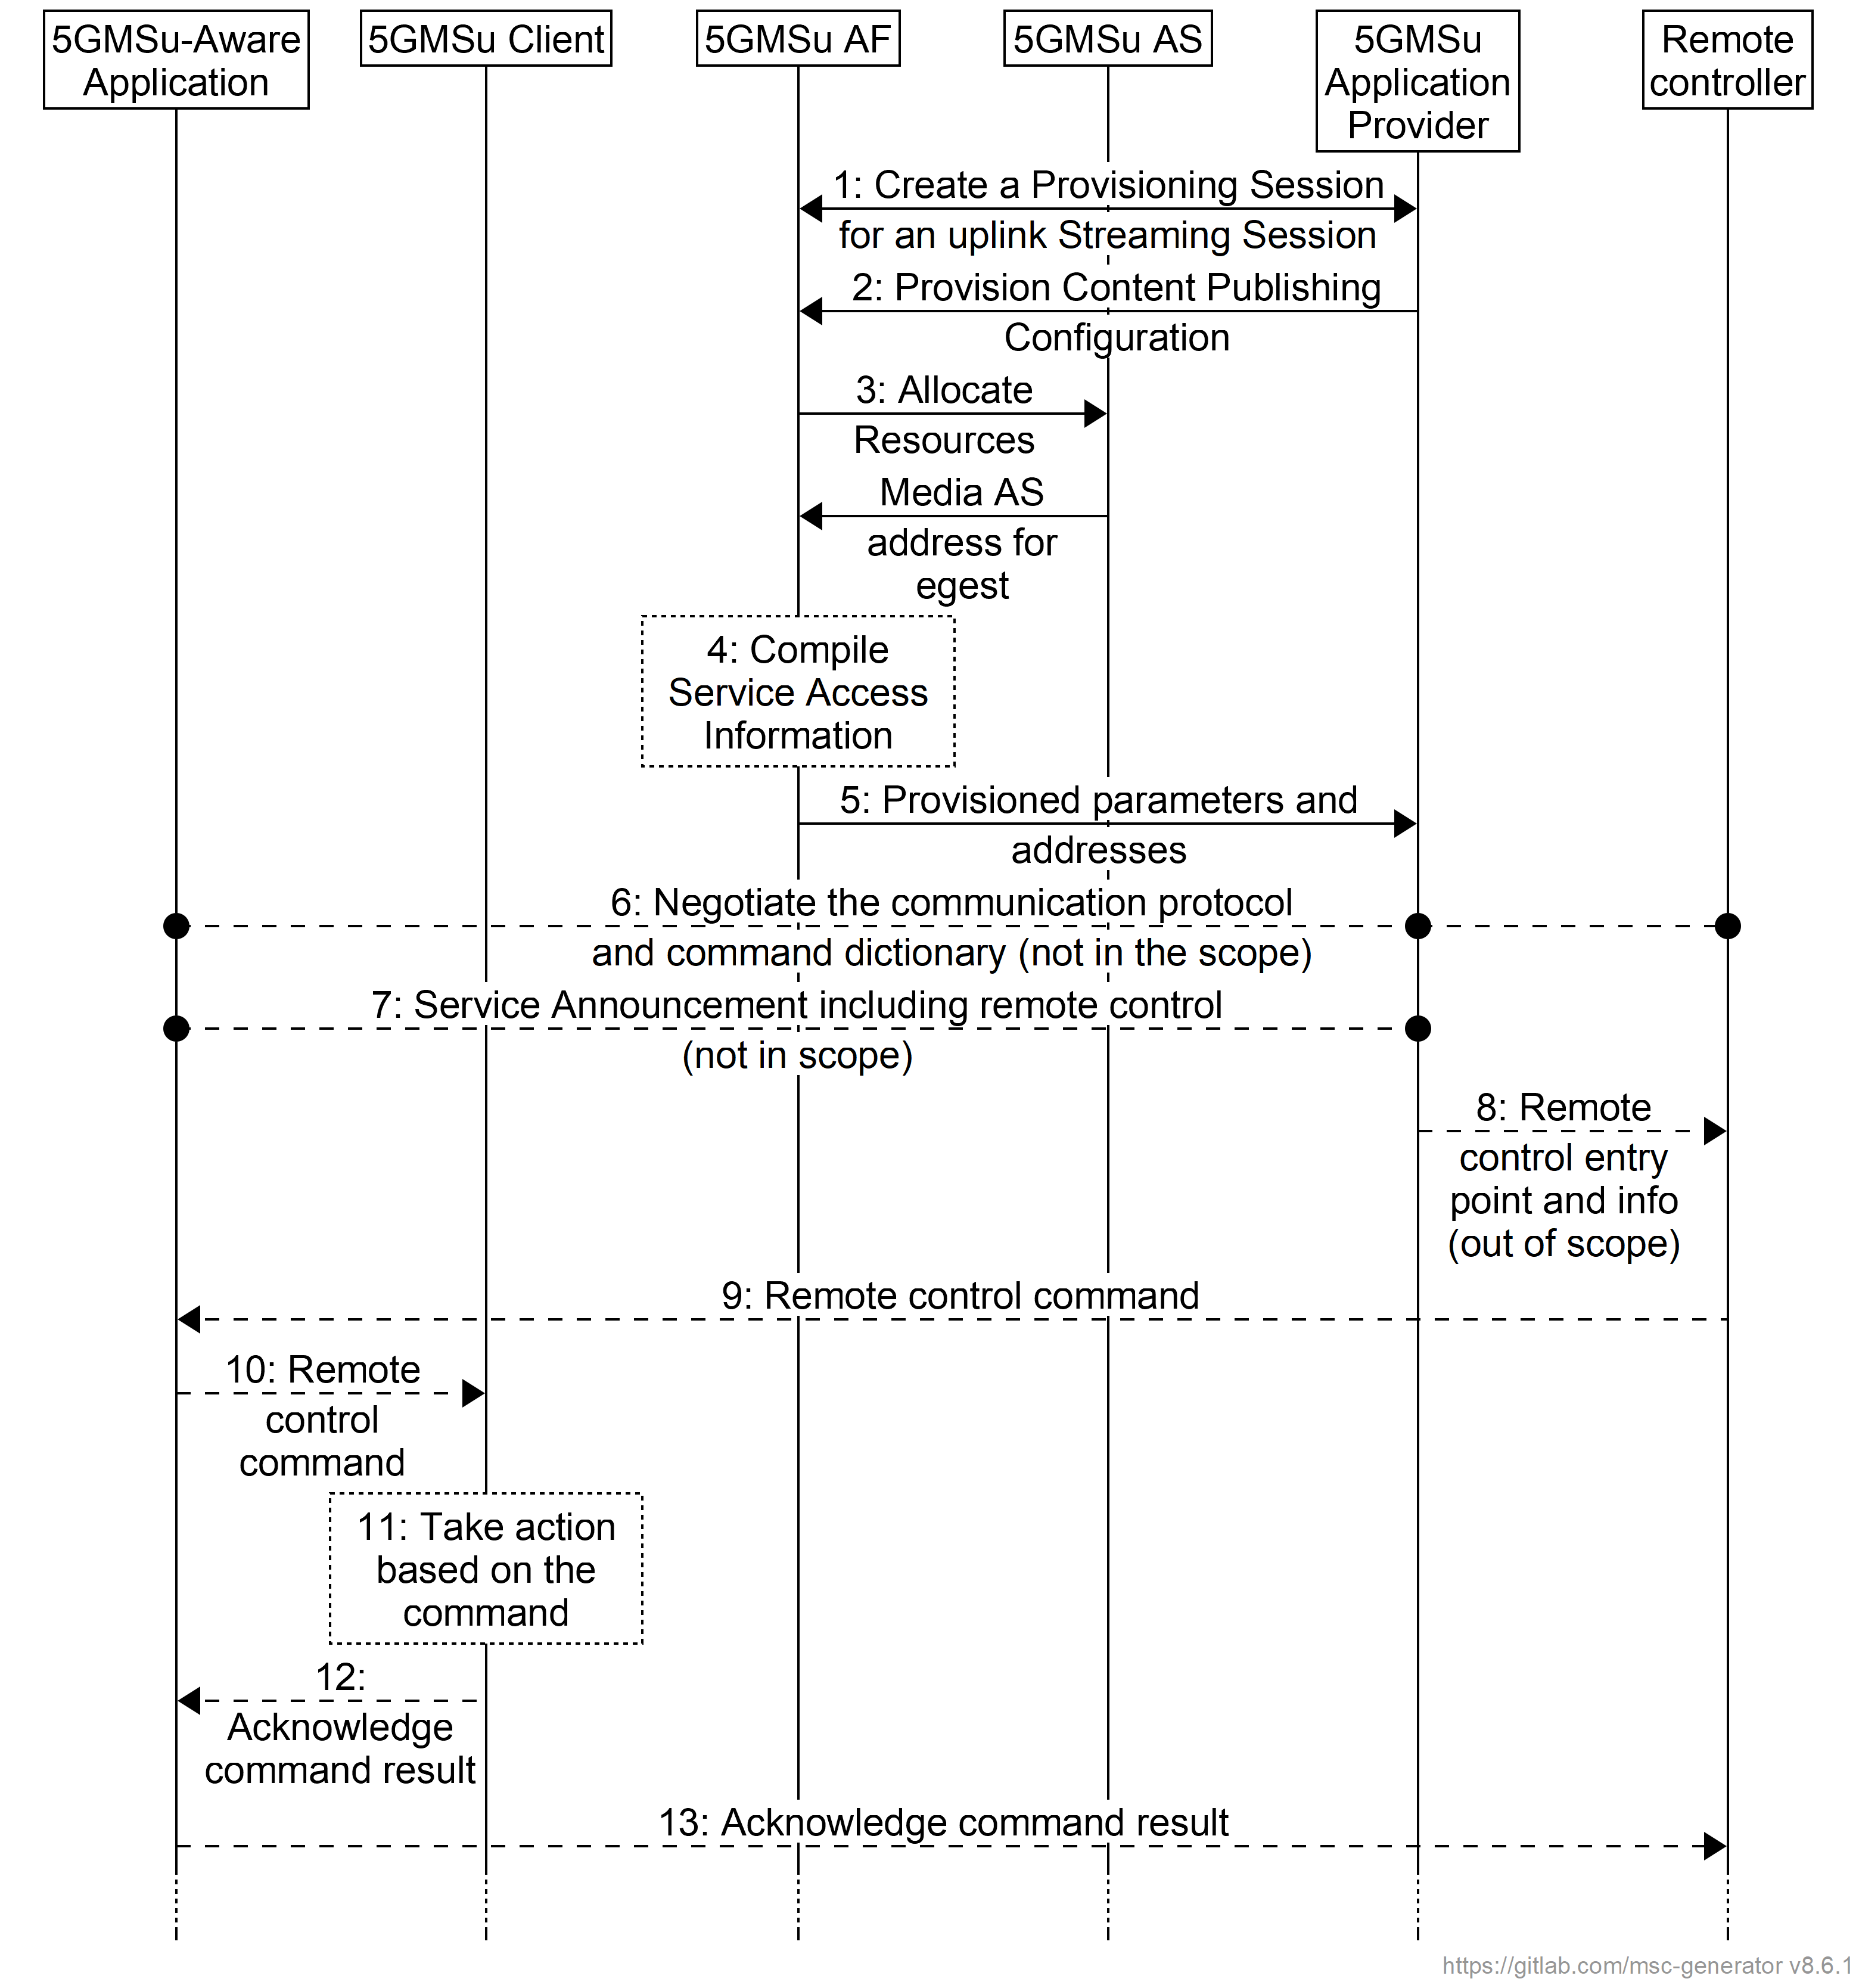
Figure 6.6-1: High-level procedure for remote control of a 5GMS uplink streaming session
Steps:
1. The 5GMSu Application Provider creates a Provisioning Session at reference point M1u, providing its 5GMSu Application Provider identifier as input. 5GMSu Application Provider queries the capabilities and authorized features.
2. The 5GMSu Application Provider requests Content Publish Configuration provisioning at reference point M1u.
3. The 5GMSu AF interacts with the 5GMSu AS at reference point M3u to allocate resources for the M2u egest protocol and format. Then the 5GMSu AS responds with the M2u address.
4. The 5GMSu AF compiles the Service Access Information. The Service Access Information contains access details and options such as the Provisioning Session identifier, and M5u (Media Session Handling) address for an uplink entry point.
5. The 5GMSu AF provides the results of the provisioning request (step 1) to the 5GMSu Application Provider via reference point M1u.
a. When the 5GMSu Application Provider has selected full-Service Access Information, the results are provided in the form of addresses and configurations for M2u (egest), M5u (Media Session Handling), M4u (Media Uplink Streaming).
b. When the 5GMSu Application Provider has delegated the Service Access Information handling to the 5GMS System, then a reference to the Service Access Information (e.g. an URL) is provided. The Media Session Handler fetches the full-Service Access Information later from the 5GMSu AF.
6. The 5GMSu-Aware Application, the 5GMSu Application Provider and the third party Remote Controller negotiate the communication protocol and the command dictionary for remote control, and reach an agreement (if any).
7. The 5GMSu Application Provider announces the uplink streaming service to the 5GMSu-Aware Application at reference point M8u (during the lifetime of the Provisioning Session).
8. The 5GMSu Application Provider sends the remote control information to the Remote Controller.
9. The Remote Controller sends a remote control command to the 5GMSu-Aware Application using the protocol negotiated in step 6.
10. Based on the received the remote control command, the 5GMSu-Aware Application sends a corresponding request to the 5GMSu Client.
11. The 5GMSu Client takes the required action based on the received request.
12. The 5GMSu Client acknowledges execution of the received request to the 5GMSu-Aware Application, including the results (if any).
13. The 5GMSu-Aware Application acknowledges execution of the remote control command to the Remote Controller, including the results (if any).

6.7 RAN Signalling based Support for Uplink Network Assistance
Figure 6.7-1 depicts an uplink streaming architecture where RAN signalling is employed to support uplink Network Assistance functionality.
The RAN in the architecture contains control plane and user plane entities that interact with peer control and user plane entities in the UE, in the request/response for uplink bit rate recommendations, or boost of the uplink streaming data rate, and subsequent media transport. The user plane functionality as shown in Figure 6.7-1 (solid line going from UE to RAN to 5GMSu AS) illustrates the scheduling/passthrough functionality associated with user plane communications, governed by the RAN, as result of the uplink assistance messaging over the control plane (shown by dotted line between the UE and RAN). It is assumed in this case that 5GMSu AF-based Network Assistance is not utilized.
It should be noted that although the 5GMSu AF is not utilized when RAN signalling based network assistance is performed, it is assumed that there is a higher-level network entity which coordinates and tracks network assistance performed using RAN signalling versus application signalling for individual UEs.
Figure 6.7-1: RAN Signalling based Uplink Network Assistance

6.8 Procedures for uplink media streaming data collection, reporting and exposure

6.8.1 Configuration of 5GMSu AS data collection client for uplink media streaming access reporting
The 5GMSu AS obtains its data collection client configuration at reference point R4 as part of its initialisation procedure, as shown in figure 6.8.1-1.
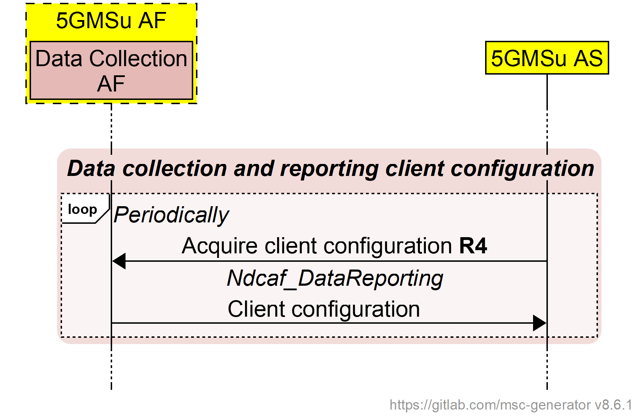
Figure 6.8.1-1: Data collection client configuration
for uplink media streaming access reporting
The 5GMSu AS shall periodically refresh its data collection client configuration and act appropriately on any changes in the configuration.

6.8.2 Uplink media streaming access reporting by 5GMSu AS
The 5GMSu AS shall use the procedure shown in figure 6.8.2-1 to report uplink media streaming access to the Data Collection AF instantiated in the 5GMSu AF when the data collection client configuration obtained using the procedure in clause 6.8.1 indicates that it should do so.
Figure 6.8.2-1: Uplink media streaming access reporting
The data report defined in clause 4.6.4 of TS 26.531 [22] shall be used by the 5GMSu AS to report the activity of uplink media streaming access by the Media Streamer. Each uplink access logged by the 5GMSu AS in relation to such activity shall be reported as a single record in a report submitted to the Data Collection AF at reference point R4.
The parameters included in the data report are defined in clause 4.7.2.4.

6.8.2A Configuration of Direct Data Collection Client for data reporting
The Direct Data Collection Client instantiated in the 5GMSu Client obtains its data collection client configuration at reference point R2 as part of its initialisation procedure, as shown in figure 6.8.2A-1.
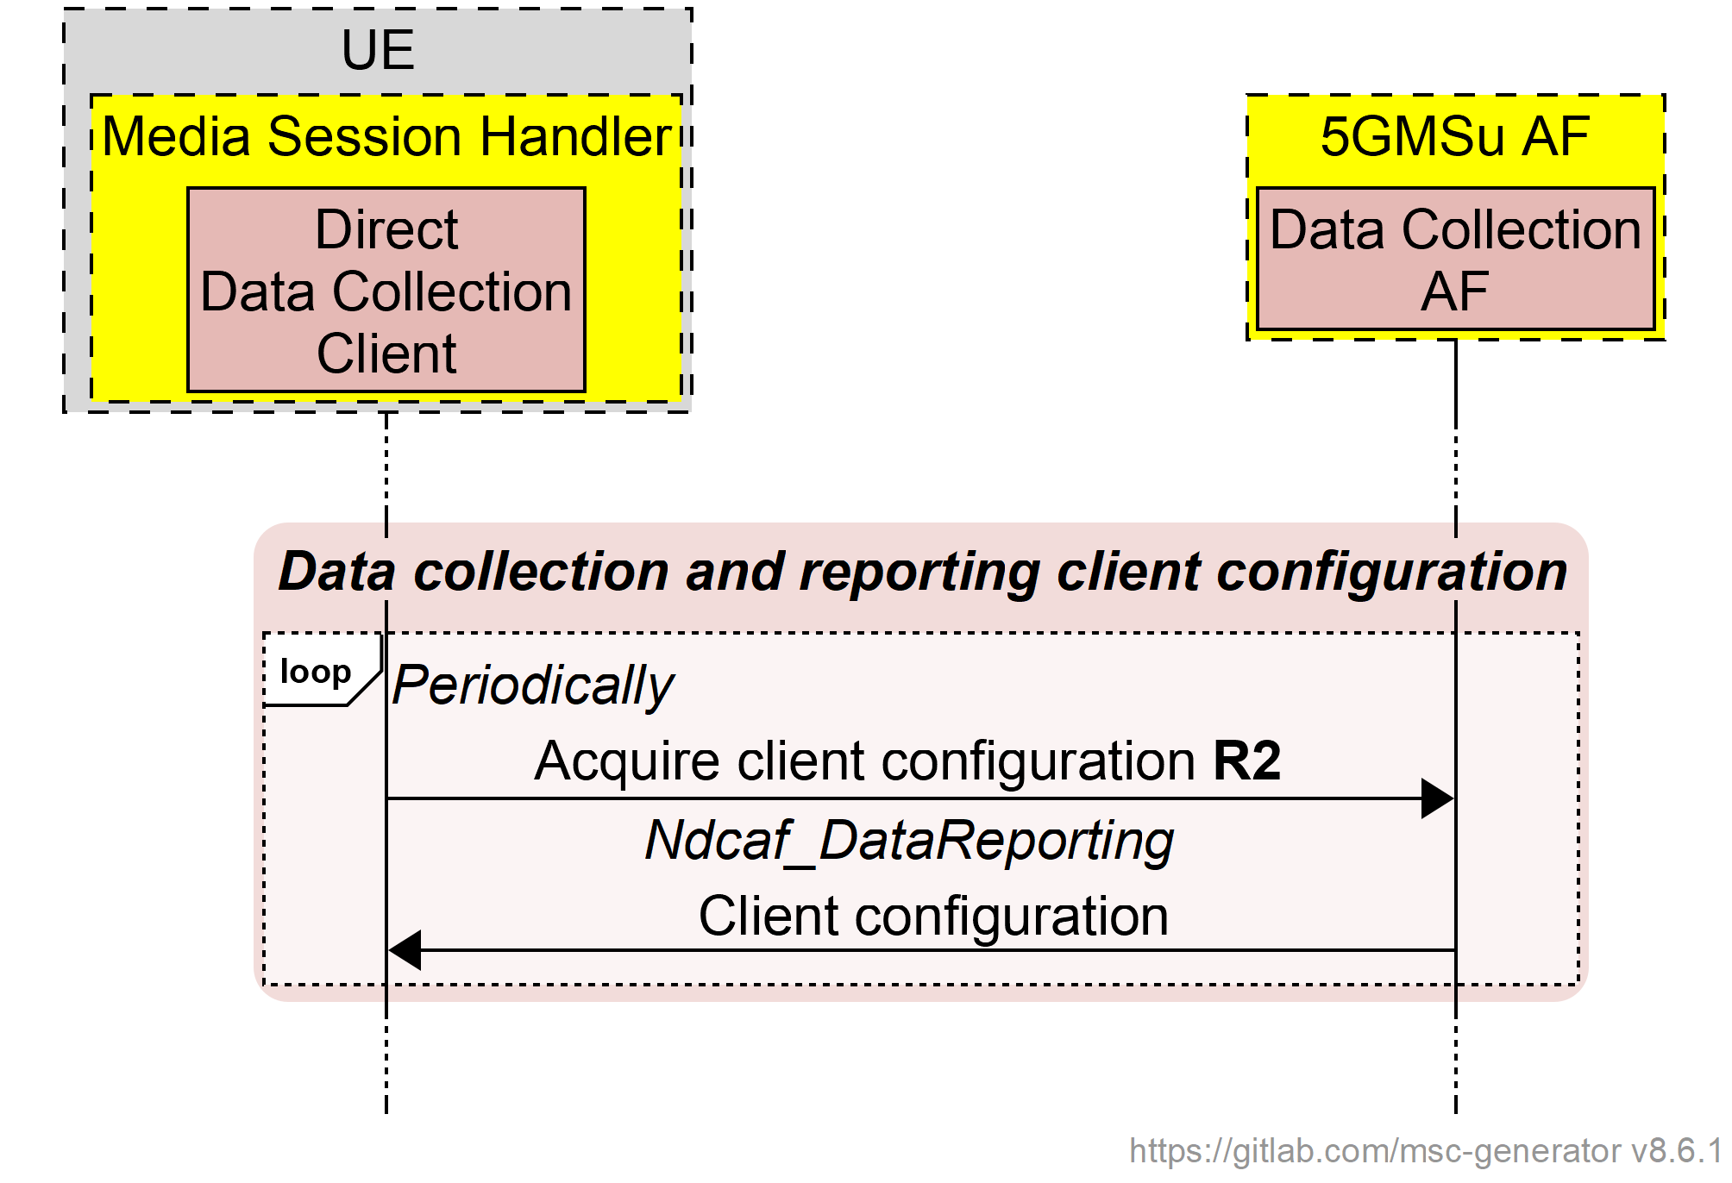
Figure 6.8.2A-1: Data collection client configuration
for uplink media streaming access reporting
The Direct Data Collection Client shall periodically refresh its data collection client configuration and act appropriately on any changes in the configuration.

6.8.2B Direct Data Collection Client reporting for uplink media streaming
The Direct Data Collection Client shall use the procedure shown in figure 6.8.2B-1 to report to the Data Collection AF instantiated in the 5GMSu AF when the data collection client configuration obtained using the procedure in clause 5.11.2A indicates that it should do so.
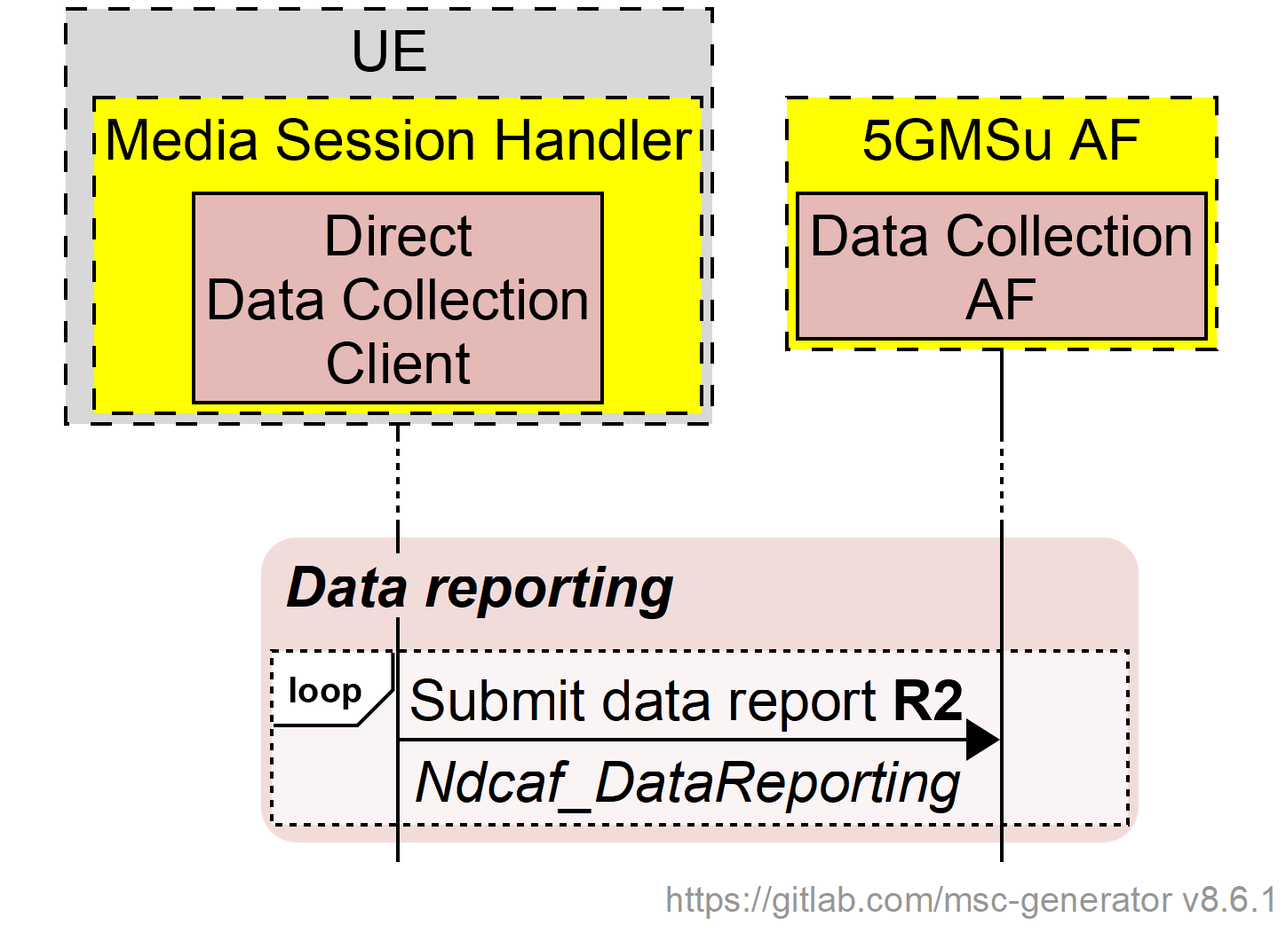
Figure 6.8.2B-1: Direct Data Collection Client reporting for uplink media streaming
The parameters included in reports of uplink ANBR-based Network Assistance invocations are specified in clause 4.7.2.5.

6.8.3 Uplink media streaming access event exposure
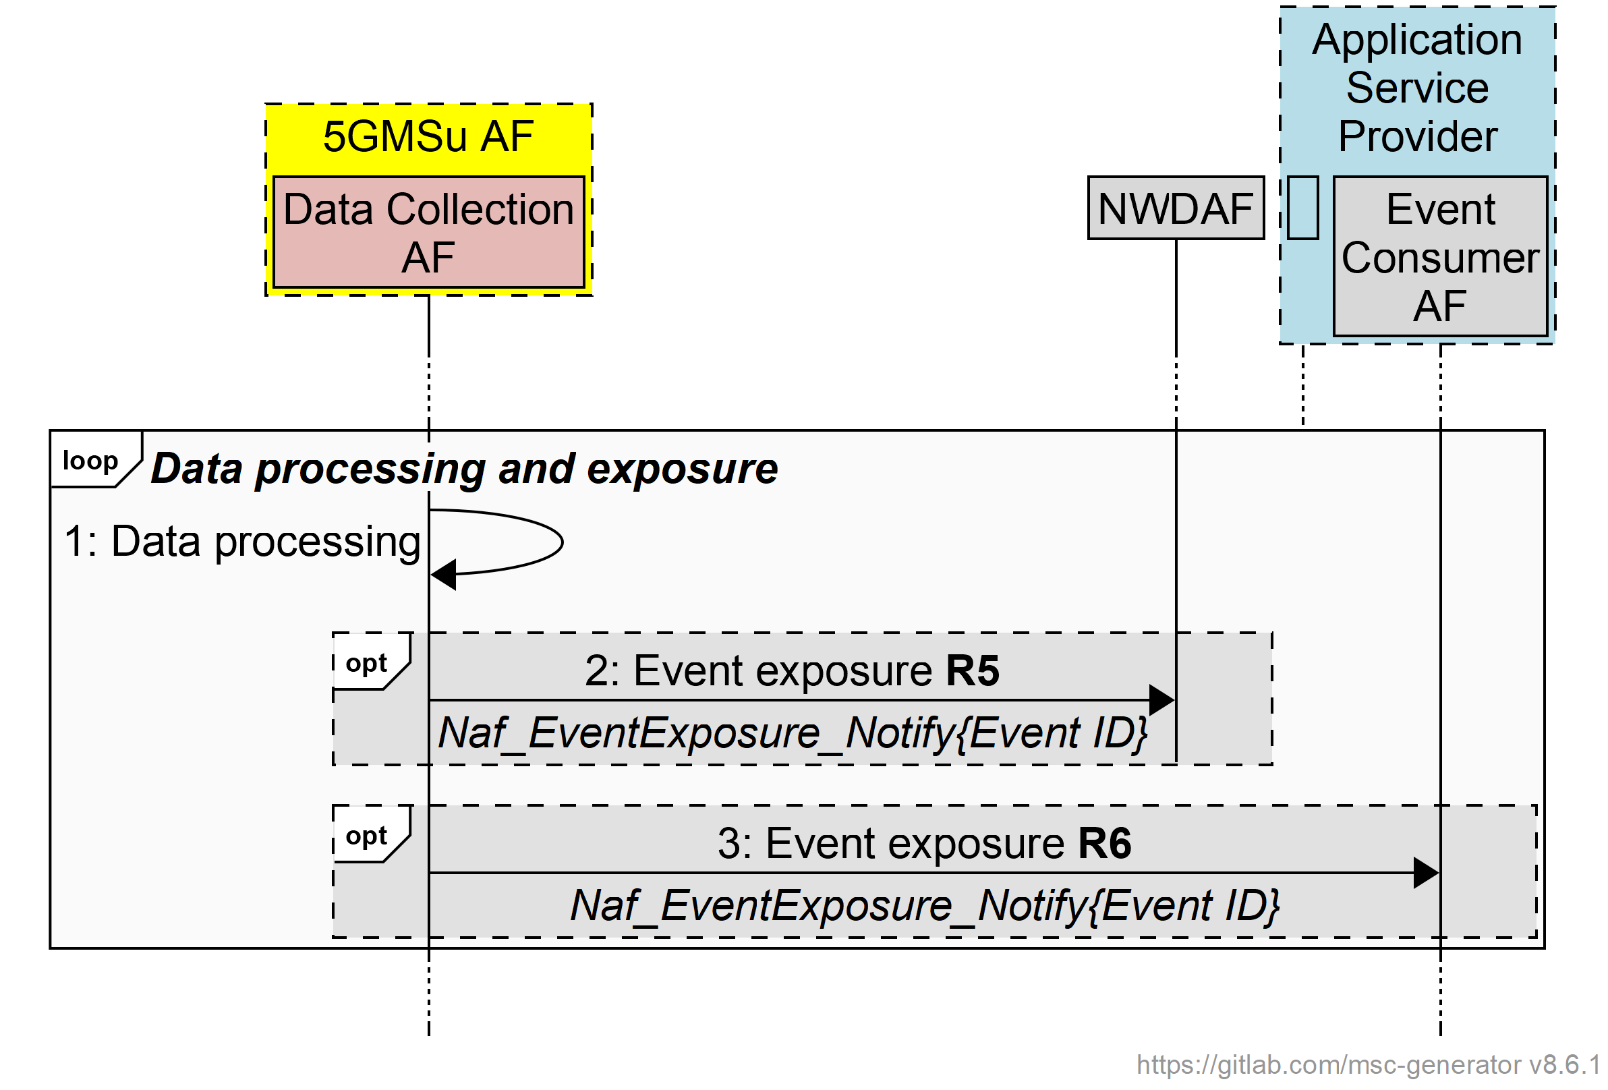
Figure 6.8.3-1: Uplink media streaming access event exposure
The 5GMS System shall follow the procedures for event reporting defined in clause 4.15.1 of TS 23.502 [3]. In the context of uplink media streaming:
- The role of event provider NF (also referred to in [3] as event provider NF, event provider, or NF producer) is performed by the 5GMSu AF and its subordinate Data Collection AF.
- The role of event consumer NF (also referred to in [3] as consumer NF, NF service consumer, or NF consumer) is performed by the NWDAF, the NEF and/or the Event Consumer AF of the 5GMSd Application Provider.
When one of the abovementioned event consumer entities subscribes to event reporting at the 5GMSu AF:
- Event subscription parameters contained in Event Reporting Information (such as maximum number of reports, maximum duration of reporting, sampling ratio, partitioning criteria, etc. as defined in clause 4.15.1 of [3]) shall be limited or superseded by similar or identical rules optionally set by a 5GMSu Application Provider in the Event Data Processing Configuration of the 5GMSu AF Provisioning Session, as defined in clause 5.3.1 of the present document.
- UE targeting rules contained in the Target of Event Reporting (see clause 4.15.1 of [3]) shall be limited or superseded by similar or identical rules optionally set by a 5GMSd Application Provider in Data Access Profiles in the Event Data Processing Configuration of the 5GMSd AF Provisioning Session, as defined in clause 5.3.1 of the present document.

6.8.4 Void

6.8.5 Void

6.9 Establishing an uplink streaming session with 5GMSu AF interactions for dynamic policy invocation and updates

6.9.1 General
This clause describes the procedures for provisioning Policy Templates and the establishment of uplink streaming session using dynamic policy invocation. The establishment of the uplink streaming session uses 5GMSu AF interactions, as described in clause 6.1. The Dynamic Policy feature allows separate handling of Service Data Flows within the same PDU Session. The Media Session Handler provides a Policy Template Id together with Service Data Flow Descriptions when requesting a dynamic policy. An example Policy Template Id value is "background_data".
The Media Session Handler provides needed information to the 5GMSu AF, so that the 5GMSu AF can combine the semi-static parameters from a Policy Template (which is associated with the Policy Template Id) with parameters supplied dynamically by the Media Session Handler to trigger a dynamic PCC rule update using the NEF or PCF.
The 5GMSu AF may trigger, for example, the "AF session with required QoS procedure" (see clause 4.15.6.6 of TS 23.502 [3]) to update QoS-related dynamic PCC rules. For changing charging-related rules, the 5GMSu AF may trigger the "Change the chargeable party during the session" procedure (see clause 4.15.6.5 of TS 23.502 [3]).

6.9.2 Provisioning
The provisioning for the dynamic policy procedure follows the general procedure from clause 6.2.2. Specifically, the Dynamic Policy feature is activated and, as result, the 5GMSu Application Provider is able to provision one or more Policy Templates.
The domain model of M1u and M5u APIs is depicted in figure 6.9.2-1. Realization of the dependencies between M1u and M5u data entries are up to implementation.
NOTE: Multiple M5u 5GMSu AF nodes may reference the same M1u resource.
Figure 6.9.2-1: Domain model for dynamic policies for uplink streaming
A Policy Template is identified by a Policy Template Id and contains semi-static parameters, including the API entry for the PCF/NEF interactions. The list of provisioned Policy Template Ids is communicated as valid Policy Template Ids to the Media Session Handler. The Media Session Handler uses one of the valid Policy Template Ids when invoking a dynamic policy.

6.9.3 Uplink streaming with dynamic policy invocation
This procedure describes the establishment of an uplink streaming session with 5GMSu AF interactions for dynamic policy invocation.
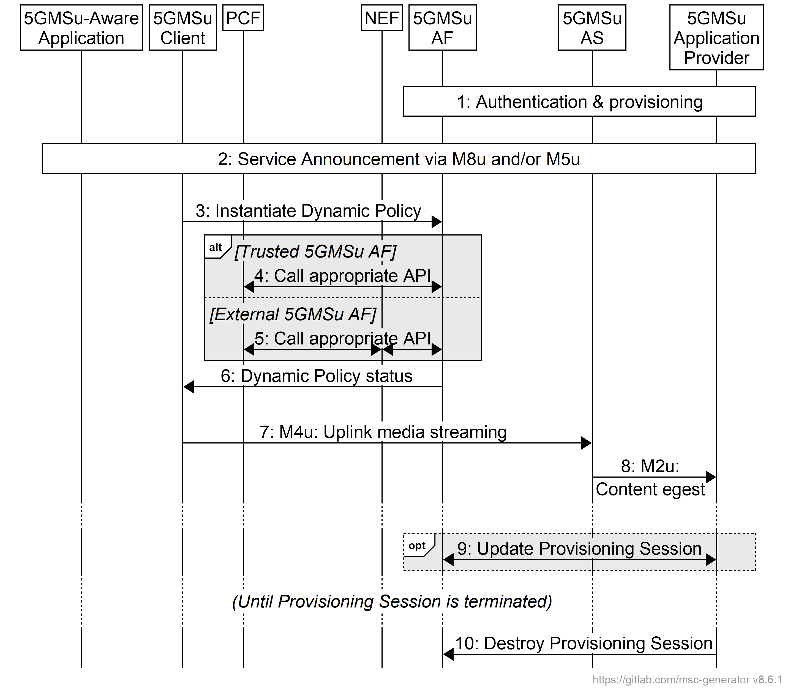
Figure 6.9.3-1: High-level procedure for uplink media streaming session
with dynamic policy invocation
Steps:
1. The 5GMSu Application Provider authenticates and provisions the 5GMS System for uplink media streaming.
2. The 5GMSu Application Provider provides the Service Access Information to the 5GMSu-Aware Application via reference point M8u, or alternatively the 5GMSu Client acquires the Services Access Information from 5GMSu AF via reference point M5u.
Then:
3. The 5GMSu Client requests that a dynamic policy is applied to the media streaming session. The request includes at least the Provisioning Session identifier, the Service Data Flow Description(s) and the Policy Template identifier (see figure 6.9.2-1), to be applied to the described transport session. In some cases, a QoS specification is also provided, containing desired QoS information. The 5GMSu AF uses the Policy Template for the related procedure and to identify the related network function. The status parameters for dynamic policy instances returned to the 5GMSu Client are listed in table 6.9.4-1.
NOTE: The 5GMSu Client may add and remove Service Data Flow description(s) from the dynamic policy during the lifetime of the uplink media streaming session.
4. This step applies when the 5GMSu AF resides in the trusted Data Network. Depending on the Policy Template, the step is executed either:
a. When the Policy Template relates to QoS, the 5GMSu AF may either directly interact with the PCF or may use a NEF service:
- when directly interacting with the PCF, the 5GMSu AF uses the Npcf_PolicyAuthorization service as defined in clause 5.2.5.3 of TS 23.502 [3]).
- when interacting via the NEF with the PCF, continue at step 5a.
b. When the Policy Template relates to a different charging scheme, the 5GMSu AF may either directly interact with the PCF or may use a NEF service:
- when directly interacting with the PCF, the 5GMSu AF uses the Npcf_PolicyAuthorization service as defined in clause 5.2.5.3 of TS 23.502 [3]).
- when interacting via the NEF with the PCF, continue at step 5b.
5. This step applies when the 5GMSu AF resides in the external Data Network. Depending on the Policy Template, the step is executed either:
a. When the Policy Template relates to QoS, the 5GMSu AF uses the Nnef_AFsessionWithQoS service as defined in clause 5.2.6.9 of TS 23.502 [3]. (The complete call flow is described in clause 4.15.6.6 of TS 23.502 [3].)
b. When the Policy Template relates to a different charging scheme, the 5GMSu AF uses the Nnef_ChargeableParty service as defined in clause 5.2.6.8 of TS 23.502 [3]. (The complete call flow is described in clause 4.15.6.4 and 4.15.6.5 of TS 23.502 [3].) The Policy Template may contain Sponsor Information (values based on SLA negotiation) and a Background Data Transfer Reference ID. The Flow Description is provided by the Media Session Handler at API invocation.
6. The response to step 3 from the 5GMSu AF contains status information (policy accepted, rejected, etc) and information on policy enforcement such as the enforcement method and enforcement bit rate.
7. The 5GMSu Client streams the content to the 5GMSu AS via reference point M4u.
8. When content publishing is offered and has been selected in step 1, the content contributed to the 5GMSu AS in the previous step is made available to the 5GMSu Application Provider via reference point M2u.
Optionally:
9. The 5GMSu Application Provider may update the Provisioning Session.
According to schedule, or upon request by the 5GMSu-Aware Application:
10. The 5GMSu Application Provider may manually terminate the Provisioning Session (at any time). All associated resources are released. Content may be removed from the 5GMSu AS. The 5GMSu Application Provider may configure a schedule for Provisioning Session termination.

6.9.4 Status information for dynamic policy instance
Table 6.9.4-1: Status information for dynamic policy instance
Parameters | Description
Policy Enforcement | Information about the policy enforcement system.
L4S enabled | A flag indicating that ECN marking for L4S is in force for this Dynamic Policy instance.
QoS monitoring enabled | A flag indicating that QoS monitoring is currently enabled for this Dynamic Poilicy instance.

6.9.5 Dynamic Policy selection for uplink media streaming based on Service Operation Point signalling
This clause provides an extension to the general call flow in clause 6.2.3 in order to address the usage of Service Descriptions to select a Dynamic Policy in uplink 5G Media Streaming services that supports the requirements of an abstract Service Operation Point. Details are shown in figure 6.9.5-1.
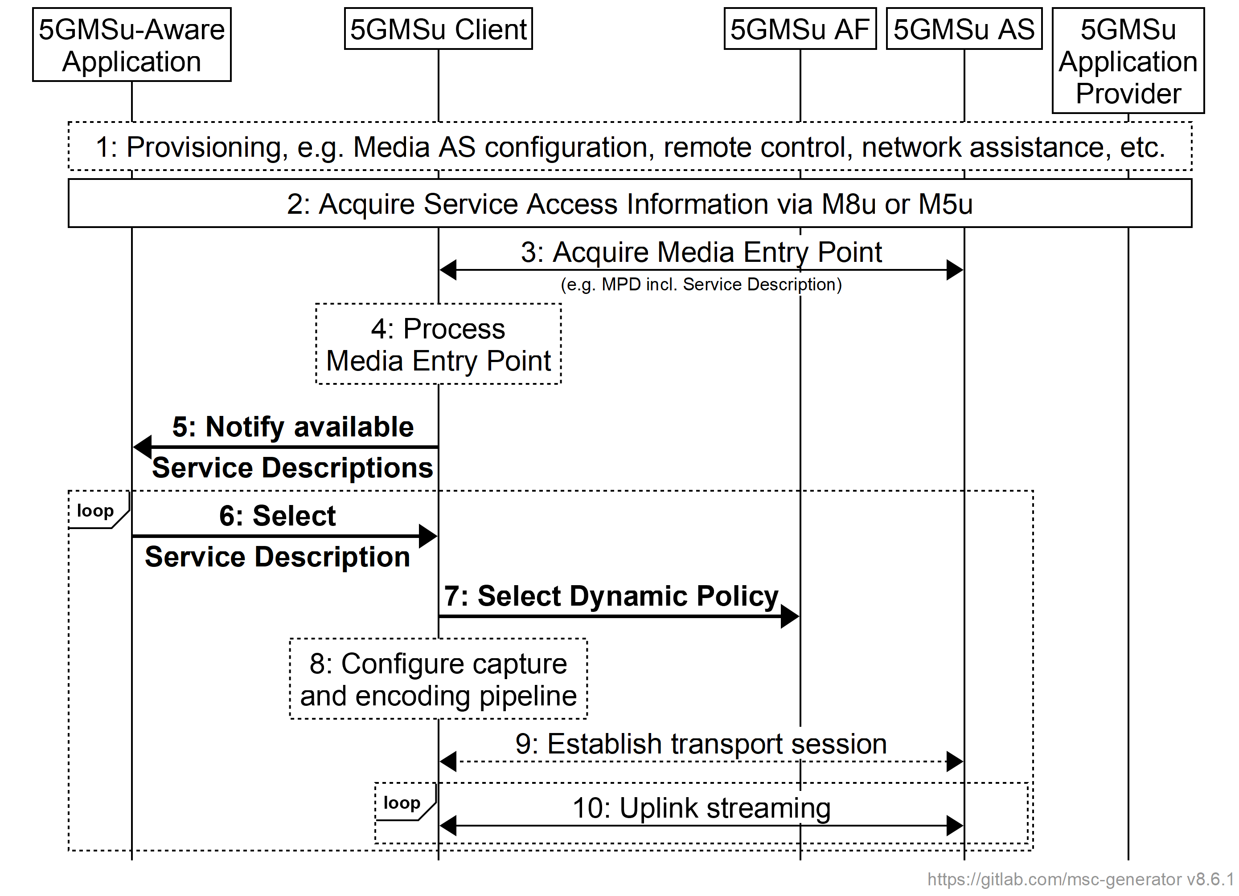
Figure 6.9.5-1: High-level procedure for uplink media streaming
with Service Operation Point handling
Steps:
1. Policy Templates are provisioned in the 5GMSd AF and various configurations are performed.
2. Either the 5GMSu-Aware Application acquires Service Access Information from the 5GMSu Application Provider via reference point M8u, or else Service Access Information is acquired by the 5GMSu Client from the 5GMSu AF via reference point M5u (as defined in steps 7–11 of figure 6.2.2.2-1).
3. The 5GMSu Client acquires the Media Entry Point from the 5GMSu AS.
4. The 5GMSu Client processes the Media Entry Point to discover the set of available Service Descriptions, each one identified by a different External reference.
5. The 5GMSu Client notifies the 5GMSu Application about the available Service Descriptions.
6. The 5GMSu Application selects a Service Description and notifies the 5GMSu Client by supplying its External reference.
7. The 5GMSu Client selects a Dynamic Policy with a matching External reference.
8. The 5GMSu Client configures its capture and encoding according to the selected Service Description.
9. A transport session is established by the 5GMSu Client for uplink media streaming.
10. Media is streamed to the 5GMSu AS via the uplink.

6.9.6 Dynamic Policy based on Network Slicing for uplink media streaming
The 5GMSu Application Provider requests the assignment of more than one network slice for the uplink media streaming service. The 5GMSu Application Provider indicates the desired network slice features that correspond to the Service Access Information. Upon successful assignment of the network slices for the service, the 5GMSu AF shall respond with the list of allowed S-NSSAIs to the 5GMSu Application Provider.
Figure 6.9.6-1 is the sequence diagram for this procedure.
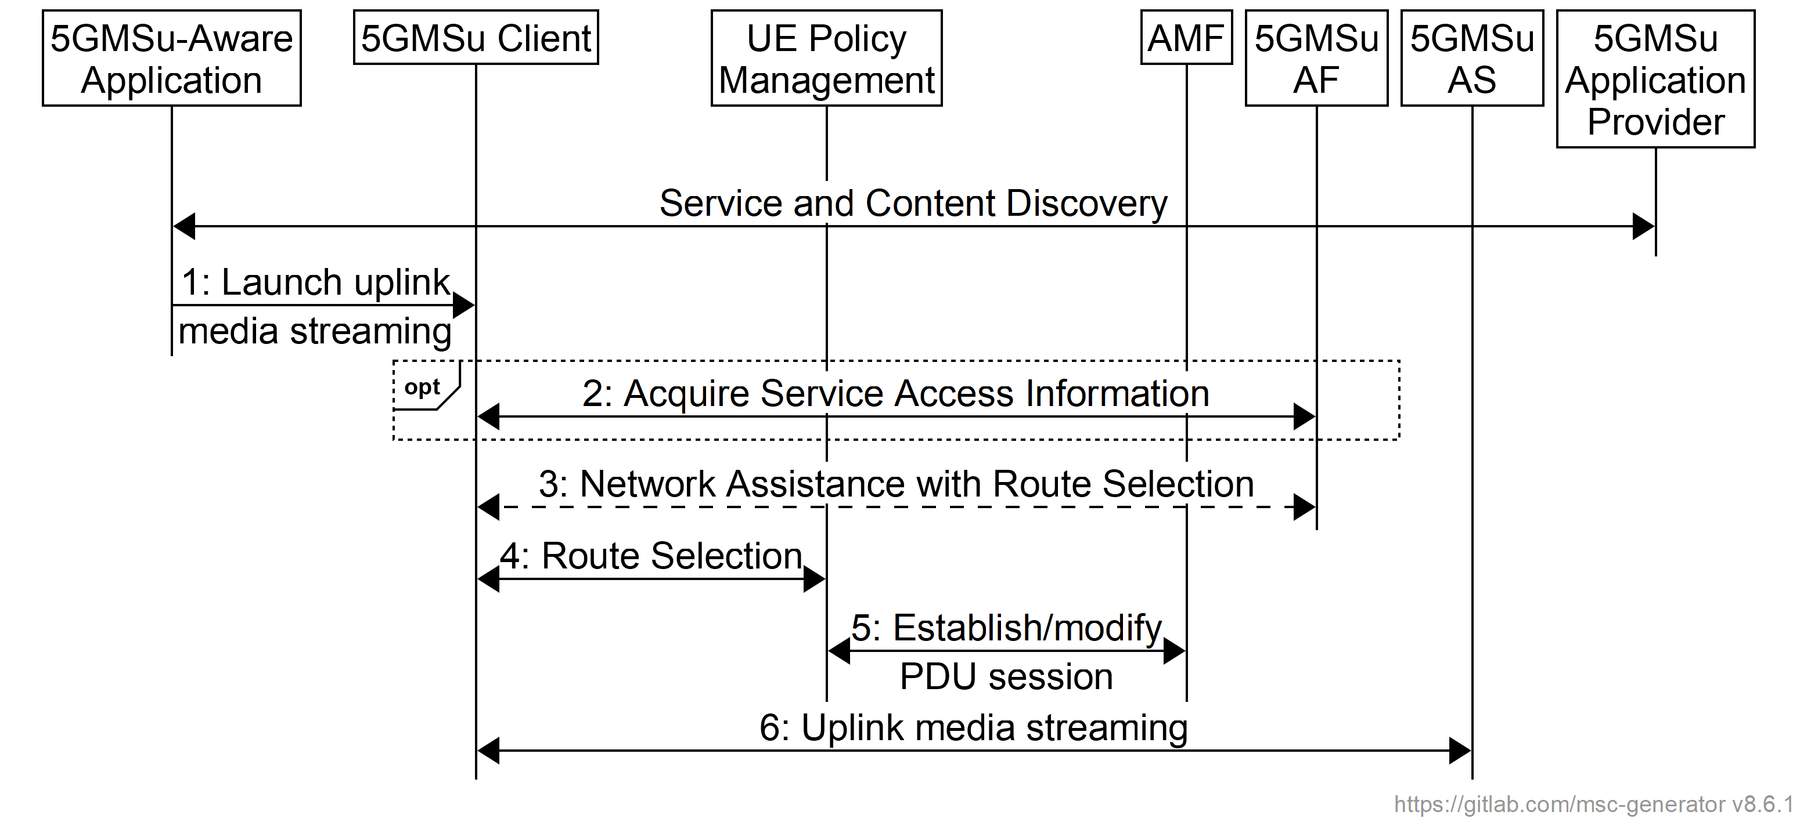
Figure 6.9.6-1: Dynamic Policy based on Network Slicing for uplink streaming
Pre-requisites:
1. The UE knows how to access the network slice(s) associated with a particular Provisioning Session.
2. The 5GMSu AS instance(s) serving the content for the particular Provisioning Session are accessible through the DNN(s) associated with the network slice(s) provisioned for the contribution of that content.
3. The 5GMSu Application Provider may identify Network Slice(s) and/or Data Network(s) applicable to each Policy Template it provisions in the 5GMSu AF in step 3 of the baseline provisioning procedure defined in clause 6.2.2.2 of the present document.
NOTE: The 5GMSu AF may map the external slice identifier and DNN to operator-internal identifiers
4. The 5GMSu AF has been preconfigured by the 5G System operator with a mapping from IP subnet range(s) to slice identifiers/DNN duples so that it can select an appropriate network slice and/or Data Network when manipulating the network QoS of the application flows described by a Network Assistance session or Dynamic Policy invocation. The 5GMSu AF may use information about the selected network slice and/or Data Network to filter viable Policy Templates before including them in Service Access Information provided to the 5GMSu Client described in clause 4.3.2 of the present document.
The steps are as follows:
1. The 5GMSu-Aware Application triggers the 5GMSu Client for uplink media streaming of content.
2. If it has not already been provided with the necessary Service Announcement parameters by the 5GMSu-Aware Application in the previous step, the Media Session Handler in the 5GMSu Client retrieves Service Access Information from the 5GMSu AF for the Provisioning Session of interest.
3. The Media Session Handler in the 5GMSu Client invokes Network Assistance on the 5GMSu AF and receives information in response to assist it with the route selection for the uplink media streaming session. This may include information about the network slices, the DNNs and any pre-authorized QoS guarantees for that Provisioning Session.
4. The 5GMSu Client and the UE Policy Management in the UE perform the route selection procedure using information such as the uplink streaming Service Operation Point and the traffic descriptors. The UE Policy Management uses the matching filter to retrieve the Route Selection descriptor, which provides the DNN and the S-NSSAI(s) identifying the network slice(s) to be used for uplink media streaming sessions associated with this Provisioning Session.
5. The UE either reuses an existing PDU Session with the selected S-NSSAI and DNN from step 3 or, if one doesn't exist already, it requests the establishment of a new PDU Session with the identified parameters.
6. The 5GMSu Client contributes media content to the 5GMSu AS at reference point M4u using the PDU Session selected in the previous step and this content is made available to the 5GMSu Application Provider at reference point M2u.

6.9.7 Uplink Background Data Transfer using dynamic policy invocation
Figure 6.9.7-1 shows a high-level call flow for the configuration and usage of a Background Data Transfer session in uplink 5G Media Streaming:
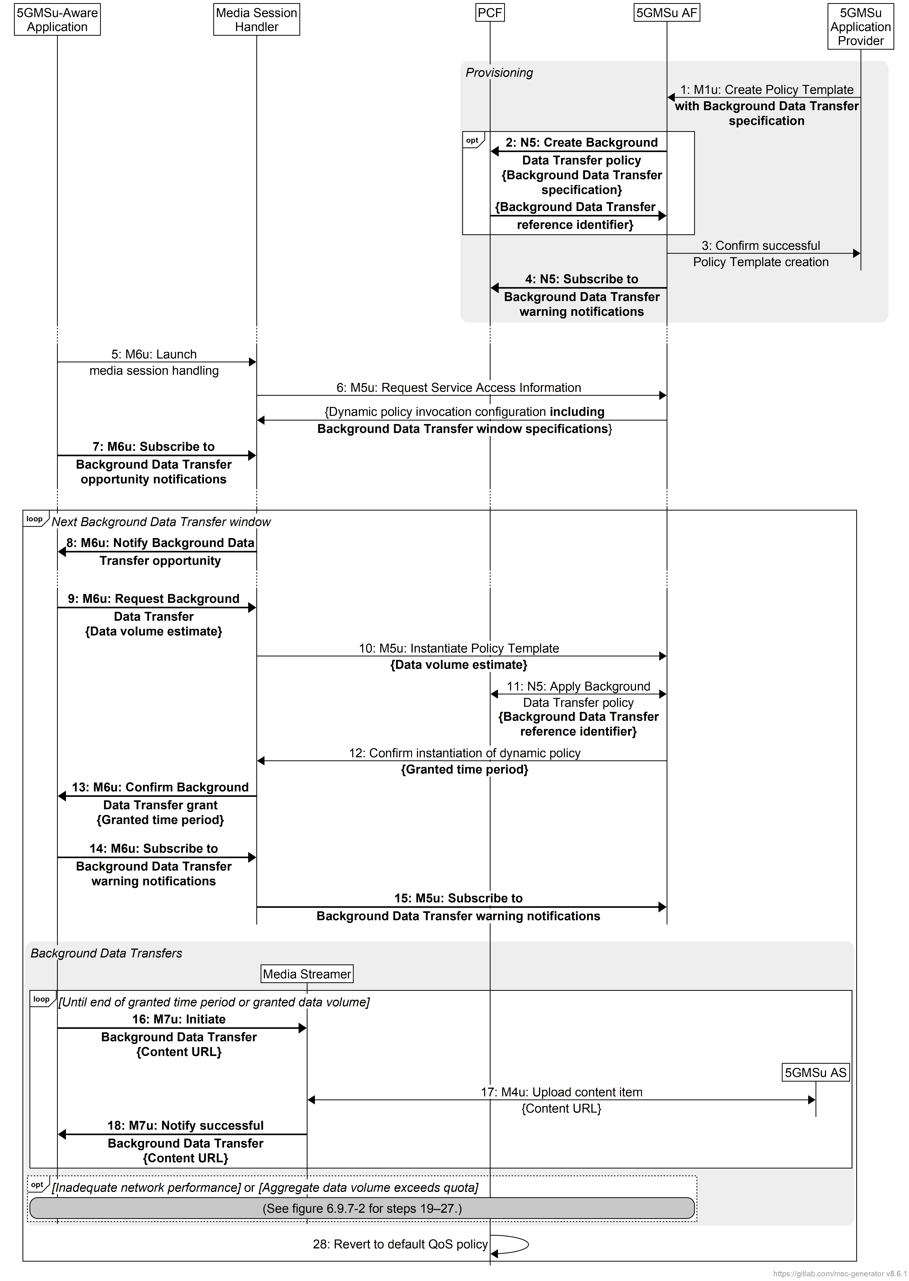
Figure 6.9.7-1: Call flow for uplink Background Data Transfer
session configuration and establishment
Pre-requisites:
1. The 5GMSu Application Provider has negotiated a Service Level Agreement with the 5GMS System operator that includes all or some of the following:
a. Time window(s) when Background Data Transfers are available. These may recur on a regular pattern (e.g., daily, weekly, monthly, etc.).
b. A quota for the maximum number of 5GMS Clients that may avail themselves of a Background Data Transfer during each such time window.
c. A quota for the maximum aggregate volume of data that may be transferred by all 5GMS Clients during each Background Data Transfer window.
2. The 5GMS System operator may have provisioned a Background Data Transfer Policy in the PCF based on the Service Level Agreement, in which case it may share the corresponding Background Data Transfer reference identifier directly with the 5GMSu Application Provider.
The steps in the call flow sequence are as follows with differences from the baseline call flow highlighted in bold:
1. The 5GMSu Application Provider provisions a Policy Template in the 5GMSu AF at reference point M1u including network QoS parameters that either references an existing Background Data Transfer policy already provisioned in the PCF that embodies the aforementioned Service Level Agreement or else directly specifies Background Data Transfer parameters in line with the aforementioned Service Level Agreement.
2. If the supplied Policy Template explicitly declares new Background Data Transfer parameters, the 5GMSu AF creates a corresponding new Background Data Transfer policy in the PCF based on them using the Npcf_BDTPolicyControl service (or, if the 5GMSu AF is deployed outside the Trusted DN, the Nnef_BDTPNegotiation service (see clause 4.16.7.2 of TS 23.502 [3]). The PCF may interact with the UDR as a consequence. The procedure yields a Background Data Transfer reference identifier.
3. The 5GMSu AF acknowledges successful creation of the Policy Template to the 5GMSu Application Provider. This confirms that the parameters of the Policy Template (including the Background Data Transfer parameters) are acceptable to the 5GMS System.
4. If it has not already done so, the 5GMSu AF subscribes to receive Background Data Transfer warning notifications from the PCF as defined in clause 4.16.7 of TS 23.502 [3].
At some later point in time:
5. The 5GMSu-Aware Application launches media session handling using an appropriate service launch mechanism at reference point M6u.
6. In response, the Media Session Handler fetches Service Access Information from the 5GMSu AF for the relevant Provisioning Session via reference point M5u. A client dynamic policy invocation configuration is provided that describes the Policy Templates applicable to the requesting 5GMSu Client, including information about Background Data Transfer windows and endpoint(s) that the Media Session Handler may subscribe to in order to receive Background Data Transfer warning notifications from the 5GMSu AF.
7. The 5GMSu-Aware Application also subscribes to receive notifications of Background Data Transfer opportunities from the Media Session Handler by invoking a client API on the latter at reference point M6u.
At the start of the next Background Data Transfer window:
8. According to its list of current subscriptions (see step 7), the Media Session Handler notifies its 5GMSu-Aware Application subscriber(s) of the Background Data Transfer opportunity by sending a notification to each one via reference point M6u. The notification indicates the time window of the Background Data Transfer opportunity.
9. If it wishes to avail itself of the Background Data Transfer opportunity (immediately or at some later point during the time window indicated in the previous step) a 5GMSu-Aware Application that has received such a notification invokes a suitable client API on the Media Session Handler at reference point M6u. The invocation includes an estimate of the data volume the 5GMSu Client intends to transfer in the background.
10: The Media Session Handler instantiates a dynamic policy resource on the 5GMSu AF based on one of the Policy Templates advertised in the Service Access Information that includes Background Data Transfer parameters. The request includes an estimate of the data volume the 5GMSu Client intends to transfer in the background.
11. If the request falls within a time window for Background Data Transfers advertised in the Service Access Information and if the quota for the number of Background Data Transfers within the current time window has not been exceeded, the Media Session Handler requests a change to the network QoS of the appropriate PDU Session by invoking the Npcf_PolicyAuthorization_Create operation (either directly or via the NEF) according to clause 4.16.7.1 of TS 23.502 [3] based on the Background Data Transfer parameters described in the appropriate Policy Template and citing the reference identifier of the Background Data Transfer referenced in step 1 or created in step 2.
12. The 5GMSu AF responds to the Media Session Handler to grant the Background Data Transfer request. The grant response includes a recommendation from the 5GMSu AF of the maximum time period for which the Background Data Transfer is available.
13. The Media Session Handler informs the 5GMSu-Aware Application of the Background Data Transfer grant by sending a synchronous response or asynchronous notification to the latter at reference point M7u. This conveys the maximum time period recommendation indicated by the 5GMSu AF in the previous step.
14: The 5GMSu-Aware Application subscribes to receive Background Data Transfer warning notifications from the Media Session Handler by invoking a client API on the latter at reference point M6u.
15. As a consequence, the Media Session Handler subscribes to receive Background Data Transfer warning notifications from the 5GMSu AF by invoking a network API on the latter at reference point M5u. The subscription endpoint(s) are indicated in the Service Access Information obtained in step 6.
The following steps are repeated for each content item the 5GMSu-Aware Application would like to download during the granted time period for Background Data Transfers:
16. The 5GMSu-Aware Application initiates upload of a content item in the background by invoking a suitable client API on the Media Streamer at reference point M7u. The content is identified by a URL that is available on a 5GMSu AS.
17. The Media Streamer uploads the content item from the 5GMSu AS at reference point M4d using the content item URL supplied in the previous step.
18. The Media Player confirms that the content item has been successfully uploaded by sending a notification to the 5GMSu-Aware Application at reference point M7u.
(Steps 19–27 are described below.)
When the granted time period for Background Data Transfers subsequently expires:
28. The PCF automatically reverts the network QoS of the media streaming session to its state prior to the Background Data Transfer grant without intervention from the 5GMS System.
At any time during a Background Data Transfer window the PCF may detect that the network cannot satisfy the requirements of the Background Data Transfer policy at the UE’s current location (as defined in clause 6.1.2.4 of TS 23.503 [4]) or that the volume of data transferred by all UEs in the current Background Data Transfer window has exceeded the quota provisioned in the Background Data Transfer policy. The procedures in this case are summarised in figure 6.9.7-2.
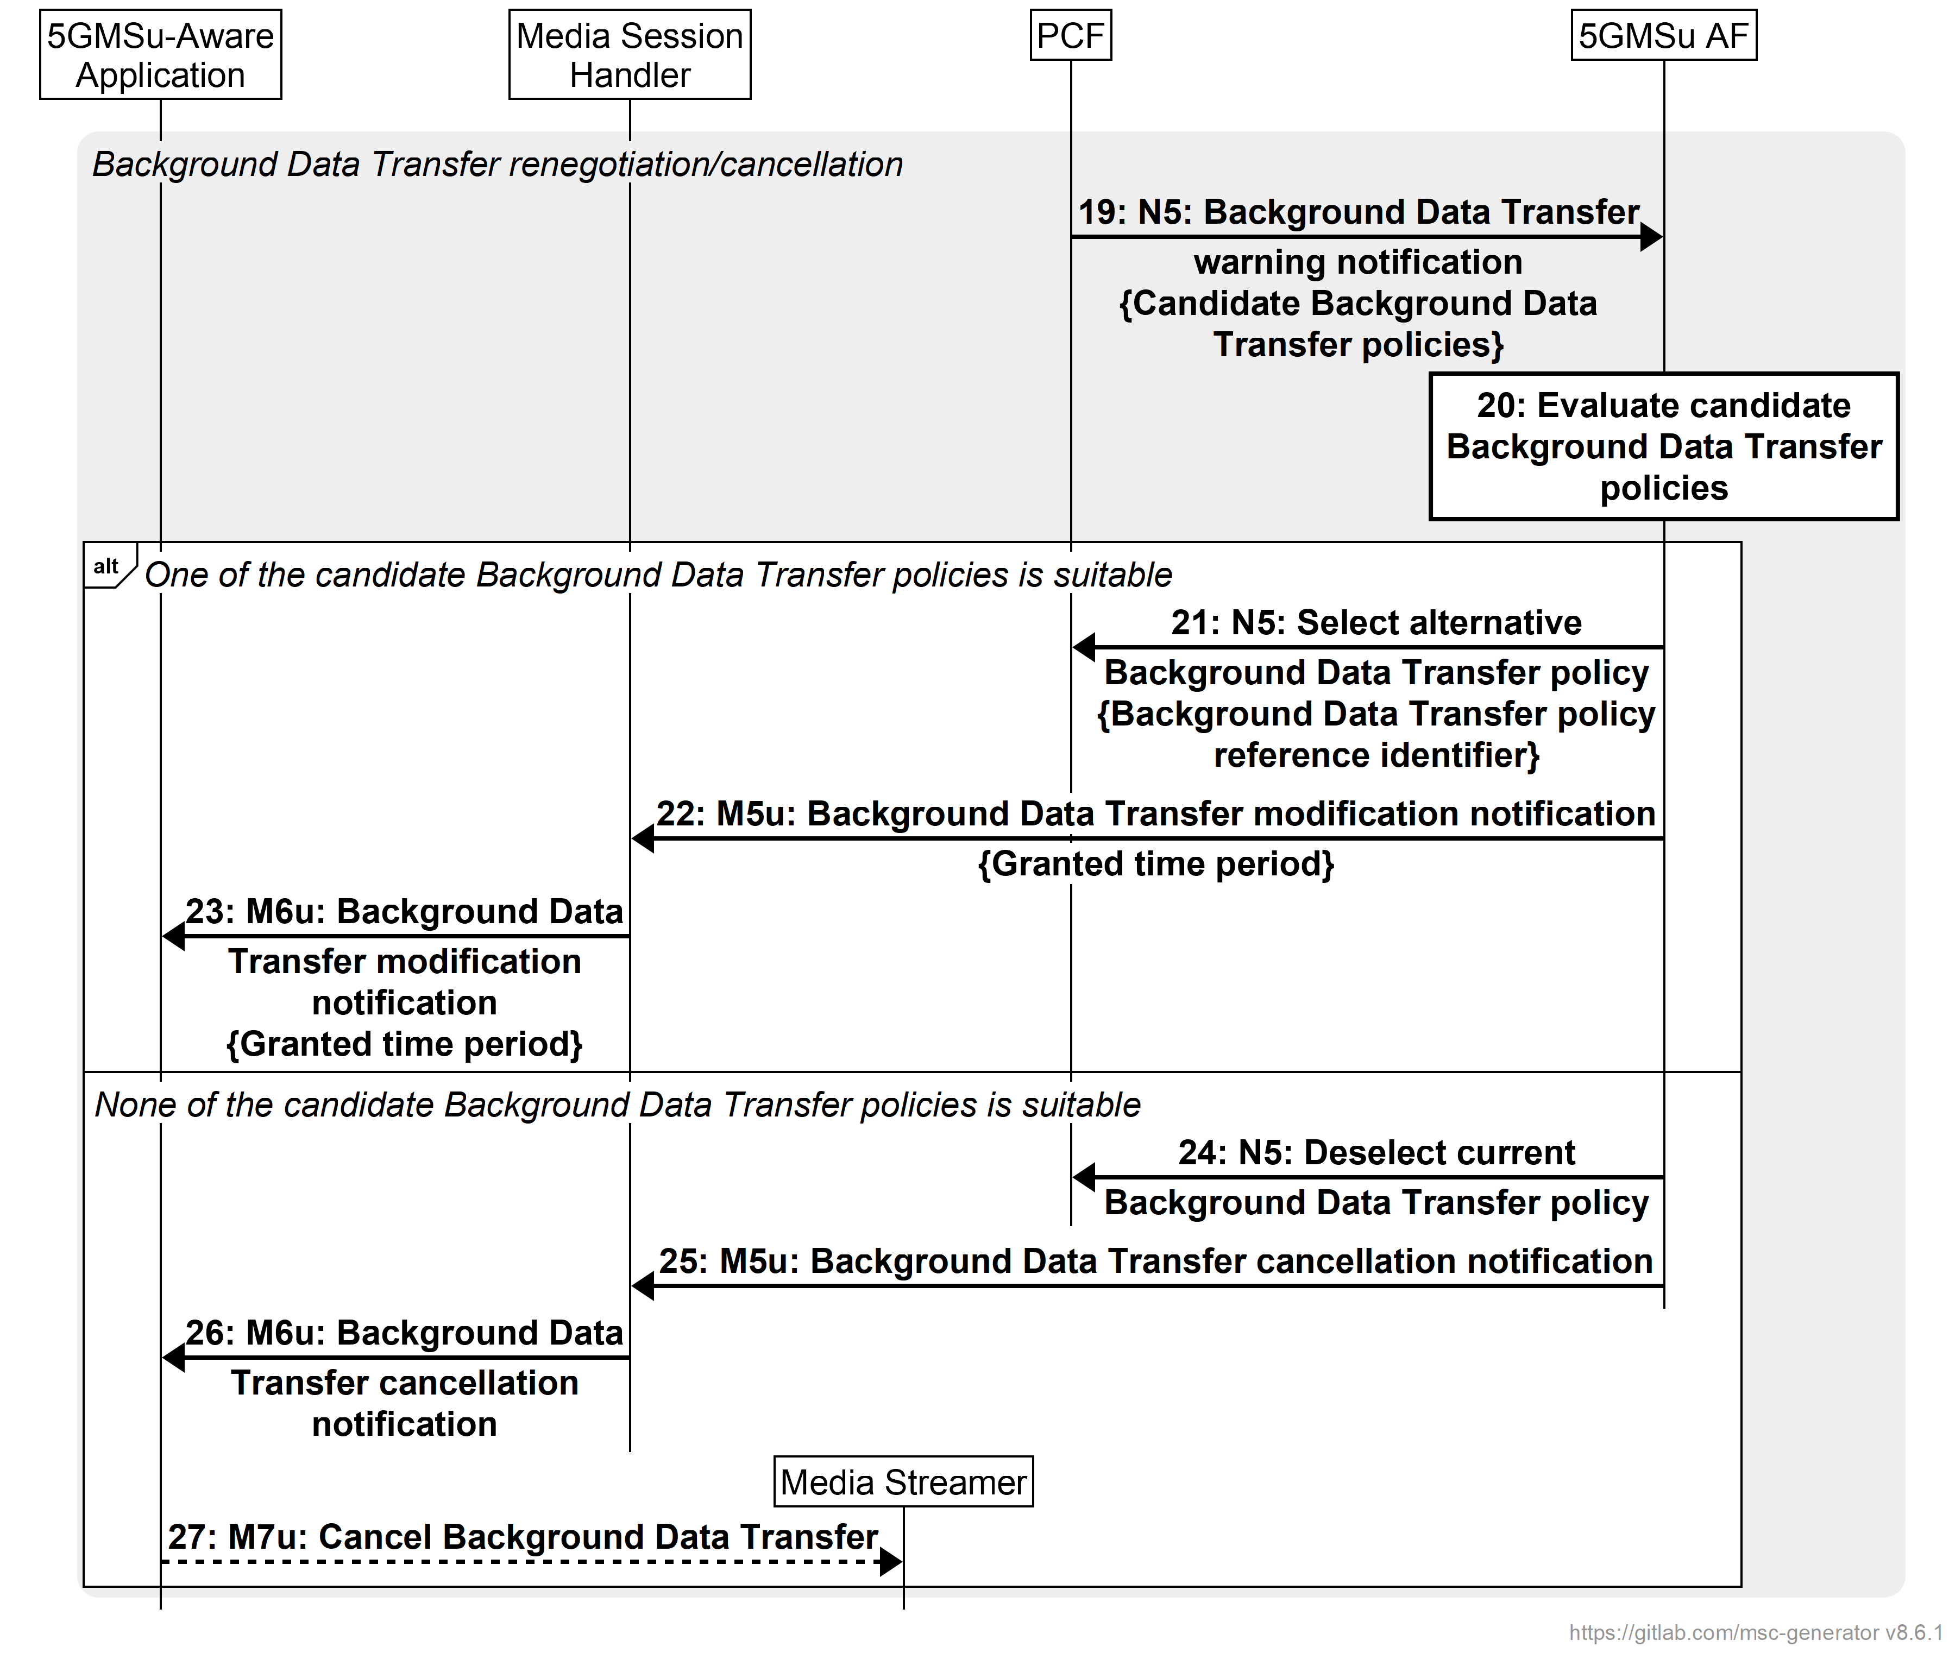
Figure 6.9.7-2: Call flow for uplink Background Data Transfer session renegotiation/cancellation
The steps are as follows:
19: If it is able to identify alternative Background Data Transfer policies, the PCF sends a Background Data Transfer warning notification with these candidates to the 5GMSu AF as defined in clause 4.16.7.3 of TS 23.502 [3].
20: The 5GMSu AF evaluates the candidate alternative Background Data Transfer policies for suitability.
If the 5GMSu AF determines that one of the candidate alternative Background Data Transfer policies suggested by the PCF is suitable for the media streaming session in question:
21: The 5GMSu AF requests that its chosen alternative Background Data Transfer policy is applied, according to step 12 in clause 4.16.7.3 of TS 23.502 [13]. As defined in clause 6.1.2.4 of TS 23.503 [4], in this case the current Background Data Transfer policy remains in force until its natural end (see step 29 above).
22. Using an asynchronous notification mechanism at reference point M5u, the 5GMSu AF notifies the Media Session Handler of the modified Background Data Transfer grant, including the new maximum time period for which the Background Data Transfer is available.
23: The Media Session Handler informs the 5GMSu-Aware Application of the Background Data Transfer grant by sending an asynchronous notification to the latter at reference point M6u. This conveys the maximum time period recommendation indicated by the 5GMSu AF in the previous step.
Otherwise, if none of the candidate Background Data Transfer policies suggested by the PCF deemed suitable by the 5GMSu AF:
24: The 5GMSu AF informs the PCF that none of the candidate Background Data Transfer policies is suitable, according to step 13 in clause 4.16.7.3 of TS 23.502 [13].
25: Using an asynchronous notification mechanism at reference point M5u, the 5GMSu AF notifies the Media Session Handler that the Background Data Transfer window has ended prematurely.
26: Using an asynchronous notification mechanism at reference point M6u, the Media Session Handler notifies the 5GMSu-Aware Application that the Background Data Transfer window has ended prematurely.
27: As a consequence, the 5GMSu-Aware Application may choose to cancel an in-progress Background Data Transfer by invoking a suitable client API method on the Media Player at reference point M7u.

6.9.8 Dynamic Policy of ECN marking for L4S for uplink media streaming
Figure 6.9.8-1 below shows a high-level call flow for uplink media streaming for configuration and usage of ECN marking for L4S. Differences from the procedure for uplink media streaming with dynamic policies defined in clause 6.9.3 are indicated in boldface.
The following is assumed:
- The service here is a unicast uplink media streaming service with dynamic policy support.
- As an example, the Layer 4 protocol used for application flows is TCP and the TCP stack used supports L4S.
- The 5GS network supports ECN marking for L4S.
- The application has specifically requested ECN marking for its media delivery session.
- NG-RAN manipulates the ECN bits (per clause 5.37.3.2 of TS 23.501 [2]). It is equally possible that the PDU Session Anchor UPF (PSA-UPF) manipulates the ECN bits (per clause 5.37.3.3 of [2]).
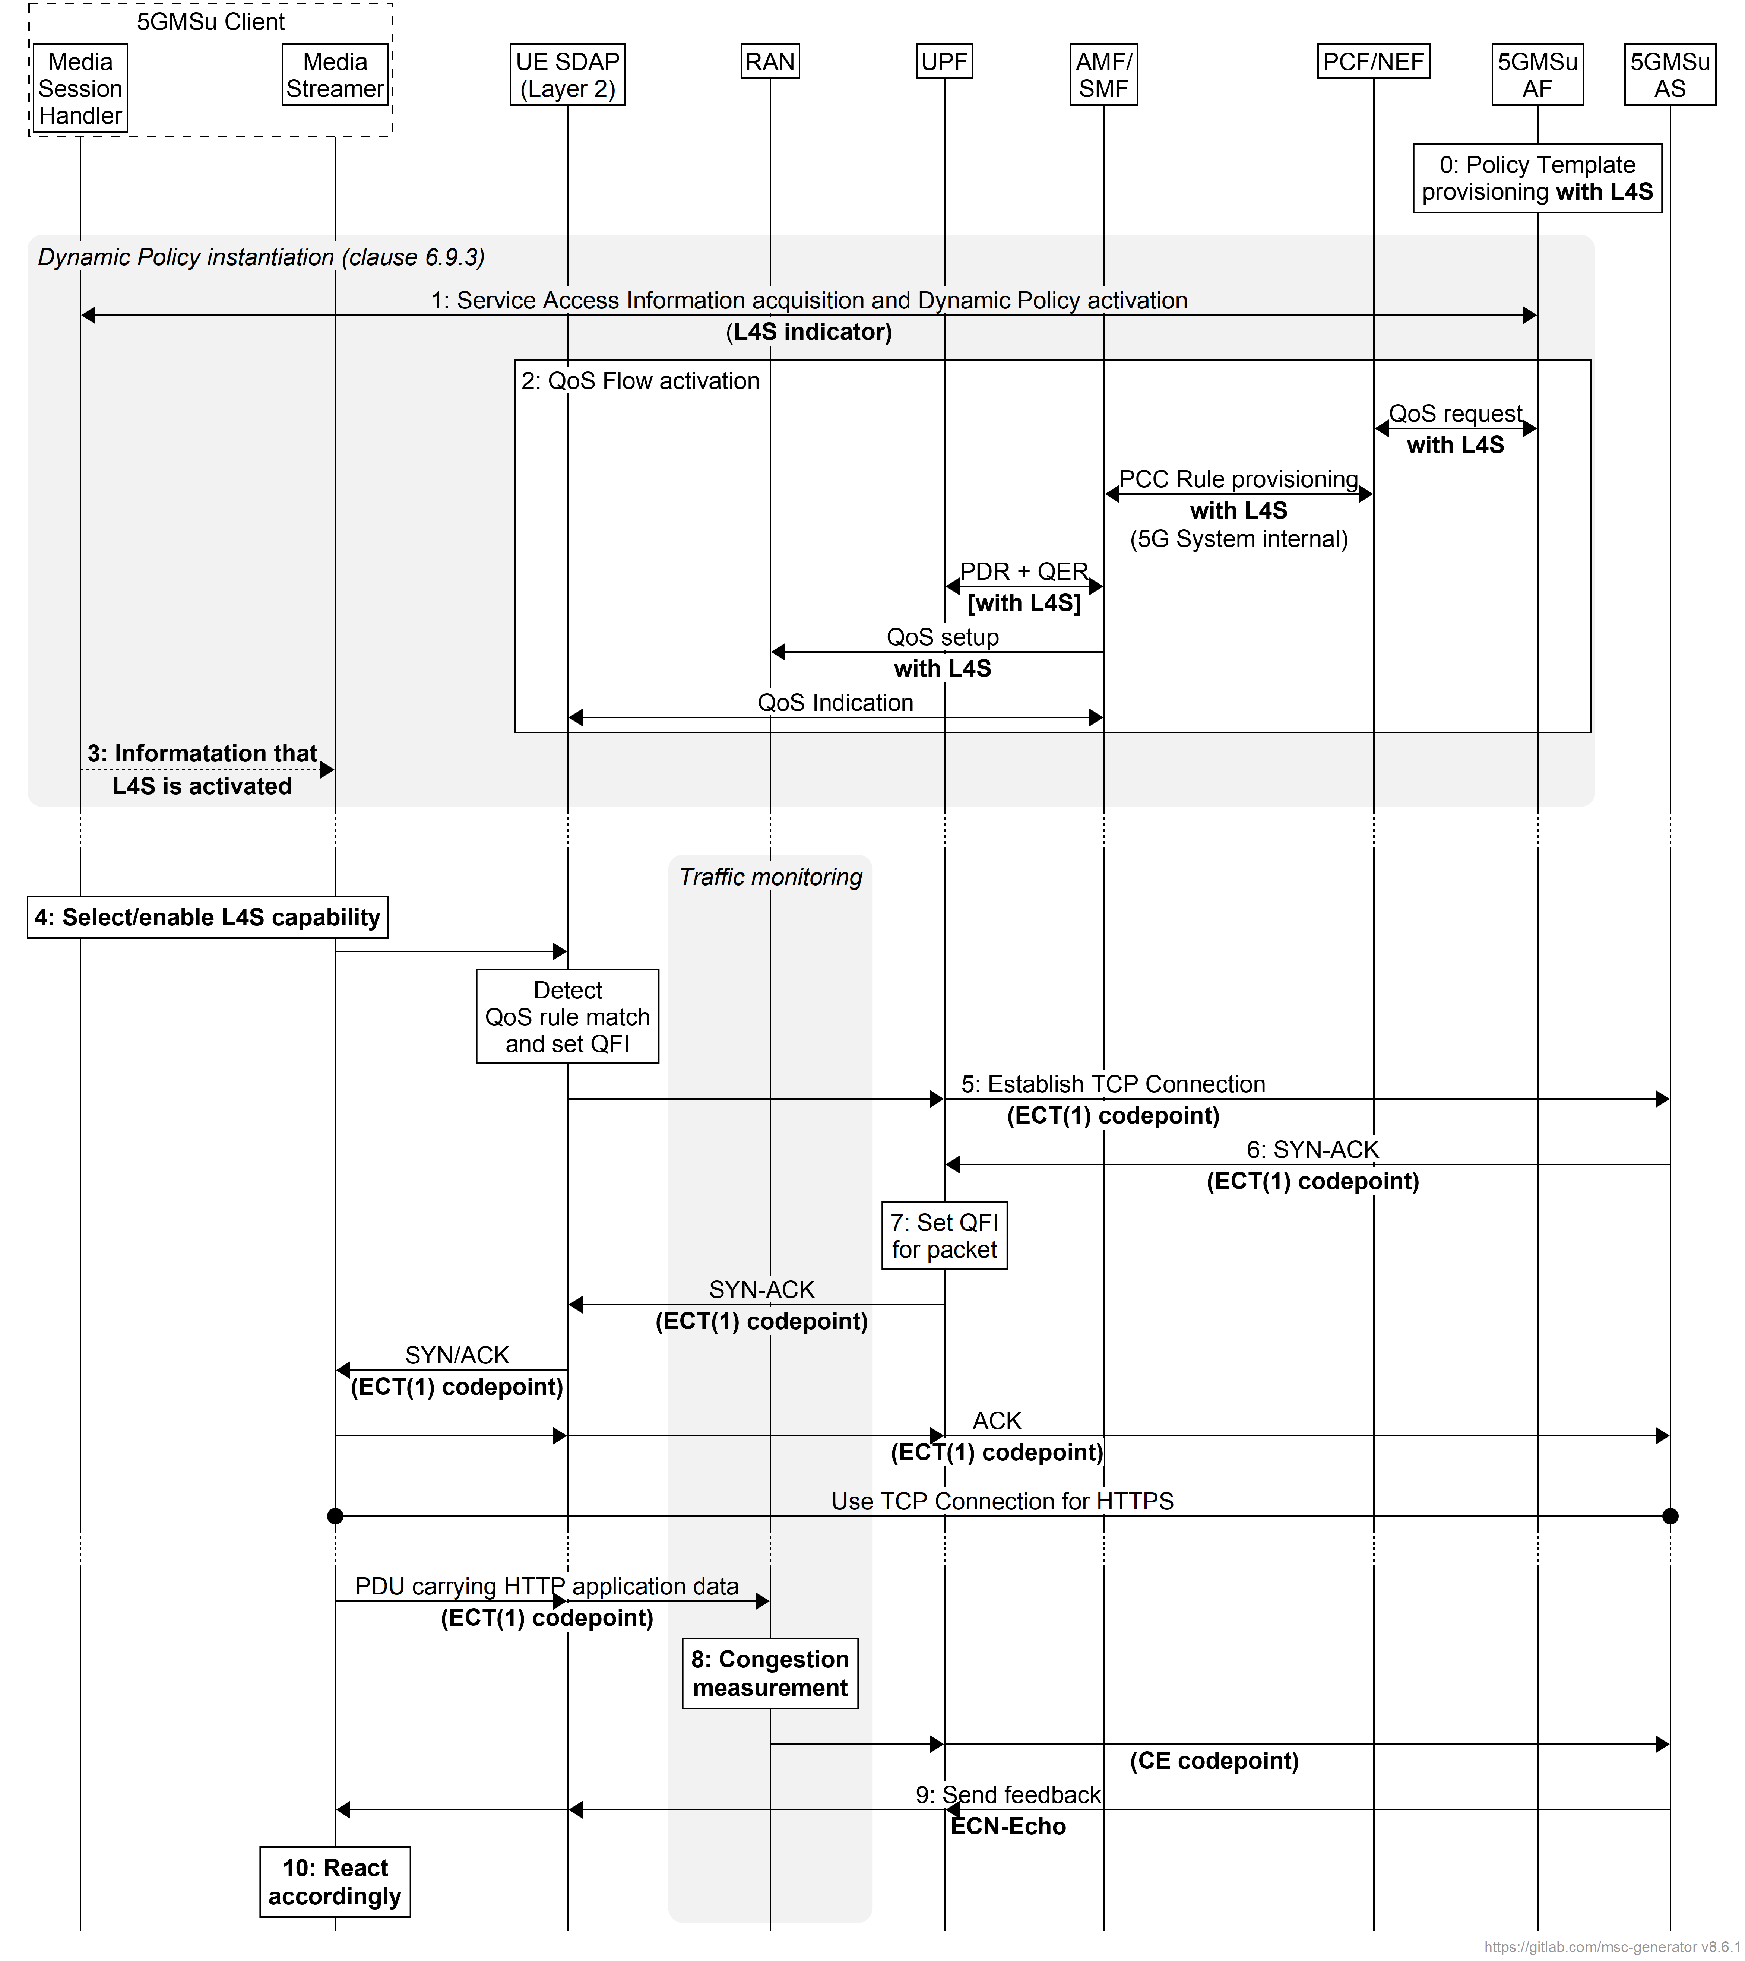
Figure 6.9.8-1: Uplink media streaming call flow for ECN marking for L4S
The steps are as follows:
0: Policy Template Provisioning. A Policy Template is provisioned with the L4S enablement preference flag set, indicating a preference for enabling ECN marking for L4S functionality.
1: Service Access Information acquisition and Dynamic Policy activation. The Media Session Handler within the 5GMSu Client obtains Service Access Information and triggers a dynamic policy activation. A Policy Template Binding is present within the Service Access Information for each provisioned Policy Template. Policy Template Bindings suitable for L4S are indicated by an L4S enablement preference flag being set. When instantiating the Dynamic Policy, the Media Session Handler only sets the L4S required flag in the Dynamic Policy request when the Media Player supports an L4S-capable media transport stack.
2: QoS request. The 5GMSu AF requests QoS handling using e.g. the Nnef_AfSessionWithQoS service or the Npcf_PolicyAuthorization service. If the L4S required flag is set in the Dynamic Policy request from the Media Session Handler, this indicates that the new QoS flow is required to be L4S-enabled. The new QoS flow with the ECN marking for L4S indication setting propagates through the 5G System.
3: The Media Session Handler may inform the Media Streamer about the successful activation of the L4S-enabled Dynamic Policy via the client API at reference point M11u. Subject to availability of API access, the Media Player may use congestion notifications to perform early adaptation.
4: If the L4S enablement Dynamic Policy is successfully activated, the 5GMSu Client selects/enables the L4S capability of the used transport protocol.
NOTE 1: This step may happen implicitly by selecting an L4S-supporting transport protocol stack in case of availability of API access.
5: The Media Streamer within the 5GMSu Client triggers the establishment of a TCP connection. The ECT(1) codepoint is set in the IP header, indicating an L4S-Capable Transport, and the SDAP entity ensures that the packet is forwarded via the matching QoS flow.
6: The 5GMSu AS responds to the TCP connection establishment request. The 5GMSu AS sets ECT(1) in the IP headers, indicating an L4S-Capable Transport.
7: The UPF finds the matching QoS Flow Identifier for the downlink packet and sends the packet via the corresponding QoS flow to the UE. TCP Connection setup continues, with one ECT bit set in all packets.
8: When the RAN detects an upcoming congestion according to the congestion measurement (based on continuous congestion monitoring), the 5G System the CE (Congestion Experienced) codepoint in the IP header of the uplink packet.
9: The TCP protocol stack used by the 5GMSu AS reflects the Early Congestion Notification to the TCP sender by setting the ECN-Echo (ECE) flag in the TCP header of a downlink PDU of the same TCP connection. The TCP sender reacts to the ECN-Echo accordingly (i.e., by reducing its sending congestion window).
NOTE 2: The ECN-Echo flag is also acknowledged by the TCP sender setting the Congestion Window Reduced (CWR) flag in an outgoing TCP frame, but this acknowledgement is not illustrated in this call flow.
NOTE 3: Classic ECN as specified in RFC 3168 [41] requires an ECN signal to be treated as equivalent to a packet drop. L4S as specified in RFC 9330 [38] specifies a more fine-grained response and an early congestion signal triggers a less severe reaction. How a TCP sender behaves "accordingly" is beyond the scope of the present document.
10: Based on the CE indication received in step 8, or by detecting a reduced bit rate in the uplink application flow, the Media Streamer in the 5GMSu Client may react by, for example, changing the bit rate of the representation.

6.9.9 QoS monitoring of uplink media streaming based on Dynamic Policy
Figure 6.9.9-1 below shows a high-level call flow for the configuration and usage of QoS monitoring with uplink media streaming.
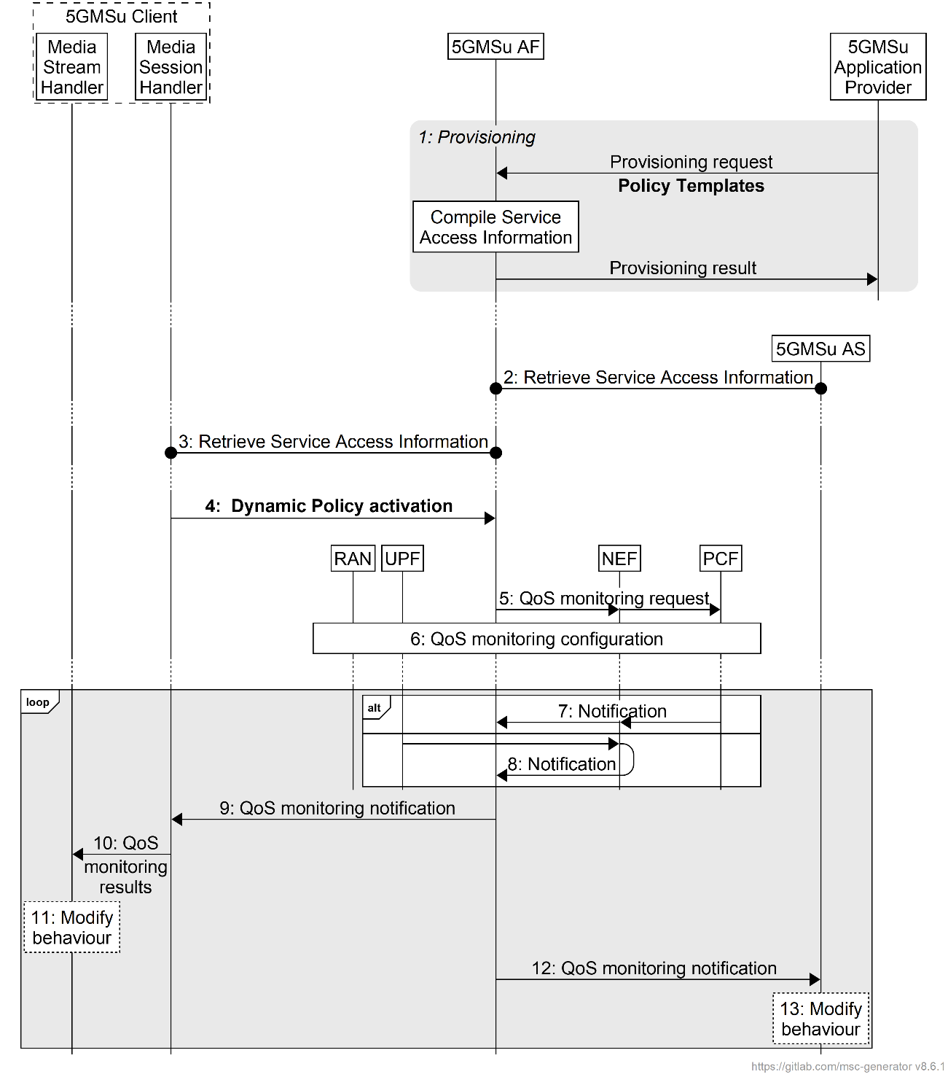
Figure 6.9.9-1: High-level call flow for QoS monitoring for uplink Media Streaming
The steps are as follows:
1. Policy Template Provisioning. A Policy Template is provisioned with a QoS monitoring configuration, indicating a preference for enabling QoS monitoring functionality. The QoS monitoring configuration includes the parameters to be monitored, the reporting frequency (event triggered, periodic), and optionally the notification via UPF.
NOTE 1: In case the 5GMSu AS is deployed as an EAS instance in the Edge DN, a local UPF can also be inserted for local access to the 5GMSu Edge AS. In order to reduce the latency used for exposure of the QoS monitoring results, the local UPF is expected to provide the notifications of network status directly to the 5GMSu AF and 5GMSu AS, or via a locally deployed NEF as defined in clause 5.8.2.17 of TS 23.501 [2].
2. Service Access Information retrieval by 5GMSu AS. The 5GMSu AS retrieves Service Access Information from 5GMSu AF via reference point M3u. The 5GMSu AS subscribes to receive notifications from the 5GMSu AF about changes to the monitored QoS parameters for all relevant Dynamic Policies.
3. Service Access Information retrieval by Media Session Handler. The Media Session Handler retrieves Service Access Information from the 5GMSu AF via reference point M5u. A Policy Template Binding is present within the Service Access Information for each provisioned Policy Template. Policy Template Bindings include a QoS monitoring enablement preference flag indicating a preference that QoS monitoring is be enabled when instantiating the corresponding Policy Template.
4. Dynamic Policy activation. The Media Session Handler within the 5GMSu Client obtains Service Access Information and triggers a dynamic policy activation. If the Media Session Handler determines that the Media Access Function is capable of consuming QoS monitoring results (based on interrogating the capabilities of the Media Access Function) it shall set a QoS monitoring enabled flag accordingly in the Dynamic Policy activation. If successful, the Media Session Handler subscribes to receive notifications from the 5GMSu AF about QoS monitoring results for this Dynamic Policy.
5. QoS monitoring request. The 5GMSu AF invokes the Npcf_PolicyAuthorization service or the Nnef_AFsessionWithQoS service with the requested QoS monitoring configurations if the QoS monitoring enabled flag is set to true in the Dynamic Policy request from the Media Session Handler. In the case where the 5GMSu AS is deployed in the Edge DN, the 5GMSu AF may additionally enable the exposure of QoS monitoring results via the local UPF or local NEF in this step.
6. The PCF accepts the request and enables QoS monitoring within the 5G System, i.e., by configuring the RAN and/or the (local) UPF for monitoring and reporting of target QoS parameters for the uplink media streaming.
Following the QoS monitoring request(s):
7. The PCF may expose the QoS monitoring results to the 5GMSu AF periodically or by event triggers using the Npcf_PolicyAuthorization_Notify service operation directly at reference point N5, or else using the Nnef_EventExposure_Notify service operation via the NEF at reference point N33.
8. Alternatively, the QoS monitoring results may be exposed to the 5GMSu AF by the UPF directly using the Nupf_EventExposure_Notify service or via a locally deployed NEF using the Nnef_EventExposure_Notify service at reference point N33.
9. If QoS monitoring was requested by the Media Session Handler, the 5GMSu AF sends the notifications of the QoS monitoring results to the Media Session Handler via reference point M5u.
10. The Media Session Handler provides QoS monitoring results to the Media Stream Handler at reference point M11u.
11. The Media Stream Handler may use the notified QoS monitoring results to modify its behaviour. For example, in the case of uplink media streaming, the Media Player may use the monitored packet latency, congestion status, etc. to determine the bit rate of the uplink streaming.
12. The 5GMSu AF may provide the QoS monitoring results to the 5GMSu AS at reference point M3u.
13. The 5GMSu AS may use the notified QoS monitoring results to modify its behaviour.

7 5GMS network media processing

7.1 General
A 5GMS Application Provider may request media processing to be performed on its media data. This can be instantiated as part of the uplink or downlink media streaming.
The media processing is performed according to one or more Content Preparation Templates by a set of 5GMS AS instances, which may need to build complex media processing workflows. The 5GMS AF coordinates the media processing and ensures that the appropriate QoS and traffic handling for the session are provided.

7.2 Media processing procedures for downlink media streaming
As part of setting up a Content Hosting Configuration for downlink media streaming, a 5GMSd Application Provider may request content preparation to be performed.
The following content preparation operations may be available:
- Adaptive Bit Rate (ABR) encoding, encryption and encapsulation.
- Presentation manifest (e.g., MPD) generation and media segment (e.g., DASH) packaging.
- Content replacement (e.g., advertising insertion, blackouts, regional content):
- Presentation manifest (e.g., MPD) modification.
- Content enrichment, such as Closed Caption insertion, object detection, content filtering, etc.
- Media object encoding and/or packaging.
The procedures are as follows:
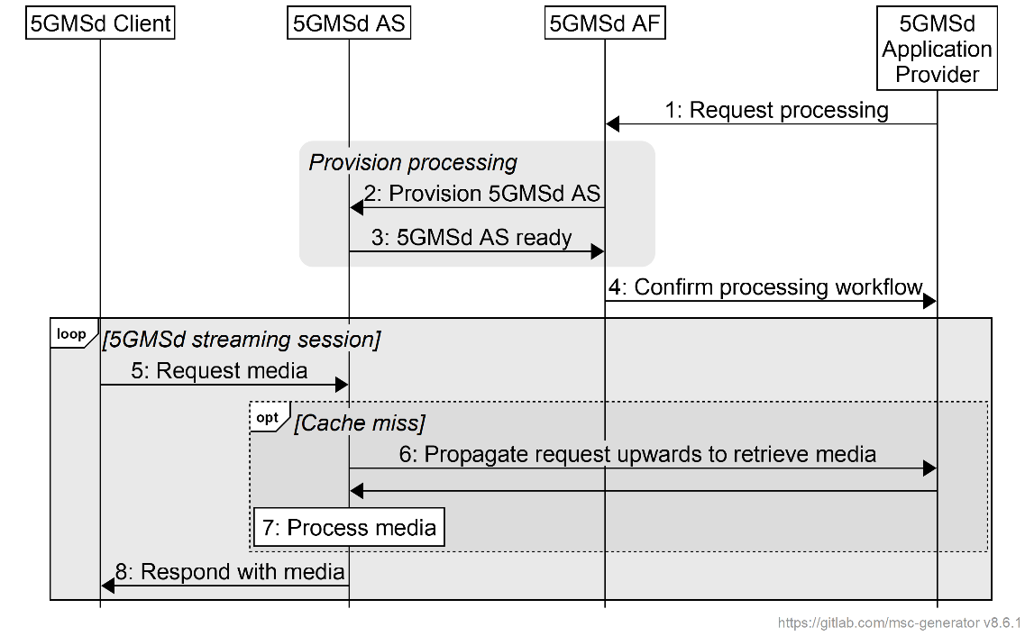
Figure 7.2-1: Media processing procedures for downlink media streaming
The steps are as follows:
1. Upon setting up a Content Hosting Configuration, the 5GMSd Application Provider requests media processing to be set up. The 5GMSd Application Provider provides a description of the type and placement of the processing. The 5GMS System may only allow a shortlisted set of media processing functions to be used by the 5GMSd Application Provider.
2. The 5GMSd AF provisions via reference point M3d a selected set of 5GMSd AS instance(s) to fulfil the requested media processing in the appropriate placement by means of one or more Content Preparation Templates references by a Content Hosting Configuration. Depending on the configuration, one or multiple AS instance(s) may be involved. The Content Hosting Configuration may also reference Server Certificates configured at reference point M3d.
3. The 5GMSd AS instance(s) confirm successful provisioning to the 5GMSd AF.
4. The 5GMSd AF confirms the successful creation of the Content Hosting Configuration with the requested media processing to the external Media application server.
5. A 5GMSd Client sends a request for media content to one of the 5GMSd AS instance(s) listed in the provisioned Content Hosting Configuration (see clause 5.4).
6. If it does not already have a copy of the requested media cached, the 5GMSd AS fetches the media from the 5GMSd Application Provider.
7. The 5GMSd AS processes the ingested media based on the media processing workflow configured by the Content Preparation Template(s) provisioned in step 2.
8. The 5GMSd AS serves the requested media to the 5GMSd Client after successful media processing.
Different variants of these procedures may be possible, depending on the type of processing, the placement of the processing, and the characteristics of the Content Hosting Configuration.

7.3 Media processing procedures for uplink media streaming
The 5GMSu AF instructs the 5GMSu AS to perform processing of the media according to the provided media processing document.
The procedure is defined as follows:
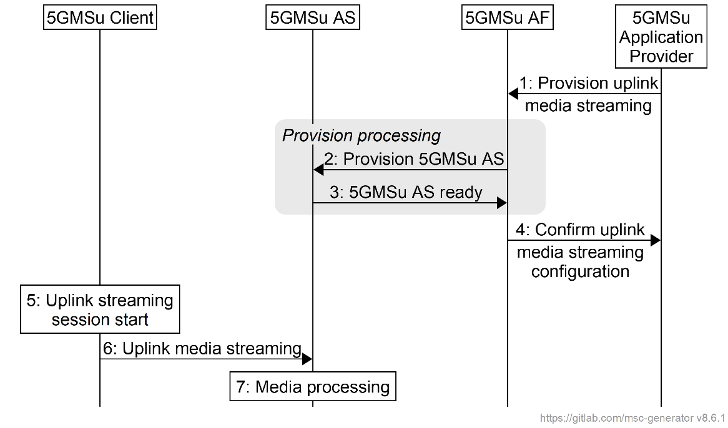
Figure 7.3-1: Media processing procedures for uplink media streaming
The steps are as follows:
1. Setup of uplink streaming configuration: The 5GMSu Application Provider sends a request to start an uplink session to the 5GMSu AF. The request contains a description of the media processing that is to be performed by the 5GMSu AS in the form of one or more Content Preparation Templates referenced by a Content Publishing Configuration. Depending on the configuration one 5GMSu AS may be involved.
2. Provision 5GMSu AS: The 5GMSu AF parses the media processing description and provisions the 5GMSu AS that will perform the requested processing via reference point M3u. If the requested processing is not accepted, the session creation fails.
3. 5GMSu AS ready: The 5GMSu AS confirms the correct configuration and informs the 5GMSu AF that it is ready to receive and process media as requested.
4. Confirm uplink streaming configuration: The 5GMSu AF confirms the successful creation of the uplink streaming configuration to the 5GMSu Application Provider.
5. Uplink streaming session starts: the session is triggered in the 5GMSu Client.
6. Uplink media streaming: Media content is streamed from the 5GMSu Client to the 5GMSu AS.
7. The 5GMSu AS process(es) the received media based on the provisioned media processing workflow configured in step 2.

8 Procedures for 5GMS Edge Processing

8.1 Procedure for client-driven management of 5GMS Edge Processing
Figure 8.1-1 outlines a detailed call flow for client-driven session establishment.
Figure 8.1-1: Client-driven session establishment
The Edge Computing Provisioning phase is a provisioning phase, that may be repeated several times (e.g. to extend edge processing coverage to new geographical areas or to increase the capacity of an already provisioned area). All steps in this phase are optional and performed on need basis. The steps are:
1. Spawn ECS: In this step, a new ECS is instantiated to manage new or increased demand for edge processing.
2. Spawn 5GMS AF: In this step, a new 5GMS AF that is edge-enabled is instantiated to handle new or increased demand for media sessions with edge processing.
3. EES Configuration: The EES is configured for a specific Edge Data Network.
4. EES Registration with ECS: The EES registers with the ECS that is in authority over the target EDN.
The 5GMS Application Provider Provisioning phase is performed prior to the establishment of any related media streaming sessions by the 5GMS Application Provider. Subsequent updates to the provisioning session are possible.
5. Create Provisioning Session: In this step, the 5GMS Application Provider creates a new provisioning session.
6. Provision 5GMS features: In this step, the 5GMS Application Provider may create different configurations such as Content Hosting, Reporting, Edge Processing, etc.
The 5GMS-Aware Application initiates a new media streaming session:
7. Application Initialization: The user launches the 5GMS-Aware Application. The application performs any required initialization steps.
8. Start session: The 5GMS-Aware Application invokes the Media Streamer with appropriate streaming access parameters.
9. Session starting event: The application informs the Media Session Handler about the start of a new 5GMS session.
10. Retrieve Service Access Information: The Media Session Handler retrieves Service Access Information from the 5GMS AF appropriate to the 5GMS session.
11. Determine eligibility for requesting edge resources: Using information from the Service Access Information, the Media Session Handler determines whether the media streaming session is eligible for requesting edge resources.
If the eligibility criteria are met in the previous step, the UE discovers an EAS instance offering 5GMS AS functionality in the Client-based Edge Computing Discovery phase:
12. Locate candidate"5GMS AS" EAS instances: The Media Session Handler (potentially triggered by a request from the 5GMS-Aware Application) asks its embedded EEC to discover the location of one or more suitable EAS instances offering the "5GMS AS" capability that are able to serve the application.
13. Locate local EES: The EEC queries the ECS for a suitable EES.
14. Register with EES: The EEC registers with the selected EES.
15. Request list of "5GMS AS" EAS instances: The EEC contacts the EES to query for one or more EAS instances offering the "5GMS AS" capability that can serve the session, using EAS discovery filters (see Table 8.5.4.2-2 in [16]) obtained as a part of the Service Access Information and/or provided by the Application Client, e.g. "5GMS AS" for EAS type, appropriate values for service feature(s), and other EAS characteristics.
The optional sub-flow is for provisioning an additional 5GMS AS instance if a suitable EAS instance offering the "5GMS AS" capability cannot be located. The steps are:
16. Check resource template: The 5GMS AF checks the provisioned edge processing resource template for the related application to determine the edge resource requirements of the application.
17. Instantiate new EAS/5MGS AS: The 5GMS AF requests the MnS to instantiate a new "5GMS AS" EAS instance using the specified requirements in the provisioned edge processing resource template and parameters provided in the query by the EEC.
18. Spawn 5GMS AS instance: The MnS creates a new instance of the EAS offering "5GMS AS" capability with the requested placement and resources.
19. EAS configuration: The newly instantiated "5GMS AS" EAS instance is configured, after which it is discoverable through DNS procedures or the discovery procedures as defined in TS 23.558 [16].
20. Register EAS with EES: The newly instantiated EAS instance registers itself with the triggering EES.
21. Configure provisioned features: This may include configuring and launching the server-side application in the 5GMS AS.
Completion of Client-based Edge Computing Discovery phase:
22. List of suitable "5GMS AS" EAS instances: The EES/5GMS AF responds to the EEC with a list of "5GMS AS" EAS instances and their characteristics in an EAS discovery response (see Table 8.5.3.3-1 in [16]). Every EAS instance in the list satisfies the requirements defined in the provisioned edge processing resource template.
23. Select preferred "5GMS AS" EAS instance: The AC and/or EEC/Media Session Handler select(s) a "5GMS AS" EAS instance from the provided list, based on the AC's desired criteria.
In the case where the media entry point provided in the Service Access Information includes a host name, the EEC/Media Session Handler inserts a record into the UE's local DNS resolver that resolves this host name to the IP address of the chosen EAS instance.
After the successful discovery of a "5GMS AS" EAS instance, the actual streaming session may start:
24. Media transfer: The 5GMS-Aware Application connects to the selected EAS "5GMS AS" and the streaming starts.
In the case where the media entry point provided in the Service Access Information includes a host name, before connecting, the Media Stream Handler first resolves this to the IP address of the EAS instance selected in step 23.
25. Method calls and notifications: Supporting information about the 5GMS session is passed from the Media Stream Handler to the Media Session Handler.
26. Reporting, network assistance, and dynamic policy: The Media Session Handler exchanges supporting information about the 5GMS session with the 5GMS AF.
27. End session: the 5GMS-Aware Application informs the Media Session Handler that the 5GMS session has ended.
28. Session ending event: The Media Streamer informs the Media Session Handler about the end of the 5GMS session.
29. Final reporting: The Media Session Handler performs any final reporting to the 5GMS AF.

8.2 Procedure for AF-driven management of 5GMS Edge Processing
Figure 8.2-1 outlines a detailed call flow for the AF-driven management of edge processing. In clause 8.1, the optional provisioning of an additional 5GMS AS instance occurs in response to an explicit call from the Application Client to an on-board EEC, whereas in this procedure the provisioning of an additional 5GMS AS instance is initiated by the 5GMS AF. This occurs, if needed, as part of and in response to Application Provider provisioning, and subsequently when needed to support the dynamically changing demands of eligible media streaming sessions. The 5GMS AS instance may also be reprovisioned at any time during the lifetime of the 5GMS Provisioning Session in response to changing demand levels (not illustrated for brevity).
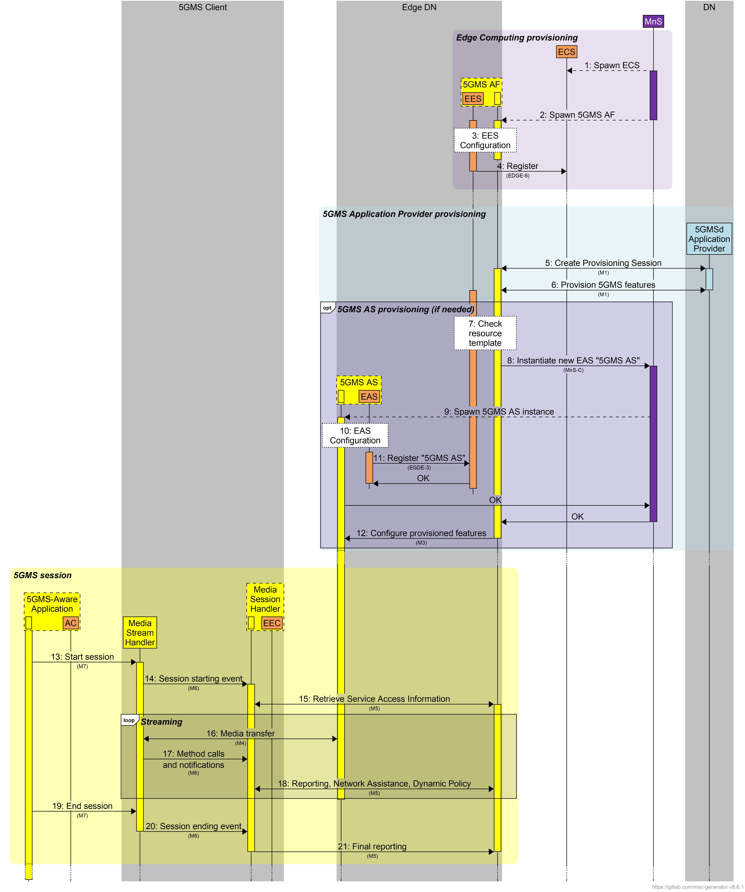
Figure 8.3.2-1: AF-driven management of 5GMS edge processing
The Edge Computing Provisioning phase is a provisioning phase, that may be repeated several times (e.g. to extend edge processing coverage to new geographical areas or to increase the capacity of an already provisioned area). All steps in this phase are optional and performed on need basis. Steps 1-4 are identical to those described in clause 8.1 above.
The 5GMS Application Provider Provisioning phase is performed prior to the establishment of any related media streaming sessions by the 5GMS Application Provider. Subsequent updates to the provisioning session are possible. Steps 5-6 are identical to those described in clause 8.1 above.
The optional sub-flow to provision an additional 5GMS AS instance may be repeated multiple times on need basis to add new capacity, to increase existing capacity for edge processing or to reallocate underused edge processing resources to other tasks. The edge processing capacity is tailored for the specific 5GMS Application Provider based on the information in the Provisioning Session. Steps 7-12 are identical to steps 16-21 described in clause 8.1 above with the following exception:
- In step 7, based on the eligibility criteria in the edge resource template, the 5GMS AF shall determine whether the media streaming session is eligible to use edge resources.
After successful discovery, the actual streaming session may start in the 5GMS Session phase. Steps 13-15 are identical to steps 8-10 described in clause 8.1 above, and steps 16-21 are identical to steps 24-29.
NOTE: In this call flow, the Application Client (AC) and EEC are not used to discover the 5GMS AS location. Instead, a Media Player Entry may be provided to the Media Session Handler by the 5GMS AF in the Service Access Information at M5 (step 15), or otherwise the location of the 5GMS AS is provided directly to the 5GMS-Aware Application via (out of scope) interface M8.

9 Procedures for Service URL handling

9.1 Baseline procedure
The launch of a 5GMS session using a 3GPP Service URL (see clause 4.10) is shown in figure 9.1-1. In this procedure, the Application is not assumed to be a 5GMS-Aware Application.
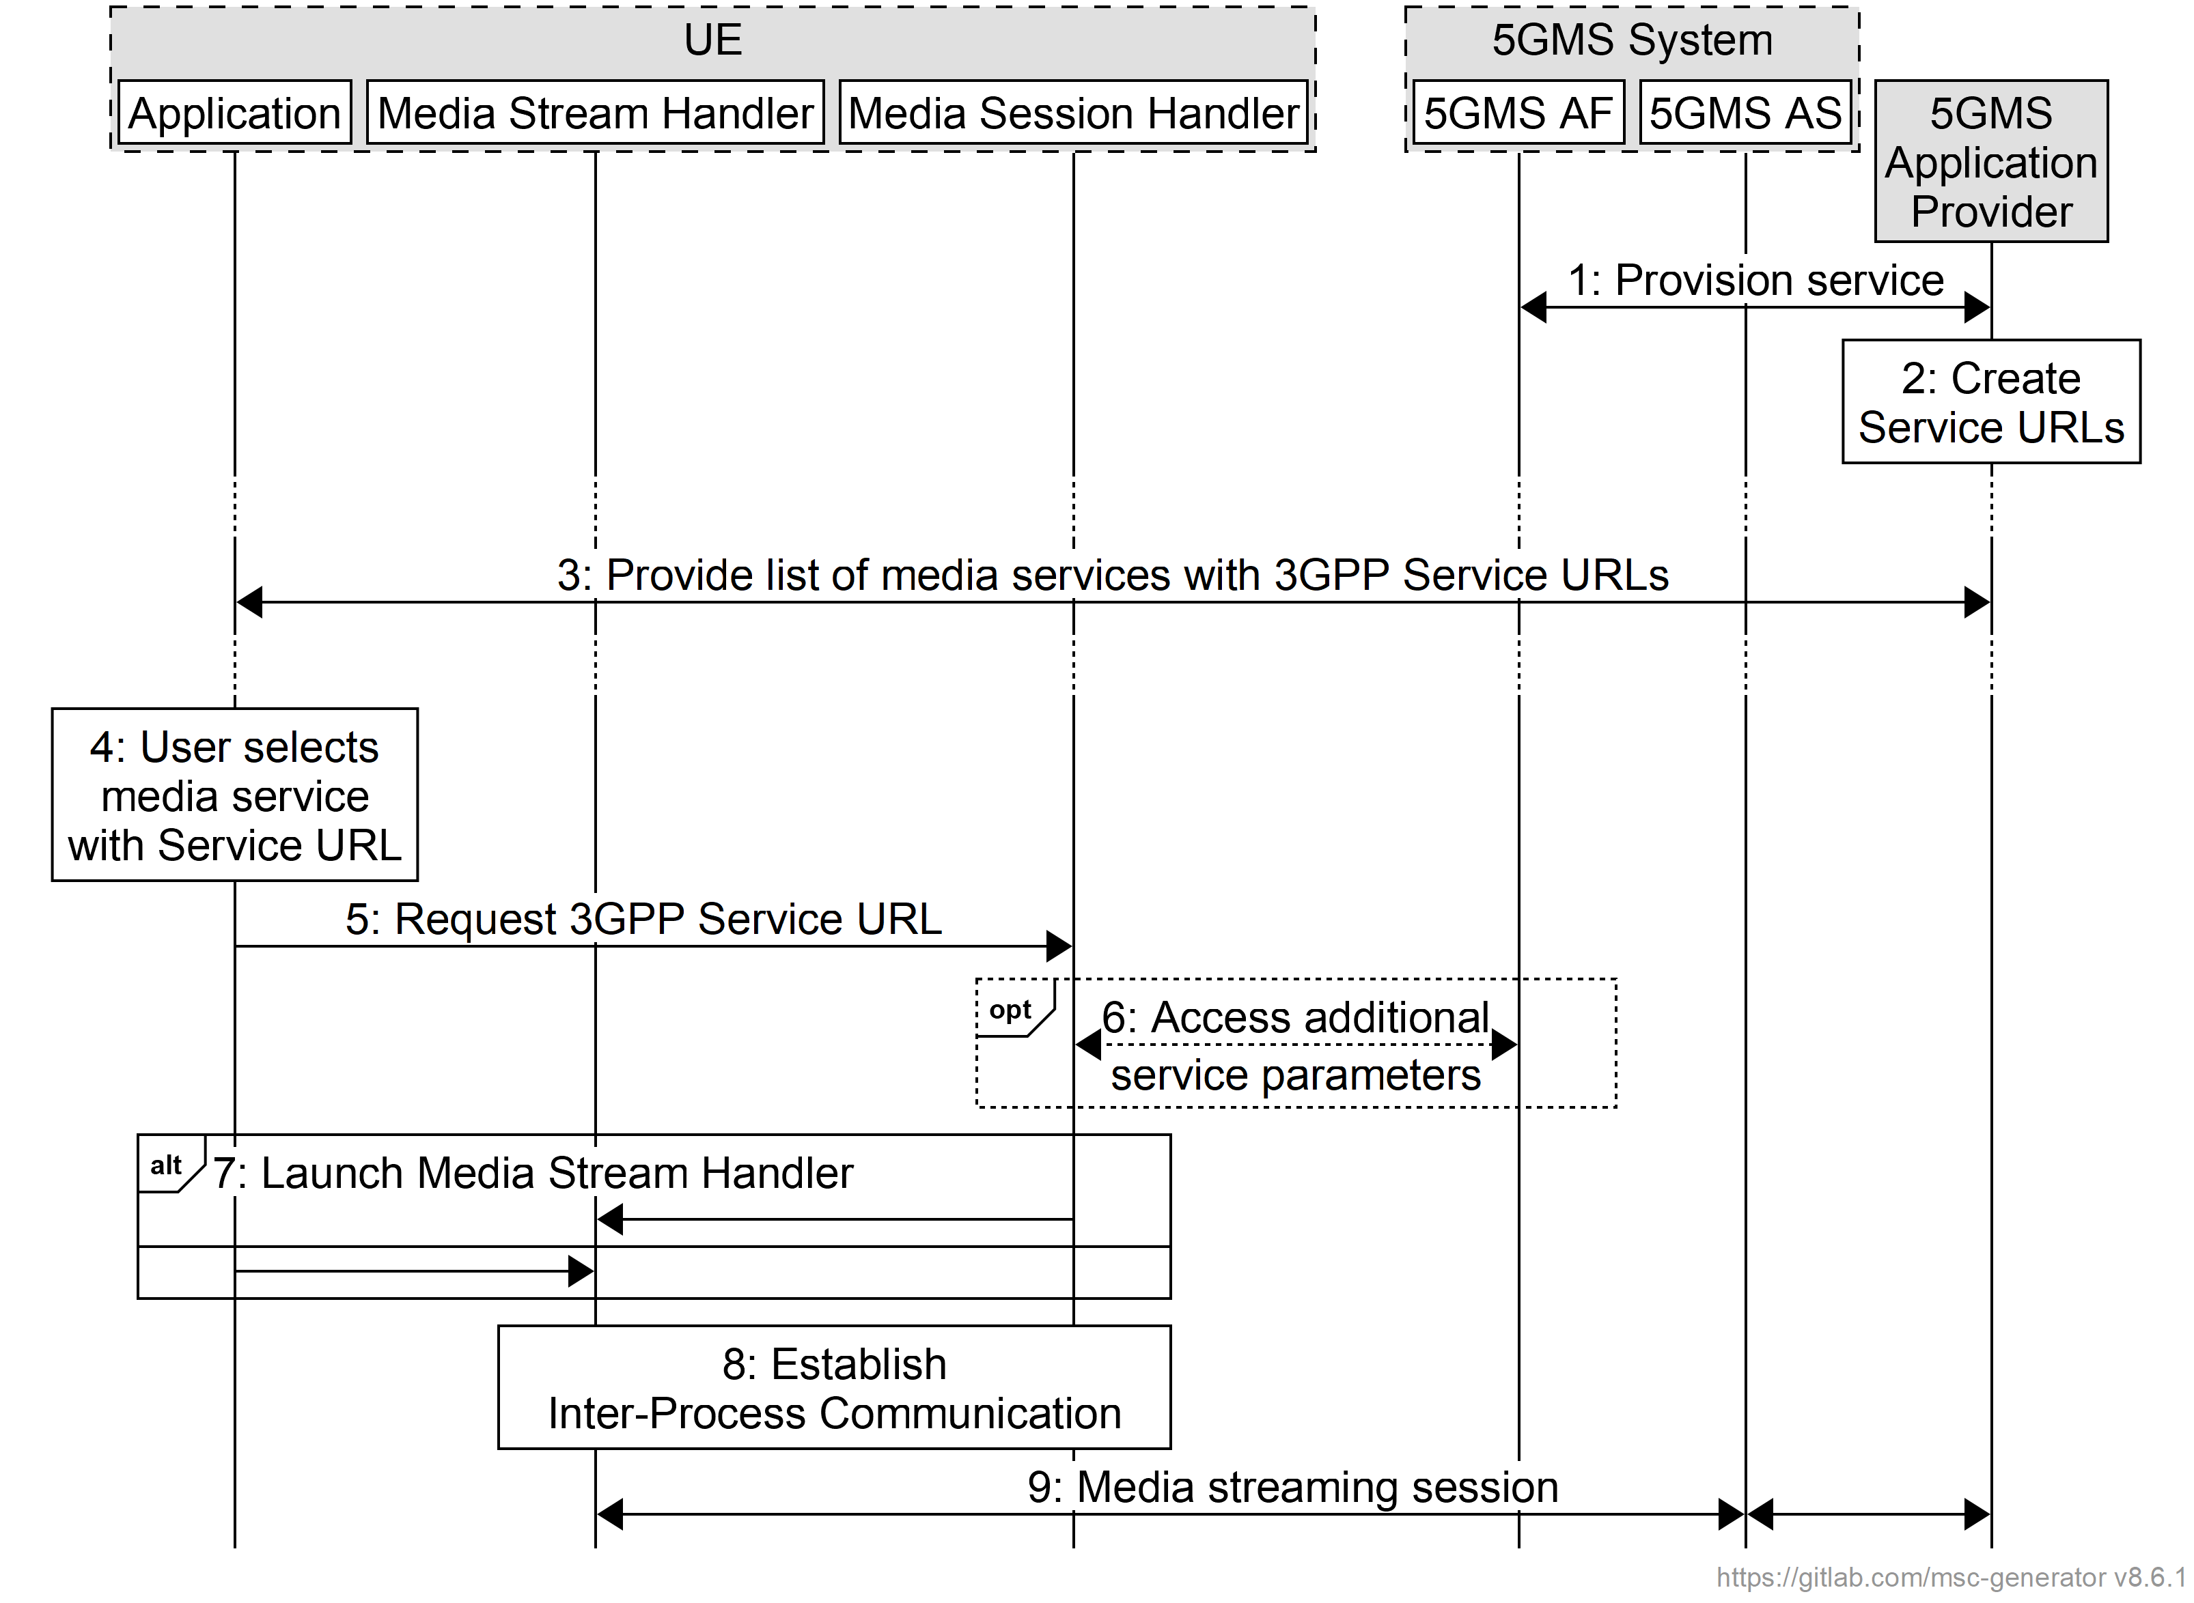
Figure 9.1-1 Baseline procedure for 3GPP Service URL Handling
The call flow is as follows:
1. The 5GMS Application Provider provisions media streaming services at reference point M1 and provides one or more External service identifiers to the 5GMS AF as part of the Provisioning Session.
2. The 5GMS Application Provider generates a unique 3GPP Service URL that includes one of the provisioned External service identifiers. Additional service announcement parameters, including a Media Entry Point URL, may also be embedded in this 3GPP Service URL.
3. The Application discovers the set of currently available media services at reference point M8.
4. The user selects a media service in the Application that is offered as a 3GPP Service URL.
5. The Application requests the 3GPP Service URL corresponding to the media service. If the Media Session Handler is available, it handles and resolves the URL.
NOTE: If the Media Session Handler is not available, the 3GPP Service URL request may be handled by the 5GMS AF as a fallback. In this case, the 5GMS AF may provide a Media Entry Point corresponding the 3GPP Service URL or reject the request.
6. The Media Session Handler may collect additional service parameters from the 5GMS AF. In particular, Service Access Information may be retrieved from the 5GMS AF using the External service identifier extracted from the 3GPP Service URL to identify the Provisioning Session of interest.
7. If the 3GPP Service URL requested in step 4 contains an embedded Media Entry Point URL, or if a Media Entry Point URL was obtained in step 5 or 6 the Media Session Handler launches the Media Stream Handler.
Alternatively, the Application may launch the Media Stream Handler directly itself using any Media Entry Point it obtained in preceding steps that is supported by the 5GMS Client.
8. Inter-Process Communication is established between the Media Stream Handler and the Media Session Handler.
9. Media streaming occurs between the Media Player, 5GMS AS and the 5GMS Application Provider.

Annex A (informative):
Usage Guidelines for collaboration scenarios

A.0 General
This annex describes a set of collaboration scenarios and deployment options of the 5G Media Streaming architecture. The intention is to illustate different deployment options.
Note that the scenarios focus on the ownership of the functions. Scalability realizations such as a CDN are not illustrated. As result of the scalability considerations, the M4-serving 5GMS AS and/or M5-serving 5GMS AF:
- May consist of multiple (physical) servers, which may be addressed using a single FQDN. A load balancer forwards client requests to one of these servers. Forwarding may be via HTTP redirects or transparent towards the client.
- May consist of multiple (physical) servers, where different servers, or different groups of servers, may be addressed with different FQDNs. The client may be made aware of this via the manifest (i.e. listing multiple base URLs).
NOTE: In this case the servers may be managed by the same or different parties (e.g. MNO and/or 5GMS Application Provider).
- May be addressed with a single FQDN. For example, the MNO AS is mostly transparent and acts as a proxy/cache.
NOTE: In every collaboration scenario of this Annex, any step which differs from the baseline call flow is shown in bold text.

A.1 Downlink media streaming with AS deployed in an external Data Network (OTT)
The collaboration scenario shown in figure A.1-1 represents a typical OTT collaboration scenario, where only the 5GMSd AS is deployed and which resides in an external Data Network. In this collaboration scenario, neither the 5GMSd AF nor the Media Session Handler function of the 5GMSd Client is present/necessary for downlink media streaming operation. All Service Announcement Information is delivered at reference point M8d from the 5GMSd Application Provider to the 5GMSd-Aware Application. The latter then passes the Service Acess Information contained in the service announcement to the Media Player to enable downstream media streaming session establishment and media transfer. In addition, M8d is used for UE application-level data reporting from the 5GMSd Aware Application to the 5GMSd Application Provider. The Provisioning API (M1d′) and Ingest API (M2d′) may follow 5GMS specifications.
Figure A.1-1: Downlink media streaming with AF and AS in an external Data Network
The interfaces M1d′ and M2d′ may be similar to interfaces M1d and M2d respectively. Interface M4d follows 3GPP specifications.
NOTE: Although a single logical 5GMSd AS exposes both the M2d′ (Ingest) and M4d (Downlink Streaming) interfaces, these APIs may, in a real deployment, be implemented on different physical servers (with different FQDNs). Furthermore, a large number of serving nodes, each with its own FQDN may offer the M4d service, following CDN scaling principles.

A.2 Downlink media streaming with both AF and AS deployed in the trusted Data Network
This collaboration scenario shown in figure A.2-1 represents a MNO CDN scenario, where the CDN is used for ingest and delivery of the content. In this collaboration scenario, similar to that in clause A.1, the Media Session Handler is not present/necessary for downlink media streaming operation since all Service Access Information is delivered at reference point M8d from the 5GMSd Application Provider to the 5GMSd-Aware Application, and in turn the Service Access Information is passed to the Media Player. Similarly, M8d is used for UE application-level data reporting from the 5GMSd-Aware Application to the 5GMSd Application Provider. The 5GMSd AF is present in this scenario to obtain Service Access Information from the 5GMSd Application Provider (at M1d), and in turn, passes that information to the 5GMSd AS.
Figure A.2-1: Downlink media streaming with AF and AS in the trusted Data Network

A.3 Downlink media streaming with both AF and AS deployed in an external Data Network (OTT)
The collaboration scenario shown in figure A.3-1 represents a typical OTT collaboration scenario, where the 5GMSd AF and 5GMSd AS are deployed in an external Data Network. The 5GMSd AF interacts with the NEF via N33. The Provisioning API (M1d′) and Ingest API (M2d′) may follow 5GMS specifications.
Figure A.3-1: Downlink media streaming with AF and AS in an external Data Network (OTT)
NOTE 1: The M5d API may be exposed using a different FQDN than the M1d′ API exposing function.
NOTE 2: The M5d API may be exposed using several FQDNs, e.g. for different M5d assistance services.

A.4 Downlink media streaming with AF deployed in the trusted Data Network and AS deployed in an external Data Network
This collaboration scenario shown in figure A.4-1 depicts a content hosting function in the external Data Network, e.g. using a third-party CDN in collaboration with MNO offered assistance and network services. The Provisioning API (M1d′) and Ingest API (M2d′) may follow 5GMS specifications.
Figure A.4-1: Downlink media streaming with AF in the trusted Data Network and AS in external Data Network
Interfaces M1d′ and M2d′ may be similar to interfaces M1d and M2d respectively. Interface M4d follows 5GMS specifications.

A.5 Downlink media streaming with AS deployed in an external Data Network, provisioned by AF deployed in the trusted Data Network
The collaboration scenario shown in figure A.5-1 is similar to that depicted in clause A.4 with the difference that the external content hosting function (5GMSd AS) is provisioned from a 5GMSd AF which is located in a trusted Data Network. It is expected that a 5GMSd AF and 5GMSd AS from different providers are interconnected using an M3d interface. The Ingest API (M2d′) may follow 5GMS specifications.
Figure A.5-1: Downlink media streaming with AS in external Data Network, provisioned by AF in the trusted Data Network
Interface M2d′ may be similar to interface M2d. All other interfaces depicted follow 3GPP specifications.

A.6 Downlink media streaming with AS deployed in the trusted Data Network, provisioned by AF deployed in an external Data Network
The collaboration scenario shown in figure A.6-1 is similar to those depicted in clauses A.4 and A.5 with the difference that the trusted content hosting function (5GMSd AS) is provisioned from an external 5GMSd AF. It is expected that a 5GMSd AF and 5GMSd AS from different providers are interconnected using an M3d interface. The Provisioning API (M1d′) may follow 5GMS specifications. Interactions between the externally-deployed 5GMSd AF and the PCF are proxied via the NEF at reference point N33.
Figure A.6-1: Downlink media streaming with AS in the trusted Data Network, provisioned by AF in external Data Network
The interface at reference point M1d′ may be similar to that defined at reference point M1d. All other interfaces depicted follow 3GPP specifications.

A.7 Downlink media streaming with both AF and AS deployed in the trusted Data Network and AF interaction with PCF
The collaboration scenario shown in figure A.7-1 represents a MNO CDN scenario (similar to that in clause A.2) where the CDN is used for ingest and delivery of the content. Additional 5GMS features are used which require interaction with the PCF.
Figure A.7-1: Downlink media streaming with AF and AS in the trusted Data Network

A.8 Downlink media streaming with AFs deployed in two separate trusted Data Networks sharing AS in an external Data Network
The collaboration scenario shown in figure A.8-1 represents a multi-MNO distribution scenario where an external CDN (5GMSd AS) is used to deliver content through multiple 5GMSd capable PLMNs. Additional 5GMSd features are used from the serving 5GMS System which need interactions with the PCF of the serving PLMN. The Provisioning API (M1d′) and Ingest API (M2d′) may follow 5GMS specifications.
Figure A.8-1: Downlink media streaming with AFs in two trusted Data Networks sharing AS in external Data Network

A.9 Downlink media streaming with both AF and AS deployed in external Data Network and AS delivering content through two trusted Data Networks (OTT)
This collaboration scenario shown in figure A.9-1 represents a multi-MNO distribution scenario where an external CDN (5GMSd AS) is used to deliver content through multiple 5GMSd-capable PLMNs. Additional 5GMSd features are used from the serving 5GMSd system which need interactions with the NEF of the serving PLMN. The Provisioning API (M1d′) and Ingest API (M2d′) may follow 5GMS specifications.
Figure A.9-1: Downlink media streaming with AF and AS in external Data Network delivering through two trusted Data Networks (OTT)

A.10 Uplink media streaming using content preparation with both AF and AS deployed in the trusted Data Network
In this collaboration scenario shown in figure A.10-1, both the 5GMSu AS and 5GMSu reside in the trusted Data Network. Additionally, reference point M2u is used for content egest to the external 5GMSu Application Provider.
Figure A.10-1: Uplink media streaming with AF and AS in trusted Data Network
Figure A.10-2 provides a high-level call flow for this collaboration scenario.
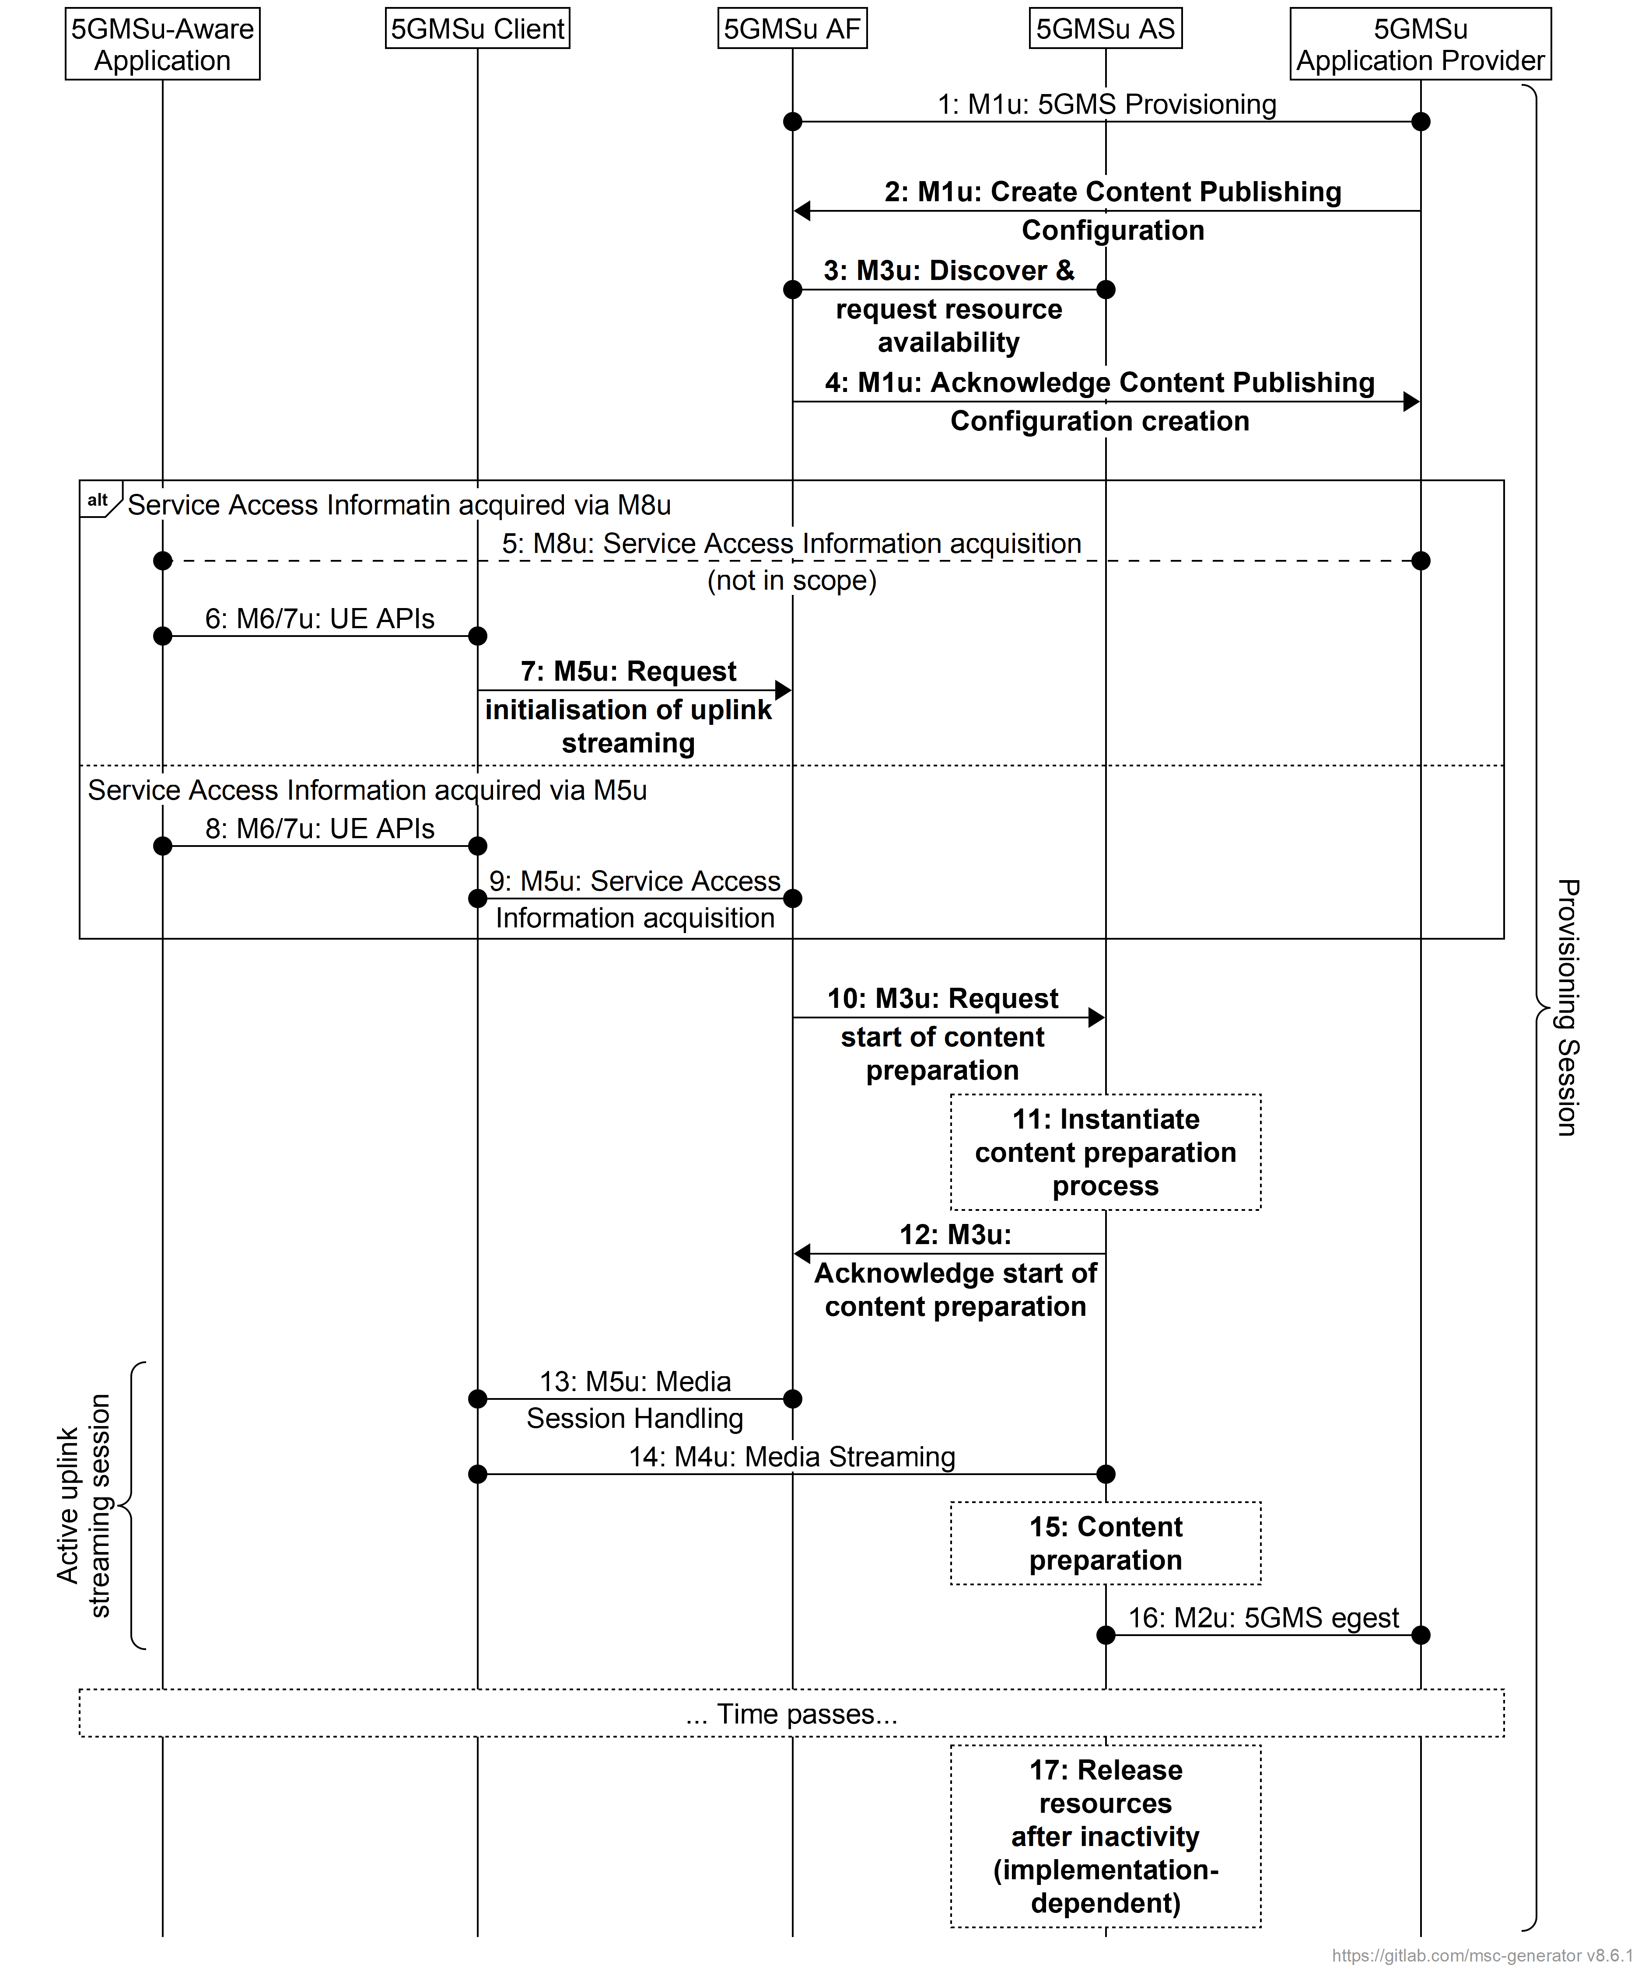
Figure A.10-2: Call flow for uplink media streaming using content preparation with AF and AS in trusted Data Network
Steps:
1. The 5GMSu Application Provider creates a Provisioning Session with the 5GMSu AF.
2. The 5GMSu Application Provider requests the 5GMSu AF to create one Content Publishing Configuration that defines the instructions for content egest (M1u).
3. The 5GMSu AF, based on the received Content Publishing Configuration, requests the 5GMSu AS to confirm the availability of content resources for content preparation (M3u).
4. The 5GMSu AF acknowledges the successful creation of the Content Publishing Configuration to the 5GMSu Application Provider (M1u).
At some later point in time:
5. The 5GMSu Application Provider provides Service Access Information to the 5GMS-Aware Application at reference point M8u.
6. The 5GMS-Aware Application requests the 5GMSu Client to start an uplink streaming session (M6u/M7u).
7. The 5GMSu Client requests that the 5GMSu AF initialises uplink media streaming, including any content preparation required by the Content Publishing Configuration (M5u).
Alternatively:
8. The 5GMS-Aware Application requests the 5GMSu Client to start an uplink streaming session (M6u/M7u).
9. The 5GMSu Client requests Service Access Information from the 5GSMu AF at reference point M5u.
As a consequence:
10. The 5GMSd AF requests initialisation of the content preparation process by the 5GMSd AS (M3u).
11. The 5GMSd AS initialises the content preparation process, if it is not already running.
12. The 5GMSd AF acknowledges the initialisation of the content preparation process (M3u).
Then:
13. The 5GMSu Client performs media session handling for the uplink streaming session (M5u).
14. Uplink media streaming starts from the 5GMSu Client to the 5GMSu AS (M4u).
15. If content preparation was successfully initialized at step 11 or before, the uplinked media may be manipulated by the 5GMSu AS prior to egest.
16. Media streaming egest starts from the 5GMSu AS to the 5GMSu Application Provider (M2u).
Finally:
17. The 5GMSu AS releases its resources after observing a period of interactivity.
NOTE: This step is implementation dependent.

A.11 Uplink media streaming using content preparation (media plane only) with both AF and AS deployed in the trusted Data Network
This scenario pertains to a collaboration in the uplink media plane only for which the 5GMSu AS is deployed in the trusted Data Network. Here, the 5GMS System is assumed to offer uplink streaming capabilities as a service to an external 5GMSu Application Provider. This collaboration scenario is analogous to the scenario in clause A.2 in terms of the use of M8u (as opposed to M8d in clause A.2) for the delivery of Service Access Information from the 5GMSu Application Provider to the 5GMSu Client via the 5GMSu Aware Application, and the reporting of UE application data from the 5GMSu-Aware Application to the 5GMSu Application Provider.
NOTE: Although provisioning at reference point M1u is shown between the (external) 5GMSu Application Provider and the 5GMSu AF, due to the absence of reference point M5u in this collaboration, there is no control interaction between the 5GMSu Client and the 5GMS System during an uplink streaming session.

Figure A.11-1: Uplink media streaming (media plane only) with AF and AS in the trusted Data Network
Figure A.11-2 provides a high-level call flow for this collaboration scenario.
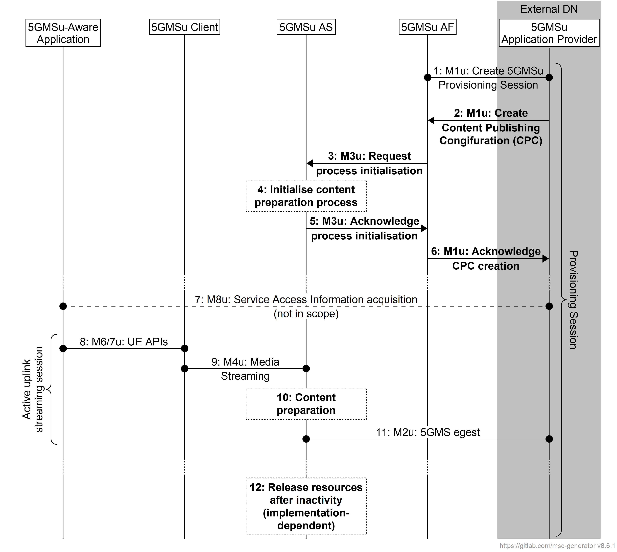
Figure A.11-2: Uplink media streaming using content preparation (media plane only) with AF and AS in the trusted Data Network
Steps:
1. The 5GMSu Application Provider creates a Provisioning Session for uplink streaming with the 5GMSu AF.
2. The 5GMSu Application Provider creates a Content Publishing Configuration as part of the Provisioning Session that defines the instructions for content egest (M1u).
3. The 5GMSu AF, based on the received Content Publishing Configuration, requests the 5GMSu AS to instantiate the content preparation process (M3u).
4. The 5GMSu AS initialises the content preparation process.
5. The 5GMSu AS acknowledges the initialisation of the required process (M3u).
6. The 5GMSu AF acknowledges the successful creation of the Content Publishing Configuration to the 5GMSu Application Provider (M1u).
At some later point in time:
7. The 5GMSu Application Provider optionally provides Service Access Information to the 5GMS-Aware Application (M8).
8. The 5GMS-Aware Application requests the 5GMSu Client to start an uplink streaming session (M6u/M7u).
9. Uplink media streaming starts from the 5GMSu Client to the 5GMSu AS (M4u).
10. If content preparation was initialized in step 4, the uplinked media may be manipulated by the 5GMSu AS prior to egest.
11. Media streaming egest starts from the 5GMSu AS to the 5GMSu Application Provider (M2u).
Finally:
12. The 5GMSu AS releases its resources after observing a period of inactivity.
NOTE: This step is implementation-dependent.

A.12 Uplink media streaming using content preparation (media plane only) with provisioning and AS in the external domain
This scenario pertains to a media plane only collaboration for which the 5GMSu AS is deployed in the external domain and the 5GMSu AF is not involved. Specifically, reference points M1′ and/or M2u′ do not follow 3GPP specifications. This collaboration scenario is analogous to the scenario in A.1 in that neither the 5GMSu AF nor the Media Session Handler function of the 5GMSu Client is present/necessary for uplink media streaming operation. Similar to the collaboration scenario in A.11, M8u is used for the delivery of Service Access Information from the 5GMSu Application Provider to the 5GMSu Client via the 5GMSu Aware Application, and the reporting of UE application data from the 5GMSu Aware Application to the 5GMSu Application Provider. The Provisioning API (M1u′) and Ingest API (M2u′) may follow 5GMS specifications.
Figure A.12-1: Uplink media streaming (media plane only) with provisioning and AS in the external domain
Figure A.12-2 provides a high-level call flow for this collaboration scenario.
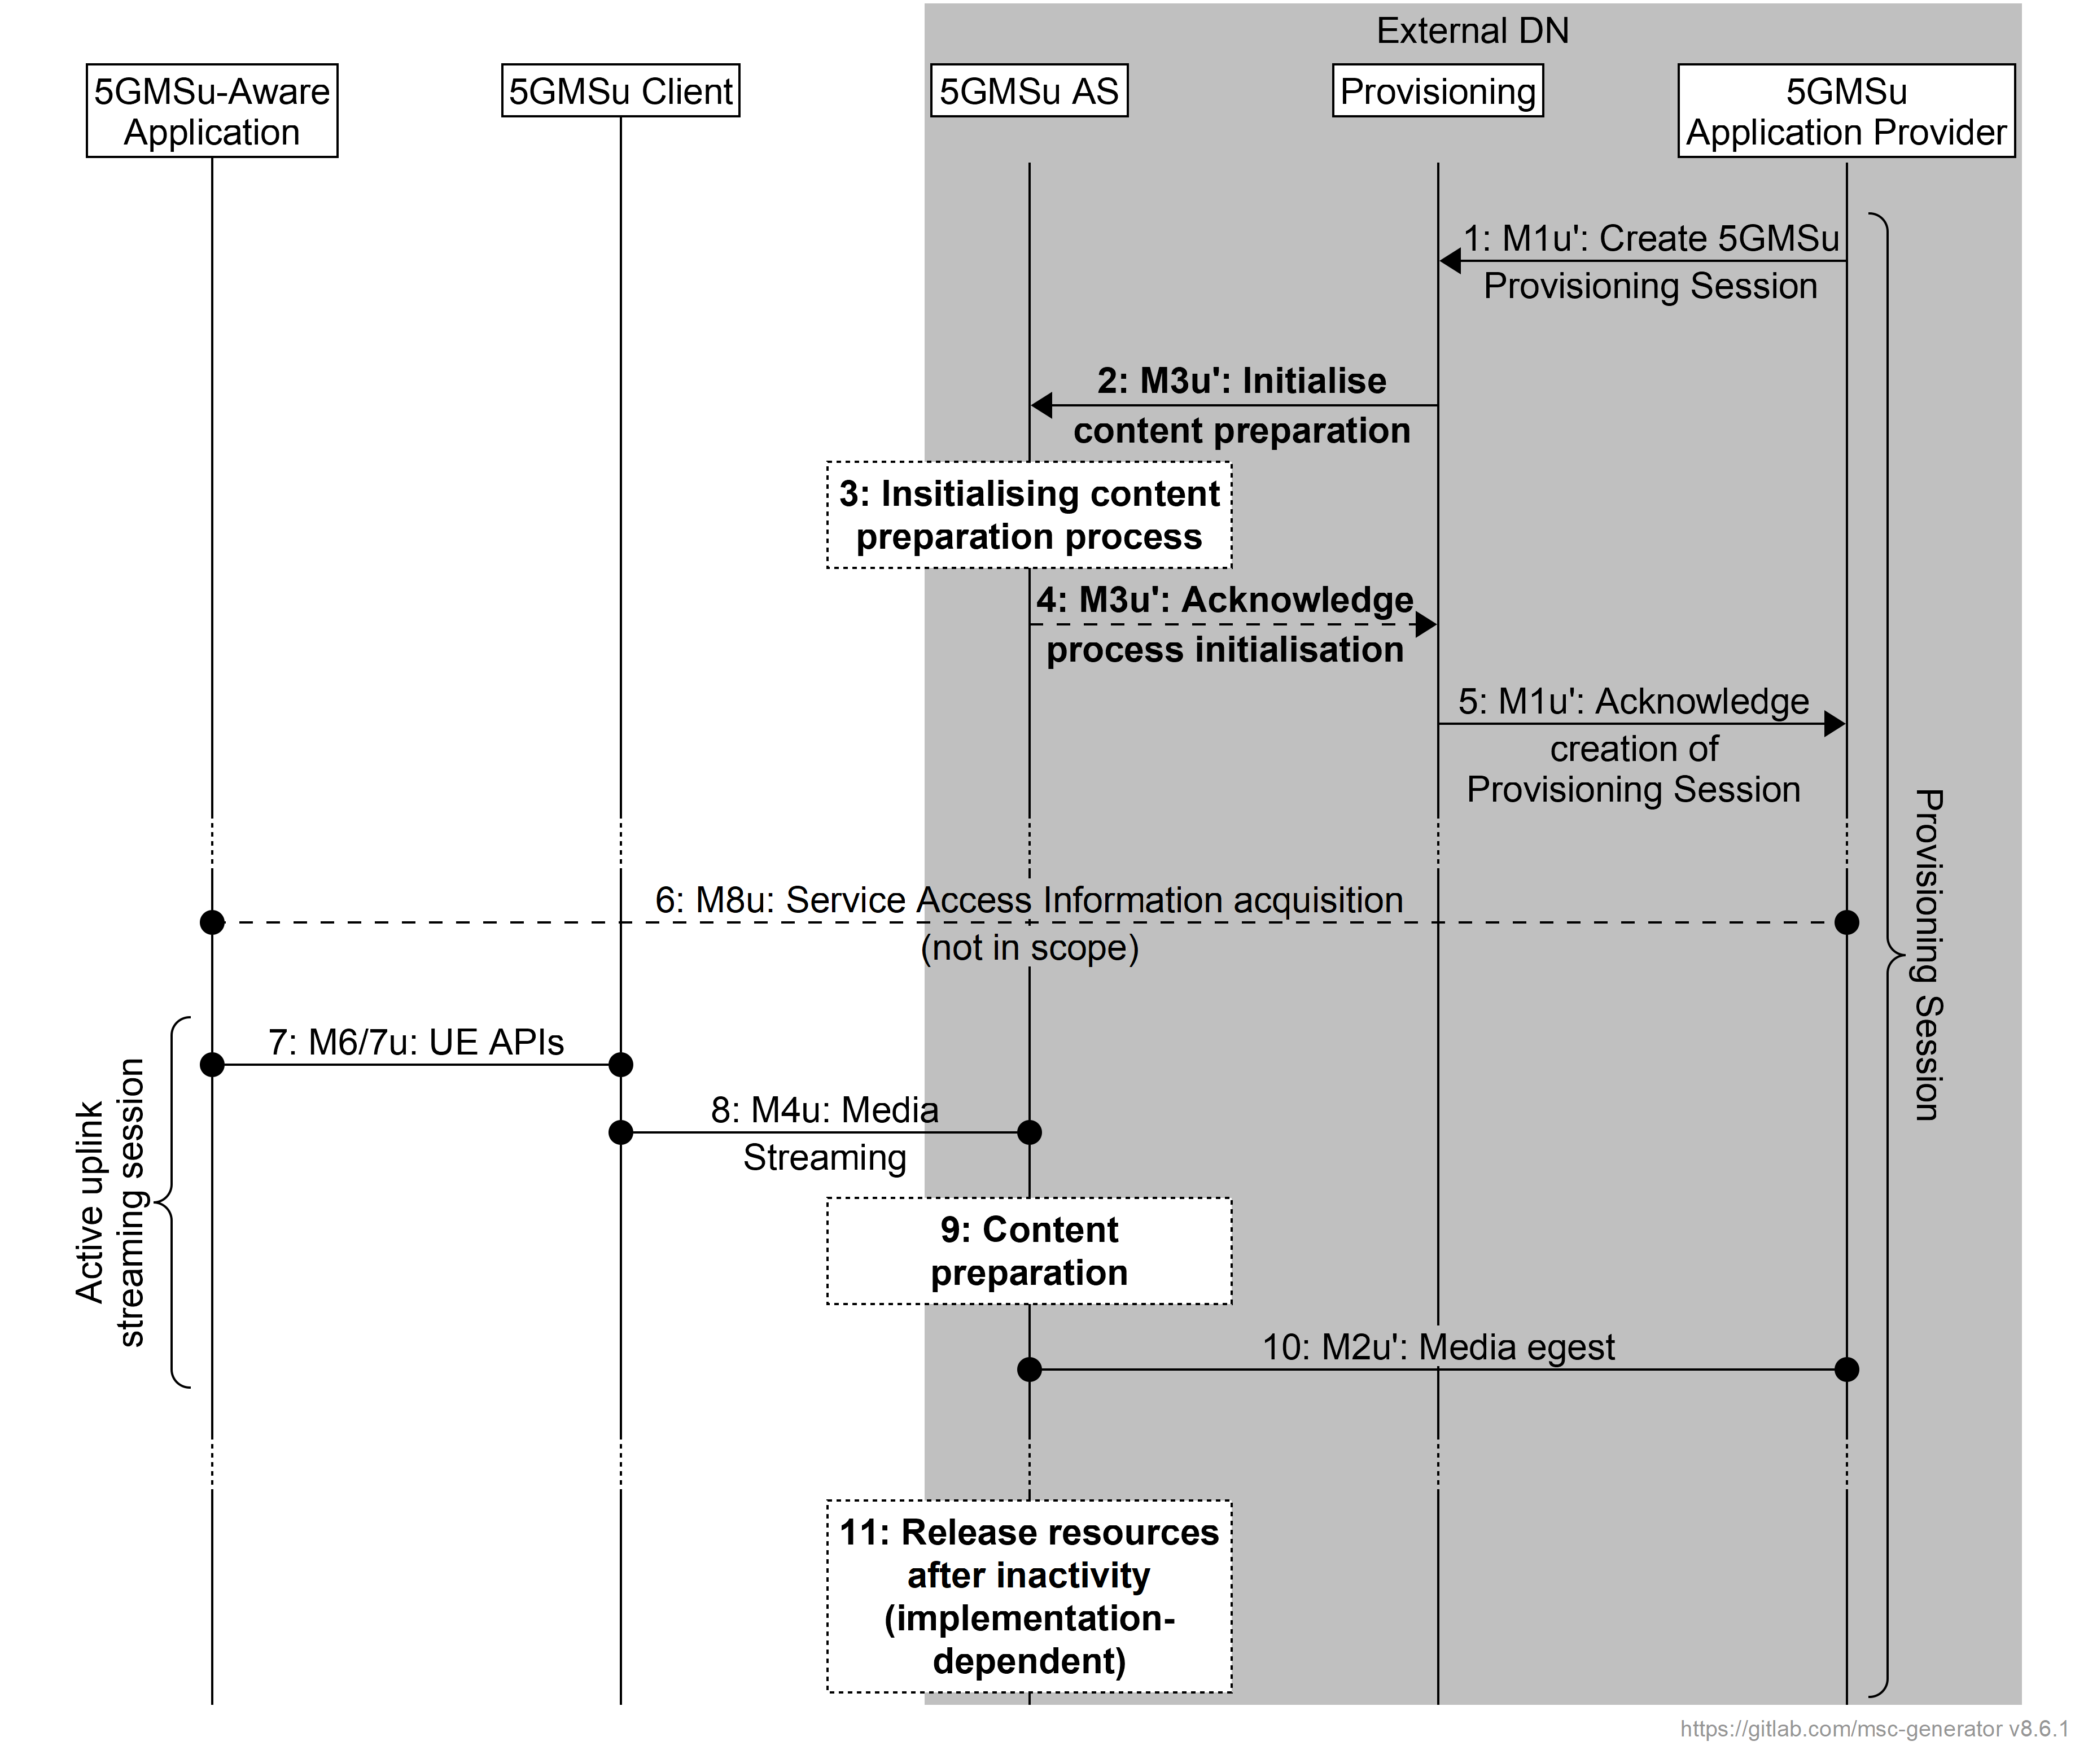
Figure A.12-2: Call flow for Uplink media streaming using content preparation (media plane only) with provisioning and AS in the external domain
Steps:
1. The 5GMSu Application Provider creates a Provisioning Session for uplink streaming with the 5GMSu AF (M1u′).
2. The Provisioning function requests the 5GMSu AS to initialise the required content preparation process (M3u′).
3. The 5GMSu AS initialises the content preparation process.
4. The 5GMSu AS acknowledges the initialisation of the required process (M3u′).
5. The Provisioning function acknowledges the successful creation of the Provisioning Session to the 5GMSu Application Provider (M1u′).
At some later point in time:
6. The 5GMSu Application Provider provides Service Access Information to the 5GMS-Aware Application (M8).
7. The 5GMS-Aware Application requests the 5GMSu Client to start an uplink streaming session (M6u/M7u).
8. Uplink media streaming starts from the 5GMSu Client to the 5GMSu AS (M4u).
9. If content preparation was initialized in step 3, the uplinked media may be manipulated by the 5GMSu AS prior to egest.
10. Media streaming egest starts from the 5GMSu AS to the 5GMSu Application Provider (M2u).
Finally:
11. The 5GMSu AS releases its resources after observing a period of inactivity.
NOTE: This step is implementation-dependent.

A.13 Uplink media streaming using content preparation with AF in the trusted Data Network and AS in the external domain
In this collaboration scenario, both the 5GMSu AS and 5GMSu AF are present. The 5GMSu AS resides in the external domain. While it employs 5GMS protocol and format for uplink media reception from the 5GMSu Client (M4u), norit performs content egest to the 5GMSu Application Provider over a M2u-like (M2u’) protocol and format (and therefore it is called 5GMSu-like AS). The 5GMSu AF is used to interact with the 5GMSu Application Provider at the reference point M1 for uplink media streaming provisioning System, and to interact with the Media Session Handler of the 5GMSu Client for providing Service Access Information, dynamic policy invocation and/or other uplink media streaming related functionality such as metrics reporting and network assistance). The Provisioning API (M1u′) and Ingest API (M2u′) may follow 5GMS specifications.
Figure A.13-1: Uplink media streaming AF in the trusted Data Network and AS in the external domain
Figure A.13-2 provides a high-level call flow for this collaboration scenario.
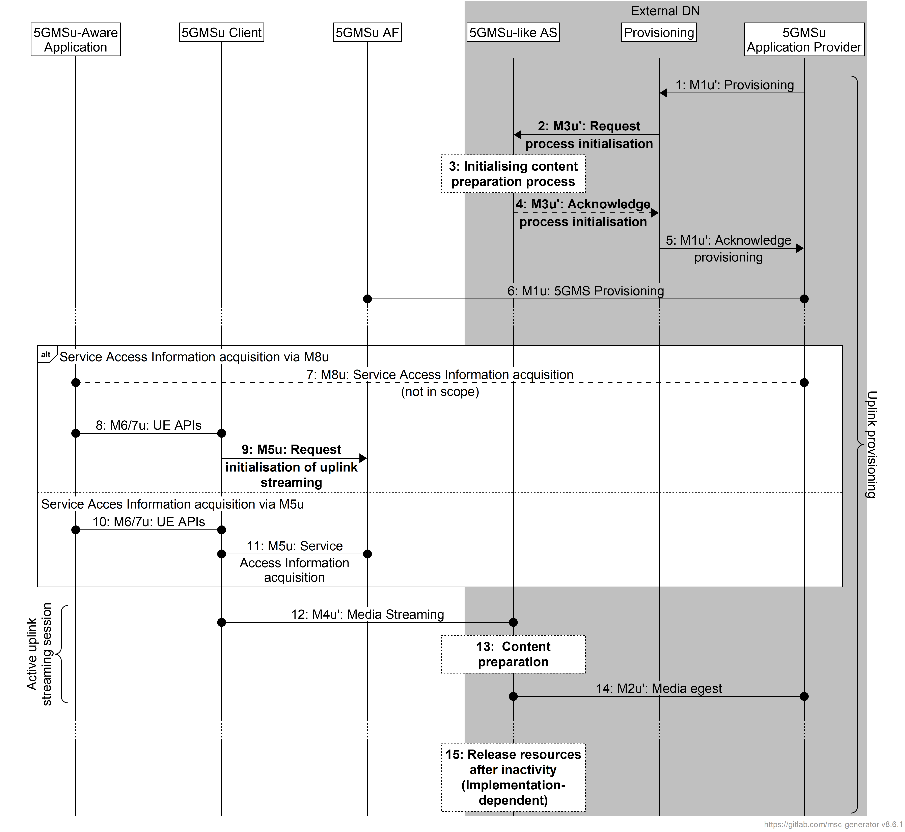
Figure A.13-2: Call flow for uplink media streaming using content preparation with AF in the trusted Data Network and AS in the external domain
Steps:
1. The 5GMSu Application Provider creates a Provisioning Session with its internal Provisioning function (M1u′).
2. The Provisioning function requests the 5GMSu-like AS to initialise the required content preparation process instantiation (M3u′).
3. The 5GMSu-like AS instantiates the content preparation process.
4. The 5GMSu-like AS acknowledges the Provisioning the instantiation of required process (M3u′).
5. The Provisioning function acknowledges successful provisioning to the 5GMSu Application Provider (M1u′).
6. The 5GMSu Application Provider creates a Provisioning Session for uplink streaming with the 5GMSu AF.
At some later point in time:
7. The 5GMSu Application Provider provides Service Access Information to the 5GMS-Aware Application at reference point M8u.
8. The 5GMS-Aware Application requests the 5GMSu Client to start an uplink streaming session (M6u/M7u).
9. The 5GMSu Client requests that the 5GMSu AF initialises uplink media streaming (M5u).
NOTE: This step is redundant in this collaboration, but occurs in order that other collaborations are supported.
Alternatively:
10. The 5GMS-Aware Application requests the 5GMSu Client to start an uplink streaming session (M6u/M7u).
11. The 5GMSu Client requests Service Access Information from the 5GSMu AF at reference point M5u.
At some later point in time:
12. Uplink media streaming starts from the 5GMSu Client to the 5GMSu-like AS (M4u′).
13. If content preparation was initialized in step 3, the uplinked media may be manipulated by the 5GMSu AS prior to egest.
14. Media streaming egest starts from the 5GMSu-like AS to the 5GMSu Application Provider (M2u′).
Finally:
15. The 5GMSu AS releases its resources after observing a period of inactivity.
NOTE: This step is implementation dependent.

A.14 Uplink media streaming using content preparation with AF and AS in the external domain
In this collaboration scenario, both the 5GMSu AS and 5GMSu AF are present and follow 3GPP specifications. Both the 5GMSu AS and 5GMSu AF reside in the external DN/domain. The Provisioning API (M1u′) and Ingest API (M2u′) may follow 5GMS specifications.
Figure A.13-1: Uplink media streaming with AF and AS in the external domain
Figure A.14-2 provides a high-level call flow for this collaboration scenario.
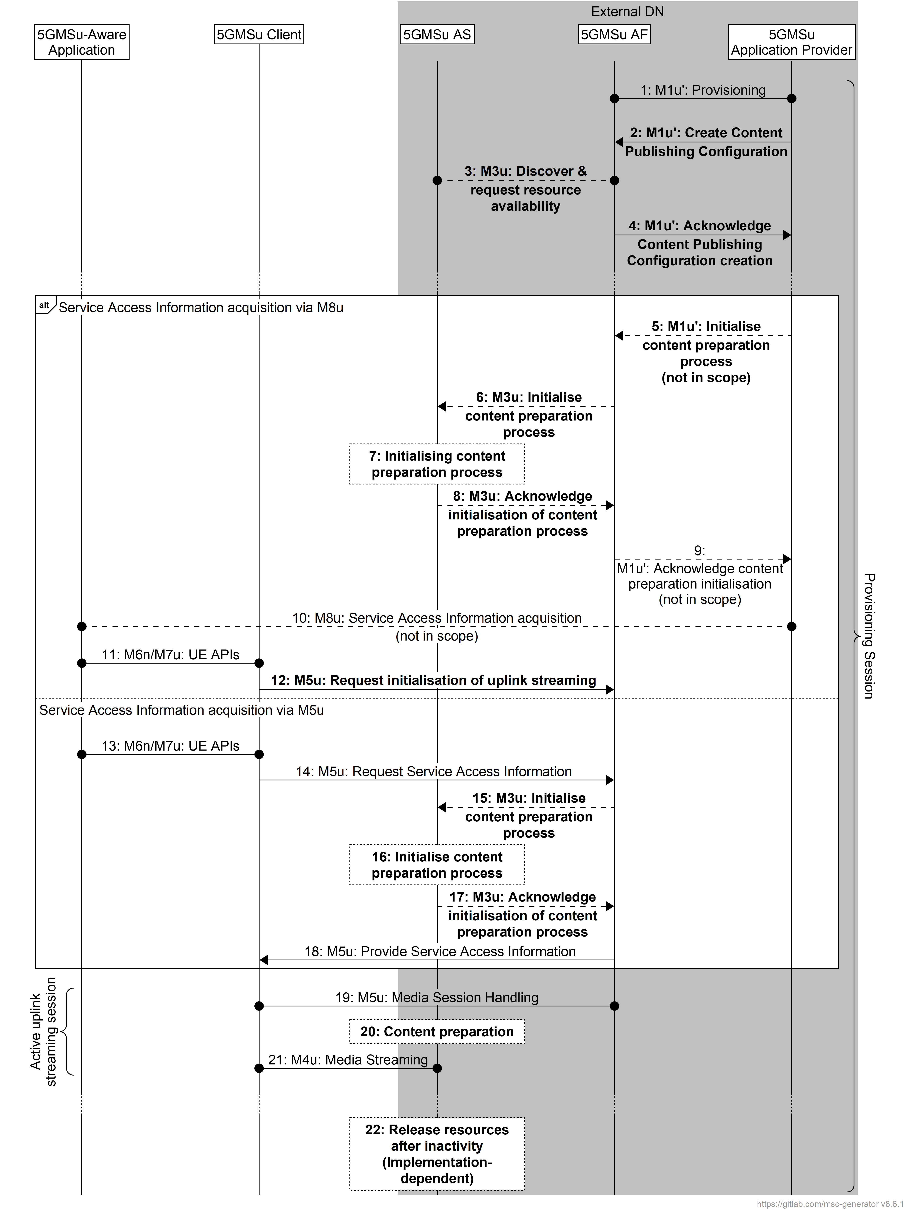
Figure A.14-2: Call flow for uplink media streaming using content preparation with AF and AS in the external domain
Steps:
1. The 5GMSu Application Provider creates a Provisioning Session for uplink streaming with the 5GMSu AF (M1u′).
2. The 5GMSu Application Provider creates a Content Publishing Configuration as part of the Provisioning Session that defines the instructions for content egest (M1u′).
3. The 5GMSu AF, based on the received publishing configuration, requests the 5GMSu AS to confirm the availability of content resources for egest (M3u).
4. The 5GMSu AF acknowledges the successful creation of the Content Publishing Configuration to the 5GMSu Application Provider (M1u′).
At some later point in time:
5. The 5GMSu Application Provider requests that the 5GMSu AF initialises the content preparation process (M1u′).
6. The 5GMSd AF requests initialisation of the content preparation process (M3u).
7. The 5GMSd AS initialises the content preparation process, if is not already running (M3u).
8. The 5GMSd AS acknowledges the initialisation of the content preparation process (M3u).
9. The 5GMSu AF acknowledges the initialisation of the content preparation process (M1u′).
10. The 5GMSu Application Provider provides Service Access Information to the 5GMS-Aware Application (M8).
11. The 5GMS-Aware Application requests the 5GMSu Client to start an uplink streaming session (M6u/M7u).
12. The 5GMSu Client requests that the 5GMSu AF initialises uplink media streaming (M5u).
NOTE: This step is redundant in this collaboration, but occurs in order that other collaborations are supported.
Alternatively:
13. The 5GMS-Aware Application requests the 5GMSu Client to start an uplink streaming session (M6u/M7u).
14. The 5GMSu Client requests Service Access Information from the 5GSMu AF (M5u).
15. The 5GMSd AF requests initialisation of the content preparation process (M3u).
16. The 5GMSd AS initialises the content preparation process, if is not already running (M3u).
17. The 5GMSd AF acknowledges the initialisation of the content preparation process (M3u).
18. The 5GMSMu AF provides Service Access Information to the 5GMSu Client (M5u).
Then:
19. Uplink media streaming starts from the 5GMSu Client to the 5GMSu AS via reference point M4u.
20. If content preparation was initialized in step 7 or 16, the uplinked media may be manipulated by the 5GMSu AS prior to egest.
21. Media streaming egest starts from the 5GMSu AS to the 5GMSu Application Provider (M2u′).
Finally:
22. The 5GMSu AS releases its resources after observing a period of inactivity.
NOTE: This step is implementation-dependent.

A.15 Cascaded uplink and downlink media streaming using content preparation

A.15.1 Introduction
This scenario represents a hybrid end-to-end form of collaboration across uplink media streaming and downlink media streaming services. An external 5GMS Application Provider relies on the 5GMS System to support both the uplink streaming media transmission by 5GMSu Clients and subsequent redistribution of that content via downlink media streaming for reception by 5GMSd Clients within the same 5GMS System.
Two distinct methods are described in the following clauses.
- In the first method (clause A.15.2) the content contributed to the 5GMSu AS using uplink media streaming is transferred indirectly to the 5GMSd AS via a 5GMS Application Provider for redistribution using downlink media streaming.
- In the second method (clause A.15.3) the content contributed to the 5GMSu AS using uplink media streaming is transferred directly from the 5GMSu AS to the 5GMSd AS without any intermediary.
These two methods are not mutually exclusive. For example, content transferred using the second method may also be egested to a 5GMSu Application Provider for subsequent redistribution by other 5GMS Systems and/or non-3GPP distribution systems.

A.15.2 Cascaded uplink and downlink media streaming using content preparation with external content re-ingestion
In a first variant of this collaboration scenario, content contributed to the 5GMS System by the 5GMSu Client is egested by the 5GMSu AS at reference point M2u (by either push- or pull-based means) and subsequently ingested by the 5GMSd AS from the 5GMS Application Provider at reference point M2d (by either push- or pull-based means).
NOTE: For redistribution with the lowest possible latency, the provisioning of both push-based egest and push-based ingest are recommended.
Figure A.15.2-1: Cascaded uplink and downlink media streaming with external content re-ingestion
Figure A.15.2-2 shows the call flow for this scenario. (To simplify the call flow, the details of the content preparation process are omitted.)
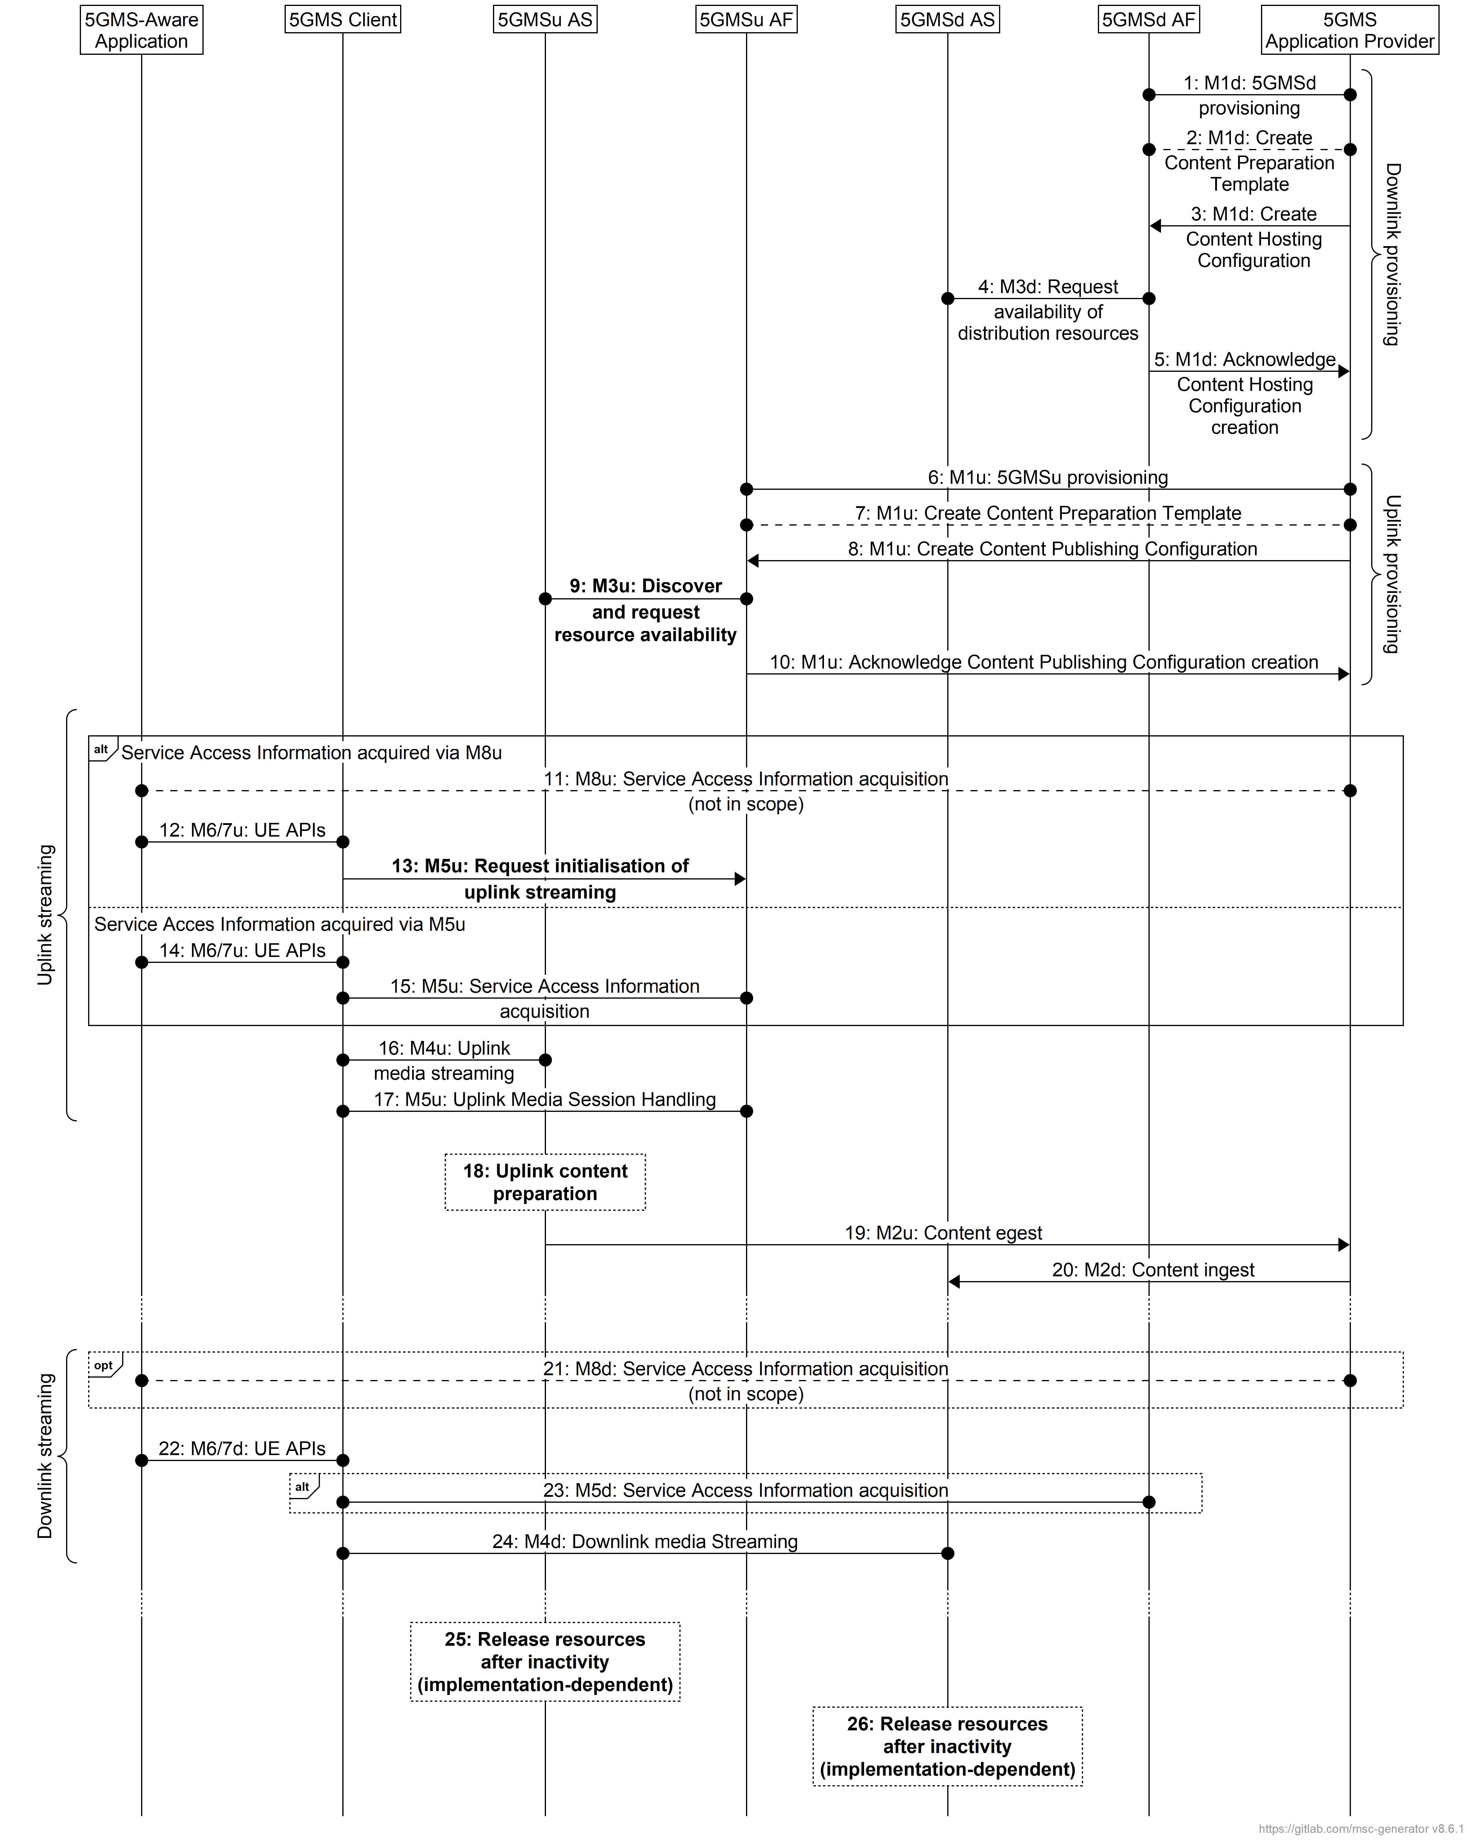
Figure A.15.2-2: Call flow for cascaded uplink and downlink media streaming using content preparation with external content re-ingestion
Steps:
1. The 5GMSd Application Provider creates a Provisioning Session with the 5GMSd AF (M1d).
2. The 5GMS Application Provider may provision the 5GMSd AF with a Content Preparation Template (M1d).
3. The 5GMSd Application Provider provisions the 5GMSd AF with a Content Hosting Configuration. The ingest configuration indicates that content will be ingested from the 5GMS Application Provider by either pull- or push-based means. If a Content Preparation Template was provisioned in the previous step, the Content Hosting Configuration may reference it.
4. The 5GMSd AF, based on the provisioned Content Hosting Configuration and Content Preparation Template, requests the 5GMSd AS to confirm the availability of content distribution resources (M3d).
5. The 5GMSd AF acknowledges to the 5GMSd Application Provider the successful creation of the Content Hosting Configuration (M1d).
6. The 5GMS Application Provider creates a Provisioning Session with the 5GMSu AF (M1u).
7. The 5GMS Application Provider may provision the 5GMSu AF with a Content Preparation Template (M1u).
8. The 5GMS Application Provider provisions the 5GMSu AF with a Content Publishing Configuration (M1u). The egest configuration indicates that contributed content will be made available to the 5GMS Application Provider by either pull- or push-based means. If a Content Preparation Template was provisioned in the previous step, the Content Publishing Configuration may reference it.
9. The 5GMSu AF, based on the provisioned Content Hosting Configuration and Content Preparation Template (if any) requests the 5GMSu AS to confirm the availability of content contribution resources (M3u).
10. The 5GMSu AF acknowledges successful provisioning to the 5GMSu Application Provider (M1u).
NOTE: In this variant of the collaboration scenario the order of downlink media streaming provisioning (steps 1–5) and uplink media streaming provisioning (steps 6–10) may be reversed.
At some later point in time:
11. The 5GMSu Application Provider provides Service Access Information for uplink media streaming to the 5GMSu-Aware Application at reference point M8u.
12. The 5GMSu-Aware Application requests the 5GMSu Client to start an uplink streaming session (M6u/M7u).
13. The 5GMSu Client requests that the 5GMSu AF initialises uplink media streaming (M5u).
Alternatively:
14. The 5GMSu-Aware Application requests the 5GMSu Client to start an uplink streaming session (M6u/M7u).
15. The 5GMSu Client requests Service Access Information from the 5GSMu AF at reference point M5u.
At some later point in time:
16. Uplink media streaming starts from the 5GMSu Client to the 5GMSu AS (M4u).
17. The 5GMSu Client invokes media session handling procedures during the uplink media streaming session (M5).
18. If content preparation was provisioned in step 7, the uplinked media may be manipulated by the 5GMSu AS prior to being egested by it.
19. The 5GMSu AS egests the content to the 5GMS Application Provider (M2u) by pull- or push-based means according to the Content Publishing Configuration provisioned in step 8.
NOTE: Steps 16–19 may continue in parallel with steps 20 and 24.
20: The 5GMSd AS ingests the content from the 5GMS Application Provider (M2d) by pull- or push-based means according to the Content Hosting Configuration provisioned in step 3.
Steps 21–24 concern the 5GMS downlink streaming process:
21. The 5GMS Application Provider optionally provides Service Access Information for downlink media streaming to the 5GMSd-Aware Application (M8d).
22. The 5GMSd-Aware Application requests the 5GMSd Client to start an uplink streaming session (M6d/M7d).
23. If Service Access Information was not provided in step 21, the 5GMSd Client requests this information from the 5GSMd AF (M5d).
24. Downlink media streaming starts from the 5GMSd AS to the 5GMSd Client (M4d).
Finally:
25. The 5GMSu AS releases its uplink content preparation resources after observing a period of interactivity.
26. The 5GMSd AS releases its downlink content preparation resources after observing a period of interactivity.
NOTE: Steps 25 and 26 are implementation-dependent.

A.15.3 Cascaded uplink and downlink media streaming using content preparation with direct content re-ingestion
In a second variant of this collaboration scenario, content contributed to the 5GMS System by the 5GMSu Client is egested by the 5GMSu AS at reference point M2u (by either push- or pull-based means) and directly ingested by the 5GMSd AS at reference point M2d (with push- or pull-based content ingest provisioned the same way as for the corresponding content egest). The content thus bypasses the external 5GMS Application Provider altogether.
NOTE 1: Although not depicted, the 5GMSd AS in this collaboration acts as a 5GMSu Application Provider for the 5GMSu AS to target. Conversely, the 5GMSu AS acts as a 5GMSd Application Provider supplying content to the 5GMSd AS.
NOTE 2: For redistribution with lower latency, the provisioning of push-based content egest and ingest is recommended.
Figure A.15.3-1: Cascaded uplink and downlink media streaming with direct content re-ingestion
Figure A.15.3-2 shows the call flow for this scenario when push-based egest/ingest is used for direct content re-ingestion. (To simplify the call flow, the details of the content preparation process are omitted.)
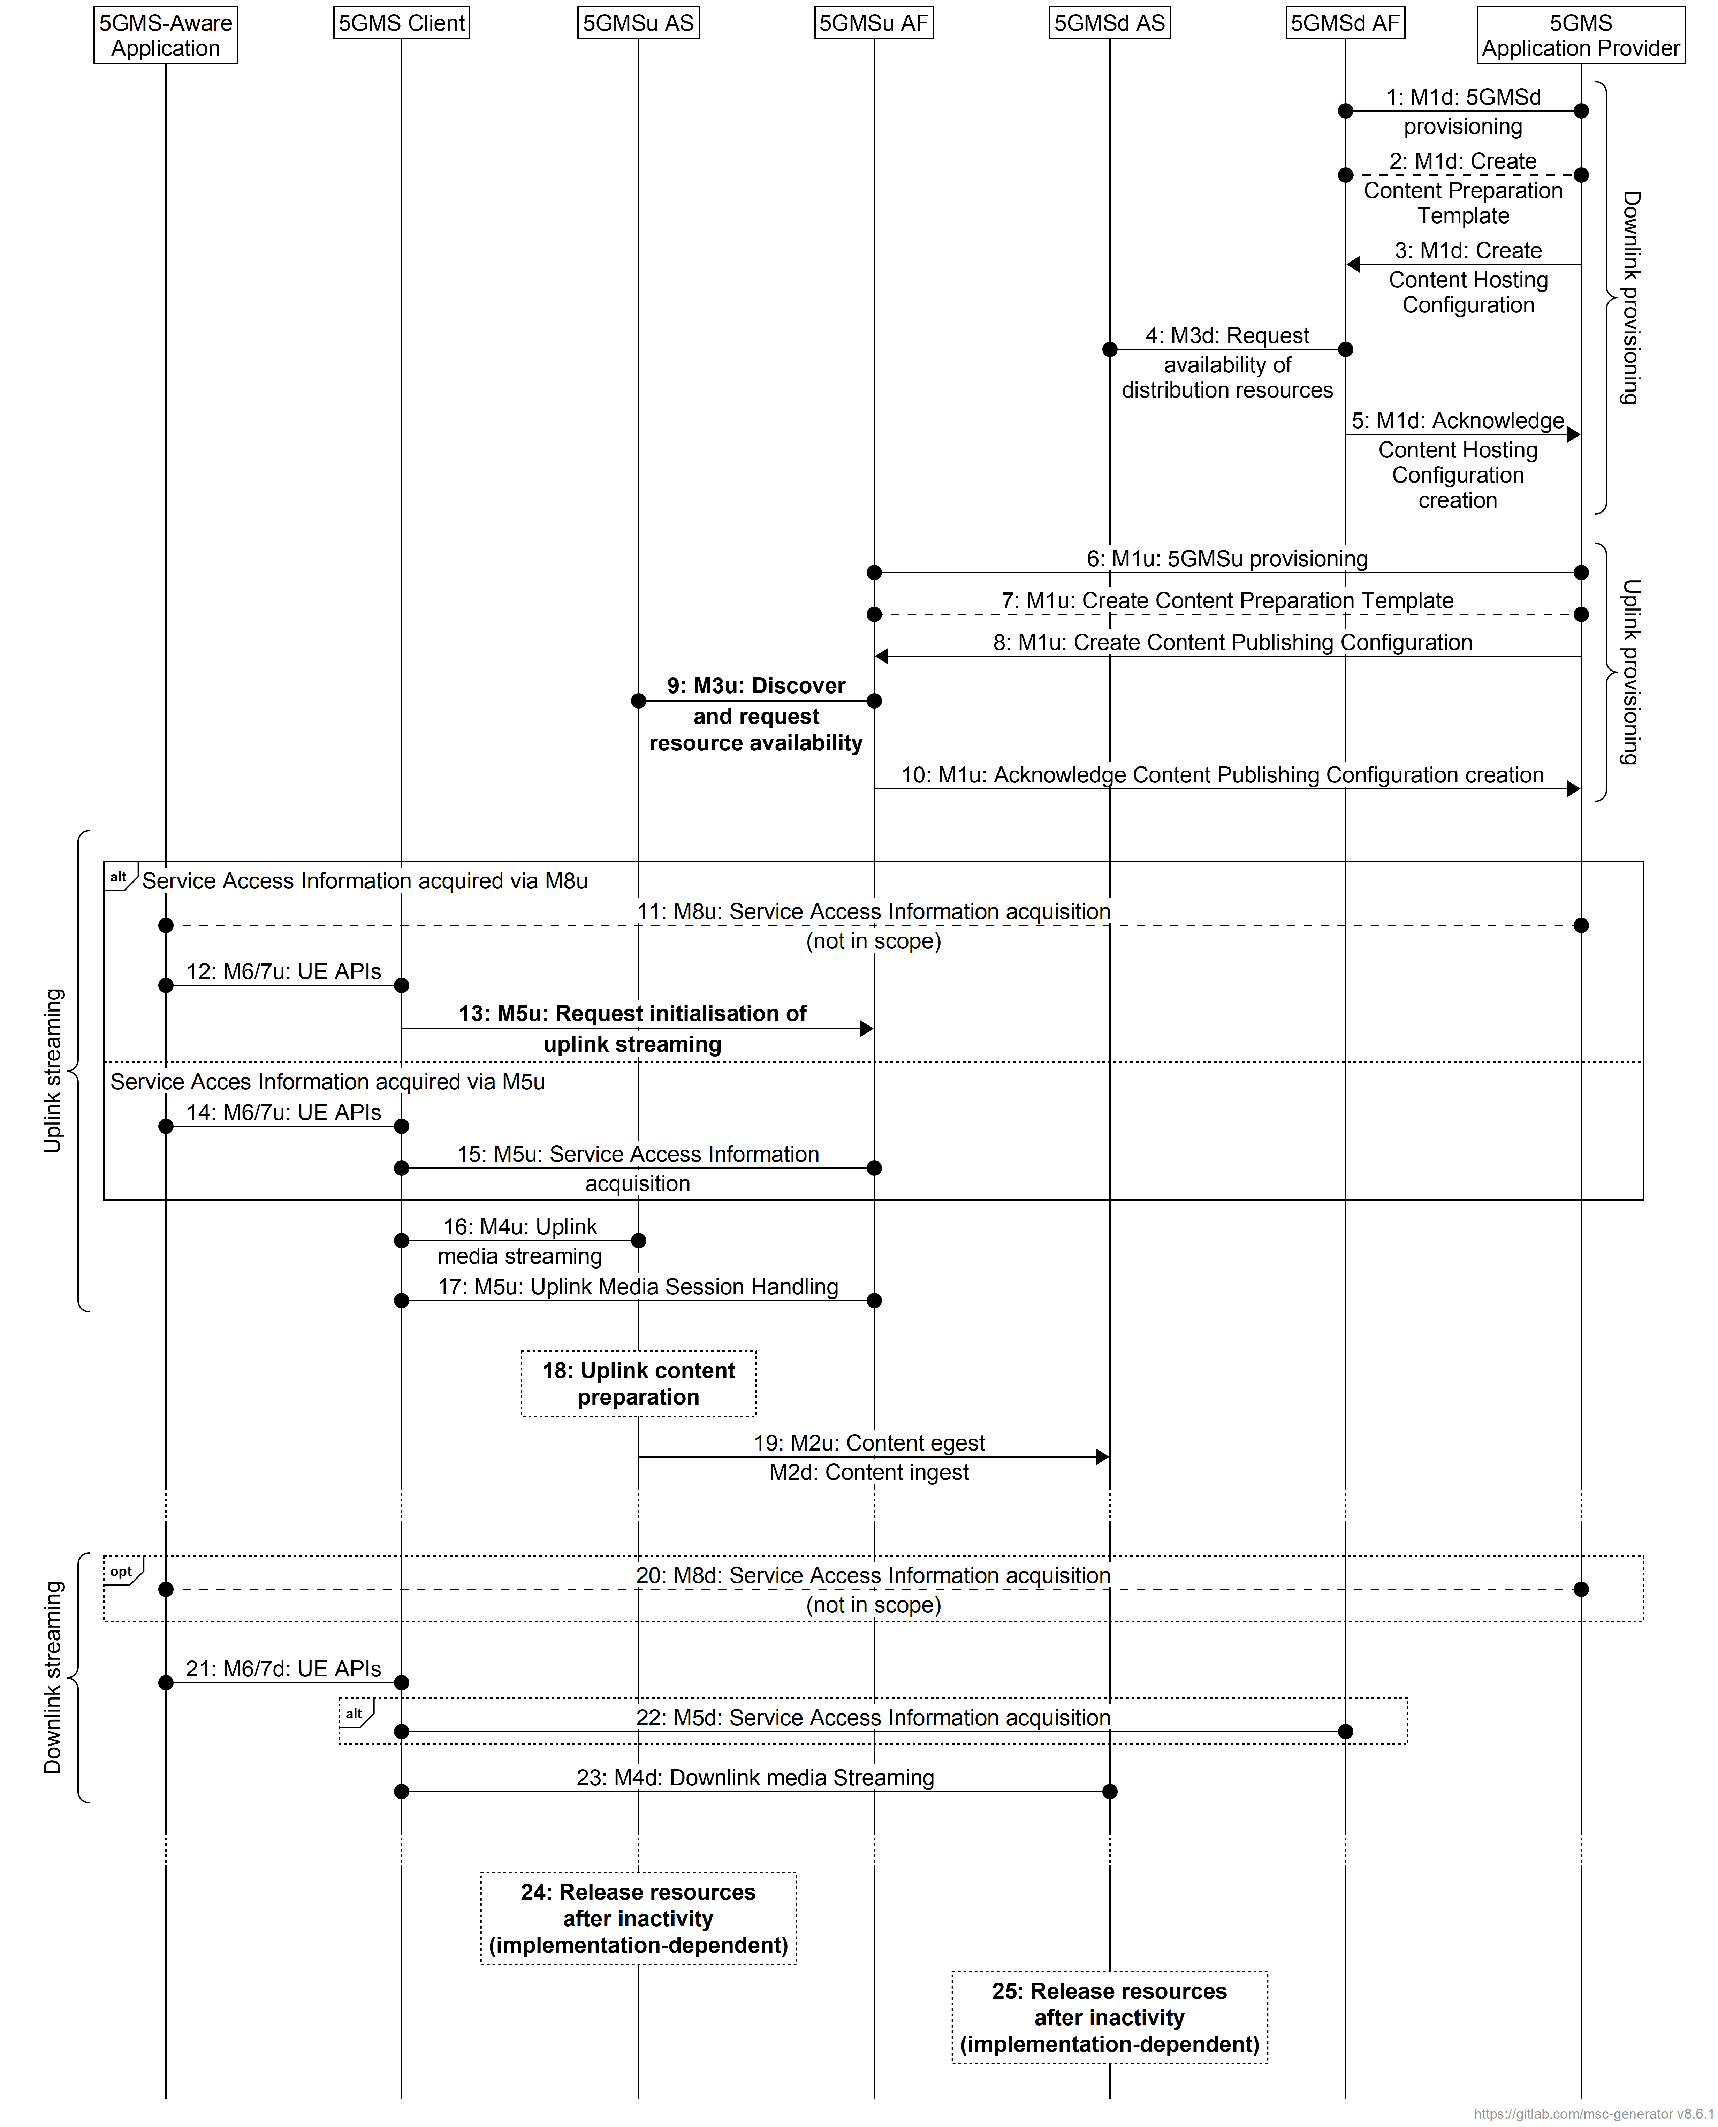
Figure A.15.3-2: Call flow for cascaded uplink and downlink media streaming using content preparation with direct push-based content re-ingestion
The steps for this call flow are identical to those in clause A.15.2 except for the following:
3. The 5GMSd Application Provider provisions the 5GMSd AF with a Content Hosting Configuration. The ingest configuration indicates that content will be ingested from the 5GMSu AS by push-based means. If a Content Preparation Template was provisioned in the previous step, the Content Hosting Configuration may reference it.
5. The 5GMSd AF acknowledges to the 5GMSd Application Provider the successful creation of the Content Hosting Configuration (M1d). The acknowledgement includes the ingest base URL on the 5GMSd AS to which downlink media streaming content is to be pushed.
8. The 5GMS Application Provider provisions the 5GMSu AF with a Content Publishing Configuration (M1u). The egest configuration indicates that contributed content will be made available to the 5GMSd AS by push-based means. The egest destination is specified to be the base URL on the 5GMSd AS returned in prior step 5. If a Content Preparation Template was provisioned in the previous step, the Content Publishing Configuration may reference it.
19. The 5GMSu AS egests the content (M2u) by push-based means according to the Content Publishing Configuration provisioned in step 8 and the 5GMSd AS directly ingests the content by the same means (M2d) according to the Content Hosting Configuration provisioned in step 3.
If pull-based egest/ingest is instead used between the 5GMSu AS and the 5GMSd AS, the order of the provisioning (steps 1–5 and 6–10 of figure A.15.3-2) is reversed to the order shown in figure A.15.3-3 with uplink streaming provisioned before downlink streaming:
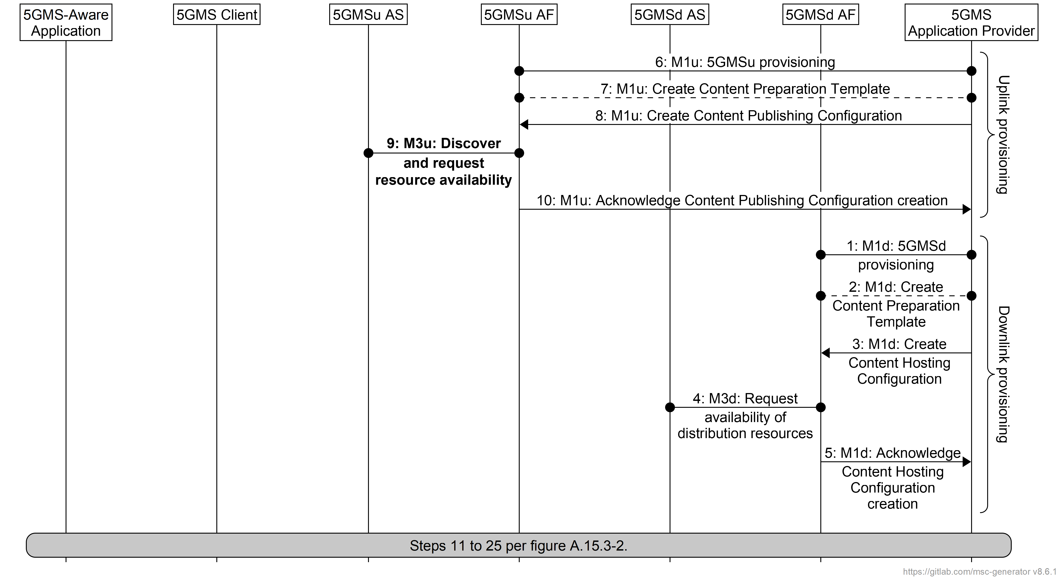
Figure A.15.3-3: Call flow for cascaded uplink and downlink media streaming using content preparation with direct pull-based content re-ingestion
The steps for this call flow are identical to those in clause A.15.2 except for the following:
8. The 5GMS Application Provider provisions the 5GMSu AF with a Content Publishing Configuration (M1u). The egest configuration indicates that contributed content will be made available to the 5GMSd AS by pull-based means. If a Content Preparation Template was provisioned in the previous step, the Content Publishing Configuration may reference it.
10. The 5GMSu AF acknowledges successful provisioning to the 5GMSu Application Provider (M1u). The acknowledgement includes the egest base URL on the 5GMSu AS from which contributed uplink media streaming content will be made available.
3. The 5GMSd Application Provider provisions the 5GMSd AF with a Content Hosting Configuration. The ingest configuration indicates that content will be ingested from the 5GMSu AS by pull-based means from the egest base URL on the 5GMSu AS returned in prior step 10. If a Content Preparation Template was provisioned in the previous step, the Content Hosting Configuration may reference it.
16. The 5GMSu AS makes the content available for pull-based egest (M2u) according to the Content Publishing Configuration provisioned in step 8 and the 5GMSd AS directly ingests the content by the same means (M2d) according to the Content Hosting Configuration provisioned in step 3.

A.15.4 Cascaded uplink and downlink media streaming using content preparation with internal content re-ingestion
In a third variant of this collaboration scenario, the 5GMS System is provisioned by the 5GMS Application Provider for uplink–downlink content redistribution per clause A.15.3. The 5GMS System recognises this and arranges for content to be transferred directly from the 5GMSu AS to the 5GMSd AS via an internal interface not specified by 3GPP (as an implementation-specific optimisation) instead of egesting the content at reference point M2u and re-ingesting it at M2d.
Content may additionally be egested by the 5GMSu AS at reference point M2u for ingestion by the 5GMS Application Provider and possible redistribution to other 5GMS Systems and/or other destination networks.
Figure A.15.4-1: Cascaded uplink and downlink media streaming with internal content re-ingestion

A.16 Media ingest for downlink media streaming using multiple service locations

A.16.1 Introduction
These collaboration scenarios supplement the downlink media streaming scenarios provided in clauses A.1 through A.9 where media content is available and/or streamed to the 5GMSd Client from multiple service locations via reference points M4d and M13d. These collaboration scenarios focus on different methods media content may be ingested into the 5GMSd AS via reference point M2d, distributed within the 5GMSd AS via reference point M10d, and made available via M4d at different service locations. The 5GMSd AF (not shown) may or may not be used to configure the 5GMSd AS via reference point M3d, and it may or may not be used to provide Service Access Information to the Media Session Handler (not shown) via reference point M5d.
Three distinct methods are described in the following clauses.
- In the first method (clause A.16.2), the 5GMSd Application Provider performs any necessary operations to prepare media content for multiple service location delivery. The 5GMSd Application Provider prepares all media content intended to be served at each service location and provides it to the 5GMSd AS.
- In the second method (clause A.16.3), media content is ingested into the 5GMSd AS via reference point M2d where the 5GMSd AS performs any necessary operations at the point of ingest to prepare media for multiple service location delivery. This media content is then exposed at each provisioned M4d service location via reference point M10d.
- In the third method (clause A.16.4), media content is ingested into the 5GMSd AS via reference point M2d. This media content is exposed at each provisioned M4d service location via reference point M10d. Any operations to prepare media content for multiple service location delivery are performed independently immediately prior to exposure at each provisioned M4d service location.
These three methods are not mutually exclusive. For example, media content made available via reference point M4d at one service location may use the first method, while media content made available via reference point M4d at a second service location may use the second or third methods. Furthermore, the collaboration scenarios below show service locations exposed at different physical network locations within the 5GMS System. This is accomplished by placing each service location into different affinity groups within the Contest Hosting Configuration.

A.16.2 5GMSd Application Provider content preparation and ingest
In the first variant of this collaboration scenario, the 5GMSd Application Provider performs any necessary operations to prepare media content for multiple service location delivery prior to ingest into the 5GMSd AS. This content preparation may include manifest manipulation, media object encoding, etc. Furthermore, this media content is ingested independently by each 5GMSd AS via reference point M2d. The 5GMSd Client may stream media content from any of the available service locations by either switching among them or using each in parallel. This is illustrated in figure A.16.2-1.
NOTE: A service location accessible by a 5GMSd Client at reference point M13d is depicted. Content preparation and provisioning of this service location is the responsibility of the 5GMSd Application Provider and is outside the scope of the present document.

Figure A.16.2-1: 5GMSd Application Provider content preparation and ingest
for downlink media streaming from multiple service locations
Figure A.16.2-2 shows the call flow for this scenario describing the process followed by the 5GMSd AS at each service location it exposes to the 5GMSd Client at reference point M4d. To simplify the call flow, only the processes for content ingest and preparation are shown. These procedures reflect the process followed in the execution of steps 17 and 18 of figure 5.2.6-1.
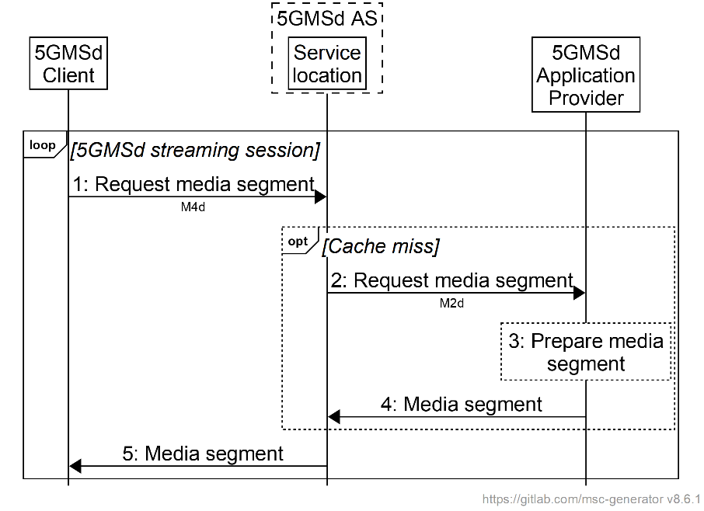
Figure A.16.2-2: Procedure for 5GMSd Application Provider content preparation and ingest
for downlink media streaming from multiple service locations
The steps are as follows:
1. The 5GMSd Client sends a request for media content to one or more service locations via reference point M4d.
2. If the requested media content is not cached at the target service location, the 5GMSd AS propagates the request to the 5GMSd Application Provider via reference point M2d.
3. The 5GMSd Application Provider may prepare the requested media content for delivery via the requested service location. Depending on the type of media segment requested, this may include manifest manipulation, media object encoding, etc.
4. The 5GMSd Application Provider responds with the requested media content via reference point M2d. Upon receipt, the media content may also be cached by the 5GMSd AS at the service location for future delivery to another 5GMSd Client.
5. The 5GMSd AS responds from the target service location via reference point M4d with the requested media content.

A.16.3 Centralized 5GMSd AS content preparation and ingest
In the second variant of this collaboration scenario, media is ingested into the 5GMSd AS via reference point M2d where the 5GMSd AS performs any necessary operations to prepare media for multiple service location delivery. This media content is then exposed at each provisioned M4d service location via reference point M10d. The 5GMSd Client may request media content from any of the available service locations by either switching among them or using each in parallel. This is illustrated in figure A.16.3-1.
NOTE: A service location accessible by a 5GMSd Client at reference point M13d is depicted. Content preparation and provisioning of this service location is the responsibility of the 5GMSd Application Provider and is outside the scope of the present document.

Figure A.16.3-1: Centralized 5GMSd AS content preparation and ingest
for downlink media streaming from multiple service locations
Figure A.16.3-2 shows the call flow for this scenario that describes the process followed by the 5GMSd AS at each service location it exposes to the 5GMSd Client at reference point M4d. To simplify the call flow, only the processes for content ingest and preparation are shown. These procedures reflect the process followed in the execution of steps 17 and 18 of figure 5.2.6-1.
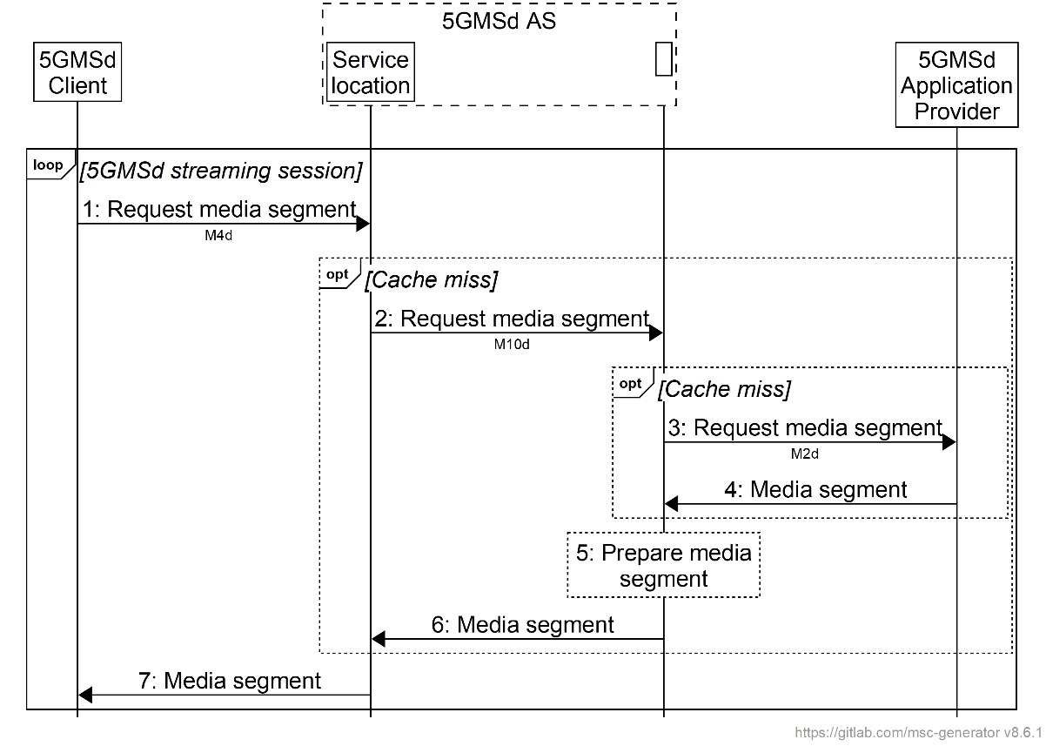
Figure A.16.3-2: Procedure for centralized 5GMSd AS content preparation and ingest
for downlink media streaming from multiple service locations
The steps are as follows:
1. The 5GMSd Client sends a request for media content to one or more service locations via reference point M4d.
2. If the requested media content is not cached at the target service location, the request is propagated via reference point M10d to ingest and prepare the requested media content.
3. If the requested media content is not cached, the request is propagated to the 5GMSd Application Provider via reference point M2d.
4. The 5GMSd Application Provider responds with the requested media content via reference point M2d.
5. The 5GMSd AS may prepare the requested media content for delivery from the requesting service location. Depending on the type of media segment requested, this may include manifest manipulation, media object encoding, etc. The media content may also be cached for future delivery from another service location.
6. The 5GMSd AS makes the requested media content available at the service location via reference point M10d. Upon receipt, this media content may be cached at this location for future delivery to another 5GMSd Client.
7. The 5GMSd AS responds from the target service location via reference point M4d with the requested media content.

A.16.4 Decentralized 5GMSd AS content preparation and ingest
In the third variant of this collaboration scenario, media content is ingested by the 5GMSd AS via reference point M2d; and this media content is made available at each provisioned M4d service location via reference point M10d. The former may be considered a primary service location, and the latter peer service locations. The 5GMSd AS may also independently prepare the ingested media content at each service location for exposure via reference point M4d. The 5GMSd Client may stream media content from any of the available service locations by either switching among them or using each in parallel. This is illustrated in figure A.16.4-1.
NOTE: A service location accessible by a 5GMSd Client at reference point M13d is depicted. Content preparation and provisioning of this service location is the responsibility of the 5GMSd Application Provider and is outside the scope of the present document.

Figure A.16.4-1: Decentralized 5GMSd AS content preparation and ingest
for downlink media streaming from multiple service locations
Figure A.16.4-2 shows the call flow for this scenario that describes the process followed by the 5GMSd AS at each service location it exposes to the 5GMSd Client at reference point M4d. Within the figure, the 5GMSd AS ingests media content from the 5GMSd Application Provider via reference point M2d and exposes it at a primary service location. Those service locations that only obtain media content via reference point M10d are labelled as "peer". To simplify the call flow, only the processes for content ingest and preparation are shown. These procedures reflect the process followed in the execution of steps 17 and 18 of figure 5.2.6-1.
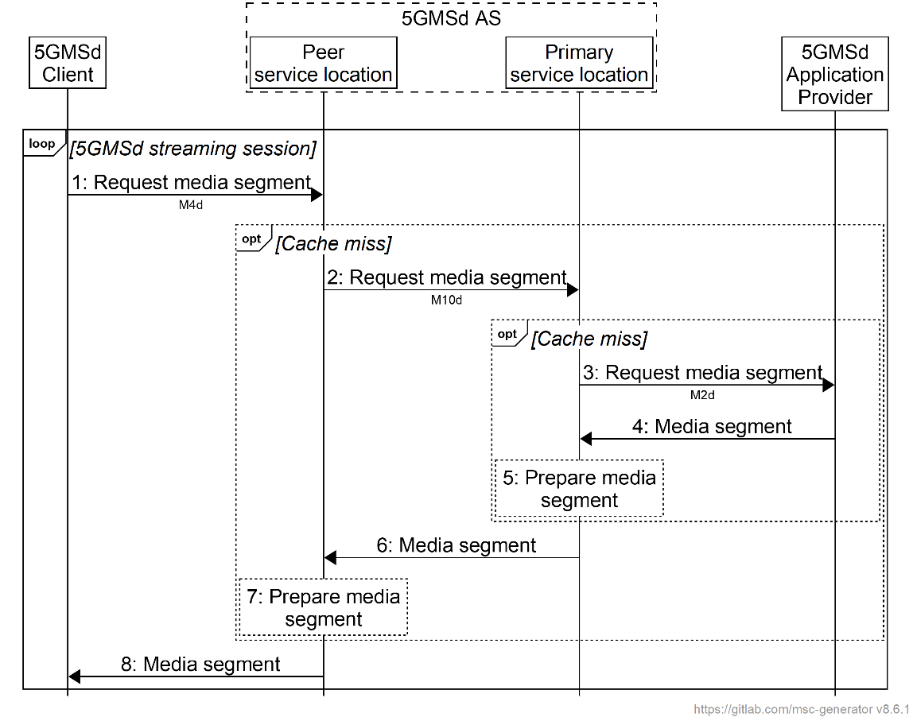
Figure A.16.4-2: Procedure for decentralized 5GMSd AS content preparation and ingest
for downlink media streaming from multiple service locations
The steps are as follows:
1. The 5GMSd Client sends a request for media content to one or more service locations via reference point M4d.
2. If the requested media content is not cached at the target service location, the request is propagated to the primary service location via reference point M10d.
NOTE 1: The procedure shows a request from the 5GMSd Client to a peer service location. If the request is received by a primary service location, the request may be propagated upward to the 5GMSd Application Provider via reference point M2d instead of to a peer service location via reference point M10d.
3. If the requested media content is not cached at the primary service location, the request is propagated to the 5GMSd Application Provider via reference point M2d.
NOTE 2: The procedure shows a request from a peer service location to a primary service location where media content is also ingested from the 5GMSd Application Provider via reference point M2d. Alternatively, the service location receiving the request from a peer service location may not be co-located with the service location from which media content is ingested via reference point M2d. In this case, a sub-procedure starting at step 2 is initiated by the 5GMSd AS to obtain the requested content at the service location.
4. The 5GMSd Application Provider responds with the requested media content via reference point M2d.
5. The 5GMSd AS may prepare the requested media content at the service location for delivery either through another service location (reference point M10d) or to a 5GMSd Client (reference point M4d). Depending on the type of media segment requested, this may include manifest manipulation, media object encoding, etc. The 5GMSd AS may also cache this media content at the service location for future exposure from another M4d service location.
6. The 5GMSd AS responds with the requested media content from the primary service location to the peer service location via reference point M10d.
7. The 5GMSd AS may prepare the requested media content at the peer service location for delivery either to another service location via reference point M10d (not depicted) or for exposure to a 5GMSd Client at reference point M4d. Depending on the type of media segment requested, this may include manifest manipulation, media object encoding, etc. The 5GMSd AS may also cache this media content at the service location for future delivery to another service location or 5GMSd Client.
8. The 5GMSd AS responds from the target service location via reference point M4d with the requested media content.

Annex B (informative):
MNO-specific Service Access Information acquisition

B.1 General
A 5GMSd Application Provider may offer its content via multiple Access Networks from different operators. Each access network can consist of a 5G System and one or more 5G Media Streaming Architecture components, in particular its own 5GMSd AFs. The 5GMSd AFs of that access network use their own FQDNs and potentially their own URL root path elements. When a 5GMSd-Aware Application is deployed in different 5G Systems the 5GMSd Client needs to acquire Service Access Information that resolves to the 5GMSd AF endpoint address(es) appropriate for the serving 5G System. The Service Access Information contains the URLs and API parameters of the configured 5GMSd AFs and ASs of that 5G Media Streaming System.
There are different ways to resolve the matching service access information. This annex focuses on two solutions where the 5GMSd Client fetches the Service Access Information from a 5GMSd AF within the Trusted DN of the serving mobile network.

B.2 Deployment with DNS-based resolution
Figure B.2-1 depicts the deployment for DNS-based resolution of the 5GMSd AF in the Trusted DN of the MNO which is currently providing connectivity to the 5GMSd Client. The DNS functions are defined in RFC 1034 [14].
Figure B.2-1: DNS based resolution of 5GMSd AF in trusted DN
For the DNS-based resolution mechanism, the 5GMSd Client is provisioned with a Service Access Information URL, for example dynamically via M8d or statically within the code of the 5GMSd-Aware Application. The Service Access Information URL contains an FQDN from the 5GMSd Application Provider or a global URL in the GSMA domain (i.e. in the "3gppnetworks.org" domain).
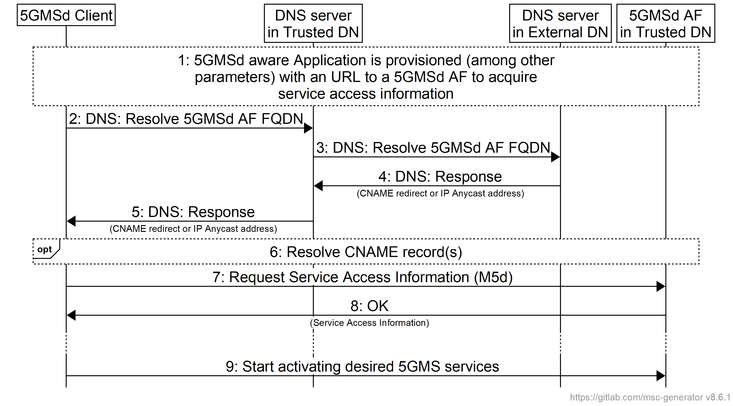
Figure B.2-2: Message Sequence Chart for DNS-based resolution
Steps:
1: The 5GMSd-Aware Application is provisioned (among other parameters) with a URL of the 5GMSd AF from which to acquire Service Access Information. The 5GMSd-Aware Application provides this URL to the 5GMSd Client upon start.
2: The 5GMSd Client uses DNS to resolve the FQDN of the URL. The 5GMSd Client sends a DNS request to the DNS server in the Trusted DN.
3: The DNS server in the trusted DN is not responsible for the FQDN and the DNS server forwards the DNS request to a DNS server in the external DN responsible for the FQDN. This may be the DNS server of the 5GMSd Application Provider or a GSMA DNS server.
4: Based on information from the originating network, the external DNS creates a response. The response may be a CNAME redirect (i.e. FQDN from the serving mobile network responsibility) or an IP address (preferably an IP Anycast Address).
5: The DNS server forwards the DNS response to the 5GMSd Client.
6: When the 5GMSd Client received another FQDN with the response (i.e. a CNAME DNS record), then the 5GMSd Client resolves the FQDN to an IP address. The resolved IP address should be an IP address of an 5GMSd AF in the Trusted DN.
7: The 5GMSd Client issues a request to the resolved 5GMSd AF in order to acquire the Service Access Information.
8: The 5GMSd AF provides the Service Access Information in its response to the 5GMSd Client. The Service Access Information contains URLs and parameters according to provisioned 5GMS features.
9: When needed, the 5GMSd Client uses the acquired Service Access Information to activate the needed 5GMSd feature(s).

B.3 Deployment with HTTPS-based resolution
Figure B.3-1 depicts the deployment for HTTPS-based resolution of the 5GMSd AF in the Trusted DN of the MNO which is currently providing connectivity to the 5GMSd Client.
NOTE: The process of resolving IP addresses from FQDNs is not depicted in this deployment architecture.
Figure B.3-1: HTTPS based resolution of 5GMSd AF in Trusted DN
For the HTTPS-based resolution mechanism, the 5GMSd Client is provisioned with a Service Access Information URL, for example dynamically via M8d or statically within the code of the 5GMSd-Aware Application. The Service Access Information URL contains an FQDN of a 5GMSd AF within the 5GMSd Application Provider domain, which acts as a request redirector.
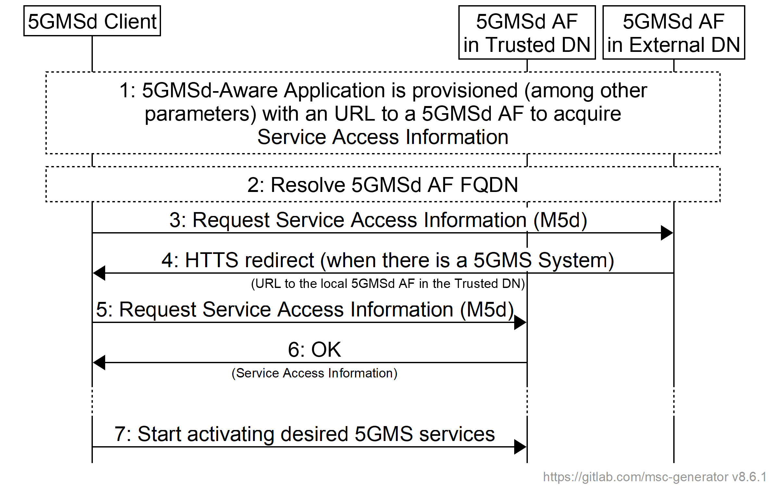
Figure B.3-2: Message Sequence Chart for HTTPS based resolution
Steps:
1: The 5GMSd-Aware Application is provisioned (among other parameters) with a URL of the 5GMSd AF from which to acquire Service Access Information. The 5GMSd-Aware Application passes this URL to the 5GMSd Client upon start.
2: The 5GMSd Client uses DNS to resolve the FQDN of the URL.
3: The 5GMSd Client issues a request to the resolved 5GMSd AF in order to acquire the Service Access Information.
4: Based on information from the originating network (e.g. visible IP of the 5GMSd Client), the 5GMSd AF in the External DN creates an HTTPS redirection response. The 5GMSd AF looks up the according FQDN of the 5GMSd AF in the trusted DN and sends an HTTPS redirection response to the 5GMSd Client.
When the 5GMSd AF in the External DN does not offer 5GMS features, or if the 5GMS features are not provisioned it instead provides a response containing an HTTP error message.
NOTE: Instead of redirecting a 5GMSd Client to the 5GMSd AF in the Trusted DN, the External 5GMSd AF may directly provide the Service Access Information in the above step. In this case, the 5GMSd Application Provider needs to update its 5GMSd AF according to changes within the Trusted DN, e.g. changes of FQDNs.
5: The 5GMSd Client issues a request to the resolved 5GMSd AF in order to acquire the Service Access Information.
6: The 5GMSd AF provides the Service Access Information in its response to the 5GMSd Client. The Service Access Information contains URLs and parameters according to provisioned 5GMS features.
7: When needed, the 5GMSd Client uses the acquired Service Access Information to activate the needed 5GMSd feature(s).

Annex C (informative):
Collaboration Models for 5GMS via eMBMS

C.1 Introduction
For 5GMS via eMBMS as introduced in clauses 4.6 and 5.10, different deployment collaboration scenarios of the architecture as provided in clause 4.6 may be considered. In all cases, the same UE architecture is used, but different network side operation modes are considered, including the following parties:
- 5G Mobile Network Operator: A party that offers 5G System reference points to a content provider.
- 5G Broadcast Network Operator: A party that offers eMBMS reference points to a third party.
- 5GMS Content Provider: A party that provides 5GMS content.
- 5GMS Network Operator: A party that offers 5GMS System reference points to a content provider.
- 5G Broadcast Service Provider: A party that offers 5GMS content via eMBMS and also provides the same content to a 5G Mobile Network Operator.
- 5GMS Service Provider: A party that distributes 5GMS content via a 5G System and via eMBMS.

C.2 Collaboration 5GMS-MBMS 1: 5GMS Content Provider uses different delivery networks
Figures C.2-1 illustrates a collaboration in which the 5GMS Content Provider uses different delivery networks.
Figure C.2-1: Collaboration 5GMS-MBMS 1: 5GMS Content Provider uses different delivery networks

C.3 Collaboration 5GMS-MBMS 2: 5GMS Network Operator offloads to 5G Broadcast Network Operator
Figure C.3-1 illustrates a collaboration in which a 5GMS Network Operator offloads to a 5G Broadcast Network Operator.
Figure C.3-1: Collaboration 5GMS-MBMS 2: 5GMS Network Operator offloads to 5G Broadcast Network Operator

C.4 Collaboration 5GMS-MBMS 3: 5GMS Service Operator includes MBMS network
Figure C.4-1 illustrates a collaboration in which a 5GMS Service Operator includes an MBMS network.
Figure C.4-1: Collaboration 5GMS-MBMS 3: 5GMS Service Operator includes MBMS network

C.5 Collaboration 5GMS-MBMS 4: 5G Broadcast Service Provider offloads to 5G MNO
Figure C.5-1 illustrates a collaboration in which a 5G Broadcast Service Provider offloads to a 5G Mobile Network Operator.
Figure C.5-1: Collaboration 5GMS-MBMS 4: 5G Broadcast Service Provider offloads to 5G MNO

Annex D (informative):
Use Cases for 5GMS event exposure

D.1 Introduction
This annex describes Use Cases related to the exposure of events relating to 5G Media Streaming by the Data Collection AF instantiated in the 5GMS AF.

D.2 Controlling Event exposure

D.2.1 Data exposure restrictions
The 5GMS Application Provider wishes to limit the level of access that different classes of Event consumer subscribers have to UE data reported to and subsequently exposed by the Data Collection AF. These restrictions are expressed in the form of data processing instructions that it provisions in the Data Collection AF instantiated in the 5GMS AF along the dimensions described below. Each set of data processing instructions applies to a particular Event ID and Event consumer type:
- Time-based restriction determines the granularity of access along the time axis, ranging from the finest granularity which permits Event consumer access to individual events as they occur, to the coarsest granularity which combines all event data into a single aggregated value.
- User-based restriction controls access based on end-user grouping. Such restriction ranges from the fine granularity which permits Event consumer access to individual events related to individual end users, through medium granularity which aggregates collected event data at the level of user groups, to coarse granularity which bundles the data across all users.
- Location-based restriction defines access based on the geographical location of the data collection client at which the UE data was collected. Fine-grained control allows the Event consumer to access individual events, irrespective of the location. Medium-grained control aggregates collected event data for a defined geographical area. Coarse-grained control aggregates all event data to produce a single aggregated value for all locations.
For example, the 5GMS Application Provider decides that its own Event Consumer AF is granted the finest-grained access to event data by all of the above dimensions. On the other hand, according to the "silver" business agreement it has established with the Mobile Network Operator, the NWDAF is granted medium-grained access to event data, while based under a "bronze" business agreement it has established with another Application Service Provider, the Event Consumer AF of that third-party ASP is granted only coarse-grained access to event data.

D.2.2 Event subscription filters
A certain Event consumer is only interested in receiving events for a specific user or group(s) of users, or a specific application or UEs at a certain location. It expresses these preferences in the form of filters when subscribing to the event at the Data Collection AF.

D.3 QoE metrics for downlink media streaming
The Use Case for exposing QoE metrics for downlink media streaming as an event is in clause 6.4 of TS 23.288 [23].

D.4 Consumption of downlink media streaming
The 5GMSd Client collates feedback reports on currently consumed downlink media streaming content according to a provisioned Consumption Reporting Configuration it obtains from the Service Access Information for its Provisioning Session. The consumption reports include the media player entry point URL, the start time, duration and UE locations. The Media Session Handler sends the consumption reports to 5GMSd AF for subsequent event exposure to subscribed Event consumers.
The 5GMSd Application Provider subscribes to downlink media streaming consumption events from the Data Collection AF, specifying an appropriate application filter in its subscription request. To drill down into downlink media streaming consumption at a finer geographical granularity, a location filter is also specified as part of the subscription. To analyse use of a new application feature in isolation as part of a beta testing programme, a user group filter corresponding to the test population is also specified. With the exposed event, the 5GMSd Application Provider performs data analytics to determine, for example, which media content is most popular in the 5GMS System, which media content is most popular at a specific location, or which portions of the media content are consumed. This helps the 5GMSd Application Provider to optimise distribution of the most popular media content in the 5GMS System.
Alternatively, the NWDAF subscribes to this event for data analytics, exposing the results to the 5GMSd Application Provider.

D.5 Invocation of dynamic policies
The Media Session Handler invokes the Dynamic Policy API on the 5GMS AF via M5 to request a specific policy and charging treatment to be applied to a particular media streaming application data flow. As a result, the 5GMS AF invokes appropriate service operations on Network Functions in the 5G Core, e.g. Npcf_PolicyAuthorization or Nnef_AFSessionWithQoS, to effect the requested network QoS policy change. The 5GMS AF obtains status information (policy accepted, rejected, etc.) about these service operation invocations, and policy enforcement information, such as the enforcement method selected and the enforcement bit rate. After recording the invocation of the dynamic policies, the 5GMS AF reports these records to its subordinate Data Collection AF for exposure to subscribed Event consumers.
The event for invocation of dynamic polices may include the timestamp when the Media Session Handler invokes the dynamic function in 5GMS AF, the requested policy template identifier, the status information, etc.
The Event Consumer AF within the 5GMS Application Provider or the NWDAF subscribes to events of this type from the Data Collection AF, specifying the relevant application filter and any relevant location and/or user filters in its subscription request. Using the details about the invocations for dynamic policies, the 5GMS Application Provider or the NWDAF analyse the network quality provided by the 5G System and the dynamic network requirements for this media streaming service.
Alternatively, the NWDAF subscribes to the event, specifying any relevant filters, and exposes analytics results to the 5GMS Application Provider, enabling the 5GMS Application Provider to optimise the media streaming service, e.g. by provisioning more appropriate policy templates or by negotiating more suitable Service Level Agreement (SLA) with the MNO.

D.6 Invocation of Network Assistance
The AF-based Network Assistance feature enables a UE to receive a bit rate recommendation from a 5GMS AF providing the Network Assistance server function.
The 5GMS AF uses the Npcf_PolicyAuthorization notification or Nnef_MonitoringEvent procedure to receive notifications of network QoS changes, e.g. estimation of throughput, recommendation of a bit rate. The 5GMS AF receives these policy change notifications asynchronously.
The 5GMS AF reports the invocation of AF-based network assistance to its subordinate Data Collection AF, including information about requested QoS and recommended QoS. The Data Collection AF subsequently exposes this UE data to the Event Consumer AF within the 5GMS Application Provider. Using this information, the 5GMS Application Provider is able to optimise the use of the 5GMS System, e.g. by performing dynamic congestion window adjustment.
Data collection and reporting may also be used in case the UE implements ANBR-based Network Assistance. In this case the Direct Data Reporting Client reports the invocations of ANBR-based Network Assistance directly to the 5GMS AF’s subordinate Data Collection AF.
The NWDAF subscribes to events of this type at the Data Collection AF, specifying the relevant application filter and any relevant location and/or user filters. Based on the requested QoS and recommended QoS in the exposed events, the NWDAF analyses whether the current network deployment or status can support the currently provisioned media streaming services, and exposes these results to the OAM for better network optimization.

D.7 Media streaming access activity

D.7.1 Downlink media streaming access activity
In downlink 5G Media Streaming, the 5GMSd AS acts as a CDN (e.g., edge server) in the hosting and delivery of streaming media content that it has ingested. The corresponding media streaming access activity (i.e., CDN access logs) available at the 5GMSd AS are reported to the Data Collection AF instantiated in the 5GMSd AF for subsequent event exposure to the Event Consumer AF in the 5GMSd Application Provider.
The 5GMSd Application Provider uses information in the exposed events (e.g. the number of unique users and the access history for different media content items) to improve its CDN content distribution. It specifies the relevant application filter and any relevant location and/or user filters in its subscription request to the Data Collection AF.
Alternatively, the NWDAF subscribes to events of this type, specifying the relevant application filter and any relevant location and/or user filters, and analyses the total volume of data delivered by the 5GMSd AS or the average response time for downlink media requests in order to optimise the 5GMS System deployment or to demonstrate to the 5GMSd Application Provider that the SLA for downlink media streaming has been satisfied.

Annex E (informative):
Collaboration models for per-application authorisation

E.1 Introduction
Operation of certain 5GMS services may include an SLA between the Application Provider and the 5GMS System provider. In this context, "Per-application authorisation" refers to scenarios where one or more 5GMS-Aware Application is hosted on the same UE and can access services only from the associated 5GMS Application Provider.
The 5GMS System provider may offer one common 5GMS AF serving all 5GMS Application Providers or separate logical 5GMS AFs, each serving a single 5GMS Application Provider.
In the following, two example scenarios are described:
- A single UE hosting multiple 5GMS-Aware Applications from different 5MGS Application Providers.
- A single 5GMS Application Provider offers different subscription levels.

E.2 UE hosting multiple applications
This collaboration scenario focuses on cases where one or more 5GMS-Aware Applications are hosted on the same UE and are using the same 5GMS Client. This may be the case when the Media Session Handler in the 5GMS Client is provided as a common Operating System service. The Media Session Handler in the 5GMS Client supports isolation between different 5GMS-Aware Application contexts.
Figure E.2-1: Per-application authorisation collaboration scenario
Each 5GMS-Aware Application uses an M8 reference point instance to connect to its 5GMS Application Provider.
The 5G System provider offers a common 5GMS AF within the Trusted DN. The 5GMS AF supports request and provider isolation so that 5GMS Application Provider #1 and #2 do not interfere with each other.
EXAMPLE 1: 5GMS Application Provider #1 has agreed different charging conditions from 5GMS Application Provider #2. The 5GMS System ensures that only 5GMS-Aware Application #1 can benefit from the conditions agreed with 5GMS Application Provider #1.
EXAMPLE 2: 5GMS-Aware Application #1 is entitled to receive higher network QoS than 5GMS-Aware Application #2.

E.2 Applications with multiple subscription levels
This collaboration scenario focuses on cases where a 5GMS Application Provider offers multiple subscription levels to its consumers, for example the user of 5GMS-Aware Application #1 is entitled to the "Premium Connectivity" subscription level while the user of 5GMS-Aware Application #2 is entitled only to the "Default Connectivity" level.
Figure E.3-1: Per-Application authorisation collaboration scenario
Each 5GMS-Aware Application uses an M8 reference point instance to connect to its 5GMS Application Provider. The 5GMS Application Provider is aware about the different user subscription levels.
The 5G System provider offers a common 5GMS AF within the Trusted DN. Using an appropriate authorisation mechanism, the 5GMS AF determines that 5GMS-Aware Application #1 is entitled to higher bit rates than 5GMS-Aware Application #2.

Annex F (informative):
Network Slice selection for 5GMS

F.1 Introduction
Clauses 5 and 6 of the present document describe the high-level procedures for downlink and uplink media streaming respectively. As part of these procedures, the 5GMS Application Provider performs service provisioning at the 5GMS AF. The 5GMS-Aware Application subsequently receives Service Access Information from the 5GMS Application Provider over reference point M8 or else the Media Session Handler acquires it directly from the 5GMS AF over reference point M5. This annex describes an example method for network slice selection based on traffic description information inside URSP rules for bootstrapping 5GMS application invocation on a Network Slice.

F.2 Network Slice selection based on Application Descriptor in URSP rules
From clause 5.15.5.2.2 of TS 23.501 [2], the UE uses either the URSP rules (which includes the NSSP) or the UE local configuration to determine which PDU Sessions to use to route ongoing application traffic. Clause 6.6.2.1 of TS 23.503 [4] describes the structure of URSP rules. One of the components of a URSP rule is the Traffic description information that helps a UE to identify matching application traffic. Table 6.6.2.1-2 of TS 23.503 [4] specifies a number of Traffic descriptor options, one of which is the Application descriptor that identifies traffic of applications running on the UE. An Application descriptor consists of OS Id and OS App Id properties that are known to both the UE application and the 5GMS Application Service Provider.
Assumptions:
- The 5GMS-Aware Application developer is aware of different OS App Ids supported by the UE operating system.
Figure F.2-1 below illustrates the procedure for bootstrapping application invocation on a Network Slice.
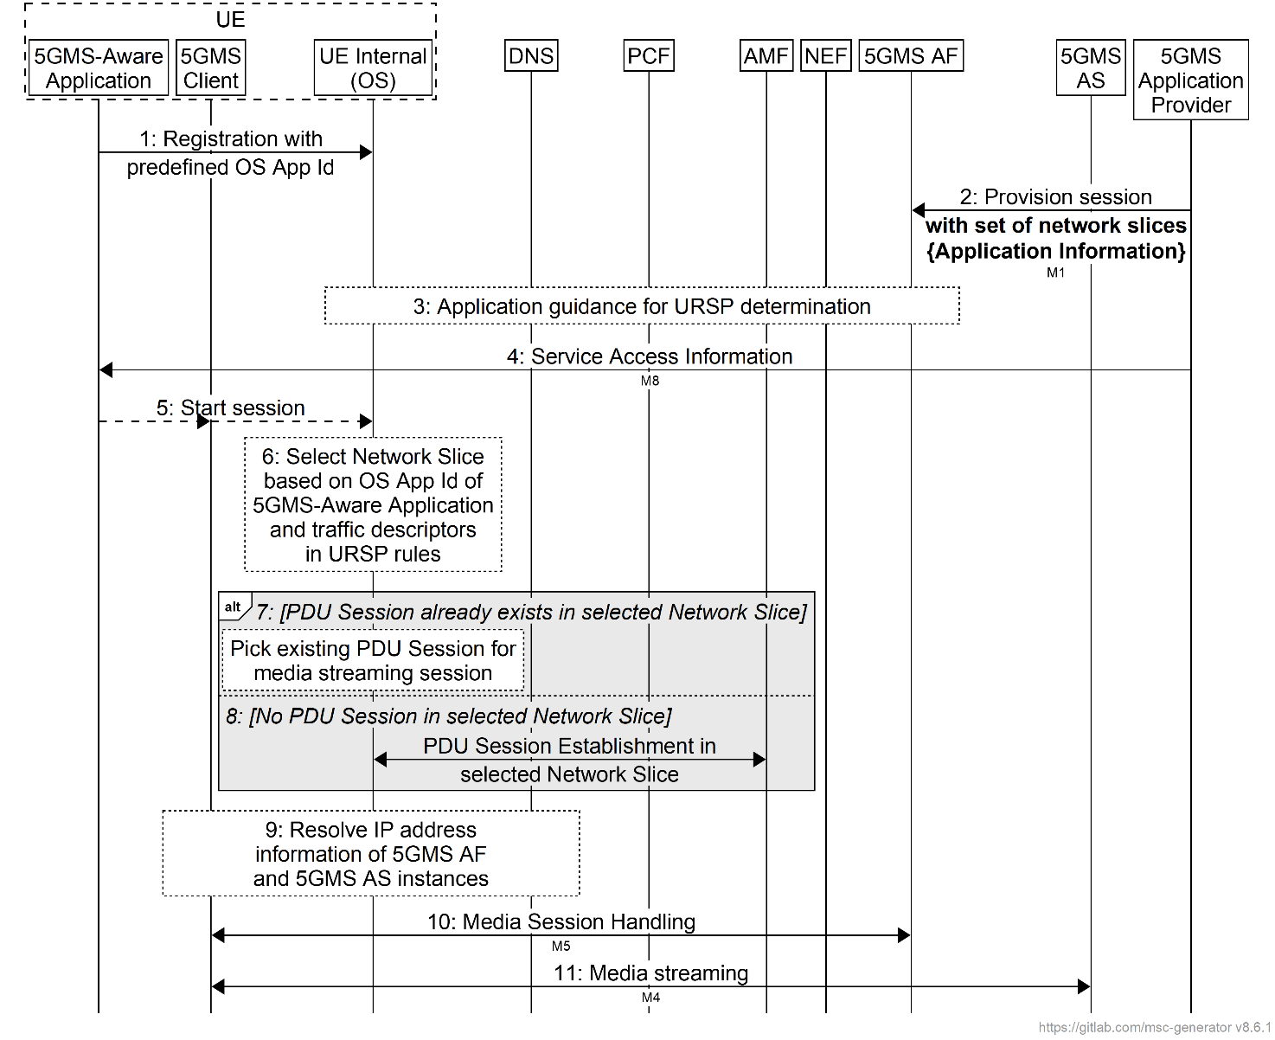
Figure F.2-1: Call flow for bootstrapping application invocation on a Network Slice
The steps are as follows:
1. The 5GMS-Aware Application is installed on the UE, and and is programmed to invoke an OS-specific network connection API using a pre-defined OS App Id supported by the UE operating system.
2. The 5GMS Application Provider provisions the media streaming session in the 5GMS AF with one or more network slices at reference point M1. The provisioning information may include external application Id information. The 5GMS AF uses this information to synthesise application traffic descriptor information used for application guidance, as specified in clause 4.15.6.10 of TS 23.502 [3].
3. The 5GMS AF uses the Nnef_ServiceParameter service defined in clause 5.2.6.1 of TS 23.502 [3] to provide application guidance for URSP determination via the NEF as described in clause 4.15.6.10 of TS 23.502 [3], which is eventually delivered to the UE as described in clause 4.15.6.7 of TS 23.502 [15]. The application guidance for URSP includes service parameters such as the application traffic descriptor information (synthesised in the previous step) and Route selection parameters (DNN and S-NSSAI) as specified in clause 4.15.6.10 of TS 23.502 [3].
NOTE 1: URSP rules may also be configured in the UE as described in TS 23.503 [4].
4. The 5GMS Application Provider may provide Service Access Information to the 5GMS-Aware Application at reference point M8. In the Service Access Information, the 5GMS Application Provider may include information related to Service Operation Points associated with different Network Slices.
5. The 5GMS-Aware Application initiates a media streaming session with the 5GMS Client at reference point M6. The 5GMS Client uses an OS-specific UE-internal API to request a network connection for use at reference points M5 (step 10) and M4 (step 11).
NOTE 2: If the 5GMS-Aware Application is aware about Network Slices, the 5GMS-Aware Application may explicitly indicate the Network Slice to use as part of its request for a network connection. In this case, the following step is skipped.
6. Based on the OS App Id configured for the 5GMS-Aware Application in step 1, the UE Operating System enables selection of the appropriate Network Slice using the application descriptor present in the traffic description information inside the currently configured URSP rules.
NOTE 3: If multiple network slices are provided for the same traffic descriptor, the precedence information in the route selection descriptor is used to select the appropriate Network Slice.
NOTE 4: Whether the UE OS should evaluate the URSP rule is up to implementation.
7. The UE Operating System checks whether a PDU Session already exists in the selected Network Slice and, if so, selects this PDU Session for further interaction with the media streaming endpoints (steps 10 and 11).
8. Alternatively, if no PDU Session exists in the Network Slice, the UE Operating System creates a PDU Session using the UE-requested PDU Session establishment procedure specified in clause 4.3.2.2 of TS 23.502 [3].
NOTE 5: See table A-1 in TS 23.503 [4] for an example of this procedure.
NOTE 6: According to clause 6.6.2.3 of TS 23.503 [4], the mechanisms used by the UE Operating System to check for the existence of a PDU Session in the selected Network Slice and to establish a new PDU Session if needed are up to UE implementation.
9. Once the PDU Session is available, the 5GMS Client interacts with DNS system to resolve the IP address of the 5GMS AF and 5GMS AS instances.
10. The 5GMS Client interacts with the 5GMS AF for media session handling procedures.
11. The 5GMS Client interacts with the 5GMS AS for media streaming.

Annex G (informative):
Collaboration scenarios for network slicing

G.1 Collaboration scenarios for network slicing based on 5G Media Streaming scenarios

G.1.1 Introduction
This clause presents the MNO CDN, OTT, and multi-MNO distribution collaboration scenarios corresponding to those described in clauses A.2, A.3, A.8, A.11, and A.14 of the present document enhanced with network slicing. Other MNO CDN and OTT collaboration scenarios (clauses A.1, A.4, A.5, A.6, A.7, A.10, A.12, and A.13 of the present document) can be similarly enhanced, and are therefore not presented here.

G.1.2 Media streaming with both AF and AS deployed in the trusted Data Network
The collaboration scenario shown in figure G.1.2-1 corresponds to the MNO CDN collaboration scenario described in clause A.2 and A.11 of the present document delivered using a network slice.
Figure G.1.2-1: Media streaming with AF and AS in the trusted Data Network
with Network Slicing
The 5GMS Application Provider may negotiate with the MNO for creation of a network slice.
All the interactions between the participating entities (5GMS Application Provider, 5GMS-Aware Application, 5GMS Client, 5GMS AF, and 5GMS AS) for the 5G Media Streaming session described in clause A.2 and A.11 of the present document apply in this scenario. All M4 interactions happen through a PDU Session established within the provisioned network slice.

G.1.3 Media streaming with both AF and AS deployed in an external Data Network (OTT)
This collaboration scenario shown in figure G.1.3-1 corresponds to the OTT collaboration scenario described in clause A.3 and A.14 of the present document delivered using a network slice.
Figure G.1.3-1: Media streaming with AF and AS in an external Data Network (OTT)
with Network Slicing
The 5GMS Application Provider may negotiate with the MNO for the creation of a network slice.
All the interactions between all the participating entities (5GMS Application Provider, 5GMS-Aware Application, 5GMS Client, 5GMS AF, and 5GMS AS) described in clause A.3 of the present document apply in this scenario. All M4 and M5 interactions happen through a PDU Session established within the provisioned network slice.

G.1.4 Media streaming with AFs deployed in two separate trusted Data Networks sharing AS in an external Data Network
This collaboration scenario shown in figure G.1.4-1 represents a multi-MNO distribution scenario where an external CDN (5GMS AS) is used to deliver content to multiple UEs connected to different 5GMS-capable PLMNs, as described in clause A.8 of the present document, but delivered using network slices on those PLMNs.
Figure G.1.4-1: Media streaming with AFs in two trusted Data Networks sharing AS in external Data Network with Network Slicing
The 5GMS Application Provider may negotiate with each of the PLMNs for creation of network sliced. The network slice for each PLMN is provisioned by the PLMN operator.
All the interactions between all the participating entities (5GMS Application Provider, 5GMS-Aware Application, 5GMS Client, 5GMS AF, and 5GMS AS, PCF) described in clause A.8 of the present document apply in this scenario. All M4 and M5 interactions happen through PDU Sessions established within the provisioned network slices. Each UE in a different PLMN may use the provisioned network slice in that PLMN for all the 5G Media Streaming operations. The same external CDN (5GMS AS) serves the users of both the PLMNs, and all the signalling and media traffic is sent through PSU Sessions in respective network slices.

G.2 Collaboration scenarios for network slicing with multiple slices or Data Networks

G.2.1 Introduction
From the network slicing architecture specification in TS 23.501 [2], the following is inferred:
1. A UPF instance may be shared between multiple network slices.
2. Multiple PDU Sessions terminating in different Data Networks may share the same slice.
3. PDU Sessions in different network slice instances may terminate in the same Data Network.
Based on this, the following two collaborations are possible:
- Media streaming wherein content is delivered by/to a 5GMS AS through two different network slices.
- Media streaming wherein 5GMS AS instances deployed in different Trusted DNs are accessed by the 5GMS client in the same network slice.
This clause describes collaboration options based on the above two possibilities.

G.2.2 Media streaming with AS deployed in external Data Network and AS delivering content through two different network slices
This collaboration scenario shown in figure G.2.2-1 represents the case of accessing the same external Data Network through two different network slices. An external CDN (5GMS AS) is accessed by the UE via this Data Network.
Figure G.2.2-1: Media streaming with AS in external Data Network accessible through two different network slices
The 5GMS Application Provider may negotiate with the MNO to setup two different network slices with different service level agreements (SLA). After the SLA negotiation, the operator may provision two network slices, and provide connectivity services to the external Data Network through both the slices.
The 5GMS Application Provider may deliver Service Access Information through reference point M8. The Service Access Information delivered to the 5GMS-Aware Application may have information about different Service Operation Points accessible through each of the network slices. Upon receiving the Service Access Information, the 5GMS-Aware Application passes this information to the 5GMS Client. The 5GMS Client selects the Service Operation Point of interest, and requests media streaming session establishment over the PDU Session in the network slice that provides the required Service Operation Point. Media streaming (M4) thus happens through the selected network slice.
The other network slice may be used to fetch/contribute other media streaming assets (depending on criticality and SLA availability considerations), or serves as an alternate network slice in case the first slice becomes unavailable, as discussed in clause 6.3.
NOTE: The usage of multiple network slices simultaneously by the same application is currently not supported by either Android or iOS. This collaboration scenario is unlikely to be deployed.

G.2.3 Media streaming with AS deployed in multiple trusted Data Networks
This collaboration scenario shown in figure G.2.3-1 represents the case of accessing two different Data Networks using the same network slice. A CDN server (5GMS AS) is either deployed in each of the trusted Data Networks, or presents a multi-homed interface at reference point M4 through each of the trusted DNs.
Figure G.2.3-1: Media streaming with AS deployed in multiple trusted Data Networks
The 5GMS Application Provider may negotiate with the MNO to provision a network slice. The operator provisions the network slice, and provides connectivity services to both the DNs through the slice.
The 5GMS Application Provider may deliver Service Access Information through reference point M8. The Service Access Information delivered to the 5GMS-Aware Application may have information about different Service Operation Points accessible through each of the DNs. For example, an enterprise may use an enterprise-specific CDN (e.g., hosting enterprise-related video tutorials). 5G Media Streaming sessions for enterprise-related video tutorials use the PDU Session terminating in the enterprise-specific CDN, while some other video tutorial requests are sent through PDU Sessions terminating in a different CDN. Alternatively, a DN may act as a back-up CDN, utilised by the 5GMS Client if the primary CDN is inaccessible or unavailable for any reason.
In a variant of this scenario, the second CDN may be a CDN edge with optional media processing.
In another variation of the above scenario shown in figure G.2.3-1, a common 5GMS AS may serve traffic via two trusted Data Networks down the separate PDU Sessions, as shown in figure G.2.3-2.
Figure G.2.3-2: Media streaming with single AS serving traffic
through multiple Data Networks

G.3 Collaboration options based on network slicing scenarios

G.3.1 Introduction
Clause 5.15.2 of TS 23.501 [2] describes the identification of a network slice using S-NSSAI, and specifies the following:
An S-NSSAI identifies a Network Slice.
An S-NSSAI is comprised of:
- A Slice/Service type (SST), which refers to the expected Network Slice behaviour in terms of features and services;
- A Slice Differentiator (SD), which is optional information that complements the Slice/Service type(s) to differentiate amongst multiple Network Slices of the same Slice/Service type.

Based on the above NSSAI identification, different network slicing scenarios are possible:
1. A slice allocated for a specific customer/tenant. For example, a network slice allocated by the MNO for a specific enterprise. In this scenario, all applications of every UE in the enterprise use the allocated network slice. The SD field of the S-NSSAI is used to indicate the customer/tenant.
- Both the Android and iOS mobile Operating Systems have recently started supporting 5G network slicing in mobile devices for enterprise users [43, 44]. Android 12 onwards supports network slicing with a separate enterprise slice and slicing based on user profiles, while Android 13 onwards supports network slicing with multiple enterprise slices [43].
2. A slice allocated for a specific customer/tenant for a specific service/application. For example, a network slice allocated by the MNO for a specific enterprise and application. In this scenario, the application in every UE in the enterprise uses the allocated enterprise network slice; all other applications in enterprise UEs use a different (possibly default) network slice. The SD field of the S-NSSAI is used to indicate the customer/tenant and the service information.
3. A slice allocated for a specific service/application: For example, a slice optimized for 5G Media Streaming. In this scenario, the optimized slice is shared between all UEs, specifically for 5G Media Streaming application; the UEs use a different (possibly default) slice for other applications/services. The SD field of the S-NSSAI is used to indicate the service/application.
- The GSM Association specifies application-based network slicing [42], in which different network slices are provisioned for different applications.
4. A slice leased by MNO to a virtual operator. In this scenario, the virtual operator leases a network slice from the MNO, and in turn, can offer any of the above three network slicing scenarios to its customers over the leased network slice.
This clause describes collaboration options based on the above network slicing scenarios by presenting MNO CDN collaboration scenario described in clause A.7 of the present document wherein both the 5GMS AF and 5GMS AS are deployed in the Trusted DN, and the 5GMS Application Provider uses reference points M1 and M2 respectively to interact with them.
NOTE: All the collaboration scenarios described in clause A of the present document can be similarly shown with each of the network slicing scenarios described in this clause.

G.3.2 Scenario #1: Slice serving a set of enterprise services/applications
This is a network slicing scenario wherein the MNO, upon a request from an enterprise, allocates one or more network slices exclusively for enterprise users.
Figure G.3.2-1 shows the case of an enterprise network slice for all applications in the enterprise UE. Every application on the enterprise UE, including the 5GMS-Aware Application, uses the allocated network slice for communication with the DN entities.
NOTE: Android 12 onwards supports network slicing with a separate enterprise network slice allocated by the MNO.
Figure G.3.2-1: Network slice for all applications in the enterprise UE
Figure G.3.2-2 shows the case of an enterprise network slice for applications in the enterprise profile of the UE.
Figure G.3.2-2: Network slice for enterprise profile applications
In this scenario:
- Every application in the enterprise/work profile of the UE, including the 5GMS-Aware Application, uses the allocated enterprise network slice for communication with DN entities accessible from that slice.
- Every application in the non-enterprise profile of the UE (e.g., personal profile), including the 5GMS-Aware application, uses the default (e.g., eMBB) network slice for communication with DN entities accessible from that slice.
NOTE: Android 13 onwards supports network slicing with multiple enterprise slices, and slicing based on user profiles.

G.3.3 Scenario #2: Slice serving a specific application of an enterprise
This is a network slicing scenario wherein the MNO, upon a request from an enterprise, allocates a specific network slice for a specific service/application for enterprise users.
Figure G.3.3-1 shows the case of an enterprise network slice for a specific application (e.g., 5GMS-Aware Application) for enterprise UEs. The media streaming traffic belonging to the 5GMS-Aware application is sent through the enterprise network slice, while traffic for all other applications is sent through a default network slice (e.g. eMBB).
Figure G.3.3-1: Network slice for specific application for enterprise users
URSP rules, provisioned by the PCF, as described in clause 6.6.2.2 of TS 23.503 [4], assist in traffic detection and route selection of appropriate network slice for application traffic in the UE.

G.3.4 Scenario #3: Slice optimised for a specific service/application
This is a network slicing scenario wherein the MNO allocates a specific network slice for a specific service/application for use by multiple users. (The MNO may also provision additional network slices for carrying traffic of other specific applications.)
NOTE 1: The GSM Association specifies application-based network slicing [45], in which different network slices are provisioned for different applications.
NOTE 2: Unlike Scenario#1 and Scenario#2, the users in this scenario need not belong to the same enterprise.
Figure G.3.4-1 shows the case of a slice optimized for 5G Media Streaming. The traffic belonging to the 5GMS-Aware Applications of all users is sent through this network slice, while the traffic of other applications is sent through a default network slice (e.g., eMBB).
Figure G.3.4-1: Network slice for specific application for all users
URSP rules, provisioned by the PCF, as described in clause 6.6.2.2 of TS 23.503 [4], assist in traffic detection and route selection of the appropriate network slice for application traffic in the UE.

G.3.5 Scenario #4: Slice serving a virtual operator
This is a network slicing scenario where in virtual operator leases network slice from the MNO, and uses it to provide service to its customers. The virtual operator may, in turn, offer any of the above three slicing scenarios on the leased network slice.

Annex H (informative):
Multi-access media delivery

H.1 Introduction
Media streaming applications traditionally obtain content from a single source over a single path within a network. This imposes several limitations:
1. Performance is constrained to that of the source and path chosen. Any limits on network bandwidth and latency between the client and that source are directly translated to the client’s achievable Quality of Service (QoS) and Quality of Experience (QoE).
2 Disruptions or degraded performance caused by any of the network links between the client and source can lead to poor user experience, often in the form of lower playback quality, rebuffering, or complete playback failure.
Multi-access technologies may be integrated into the 5G Media Streaming System to allow media streaming applications to efficiently access content from the source over multiple access networks either serially or concurrently, potentially guided by the service or network provider.
To access content over multiple access networks, a UE may use a 3GPP access network and/or a non-3GPP access network. However, a UE contains at most one USIM and smartphone UEs with multiple SIM card slots are not typically able to use more than one at the same time. Multiple UEs may be combined in a single device to form a composite terminal that is able to access more than one access network concurrently. In a common scenario for media production, 5G modem units provide multiple SIM card slots intended for concurrent use.
UEs connected to multiple access networks (whether they be a 3GPP access network or non-3GPP access network, multiple disjoint 3GPP networks, etc.) may deploy and utilise multi-access techniques using any of the following:
- The use of a multipath transport protocols such as MPTCP [46] or MPQUIC [47] is one approach to enable multi-access media delivery. This approach requires implementation of the protocol(s) on both the UE and on the Application Server.
- Another method to enable multi-access media delivery is to use an application layer approach whereby a suitable object coding protocol is employed to enable efficient simultaneous use of the available access networks. The benefit of this approach is that the Application Server can remain agnostic of the UEs’ use of multiple access networks.
- The use of lower-layer network support using ATSSS (Access Traffic Steering, Switching, and Splitting) an optional feature for multi-access supported by the UE and 5G Core network and described in TS 23.501 [2]. The ATSSS feature enables a Multi-Access PDU Connectivity Service allowing for the exchange of PDUs between the UE and a Data Network by simultaneously using one or more 3GPP access networks and/or non-3GPP access networks. The Multi-Access PDU Connectivity Service is facilitated by a Multi-Access PDU (MA PDU) Session that may have User Plane resources on two access networks. In the context of the generalised media delivery architecture specified in the present document, the application flow between the Media Session Handler and the 5GMS AF at reference point M5 or the application flow between the Media Stream Handler (i.e., Media Player or Media Streamer) and the 5GMS AS at reference point M4, if conveyed over an MA PDU Session, may use two different access networks.
In multi-access delivery using ATSSS, the UE and the UPF are provided with ATSSS and N4 rules respectively by the network that specify how the upstream and downstream traffic is to be split, switched, or steered over multiple access networks. Clause 5.32 of TS 23.501[2] specifies higher-layer steering mechanisms such as Multipath TCP (MPTCP) [46] and Multipath-enabled QUIC (MPQUIC) [47], and lower layer ATSSS-LL (ATSSS Low-Layer) functionalities. TS 23.501 [2] also specifies different steering modes that define how traffic is to be distributed across multiple access networks. RFC 6897 [46] and the Internet Draft on multipath QUIC [47] describe capabilities and APIs available for higher level applications (e.g., 5G Media Streaming) to interact with the lower layers for application control of multipath delivery if the underlying transport connections are using MPTCP or MPQUIC respectively.

H.2 ATSSS mapping into 5GMS architecture
Figure H.2-1 shows the collaboration scenario for multi-access media delivery using different ATSSS steering functionalities described in clause 5.32 of TS 23.501 [2].
Figure H.2-1: Multi-access media delivery using different ATSSS steering mechanisms
The UE and the network may negotiate the use of one or more ATSSS steering mechanisms as specified in clause 5.32 of TS 23.501 [2]:
1. If the UE and the network agree on using the low-layer steering mechanism (ATSSS-LL):
a. The 5GMS Client and the 5GMS AS are unaware of multi-access media delivery.
b. Traffic steering, switching, and splitting decisions at the UE and UPF are based on information at IP the layer and below.
c. A data switching function in the UE decides how to steer, switch, and split M4 flows across the 3GPP and non-3GPP accesses based on provisioned ATSSS rules and local conditions (e.g., signal loss conditions).
d. Any type of traffic, including the TCP traffic, UDP traffic, Ethernet traffic, etc. from the 5GMS Client may be steered, switched, or split.
2. If the UE and the network agree on using the high-layer MPTCP Steering mechanism:
a. The 5GMS Client and the 5GMS AS may be unaware of multi-access media delivery.
b. Traffic steering, switching, and splitting decisions at the UE and UPF are based on information at the IP layer and above.
c. The network enables an MPTCP proxy in the UPF for the multi-access PDU Session.
d. The network allocates three IP addresses/prefixes to the UE – one for the multi-access PDU Session and two additional IP addresses/prefixes called "MPTCP link-specific multipath" addresses associated with each of the 3GPP and non-3GPP Accesses. The "MPTCP link-specific multipath" addresses may not be routable via reference point N6.
e. TCP application flows at reference point M4 terminating at the Media Stream Handler of the 5GMS Client in a UE allowed to use MPTCP functionality are sent to the MPTCP proxy over the two access networks using the two link-specific multipath addresses, and the MPTCP proxy functionality in the UPF uses the multi-access PDU Session IP address/prefix to communicate with the 5GMS AS in the Data Network (DN).
f. Any non-MPTCP traffic from the 5GMS Client is routed over either the 3GPP Access or the non-3GPP Access based on a received ATSSS rule for non-MPTCP traffic as specified in clause 5.32.2 of TS 23.501 [2].
3. If the UE and the network agree on using the high-layer MPQUIC Steering mechanism:
a. The 5GMS Client and the 5GMS AS may be unaware of multi-access media delivery.
b. Traffic steering, switching, and splitting decisions at the UE and UPF are based on information at the IP layer and above.
c. The network enables an MPQUIC proxy in the UPF for the multi-access PDU Session.
d. The network allocates three IP addresses/prefixes to the UE – one IP for the multi-access PDU Session and two additional IP addresses/prefixes called "MPQUIC link-specific multipath" addresses associated with each of the 3GPP and non-3GPP Accesses. The "MPQUIC link-specific multipath" addresses may not be routable via reference point N6.
e. A QoS Flow selection and steering mode selection component in the Media Stream Handler of the 5GMS Client determines the number of multipath QUIC connections to be set up for the application flows at reference point M4. Each QUIC connection carries one QoS flow (based on QoS rules) i.e. each multipath QUIC connection carries the UDP traffic mapped to a single QoS flow
f. QUIC-based UDP application flows at reference point M4 terminating at the Media Stream Handler of a 5GMS Client are sent over the two access networks to the MPQUIC proxy using the two link-specific multipath addresses with multiple QUIC paths, and the MPQUIC proxy functionality in the UPF uses the multi-access PDU Session IP address/prefix to communicate with the 5GMS AS in the Data Network (DN).
Table H.2-1 provides a description of whether the 5GMS Client and/or 5GMS-Aware Application is aware of multi-access media delivery for each of the steering functionalities supported in this release.
Table H.2-1: Application awareness of UE steering functionalities
Steering functionality | Application awareness | Application transparency
ATSSS-LL | No | Yes
MPTCP | Yes. 5GMS Client or 5GMS-Aware Application may use API as described in [46] to control MPTCP behaviour. | Yes. 5GMS Client or 5GMS-Aware Application may use just the standard TCP sockets API as described in [46] to be transparent with MPTCP functionality.
MPQUIC | Yes. 5GMS Client or 5GMS-Aware Application may use API as described in [47] to control MPQUIC behaviour. | Yes. 5GMS Client or 5GMS-Aware Application may be transparent with MPQUIC functionality.

Annex I (informative):
Change history
Change history
Date | Meeting | TDoc | CR | Rev | Cat | Subject/Comment | New version
2019-03 | SA#83 | SP-190037 |  |  |  | Presented to TSG SA#83 (for information) | 1.0.0
2019-06 | SA#84 | SP-190333 |  |  |  | Presented to TSG SA#84 (for approval) | 2.0.0
2019-06 | SA#84 |  |  |  |  | Approved at TSG SA#84 | 16.0.0
2019-09 | SA#85 | SP-190654 | 0001 | 2 | F | Clarification of configuration updates when not streaming media data | 16.1.0
2019-09 | SA#85 | SP-190654 | 0002 | 3 | F | Correction of Architecture, Unicast Streaming Procedure, QoE metrics reporting, Consumption reporting and Session Handling for 5GMS | 16.1.0
2019-12 | SA#86 | SP-190999 | 0003 | - | F | Correction to architecture and procedures | 16.2.0
2020-03 | SA#87-e | SP-200040 | 0004 | 1 | B | Triggering conditions for Consumption Reporting | 16.3.0
2020-03 | SA#87-e | SP-200040 | 0005 |  | F | Correction on downlink media streaming establishment | 16.3.0
2020-03 | SA#87-e | SP-200040 | 0006 | 1 | F | Collaboration Scenarios for 5G Media Streaming | 16.3.0
2020-03 | SA#87-e | SP-200040 | 0007 | 1 | F | Correction on Provisioning procedures | 16.3.0
2020-03 | SA#87-e | SP-200040 | 0008 | 1 | F | Corrections and clarifications for Dynamic Policy Procedures | 16.3.0
2020-03 | SA#87-e | SP-200040 | 0009 | 1 | C | Metrics collection parameters | 16.3.0
2020-03 | SA#87-e | SP-200040 | 0010 |  | C | UE-internal interfaces | 16.3.0
2020-03 | SA#87-e | SP-200040 | 0011 |  | F | Procedures for Unicast Downlink Streaming with 5GMSd AS interactions | 16.3.0
2020-03 | SA#87-e | SP-200040 | 0012 |  | F | Network Assistance | 16.3.0
2020-03 | SA#87-e |  |  |  |  | Editorial | 16.3.1
2020-04 | SA4#108-e |  |  |  |  | Working draft following SA4#108-e as baseline for SA4#109-e draft CRs.
2020-06 | SA#88-e | SP-200388 | 0018 |  | F | Consolidated changes from SA4#108-e and SA4#109-e | 16.4.0
2020-06 | SA#88-e | SP-200388 | 0015 |  | F | Corrections on network slicing | 16.4.0
2020-06 | SA#88-e |  |  |  |  | Editorial Corrections | 16.4.1
2020-09 | SA#89-e | SP-200663 | 0019 | 1 | F | Corrections and Clarifications on Network Assistance | 16.5.0
2020-12 | SA#90-e | SP-200930 | 0020 | 2 | F | Corrections on Metrics | 16.6.0
2020-12 | SA#90-e | SP-200930 | 0022 | 1 | F | Corrections to align with TS 26.512 v16.0.0 | 16.6.0
2020-12 | SA#90-e | SP-200930 | 0023 | - | F | Corrections and Clarifications on Network Assistance | 16.6.0
2020-12 | SA#90-e | SP-200930 | 0024 | - | F | Corrections on Metrics Configuration and Reporting via 5G control plane | 16.6.0
2020-12 | SA#90-e | SP-200930 | 0025 | 1 | F | Corrections and Clarifications on Metrics and Consumption Reporting | 16.6.0
2020-12 | SA#90-e | SP-200930 | 0026 | - | F | Correction of Dynamic Policy Procedure | 16.6.0
2021-01 | Post SA#90-e | SP-200930 |  |  |  | Editorial Corrections | 16.6.1
2021-04 | SA#91-e | SP-210037 | 0027 | - | F | CR to TS 26.501 0027 on clarifications and corrections (Rel-16) | 16.7.0
2021-06 | SA#92-e | SP-210535 | 0028 | 1 | F | Corrections to TS 26.501 | 16.8.0
2021-12 | SA#94-e | SP-211351 | 0029 | - | F | Aligning Stage 2 Content Hosting function of 5GMSd AS to Stage 3 | 16.9.0
2021-12 | SA#94-e | SP-211351 | 0030 | - | B | CR on the Support of Edge Media Processing in 5GMS | 17.0.0
2022-01 |  |  |  |  |  | Editorials | 17.0.1
2022-03 | SA#95-e | SP-220037 | 0033 | 1 | A | Correction 5GMS Client definition and clarification of reference point usage | 17.1.0
2022-03 | SA#95-e | SP-220039 | 0034 | 2 | B | 5GMS via eMBMS | 17.1.0
2022-06 | SA#96 | SP-220598 | 0035 |  | B | [EVEX] Data collection and reporting for 5G Media Streaming | 17.2.0
2022-06 | SA#96 | SP-220598 | 0036 |  | B | [EVEX] [5GMS_EDGE] Expanded downlink provisioning procedures and domain model | 17.2.0
2022-06 | SA#96 | SP-220598 | 0037 |  | F | CR on use cases for newly defined 5GMS event | 17.2.0
2022-06 | SA#96 | SP-220594 | 0038 | 1 | F | CR 26.501-0038 rev1 Improved CR on edge provisioning procedures | 17.2.0
2022-06 | SA#96 | SP-220621 | 0039 |  | F | Corrections to 5GMS via eMBMS | 17.2.0
2022-09 | SA#97-e | SP-220757 | 0040 | 1 | F | CR on subscription filters for 5GMS event | 17.3.0
2022-12 | SA#98-e | SP-221054 | 0047 | 2 | F | CR to TS 26.501 Add slice scope into the metrics configuration | 17.4.0
2022-12 | SA#98-e | SP-221057 | 0041 | 1 | B | [5GMSA_PH2] Uplink high level procedure | 18.0.0
2022-12 | SA#98-e | SP-221057 | 0042 | 1 | B | [5GMSA_Ph2] Uplink streaming: removing FLUS and updating the workflows | 18.0.0
2023-03 | SA#99 | SP-230255 | 0058 | 1 | A | Correction of metrics reporting for eMBMS | 18.1.0
2023-03 | SA#99 | SP-230252 | 0046 | 4 | B | [5GMSA_Ph2] Downlink Streaming to Media Players with Different Manifests | 18.1.0
2023-03 | SA#99 | SP-230252 | 0050 | 1 | C | [5GMS_Ph2] Uplink high Remote Control- General | 18.1.0
2023-03 | SA#99 | SP-230252 | 0051 | 1 | C | [5GMS_Ph2] Uplink Remote Control- procedure | 18.1.0
2023-03 | SA#99 | SP-230252 | 0052 | 1 | C | [5GMS_Ph2] Uplink Remote Control- procedure | 18.1.0
2023-03 | SA#99 | SP-230252 | 0055 | 1 | C | [5GMS_Ph2] UE data processing for AF-based NA | 18.1.0
2023-06 | SA#100 | SP-230545 | 0044 | 13 | B | [5GMS_Ph2] Feature description, dynamic policies and Service URL handling | 18.2.0
2023-06 | SA#100 | SP-230545 | 0045 | 9 | B | [5GMSA_Ph2] 5GMS over 5MBS | 18.2.0
2023-06 | SA#100 | SP-230545 | 0056 | 5 | B | [5GMS_Ph2] Data collection for ANBR-based NA | 18.2.0
2023-06 | SA#100 | SP-230545 | 0059 | 5 | B | [5GMS_Ph2] 5GMS AS configuration via M3 | 18.2.0
2023-06 | SA#100 | SP-230545 | 0061 | 3 | D | [5GMS_Ph2] Improvements on the multiple manifest downlink streaming call flow | 18.2.0
2023-06 | SA#100 | SP-230545 | 0063 | 1 | D | [5GMS_Ph2] Uplink Streaming: editorial correction | 18.2.0
2023-09 | SA#101 | SP-230917 | 0069 | 4 | C | [5GMS_Ph2] Event exposure | 18.3.0
2023-09 | SA#101 | SP-230917 | 0070 | 2 | C | [5GMS_Ph2] Additional baseline parameter for 3GPP Service URL | 18.3.0
2023-09 | SA#101 | SP-230917 | 0071 | 1 | F | [5GMS_Ph2] Update to 5GMS+MBS architecture | 18.3.0
2023-09 | SA#101 | SP-230919 | 0066 | 5 | F | [5GMSA, TEI18] Clarifications to Network Assistance feature | 18.3.0
2023-09 |  |  |  |  |  | Editorial corrections | 18.3.1
2023-12 | SA#102 | SP-231363 | 0077 | 5 | F | [5GMS_Ph2] Addition of Background Data Transfer feature | 18.4.0
2023-12 | SA#102 | SP-231363 | 0078 | 3 | F | [5GMS_Ph2] Cascaded uplink-downlink media streaming collaboration | 18.4.0
2023-12 | SA#102 | SP-231363 | 0079 | 1 | F | [5GMS_Ph2] Adjustment of baseline parameters for 3GPP Service URL | 18.4.0
2023-12 | SA#102 | SP-231363 | 0080 | 2 | A | [5GMSA] ANBR-based NA | 18.4.0
2023-12 | SA#102 | SP-231363 | 0081 | 2 | F | [5GMS_Ph2] Addition the dynamic policies invocation for uplink streaming | 18.4.0
2024-03 | SA#103 | SP-240039 | 0074 | 3 | F | 5GMS Functions are general Media Functions | 18.5.0
2024-03 | SA#103 | SP-240041 | 0086 |  | A | [5GMSA] ANBR abbreviation | 18.5.0
2024-06 | SA#104 | SP-240688 | 0089 | 1 | F | [5GMS_Ph2] Procedures for reporting of ANBR-based Network Assistance invocations | 18.6.0
2024-06 | SA#104 | SP-240688 | 0093 | - | F | [5GMS_Ph2] Alignment of generalised media delivery architecture with RTC | 18.6.0
2024-06 | SA#104 | SP-240688 | 0090 | 5 | F | [5GMS_Ph2]: Stage 2 corrections to support Oauth 2.0 authorization | 18.6.0
2024-09 | SA#105 | SP-241107 | 0094 | 2 | F | [5GMS_Ph2] 5GMS AS configuration procedure at M3 with authorisation | 18.7.0
2024-09 | SA#105 | SP-241107 | 0095 | 2 | F | [5GMS_Ph2] Media delivery session identifier assignment | 18.7.0
2024-09 | SA#105 | SP-241107 | 0096 |  | F | [5GMS_Ph2] Alignment of stage-2 BDT design with stage-3 | 18.7.0
2024-09 | SA#105 | SP-241107 | 0097 |  | F | [5GMS_Ph2] Pre-selection of Service Operation Point in Service URL | 18.7.0
2025-01 | SA#106 | SP-241741 | 0099 | 2 | F | [5GMS_Ph2] Introduce 5GMSd over MBS | 18.8.0
2025-01 | SA#106 | SP-241751 | 0100 | 2 | F | Support of QMC over MBS Communication Service Type | 18.8.0
2025-03 | SA#107 | SP-250133 | 0108 | 2 | B | Advanced Media Delivery; Stage 2 features | 19.0.0
2025-06 | SA#108 | SP-250691 | 0109 | 1 | F | Clarification on support of Improved QoS for media streaming services | 19.1.0
2025-09 | SA#109 | SP-250927 | 0110 | 2 | F | [AMD-ARCH-MED] WT2: M10u definition to allow uplink service chaining - Alignment with TS 26.510 CR 0016 and TS 26.512 CR 0086 | 19.2.0
2026-01 | SA#110 | SP-251433 | 0112 | 1 | F | [AMD-ARCH-MED] Security architecture for metrics reporting at M3 | 19.3.0

