3GPP TSG-SA4 Meeting #133-e S4-251281r03

Online, , 18th Jul 2025 - 25th Jul 2025
CR-Form-v12.3
CHANGE REQUEST
 | 26.501 | CR | 0111 | rev | 2 | Current version: | 19.1.0
For HELP on using this form: comprehensive instructions can be found at
http://www.3gpp.org/Change-Requests.

Proposed change affects: | UICC apps |  | ME | X | Radio Access Network |  | Core Network | X

Title: | [AMD-ARCH-MED] WT2: Architecture and procedures for media streaming with concurrent use of multiple service locations - Alignment with TS 26.512 CR 0091
Source to WG: | Dolby Laboratories Inc.
Source to TSG: | S4
Work item code: | AMD-ARCH-MED |  |  |  |  |  | Date: |  |  | 2025-07-14
Category: | B |  |  |  |  |  | Release: |  |  | Rel-19
 | Use one of the following categories:  F (correction)  A (mirror corresponding to a change in an earlier release)  B (addition of feature),  C (functional modification of feature)  D (editorial modification)  Detailed explanations of the above categories can  be found in 3GPP TR 21.900. |  |  |  |  |  |  |  | Use one of the following releases:  Rel-8 (Release 8)  Rel-9 (Release 9)  Rel-10 (Release 10)  Rel-11 (Release 11)  …  Rel-17 (Release 17)  Rel-18 (Release 18)  Rel-19 (Release 19)  Rel-20 (Release 20)
Reason for change: |  | Specify the architecture extensions and procedures necessary to stream media using multple service locations simultaneously and achieve alignment with TS 26.512 CR 0091
Summary of change: |  | New annex that maps the concurrent use of multiple service locations for media streaming onto the 5GMS architecture and procedures.
Consequences if not approved: |  | Objectives of the Work Item not completely satisfied.
Clauses affected: |  | Annex I (new)
 |  | Y | N
Other specs |  | X |  | Other core specifications |  |  |  | TS 26.510 CR 0016  TS 26.512 CR 0086 and 0091
affected: |  |  | X | Test specifications
(show related CRs) |  |  | X | O&M Specifications
Other comments:
This CR's revision history: |  | S4aI250098: New CR. Noted.  S4-251281: Updated to address comments from BBC and Qualcomm.

===== CHANGE =====

3.1 Terms
…
media resource: A media object that is rendered by the 5GMSd Media Player or captured by the 5GMSu Media Streamer.
…
transport resource: A uniquely identifiable object constructed for the purposes of transmission from a service location at reference points M2, M4 or M10 that contains a variant or representation of a media resource.
…

===== CHANGE =====

Annex I (normative):
Concurrent use of multiple service locations for media streaming

I.1 Introduction
Content delivery within the 5GMS System may be augmented using various approaches to enable delivery of media resources (typically Media Segments) through the simultaneous use of multiple service locations exposed by the 5GMS AS at reference point M4 and/or the 5GMSd Application Provider at reference point M13. The simultaneous use of multiple service locations for content delivery is initiated by the 5GMS Application Provider establishing:
- A Provisioning Session in which a Content Hosting Configuration or Content Publishing Configuration is defined to distribute media resources (e.g., Media Segments) from multiple service locations exposed at reference points M4 and/or M13. These media resources may be further transformed (e.g., encoded) into transport resources by the 5GMS Application Provider or by the 5GMS AS for efficient distribution from multiple service locations simultaneously.
- A Media Entry Point containing configuration information indicating that the 5GMS Client should stream media through the concurrent use of multiple service locations (e.g., the Media Entry Point contains transport resource configuration information, references to multiple service locations, etc.).
This annex describes the concurrent use of service locations exposed at reference points M4 and/or M13 for media streaming within the 5GMS System.

I.2 Downlink Media Streaming architecture with concurrent use of multiple service locations
The concurrent use of multiple service locations mapped onto the downlink media streaming architecture defined in clause 4.2 is shown in figure I.2-1. Compared with figures 4.2.1-2 and 4.2.2-1:
- The 5GMSd AS may be augmented with a Multiple Service Location Object Server subfunction.
- The Media Access Client, which is a subfunction of the Media Player, has the functionality to access media resources from multiple service locations exposed at reference points M4d and/or M13d concurrently.
Figure I.2-1: Downlink media streaming architecture with concurrent use of multiple service locations
Descriptions for the following functions defined in clause 4.2 are expanded upon to describe the concurrent use of service locations exposed at reference points M4d and/or M13d for downlink media streaming:
- Media Player: A function as defined in clause 4.2.1 that additionally supports the concurrent use of multiple service locations exposed at reference point M4d and/or M13d to obtain and play back media resources. It sets up and configures a (Multi-service-location-enabled) Media Access Client upon reception of a Media Player Entry containing configuration information defining the concurrent use of multiple service locations (e.g., a Media Entry Point containing transport resource configuration information, references to multiple service locations, etc.).
- (Multi-service-location-enabled) Media Access Client: A function as defined in clause 4.2.2 and which:
- May extend or replace the functionalities of other defined Media Access Clients (e.g., a DASH Access Client) to enable the streaming of media through the concurrent use of multiple service locations exposed at reference point M4d and/or M13d.
- Uses the Media Player Entry to locate and request media resources (e.g., Media Segments) and/or transport resources (e.g., encoded representations of Media Segments) required by the Media Player from one or more service locations exposed by the 5GMSd AS at reference point M4d and/or by the 5GMS Application Provider at reference point M13d. If indicated by the Media Player Entry, the (Multi-service-location-enabled) Media Access Client may also translate media resource URLs described by a media presentation (e.g., MPD for DASH content, URL to a video clip file, etc.) into URLs pointing to transport resources containing transformed representations of those media resources hosted at multiple service locations exposed at reference point M4d and/or M13d.
- For each media resource, downloads one or more transport resources (either partially or in full) from one or more service locations exposed by the 5GMSd AS at reference point M4d and/or by the 5GMSd Application Provider at reference point M13d.
- Recovers the media resource from the downloaded transport resource(s) obtained at reference point M4 and/or M13.
- Makes recovered media resources available to the Media Playback and Content Decryption Platform (specified in TS 26.511 [26]) for immediate or delayed consumption.
- 5GMSd AS: A function as defined in clause 4.2.1 that may additionally:
- Create or modify a Media Entry Point (or a document pointed to by a Media Entry Point) that contains necessary configuration information defining the concurrent use of multiple service locations (e.g., a Media Entry Point containing transport resource configuration information, references to multiple service locations, etc.).
- Ingest transport resources, where each transport resource is potentially a different representation or variant of a media resource, from the 5GMSd Application Provider at reference point M2d.
- Ingest a media resource from the 5GMSd Application Provider at reference point M2d and transform (e.g., encode) it into one or more transport resources (where each may be a different representation or variant of the ingested media resource) using a provisioned Content Preparation Template.
- Cache the contents of ingested transport resources, which may be complete or partial representations of a media resources.
- Distribute complete or partial representations of media resources as transport resources to (Multi-service-location-enabled) Media Access Clients from one or more service locations exposed at reference point M4d.
- Distribute complete or partial representations of media resources as transport resources to another 5GMSd AS via reference point M13d.
- 5GMSd Application Provider: A function as defined in clause 4.2.1 that may additionally:
- Create a Media Entry Point (or a document pointed to by a Media Entry Point) for ingest at reference point M2d or distribution via reference point M8d. The Media Entry Point (or a document pointed to by a Media Entry Point) contains configuration information defining the concurrent use of multiple service locations and/or a description of a media presentation (e.g., MPD for DASH content, URL to a video clip file, etc.), including any relevant service location information for service locations exposed at reference point M13d.
- Transform (e.g., encode) a media resource into one or more transport resources (where each may be a different representation or variant of the media resource) prior to ingest at reference point M2d and/or distribution via reference point M13d.
- Host complete or partial representations of media resources and provide them as transport resources for ingest by the 5GMSd AS at reference point M2d.

I.3 Procedures for downlink media streaming with concurrent use of multiple service locations

I.3.1 General
The procedures for downlink media streaming with concurrent use of multiple service locations follow those described in clause 5. This clause provides additional details for provisioning the 5GMS System for downlink media streaming and delivery from multiple service locations concurrently.

I.3.2 Delivery procedure with concurrent use of multiple service locations
Figure I.3.2-1 illustrates a variant of the high-level procedure defined in clause 5.2.6 in multiple service locations are used simultaneously to stream media. Differences from the baseline procedure are highlighted in boldface.
The procedure makes the following assumptions:
- Content is hosted at two or more service locations. These service locations may be located inside the 5GMS System (i.e., hosted by the 5GMSd AS and exposed via reference point M4d) or outside it (i.e., hosted by the 5GMSd Application Provider and exposed via reference point M13d). Furthermore, transport resources may be prepared where each service location hosts a different representation or variation of the media resources (e.g., Media Segments) to be delivered to 5GMSd Clients.
NOTE: It is the responsibility of the 5GMSd Application Provider to configure and provision service locations hosted outside the 5GMS System. In such cases, the 5GMSd Application Provider is also responsible for updating the Media Player Entry to include the necessary multiple service location configuration information to access content from these service locations.
- The (Multiple-service-location-enabled) Media Access Client in the Media Player has the necessary functionality to acquire media content from multiple service locations simultaneously and extract media resources from received transport resources.
- Multiple service location configuration information required to access content from multiple service locations simultaneously is available within the Media Player Entry (or available alongside the Media Player Entry, such as within a document referenced by the Media Player Entry). This configuration information may be:
- Embedded in a Media Player Entry document (e.g., DASH MPD),
- Provided alongside the Media Player Entry document, such as in a separate document referenced by a Media Player Entry document (e.g., DASH MPD), or
- Provided as the Media Player Entry document with a reference to a document containing the media streaming presentation information (e.g., DASH MPD).
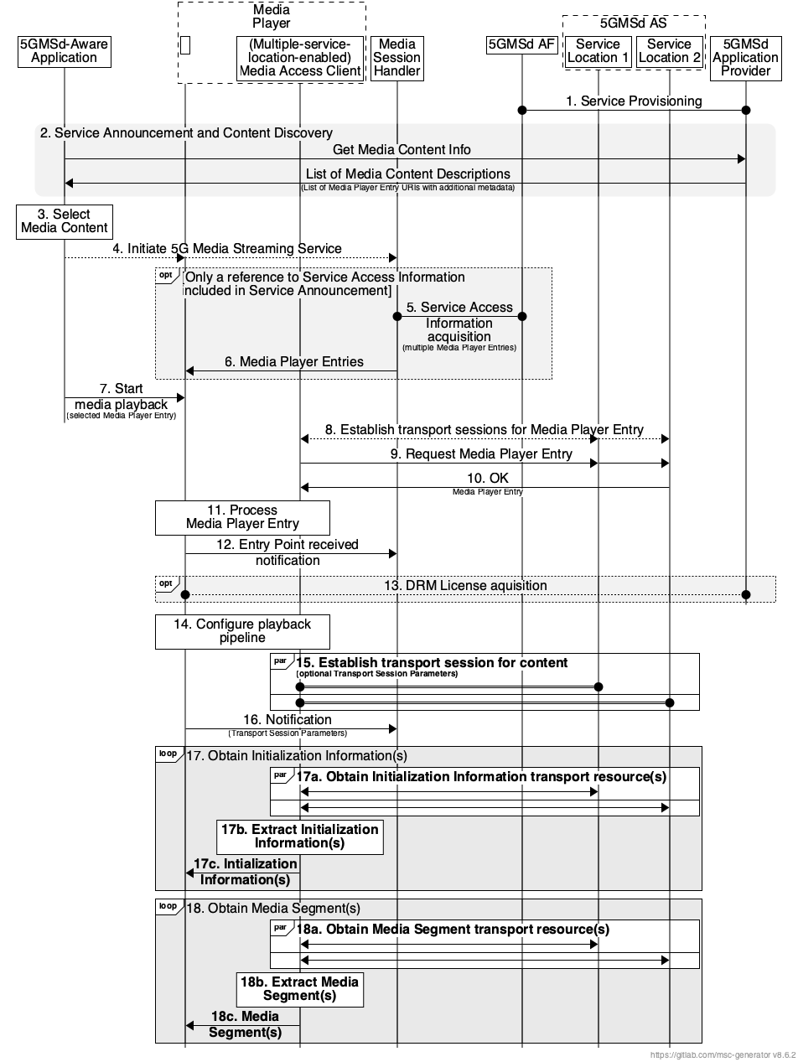
Figure I.3.2-1: High-level procedure for downlink streaming with concurrent use of multiple service locations
Steps:
1. The 5GMSd Application Provider provisions the 5G Media Streaming System, including content hosting and ingest, such that content is available from two or more service locations (labelled Service Location 1, Service Location 2, etc.) where each service location hosts a unique transport resource (e.g., each transport resource is a unique representation or variant of the media resource) to be acquired. Upon successful provisioning and content ingest (see clause 5.4.4), either the 5GMSd Application Provider or the 5GMSd AS may create or update Media Player Entry documents (or documents pointed to by each Media Player Entry document) to include any necessary configuration information required by the 5GMSd Client to concurrently access media content from multiple service locations.
2. The 5GMSd-Aware Application triggers the Service Announcement and Service and Content Discovery procedure. The Service and Content Discovery procedure only involves the 5GMSd-Aware Application and the 5GMSd Application Provider. The Service Announcement includes either the whole Service Access Information (i.e. details for Media Session Handling at reference point M5d and for Media Streaming access at reference point M4d) or a reference to the whole Service Access Information.
3. A media content item is selected.
4. The 5GMSd-Aware Application triggers the 5GMSd Client to initiate the downlink 5G Media Streaming service.
When the 5GMSd-Aware Application has received only a reference to the Service Access Information (see step 1):
5. The Media Session Handler interacts with the 5GMSd AF to acquire the whole Service Access Information. The Service Access Information may include Media Player Entry URLs.
6. The Media Session Handler provides the Media Player Entries to the 5GMS-Aware Application. The information may indicate a precedence order for these Media Player Entries.
Then:
7. The Media Player is invoked with the selected Media Player Entry to start media access and playback.
8. The (Multiple-service-location-enabled) Media Access Client establishes the transport session for acquiring the Media Player Entry.
9. The (Multiple-service-location-enabled) Media Access Client requests the Media Player Entry.
10. The (Multiple-service-location-enabled) Media Access Client receives the Media Player Entry.
11. The Media Player processes the Media Player Entry. From the Media Player Entry, the Media Player determines the configuration, including the set of available service locations where transport resources can be accessed and the transport resource URL(s) for the media resources to be acquired. It further determines, for example, the number of transport sessions to each service location needed for media acquisition. The Media Player uses the Media Player Entry information to initialize the media pipelines for each media stream. The Media Player Entry also contains information to initialize the DRM client, when DRM is used.
12. The Media Player notifies the Media Session Handler about the Media Player Entry.
13. Optional: the Media Player acquires the necessary DRM information, for example a DRM License.
14. The Media Player configures the media playback pipeline.
15. The Media Player establishes the necessary transport sessions for the content according to configuration information indicated by the Media Player Entry. These transport sessions may be established between the (Multiple-service-location-enabled) Media Access Client and any one or more of the available service locations. For example, the Media Player may establish one transport session for each media component (audio, video, etc) and possibly additional transport sessions for other media representations to each service location.
16. The Media Player notifies the Media Session Handler that it is ready to commence playback and optionally provides transport session parameters for those transport sessions terminating at the 5GMSd AS.
17. The Media Player requests and obtains the initialization information. The Media Player repeats this step for each required initialization segment.
17a. The (Multiple-service-location-enabled Media) Access Client requests and obtains, in parallel, unique transport resources (each containing a unique representation or variant of the required initialization information) from two or more available service locations.
17b. Upon reception of enough information from the combination of partially or fully obtained transport resources, the required media resource is reconstituted by the (Multiple-service-location-enabled) Media Access Client.
17c. The (Multiple-service-location-enabled) Media Access Client provides the extracted initialization information to the Media Playback and Content Decryption Platform as specified in TS 26.511 [26] where it is inserted into the appropriate media rendering pipeline.
18. The Media Player requests and obtains the Media Segments. The Media Player repeats this step for each required Media Segment according to the Media Player Entry information.
18a. The (Multiple-service-location-enabled) Media Access Client requests and obtains, in parallel, unique transport resources (each containing a unique representation or variation of the Media Segment) from two or more available service locations.
18b. Upon reception of enough information from the combination of partially or fully obtained transport resources, the required Media Segment is reconstituted by the (Multiple-service-location-enabled) Media Access Client.
18c. The (Multiple-service-location-enabled) Media Access Client provides the extracted Media Segment to the Media Playback and Content Decryption Platform as specified in TS 26.511 [26] where it is inserted into the appropriate media rendering pipeline.

I.3.3 Provisioning Session for downlink media streaming with concurrent use of multiple service locations
A simplified domain model suitable for downlink media streaming with concurrent use of multiple service locations where transport resources (each containing a unique representation or variation of every media resource) are hosted at different service locations exposed at reference point M4d is depicted in figure I.3.3-1. It consists of a Provisioning Session containing, at a minimum, a Content Hosting Configuration where one or more Distribution Configurations are defined. Each Distribution Configuration is associated with a single service location exposed by the 5GMSd AS at reference point M4d.
Figure I.3.3-1: Multi-source object coding provisioning domain model
The 5GMSd Application Provider may provision one or more Content Preparation Templates that are referenced by the configured Distribution Configurations for the purposes of transforming (e.g., encoding) media resources (e.g., Media Segments) ingested at reference point M2d into one or more transport resources where each transport resource is a different representation or variation of the ingested media resource.
Different representations or variations of the ingested media resource (each a different transport resource) are distributed to a 5GMSd Client at reference point M4d via a different service location exposed by the 5GMSd AS. Each representation or variant of a media resource (e.g., Media Segment) shall be exposed via a unique transport resource by exactly one 5GMSd AS service location at reference point M4d.
The high-level procedure to provision the features of the 5GMS System for media streaming with concurrent use of multiple service locations is defined in clause 5.

