Source: China Mobile Com. Corporation
Title: [FS_Beyond2D] Permanent Document v0.0.9
Version: 0.0.9
Agenda Item: 9.7
Document for: Agreement

1 Introduction
During SA4 AH Telco on Rel-19, New Study Item on “Study on Beyond 2D Video” was agreed in S4-240525 and afterwards approved in by SA#103 in SP-240479.
The objective of this study item are are as follows:
1. Identify and document beyond 2D formats, that are market-relevant within the next few years, generated from established and emerging capturing systems (including cameras for spatial video capturing), contribution, and usable on display technologies (smartphones, VR HMDs, AR glasses, autostereoscopic and multiscopic displays).
2. Establish and document a set of beyond 2D video end-to-end reference scenarios, including real-time communication, streaming services, split rendering, and messaging and corresponding workflows (capturing, encoding, packaging, delivery, decoding, rendering, including general constraints on latency, as well as complexity) to support 3GPP network related delivery and devices leveraging the generation or display technologies. This includes identifying and defining relevant beyond 2D formats in the context of above workflows, and representation technologies to support delivery of these formats within 3GPP networks.
3. Prioritize the scenarios and the associated formats based on market relevance for further evaluation.
4. Define concrete evaluation framework per scenario (test conditions, KPIs, Metrics, test sequences, agreed reference signals) based on the above prioritized reference scenarios, and evaluate the feasibility and performance of existing 3GPP codecs as well as potentially new codecs to support the scenarios.
5. Based on the findings in steps 1, 2, and 4 document (i) interoperability requirements, (ii) traffic characteristics and (iii) potential QoS optimizations or requirements, to support the above workflows and evaluate the feasibility of new formats with different services, considering the implementation constraints and performance indicators such as encoding, decoding, and rendering complexity, bandwidth utilization, and interoperability considerations.
6. Based on the findings in steps 1, 2, 4 and 5, identify potential gaps or deficiencies of existing 3GPP codecs, and offer recommendations to potentially extend 3GPP video specifications and capabilities.
- Identify potential areas for normative work as the next phase and communicate with other 3GPP WGs regarding relevant aspects related to the study to the extent needed.

2 Collected Scenarios
For the B2D study and based on the reference model, we consider the following scenarios as good candidates to be further detailed.
Messaging (aligned with consideration in TR 26.955, Scenario 4): A UE generates B2D video content in real-time and shares the media content with one or several UEs with B2D capabilities. The scenario reflects what is presented in TS 26.143. The following high-level constraints apply
- B2D content can be captured on existing or emerging devices
- Real-time B2D video encoding on typical mobile device is possible
- Encoding latency constraints relaxed
- Uploading of the formats through 5G network is possible
- Media can be packaged into a messaging format
Streaming (aligned with consideration in TR 26.955, Scenario 1 and 2): A content provider offers content to an MNO in a well-defined contribution format and the MNO transcode the B2D video to stream this to several or many UEs. In an alternative the encoding may also be done externally of the MNO network and the encoded content is ingest into the 3GPP network. The workflow is aligned with 5G Media Streaming as defined in TS 26.501 and TS26.512. The following high-level constraints apply
- Cloud encoding, real time encoding for live, and possibly offline for VOD content
- Encoding latency constraints relaxed
- Media can be packaged into a streaming formats, in particular CMAF/DASH/HLS
- Random Access and switching bitrates is needed (IDR frames/RAP)
- Content can originate from different sources, for example may be user generated, may be produced by game engines, or may be professionally produced.
- Well defined source formats exist that can be described in manifests
UE-to-UE Communication (No matching scenario on TR 26.955): A UE to UE communication between two B2D UEs to permit improved user experiences. The workflow is aligned with Real-time Communication as defined in TS 26.506, TS 26.113 and TS 26.114.
- Typically content is addressing a communication scenario, for example heads.
- Real-time encoding on typical mobile device is possible.
- Latency constraints stringent to meet communication latency requirements
- Uplink and downlink provide sufficient bitrates over 5G network
- Media can be packaged into a communication formats, in particular RTP
- Expected criteria from above
Other types of communication (No matching scenario on TR 26.955): TBD
Online Gaming/Split Rendering (aligned with consideration in TR 26.955, Scenario 5): A B2D UE uses a cloud rendering/game engine to produce B2D formats to provide improved experiences. In case the user interacts with the content (body pose and game interaction), the encoding and delivery requirements are such that you need to meet the latency requirements. This workflow is aligned with TR 26.565. The following high-level constraints apply:
- Content generated in game engines
- encoding in cloud/edge servers
- Latency constraints very stringent
- Media can be packaged into a Split Rendering formats
- Expected criteria from above
The scenarios may be further refined and detailed by addressing details, for example on the B2DV formats to be evaluated.

2.1 Scenario 1: Beyond 2D Messaging and Social Sharing

2.1.0 B2D formats of relevance
While it is understood that there is currently no harmonized set of formats for production and or device playback, the attempt towards improved format compatiblity and is the core driver for global standards. 3GPP should definitely contribute to this as we already do for the VOPS case with stereo MV-HEVC.
Note that devices are expected to render B2D formats based on their implementation, i.e. there is no need for interoperability or requirements beyond the decoding and the provisioning of metadata. The issue of rendering and presenting should not be part of the discussion. However, it can be checked how existing devices can render such formats in a beyond 2D experiences and invite interested companies to do so and bring data.
In order to understand the B2D formats, here are some data points
- https://techcrunch.com/2023/12/11/apple-releases-spatial-video-recording-on-iphone-15-pro/
  - Spatial Video if 1080p at 30fps
- https://9to5mac.com/2024/01/04/will-the-iphone-16-be-able-to-record-4k-spatial-video/
  - Spatial Video with 4K may come
- https://appleinsider.com/articles/24/03/06/capturing-spatial-video-apple-vision-pro-vs-iphone-15-pro
  - The spatial video captured is in a square 1:1 format at 2200 pixels by 2200 pixels. It is a near-perfect recreation of the passthrough viewed by the user.
- Some screenshots from video:
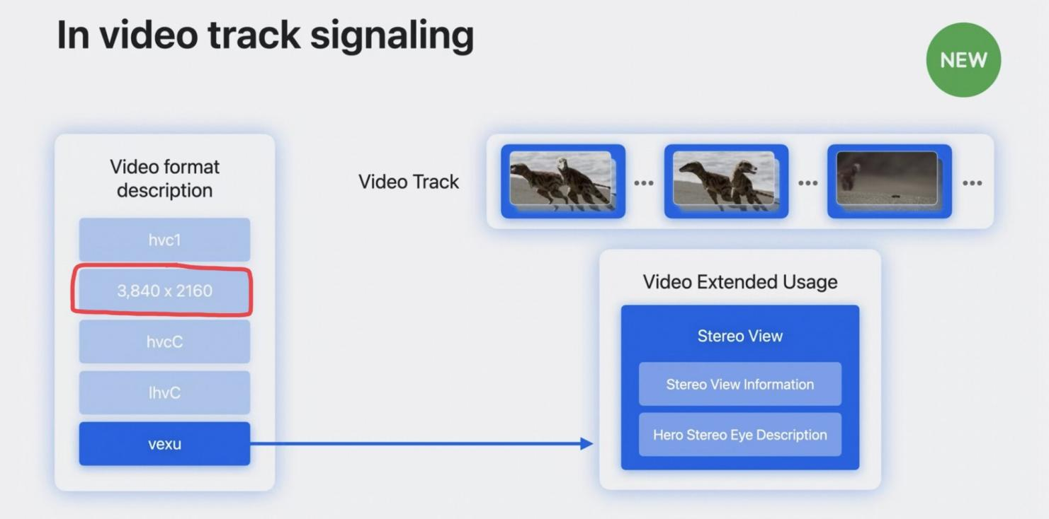
- https://developer.apple.com/documentation/avfoundation/avoutputsettingspreset/4172596-mvhevc1440x1440
- Once capture stereo on iPhone 15 and offline postprocess to acquire accompanying depth (using ZoeDepth or similar).
- Meta Quest can record spatial video: https://360rumors.com/quest-3-3d-videos/
  - After recording, you’ll see that the video or photo will be captured in side by side format, with a square aspect ratio. Photos will also be side by side but they are stretched vertically, and need to be edited to fix that.
- https://deovr.com/blog/84-record-vr-footage-on-the-meta-quest-3
  - The Quest 3 features two cameras that deliver full-color passthrough, allowing users to record content in 4K (2k per eye), using the Meta Quest Developer HUB.
  - The Quest 3's passthrough cameras record footage that is flat 120-100 (possibly 90) degrees.

Based on all of the observations, the following baseline formats may be considered:
- Stereo views for left and right eye
- Resolution per eye: 1080x1080, 1440x1440, 2048x2048
- Frame rates: 30, 50, 60 fps
- Chroma format: Y’CbCr (RGB?)
- Chroma subsampling: 4:2:0 (4:4:4)
- Bit depth: 10
- Colour space formats: BT.709, BT.2020
- Transfer characteristics BT.709, BT.2100 (HDR)

Beyond the basic information, the following information may be available:
- Static metadata:
  - Relative position between cameras
  - Camera intrinsics
  - Line time (per camera)
  - Examples: https://github.com/MPEGGroup/FileFormatConformance/tree/m62054_exintrinsics/data/file_features/under_consideration
- Disparity/depth map: 10bit, same resolution as source content, monochrome

A few spatial video sequences are provided here: https://www.zdnet.com/article/download-my-spatial-videos-from-tech-events-and-view-them-on-quest-3-or-vision-pro/. Also here some information is provided on how to capture spatial video: https://www.zdnet.com/article/how-to-capture-spatial-video-with-the-iphone-15-pro-theres-a-trick/

2.1.1 Motivation
In TR 26.955, clause 6.5 introduces messaging and social scenario. It addressed existing standardized and proprietary messaging services. Messaging applications, especially on the upstream, continue to become a critical part of the mobile experience, replacing old style text messaging, and increasingly are video-based. Four of the top 20 applications on the upstream are messaging apps. In another activity, operators are promoting enhanced messaging services based on Rich Communication Services (RCS).
As summarized in TR 26.955, sharing and uploading content as part of social sharing is predominantly pictures and videos that uploaded directly into a cloud and uploaded to one or many social networks, and then discussed (or shared again) over messaging networks. The relevant quality-of-experience factors include the quality of shared content, the time it takes to upload, the costs associated with the upload and also the processing and battery consumption requirements on the device to prepare the content for upload.
In the context of beyond 2D video experiences, existing and emerging capturing systems on mobile devices are used to capture video formats that go beyond regular 2D video formats. The captured scene is recorded and shared with another UE, for example another mobile device with a 2D screen, a mobile device with an Autostereoscopic Display, a VR or MR HMD, or it consumed on AR glass. While sharing may be done by different means (upload and download, stream, communication), the initial focus is on message exchange.
The scenario is shown in the below figure.
Editor’s Note: Diagram will be aligned with 1064 diagram
On the upper part, two examples of UE camera setup are shown that allow to generate a B2D message on the device. The input the encoder and packager is the result of a proprietary capturing towards a well-defined B2D format. The B2D message is shated with the network that stores B2D messages in a well-defined format. On the lower end, a regular 2D UE may produce content and upload the content to a network server. The server processes the data and produces again a B2D format that can be encoded and packaged to meet a well-defined B2D formats. In yet another scenario, some professional content is produced and exported in a well-defined B2D format, that is then encoded and packaged and also made available as B2D message.
Any of these messages can then be accessed/downloaded by B2D UEs that can unpack and decode in the included data and provide the B2D formatted content to the proprietary rendering systems.
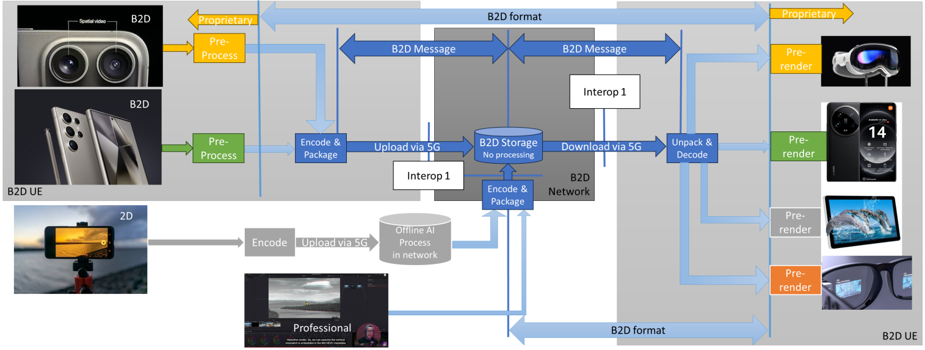
From the scenario, the B2D format and the encoding and packaging is expected to meet a few criteria, namely:
- The B2D format can be generated with market-relevant UEs
- The B2D messages can be encoded and packaged with market-relevant UEs
- The B2D messages can be unpacked and decoded on market-relevant UEs
- The B2D formats can provide a B2D experience on market-relevant UEs
- The B2D messages can be delivered via a 5G network in the upload and/or download.
Editor’s Note: On the typical and market-relevant formats, some information from clause 2.3 may be used.

2.1.2 Description of the Anticipated Application
In the context of 3GPP services, the Media Messaging Profiles and the architecture and the capabilities in TS 26.143 provides the appropriate context.
Editor’s Note: Architecture and capabilities from TS 26.143 may be added here
The considered scenario is the UE-based generation and consumption of messages and encapsulating into ISO/BMFF container format. Important aspects that are expected to be considered when evaluating a codec in the context of this:
- Quality and Coding Efficiency:
- The ability to compress a B2D video sequence targeting the maximum file size and maintaining high quality.
- The ability to compress 2 or more B2D streams in real-time to minimize storage requirements and sending latency.
- Considered settings for encoding:
- Regular random access at least every 2 seconds, preferably more often
- No specific encoding latency constraints are applicable
- Encoding in this scenario is typically done as
- Real-time encoding for social sharing
- UE-based Encoding

2.1.3 B2D Messaging Video Formats
Table 2.1.3-1 provides an overview of typical beyond 2D source signal properties for UE-to-UE messaging. This information is used to select proper test sequences.
Editor’s Note: This is a first draft, details needs to be confirmed.
Table 2.1.3-1 Beyond 2D Source Format Properties for UE-to-UE messaging
Source format properties | Social Sharing
Number of views | 2
Spatial resolution for each view | 2160 x 2160, 1440 x 1440, 1080 x 1080
Chroma format | Y’CbCr
Chroma subsampling | 4:2:0
Picture aspect ratio | 1:1
Frame rates | 30, 50, 60 Hz
Bit depth | 10
Colour space formats | BT.709, BT.2020
Transfer characteristics | BT.709, BT.2100 (HDR)
Optional Depth/Disparity
Spatial Resolution | Same resolution as view
Chroma format | Y’CbCr
Chroma subsampling | 4:0:0
Picture aspect ratio | Same as views
Frame rates | Same as views
Bit depth | 10
Format | tbd

2.1.4 Encoding and Decoding Constraints
Table 2.1.4-1 provides an overview of encoding and decoding constraints for H.265/HEVC for UE-to-UE messaging scenario. This information supports the definition of detailed anchor conditions.
Editor’s Note: This is a starting point and additional considerations need to apply.
Table2.1.4-1 Encoding and Decoding Configurations
Encoding and Decoding Constraints | General | H.265/HEVC
Relevant Codec and Codec Profile/Levels | Profile suitable for messaging content, no specific requirements.  Levels to meet the above formats | H.265/HEVC Main 10 Profile  Level 4.1, 5.1
Random access frequency | 1 second and 10 seconds | 1 and 10 seconds
Bit rates and quality configuration | Capped-VBR (social sharing) and VBR (messaging)  Fixed QP | B = {2.5, 5, 7.5,10} Mbps  Capped-VBR (social sharing) and VBR (messaging)  Fixed QP
Bit rate parameters (CBR, VBR, CAE, HRD parameters) | Covering a range of relevant bitrates and qualities | No latency requirements beyond RAP so picture reordering allowed
Latency requirements and specific encoding settings | No latency requirements | No specific requirements
Encoding complexity context | real-time encoding (social sharing), offline encoding (messaging) on mobile device, single path | see General
Required decoding capabilities | Profile suitable for messaging content, no specific requirements.  Levels to meet the above formats | Up to x streams of H.265/HEVC Main 10 Profile  Level 4.1, 5.1

2.1.5 Performance Metrics
The following metrics are expected to be reported <tbd>

2.1.6 Interoperability Considerations
Messaging applications require that the content is included in a packaging and file format.
Editor’s Note: More details on backward-compatibility being a benefit

2.1.7 Reference Sequences
Table 2.1.7-1 provides the selected reference sequences for this scenario. Keys are identified to refer to the sequences in the context of the scenario. The sequences are named and a reference to the details of the sequence is provided. A justification is provided, why this sequence is selected.
<Editor’s Note: We should have 1080 sequences and 2K sequences, and we should have sequences with depth available>
Table 2.1.7-1 Reference Sequences for UE-to-UE Sharing
Key | Name | Reference | Justification/Comment
SX-R01 |  | Annex C.5.2
SX-R02 |  | Annex C.5.3
SX-R03 |  | Annex C.5.4
SX-R04 |  | Annex C.5.5

2.1.8 Anchor Definition

2.1.8.1 Overview
This clause provides details on how to generate the anchors for the social sharing and messaging scenario.
The Social sharing and messaging scenario relies on relaxed delay encoding modes with limited encoding complexity.

2.1.8.2 Anchors
Editor’s Note: This serves as a template. Details are to checked.

2.1.8.2.1 Overview
Table 2.1.8.2.1-1 provides an overview of the anchor tuples. Keys are identified to refer to the anchors in the context of the scenario.
The details are also provided here: https://dash-large-files.akamaized.net/WAVE/3GPP/Beyond2D/Bitstreams/Scenario-X-Sharing/265/streams.csv.
Table 2.1.8.2.1-1 Anchor Tuple generation with H.265/HEVC for Social sharing and messaging
Key | Clause | Reference Sequence | Reference Encoder | Config | Variations | Anchor Key
SX-A01-265 | 6.X.8.3.3 | SX-R01 | HM16.22 | SX-HM-01 | QP = [17, 22,27,32,37] | SX-A01-265-<QP>
SX-A02-265 | 6.X.8.3.3 | SX-R02 | HM16.22 | SX-HM-01 | QP = [17, 22,27,32,37] | SX-A02-265-<QP>
SX-A03-265 | 6.X.8.3.4 | SX-R03 | HM16.22 | SX-HM-01 | QP = [17, 22,27,32,37] | SX-A03-265-<QP>
SX-A04-265 | 6.X.8.3.4 | SX-R04 | HM16.22 | SX-HM-01 | QP = [17, 22,27,32,37] | SX-A04-265-<QP>
SX-A05-265 | 6.X.8.3.5 | SX-R01 | HM16.22 | SX-HM-02 | QP = [17, 22,27,32,37] | SX-A05-265-<QP>
SX-A06-265 | 6.X.8.3.5 | SX-R02 | HM16.22 | SX-HM-02 | QP = [17, 22,27,32,37] | SX-A06-265-<QP>
SX-A07-265 | 6.X.8.3.6 | SX-R03 | HM16.22 | SX-HM-02 | QP = [17, 22,27,32,37] | SX-A07-265-<QP>
SX-A08-265 | 6.X.8.3.6 | SX-R04 | HM16.22 | SX-HM-02 | QP = [17, 22,27,32,37] | SX-A08-265-<QP>

2.1.8.3.2 Common Parameters
Editor’s Note: This is a starting point, details are to be checked.
To generate the anchor bitstreams, HM16.22 is used.
Each source sequence is encoded with:
- QP: [17, 22, 27, 32, 37]
- InternalBitDepth is 10 # codec operating bit-depth where all sequences (including 8 bit sequences) are coded with an internal bitdeph of 10 in accordance with [44] and metrics are calculated in 10 bits.
- SEIDecodedPictureHash=1
As the SEIDecodedPictureHash is set to 1, the effective file size (EFS) needs to take into account the removal of this SEI message when computing the bitrate metric as defined in clause 5.5.2.

2.1.8.3.3 SX-HM-01: no random access
Each source sequence is encoded with the following changes:
- The common parameters as defined in clause 2.1.8.3.2
- IntraPeriod with no fix interval
- GOPSize is equal to 8. Each B picture refers to up to 4 preceding pictures in display order within the GOP
- IntraQPOffset is -1. B picture QP offsets are IntraQPOffset is -1. B picture QP offsets are adjusted based on the base QP and on the QPmod, QPoffset, QPOffsetModelScale and QPOffsetModelOff.
The settings are defined in the attached configuration file sX-hm-01.cfg.

2.1.8.3.4 SX-HM-02: Intra
Each source sequence is encoded with the following changes:
- The common parameters as defined in clause 6.6.8.3.3
- IntraPeriod = power of 2 value that is greater than or equal to the frame rate (fps), such that near 1 second is achieved: 32 for 30fps sequences and 64 for 60fps sequences
- DecodingRefreshType: (2) IDR
- IntraQPOffset and B pictures QPoffsets are set equal to 0
- Each B picture refers to immediately preceding pictures in display order.
The settings are defined in the attached configuration file sX-hm-02.cfg.

2.1.9 Anchor Results
<TBD>

7.x Scenario 2: Streaming of Multi-view Produced Content

7.x.1 Motivation for the scenario
The proposed scenario handles the streaming of produced multi-view content that provides experiences beyond what is achievable with 2D content. The scenario allows to evaluate the streaming of high-quality, professionally captured and produced multi-view video content.
Multi-view content may be in the form of volumetric video, which is a frame-based immersive experience whereby each frame represents a volumetric region in 3D space in which any point is either non-occupied or having a color that may depend on the viewing direction. Volumetric video has the potential to provide an immersive and interactive experience for use cases in diverse domains such as e.g. education, entertainment, and industrial monitoring. Streaming of volumetric video has been previously considered in 3GPP for some use cases described in TR 26.928 [R1] and TR 26.998 [R2].
NOTE: Streaming of volumetric video with single asset is not a part of this scenario and handled separately in the scenario described in clause 7.y.
This scenario is based on the multi-view video representation formats that is defined in clause 4.3.4. Capturing setups and production software are available as described in the related representation format definitions. Contribution, compression and storage formats for multi-view video are available, see clause 7.x.3. It is expected that segmented media delivery will be used based on DASH and ISOBMFF. Carriage of coded media using ISOBMFF has been specified for MIV in [R4]. Hardware video decoder capabilities can be used for all pixel data. Rendering and display systems for multi-view video are described in clause 4.3.4.3.

7.x.2 Description of the scenario
This scenario considers on-demand streaming of multi-view produced content to a UE. Capture setup, production tools and workflows for multi-view video capture systems and production tools are described in clause 4.3.4.2. Contribution, compression and storage formats are linked to the representation format. Well-defined contribution formats exist that carry the raw texture/depth images and camera parameters, e.g. as described in clause 4.3.4.2. Compression formats for multi-view video are described in clause 4.3.4.4. One codec that can be used to realize this scenario is MPEG Immersive Video (MIV) specified in ISO/IEC 23090-12. Below the workflow with MIV is described.
The multiple camera views and depth maps are encoded to create a unified representation. An example could be MIV constrained to one or more atlases and packed video data. The single video sub-bitstream per atlas would be encoded with HEVC Main10 profile. The bitstream contains all camera parameters that are necessary for 6DoF rendering. Each atlas is independently renderable.
NOTE: This study may include multi-view content for which some or all views lack depth information.
Figure 7.x.3-2 provides an example of a MIV encoder flow.

Figure 7.x.3-2: MIV encoder example

- Patch Extraction and Filtering: extraction of regions from the texture and depth map for the purpose of pixel-rate reduction and allowing object interactivity at the client.

- Background Sprite Extraction: The ground surface and far-away background can be represented by a single sprite texture with depth. This greatly reduces the required pixel space.

- Atlas Generation: The patches and sprite are packed in an atlas such that both the pixel area is optimally used and the temporal correlation is retained to guarantee an acceptable bitrate.

An example of multi-view video encoding has been described in the paper [R5].
The encoded bitstream is encapsulated to ISOBMFF according to the rules of the used codec.
For example, an MIV bitstream may be packaged in one track, or multiple tracks where the packed video data is one track, common atlas data is one track, and atlas data is another track. ISO/IEC 23090-10 [R4] specifies how to map MIV (V3C) onto ISOBMFF, file format and DASH.
When a scene is represented by multiple atlases, only one of them may be decoded based on the viewing position. This is called atlas-level sub-bitstream access. In the case of DASH, switching atlas would amount to changing tracks.
The decoder(s) will make use of hardware video decoder capabilities for all pixel data, and metadata describing information needed for rendering is decoded/parsed by a CPU.
Rendering and display systems for multi-view video are described in clause 4.3.4.3.
In the case of MIV, efficient rendering can be performed directly from the atlas after decoding to GPU memory:

- Patch Depth Binning: patches are warped to the target view and sorted on depth using an efficient histogram-based method

- Back-to-front View Synthesis: patches with the same depth from multiple source views are blended together using view-angle based weighting.

- Blend and Composite: After blending over views (per depth layer), layers are composited back to front.
The codec should support a random access reference frame structure.
For example, the MIV access units and the video sub-bitstream are organized using a random access reference frame structure. All sub-bitstreams could have the same prediction structure, but atlas data and common atlas data frames may be skipped.
The common atlas data with camera parameters could only change infrequently (once per second or less), for instance each time an online camera calibration is updated. While it is possible to transmit common atlas data at non-IRAP frames, this would be not desirable in this scenario.
The atlas data with patch information may be static when transmitting only full views or dynamic when an encoder selects regions of the source views for transmission based on e.g. occlusion detection or depth segmentation. In MIV, patch information is always intra-coded (unlike V3C in general).
All decoder and renderer processes are real-time. End-to-end latency may be in the range from 500 ms to multiple seconds.
Synthesis views or a view based on view control can be delivered to the client. The trade off between prediction error and bandwidth needs to be considered while selecting the number of views.

7.x.3 Source format properties
For this scenario, the multi-view video source format has 10 to 20 views. It is expected that most or all test data will have perspective projection (PSP), but test data with equirectangular projection (ERP) may be included.
Each view has the following components:
- Texture (color)
- Depth coded as normalized disparity
Depth information can be used in rendering e.g. by shaders for surface normal estimation. If depth is not provided, decoder-side depth estimation can be possible.
Editor’s note: Further details on depth processing is FFS.
All views have view parameters: camera ID, camera intrinsics, camera extrinsics (pose) and depth quantization parameters (optional).
Views may be undistorted, otherwise distortion parameters have to be provided.
The signal properties defined in clause 4.3.4.1 apply with no further constraints.

7.x.4 Encoding and decoding constraints and settings
Some constraints and settings below are given for MIV.
Codec profiles/levels:
- HEVC Main 10 MIV Main
  - MIV level 2.0 or 2.5.
- HEVC Main 10 MIV Extended
  - MIV level 2.0, 2.5 or 3.0 whereby the level 3.0 is only allowed if there is a single video sub-bitstream.

Typical random-access frequency of 32 frames can be considered. It is up to the service provider to define the exact random access frequency.
Transmission systems need to be prepared to resend data in case of data loss. If data loss still occurs or retransmitted data does not reach the receiver device in time for rendering, previous volumetric frames may be re-rendered with updated viewing poses. In case one or more of the sub-bitstreams is lost, it is up to the application to determine an optimal method for hiding the missing information.
Typically, bitrates between 5 and 50 Mbit/s may be considered.
Bitrate parameters related to video sub-bitstreams need to be configured by the streaming service provider. Transfer characteristics are signalled in the video sub-bitstreams.
No special requirements regarding ABR. Configuration is left for the service provider to determine.
Latencies between 500ms to several seconds are considered. Random access interval or segment duration are configured according to the latency requirements.
Encoding is performed by a content provider. This scenario assumes professional setting for recording and processing the content, so no real-time or encoder hardware or architecture requirements are provided.
It is expected that devices support HW accelerated video decoding.
Decoding requirements:
- HEVC Main 10
- HEVC levels are determined according to the maximum HEVC Level that is needed for a video sub-bitstream decoder to fulfill the MIV level.
- HEVC level 5.1 for MIV level 2.0
- HEVC level 5.2 for MIV level 2.5
- HEVC level 6.1 for MIV level 3.0
- Video sub-bitstreams need to be independently decodable. This helps implementations on various platforms that may have only high-level APIs. For instance, geometry needs to be full range.
Samples in the sub-bitstreams should be temporally aligned.

7.x.5 Performance Metrics and Requirements
The tests are run for a chosen level as described in clause 7.x.6. Bitstreams are provided. Camera calibration, depth estimation, and encoding are not evaluated.
The test will have four rate points and QP values are selected for each sequence to approximately match the 5 to 50 Mbps range. When saturation occurs before 50 Mbps a lower value may be chosen in consultation. When there are multiple video components or packed regions then the other QP values need to be directly derived from the texture QP using an equation or a look-up table. (They cannot depend on the sequence.)
[Ed.(BK): To be aligned with the agreed evaluation framework.]
The IV-PSNR tool, available at https://gitlab.com/mpeg-i-visual/ivpsnr, is available to compute full-reference objective metrics:
- Weighted sphere PSNR (WS-PSNR)
- Immersive video PSNR (IV-PSNR)
All source views that were used for encoding are provided. Each source view is reconstructed by decoding and rendering (view synthesis). The IV-PSNR tool is then run on all source views and the score is averaged over all views.
Depending on bit rate, quality of depth maps and rendering, either the video codec or view synthesis is the limiting factor. BD-PSNR is calculated for both metrics because the metric behaves more predictably than BD-rate.
[Ed.(BK): To be aligned with the agreed evaluation framework. The discussion here on correlation of objective and subjective metrics may need to be moved to that framework after more deliberation.]
There is experience in testing of immersive video in MPEG context. The test conditions as described are a simplification and evolution of the common test conditions for MIV defined in [R6].
The main challenge with testing of multi-view video is that codecs are asymmetric. The input is a number of source views (with depth maps), and the output of the decoder + renderer can be any viewport within a spatial region around those source views. In the mentioned CTC two tests are used:
- Objective evaluation at source view positions
- Subjective evaluation of pose trace videos (dynamic viewports)
This has resulted in a lack of correlation between objective and subjective results, but despite that it is the best-known approach. Alternatives that have been tried and dismissed (for now):
- Objective evaluation at dynamic viewports: It includes view synthesis in the reference condition and this skews the results towards a specific renderer. It prevents an A/B comparison of different renderers.
- Subjective evaluation at source view positions: This is not how the end-user will interact with the content, and it does not evaluate artifacts due to viewport dynamics.
For this test, because the aim is to prove feasibility of a scenario, objective evaluation may be sufficient, especially when supplemented with (informal) real-time demonstration of the same bitstreams that were used for objective evaluation.

7.x.6 Interoperability Considerations for the application
The multi-view video bitstream needs to be carried over DASH for this scenario. It is not necessary to prove this as part of the feasibility test, if written evidence can be provided.
In the example of using MIV as a codec, there are implementations for DASH (InterDigital/Philips) and RTP + SDP (Nokia and an open source implementation by Tampere University: https://github.com/ultravideo/uvgRTP).

7.x.7 Test Sequences
Test sequences that were used during the development of a codec are discouraged because they may create a bias towards that specific codec. Sequences that were used in a verification test are permissible.
Preferably test sequences match with the intended use case both in terms of technical requirements and content semantics.
For MIV a list of available sequences is provided in [R6].

7.x.8 Detailed test conditions
[Ed.(BK): To be aligned with the agreed evaluation framework.]
For each candidate codec, a suitable decoder + renderer needs to be made available for testing purposes.
For MIV a reporting template or script will be provided to compute BD-PSNR based on IV-PNSR log files of all rates and sequences.
For MIV the common test conditions defined in [R6] are followed.

7.x.9 External Performance data
For MIV the performance data is available from the verification test report [R7].
NOTE: This performance data was based on different source view properties and the results may not translate to this study.

7.x.10 Additional Information
The Metaverse Standards Forum (MSF) has established a Volumetric Media Interoperability working group which aims to build a better understanding of volumetric media, to identify relevant areas of applications and compatibility requirements, and to establish common requirements for different systems. See here the WG description: https://metaverse-standards.org/domain-groups/volumetric-media-interoperability/
The technology is expected to be highly scalable since it uses well-established transport technologies like DASH and 2D video coding techniques.
Regarding complexity, rendering and decoding frame rates for MIV content were measured for Windows and Android platforms in [R5]. The results show that the developed platform can decode V3C content in real time on both Windows and Android. Evaluation of battery consumption (power levels) is FFS.
Streaming of multi-view content has the potential to disrupt several markets including entertainment/media, education/training, retail/shopping.
Several use cases can be envisioned related to these domains. For example, in an education/training scenario, a pre-recorded video of a fitness instructor showing how to perform an exercise can help the student to better understand how the exercise is done and thus replicate in a correct way. Another example in education domain would be a mechanic giving a tutorial on how to assemble a mountain bike. The viewer can watch the movements of the mechanic from different angles and get an improved understanding of the different steps due to depth perception and different viewpoints. In the entertainment domain, users can stream a performance from their favorite band to their living room and experience greater immersion potentially together with spatial audio.

2.3 Scenario 3: Streaming of Beyond 2D Produced VoD Content – Use Case “Volumetric Video with single asset”

2.3.1 Scenario name
Streaming of Beyond 2D Produced VoD Content - Use case “Volumetric Video with single asset”

2.3.2 Motivation for the scenario
What is the market relevance of the proposed scenario within the next few years? Are there any commercially available or pre-released products or prototypes?
This scenario handles the streaming of produced Beyond 2D content providing experiences beyond what is achievable with 2D content. “Beyond 2D” content may be in the form of volumetric video, which is a frame-based immersive experience whereby each frame represents a volumetric region in 3D space in which any point is either non-occupied or having a colour that may depend on the viewing direction. Volumetric video has the potential to provide a more immersive and interactive experience for use cases in diverse domains such as e.g. education, entertainment, and industrial monitoring.
Streaming of volumetric video has been previously considered in 3GPP in TR 26.928 (Cl. A.4 - Streaming of Immersive 6DoF, Cl 5.4 - XR Multimedia Streaming) [X2] and TR 26.998 (Cl. A.3 - Use Case 18: Streaming of volumetric video for glass-type MR devices) [X3].
On-demand volumetric video streaming enables distribution of high-quality, professionally captured and produced volumetric video content. Some aspects of production and capturing systems for volumetric representation formats such as point clouds and meshes are documented in TR 26.928, clause 4.6.7.
Several use cases of on-demand volumetric video streaming can be envisioned related to various domains including education, entertainment and industrial monitoring. For example, in an education/training scenario, a pre-recorded video of a fitness instructor showing how to perform an exercise can help the student to better understand how the exercise is done and thus replicate in a correct way. Another example in the education domain would be a mechanic giving a tutorial on how to assemble a mountain bike. The viewer can watch the movements of the mechanic from different angles and get an improved understanding of the different steps due to depth perception and different viewpoints. In the entertainment domain, users can stream a performance from their favorite band to their living room and experience greater immersion potentially together with spatial audio. For first implementations of relevant use cases the content can be quite simple without hindering the purpose, consisting of a camera captured 6 DoF person or object and 3D background or a background coming from an AR camera in the rendering device.
Motivation for the use case:
In the use case “Volumetric video with single asset”, and particularly in AR mode, the viewer can see the volumetric video asset, as if it were naturally in front of him. In AR and VR applications, the viewer can move smoothly around the asset or make the asset rotate.
NOTE 1: This use case is part of the scenario “Streaming of Beyond 2D Produced VoD Content”.
In recent years, several collaborations regarding on-demand volumetric video streaming were established between various mobile network operators, volumetric capture studios and technology providers. Some of these collaborations are listed here:
- Volucap, based in Potsdam, Germany:
  - Tagesschau: Volucap and the German news broadcaster Tagesschau collaborated to capture a volumetric representation of a news anchor: https://volucap.com/portfolio-items/tagesschau-2025/
  - Music Group: Volucap and the music group “Boss Hoss” prototyped the your favorite band in your living room: https://volucap.com/portfolio-items/the-bosshoss-augmented-reality/
  - Book enhanced with AR: Volucap enhanced a children song book with AR content on a smartphone: https://volucap.com/portfolio-items/rolf-zuckowski/
  - Sports training: Volucap and Deutsche Telekom produced a clip to learn cool dribbles and precise throws from the former basketball star Josh Mayo: https://volucap.com/portfolio-items/meeting-josh/
  - XR Fashion show: Volucap and Lana Mueller, a Berlin based designer, produced a fashion presentation in XR: https://volucap.com/portfolio-items/lana-mueller-fashion/
- Volograms, based in Dublin, Ireland
  - Provides professional volumetric content creation services to feed AR use cases such as augmented museum, training or fashion experiences: https://www.volograms.com/made-with-volograms
  - The company has also developed AI based solution to enable AR volumetric content from 2D single photo or video: https://www.volograms.com/
- 8i, Mantis Vision, Metastage, Volograms, XD Productions, etc. present volumetric capturing projects on their websites, similar to Volucap
- XD Productions and Volograms content (both professional and AI-based) has been showcased in public trade shows and conferences by InterDigital as part of MPEG-I V3C platform demonstration with the V-PCC player.
- Zerospace and Canon are collaborating to open a volumetric video capturing studio in Spring 2024. With over 100 Canon Cinema EOS cameras, it claims to offer unmatched capabilities. The website illustrates capture of sports content (e.g. basketball, Karate): https://www.zerospace.co/studios/canon-volumetric-capture
- Philips, InterDigital and Broadpeak are collaborating on an end-to-end implementation platform for packaging and delivery of volumetric video over content delivery network (CDN).
  - https://broadpeak.tv/newsroom/mpeg-v3c-standardized-content-distribution-at-scale/
  - https://ir.interdigital.com/news-events/press-releases/news-details/2024/InterDigital-and-Broadpeak-Announce-Collaboration-on-MPEG-V3C-Standardized-Content-Distribution-At-Scale/default.aspx
- The following video presents new video production technology used by Hollywood production studios and volumetric video is presented starting at minute 14: https://www.youtube.com/watch?v=u7pu1cQBqtQ&t=373s

NOTE 2: The examples are meant to provide motivation and demonstrate the market relevance of the scenario and use case and not to give detailed information on the capture setup, formats or other aspects of the workflow. For the workflow description see clause 3.
Volumetric video content can be consumed on devices such as smartphones, tablets, HMDs, TV sets, STBs and PCs, provided that a player for volumetric video is installed. The renderer in the player adapts the content to the specific display.
Brazilian SBTVD Forum has adopted volumetric video for inclusion in their TV 3.0 standards (support will not be mandatory in all receivers; focus on content distribution over the Internet and consumption on smartphones and HMDs). TV3.0 services are planned to be launched in 2025.
DVB is running a study mission on volumetric video and the first results are published in Study Mission Report S101. [X4]

2.3.3 Description of the scenario – with use case Volumetric Video with single asset
This provides a description of beyond 2D video end-to-end workflows, which includes identifying and defining beyond 2D formats being used in the context and representation technologies to delivery these formats. The following aspects may be considered for each workflow:
This scenario considers streaming of Beyond 2D produced VoD content, with the use case "Volumetric Video with single asset”.
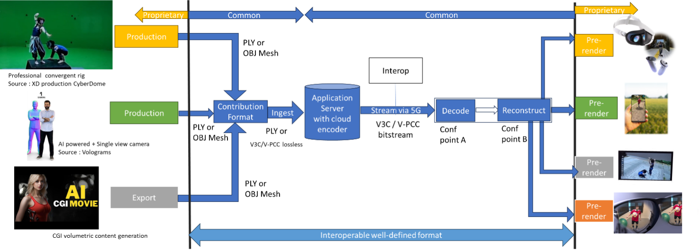
Figure x1: Streaming of Beyond 2D produced VoD content
Editor’note: that figure is a “specialized figure” of a generic streaming scenario. Some changes will be needed.
- Capturing and processing
Capturing of high-quality 6 DoF assets as a volumetric video is typically done with a rig of cameras aligned on a circle around the asset(s) to be captured. Depending on the rig, there can be one or more layers of cameras at different height positions, with each layer consisting of up to 60 cameras. Cameras can be equipped with depth sensors. Hardware such as cameras and depth sensors are off the shelf equipment, but the assembly in the rig is vendor dependent and proprietary.
The various camera and depth sensor signals are fed into a production pipeline that produces the volumetric video. Production includes stitching the various signals, filling holes, correcting occlusions, etc. Persons or physical objects (e.g. a ball or an instrument) can be combined in an asset or separate assets can be used for each person or object. For simplification and not hindering the purpose, the use case described in this document is limited to a single asset. The representation format of a produced asset is typically a dynamic point cloud or a dynamic mesh. The use case “Volumetric Video with single asset” described in this document is entirely based on point clouds as the representation format.
As an example, in the following we describe the production pipeline of the company XD Productions.
The figures below show the XD Productions CYBERDOME capture rig and associated real time viewing to control acquisition.
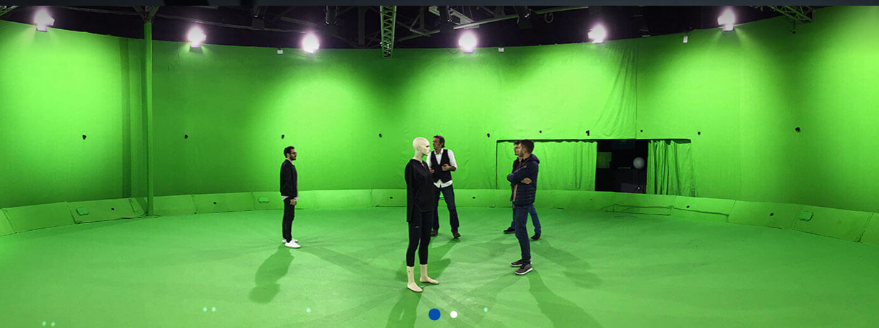
Figure x2: XD Productions capture rig (https://www.xdprod.com/services/studio/studio-virtuel/)
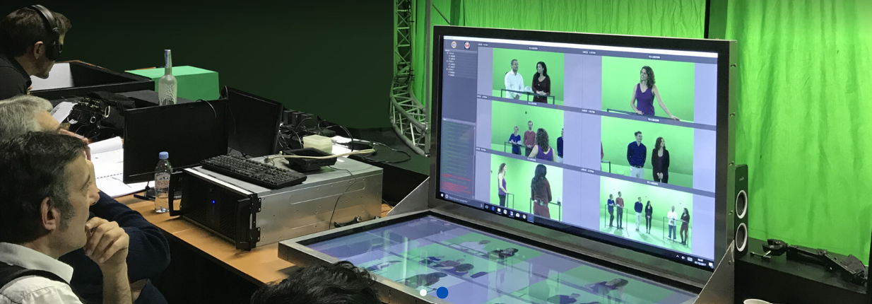
Figure x3: XD Production real time virtual production (https://www.xdprod.com/services/studio/studio-virtuel/)
The figures below show CYBERDOME acquisitions covering single or multiple characters in dynamic scenes.
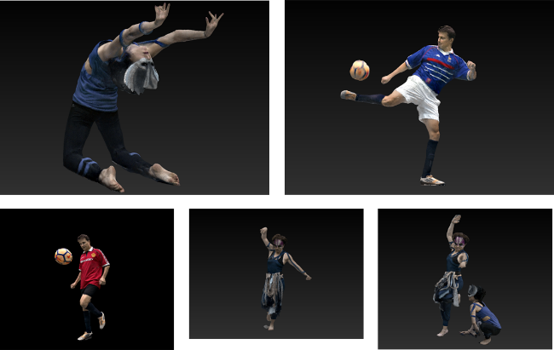
Figure x4: XD Productions contents screenshots, from top right to left: Acrobat01, Soccer Blue, Soccer Red, Dancer01 and Acrobat Duo
Acquisition processing pipeline includes a rig of about sixty 4K cameras, arranged in hemispheres around the scene to be captured. The set is 15-meter in diameter for a 7-meter diameter capture area. Two types of lenses are simultaneously used, with variable focal lengths, which allows to adapt the size of the capture area, and to mix wide shots and close-ups on the same captures to improve the quality of the textures. Each content item is then converted into point cloud frames contained in a 10bit-sized bounding box with integer, positive coordinates. The processing output is shared in the PLY format.
Another example on how single asset volumetric video is produced is shown in a video by Metastage.
There are a number of companies that provide volumetric video capturing technology or entire volumetric video capturing studios. For a more detailed list we refer to chapter 5.4.4 in the DVB Study Mission report S101 on Volumetric Video.[X4]
Editor’s note: information to be provided on quality of the generated point cloud (e.g. number of points, fps, for a sufficient quality).
- Encoding
The representation format(s) point cloud is encoded with MPEG V-PCC standardized in ISO/IEC 23090-5 Visual Volumetric Video-based Coding (V3C) and Video-based Point Cloud Compression (V-PCC) – 2nd edition. [X5]
The following diagram shows the V-PCC encoder main steps.

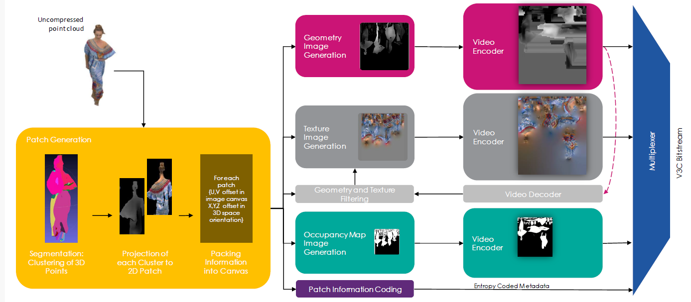

For coding of geometry, texture and occupancy map, V-PCC relies on 2D video encoders such as HEVC or VVC.
An example of point cloud data encoding processing has been described in [X1]

- Packaging and delivery
Storage and delivery of MPEG V-PCC is standardized in ISO/IEC 23090-10 Carriage of visual volumetric video-based coding data – 1st edition. [X6]
- Decoding
The decoder(s) make use of hardware video decoders capabilities for all pixel data, and a small amount of metadata is decoded by a CPU. No dedicated hardware is needed for real-time decoding. The following diagram shows the architecture of MPEG V-PCC.

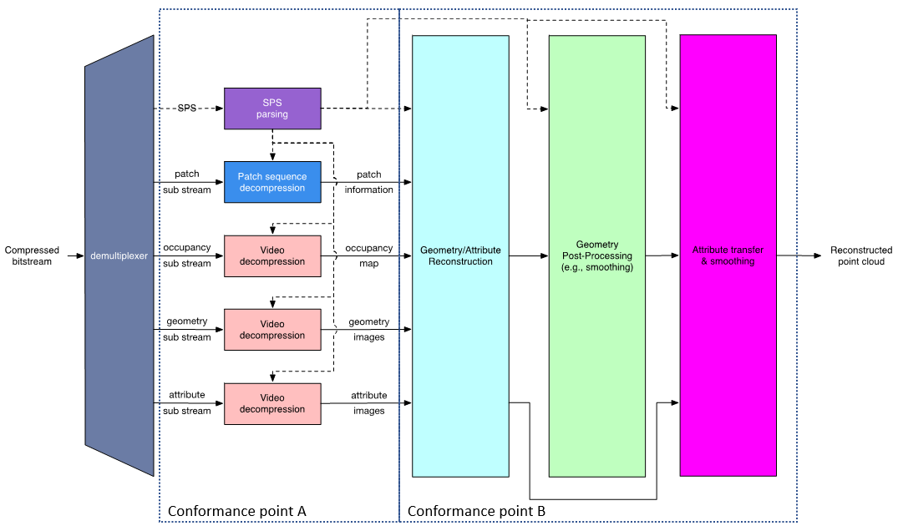

Decoding of the point cloud is terminated at the output of the video decoders, but these images are just intermediate results and do not represent a useable image for the human eye. Additional stages are needed to reconstruct the point cloud in 3D space and render it to the display of the consumer device.
An example of point cloud data decoding processing has been described in [X1].

By the end of 2023, Futuresource estimates that there are 4.1 billion Smartphones globally in the field with the capacity to decode HEVC video, therefore we propose using HEVC as the underlying 2D video codec.

- *Post-processing
- Rendering
Rendering is implementation dependent, but it is typically performed on a GPU without dedicated V-PCC hardware.
An example of point cloud data rendering has been described in the paper “Efficient Delivery and Rendering on Client Devices via MPEG-I Standards for Emerging Volumetric Video Experiences”
- General constraints on latency, bandwidth, reliability and complexity
For delivery, the volumetric frames are organized using a random-access reference frame structure.
All decoder and renderer processes are real-time and may have a latency in the order of a few frames.
Editor’s note: further information on “bandwidth” and complexity to be added when tests are made, further information on “reliability” to be provided once the term is clarified.

2.3.4 Supporting companies and 3GPP members
- This documents the 3GPP members that support this scenario in terms of providing the information, test material, test requirements and the characterization for the tests. For each of the identified necessities, a tick box is created in the template.
- Preferably several 3GPP members are included in the support, and in addition a video service provider may be included (not necessarily a 3GPP member).
- Cross-verification is preferably done by the supporters of the scenario
Deutsche Telekom, Fraunhofer HHI, Interdigital, KDDI, Nokia, Philips, Samsung and Sony

2.3.5 Source format properties
This defines a clear range of the considered and relevant source formats, including the signal properties, but also the characteristics of the content. As an example, the texture and depth format properties of the source may be used which include:
Table xxx1 lists Beyond 2D Source Format Properties for Volumetric Video with single asset streaming scenario..

Source format properties | Volumetric Video with single asset streaming scenario
Number of points /Spatial Resolution | Up to 1 million points per frame
Chroma format | RGB
Chroma subsampling | Not Applicable
Picture aspect ratio | Not Applicable
Frame rates | 25, 30 Hz
Bit depth | 8 and 10
Colour space formats | RGB 444 nonlinear, BT.709
Transfer characteristics | BT.709
Viewpoints | All assets can be viewed from all directions
Table x1

2.3.6 Encoding and decoding constraints and settings
Table xx2 provides an overview of encoding and decoding constraints for V-PCC with H.265/HEVC for Volumetric Video with single asset streaming scenario. Contribution aspects are not considered in this table. This information supports the definition of detailed anchor condition.
Encoding and Decoding Constraints | V-PCC with H.265/HEVC
Relevant Codec and Codec Profile/Levels | H.265/HEVC Main 10 Profile  Level 4.1, 5.1  Metadata stream parsing
Random access frequency | 1 seconds
Bit rates and quality configuration | Fixed QP Geometry: [32;28;24;20;16]  Fixed QP Texture: [42;37;32;27;;22]  bitrates [1;50 Mbps]
Bit rate parameters (CBR, VBR, CAE, HRD parameters) | Covering a range of relevant bitrates and qualities
Latency requirements and specific encoding settings | No specific latency requirement
Encoding complexity context | Cloud-based encoding, offline encoding
Required decoding capabilities | 3 decoder instantiations of H.265/HEVC Main 10 Profile  Level 4.1, 5.1for (occupancy, geometry and color)  One synchronized metadata bitstream (Atlas)
Table 7.3.6 Encoding and decoding constraints
Encoding and Decoding Constraints | V-DMC with H.265/HEVC
Relevant Codec and Codec Profile/Levels | Texture: H.265/HEVC Main 10 Profile Level 4.1, 5.1  Geometry: H.265/HEVC Main 10 Profile Level 3.0 (e.g. 256x768 at 30 fps)  Metadata stream parsing
Random access frequency | 1 seconds
Bit rates and quality configuration | TBD
Bit rate parameters (CBR, VBR, CAE, HRD parameters) | TBD
Latency requirements and specific encoding settings | No specific latency requirement
Encoding complexity context | Cloud-based encoding, offline encoding
Required decoding capabilities | - Two decoder instantiations of H.265/HEVC Main 10 Profile (Level 5.1 for texture, Level 3.0 for displacement)  - For packed video, one H.265/HEVC Main 10 Profile, Level 5.1  - Decoding of the base mesh (not video decoding) TBD

Editor’s note: Information TBD to be provided

2.3.7 Performance Metrics and Requirements
- A clear definition on how the performance needs to be evaluated including metrics, etc addressing the main KPIs of the scenario.
- Objective measures such as PSNR, VMAF, etc, may be used.
- Justification on whether objective metrics are sufficient and representative of the subjective performance.
For objective tests it is proposed to use the point-based metric described in annex B1, B3 and B4 of the following document: https://www.mpeg.org/wp-content/uploads/mpeg_meetings/136_OnLine/w21000.zip
The point-based metric has been used by MPEG throughout the complete development process of V-PCC. On case-by-case basis and complementary to the point-based metric, MPEG produced snapshots of frames and studied subjectively the impact of a tool before selection.
Editor’s note: assessment of the quality to be further considered.

2.3.8 Interoperability Considerations for the application
- Streaming with DASH/HLS/CMAF/QUIC
MPEG-DASH is used with ISO/IEC 23090-10 Carriage of visual volumetric video-based coding data – 1st edition.[X6]
- RTP based delivery
RTP is not proposed for this use case.

2.3.9 Test Sequences
A set of selected test sequences that are provided by the proponents in order to do the evaluation. They should cover a set of source format properties
- Longdress, Soldier, Loot, Red and Black from 8i as shown in Figure x5.
- Mitch, Thomas from Volucap as shown in Figure x6
- Red Soccer Player, Two_Acrobats from XD Productions as shown in Figure x7

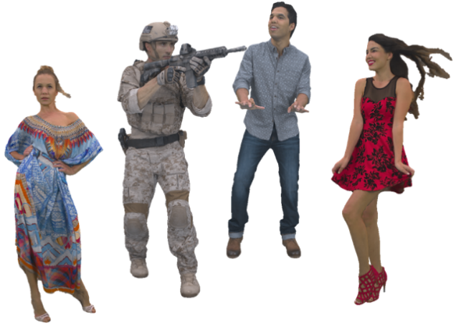
Figure x5 - 8i content sequences, first frame, from left to right, Longdress, Soldier, Loot, Red and Black.
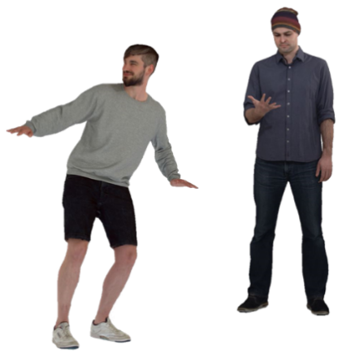
Figure x6 - Volucap sequences, first frame, from left to right, Mitch, Thomas.
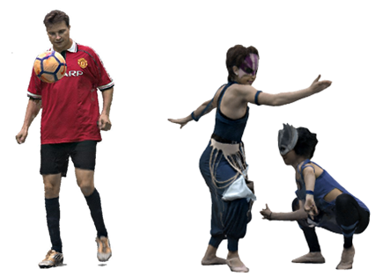
Figure x7 - XD Productions sequences, first frame, from left to right, Red Soccer Player, Two acrobats.

Figure x8 gives characteristics of the 3D point cloud sequences.

Sequence | Provider | FPS | Number of frames | Duration (s) | ~ Point number per frame | Geometry precision | Attributes
Longdress | 8i | 30 | 300 | 10,0 | 800000 | 10 bits | R,G,B
Soldier | 8i | 30 | 300 | 10,0 | 1000000 | 10 bits | R,G,B
Loot | 8i | 30 | 300 | 10,0 | 780000 | 10 bits | R,G,B
Red and black | 8i | 30 | 300 | 10,0 | 700000 | 10 bits | R,G,B
Mitch | Volucap | 30 | 475 | 15,8 | 860000 | 10 bits | R,G,B
Thomas | Volucap | 30 | 748 | 24,9 | 790000 | 10 bits | R,G,B
Red Soccer player | XD Productions | 25 | 125 | 5,0 | 950000 | 10 bits | R,G,B
Two Acrobats | XD Productions | 30 | 211 | 7,0 | 790000 | 10 bits | R,G,B

Figure x8 - Test material datasets

2.3.9.1 Raw Point Cloud Sequences

2.3.9.1.1 Overview
For a raw point cloud sequence used in the context of this Technical Report, the following metadata is proposed:
- Name of the sequence
- Scenario
- Sequence key as provided in TR 26.956
- URI to zip file containing PLY files (URL to weblink where the original sequence is available)
- Name Format of files
- Frame count
- Start frame number
- Frame rate
- Geometry precision
- Color format
- Peak Value (bounding box resolution e.g. 1023, 2047)
- Copyright statement
- Contact Person
Optionally, the following metadata could be added:
- Background
- TR26.956 reference
- Thumbnail preview
- Preview MP4
- Average point number per frame
- Duration
- MD5 of the zip file containing all point cloud frames
- Size in bytes of the zip file containing all point cloud frames.
A JSON scheme is defined in clause 2.9.1.1.2 for this matter. An example is provided in clause 2.9.1.1.3.

2.3.9.1.2 Json Scheme
JSON schema for the raw format is attached to the zip file:
{
"$schema": "http://json-schema.org/draft-07/schema",
"$id": "https://dash-large-files.akamaized.net/WAVE/3GPP/Beyond2D/ReferenceSequences/B2DPC-schema.json",
"type": "object",
"title": "The root schema",
"description": "Schema for beyond 2D point cloud sequences.",
"default": {},
"required": [
"Sequence",
"Properties",
"CopyRight",
"Contact"
],
"properties": {
"Sequence": {
"$id": "#/properties/Sequence",
"type": "object",
"title": "Schema for the Sequence",
"description": "Includes all information about the sequence",
"default": {},
"required": [
"Name",
"Scenario",
"Key"
],
"properties": {
"Name": {
"$id": "#/properties/Sequence/properties/Name",
"type": "string",
"title": "The Name schema",
"description": "Provides a unique name of the sequence."
},
"Background": {
"$id": "#/properties/Sequence/properties/Background",
"type": "string",
"title": "The Background schema",
"description": "Provides a background information on the sequence."
},
"Scenario": {
"$id": "#/properties/Sequence/properties/Scenario",
"type": "string",
"title": "The Scenario schema",
"description": "Provides information to which Scenario this sequence relates."
},
"Key": {
"$id": "#/properties/Sequence/properties/Key",
"type": "string",
"title": "The Key schema",
"description": "Provides the key used in TR 26.956.",
"examples": [
"S41"
]
},
"TR26.956": {
"$id": "#/properties/Sequence/properties/TR26.956",
"type": "string",
"title": "The TR26.956 schema",
"description": "Provides the reference to TR26.956 used.",
"examples": [
"S41"
]
}
},
"additionalProperties": true
},
"Properties": {
"$id": "#/properties/Properties",
"type": "object",
"title": "The Properties schema",
"description": "the properties of the raw video.",
"required": [
"URI",
"NameFormat",
"frameCount",
"startFrame",
"frameRate",
"geometryPrecision",
"colorformat",
"peak"
],
"properties": {
"URI": {
"$id": "#/properties/Properties/properties/URI",
"type": "string",
"title": "The URI schema",
"description": "Provides a reference/URL to the sequence point cloud data."
},
"thumbnail": {
"$id": "#/properties/Properties/properties/thumbnail",
"type": "string",
"title": "The thumbnail schema",
"description": "Provides a reference/URL to a typical frame of the video."
},
"preview": {
"$id": "#/properties/Properties/properties/preview",
"type": "string",
"title": "The preview schema",
"description": "Provides a reference/URL to an mp4 encoded video."
},
"NameFormat": {
"$id": "#/properties/Properties/properties/NameFormat",
"type": "string",
"title": "The NameFormat schema",
"description": "Provides a name of the sequence to which a frame index is added.",
"examples": [
"exemple%04d.ply"
]
},
"frameCount": {
"$id": "#/properties/Properties/properties/frameCount",
"type": "integer",
"title": "The frameCount schema",
"description": "The number of point cloud frames in the sequence.",
"examples": [
327
]
},
"startFrame": {
"$id": "#/properties/Properties/properties/startFrame",
"type": "integer",
"title": "The startFrame schema",
"description": "The first frame in the sequence that is to be used starting from 1.",
"default": 1,
"examples": [
1
]
},
"frameRate": {
"$id": "#/properties/Properties/properties/frameRate",
"type": "integer",
"title": "The frameRate schema",
"description": "Framerate of the video.",
"examples": [
30
]
},
"pointsCountMean": {
"$id": "#/properties/Properties/properties/pointsCountMean",
"type": "integer",
"title": "The average of points number per frame schema",
"description": "The average point number per frame.",
"examples": [
857241
]
},
"geometryPrecision": {
"$id": "#/properties/Properties/properties/geometryPrecision",
"type": "integer",
"title": "The geometry procision schema",
"description": "geometry precision in bits of the point cloud sequence.",
"default": "10",
"examples": [
10
]
},
"colorformat": {
"$id": "#/properties/Properties/properties/colorformat",
"type": "string",
"title": "The colorformat schema",
"description": "Format of texture attribute",
"default": "rgb",
"enum": [
"rgb",
"yuv"
],
"examples": [
"rgb"
]
},
"peak": {
"$id": "#/properties/Properties/properties/peak",
"type": "integer",
"title": "The peak schema",
"description": "peak of the point cloud sequence.",
"default": "1023",
"enum": [
1023,
2047
],
"examples": [
1023
]
},
"duration": {
"$id": "#/properties/Properties/properties/duration",
"type": "number",
"title": "The duration schema",
"description": "Duration of the sequence in seconds.",
"examples": [
5.46
]
},
"md5": {
"$id": "#/properties/Properties/properties/md5",
"type": "string",
"title": "The md5 string",
"items": {
"description": "md5 of the zip files containing all point cloud frames.",
"type": "string",
"examples": [
"d055a94f35f7594776186fc5d09a9fa4"
]
}
},
"size": {
"$id": "#/properties/Properties/properties/size",
"type": "integer",
"title": "The size integer",
"items": {
"description": "Size in bytes of the zip file containing all point cloud frames.",
"type": "integer",
"examples": [
149190147
]
}
}
},
"additionalProperties": true
},
"CopyRight": {
"$id": "#/properties/CopyRight",
"type": "string",
"title": "The CopyRight schema",
"description": "Copyright statement."
},
"Contact": {
"$id": "#/properties/Contact",
"type": "object",
"title": "The Contact schema",
"description": "A contact for the sequence.",
"required": [
"Name"
],
"properties": {
"Name": {
"$id": "#/properties/Contact/properties/Name",
"type": "string",
"title": "The Name schema",
"description": "The name of a person."
},
"Company": {
"$id": "#/properties/Contact/properties/Company",
"type": "string",
"title": "The Company schema",
"description": "Company."
},
"e-mail": {
"$id": "#/properties/Contact/properties/e-mail",
"type": "string",
"title": "The e-mail schema",
"description": "e-mail or web page link."
},
"generation": {
"$id": "#/properties/Contact/properties/generation",
"type": "string",
"title": "The generation schema",
"description": "Information on how the data was generated"
}
},
"additionalProperties": true
}
},
"additionalProperties": true
}

2.3.9.1.3 Example
An example is attached to the zip file:

{
"Sequence": {
"Name": "Exemple",
"Background": "This is a B2DV format example",
"Scenario": "Streaming of Beyond 2D Produced VoD Content",
"Key": "S01",
"TR26.956": "Annex X.Y.Z"
},
"Properties": {
"URI": "https://dash-large-files.akamaized.net/WAVE/3GPP/Beyond2D/ReferenceSequences/file.zip",
"thumbnail": "https://dash-large-files.akamaized.net/WAVE/3GPP/Beyond2D/ReferenceSequences/file.png",
"preview": "https://dash-large-files.akamaized.net/WAVE/3GPP/Beyond2D/ReferenceSequences/file.mp4",
"NameFormat": "exemple%04d.ply",
"frameCount": 320,
"startFrame": 0,
"frameRate": 30,
"pointsCountMean": 1000000,
"geometryPrecision": 10,
"colorformat": "rgb",
"peak": 2047,
"duration": 10.0,
"md5": "d055a94f35f7594776186fc5d09a9fa4",
"size": 11510343938
},
"CopyRight": "Conditions that are suitable for this study",
"Contact": {
"Name": "Celine Guede",
"Company": "InterDigital",
"e-mail": "celine.guede@interdigital.com",
"generation": "provided by contact"
}
}

2.3.9.2 Candidate source sequences
Collected candidate raw dense point cloud sequences and dynamic mesh sequences that are available for testing are presented in Annex C.2

2.3.9.4 Selected source sequences for testing
This section lists 5 sequences that have been selected for objective and subjective testing.
Test sequences have been selected based on visual quality and that these have not been used during codec development in MPEG. The following table lists the selected test sequences:
Table 7.3.8.2 Selected source dense dynamic point cloud sequences
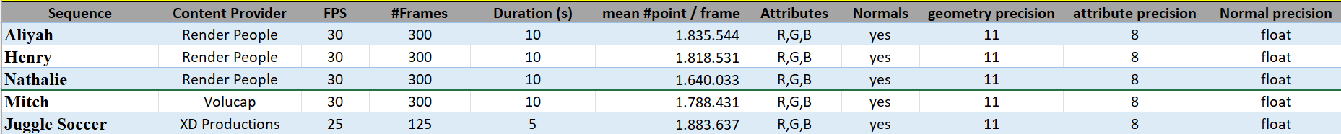

Table 7.3.8.3 Selected source dynamic mesh sequences
Editor’s note: To be done for dynamic mesh

The following thumbnails illustrate the selected test sequences:
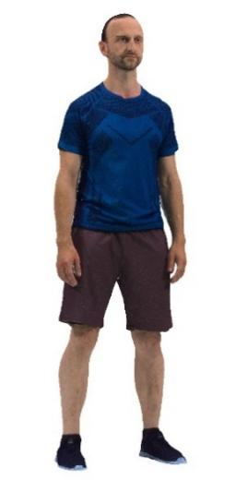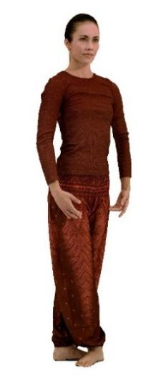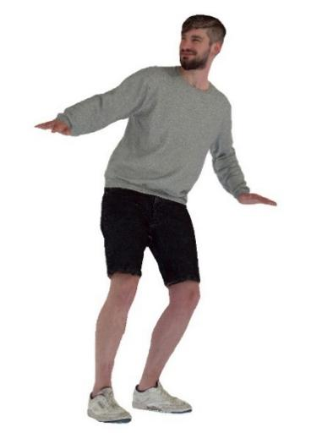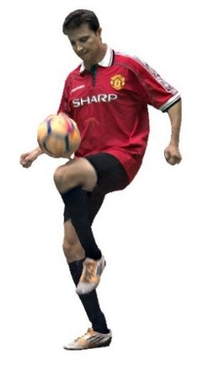
Figure 7.3.8.2-1 Aliya, Henry, Nathalie, Mitch and Joggle Soccer (content courtesy by Renderpeople, Volucap and XD Productions)
The selected licensed source sequences can be grouped as follows:
- Group 1 - Freely available to 3GPP members: Nathalie, Mitch and Joggle Soccer
- Group 2 - Publicly purchasable: Henry
- Group 3 - Publicly free available: Aliyah

Editor’s note: Test sequences for dynamic mesh to be added

Sequences of group 1 have already been converted to pointclouds of around 2 million points per frame and maximum 10s length and are provided on the server. Sequences of group 2 and group 3 need to be downloaded and converted by those wanting to reproduce completely the test.
Editor’s Note: Provide instructions and scripts on how to convert sequences of group 2 and group 3

2.3.9.1.5 Production of point cloud sequences
Contribution S4-241197 presents various volumetric production facilities which deliver assets typically as dynamic point cloud or as a dynamic mesh. Both representation formats are able to deliver high quality and can be converted from one to the other by keeping a high level of quality for the discussed scenario. This contribution focuses uniquely on the quality of the point cloud format and other aspects will be covered in separate contributions.

2.3.9.1.6 Example sequences
In this document we use a subset of candidate sequences introduced in S4aV240021 that have been produced by Volucap [2]. Volucap claims to have the world’s highest resolution for capturing volumetric video with 700 megapixels for each shot and a unique lighting system [3].
The following sequence has been provided by Volucap in high quality in dynamic point cloud and dynamic mesh formats for use in standards setting purposes. The sequence including the license can be provided to 3GPP SA4 as soon as a password protected server has been set up.
- Volucap/Volucap_T003_ThomasScenic-03, 320 frames
The second sequence we have selected is a free sequence provided by Renderpeople [4], which is a company that captures and commercializes people in various 3D formats for use in visualization, VFX, games, as well as VR/AR. Volumetric video sequences are named “4D People” and the selected free sequence is named DancingAliyah. RenderPeople uses the Volucap technology for capturing “4D People”.
- RenderPeople/DancingAliyah, 320 frames

2.3.9.1.7 Conversion and quantisation
Volucap provided the sequence with high resolution in floating point format, which is appropriate for production interchange or contribution, but for consumer applications the delivery bandwidth would be too high. Therefore, we sample and quantize to reduce the number of points and use fixed-point format. The result of that conversion is that the sequence is in a bounding box of 10, 11 or 12 bit which we name in the following as Vox10, Vox11 and Vox12.
- Vox 12 creates a quality that is close to the quality that comes out of the production system for the provided sequences, as examples see Figure 7 for Thomas and Figure 19 for Aliyah.
- Vox 11 creates a quality that allows viewing the sequence from a wider distance and it allows to zoom closer and see details of the face and of cloth, as example see Figure 8 for Thomas and Figure 20 for Aliyah. Emotional facial expressions and buttons and tissue structure of cloths is visible.
- Vox 10 creates a quality allowing to view the sequence from a wider distance, but getting too close is less recommended, as examples see Figure 6 and Figure 9 for Thomas and Figure 18 and Figure 21 for Aliyah.
In chapter 7 we will indicate for each test sequence and for each conversion the number of points so that FS_Beyond2D contributors get an idea of what quality can be achieved with a number of points for that type of asst.

2.3.9.1.8 Impact of rendering
The visual viewing quality of the point cloud format depends heavily on how voxels are rendered. Just reconstructing voxels in 3D space may bring a limited viewing experience and holes/cracks may become visible. To show the impact of rendering we show the sequences with two different renderers:
- MPEG renderer: Each voxel is replaced by a cube of a configurable fixed size. This renderer is deliberately simple for studying the pure impact of compression.
- Industry renderer: Each voxel is replaced by a splat of a size that depends on the viewing distance and some blending is implemented to avoid flickering of points. There are no sophisticated techniques such as lighting or use of normals integrated.
Rendering is device manufacturer dependent and not covered in standards. However, a manufacturer or application developer would implement a decent point cloud renderer so that delivered content would look acceptable. Therefore it is beneficial to demonstrate also the industry type renderer to judge realistically the quality of the point cloud format.

In the following we give an example of the impact of the renderer on the head of the sequence Thomas with Vox 10 conversion:
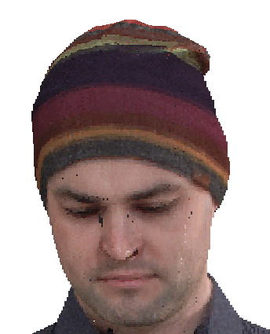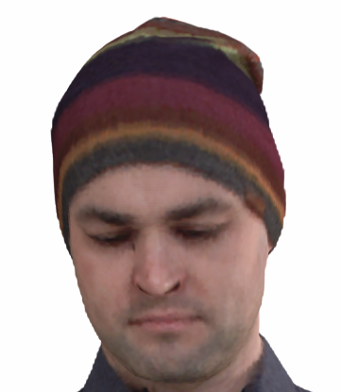
Figure 1 Vox 10 MPEG renderer Figure 2 Vox 10 Industry renderer

Both snapshots are rendered from the same Vox 10 sequence. On the left side we see far more cracks and holes and the borderline of the sequence is less smooth. However, the eyebrows look a bit sharper on the left side. A high-end industry renderer may do better than the renderers illustrated here.

2.3.9.1.9 Impact of the background
To avoid interference between the background and the example sequence, we use in chapter 7 a neutral background colour for the snapshots. If a VR or AR background is used instead of a neutral background, potential artefacts in the sequence are less visible, as the human eye concentrates on the overall picture and not only on the sequence.

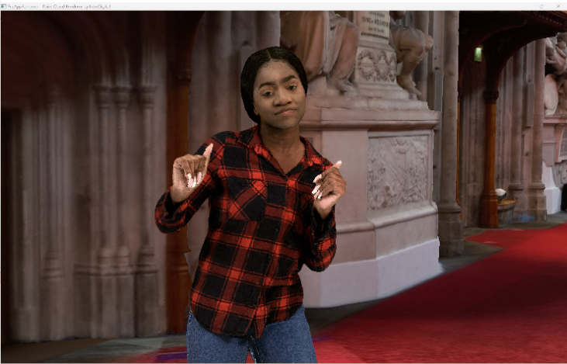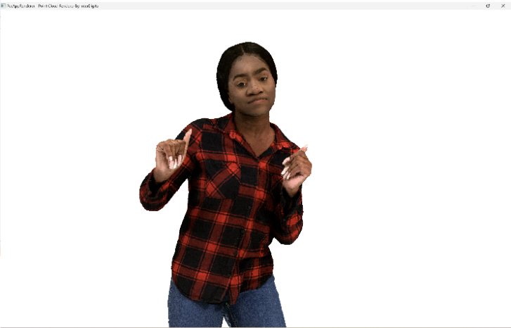
Figure 3 Impact of background on perceived quality of Aliyah Vox 10 and MPEG renderer

2.3.9.1.10 Snapshots of test sequences in uncompressed point cloud representation format as still pictures
In the following we show the impact of conversion including the number of points in a frame and renderer type on the quality of the point cloud format. We use mostly full screen snapshots (still pictures) allowing to judge the preserved detail. Note that in a volumetric video sequence some artefacts in the snapshots would not be visible.
It can be observed that point clouds of around 1M points/frame allow to watch the sequence from a wider distance (e.g. from 3m*) and point clouds of around 2M points/frame allow to get closer (e.g to around 1.5m distance) at good quality for the target scenario. Emotional facial expressions and buttons and tissue structure of cloths is visible. More points per frame improve the details, but this may not be required for the target scenario. But if a scenario would require it, a high-end volumetric video production system is able to capture details from e.g. skin or finer details of tissue and it can be represented with the point cloud representation format.
*A typical demonstration scenario would be to use e.g. a smartphone or tablet running a volumetric video application showing a real person of e.g. 3m distance on the screen captured by the camera and rendering at the same time a second person rendered from a point cloud next to the first person.
Thomas far with proprietary renderer and neutral background

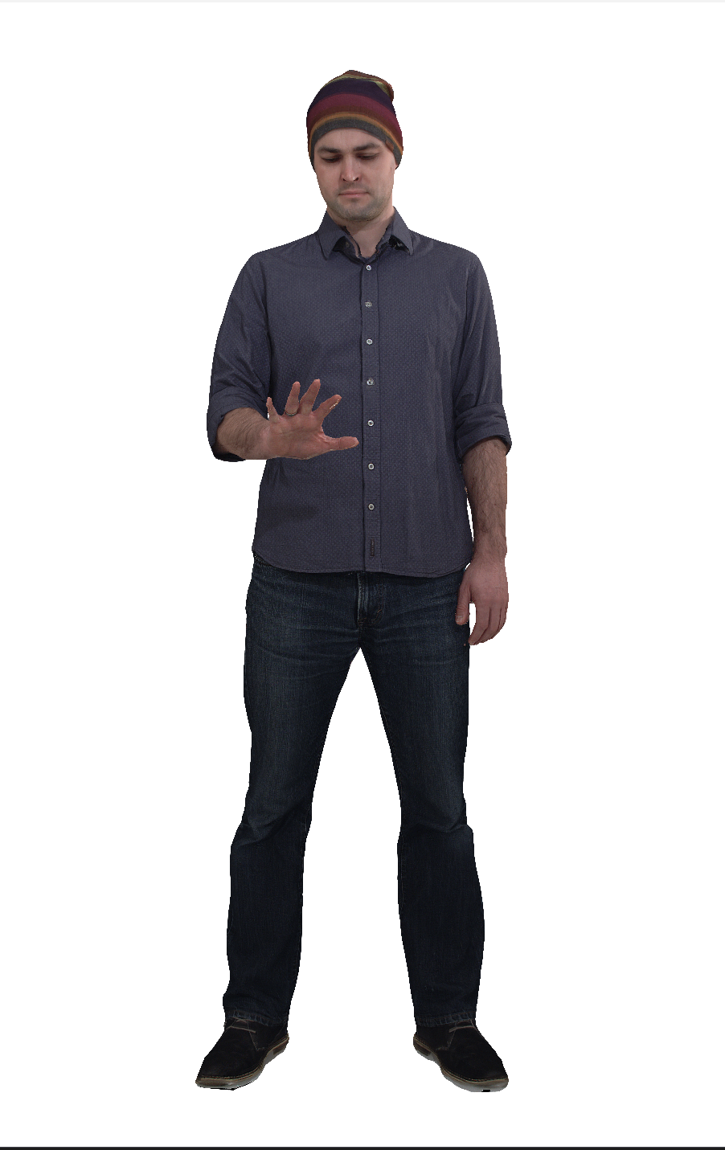
Figure 4 Vox 12 with 9.5M points per frame
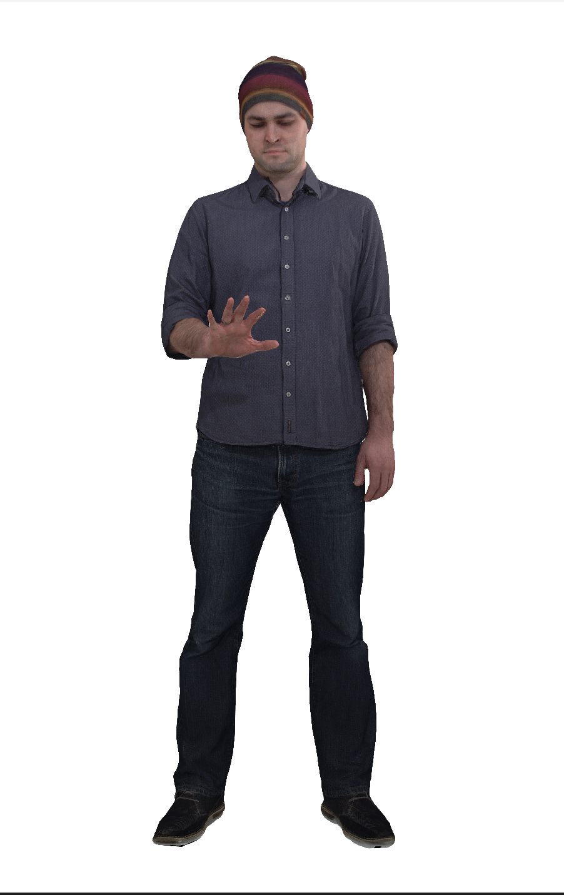
Figure 5 Vox 11 with 2.3M points per frame

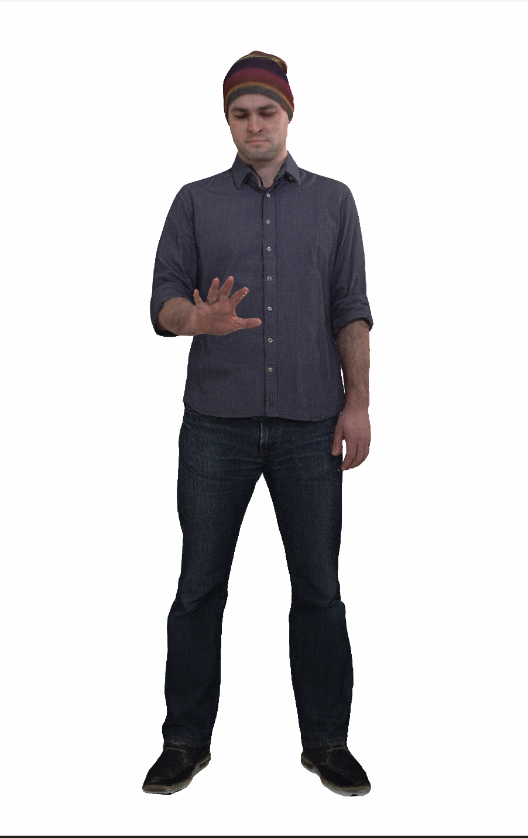
Figure 6 Vox 10 with 600K points per frame

Thomas near with proprietary renderer and neutral background

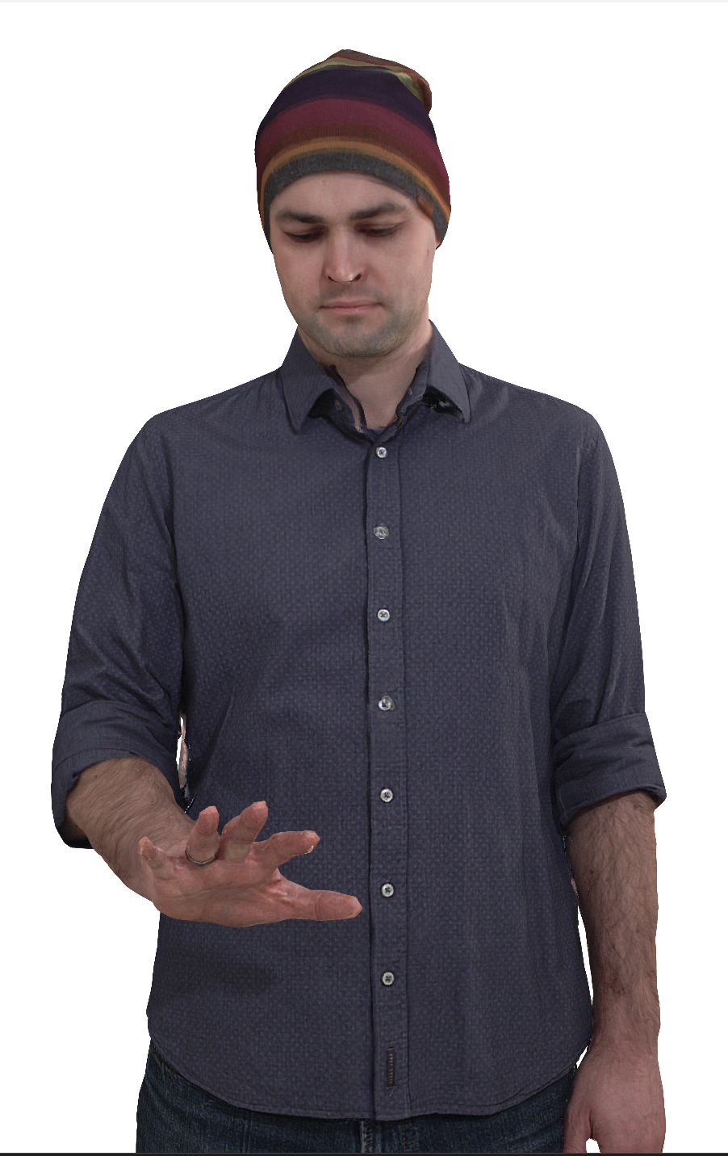
Figure 7 Vox 12 with 9.5M points per frame
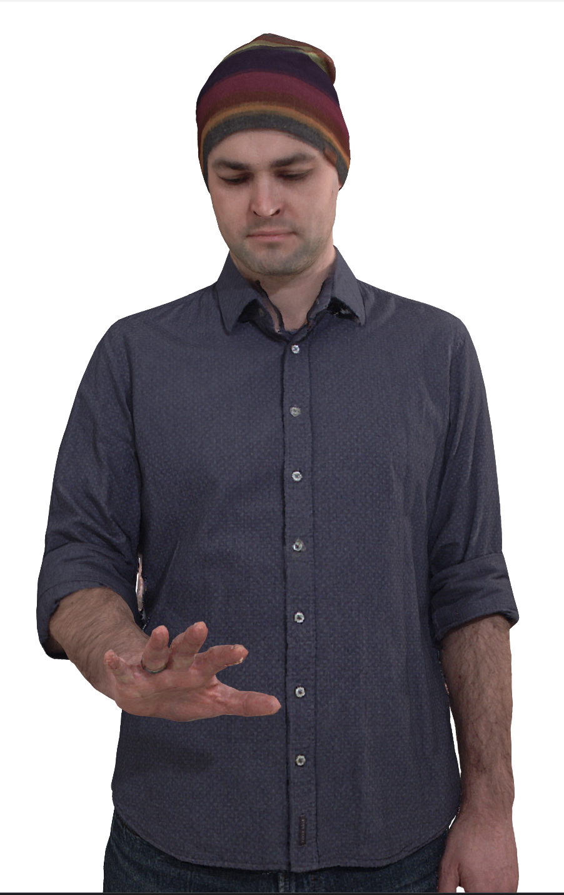
Figure 8 Vox 11 with 2.3M points per frame
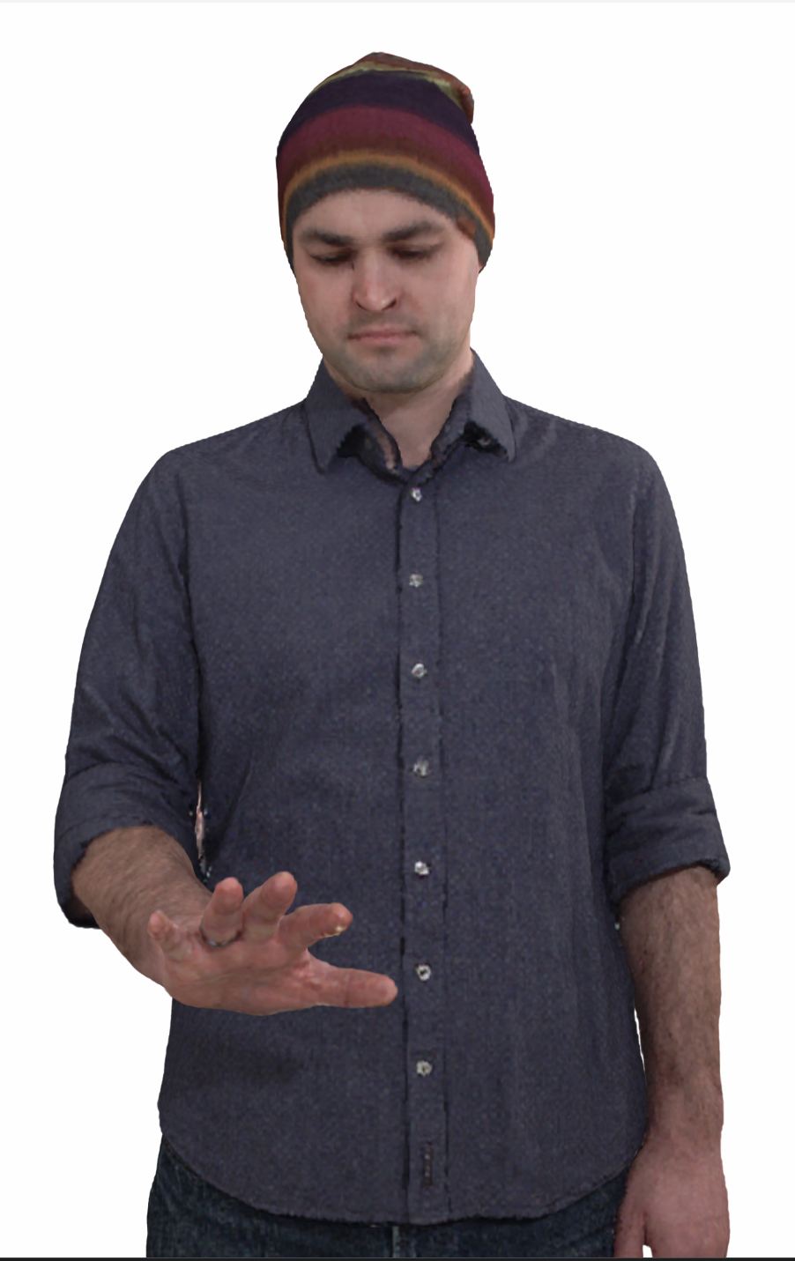
Figure 9 Vox 10 with 600K points per frame

Thomas far with MPEG renderer and neutral background
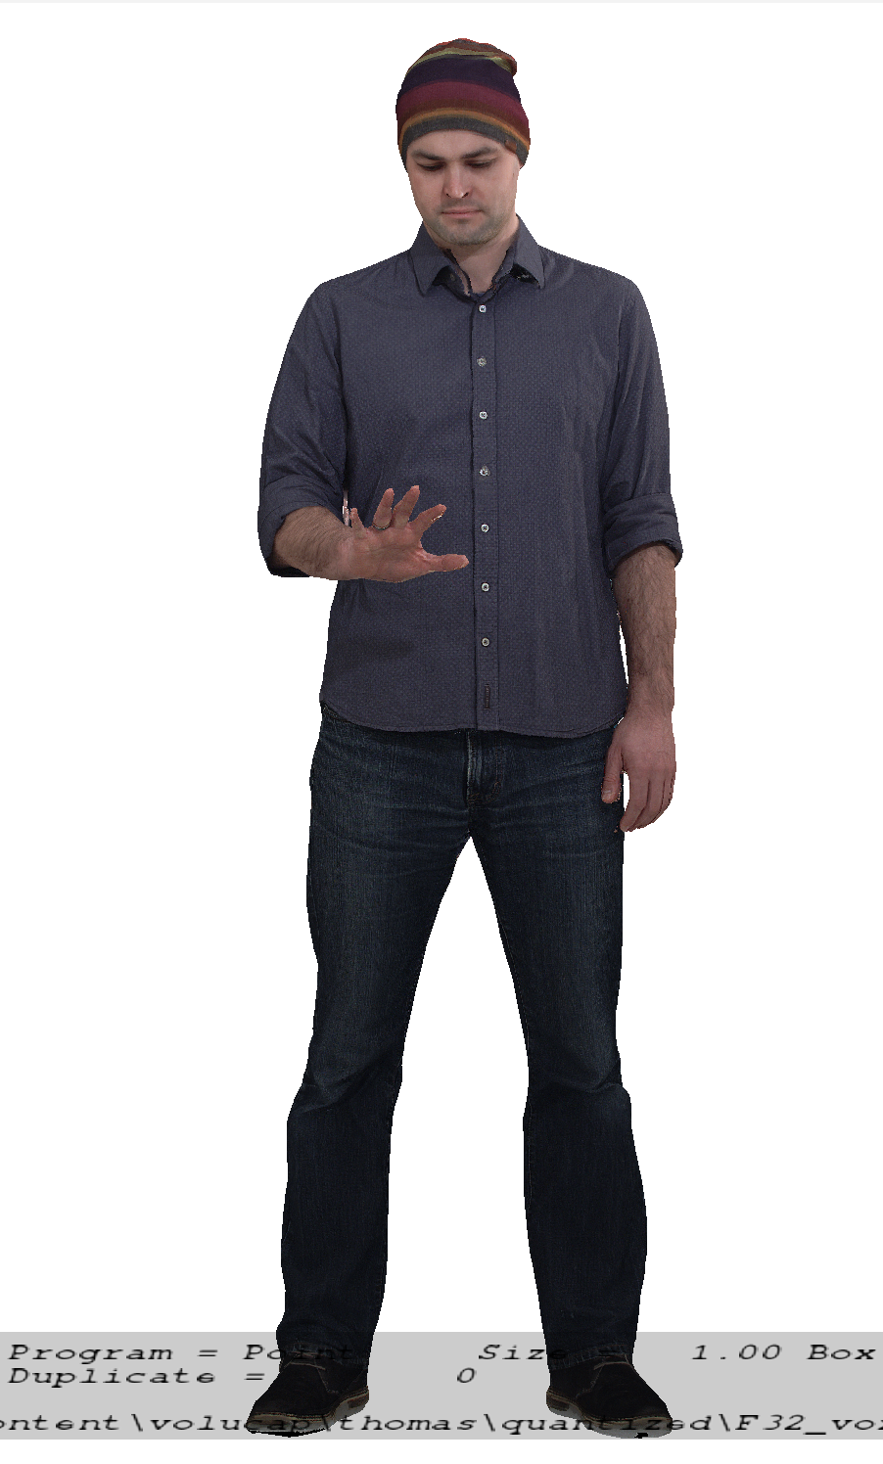
Figure 10 Vox 12 with 9.5M points per frame
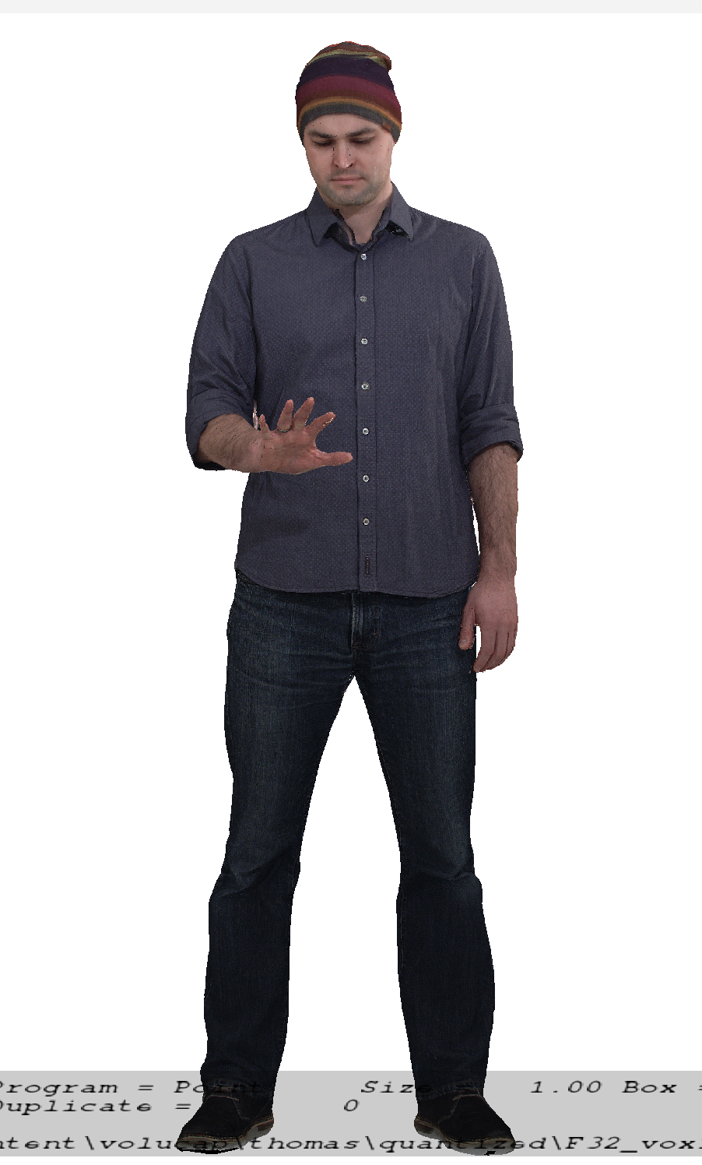
Figure 11 Vox 11 with 2.3M points per frame
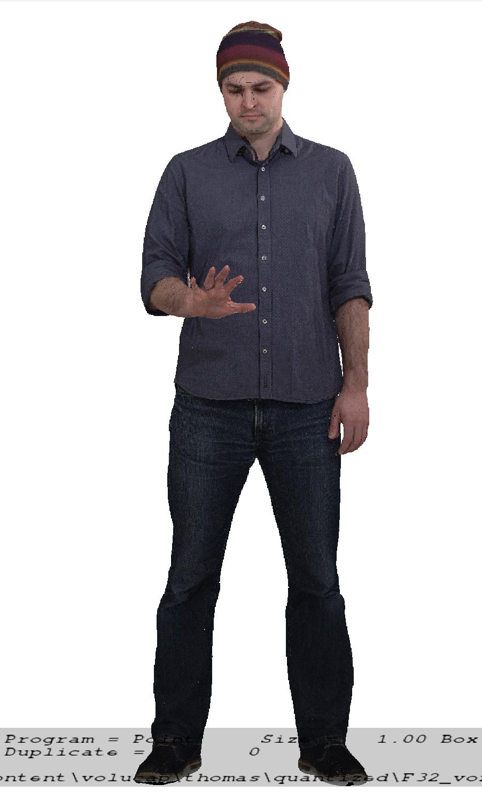
Figure 12 Vox 10 with 600K points per frame

Thomas near with MPEG renderer and neutral background
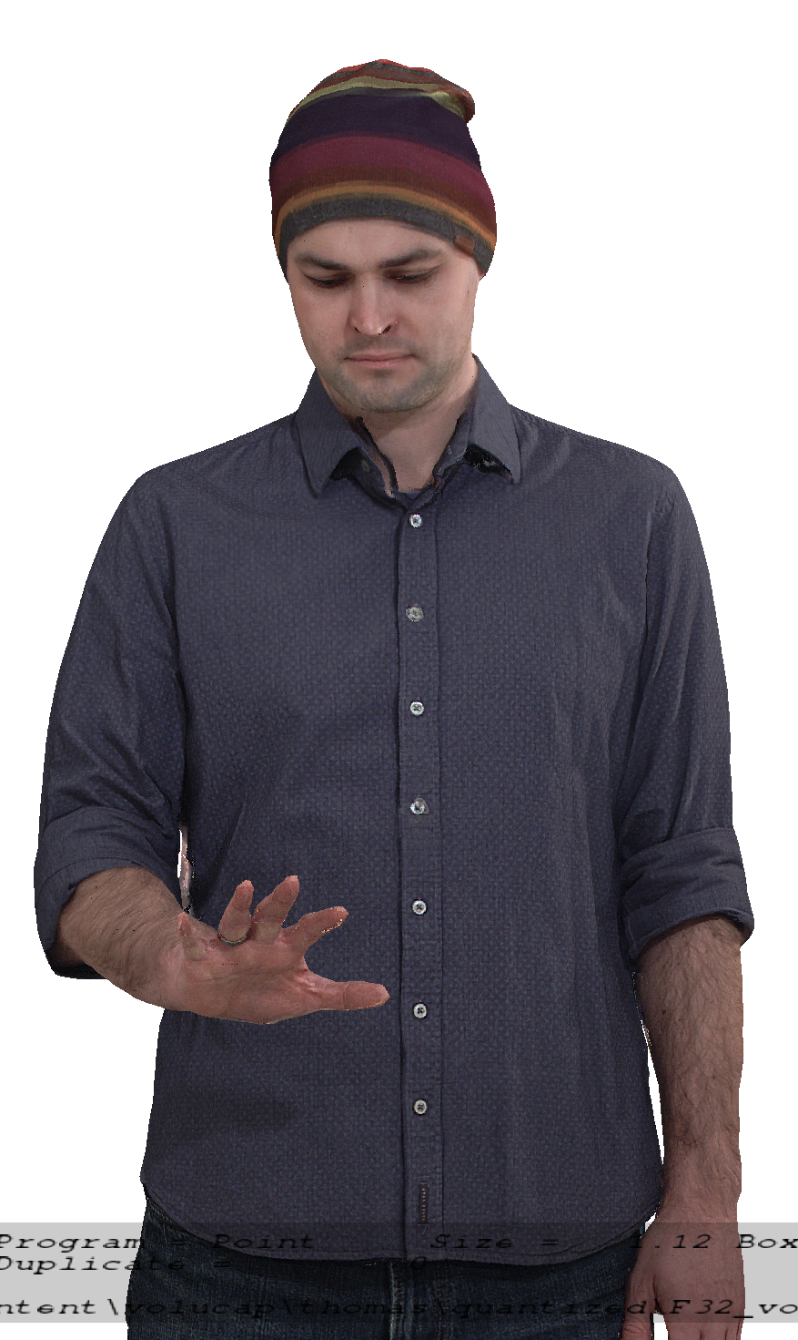
Figure 13 Vox 12 with 9.5M points per frame
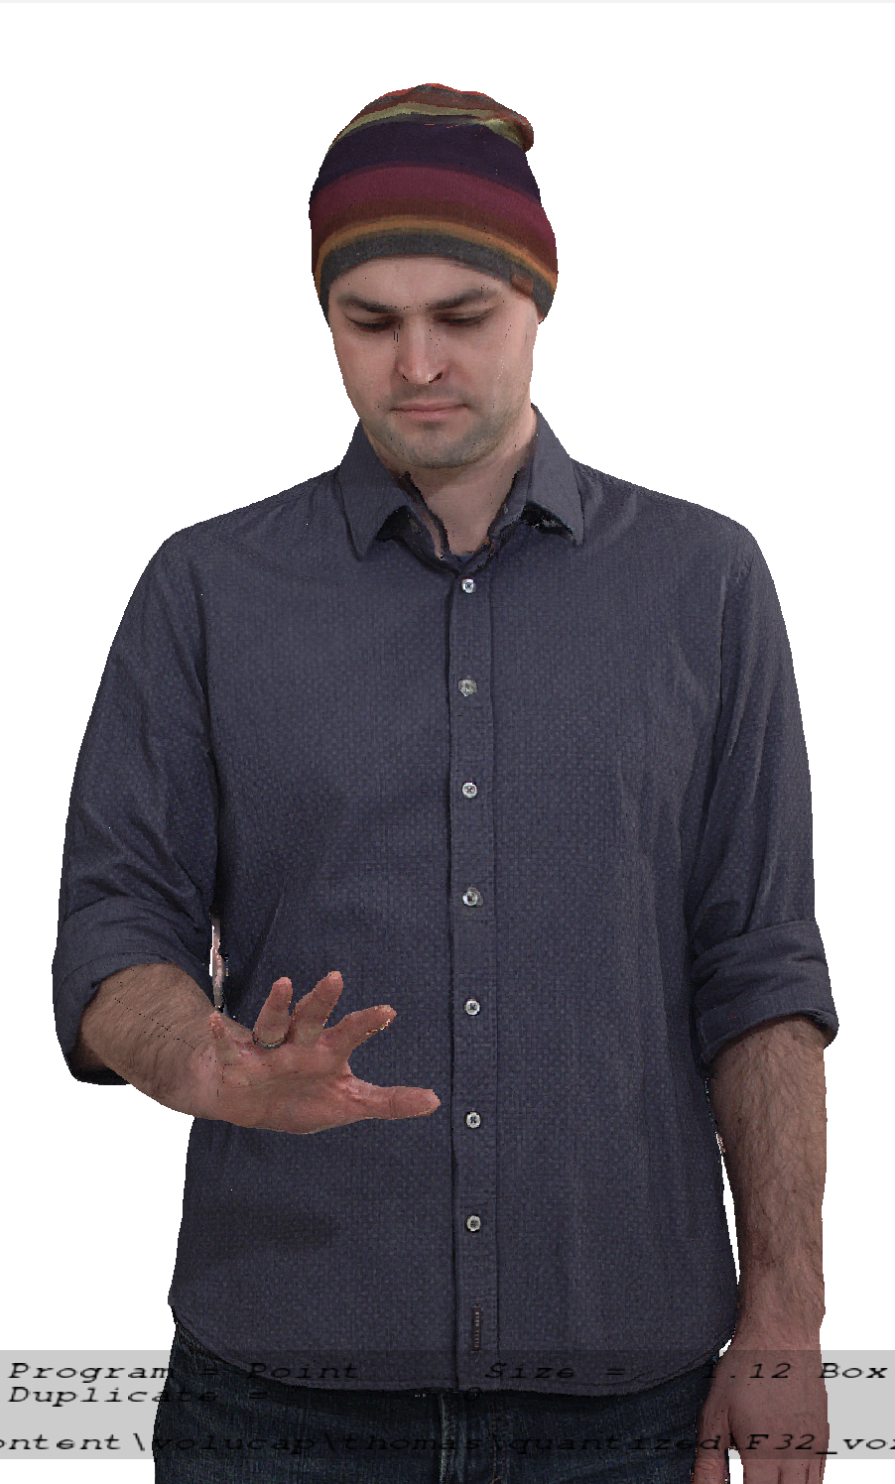
Figure 14 Vox 11 with 2.3M points per frame
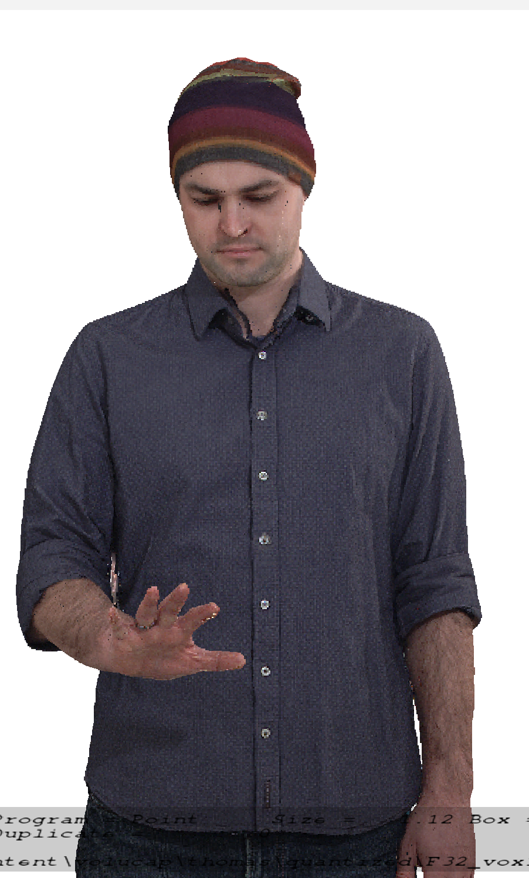
Figure 15 Vox 10 with 600K points per frame

Aliyah far with proprietary renderer and neutral background
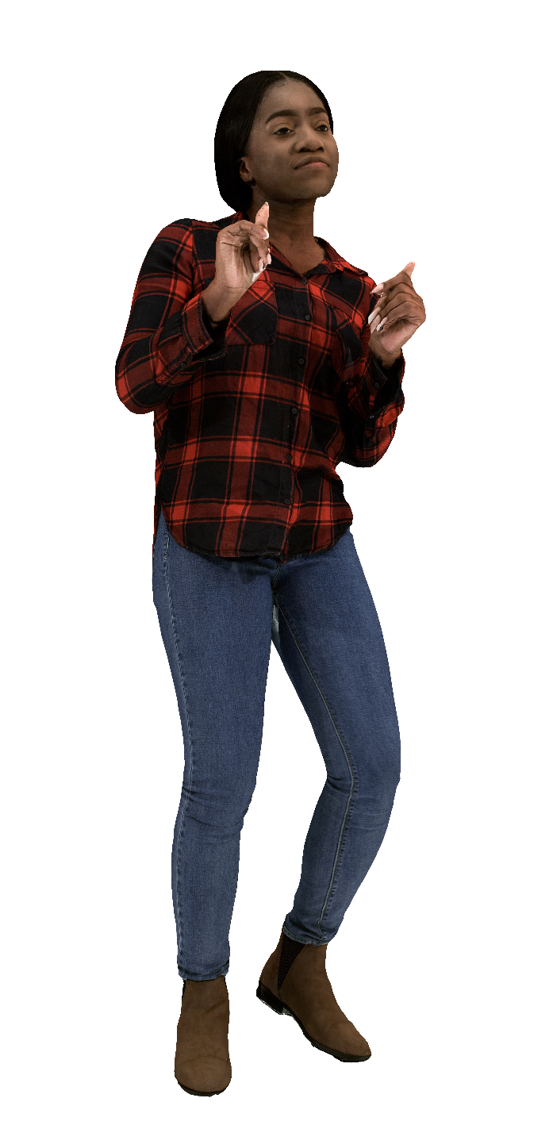
Figure 16 Vox 12 with 9.3M points frame
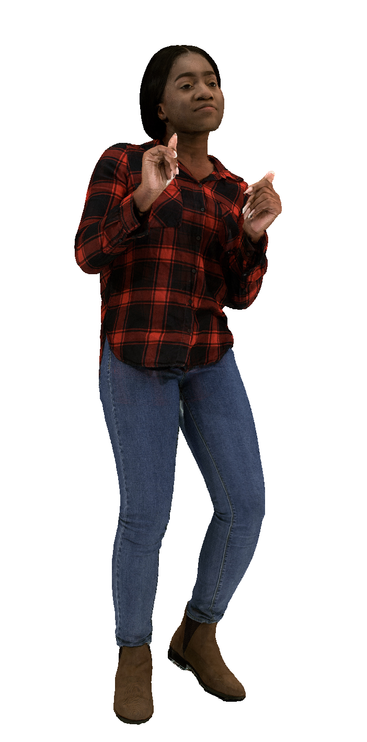
Figure 17 Vox 11 with 2.3M points per frame
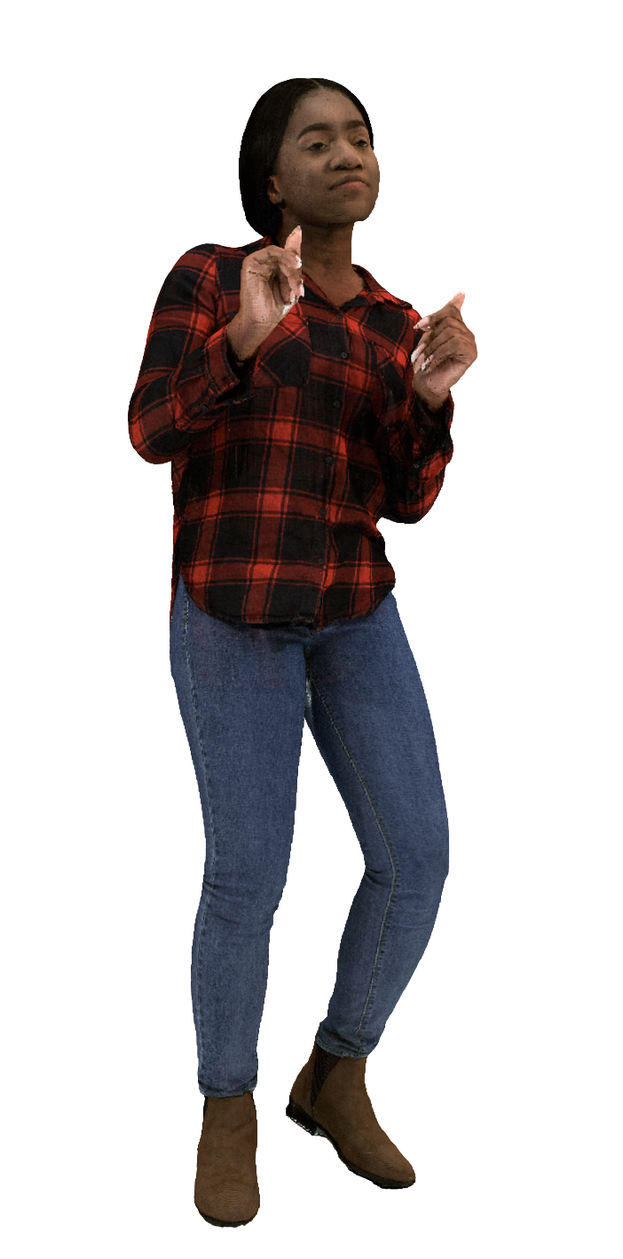
Figure 18 Vox 10 with 580K points per
Aliyah near with proprietary renderer and neutral background
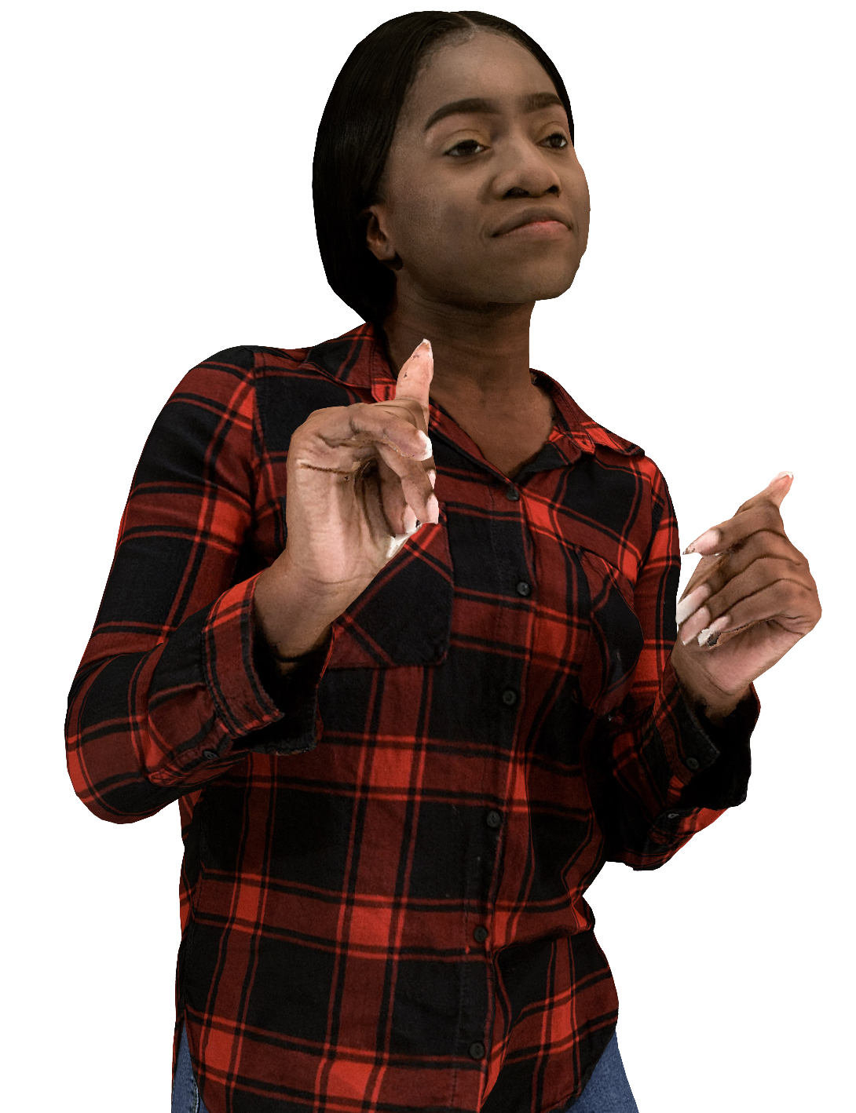
Figure 19 Vox 12 with 9.3M points per frame
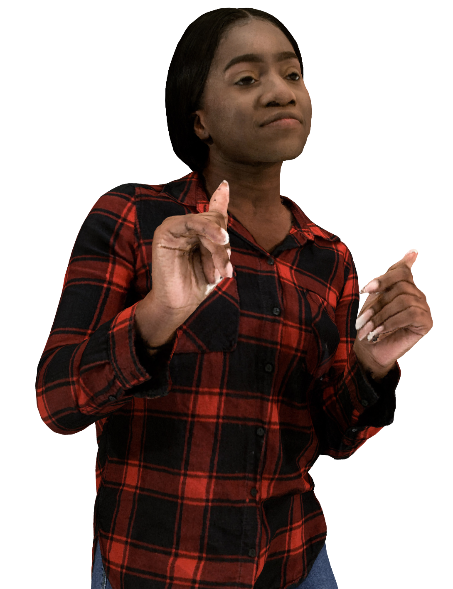
Figure 20 Vox 11 with 2.3M points per frame
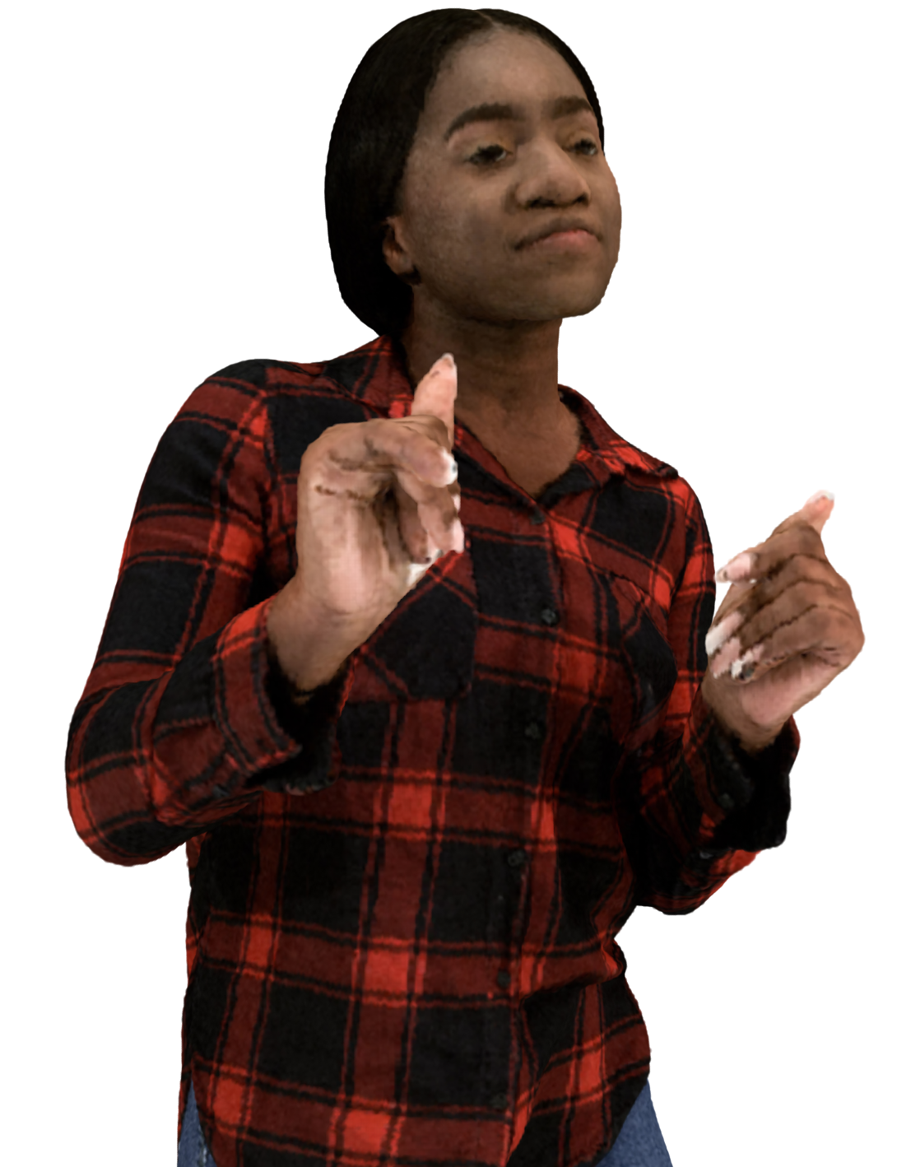
Figure 21 Vox 10 with 580K points per frame

Aliyah far with MPEG renderer and neutral background
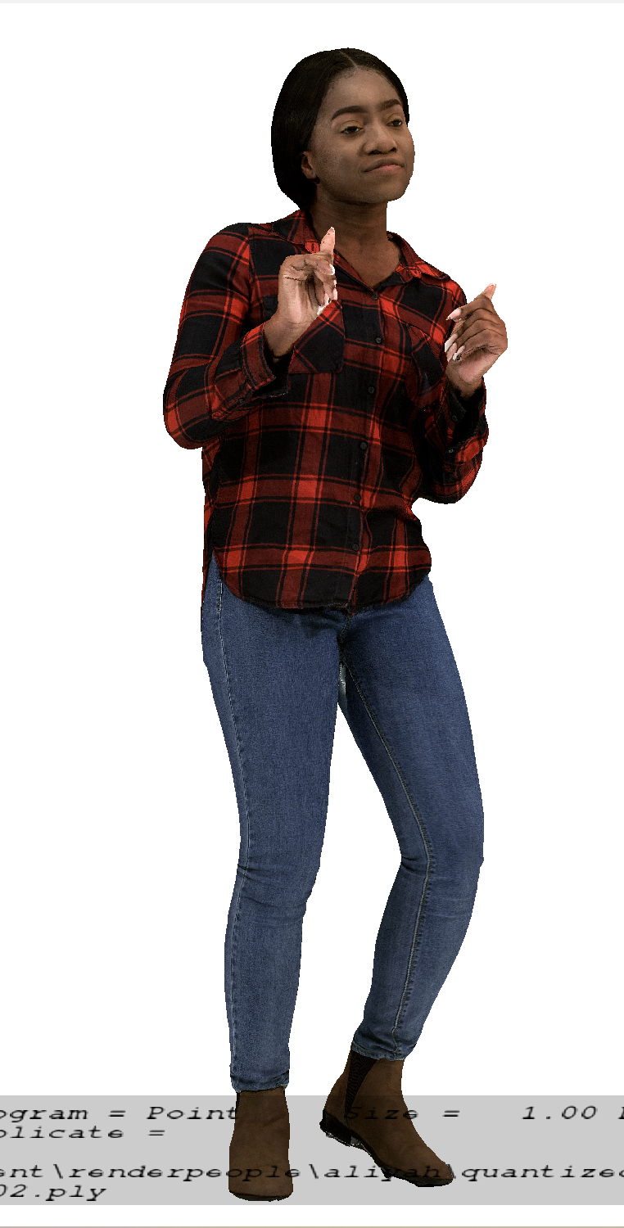
Figure 22 Vox 12 with 9.3M points per frame
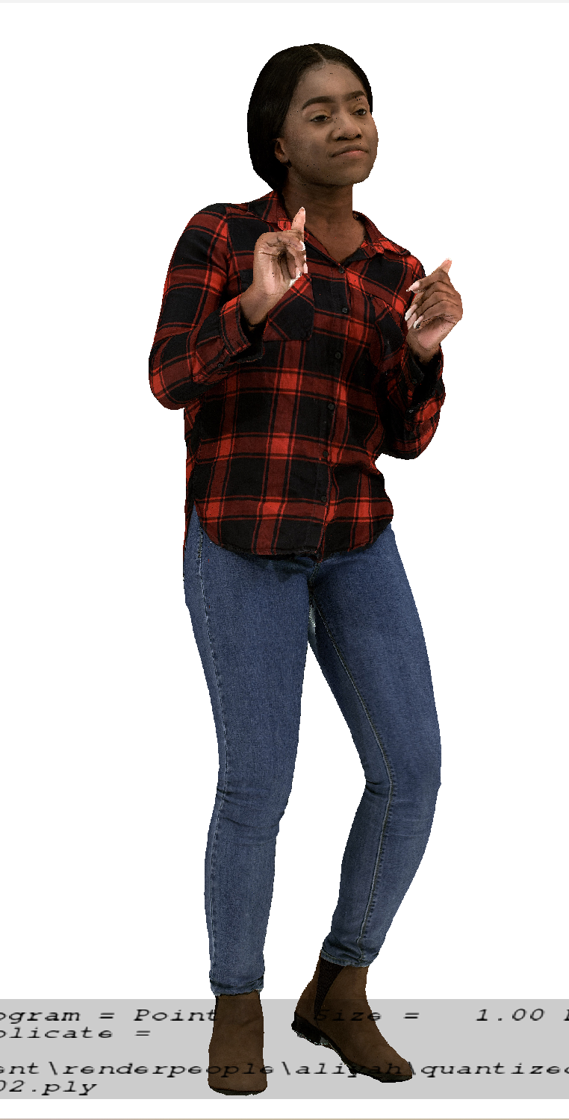
Figure 23 Vox 11 with 2.3M points per frame
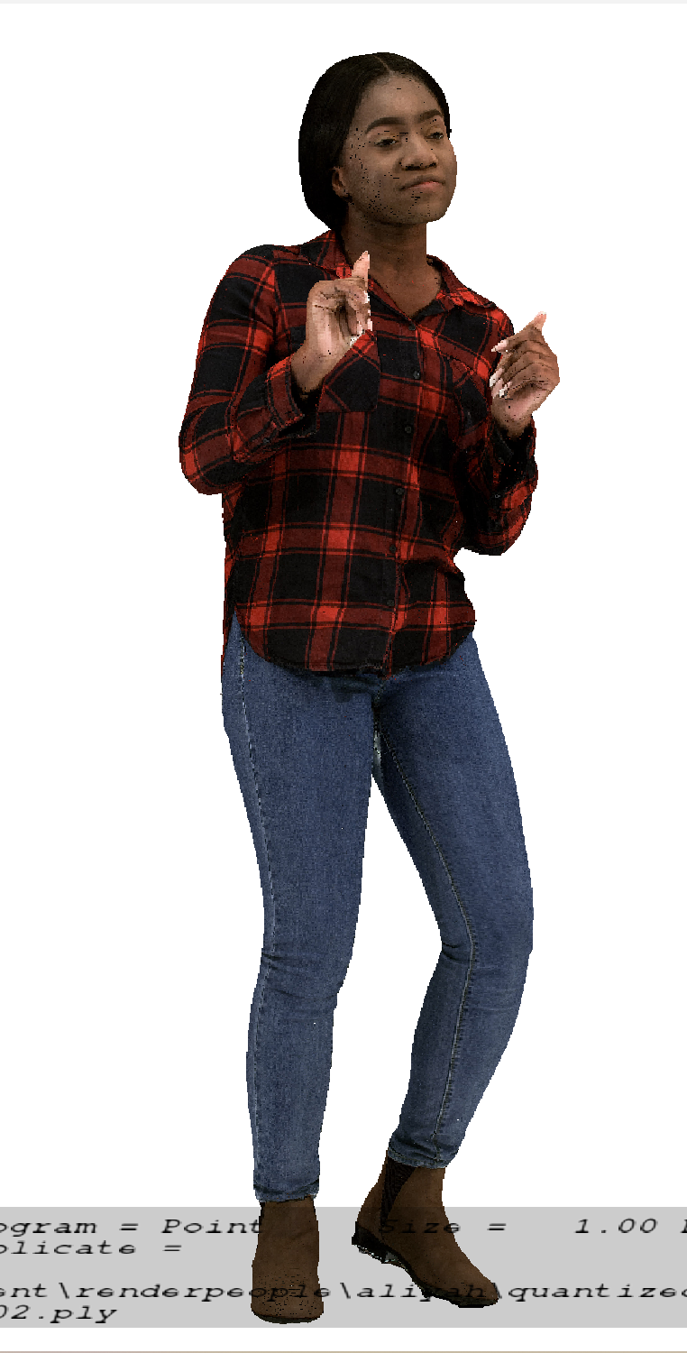
Figure 24 Vox 10 with 580K points per frame

Aliyah near with MPEG renderer and neutral background

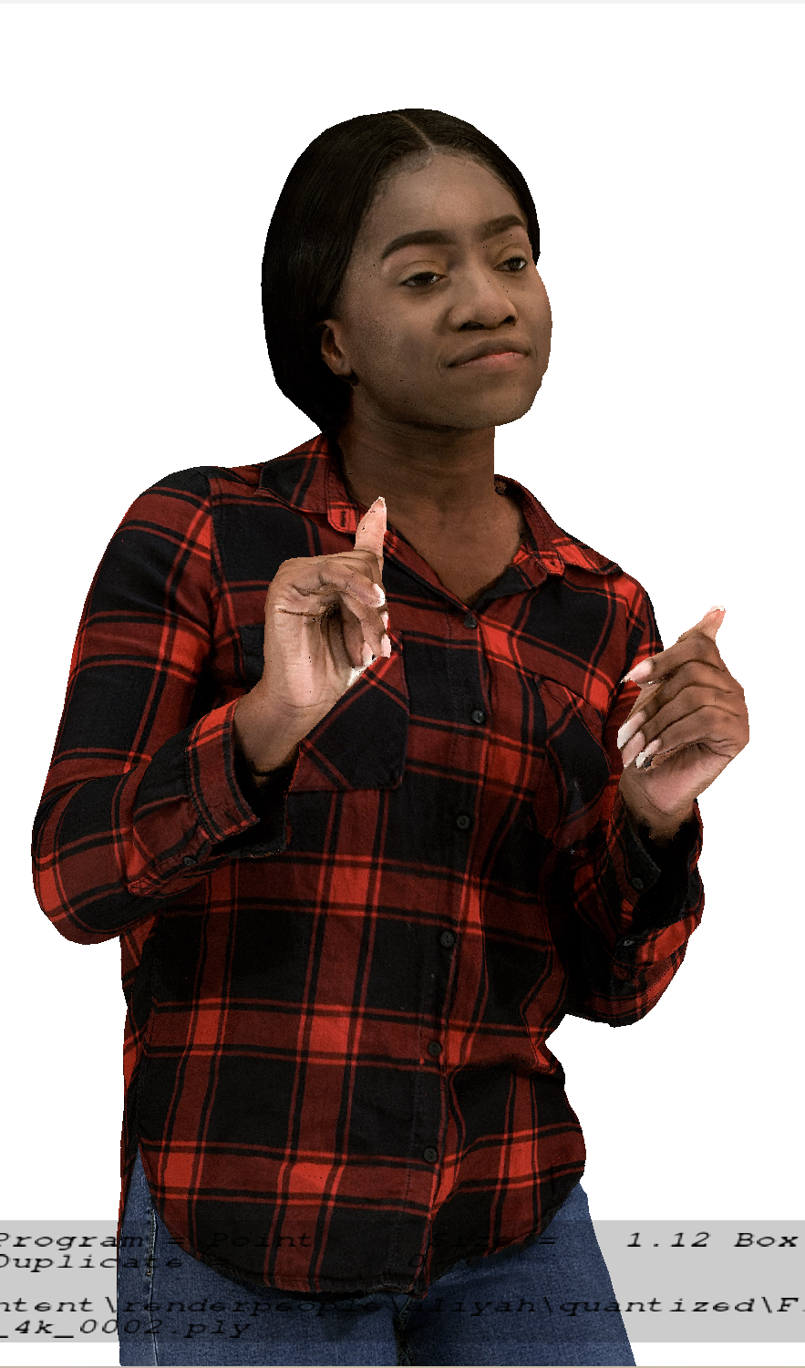
Figure 25 Vox 12 with 9,3M points per frame
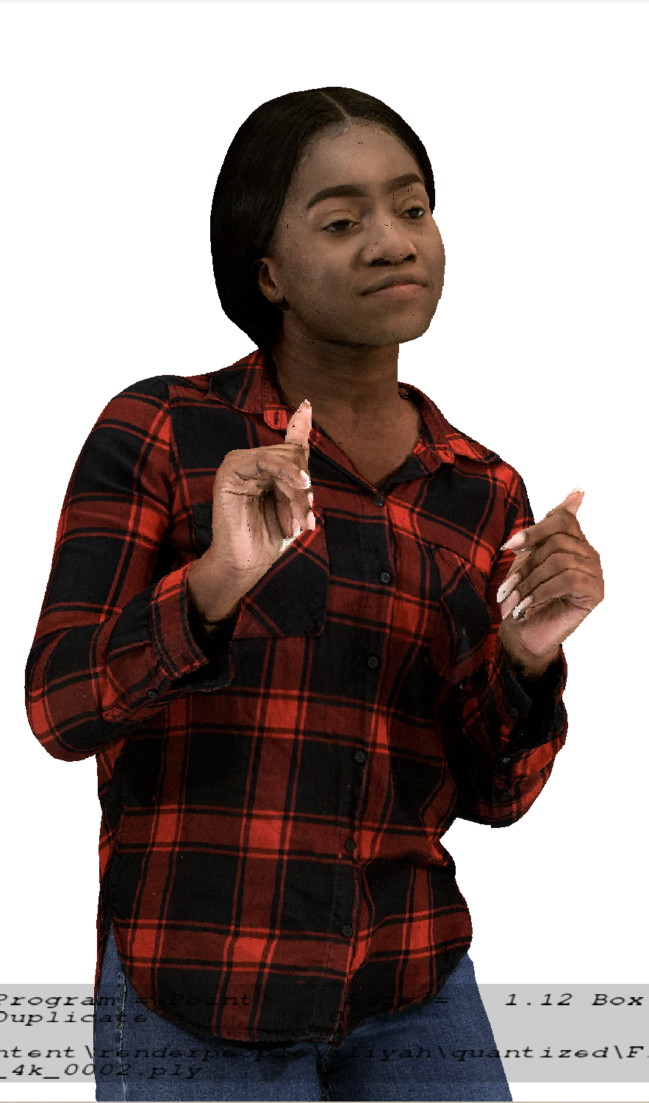
Figure 26 Vox 11 with 2.3M points per frame
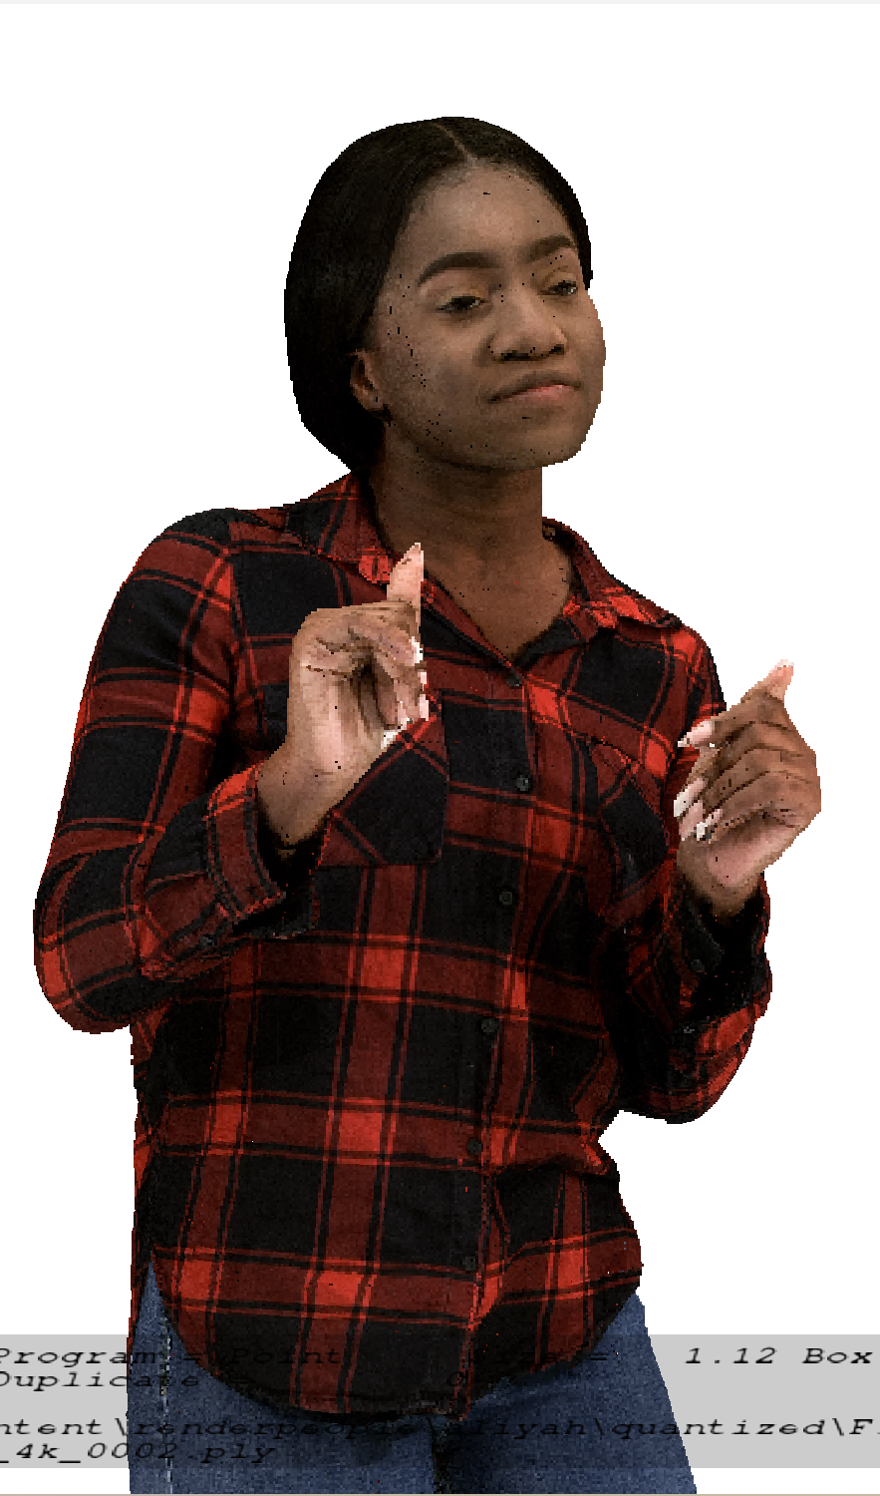
Figure 27 Vox 10 with 580K points per frame

2.3.9.2 Metadata for source dense dynamic point cloud sequences

2.3.9.2.1 Overview
For a raw dense point cloud sequence used in the context of this Technical Report, the following metadata is proposed:
- Name of the sequence
- Scenario
- Sequence key as provided in TR 26.956
- URI to zip file containing PLY files (URL to weblink where the original sequence is available)
- Name Format of files
- Frame count
- Start frame number
- Frame rate
- Geometry precision
- Color format
- Peak Value (bounding box resolution e.g. 1023, 2047)
- Copyright statement
- Contact Person
Optionally, the following metadata can be added:
- Background
- TR 26.956 reference
- Thumbnail preview
- Preview MP4
- Average point number per frame
- Duration
- MD5 of the zip file containing all point cloud frames
Size in bytes of the zip file containing all point cloud frames.
A JSON scheme is defined in clause 2.2 for this matter. An example is provided in clause 2.3

2.3.8.3.2 JSON Scheme
JSON schema for the raw format can be found in Annex B.2.3.

2.3.8.3.3 Example
An example is attached to the zip file:
{
"Sequence": {
"Name": "Exemple",
"Background": "This is a B2DV format example",
"Scenario": "Streaming of Beyond 2D Produced VoD Content",
"Key": "S01",
"TR26.956": "Annex X.Y.Z"
},
"Properties": {
"URI": "https://dash-large-files.akamaized.net/WAVE/3GPP/Beyond2D/ReferenceSequences/file.zip",
"thumbnail": "https://dash-large-files.akamaized.net/WAVE/3GPP/Beyond2D/ReferenceSequences/file.png",
"preview": "https://dash-large-files.akamaized.net/WAVE/3GPP/Beyond2D/ReferenceSequences/file.mp4",
"NameFormat": "exemple%04d.ply",
"frameCount": 320,
"startFrame": 0,
"frameRate": 30,
"pointsCountMean": 1000000,
"geometryPrecision": 10,
"colorformat": "rgb",
"peak": 2047,
"duration": 10.0,
"md5": "d055a94f35f7594776186fc5d09a9fa4",
"size": 11510343938
},
"CopyRight": "Conditions that are suitable for this study",
"Contact": {
"Name": "Celine Guede",
"Company": "InterDigital",
"e-mail": "celine.guede@interdigital.com",
"generation": "provided by contact"
}
}

2.3.8.3 Metadata for source dynamic mesh sequences
Editor’s note: To be done for dynamic mesh

2.3.9.2.4 Candidate raw dense point cloud sequences
This section presents candidate raw dense point cloud sequences that are available for testing. Some sequences have been made freely available under license agreement and must be kept protected with a password when stored on a server. Some sequences are not free but can be openly purchased by those who need to work with the source sequences. Yet other sequences are freely and openly available for download by respecting the license.
XD Productions[X7] kindly made available some source sequences under license. These source sequences cannot be publicly shared on the Internet and they were provided in the dense point cloud format.
- JuggleSoccer, 125 frames @ 25 fps
- Soccer02, 249 frames @ 30 fps
- Acrobat01, 449 frames @ 30 fps
- Acrobat02, 211 frames @ 30 fps
- Dancer01, 153 frames @ 30 fps
- Fakeswords, 250 frames @ 30 fps

Volucap [X8] kindly made available some sequences under license. These source sequences cannot be publicly shared on the Internet. These source sequences were delivered in the dense point cloud format and mesh format.
- Thomas, 748 frames @ 25fps
- Mitch, 475 frames @ 25 fps
Renderpeople [X14] provides a free and publicly downloadable “4D People” source sequence under license. This source sequence is provided in mesh format and on request in dense point cloud format.
- DancingAliyah (RenderPeople), 1112 frames @ 30 fps
Renderpeople[X15] provides a catalogue of currently 130 “4D People” under license and the catalog is growing. These sequences are provided in mesh format and on request in dense point cloud format. The quality is similar to the Renderpeople free sequence. Those who need to work with the source sequence such as the proponent and the crosscheckers need to purchase the sequence.
Ultra Video Group of Tampere University [X12] kindly provides 12 sequences in the dense point cloud format @25 fps under license.
- BlueBackpack
- BlueSpin
- BlueSquat
- CasualSpin
- CasualSquat
- ElegantDance
- ElegantWave
- FlowerDance
- FlowerWave
- Gymnast
- HelloGoodbye
- ReadyForWinter

2.3.9.2.5 Selected raw dense point cloud sequences
This section lists 5 raw point cloud sequences that have been selected for objective and subjective testing. The following sequences have been selected for performing objective and subjective tests.
Test sequences have been selected based on visual quality and that these have not been used during codec development in MPEG. The following table lists the selected test sequences:
Table 1 Selected raw point cloud sequences
*max 2 million points/frame, exact numbers will be provided
The following thumbnails illustrate the selected test sequences:
Aliyah Henry Nathalie Joggle Soccer Mitch

2.3.10 Detailed test conditions
Provides a proposal for detailed test conditions, for example based on a reference software together with the sequences and configuration parameters.

2.3.10.1 V-PCC
Editor’s note: Contribution S4-250446 on update V-PCC testing will replace that section if agreed

2.3.10.1.1 V-PCC test model and configuration files
The public version of the MPEG V-PCC test model named tmc2 in master branch is used to encode and decode dense dynamic point clouds [Vol-26].
Editor’s note: Configuration files to be validated
For using tmc2 in Random Access (RA) mode, MPEG provides a configuration file [Vol-27].
For each selected test sequence, a configuration file containing information needed for tmc2 configuration will be provided.

2.3.10.1.2 Rate points and test conditions
In line with the V-PCC verification test [Vol-28], 5 rate points R1 to R5 for Random Access (RA) will be used for each test sequence. Rates are obtained with the following V-PCC codec parameters:
 | R1 | R2 | R3 | R4 | R5
QP geometry | 32 | 28 | 24 | 20 | 16
QP Texture | 42 | 37 | 32 | 27 | 22
Occupancy Precision | 4 | 4 | 4 | 4 | 2

Editor’s note: Configuration files to be validated
For using this rate configuration, MPEG provides configuration files for each rate [Vol-29].

2.3.10.1.3 Profiles
In line with the V-PCC verification test [Vol-28], the following profiles are evaluated:
- Basic which corresponds to V-PCC profile HEVC Main10 V-PCC Basic Rec0. This profile uses the basic V-PCC toolset and a simple reconstruction of points in 3D space.
- Enhanced which corresponds to V-PCC profile HEVC Main10 V-PCC Basic Rec2. This profile uses the basic V-PCC toolset and a more sophisticated reconstruction of points in 3D space.
- High which corresponds to V-PCC profile HEVC Main10 V-PCC Extended Rec2. This profile uses the extended V-PCC toolset and a more sophisticated reconstruction of points in 3D space.

2.3.10.1.4 Bitstream Generation, output
The MPEG V-PCC test model is used to encode and decode test sequences as described previously [Vol-26].
To compute metrics, the tool mpeg-pcc-mmetric [Vol-18] is used.
Python scripts will be provided to be able to:
- Encode each sequence for each condition, rate and profile
- Decode the corresponding sequence
- Compute metrics
- Generate tables and graphs
Below are examples of command lines for the basic profile for a vox11 sequence:
- to encode a test sequence:
mpeg-pcc-tmc2/bin/PccAppEncoder \
--config=mpeg-pcc-tmc2/cfg/common/ctc-common.cfg \
--config=mpeg-pcc-tmc2/cfg/condition/ctc-random-access.cfg \
--config=mpeg-pcc-tmc2/cfg/sequence/${test_sequence}.cfg \
--config=mpeg-pcc-tmc2/cfg/rate/ctc-r1.cfg \
--configurationFolder=mpeg-pcc-tmc2/cfg/ \
--uncompressedDataFolder=${source_sequence}/ \
--compressedStreamPath=${test_sequence}.bin \
--normalDataPath=${source_sequence}/${source_sequence}_%04d.ply \
--frameCount=32 \
--resolution=2047 \
--mapCountMinus1=0 \
--profileToolsetIdc=0 \
--profileReconstructionIdc=0

- to decode a test sequence:
mpeg-pcc-tmc2/bin/PccAppDecoder \
--startFrameNumber=0 \
--compressedStreamPath=${test_sequence}.bin \
--reconstructedDataPath=${test_sequence}_dec_%04d.ply \
--inverseColorSpaceConversionConfig=mpeg-pcc-tmc2/cfg/hdrconvert/yuv420toyuv444_16bit.cfg

- to compute metrics of a test sequence:
mpeg-pcc-mmetric/build/Release/bin/mm sequence \
--firstFrame 0 \
--lastFrame 31 END \
compare --mode pcc \
--inputModelA source_sequence_%04d.ply \
--inputModelB test_sequence_dec_%04d.ply END \
compare --mode pcqm \
--inputModelA source_sequence_%04d.ply \
--inputModelB test_sequence_dec_%04d.ply

For each test, outputs are:
- Bitstream file
- Log files containing metrics information
- Encoder log output
- Decoder log output
- Metric log output
A CSV file containing concatenated metrics information for each condition and one profile is generated for all sequences and rates.
The following information will be stored:
- SeqId: identifier of the sequence
- CondId: tested condition (RA)
- RateId: tested rate number [R1..R5]
- nbFrame: number of tested frames
- NbInputPoints: number of points in the source sequence
- NbOutputPoints: number of points in the candidate test sequence
- MeanOutputPoints: mean number of points in the candidate test sequence
- MeanDuplicatePoints: mean number of duplicated points (with same geometry) in the candidate test sequence
- TotalBitstreamBits: size of the bistream in bits
- geometryBits: size of the geometry stream in bits
- metadataBits: size of the metadata stream in bits
- attributeBits: size of the attribute stream in bits
- D1Mean: mseF,PSNR (p2point)
- D2Mean: mseF,PSNR (p2plane)
- LumaMean: c[0],PSNRF
- CbMean: c[1],PSNRF
- CrMean: c[2],PSNRF
- PCQM: PCQM PSNR
- SelfEncoderRuntime: encoder time for current process
- ChildEncoderRuntime: encoder time for child processes
- SelfDecoderRuntime: decoder time for current process
- ChildDecoderRuntime: decoder time for child processes
From this CSV file, an excel spreadsheet is generated to get tables and graphs for interpretation of the results.

2.3.10.1.5 Videos Generation for subjective tests
The representative renderer [Vol-19] is used to generate the videos for the subjective test.
To avoid interference between the background and the test material, a neutral background with a color will be selected. A floor makes the rendered scene more realistic by preventing interference with the test material.
A script will be provided to generate videos with chosen camera path.
For each sequence, a video is generated. A camera path and blend parameter options adapted to each sequence is provided [Vol-30]. The output of this video generation with a camera path is stored as high-quality video sequence of a length as close as possible to 10s.
The generation is done into two steps: first the generation of the RBG raw file with the camera path and then the conversion into YUV or MP4 files.
Here is an example of the two command lines:
1-To generate a RGB raw file with a specific camera path
./PccAppRenderer.exe -d ${test_sequence}\
-i 1 \
-n 32 \
--play=1 \
--playBackward=1 \
--height=1080 --width=1920 \
--type=3 --alphaFalloff=6 --size=3.2 --blendMode=0 \
--floor=1 --overlay=0 \
--camera=${camera_path}.txt
--RgbFile=${test_sequence_rgb}

2-To convert the RGB file to x265 lossless mp4 file
./scripts/convert_video.sh \
-o ${test_sequence}_x265lossless.mp4 \
--videoType=2
--ffmpeg=ffmpeg.exe
-i ${test_sequence_rgb}.rgb

The video sequences are generated with the following video parameters:
- Video resolution: progressive uncompressed full-range HD format (1920x1080). Note that upsampling by the TV set should be avoided
- Frame rate: The frame rate will be aligned with the frame rate in the test data set
- Color space: ITU-R BT.709
- Sub-sampling: 4:2:0 YUV 10 bits or x265 fast preset lossless

2.3.10.2 V-DMC
Editor’s note: Testing of V-DMC will depend on availability of stable V-DMC specification (including profile to be tested), stable public test model and volunteers to contribute

2.3.10.2.1 V-DMC test model and configuration files

2.3.10.2.2 Rate points and test conditions

2.3.10.2.3 Profiles

2.3.10.2.4 Bitstream Generation, output

2.3.10.2.5 Videos Generation for subjective tests

2.3.10..3 Verification / crosschecks
All produced bitstreams, metric results and produced videos will be crosschecked by at least one other SA4 member to ensure that results are correct.

2.3.11 External Performance data
References to external performance data that can be added, for example other SDOs, public documents and so on.
The subjective verification test report for V-PCC can be downloaded from the public MPEG website: https://www.mpeg.org/wp-content/uploads/mpeg_meetings/136_OnLine/w20992.zip
The Brazilian SBTVD Forum performed objective tests with V-PCC. Full results are available in chapter 6.10 (Candidate Technology I), 6.10.3.2 and 6.10.4 of the following document: https://forumsbtvd.org.br/wp-content/uploads/2021/12/SBTVD-TV_3_0-VC-Report.pdf

2.3.12 Additional Information
Sequences can be decoded and visualized in real time using a 3D background or in Augmented Reality on a smartphone, tablet, head-mounted display using DASH streaming mode or local file system.
Nokia’s real-time V-PCC decoder implementation that was released as open source: https://github.com/nokiatech/vpcc
A simple scene description could be added to enable the placement of the asset in the scene (position, orientation, scale…) but is outside the scope of this document, which is focused on the format and codec evaluation.

2.4 Scenario 4: Scenario UE-to-UE Beyond 2D Video Communication

2.4.1 Scenario name
Scenario UE-to-UE Beyond 2D Video Communication

2.4.2 Motivation for the scenario
What is the market relevance of the proposed scenario within the next few years? Are there any commercially available or pre-released products or prototypes?‘
The proposed scenario handles the UE-to-UE Beyond 2D Video communication that provides experiences beyond what is achievable with 2D content.
“Beyond 2D” content may be in the form of volumetric video, which is a frame-based immersive experience whereby each frame represents a volumetric region in 3D space in which any point is either non-occupied or having a color that may depend on the viewing direction. Volumetric video has the potential to provide a more immersive and interactive experience for use cases in diverse domains such as e.g. education, entertainment, and industrial monitoring.
This scenario considers Beyond 2D Video communication which has many applications. Having lifelike communication between UE's will reduce the need for travel and contribute to sustainability goals.

2.4.3 Description of the scenario
This provides a description of beyond 2D video end-to-end workflows, which includes identifying and defining beyond 2D formats being used in the context and representation technologies to delivery these formats. The following aspects may be considered for each workflow:
This scenario considers UE-to-UE format exchange (conversational). Typically, the exchange will be symmetrical and both UEs will capture and render. Storage and delayed playback on the same UE will also be possible.
In this scenario (Figure 1), a first UE captures beyond 2D video and transmits to a second UE that renders one or two viewports of the transmitted scene.
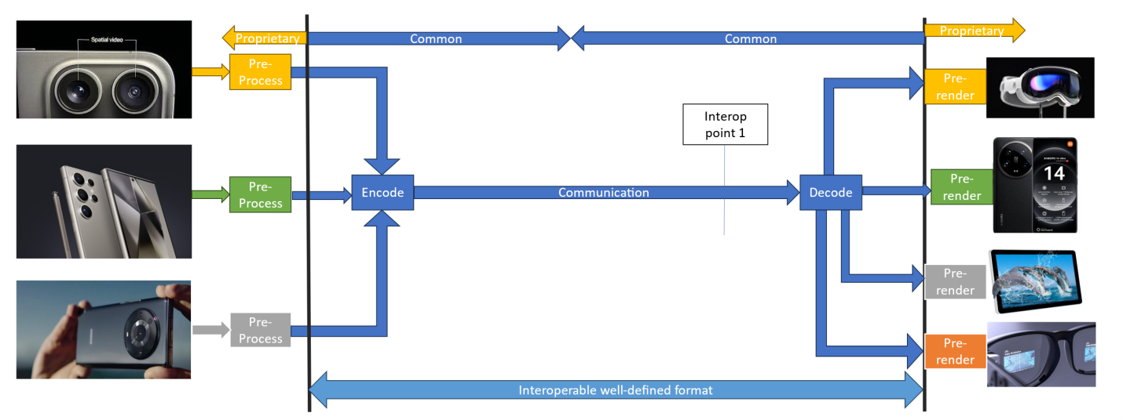
Figure 1: Direct UE->UE communication
[Ed.(BK): The figure will be redrawn if needed for copyright reasons.]
- Capturing and processing
Capture capabilities of UEs will vary and are typically constrained by form factor. A mobile phone has multiple closely packed cameras and may also have a depth sensor. Other devices like computer monitors or camera bars are larger and can have more cameras with more separation. Mobile phones capable of acquiring two views with or without depth are the focus of this scenario. Study of other form factors and other view counts are optional.
The beyond 2D video is captured and processed using one or more cameras. Zero or more of those cameras may be range-sensing cameras, and one or more of these cameras have colour sensors. In the case of two or more cameras that are not rigidly connected, camera extrinsics are online calibrated. For mobile phones cameras are rigid, and both offline and online calibration may be considered.
Captured content is converted in real-time to a representation format that is suitable for encoding. The parameters of the source cameras may or may not be part of the representation format. At a minimum, inter-view consistent depth information is estimated, but more processes like reprojection, pruning, refinement, meshing and texturing steps may be needed depending on the representation format and application-specific constraints.
- Encoding
One codec that may be considered is MV-HEVC, which is the multiview extension of HEVC.
Another codec that can be used to realize this scenario is MPEG Immersive Video (MIV) specified in ISO/IEC 23090-12.
In addition to MV-HEVC and MIV, other codecs may be studied as part of this scenario.
The multiple camera views and depth maps if available are encoded to create a unified representation. An example could be MIV constrained to one atlas and packed video data. The single video sub-bitstream would be encoded with HEVC Main10 profile. The bitstream would contain all camera parameters that are necessary for 6DoF rendering.
- Packaging and delivery
The encoded bitstream is packed to RTP payload format according to the used codec.
For example, if MIV codec is used, MIV bitstream may be packaged as a sequence of V3C units including V3C units for the packed video data, or the MIV bitstream can be packaged as three separate tracks, one for common atlas data, atlas data, and packed video data.
IETF proposal avtcore-rtp-v3c enables carriage of MIV as a RTP stream. In this proposal at least the VPS and possibly also atlas data is carried over SDP. Integration in WebRTC is possible.
- Decoding
The decoder(s) will make use of hardware video decoder capabilities for pixel data, and a metadata describing information needed for rendering is decoded/parsed by a CPU.
- *Post-processing
- Rendering
Rendering is typically performed on a GPU without dedicated hardware.
Rendering can be on:
- a device for 2D presentation (fixed viewpoint) such as a phone,
- a device for 3D presentation (multiple viewpoints) such as an autostereoscopic display,
a device for 6DoF presentation (dynamic viewports) such as an HMD or an autosteoscopic display with eye tracking.When a viewing space is used, then:
- What is rendered is one or two viewports with perspective projection and with 6 degrees of freedom (3-D position and 3-D orientation).
- The pose of the viewport is within a viewing space that can be signalled or implicitly determined from a decoded frame. A viewing space can limit both position, orientation or both in combination. For instance, it is generally not intended for a viewport to intersect with scene elements.
- When a viewport would be is rendered that is outside of the viewing space, then the renderer has to perform a mitigation to avoid a viewing experience that is not intended by the content provider.
- General constraints on latency, bandwidth, reliability and complexity
The codec should support low-delay reference frame structure.
For example, the MIV access units and the video sub-bitstream can be organized using a low-delay reference frame structure. All sub-bitstreams could have the same GOP structure, but atlas data and common atlas data frames may be skipped.
The common atlas data with camera parameters will only change infrequently (once per second or less), for instance each time an online camera calibration is updated. While it is possible to transmit common atlas data at non-IRAP frames, this is not expected in this scenario.
The atlas data with patch information may be static when transmitting only full views or dynamic when an encoder selects regions of the source views for transmission based on e.g. occlusion detection or depth segmentation. In MIV, patch information is always intra-coded (unlike V3C in general).
All encoder, decoder and renderer processes are real-time and may have a latency in the order of at most a few frames.

2.4.4 Supporting companies and 3GPP members
- This documents the 3GPP members that support this scenario in terms of providing the information, test material, test requirements and the characterization for the tests. For each of the identified necessities, a tick box is created in the template.
- Preferably several 3GPP members are included in the support, and in addition a video service provider may be included (not necessarily a 3GPP member).
- Cross-verification is preferably done by the supporters of the scenario
Deutsche Telekom, Fraunhofer HHI, InterDigital, Nokia Corporation, Philips, Sony

2.4.5 Source format properties
This defines a clear range of the considered and relevant source formats, including the signal properties, but also the characteristics of the content. As an example, the texture and depth format properties of the source may be used which include:
The source format has 2 views with perspective projection (PSP). Study of 1, 3 or 4 views is optional.
Each view has the following components:
- Required: Texture (color)
- Optional: Depth coded as normalized disparity
- Optional: Object ID map with ordinal values, 0 indicating "invalid pixel" (to support depth cameras), 1 indicating "background" and all other values indicating "foreground object i".
Views may be undistorted, otherwise distortion parameters have to be provided.
- Spatial resolutions
Each component of each view is 1920 × 1080, 1080 × 1080, 1440 × 1440, or 2048 × 2048.
- Chroma Format
The texture components are YCbCr.
All other components can be luma only, or YCbCr with chroma planes set to neutral gray.
- Chroma Subsampling
The texture components are 4:2:0.
All other components can be 4:0:0, or 4:2:0 with chroma planes set to neutral gray.
- Aspect ratios
The pixel aspect ratio of all video components is 1:1.
- Frame rates
The source frame rate is 30, 50 or 60 fps.
Note that the video frame rate may be different from the rendering frame rate, especially when the viewport pose is dynamic.
- Colour space formats
All texture components will use the ITU-R BT.709 colour space. The colour space format of other components is undefined because the chroma planes are not used.
- Transfer Characteristics
All texture components will use the ITU-R BT.709 transfer characteristics with limited range. The transfer characteristic of other components is linear with full rnage.
- Bit depth
The source texture components will be 8 or 10 bit.
The source depth components (if any) will be in between 8 and 16 bit.
The source object ID maps (if any) will be 16 bit.
- Viewpoints
The viewpoints are within a viewing space that can be provided as metadata or implicitly derived from the parameters of the set of source views.
- Other signal properties

2.4.6 Encoding and decoding constraints and settings
Typical encoding constraints and settings such as
- Relevant Codec and Codec Profile/Levels according to TS26.119
- Random access frequency
- Error resiliency requirements
- Bitrates and quality requirements
- Bitrate parameters (CBR, VBR, CAE, HRD parameters)
- ABR encoding requirements (switching frequency, etc.)
- Latency requirements and specific encoding settings
- Encoding context: real-time encoding, on device encoding, cloud-based encoding, offline encoding, etc.
- Required decoding capabilities
- Synchronization requirements
TBD

2.4.7 Performance Metrics and Requirements
- A clear definition on how the performance needs to be evaluated including metrics, etc addressing the main KPIs of the scenario.
[Ed.(BK): To be aligned with the agreed evaluation framework.]
The tests are run for a chosen level as described in 5 a. Bitstreams are provided. Camera calibration, depth estimation, and encoding are not evaluated.
The test will have four rate points and QP values are selected for each sequence to approximately match the 5 to 50 Mbps range. When saturation occurs before 50 Mbps a lower value may be chosen in consultation. When there are multiple video components or packed regions then the other QP values need to be directly derived from the texture QP using an equation or look-up table. (They cannot depend on the sequence.)
- Objective measures such as PSNR, VMAF, etc, may be used.
[Ed.(BK): To be aligned with the agreed evaluation framework.]
The IV-PSNR tool, available at https://gitlab.com/mpeg-i-visual/ivpsnr, is available to compute full-reference objective metrics:
- Weighted sphere PSNR (WS-PSNR)
- Immersive video PSNR (IV-PSNR)
All source views that were used for encoding are provided. Each source view is reconstructed by decoding and rendering (view synthesis). The IV-PSNR tool is then run on all source views and the score is averaged over all views.
Depending on bit rate, quality of depth maps and rendering, either the video codec or view synthesis is the limiting factor. BD-PSNR is calculated for both metrics because the metric behaves more predictably than BD-rate.
- Justification on whether objective metrics are sufficient and representative of the subjective performance.
[Ed.(BK): To be aligned with the agreed evaluation framework. The discussion here on correlation of objective and subjective metrics may need to be moved to that framework after more deliberation.]
There is experience in testing of immersive video in MPEG context. The test conditions as described are a simplification and evolution of:
Dziembowski, B. Kroon, J. Jung (Eds.), Common test conditions for MPEG immersive video, ISO/IEC JTC 1/SC 29/WG 04 N 0372, July 2023, Geneva.
The main challenge with testing of Beyond 2D video is that codecs are asymmetric. The input is a number of source views (with depth maps), and the output of the decoder + renderer can be any viewport within a spatial region around those source views. In the mentioned CTC two tests are used:
- Objective evaluation at source view positions
- Subjective evaluation of pose trace videos (dynamic viewports)
This has resulted in a lack of correlation between objective and subjective results, but despite that it is the best-known approach. Alternatives that have been tried and dismissed (for now):
- Objective evaluation at dynamic viewports: It includes view synthesis in the reference condition and this skews the results towards a specific renderer. It prevents an A/B comparison of different renderers.
- Subjective evaluation at source view positions: This is not how the end-user will interact with the content, and it does not evaluate artifacts due to viewport dynamics.
For this test, because the aim is to prove feasibility of a scenario, objective evaluation may be sufficient, especially when supplemented with (informal) real-time demonstration of the same bitstreams that were used for objective evaluation.

2.4.8 Interoperability Considerations for the application
- Streaming with DASH/HLS/CMAF/QUIC
- RTP based delivery
The Beyond 2D Video bitstream needs to be carried over RTP with SDP for this use case of this scenario. WebRTC may be considered. It is not necessary to prove this as part of the feasibility test, if written evidence can be provided.
In the example of using MIV as a codec, there are implementations for DASH (InterDigital/Philips) and RTP + SDP (Nokia).

2.4.9 Test Sequences
A set of selected test sequences that are provided by the proponents in order to do the evaluation. They should cover a set of source format properties
Test sequences that were used during the development of a codec are discouraged because they may create a bias towards that specific codec. Sequences that were used in a verification test are permissible.
Preferably test sequences match with the intended use case both in terms of technical requirements and content semantics.

2.4.10 Detailed test conditions
Provides a proposal for detailed test conditions, for example based on a reference software together with the sequences and configuration parameters.
[Ed.(BK): To be aligned with the agreed evaluation framework.]
For each candidate codec, a suitable decoder + renderer needs to be made available for testing purposes.
A reporting template or script will be provided to compute BD-PSNR based on IV-PNSR log files of all rates and sequences.
For MIV the following test conditions were followed:
- Dziembowski, B. Kroon, J. Jung (Eds.), Common test conditions for MPEG immersive video, ISO/IEC JTC 1/SC 29/WG 04 N 0372, July 2023, Geneva.

2.4.11 External Performance data
References to external performance data that can be added, for example other SDOs, public documents and so on.
For MIV the following performance data is available:
- D. Mieloch (Ed.), Verification test report of MPEG immersive video, ISO/IEC JTC 1/SC 29/WG 04 N 0341, April 2023, Antalya.
NOTE: This performance data was based on different source view properties and the results may not translate to this study.

2.4.12 Additional Information
TBD

2.5 Scenario 5: UE-to-UE Beyond 2D Video Streaming

2.5.1 Scenario name
UE-to-UE Beyond 2D Video Streaming

2.5.2 Motivation for the scenario
What is the market relevance of the proposed scenario within the next few years? Are there any commercially available or pre-released products or prototypes?
Live Streaming services can be deployed across various platforms, including social media platforms like YouTube Live, Facebook Live, and TikTok, as well as though e-commerce platforms such as eBay and Taobao [Y1, Y2]. It significantly impact marketing by providing a dynamic and interactive channel to directly connect markets and their target audiences in real time. In 3GPP TR 26.955 [Y3] clause 6.2, Full HD Streaming has been introduced, complemented by 5G Media Streaming [Y4] and the TV Video Profiles [Y5] specifications. Additionally, TS 26.118 [Y6] defines VR profiles for streaming applications, focusing on the coded representation of 360 VR distribution signals.
As technology continues to advance in capturing devices (e.g., ToF cameras, phones equipped with depth sensors, spatial cameras) and displays technology (e.g., HMDs, AR Glasses, MR HMDs, glasses-free autostereoscopic displays, and multiscopic displays), we are entering a new era of live streaming with the introduction of Beyond 2D technology. This revolutionary advancement is bringing a whole new level of immersion and interactivity to the live event experience, allowing viewers to feel as though they are truly a part of the action.
Market relevance key indicators:
- Technology evaluation on the market
Are there indications of pre-evaluation by service providers, device manufacturers, and/or network operators?
- Leia, LeiaTube allows you to view your favorite streaming video content in Lightfield 3D. https://forums.leialoft.com/c/leia-apps/leiatube/62
- IQH3D – Believing is Seeing!™ https://iqh3d.com/
- CMCC delivers a full series of Beyond 2D streaming services in three cities of the province (Hangzhou,Ningbo, and Jinhua) and 2023 Hangzhou Asian Game. https://www.lightreading.com/5g/wireless-s-next-frontier-5g-advanced-meets-the-hangzhou-asian-games
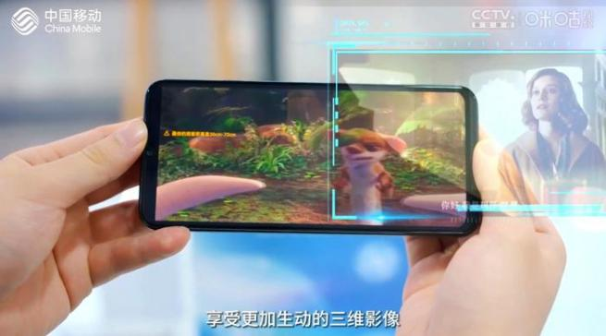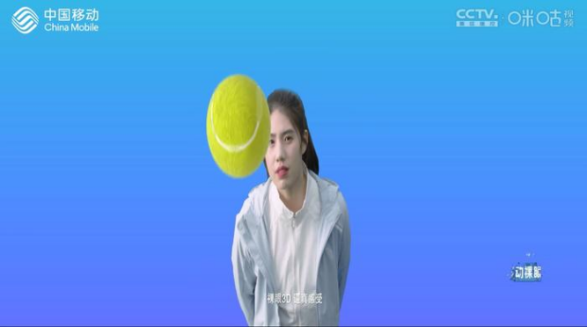

- Industry activities
Is there relevant work in 3GPP MRPs, industry collaborations or among market stakeholders?
Operators and leading vendors demonstrated glasses-free 3D applications at the Beijing PT Expo in 2023. Some of the applications can already provide a clear, jump-free, 100-degree 3D view, and the depth of the screen-out effect is up to one meter. Chinese operators and their industry partners are actively investing in glasses-free 3D applications. They hope the new applications can stimulate 5G consumption. During the expo, Chinese industry players, including Huawei, Xiaomi, and Honor, launched the glasses-free 3D industry promotion initiative to accelerate the maturity of the glasses-free 3D industry chain (e.g., to extend glasses-free 3D display from laptops and tablets to smartphones and to promote the production of 3D video contents). It is expected that more glasses-free 3D applications will emerge soon. We may see them in industry events next year, such as Mobile World Congress 2024” (Omdia report, https://omdia.tech.informa.com/-/media/tech/omdia/marketing/commissioned-research/pdfs/new-applications-showcased-at-the-beijing-pt-expo.pdf?rev=1daced414642406d984e755445ae3b67 )

- Production tools/companies
What is the availability of capturing setups, and production software? Are there endorsed formats for representation, contribution, compression, and storage? Is there an ecosystem of content creators?
Acer has been a leader in glasses-free 3D screens for a while now, having released a series of monitors and laptops under its SpatialLabs brand. Now the company is providing a means to create content for these displays, the SpatialLabs Eyes, a stereoscopic camera cable of capturing at up to 8-MP (aka 4K) per eye at 30 fps or 2K per eye at 60 fps. (https://www.tomshardware.com/cameras/3d-call-me-maybe-acers-new-spatiallabs-camera-live-streams-impressive-3d-video-in-8k-but-few-can-view-it)
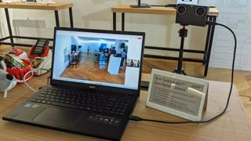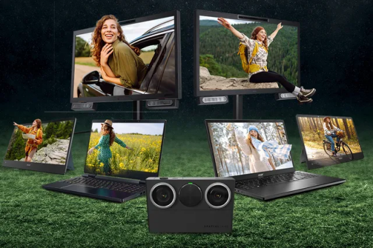
The stereo camera setup shown in the figure below, which consists of two identical HD camcorders (Canon HG-20) and an adjustable stereo mount. The mount ensures that optical axes of the cameras are parallel and supports the continuous adjustment of the camera distance in the range 7-50 cm. To ensure matching of the focal length the wide angle end of the zoom lens with a focal length of 43 mm has been used. In order to match the cameras with each other the focal length, white balance and shutter speed have been set manually. The synchronized operation of the two camcorder is ensured through the use of a single remote control. The camcorders support the capture of images with a resolution of 1920×1080 pixels and store them as high quality JPEG files.
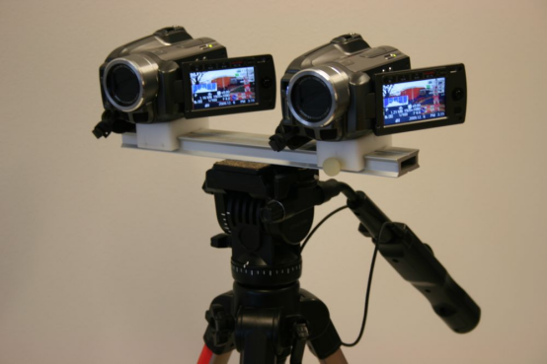

Deep3D: Automatic 2D-to-3D Video Conversion with CNNs (https://github.com/piiswrong/deep3d)

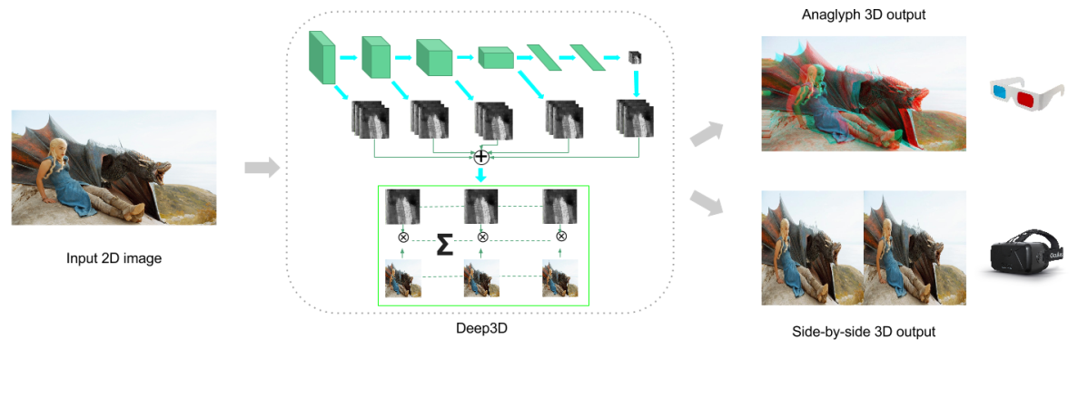
The commercialized glasses-free 3D monitors and tablets takes stereo 3D video frames (side-by-side) as input, combined with eye-tracking technology on the terminal side to render 3D effects.

- Delivery solutions
Which delivery type is expected to be used? What are the expected transport formats? Is there SW or HW support and providers?
Existing Stereo 3D video formats, such as frame-compatible side-by-side and 2D video plus depth. Particular emphasis is given to the DVB systems (terrestrial, satellite, and cable) and IP transport, focusing HTTP/TCP streaming, adaptive HTTP streaming, RTP/UDP streaming, P2P Networks, and Information-Centric Networking-ICN. Hybrid transport technologies, combining broadcast and broadband networks for video delivery are also addressed.
- Content decoding and rendering
Is there decoding SW/HW support, and providers?
H.265/HEVC MV-HEVC 3D-HEVC
Are there rendering devices and displays available yet?
AR/VR HMDs/ Glasses-free 3D displays (tablets, phones, laptops):
This is a list of 3D-enabled mobile phones. The devices on this list typically use autostereoscopic displays. Some devices may use other kinds of display technology, like holographic displays or multiscopic displays. Some devices employ eye tracking in aiming the 3D effect to the viewer's eye. The 3D smartphone with stereoscopic cameras, which enables 3D livestream technology. (https://en.wikipedia.org/wiki/List_of_3D-enabled_mobile_phones)
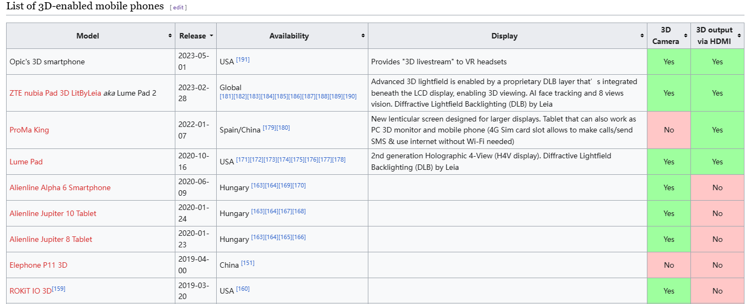

2.5.3 Description of the scenario
This provides a description of beyond 2D video end-to-end workflows, which includes identifying and defining beyond 2D formats being used in the context and representation technologies to delivery these formats. The following aspects may be considered for each workflow:
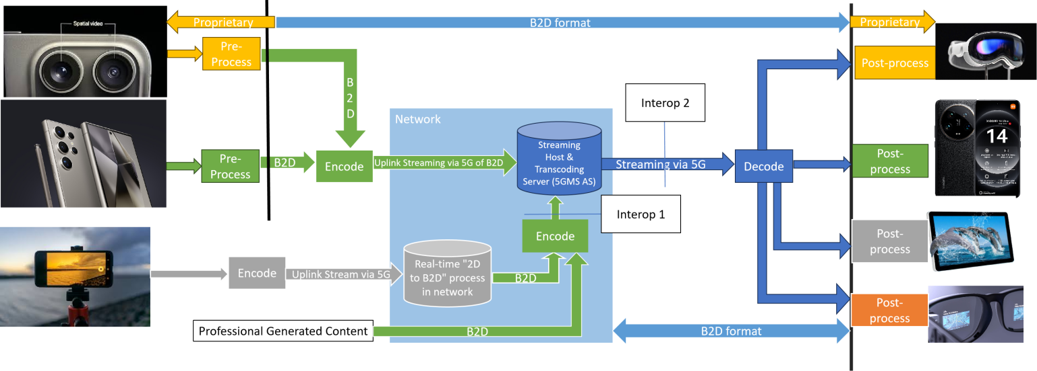
- Capturing and processing
For UE capable of directly capturing beyond 2D video on the device (e.g., UE with a stereoscopic camera, UE equipped with ToF, LiDAR or Spatial camera), it pre-processes the captured video frames into a well-defined B2D format and sends them to the encoder as input. The encoded B2D video streams are then streamed to the streaming server within the network, where the server may transcode them into different bitrates and distribute them to various audiences. The receiving end decodes B2D video streams and perform post-processing to adapt to the rendering system.
For UE limited to capturing only 2D video (e.g., UE with a monocular camera), the UE initially encodes the regular 2D video and streams it to a cloud server capable of real-time 2D-to-beyond 2D transcoding (the process is described in the pipeline below). The cloud server then encodes the transcoded B2D video and streams it to the streaming server.
Pipeline for 2D-to-beyond 2D conversion:
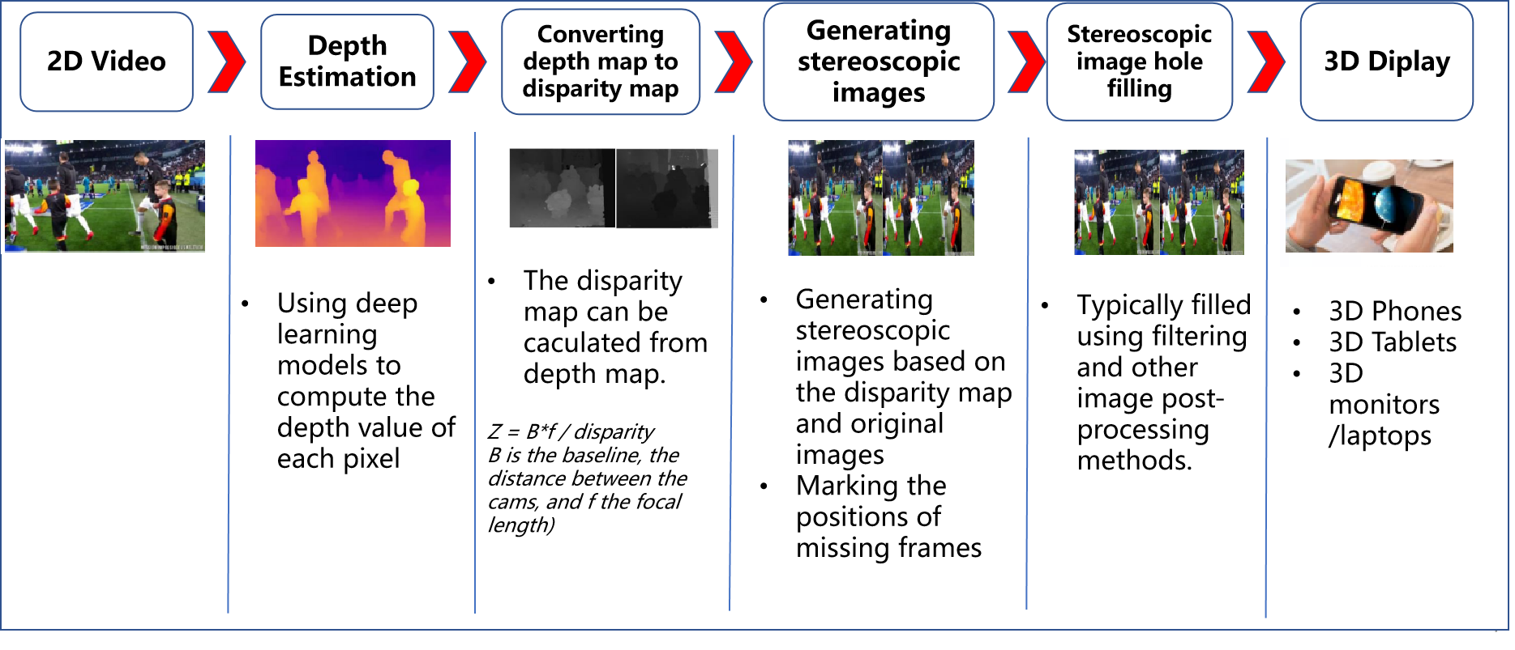
- Encoding
One codec that can be used to realize this scenario is concurrent H.265/HEVC.
Another codec that can be used to realize this scenario is MV-HEVC. Other codecs may be studied as part of this scenario.
- Packaging and delivery
Schierl, Thomas & Narasimhan, Sam. (2011). Transport and Storage Systems for 3-D Video Using MPEG-2 Systems, RTP, and ISO File Format. Proceedings of the IEEE. 99. 671 - 683. 10.1109/JPROC.2010.2091370.
Transport of 3D Video in DVB System (https://research.thea.ie/bitstream/handle/20.500.12065/3101/Transmission%20of%203D%20video%20content.pdf?sequence=1&isAllowed=y)
- Decoding
concurrent H.265/HEVC decoding capabilities or MV-HEVC
- *Post-processing
- Rendering
The display devices tracks the viewer's eye position and adjusts the 3D effect in real-time for single viewer applications (parallax adjustment) and rendering.
- General constraints on latency, bandwidth, reliability and complexity
[Latency: 1s
Bandwidth: 100Mbit/s～1Gbit/s (evaluate the impact of the beyond 2D video representations on the bandwidth requirements of streaming with minuscule loss probabilities)]

2.5.4 Supporting companies and 3GPP members
China Mobile, ZTE.

2.5.5 Source format properties
Table 2.5.5-1 provides an overview of typical beyond 2D source signal properties for UE-to-UE Live Streaming. This information is used to select proper test sequences.
Table 2.5.5-1 Stereo Video Format Properties for UE-to-UE Live Streaming
Source format properties | B2D Live Streaming
Number of views | 2
Spatial resolution for each view | For each view:  1920 x 1080  2560 x 1600
Chroma format | Y’CbCr, RGB
Chroma subsampling | 4:2:0
Picture aspect ratio | 32:9  16:9  16:10
Frame rates | 25, 30, 60, 90, 120 Hz
Bit depth | 8, 10
Colour space formats | BT.709,BT.2020
Transfer characteristics | BT.709,BT.2020

2.5.6 Encoding and decoding constraints and settings
Table 2.5.6-1 provides an overview of encoding and decoding constraints for H.265/HEVC for UE-to-UE Live Streaming scenario. This information supports the definition of detailed anchor conditions.
Table 2.5.6-1 Encoding and Decoding Configurations for Stereo Video
Encoding and Decoding Constraints | H.265/HEVC
Relevant Codec and Codec Profile/Levels | H.265/HEVC Main 10 Profile  Level 4.1, 5.1
Random access frequency | 1 seconds
Bit rates and quality configuration | Fixed QP: [17, 22, 27, 32, 37]  CBR  Half Width/Height: 5-8Mbps  Full Width/Height: 8-16Mbps  Capped-VBR
Bit rate parameters (CBR, VBR, CAE, HRD parameters) | Covering a range of relevant bitrates and qualities
Latency requirements and specific encoding settings | Low latency requirements
Encoding complexity context | Real-time encoding, Cloud-based encoding
Required decoding capabilities | H.265/HEVC Main 10 Profile  Level 4.1, 5.1

2.5.7 Performance Metrics and Requirements
- A clear definition on how the performance needs to be evaluated including metrics, etc addressing the main KPIs of the scenario.
- Objective measures such as PSNR, VMAF, etc, may be used
- Justification on whether objective metrics are sufficient and representative of the subjective performance.
PSNR, SSIM, SIM, BD-Rate, signal-to-noise ratio (SNR)
<To Be aligned with agreed evaluation framework>

2.5.8 Interoperability Considerations for the application
DASH
LL-HLS
RTP based delivery

2.5.9 Test Sequences
A set of selected test sequences that are provided by the proponents in order to do the evaluation. They should cover a set of source format properties

2.5.9.1 Candidate Sources Sequences
This section offers public datasets, generation software, and capturing tools for producing stereoscopic source sequences.
Editor’s Note: The selection of test sequences prioritizes quality considerations.

2.5.9.1.1 Public Datasets
Dataset | Generated  /Natural | Stereo | Depth | Resolution | Download Link | characteristics
InStereo2K [Y8] | Natural | Y | Y | 1080*860 | https://github.com/YuhuaXu/StereoDataset | Color space: BT.709  SDR
Middlebury 2021 Mobile stereo datasets [Y9] | Natural | Y | Y | 1920*1080 | https://vision.middlebury.edu/stereo/data/scenes2021/ | Color space: BT.709  SDR
Middlebury 2014 stereo datasets [Y9] | Natural | Y | Y | 2964*1988 | https://vision.middlebury.edu/stereo/data/scenes2014/ | Color space: BT.709  SDR
[Stereo3D Video dataset: The Web Stereo Video Dataset consists of 553 stereoscopic videos from YouTube. This dataset has a wide variety of scene types, and features many nonrigid objects (especially people). https://sites.google.com/view/wsvd/]
Editor’s Note: The copyright of stereo3D video datasets needs to be further check.
Copyrights:
InStereo2K: This dataset is made freely available to academic and non-academic entities for non-commercial purposes such as academic research, teaching, scientific publications, or personal experimentation.[The author had granted the permission to use this dataset]
Middlebury:We grant permission to use and publish all images and numerical results on this website. If you report performance results, we request that you cite our paper. Instructions on how to cite our datasets are listed on the datasets page. If you want to cite this website, please use the URL "vision.middlebury.edu/stereo/".

2.5.9.1.2 AI Based 2D-to-Stereo3D Conversion
The AI-based conversion of existing 2D images and Video to stereo3D is proving commercially viable and fulfills the growing need for high quality stereoscopic images. This approach is particularly effective when creating content for the new generation of autostereoscopic displays that require multiple stereo images.
- Commercial Services
- Owl3D - AI-powered 2D to 3D video conversion software: https://www.owl3d.com/
- Leia Inc. Immersity AI | Convert Image and Video to 3D: https://www.immersity.ai/
-Meta Turning any 2D photo into 3D using convolutional neural nets https://ai.meta.com/blog/powered-by-ai-turning-any-2d-photo-into-3d-using-convolutional-neural-nets/
- China Mobile (Zhejiang) adopt this solution and has successfully utilized it to automatically convert over one hundred 2D movies into 3D, allowing users to obtain an immersive video experience on different types of terminals. (https://www.lightreading.com/5g/wireless-s-next-frontier-5g-advanced-meets-the-hangzhou-asian-games)
- Depthify.ai - AI-powered 2D to 3D video converter for Apple Vision Pro and Meta Quest. (https://www.depthify.ai/）
- Algorithm
Various open-source algorithms and platforms use deep neural networks to perform real-time end-to-end conversion of 2D videos and images to stereoscopic 3D format. The performance of these conversions may vary based on the algorithm's efficiency and the hardware capabilities.
The following are capabilities and requirements of the Deep3D [10] algorithm (https://github.com/HypoX64/Deep3D):
Prerequisites:
- Linux, Mac OS, Windows
- Python 3.7+
- ffmpeg 3.4.6+
- Pytorch 1.7.1
- CPU or NVIDIA GPU
Inference speed:
Plan | 360p (FPS) | 720p (FPS) | 1080p (FPS) | 4k (FPS)
GPU (2080ti) | 84 | 87 | 77 | 26
CPU (Xeon Platinum 8260) | 27.7 | 14.1 | 7.2 | 2.0

- Related tools
As 2D-to-Stereo3D conversion algorithms usually take RGB video format, the Python codes below can be used to convert between YUV and RGB formats.
A Python code for converting YUV to RGB:
- import cv2
- import numpy as np

- def read_yuv_frame(file, width, height):
- # calculate size of YUV frame
- frame_size = width * height * 3 // 2
- # Read YUV frames
- yuv = np.fromfile(file, dtype=np.uint8, count=frame_size)
- if yuv.size != frame_size:
- return None
- # reconstruct YUV data to YUV420 format
- y = yuv[0:width*height].reshape((height, width))
- u = yuv[width*height:width*height + (width//2)*(height//2)].reshape((height//2, width//2))
- v = yuv[width*height + (width//2)*(height//2):].reshape((height//2, width//2))
- return y, u, v

- def yuv_to_rgb(y, u, v):
- # convert YUV420 to YUV444
- u = cv2.resize(u, (y.shape[1], y.shape[0]), interpolation=cv2.INTER_LINEAR)
- v = cv2.resize(v, (y.shape[1], y.shape[0]), interpolation=cv2.INTER_LINEAR)
- yuv = np.stack((y, u, v), axis=-1)
- # convert yuv to rgb
- rgb = cv2.cvtColor(yuv, cv2.COLOR_YUV2RGB)
- return rgb

- def main():
- # read YUV file path
- yuv_file_path = 'video.yuv'
- # set width and height
- width, height = 1920, 1080

- with open(yuv_file_path, 'rb') as file:
- while True:
- # red yuv frame
- yuv_frame = read_yuv_frame(file, width, height)
- if yuv_frame is None:
- break
- y, u, v = yuv_frame
- # convert yuv to rgb
- rgb_frame = yuv_to_rgb(y, u, v)
- # display rgb frame
- cv2.imshow('RGB Frame', rgb_frame)
- if cv2.waitKey(30) & 0xFF == ord('q'):
- break

- cv2.destroyAllWindows()

- if __name__ == "__main__":
- main()

A Python code for converting RGB to YUV:
- import cv2
- import numpy as np
- import time

- def rgb_to_yuv420(frame):
- # Using OpenCV for converting RGB to YUV format
- yuv = cv2.cvtColor(frame, cv2.COLOR_RGB2YUV_I420)
- return yuv

- def main():
- # read RGB video file path
- rgb_video_path = 'video.mp4'
- # set output YUV file path
- yuv_file_path = 'output.yuv'
- # open video file
- cap = cv2.VideoCapture(rgb_video_path)

- # check if video file is open
- if not cap.isOpened():
- print("Error: Could not open video.")
- return

- # get width and height of video file
- width = int(cap.get(cv2.CAP_PROP_FRAME_WIDTH))
- height = int(cap.get(cv2.CAP_PROP_FRAME_HEIGHT))
- print(f'Video dimensions: {width}x{height}')

- # set framerate
- fps = 60
- frame_duration = 1.0 / fps

- with open(yuv_file_path, 'wb') as yuv_file:
- while cap.isOpened():
- start_time = time.time()
- # read RGB frame
- ret, frame = cap.read()
- if not ret:
- break

- # convert RGB to YUV
- yuv_frame = rgb_to_yuv420(frame)

- # write YUV frame to yuv file
- yuv_file.write(yuv_frame)

- elapsed_time = time.time() - start_time
- wait_time = max(1, int((frame_duration - elapsed_time) * 1000))
- if cv2.waitKey(wait_time) & 0xFF == ord('q'):
- break

- cap.release()
- cv2.destroyAllWindows()

- if __name__ == "__main__":
- main()

- Example
The following is the test sequence that auto-converting a 2D video frame (BQTerrance 1920x1080, 60fps) to a stereoscopic 3D video (1920x1080 for each eye, 60fps) using CMCC’s 2D-to-Stereo3D conversion algorithm.
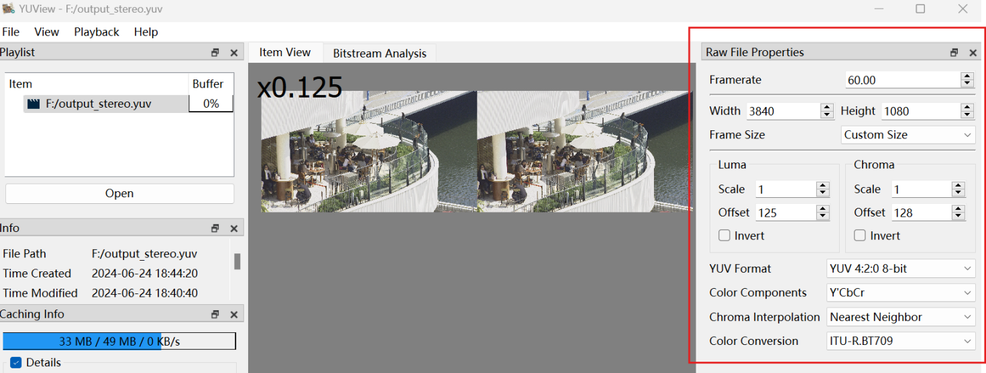

2.5.9.1.3 Stereo 3D Video Capturing
Another option is to use a dual-lens camera to directly capture stereo 3D video. There are many mobile devices on the market with this capability. For example, SpatialLabs Eyes provided by Acer is a stereoscopic camera capable of capturing up to 8-MP (4K) per eye at 30 fps or 2K per eye at 60 fps. Or the ZTE Nubia Pad 3D II can capture stereo 3D video with the following specifications:

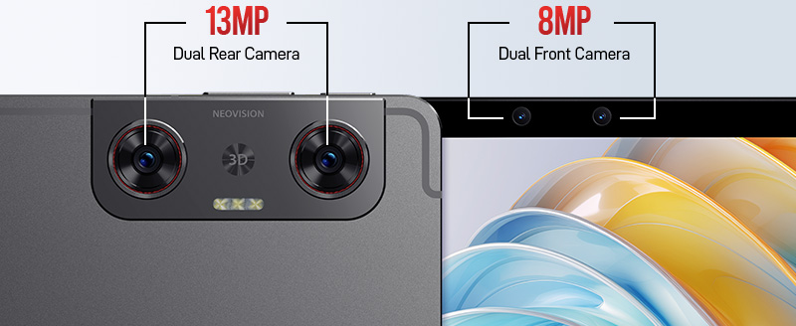

The main camera setup is the dual-camera systems includes two identical 13 MP lenses. These cameras capture slightly different perspectives of the same scene, mimicking the way human eyes perceive depth. The AI then processes these images to produced a coherent 3D representation.

Rear Camera | Specification
Number of Cameras | 2 (Dual)
Resolution | 13 MP (wide); 13 MP (wide)
Autofocus | AF, AF
Video Recording | 1200 @ 30 fps
Others | LED Flash, panorama, HDR, Stereoscopic AI-powered 3D capture

The selfie camera setup features two lenses positioned near the center of the top bezel when the tablet is oriented horizontally (with the longer side on the top). Here are the relevant specs:
Front Camera | Specification
Number of Cameras | 2 (Dual)
Resolution | 8 MP (ultra wide); 8 MP (ultra wide)
Aperture | f/2.2, f/2.2
Field of View | 105°, 105°
Video Recording | 1200 @ 30 fps
Others | Stereoscopic AI-powered 3D capture

The captured videos (in mp4 file) need further processing (e.g., reading the right/left views and concatenate them into one video frame) to generate the proper test sequences.
A Python code for doing these tasks:
- import numpy as np
- import json
- import subprocess

- def videoInfo(filename):
- proc = subprocess.run([
- *"ffprobe -v quiet -print_format json -show_format -show_streams".split(),
- filename
- ], capture_output=True)
- proc.check_returncode()
- return json.loads(proc.stdout)

- def readVideo(filename):
- cmd = ["ffmpeg", "-i", filename]
- streams = 0
- for stream in videoInfo(filename)["streams"]:
- index = stream["index"]
- if stream["codec_type"] == "video":
- width = stream["width"]
- height = stream["height"]
- cmd += "-map", f"0:{index}"
- streams = streams + 1
- cmd += "-f", "rawvideo", "-pix_fmt", "rgb24", "-"
- shape = np.array([streams, height, width, 3])
- with subprocess.Popen(cmd, stdout=subprocess.PIPE) as proc:
- while True:
- # One byte per each element
- data = proc.stdout.read(shape.prod())
- if not data:
- return
- yield np.frombuffer(data, dtype=np.uint8).reshape(shape)

- if __name__ == '__main__':
- import matplotlib.pyplot as plt
- from PIL import Image
- idx = 1
- for left, right in readVideo("./StereoCaptured.mp4"):
- # concatenate left and right
- img = np.concatenate((left[0:1080,:], right[0:1080,:]), axis=1)
- img = Image.fromarray(img)
- img.save(f"imgs/{idx}.jpg")
- idx += 1

A FFMPEG command for storage them into .yuv
- ffmpeg -start_number 1 -r 30 -i %d.jpg -pix_fmt yuv420p -s 1920x1200 out.yuv

Example
The following is the test sequence captured with ZTE Nubia Pad 3D II main camera (1920*1200, 30fps) and post-processed by the above tools.
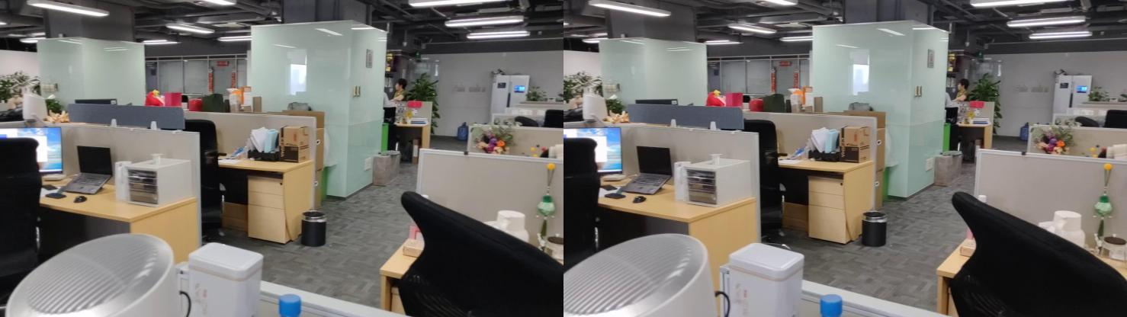
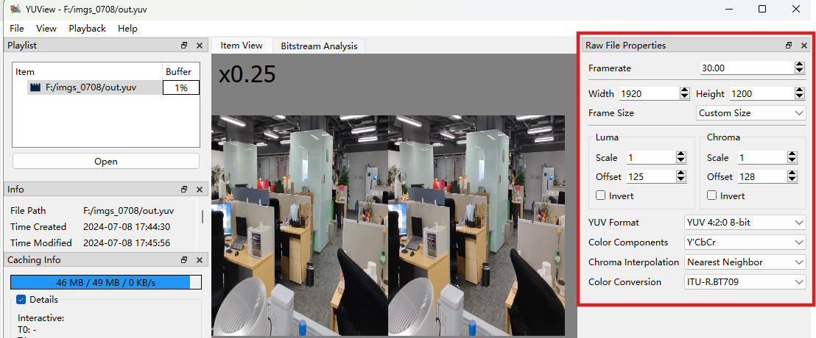
Others:
High resolution 3D stereo camera
(specification: https://assets.balluff.com/WebBinary1/BVS_3D_RV1_3D_Stereo_Camera_EN.pdf)

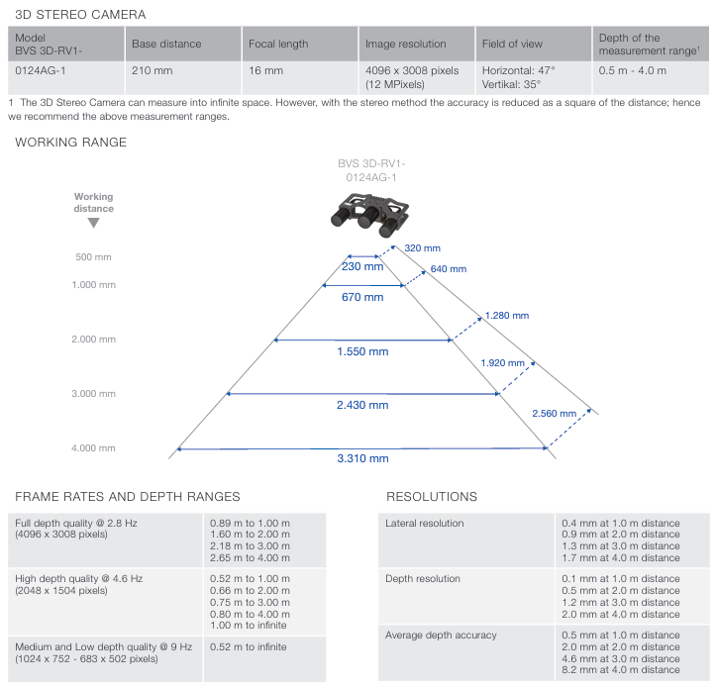

2.5.10 Detailed test conditions
Provides a proposal for detailed test conditions, for example based on a reference software together with the sequences and configuration parameters.
<TBD>

2.5.12 Additional Information
- Industry activities
Is there Relevant work in industry forums?
- Implementation constraints
Are there any indications about scalability of the technology with regards to network and devices?
- Innovation
Does the technology address a current or a future need on the market? Can it potentially disrupt existing markets?
<TBD>

3 Beyond2D Representation Formats

3.1 Dynamic Mesh

3.1.1 Definition
A mesh is a structure composed of several polygons that define the boundary surface of a volumetric object. It typically includes five components: connectivity information, geometry information, mapping information, vertex attributes, and attribute maps. A dynamic mesh is a mesh where at least one of these five components in varying in time [DM-1]. Such change can result from prescribed motion, flow induced rigid body motion, fluid structure interaction or adaptive mesh refinement.
Dynamic meshes are one of the immersive contents that are widely used in the commercial markets. The demand for processing and visualizing such rich 3D content has led to the increasing popularity of dynamic meshes, as they are natively supported by virtually all the 3D software and graphic hardware, friendly to GPU rendering, and have a strong applicability to interactive and real-time 3D task [DM-3].
MPEG has defined several use cases for dynamic mesh compression, including Real-time 3D Immersive Telepresence, Content AR/VR viewing with Interactive Parallax and 3D Free viewpoint Sport Replays Broadcasting [DM-2]. The typical characteristics of the meshes in these use cases are summarized in Table. 4.3.5.1-1.
Table 4.3.5.1-1 Typical Characteristics of Meshes in MPEG-Defined Use Cases
Use Case | Triangle Count | Color Representation | Additional Properties
Real-time 3D Immersive Telepresence | To represent a reconstructed human:  - 40,000 – 100,000 triangles (with color per vertex)  - 10,000 – 50,000 triangles (with texture maps) | - Texture maps: 2K–8K square pixels  - Color per vertex | - Normals and/or material properties for shader rendering
Content AR/VR Viewing with Interactive Parallax | To represent a reconstructed human:  - 10,000 – 100,000 triangles | - Texture maps: 2K – 8K square pixels | - Normals and/or material properties for shader rendering  - Global parameters for spatial constraints
3D Free Viewpoint Sport Replays Broadcasting | To represent a reconstructed human:  - 20,000 – 200,000 triangles | - Texture maps: 8 – 12 bits per color component | - Multiple clusters/groups of meshes (e.g., different players)

3.1.2 Production and Capturing Systems
Dynamic meshes cannot be directly captured through 3D scanning devices. Instead, meshes can be generated either manually by artists or automatically through 3D generation algorithms. The current production methods include:
- Manual Creation: artists use 3D modeling software packages (such as Blender TM, Maya TM, and etc.) to manually create dynamic meshes. The artist-created meshes capture not only the external appearance of objects but also their intrinsic properties and construction details through mesh topology. High-quality meshes used in games and movies are almost exclusively created by artists.
- Volumetric Capture Studio: An array of multi-camera or multi-stereo cameras is placed around a recording space to capture a subject within that space. After the capture, a generation and production process is required to create the dynamic meshes. For further details, refer to Clause 4.6.7 of TR 26.928 [26928].
- Converted from other formats: A mesh can be extracted algorithmically from other beyond 2D representations, such as 3D Gaussians, neural fields, voxels and point clouds.
- AI-generated meshes: An emerging line of research generates 3D meshes in a data-driven fashion by learning from artist-created meshes using machine learning algorithms. For example, PolyGen (https://polygen.io/), MeshGPT (https://nihalsid.github.io/mesh-gpt/), MeshAnything (v1:https://buaacyw.github.io/mesh-anything/ and v2:https://buaacyw.github.io/meshanything-v2/), and MeshXL (https://meshxl.github.io/). These methods show significant promise, particularly in terms of automating 3D asset creation. However, they are still limited by scalability, with the best method handling up to approximately 1.6K faces, and the resulting meshes often exhibit a significant quality gap compared to those crafted by artists.

3.1.3 Rendering and Display Systems
Dynamic meshes can be rendered directly on GPUs that are highly optimized for mesh-based rendering. The following are the rendering APIs and engines for dynamic mesh processing:
- Low-Level rendering APIs:
- OpenGL: https://learnopengl.com/Model-Loading/Mesh
- DirectX 12: https://microsoft.github.io/DirectX-Specs/d3d/MeshShader.html
- Vulkan: https://docs.vulkan.org/spec/latest/chapters/VK_NV_mesh_shader/mesh.html
- Graphic Engines:
- Unity TM : https://docs.unity3d.com/6000.0/Documentation/ScriptReference/Mesh.MarkDynamic.html
- Unreal Engine TM: https://dev.epicgames.com/documentation/en-us/unreal-engine/BlueprintAPI/DynamicMesh
- NVIDIA RTX / OptiX TM: https://developer.nvidia.com/rtx/ray-tracing/optix
- Web-Based rendering APIs:
- WebGL:https://www.khronos.org/webgl/
- Three.js: https://threejs.org/docs/api/en/objects/Mesh.html
- WebGPU: https://webgpu.github.io/webgpu-samples/?sample=skinnedMesh
Rendering can be on:
- a device for 2D presentation such as a phone
- a device for 3D presentation such as an autostereoscopic display, providing depth perception for dynamic meshes
- a device for 6DoF presentation such as VR/AR devices like Meta Quest TM, HTC Vive TM, and Apple Vision ProTM support real-time rendering of dynamic content.

3.1.4 Supporting Information
Existing compression technologies for dynamic meshes include:
- Googles’ Draco [D5], a C++ compression library. It achieves good performance for static meshes, they typically encode each frame independently and can not leverage the temporal coherence and redundancies in dynamic meshes.
- Mesh compression standards such as IC, MESHGRID, and FAMC, previously developed by MPEG. They can only compress dynamic mesh sequences with constant topological information (same vertex counts and face connections), and this method can't handle dynamic meshes with time-varying topology, geometry and attribute information.
- V-DMC [DM-3], a new mesh compression standard to directly handle dynamic meshes with time varying connectivity information and optionally time varying attribute maps.The initial V-DMC test model was released by MPEG in July 2022.
Editor’s Note:
- Typical quality criteria for evaluating the format
- Existing test and reference sequences
- Uncompressed data size
- Conversion from other formats (lossless, lossy)
- Extensibility of the format

3.1.5 Benefits and Limitations

3.1.5.1 Benefits
The dynamic mesh format has the following benefits:
- Good visual quality. Meshes provide a more complete representation of an object's surface shape, allowing for finer details and realistic shading and rendering through texture mapping, making 3D assets look photorealistic.
- Most important and widely used representation for 3D assets in the commercial market. De facto standard in the film, design and gaming industries.
- Natively supported by virtually all 3D software and graphic hardware.
- Friendly to GPU.
- Backward-compatible rendering. The content can be rendered on 2D displays.

3.1.5.2 Limitations
A dynamic mesh sequence may require a large amount of data since it may consist of a significant amount of information changing in time. Compare with normal meshes, efficient compression, storage, and transmission of dynamic meshes are expected.
Editor’s Note: More Benefits and limitations will be added over time

4 Evaluation and Characterization Framework – Basic Principles
Based on the above discussion, an evaluation of a scenario requires the definition of a evaluation and characterization framework, aligned with the framework in TR 26.955.
An evaluation framework allows to identify at least the following aspects for a technology under evaluation:
- One or multiple meaningful quality metrics of the scenario and the technology under evaluation for different configurations to determine adequate quality thresholds under typical application constraints. The evaluation configuration needs to take into account restrictions in terms of encoding complexity, latency, and/or other functional requirements, such as random access.
- The network requirements to delivery such content, primarily the resulting required bitrates can be determined.
- The packaging requirements in order to deliver the data in interoperable manner can be determined.
Once such an evaluation framework is in place, the framework may also be used for
- To determine the quality/network parameters for existing 3GPP technologies – referred to as anchors
- To determine the quality/network parameters for new technologies - referred to as technologies under test
- Typically, for each of the above not a single configuration is tested, but a tuple (for example to obtain quality rate curves)
- To compare anchors with technologies under test using the results of the tuples.

The evaluation framework is documented in the figure below and follows the principles as defined in TR 26.955.
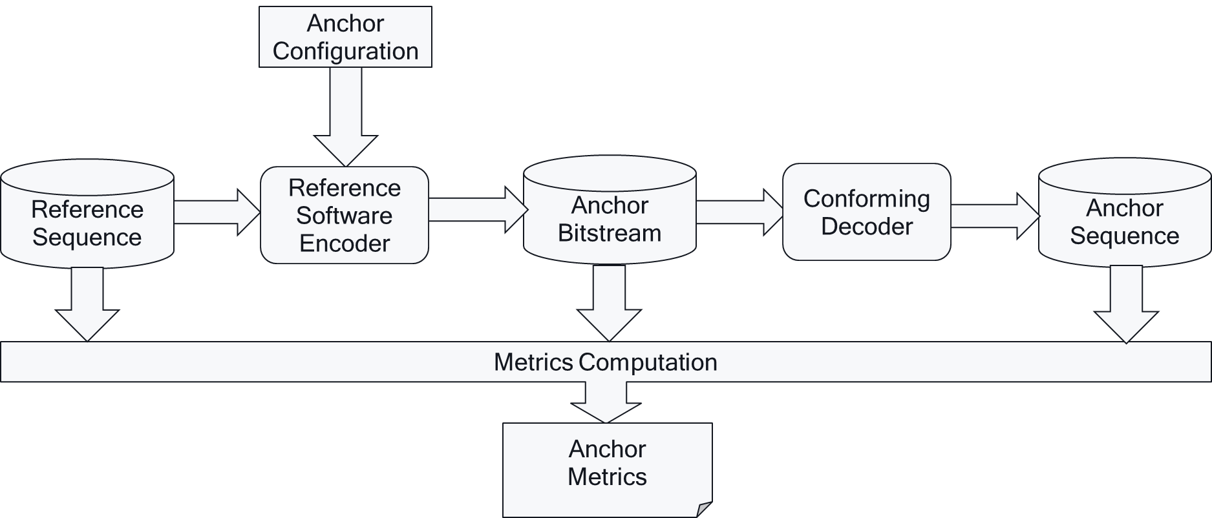
Based on all of the results for anchors and tests, technologies may be compared in a characterization framework as shown below
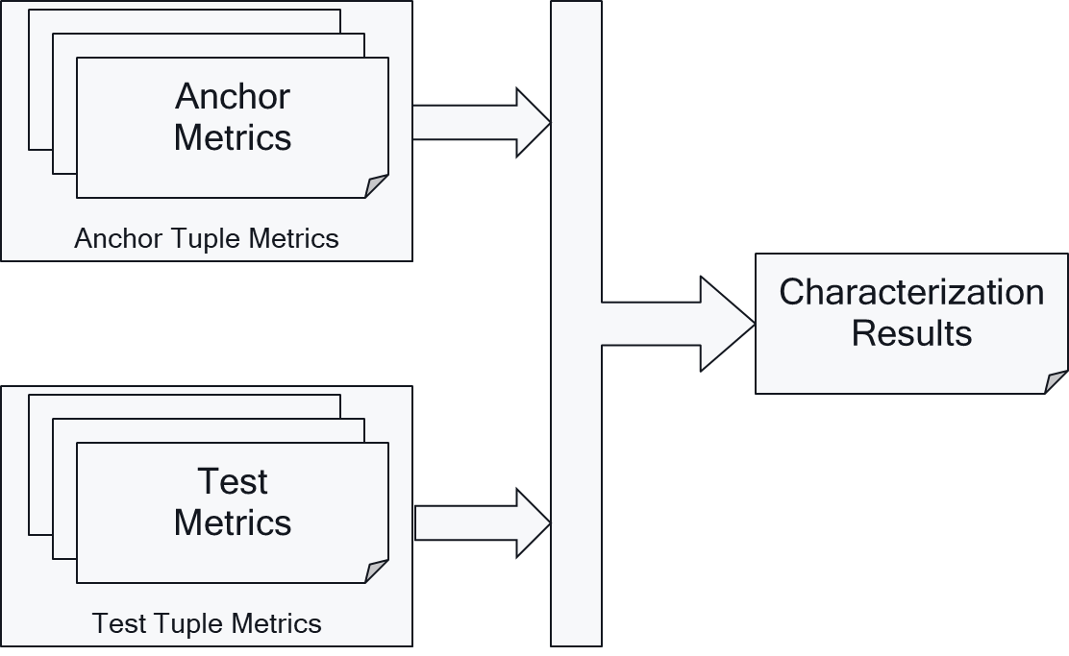

5 Evaluation Framework for B2D Delivery
Based on the discussion in clause 2, 3 and 4, an adjusted common evaluation framework for Beyond 2D is presented following Figure 5.1-1.
For evaluating a scenario, it is expected that the following information is present:
- Representative Reference Sequences that reflect the scenario are collected and stored in a well defined B2DV format.
- A video encoding system takes the the B2DV reference sequences and produces one or more bitstreams together with metadata which is packaged into a delivery format.
  - The actual packaging may not be done, but a "pseudo"-packing is applied that allows to interface with the video decoder of the system, but also allows to evaluate a bitrate determination.
  - Packaging may for example be just to assume interleaving of samples from different video streams, adding relevant metadata that is not included in the bitstream, etc.
  - A well-defined format should be defined to estimate the resulting bitrate.
- The data is then unpackaged such that it can be made available to the B2D video decoder in its appropriate format. The B2D video decoder input format is out of scope for the evalution. The B2D video decoder reconstructs at the output the a signal in B2DV format again. The sequences may also be inspected subjectively on a 2D plane or in a device that supports B2D rendering.
- By full-reference evaluation and by using the B2DV packed streams, metrics are generated.

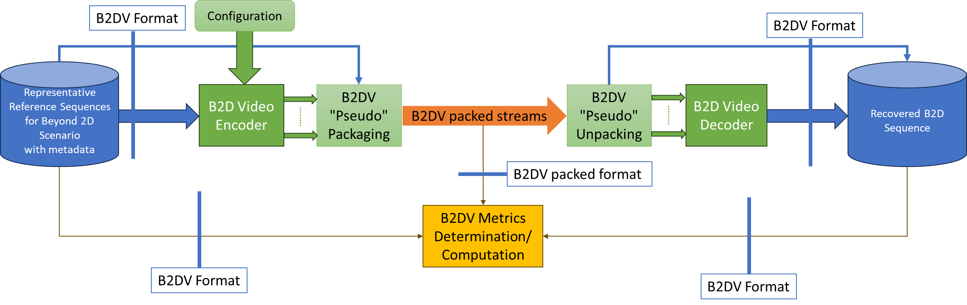
Figure 5.1-1 High-Level evaluation framework

5.1 Evaluation of multi-view content

It is applicable to Scenario 1 Beyond 2D Messaging and Social Sharing, Scenario 2 Streaming of multi-view video, and Scenario 3: UE-to-UE Beyond 2D Video Communication

5.1.0 External Performance data
References to external performance data that can be added, for example other SDOs, public documents and so on.
G. Piro, C. Ceglie, D. Striccoli and P. Camarda, "3D Video transmissions over LTE: A performance evaluation," Eurocon 2013, Zagreb, Croatia, 2013, pp. 177-185, doi: 10.1109/EUROCON.2013.6624983.
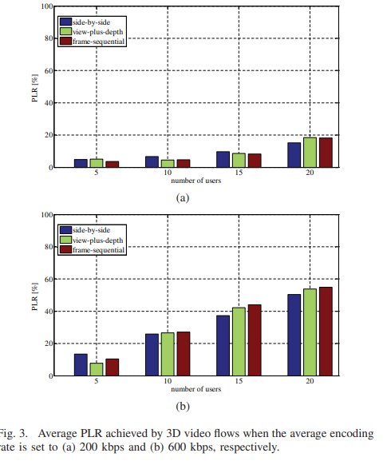

5.1.1 Definition of an anchor
Our assumption is that multiple codecs will be studied, including MIV + HEVC and MV-HEVC, and that evaluation will be “end-to-end” on multiple bitrates at synthesized viewpoints. As there is no previous generation to compare against, it is not obvious what the anchor should be. During the MIV project two anchors have been created:

- 3DoF+ CfP: Multicast HEVC + zipped JSON for view parameters
- MIV verification test: MV-HEVC + zipped JSON for view parameters

Given that it is likely that MV-HEVC will be tested, it is not a good choice as an anchor, and the first one is arguably not representative enough. Because this is a feasibility study into new representations, we argue that it is acceptable to have no anchor. Instead, we propose to combine the results of all evaluated codecs in one graph. The assumption is that we have no more than a few codecs for each sequence.

5.1.2 Objective evaluation
We propose to carry out objective evaluation based on the following information:
- For each codec:
  - A decoder-renderer executable
- For each sequence:
  - A set of source view texture videos in 4:2:0 format
  - View parameters of the source views
- For codec-sequence combinations:
  - One bitstream for each rate point
  - A set of pose traces for each sequence
We propose having four rate points: 5, 10, 20 and 40 Mbps. For each sequence and codec this can be translated to an integer QP value.
Each bitstream is a codec-sequence-rate combination. The decoder-renderer executable is used to render a video at all source view positions. For the messaging and communication scenarios, it is likely that the source views are directly encoded. For streaming there is a higher number of source views, and it is assumed that only a subset or parts of source views are encoded, and other parts are to be synthesized.

5.1.3 Aggregation of metrics over views
The metrics (see below) are computed for each source view. To have one number that considers that the reconstructed view is partially synthesized, the metrics [dB] are averaged in the squared error domain and converted back to decibels.

5.1.4 Metrics
It is important to use tools that are independent of specific codecs.
We propose to use the IV-PSNR tool [A1] outputs two complementary metrics:
- Weighted sphere PSNR (WS-PSNR) [dB] which is equivalent to PSNR for perspective viewports.
- Immersive video PSNR (IV-PNSR) [dB] which correlates better with subjective results.
In the MIV project other metrics such as VMAF, MS-SSIM have been tested but they did not provide a better correlation with subjective results and have been dropped. We do not propose to include those metrics to keep reporting simple and reduce workload.

5.1.5 Subjective evaluation
Subjective evaluation (informal expert viewing) is performed by rendering the same bitstreams as used for objective evaluation, with two pose traces. This results in three pose trace videos that can be watched and rated. The number of pose trace videos is a trade-off in time and being able to view the content from enough viewpoints.
In addition, interactive real-time demonstration may be considered.

5.1.6 Crosschecking
As written in the PD for Scenario 2 and 3, we propose to exclude encoders from evaluation, and require the sources to provide the bitstreams for evaluation. The provided bitstreams and decoder-renderer executables allow for verifying that the rate-distortion result can be reproduced.
All produced bitstreams, metric results and produced videos shall be crosschecked by at least one other company to ensure that results are correct.

5.2 Evaluation of Stereoscopic video content
In general, the quality of stereoscopic 3D video includes the spatial-temporal visual quality, depth perception and visual comfort. The follow table provides an overview of existing stereoscopic quality metrics.

5.2.1 Overview of Different Full Reference Stereoscopic video Quality Metrics

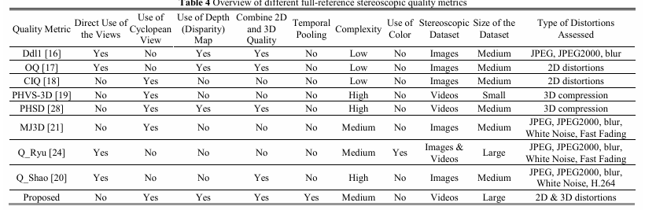
The Mean Square Error (MSE) is used as a quality measure, which is known to have low performance in accurately representing the human visual system. Moreover, this method utilizes disparity information instead of the actual depth map, which may result in inaccuracies in the case of occlusions.
Similarly, in the study by Jin et al. the quality of cyclopean view was taken into account in the design of a full-reference 3D quality metric for mobile applications, which is called PHVS-3D [A4]. In this study the information of the left and right channels are fused using the 3D DCT transform to generate a cyclopean view. Then, a map of local block dis-similarities between the reference and distorted cyclopean views is estimated using the MSE of block structures. The weighted average of this map is used as the PHVS-3D quality index. Although the proposed schemes take into account the quality of cyclopean view, they ignore the depth effect of the scene.

5.2.2 Human-Visual-System-based 3D (HV3D) Quality Metric
A full-referenced human visual-system-based quality metric for 3D videos called HV3D had been proposed in ITU-T [A5]. It takes into account the quality of individual views, the quality of the cyclopean view (fusion of the right and left view, what the viewer perceives), as well as the quality of the depth information.
The HV3D quality metric is taking values between 0 and 1 (because it is optimized to be correlated with MOS/10), and higher than 1 in case quality is improved.
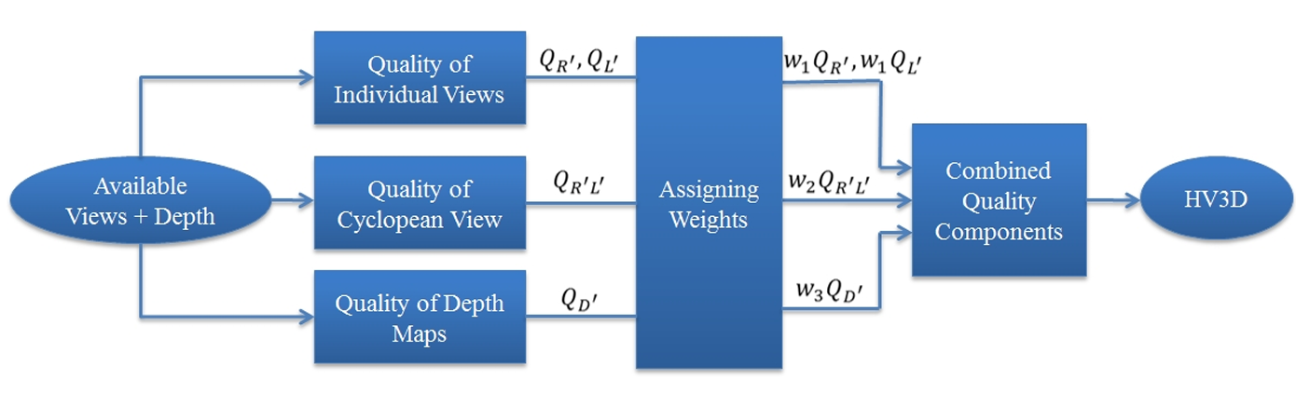
Figure 2.2-1 HV3D Flowchart
The performance of the proposed HV3D metric is validated by subjective tests, using 4 reference and 40 modified videos and 19 subjects, following the ITU-R BT.500-11 recommendation [A6].
Performance evaluations showed that HVS 3D quality metric quantifies quality degradation caused by several representative types of distortions very accurately, with Pearson correlation coefficient of 90.8 %, a competitive performance compared to the state-of-the-art 3D quality metrics. (Ref: https://arxiv.org/pdf/1803.04832)

5.2.2.1 Quality of individual views
The metrics (see below) are computed for the quality of individual views that form the stereo pair. The quality of the distorted right view with respect to its matching reference view is calculated as followings. The quality of the left view is calculated in the same fashion..
Where YR and YR’are luma information of the reference and distorted right views respectively, UR and VR are the chroma information of the reference right-view, UR’and VR’are the chroma information of the distorted right-view, w₁ and w₄ are weighting constants.

5.2.2.2 Quality of cyclopean view
In order to measure the quality of the cyclopean view, first the cyclopean view is constructed by combining the corresponding areas from the left and right views.This is done by finding the matching blocks between right and left views. To this end, the luma information of each view is divided into 16×16 blocks. Here the 3D-DCT transform is applied to each pair of the matching blocks (left and right views) to generate two 16×16 DCT-blocks, which contain the DCT coefficients of the fused blocks. Since the human visual system is more sensitive to the low frequencies of the cyclopean view, only the first level of the coefficients is considered (which is a 16×16 DCT-block) and the rest of them are discarded.
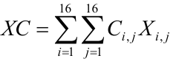
Where XC is the cyclopean-view model for a pair of matching blocks in the right and left views, X_{i,j} are the low frequency 3D-DCT coefficients of the fused view, i and j are the horizontal and vertical indices of coefficients, and C_{i,j} is the CSF modeling mask C_{i,j} is derived based on the JPEG quantization table (see[A7] for more details).
Once the cyclopean-view model for all the blocks within the distorted and reference 3D views is obtained, the quality of the cyclopean view is calculated as follows:
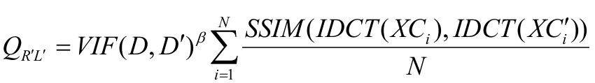
Where D is the depth map of the reference 3D view, D' is the depth map of the distorted 3D view, XC_{i} is the cyclopean-view model for the i^{th} matching block pair in the reference 3D view,XC'i is the cyclopean-view model for the i^{th} matching block pair in the distorted 3D view, IDCT stands for inverse 2D discrete cosine transform,N is the total number of blocks in the each view, β is a constant, empirically assigned to 0.7 (resulted from a series of subjective tests).

5.2.2.3 Quality of depth map
The quality of depth map is formulated as follows:
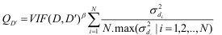
Where d_{i} is the variance of block i in the depth map of the 3D reference view and the local disparity variance is calculated over a block size area of 64x64.

5.2.2.4 Weighting constants
Weighting constants are found using least mean square such that the difference between the mean opinion scores (MOS) values and the HV3D values is minimized as follows:
The authors [X] has conduct experiment to to determine the best values for the weighting constants w₁, w₂, w₃ and w₄ which result in the minimum mean of square errors between our HV3D index and the MOS.
TABLE X shows the resulting values for these constants from their experiment.
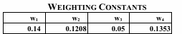
]

5.2.3 Subjective evaluation
- Subjective Assessment Methods for 3D Video Quality, document ITU-T P.3D-sam, International Telecommunication Union, Geneva,Switzerland, Jul. 2015.[A8]
“In stereo 3D systems, a binocular 3D image is formed by presenting the left and right image to their respective eye. If discrepancies arise between these two images, they can cause psychophysical stress, and in some cases 3D viewing can fail. For example, when shooting and displaying stereoscopic 3DTV programmes, there may be geometrical, optical, electrical or temporal asymmetries, such as size inconsistency, vertical shift, rotation error, and luminance or colour levels between the left and right images. For the production of natural scene content using two independent video cameras, the main issue is to guarantee that the asymmetries of the views are under perceptual limits.”
Table 1 illustrates visibility thresholds obtained from subjective experiments using an impairment scale and for a viewing distance of 4.5 times the display height.
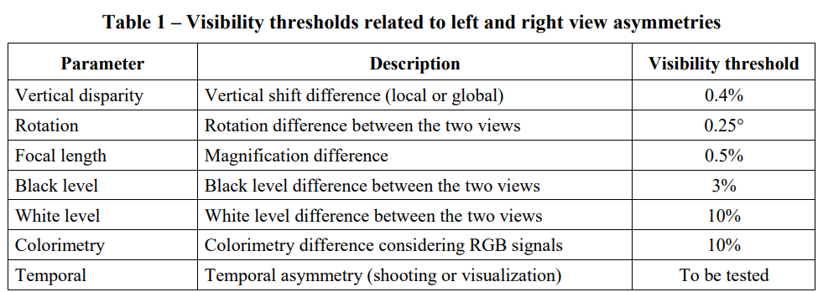
- Assessment Methods of Visual Fatigue and Safety Guideline for 3D Video, document ITU-T J.3D-fatigue, International Telecommunication Union, Geneva, Switzerland, 2015.

5.3 Evaluation of multi-view plus depth produced content

5.3.1 Test sequences
The evaluation has been performed on the sequences listed in Table 5.3.1. Only the first 65 frames were used of each test sequence.
Table 5.3.1: Test sequences for the evaluation of the scenario
Sequence | Provider | Frames | Resolution | Bit depth | Color format
Breakfast (D02)  (Figure 5.3.1) | InterDigital | 97 @ 30 Hz  3.2 s | 1920 x 1080  5 x 3 views | texture: 10b  depth: 16b | texture: 4:2:0 BT.709  depth: 4:2:0 full range linear
Bartender  (Figure 5.3.2) | ETRI | 300 @ 30 Hz  10.0 s | 1920 x 1080  21 views | texture: 10b  depth: 16b | texture: 4:2:0 BT.709  depth: 4:2:0 full range linear
DanceMoves  (Figure 5.3.3) | Philips | 449 @ 15 Hz  29.9 s | 1920 x 1080  6 views | texture: 10b  depth: 16b | texture: 4:2:0 BT.709  depth: 4:2:0 full range linear

5.3.1.1 Test sequence Breakfast
The Breakfast sequence (Figure 5.3.1) is part of the MIV CTC [5.3.1] but has not been used for the development of ISO/IEC 23090-12:2023. It consists of 97 frames @ 30 fps, and was captured using a 5 x 3 planar rig of BlackMagic Micro Studio cameras. The total size of the rig is about 1 m wide and 0.5 m tall. The cameras have a field of view of about 66° by 40°. The scene has been shot in the dining room of Chateau de la Ballue, 35560 Bazouges-la-Pérouse, France. While InterDigital originally provided depth maps, later these have been replaced by depth maps that were produced by ETRI using their internal tools, comprising block matching based on plane-sweeping, cost aggregation, semi-global matching, and depth refinement.
For the purpose of this study, the license has been updated. The test sequence and derived work are hosted by InterDigital on their Aspera server.
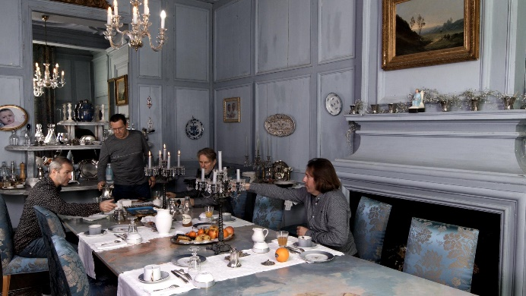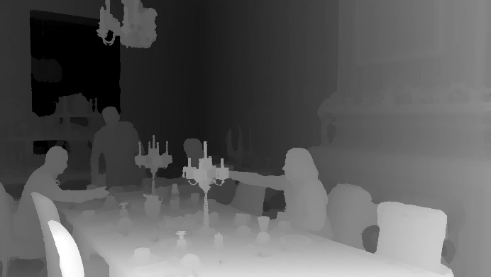
Figure 5.3.1: Breakfast sequence (view 7, frame 0)

5.3.1.2 Test sequence Bartender
The Bartender sequence (Figure 5.3.2) was originally provided by ETRI for the 3D Implicit Neural Video Representation (3D-INVR) activity in SC 29/WG 4 [5.3.2], and it is currently being used as a reference sequence in the MPEG Gaussian splat coding (GSC) exploration in WG 4/WG 7. The sequence has not been used for the development of ISO/IEC 23090-12 MIV. It consists of 300 frames @ 30 fps, and was captured using a 7 x 3 planar rig of BlackMagic Micro Studio 4K cameras. The total size of the rig is about 3 m wide and 0.5 m tall. The calibration of the camera system was done using Reality Capture, mainly relying on bundle adjustment.
Permission was obtained form ETRI to use this sequence for this study. The license requires citation of [5.3.2]. Because the cited document is not publicly available, it was agreed with ETRI to distribute the cited document with the test sequence.
As the sequence was provided without depth maps, Philips has generated depth maps using Immersive Video Depth Estimator (IVDE) 8.0 [5.3.3] by Pozań University of Technology. We have used the default parameters of the software, except that we disabled temporal enhancement. Each frame was estimated in parallel and the resulting YUV files were concatenated.
NOTE: Visual inspection of the depth maps shows that the quality of the depth maps is below that of Breakfast, and this has an impact on the evaluation.
ETRI and Philips have agreed that Philips will provide the source material, original MPEG contribution, copyright license, and derived work on a Philips-managed OneDrive server, and participants of this study may request access based on their e-mail address, by sending an e-mail to the contact person: Bart Kroon <bart.kroon@philips.com>.
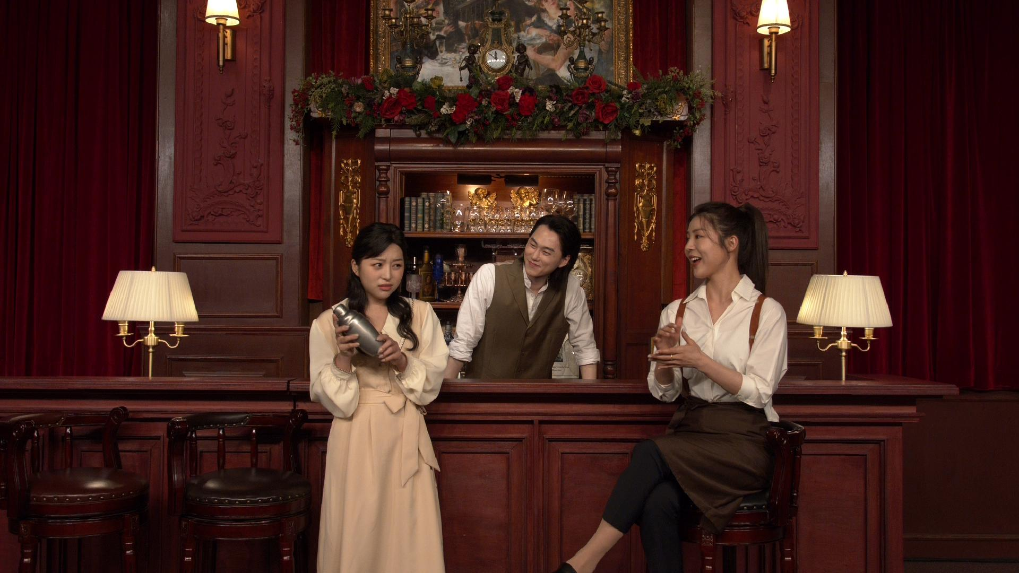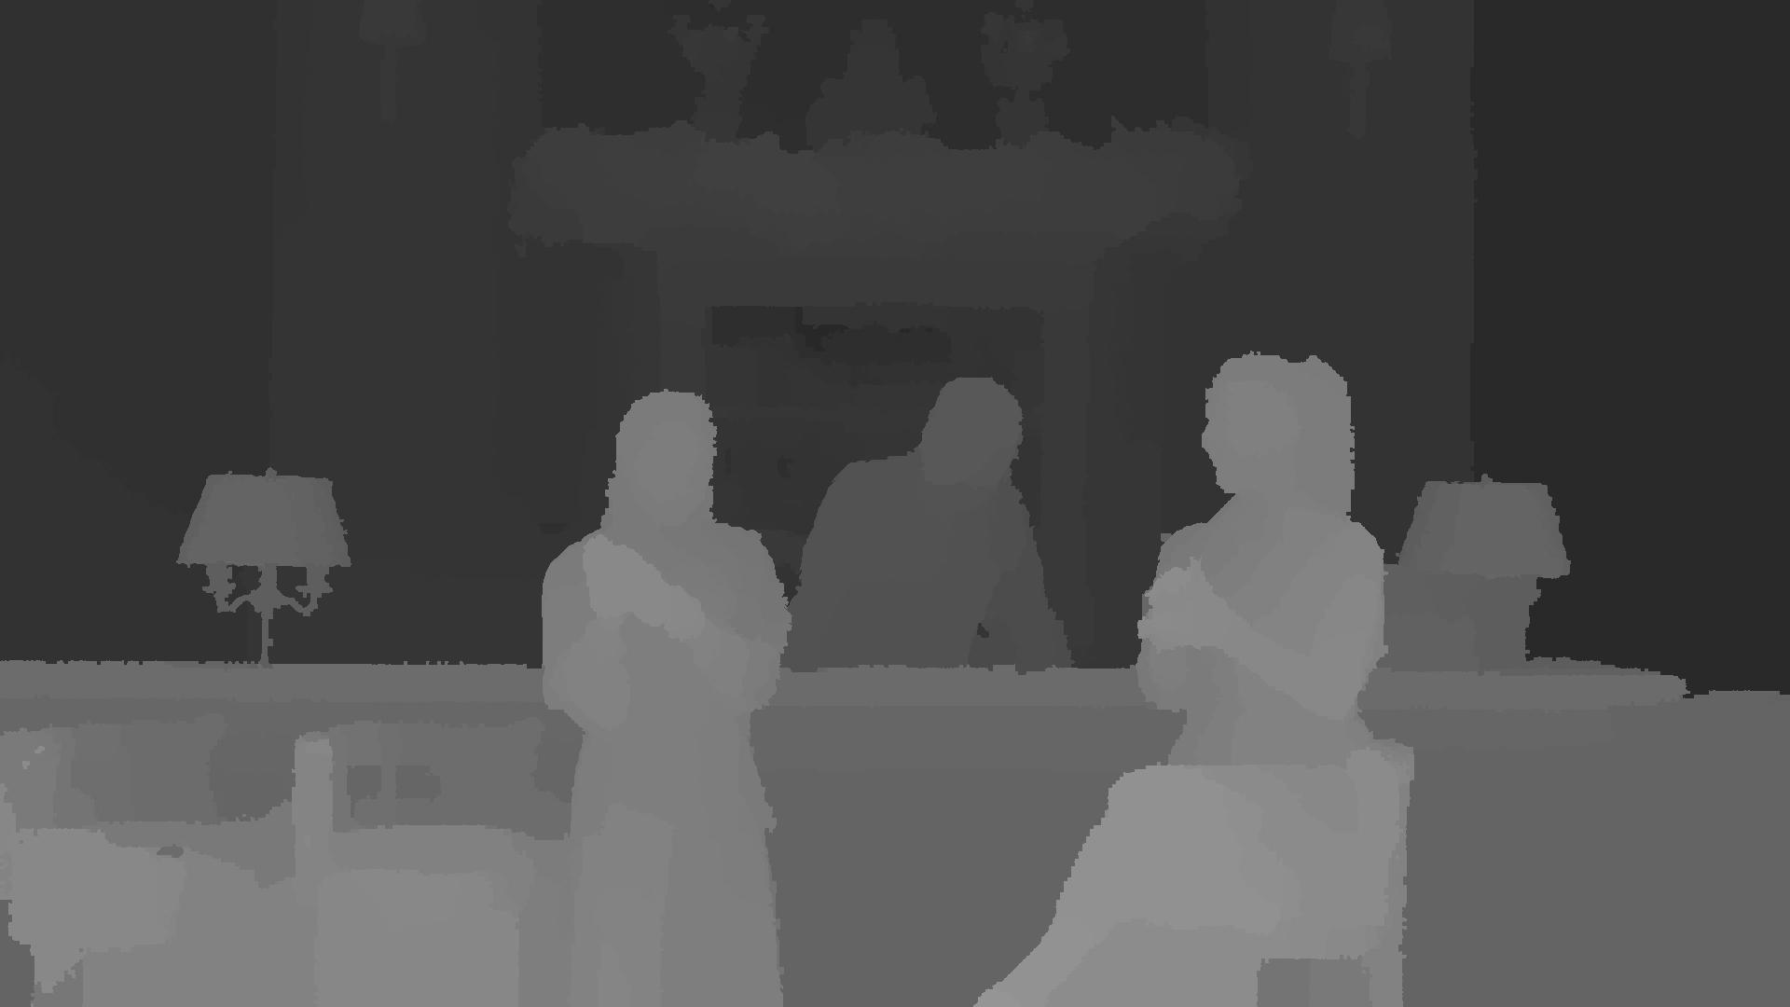
Figure 5.3.2: Bartender sequence (view 10, frame 0)

5.3.1.3 Test sequence DanceMoves
The DanceMoves sequence was captured by Philips on location in Veghel with the help of a professional production company, a self-built capture rig, and volunteer actors. The sequence has not been used for the development of any standard. It consists of 449 frames @ 15 Hz, and was captured using a linear rig of six Azure Kinect cameras. The total size of the rig is about 60 cm wide. Due to limitations with the capture system (a single laptop with USB 3 interface) the frame rate was limited to 15 fps.
As the depth maps of the Azure Kinect cameras were cropped compared to the texture frames, Philips has generated new depth maps using Immersive Video Depth Estimator (IVDE) 8.0 [5.3.3] by Pozań University of Technology. We have used the default parameters of the software, except that we disabled temporal enhancement. Each frame was estimated in parallel and the resulting YUV files were concatenated.
NOTE: Visual inspection of the depth maps shows that the quality of the depth maps is below that of Breakfast, and this has an impact on the evaluation.
Philips will provide the source material, copyright license and derived work on a Philips-managed OneDrive server, and participants of this study may request access based on their e-mail address, by sending an e-mail to the contact person: Bart Kroon <bart.kroon@philips.com>.
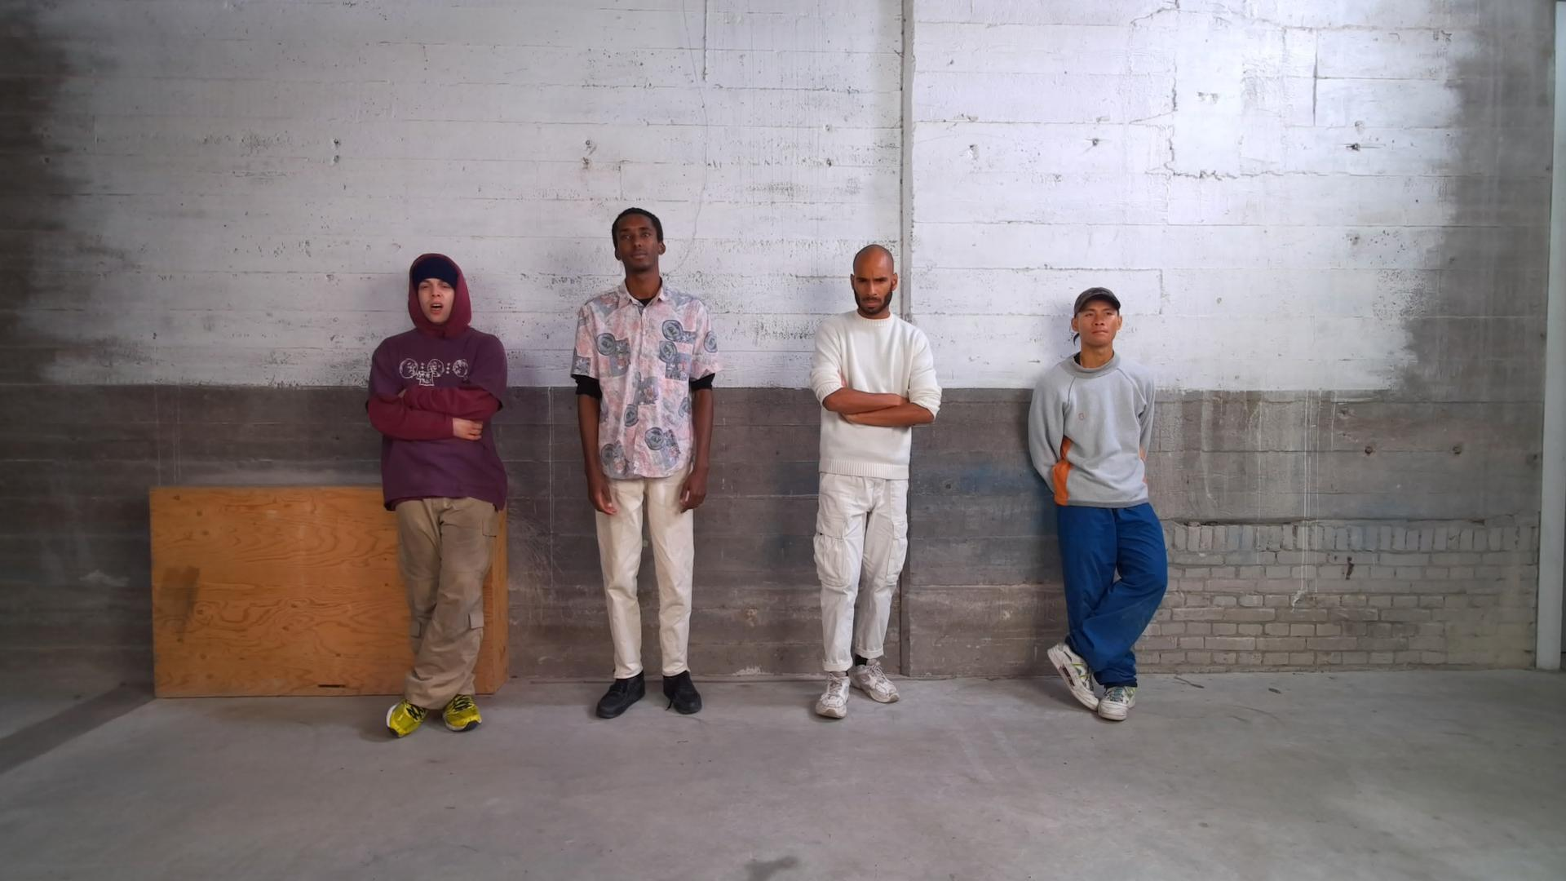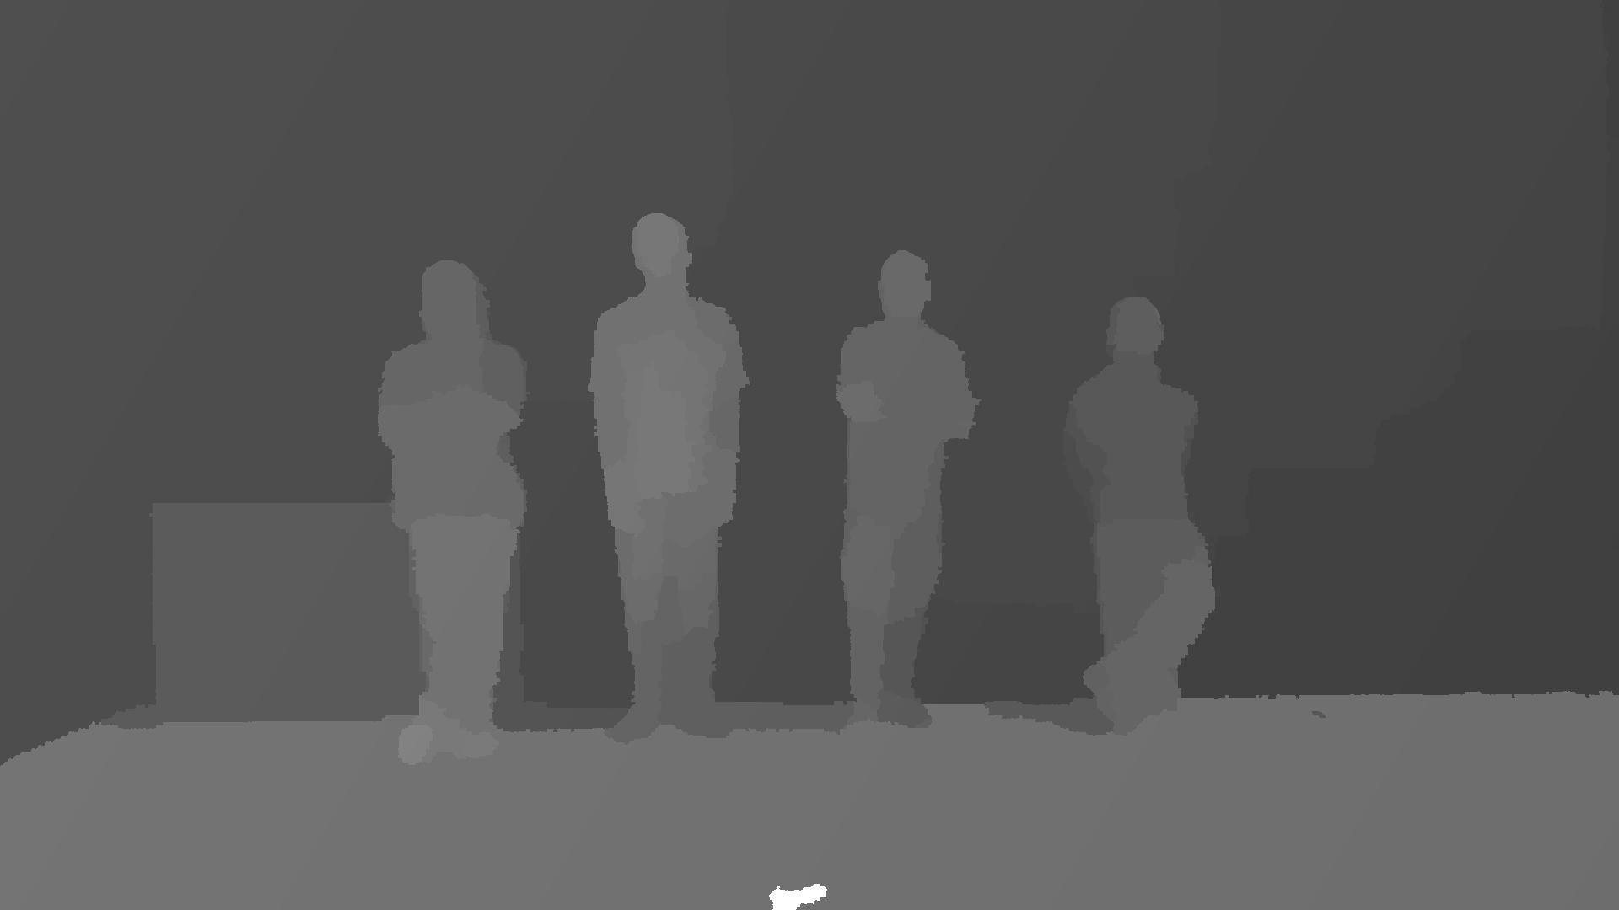
Figure 5.3.3: DanceMoves sequence (view 3, frame 0)

5.3.2 Software
The software that has been used for the evaluation of the scenario is listed in Table 5.3.2. All software has been built from source using Python 3.10, LLVM 18.1.8 with help of the install.py script of TMIV, as follows:
# environment with python, clang and clang++ on the path
git clone https://gitlab.com/mpeg-i-visual/tmiv.git
cd tmiv
python -m venv venv
. venv/bin/activate
python -m pip install --upgrade pip
pip install -r requirements.txt
scripts/install.py clang-release
Table 5.3.2: Software used for the evaluation of the scenario
Software | URL | Version
Test model for MPEG immersive video (TMIV) | https://gitlab.com/mpeg-i-visual/tmiv | 24.0
HEVC test model (HM) | https://vcgit.hhi.fraunhofer.de/jvet/HM | 18.0
Quality metrics for immersive video (QMIV) | https://gitlab.com/mpeg-i-visual/qmiv | 2.0

HM 18.0 and Kvazaar 2.3.1 have been compared in MPEG context for the coding of MIV video sub-bitstreams [XY2]. HM 18.0 was selected for this study because it has a better rate-distortion characteristic in general. However, because HM lacks support for delta QP maps, packed video support was disabled in TMIV.

5.3.3 Encoding of bitstreams
For this study, content was encoded using TMIV and HM. Encoding of MIV bitstreams using TMIV and HM involves three steps:
1. Run the TMIV encoder to output a raw YUV video file for each video sub-bitstream, and a partial MIV bitstream with patch parameters and video parameters. The main work of the TMIV encoder is to prune pixels, patch patches, and generate atlas frames.
2. Run HM TAppEncoder to encode each YUV file.
3. Run the TMIV multiplexer to combine the partial MIV bitstream and the coded video sub-bitstream into a full MIV bitstream (a V3C sample stream).
NOTE: While currently only MIV + HEVC has been tested, the scenario includes MV-HEVC and is open to the evaluation of other codecs.
All sequences have been encoded using the configurations in Table 5.3.3. The purpose of having multiple configurations is to illustrate the impact of pixel rate on rate-distortion characteristics. Because this is a new representation there is no anchor.
- The full views (FV) condition codes the texture and geometry video component of each view as a separate HEVC Main 10 video sub-bitstream. This condition gives the highest quality, but also the largest pixel rate and bit rate. It serves as an upperbound of what can be achieved with the current test sequences and software if pixel rate is not a concern. The MIV level depends on the input.
- The MPEG MIV main (A) condition is part of the MIV CTC anchor, defined in ISO/IEC JTC 1/SC 29/WG 04 N 0659. It results in two atlases, each with a texture and geometry component, thus resulting in four video sub-bitstreams. It causes TMIV to select a number of source views based on an available pixel budget. The resulting bitstreams have MIV level 3.5. Some source views are selected to be basic views and they are fully coded. Some other views are selected as semi-basic views and they are placed in full in the atlas, but then some patches can be placed on top. Finally there are additional views from which only patches are taken (Figure 5.3.4).
- The Synthesize center view (SCV) condition was designed for this study because the pixel rate of the MIV CTC may be too high for mobile devices. The atlas has a single synthesized center view plus patches of the source views. The aim of this condition is to provide a MIV level 2.5 result by lowering the pixel rate compared to the A condition (Figure 5.3.5).
Table 5.3.3: Encoder conditions
Condition | Profile | Level | Abbreviation | Directory name
Full views | HEVC Main 10 | - | FV | config/full_views
MIV main anchor | HEVC Main 10 MIV 2  (FDIS 23090-12:—) | 3.5 | A | config/miv_main_anchor
Synthesize center view | HEVC Main 10 MIV Extended  (23090-12:2023) | 2.5 | SCV | config/synthesize_center_view

Encoding was performed by running the encode.py script of TMIV with appropriate parameters. For all sequences the first 65 frames were encoded. It executes the TMIV Encoder, HM, and the TMIV Multiplexer with appropriate parameters. For example:
TMIV_DIR/bin/encode.py -i INPUT_DIR -o out -s D02 -n 65 \
-r RP0 -f 0 -v HM -j 4 -t TMIV_DIR \
--config-dir share/config \
-c config/synthesize_center_view/SCV_1_TMIV_encode.json \
-m config/synthesize_center_view/SCV_3_TMIV_mux.json \
-C share/config/hm/encoder_randomaccess_main10.cfg
The only substantial difference between the encoder conditions is the TMIV encoder configuration because the TMIV multiplexer configuration is trivial and the HM configuration is kept to the same random-access configuration for all conditions.
The rate point RP0 is a result without coding of the video sub-bitstreams that can be used to determine how much quality is lost by the pixel pruning prior to video coding. Rates RP1 .. RP4 correspond to the following QP values in Table 5.3.4. The same QP values are used for all sequences and all encoder conditions. The geometry QP is derived from the texture QP as done for the MIV CTC [XY1]. Hence, virtually no QP tuning has been performed at all.
Table 5.3.4: QP values for all sequences and encoder conditions
Rate point | Texture | Geometry
RP1 | 20 | 2
RP2 | 30 | 10
RP3 | 40 | 18
RP4 | 50 | 26

5.3.4 Results

5.3.4.1 Example atlas frames
The full views (FV) condition encodes each component of each view separately, e.g. resulting in 30 separate 1920 x 1080 videos for the Breakfast sequence. Figure 5.3.2 and Figure 5.3.3 provide examples of atlas frames for the MIV main anchor (A) and synthesize center view (SCV) conditions. A comparison of pixel rates is provided in Tabe 5.3.5. Note that the size of each atlas depends on the sequence and on the encoding condition. This is because TMIV calculates the atlas frame size based on a number of inputs.
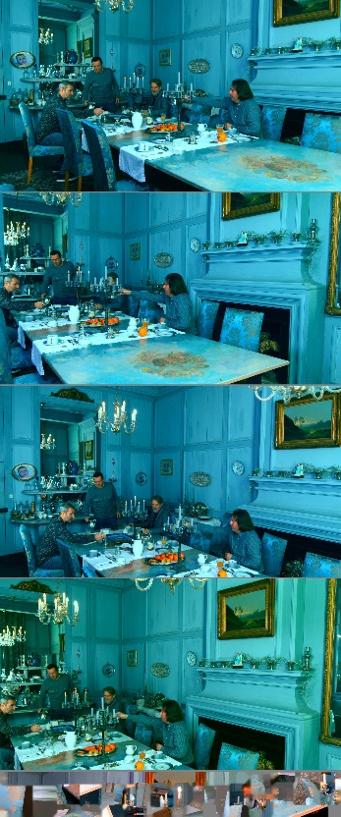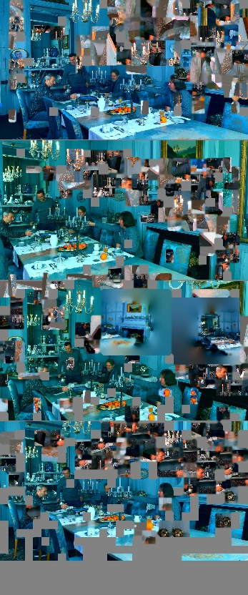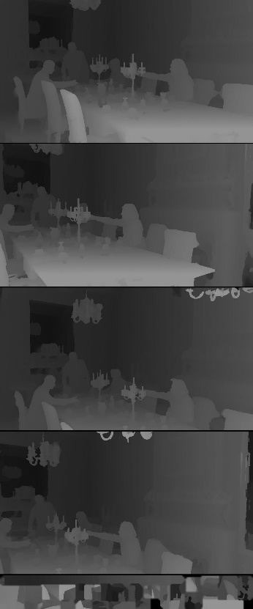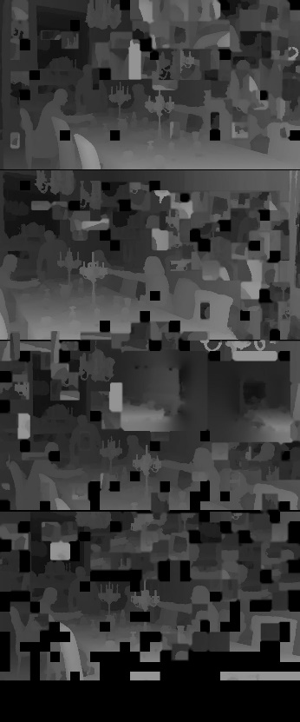
Figure 5.3.4: Video components of condition A with left to right: texture for atlas 0 and 1, geometry for atlas 0 and 1
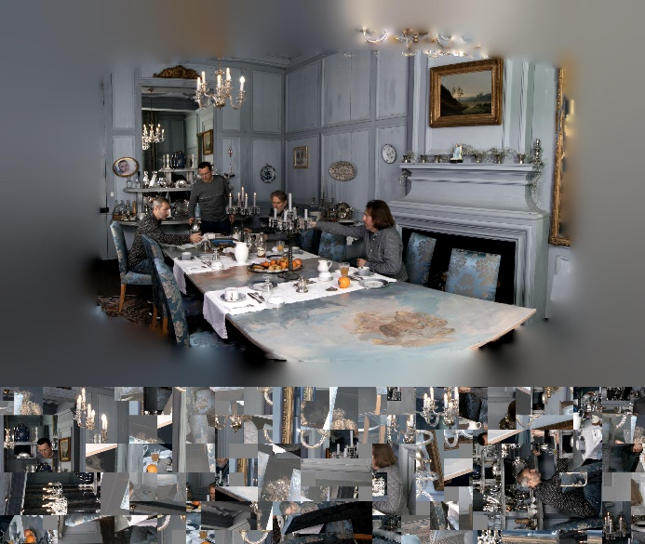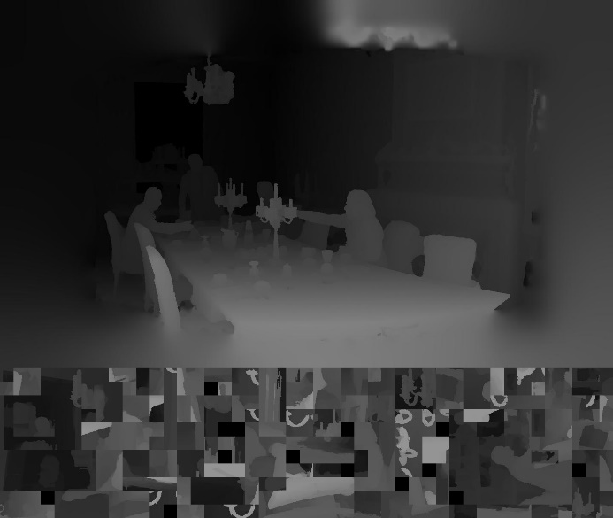
Figure 5.3.5: Video components of condition SCV with left texture and right geometry

5.3.4.2 Pixel rate and MIV levels
The pixel rates per video sub-bitstreams and the aggregate pixel rate are depicted in Table 5.3.5. The MIV level is based on the luma picture size and aggregate luma sample rate level limits as provided in ISO/IEC FDIS 23090-12:— Table A.7. Note that the MIV level for the FV condition is determined mainly by the aggregate luma sample rate because the luma picture size is only 1920 x 1080 but there are many video sub-bitstreams. Note that the coding of DanceMoves for condition A is inefficient because not all space in the atlases is used.
Table 5.3.5: Pixel rates for all sequences and conditions:
Condition | Sequence | Components | Sizes | Aggregate size  (# luma samples) | Aggregate luma  sample rate | MIV level
FV | Breakfast | 15 x texture  15 x depth | 1920 x 1080  1920 x 1080 | 62.2 M | 1.87 G/s | 3.0
FV | Bartender | 21 x texture  21 x depth | 1920 x 1080  1920 x 1080 | 87.1 M | 2.61 G/s | 3.5
FV | DanceMoves | 6 x texture  6 x depth | 1920 x 1080  1920 x 1080 | 24.9 M | 0.373 G/s | 2.0
A | Breakfast | 2 x texture  2 x geometry | 1920 x 4608  960 x 2304 | 22.1 M | 0.664 G/s | 2.5
A | Bartender | 2 x texture  2 x geometry | 1920 x 4608  960 x 2304 | 22.1 M | 0.664 G/s | 2.5
A | DanceMoves | 2 x texture  2 x geometry | 1920 x 4608  960 x 2304 | 22.1 M | 0.664 G/s | 2.5
SCV | Breakfast | 1 x texture  1 x geometry | 2880 x 2432  1440 x 1216 | 8.76 M | 0.263 G/s | 2.0
SCV | Bartender | 1 x texture  1 x geometry | 2944 x 2368  1472 x 1184 | 8.71 M | 0.261 G/s | 2.0
SCV | DanceMoves | 1 x texture  1 x geometry | 2048 x 3456  1024 x 1728 | 8.85 M | 0.133 G/s | 2.0

5.3.4.3 Rate-distortion characteristics

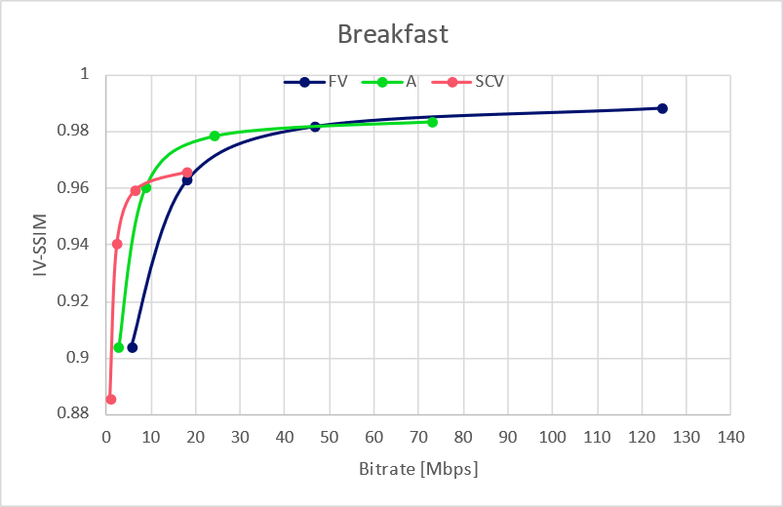
Figure 5.3.6: Rate distortion curves for Breakfast for all three coding conditions
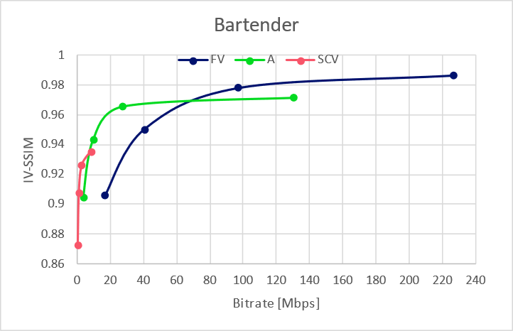
Figure 5.3.7: Rate distortion curves for Bartender for all three coding conditions
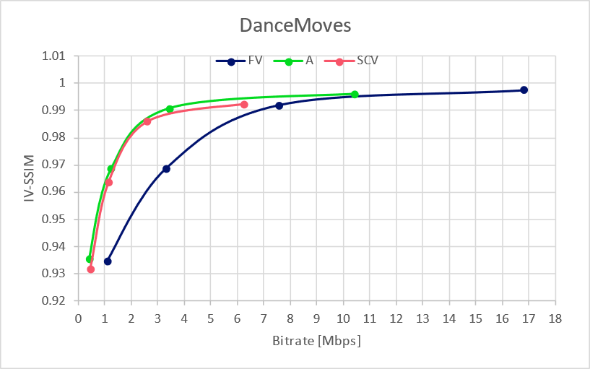
Figure 5.3.8: Rate distortion curves for DanceMoves for all three coding conditions

5.3.4.4 Pose trace videos
For each bitstream, that is for each sequence for each encoder condition and for each rate RP0 .. RP4, three pose trace videos have been rendered. A bitstream can be decoded and rendered using a command like this:
TMIV_DIR/bin/TmivDecoder -j 1 -n 32 -N 128 -s D02 -r RP3 -P p01 \
-c config/synthesize_center_view/SCV_4_TMIV_decode.json \
-p inputDirectory out -p outputDirectory out \
-p configDirectory share/config
The decoder configurations differ only in path formats: there is no out-of-band information for RP1 .. RP4.

5.3.4.5 Availability of test data
The source video data (texture and depth), camera parameters, pose trace definitions, bitstreams and pose trace videos are available. For Breakfast, the information is hosted by InterDigital. For Bartender and DanceMoves, the information is hosted by Philips. Access will be provided to participants on request.

6 Metrics
Table 3-1 summarizes the identified open issues on Metrics
Number | Issue | Responsible

7 Reference Sequences
The reference sequences for the anchor generation are provided below.
- Pink: reference sequences are missing
- Yellow: reference sequences are selected, but not yet frozen.
- Green: Reference Sequences are frozen
Scenario | Clause | Reference Sequences | Notes

8 Reference Software and Configurations Anchors
The configuration files for the anchor generation are provided below.
- Pink: configurations are missing
- Yellow: configurations are available, but not yet frozen. Comments still welcome
- Green: Configurations are frozen

Scenario | Clause | General constraints | Codec A configurations | Codec X configurations | Notes

9 Anchors and Metrics
- Pink: anchors definitions are missing
- Yellow: anchors defined, but open for comments
- Cyan: anchor definition frozen, but not yet produced
- Green: anchors available
Scenario | Clause | Codec A anchors | Codec X anchors | Notes

10 Verification Anchors
- Pink: verification missing
- Yellow: verification assigned to someone
- Green: verification done

Scenario | Clause | Codec A anchors | Codec X anchors | Notes

11 Reference Software and Configuration Tests
The configuration files for the anchor generation are provided below.
- Pink: configurations are missing
- Yellow: configurations are available, but not yet frozen. Comments still welcome
- Green: Configurations are frozen
Scenario | Clause | Codec A configurations | Codec B configurations | Codec X configurations | Notes

Table 8-1 summarizes the open issues on Configurations.
Number | Issue | Responsible

12 Tests
- Pink: test definitions are missing
- Yellow: tests defined, but open for comments
- Cyan: test definition frozen, but not yet produced
- Green: tests available

Scenario | Clause | Codec A Tests | Codec B Tests |  | Codec X Tests | Notes

Table 6-1 summarizes the open issues on Configurations.
Number | Issue | Responsible

13 Verification Tests
- Pink: verification missing
- Yellow: verification assigned to someone
- Green: verification done

Scenario | Clause | Code A Tests | Codec B Tests | Codec X Tests | Notes

14 Characterization
Table 11-1 summarizes the open issues on Characterization.

15 Software
see above actions that relate to the software.

16 Online Repository
CSV of all Files are provided here:
All reference sequences are documented.
Table 13-1 summarizes the open issues on Online Repository.
Number | Issue | Responsible

Other content issues are documented here:

17 References
[X1] "https://www.ibc.org/technical-papers/ibc2023-tech-papers-efficient-delivery-and-rendering-on-client-devices-via-mpeg-i-standards-for-emerging-volumetric-video-experiences/10277.article" By C. Guede, P. Fontaine, J. Mulard, B. Leroy, C. Quinquis, R. Gendrot, S. Gudumasu, V. Allié, B. Kroon, B. Sonneveldt, R. Schimanofsky, IBC 2023 Tech Papers
[X2] TR 26.928 Extended Reality (XR) in 5G
[X3] TR 26.998 Support of 5G glass-type Augmented Reality / Mixed Reality (AR/MR) devices
[X4] DVB Study Mission Report S101

[X5] ISO/IEC 23090-5 Visual Volumetric Video-based Coding (V3C) and Video-based Point Cloud Compression (V-PCC) – 2nd edition
[X6] ISO/IEC 23090-10 Carriage of visual volumetric video-based coding data – 1st edition
[X7] XD Productions, https://xdprod.com/
[X8] Volucap, https://volucap.com/
[X9] Volucap_T003_ThomasScenic-03 - Google Drive
[X10] Volucap_T097_Mitch2.1-05 - Google Drive
[X11] Free 3D People for Max, Maya, C4D & more | RENDERPEOPLE, https://renderpeople.com/free-3d-people/
[X12] Ultra Video Group – UVG-VPC Dataset, https://ultravideo.fi/UVG-VPC/index.html
[X13] UVG-VPC: Voxelized Point Cloud Dataset for Visual Volumetric Video-based Coding
[X14] Render people free 4D People sample: https://4dpeople.com/samples/
[X15] Render people 4D People catalogue: https://4dpeople.com/
[Y1] Wang, Y., Lu, Z., Cao, P. et al. How Live Streaming Changes Shopping Decisions in E-commerce: A Study of Live Streaming Commerce. Comput Supported Coop Work 31, 701–729 (2022). https://doi.org/10.1007/s10606-022-09439-2
[Y2] Coresight Research, “Inside the $50 billion shopping spree happening on livestreams.”, https://www.cnbc.com/video/2023/06/09/inside-the-50-billion-shopping-spree-happening-on-livestreams.html
[Y3] 3GPP TR 26.955: “5G Video Codec Characteristics”
[Y4] 3GPP TS 26.511: “5G Media Streaming (5GMS); Profiles, codecs and formats”
[Y5] 3GPP TS 26.116: “Television (TV) over 3GPP services; Video profiles”
[Y6] 3GPP TS 26.118: “3GPP Virtual reality profiles for streaming applications”
[Y7] Bao, W., Wang, W., Xu, Y. et al. InStereo2K: a large real dataset for stereo matching in indoor scenes. Sci. China Inf. Sci. 63, 212101 (2020). https://doi.org/10.1007/s11432-019-2803-x
[Y8] T. Schöps, J. L. Schönberger, S. Galliani, T. Sattler, K. Schindler, M. Pollefeys, A. Geiger, "A Multi-View Stereo Benchmark with High-Resolution Images and Multi-Camera Videos", Conference on Computer Vision and Pattern Recognition (CVPR), 2017.
[Y9] D. Scharstein, H. Hirschmüller, Y. Kitajima, G. Krathwohl, N. Nesic, X. Wang, and P. Westling. High-resolution stereo datasets with subpixel-accurate ground truth. In German Conference on Pattern Recognition (GCPR 2014), Münster, Germany, September 2014.
[Y10] Xie, J., Girshick, R., Farhadi, A. (2016). Deep3D: Fully Automatic 2D-to-3D Video Conversion with Deep Convolutional Neural Networks. In: Leibe, B., Matas, J., Sebe, N., Welling, M. (eds) Computer Vision – ECCV 2016. ECCV 2016. Lecture Notes in Computer Science(), vol 9908. Springer, Cham. https://doi.org/10.1007/978-3-319-46493-0_51
[A1] A. Dziembowski, D. Mieloch, J. Stankowski and A. Grzelka, "IV-PSNR – the objective quality metric for immersive video applications," in IEEE Transactions on Circuits and Systems for Video Technology, doi: 10.1109/TCSVT.2022.3179575, software: https://gitlab.com/mpeg-i-visual/ivpsnr.
[A2] Test model for MPEG immersive video, https://gitlab.com/mpeg-i-visual/tmiv.
[A3] Reference view synthesizer (RVS), https://gitlab.com/mpeg-i-visual/tmiv.
[A4] L. Jin, A. Boev, A. Gotchev, K. Egiazarian, “3D-DCT based perceptual quality assessment of stereo video,” 18th International Conference on Image Processing, ICIP, 2011.
[A5] ITU-T SG 16 WP 3 and ISO/IEC JTC 1/SC 29/WG 11 - JCT3V-C0032: A human visual system based 3D video quality metric
[A6] Recommendation ITU-R BT.500-11, “Methodology for the subjective assessment of the quality of the television pictures”.
[A7] A. Banitalebi-Dehkordi, Mahsa T. Pourazad, P. Nasiopoulos, “A human visual system based 3D video quality metric,” 2nd International Conference on 3D Imaging, IC3D, Dec. 2012, Liege, Belgium.
[A8] ITU-R Recommendation BT.2021, “Subjective methods for the assessment of stereoscopic 3DTV systems,” Aug. 2012.
[R1] 3GPP TR 26.928: “Extended Reality (XR) in 5G”.
[R2] 3GPP TR 26.998: “Support of 5G glass-type Augmented Reality / Mixed Reality (AR/MR) devices”.
[R4] ISO/IEC 23090-10:2022 (Amd1), “Information Technology — Coded Representation of Immersive media — Part 10: Carriage of Visual Volumetric Video-Based Coding Data”
[R5] Guede et al., IBC 2023, “Efficient Delivery and Rendering on Client Devices via MPEG-I Standards for Emerging Volumetric Video Experiences”. https://www.ibc.org/technical-papers/ibc2023-tech-papers-efficient-delivery-and-rendering-on-client-devices-via-mpeg-i-standards-for-emerging-volumetric-video-experiences/10277.article
[R6] Dziembowski, B. Kroon, J. Jung (Eds.), Common test conditions for MPEG immersive video, ISO/IEC JTC 1/SC 29/WG 04 N 0372, July 2023, Geneva.
[R7] D. Mieloch (Ed.), Verification test report of MPEG immersive video, ISO/IEC JTC 1/SC 29/WG 04 N 0341, April 2023, Antalya.
[XY1] Common test conditions for MPEG immersive video, ISO/IEC JTC 1/SC 29/WG 04/N 659, April 2025, url: https://www.mpeg.org/wp-content/uploads/mpeg_meetings/150_OnLine/w25084.zip, Online.
[XY2] Encoder guidelines for MPEG immersive video, ISO/IEC JTC 1/SC 29/WG 04/N 660, April 2025, url: https://www.mpeg.org/wp-content/uploads/mpeg_meetings/150_OnLine/w25085.zip, Online.

Images were copied from S4-240831
https://datatracker.ietf.org/doc/draft-ietf-avtcore-rtp-v3c/
To be pulished soon. A zip-file can be provided to non-MPEG members on request.

