**3GPP TSG-SA WG4 Meeting #132S4-250860rev1(1071)**

**Fukuoka, Japan, 19 – 23 May 2025**

**Source: Tencent**

**Title: [FS_ARSpatial] pCR on Call flow for spatial computing**

**Agenda item: 9.8**

**Document for: Agreement**

**1. Introduction**

The present contribution proposes to clarify the negotiation responsibilities when establishing a spatial computing session.

Currently, section 7.3 indicates the following:

* Media Application Function (Media AF): This function is responsible for the negotiation of the spatial computing service session between the Media AS and the Media Client.

However, this is not a correct description of the Media AF functionality. Based on its interaction with the Media Session Handler via M5, the Media AF may communicate with the 5G Core for the purpose of QoS allocation. The Media AF can also provide QoS flow information to the Media AS via M3. However, the responsibility for session negotiation is not within its scope; rather, this negotiation occurs between the Media AS and the Media Access Function via M4.

Further, the call flow in clause 7.4 indicates in step 1 and 2:

1. The Media Client discovers Media AS and sets up a connection to it. It provides information about the spatial computing capabilities of the UE to configure the Spatial Computing Functions in the Media AS.

2. In response to step 1, the Media AS creates and transmits a description of the XR Spatial Description format, the configuration data and the input it expects to receive from the Spatial Computing Client to the Media Client.

This call flow currently does not include the Media AF and Media Session Handler. It is proposed to include those and include the Media Session Handler for control plane communications and Media Access Function to support the spatial computing functions as described in clause 7.3.

The following call flow is meant to fix this inconsistency.

**2. Proposal**

It is proposed to agree the following changes to the 3GPP draft TR 26.819 v0.4.0

* * * First Change * * *

## 7.3 General Architecture for Spatial Computing

Figure 7.3-1 – Spatial computing architecture.

[Editor’s Note: Whether the SCC should be an independent entity outside the MAF is to be further studied.]

The architecture includes the following network functions and UE entities:

* Media Application Provider: Offers the spatial computing service.
* Media Application Function (Media AF): This function is responsible for QoS allocation in the 5G Core and providing service configuration information to the Media AS and Media Session Handler.
* Media Application Server (Media AS): This function is responsible for establishing the spatial computing session with the Media Client and monitoring the server’s edge resource usage. It hosts a Spatial Computing Function which can manage and run the spatial computing functions.
* Media-aware Application: The application running on the UE that makes use of 3GPP-defined APIs to invoke the Media Session Handler and/or the Media Access Function.
* Media Session Handler (MSH): This entity on the UE is responsible for the control plane signalling with the Media AF to establish a spatial computing session.
* Spatial Computing Client (SCC): This function is responsible for discovering the UE Spatial computing capabilities and negotiating with the Media AS to agree on the spatial computing session.
* Media Access Function: This function is as defined in TS 26.506 with the capabilities to send sensor data and receive XR Spatial Descriptions from the Media AS.
* Scene Manager: a set of functions that supports the application in arranging the logical and spatial representation of a multisensorial scene based on support from the XR Runtime. The Scene Manager composes the scene using the XR Spatial Description data.
* XR Source Management: management of data sources provided through the XR runtime. It retrieves the sensor data from the XR Runtime and provides them to the Media Access Function.
* XR Runtime: Set of functions provided by the XR Device to the Media Application to create XR experiences. It may include some spatial computing functions.

The relevant interfaces shown in Figure 7.3-1 are:

* M1: The Media Application Provider provisions the spatial computing service through M-1.
* M4: The signaling as well as the data delivery between Media Access Function and Media AS is though M-4.
* M5: The Media Session Handler (MSH) and the Media AF (Application Function) may exchange spatial computing configuration related information through the M-5 interface.
* M7: The Spatial Computing Client discovers the UE spatial computing capabilities through the M-7 interface.
* M11: This interface may be used to convey QoS allocation and QoE information related to spatial computing functions between the Media MSH and the Media Access Function.

* * * Second Change * * *

## 7.4 Call flow for spatial computing session setup and operation

The spatial computing operation can be described by the call flow in Figure 7.4.1.

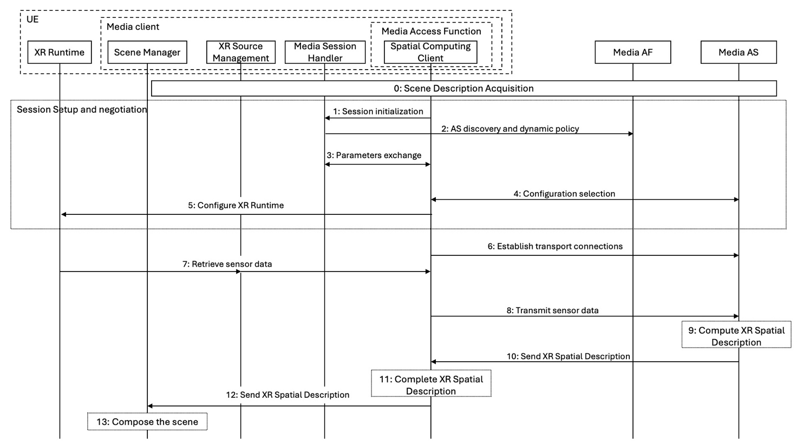

Figure 7.4.1 - High-level call flow for spatial computing session setup and operation.

The steps are:

0. The Scene Manager acquires the scene description information and discovers the needed spatial computing functions for the XR experience.

1. The Media-aware Application initiates a session by configuring the Media Access Function at reference point M7.

2. The Media Session Handler communicates with the Media AF for the discovery of the AS (in the case of edge computing) and the configuration of quality-of-service parameters.

3. The Media Session Handler passes the information configured in step 2 to the Media Access Function via the interfaces M6/M11.

4. The Spatial Computing Client inside Media Access Function establishes the session with the Media AS.

5. The XR runtime is configured. This configuration aims to provide sensor data needed for the Spatial Computing functions configured in the Media AS in step 1.

6. The Spatial Computing Client requests the instantiation of pipelines for XR Spatial Description from the Media Access Function, which in turn establishes a connection to the Media AS.

7. The Source Manager retrieves sensor data from the XR runtime and provides them to the Media Access Function.

8. The Media Access Function sends sensor data to the Media AS.

9. The Media AS uses that data to invoke the spatial computing functions and compute the XR Spatial Description.

10. The Media AS transmits the generated XR Spatial Description to the Media Access Function.

11. Spatial Computing Client may complete XR Spatial Description using local sensor data.

12. Spatial Computing Client provides the XR Spatial Description to the Scene Manager.

13. The Scene Manager composes the scene using the XR Spatial Description.

* * * Second Change * * *

* * * End of Changes * * *