**3GPP TSG-SA WG4 Meeting #131S4-250193r02**

**Geneva, Switzerland, 17 – 21 February 2025**

**Source: InterDigital Canada**

**Title: [FS_ARSpatial] Pseudo-CR on Architecture Mapping**

**Spec: 3GPP TR 26.819**

**Agenda item: 9.9**

**Document for: Agreement**

**1. Introduction**

The Study on Spatial Computing for AR Services (FS_ARSpatial) was approved during SA#104 meeting. The objectives of the study include identifying where spatial computing functions run and which media, metadata, and description formats are used for exchange between these elements based on the architecture defined in the TS 26.506, notably in split processing scenarios.

This document provides a mapping of spatial computing functions to the general Media Delivery architecture in TS 26.506.

**2. Reason for Change**

The mapping of network functions related to spatial computing into the general Media Delivery architecture in order to support spatial computing service.

**3. Proposal**

It is proposed to agree the following changes to 3GPP TR 26.819.

* * * First Change * * * *

## 7.1 Introduction

Using the Reference Architecture for Media Delivery defined in clause 4.1.2.2 of TS 26.506 [TS26506] as a reference architecture, it is also possible to directly map specific spatial computing functions into the generalized functions in order to support spatial computing services. Spatial Computing Functions are located in the Media AS and in the XR Runtime. These functions deliver XR Spatial Description data.

* * * Next Change * * * *

## 7.3 General Architecture for Spatial Computing

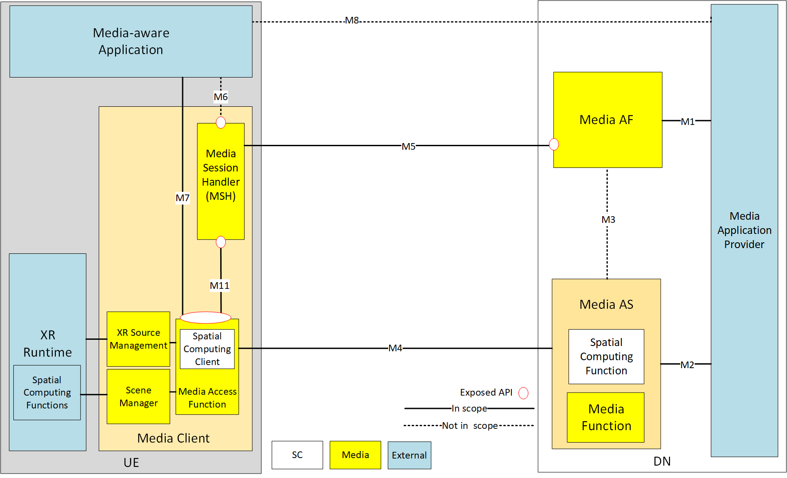

Figure 7.3-1 – Spatial computing architecture.

[Editor’s Note: Whether the SCC should be an independent entity outside the MAF is to be further studied.]

The architecture includes the following network functions and UE entities:

- Media Application Provider: Offers the spatial computing service.

- Media Application Function (Media AF): This function is responsible for the negotiation of the spatial computing service session between the Media AS and the Media Client.

- Media Application Server (Media AS): This function is responsible for establishing the spatial computing session with the Media Client and monitoring the server’s edge resource usage. It hosts a Spatial Computing Function which can manage and run the spatial computing functions.

- Media-aware Application: The application running on UE.

- Media Session Handler (MSH): This entity on the UE is responsible for the control plane signalling with the Media AF to establish a spatial computing session.

- Spatial Computing Client (SCC): This function is responsible for discovering the UE Spatial computing capabilities and negotiating with the Media AS to agree on the spatial computing process.

- Media Access Function: This function is as defined in TS 26.506 with the capabilities to send sensor data and receive XR Spatial Descriptions from the Media AS.

- Scene Manager: a set of functions that supports the application in arranging the logical and spatial representation of a multisensorial scene based on support from the XR Runtime. The Scene Manager composes the scene using the XR Spatial Description data.

- XR Source Management: management of data sources provided through the XR runtime. It retrieves the sensor data from the XR Runtime and provides them to the Media Access Function.

- XR Runtime: Set of functions provided by the XR Device to the Media Application to create XR experiences. It may include some spatial computing functions.

The relevant interfaces shown in Figure 7.3-1 are:

* M1: The Media Application Provider provisions the spatial computing service through M-1.
* M4: The signaling as well as the data delivery between Media Access Function and Media AS is though M-4.
* M5: The Media Session Handler (MSH) and the Media AF (Application Function) may exchange spatial computing configuration related information through the M-5 interface.
* M7: The Spatial Computing Client discovers the UE spatial computing capabilities through the M-7 interface.
* M11: This interface may be used to convey QoS allocation and QoE information related to spatial computing functions between the Media MSH and the Media Access Function.

* * * End of Changes * * * *