3GPP TSG SA WG4 Meeting #131 TDoc S4-250391
Geneva, 17 Feb. 2025 – 21 Feb. 2025
Title: LS on 3GPP and MPEG meeting planning
Response to: -
Release: n/a
Work Item: n/a

Source: 3GPP SA4
To: ISO/IEC JTC1 SC29 AG2 (MPEG Technical coordination)
Cc:

Contact person: Mary-Luc Champel
champelmaryluc@xiaomi.com

Send any reply LS to: 3GPP Liaisons Coordinator, mailto:3GPPLiaison@etsi.org

Attachments:

Overall description:
3GPP SA4 would like to coordinate with you on the matter of meeting planning for the upcoming two years. 3GPP SA4 schedule their meetings in advance, based on the Working Group requirements, main regional holidays, 3GPP working procedures, other 3GPP WGs, TSGs, hosts and Organizational Partners, and other standard group meetings. Many of the 3GPP SA4 delegates are also MPEG delegates, and it is a general requirement to avoid overlapping meeting dates between our two groups. We also like to consider geographical impacts. For example, back-to-back face-to-face meetings on two different continents are quite challenging.
SA4 have now planned their meetings (5 per year) for year 2025 and 2026. Based on our requirements, SA4 schedule is defined as follows:
SA4 calendar - 2025
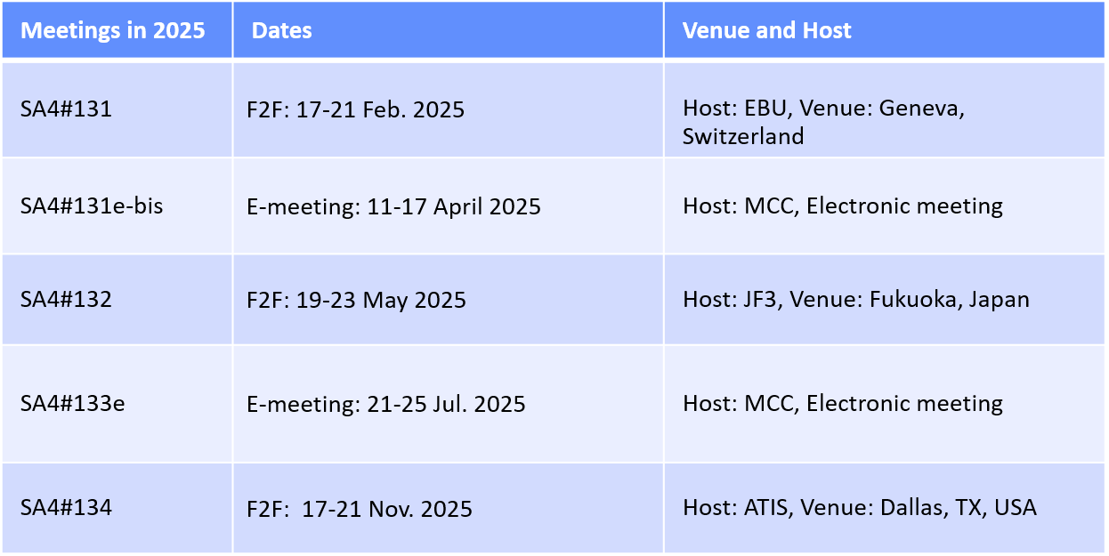
SA4 calendar - 2026
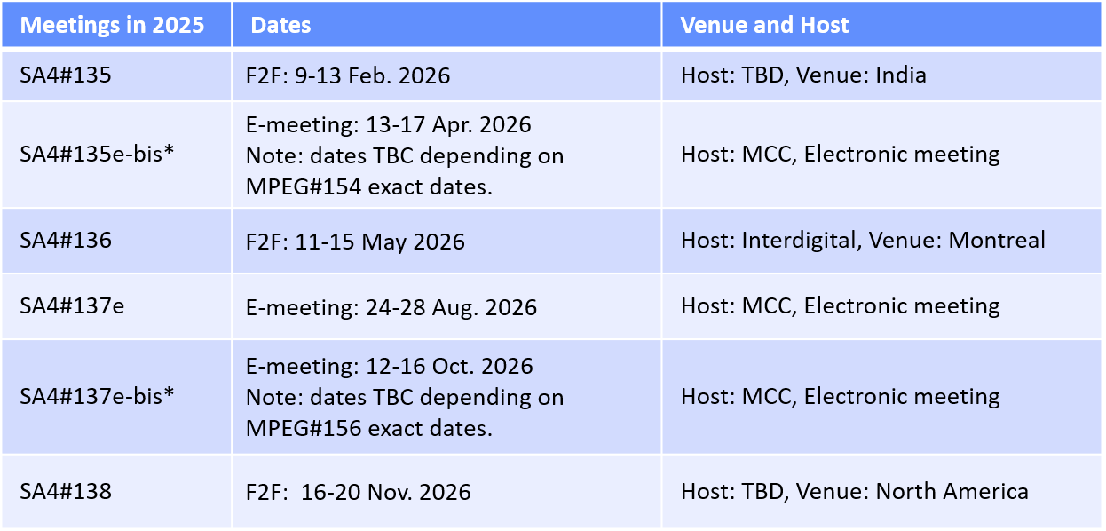
* Only one of April or October bis meeting is expected to be needed.
We understand that MPEG meetings are currently planned as follows (based on SC29/AG02/N0128, from your January 2025 meeting):
# | City | Country | Start | End
150 | Online |  | 2025-03-31 | 2025-04-04
151 | Daejeon | KR | 2025-06-30 | 2025-07-04
152 | Geneva (CICG) with SG 21 | CH | 2025-10-06 | 2025-10-10
153 | Online |  | 2026-01-19 | 2026-01-23
154 | Santa Eularia | ES | 2026-04-27 | 2026-05-01
155 | Geneva with SG21 | CH | 2026-07-13 | 2026-07-17
156 | Hangzhou | CN | 2026-10-19 | 2026-10-23

SA4 would like to thank ISO/IEC JTC 1/SC29/AG2 for providing their calendars and suggest that we keep on regularly exchanging our updated calendars so that planning can be done carefully to avoid overlaps and back-to-back meeting dates.
- Actions:
To ISO/IEC JTC 1/SC29/AG2 (MPEG Technical coordination).
ACTION: SA4 respectfully asks AG2 to:
- Inform SA4 about relevant MPEG calendar updates (SA4 will inform AG2, about relevant calendar updates).
- Take into account updated SA4 meeting dates and locations, and plan their MPEG meetings to avoid overlapping and back-to-back meeting dates; (SA4 will continue to take into account MPEG meeting dates and locations when planning meetings).

- Dates of next 3GPP TSG SA WG 4 meetings:

SA4#131e-bis 11th – 17th April 2025 Online
SA4#132 19th – 23rd May 2025 Fukuoka (Japan)
SA4#133e 21st – 25th July 2025 Online
SA4#134 17th – 21st November 2025 Dallas (USA)

