3GPP TSG SA WG4 Meeting 131-bis-e S4-250473r01

online, , 11th Apr 2025 – 17th Apr 2025 revision of S4aV250027

Source: Qualcomm Germany, Tencent, Apple, Xiaomi
Title: [VOPS] Proposed Way Forward on Conformance
Agenda item: 9.5
Document for: Discussion

1. Introduction
Value for implementors and usability of 3GPP spec is likely only created if implementors can use the specification and get examples, conformance bitstreams and so on. You may also check our arguments document S4-250143 about reference software and so on.
Specifically, for VOPS and in the context of TS 26.265 it should be in everyone’s interest to define well-defined set of conformance bitstreams. This may be done for existing codecs on a best effort basis, but the largest benefit would be for new codecs, such as MVHEVC for now.
What could be considered are bitstreams and associated metadata for systems integration, for example the codecs parameter, random access points and so on. A consistent data structure and storage would be quite useful. We can build on experience in JVET and also in the TR 26.955. https://dash-large-files.akamaized.net/WAVE/3GPP/5GVideo/Bitstreams/
But we need more, namely original content that can be used by implementors. We may consider using the test content in CTA WAVE, but we have no stereo at this stage. Attached is a slide set that provides an idea around the CTA WAVE test framework.
For CTA WAVE, we have a workflow for text content generation – this would be beneficial as well as it helps implementors to get example streams. Then the workflow for HEVC here can be reused: https://github.com/cta-wave/Test-Content-Generation.
This work could be added to the current VOPS work item, or we may create another phase (which could run until December 2025, arguing that this is conformance work in Rel-19).
Note that the work is not considered to address optimized encoding, bitrates and so on, so not characterization right now. It is considered to help implementors.
2. What would be needed
Here is a list of components that may be needed:
- Hosting environment for example conforming bitstreams and possibly raw sequences.
- Database reflecting the relationship between example conforming bitstreams, 3GPP SA4 service requirements and 3GPP SA4 device capabilities.
- Raw video sequences that follow the requirements of a representation format, together with all metadata. The annotation format in TR 26.955 may be used as a baseline.
- Encoding tools and instructions for each operation point. The CTA WAVE content generation workflow or the the one used for TR 26.955 may be candidates.
- Bitstream validation tools for 3GPP delegates to validate example conforming bitstreams and for implementors to validate their implementation.
- Storage formats of the encoding bitstream including all metadata. The format used for TR 26.955 may be candidates.
- Guidelines and instructions for implementors on how to use the material.
3. Discussion at Last Meeting
S4aV250018 | [VOPS] Discussion on Conformance | Qualcomm Germany | Thomas Stockhammer
Online Discussion: (March 4 2025)
- Emmanuel: Generally, we are supporting this idea. But 2 points. The bullet list is bitstream centric. On our side, we would prefer to be UE centric. About the conformance, do you want sample contents or do all tests which could be complex.
  - Thomas: Being device centric is very complex. I don’t recommend this as a 1st step.
  - Thomas: On conformance coverage, I believe we want to do full coverage.
- Waqar: For VOPS, sample content could be more suitable. Having 100% conformant content, it is very difficult. We need to scope it.
  - Alexis (via chat): Content provided should conform 100%. I think the point is getting full coverage of all possible cases would be hard.
  - Gilles: My understanding is we don’t want to test all options. Having only some test streams showing capabilities is interesting.
- Rufael: What is the relationship with CTA WAVE?
  - Thomas: CTA WAVE is not working on MV-HEVC. It could be a collaboration effort. They have HEVC contents, why would we redo it?
  - Rufael: If it is possible to use their tools, this is fine.
  - Thomas: Their tools are open source. And it helps to understand how the content has been produced.
- Gilles: I see some support going into this direction. Should we wait for the full completion of VOPS operating points and create a new WI?
  - Thomas: The goal is to check interest, “when” will be discussed later.
  - Waqar: If there is something small, we could add it to the current WI.
Decision: No concern on this proposed effort. How it is implemented is TBD (VOPS completion date extended or new WI). Noted.
S4aV250018 is noted.
4. Offline since then
Usage of a database
Assuming we would build a “database” of sample bitstreams conforming to VOPS :
- VOPS is merely a starting point. The repo could collect all SA4 media capabilities (yes why not audio too?) and this way become even more relevant for the outside world.
  - This should be our “stage-4” work, similar to OpenAPI or ASN.1. Audio does have this already to some extent, they have conformance bitstreams.
  - A central place for SA4 would be good, even if we just link to the audio conformance bitstream hosted somewhere else.
- For implementers, it would be convenient to have an entry point into this database via UE requirements and, e.g. MeCAR device type 1 -> cap 1, cap 2, etc., and via service requirement, e.g. SR_MSE SRC 2D pixel profile -> cap x, cap y, etc..
  - Automating this is a great idea. May not have to be done in 3GPP though, it could be vendors developing tests or could also be 5G-MAG and so on.
- I am not sure how much work it would be but having a bitstream validator to check if a bitstream conforms to cap XYZ would also be interesting.
  - We should have “some” sort of credibility process that the content is correct. This could be done by inspection of multiple companies. Validators even better. We do have those for DASH conformance as well as for CTA WAVE, but not on elementary stream level.
- For test content, I am not sure we want to follow the CTA Wave test signals approach, at least not exclusively. I am not even sure how they would extend their setup for stereo content for example. But good looking content, around one minute long and reflecting video consumption on mobile today would make the repo appealing compared to other test content repos like JVET’s, BBB, etc...
  - CTA WAVE is an example to show that the content should speak to implementors to validate the requirements of the spec (on playback).
MV-HEVC Test Content
Regarding test content, I think almost any stereo content could work since its going to be used for generating conformance stream (and not for visual quality testing). We don’t have to be as particular about uncompressed content quality as we were during the 5G_VIDEO characterization study.
Existing Source Content see S4-231297
As a part of subjective video quality assessment investigations published at [1], RMIT uncompressed stereoscopic 3D video content [2] is made available for download at ftp site [3] and peer folders and can be used to for example generate MV-HEVC conformance streams.
The database is made freely available online via the Creative Commons Attribution-ShareAlike License [2], and hence is suitable for 3GPP SA4 purposes.
The dataset is composed of 31 sequences, 1920 x 1080, 10-bit 4:2:2 YUV at 25 fps [2]. A screen shot of some of the content is provided in the following from [2].
1] Urvoy, Matthieu, Marcus Barkowsky, Romain Cousseau, Yao Koudota, Vincent Ricorde, Patrick Le Callet, Jesus Gutierrez, and Narciso Garcia. "NAMA3DS1-COSPAD1: Subjective video quality assessment database on coding conditions introducing freely available high quality 3D stereoscopic sequences." In 2012 Fourth International Workshop on Quality of Multimedia Experience, pp. 109-114. IEEE, 2012.
[2] "RMIT uncompressed stereoscopic 3D HD video library," https://qualinet.github.io/databases/video/rmit_uncompressed_stereoscopic_3d_hd_video_library/
[3] FTP access: ftp://ftp.ivc.polytech.univ-nantes.fr/NAMA3DS1_COSPAD1

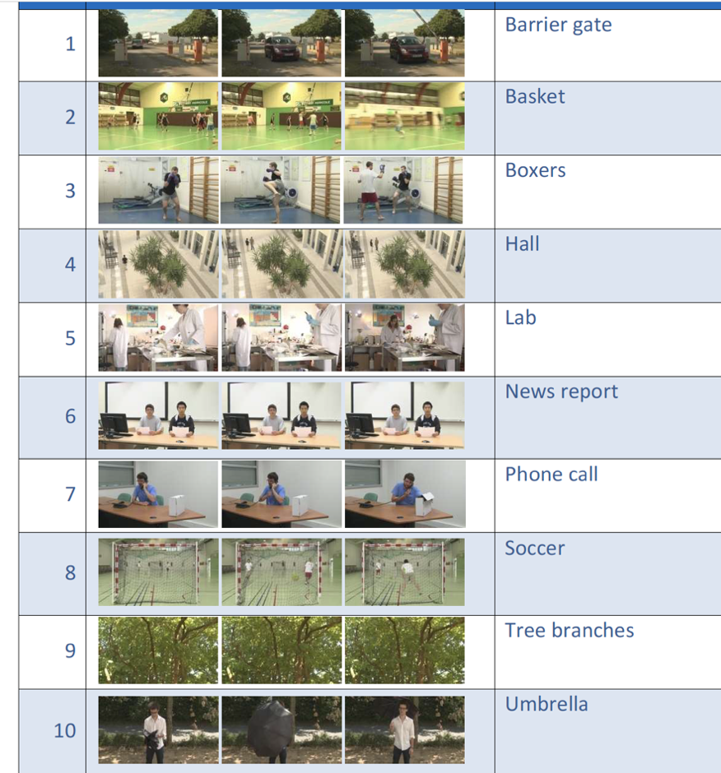
Existing HLS Content
HLS samples: https://developer.apple.com/streaming/examples/
S4aV250027 | [VOPS] Proposed Way Forward on Conformance | Qualcomm Germany | Thomas Stockhammer
Online Discussion: (March 18, 2025)
- Emmanuel: This is valuable work, we are supportive and will contribute.
- Alexis: What conformance means in this context? It can be a lot of work.
  - Thomas: I haven’t considered it yet. I don’t want something unmanageable. We probably need to focus on something specific with this timeline.
  - Alexis: I agree this is valuable but we have to provide some guidelines explaining what should be done with the bitstream.
Decision: Agreement in principle on how to generate conformance streams. But more discussions are needed. A revision will be provided.
S4aV250027 is noted.
Offline meanwhile
Apple indicated that they would support on creating conformance content, particularly on MV-HEVC
Comments and feedback during SA4#131-bis-e
Waqar Zia on Mon, 14 Apr 2025 09:24:36 +0200
Used revision as baseline
Also indicated that a submission would be carried out for SA4#132 Updated proposal.

Rufael Mekuria on Mon, 14 Apr 2025 09:25:31 +0000
Hi, we are generally supportive, but conformance work has risks especially streams need to be crosschecked and software tools need to be developed which can take a lot of time and resources.
It would be good if my earlier comment clarifying the relation with CTA WAVE is clarified in the document before moving forward on this, I understand the tools are open source but it doesn't mean we can just fork it and use it. My preference would be if we can convince CTA WAVE to pickup this work, or at least have some common understanding between CTA-WAVE and 3GPP, That it doesn't look we are taking over work from CTA-WAVE.

At this stage, there is no plan to replicate CTA WAVE. It should be collaborative and complementary. I added some text below.

Emmanuel Thomas on Mon, 14 Apr 2025 09:38:13 +0000
Agree with the comments, did not identify any changes needed.

Rufael Mekuria on Mon, 14 Apr 2025 11:31:04 +0000
Some text was added

Emmanuel Thomas on Mon, 14 Apr 2025 11:53:06 +0000
Agree with the comments, did not identify any changes needed.

5. Proposal
It is proposed based on the feedback to
- Initiate conformance in VOPS based on the feedback and discussions
- Make VOPS as test to possibly discuss a more consistent set of test vectors
- extend the work item accordingly as shown below.
- Submit a revised work item to SA4#132 for agreement to be sent to SA plenary in June for approval.

6. Proposed Updated Work item

3 Justification
TR 26.966 (Evaluation of new HEVC coding tools) identifies new scenarios and video applications that can be addressed by various HEVC tools and profiles that are currently not included in SA4 specifications. One of these scenarios is delivery of immersive video content for streaming and communication use cases. Several solutions including simulcast HEVC, frame-packed HEVC, stereo view (texture only) MV-HEVC, and stereo MV-HEVC with a single or two texture layers and auxiliary alpha layers are introduced and assessed. Currently, the conclusion on using auxiliary depth data for MV-HEVC is not available in TR 26.966 and hence is not included here. Although simulcast and frame-packed HEVC are already included in video operation points for VR in TS 26.118, MV-HEVC is not. Stereoscopic MV-HEVC is currently being deployed in both mobile and immersive video ecosystems.
At the same time, it is noted that the SA4 operating points and media capabilities for video are already scattered around various specifications. Such include the Video profiles Operation Points in TS 26.116, which are intended for general video streaming, the Video Operation Points in TS 26.118, which are intended for VR applications, and the video encode and decode capabilities in TS 26.119, among others.
This work targets to update all relevant SA4 specifications to provide stereoscopic MV-HEVC encode/decode capabilities. At the same time, this work would address the scattered and fragmentated state of video operating points in SA4 specifications and upgrade to stereoscopic MV-HEVC-based capabilities to align with current industry practice. Finally, this work will coordinate with related SDOs and industry fora such as MPEG, DASH-IF, CTA-WAVE, and IETF, and reference the related standards and guidelines, e.g. the Common Media Application Format (CMAF), the ISO base media file format (ISOBMFF), and DASH.
In order to support developers of encoders and decoders, and to increase the value for implementors as well as the usability of 3GPP specs, the specification should be supported by example conforming bitstreams and other supporting material and tools. Specifically, for this work and in the context of TS 26.265, it is in the group’s interest to define well-defined set of conformance bitstreams as well as to provide the means to validate them. This may be done for existing codecs on a best effort basis and cover the whole SA4’s video specification scope, but the largest benefit would be for new codecs, such as MV-HEVC for now. Collaboration with organizations that already have developed conformance bitstreams and test environments may be envisaged, including CTA WAVE, MPEG/JVET or other organizations.

4 Objective
The objectives of this work are to:
- Harmonize and include as needed all the SA4 video operating points, such as Video profiles Operation Points, Video Operation Points, video encode and decode capabilities etc., which are currently scattered in various SA4 specifications (e.g. TS 26.116, TS 26.118, TS 26.119, TS 26.143, and TS 26.511), into a new specification that will be home to all such video operating points and upgrade HEVC-based levels based on industry practices.
- Define the MV-HEVC capability in this new specification.
- Then add and harmonize stereoscopic MV-HEVC (potentially with auxiliary information, e.g. alpha channels) encode/decode operating points, capabilities, streaming (e.g. CMAF, DASH) and transport aspects for:
  - 5G-media streaming profiles, codecs, and formats (TS 26.511)
  - Media capabilities for AR devices (TS 26.119)
  - Video messaging media profiles (TS 26.143)
- Perform the above work in coordination with related SDOs and industrial fora such as MPEG, DASH-IF, CTA-WAVE, and IETF, and by referencing the related specifications, e.g. the Common Media Application Format (CMAF) and the ISO base media file format (ISOBMFF), among others.
- Define a conformance environment, including hosting, tooling and process, as well as conforming test vectors for MV-HEVC and provide selected conforming test vectors for other operation points, as time permits.
NOTE: Collaboration with and re-use/referencing of existing test and conformance tools, for example in MPEG/JVET for CTA WAVE will be considered to avoid overlap with existing tools and specifications.

5 Expected Output and Time scale
New specifications
Type | TS/TR number | Title | For info  at TSG# | For approval at TSG# | Editor
TS | 26.xxx  [26.115] (New) | Media Delivery: Video Capabilities and Operating Points | SA#106 (Dec 2024) | SA#108 (Jun 2025) | Thomas Stockhammer (Qualcomm Incorporated)

Impacted existing TS/TR
TS/TR No. | Description of change | Target completion plenary# | Remarks
TS 26.116 | Updates to video operation points (profile/levels, aspect ratios, framerates, etc.). Updates to file format and DASH signalling. Harmonization with TS 26.xxx operating points. | SA#108 (Jun 2025)
TS 26.118 | Updates to video operation points (profile/levels, aspect ratios, framerates, etc.). Harmonization with stereo/frame packed arrangements. Updates to file format and DASH signalling. Harmonization with TS 26.xxx operating points. | SA#109 (Sep 2025)
TS 26.119 | Impact on video encode and decode capabilities, and device types. Adding support for MV-HEVC. Harmonization with TS 26.xxx operating points. | SA#109 (Sep 2025)
TS 26.143 | Impact on video messaging media profiles. Adding support for MV-HEVC. | SA#109 (Sep 2025)
TS 26.511 | Impact and harmonization with video codecs and formats capabilities, also video encoding and decoding operation points referring to TS 26.xxx operating points. Adding support for MV-HEVC. | SA#109 (Sep 2025)
TS 26.265 | Conformance bitstreams | SA4#110 (Dec 2025)

6 Work item Rapporteur(s)
Waqar Zia (waqar_zia (at) apple.com)

7 Work item leadership
SA4

8 Aspects that involve other WGs
None

9 Supporting Individual Members

Supporting IM name
Apple Inc.
Qualcomm Incorporated
Dolby Germany GmbH
Ateme
Nokia Corporation
Fraunhofer HHI
Tencent Cloud

