**3GPP TSG-SA WG4 Meeting #131-bis-eS4-250542**

**Online, 11th Apr 2025 – 17th Apr 2025**

|  |  |  |  |  |  |  |  |  |
| --- | --- | --- | --- | --- | --- | --- | --- | --- |
| *CR-Form-v12.2* | | | | | | | | |
| **CHANGE REQUEST** | | | | | | | | |
|  | | | | | | | | |
|  |  | **CR** |  | **rev** |  | **Current version:** |  |  |
|  | | | | | | | | |
| *For* [***HE******LP***](http://www.3gpp.org/3G_Specs/CRs.htm#_blank)*on using this form: comprehensive instructions can be found at* [*http://www.3gpp.org/Change-Requests*](http://www.3gpp.org/Change-Requests)*.* | | | | | | | | |
|  | | | | | | | | |

|  |  |  |  |  |  |  |  |  |
| --- | --- | --- | --- | --- | --- | --- | --- | --- |
| ***Proposed change affects:*** | UICC apps |  | ME |  | Radio Access Network |  | Core Network |  |

|  |  |  |  |  |  |  |  |  |  |  |
| --- | --- | --- | --- | --- | --- | --- | --- | --- | --- | --- |
|  | | | | | | | | | | |
| ***Title:*** | Editorial Updates to TS 26.565 | | | | | | | | | |
|  |  | | | | | | | | | |
| ***Source to WG:*** | Nokia | | | | | | | | | |
| ***Source to TSG:*** | S4 | | | | | | | | | |
|  |  | | | | | | | | | |
| ***Work item code:*** | TEI18, SR_MSE | | | | |  | ***Date:*** | | | 2025-04-08 |
|  |  | | | |  | |  | | |  |
| ***Category:*** | F |  | | | | | ***Release:*** | | | -18 |
|  | *Use one of the following categories:* ***F*** *(correction)* ***A*** *(mirror corresponding to a change in an earlier release)* ***B*** *(addition of feature),* ***C*** *(functional modification of feature)* ***D*** *(editorial modification)*  Detailed explanations of the above categories can be found in 3GPP [TR 21.900](http://www.3gpp.org/ftp/Specs/html-info/21900.htm). | | | | | | | | *Use one of the following releases: Rel-8 (Release 8) Rel-9 (Release 9) Rel-10 (Release 10) Rel-11 (Release 11) … Rel-16 (Release 16) Rel-17 (Release 17) Rel-18 (Release 18) Rel-19 (Release 19)* | |
|  |  | | | | | | | | | |
| ***Reason for change:*** | | Alignment of URNs across SA4 specifications | | | | | | | | |
|  | |  | | | | | | | | |
| ***Summary of change:*** | | URNs for split rendering configuration and profiles edited to follow the same template as other URNs in the spec. | | | | | | | | |
|  | |  | | | | | | | | |
| ***Consequences if not approved:*** | | Misaligned URNs for metadata between SA4 specifications | | | | | | | | |
|  | |  | | | | | | | | |
| ***Clauses affected:*** | | 8.2, C.1.2.4, C.1.3.4, C.2.6 | | | | | | | | |
|  | |  | | | | | | | | |
|  | | **Y** | **N** |  | | | |  | | |
| ***Other specs*** | |  | **X** | Other core specifications | | | | TS/TR ... CR ... | | |
| ***affected:*** | |  | **X** | Test specifications | | | | TS/TR ... CR ... | | |
| ***(show related CRs)*** | |  | **X** | O&M Specifications | | | | TS/TR ... CR ... | | |
|  | |  | | | | | | | | |
| ***Other comments:*** | |  | | | | | | | | |
|  | |  | | | | | | | | |
| ***This CR's revision history:*** | |  | | | | | | | | |

**CHANGE 1**

8.2 Split Rendering Signalling Protocols

Both SRC and SRS shall support the SWAP protocol as defined in TS 26.113 [6] clause 13.2.

The SWAP protocol allows for the definition of application-specific messages.

The following application-specific messages shall be supported for split rendering:

- The configuration message carries the split rendering configuration information from the SRC to the SRS. It shall be identified by the type “**urn:3gpp:split-rendering:sr-configuration**” and the object shall be formatted according to clause 8.4.2.2.

- The rendering description message carries the description of the split rendered media from the SRS to SRC. The format of the message is SR-profile-specific and shall be defined by each profile. It shall be identified by the type “**urn:3gpp:split-rendering:sr-description**”. The rendering description message provides the semantics of the media that is delivered over WebRTC from the SRS to SRC.

The SWAP message exchange for the establishment of a split rendering session is depicted by the following call flow diagram:

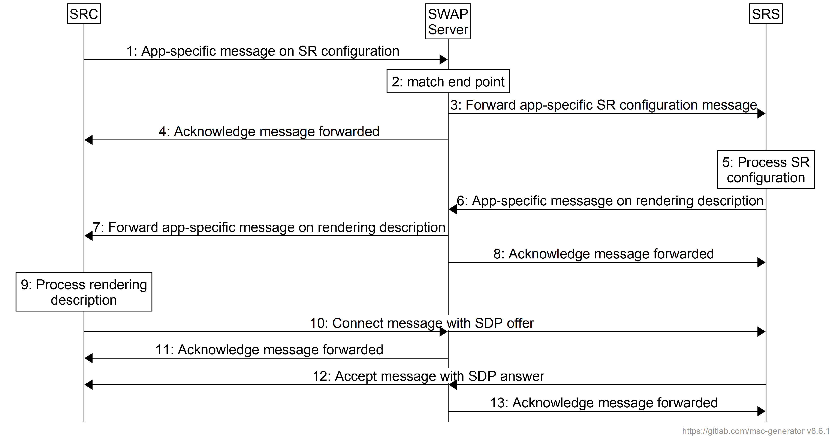**Figure 8.2-1 Call flows for SWAP message exchange**

Pre-requisites:

- The SRC has discovered the identifier of the SRS that it will use for its split rendering session.

- The SRC has retrieved the address of the SWAP server as part of the configuration.

The steps are as follows:

1. The SRC sends the configuration message as an application-specific SWAP message to the SWAP server. It provides the identifier of the target SRS as a matching criteria.

2. The SWAP server uses the provided matching criteria to locate the SRS.

3. The SWAP server forwards the configuration message to the target SRS.

4. The SWAP server confirms the successful forwarding of the message to the SRC.

5. The SRS processes the SR configuration message. It may for instance verify application and resource availablity, launch the application, configure its rendering, and create a rendering description.

6. The SRS sends the rendering description message as an application-specific SWAP message to the SWAP server.

7. The SWAP server forwards the message to the SRC.

8. The SWAP server acknowledges the successful forwarding of the message to the SRS.

9. The SRC processes the rendering description and identifies the required data channel and media sessions.

10. SRC sends a connect message with the SDP offer to the SRS. The offer reflects the negotiated media and data channel streams.

11. The SWAP server acknowledges the forwarding of the message to the SRS.

12. The SRS replies with an accept message that includes the SDP answer. The SDP answer reflects the information that was provided in the split rendering description.

13. The SWAP server acknowledges the forwarding of the message to the SRC.

**CHANGE 2**

C.1.2.4 Profile identifier

The type **urn:3gpp:split-rendering:src:profile:2dpixelstreaming** shall be included in splitRenderingProfile parameter when the SRC signals SRS the Split Rendering Configuration [8.4.2.2].

**CHANGE 3**

C.1.3.4 Profile identifier

The type **urn:3gpp:split-rendering:src:profile:3dpixelstreaming** shall be included in *splitRenderingProfile* parameter when the SRC signals SRS the Split Rendering Configuration [8.4.2.2].

**CHANGE 4**

C.2.6 Profile identifiers

If the adaptive split rendering profile is used in monoscopic mode the type **urn:3gpp:split-rendering:src:profile:asr2dpixelstreaming** shall be included in *splitRenderingProfile* parameter when the SRC signals SRS the Split Rendering Configuration [8.4.2.2].

If the adaptive split rendering profile is used in in stereoscopic mode the type **urn:3gpp:split-rendering:src:profile:asr3dpixelstreaming** shall be included in *splitRenderingProfile* parameter when the SRC signals SRS the Split Rendering Configuration [8.4.2.2].

**END OF CHANGES**