3GPP TSG-SA WG4 Meeting #131-bis-eS4-250591

Online, 11 – 17 April 2025

**Source: vivo, Fraunhofer IIS, Qualcomm Incorporated**

**Title: Application scenario for IMS voice call using GEO satellite**

**Spec: 3GPP TR 26.940 v0.0.1**

**Agenda item: 7.9**

**Document for: Agreement**

**1. Introduction**

At the recent SA#107 meeting, the "Study on Ultra Low Bitrate Speech Codec" has been approved. According to the WID description [1], the primary focus of this study is to develop design constraints and performance requirements for a codec supporting use cases like IMS Voice Call over GEO and the resulting transmission parameters.

The use case of IMS voice all using GEO satellite access is specified in clause 5.1 of TR 22.887 [2], and corresponding requirements and KPIs are outlined in in clause 6.46.11and in Table 7.4.2-1 of TS 22.261 [3].

#### **Current commercialized satellite voices using GEO satellite**

There are two main types of commercial satellite phone services available on the market. One type utilizes a directional antenna, exemplified by the Inmarsat phone (iSatPhone2), which operates based on the GMR-2 specification [4], with performance details provided in [5]. The other type uses an omnidirectional antenna, such as vivo and Huawei satellite phones, which rely on proprietary solutions, with performance examples available in [6] and [7].

#### **Reference architecture in 3GPP**

Regarding satellite radio access types (RATs), from the core network's perspective, there are a total of 12 RAT types, generally categorized into IoT NTN and NR NTN. Among these, only four types specifically focus on GEO satellites.

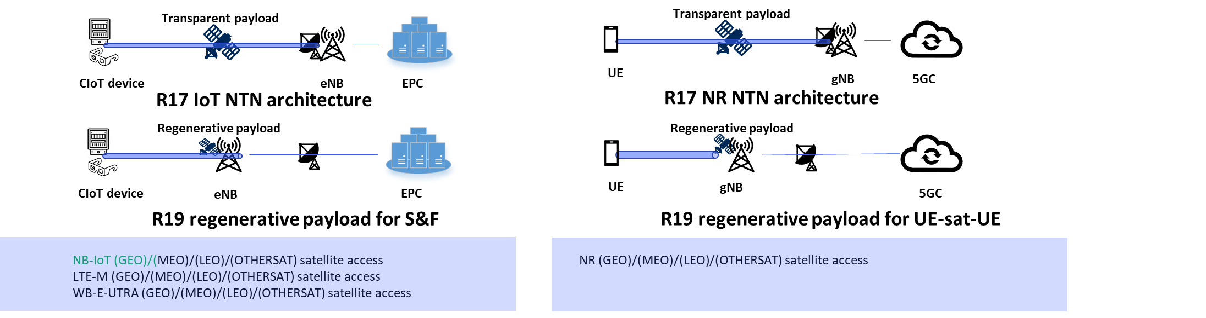

Fig. 1: reference architectures defined in 3GPP

* IoT NTN: NB-IoT (GEO) satellite access, LTE-M (GEO) satellite access, WB-E-UTRA (GEO) satellite access, with referring architecture as Fig.1 (right) shows:
* NR NTN: NR (GEO) satellite access, with referring architecture as Fig.1 (left) shows.

S1-241247 provides a simulation comparison explaining why NB-IoT is preferred over LTE-M and NR eRedCap. As shown in Fig. 2, NB-IoT achieves a higher data rate than LTE-M when considering link budget constraints imposed by GEO’s high orbital altitude, atmospheric fading, oscillation, and etc.

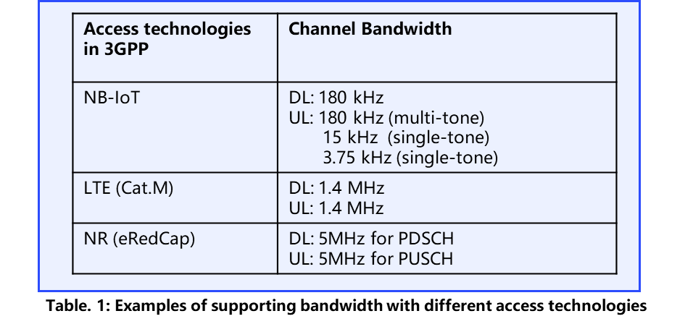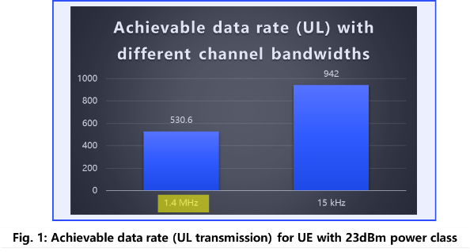

Fig.2: comparison between LTE-M and NB-IoT (S1-241247)

Furthermore, the observations and analysis on utilizing NB-IoT (GEO) satellite access have also been referenced in defining the contents of the SA2 SID (SP-250400) and the RAN Rel-20 IoT NTN discussion paper (RP-250204).

**Observation #1**: NB-IoT (GEO) satellite access connecting to the EPC is considered a reference architecture for the Rel-20 3GPP specification.

#### Conversation communication between two-parties

As stated in Clause 5 of TR22.887, the use case focuses on conversational communication between two parties:

* **Case I:** Mobile-originated satellite-to-terrestrial call and Mobile-terminated satellite-from-terrestrial call
* **Case II:** Satellite-to-satellite call

The IMS platform is utilized due to its ability to ensure interoperability with other operators (e.g., VoLTE/VoNR) and call systems (e.g., fixed-line networks). This means that on the terrestrial side, all originating/termination IMS-supported phone calls with satellite terminal are allowed, leading to interoperability requirements for ULBC to transcode with other operator/system-supported codecs such as AMR and EVS.

**Observation#2**: If the other party in the conversation is on a terrestrial network, transcoding between ULBC and other IMS-supported codecs available in SDP negotiation should be supported. However, if both parties are using satellite phones that support the same ULBC codec, transcoding may be avoided.

Terminal and satellite requirements

The satellite terminal is specified as handheld, with 3GPP specifications indicating support for 23dBm (pre-R19), and 26dBm, 29dBm (Rel-19 R4-2417205, under discussion). Additionally, the handheld terminal typically uses an omnidirectional antenna and is expected to function similarly to a regular mobile phone. In general, the mobile phone can be enhanced with a 0dBi antenna gain.

The operating GEO satellites available, as specified in 3GPP (pre-Rel-20), include GEO Set 1 and GEO Set 2, as shown in the table below, which is sourced from List of calibration study cases as specified in Table 6.1.1.1-9 in TR 38.821 [8].

#### **Transmission data rate**

SA1 has agreed upon a transmission data rate for UL/DL on the terminal side of approximately [1-3] kbps.

**Observation#3**: The estimated data rate provided by SA1 requires further validation by downstream groups, such as RAN1, for validation.

#### **Propagation delay**

In 3GPP, propagation delay is addressed in at least two specifications. One is in the SA1 specification, TS 22.261 [3], where Table 7.4.1-1 indicates that the maximum propagation delay from the UE to the ground via a GEO satellite is 280 ms (one-way delay). The other is in the RAN study report, TR 38.821, where Table 7.1-1 provides a delay range of 477.48 ms to 541.46 ms (round trip delay).

Based on the reference architecture and use cases discussed, the delay would be as follows:

|  |  |
| --- | --- |
| MO satellite call to terrestrial |  |
| MT satellite call from terrestrial |  |
| MO to MT satellite call | NOTE: Even though the Mobile-Originated terminal and Mobile-Terminated terminal are under the same GEO satellite coverage, the propagation delay should be calculated twice. This is because the satellite uses a transparent payload, which cannot locally switch the phone calls. |

**2. Reason for Change**

The present document provides the applied scenarios based on the use case captured in TR 22.887 [2] and requirements captured in TS 22.261 [3].

**3. Proposal**

It is proposed to agree the following changes to 3GPP TR 26.940 [9]

NOTE: Nokia and VoiceAge indicated support for an earlier version of this document that is basically unmodified in the changes below. Only the introduction above had been changed and expanded.

* * * First Change * * * *

# 4 Application scenarios

## 4.1 Introduction

This clause introduces application scenarios that may potentially be relevant for an Ultra-Low Bitrate speech Codec (ULBC). For each scenario, technical assumptions and resulting potential open questions are extracted. These assumptions and open questions are expected to be addressed in the remainder of this document to derive design constraints for a ULBC when used in this application scenario.

The primary application scenario is in the context of voice communication via Geostationary Earth Orbit (GEO) satellites as introduced in clause 4.2.

Editor’s Note: Other application scenarios may be considered with lower priority if time permits.

## 4.2 Scenario 1: IMS Voice Call over GEO

### 4.2.1 Background

Satellite communication plays a vital role in extending terrestrial network coverage, ensuring seamless connectivity for users anytime, anywhere. This technology unlocks new opportunities across various sectors, including smartphones and IoT. Geostationary Earth Orbit (GEO) satellites are particularly well-suited for delivering low-data-rate services on a global scale. By leveraging existing GEO satellites, messaging and voice services can be deployed quickly and efficiently.

Conversational two-party communication is the most common and essential use case for IMS voice over GEO satellite access. This use case is extensively discussed in SA1 and documented in clause 5.1 of TR 22.887 [2]. Due to the limitations of low transmission data rates [1-3] kbps as estimated in Table 7.4.2-1 in TS 22.261 [3], an ultra-low bit rate codec (with at least one available codec bit rate) is required. Users primarily rely on this service when they are beyond terrestrial network coverage but within satellite range, ensuring essential connectivity.

NOTE 1: The bit rate range is a working assumption according to TS 22.261 and might be adjusted after RAN consultation.

### 4.2.2 Scenario Description

#### 4.2.2.1 General

The typical UE is a handheld device supporting GEO satellite access with built-in microphones and loudspeakers or a monaural hands-free set, as outlined in Table 7.4.2-1 in TS 22.261 [3]. This means there is no need for the user to extend the antenna or carry any extra devices to access the IMS voice call service anywhere and anytime. It is expected that the feature is available on commercially widespread mobile devices.

The typical service is IMS voice call service that containing both regular call and emergency call as outlined in clause 6.46.11 in TS 22.261 [3]. From market’s perspective, such service can be provided as:

- Supplementary regular IMS voice service provided by the terrestrial operators, especially when the user suffers from no terrestrial coverage.

- Main regular IMS voice service provided by the satellite operators.

- An IMS voice call service using GEO satellite access in case of emergency situations.

The UEs under consideration may typically be commercial smartphones, but other form factors such as IoT devices or automotive vehicles are not excluded.

In the following, different scenarios establishing an end-to-end voice service are considered.

#### 4.2.2.2 Main Scenario: One UE connects via GEO-satellite access only

In a common scenario, one party in the conversation is assumed to be using a handheld mobile terminal over a GEO satellite network, while the other may be on a terrestrial mobile network (e.g., VoLTE, VoNR), a fixed-line connection, or another IMS-supported platform, as outlined in Figure 4.2.2.1, where a sketch of the bi-directional voice data flow for this main scenario is depicted.

Figure 4.2.2.2-1: Bi-directional voice data flow main scenario

NOTE: eNodeB is typically collocated with the ground station and not explicitly mentioned here, core network typically stands for 3GPP core network and IMS core network.

In particular, for regular IMS voice services introduced in clause 4.2.2.1, the participants (in particular the user of UE2, the regular phone) in the IMS voice service may and typically should preferably not even be aware that UE1 is using a GEO satellite link during the communication.

#### 4.2.2.3 Sub-Scenario 1: Both UEs connect via GEO-satellite access

In a less common scenario, both parties in the conversation are connected to a GEO satellite as outlined in Figure 4.2.2.3-1 using IMS-based communication services.

Figure 4.2.2.3-1: Bi-directional voice data flow sub-scenario

NOTE: eNodeB is typically collocated with the ground station and not explicitly mentioned here, core network typically stands for 3GPP core network and IMS core network.

When the GEO satellite operates in a transparent payload, the voice packets are transmitted to the ground before transmitted to the other UE, even if both UEs are connected to the same GEO satellite.

### 4.2.3 Extracted technical assumptions and open questions

#### 4.2.3.1 General

The following general assumptions apply.

- As the UE may be a regular (Release 20?) smartphone, the ULBC needs to be implementable in real-time (encoding and decoding) on such devices and meet common complexity and power-consumption requirements.

- As the IMS voice call service using GEO satellite access can be considered as coverage enhancement, the voice quality preferably meets the user expectation for deployed terrestrial voice services.

Editor’s Note: More details may be added.

#### 4.2.3.2 Main scenario

The following assumptions apply for the main scenario described in clause 4.2.2.2.

- For the connection “UE1 – GEO satellite – Ground station” (UE1 uplink), the transmission data rate is significantly limited ([1-3] kbit/s), requiring an ultra-low bit rate codec fitting the transmission data rate for this link.

- For the connection “Ground station – GEO satellite – UE1” (UE1 downlink), the transmission data rate is expected to be limited similarly to UE1 uplink.

- For both uplink and downlink it is expected that the link is subject to transmission errors.

- The delay in uplink and downlink is expected to be greater than the one of typical terrestrial networks.

- For the connection “Core Network – UE2” (UE2 downlink), the transmission data rate of a regular TN network is available. This link could be covered either by an existing IMS codec (transcoding necessary) or by the same ultra-low bit rate codec as used for the satellite link (transcoding-free).

- To ensure seamless communication across different network types, roaming, etc. transcoding functionality in core network is likely needed.

The following open issues remain to be addressed:

- Details on bitrate limitations in uplink and downlink are needed.

- Details on typical error conditions (including the frame loss rate and frame loss pattern) and worst-case conditions for both links are needed.

- Details on transmission delays conditions for both links are needed.

- What are the impacts when an ULBC codec is used in transcoding scenarios?

Editor’s Note: More details may be added.

#### 4.2.3.3 Sub-scenario 1

The following assumptions apply for sub-scenario 1 described in clause 4.2.2.3.

- For both connections “UE1 – GEO satellite – Ground station” and “Ground station – GEO satellite – UE2” the transmission data rate is significantly limited ([1-3] kbit/s), requiring an ultra-low bit rate codec fitting this transmission data rate for these links.

- This scenario may allow both transcoded (ULBC 🡨🡪 existing IMS speech codecs 🡨🡪ULBC) and transcoding-free operation (ULBC end-to-end)

- This scenario may operate in transcoding-free mode as ULBC is used end-to-end.

On top of some of the open questions in clause 4.3.2.2, the following open question apply:

* What is the end-to-end transmission latency in this scenario?

Editor’s Note: More details may be added.

* * * End of Changes * * * *

[1] Tdoc [SP-250378](https://www.3gpp.org/ftp/tsg_sa/TSG_SA/TSGS_107_Incheon_2025-03/Docs/SP-250378.zip), "Study on Ultra Low Bitrate Speech Codec"

[2] TR 22.887, "Study on satellite access - Phase 4"

[3] TS 22.261, "Service requirements for the 5G system"

[4] GMR-2 03.050, "Transmission planning for speech service"

[5] Inmarsat Phone <https://www.youtube.com/watch?v=iaI-rVMB6wk>

[6] vivo Phone <https://youtube.com/watch?v=EskEtJt9aQM&feature=shared>

[7] Huawei Phone <https://www.youtube.com/watch?v=MN4T4TV0Zpc>

[8] TR 38.821, "Solutions for NR to support non-terrestrial networks (NTN)"

[9] 3GPP TR 26.940, "Study on Ultra Low Bitrate Speech Codecs"