3GPP TSG-SA4 Meeting #130 S4-242201

Orlando, United States, 18th Nov 2024 - 22nd Nov 2024 revision of S4-242038
CR-Form-v12.3
CHANGE REQUEST
 | 26.804 | CR | 0006 | rev | 22 | Current version: | 18.1.0
For HELP on using this form: comprehensive instructions can be found at
http://www.3gpp.org/Change-Requests.

Proposed change affects: | UICC apps |  | ME | X | Radio Access Network |  | Core Network | X

Title: | [FS_AMD] WT#3a: Media delivery from multiple service endpoints/locations
Source to WG: | Dolby France SAS, Qualcomm, BBC, Huawei, HiSilicon
Source to TSG: | S4
Work item code: | FS_AMD |  |  |  |  |  | Date: |  |  | 2024-11-21
Category: | B |  |  |  |  |  | Release: |  |  | Rel-19
 | Use one of the following categories:  F (correction)  A (mirror corresponding to a change in an earlier release)  B (addition of feature),  C (functional modification of feature)  D (editorial modification)  Detailed explanations of the above categories can  be found in 3GPP TR 21.900. |  |  |  |  |  |  |  | Use one of the following releases:  Rel-8 (Release 8)  Rel-9 (Release 9)  Rel-10 (Release 10)  Rel-11 (Release 11)  …  Rel-17 (Release 17)  Rel-18 (Release 18)  Rel-19 (Release 19)  Rel-20 (Release 20)
Reason for change: |  | Document the FS_AMD key topic “c) Multi-Access and Multi-CDN Delivery” description and collaboration scenarios.
Summary of change: |  | Addition of new clause 5.19 Media delivery from multiple service endpoints/locations including sub-clause structure and headings. Addition of prose for Description and Collaboration Scenarios.
Consequences if not approved: |  | FS_AMD objectives not achieved.
Clauses affected: |  | 2, 3.3, 5.19 (NEW), 6.19 (NEW)
 |  | Y | N
Other specs |  |  | X | Other core specifications
affected: |  |  | X | Test specifications
(show related CRs) |  |  | X | O&M Specifications
Other comments:
This CR's revision history: |  | S4-240591: SA4#127-bis-e, description and collaboration scenarios  S4-240844: updates with comments received at SA4#127-e-bis  S4aI240052: updated to match proposed template and address pending comments.  S4al240894: S4al240052 endorsed at SA4 post 127-bis-e and comments/changes accepted for ease of reading. Updates with comments received at SA4 post 127-bis-e and introduction of candidate solutions. More background on candidate solution is contained in S4-240895. Multi-access media delivery overview and collaboration scenarios have been moved to S4-241082.  S4-241230: updates to address pending comments.  S4-241273: updates to address pending comments.  S4al240095: S4-241273 endorsed at SA4#128. Comments/changes accepted for ease of reading. CMMF candidate solution architecture and reference point descriptions added.  S4al240107: CMMF candidate solution architecture and reference point descriptions replaced with options to incorporate CMMF within the existing 5GMS architecture.  S4al240114: Edits from BBC. Endorsed by MBS SWG.  S4-241588: Addition of CMMF background information and addresses outstanding comments.  S4-241665: Reorginization of content to fit within the existing template and updates to address received comments.  S4aI240120: updates to CMMF architecture and high-level call flows.  S4aI240138: Updates to CMMF’s introduction to include more details concerning the expected overhead CMMF induces as well as an example architecture and call flow used to deliver CMMF content for the trial where the included performance metrics were collected. Further updates to the CMMF architecture and high-level call flows to address outstanding comments.  S4al240145: Incorporates edits and captures additional BBC comments.  S4aI240160: Updates to CMMF’s architecture mapping and high-level flowcall sections. Addition of CMMF gap analysis.  S4aI240185: Updates to address comments from BBC and Qualcomm.  S4-242038: Refactor to incorporate S4al240195, include a general multi-source/endpoint architectures and call-flows, revised gap analysis, and summary/recommendations.  S4-242201: Material from Qualcomm added to introduction, architecture, and call flows. Updates to the candidate solutions and summary. Addition of clause 6.19.

FIRST CHANGE

2 References
…
[3] IETF RFC 9112: "HTTP/1.1", June 2022.
[4] IETF RFC 9113: "HTTP/2", June 2022.
[5] IETF RFC 9114: "HTTP/3", June 2022.
…
[15] 3GPP TS 26.501: "5G Media Streaming (5GMS) General description and architecture (Release 18)".
[16] 3GPP TS 26.512: "5G Media streaming (5GMS) protocols (Release 18)".
…
[32] IETF RFC 9000: "QUIC: A UDP-Based Multiplexed and Secure Transport", May 2021.
…
[40] 3GPP TS 26.247: "Transparent end-to-end Packet-switched Streaming Service (PSS); Progressive Download and Dynamic Adaptive Streaming over HTTP (3GP-DASH)".
…
[96] 3GPP TS 26.511: "5G Media Streaming (5GMS); Profiles, codecs and formats".
…
[104] IETF RFC 3986: "Uniform Resource Identifier (URI): Generic Syntax", January 2005.
[DASH9] Draft Text of ISO/IEC FDIS 23009-9: "Information technology - Dynamic adaptive streaming over HTTP (DASH) – Part 9: Redundant Encoding and Packaging for segmented live media (REaP)", ISO/IEC JTC 1/SC 29/WG 3 NO 1165, Jan. 26, 2024. [Online]. Available: https://www.mpeg.org/standards/MPEG-DASH/9/
[UNPKG24] Emma Roth, "A popular open-source content delivery network went down for hours", The Verge, Apr. 12, 2024. [Online]. Available: https://www.theverge.com/2024/4/12/24128276/open-source-unpkg-cdn-down (accessed May 9, 2024).
[NET23] Sebastian Moss, "Cloudflare recovers from service outage after power failure at core North American data center", Data Center Dynamics, Nov. 3, 2023. [Online]. Available: https://www.datacenterdynamics.com/en/news/cloudflare-recovers-from-service-outage-after-power-failure-at-core-north-american-data-center/ (accessed May 9, 2024).
[FSLY21] Brian Barrett, "How an Obscure Company Took Down Big Chunks of the Internet", Wired, Jun. 8, 2021. [Online]. Available: https://www.wired.com/story/fastly-cdn-internet-outages-2021/ (accessed May 9, 2024).
[AKAM21] Josh Fomon, "CDN Provider Akamai Takes Down Popular Internet Services During Outage", Ookla, Jul. 22, 2021. [Online]. Available: https://www.ookla.com/articles/akamai-outage-july-22-2021 (accessed May 9, 2024).
[NET22] Charlotte Trueman, "Cloudflare outage brings hundreds of sites, services temporarily offline", Computer World, Jun. 21, 2022. [Online]. Available: https://www.computerworld.com/article/1627967/cloudflare-outage-brings-hundreds-of-sites-services-temporarily-offline.html (accessed May 9, 2024).
[VZ19] Jim Salter, "The Internet broke today: Facebook, Verizon, and more see major outages", Ars Technica, Jul. 3, 2019. [Online]. Available: https://arstechnica.com/information-technology/2019/07/facebook-cloudflare-microsoft-and-twitter-suffer-outages/ (accessed May 9, 2024).
[DEMX01] Marc Hoppner, "A content owner, a CDN and a player walk into a bar", (Jan. 6, 2023). Accessed: May 9, 2024. [Online Video]. Available: https://www.youtube.com/watch?v=S9EdoQFOQ9I&list
=PLkyaYNWEKcOf98lZxnCcL6y7ZIVU3oSYO&index=12
[DEMX02] Guillaume du Pantavice, "Improving streaming experience with Bayesian optimization, from AB to AZ test", (Dec. 25, 2021). Accessed: May 9, 2024. [Online Video]. Available: https://www.youtube.com/
watch?v=t4nRrLygVwo&list=PLkyaYNWEKcOfD1GYFxFbZXDP03XM-cZPg&index=19
[IEEE01] E. Ghabashneh and S. Rao, "Exploring the interplay between CDN caching and video streaming performance", IEEE INFOCOM 2020 – IEEE Conference on Computer Communications, Toronto, ON, Canada, 2020, pp. 516-525.
[ACM01] K. Vermeulen, L. Salamatian, S. H. Kim, M. Calder, and E. Katz-Bassett, "The central problem with distributed content: common CDN deployments centralize traffic in a risky way", In Proceedings of the 22nd ACM Workshop on Hot Topics in Networks (HotNets ’23). Association for Computing Machinery, New York, NY, USA, 70-78.
[MHV01] A. Bentaleb, R. Farahani, F. Tashtarian, C. Timmerer, H. Hellwagner, and R. Zimmermann, "Which CDN to Download From? A Client and Server Strategies", (Jan. 6, 2024). Accessed: May 9, 2024. [Online Video]. Available: https://www.youtube.com/watch?v=xCZmCnWgQRE
[VAS01] Will Law, "Content steering with MPEG DASH", (May 4, 2023). Accessed: May 9, 2024. [Online Video]. Available: https://www.youtube.com/watch?v=o9Pa5y-Usxw
[MWS23] W. Law and Y. Reznik, "DASH content steering at scale", Media Web Symposium (MWS’23), June 2023.
[DIFCS] ETSI TS 103 998: "DASH-IF: Content steering for DASH".
[CMMF] ETSI TS 103 973: "Coded multisource media format (CMMF) for content distribution and delivery".
[26510] 3GPP TS 26.510: "Interactions and APIs for provisioning and media session handling (Release 18)".
[RAPTORQ] IETF RFC 6330: "RaptorQ forward error correction scheme for object delivery", August 2011.
[RSFEC] IETF RFC 5110: "Reed-Solomon forward error correction (FEC) schemes", April 2009.
[103285] ETSI TS 103 285: "Digital Video Broadcasting (DVB); MPEG-DASH Profile for Transport of ISO BMFF Based DVB Services over IP Based Networks".
[MPEGI8] ISO/IEC 26090-8:2020: "Information technology – Coded representation of immersive media, Part 8: Network based media processing".
[RFC5052] IETF RFC 5052: "Forward Error Correction (FEC) Building Block", August 2007.
[RFC5053] IETF RFC 5053: "Raptor Forward Error Correction Scheme for Object Delivery", October 2007.
[RFC6726] IETF RFC 6726: "FLUTE - File Delivery over Unidirectional Transport," November 2012.
[26502] 3GPP TS 26.502: "5G multicast-broadcast services; User service architecture (Release 18)".

SECOND CHANGE

3.3 Abbreviations
…
FDT File Delivery Table
FLUTE File delivery over Unidirectional Transport
SAND Server-Assisted Network Delivery
TOI Transmission Object Identifier
TSI Transport Session Identifier
…

THIRD CHANGE (All new text)

5.19 Media delivery from multiple service endpoints/locations

5.19.1 Description

5.19.1.1 Introduction
Media streaming applications conventionally obtain content from a single source or endpoint over a single path within a network. Each source, or endpoint, may consist of a single server located within the network or an entire network of servers (e.g., a Content Distribution Network (CDN)). Operating in this manner imposes several limitations:
1. Performance is constrained to that of the source/endpoint and path chosen. Whatever the limits on network bandwidth and latency between the client and that source/endpoint are directly translated to the client’s achievable Quality of Service (QoS) and Quality of Experience (QoE).
2 Disruptions or degraded performance caused by the source/endpoint in use or on any of the network links between the client and source/endpoint can lead to poor user experience, often in the form of lower playback quality, rebuffering, or complete playback failure.
This study considers integration of different technologies into the 5G Media Streaming System that addresses these, and similar, issues by allowing media streaming applications to efficiently access content across multiple sources/endpoints and/or multiple access networks. Different client implementations may then beneficially use the content on these multiple sources or networks concurrently, potentially guided by service or network provider. In addition, formats and techniques for generating content for multiple sources/endpoints or multiple access network delivery such as MPEG-DASH Part 9 (ReAP) [DASH9] may be considered. Further extensions include the ability for a client to use multiple access networks at the same time to support media delivery. Study of integration of different technologies into the 5G Media Streaming System is of relevance to address content provisioning, content hosting, impacts on user plane reference points M2 and M4, and on media session handling at reference point M5 as well as potential benefits in terms of quality and resource usage.
A multi-CDN or multiple service location/endpoint content offering generally provides content in a redundant manner at locations that can be differentiated by the client. The locations typically differentiate in one or multiple Quality-of-Service criteria. For example, every service location/endpoint may have different access bit rates, reliability and/or availability, distribution costs, etc. When implemented by a commercial Content Delivery Network (CDN), this is sometimes referred to as multi-CDN, but the concept is more general and may preferably be named multiple service locations/endpoints.
In one embodiment, identical content is offered at multiple service locations. In another embodiment, different subsets of content are offered on one or the other service location/endpoint (e.g., these may be CMMF-coded redundant versions). Decisions on which location to use at which time may be made by the client only, by instruction from the network or service provider, or by a combination of the two. Multiple service location/endpoint approaches may also be considered in broadcast/multicast/unicast scenarios.
For the purposes of this study, the terms "CDN", "source", "endpoint", and "service location" are used interchangeably. They each refer to a single entity within the network consisting of one or more physical hosts where content is made accessible to streaming media clients. Each individual entity may be distinguishable from the others through differences in configuration (e.g., different domain names, hosting configuration, etc.).

5.19.1.2 Challenges Multi-CDN deployments aim to address
CDNs are often used by content distributors to globally scale delivery of their content to end-users. These networks consist of a number of Points of Presence (PoPs) located at various locations around the networks’ edge. These PoPs help load-balance delivery of content as well as improve Quality of Service (QoS) by reducing the distance/latency between every client and the content they are accessing. In many cases, content distributors employ multiple CDNs to leverage the strengths of one CDN over another in every location those CDNs have a PoP. For example, a client experiencing degraded performance while using one CDN may switch to another that is offering better performance at that time and location. As another example, a content distributor may prefer one CDN over another at a given time to reduce delivery costs and/or meet monthly contractual commitments. These multi-CDN deployments aim to solve content delivery issues that exist when only one CDN is used; but the benefits they provide may not be fully realized because of the various challenges experienced and underlying methods used to stream content to every client.
Challenges multi-CDN deployments and architectures aim to address may include:
1. Sustained CDN-/network-wide service disruptions where network access, connectivity or QoS is severely degraded. Examples may include cases where an entire CDN’s network is degraded because of a network-wide misconfiguration or power failure. The duration of these events may last minutes to hours and affect a majority of the client population. Examples of recorded instances can be found in [UNPKG24], [NET23], [FSLY21], [AKAM21], [NET22], and [VZ19].
2. Intermittent or short-term disruptions affecting QoS for an individual or small group of clients. Examples include short periods of congestion within the network, isolated HTTP request/response failures or delays caused by application server congestion, etc. The following discusses these in greater detail: [DEMX01], [DEMX02], [IEEE01], [ACM01], [MHV01], [VAS01], and [MWS23]
3. Augmentation of one CDN's performance with that of another to achieve a level of performance that neither can provide on its own. An example is a peer-to-peer CDN where each peer has limited uplink capacity and is unable to satisfactorily service client demand on its own.
The following clauses summarize some of the approaches that can be used to enable multi-CDN or multi-source/endpoint delivery to mitigate the challenges described above. Some of these solutions may be implemented over the top of the 5GMS System in such a way that content hosted within the 5GMS System is treated as a single CDN/source/endpoint, while others exist outside of the 5GMS System (e.g., commercial CDNs, etc.).

5.19.1.3 Media delivery with DNS-based switching

5.19.1.3.1 Functional description of DNS-based switching
Multi-CDN delivery using a DNS server to perform switching between CDNs is a popular way to improve the delivery of services. In this solution, an Application Provider selects the source, or endpoint, media players stream from by updating Domain Name System (DNS) records with pointers to the appropriate content source/endpoint. This approach is convenient since it is transparent to the media player.
In this case the media player does the following:
1. Segment or MPD request: The media player selects a Media Presentation Description (MPD) or a media segment to download, along with its associated URL. The domain name contained within this URL is typically generic to the Application Provider’s service, rather than to a specific CDN or content source/endpoint. Furthermore, this domain name is typically an alias to a canonical domain that can be resolved by obtaining the associated CNAME record within DNS.
2. DNS resolution: The media player first initiates a DNS lookup to resolve the domain name contained within the URL selected in step 1. This process ultimately returns with the IP address(es) required to establish the appropriate transport session(s) needed to request and download the MPD or media segment. The media player sends a DNS query to a DNS resolver (typically located within the ISP’s network). Depending on the status of the DNS resolver’s cache, the resolver may forward this query to an authoritative DNS server. In the case where a CNAME record is obtained by the DNS resolver, the canonical domain name contained in the CNAME record is resolved. This process continues until the appropriate A (IPv4 address) or AAAA (IPv6 address) DNS record is obtained. The DNS resolver finally responds to the media player’s DNS query with the resolved IP address(es) associated with the domain name contained within the original URL.
3. The media player establishes a transport session (e.g., TCP session) with the server associated with the IP address(es) returned by the DNS resolver. In the case where multiple IP addresses are returned in response to the prior DNS query, establishment of a transport session to the first IP address listed in the DNS query response is attempted. If unsuccessful, an attempt to establish a transport session with the second IP address listed in the DNS query response is attempted. This process continues until establishment of a transport session is successful or all attempts to each of the returned IP address have failed.
4. HTTP request and content delivery: The media player requests and obtains the MPD or media segment from the remote endpoint of the established transport session via HTTP.
The process, outlined above, which the media player follows is no different than what it would normally do to request and stream content. However, the functionality to switch sources, or endpoints, in this multi-CDN approach is implemented by changing the DNS records used to resolve the DNS queries in step 2 above. As mentioned above, the domain name of the URL used by the media player is typically setup as an alias in a DNS CNAME record where the canonical domain name contained in this record points to the location where the content should be streamed. An Application Service may change this DNS CNAME record so that the canonical domain name points to a different location (e.g., a different CDN, source, or endpoint). Determination of the canonical name used in the DNS CNAME record may be based on criteria such as performance (e.g., latency, bit rate, etc.), cost, geographic location, etc.

5.19.1.3.2 DNS-based switching requirements on multi-CDN delivery
Evaluating DNS-based switching requirements on multi-CDN delivery is left for further study.

5.19.1.3.3 DNS-based switching performance
Evaluating DNS-based switching performance for the purposes of enabling multi-source delivery is left for further study.

5.19.1.4 Media delivery with DASH-based client-side switching

5.19.1.4.1 Functional description of DASH-based client-side switching
In the specific case of MPEG-DASH, the same steps as in clause 5.19.1.3.1 may be applied, but some preceding steps can be implemented to select CDN or URL in the DASH Media Presentation Description.
The usage of multiple base URLs and consistent resolution is also described in the 3GPP DASH profile specified in clause 8.6 of TS 26.247 [40]. In DASH, it is possible to use a relative base URL to point to files on a relative path, or one could use an absolute base URL that contain the full base path to be used. For multi-CDN usage the absolute base URL path is typically used.
The Media Presentation Description can contain different BaseURL elements that enable fetching segments from different locations. In this case the media player (DASH client) can apply some additional logic, such as based on its historical data or assigned priorities in the Media Presentation Description to select a base URL. This base URL can then be combined with the relative path for the media segment’s full URL. This way, the media player can, by interpreting the media presentation description, decide on the URL to use for the request for the media segment or Media Presentation Description. After this step, the steps in clause 5.19.1.3.1 are followed.
To summarize, the following steps may be followed by the media player for media segment requests using the base URL in the Media Presentation Description before the step of multi-CDN delivery with a DNS server in clause 5.19.1.3.1.
1. Check the different base URLs in the Media Presentation Description that apply to the segment.
2. Check which base URL has the highest priority for usage, based on internal logic of the media player. In case a previous request has failed, another base URL may be selected, as before.
3. Combine the base URL with the relative path obtained for the media segment.
4. Apply the steps as described in clause 5.19.1.3.1.
This approach is applied in profiles for DASH used in the industry, such as DVB-DASH [103285].
An example of handling error responses and using multiple base URLs is shown in figure 5.19.1.1.4.1-1.
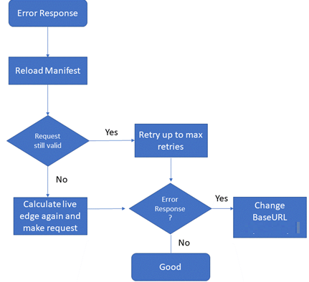
Figure 5.19.1.4.1-1: A media player combining baseURL changes,
MPD update and live edge calculation as in [103285]
In this case, the step may include reloading the Media Presentation description and recalculating the live edge (in case a DASH dynamic media presentation is used) to obtain again the relative request URL and make sure it is valid.
The media segment is requested again, and in this case there should not be an error response.
In case of an error response the process may be repeated.

5.19.1.4.2 DASH-based client-side switching requirements on multi-CDN delivery
Evaluating DASH-based client-side switching requirements on multi-CDN delivery is left for further study.

5.19.1.4.3 DASH-based client-side switching performance
Evaluating DASH-based client-side switching performance for the purposes of enabling multi-source delivery is left for further study.

5.19.1.5 Media delivery using a Content Steering Server

5.19.1.5.1 Functional description of multi-CDN delivery using a Content Steering Server
There is no equivalent base URL feature available when using HTTP Live Streaming (HLS) [87] for media delivery. Instead, a mechanism known as HLS Content Steering was developed by Apple to support downloads from different pathways.
This feature uses an external Content Steering server to provide server paths to HLS clients allowing them to change the path of the requests. An HLS playlist may contain a tag to indicate information about the content steering server location (e.g. the tag #EXT-X-CONTENT-STEERING with SERVER-URI attribute indicates the steering server URI using this tag). An HLS client can then use this URI to request the steering manifest that includes information about the different pathway URIs (CDN paths) and suggested priority.
This approach has recently also been considered for use with MPEG-DASH by the DASH Industry Forum’s content steering architecture [DIFCS], so it is potentially applicable to DASH as well as HLS.
Figure 5.19.1.5.2-1 shows the basic architecture for Content Steering based on ETSI TS 103 998 [ETSI-CS]. Content steering provides a deterministic capability for a content distributor to switch the content source that a media player uses, either at start-up or at any point during the presentation, by means of a remote steering service.
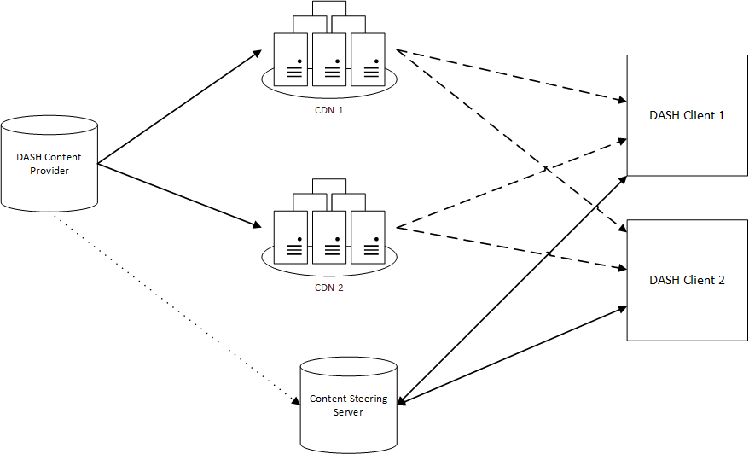
Figure 5.19.1.5.2-1: Content Steering architecture according to ETSI TS 103 998 [ETSI-CS]
Steering is accomplished by having the DASH client periodically access a Content Steering Server to retrieve a steering manifest, which instructs the player as to the availability and priority of content sources.
The typical procedures followed when content steering is in use are shown in figure 5.19.1.5.2-2 for the case when the content is provided on two CDNs.
Figure 5.19.1.5.2-2: Typical procedures for Content Steering according to ETSI TS 103 998
The DASH content provider generates an MPD that includes Base URLs to CDN1 and CDN2, as well as an address where the DASH clients can access the Content Steering Server.
3. The provider also uploads the MPD and the content segments to both CDNs.
6. At the start of playback, the DASH client requests the MPD from one CDN, in this case from CDN2. It finds the content steering server URL, and it may find information that instructs it to contact the content steering server prior to the first segment request versus the default behaviour of making the request once its starting buffer is full.
7. The DASH player then makes a request to the Content Steering Server.
8. The content server responds with a content steering manifest and the DASH client uses the information within to select the segment source, in this case from CDN2.
10. After some time, the content provider may collect operational information from the participating clients, for example by using Common Media Client Data (CMCD) as defined in CTA-5004 [CTA-5004]. Based on this information, the content provider may update the Content Steering Server, and based on this updated information, the content steering manifest may change.
11. When the client requests an update to the content steering manifest, new information may be provided that instructs the DASH client to request media segments from CDN1 instead of CDN2.
13. The DASH client then switches smoothly, at a segment boundary, to download the next media segments from CDN1 instead of CDN2. The steering server response can also be used to steer the DASH client between alternate sources for DASH manifest refreshes, via service descriptors contained within the MPD.

5.19.1.5.2 Content Steering Server requirements on multi-CDN delivery
Evaluating Content Steering Server requirements on multi-CDN delivery is left for further study.

5.19.1.5.3 Content Steering Server performance
Evaluating Content Steering Server performance for the purposes of enabling multi-source delivery is left for further study.

5.19.1.6 Media delivery using SAND4M

5.19.1.6.1 Functional description of multi-CDN delivery using SAND4M
3GPP DASH as specified in clause 13.10 of TS 26.247 [40], defines the Server-Assisted Network Delivery (SAND) functionality that enabling SAND for Multi-Network support (SAND4M). The primary use case for SAND for Multi-Network Access resulted from the distribution of DASH content over MBMS or other networks, for which the MBMS Client acts as a DASH server or DASH-Aware Network Element (DANE) in order to provide DASH formats to the DASH client in a manner compatible with TS 26.247 [40].
Clause 13.10 of TS 26.247 [40] specifies required and recommended functions for both a DANE and a DASH client. Despite the requirements of this mode having been designed to fulfill the SAND functionalities, it is not restricted to this use case: this mode may also be used in other contexts, in particular when using multiple networks for distribution and dynamic steering across the network. Specifically, the following cases are considered potentially relevant to the topic of multi-CDN delivery:
- Not all resources announced in the presentation manifest (e.g. MPEG-DASH MPD) are always accessible on all networks, e.g. broadcast resource is unavailable when the UE is outside broadcast coverage.
- Not all resources are available on all networks all the time.
- Networks may have different availability times.
- Networks go down dynamically and may re-appear.
- The DANE may issue preferences for one network.
- The information may be established via in-band and out-of-band channels.

5.19.1.6.2 SAND4M requirements on multi-CDN delivery
Evaluating SAND4M requirements on multi-CDN delivery is left for further study.

5.19.1.6.3 SAND4M performance
Evaluating SAND4M performance for the purposes of enabling multi-source delivery is left for further study.

5.19.1.7 Media delivery using Coded Multi-source Media Format (CMMF)

5.19.1.7.1 Functional description of CMMF
Coded Multi-source Media Format (CMMF) [CMMF] is an extensible container format designed to facilitate the management and interchange of audio-visual media and metadata in one or more coded representations (e.g., encoded with application-layer, forward error correction (FEC), linear, network, or channel codes). The coded media representations supported by CMMF enable the efficient use of multi-source, multi-path, and multi-access connectivity for network-delivered media applications. The use of CMMF does not replace the basic media streaming architectures and procedures already defined. Rather, it is intended to supplement them to provide additional capabilities.
A typical Video-on-Demand (VoD) MPEG-DASH HTTP adaptive streaming system is set up similarly to the non-shaded blocks shown in figure 5.19.1.3.6.1-1. Source media (e.g. audio/video elementary streams) are segmented and encoded into multiple representations, each with a different quality and bit rate. These segments are packaged together using MPEG-DASH (or HLS) and stored on an origin server located within the network. One or more CDNs are set up to distribute and deliver this content to an OTT service provider’s customer base. These CDNs obtain every requested MPEG-DASH (or HLS) segment from an origin server, caches these segments at their respective network edges, and deliver these segments to clients.
Enabling multisource delivery using CMMF within this existing delivery architecture can be accomplished through the addition of a CMMF Bitstream Generator/Source before segments are delivered to the CDNs, and a CMMF Receiver on each client, as illustrated by the shaded boxes in figure 5.19.1.7.1-1.
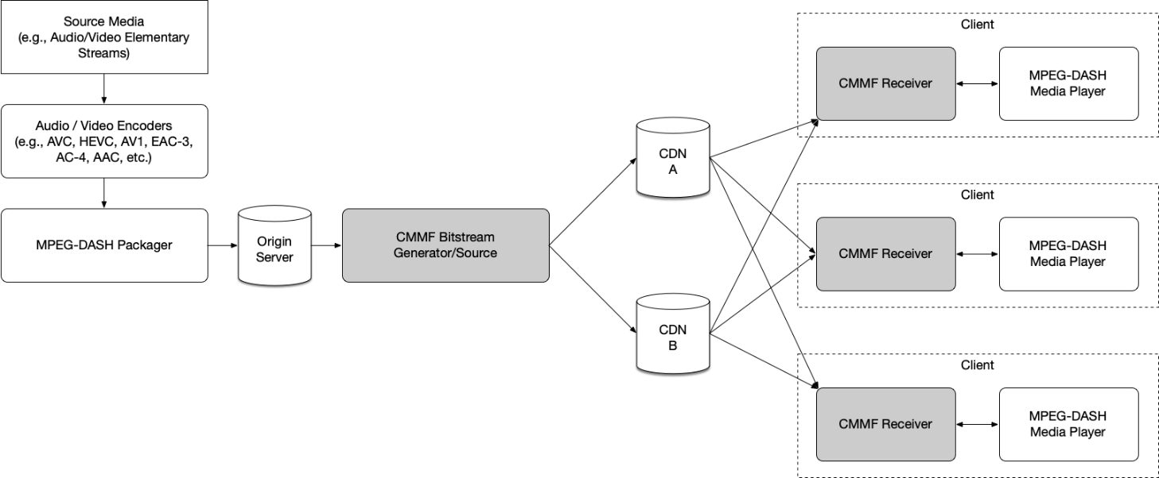
Figure 5.19.1.7.1-1: MPEG-DASH with CMMF Delivery System Example
While figure 5.19.1.7.1-1 shows the CMMF Bitstream Generator/Source between the Origin Server and the CDNs (i.e., CMMF bitstreams are created on demand), the CMMF Bitstream Generator/Source can just as easily be located between the MPEG-DASH Packager and the Origin Server. In the former case, the original MPEG-DASH segments are stored on the Origin Server and CMMF representations of those segments are cached on each CDN. In the latter case, the CMMF Bitstream Generator/Source creates multiple CMMF representations of each segment produced by the MPEG-DASH Packager and stores them on the Origin Server for later retrieval by a CDN.
In this system, the Application Service Provider is responsible for segmenting, encoding, and packaging the media. It is also responsible for creating a presentation manifest (MPD, shown in figure 15.19.1.7.1-2) that contains relative URLs to the files/segments (shown in a dotted outline) that make up the adaptation sets. This information is transferred from the Application Service Provider to the media player (using a method preferred by the Application Service Provider) and is used by the media player to determine which segments are to be downloaded (via the CMMF Receiver) and played.
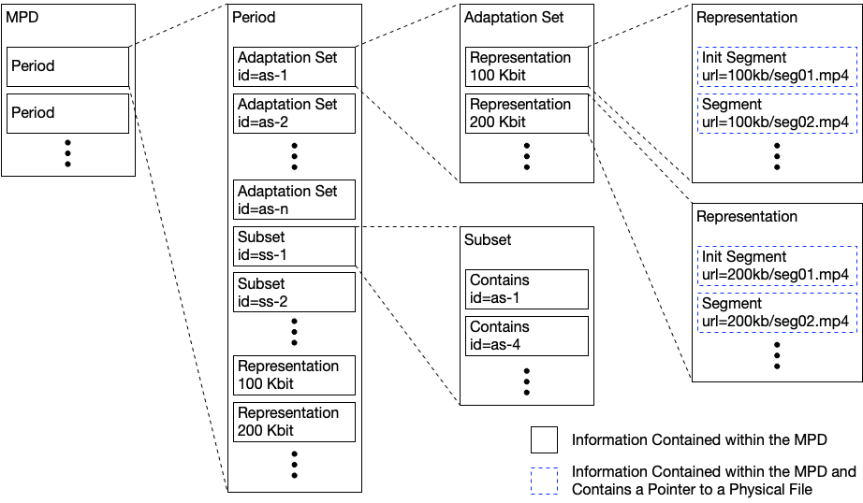
Figure 15.19.1.7.1-2: Example MPEG-DASH MPD
The Application Service Provider in this example is also responsible for determining and setting up the delivery system (i.e., the CDNs) to distribute CMMF-encoded media. Information about this setup is captured within the CMMF Configuration Information as a list of host URLs to each of the CDNs. It is important to note that both the MPEG-DASH master manifest and the CMMF Configuration Information is required to download the media. In this example, it is assumed that the Application Service Provider is utilizing two CDNs and each segment listed in the MPEG-DASH MPD is encoded and packaged into two unique CMMF bitstreams/objects, one intended for the first CDN and the other for the second CDN according to the list of host URLs provided in the CMMF Configuration Information. An example of this is shown in figure 15.19.1.7.1-3. Furthermore, example bitstream/object constructions can be found in annex C of [CMMF].
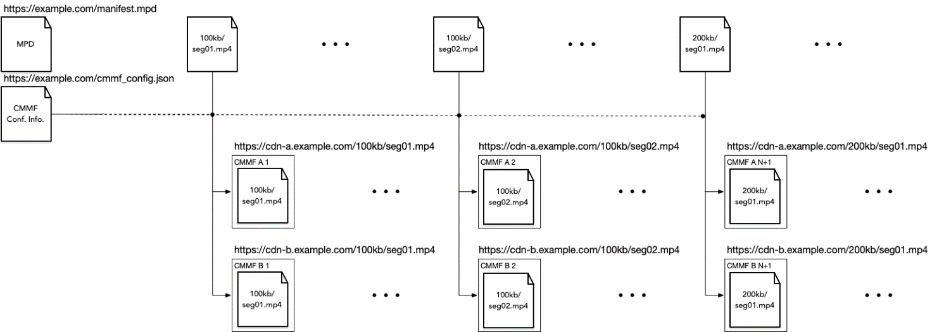
Figure 15.19.1.7.1-3: CMMF bitstreams/objects generated
to deliver the MPEG-DASH packaged content
The process for streaming this content is shown in figure 15.19.1.7.1-4.
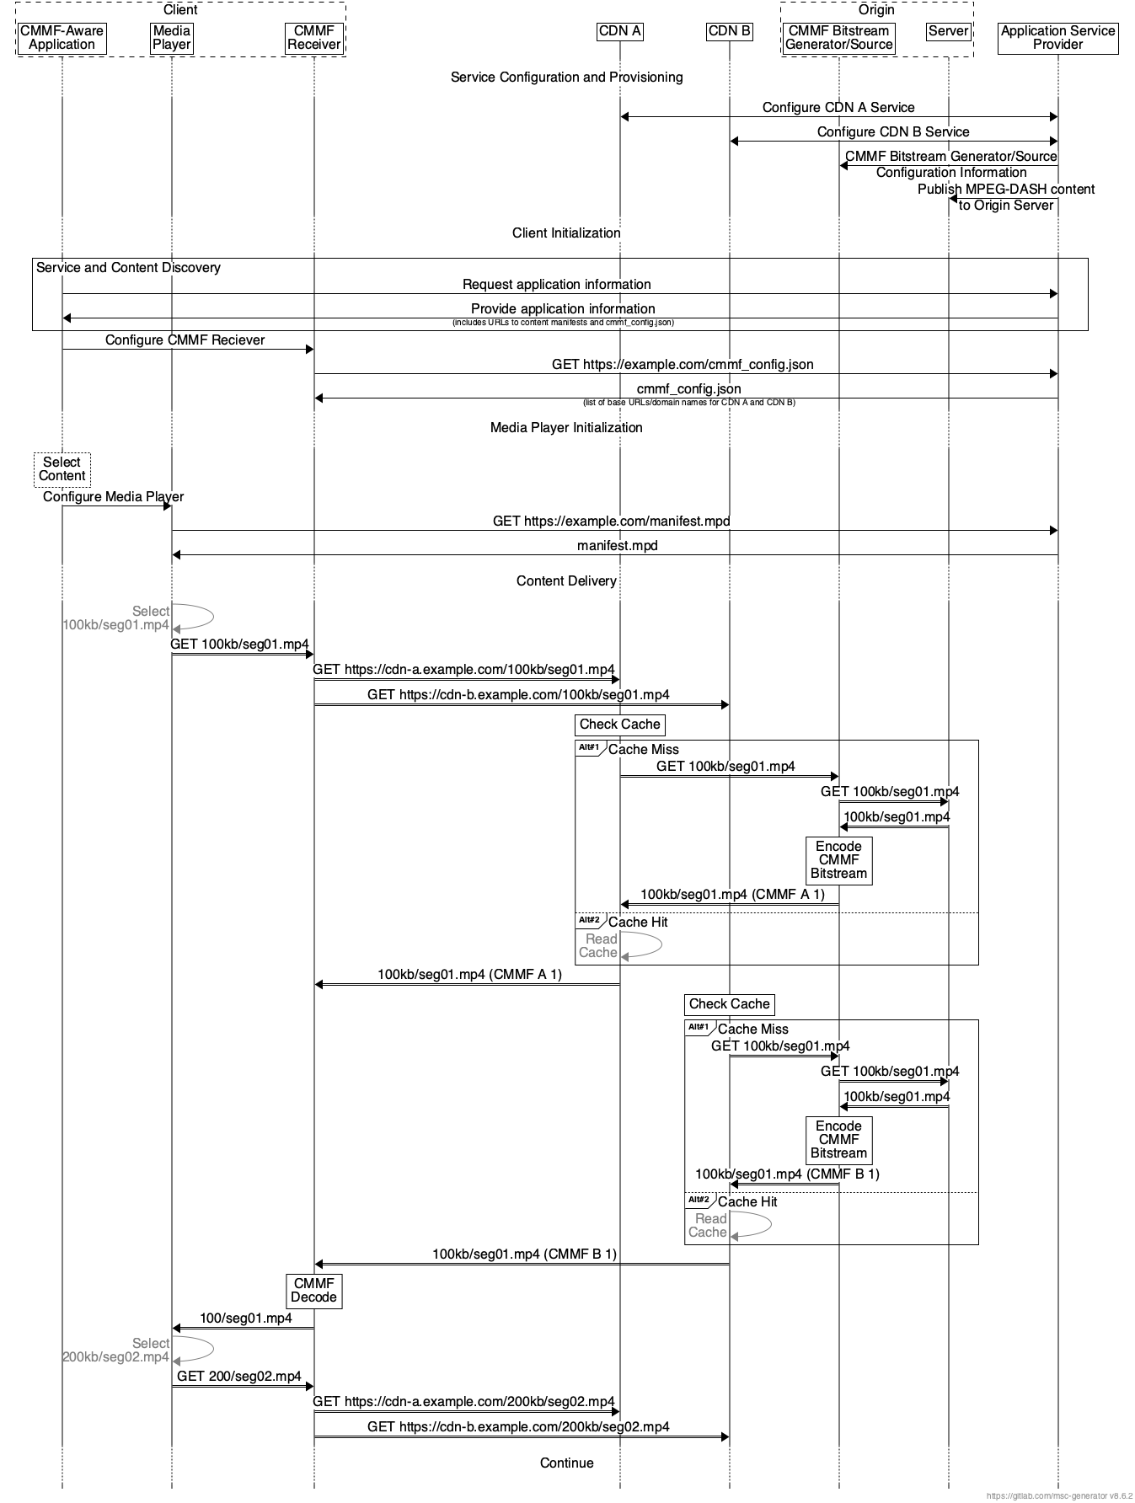
Figure 15.19.1.7.1-4: CMMF request and content delivery example for MPEG-DASH
An Application Service Provider first configures and provisions the CMMF service. The first steps are configuration of multiple CDNs. This configuration includes defining each CDN’s service domain names, origin host (e.g., the domain name of the CMMF Bitstream Generator/Source), caching policies, etc. The Application Service Provider also configures the CMMF Bitstream Generator/Source. This configuration includes the definition of necessary information for the CMMF Bitstream Generator/Source to properly encode and generate CMMF objects. Per [CMMF], this may include:
- the definition of a code type and code construction parameters,
- the definition of a CMMF profile,
- information about source object construction (e.g., fragmented HLS/MPEG-DASH segments, etc.),
- the location where source media can be found, etc.
The final step of this process is to publish MPEG-DASH and/or HLS content to an origin server (e.g., AWS S3 bucket).
Upon client initialization, the CMMF Receiver requests the CMMF Configuration Information (in this case it is stored as a JSON file) from the Application Service Provider. This information communicates a list of host URLs specifying the locations for which the client can retrieve CMMF encoded content for every segment listed within the master manifest file. In this case, this list includes the domain names used during the CDN configuration step. All other information required by the CMMF Receiver to successfully decode is provided within each downloaded CMMF object. This information includes the CMMF code type used to encode the source object, the methods used to construct the CMMF object (e.g., block structure, symbol size, etc.), and other relevant information.
Upon media player/delivery session initialization, the media player retrieves and parses the presentation manifest (MPD) from the Application Service Provider and chooses the adaptation set(s) it wishes to stream. Once selected, the media player requests the appropriate segment from the CMMF Receiver. The CMMF Receiver converts the received URL to two CMMF bitstream/object URLs (one for each base URL obtained from the CMMF Configuration Information file) and requests two distinct CMMF bitstreams/objects of that segment from the two available CDNs. Assuming the appropriate CMMF bitstream is cached, the CDN begins delivery. Otherwise, the CDN requests the segment from the CMMF Bitstream Generator/Source. At which point, the original segment is pulled from storage, encoded, and delivered to the CDN and to the client. The CMMF Receiver downloads the two CMMF bitstreams of that segment until it is capable of decoding. These downloads are performed using an appropriate strategy based on the underlying network protocols in use and network conditions. Once enough CMMF-encoded content has been received, the CMMF Receiver decodes the segment and delivers it to the media player. The media player selects the next segment to be downloaded and the process repeats.
In the case of a third CDN being introduced, a new CMMF bitstream can be generated and cached without replacing or modifying the existing CMMF bitstreams already cached in the initial two CDNs. All that is required is an update to the host URL list managed by the Application Service Provider.

5.19.1.7.2 CMMF as a Content Delivery Protocol
Annex D of ETSI TS 103 973 defines a content delivery protocol instantiation. In this case, CMMF is considered as a Content Delivery Protocol (CDP) as defined in clause 8 of RFC 5052 [RFC5052]. Annex D provides a mapping of CMMF to the RFC 5052 principles and vice versa. This instantiation also permits re-use of existing FEC Codes including Raptor (the 3GPP MBMS code) as defined in RFC 5053 [RFC5053] and RaptorQ as defined in RFC 6330 [RAPTORQ]. The content delivery protocol also makes use of 3GPP concepts such as the FLUTE [RFC6726] File Delivery Table (FDT) as used in MBMS User Services [54] and MBS User Services [26502]. A simplified architecture to provide an overview of the CMMF instantiation is shown in figure 5.19.1.7.2-1.
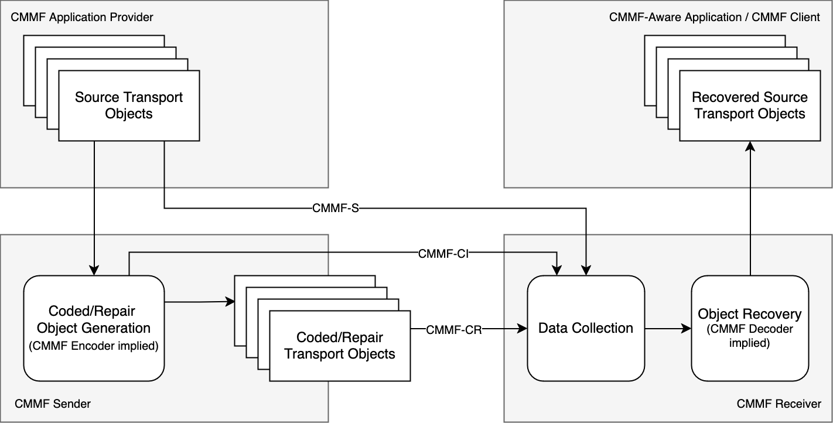
Figure 15.19.1.7.2-1: Simplified architecture addressing CMMF as a CDP
In this case, the following reference points are defined:
- CMMF-CI: This reference point provides Configuration Information describing the location and relationship of the source and coded/repair objects. This information may be provided to a CMMF receiver.
- CMMF-S: This reference point provides the source transport objects. For CMMF, these objects are unmodified from original data. Parts of these objects may be used by Object Recovery to recover source objects.
- CMMF-CR: This reference point provides the coded/repair transport objects..
Not explicitly mentioned in the diagram are the following reference points:
- The server-side configuration of the CMMF sender.
- The client-side API between the CMMF receiver and the application.
Operation is completely independent of any application manifest.
A call flow based on figure D.1 in ETSI TS 103 973 [103973] is provided in the following.
Figure 15.19.1.7.2-2: Call flow for FLUTE-based CMMF CDP instantiation
According to ETSI TS 103 973 [103973], object delivery may be organized in a session, where a session can include multiple transport flows, and each transport flow may include multiple objects. This arrangement is illustrated in figure 15.19.1.7.2-3.
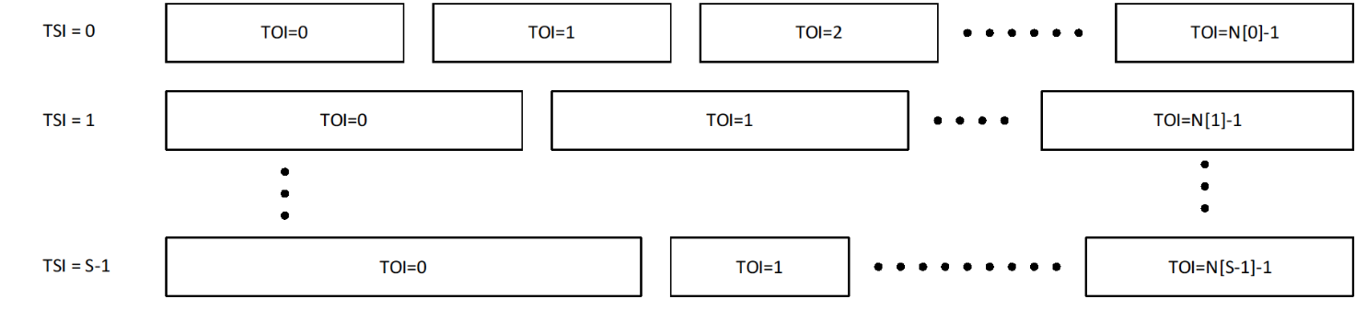
Figure 15.19.1.7.2-3: CMMF Transport Objects and Transport Sessions
In this case, information is provided to the CMMF receiver through configuration information, describing:
- Each logical flow that is operated.
- Each object, metadata of the object and other information.
- The type of the object as well encoding parameters.
More specifically:
- The Configuration Information describes source and coded/repair transport objects.
- The Configuration Information describes the CMMF encoding details, i.e. the FEC code in use, the structure of each object, etc.
- The Configuration Information allows the CMMF client to map an application request to CMMF receiver operations, for example to collect the relevant information from the network and recover an object.
- An application may also subscribe to a TSI, and the CMMF receiver pre-fetches all objects at the appropriate time for the application.
Some use cases may require additional information or only a subset of this information, and a simpler version of this parameter set may be used. The Configuration Information may be updated during the course of a session, for example when no files are available in a live service.
Table 15.19.1.7.2-1 lists typical configuration parameters.
Table 15.19.1.7.1-1: CMMF Configuration Information based on annex D of ETSI TS 103 973 [103973]
Parameter |  |  |  | Usage | Definition
Complete |  |  |  | OD | Indicates whether the Configuration Information is complete.
Location |  |  |  | O | Information where the Configuration Information can be accessed, if carried externally.
Expires |  |  |  | M | Provides information when this Configuration Information is no longer valid and an update is needed, for example using a reload from Location.
Source Flow |  |  |  | 1 … S | Provides 1 … S source flows.
 | TSI |  |  | M | Transport Session Identifier (TSI) of the source flow.
 |  | Object |  | 1 … N | Provides 1 … N objects in the source flow.
 |  |  | TOI | M | Transmission Object Identifier (TOI) value that represents the source object.
 |  |  | Size | M | Size of the transmission object in bytes.
 |  |  | Content type |  | MIME media type of transmission object.
 |  |  | Encoding |  | Encoding of the transmission object.
 |  |  | Message Digest |  | Message digest of transmission object.
 |  |  | Associated URI |  | Name, identification, and location of transmission object (specified by the URI).
 |  |  | Access URL |  | The URL where the source object can be accessed. If the field is not present, then the source flow is not directly accessible.
 |  |  | Availability start time |  | Wall-clock time when the resource is accessible.
 |  |  | Availability end time |  | Wall-clock time when the resource ceases to be available.
 |  |  | <Additional metadata> |  | May include cache or entity tag metadata.
 |  | Representation |  |  | Refers to a DASH Representation in an MPD or a Track in an HLS manifest.
Coded/Repair Flow |  |  |  | 1 … R | Provides 1 … R coded/repair flows.
 | TSI |  |  | M | Identifier of the coded/repair flow.
 |  | Object |  | 1 … N | Provides 1 … N objects in the coded/repair flow.
 |  |  | TOI | M | Transmission Object Identifier (TOI) value that represents the coded/repair transport object.
 |  |  | FEC-OTI |  | If the transmission object is coded using a scheme based on RFC 5052 [RFC5052], FEC Object Transmission Information including the FEC Encoding ID and, if relevant, the FEC Instance ID.
 |  |  | Included source TOI | M | List of (TSI, TOI pairs) of the included source transport objects forming super objects.  Typically, only a single pair is provided.
 |  |  | Content type |  | MIME content type of the transmission object.
 |  |  | Complete object | OD  FALSE | Indicates whether the transmission object includes sufficient information to recover all files included in this coded/repair object.
 |  |  | Symbol arrangement |  | If not present, the symbol arrangement is unknown and only present in the bitstream.
 |  |  | Symbol arrangement parameters |  | May be present if the symbol arrangement is present. If present, it provides the parameters assigned to the symbol arrangement. For arrangement 2 and 3, this is a list of: index difference, symbol group, index in symbol group.
 |  |  | Access URLs |  | The URLs where the coded/repair object can be accessed.
 |  |  | Availability start time |  | Wall-clock time when the resource is accessible.
 |  |  | Availability end time |  | Wall-clock time when the resource ceases to be available.
 |  |  | <Additional metadata >

An example of a configuration file based on an extension of the FDT is provided in listing 15.19.1.7.1-1.
Listing 15.19.1.7.1-1: EFDT as defined in TS 103 973 [103973] with multiple files and self-contained objects including source symbols
<FDTInstance xmlns:xsi="http://www.w3.org/2001/XMLSchema-instance"
xmlns="urn:ETSI:CMMF:2023:FDT"
xsi:schemaLocation="urn:ETSI:CMMF:2023:FDT extendedFDT.xsd"
Expires="2024-05-30T09:30:10Z"
Complete="true"
FEC-OTI-FEC-Encoding-ID="6"
FEC-OTI-Encoding-Symbol-Length="64">
<File ContentLocation="https://example.com/efd1-video.mp4"
ContentType="video/mp4 codecs='avc1.42c01e' profiles='iso8'"
TOI="0"
Content-Length="64000">
<EncodedObjects type="self-contained"
interleavingType="spread"
independentObject="true"
includedSymbols="1001,3,1,0,0,0">https://example.com/part1-video.cmf</EncodedObjects>
<EncodedObjects type="self-contained"
interleavingType="spread"
independentObject="true"
includedSymbols="1001,3,1,0,0,1">https://example.com/part2-video.cmf</EncodedObjects>
<EncodedObjects type="self-contained"
interleavingType="spread"
independentObject="true"
includedSymbols="1001,3,1,0,0,2">https://example.com/part3-video.cmf</EncodedObjects>
</File>
<File ContentLocation="https://example.com/efd1-audio.mp4"
ContentType="audio/mp4 codecs='mp4a.40.29' profiles='iso8'"
TOI="1"
Content-Length="4800">
<EncodedObjects type="self-contained"
interleavingType="spread"
independentObject="true"
includedSymbols="80,3,1,0,0,0">https://example.com/part1-audio.cmf</EncodedObjects>
<EncodedObjects type="self-contained"
interleavingType="spread"
independentObject="true"
includedSymbols="80,3,1,0,0,1">https://example.com/part2-audio.cmf</EncodedObjects>
<EncodedObjects type="self-contained"
interleavingType="spread"
independentObject="true"
includedSymbols="80,3,1,0,0,2">https://example.com/part3-audio.cmf</EncodedObjects>
</File>
</FDTInstance>

CMMF defines a format to allow creating redundant objects of a source object. CMMF does not define any of the following:
- Structured configuration information beyond the Extended FDT.
- APIs to the CMMF Client for configuration of the CMMF client and for communication between an application and the client
- A normative and well-defined CMMF client implementation that describes the operation for different configuration parameters.

5.19.1.7.3 CMMF requirements on multi-CDN delivery
Based on the description in the previous clause, multi-CDN and/or multi-access media delivery using CMMF requires preparation of the content to be served to a population of clients and clients that can access and download from multiple sources in parallel. Specifically,
1. The ability to create CMMF-encoded media objects and distribute/stripe these (in addition to possibly distributing the original source media such as MPEG-DASH or HLS media segments) across multiple client-accessible network locations (e.g., 5GMS Application Servers, CDNs, etc.).
Accessing content efficiently from multiple sources/endpoints within the network simultaneously requires that each network source/endpoint be populated with a unique CMMF bitstream/object containing the content being requested. A CMMF network source/endpoint is one that can be individually addressable or reachable (i.e., it is recommended that there exists a one-to-one mapping between the set of individually addressable or reachable sources/endpoints and the set of CMMF bitstreams/objects for each CMMF encoded piece of content). Source/endpoint types may be entire CDN distributions, single points-of-presence (PoPs) within a single CDN distribution, or standalone servers. For example, a single CDN which replicates content across their PoPs and uses DNS or anycast to route traffic to the PoPs within their network would be considered one source/endpoint. Alternatively, a CDN that enables clients to reach individual PoPs within their network may allow for each PoP to be an CMMF source/endpoint assuming each PoP can be populated with a unique CMMF bitstream/object.
Various methods for creating unique CMMF bitstreams/objects for each CMMF network source/endpoint exist. The necessary CMMF bitstreams/objects can be created offline (e.g., at the time the video/audio is encoded and packaged) and stored on an origin server for later retrieval by the CMMF network sources/endpoint. They can also be created on demand using a cloud-based or edge-based just-in-time encoder as client requests are received.
Detailed examples for preparing original source media for delivery from multiple serving endpoints using CMMF are provided in [CMMF]. In general, the processing required to create CMMF bitstreams/objects is minimal (and scalable) allowing for a wide range of available implementation options.
2. The capability for clients to access, efficiently download, and decode information collected from the partially received CMMF-encoded media bitstreams/objects obtained in parallel from multiple network endpoints where CMMF-encoded media objects (and possibly original source media) are stored/cached.
These capabilities can be implemented as a plug-in similar to the MBMS Client shown in clause 4.6.1 of TS 26.501 [15] to simplify integration into existing platforms and players, or they can be implemented directly within the streaming media player located on each client. When downloading content (e.g., a segment that is intended to be played), a CMMF client will connect to multiple sources/endpoints and request the CMMF bitstream/object associated with that content from each. Any one of these CMMF bitstreams/objects do not need to be obtained in their entirety, nor does any byte-level scheduling need to occur (e.g., each CMMF bitstream/object can be transmitted from their beginning to their end). Rather, a client only needs to obtain enough information from all of the transmitted CMMF bitstreams/objects so that it can decode the content those bitstreams/objects carry.
The methods used to efficiently download media using CMMF from multiple sources/endpoints are heavily dependent on the underlying network and transport protocols used to deliver CMMF-encoded bitstreams/objects, as well as the implementation of the CMMF-enabled client. For streaming use cases utilizing either HTTP/1.1 [3] or HTTP/2 [4] over TCP, total overhead (i.e., total amount of data egressed from all of the sources/endpoints (including HTTP and CMMF headers) with respect to the size of the original source media object) has been demonstrated to be between 0.5-3% when downloading 1080p, 4-second MPEG-DASH segments encoded at approximately 5 Mbps (it should be highlighted that this is roughly on-par with the overhead induced by in-market media players related to downloading multiple bit rates of the same segment and (obviously) rendering only one during playback). Overhead when using other network/transport protocols or different implementations may differ.
Likewise, the number of requests sent by a CMMF-enabled client to each CMMF endpoint can also be considered overhead. Various strategies can be employed depending on the capabilities or limitations of the underlying transport protocols and network. Cases where the client is limited (e.g., it is using HTTP/1.1 [3] to obtain CMMF-encoded content where the client can only make requests serially and cancel them by closing the underlying TCP connection) may require a different strategy than cases where a more advanced protocol is used (e.g., HTTP/2 [4]).
- In the case where HTTP/1.1 is used as the application protocol, one strategy to download CMMF-encoded content while limiting the amount of extra data downloaded as well as avoiding cancelling requests may be to make several byte range requests to each CMMF endpoint where these byte range requests are sized appropriately for the observed network conditions and the amount of data that is still required at that time. A current, state-of-the-art implementation of this strategy generates between three and six requests to each CMMF endpoint (depending on the network conditions) while downloading 1080p, 4-second MPEG-DASH segments encoded at approximately 5 Mbps.
- In cases where the client is using an underlying protocol suite with more features (e.g., HTTP/2 over TCP or HTTP/3 [5] over QUIC [32]), those features may allow for different strategies. A strategy that uses flow control features available within HTTP/2 achieves the same download as mentioned above while only sending one request to each CMMF endpoint.
Of course, other strategies exist, and the approach they take to obtain CMMF-encoded content from multiple CMMF endpoints is dependent on the network protocols used, the underlying networks’ capabilities, and the overall use case.
The complexity and client device impacts of decoding received CMMF bitstreams/objects has also been demonstrated to be minimal. While the decode complexity is dependent on the CMMF code type used (CMMF [CMMF] supports a variety of different code types including general deterministic and random linear codes (RLC), the 3GPP Raptor code specified in RFC 5053 [RFC5053] as defined in TS 26.346 [26346], RaptorQ as specified in RFC 6330 [RAPTORQ], and Reed-Solomon as specified in RFC 5110 [RSFEC]), CMMF has been demonstrated on over 4000 unique client device models without issue.

5.19.1.7.4 CMMF performance
To understand some of the advantages of using CMMF for streaming media, CMMF was implemented and trialed on a commercial streaming platform from approximately September 2022 through September 2023. This platform offers a large content library, streamed to a world-wide customer base where the majority of the content had a maximum bit rate of 5 Mbps or less (the median maximum bit rate available was approximately 3.5 Mbps while over 70% of all sessions had a maximum possible bit rate of 5 Mbps or less). Approximately 5%–50% of the traffic on selected device types was streamed using CMMF while the remainder of the traffic was streamed using a popular conventional server-side switching/DNS-based multi-CDN implementation. Both the CMMF multi-source and the conventional multi-CDN approach used three tier 1 CDNs. CMMF clients downloaded content from each CDN in parallel, while the "conventional" clients switched between the three based on input from the multi-CDN switching platform. Performance measurements for all traffic were collected using an industry-leading performance measurement platform. This data includes session-level information about relevant QoE key performance indicators (KPIs). In addition, supplemental QoS information was collected for only those sessions using CMMF multi-source as a delivery method.
A summary of the amount of traffic measured for each delivery method during this trial is provided in table 5.19.1.7.3-1. This and subsequent tables only show traffic measured for Android clients streaming over cellular networks from January 1 through July 26, 2023. Furthermore, only those sessions where the mean edge cache hit rate is greater than 50% are considered. For CMMF traffic, this was determined using the supplemental QoS information collected for each CMMF session. For conventional traffic, this supplemental information was not available on a session-by-session basis since this traffic bypassed the functionality added when implementing CMMF within the player. Rather, it was confirmed, via querying each CDN utilized, that the mean edge cache hit rates for all conventional traffic was greater than 95%. This estimate of the edge cache hit rate was also validated in a separate experiment where conventional traffic was routed through the new CMMF player functionality so that QoS metrics (including cache hit status) could be collected. Unfortunately, the volume of CMMF traffic and the diversity of the content streamed during the trial made it very difficult to keep CDN caches warm with CMMF encoded content. Trying to match multi-source and conventional edge cache hit rates on a one-to-one basis was not possible. As a result, the threshold established above provides sufficient data to provide statistically significant results; but it also implicitly favors conventional delivery since those sessions were more often served by the CDNs’ edge.
Table 5.19.1.7.4-1: CMMF real-world multi-CDN trial summary. Only sessions measured on cellular networks and running Android are shown
Delivery method | Hours watched | Number of playback sessions | Number of unique devices | Number of unique countries | Minutes watched per unique device
Conventional | 25,026.92 | 120,269 | 23,752 | 178 | 63.22
CMMF | 14,013.76 | 44,081 | 12,534 | 141 | 67.08

An overview of the performance improvements multi-source delivery provided over conventional multi-CDN switching for various QoE KPI’s is shown in table 5.19.1.3.6.3-2. The table provides the mean value of the relevant KPI plus/minus one standard deviation. In general, double-digit gains were observed across all key QoE performance indicators showing that CMMF enabled multi-source delivery can drastically improve the quality of streamed media.
Table 5.19.1.7.4-2: Real-world multi-CDN QoE performance results
Delivery method | Normalized average session bit rate (% of max session bit rate)  (NOTE 1) | Playback start-up time (s)  (NOTE 2) | Connection-induced rebuffering ratio (%)  (NOTE 3) | Start-up failure rate (%) | Playback failure rate (%)
Conventional | 83.70 ± 28.08 | 3.40 ± 10.08 | 0.28 ± 1.78 | 0.51 | 1.22
CMMF | 94.31 ± 16.23 | 1.83 ± 9.34 | 0.19 ± 1.17 | 0.07 | 0.59
Difference | 10.61 ± 32.43 | -1.57 ± 13.74 | -0.09 ± 2.13 | -0.44 | -0.63
Gain | + 12.68% | - 46.18% | - 32.14% | -86.27 % | - 51.64%
NOTE 1: The normalized average session bit rate is defined as the average bit rate measured during a session divided by the maximum bit rate listed in the session’s content manifest. Only sessions without a start-up or video playback failure, a playing time greater than or equal to 60 seconds, playback completed at least 10% of the content, and the maximum bit rate as defined by the sessions’ corresponding manifest was available. These statistics are weighted using the sessions’ duration.
NOTE 2: Only sessions without a start-up or playback failure and a start-up time greater than 0 seconds.
NOTE 3: Only sessions without a start-up or playback failure, a playing time greater than or equal to 60 seconds, and playback completed at least 10% of the content. These statistics are weighted using the sessions’ duration.

The empirical CDFs for the content normalized average session bit rate, start-up time, and connection-induced rebuffering ratio are provided in figures 5.19.1.7.4-1, 5.19.1.6.4-2, and 5.19.1.7.4-3 respectively. These results were collected using a system similar to that presented in clause 15.19.1.7.1.
Figure 5.19.1.7.4-1 shows that 60% of the sessions, regardless of delivery method, experienced an average session playback bit rate close to the maximum possible based on the content being played. However, CMMF multi-source delivery was able to lift more of those clients that could not reach the highest bit rate further up the bit rate ladder than conventional delivery.
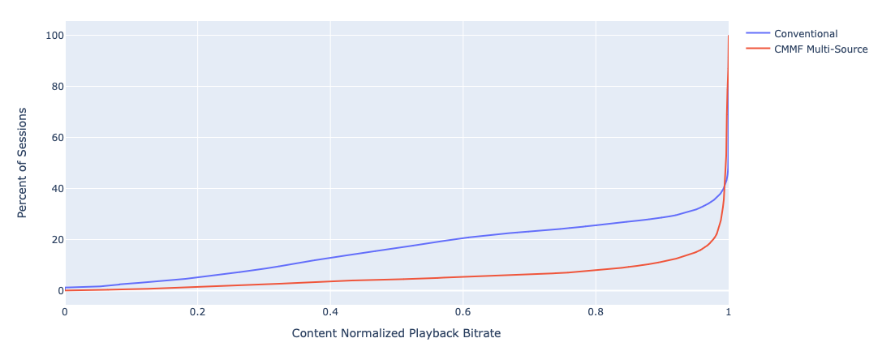
Figure 5.19.1.7.4-1: Empirical CDF of the content normalized average session bit rate
Figure 5.19.1.7.4-2 shows that CMMF multi-source delivery was able to significantly reduce the playback start-up time as well. For example, only 10.4% of the CMMF sessions experienced a startup time greater than 3 seconds compared to 29.0% of the conventional sessions.
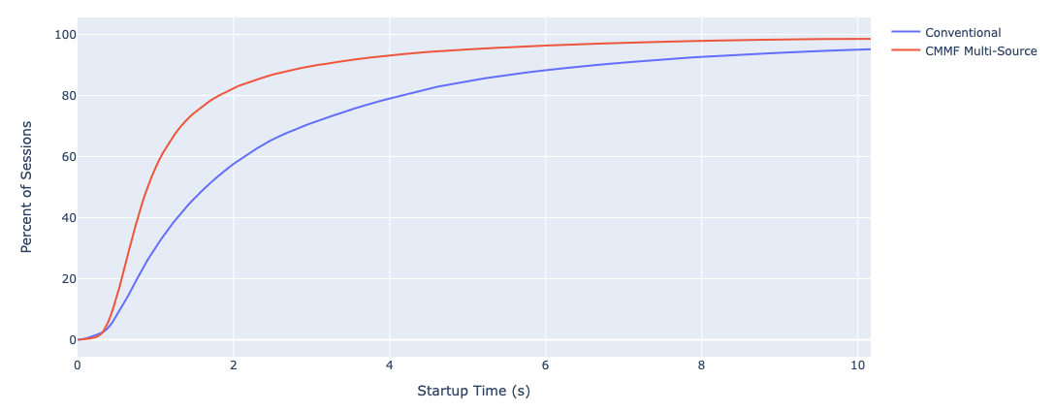
Figure 5.19.1.7.4-2: Empirical CDF of the video startup time
Finally, figure 5.19.1.7.3-3 shows that CMMF multi-source delivery reduced the number of sessions that experienced a connection-induced rebuffering event from 22.4% to 14.9% in addition to reducing the total duration of rebuffering given a rebuffering event occurred.
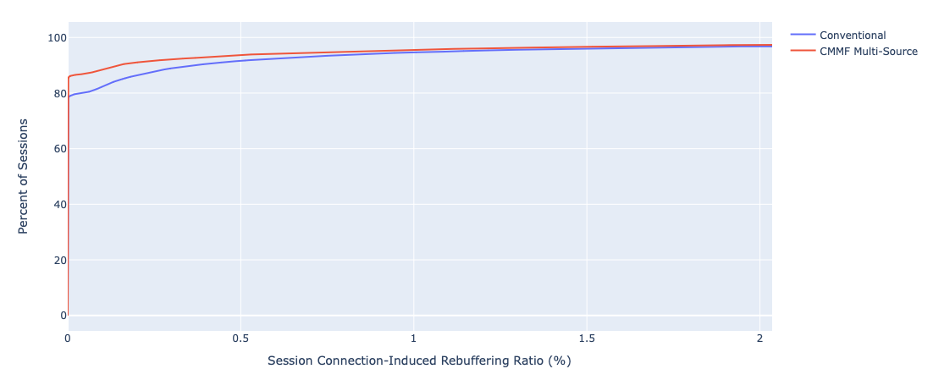
Figure 5.19.1.7.4-3: Empirical CDF of the connection-induced rebuffering ratio (CIRR)

5.19.2 Collaboration scenarios

5.19.2.1 Multi-source media delivery
In this scenario, the 5GMSd Client requests adaptive media streaming content from two or more 5GMSd AS endpoints. These 5GMS AS endpoints are functionally identical and differ only in configuration and potentially in the content that they host. The 5GMSd Client may use one 5GMSd AS endpoint or use multiple simultaneously. This allows the network load to be distributed across the 5GMSd AS endpoints and transport sessions setup at reference point M4d, the cost to be optimized, as well as the QoS to be improved.
As an example, a 5GMS System Operator provides a video streaming service where media is streamed from a 5GMSd AS endpoint deployed within its Trusted DN. To manage peak demand, it may choose to offload a fraction of the total traffic to an externally deployed 5GMSd AS. The quality of the streaming service in this case may be required to be equivalent regardless of whether media is streamed from the 5GMSd AS deployed within the Trusted DN or that deployed externally. By enabling traffic to be offloaded to an externally deployed 5GMSd AS, the 5GMS System Operator may be able to optimize the costs of hosting and delivering media by exploiting third-party capacity during peak periods to deliver content in a stable and consistent manner.
The client’s Media Session Handler discovers the URLs of these 5GMSd AS endpoints from the 5GMSd Application Function (AF), either through a Media Entry Point or from a separate piece of metadata. QoE metrics from the 5GMSd Client may be used by the 5GMSd AF to determine the best 5GMSd AS endpoint(s) for each Media Player to use when streaming media.
Figure 5.19.2.1-1 shows an example collaboration scenario where the Media Player in a 5GMSd Client communicates with multiple 5GMSd AS instances to stream media. Each 5GMSd AS instance has no direct communication with its peers; rather it communicates directly with the 5GMSd Application Provider via reference point M2d and with the 5GMSd AF (not depicted) via reference point M3d.
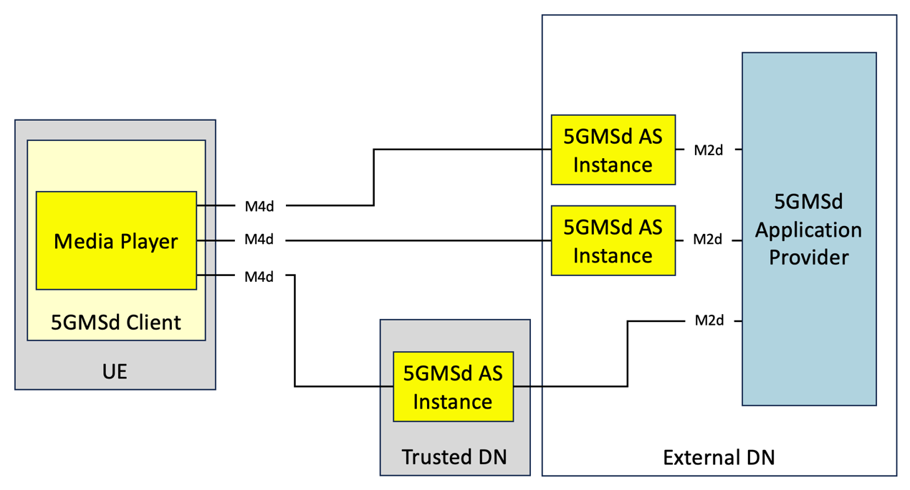
Figure 5.19.2.1-1: Multi-CDN media delivery within 5G system

5.19.2.2 Joint multi-source and multi-access media delivery
In this scenario, the 5GMSd Client is directly connected to multiple Data Networks or access networks (e.g., an unmanaged Wi-Fi network and the 5G network), as described in clause 5.18. The Media Player in the 5GMSd Client requests adaptive media streaming content from two or more 5GMSd AS endpoints. The Media Player may choose one endpoint or use multiple simultaneously. This allows the 5GMSd Client to distribute network load across access networks and 5GMSd AS instances, optimize costs, as well as improve QoS.
The client’s Media Session Handler discovers the URLs of these 5GMSd AS endpoints from the 5GMSd AF, either through a Media Entry Point or from a separate piece of metadata. QoE metrics from the 5GMSd Client may be used by the 5GMSd AF to determine the best 5GMSd AS instance for each Media Player to use when streaming media.
Figure 5.19.2.2-1 shows an example collaboration scenario where the Media Player is consuming media from multiple 5GMSd AS endpoints through different data networks. Neither data network nor the deployed 5GMSd AS instances has direct communication with its peers. Rather, each 5GMSd AS instance communicates with the 5GMSd Application Provider at reference point M2d and with the 5GMSd AF (not depicted) via reference point M3d.
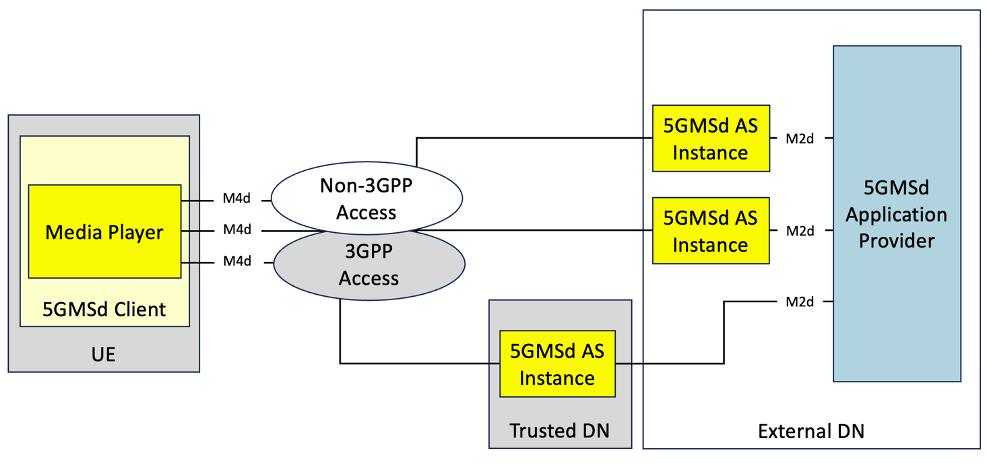
Figure 5.19.2.2-1: Multi-access media delivery within 5G system

5.19.2.3 MPEG-DASH presentations with multiple service locations
Aligned with the functional description of DASH-based client-side switching in clause 5.19.1.4.1, a service location defines a collection of network resources that share commonalities and can be referred to by a common label. Typically, service locations have assigned different URLs. Two different collaboration scenarios are considered:
1) The Application Service Provider creates multiple service locations, one of which is a 5GMSd AS. In this case, the management of the resources, management of switching and so on, is the responsibility of the Application Service Provider, largely outside the scope of the 5GMSd System.
2) The 5GMSd Application Provider creates multiple service locations to distribute content using the 5GMS System based on configuration by the 5GMSd Application Provider.

5.19.3 Architecture mappings

5.19.3.1 Architecture mapping #1: Over-the-top (OTT) multi-source delivery

5.19.3.1.1 General architecture mapping
A general architecture mapping for the case where the 5GMSd Application Provider supplements media delivery over the 5GMS System with externally configured sources (e.g., CDNs) is shown in figure 5.19.3.1.1-1. In this architecture, the 5GMS System is configured and provisioned to deliver media from a single content source/endpoint (i.e., 5GMSd AS); and additional sources/endpoints are configured and provisioned by the 5GMSd Application Provider independent of the 5GMS System. With minor exceptions (as noted below), the use of multi-source delivery is largely transparent to the 5GMS System.
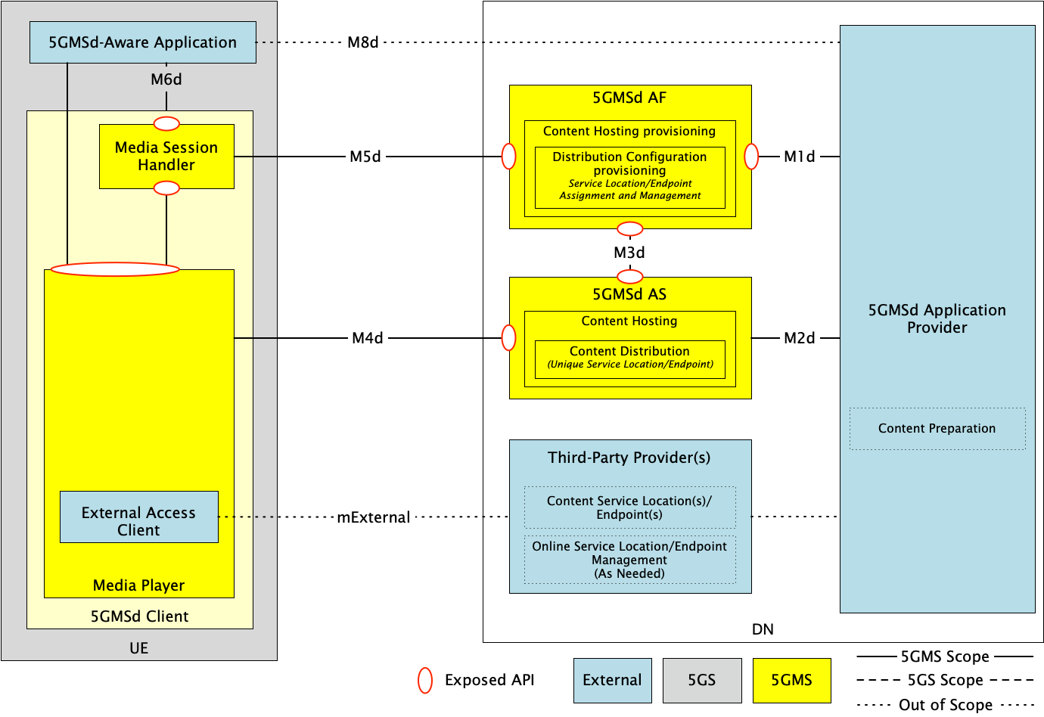
Figure 5.19.3.1.1-1: General architecture mapping for Over-The-Top (OTT) multi-source delivery
A description of the functions and reference points specific to multi-source delivery shown in figure 5.19.3.1.1-1 are provided below. Gaps between these descriptions and the architecture specified in clause 4.2 of TS 26.501 [15] are highlighted in boldface.
The following functions are defined:
- 5GMSd Application Provider: A 5GMSd Application Provider as defined in clause 4.2 of TS 26.501 [15]. The 5GMSd Application Provider is responsible for overall configuration and operation of the multi-source delivery session. This includes selecting the multi-source delivery approach used to deliver content from multiple endpoints, configuring all endpoints (both within the 5GMS System and external to it), preparing all content for multi-source delivery, operation of any management functions required by the multi-source delivery approach in use, etc. Specific subfunctions that may be used include:
- Content Preparation: For multi-source approaches that require content preparation (e.g., content manifest manipulation, CMMF object creation, etc.), the 5GMSd Application Provider is responsible for preparing the content prior to its distribution to the service location/endpoint.
- Content service location(s)/endpoints(s): The 5GMSd Application Provider is responsible for configuration and provisioning of all service locations/endpoints external to the 5GMS System and available to Media Players at a new reference point Mexternal. An example of an external service location/endpoint may include a commercial CDN. Furthermore, each Content service location/endpoint is required to be uniquely addressable and reachable by 5GMSd Clients (e.g., each service location/endpoint, whether external or not, has a unique domain name or base URL).
- Online Service Location/Endpoint Management: Depending on the multi-source approach in use, some form of management function may be required. An example may include a Content Steering Server [DIFCS]. The 5GMSd Application Provider is responsible for operation of this function.
- 5GMSd AF: A 5GMSd AF as defined in clause 4.2 of TS 26.501 [15]. The 5GMSd Application Provider provisions the Content Hosting feature for downlink media delivery. Furthermore, the Content Hosting Configuration defines one or more Distribution Configurations (clause 8.8.3.1 of TS 26.510 [26510]). Each Distribution Configuration is assigned a base URL (i.e., one that includes a scheme, authority and, optionally, path segments) from which content is made available to 5GMSd Clients at reference point M4d. See clause 8.8.3.1 of TS 26.510 [26510] for further details. Details about the provisioned Content Hosting Configuration are made available to the 5GMSd Client’s Media Session Handler at reference point M5d via the Service Access Information (clause 9.2 of TS 26.510 [26510]) and the 5GMSd Application Provider via the Maf_Provisioning API at reference point M1d.
- 5GMSd AS: An Application Server as defined in clause 4.2 of TS 26.501 [15]. Content Hosting is provisioned and configured on the 5GMSd AS by the 5GMSd AF using the Mas_Configuration API at reference point M3d. The provisioned Content Distribution ingests content from the 5GMSd Application Provider at reference point M2d and makes this content available to 5GMSd Clients at reference point M4d. Each provisioned Content Distribution may be located on a single physical host or span multiple physical hosts as required.
- 5GMSd-Aware Application: A 5GMSd-Aware Application as defined in clause 4.2 of TS 26.501 [15]. The 5GMSd-Aware Application is responsible for communicating with the 5GMSd Application Provider at reference point M8d to obtain any necessary configuration information required to access media from multiple service locations/endpoints. This information may include the necessary information required by the specific multi-source approach in use, base URLs of the configured Content Distributions, URLs of any provisioned multi-source management functions, etc. The 5GMSd-Aware Application is also responsible for any configuration of the Media Player needed to enable multi-source delivery via reference point M7d.
- 5GMSd Client: A 5GMSd Client as defined in clause 4.2 of TS 26.501 [15]. Depending on the specific multi-source approach used to deliver media, the 5GMSd Client may require additional functionality than is currently specified. Any differences to the architecture shown here to enable these multi-source delivery approaches are expanded upon in clause 5.19.3.1.2. The 5GMSd Client contains two subfunctions:
- Media Session Handler: A Media Session Handler as defined in clause 4.2 of TS 26.501 [15]. The Media Session Handler communicates with the 5GMSd AF at reference point M5d to establish, control, and support delivery of media from Content Distributions provisioned within the 5GMS System.
- Media Player: A Media Player as defined in clause 4.2 of TS 26.501 [15]. The Media Player communicates with the 5GMSd AS at reference point M4d and external service location(s)/endpoint(s) at reference point Mexternal to download content. The Media Player may also include a Media Access Client subfunction required to operate when using a specific multi-source delivery approach (e.g., switching logic, CMMF decoder, etc.). Specifics are provided in clause 5.19.3.1.2.
The following reference points are defined:
- M1d (5GMSd Provisioning API): 5GMSd Provisioning API as defined in clause 4.2 of TS 26.501 [15].
- M2d (5GMSd Ingest API): 5GMSd content ingest interactions as defined in clause 4.2 of TS 26.501 [15].
- M3d: Internal API as defined in clause 4.2 of TS 26.501 [15].
- M4d (Media Streaming APIs): Media Streaming interactions as defined in clause 4.2 of TS 26.501 [15].
- Mexternal (External Media Streaming APIs): Media Streaming interactions and in-band metrics reporting interactions as described in clause 5.19.3.1.2.4 below between the Media Player and a third-party provider or the 5GMSd Application Provider.
NOTE: This reference point is private and therefore beyond the scope of standardisation.
- M5d (Media Session Handling API): Media Session Handling API as defined in clause 4.2 of TS 26.501 [15].
- M6d (UE Media Session Handling APIs): UE Media Session Handling APIs as defined in clause 4.2 of TS 26.501 [15]. See description of reference point M8d below.
- M7d (UE Media Player APIs): UE Media Player APIs as defined in clause 4.2 of TS 26.501 [15]. See description of reference point M8d below.
- M8d (Application API): Application interface as defined in clause 4.2 of TS 26.501 [15]. In the case where the 5GMSd AS is deployed in an external DN and is not directly configured by the 5GMSd AF (the collaboration scenario depicted in clause A.4 of TS 26.501 [15]), service information (e.g., service location/endpoint base URLs, multiple service location/endpoint delivery configuration information, CMMF Configuration Information, etc.) are communicated from the 5GMSd Application Provider to the 5GMSd-Aware Application via reference point M8d. This information is provided to the Media Session Handler at reference point M6d to be combined with the corresponding Service Access Information obtained from the 5GMSd AF over reference point M5d, or it may be provided directly to the Media Player over reference point M7d.
- M11d (UE Media Player APIs and UE Media Session Handling APIs): UE Media Player APIs and UE Media Session Handling APIs as defined in clause 4.2 of TS 26.501 [15]. Any necessary information obtained from the Service Access Information at reference point M5d or from the 5GMSd-Aware Application at reference point M6d to configure the Media Player for multi-source media delivery is provided at reference point M11d. This information may be dependent on the multi-source delivery approach used. Further details are provided in clause 5.19.3.1.2.
Variations of this general architecture are possible depending on the use case and configuration of the network.

5.19.3.1.2 Multi-source approach-specific architecture mappings

5.19.3.1.2.1 Overview
Depending on the approach used to implement multi-source functionality, the functions and reference points discussed in clause 5.19.3.1.1 may be used differently. These are expanded upon in subsequent clauses.

5.19.3.1.2.2 DNS-based switching
Multi-source delivery using DNS to switch between provisioned service locations/endpoints as described in clause 5.19.1.3 can be realized using the architecture depicted in figure 5.19.3.1.1-1. As an example, the Online Service Location/Endpoint Management function within the 5GMSd Application Provider is used to collect performance metrics from the population of 5GMSd Clients, to make decisions on when 5GMSd Clients should switch to a different service location/endpoint, and to update the appropriate DNS records accordingly, should it determine switching is necessary. Additional 5GMSd Client functionality is not needed if these metrics are reported to the 5GMSd Application Provider via reference point M8d after exposure to the 5GMSd-Aware Application via reference point M7d (see clause 13.2.6 of TS 26.512 [16]). However, modifications to the client may be necessary if those metrics need to be sent via reference point M4d′.

5.19.3.1.2.3 MPEG-DASH client-side switching
Multi-source delivery using MPEG-DASH client-side switching as described in clause 5.19.1.4 may be realized using the architecture depicted in figure 5.19.3.1.1-1. However, additional functionality in the Media Player is required (if not already implemented) to switch between the available Content Distributions (or service locations) as necessary. As described in clause 5.19.1.4, MPEG-DASH client-side switching is signalled using service location decorators within the manifest (i.e., MPD). These service location decorators may be added to each MPD using the 5GMSd Application Provider’s Content Preparation subfunction prior to distribution of those MPDs to 5GMSd Clients.

5.19.3.1.2.4 Content Steering Server driven switching
Multi-source delivery using a Content Steering Server as described in clause 5.19.1.5 may be realized using the architecture as shown in figure 5.19.3.1.1-1. In this case, the 5GMSd Application Provider implements the Content Steering Server within the Online Service Location/Endpoint Management subfunction. The Content Steering Server’s location is signalled privately via reference point M8d or in the content presentation manifest (i.e., MPD). Additional functionality within the Media Player is required (if not already implemented) to switch between provisioned service locations/endpoint accessible via reference points M4d and M4d′, in addition to the functionality to communicate with the Content Steering Server via reference point M4d′.

5.19.3.1.2.5 SAND4M multi-source delivery
Determination of how SAND4M multi-source delivery can be realized within the architecture shown in figure 5.19.3.1.1-1 is left for further study.

5.19.3.1.2.6 CMMF-based multi-source delivery
Several options exist when implementing CMMF as described in clause 5.19.1.7 within the architecture shown in figure 5.19.3.1.1-1. These are expanded upon below.

5.19.3.1.2.6.1 CMMF-enabled 5GMS client architecture
Implementing multi-source delivery using CMMF requires modifications to the 5GMSd client architecture. At minimum, a UE must be able to download CMMF bitstreams/objects from multiple service locations/endpoints (including 5GMSd Content Distributions) simultaneously and be able to decode the received bitstreams/objects. Options for implementing multi-source delivery using CMMF within the UE include:
1. CMMF Client Proxy. This option implements multi-source using CMMF within the UE as a proxy between the Media Player and each CMMF service location/endpoint (which may be a 5GMSd Content Distribution at reference point CMMF-1). The proxy consists of a CMMF Client and a Media Server. Once the Media Session Handler of the 5GMSd Client has configured the CMMF Client via reference point CMMF-2, the Media Player may request source content via the Media Server using reference point CMMF-3. Once a request is received, the CMMF Client downloads different CMMF encoded representations of the requested content via reference point(s) CMMF-1 and/or CMMF-1′ (these reference points are functionally equivalent to reference points M4d and M4d′ respectively despite terminating on a different logical function in the UE), decodes the received CMMF bitstreams/objects, and replies to the Media Player with the requested source content via CMMF-3. This option is illustrated in figure 5.19.3.1.2.6.1-1.
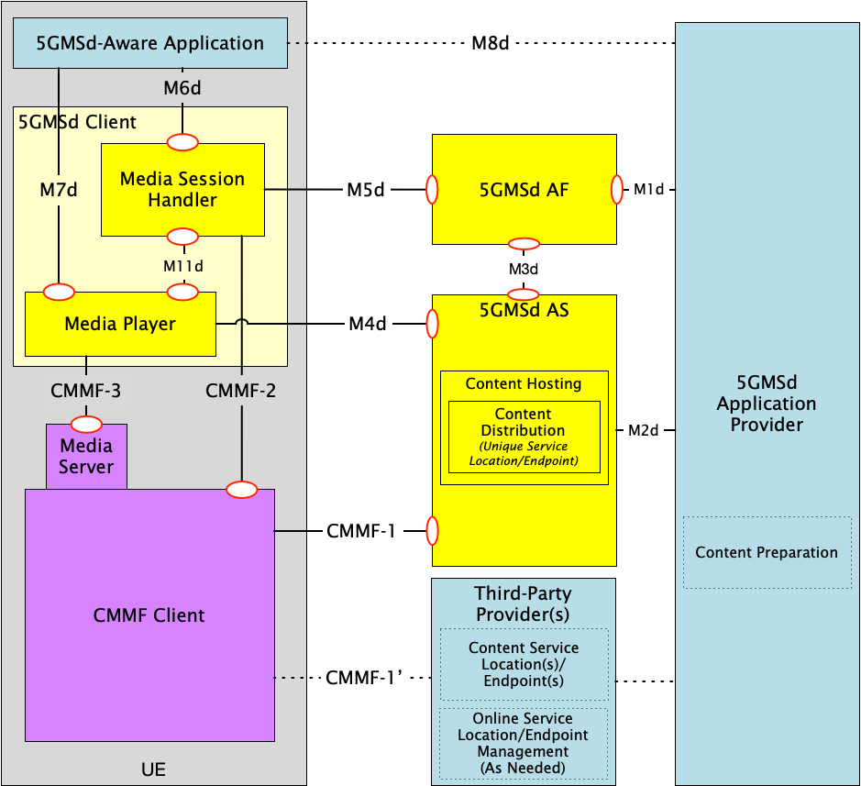
Figure 5.19.3.1.2.6.1-1: Client architecture #1 for integration of CMMF within the 5GMS Client where CMMF is implemented as a client proxy
2. CMMF decoder integrated within the Media Player. This option implements CMMF within the Media Player itself. An example is provided in figure 5.19.3.1.2.6.1-2 depicting CMMF integrated within the DASH-based 5GMSd Client specified in clause 13.2 of TS 26.512 [16]. The architecture and operation of the 5GMS Client is similar to that in [16] with the following exceptions:
a. Download: Downloads source content objects and/or CMMF bitstreams/objects from one or more service location(s)/endpoint(s) in parallel.
b. Request Scheduling: Performs the same function as defined in clause 13.2 of [16] with the addition of managing concurrent requests sent over reference point M4d and CMMF-1′ during the download of CMMF-encoded bitstreams/objects.
c. Throughput Estimation: Estimates the throughput from each individual service location/endpoint (including 5GMSd Content Distributions at reference point M4) in addition to estimating the aggregated throughput from all these service locations/endpoints.
d. CMMF Receiver/Decoder: Temporarily stores and jointly decodes CMMF bitstreams/objects as they are downloaded. Once decoded, the source content objects are moved to the Media Playback Management and Protection Controller subfunctions. The CMMF Receiver/Decoder subfunction also provides status updates containing decode progress to each active download function for the purposes of managing/terminating in-process downloads.
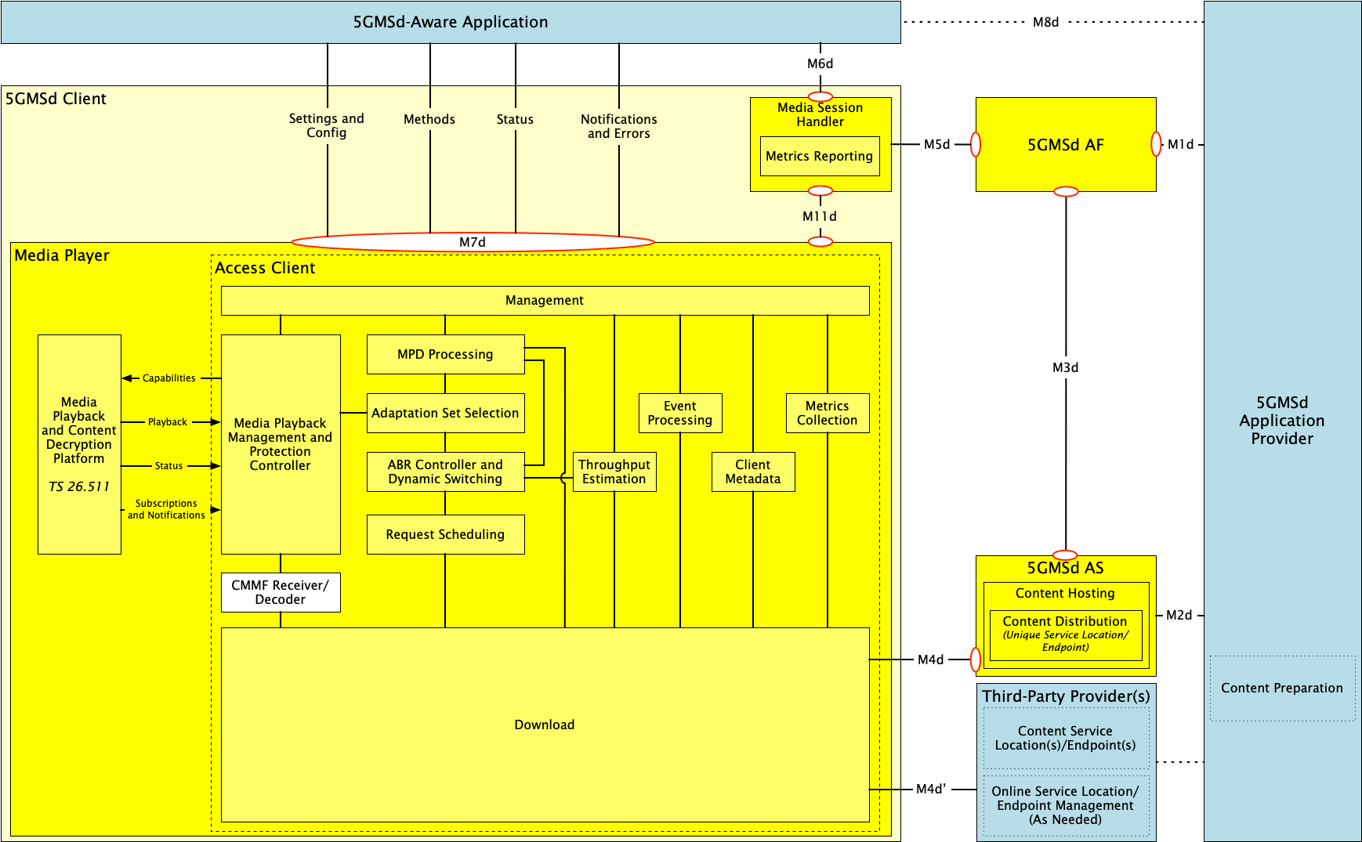
Figure 5.19.3.1.2.6.1-2: Client architecture #2 for integration of CMMF within the 5GMS Client where CMMF is integrated directly within the Media Player

5.19.3.1.2.6.2 5GMSd Client configuration for downlink media streaming using CMMF
CMMF supplements existing media streaming architectures (e.g., MPEG-DASH, etc.) to enable clients to obtain media from multiple endpoints in parallel. Enabling this functionality requires, at a minimum, information concerning where and how CMMF-encoded media can be accessed on one or more service location(s)/endpoint(s) within the network(s).
This CMMF client configuration information may be conveyed to the CMMF Client (assuming client architecture #1 in clause 5.19.3.1.2.6.1) or to the Media Player (assuming client architecture #2 in clause 5.19.3.1.2.6.1) in the 5GMSd Client either:
1. Privately by the 5GMSd Application Provider via a 5GMSd-Aware Application at reference point M8d.
- For client architecture #1, this information may be provided to the Media Session Handler via reference point M6d and then on to the CMMF Client via reference point CMMF-2.
- For client architecture #2, this information may be provided directly to the Media Player via reference point M7d or routed through the Media Session Handler via reference point M6d followed by reference point M11d.
This option is relevant when the CMMF client configuration information is relatively static and is not frequently updated.
2. Contained within a Media Entry Point specified by an existing media streaming framework that is understood by the Media Player (e.g., as additional XML elements or attributes within an MPEG-DASH MPD). This option is relevant when the CMMF client configuration information is relatively static and is not frequently updated.
3. Over reference M4d′ from the Online Service Location/Endpoint Management subfunction (e.g. a Content Steering Server) when more active or extensive management is required. This option is relevant when the CMMF client configuration information is dynamic and may be frequently updated.
The CMMF client configuration information is the set of parameters and addresses which are needed by a 5GMSd Client to activate and control the reception of a CMMF-enabled media downlink media streaming session, primarily information concerning how the CMMF Client (client architecture #1) or Media Player (client architecture #2) accesses one or more CMMF-encoded objects, each containing a different encoded representation of the original source media to be played, from the available service locations/endpoints hosting this content (some of which may be 5GMSd Content Distributions at reference point M4d).
Other CMMF client configuration information that are outside the scope of the present document may also be provided and/or required based on implementation. This may include additional configurable parameters such as load-balancing policies that influence client behaviour when downloading from multiple CMMF endpoints, information about the CMMF profile in use, etc.

5.19.3.1.2.6.3 CMMF content preparation and distribution
CMMF content preparation and distribution is the overall responsibility of the 5GMSd Application Provider in this architecture mapping.
- The 5GMSd Application Provider configures and provisions resources to deliver media using CMMF across both external and trusted data networks. For the architecture shown in figure 5.19.3.1.1-1, CMMF-encoded media delivery is transparent to both the 5GMSd AS at reference point M4d and to any third-party CDN at reference point M4d′/CMMF-1′.
- The 5GMSd Application Provider prepares all CMMF bitstreams/objects intended to be distributed across every service location/endpoint (including 5GMSd Content Distribution) whether or not located within the 5GMS System.
- Hosting of CMMF-encoded media within the 5GMS System follows the established architecture (see clause 4.2 of TS 26.501 [15]) and procedures (see clause 5.2 of [15]) for downlink 5G Media Streaming.
- CMMF-enabled 5GMSd Clients accessing CMMF-encoded media hosted on one or more service locations/endpoints where the media is replicated (rather than different CMMF-encoded representations of that media) treat the set of service endpoints/locations as a single CMMF endpoint. CMMF endpoints established in external Data Networks configured and provisioned by the 5GMSd Application Provider can be used to supplement at reference point M4d′/CMMF-1′ the 5GMS-delivered media at reference point M4d.

5.19.3.1.2.6.4 CMMF object addressing and URL handling
The capability to locate and access multiple CMMF-encoded media objects (each containing different encoded representations of the same original source media) and/or the original source media across multiple service locations/endpoints is required by Media Players to effectively acquire streaming content. Furthermore, the creation of these CMMF-encoded media representations may be dynamic where the 5GMSd Application Provider is creating and caching new CMMF-encoded media objects on demand. Having robust and extensible methods for addressing each CMMF-encoded media object, including the original source media, is necessary to ensure the proper operation of coded multi-source media delivery. At least two approaches exist for addressing these media. Each approach can be used independently or a hybrid of the two can be used in combination.
1. Unique URL path names. Each CMMF-encoded media object containing a different representation of the same original source media object, as well as the original source media object itself, is assigned a unique URL path (i.e., there exists a one-to-one mapping between each CMMF-encoded media object or original source media object and each URL path). For example, every URL contains a unique path to a unique CMMF-encoded media object and original source media object. Table 5.19.3.1.2.6.4-1 provides examples of possible URL path formats where the differences in each URL are emphasised in boldface. This approach enables multiple CMMF-encoded media objects, each containing a different representation of the same original source media object, to be hosted side by side at a single service location/endpoint (or CMMF endpoint) if desired.
Definition of the patterns used may be defined by a CMMF URL template that aids in mapping the URLs obtained from a content manifest (e.g., MPD) to CMMF-encoded media resources that are available via reference points M4d, CMMF-1 or M4d′ (client architecture #2). In addition to this CMMF URL template, the CMMF endpoint URLs may also be required by the CMMF Client (client architecture #1) or Media Player (client architecture #2) to construct a complete URL needed to fetch CMMF-encoded content.
Table 5.19.3.1.2.6.4-1: Approach #1 example URLs assigned to each unique CMMF-encoded media object and original source media object
Object description | Path examples
Original source media object (e.g., media object referenced within an MPEG-DASH MPD or HLS manifest) | /1080p/4mbps/1.m4s
CMMF-encoded media object containing representation A of the original source media object | Example 1: /1080p/4mbps/1.m4s.cmmf-a  Example 2: /1080p/4mbps/cmmf-a/1.m4s
CMMF-encoded media object containing representation B of the original source media object | Example 1: /1080p/4mbps/1.m4s.cmmf-b  Example 2: /1080p/4mbps/cmmf-b/1.m4s
… | …

2. Unique URL authority names. Each CMMF-encoded media object containing a different representation of the same original source media object, as well as the original source media object itself, are each assigned a unique URL where they all share a common URL path, but their URLs differ in the authority (host name and/or port subcomponents per section 3.2 of RFC 3986 [104]). Table 5.19.3.1.2.6.4-2 provides examples of possible URLs where the differences in each URL are emphasised in boldface; and the approach is also illustrated in figure 15.19.1.7.1-3.
URL assignment following this method requires that each service location/endpoint (CMMF endpoint) hosts one, and only one, representation of the original source media. That representation may be the original source media object itself, or a CMMF-encoded media object created from the original source media object. While this approach limits how CMMF-encoded media is distributed within the 5GMS System, it may also simplify content preparation and hosting management by eliminating the need to track and manage creation and placement of CMMF-encoded media objects across service locations/endpoints because it is implied that each and every uniquely addressable Content Distribution (CMMF endpoint) hosts a different representation of the original source media (whether that is the original source media object itself or a CMMF-encoded media object created from the original source media object).
Table 5.19.3.1.2.6.4-2: Approach #2 example URLs assigned to each unique CMMF-encoded media object and original source media object
Object description | Path examples
Original source media object (e.g., media object referenced within an MPEG-DASH or HLS manifest) | //5gms-as-1/1080p/4mbps/1.m4s
CMMF-encoded media object containing representation A of the original source media object | //5gms-as-2/1080p/4mbps/1.m4s
CMMF-encoded media object containing representation B of the original source media object | //5gms-as-3/1080p/4mbps/1.m4s
… | …

5.19.3.2 Architecture mapping #2: 5GMS-integrated multi-source delivery

5.19.3.2.1 General architecture mapping
A general architecture mapping for the case where the multi-source delivery is integrated within the 5GMS System is shown in figure 5.19.3.2.1-1. In this architecture, the 5GMS System is configured and provisioned to deliver media from one or more content sources/endpoints (i.e., Content Distributions) located within the 5GMS System.
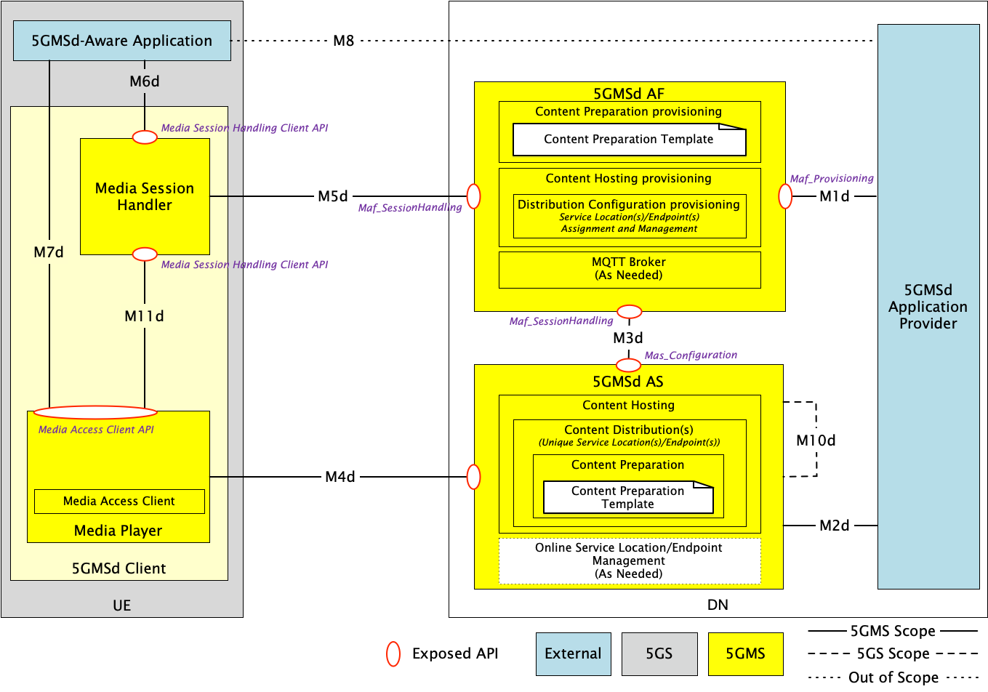
Figure 5.19.3.2.1-1: General architecture mapping for 5GMS-integrated multi-source delivery
A description of the functions and reference points specific to multi-source delivery shown in figure 5.19.3.2.1-1 are provided below. Gaps between these descriptions and the architecture specified in clause 4.2 of TS 26.501 [15] are highlighted in boldface.
The following functions are defined:
- 5GMSd Application Provider: A 5GMSd Application Provider as defined in clause 4.2 of TS 26.501 [15]. The 5GMSd Application Provider provisions the 5GMS System for multi-source media delivery at reference point M1d. The 5GMSd Application Provider provisions the 5GMSd AF with Content Preparation Template(s) (clause 5.2.5 of TS 26.510 [26510]) as required by the multi-source delivery approach used; in addition to providing the 5GMSd AF with a Content Hosting Configuration (clause 5.2.8 of TS 26.510 [26510]) which indicates one or more Distribution Configurations, one for each intended service location/endpoint.
- 5GMSd AF: An Application Function as defined in clause 4.2 of TS 26.501 [15]. The following 5GMSd AF subfunctions are used to enable multiple service location/endpoint capabilities within the 5GMS System:
- Content Preparation provisioning: For cases where the 5GMSd AS is required to process content ingested at reference point M2d, the necessary content processing operations are described by Content Preparation Templates provisioned within the 5GMSd AF by the 5GMSd Application Provider at reference point M1d. These Content Preparation Templates are referenced by the Distribution Configuration(s) indicated within the Content Hosting Configuration. Examples of Content Preparation Templates for the purposes of multiple service location/endpoint delivery may include manifest (e.g., MPD) manipulation to update service location references, CMMF encoding and packaging, etc.
- Content Hosting provisioning: The 5GMSd Application Provider provisions the Content Hosting feature for downlink media delivery. For cases where multiple service locations/endpoints are needed, the Content Hosting Configuration defines multiple Distribution Configurations. Each Distribution Configuration is assigned a base URL (i.e., one that includes a scheme, authority and, optionally, path segments) from which content is made available to 5GMSd Clients at reference point M4d. This base URL is chosen by the 5GMSd AF when the Content Hosting Configuration is provisioned. Furthermore, provisioned Content Preparation Templates are referenced by each configured Distribution as needed to perform any necessary content preparation required to enable multiple service location/endpoint operation. See clause 8.8.3.1 of TS 26.510 [26510] for further details. The format and/or detailed specification of the Content Preparation Template depends on the multi-source delivery approach used. Details of the Media Entry Point specified in each Distribution Configuration in the provisioned Content Hosting Configuration are made available to the 5GMSd Client Media Session Handler at reference point M5d via the Service Access Information.
- MQTT Broker: Optionally, the 5GMSd AF may provide an MQTT Broker (clause 10.2 of TS 26.510 [26510]) for the purposes of managing MQTT notification channels that are used by the 5GMSd AF to notify the 5GMSd Client Media Session Handler about updates to the Service Access Information available at reference point M5d. Updates triggering a notification may include changes to the Distribution Configuration(s) defined in the Content Hosting Configuration such as updates to the Distribution Configuration base URL(s).
- 5GMSd AS: An Application Server as defined in clause 4.2 of TS 26.501 [15]. The following 5GMSd AS subfunctions are used to enable multiple service location/endpoint operations within the 5GMS System.
- Content Hosting: Content Hosting is configured in the 5GMSd AS by the 5GMSd AF using the Mas_Configuration API at reference point M3d. For cases where multiple service locations/endpoints are needed, multiple Content Distributions are configured where each is assigned a unique base URL by the 5GMSd AF. In some cases, a Content Distribution may prepare ingested content prior to making it available to 5GMSd Clients at reference point M4d. Examples of content preparation for multiple service point/endpoint delivery may include manifest (e.g., MPD) manipulation to update service location/endpoint references, CMMF encoding and packaging, etc. Furthermore, each configured Content Distribution may be instantiated on a different physical host as needed to improve reliability and robustness of the 5GMSd System in the cases of hardware failure, network congestion, etc.
- Online Service Location/Endpoint Management: Optionally, an Online Service Location/Endpoint Management subfunction is configured by the 5GMSd AF to support multiple service point/endpoint use cases where more complex management is required than the 5GMSd AF can provide. For example, a Content Steering Server [DIFCS] is needed to steer 5GMSd Clients to specific service locations/endpoints based on application-specific rules and/or performance requirements. 5GMSd Clients communicate with this subfunction over reference point M4d, and the subfunction can receive input from the 5GMSd Application Provider over reference point M2d.
- 5GMSd-Aware Application: A 5GMSd-Aware Application as defined in clause 4.2 of TS 26.501 [15].
- 5GMSd Client: A Media Client as defined in clause 4.2 of TS 26.501 [15]. The following 5GMSd Client subfunctions are used to enable multiple service locations/endpoint operations within the 5GMS System.
- Media Session Handler: A Media Session Handler as defined in clause 4.2 of TS 26.501 [15]. The Media Session Handler obtains complete Service Access Information from the 5GMSd AF via reference point M5d. This Service Access Information contains information regarding the service location/endpoint of each provisioned Content Distribution in the form of Media Entry Points. This information can be made available to the Media Player at reference point M11d to enable multiple service location/endpoint delivery. Optionally, the Media Session Handler may subscribe to an MQTT notification channel established by the 5GMSd AF for the purpose of signalling changes to the Service Access Information (including the changes to the provisioned Media Entry Points) at reference point M5d.
- Media Player: A Media Player as defined in clause 4.2 of TS 26.501 [15]. The Media Player is provided with information about each of the provisioned service locations/endpoints (Media Entry Points) either by the Media Session Handler at reference point M11d or else by the 5GMSd-Aware Application at reference point M7d. This information is provided to the Media Player’s subfunctions, such as the Media Access Client. The Media Access Client uses this information for the purposes of accessing content over reference point M4d from one or more provisioned Content Distributions. For example, this information may be used by the Media Access Client to switch between available Content Distributions or, in the case of CMMF delivery, to download from multiple Content Distributions simultaneously. In the case where an active 5GMSd AS Online Service Location/Endpoint Management subfunction exists in the 5GMSd AS, the Media Access Function communicates with this subfunction via reference point M4d to influence its selection of the appropriate Content Distribution(s) in the 5GMSd AS from which it should access and download content.
The following reference points are defined:
- M1d (5GMSd Provisioning API): 5GMSd Provisioning API as defined in clause 4.2 of TS 26.501 [15].
- M2d (5GMSd Ingest API): 5GMSd content ingest interactions as defined in clause 4.2 of TS 26.501 [15].
- M3d: Internal API as defined in clause 4.2 of TS 26.501 [15].
- M4d (Media Streaming APIs): Media Streaming interactions as defined in clause 4.2 of TS 26.501 [15]. The 5GMSd Client connects to the 5GMSd AS and streams from one or more configured Content Distributions. In addition, the 5GMSd Client may provide performance metrics and service location/endpoint management information to the Online Service Location/Endpoint Management function configured within the 5GMSd AS as described in clause 5.19.3.2.2.4 below. In cases where performance metrics are reported at this reference point, the reported metrics may be in lieu of or in addition to any reporting the Media Session Handler performs over reference point M5d.
- M5d (Media Session Handling API): Media Session Handling API as defined in clause 4.2 of TS 26.501 [15]. The Media Session Handling API is used to provide Service Access Information to the Media Session Handler. This Service Access Information includes references to the Media Entry Point indicated in each of the provisioned Content Distributions. Furthermore, this Service Access Information may be augmented to provide additional information necessary to operate an integrated multi-source delivery platform within the 5GMS System. Further details are provided in clause 5.19.3.2.2.
In the case where the 5GMSd AS is deployed in an external DN and is directly configured by the 5GMSd AF via reference point M3d (the collaboration scenario depicted in clause A.5 of TS 26.501 [15]), service information is communicated as part of the complete Service Access Information provided by the 5GMSd AF at reference point M5d and may additionally be provided at reference point M8d.
- M6d (UE Media Session Handling APIs): UE Media Session Handling APIs as defined in clause 4.2 of TS 26.501 [15]. See description of reference point M8d.
- M7d (UE Media Player APIs): UE Media Player APIs as defined in clause 4.2 of TS 26.501 [15]. See description of reference point M8d.
- M8d (Application API): Application interface as defined in clause 4.2 of TS 26.501 [15].
In the case where the 5GMSd AS is deployed in an external DN and is directly configured by the 5GMSd AF via reference point M3d (the collaboration scenario depicted in clause A.5 of TS 26.501 [15]), service information may be communicated at reference point M8d in addition to being part of the Service Access Information provided by the 5GMSd AF at reference point M5d, as noted above.
- In the case where the 5GMSd AS is deployed in an external DN and is not directly configured by the 5GMSd AF (the collaboration scenario depicted in clause A.4 of TS 26.501 [15]), service information (e.g., service location/endpoint base URLs, multiple service location/endpoint delivery configuration information, CMMF Configuration Information, etc.) may be communicated from the 5GMSd Application Provider to the 5GMSd-Aware Application via reference point M8d. This information is provided to the Media Session Handler at reference point M6d to be combined with the corresponding Service Access Information obtained from the 5GMSd AF over reference point M5d, or it may be provided directly to the Media Player over reference point M7d.
- M11d (UE Media Player APIs and UE Media Session Handling APIs): UE Media Player APIs and UE Media Session Handling APIs as defined in clause 4.2 of TS 26.501 [15]. Any necessary information obtained from the Service Access Information at reference point M5d or from the 5GMSd-Aware Application at reference point M6d to configure the Media Player for multi-source media delivery is provided at reference point M11d. This information may be dependent on the multi-source delivery approach used. Further details are provided in clause 5.19.3.2.2.
Variations of this general architecture, including the combination of this architecture and the one discussed in clause 5.19.3.1.1, are possible depending on the use case and network configuration.

5.19.3.2.2 Multi-source approach-specific architecture mappings

5.19.3.2.2.1 Overview
Depending on the approach used to implement multi-source functionality, the functions and reference points discussed in clause 5.19.3.2.1 may be used differently. These are expanded upon in subsequent clauses.

5.19.3.2.2.2 DNS-based switching
Multi-source delivery using DNS to switch between provisioned Content Distributions as described in clause 5.19.1.3 can be realized using the architecture depicted in figure 5.19.3.2.1-1. Upon provisioning of each Content Distribution in a Content Hosting Configuration, the 5GMSd AF assigns a canonical Fully-Qualified Domain Name (FQDN) where this Content Distribution is accessible via reference point M4d. An alias domain name may also be specified by the 5GMSd Application Provider for use in the URL of the Media Entry Point and/or media. This alias is then used within a DNS CNAME record where the record’s name references the canonical Content Distribution FQDN. Either the 5GMSd AS Online Service Location/Endpoint Management subfunction or another 5GMS System function can update these DNS CNAME records when it determines switching to a different Content Distribution is necessary. No additional 5GMSd Client functionality is needed to implement this approach.

5.19.3.2.2.3 MPEG-DASH client-side switching
Multi-source delivery using MPEG-DASH client-side switching as described in clause 5.19.1.4 may be realized using the architecture depicted in figure 5.19.3.2.1-1. However, additional functionality in the Media Player is required (if not already implemented) to switch between the available Content Distributions as necessary.
Two approaches are possible:
1. MPEG-DASH client-side switching is signalled using service location decorators within the manifest (i.e., MPD) as described in clause 5.19.1.4. These service location decorators may be added to each MPD using a provisioned Content Preparation subfunction that modifies each MPD prior their delivery over reference M4d.
2. A list of the provisioned Content Distribution base URLs or domain names is made available to the Media Access Client by the Media Session Handler over reference point M11d, this list of base URLs having been retrieved from the Service Access Information obtained from the 5GMSd AF over reference point M5d. The Media Player selects one of the available base URLs from the list and joins it to the path URL of the media to be streamed.

5.19.3.2.2.4 Content Steering Server driven switching
Multi-source delivery using a Content Steering Server as described in clause 5.19.1.5 may be realized using the architecture depicted in figure 5.19.3.2.1-1. In this case, the Content Steering Server is implemented within the Online Service Location/Endpoint Management subfunction of the 5GMSd AS. The Content Steering Server’s location is signalled in the content presentation manifest (i.e., MPD). Additional functionality within the Media Player is required (if not already implemented) to switch between provisioned Content Distributions accessible via reference point M4d, in addition to the functionality to communicate with the Content Steering Server via reference point M4d.
No changes are needed when deploying.

5.19.3.2.2.5 SAND4M multi-source delivery
Determination of how SAND4M multi-source delivery can be realized within the architecture shown in figure 5.19.3.2.1-1 is left for further study.

5.19.3.2.2.6 CMMF-based multi-source delivery
Several options exist when implementing CMMF as described in clause 5.19.1.7 within the architecture shown in figure 5.19.3.2.1-1. These are expanded upon below.

5.19.3.2.2.6.1 CMMF-enabled 5GMS client architecture
The 5GMSd Client architecture options described in clause 5.19.3.1.2.6.1 also support the use of CMMF delivery within the general architecture shown in figure 5.19.3.2.1-1.

5.19.3.2.2.6.2 5GMSd Client configuration for downlink media streaming using CMMF
CMMF supplements existing media streaming architectures (e.g., MPEG-DASH, etc.) to enable clients to obtain media from multiple endpoints in parallel. Enabling this functionality requires, at a minimum, information concerning where and how CMMF-encoded media can be accessed on one or more service location(s)/endpoint(s) within the network(s).
This CMMF client configuration information may be conveyed to the CMMF Client (assuming client architecture #1 in clause 5.19.3.1.2.6.1) or to the Media Player in the 5GMSd Client (assuming client architecture #2 in clause 5.19.3.1.2.6.1) either:
1. By the 5GMSd AF to the Media Session Handler as Service Access Information (e.g. Media Entry Point metadata) made available at reference point M5d. The Media Session Handler may then provide this information to the CMMF Client (assuming client architecture #1) via reference point CMMF-2 or to the Media Player (assuming client architecture #2) via reference point M11d. This option is relevant when the CMMF client configuration information is relatively static and is not frequently updated.
2. Contained within a Media Entry Point specified by an existing media streaming framework that is understood by the Media Player (e.g., as additional XML elements or attributes within an MPEG-DASH MPD). This option is relevant when the CMMF client configuration information is relatively static and is not frequently updated.
3. Over reference point M4d from the Online Service Location/Endpoint Management subfunction of the 5GMSd AS (e.g. a Content Steering Server) when more active or extensive management is required. This option is relevant when the CMMF client configuration information is dynamic and may be frequently updated.
The CMMF client configuration information is the set of parameters and addresses which are needed by a 5GMSd Client to activate and control the reception of a CMMF-enabled media downlink media streaming session, primarily information concerning how the CMMF Client (client architecture #1) or Media Player (client architecture #2) accesses one or more CMMF-encoded objects, each containing a different encoded representation of the original source media to be played, from the available Content Distributions hosting this content.
- For option 1 above, additions to the Service Access Information defined in clause 4.2.3 of TS 26.501 [15] may be needed to enable the use of CMMF. This additional information can be used along with existing Service Access Information (e.g., a Media Entry Point document such as an MPEG-DASH MPD) to construct proper URLs that enable the download of CMMF-encoded content from each 5GMSd AS Content Distribution (CMMF endpoint).
- For option 2 above, additional XML elements or attributes in the MPEG-DASH MPD are needed to enable the use of CMMF. This additional information is then used along with the base URLs provided in the MPEG-DASH MPD (i.e., service locations) to construct proper URLs to download CMMF-encoded content from each 5GMSd AS Content Distribution (CMMF endpoint).
Other CMMF client configuration information that are outside the scope of the present document may also be provided and/or required based on implementation. This may include additional configurable parameters such as load-balancing policies that influence client behaviour when downloading from multiple CMMF endpoints, information about the CMMF profile in use, etc.

5.19.3.2.2.6.3 CMMF content preparation and distribution
CMMF configuration, provisioning, and hosting is the overall responsibility of the 5GMSd Application Provider in this architecture mapping.
- The 5GMSd Application Provider may configure and provision resources to deliver media using CMMF across both external and trusted data networks.
- For the general architecture shown in figure 5.19.3.2.1-1, CMMF content preparation and/or hosting is performed by the 5GMS System. The 5GMSd Application Provider configures and provisions 5GMS System resources (e.g., 5GMSd AF, 5GMSd AS, etc.) via reference point M1d to prepare and/or deliver CMMF-encoded media. The 5GMSd Application Provider specifies CMMF content preparation (e.g., CMMF encoding, etc.) and/or hosting by network-side components of the 5GMS System according to a provisioned CMMF Content Preparation Template. In such cases, individual 5GMSd AS Content Distributions operate as separate CMMF endpoints for the purposes of CMMF-enabled media delivery, assuming the 5GMS System has been appropriately configured and provisioned to ensure CMMF-encoded media is not replicated between available Content Distributions.
- 5GMSd Client configuration information is provided to the 5GMSd Client from the 5GMS AF in Service Access Information obtained via reference point M5d.
The provisioning step allows a 5GMSd Application Provider to configure information about its CMMF content preparation and hosting requirements for media streaming sessions using 5GMS resources. The following information is made available and/or configurable over reference point M1d:
- Endpoint locations or base URLs outside the 5GMS System, if any, that support CMMF delivery.
- Information necessary for configuring the preparation of CMMF-encoded media within 5GMSd AS Content Distributions. This includes any necessary CMMF bitstream/object preparation parameters as defined in [CMMF] required to properly encode and package media within CMMF bitstreams/objects. Examples may include CMMF code type, CMMF profile, etc.
- Information necessary for configuring the hosting of CMMF-encoded media on the 5GMSd AS in the form of a Content Hosting Configuration containing one or more Content Distributions.
  - Each Content Distribution is configured with a unique base URL or FQDN.
  - Each Content Distribution may also be configured with a Content Preparation Template describing how to create CMMF bitstreams/objects from ingested media.
- CMMF object and original source object URL handling parameters describing the method and/or format used to assign URLs to CMMF objects created within the 5GMS System. More detail is provided in clause 5.19.3.1.2.6.4.
Once provisioned, the 5GMSd AF allocates and manages the set of Content Distributions (including Content Preparation resources, if necessary) needed for the creation and/or hosting of CMMF bitstreams/objects generated from media provided by the 5GMSd Application Provider at reference point M2d. The 5GMSd AF ensures that each Content Distribution (acting as a single individual CMMF endpoint) is configured to distribute unique CMMF bitstreams/objects created from the original source media to CMMF-enabled UEs.
CMMF multi-source delivery supports several content preparation and hosting workflows. These include:
1. 5GMSd Application Provider Content Preparation. In this option, it is the responsibility of the 5GMS Application Provider to encode and package source content within CMMF bitstreams/objects prior to delivery of that content separately to each 5GMSd AS Content Distribution via reference point M2d, or to each external service location/endpoint (e.g., commercial CDN). This is outlined in clause 5.19.3.1.2.6.3 above.
2. Centralized 5GMSd Content Preparation. In this option, a single, primary 5GMSd AS instance encodes and packages source content that has been ingested at reference point M2d into CMMF bitstreams/objects according to a (yet to be defined) configuration provided by a Content Preparation Template. The CMMF bitstreams/objects created during this media processing task may be delivered directly to the 5GMSd Client (via instances of reference point M4d), delivered to another (secondary) 5GMSd AS instance (via instances of reference point M10d), or delivered to a 5GMSd AS instance located in an external, possibly untrusted, Data Network. These CMMF bitstreams/objects may then be cached and/or forwarded onward. This primary 5GMSd AS instance is responsible for creation of all CMMF encoded representations used to deliver content from multiple sources. This is illustrated in figure 5.19.3.2.2.6.3-1 below. The secondary 5GMSd AS instance may be deployed either in the Trusted DN, in an Edge DN or in an External DN.
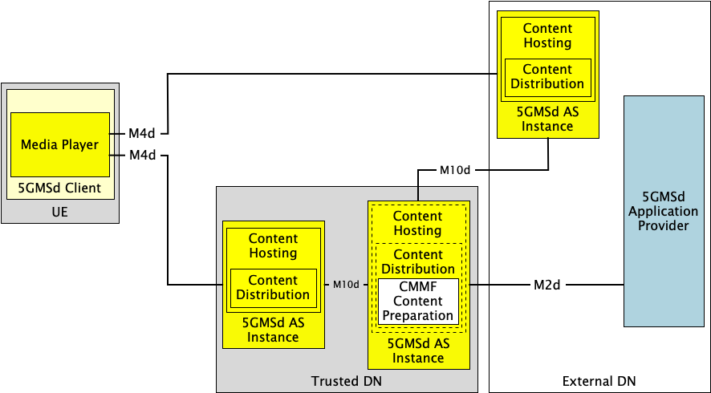
Figure 5.19.3.2.2.6.3-1: Option #2 for deploying CMMF within 5GMS
where a single, primary 5GMSd AS instance performs all CMMF content preparation.
3. Decentralized 5GMSd Content Preparation. The possibility also exists to distribute the CMMF media processing across 5GMSd AS instances such that each one is only responsible for creation of a single CMMF representation which it intends to cache and/or deliver to a 5GMSd Client via an instance of reference point M4d. In this option, each 5GMSd AS instance provisioned with the Content Preparation Template may receive original source content or CMMF-encoded content from either the 5GMSd Application Provider at reference point M2d or from another 5GMSd AS instance via an instance of reference point M10d. This received content is then processed to create a new, unique CMMF-encoded representation which can be used in conjunction with others during a multi-source download. Similarly, an externally deployed 5GMSd AS Content Distribution may be configured by the 5GMSd Application Provider (by private means, denoted M2d′) to perform a similar media processing task to create its own CMMF-encoded representation. This is illustrated in figure 5.19.3.2.2.6.3-2 below.
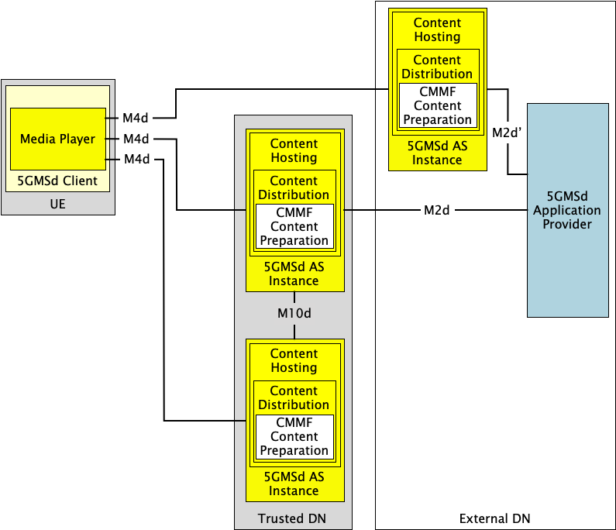
Figure 5.19.3.2.2.6.3-2: Option #3 for deploying CMMF within 5GMS
where each 5GMSd AS Content Distribution performs independent CMMF content preparation.
A combination of the above options is also possible where some aspect of all three exist within a physical realization of the network.

5.19.3.2.2.6.4 CMMF object addressing and URL handling
Details regarding how CMMF objects are addressed and how their URLs are handled are described in clause 5.19.3.1.2.6.4.
The use of one approach over another may be influenced by the method in which CMMF content is prepared and distributed within the 5GMS System.
- For content preparation options #1 and #2 in clause 5.19.3.2.2.6.3, where CMMF content preparation is centralized within either the 5GMS Application Provider or within a single primary 5GMSd AS instance, assigning unique URL path names to each original source media object and each CMMF-encoded media object can be easily implemented and managed according to object addressing Approach #1 in clause 5.19.3.1.2.6.4.
- Object addressing Approach #2, where each CMMF-encoded media object representation is assigned a different URL authority name, may be appropriate when CMMF content preparation is performed in a decentralized manner as shown in content preparation option #3 of clause 5.19.3.2.2.6.3. In these cases, no central management is necessary once the 5GMS System has been configured to prepare CMMF-encoded content or assign URLs and track the location of that content.

5.19.3.3 Multiple service locations/endpoints in the User Plane

5.19.3.3.1 General architecture mapping
A general architecture mapping for the case where the multi-source delivery is integrated within the 5GMS System is shown in figure 5.19.3.3.1-1. In this architecture, the 5GMS System is configured and provisioned to deliver media from one or more service locations. In addition to the multiple service location/endpoint functionality, independent content processing may be provided by the 5GMSd AS to prepare content for multiple service locations/endpoints.
Figure 5.19.3.31-1: General architecture mapping for with multiple service locations/endpoints
Multiple service locations/endpoints are integrated into functions of the Media Player and the 5GMSd AS. The description of multiple service locations/endpoints and related processing is described in the Media Entry Point document. No extensions or new reference points are needed. Gaps between these descriptions and the architecture specified in clause 4.2 of TS 26.501 [15] are highlighted in boldface.
The following functions are defined:
- 5GMSd Application Provider: A 5GMSd Application Provider as defined in clause 4.2 of TS 26.501 [15]. The 5GMSd Application Provider provisions the 5GMS System for multiple service location/endpoint media delivery at reference point M1d. The 5GMSd Application Provider provisions the 5GMSd AF with for multiple service locations/endpoints as well as Content Preparation Template(s) (clause 5.2.5 of TS 26.510 [26510]) in order to prepare the content according to the multiple service location/endpoint approach to be used.
- 5GMSd AF: An Application Function as defined in clause 4.2 of TS 26.501 [15]. The following 5GMSd AF subfunctions are used to enable multiple service location/endpoint capabilities within the 5GMS System:
- Content Preparation provisioning: For cases where the 5GMSd AS is required to process content ingested at reference point M2d, the necessary content processing operations are described by Content Preparation Templates provisioned within the 5GMSd AF by the 5GMSd Application Provider at reference point M1d. These Content Preparation Templates are subsequently referenced by the Distribution Configuration(s) indicated within the Content Hosting Configuration. The details of content preparation are opaque to the 5GMSd AF.
- Content Hosting provisioning: The 5GMSd Application Provider provisions the Content Hosting feature for downlink media delivery. For cases where multiple service locations/endpoints are needed, the Content Hosting Configuration defines multiple Distribution Configurations and, in response, the 5GMSd AF provides the base URLs for each Distribution Configuration to the 5GMS Application Provider.
- MQTT Broker: Optionally, the 5GMSd AF may provide an MQTT Broker (clause 10.2 of TS 26.510 [26510]) for the purpose of managing MQTT notification channels that are used by the 5GMSd AF to notify the 5GMSd Client Media Session Handler about updates to the Service Access Information available at reference point M5d.
- 5GMSd AS: An Application Server as defined in clause 4.2 of TS 26.501 [15]. The following 5GMSd AS subfunctions are used to enable multiple service location/endpoint operations within the 5GMS System.
- Content Hosting: Content Hosting is configured in the 5GMSd AS by the 5GMSd AF using the Mas_Configuration API at reference point M3d. For cases where multiple service locations/endpoints are provisioned at reference point M1d, multiple Content Distributions are configured where each is assigned a unique base URL by the 5GMSd AF.
- Content Preparation: If configured, the Content Preparation Template may include instructions on how to prepare redundant content, for example in the case of CMMF. It may also include mapping of specific content to specific service locations/endpoints.
NOTE: The functions of redundant content preparation and assignment to service locations/endpoints may be split into two different tasks.
- Service Location Management: A Service Location Management subfunction may be configured by the provisioning information to support multiple service location/endpoint use cases where more complex management is required. For example, in cases where a Content Steering Server [DIFCS] is used to steer 5GMSd Clients to specific service locations/endpoints based on application-specific rules and/or performance requirements. 5GMSd Clients communicate with this subfunction over reference point M4d.
- For CMMF, the service location management includes the CMMF configuration information and may update the configuration information.
- For SAND4M, the management uses in-band information to inform clients about changes.

- 5GMSd-Aware Application: A 5GMSd-Aware Application as defined in clause 4.2 of TS 26.501 [15].
- 5GMSd Client: A Media Client as defined in clause 4.2 of TS 26.501 [15]. The following 5GMSd Client subfunctions are used to enable multiple service locations/endpoint operations within the 5GMS System:
- Media Session Handler: A Media Session Handler as defined in clause 4.2 of TS 26.501 [15]. The Media Session Handler obtains complete Service Access Information from the 5GMSd AF via reference point M5d. This Service Access Information includes information that binds different service locations/endpoints to different distributions. The Media Session Handler may provide this information to the Media Player at reference point M11d, but this is transparent to the Media Session Handler.
- Media Player: A Media Player as defined in clause 4.2 of TS 26.501 [15]. The Media Player is provided with Service Access Information and the Service Access Information may include different service locations/endpoints. The Media Player uses the information according to the rules of the multi-source technology to access the content from multiple service locations/endpoints via M4d. The Media Player may be a DASH/HLS client with extended multi-source functionalities, or it may be a combination of a CMMF Client. In the latter case, the CMMF client may be a combination of a CMMF access client and a DASH/HLS player. The details of the player are outside of the scope.
The following reference points are defined:
- M1d (5GMSd Provisioning API): 5GMSd Provisioning API as defined in clause 4.2 of TS 26.501 [15].
- M2d (5GMSd Ingest API): 5GMSd content ingest interactions as defined in clause 4.2 of TS 26.501 [15].
- M3d: Internal API as defined in clause 4.2 of TS 26.501 [15].
- M4d (Media Streaming APIs): Media Streaming interactions as defined in clause 4.2 of TS 26.501 [15]. The 5GMSd Client connects to the 5GMSd AS and streams from one or more configured Content Distributions. In addition, the Media Player may provide performance metrics and service location management information to the Service Location Management function configured within the 5GMSd AS as described in clause 5.19.3.3.2.4 below.
- M5d (Media Session Handling API): Media Session Handling API as defined in clause 4.2 of TS 26.501 [15]. The Media Session Handling API is used to provide Service Access Information to the Media Session Handler. No changes are done to this API.
- M6d (UE Media Session Handling APIs): UE Media Session Handling APIs as defined in clause 4.2 of TS 26.501 [15].
- M7d (UE Media Player APIs): UE Media Player APIs as defined in clause 4.2 of TS 26.501 [15].
- M8d (Application API): Application interface as defined in clause 4.2 of TS 26.501 [15].
- M11d (UE Media Player APIs and UE Media Session Handling APIs): UE Media Player APIs and UE Media Session Handling APIs as defined in clause 4.2 of TS 26.501 [15].

5.19.3.3.2 Specific instantiations

5.19.3.3.2.1 DNS-based switching
Multi-source delivery using DNS to switch between provisioned Content Distributions as described in clause 5.19.1.3 can be realized using the architecture depicted in figure 5.19.3.2.2-1.
Upon provisioning of each Content Distribution in a Content Hosting Configuration, the 5GMSd AS assigns a canonical Fully-Qualified Domain Name (FQDN) where this Content Distribution is accessible via reference point M4d. An alias domain name may also be specified by the 5GMSd Application Provider for use in the URL of the Media Entry Point and/or media. This alias is then used within a DNS CNAME record where the record’s name references the canonical Content Distribution FQDN. The Service Location/Endpoint Management subfunction or another 5GMS System function can update these DNS CNAME records when it determines switching to a different Content Distribution is necessary. No additional 5GMSd Client functionality is needed to implement this approach.

5.19.3.3.2.2 MPEG-DASH client-side switching
Multi-source delivery using MPEG-DASH client-side switching as described in clause 5.19.1.4 may be realized using the architecture depicted in figure 5.19.3.3.1-1. However, additional functionality in the Media Player is required (if not already implemented) to switch between the available Content Distributions as necessary.
For MPEG-DASH, client-side switching to different service locations/endpoints is done based on the service location information within the manifest (i.e., MPD) as described in clause 5.19.1.4. This service location/endpoint information may be added to each MPD using a provisioned Content Preparation subfunction that modifies each MPD prior their delivery over reference point M4d. It may also be the case that not all resources are redundantly made available on all service locations, but only a subset, for example certain language tracks, or the differentiation between UHD/HD content.
NOTE: The MPD is typically also available from multiple service locations/endpoints.

5.19.3.3.2.3 Content Steering Server driven switching
Multi-source delivery using a Content Steering Server as described in clause 5.19.1.5 may be realized using the architecture depicted in figure 5.19.3.3.1-2.
Content preparation is similar to what is done in clause 5.19.3.3.2.2. In addition, in this case, the Content Steering Server is implemented within the Multi-source Delivery subfunction of the 5GMSd AS. The Content Steering Server’s location is signalled in the content presentation manifest (i.e., MPD). Additional functionality within the Media Player is required (if not already implemented) to switch between provisioned service locations/endpoints, possibly assigned to different Content Distributions accessible via reference point M4d, in addition to the functionality to communicate with the Content Steering Server via reference point M4d.
No changes are needed when deploying.

5.19.3.3.2.4 SAND4M multi-source delivery
Multi-source delivery using a SAND4M as described in clause 5.19.1.6 may be realized using the architecture depicted in figure 5.19.3.3.1-1.
Content preparation is similar to what is none in clause 5.19.3.3.2.2. In addition, in this case, the SAND server is implemented within the Multi-Source Delivery subfunction of the 5GMSd AS. The information is provided together with MPD updates, and the update frequency is signalled in the content presentation manifest (i.e., MPD). Additional functionality within the Media Player is required (if not already implemented) to switch between provisioned service locations/endpoints, possibly assigned to different Content Distributions accessible via reference point M4d, in addition to the functionality to communicate with the Content Steering Server via reference point M4d.

5.19.3.3.2.5 CMMF-based multi-source delivery
Several options exist when implementing CMMF as described in clause 5.19.1.7 within the architecture shown in figure 5.19.3.3.1-1. The mapping of CMMF distribution to the architecture is shown in figure 5.19.3.3.5-1.
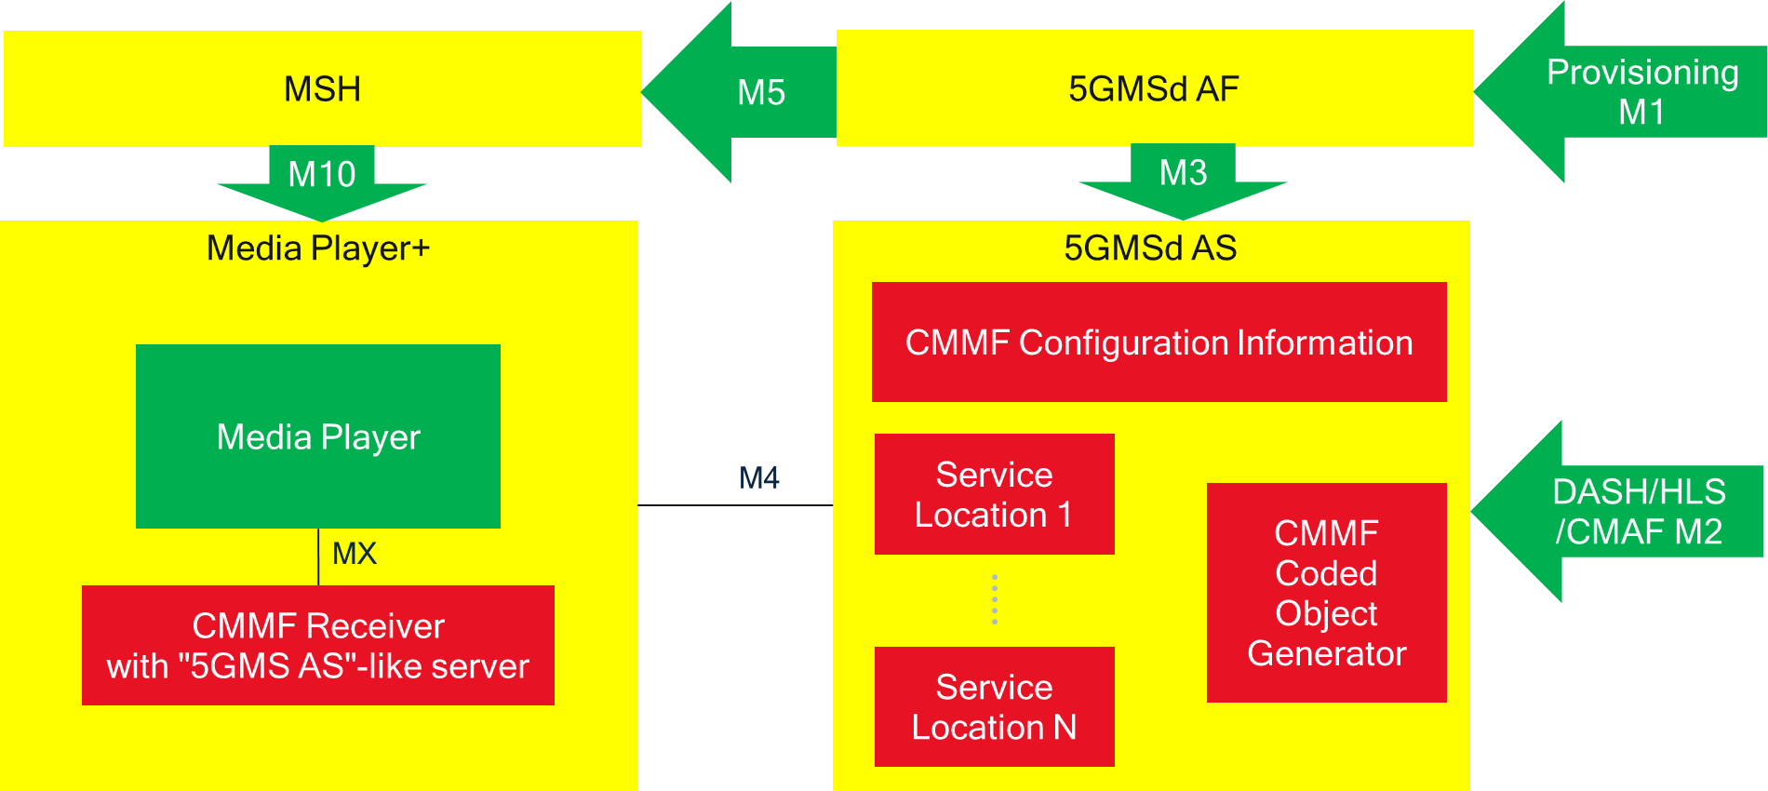
Figure 5.19.3.3.5-1: CMMF distribution mapping to generic architecture
In the provisioning step, the 5GMSd AF is provisioned to provide multiple service locations/endpoints, and to make redundant copies of DASH/HLS/CMAF content available at reference point M4d that have been ingested at reference point M2d. To achieve this, it configures multiple Content Distributions in the 5GMSd AF, and different service locations/endpoints may be mapped to these Content Distributions. Redundant content is generated with CMMF and provided at these different service locations/endpoints.
The configuration information provides all of this information in a manifest document,including an indication that the content included in the CMMF objects is DASH/HLS/CMAF content and possibly the location of the presentation manifest (e.g., MPD). As an example, ETSI TS 103 973 [CMMF] specifies the use of the Extended FDT for this purpose.)
In the UE, the Media Player is the combination of a regular DASH/HLS media player, plus the CMMF Receiver. The CMMF Receiver provides the management and the usage of the DASH media player. Figure 5.19.3.3.5-1 illustrates one embodiment in which the CMMF Receiver includes the functionality a media server.

5.19.4 High-level call flows

5.19.4.1 Over-the-top multi-source for downlink Media Streaming

5.19.4.1.1 General high-level call flows
The procedures defined in clause 5 of TS 26.501 [15] generally apply to the architecture described in clause 5.19.3.1 of the present document. However, the procedure(s) for unicast downlink Media Streaming session establishment defined in clause 5.2 of TS 26.501 [15] are dependent on the multi-source approach in use. Any differences are expanded upon further in subsequent clauses.

5.19.4.1.2 Multi-source approach-specific high-level call flows

5.19.4.1.2.1 Overview
Depending on the approach used to implement multi-source functionality, the procedures for unicast downlink Media Streaming session establishment may differ from those defined in clause 5.2 of TS 26.501 [15]. For the purposes of this study, only differences in the DASH streaming procedures (clause 5.2.3 in TS 26.501 [15]) are shown below.

5.19.4.1.2.2 DNS-based switching
The procedure for streaming MPEG-DASH content using DNS-based switching to determine which content service location/endpoint (including 5GMSd Content Distribution) is used at any one time is shown in figure 5.19.4.1.2.2-1. For this procedure, the following assumptions apply:
- URLs describing the Media Entry Point(s) and media use an alias domain name that can be resolved using DNS.
- 5GMSd Application Provider can create/modify/update DNS CNAME records.
- 5GMSd Client can report performance metrics to an Online Service Location/Management subfunction within the 5GMSd Application Provider for the purposes of determining if switching from one Content Distribution to another is necessary.
- Media hosted in each content service location/endpoint (including 5GMSd Content Distribution) is identical (i.e., media is replicated across these content service locations/endpoints).
Differences from the baseline procedure in clause 5.2.3 of TS 26.501 [15] are highlighted in boldface.
NOTE: The indicated modifications to the baseline procedure can also be extended to the other procedures defined in clause 5.2 of TS 26.501 [15].
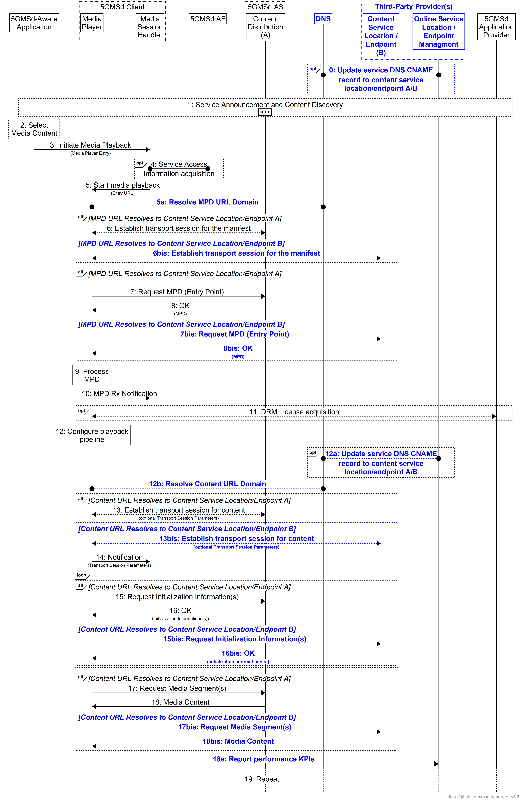
Figure 5.19.4.1.2.2-1: High-level procedure for DASH content using DNS-based switching
The steps for this procedure are largely the same as that shown in clause 5.2.3 of TS 26.501 [15]. The only differences are:
0. An Online Service Location/Endpoint Management subfunction, operated by a Third-Party Provider that is directly managed by the 5GMSd Application Provider, optionally updates the DNS CNAME record with the content service location/endpoint 5GMSd Clients should access to stream content.
NOTE 1: These updates are independent of any 5GMSd Client activity, and the 5GMSd Application Provider or Third-Party Provider can execute this update at any time.
5a. The step showing that the Media Player resolves the domain names of the URLs for the manifest and content is explicitly shown. These steps already occur during transport session establishment and do not indicate the Media Player needs to do anything different than what is described in clause 5.2.3 of TS 26.501 [15].
6bis. The source location/endpoint is different depending on the outcome of the DNS resolution when establishing the transport session.
7bis. The target source location/endpoint for the MPD request is different depending on the outcome of the DNS resolution.
8bis. The source location/endpoint responding to the MPD request is different depending on the outcome of the DNS resolution.
12a. An Online Service Location/Endpoint Management subfunction, operated by a Third-Party Provider that is directly managed by the 5GMSd Application Provider, optionally updates the DNS CNAME record with the content service location/endpoint 5GMSd Clients should access to stream content.
NOTE 2: These updates are independent of any 5GMSd Client activity, and the 5GMSd Application Provider or Third-Party Provider can execute this update at any time.
12b. The step showing that the Media Player resolves the domain names of the URLs for the manifest and content is explicitly shown. These steps already occur during transport session establishment and do not indicate the Media Player needs to do anything different than what is described in clause 5.2.3 of TS 26.501 [15].
13bis. The target source location/endpoint is different depending on the outcome of the DNS resolution when establishing the transport session.
15bis. The source location/endpoint for requesting initialization segments is different depending on the outcome of the DNS resolution.
16bis. The source location/endpoint responding to initialization segment requests is different depending on the outcome of the DNS resolution.
17bis. The source location/endpoint for requesting media segments is different depending on the outcome of the DNS resolution.
18bis. The source location/endpoint responding to media segment requests is different depending on the outcome of the DNS resolution.
18a. Media Player reports performance KPIs to the Third-Party’s Online Service Location/Endpoint Management subfunction. This reporting is necessary so that the subfunction can make informed decisions on whether and when to switch to a different service location/endpoint or not (see step 12a).

5.19.4.1.2.3 MPEG-DASH client-side switching
Streaming MPEG-DASH content using MPEG-DASH client-side switching to determine which Content Distribution and/or content service location/endpoint to stream media from is shown in figure 5.19.4.1.2.3-1.
For this procedure, the following assumptions apply:
- The 5GMSd Application Provider has included the appropriate service location decorators within the MPD that describe where the Media Player can access and download media.
- Media hosted in each Content Distribution and/or content service location/endpoint is identical (i.e., media is replicated across Content Distributions and content service locations/endpoints).
Differences from the baseline procedure in clause 5.2.3 of TS 26.501 [15] are highlighted in boldface.
NOTE: The indicated modifications to the baseline procedure can also be extended to the other procedures contained within clause 5.2 of TS 26.501 [15].
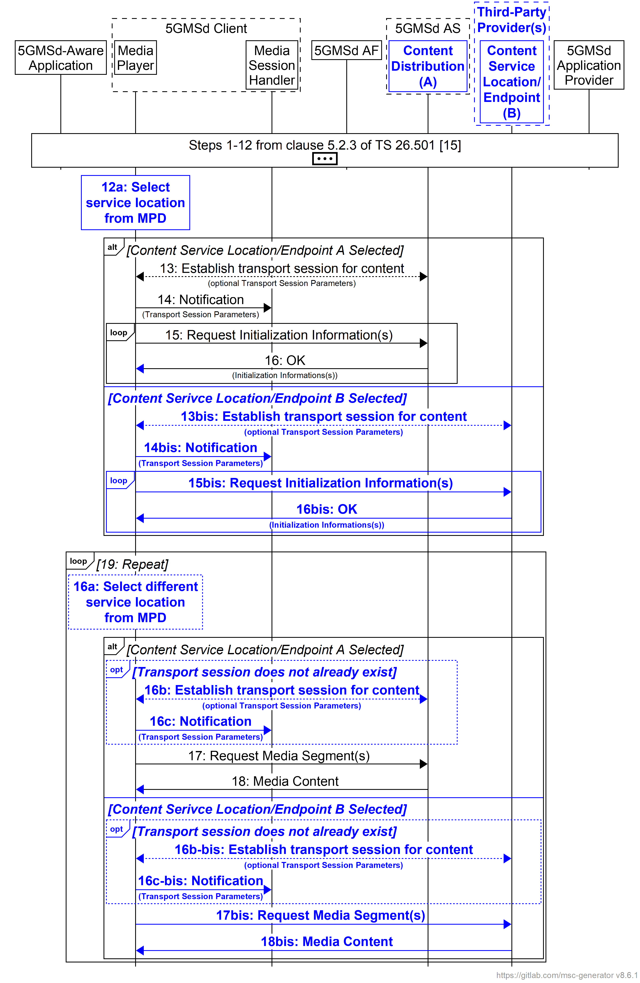
Figure 5.19.4.1.2.3-1: High-level procedure for DASH content using MPEG-DASH client-side switching
The steps for this procedure are largely the same as that shown in clause 5.2.3 of TS 26.501 [15]. The only differences are:
12a. The Media Player selects a service location/endpoint from the MPD for retrieving initialisation segments.
NOTE: The Media Player may establish a separate transport session for each media component (audio, video, etc) and possibly additional transport sessions for other media representations. This detail is omitted from figure 5.19.4.1.2.3-1 for the sake of simplicity.
15bis.The source location/endpoint for requesting initialisation segments is different depending on the Media Player’s service location selection in step 12a.
16bis. The source location/endpoint responding to initialisation segment requests is different depending on the Media Player’s service location selection in step 12a.
16a. The Media Player may select a different service location/endpoint from the MPD for retrieving media segments.
16b. If a transport session with the service location/endpoint selected in step 16a does not already exist, the Media Player establishes one.
16c. The Media Player notifies the Media Session Handler of any updates to the transport session parameters.
16b-bis. As step 16b except that the source location/endpoint for requesting media segments is different depending on the Media Player’s service location selection in step 16a.
16c-bis. As step 16c except that the source location/endpoint responding to nedia segment requesta is different depending on the Media Player’s service location selection in step 16a.
For progressive download or on-demand streaming, the call flows documented in clauses 5.7.3 and 5.7.4 of TS 26.501 [15] apply. In the case of client-side CDN switching, the Dynamic Policy resource in step 8 of clause 5.7.3 and step 15 of clause 5.7.4 declares a separate Application Data Flow description for each 5GMSd AS endpoint to which the Media Player connects at reference point M4d.
By having multiple Application Data Flow descriptions, Dynamic Policies can be instantiated that cover the multiple paths related to the multi-source deployment.
NOTE: In the case of on-demand streaming, it is straightforward to declare each 5GMSd AS endpoint address up front when the Dynamic Policy is instantiated, based on information in the Media Player Entry (MPD). In the case of live content and changing content, however, the 5GMSd AS endpoint addresses could change dynamically.

5.19.4.1.2.4 Content Steering Server driven switching
Streaming MPEG-DASH content using Content Steering Server driven switching to determine which Content Distribution and/or content service location/endpoint to stream media from is shown in figure 5.19.4.1.2.4-1. For this procedure, the following assumptions apply:
- The 5GMSd Application Provider has included the appropriate service location decorators within the MPD that describe where the Media Player can access and download media. This also includes the location of the Content Steering Server.
- The Media Player conforms to [DIFCS].
- Media hosted in each Content Distribution and/or content service location/endpoint is identical (i.e., media is replicated across Content Distributions and content service locations/endpoints).
Differences from the baseline procedure in clause 5.2.3 of TS 26.501 [15] are highlighted in boldface.
NOTE: The indicated modifications to the baseline procedure can also be extended to the other procedures contained within clause 5.2 of TS 26.501 [15].
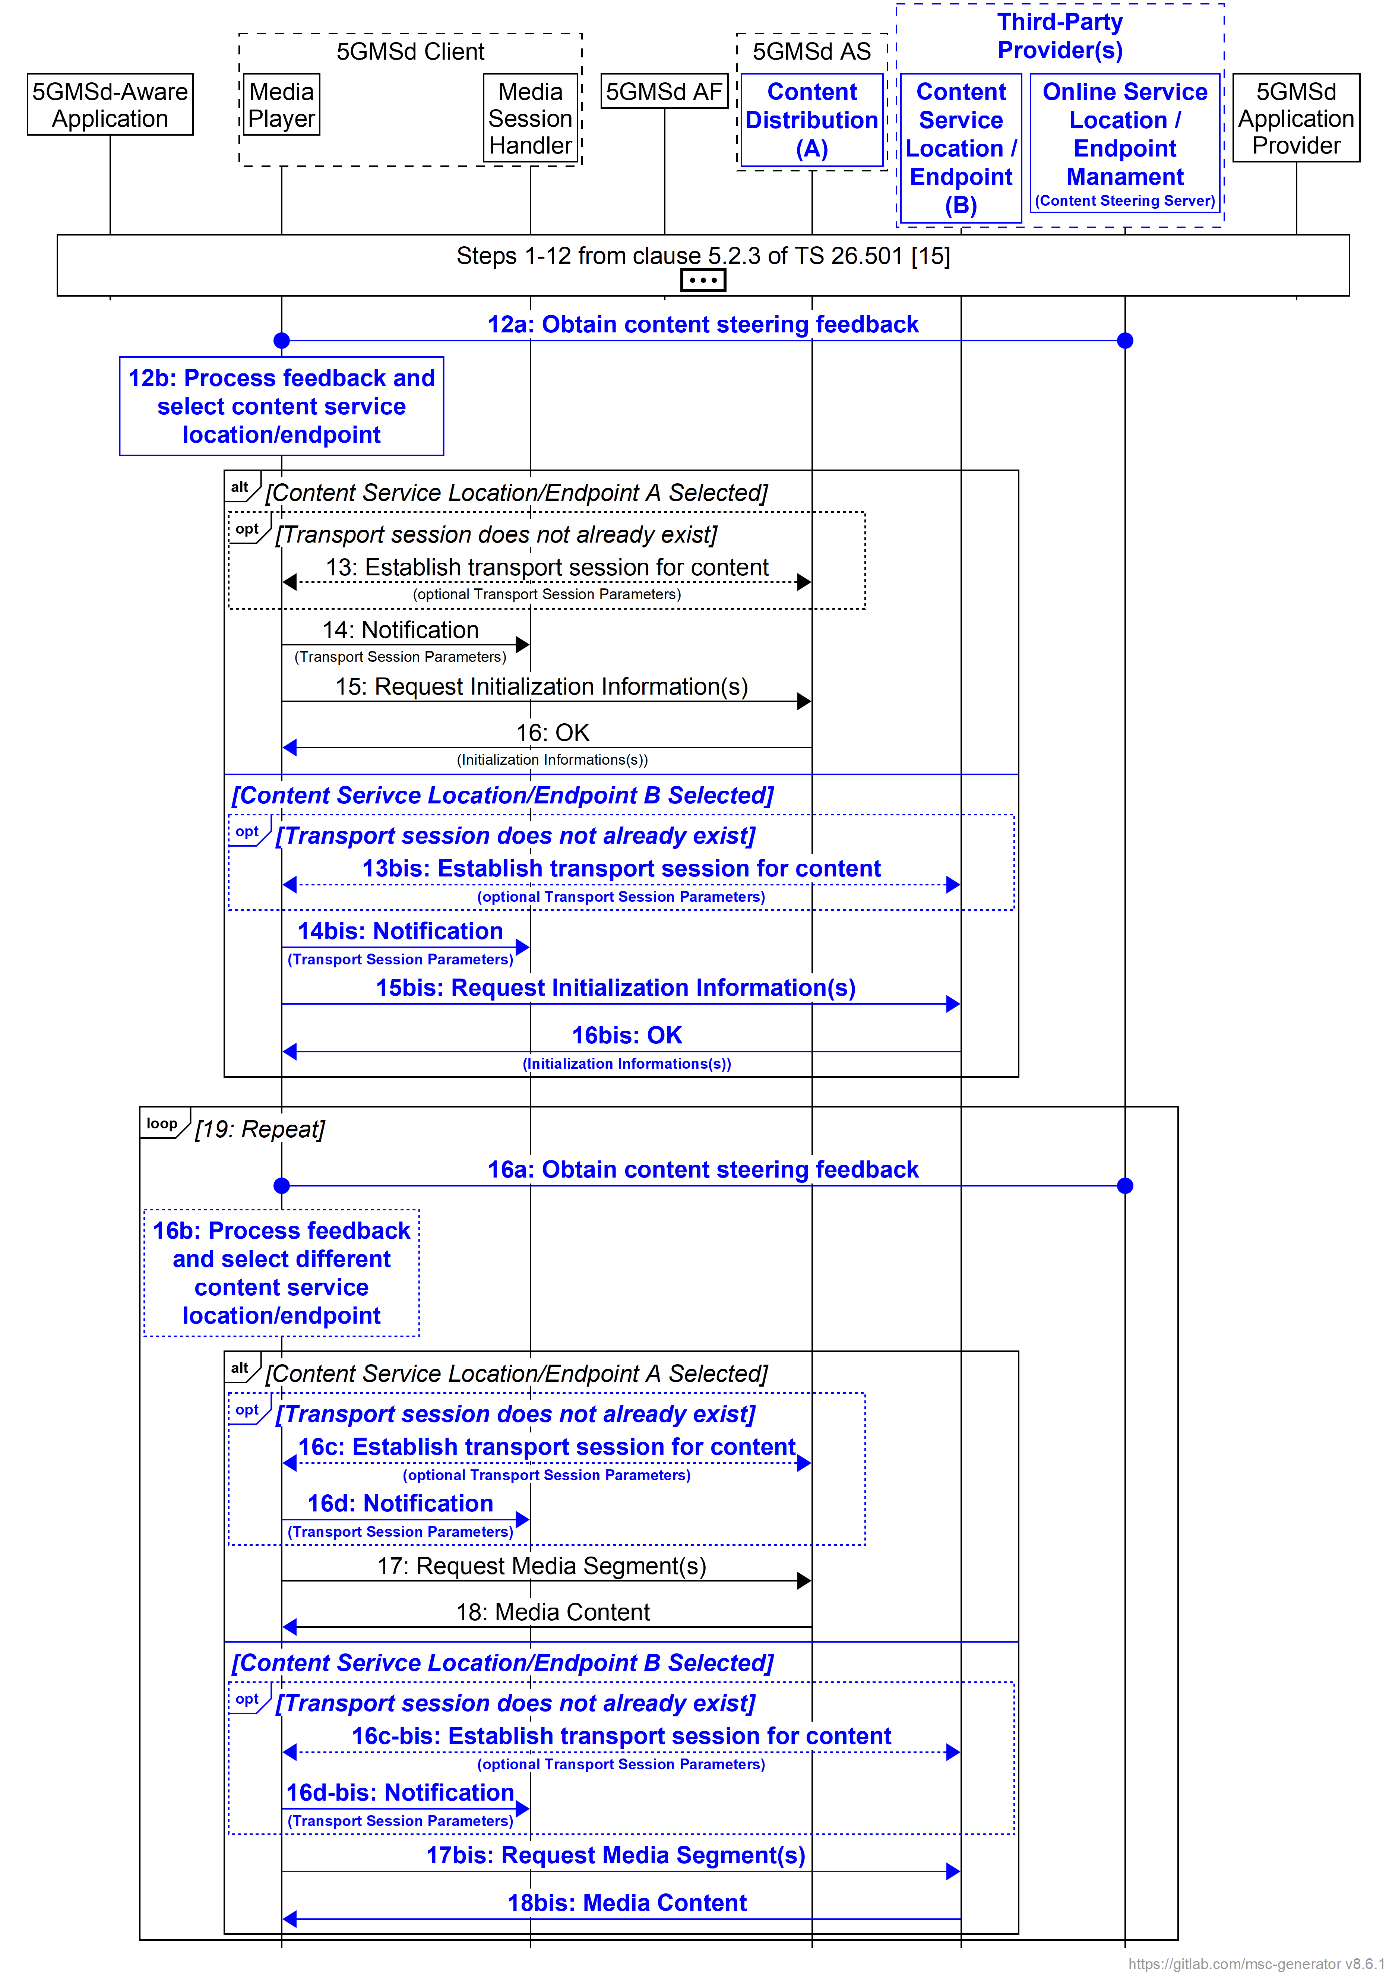
Figure 5.19.4.1.2.4-1: High-level procedure for DASH content using Content Steering Server driven switching
The steps for this procedure are largely the same as that shown in clause 5.2.3 of TS 26.501 [15]. The only differences are:
12a. The Media Player requests and receives Steering Instruction from the Content Steering Server per [DIFCS].
12b. The Media Player selects a service location/endpoint using feedback obtained from the Content Steering Server.
NOTE: The Media Player may establish a separate transport session for each media component (audio, video, etc) and possibly additional transport sessions for other media representations. This detail is omitted from figure 5.19.4.1.2.4-1 for the sake of simplicity.
15bis. The source location/endpoint for requesting initialisation segments is different depending on the Media Player’s service location selection in step 12a.
16bis.The source location/endpoint responding to initialisation segment requests is different depending on the Media Player’s service location selection in step 12a.
16a. The Media Player requests and receives Steering Instruction from the Content Steering Server per [DIFCS].
16b. The Media Player selects a service location/endpoint using feedback obtained from the Content Steering Server.
16c. If a transport session with the service location/endpoint selected in step 16b does not already exist, the Media Player establishes one.
16d. The Media Player notifies the Media Session Handler of any updates to the transport session parameters.
16c-bis. As step 16c except that the source location/endpoint is different depending on the Media Player’s service location selection in step 18a.
16d-bis. As step 16d except that the source location/endpoint is different depending on the Media Player’s service location selection in step 18a.

5.19.4.1.2.5 SAND4M multi-source delivery
High-level call flows describing how SAND4M can be used to enable multi-source delivery are left for further study.

5.19.4.1.2.6 CMMF-based multi-source delivery
The intent of CMMF is to supplement existing downlink streaming procedures, rather than replace them entirely. As such, minimal changes to the procedures provided in clause 5 of TS 26.501 [15] are necessary. Enabling multi-source media delivery using CMMF within existing downlink media delivery workflows can generally be realised through the following:
1. CMMF-encoded media objects, and possibly original source media (e.g., MPEG-DASH or HLS media segments), are striped across multiple uniquely addressable service endpoints/locations, which may include 5GMSd AS Content Distributions as well as third-party CDNs. Each service endpoint/location containing the same CMMF-encoded media object (or stripe) of the media (i.e., the CMMF-encoded media object is replicated across multiple service endpoints/locations, which may be 5GMSd AS instances) is considered a single CMMF endpoint. Within the architecture shown in figure 5.19.3.1.1-1, the 5GMSd Application Provider makes the CMMF-encoded media objects, and possibly original source media (e.g., MPEG-DASH or HLS media segments), available at reference point M2d as well as to third-party CDNs.
2. Upon initialization, the 5GMSd-Aware Application obtains relevant Service Access Information from the 5GMSd Application Provider at reference point M8d. At a minimum, this includes details concerning the location of each service endpoint/location (CMMF endpoint) from which a stripe of CMMF-encoded and possibly original media (e.g., MPEG-DASH or HLS media segments) may be obtained, as well as appropriate signalling to indicate whether the media at each location is CMMF-encoded.
3. The 5GMSd Client connects to and downloads CMMF-encoded media objects, and possibly the original source media (e.g., MPEG-DASH or HLS media segments), from each service endpoint/location (CMMF endpoint) simultaneously via reference point CMMF-1 (client architecture #1) or M4d (client architecture #2), terminating downloads early upon obtaining enough of the CMMF-encoded objects to recover the source media (e.g., MPEG-DASH or HLS media segment). Successfully decoded source media is presented by the Media Player.
The procedure depicted below illustrates how CMMF can supplement downlink media delivery using MPEG-DASH as defined in clause 5.2.3 of TS 26.501 [15]. The following assumptions apply:
- The 5GMSd Application Provider prepares source media for distribution using CMMF and ensures that each service endpoint/location (CMMF endpoint) is provisioned with a uniquely encoded representation (or stripe) of all media.
- CMMF-encoded content hosted is treated within the 5GMS System as any other non-CMMF-encoded content is treated (i.e., hosting CMMF-encoded content within the 5GMS System is transparent to the 5GMS Content Hosting function).
- The 5GMSd Client is provisioned with the functionality to access and download from multiple CMMF endpoint in parallel. This includes the functionality to efficiently download partial CMMF objects and jointly decode these partially received CMMF objects to recover the original source media requested by the Media Player.
Differences from the baseline procedure in clause 5.2.1 of TS 26.501 [15] are highlighted in boldface.
NOTE 1: Variations to the procedure below are possible for signalling necessary CMMF configuration information to the 5GMSd Client. For example, the 5GMSd Application Provider may provide an Online Service Location/Endpoint Management endpoint for the purpose of communicating this information at reference point M4d.
NOTE 2: The indicated modifications to the baseline procedure can also be extended to the other procedures contained within clause 5.2 of TS 26.501 [15].
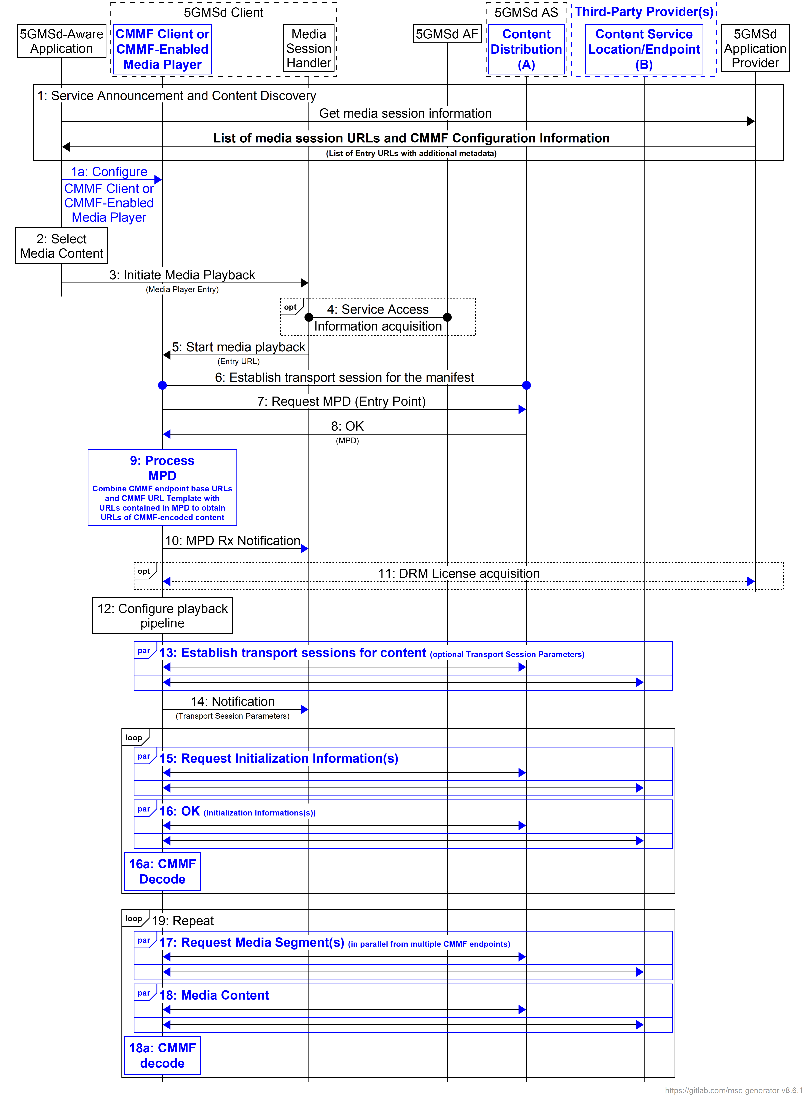
Figure 5.19.4.1.2.6: High-level procedure for DASH content using CMMF delivery
The steps for this procedure are largely the same as that shown in clause 5.2.3 of TS 26.501 [15]. The only differences are:
1. The 5GMSd-Aware Application triggers the Service Announcement and Service and Content Discovery procedure. The Service and Content Discovery procedure only involves the App and the external Application Server. The Service Announcement includes either the whole Service Access Information (i.e. details for Media Session Handling (M5d) and for Media Streaming access (M4d)) or a reference to the service access information. The Service Access Information includes relevant CMMF Client configuration information. This CMMF client configuration information may consist of URLs to each CMMF endpoint, a CMMF URL template allowing for translation of the URLs provided in content manifests (e.g., MPD) into URLs that can be used to access CMMF-encoded media within the 5GMS System, etc.
1a. The 5GMSd-Aware Application uses the CMMF client configuration information to set up and configure the CMMF object and decode functions within the CMMF Client or CMMF-Enabled Media Player.
9. The Media Player processes the MPD. Based on the information contained within the MPD as well as the relevant CMMF client configuration Information contained in the Service Access Information, the CMMF Client or CMMF-enabled Media Player determines, for example, the number of transport sessions needed for media acquisition, complete URLs to CMMF-encoded media, etc. The Media Player should use the MPD information to initialize the media pipelines for each media stream. The MPD should also contain information to initialize the DRM client, when DRM is used.
NOTE: CMMF does not impede the use of DRM as long as DRM is applied to the original source media prior to creation of CMMF-encoded objects of that media.
14. The Media Player establishes the necessary transport sessions for the CMMF-encoded content. For example, the CMMF Client or CMMF-enabled Media Player may establish one transport session for each media component (audio, video, etc) and possibly additional transport sessions for other media representations to each CMMF endpoint communicated by the CMMF client configuration information.
15. The Media Player requests initialization information. In the case where this initialization information has been encoded within CMMF objects, the CMMF Client or CMMF-enabled Media Player requests the CMMF-encoded initialization information objects from each CMMF endpoint in parallel. The URLs of the CMMF-encoded initialization information objects are determined using the MPD and information contained within the CMMF client configuration information (e.g., base URLs to each CMMF endpoint, CMMF URL Template, etc.). The CMMF Client of CMMF-enabled Media Player repeats this step for each required initialization segment.
16. The CMMF Client or CMMF-enabled Media Player receives the initialization information. In the case where this initialization information has been encoded within CMMF objects, the CMMF Client or CMMF-enabled Media Player downloads these multiple CMMF-encoded initialization information objects from each CMMF endpoint in parallel until such time as the CMMF decoder has received enough information to successfully decode, at which point the download of any incompletely acquired CMMF object is abandoned.
16a. In the case where the initialization information has been encoded within CMMF objects, the received information from the CMMF objects containing the initialization information is decoded by the CMMF decoder in the CMMF Client.
17. The CMMF Client or CMMF-enabled Media Player requests media segments according to the MPD. In the case where these media segments have been encoded within CMMF objects, the CMMF Client or CMMF-enabled Media Player requests the CMMF-encoded media segment objects from each CMMF endpoint in parallel. The URLs of the CMMF-encoded media segment objects are determined using the MPD and information contained within the CMMF Client configuration information (e.g., base URLs to each CMMF endpoint, CMMF URL template, etc.).
18. The CMMF Client or CMMF-enabled Media Player receives media segments. In the case where these media segments have been encoded within CMMF objects, the CMMF Client or CMMF-enabled Media Player downloads these multiple CMMF-encoded media segment objects from each CMMF endpoint in parallel until such time as the CMMF decoder has received enough information to successfully decode, at which point the download of any incompletely acquired CMMF object is abandoned.
18a. In the case where the media segments have been encoded within CMMF objects, the received information from the CMMF objects containing the media segment is decoded by the CMMF decoder in the CMMF Client and the decoded information is placed into the appropriate media rendering pipeline.

5.19.4.2 5GMS-integrated multi-source delivery

5.19.4.2.1 General high-level call flows
The procedures defined in clause 5 of TS 26.501 [15] generally apply to the architecture described in clause 5.19.3.2. However, some procedure(s) for unicast downlink Media Streaming session establishment defined in clause 5.2 of TS 26.501 [15] and media preparation are dependent on the multi-source approach in use. Any differences are expanded upon further in subsequent clauses.

5.19.4.2.2 Multi-source approach-specific high-level call flows

5.19.4.2.2.1 Overview
Depending on the approach used to implement multi-source functionality, the procedures for unicast downlink Media Streaming session establishment and content preparation may differ from those defined in clause 5 of TS 26.501 [15].

5.19.4.2.2.2 DNS-based switching
The call flow is similar to that contained in clause 5.19.4.1.2.2 with the following exceptions:
- The Content Service Location/Endpoint located within the Third-Party Provider(s) becomes a second Content Distribution within the 5GMSd AS.
- The Online Service Location/Endpoint Management subfunction located within the Third-Party Provider(s) is becomes a subfunction within the 5GMSd AS.

5.19.4.2.2.3 MPEG-DASH client-side switching
The call flow is similar to that contained in clause 5.19.4.1.2.3 with the following exceptions:
- The Content Service Location/Endpoint located within the Third-Party Provider(s) becomes a second Content Distribution within the 5GMSd AS.

5.19.4.2.2.4 Content Steering Server driven switching
The call flow is similar to that contained in clause 5.19.4.1.2.3 with the following exceptions:
- The Content Service Location/Endpoint located within the Third-Party Provider(s) becomes a second Content Distribution within the 5GMSd AS.
- The Online Service Location/Endpoint Management subfunction located within the Third-Party Provider(s) becomes a subfunction within the 5GMSd AS.

5.19.4.2.2.5 SAND4M multi-source delivery
High-level call flows describing how SAND4M can be used to enable multi-source delivery are left for further study.

5.19.4.2.2.6 CMMF-based multi-source delivery

5.19.4.2.2.6.1 Overview
The intent of CMMF is to supplement existing downlink streaming procedures, rather than replace them entirely. As such, minimal changes to the procedures provided in clause 5 of TS 26.501 [15] are necessary. Enabling multi-source media delivery using CMMF within existing downlink media delivery workflows can generally be realised through the following:
1. CMMF-encoded media objects, and possibly original source media (e.g., MPEG-DASH or HLS media segments), are striped across multiple uniquely addressable 5GMSd AS Content Distributions. Each 5GMSd AS Content Distribution containing the same CMMF-encoded media object (or stripe) of the media (i.e., the CMMF-encoded media object is replicated across multiple 5GMSd AS instances with an identical Content Distribution) is considered a single CMMF endpoint. The 5GMSd Application Provider makes the CMMF-encoded media objects, and possibly original source media (e.g., MPEG-DASH or HLS media segments), available at reference point M2d or they may be created by the 5GMSd AS performing content preparation on either regular media objects (e.g., MPEG-DASH or HLS media segments) ingested at reference point M2d or already created CMMF-encoded media objects ingested at reference point M2d.
2. Upon initialization of a playback session, the 5GMSd Client’s Media Session Handler obtains relevant Service Access Information from the 5GMSd AF at reference point M5d. At a minimum, this includes details concerning the location of each 5GMSd AS Content Distribution (CMMF endpoint) from which a stripe of CMMF-encoded and possibly original media (e.g., MPEG-DASH or HLS media segments) may be obtained, as well as appropriate signalling to indicate whether the media at each location is CMMF-encoded.
3. The 5GMSd Client connects to and downloads CMMF-encoded media objects, and possibly the original source media (e.g., MPEG-DASH or HLS media segments), from each 5GMSd AS Content Distribution (CMMF endpoint) simultaneously via reference point CMMF-1 (client architecture #1) or M4d (client architecture #2), terminating downloads early upon obtaining enough of the CMMF-encoded objects to recover the source media (e.g., MPEG-DASH or HLS media segment). Successfully decoded source media is presented by the Media Player.
The procedures for enabling multi-source delivery using CMMF for MPEG-DASH streaming sessions and provisioning the 5GMS System as shown in figure 5.19.3.2.1-1 to deliver CMMF-encoded media objects are provided in the following clauses.

5.19.4.2.2.6.2 CMMF provisioning, hosting, and processing procedure
The workflow for provisioning network resources and/or hosting CMMF-encoded media is dependent on the 5GMSd Application Provider requirements and network configuration. Assuming the 5GMSd Application Provider creates CMMF-encoded media, provides that media over reference point M2d, provisions CMMF endpoints external to the 5GMS System, and manages the configuration of the 5GMSd Client over reference point M8d, the procedures as outlined in clause 5.19.4.1.2.6 are sufficient to host and deliver CMMF-encoded media. However, cases exist where the 5GMS System may take a more active role in delivering CMMF-encoded media. These cases are outlined in the procedure below. Differences from the baseline procedure in clause 7.2 of TS 26.501 [15] are highlighted in boldface.
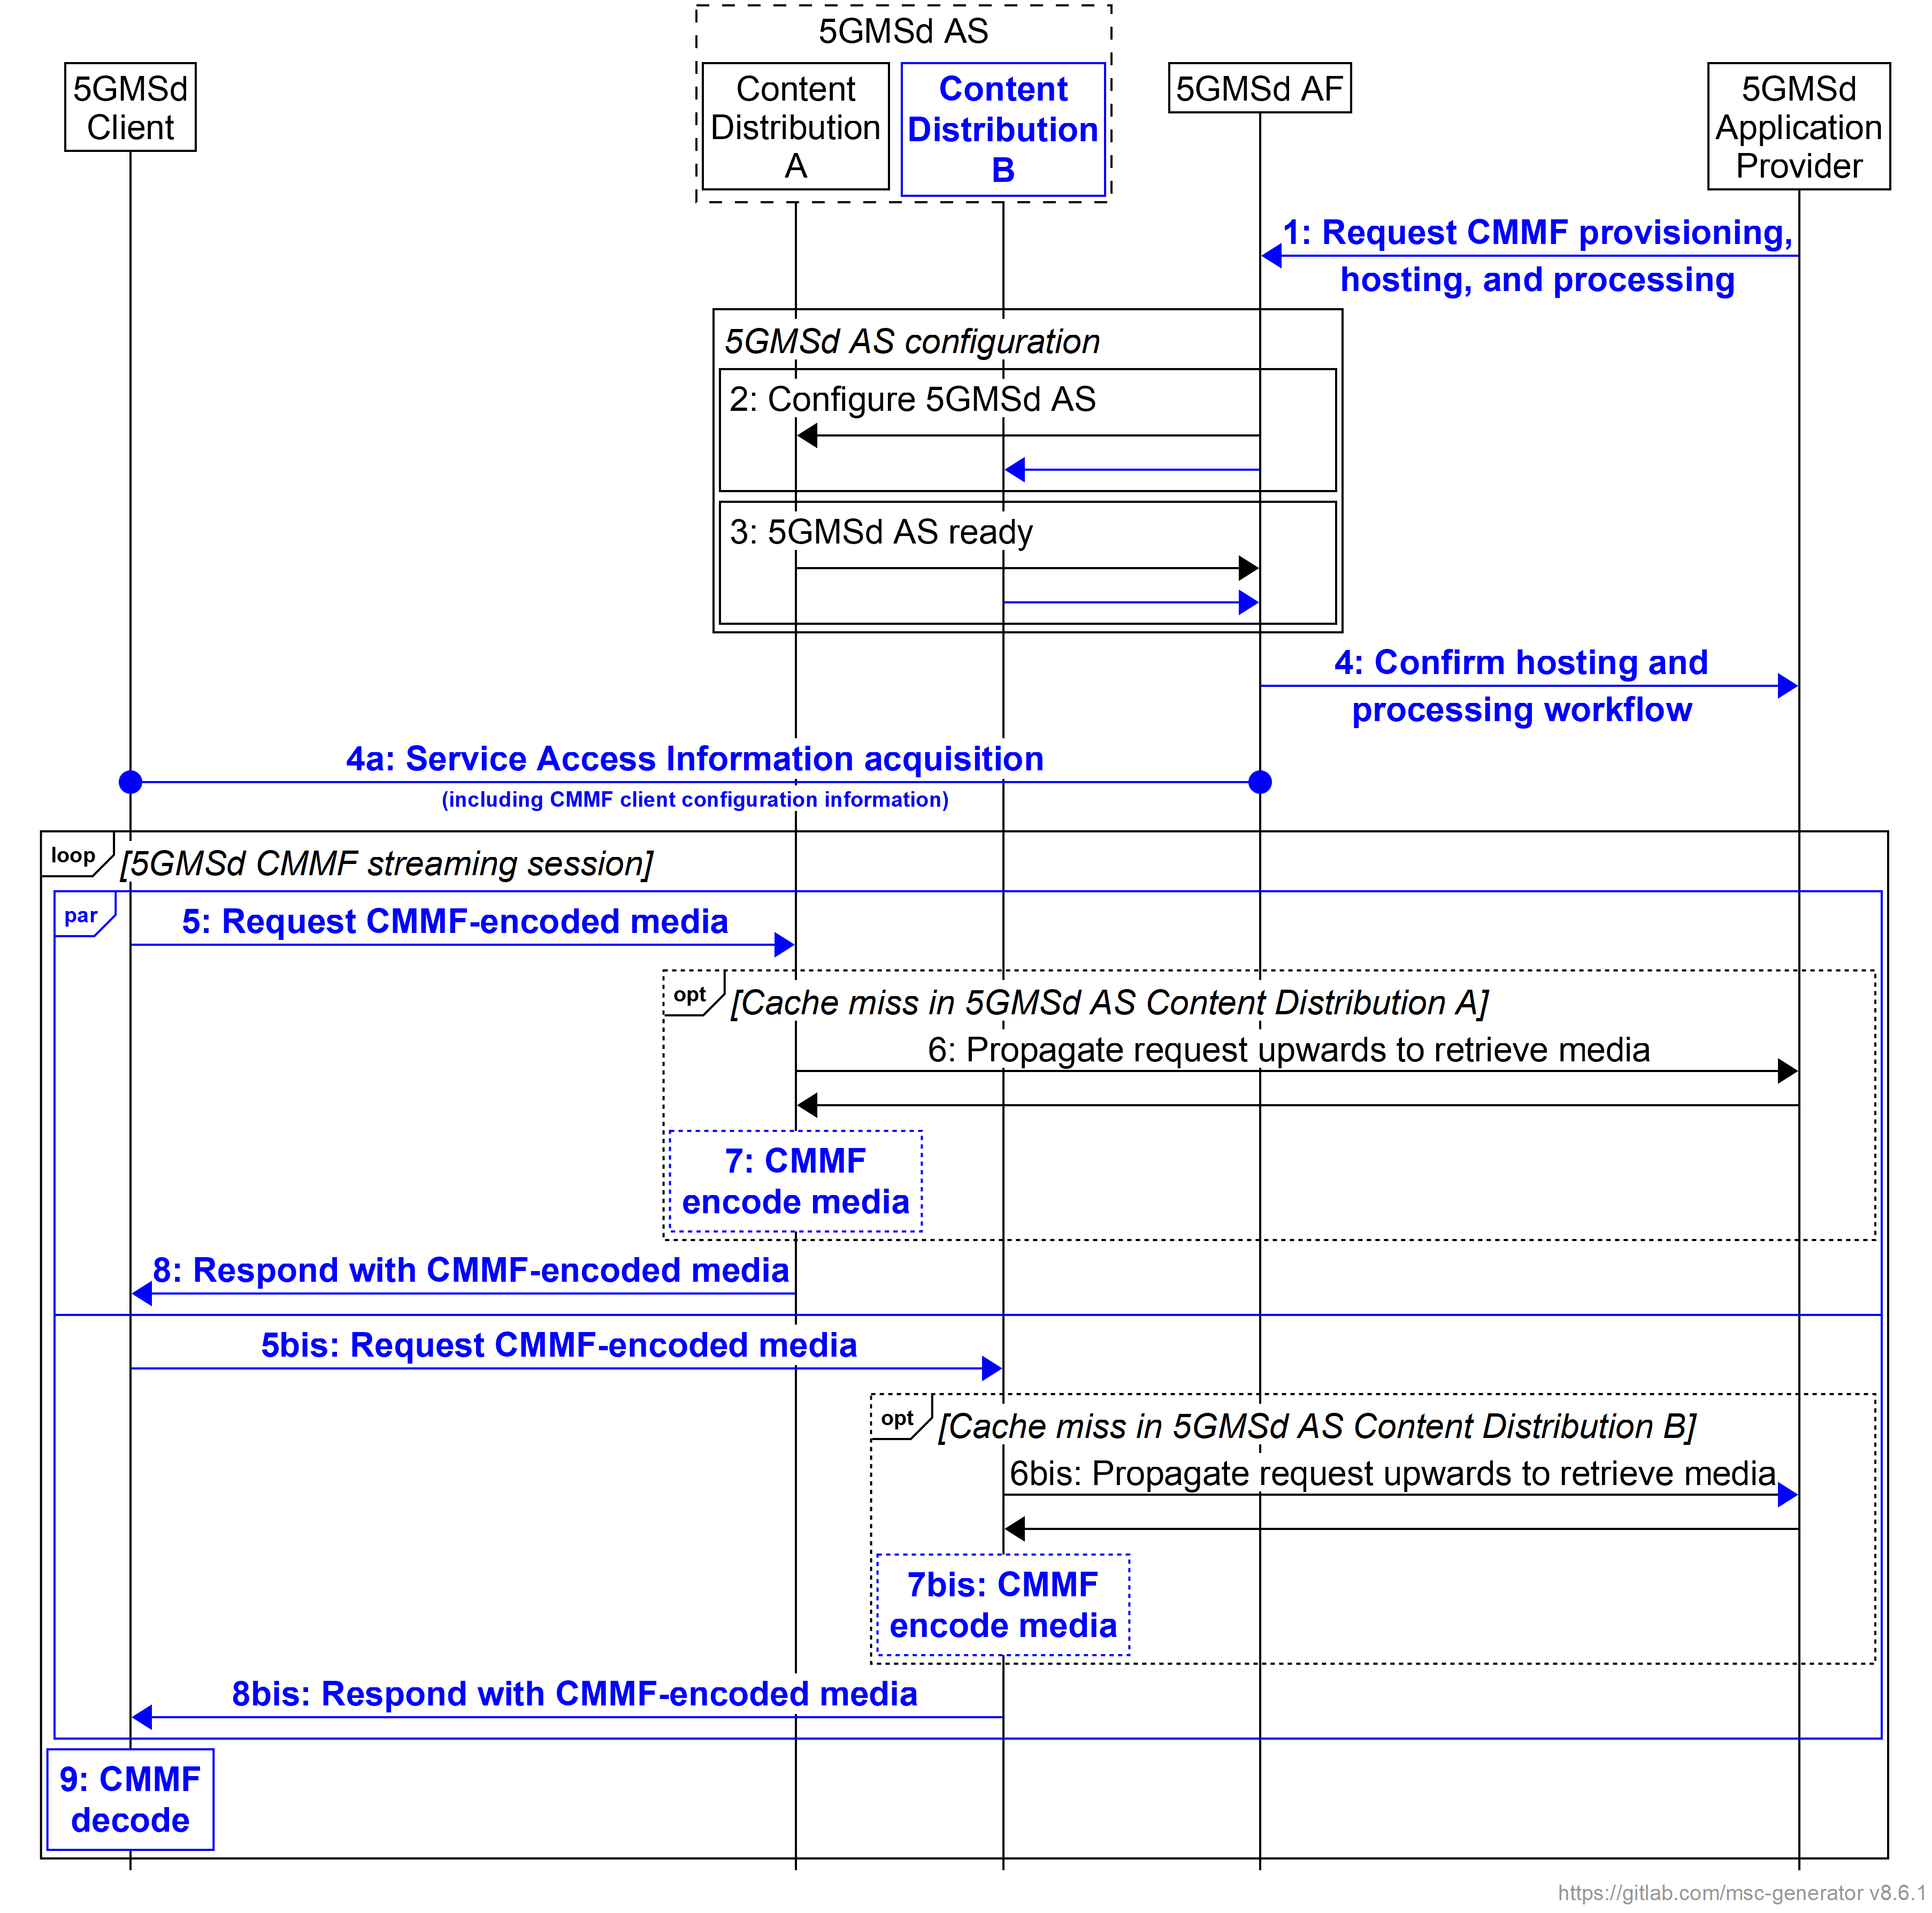
Figure 5.19.4.2.2.6.2-1: Media provisioning, hosting, and processing procedures for downlink media streaming using CMMF
Steps:
1. Upon setting up a CMMF Provisioning and Content Hosting Configuration, the 5GMSd Application Provider requests CMMF media processing and hosting to be set up. The 5GMSd Application Provider provides a description of the type and placement of the processing used to encode CMMF objects, including the required number of CMMF endpoints to be exposed as addressable 5GMSd AS Content Distribution sets, and defines the flow of content through the 5GMS System. The 5GMS System may only allow a shortlisted set of media processing functions to be used by the 5GMSd Application Provider.
4. The 5GMSd AF confirms the successful creation of the CMMF Provisioning and Content Hosting Configuration with the requested media processing to the 5GMSd Application Provider.
4a. The 5GMSd AF exchanges relevant CMMF client configuration information with the 5GMSd Client to enable the 5GMSd Client to access and download both CMMF-encoded media and original source media. This CMMF client configuration information may consist of URLs to each CMMF endpoint established in step 2, a CMMF URL template allowing for translation of the URLs provided in content manifests (e.g., MPD) into URLs that can be used to access CMMF-encoded media within the 5GMS System, etc.
5. A 5GMSd Client sends one or more requests for CMMF-encoded media content to one or more of the 5GMSd AS Content Distributions (established as CMMF endpoints) listed in the provisioned Content Hosting Configuration (see clause 5.4 of TS 26.501 [15]).
6. If it does not already have a copy of the requested media cached, the 5GMSd AS Content Distribution by the 5GMSd Client fetches the media from a back-end 5GMSd AS Content Distribution or from the 5GMSd Application Provider.
NOTE 1: Multiple options are available for distributing CMMF-encoded media to the addressed 5GMSd AS Content Distribution. These options are dependent on how the 5GMS System is provisioned and configured during steps 1–4. Options and details on the call flows involving cache misses are provided below.
7. Depending on the media content received from a back-end 5GMSd AS Content Distribution or from the 5GMSd Application Provider, the addressed 5GMSd AS Content Distribution may be required to create a unique CMMF-encoded representation of the requested media using content processing provisioned in step 1 and referenced by the Content Hosting Configuration.
NOTE 2: Additional details are provided below.
8. The addressed 5GMSd AS Content Distribution serves the requested CMMF-encoded media or original source media to the 5GMSd Client.
9. In the case where CMMF-encoded media is obtained from one or more 5GMSd AS Content Distributions, the 5GMSd Client decodes this CMMF-encoded media and recovers the original source media.
Different variants of these procedures (specifically steps 6 and 7) may be possible, depending on the placement of the processing, the placement of the CMMF endpoints, and the characteristics of the CMMF Content Provisioning and Hosting Configuration. Furthermore, the introduction of CMMF to supplement the download of media in other scenarios (e.g., downlink streaming to Media Players with different presentation manifests per clause 5.2.4 of TS 26.501 [15]) can be applied in a similar fashion to that shown below.
1. Content preparation by 5GMSd Application Provider. The procedure used when the 5GMSd Application Provider is responsible for encoding and packaging source media within CMMF bitstreams/objects prior to delivery of that content separately to each 5GMSd AS Content Distribution via reference point M2d, or to each externally deployed 5GMSd AS Content Distribution, is provided in figure 15.19.4.2.2.6.2-2. In these cases, the 5GMSd Application Provider provides a unique CMMF-encoded representation of the original source media to each 5GMSd AS Content Distribution configured as a CMMF endpoint.
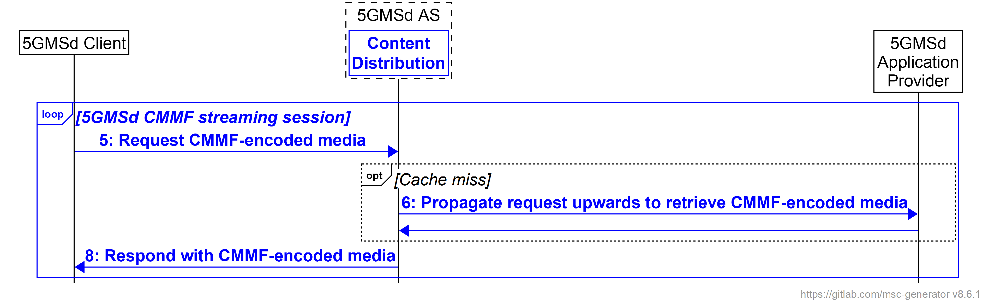
Figure 5.19.4.2.2.6.2-2: 5GMSd Application Provider CMMF Content Preparation and media processing procedures for downlink media streaming
Steps:
5. A 5GMSd Client sends one or more requests for CMMF-encoded media content to one or more of the 5GMSd AS Content Distributions (established as CMMF endpoints) listed in the provisioned Content Hosting Configuration (see clause 5.4 of TS 26.501 [15]).
6. If the 5GMSd AS Content Distribution does not have the required CMMF-encoded media cached, it requests and fetches a unique CMMF-encoded representation of the requested media from the 5GMSd Application Provider. In this case, it is the responsibility of the 5GMSd Application Provider to ensure that the CMMF-encoded representations of the requested media provided to each CMMF endpoint are unique. Upon receipt of the requested unique CMMF-encoded representation of the requested media, the 5GMS AS Content Distribution may cache the CMMF object locally to support subsequent requests for that content.
7. Media processing by the 5GMSd AS is not required.
8. The addressed 5GMSd AS Content Distribution serves the requested CMMF-encoded media to the 5GMSd Client.
2. Centralized 5GMSd content preparation. Figure 5.19.4.2.2.6.2-3 shows the procedure used when source content is ingested at reference point M2d by a single, primary 5GMSd AS Content Distribution that encodes and packages it into CMMF bitstreams/objects according to a Content Preparation Template reference by a Content Hosting Configuration previously provisioned by the 5GMSd Application Provider.
In these cases, the placement of 5GMSd AS Content Distribution is hierarchical, as shown in figure 5.19.3.2.2.6.3-1 and the client-addressable 5GMSd AS Content Distribution (CMMF endpoint) accessed at reference point M4d by 5GMSd Clients ingests, via reference point M10d, CMMF-encoded media from an upstream back-end 5GMSd AS Content Distribution that is configured to encode and package source media into CMMF bitstreams/objects. The 5GMSd AS Content Distribution performing CMMF content preparation is responsible for providing a unique CMMF-encoded representation of the original source media to each client-addressable 5GMSd AS Content Distribution configured as a CMMF endpoint.
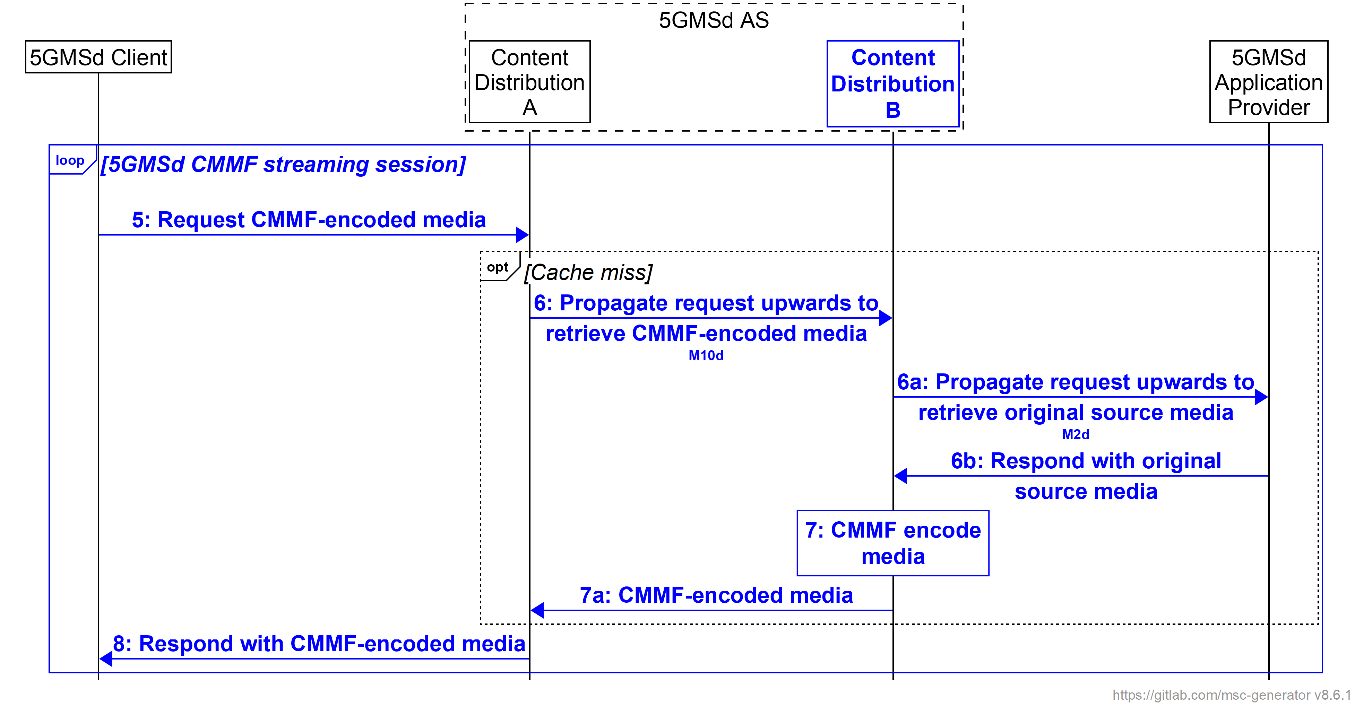
Figure 5.19.4.2.2.6.2-3: Centralized 5GMSd Content Preparation and media processing procedures for downlink media streaming
Steps:
5. The 5GMSd Client sends request(s) for CMMF-encoded media to one or more 5GMSd AS Content Distributions where each is configured as a different CMMF endpoint.
6. If 5GMSd AS Content Distribution (A) does not have the required CMMF-encoded media cached, it requests a unique CMMF-encoded representation of the requested media from a back-end 5GMSd AS Content Distribution (B).
6a. If 5GMSd AS Content Distribution (B) does not have the required CMMF-encoded media cached, it requests the original source media from the 5GMSd Application Provider.
6b: The 5GMSd Application Provider returns the requested original source media to 5GMSd AS Content Distribution (B).
7: 5GMSd AS Content Distribution (B) encodes the received original source media to create a CMMF-encoded representation unique to the requesting 5GMSd AS Content Distribution (A).
7a: 5GMSd AS Content Distribution (B) sends the requested CMMF-encoded media to 5GMSd AS Content Distribution (A).
8. 5GMSd AS Content Distribution (A) responds to the 5GMSd Client’s request with a CMMF-encoded representation of the requested media that is unique to the CMMF endpoint to which 5GMSd AS Content Distribution (A) belongs.
3. Decentralized 5GMSd content preparation. The procedure shown in figure 5.19.4.2.2.6.2-4 is used when CMMF media processing and content preparation is distributed across 5GMSd AS Content Distributions where each 5GMSd AS Content Distribution is responsible for the creation of a single CMMF representation which it intends to cache and/or deliver via reference point CMMF-1 or M4d (depending on the assumed 5GMSd Client architecture described in clause 5.19.3.2.1). This case is illustrated in figure 5.19.3.2.2.6.3-2.
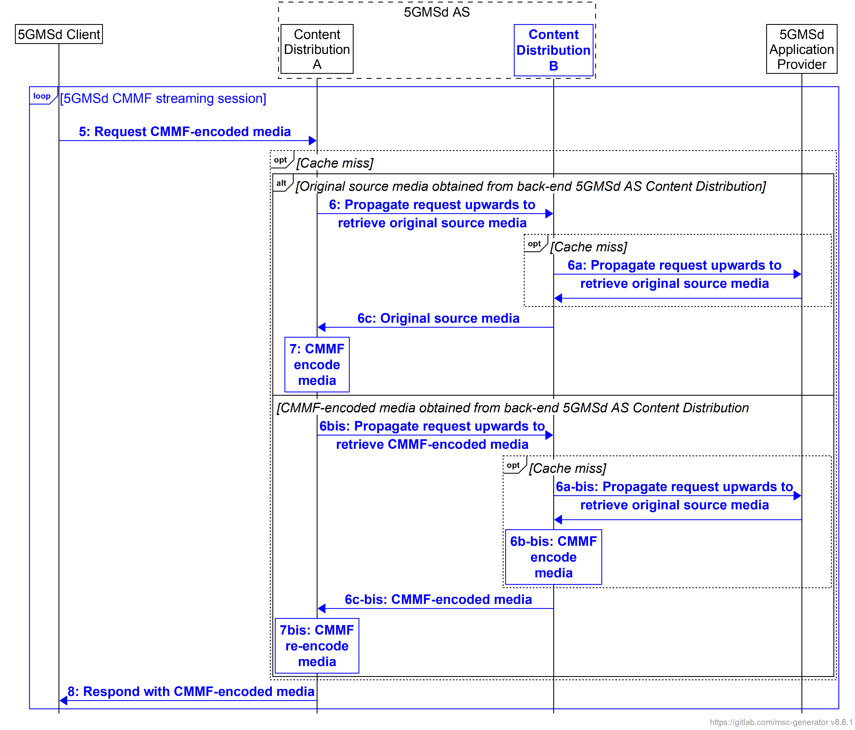
Figure 5.19.4.2.2.6.2-4: Decentralized 5GMSd Content Preparation and media processing procedures for downlink media streaming
Steps:
5. The 5GMSd Client sends request(s) for CMMF-encoded media to one or more 5GMSd AS Content Distributions where each is configured as a different CMMF endpoint.
6. If 5GMSd AS Content Distribution (A) does not have the required CMMF-encoded media cached, it requests the media from a back-end 5GMSd AS Content Distribution (B). 5GMSd AS Content Distribution (A) can explicitly request either the original source media or the CMMF representation unique to the back-end 5GMSd AS Content Distribution (B), or it can make a general request that may return one or the other.
6a. If the back-end 5GMSd AS Content Distribution (B) does not have a copy of the original source media or a CMMF-encoded representation cached, it may obtain it from the 5GMSd Application Provider.
6b. In the case where original source media is obtained in step 6, 5GMSd AS Content Distribution (B) encodes it into a unique CMMF representation where it may also be cached for later retrieval.
6c. Either the original source media or a CMMF-encoded representation unique to 5GMSd AS Content Distribution (B) is returned to 5GMSd AS Content Distribution (A).
7. In the case where original source content is obtained from the back-end 5GMSd AS Content Distribution (B), a CMMF-encoded representation unique to 5GMSd AS Content Distribution (A) is created. In the case where a CMMF-encoded representation unique to the back-end 5GMSd AS Content Distribution (B) is obtained, the CMMF-encoded representation is decoded back to the original source content and re-encoded to create a CMMF-encoded representation unique to 5GMSd AS Content Distribution (A).
8. 5GMSd AS Content Distribution (A) responds to the 5GMSd Client’s request with a CMMF-encoded representation of the requested media that is unique to the CMMF endpoint to which the 5GMSd AS Content Distribution (A) belongs.
Variations to the above content provisioning, preparation, and hosting procedures are possible to support different use cases, and 5GMS network configurations.

5.19.4.2.2.6.3 Procedures for CMMF downlink media streaming
The call flow is similar to that described in clause 5.19.4.1.2.6 with the following exceptions:
- The Content Service Location/Endpoint located within the Third-Party Provider(s) becomes a second Content Distribution within the 5GMSd AS.

5.19.4.3 Multiple service locations/endpoints in the User Plane

5.19.4.3.1 DNS-based switching
Call flows for multi-source delivery using DNS to switch between provisioned Content Distributions as described in clause 5.19.1.3 for the architecture option defined in clause 5.19.3.3 and the specific description in clause 5.19.3.3.1 are for further study.

5.19.4.3.2 MPEG-DASH client-side switching
Call flows for multi-source delivery using MPEG-DASH client-side switching as described in clause 5.19.1.4 for the architecture option defined in clause 5.19.3.3 and the specific description in clause 5.19.3.3.2 are for further study.

5.19.4.3.3 Content Steering Server driven switching
Call flows for multi-source delivery using a Content Steering Server as described in clause 5.19.1.5 for the architecture option defined in clause 5.19.3.3 and the specific description in clause 5.19.3.3.3 are provide in the following.
For provisioning, the call flow in clause 5.3.2 of TS 26.501 [15] applies with the following extensions that new provisioning parameters are needed including:
- Request for content using multiple service locations:
- Distribution of resources (copy, selected content on service locations, etc.)
- MPD hosting.
- Request for adding a Content Steering Server with parameters
- Update frequency.
- The number of service locations/endpoints, and parameters for each one.
- Each service location/endpoint may be assigned with different QoS parameters.
- Each service location/endpoint may be hosted in a different network slice.
- Other differentiating aspects may be considered.
- In a variant, the 5GMSd AS may also be informed about existing service locations/endpoints that are outside the 5GMS System, including policies on how they are to be used.
- Information on how the Content Steering Server may be used.
- In another embodiment, Content Steering for DASH and HLS may also be provided.
Details of the distribution call flow are shown in figure 5.19.4.3.4 based on clause 5.7.4 of TS 26.501 [15] as well as the call flow in clause 5.19.1.5 of the present document.
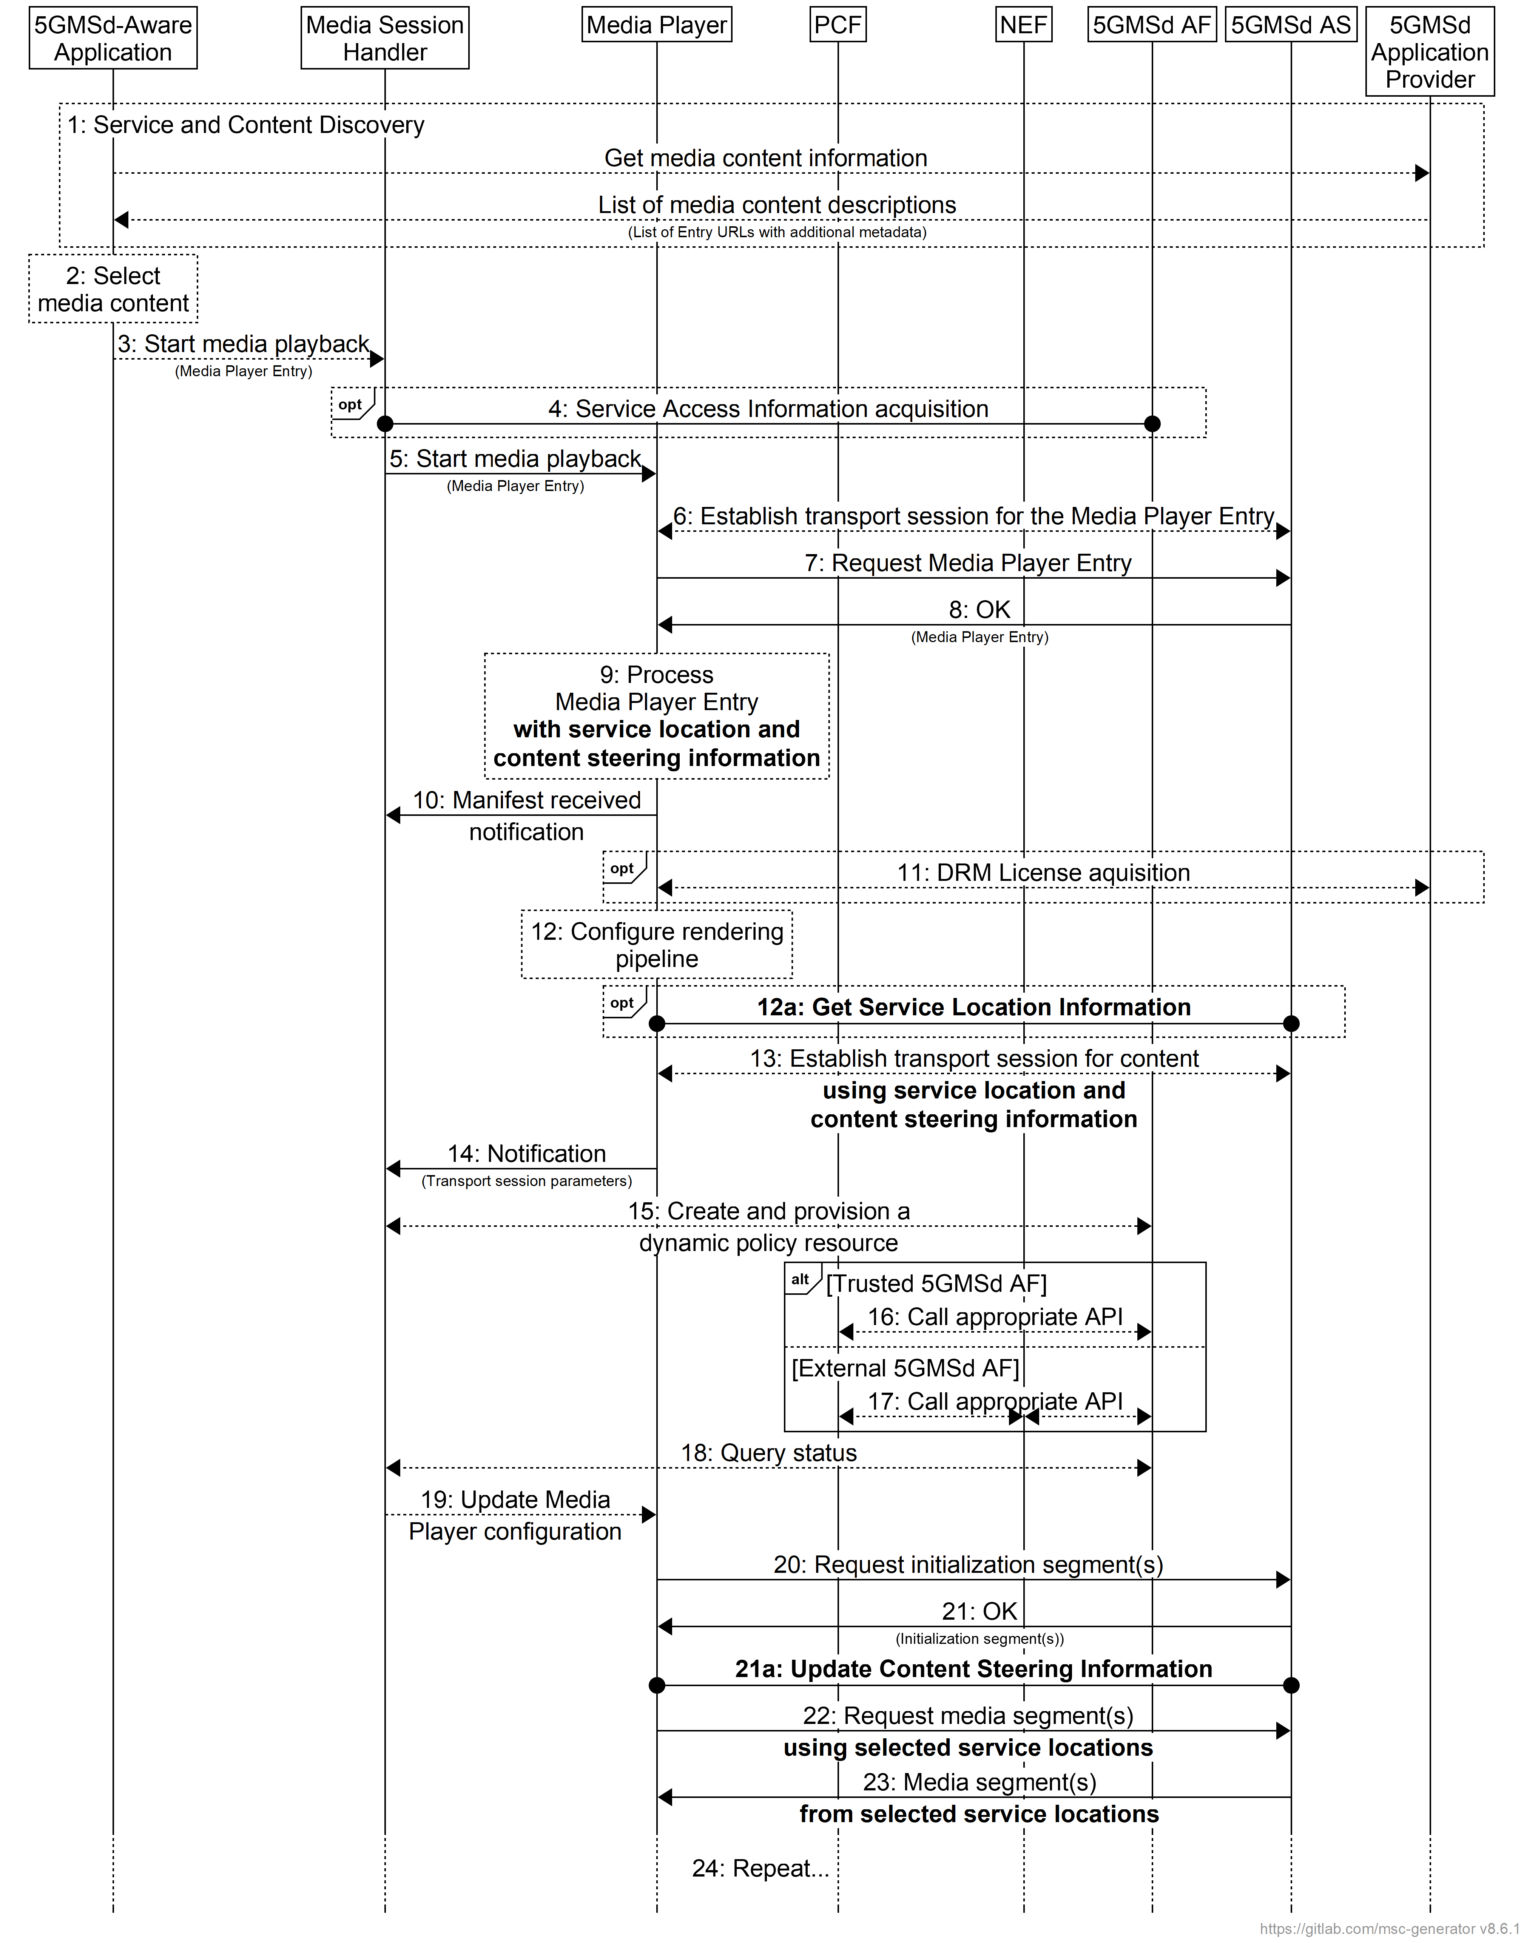
Figure 5.19.4.3.4-1: Call flow for Distribution Session with content steering
Differences with the baseline call flow in clause 5.7.4 of TS 26.501 [15] are highlighted in boldface for multiple service locations/endpoints with content steering:
8: The Media Player Entry document includes information about multiple service locations/endpoints as well as the location of the Content Steering Server.
9: The content steering and multiple service location data is processed by the Media Player.
13: The information may be used when establishing transport session.
20, 22: When accessing content segments, the selected service locations/endpoints are used.
21, 23: When accessing content segments and Media Entry documents, new information may be provided (updates to the Media Player Entry).
21a: Updated content steering information may be provided by the 5GMSd AS.
20, 22: The updated content steering information is used by the Media Player when requesting content segments available from different content locations/endpoints.

5.19.4.3.4 SAND4M multi-source delivery
Call flows for multi-source delivery using a SAND4M as described in clause 5.19.1.6 for the architecture option defined in clause 5.19.3.3 and the specific description in clause 5.19.3.3.4 are closely aligned with those for Content Steering in clause 5.19.4.3.3.

5.19.4.3.5 CMMF-based multi-source delivery
Call flows for CMMF-based media delivery as described in clause 5.19.1.7 for the architecture option defined in clause 5.19.3.3 and the specific description in clause 5.19.3.3.5 are provided in the following.
For the provisioning call flow, the call flow in TS 26.501 [15], clause 5.3.2 applies with the following extensions that new provisioning parameters are needed including:
- Request for CMMF processing with configuration parameters.
- Parameters for CMMF processing:
- Number of service locations.
- Formation of source and repair objects – (spreading, size).
- Usage of FEC code with code parameters.
- Distribution of Media Player Entry document.
- The number of service locations/endpoints and parameters for each one.
- Each service location/endpoint may be assigned with different QoS parameters
- Each service location/endpoint may be hosted in a different network slice.
- Other differentiating aspects to be added to service locations may be considered.
Details of the distribution call flow are shown in figure 5.19.4.3.4 based on clause 5.7.4 of TS 26.501 [15] as well as the call flow in clause 5.19.1.7.2 of the present document.
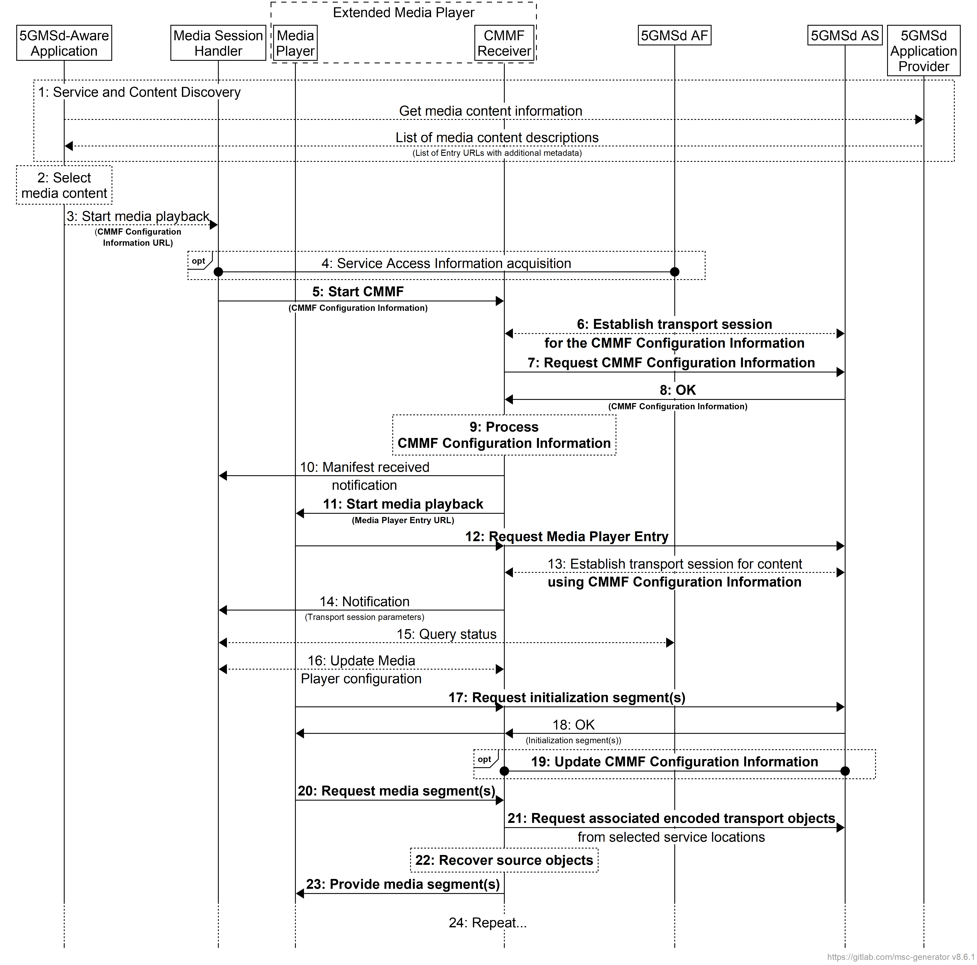
Figure 5.19.4.3.5-1: Call flow for Distribution Session with CMMF Content Delivery Protocol
For the distribution call flow, the updates based on clause 5.7.4 of TS 26.501 [15] are provided in bold for multiple service locations/endpoints with CMMF CDP
- Service announcement includes a CMMF Configuration Information document URL, including MIME content type.
- The Media Session Handler starts CMMF part of the Extended Media Player.
- The CMMF Configuration Information is acquired by the Extended Media Player.
- The CMMF Receiver in the Extended Media Player identifies MPD and starts the Media Player.
- Media Player identifies segments to be requested and requests them from the CMMF Receiver.
- CMMF Receiver, based on continuous updates, retrieves the associated encoded objects from the 5GMSd AS, recovers the source objects and provides the media segments to the Media Player for presentation.
In variants of the above:
- Parts of the information may go directly to the Media Player.
- The CMMF Configuration Information is static (for example, a template).

5.19.5 Gap analysis and requirements

5.19.5.1 Over-the-Top (OTT) multi-source delivery
Support for delivering media from multiple locations using the architecture described in clause 5.19.3.1 is largely supported by the 5GMS System. Within this architecture, the 5GMS System is configured such that it can be considered a single service location/endpoint; additional service location(s)/endpoint(s) (e.g., commercial CDNs) are outside of the scope of the 5GMS System. Furthermore, signalling availability of multiple service locations and management of their selection is performed by the 5GMSd Application Provider and the 5GMSd-Aware Application at reference point M8d which is also outside of the scope of the 5GMS System. However, 5GMSd Client support for multi-source/endpoint functionality is necessary for most multi-source delivery approaches considered. The required functionality includes:
1. 5GMSd Client supports the multi-source/endpoint approach in use. This includes:
a. Functionality to switch between or simultaneously use multiple source/endpoints located within either the Trusted or External DNs. For MPEG-DASH client-side switching and client-side switching driven by a Content Steering Server, this functionality includes the capability to switch the source/endpoint in use while accessing/downloading media. For CMMF-based delivery, this functionality includes the capability to efficiently access/download multiple CMMF-encoded media objects in parallel, as well as the capability to decode these received (or partially received) CMMF-encoded media objects to recover original source media objects required for playback.
b. Functionality necessary to support signalling of measurement and control messaging at reference point M4d′.
2. Multi-source/endpoint configuration information exchanged over client Media Session Handling (M6) and/or Media Stream Handler (M7/M11) APIs (clauses 12 and 13 of TS 26.512 [16]). In cases where multi-source delivery is configured and signalled by the 5GMSd Application Provider at reference point M8d rather than in-band (e.g., within the manifest), the Media Session Handling (M6) and/or Media Stream Handler (M7/M11) APIs are required to support signalling of parameters needed to configure a Media Player to execute multi-source/endpoint delivery. These parameters may include a list of source/endpoint base URLs, CMMF configuration information, remote multi-source/endpoint management information (e.g., Content Steering Server URL), etc.
3. User-plane reference point between Media Player and out-of-scope function. A new reference point is necessary in the 5GMS Architecture between the Media Player and a third-party provider that carries user-plane information (e.g., media).

5.19.5.2 5GMS-integrated multi-source delivery
Fully integrating multi-source/endpoint delivery within the 5GMS System as described in clause 5.19.3.2 is generally supported with several exceptions. Within this architecture, the 5GMS System is configured such that it natively supports multi-source/endpoint delivery. The 5GMS System currently supports establishment of multiple Content Distributions in the Content Hosting Configuration where each can be considered a distinct content location/endpoint. Each Content Distribution can also be configured to perform Content Preparation as needed by the specific multi-source/endpoint approach in use. However, this Content Preparation subfunction or its configuration is not fully specified. Furthermore, signalling of necessary multi-source/endpoint delivery parameters both to the 5GMSd Client and within the 5GMSd Client is also not fully specified. The following gaps in existing 5G Media Streaming specifications have not yet been addressed to support the capabilities discussed.
1. Capability to configure and provision content locations/endpoints within the 5GMS network to support multi-source/endpoint delivery. Multiple content endpoints can be provisioned and established within the 5GMS System by means of a Content Hosting Configuration (see clause 8.8 of TS 26.510 [26510]). Each content location/endpoint is established as a unique Distribution Configuration where each Distribution Configuration is assigned a canonical Fully-Qualified Domain Name (FQDN) and base URL by the 5GMSd AF. Content in each Content Distribution is made available to 5GMSd Clients at reference point M4d. Furthermore, Content Preparation Templates can be linked to each Content Distribution to support use cases where either the manifest (i.e., MPD) or content requires modification/preparation prior to its delivery at reference point M4d. While most of the capabilities currently exist to configure and provision multiple content endpoints within the Content Hosting Configuration, the following capabilities are currently missing:
a. Content Preparation and Content Preparation Templates to support multi-source/endpoint delivery. Content Preparation Templates used during Content Distribution provisioning are not currently specified by 5GMS. These Content Preparation Templates need to define the content preparation operations necessary to prepare content for delivery at reference point M4d, specifically:
i. Manipulation of the presentation manifest (e.g. MPEG-DASH MPD) for cases where content endpoints/locations and/or the content endpoint access management function (e.g., Content Steering Server) locations are communicated within the manifest. The Content Preparation subfunction needs to accept content endpoint URLs and content endpoint access management function locations from the 5GMSd AF and make the appropriate changes to each manifest before delivery to a 5GMSd Client at reference point M4d.
ii. CMMF encoding and packaging for cases where the content endpoints are provisioned to perform these operations. These Content Preparation Templates and Content Preparation subfunctions is required to support the workflows described in clause 5.19.4.2.2.6.2.
To simplify deployments, it is desirable to be able to address fragments of a shared Content Preparation Template from a Content Distribution to dereference a particular Content Preparation action rather than provision each action using a separate Content Preparation Template document.
b. Capability to configure and provision Content Distribution ingest configurations. As currently specified in clause 8.8.3.1 of TS 26.510 [26510], Content Distributions are implicitly fed from the ingest configuration of the Content Hosting Configuration to which they belong, and the ingest configuration specifies the parameters for ingesting media content into the 5GMSd AS at reference point M2d. Support for more complex Content Distribution deployments (e.g., the centralized and decentralized content preparation workflows described in clause 5.19.4.2.2.6.2) in which a Content Distribution is instead fed from a parent or sibling Content Distribution at reference point M10d also needs to be supported.
c. Capability to configure Content Distribution deployment requirements. Current specifications are unclear about where and how distinct Content Distributions in the (logical) 5GMSd AS are to be deployed in the DN. As an example, the capability to configure each Content Distribution on a separate 5GMSd AS physical host or Edge AS may be desirable for cases where improved robustness to content endpoint degradation/failure is required.
2. Capability to signal multi-source/endpoint configuration information to 5GMSd Clients at reference point M5d. For use cases where multi-source/endpoint delivery configuration information is not signalled in-band at reference point M4d (e.g., via a presentation manifest), out-of-band signalling of this information is necessary. The 5GMS System supports this via the Service Access Information provided by the 5GMSd AF at reference point M5d. However, the currently specified Service Access Information does not allow for the following:
a. Capability to signal external content endpoint locations. Use cases where the 5GMSd Application Provider provisions content endpoints externally to the 5GMS System are not currently supported since there are currently no methods to communicate content endpoints provisioned by the 5GMSd Application Provider in External DNs via the 5GMSd AF.
b. Capability to signal a list of endpoint locations that can be used for multi-source/endpoint delivery. The Service Access Information currently only supports the communication of a list of Media Entry Point resources (e.g., MPDs). To support multi-source/endpoint delivery, the Service Access Information is also required to be able to communicate FQDN base URLs of the provisioned Content Distributions defined in the Content Hosting Configuration.
c. Capability to signal 5GMSd AS Online Service Location/Endpoint Management subfunction configuration information. For cases where an Online Service Location/Endpoint Management function (e.g., a Content Steering Server) is provisioned within the 5GMSd AS, information about the endpoint URL used to access this function at reference point M4d, the API in use, etc. needs to be made available to the 5GMSd Client at reference point M5d.
d. Capability to signal URL path rewrite rules 5GMSd Clients should use when accessing media from different Content Distributions. In some use cases, media may be assigned a unique URL based on the Content Distribution from which it is served, how it was packaged, etc. An example includes CMMF-encoded media where CMMF-encoded media objects containing different representations (or stripes) of the same original source media are accessible via unique URLs. Clause 5.19.3.2.2.6.4 provides examples of different URL path rewrite rules addressing CMMF-encoded content.
e. Capability to signal CMMF-specific configuration information. In some cases, additional information beyond what is discussed above may be required to support CMMF-based multi-source delivery. This additional information may include the CMMF code type used to encode media, the CMMF profile in use, etc.
3. Capability to configure and provision Online Service Location/Endpoint Management subfunctions within the 5GMSd AS. An example may include the configuration and deployment within the 5GMSd AS of a Content Steering Server such as that specified in ETSI TS 130 998 [DIFCS].
4. 5GMSd Client multi-source/endpoint functionality is necessary for most multi-source delivery approaches considered. The required functionality includes:
a. 5GMSd Client that supports the multi-source/endpoint approach in use. This includes:
i. Functionality to switch between or simultaneously use multiple source/endpoints located within either the Trusted or External DNs. See item 1a in clause 5.19.5.1.
ii. Functionality necessary to support signalling of measurement and control messaging between the 5GMSd Client and a 5GMSd AS Online Service Location/Endpoint subfunction at reference point M4d. See item 1b in clause 5.19.5.1.
b. Exchange multi-source/endpoint configuration information over Media Session Handling (M6) and/or Media Stream Handler (M7/M11) APIs (clauses 12 and 13 of TS 26.512 [16]). See item 2 in clause 5.19.5.1.

5.19.5.3 Multiple service locations/endpoints in the User Plane

5.19.5.3.1 DNS-based switching
Gap analysis for multi-source delivery using DNS to switch between provisioned Content Distributions as described in clause 5.19.1.3 for the architecture option defined in clause 5.19.3.3 and the specific description in clause 5.19.3.3.2.1 as well as the call flows in clause 5.19.4.3.1 is for further study.

5.19.5.3.2 MPEG-DASH client-side switching
Gap analysis for multi-source delivery using MPEG-DASH client-side switching as described in clause 5.19.1.4 for the architecture option defined in clause 5.19.3.3 and the specific description in clause 5.19.3.3.2.2 as well as the call flows in clause 5.19.4.3.2 is for further study.

5.19.5.3.3 Content Steering Server driven switching
Gap analysis for multi-source delivery using a Content Steering Server as described in clause 5.19.1.5 for the architecture option defined in clause 5.19.3.3 and the specific description in clause 5.19.3.3.2.3 as well as the call flows in clause 5.19.4.3.3 are provided in the following.
For the provisioning call flow, the call flow in clause 5.3.2 of TS 26.501 [15] applies with the following additional provisioning parameters needed:
- Request for using multiple service locations/endpoints.
- Distribution of resources (copy, selected content on service locations, etc.).
- MPD hosting.
- Request for adding a Content Steering Server with the following parameters:
- Update frequency of the content steering information.
- The number of service locations/endpoints and parameters for each one.
- Each service location/endpoint may be assigned different QoS parameters.
- Each service location/endpoint may be hosted in a different network slice.
- Other differentiating aspects for service locations/endpoints may be considered.
- In a variant, the 5GMSd AS may also be informed about existing service locations/endpoints that are outside the 5GMS System and may provide policies on how to use them.
- Information on how the content steering server may be used.
- In another embodiment, Content Steering for DASH and HLS may also be provided.
For the distribution call flow, the following updates based on clause 5.7.4 of TS 26.501 [15] are needed:
- Media Player Entry document includes information about multiple service locations/endpoints and the location of the Content Steering Server.
- The content steering and multiple service location data is processed by the Media Player.
- The information may be used when establishing a transport session.
- When accessing media segments, the selected service locations/endpoints are used.
- When accessing media segments and Media Entries, new information may be provided (updates to Media Player Entry document).
- Updated content steering information may be provided by the 5GMSd AS.
- The information is used by the Media Player when requesting media segments that are available from different service locations/endpoints.

5.19.5.3.4 SAND4M multi-source delivery
Gap analysis for multi-source delivery using a SAND4M as described in clause 5.19.1.6 for the architecture option defined in clause 5.19.3.3 and the specific description in clause 5.19.3.3.2.4 is similar to that for Content Steering in clause 5.19.5.3.3.

5.19.5.3.5 CMMF-based multi-source delivery
Gap analysis for CMMF-based media delivery as described in clause 5.19.1.7 for the architecture option defined in clause 5.19.3.3 and the specific description in clause 5.19.3.3.2.5 as well as the call flows in clause 5.19.4.3.5 is provided in the following.
For the provisioning, the call flow in clause 5.3.2 of TS 26.501 [15] applies with the following additional provisioning parameters needed:
- Request for CMMF processing with configuration parameters.
- Parameters for CMMF processing:
- Number of service locations/endpoints.
- Formation of source and repair objects – (spreading, size).
- Usage of FEC code with code parameters.
- Distribution of Media Player Entry document.
- The number of service locations/endpoints and parameters for each service location/endpoint:
- Each service location/endpoint may be assigned different QoS parameters.
- Each service location/endpoint may distribute a different slice of content.
- Other differentiating aspects may be considered.
For the distribution, the details are shown in figure 5.19.4.3.4 based on clause 5.7.4 of TS 26.501 [15] as well as the call flow in clause 5.19.1.7.2. The following is needed to support multiple service locations/endpoints with the CMMF Content Delivery Protocol.
- The service announcement includes CMMF configuration information URL and MIME content type.
- The Media Session Handler starts the CMMF part of an extended CMMF-capable Media Player.
- The CMMF Configuration information acquired.
- The CMMF Receiver identifies MPD and starts the Media Player.
- The Media Player identifies segments to be requested and asks CMMF receiver.
- The CMMF Receiver, based on continuous updates, acquires the associated encoded objects, recovers the source objects and provides the media segments for presentation.

5.19.6 Candidate solutions

5.19.6.1 Overview
This clause provides an overview of candidate solutions that address the gaps identified in clause 5.19.5.
5GMS largely supports Over-the-Top (OTT) multi-source/endpoint media delivery (see clause 5.19.3.1) regardless of the multi-source/endpoint approach used. In this architecture, the 5GMS System is largely agnostic to availability of multiple content endpoints and all signalling of the availability of these content endpoints is generally performed over reference points outside the scope of the 5GMS architecture (i.e., M8d). However, most of the multi-source/endpoint media delivery approaches do require 5GMSd Client functionality that is not explicitly defined in TS 26.501 [15] or specified in TS 26.512 [16].
For use cases where the 5GMS System performs a more active role enabling multi-source/endpoint content delivery, several gaps exist. These range from how the 5GMS System is configured and provisioned to functionality required by the 5GMSd Client.
Proposed candidate solutions that may address these deficiencies are discussed below. Each clause proposes multiple candidate solution options to address the identified gap.

5.19.6.2 Content endpoint provisioning and configuration candidate solutions

5.19.6.2.1 Content Preparation Templates and Content Preparation candidate solutions

5.19.6.2.1.1 Overview
Examples of content preparation that might be needed to support different multi-source/endpoint use cases include:
- Repackaging ingested content (e.g., repackage content from MPEG-DASH to CMAF).
- Encoding content ingested at reference point M2d into multiple CMMF representations/stripes before distributing it at reference point M4d (e.g., CMMF delivery).
- Embellishing, or otherwise modifying, the Media Entry Point resource (e.g., MPEG-DASH MPD) ingested at reference point M2d before distributing it at reference point M4d to include references to content service locations/endpoints (e.g., BaseURL elements), content steering service endpoints (e.g., ContentSteering URL), etc.
Before provisioning the Content Hosting Configuration and Distribution Configurations, the 5GMSd Application Provider first provisions one or more Content Preparation Templates at reference point M1d. If necessary, a Content Preparation Template is referenced by a Distribution Configuration using the Content Preparation Template’s contentPreparationTemplateId.
The syntax and semantics of all Content Preparation Template formats are opaque to the 5GMSd AF, but they are understood by the 5GMSd AS. Different 5GMSd AS Content Distributions may support different types of Content Preparation Template, or different subsets of functionality expressed in each Content Preparation Template format. The Content Protocols Discovery API specified in clause 8.3 of TS 26.510 [26510] is extended to allow a 5GMSd Application Provider to determine which types of Content Preparation Template (and which sub-features of each) are supported in a particular 5GMS System.
The following options for the format of the Content Preparation Template should be considered.

5.19.6.2.1.2 Candidate Solution 1a: Multipurpose Content Preparation Template document format specified outside the scope of 3GPP
The Content Preparation Template follows a multi-purpose format specified outside the scope of 3GPP (e.g. MPEG-I Part 8 (Network-Based Media Processing) as specified in ISO/IEC 23090-8 [MPEGI8]). The MIME content type of the Content Preparation Template is as specified in [MPEGI8]. The usage of this generic Content Preparation Template in the context of 5G Media Streaming is profiled in new clauses of 3GPP TS 26.511 [96]. The generic MIME content type is listed in clause 4.3.5.2 of TS 26.512 [16] as valid for use with the 5GMS System, along with a reference to the set of valid profiles specified in TS 26.511 [96].

5.19.6.2.1.3 Candidate Solution 1b: Bespoke Content Preparation Template document format specified outside the scope of 3GPP
The Content Preparation Template follows a file format specified outside the scope of 3GPP that is bespoke to the form of content preparation (e.g., a CMMF configuration file format specified in an annex to ETSI TS 103 973 [CMMF]). The MIME content type of the bespoke Content Preparation Template document format is also specified outside the scope of 3GPP, but it is listed in clause 4.3.5.2 of TS 26.512 [16] as valid for use with the 5GMS System along with a reference to the relevant external specification.

5.19.6.2.1.4 Candidate Solution 1c: Bespoke Content Preparation Template document format specified by 3GPP
The Content Preparation Template follows a format specified by 3GPP that is bespoke to the form of content preparation (e.g. a CMMF configuration file format specified in a new annex to TS 26.511 [96]). The MIME content type of the bespoke Content Preparation Template document format is also specified in TS 26.511 [96], and it is also listed in clause 4.3.5.2 of TS 26.512 [16] as valid for use with the 5GMS System, alongside a reference to TS 26.511 [96].

5.19.6.2.2 Content Hosting Configuration candidate solutions

5.19.6.2.2.1 Overview
The 5GMS System allows for the establishment of multiple logical content endpoints that can be used for multi-source/endpoint delivery through the Content Hosting provisioning API specified in clause 8.8 of TS 26.510 [26510] and used by a 5GMSd Application Provider at reference point M1d. An ingest configuration for media ingested at reference point M2d is specified and one or more Distribution Configurations where media is made available to 5GMSd Clients at reference point M4d. Each such Distribution Configuration is accessible through a canonical Fully-Qualified Domain Name (FQDN), and baseURL, both assigned by the 5GMSd AF. A Distribution Configuration may describe a single content item, or multiple content items. A Media Entry Point resource (e.g., MPD) is defined if the former, and it is omitted if the latter.
Several options exist for Content Hosting provisioning within the 5GMS System to support multi-source/endpoint media delivery. In some cases, the Content Hosting provisioning API is extended to allow a 5GMSd Application Provider to define a Content Hosting Configuration that supports their multi-source/endpoint use case.
The following should be considered.

5.19.6.2.2.2 Content distribution ingest configuration candidate solutions

5.19.6.2.2.2.1 Candidate Solution 2a: 5GMSd AF-managed Content Distribution ingest configuration
The 5GMSd AF configures individual 5GMSd AS Content Distributions at reference point M3d with appropriate Content Preparation Template(s). Content preparation may be centralized or distributed among multiple 5GMSd AS Content Distributions at the discretion of the 5GMSd AF. Content prepared in one 5GMSd AS Content Distribution may be conveyed to another 5GMSd AS Content Distribution via reference point M10d on a hierarchical or peer-to-peer basis at the discretion of the 5GMSd AF. Clause 5.2.8 in TS 26.510 [26510] is updated appropriately.

5.19.6.2.2.2.2 Candidate Solution 2b: 5GMSd Application Provider guided content distribution ingest configuration
In some use cases, the 5GMSd Application Provider may require specific deployment configurations where it dictates the structure of Content Distributions within the Content Hosting Configuration. In such cases, Content Distributions can be chained together to form linear, hierarchical, or peer-to-peer structures within the 5GMSd AS by adding a distributionIngest configuration property (similar to that of the ingestConfiguration property in the Content Hosting Configuration resource specified in clause 8.8.3 of TS 26.510 [26510]) to both clauses 5.2.8 and 8.8.3 of TS 26.510 [26510]. Additional properties are added to the Content Hosting Configuration resource, including:
- distributionConfigurations[ ].name. A name assigned by the 5GMSd Application Provider to this Content Distribution. This name may be referenced by other Distribution Configurations defined within the Content Hosting Configuration.
- distributionConfigurations[ ].ingestSource: A reference to the name of another distribution configuration which will be used for the purposes of ingesting media into the Content Distribution represented by this Distribution Configuration. If empty, the information defined within the ingestConfiguration is used as the source of content.
In cases where the distributionConfigurations[ ].ingestSource property is present for a Content Distribution Configuration by the 5GMSd Application Provider, the 5GMSd AF takes it into account when configuring Content Hosting within the 5GMSd AS instances at reference point M3d. If this property is not defined, Content Distribution provisioning is left to the discretion of the 5GMSd AF.

5.19.6.2.2.3 Content Distribution 5GMSd AS instance deployment configuration candidate solutions

5.19.6.2.2.3.1 Candidate Solution 3a: Require 5GMSd AF provisioning of Content Distributions on separate 5GMSd AS instance
A flag is added to the Content Hosting Configuration specified in clauses 5.2.8 and 8.8 of TS 26.510 [26510] declaring the requirement that each Content Distribution is configured by the 5GMSd AF on a separate 5GMSd AS instance.

5.19.6.2.2.3.2 Candidate Solution 3b: Content Distribution affinity property
A new top-level Boolean distributionAffinity property is added to the ContentHostingConfiguration resource specified in clause 8.8.3 of TS 26.510 [26510]. This property indicates whether all Content Distributions are to be hosted on the same 5GMSd AS instance as each other, or whether they are all to be hosted on different 5GMSd AS instances.
- If this flag is TRUE:
- The 5GMSd AF configures a set of 5GMSd AS instances at reference point M3d where each Content Distribution defined by the Content Hosting Configuration is provisioned on a different 5GMSd AS instance within the 5GMS System.
- The authority in both the distributionConfigurations[].canonicalDomainName and distributionConfigurations[].‌baseURL assigned by the 5GMSd AF for each Content Distribution is unique to the provisioned Content Distribution.
- If the flag is FALSE or omitted:
- Provisioning of content distributions across a set of 5GMSd AS instances is at the discretion of the 5GMSd AF, i.e., the 5GMSd AF may configure each Content Distribution in the Content Hosting Configuration on the same or on a different 5GMSd AS instance.
- When two or more content distributions are provisioned on a single 5GMSd AS instance, the authority in both the distributionConfigurations[].canonicalDomainName and distributionConfigurations[].baseURL assigned by the 5GMSd AF for each Content Distribution may or may not be unique. In the latter case, the path is unique to each provisioned content distribution.

5.19.6.2.2.3.3 Candidate Solution 3c: Content Distribution affinity groups
A new optional property affinityGroup is added to the DistributionConfiguration data type. This property assigns the Content Distribution to a named affinity group chosen by the 5GMSd Application Provider.
- Content Distributions belonging to the same affinity group are intended to be hosted on the same 5GMSd AS instance.
- Content Distributions belonging to different affinity groups are intended to be hosted on different 5GMSd AS instances.
- Provisioning of Content Distributions across a set of 5GMSd AS instances is at the discretion of the 5GMSd AF if this property is omitted.

5.19.6.3 Multi-source/endpoint service information candidate solutions

5.19.6.3.1 Overview
5GMSd Clients may require the following information to use any of the multi-source/endpoint approaches described in clause 5.19.1:
- Content service locations/endpoints (i.e., URLs) where content is accessible, whether internal to the 5GMSd System (e.g., 5GMSd AS Content Distributions) or external (e.g., commercial CDNs).
- Location (i.e., URL) of any functions provisioned within the network that provide service location/endpoint management (e.g., a Content Steering Server).
- URL path rewrite rules for cases where URLs available to the 5GMSd Client (e.g., URLs contained within a presentation manifest) differ from where the content can be accessed on each service location/endpoint (e.g., URLs to CMMF-encoded media are dynamically built using the URLs contained within a manifest).
- Necessary information about the multi-source/endpoint approach in use (e.g., CMMF-specific configuration information as specified within ETSI TS 103 973 [CMMF], Content Steering Server API version, etc.).
Several methods exist that can be used to provide this information to 5GMSd Clients. These are enumerated in subsequent clauses.

5.19.6.3.2 Candidate Solution 4a: Media Entry Point signalling of multi-source/endpoint service information
A Media Entry Point resource is used to convey necessary multi-source/endpoint information to 5GMSd Clients. For example:
- Service location information (e.g., base URLs). For example, this information may be added as decorators to every manifest.
- A content steering decorator is added to every manifest that provides a URL to the multi-source/endpoint management function, etc.
- CMMF configuration information required by the 5GMSd Client is included within the Media Entry Point. This may include information as specified within ETSI TS 103 973 [CMMF] (e.g., Extended FDT information).
The definition of the Media Entry Point in clause 4 of TS 26.501 [15] and TS 26.510 [26510] is relaxed to allow for the transmission of multi-source/endpoint service information which can then be combined with a Media Player Entry by the 5GMSd Client.

5.19.6.3.3 Candidate Solution 4b: 5GMSd-Aware Application signalling of multi-source/endpoint service information at reference point M8d
Information necessary for 5GMSd Clients to stream media from multiple sources/endpoints within the network is signalled between a 5GMSd Application Provider and a 5GMSd-Aware Application at reference M8d. The method(s) used are outside of the scope of the 5GMS System and no normative changes to TS 26.510 [26510] are necessary, but changes to the media stream handling client API in TS 26.512 [16] are needed (see clause 5.19.6.5.4.2 below).

5.19.6.3.4 Candidate Solution 4c: 5GMSd AF signalling of multi-source/endpoint service information at reference point M5d
Information necessary for 5GMSd Clients to stream media from multiple source/endpoints within the network may be signalled between the 5GMSd Client’s Media Session Handler and 5GMSd AF in the Service Access Information resource provided at reference point M5d and this information is passed on to the Media Player via the client API at reference point M11d (see clause 5.19.6.5.4.2 below).
In this candidate solution, the ServiceAccessInformation resource specified in clause 9.2.3.1 of TS 26.510 [26510] is extended to include the necessary information to describe the content service locations/endpoints where media can be streamed, information required by the multi-source/endpoint approach in use (e.g., Content Steering Server URL, CMMF configuration information, etc.), etc.
Additional properties in the ContentHostingConfiguration resource specified in clause 8.8.3.1 of TS 26.510 [26510] may also be defined in the case where the Service Access Information is used to communicate details about content service locations/endpoints external to the 5GMS System (e.g., third-party service locations) for subsequent exposure in the ServiceAccessInformation resource.

5.19.6.4 Online Service Location/Endpoint Management configuration and provisioning candidate solutions
Configuration and provisioning of an Online Service Location/Endpoint Management function within the 5GMSd AS is necessary if the desired multi-source/endpoint approach (e.g., Content Steering Server driven switching) requires it. However, candidate solutions describing how this is done are considered outside the scope of this Key Issue. See clause 5.17 for further details.

5.19.6.5 5GMSd Client multi-source/endpoint candidate solutions

5.19.6.5.1 Overview
Whether multi-source/endpoint media delivery is deployed as shown by the architectural mapping in clause 5.19.3.1 or that in clause 5.19.3.2, 5GMSd Clients are required to support the specific multi-source/endpoint approach used (e.g., MPEG-DASH client-side switching, CMMF-enabled delivery, etc.). The following candidate solutions address identified gaps within the 5GMSd Client that are required to be filled to support multi-source/endpoint media delivery.

5.19.6.5.2 Multi-source/endpoint capable 5GMSd Client candidate solutions

5.19.6.5.2.1 Candidate Solution 5a: Media Player supported multi-source/endpoint media delivery
The design of the Media Player and the functionality it supports are considered outside of the scope of the 5GMS architecture. It is further assumed that the Media Player as defined in clause 4.2.2 of TS 26.501 [15] and clause 13.2 of TS 26.512 [16] natively supports the multi-source/endpoint media delivery approach (e.g., MPEG-DASH client-side switching, CMMF-enabled delivery, etc.) in use. (In the case of CMMF, this corresponds to an architecture similar to client architecture #2 as described in clause 5.19.3.1.2.6.1 of the present document.) Both clauses are updated to explicitly state that the Media Player natively supports the multi-source/endpoint delivery approaches considered within this Key Issue when the approach(es) are used to delivery media.

5.19.6.5.2.2 Candidate Solution 5b: New 5GMSd Client or UE functions that enable multi-source/endpoint delivery
New 5GMSd Client or UE functions are defined within clause 4 of TS 26.501 [15] that extend the capabilities of existing Media Players that are not capable of performing multi-source/endpoint delivery to be able to switch among and/or simultaneously use multiple content sources/endpoints. An example of these functions specific to CMMF-enabled delivery is shown in figure 5.19.3.1.2.6.1-1. This architecture can be generalized for each multi-source/endpoint media delivery approach considered within this study.

5.19.6.5.2.3 Candidate Solution 5c: Specify Media Player multi-source/endpoint architecture within 5GMS
The Media Player architectures, as defined in clause 4.2.2 of TS 26.501 [15] and clause 13.2 of TS 26.512 [16] are expanded to explicitly define and specify the subfunctions necessary to stream media from multiple content sources/endpoints. In most cases, this can be accomplished by updating the descriptions of existing subfunctions to include details about operating when multiple content sources/endpoints are available. For example, the description of the Media Access Client is updated so that it includes the functionality to switch among multiple content sources/endpoints and/or to use multiple content sources/endpoints to download and decode CMMF-encoded media.
This extension may also include the definition of a new subfunction for the purposes of interacting with a 5GMSd AS Online Service Location/Endpoint Management function at reference point M4d.

5.19.6.5.3 5GMSd AS Online Service Location/Endpoint Management signalling candidate solutions
Definition of the interactions (i.e., APIs) between the 5GMSd Client and Online Service Location/Endpoint Management function deployed in the 5GMSd AS via reference point M4d or deployed externally to the 5GMS System accessed via reference point M4d′ are necessary. However, candidate solutions describing how this is done are considered outside the scope of this Key Issue. See clause 5.17 for further details.

5.19.6.5.4 Media Session Handling (M6d) and Media Stream Handler (M7d/M11d) API candidate solutions

5.19.6.5.4.1 Candidate Solution 6a: Media Entry Point signalling of multi-source/endpoint service access information
This candidate solution is relevant if Candidate Solution 4a in clause 5.19.6.3.2 is selected.
The information needed by the Media Player to enable it to use multiple sources/service locations/endpoints is contained within the Media Entry Point resource (e.g., MPD) and no modifications to existing Media Session Handling (M6d) or Media Stream Handler (M7d/M11d) APIs are necessary.

5.19.6.5.4.2 Candidate Solution 6b: 5GMSd-Aware Application and Media Session Handler signalling of multi-source/endpoint Service Access Information at reference points M7d and M11d
This candidate solution is applicable if Candidate Solutions 4b or 4c in clauses 5.19.6.3.3 and 5.19.6.3.4, respectively, are selected. The selection of this candidate solution does not impact the use of Candidate Solution 4a in clause 5.19.6.3.2 since the recommendations below would not be used or applicable.
Clause 13 of TS 26.512 [16] is updated so that information required to configure the Media Player to switch between – or simultaneously use – multiple sources/endpoints is available at reference point M7d and M11d. The Configurations and settings API defined in clause 13.2.4 of TS 26.512 [16] is updated to include additional properties within the serviceDescriptions[ ] array:
- serviceDescriptions[ ].baseURL: Base URL from which content is made available to the Media Player at reference point M4d. These base URLs may be for both content distributions provisioned within the 5GMSd AS, as well as the base URLs of content service locations/endpoints provisioned external to the 5GMS System by the 5GMSd Application Provider.
- serviceDescriptions[ ].pathRewriteRules: An ordered set of rules for each baseURL. These rules are used for rewriting the request URL paths obtained from a manifest (e.g., MPD) and translating them to URL paths specific to the referenced content service location/endpoint at reference point M4d. An example use case is provided in clause 5.19.3.1.2.6.4.
- serviceDescriptions[ ].multiSourceProfiles[ ]: An optional list of (a yet to be defined) multi-source/endpoint profiles that provide the ability to communicate information necessary for the Media Player to use the referenced content distribution in a multi-source/endpoint configuration. These profiles may indicate that the use of the referenced content distribution is controlled by an Online Service Location/Endpoint Management subfunction, indicate that the referenced content distribution can be used for the delivery of CMMF-encoded media formatted using a specific CMMF profile, etc. Furthermore, these profiles are to be defined in TS 26.511 [96].
Furthermore, the Configurations and setting API is updated to include a new top-level multiSourceManagment object that provides necessary information to the Media Player to connect with and use Online Service Location/Endpoint Management subfunctions provisioned within the 5GMSd AS or externally by the 5GMSd Application Provider. This object may include a URL where the Online Service Location/Endpoint Management subfunction can be accessed at reference point M4d/M4d′, information concerning the API(s) that the subfunction conforms to (e.g., Content Steering Server as specified in [DIFCS]), etc.

5.19.6.6 Candidate Solution 7: Reference Point between Media Player and non-5GMS content hosting function
A new reference point, Mexternal, is added to the 5GMS architecture between the Media Player and a non-5GMS content hosting function for the purposes of user plane information exchange. This reference point may terminate at the 5GMSd Application Provider or similar function as shown in figure 5.19.3.1.1-1. This reference point is for information purposes only and its definition is outside the scope of the 5GMS System.

5.19.7 Summary and conclusions
This Key Issue has considered the integration of different technologies into the 5G Media Streaming System that allow downlink media streaming applications to efficiently access content located across multiple content sources/endpoints. These technologies include:
- DNS-based switching,
- MPEG-DASH client-side switching,
- Content steering driven switching,
- SAND4M multi-source/endpoint delivery (to a limited extent), and
- CMMF-based multi-source/endpoint delivery.
In almost all cases, these technologies may be employed over-the-top of the 5GMS System using methods outside the scope of 5GMS (with the exception that the 5GMS Client is underspecified regarding multi-source/endpoint operation). However, explicit support for multi-source/endpoint media delivery throughout the 5GMS System is recommended through the following changes to 5GMS specifications:
1. Document additional collaboration scenarios for multi-source media streaming, including associated call flows for both over-the-top multi-source delivery and 5GMS-integrated multi-source delivery, in annex A of TS 26.501 [15].
2. Candidate Solution 1a (clause 5.19.6.2.1.2) and Candidate Solution 1b (clause 5.19.6.2.1.3). Specification of Content Preparation Templates are outside the scope of 3GPP. These Content Preparation Templates may be used for the following purposes:
a. Repackaging ingested content (e.g., repackage content from MPEG-DASH to CMAF).
b. Embellishing, or otherwise modifying, the Media Entry Point resource (e.g., MPEG-DASH MPD) ingested at reference point M2d before distributing it at reference point M4d to include references to content service locations/endpoints (e.g., BaseURL elements), content steering service endpoints (e.g., ContentSteering URL), etc.
c. Encoding content ingested at reference point M2d into multiple CMMF representations/stripes before distributing it at reference point M4d (e.g., CMMF delivery).
Content Preparation Templates may be specified through:
- A multipurpose document format such as MPEG-I Part 8 (Network-Based Media Processing) as specified in ISO/IEC 23090-8 [MPEGI8]), or
- A document format bespoke to the form of content preparation (e.g., a CMMF configuration file format specified in an annex to ETSI TS 103 973 [CMMF]).
The generic MIME content type of each Content Preparation Template format is listed in clause 4.3.5.2 of TS 26.512 [16] as valid for use with the 5GMS System, along with references to the set of valid profiles specified in TS 26.511 [96] and relevant external specifications.
3. Verification of Content Preparation Template signalling and implementation within 5GMS specifications is correct.
4. Candidate Solution 2a (clause 5.19.6.2.2.2.1). At the discretion of the 5GMSd AF, content preparation may be centralized or distributed among multiple 5GMSd AS Content Distributions defined within a single Content Hosting Configuration. Content prepared in one 5GMSd AS Content Distribution may be conveyed to another 5GMSd AS Content Distribution via reference point M10d on a hierarchical or peer-to-peer basis at the discretion of the 5GMSd AF. Clause 5.2.8 in TS 26.510 [26510] is updated appropriately.
To support this, the 5GMS architecture defined in clause 4.1 of TS 26.501 [15] and the reference point definitions are amended to bring reference point M10 into scope.
5. Candidate Solution 3c (clause 5.19.6.2.2.3.3). Provide the option in clauses 5.2.8 and 8.8.3 of TS 26.510 [26510] for the 5GMSd Application Provider to influence how Content Distributions are provisioned across multiple 5GMSd AS instances.
Candidate Solution 3c provides the 5GMSd Application Provider the ability to define distribution affinity groups which may be used by the 5GMSd AF when provisioning the Content Hosting Configuration across a set of 5GMSd AS instances. This candidate solution not only supports the intent of Candidate Solutions 3a (clause 5.19.6.2.2.3.1) and 3b (clause 5.19.6.2.2.3.2), but it also provides greater flexibility in how Content Distributions are provisioned within the 5GMSd AS.
6. Candidate Solution 4a (clause 5.19.6.3.2). Where applicable, document within 5GMS specifications the ability to signal the capability to deliver media from multiple content sources/endpoints using information contained within the Media Entry Point resource. This includes updating clauses within both TS 26.501 [15] and TS 26.512 [16]. Since signalling relevant information is performed outside the scope of 3GPP, 5GMS specification updates should be limited to providing clarity that this option exists.
7. A “5GMS Media Player” is defined within TS 26.501 [15] where appropriate requirements, functions, APIs, etc. are specified for the purposes of Media Player interoperability within the 5GMS System.
8. Candidate Solutions 5a (clause 5.19.6.5.2.1). The Media Player as defined in clause 4.2.2 of TS 26.501 [15] and clause 13.2 of TS 26.512 [16] natively supports the multi-source/endpoint media delivery approach (e.g., MPEG-DASH client-side switching, CMMF-enabled delivery, etc.) in use. However, its design is considered outside the scope of the 5GMS architecture. Both clauses should be updated to explicitly state that the Media Player natively supports the multi-source/endpoint delivery approaches considered within this Key Issue when the approach(es) are used to deliver media.
9. Candidate Solution 6a (clause 5.19.6.5.4.1). Changes to the existing Media Session Handling (M6d) or Media Stream Handler (M7d/M11d) APIs are not recommended at this time since the preferred solution is that multiple source/service location information required by the Media Player are communicated within a Media Entry Point document.
10. Candidate Solution 7. A new reference point between the Media Player and a non-5GMS content hosting function, currently labelled mExternal in clause 5.19.3.1.1, is added to the 5GMS architecture defined in clause 4 of TS 26.501 [15] for user plane information exchange. This may also include the definition of a new Media Player function referenced as the “External Access Client” in clause 5.19.3.1. The operation of this function is considered outside the scope of the 5GMS System.

FOURTH CHANGE (All new text)

6.19 Media delivery from multiple service endpoints/locations
A multi-CDN or multiple service location/endpoint content offering generally provides content in a redundant manner at locations that can be differentiated by the client. The study of this Key Issue identifies gaps within the existing 5GMS architecture and recommends solutions to enable the ability use multiple sources or service locations/endpoints both internal and external to the 5GMS System. Multi-source/service location approaches considered include:
- DNS-based switching.
- MPEG-DASH client-side switching.
- Content steering driven switching.
- SAND4M-based switching.
- CMMF-based multi-source delivery.
The following stage 2 extensions are recommended to TS 26.501 [15]:
1. Multi-source media streaming collaboration scenarios and associated call flows are documented (item 1 in clause 5.19.7).
2. Reference point M10 is brought into scope of 5GMS for the purposes of content preparation chaining and media delivery between provisioned content distributions (item 4 in clause 5.19.7).
3. Document the capability to signal information to the 5GMSd Client that is required to deliver media from multiple content sources/endpoints using the Media Entry Point (item 6 in clause 5.19.7).
4. Define the requirements and functions necessary for a Media Player to be interoperable within the 5GMS System (item 7 in clause 5.19.7).
5. Clarify that the Media Player used for the purposes of multi-source/service location media delivery natively supports the multi-source/service location delivery approach in use (item 8 in clause 5.19.7).
6. Define a new reference point between a new External Access Client function located with the Media Player and a non-3GPP content hosting function or 5GMSd Application Provider for the purposes of communicating user plane information between the two functions (item 10 in clause 5.19.7).
The following stage 3 extensions are recommended to TS 26.510 [26510] and TS 26.512 [16]:
7. Document the generic MIME content types and references to valid profiles or relevant external specifications for Content Preparation Templates used for the purposes of multi-source/service location content preparation (item 2 of clause 5.19.7).
8. Update the description of the Content Hosting Configuration to describe the ability of the 5GMSd AF to provision Content Distributions in hierarchical or peer-to-peer configurations (item 4 of clause 5.19.7).
9. Extend the ContentHostingConfiguration resource to allow the 5GMSd Application Provider the capability to influence the configuration and deployment of Content Distributions with the 5GMSd AS at the time of provisioning (item 5 of clause 5.19.7).
10. Clarify the use of the Media Entry Point for the purposes of communicating service location and multi-source/service location configuration information to 5GMSd Clients (item 6 of clause 5.19.7).
11. Clarify the expectation that the Media Player natively supports the multi-source/service location approach in use (item 8 of clause 5.19.7).
The set of recommended technologies within 5GMS for performing multi-source/service location media delivery (among those listed within clause 5.19.7) is to be determined.
The following are recommended for further study:
12. Verification of Content Preparation Template signalling and implementation within 5GMS specifications (item 3 of clause 5.19.7). This verification may be conducted outside 3GPP.

END OF CHANGES

