3GPP TR 26.8xy V1.0.0 (2024-08)
Technical Report

3rd Generation Partnership Project;
Technical Specification Group Services and System Aspects
Study on Film Grain Synthesis;
(Release 19)
 | 
The present document has been developed within the 3rd Generation Partnership Project (3GPP TM) and may be further elaborated for the purposes of 3GPP.
The present document has not been subject to any approval process by the 3GPP Organizational Partners and shall not be implemented.
This Specification is provided for future development work within 3GPP only. The Organizational Partners accept no liability for any use of this Specification.
Specifications and Reports for implementation of the 3GPP TM system should be obtained via the 3GPP Organizational Partners' Publications Offices.

3GPP
Postal address

3GPP support office address
650 Route des Lucioles - Sophia Antipolis
Valbonne - FRANCE
Tel.: +33 4 92 94 42 00 Fax: +33 4 93 65 47 16
Internet
http://www.3gpp.org

Copyright Notification
No part may be reproduced except as authorized by written permission.
The copyright and the foregoing restriction extend to reproduction in all media.

© 2024, 3GPP Organizational Partners (ARIB, ATIS, CCSA, ETSI, TSDSI, TTA, TTC).
All rights reserved.

UMTS™ is a Trade Mark of ETSI registered for the benefit of its members
3GPP™ is a Trade Mark of ETSI registered for the benefit of its Members and of the 3GPP Organizational Partners
LTE™ is a Trade Mark of ETSI registered for the benefit of its Members and of the 3GPP Organizational Partners
GSM® and the GSM logo are registered and owned by the GSM Association

Contents
Foreword 6
Introduction 6
1 Scope 7
2 References 7
3 Definitions of terms, symbols and abbreviations 7
3.1 Terms 7
3.3 Abbreviations 8
4 Compressibility analysis of film grain test sequences 8
4.1 Overview 8
4.2 Encoding configurations 9
4.2 Evaluation results and conclusion 10
5 Film grain characteristics SEI message capabilities and tuning tool 10
5.1 Introduction 10
5.2 FGC SEI message designer 10
5.3. Description of the tool 10
5.3.1. Graphical display and edit 10
5.3.2. Example configuration import / export 11
5.3.3. Tool chain for experimentation 12
6 Interoperability of the FGC SEI message 13
6.1 Film Grain Characteristics SEI message 13
6.2 Use of the FGC SEI message with a fixed grain pattern implementation 16
7 Potential additions to TR 26.955 for FGS scenario 16
8 Considerations on UE requirements 21
9 Communication with JVET 21
10 Conclusion 21
Annex A: Compressibility analysis of Film Grain – test results 22
A.1 Simulation Results 22
Annex B: Examples of use of the FG SEI cap and tuning tool 52
B.1 Example of use 52
B.1.1 Prepare original and degrained/decoded videos 52
B.1.2 Select a decoded picture for study 52
B.1.3 Focus on a light area, tune amplitude and size 54
B.1.4 Split interval and focus on a darker area 55
B.1.4 Create more intervals, and repeat on chroma 57
B.2 Concluding remarks 57
Annex C: Preliminary test results 59
C.1 FGS for preserving artistic intent 59
C.1.1 Workflow 59
C.1.2 Quality Evaluation Methods for FGS 60
C.1.3 Subjective Performance Evaluation Methods 60
C.1.4 Scenario FHD Test Results (Subjective) 61
C.1.4.1 Disclaimer on the results documented 61
C.1.4.2 BQTerrace Sequence 61
C.1.4.3 OldTownCross Sequence 62
C.1.4.4 InToTree Sequence 62
C.1.5 Scenario 4K-TV Test Results (Subjective) 63
C.1.5.1 CrowdRun Sequence 63
C.1.5.2 Tears of Steel Sequence 63
C.1.6 Summary remarks from proponent for FGS subjective test results for preserving artistic intent 67
C.2 FGS for masking coding artifacts 68
C.2.1 Workflow 68
C.2.2 Subjective Test Results A|B Method with DMOS 69
C.2.3 Just Noticeable Difference (JND) subjective test method 69
Annex D: Encoding configuration parameters 70
Annex <X> (informative): Change history 75

Foreword
This Technical Report has been produced by the 3rd Generation Partnership Project (3GPP).
The contents of the present document are subject to continuing work within the TSG and may change following formal TSG approval. Should the TSG modify the contents of the present document, it will be re-released by the TSG with an identifying change of release date and an increase in version number as follows:
Version x.y.z
where:
x the first digit:
1 presented to TSG for information;
2 presented to TSG for approval;
3 or greater indicates TSG approved document under change control.
y the second digit is incremented for all changes of substance, i.e. technical enhancements, corrections, updates, etc.
z the third digit is incremented when editorial only changes have been incorporated in the document.

Introduction
In the contect of the 3GPP study on Film Grain Synthesis (FGS), this technical report documents the findings consequently to the following working objectives:
1. Define motivating use cases and scenarios for the use of Film Grain synthesis in 5G video services.
2. Document relevant existing Film Grain Synthesis technologies that are not included in 3GPP yet.
3. Provide evaluation, using the HEVC standard, of the benefits/drawbacks of any corresponding solutions, including the film grain characteristics SEI message (ITU-T H.274). Such an evaluation may include information on performance results, complexity and implementation aspects, interoperability, system integration, etc. following the example of 3GPP TR 26.955 based on certain selected or newly defined scenarios.
4. Use the characterization framework in 3GPP TR 26.955, when possible, and extend it, when necessary, i.e. with subjective tests results.
5. Study and identify relevant UE requirements for consistent usability of the technology.
6. Collaborate with MPEG/JVET and other organizations to ensure broad interoperability on film grain synthesis technologies across different ecosystems.
7. Identify relevant interoperability and system level aspects to potentially support film grain synthesis.
8. Identify if any new normative work would be justified and, if so, provide relevant conclusions.

1 Scope
The present document attempts to evaluate the performance and to justify any potential benefits of film grain synthesis technologies for video compression, a qualitative and quantitative analysis on what would be the costs and benefits of using such technologies would be needed.
Clause 4 documents new content that could be used for the purpose of evaluating film grain synthesis technologies and provides some information on the content characteristics. Clause 5 describes a film grain synthesis tool named as the "FGC SEI message designer", which focuses on one particular film grain synthesis technology, i.e. the film grain characteristics (FGC) SEI message and the underlying film grain synthesis technologies it supports and permits the design and visualization of film grain synthesis parameters in the context of that technology. Clause 6 provides some suggestions on how to achieve interoperability using the FGC SEI message while Clause 7 proposes new scenarios that could be added in 3GPP TR 26.955 [2] for the evaluation of film grain synthesis technologies and provides some preliminary results not validated yet. Finally, Clause 8 introduces some initial considerations on UE requirements.

2 References
The following documents contain provisions which, through reference in this text, constitute provisions of the present document.
- References are either specific (identified by date of publication, edition number, version number, etc.) or non-specific.
- For a specific reference, subsequent revisions do not apply.
- For a non-specific reference, the latest version applies. In the case of a reference to a 3GPP document (including a GSM document), a non-specific reference implicitly refers to the latest version of that document in the same Release as the present document.
[1] 3GPP TR 21.905: "Vocabulary for 3GPP Specifications".
[2] 3GPP TR 261.955: "Video codec characteristics for 5G-based services and applications".
[3] JVET-AF0262: D. Ugur, D. Podborksi, A. M. Tourapis, "New Film Grain Material based on a Ground Truth approach", JVET-AF0262, 32nd JVET meeting, Hannover, DE, 13–20 October 2023.
[4] x265 HEVC encoder, https://github.com/videolan/x265
[5] FFMPEG reference software, https://ffmpeg.org/
[6] D. Podborski, D. Ugur, A. M. Tourapis, "Evaluating Denoising methods in the context of Film Grain Analysis/Synthesis", JVET-AE0251, 31st JVET meeting, Geneva, CH, 11-19 July 2023.
[7] JVET-AD0382, "Results of expert viewing for testing of FGC SEI message", M. Wien (RWTH Aachen University), April 2023.

3 Definitions of terms, symbols and abbreviations

3.1 Terms
For the purposes of the present document, the terms given in 3GPP TR 21.905 [1] and the following apply. A term defined in the present document takes precedence over the definition of the same term, if any, in 3GPP TR 21.905 [1].
Ground truth: noise-free version of a video content.

3.3 Abbreviations
For the purposes of the present document, the abbreviations given in 3GPP TR 21.905 [1] and the following apply. An abbreviation defined in the present document takes precedence over the definition of the same abbreviation, if any, in 3GPP TR 21.905 [1].
FGC Film Grain Characteristics
FGS Film Grain Synthesis
HEVC High Efficiency Video Coding
JVET Joint Video Exploratory Group
MPEG Moving Picture Expert Group
PSNR Pick Signal to Noise Ratio
SEI Supplemental Enhancement Information
UE User Equipment

4 Compressibility analysis of film grain test sequences

4.1 Overview
A compression performance analysis of the film grain content was introduced in JVET-AF0262 [3] and which was generated using the Ground Truth [1] method. The test material includes scenes taken from the OpenMovie project "Tears of Steel" and other captured content encompassing a wide range of video characteristics. For each scene there exist 27 variants, a relatively noise-free version referred to as the "ground truth", and 26 additional versions that add film grain noise of different characteristics on top of the ground truth version. These variants were created to enable the evaluation and design of different video processing techniques and compression algorithms in the presence of film grain noise. A complete list is shown in Table 4.1.
Table 4.1: Noise Variants used
# | Noise name | Type | Film | Color | Comments
0 | FP_16_grayscale | Template | 16mm | Grayscale
1 | FP_35_grayscale | Template | 35mm | Grayscale
2 | FP_35_digital_grayscale | Template | 35mm | Grayscale | C.A.
3 | FP_35_real_grayscale | Template | 35mm | Grayscale
4 | FP_35_real_texture_grayscale | Template | 35mm | Grayscale
5 | FP_35_soft_grayscale | Template | 35mm | Grayscale
6 | FP_8_grayscale | Template | 8mm | Grayscale
7 | FP_fine_grayscale | Template |  | Grayscale
8 | FP_fine_texture_grayscale | Template |  | Grayscale
9 | FP_organic_grayscale | Template |  | Grayscale
10 | FP_16_color | Template | 16mm | Color
11 | FP_35_color | Template | 35mm | Color
12 | FP_35_digital_color | Template | 35mm | Color | C.A.
13 | FP_35_real_color | Template | 35mm | Color
14 | FP_35_real_texture_color | Template | 35mm | Color
15 | FP_35_soft_color | Template | 35mm | Color
16 | FP_8_color | Template | 8mm | Color
17 | FP_fine_color | Template |  | Color
18 | FP_fine_texture_color | Template |  | Color
19 | FP_organic_color | Template |  | Color
20 | EF_Native_0_3 | Dynamic | N/A | Grayscale | Final Cut
21 | EF_Native_0_6 | Dynamic | N/A | Grayscale | Final Cut
22 | EF_Granularity_St64_Si64_B4 | Dynamic | N/A | Grayscale | Granularity/Blend
23 | EF_Granularity_St128_Si128_B4 | Dynamic | N/A | Grayscale | Granularity/Blend
24 | EF_Granularity_St64_Si64 | Dynamic | N/A | Grayscale | Granularity/SoftLight
25 | EF_Granularity_St128_Si128 | Dynamic | N/A | Grayscale | Granularity/SoftLight

There has been some interest in using such content for different experiments in JVET and MPEG. However, given the number of film grain variants for each scene, it is also highly desirable to define a process of selecting for each scene only a subset of "representative" film grain variants. This could lead to better focus and reduce the complexity of such experiments. This clause provides a preliminary compression analysis for all the scenes and their film grain variants, which could be used for such selection process. Compression was performed using the x265 HEVC encoder [4], which is a popular open source HEVC compliant video encoder, and in particular using the libx265 encoding library included in the FFmpeg [5] project.
It is expected that film grain would make each scene more complex to encode given its spatial and temporal impact on the content, compared to the ground truth reference. The impact on compression could then be analyzed to determine a metric of complexity for each film grain noise type added on each scene, which could then be used to characterize such noise. Such information could also be further augmented by additional experiments, e.g. by evaluating the performance of denoising on each noise type as discussed in [6].

4.2 Encoding configurations
JVET-AF0262 [3] presented 20 new scenes to JVET, 11 from the OpenMovie project "Tears of Steel" and 9 from a newly created test set, named as the "Gregory Set", which could be freely used for a variety of experiments and evaluations by the standardization and research community. For each scene there exist 27 variants, a "ground truth" variant that is relatively noise free, and 26 film grain variants that were produced using the ground truth version as a basis.
To evaluate the coding behavior of each scene and film grain variant the x265 HEVC encoder was used with a fixed QP configuration. In particular, the following encoding parameters, within the FFmpeg framework, were used:

ffmpeg -y -f rawvideo -loglevel error -pix_fmt yuv420p10le -psnr -tune psnr -qp-mode 0 -c:v libx265 -x265-params b-adapt=0:gop-lookaghead=0:rc-lookahead=25 -qp -codec=hevc -preset=slow -pass=1

This configuration generates bitstreams with the Main 10 profile, using single slice per frame, with a max coding unit size of 64x64 and a minimum CU size of 8x8. Additionally, it uses a max TU size of 32x32, with I, P and B coded frames are coded using a hierarchical structure with P frames repeating every 5th frame and a pyramid height of 3. Additionally, a constant quantizer is used to achieve rate control, which, although may not be the most efficient in terms of coding efficiency, ensures that every frame would be encoded with the same quantization parameter. It was not further explored how to adjust the QP parameter according to the coding structure used. The QP range tested is [ 6, 13, 20, 27, 34, 41, 48 ]. The slow preset was used to provide better compression.
In this test only the coding performancewas evaluated, especially since there was not a homogeneous coding environmen.t No statistics about the encoding time of each test was collected. Such information, however, may also be useful for evaluating further each film grain variant.
For each encoding the resulting bitrate and the PSNR metric compared to its input source were measured. Given that, it should be highlighted that the PSNR values for different noise variant of the same scene should not be directly compared since they do not correspond to the same input. Instead, such numbers may be seen as an indicator of the complexity of each variant. It is expected that more complex noise variants added onto a scene will result in possibly lower PSNR and higher bitrate than a less complex noise variant. This information may then be used to characterize each noise variant for each scene.
To make it easier to compare the different noise variants an additional metric was introducted and computed as:
D(i,QP)=log₁₀((Bitrate(i,QP)) + MSE(i,QP)
Where Bitrate(i,QP) and MSE(i,QP) are the total bitrate and overall luma component mean square error for a clip i resulting by encoding this clip with a quantization value equal to QP. This metric allows us to more easily rank the different noise variants.
Then the complexity for a variant may be computed as:

4.2 Evaluation results and conclusion
Detailed evaluation results are provided in the Annex A. Given this evaluation, the statistics generated demonstrate the impact of film grain noise on the compression of a scene. Such statistics could be used to characterize each film grain variant and could be considered when selecting test content and film grain variants for any experiments one may wish to conduct in the context of film grain synthesis technology evaluation.

5 Film grain characteristics SEI message capabilities and tuning tool

5.1 Introduction
This clause introduces a tool that may be used to evaluate a particular film grain synthesis technology, i.e. the Film Grain Characteristics (FGC) SEI message, that is currently supported in video coding standards such as HEVC. A tool, which highlights and demonstrates the capabilities of the FGC SEI message, that includes also a film grain synthesizer is introduced. In particular, the following FGC SEI functionalities are demonstrated using this tool:
a) model parameters fitting the grain shape and strength, and
b) local variation of both shape and strength, as observed on real film.

5.2 FGC SEI message designer
JVET (joint ISO/IEC and ITU-T expert group) is conducting active work on Film grain synthesis technologies. Software packages are made available in the "JVET AHG Film Grain Technologies" gitlab repository (https://vcgit.hhi.fraunhofer.de/jvet-ahg-fgt). This repository includes film grain synthesis related software, which is either independent or not yet merged into any JVET reference software (e.g. the HM).
A recent addition in this repository is the "FGC SEI message designer", a graphical interactive tool that may help to edit an FCG SEI message configuration file, and may be used in applications where the automatic estimation of film grain is either not practical or needs to be refined. It may also be used to export a graphical representation of film grain parameters, e.g. for use in a document, for subjective assessments, and to demonstrate and validate the capabilities of the FGC SEI message.
This tool was implemented as a single python script and connected to a film grain synthesizer. The tool was added to the "VFGS" software repository (https://vcgit.hhi.fraunhofer.de/jvet-ahg-fgt/vfgs) rather than in an independent repository. External dependencies are matplotlib and numpy.
The tool is also available from the InterDigital github (https://github.com/InterDigitalInc/VersatileFilmGrain), which is in fact its primary source.
The film grain synthesizer available in the same repository and connected to the graphical tool is intended to be hardware friendly. It is mentioned that the software was initially designed as a hardware model with clearly separated hardware and firmware layers, and that it may interoperate with different grain modes and metadata formats. However, it was also commented that this interoperability is not yet exercised by the graphical tool but there is an intent to include this functionality in a future revision.

5.3. Description of the tool

5.3.1. Graphical display and edit
Figure 5.1 reproduces the main window of the tool, with arbitrary default film grain parameters when no configuration file is loaded yet.

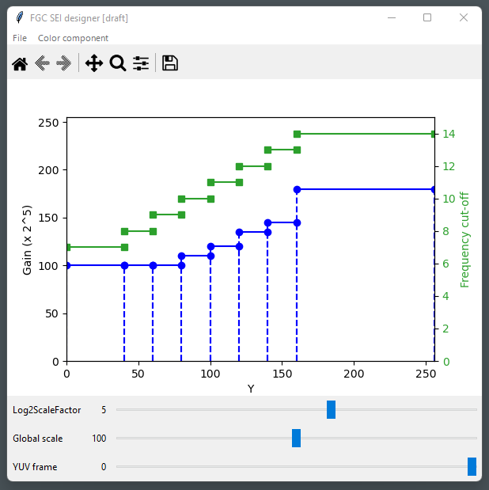
Figure 5.1: Main tool window
An FGC SEI message configuration file may be loaded and saved through the "File" menu. Currently, only the frequency-filtering mode of the FGC SEI message is supported. The syntax used in the configuration file is the same as that in the HM; there is a direct mapping between the interactive plot and the FGC SEI message model parameters.
The color component is selected from the "color component" menu.
Intensity interval boundaries, gain levels, and frequency cutoffs may be click-dragged. An interval is removed when it is reduced to zero-length, and is split by a double-click.

5.3.2. Example configuration import / export
Figure 5.2 is an example film grain parameter representation exported with the FGC SEI message designer tool, using the CrowRun.cfg file that was used for the expert viewing experiments reported in JVET-AD0382 [7]. The graphical export is provided by the "save as" feature of matplotlib (the floppy disk icon of the toolbar in Figure 5.1).

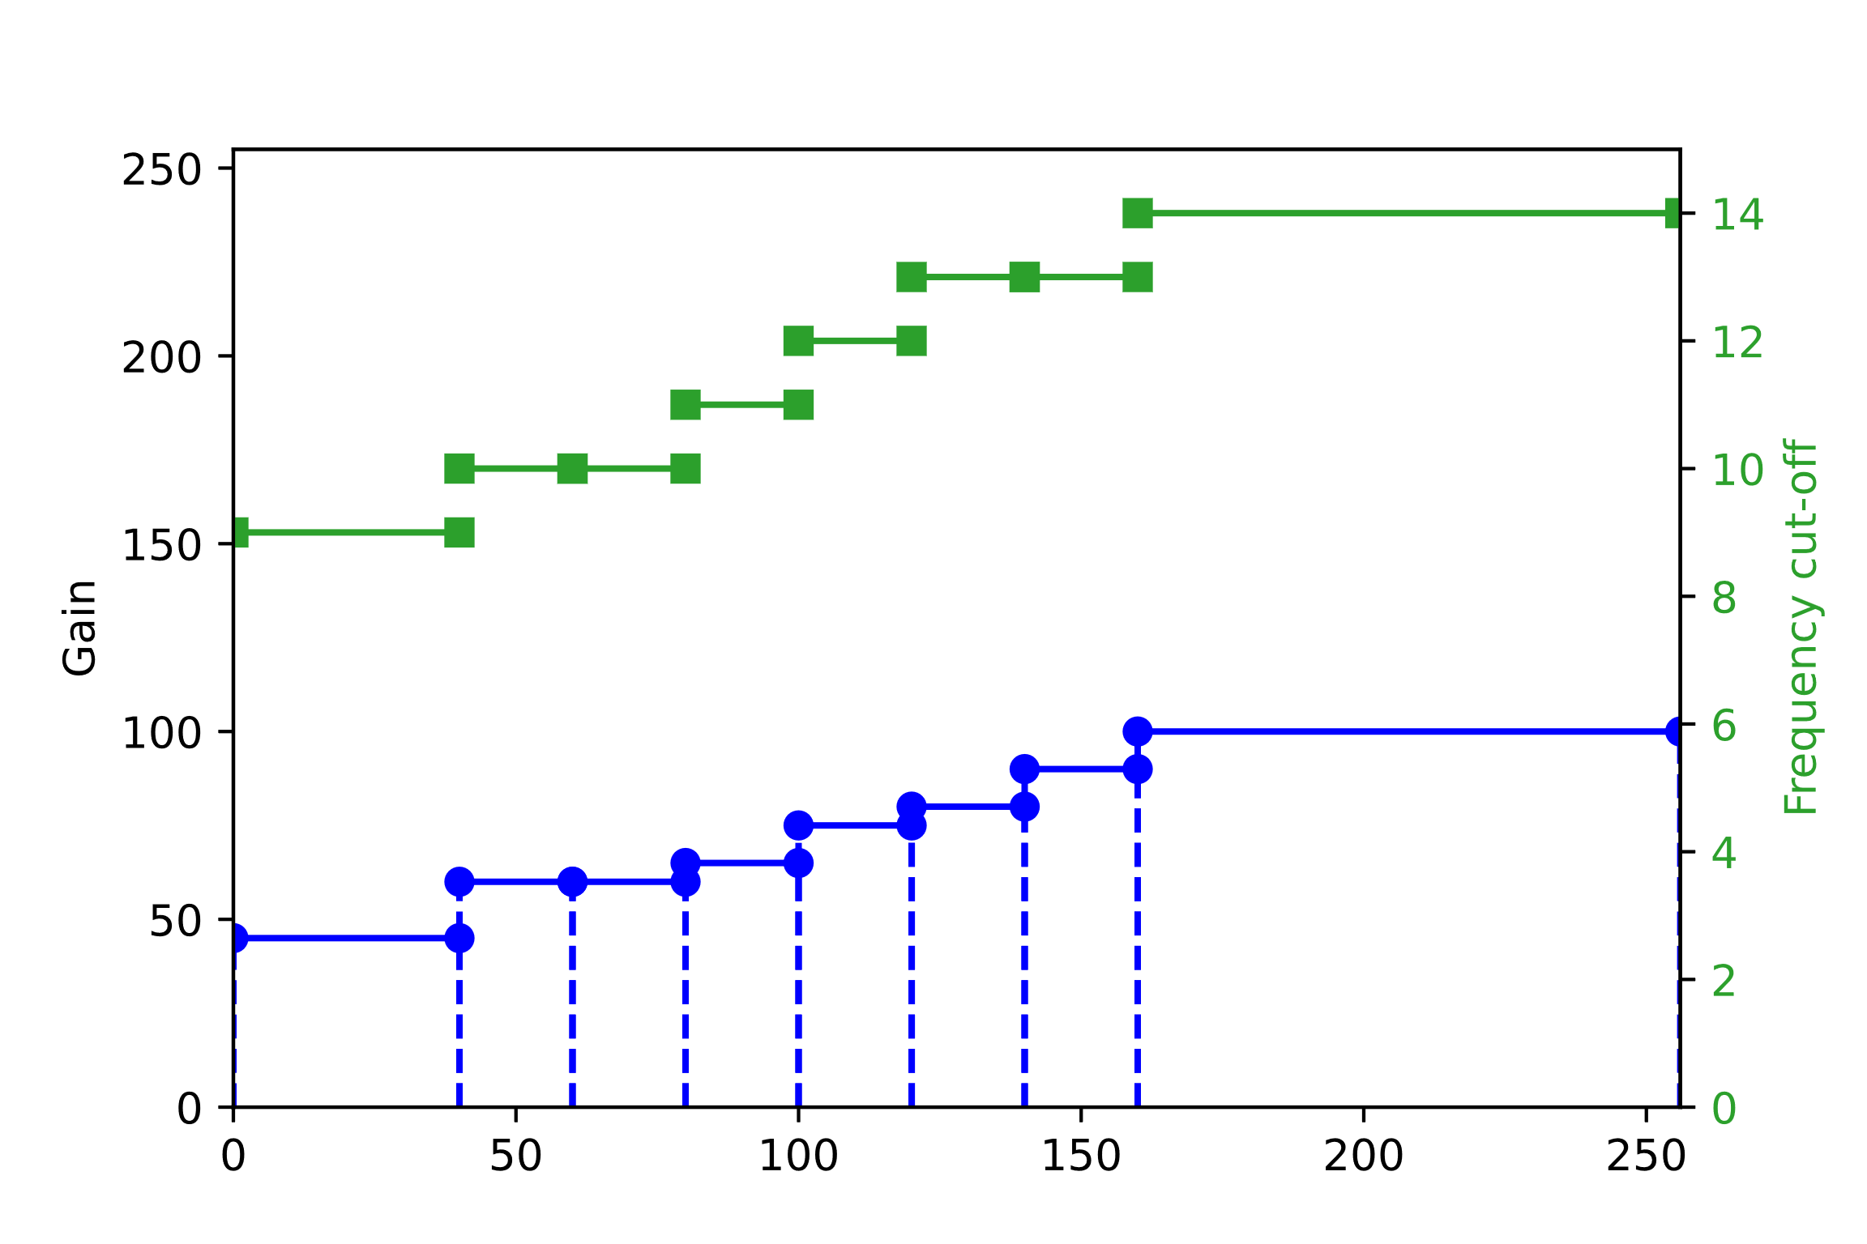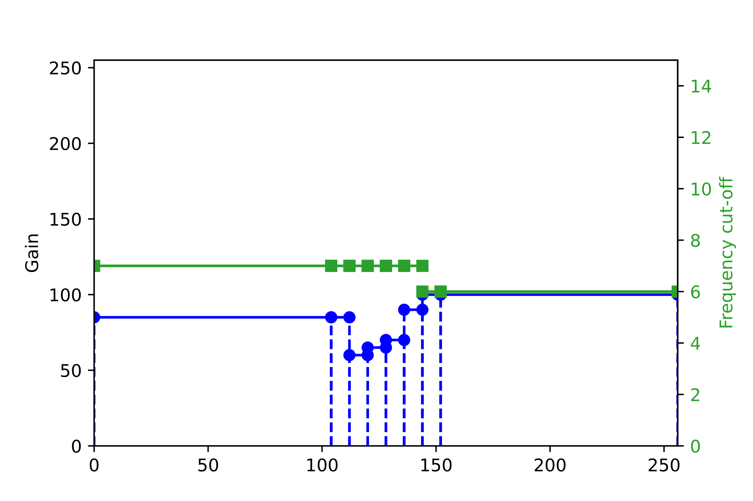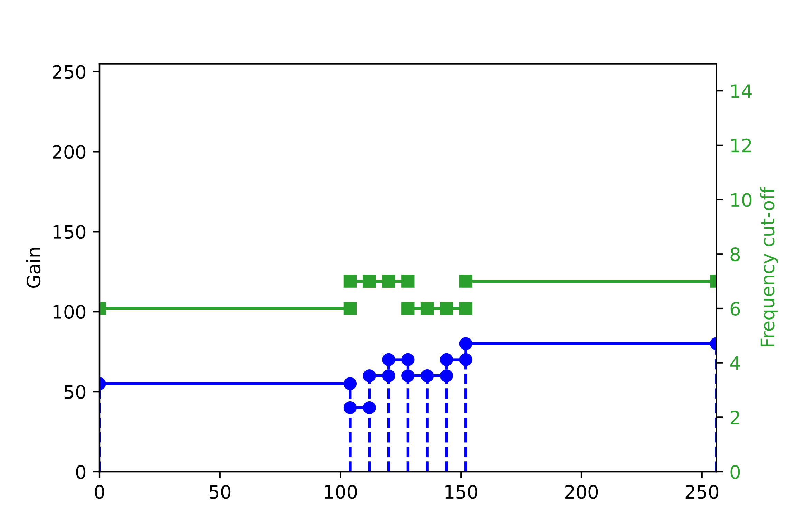
Figure 5.2: Film grain parameters used for CrowdRun in JVET-AD0382 [7] (Luma, Cb, and Cr from top to bottom and left to right)
Note1: The horizontal axis corresponds to a target image sample value (or "intensity"), normalized to 8-bits.
Note2: Here, log2ScaleFactor is equal to 4, which means that the gain axis is scaled down by 2^4 = 16 for an 8-bit target image (for a 10-bit target image, it is scaled down by 4 times less).

5.3.3. Tool chain for experimentation
Figure 5.3 depicts a tool chain that could be used to experiment with film grain synthesis, including the graphical tool described here. Items in green are still under construction.

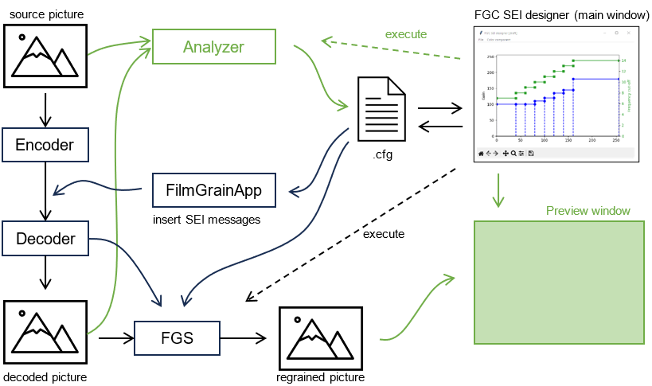
Figure 5.3: Film grain experimental tool chain
The FGC SEI message designer tool is connected to an external film grain synthesizer, so that immediate feedback of the adjustments made may be reflected on a test video (the dashed "execute" arrow in Figure 3). A YUV viewer needs to be used to watch the result until the preview window is available.
The configuration may also be saved and used in the FilmGrainApp program provided with the HM (and the VTM) to insert the FGC SEI messages in a bitstream.
Further future work would include the following aspects:
- The estimation of initial parameters when provided with a source video/picture and a clean/denoised variant (by e.g. connecting an external analyzer);
- The support of the auto-regressive mode, and potentially translations between Frequency Filtering (FF) and Auto-regressive (AR) modes;
- A visualization window that could be used to compare the source, clean/denoised, and re-grained pictures.
Further information on this tool is provided in Annex B.

6 Interoperability of the FGC SEI message

6.1 Film Grain Characteristics SEI message
This clause provides some recommendations on how to best ensure the interoperability of the FGC SEI message.
It is commented that the FGC SEI message may convey film grain characteristics through parameters of a film grain statistical mode. That mode is either based on spatial frequency cutoffs or 2D auto-regressive filter coefficients.
The FGC SEI is based on a few common parameters, like the color space and model kind (frequency filtering or auto-regressive) used and a set of independent intensity intervals. Such intervals define:
- their boundaries (range of color component value) and
- a full set of model parameters, impacting both the grain strength and shape.
It is thus possible to vary both grain strength and pattern (shape, size, sharpness, coarseness) of each interval.
This is illustrated in Figure 6.1 via the use of the FGC SEI designer tool and justified by the variability of grain observed on real film as illustrated in Figure 6.2 and Figure 6.3.
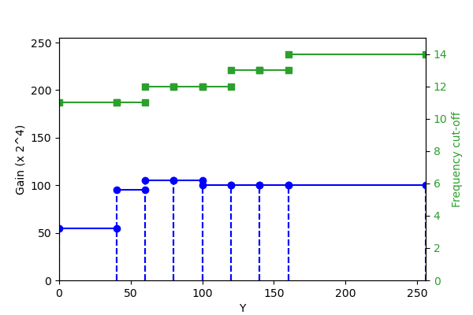
Figure 6.1: Example intervals and parameters

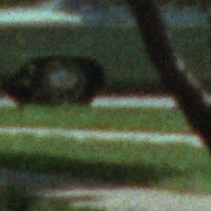

Figure 6.2: Example crops of a 1963 35mm negative film scan (around 7500 ppi / 150 lpm)
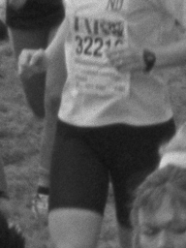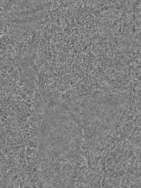
Figure 6.3: Grain variability on an example film (at around 3000 dpi / 60 lpm)
Left: luma – Right: luma grain

6.2 Use of the FGC SEI message with a fixed grain pattern implementation
To enable the use of the FGC SEI Message with implementations that only support fixed grain pattern, the following considerations may be evaluated:
As intervals are fully independent and may be transmitted in any order the following considerations need to be made:
- Transmit in the first position an interval that carries the grain pattern parameters (AR coefficients, or frequency cutoff) that are deemed as giving a good performance on average for the entire picture.
- Transmit intervals in order of the importance of the grain pattern.
Conversion of FF to AR parameters:
- The conversion of frequency-filtering parameters to auto-regressive coefficients may be implemented with pre-computed AR coefficients tuned to give visually similar results. Since the range of values of the frequency cutoffs is likely to be limited to the 3 to 14 range, the number of the AR coefficient sets is small.
Fixed grain shape implementation may generate a grain template based on the first interval and may use the parameters of the remaining intervals to modulate the amplitude of the grain.
Implementations with a limited number of grain patterns (e.g. under 8 or 10) may create templates based on the first intervals up to the maximal number they may support and may use the gain parameter of the remaining intervals to modulate the amplitude of the closest template.

7 Potential additions to TR 26.955 for FGS scenario
This proposal introduced additions to the test scenarios specified in TR26.955, primarily focused on the evaluation of film grain synthesis technologies. Preliminary and unverified analysis of some tests using these proposed additions is included in Annex C.
# | Parameter | Definition
1 | Scenario name | Film Grain Synthesis Scenario
2 | Motivation for the scenario | Study, test and analyze the effect of film grain synthesis applied to varied test scenarios encoded with H.265/HEVC, in order to ascertain whether there is benefit in (1) preservation of artistic intent and/or (2) masking artifacts / saving bitrate, while maintaining visual acuity, etc.
3 | Description of the scenario | Film grain may be unavoidably lost by a conventional video compression workflow as shown in Figure A.1. High frequency grain in the source content ($x$) may be either completely or partially lost due to quantization/resizing in adaptive streaming or broadcast applications, in which case the resulting decoded output $\tilde{x}$ could be void of the artistic effect of grain intended in the source. Even if grain is partially preserved at high bitrates, overall coding efficiency is poor as the grain is not spatially or temporally correlated, which may negatively impact the coding characteristics of the scene.  In the case of the Film Grain Preservation Workflow, as per Figure 2, the source video ($x$) is input to a denoising process that outputs a video sequence from which noise or film grain is attenuated or removed. A film grain parameterization process then compares the source and denoised videos to determine film grain model parameter values, which relate to the variance, spatial frequency characteristics, colour correlation, and other statistical characteristics of the film grain. The process of denoising followed by the film grain model parameter estimation is commonly referred to as the film grain analysis process. After these processes are performed, the denoised video is then encoded and the film grain model parameter values are either signalled in the coded bitstream ($y_{dn}$) or provided to the decoder by some external means.  On the decoder side, the film grain model parameter values are parsed and input to a film grain synthesis process that generates simulated film grain and blends the grain with the decoded video ($\tilde{x_{dn}}$) to output decoded video with simulated film grain ($\tilde{x_{g}}$).
4 | Supporting companies and 3GPP members
5 | Source format properties  Spatial resolutions  Chroma Format  Chroma Subsampling  Aspect ratios  Frame rates  Colour space formats  Transfer Characteristics  Bit depth  Other signal properties | 1920x1080, 3840x2160  YUV  420P  16: 9  24, 29.97, 30 ,59.94 ,60  ITU-R BT.709 or BT.2020  BT.709, PQ  8, 10
6 | Encoding and decoding constraints and settings: Typical encoding constraints and settings such as  Relevant Codec and Codec Profile/Levels according to TS26.116 and TS26.511.  Random access frequency  Error resiliency requirements  Bitrates and quality requirements  Bitrate parameters (CBR, VBR, CAE, HRD parameters)  ABR encoding requirements (switching frequency, etc.)  Latency requirements and specific encoding settings  Encoding context: real-time encoding, on device encoding, cloud-based encoding, offline encoding, etc.  Required decoding capabilities | HEVC/H.265  Main Profile & Main10 Profile, Level 5.3  HM version used: HM 18.0  https://vcgit.hhi.fraunhofer.de/jvet/HM/-/tags/HM-18.0  Detailed configuration parameters are listed in Annex D.  Constant QP (CQP) Random Access configurations were used for all the tests. CQP values for MOS tests were done as to meet following typical operating bit rates:  1080p60: 1Mbps to 4Mbps  2160p60: 6Mbps to 18Mbps  2160p24: 2Mbps to 9Mbps  Nearest rate matching CQP values were chosen for the MOS subjective evaluation tests to assess benefits of grain in preservation of artistic intent.  HM CQP streams and relevant FGC SEI configuration files for each test are also provided in separate zip file.  HM decoder which supports film grain synthesis as per specified frequency domain filter FGC SEI is used to decoder and output grain synthesized video.
7 | Performance Metrics and Requirements  - A clear definition on how the performance needs to be evaluated including metrics, etc addressing the main KPIs of the scenario.  - Objective measures such as PSNR, VMAF, etc, may be used.  - Subjective evaluation is not excluded and may be done, but needs commitment | Subjective Metrics  - MOS (pairwise method with hidden reference)  - Relative Grading (A v/s B method)  - JND (Just Noticeable Difference) method
8 | Interoperability Considerations for the application  - Streaming with DASH/HLS/CMAF  - RTP based delivery | The following media formats have been tested and validated for FGS interoperability.  - MP4  - MPEG-DASH  - HLS
9 | Test Sequences  - A set of selected test sequences that are provided by the proponents in order to do the evaluation. They should cover a set of source format properties | Preserving Artistic Intent  Scenario FHD  - BQTerrace 1920x1080 60fps  - OldTownCross 1920x1080 50fps  - InToTree 1920x1080 50fps  Scenario 4K-TV  - Crowdrun 3840x2160 60fps  - Tears of Steel 3840x1714 10bit 24fps (4 Scenes x 2 FG patterns per scene)  Scene_004_FG_03  Scene_004_FG_22  Scene_044_FG_03  Scene_044_FG_22  Scene_062_FG_16  Scene_062_FG_24  Scene_101_FG_21  Scene_101_FG_24  It has been reported that there is an updated "ground truth-based" film grain material available, that was generated using the "Tears of Steel" open movie and other new content. Such material may be used for investigating methods on film grain analysis, synthesis, and quality evaluation among others.  (Candidate text for TR 26.955 Sec.6.7.3)
10 | Detailed test conditions:  - Provides a proposal for detailed test conditions, for example based on a reference software together with the sequences and configuration parameters. | After denoising the content, HEVC software encoders and decoders with film grain analysis and synthesis support, respectively, are used to assess the performance of film grain modelling:  - Denoiser: The ffmpeg 'nlmeans' filter is used to denoise the source content before encoding.  - FFmpeg version: ffmpeg-v6.0  - ffmpeg-6.0.tar.gz  Sample Command  ./ffmpeg -f rawvideo -pix_fmt yuv420p -s:v 1920x1080 -I ../InToTree_1080p50.yuv -vf nlmeans=3.5:5:3:9:7 InToTree_nlmeans_3.5_5_3_9_7.yuv;  Note: FFmpeg denoiser is not used for denoising Tears of Steel content as the ground truth data (denoised) was provided by Apple.  - Film grain analysis algorithm: The frequency filtering analysis algorithm in the HM-18.0 reference encoder is used to model the grain parameters to be inserted in the FGC SEI message. FGC SEI messages are inserted only at IRAP pictures.  - Film grain synthesis algorithm: The SMPTE RDD5 based Frequency filtering grain synthesis algorithm in the HM-18.0 reference decoder is used for blending the synthesized film grain with the decoded video  - Browser player with FGS support: For Subjective evaluation, Ittiam HEVC FGS web browser player is used as it supports SMPTE RDD5 based frequency film grain synthesis using the FGC SEI messages embedded in HEVC bitstream. The player is built using optimized HEVC Decoder and FGS library (libfgs) which produces bit accurate output with HM Decoder.  The Player is tested to be bit accurate with HM + FGS (using same picture display number based seed). HM Decoder and Player will have the same output and either may be used for testing. Player may enable playback of streams with FGS on different clients where there are limitations for YUV based playback.  - https://demo.ittiam.com/demo/i265_fgs/
11 | External Performance data
12 | Additional Information

To kick off evaluation, initial focus on the following is considered:
- 5 Source format properties
- 7 Performance Metrics and Requirements
- 9 Test Sequences
- 10 Detailed test conditions

Note: the evaluation does not necessarily have to be as detailed as in TR 26.955, relying on external performance data is good. However, it should be possible to understand if and how the information fits into the 3GPP relevant use cases. Repeatability should also be considered. If JVET completes such an evaluation, this would be preferable.

8 Considerations on UE requirements
In a possible specification for requirements, what could be done is the following:
- 3GPP Film grain synthesis reference process (possibly by reference to JVET)
- Process to verify "not having perceptually significant differences" to 3GPP Film grain synthesis reference process (possibly by reference to JVET)
- Receiver Requirements:
- Either
- 3GPP Film grain synthesis reference process implemented, or
- not having perceptually significant differences to 3GPP Film grain synthesis reference process
- making sure that available receiver implementations meet the receiver requirements
- This could be a new specification or an Annex to an existing specification TS 26.116

9 Communication with JVET
Communication via liaison statement to JVET was done informing them about the 3GPP efforts in the field of film grain synthesis documented in this report and requesting some tests to be run based on a 3GPP codec, namely HEVC.
JVET agreed to modify its test plan of Film Grain Synthesis to accommodate the scope of the current technical report.
The progress of this study is therefore linked to the outcome of the work done by JVET.

10 Conclusion
Based on the initial analysis, it was concluded to await progress in JVET before considering any new work in 3GPP.

Annex A:
Compressibility analysis of Film Grain – test results

A.1 Simulation Results
Figure A.1 through A.11 show the rate distortion plots for all different scenes and their noise variants. It is observed that, all noise variants, as expected, result in a worse rate-distortion trade-off compared to the ground truth method. It is also observed that for all cases, variants FG21-FG25 seem to be the most complex to encode, with especially variant FG25 resulting always in the worst coding performance. The results for Tears of Steel sequence are presented.
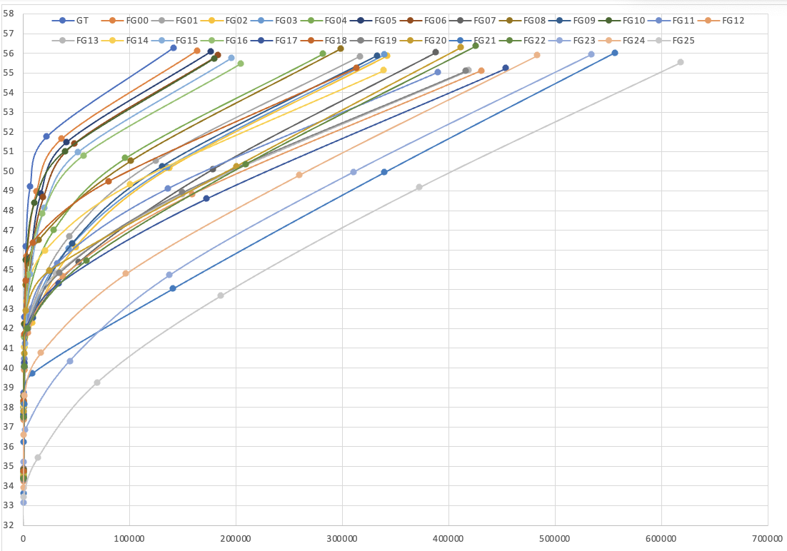
Figure A.1: Rate distortion performance for all variants for the Tears of Steel "ToS" Scene 004
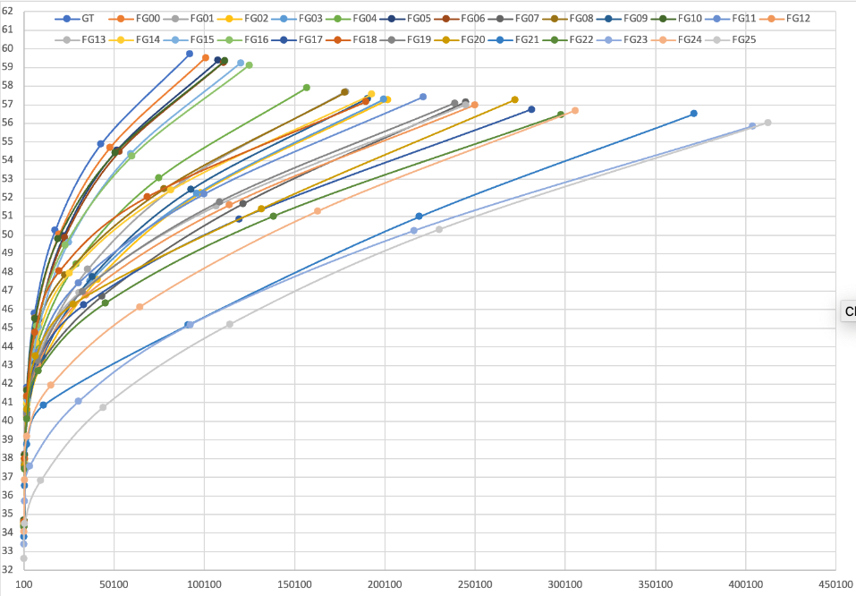
Figure A.2: Rate distortion performance for all variants for the Tears of Steel "ToS" Scene 021

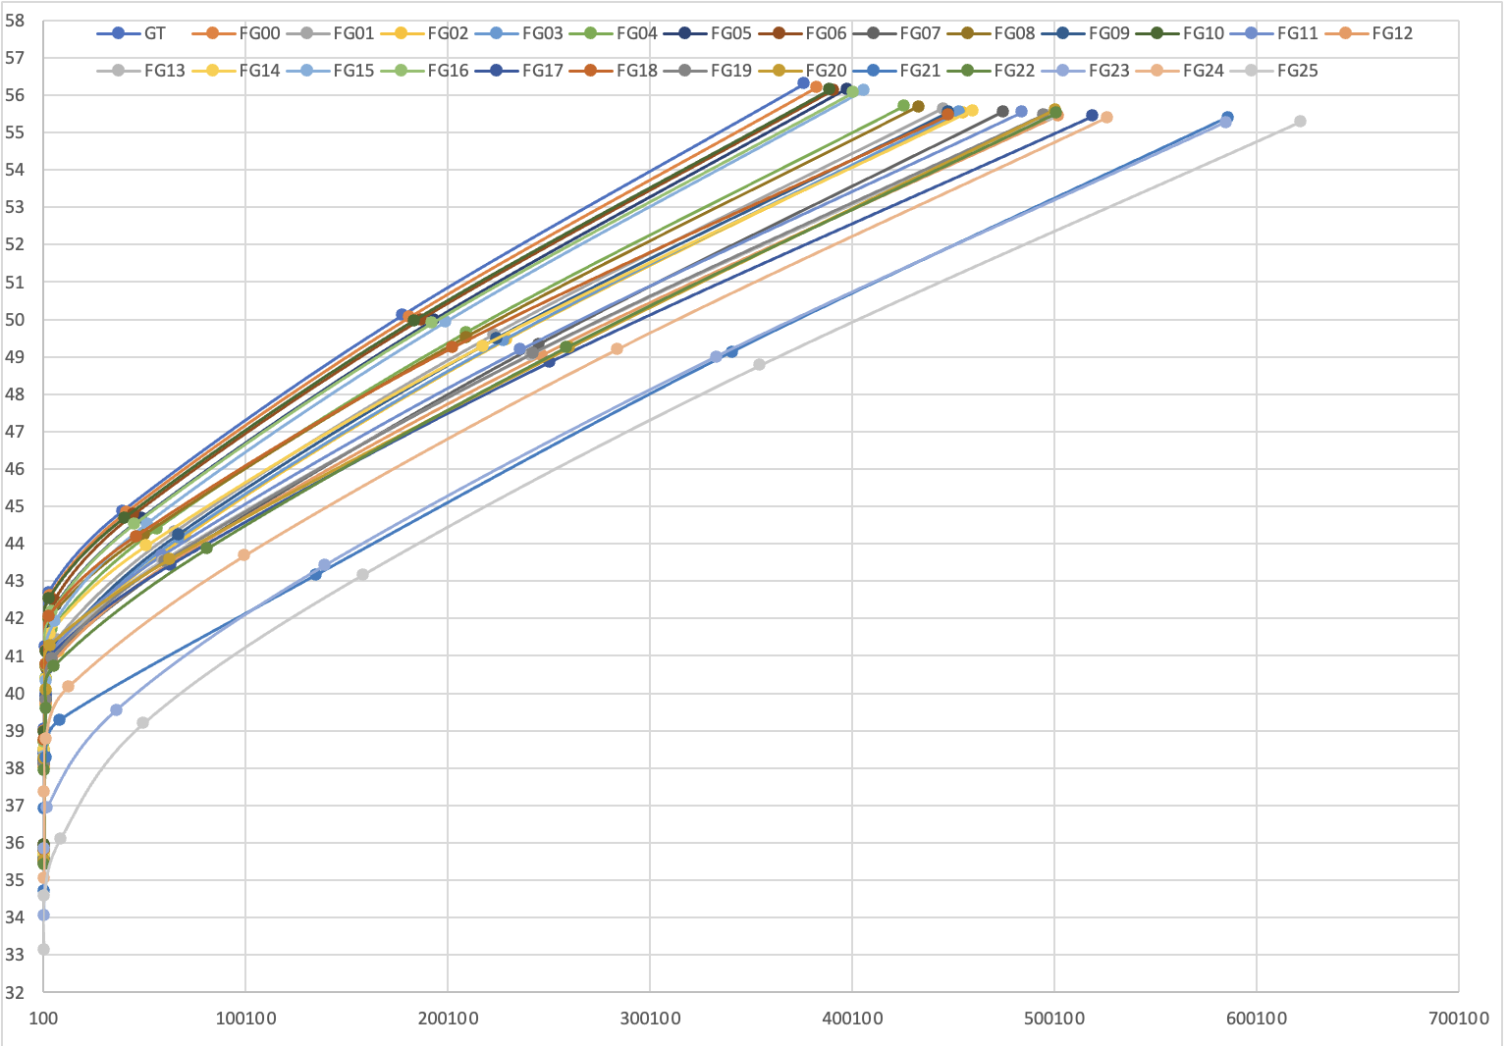
Figure A.3: Rate distortion performance for all variants for the Tears of Steel "ToS" Scene 023
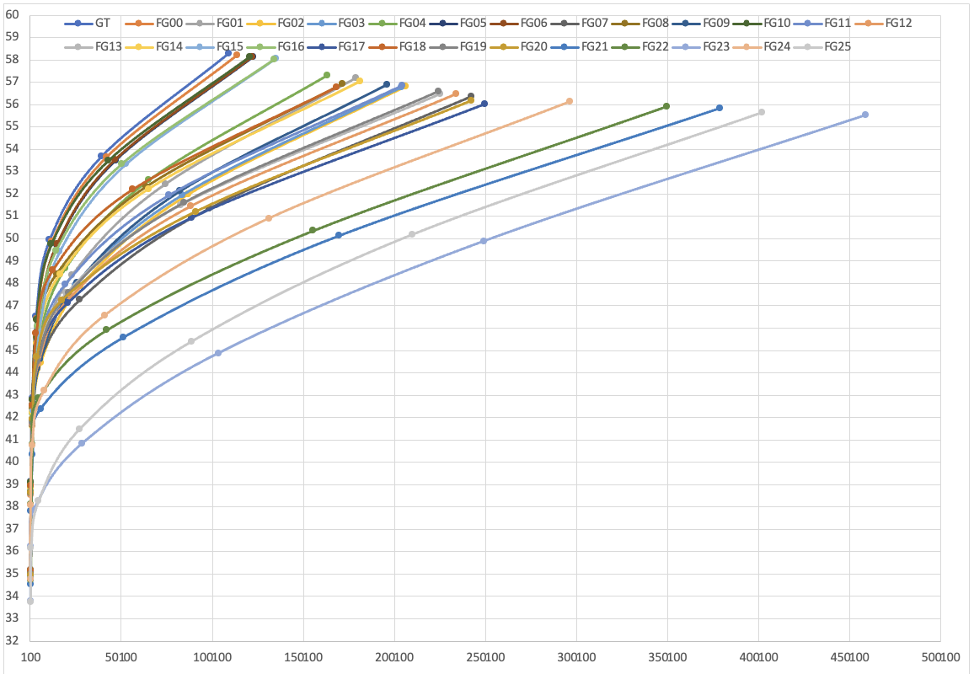
Figure A.4: Rate distortion performance for all variants for the Tears of Steel "ToS" Scene 029
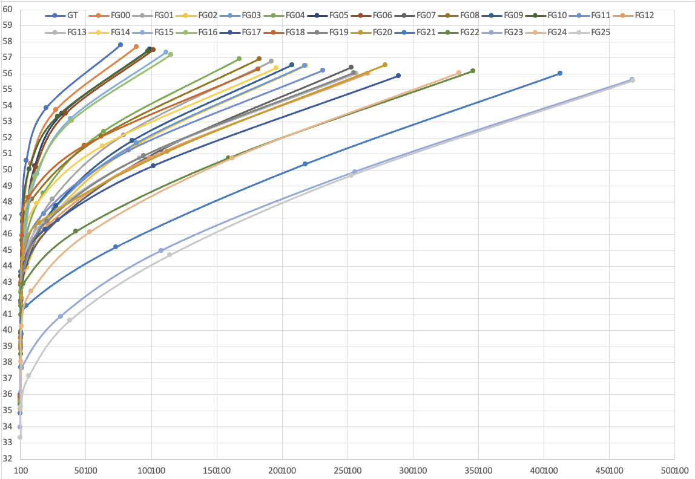
Figure A.5: Rate distortion performance for all variants for the Tears of Steel "ToS" Scene 030
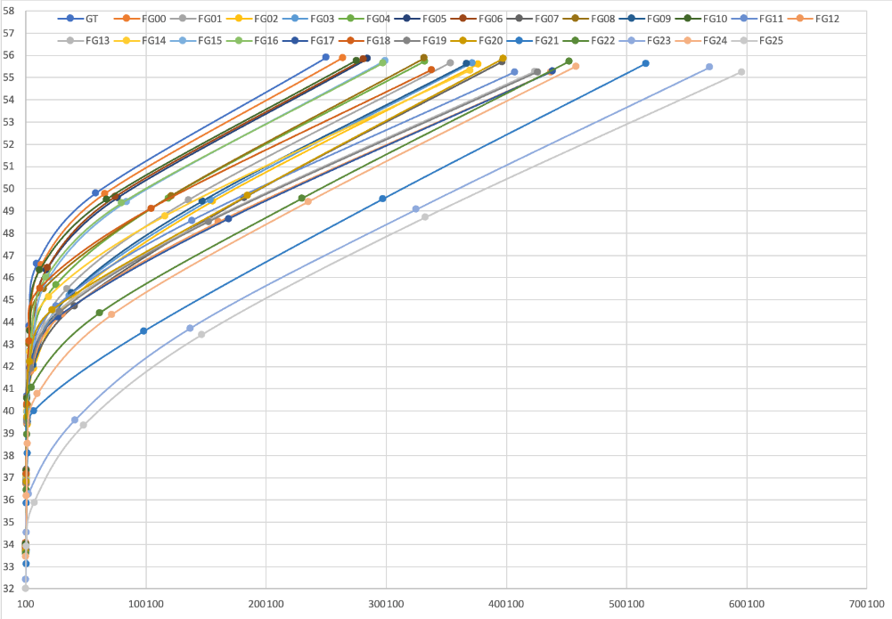
Figure A.6: Rate distortion performance for all variants for the Tears of Steel "ToS" Scene 044
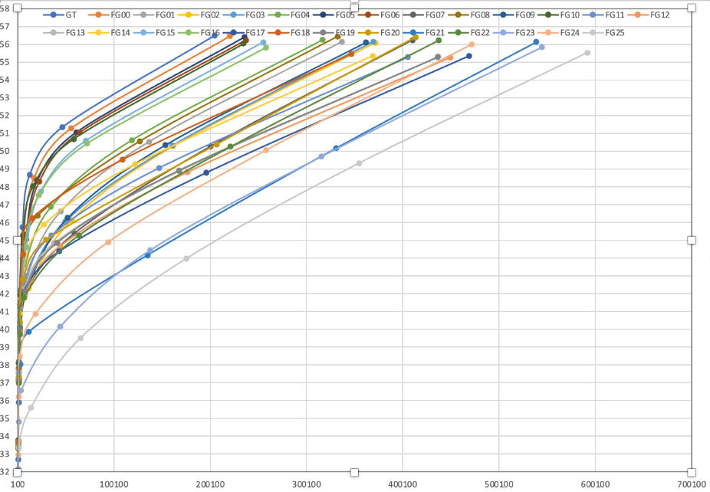
Figure A.7: Rate distortion performance for all variants for the Tears of Steel "ToS" Scene 046
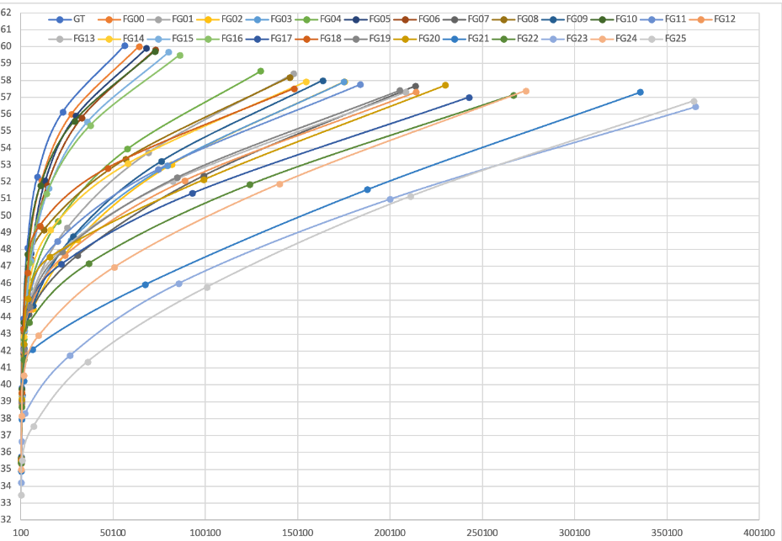
Figure A.8: Rate distortion performance for all variants for the Tears of Steel "ToS" Scene 062
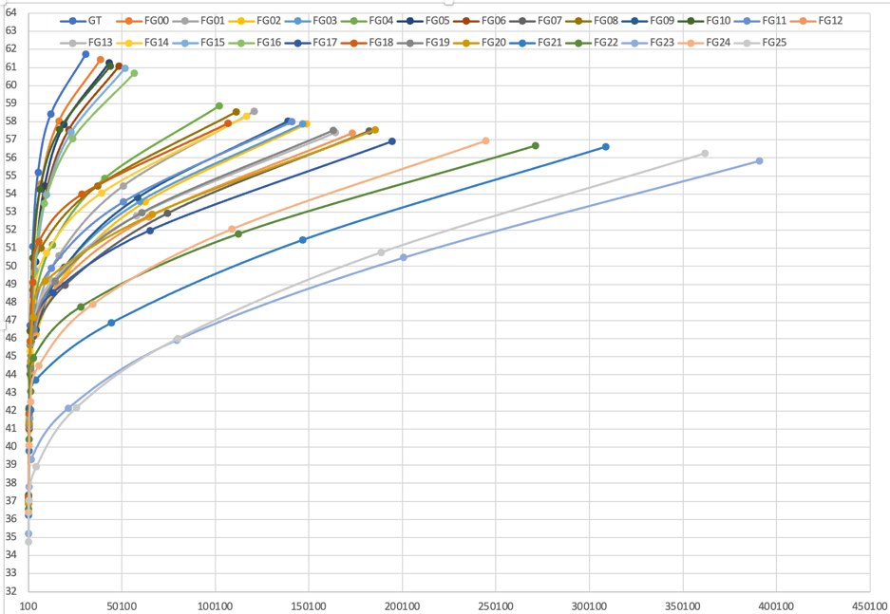
Figure A.9: Rate distortion performance for all variants for the Tears of Steel "ToS" Scene 101
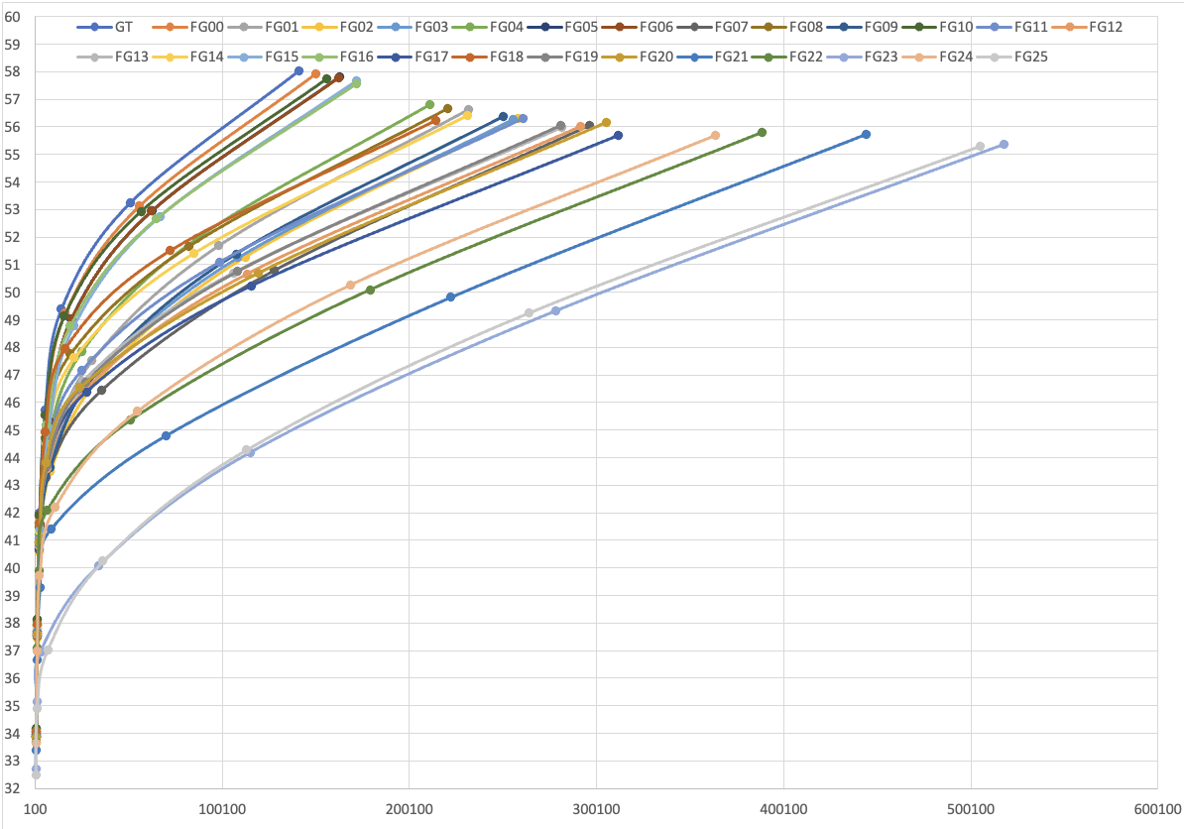
Figure A.10: Rate distortion performance for all variants for the Tears of Steel "ToS" Scene 135
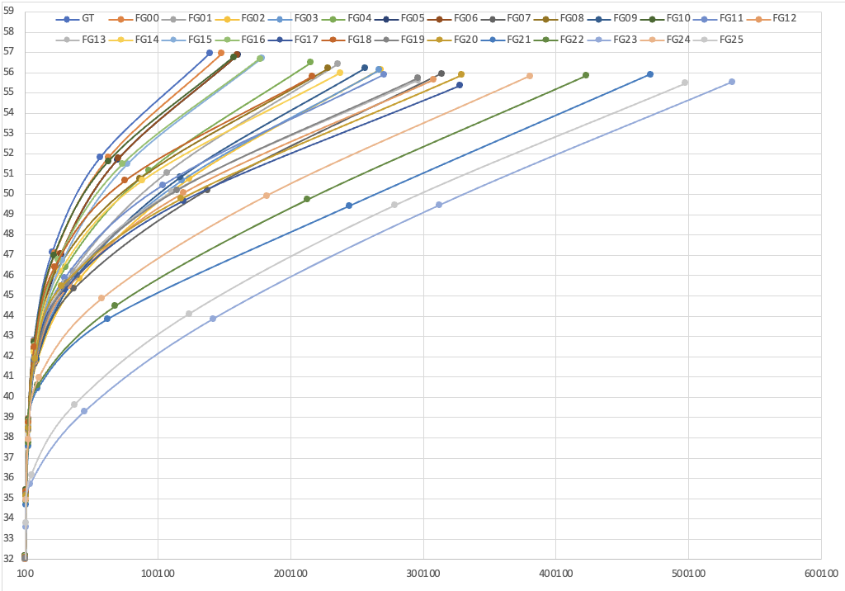
Figure A.11: Rate distortion performance for all variants for the Tears of Steel "ToS" Scene 136
Figures A.12 through A.22 show the performance of the average PSNR with the average bitrate for all variants for Tears of Steel.
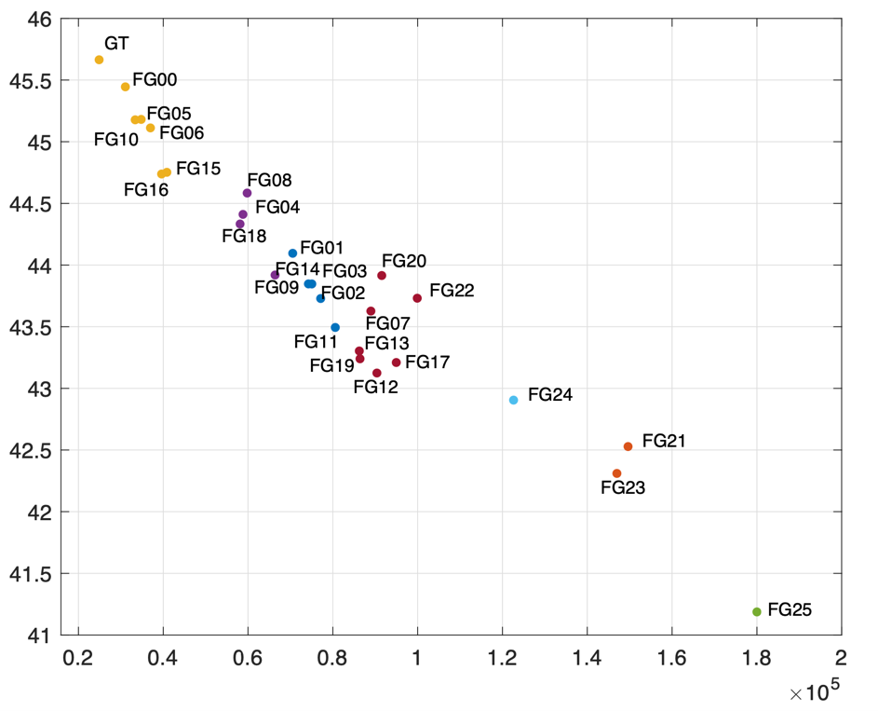
Figure A.12: Avg PSNR vs. Avg. Bitrate for all variants for the Tears of Steel "ToS" Scene 004
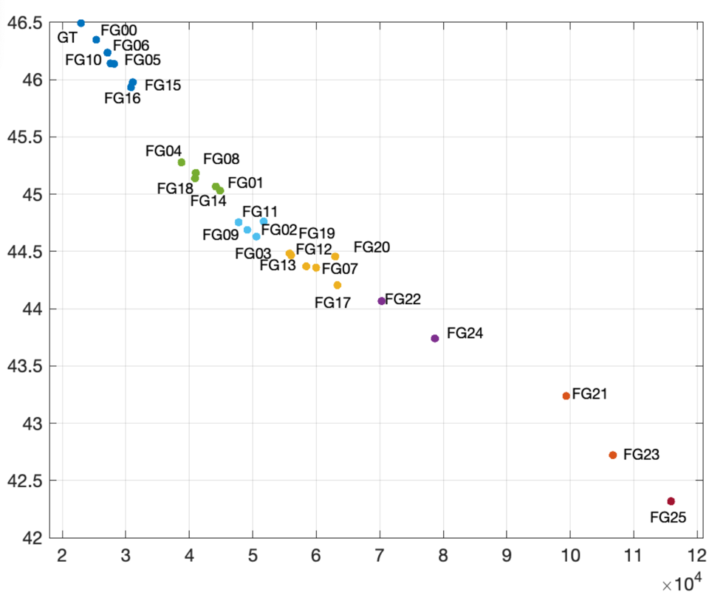
Figure A.13: Avg PSNR vs. Avg. Bitrate for all variants for the Tears of Steel "ToS" Scene 021
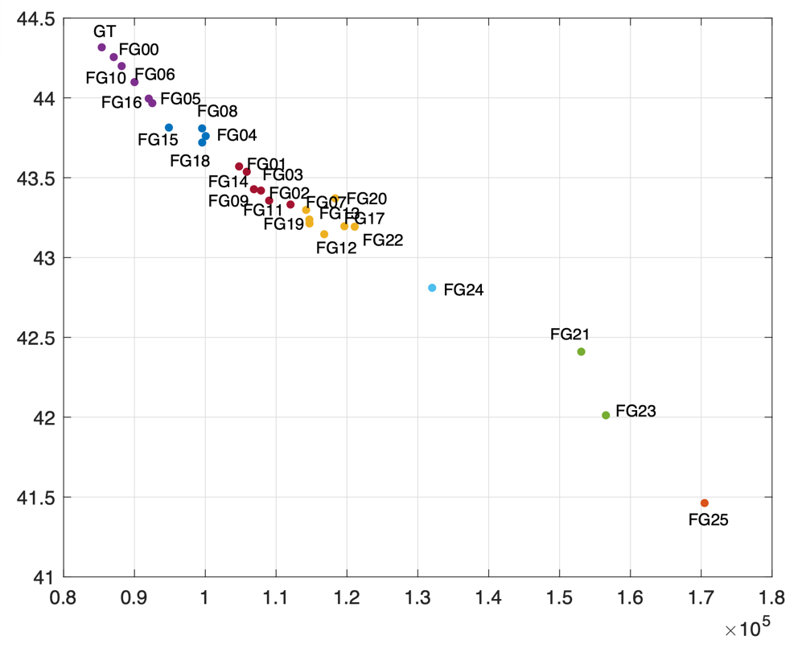
Figure A.14: Avg PSNR vs. Avg. Bitrate for all variants for the Tears of Steel "ToS" Scene 023
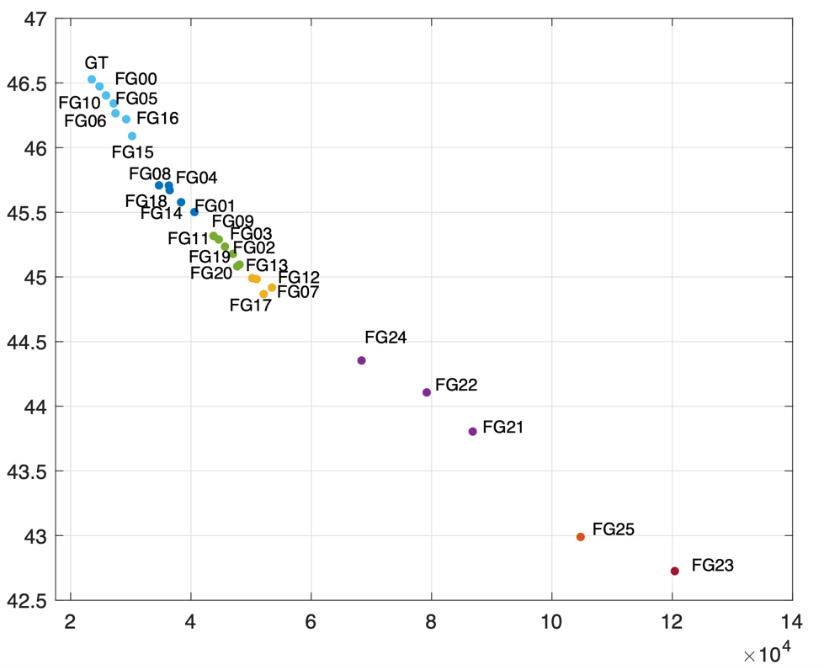
Figure A.15: Avg PSNR vs. Avg. Bitrate for all variants for the Tears of Steel "ToS" Scene 029
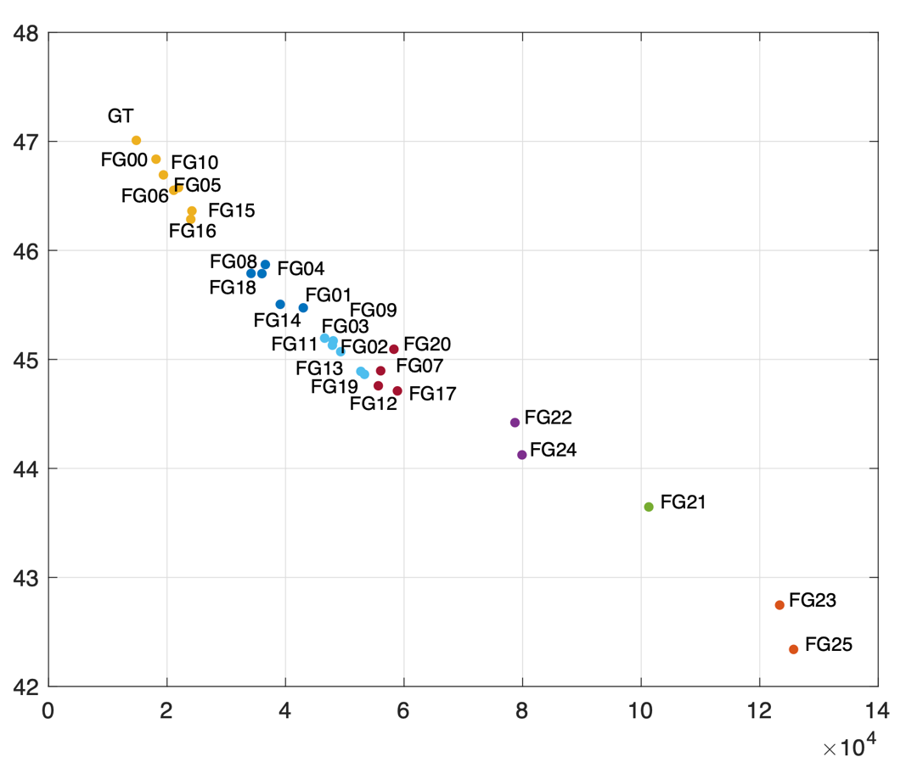
Figure A.16: Avg PSNR vs. Avg. Bitrate for all variants for the Tears of Steel "ToS" Scene 030
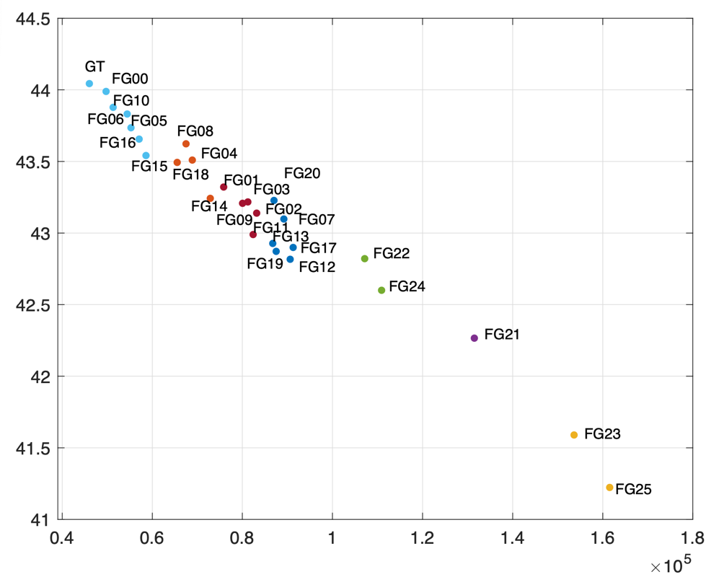
Figure A.17: Avg PSNR vs. Avg. Bitrate for all variants for the Tears of Steel "ToS" Scene 044
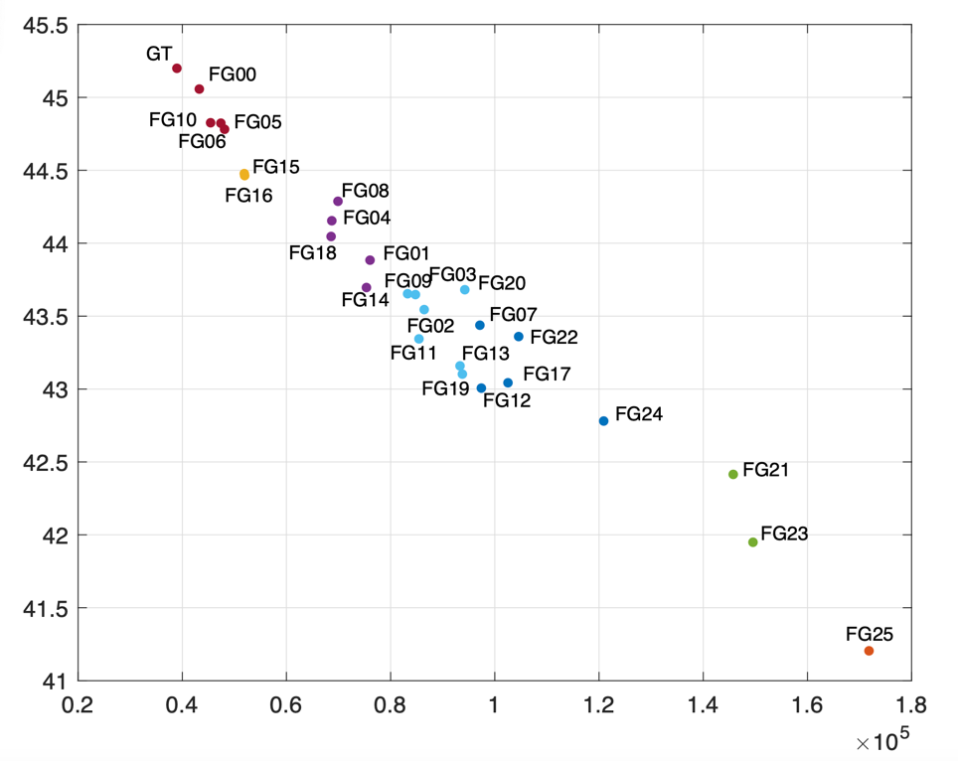
Figure A.18: Avg PSNR vs. Avg. Bitrate for all variants for the Tears of Steel "ToS" Scene 046
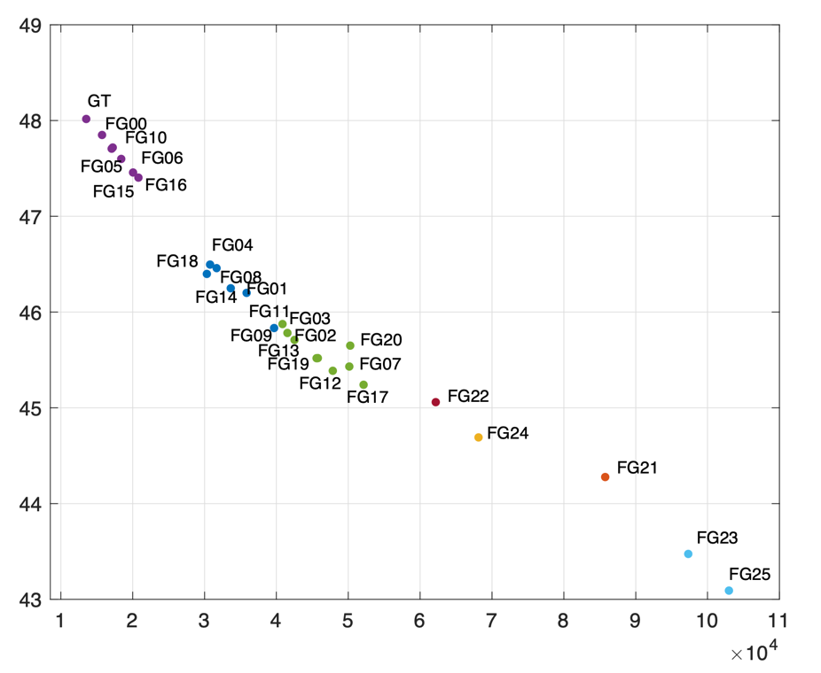
Figure A.19: Avg PSNR vs. Avg. Bitrate for all variants for the Tears of Steel "ToS" Scene 062
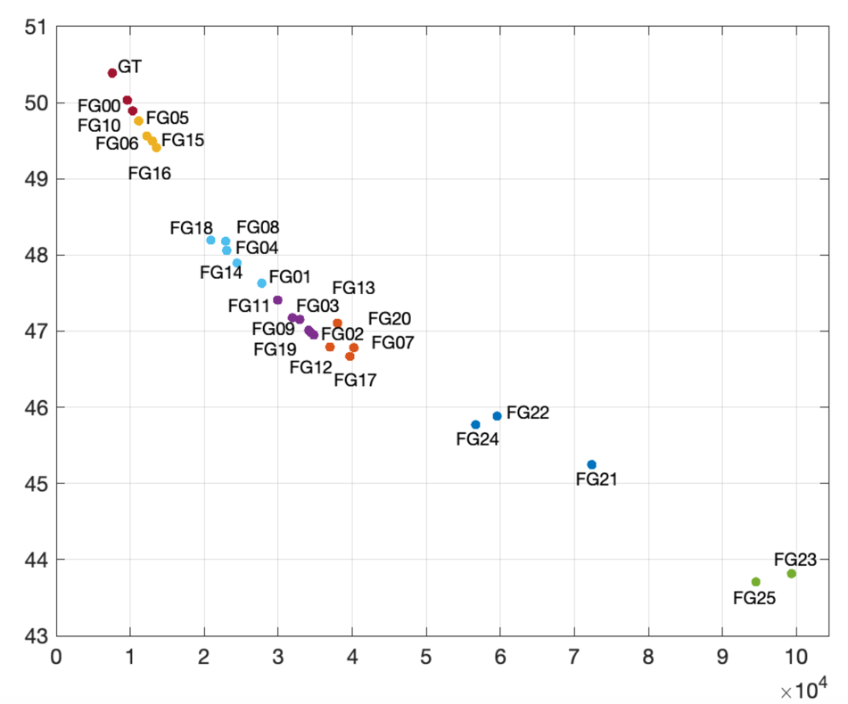
Figure A.20: Avg PSNR vs. Avg. Bitrate for all variants for the Tears of Steel "ToS" Scene 101
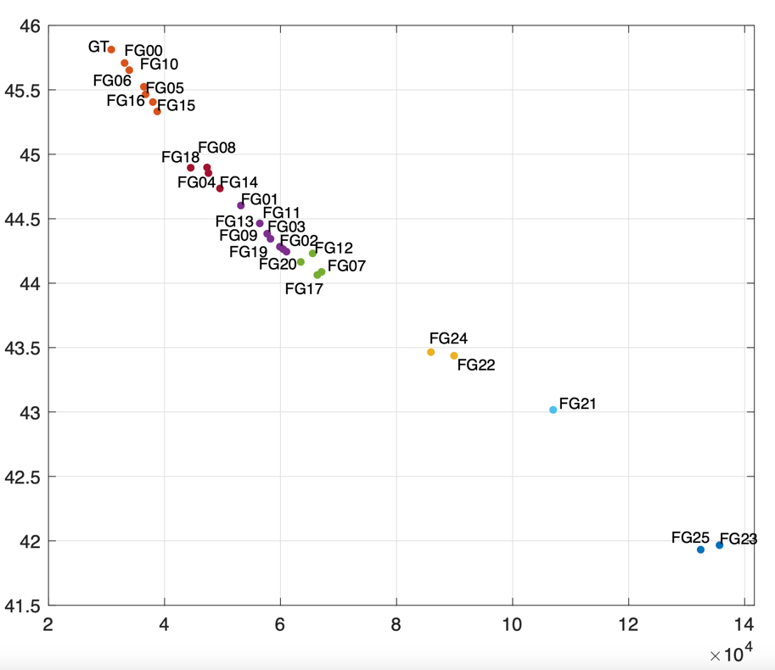
Figure A.21: Avg PSNR vs. Avg. Bitrate for all variants for the Tears of Steel "ToS" Scene 135
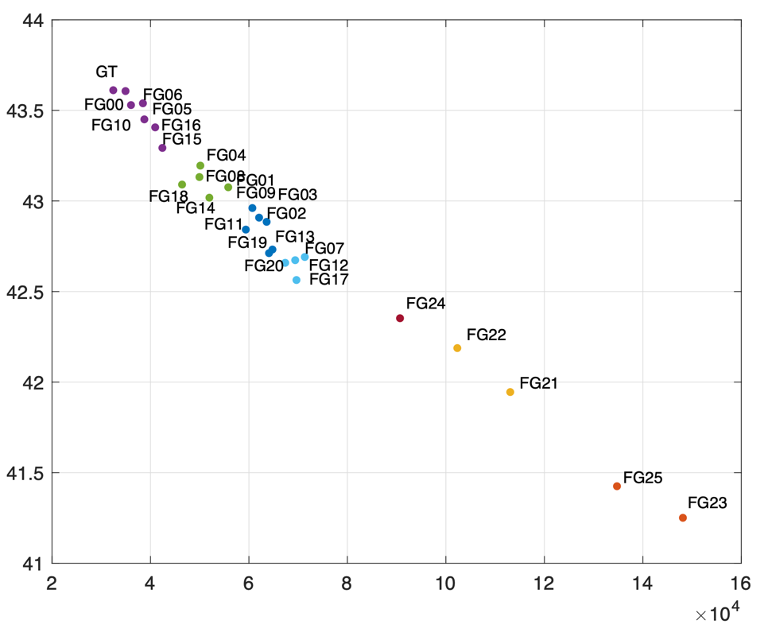
Figure A.22: Avg PSNR vs. Avg. Bitrate for all variants for the Tears of Steel "ToS" Scene 136
Figures A.23 through A.33 show the complexity ratio for each variant i compared to the ground truth, computed by dividing average Complexity(i) by Complexity(0), where Complexity(0) corresponds to the complexity value, as defined in Section 4, for the ground truth variant.
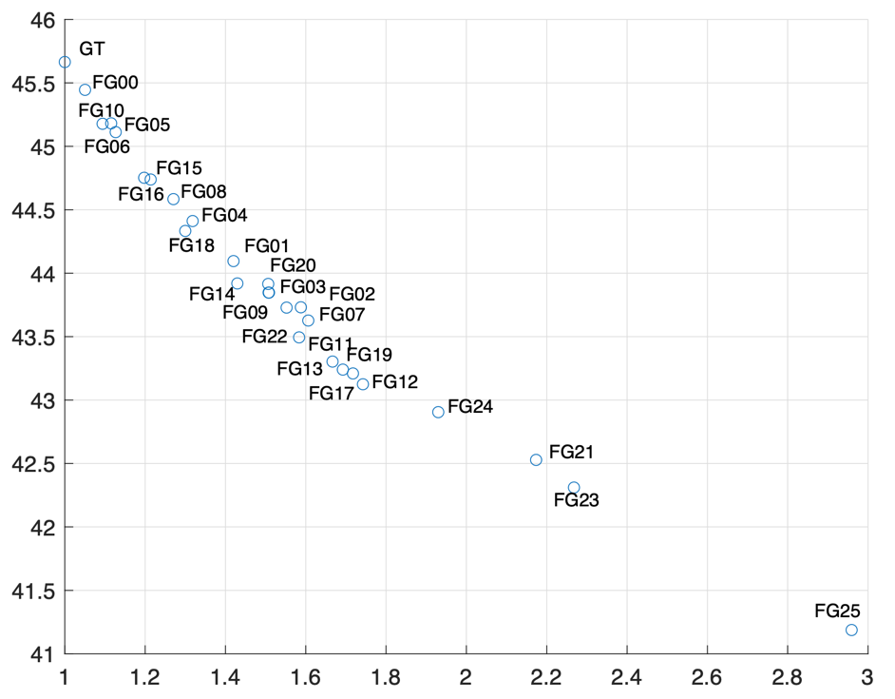
Figure A.23: Avg PSNR vs. Avg. complexity for all variants for the Tears of Steel "ToS" Scene 004
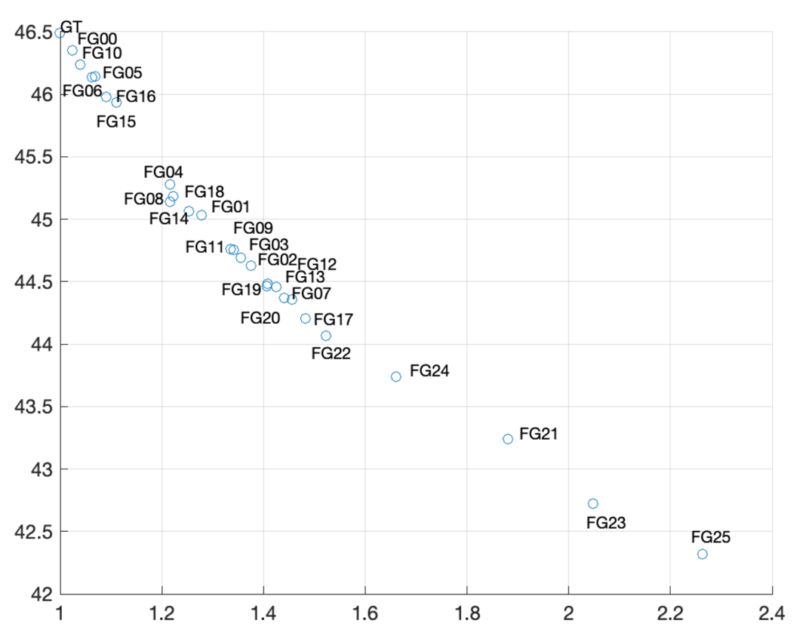
Figure A.24: Avg PSNR vs. Avg. complexity for all variants for the Tears of Steel "ToS" Scene 021
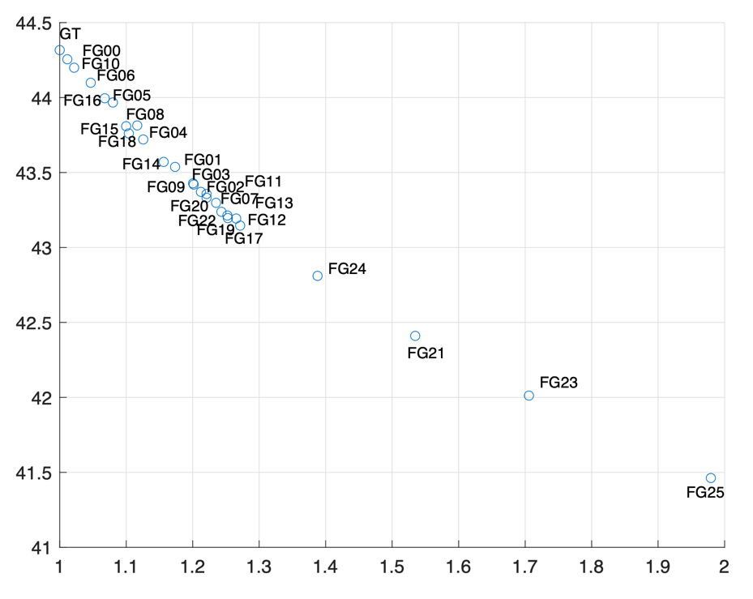
Figure A.25: Avg PSNR vs. Avg. complexity for all variants for the Tears of Steel "ToS" Scene 023
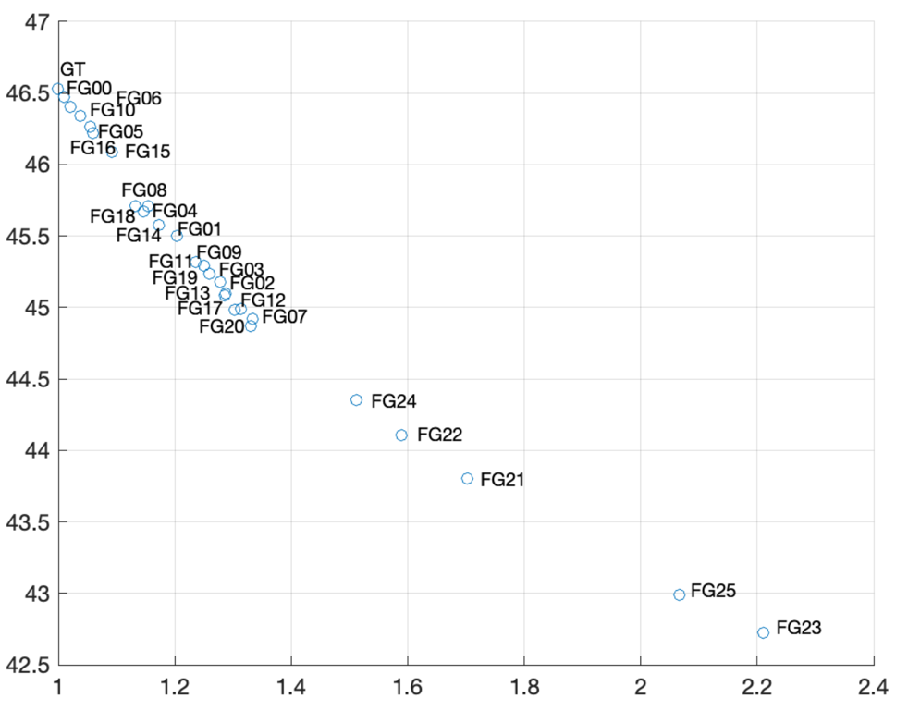
Figure A.26: Avg PSNR vs. Avg. complexity for all variants for the Tears of Steel "ToS" Scene 029
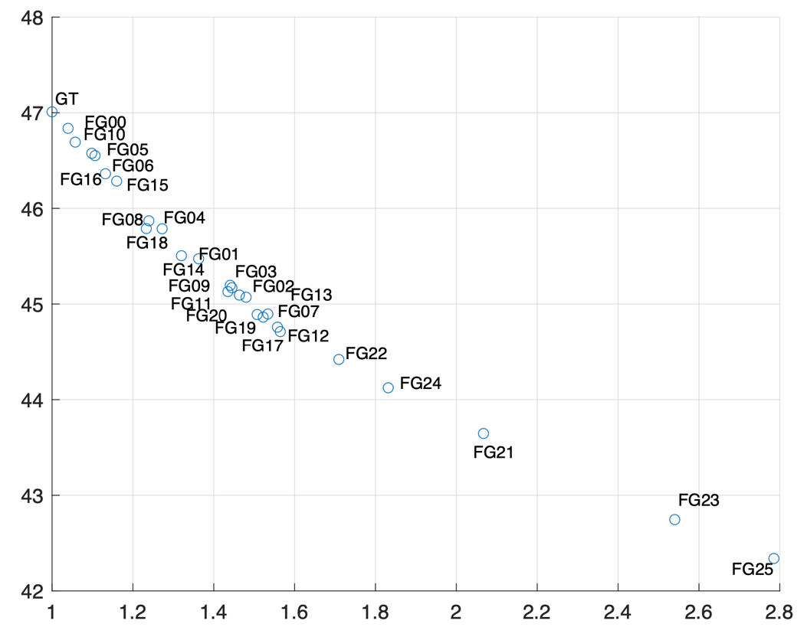
Figure A.27: Avg PSNR vs. Avg. complexity for all variants for the Tears of Steel "ToS" Scene 030
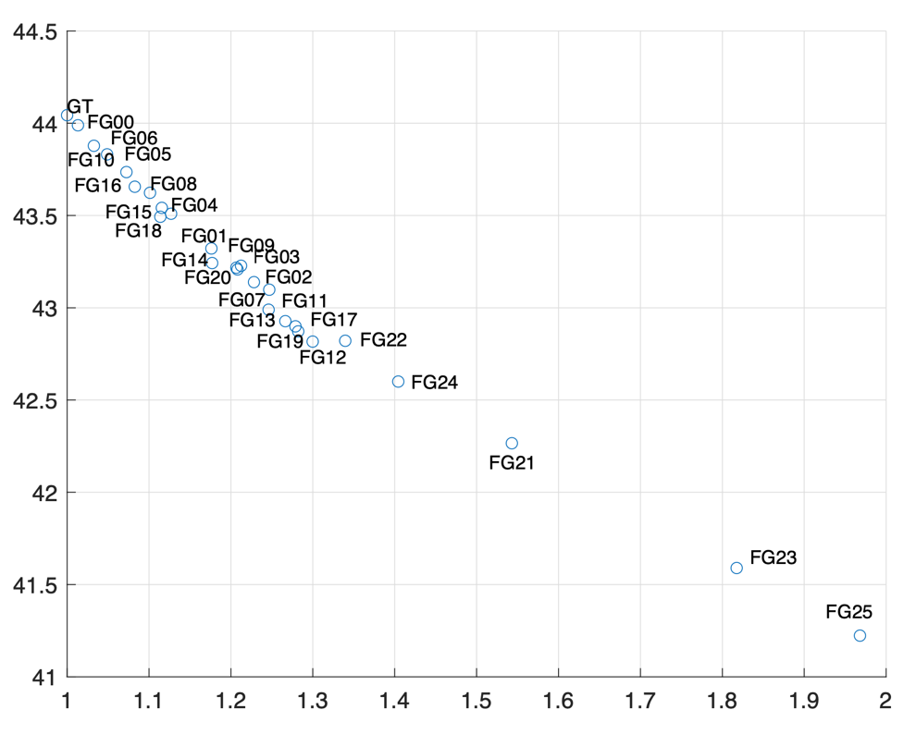
Figure A.28: Avg PSNR vs. Avg. complexity for all variants for the Tears of Steel "ToS" Scene 044
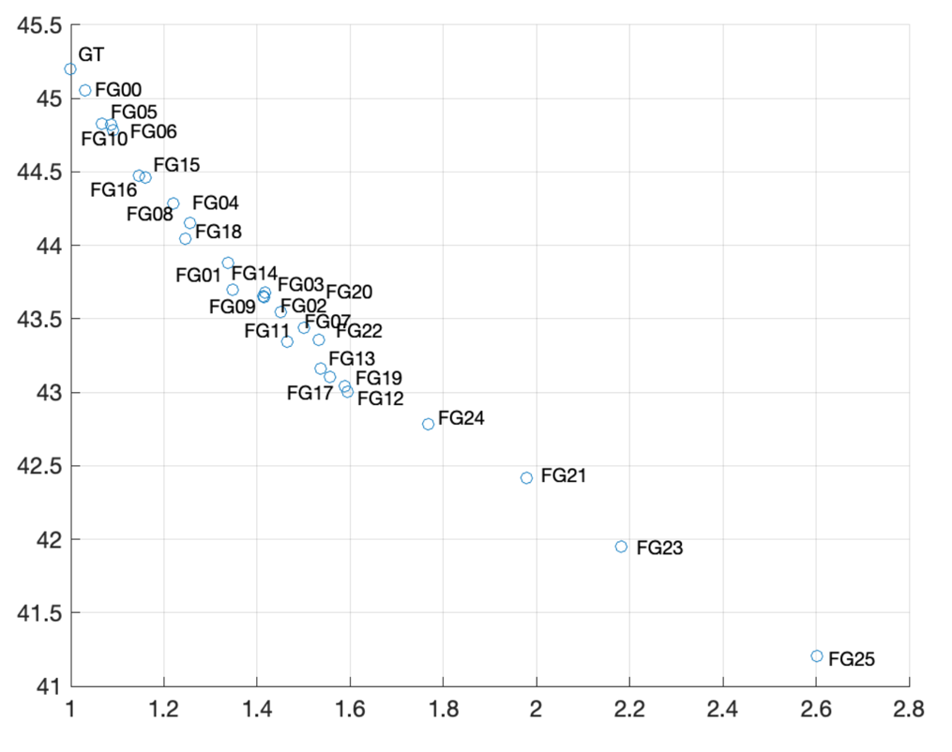
Figure A.29: Avg PSNR vs. Avg. complexity for all variants for the Tears of Steel "ToS" Scene 046
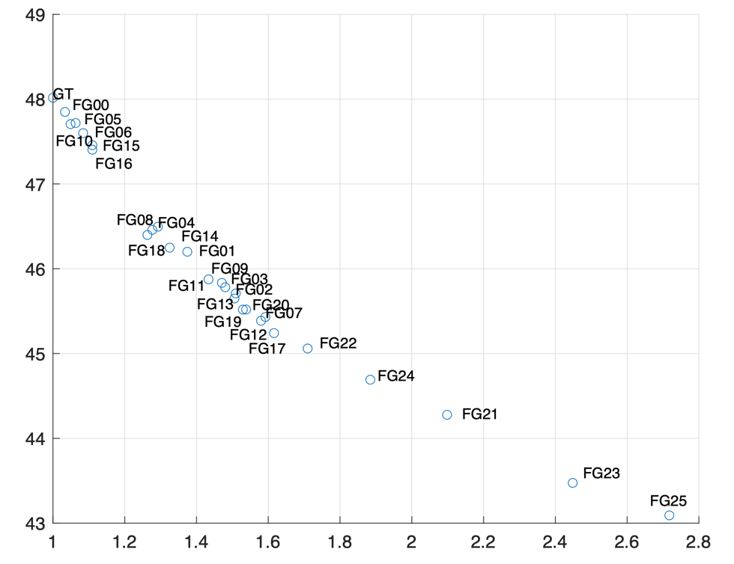
Figure A.30: Avg PSNR vs. Avg. complexity for all variants for the Tears of Steel "ToS" Scene 062
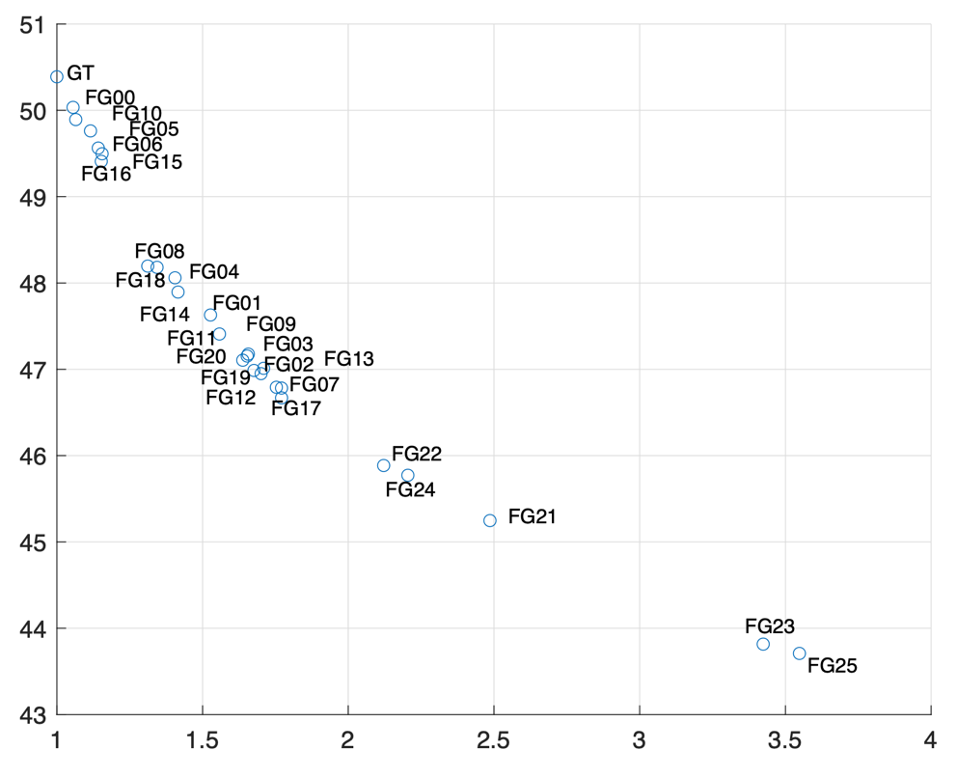
Figure A.31: Avg PSNR vs. Avg. complexity for all variants for the Tears of Steel "ToS" Scene 101
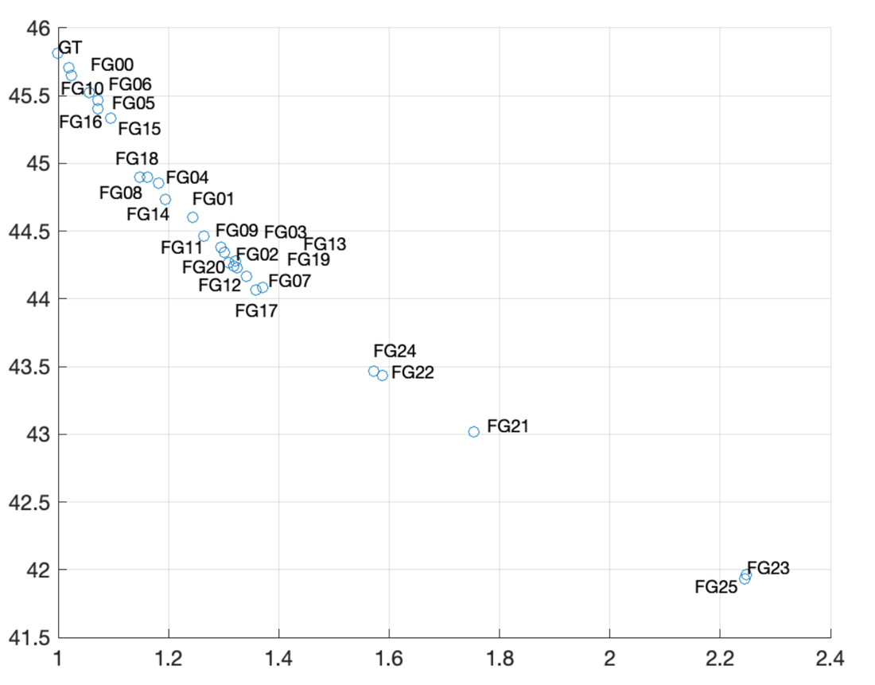
Figure A.32: Avg PSNR vs. Avg. complexity for all variants for the Tears of Steel "ToS" Scene 135
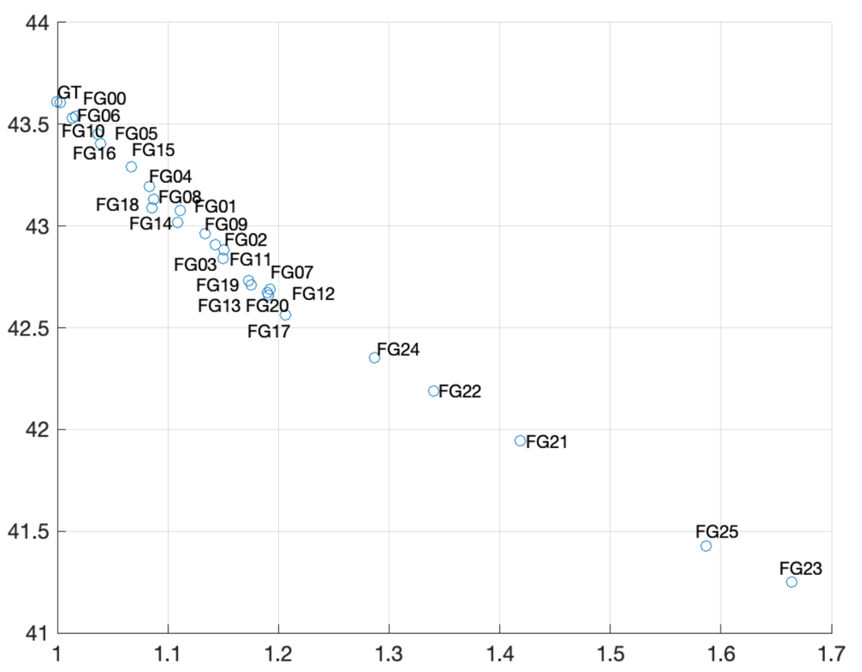
Figure A.33: Avg PSNR vs. Avg. complexity for all variants for the Tears of Steel "ToS" Scene 136
The above figures show that several variants exhibit rather similar compressibility behavior. This similarity my be used to reduce the variants that could be evaluated for different applications. In particular, one may observe from these that several noise variants seem to be exhibiting similar compressibility behavior. Table 2 through Table 4 provide an initial grouping of all noise variants using K-means clustering. It should be noted that compressibility, however, is also impacted by the spatial and/or temporal characteristics of the original video. This may be seen by the fact that some noise variants may sometimes have been characterized as being of "Low complexity" and others as being of "Moderate complexity". It may be prudent to also consider such characteristics when selecting the variant to be used for any experiments.
It is interesting to note that in several instances the coloured version of a noise variant, e.g. FG 11 vs FG 1 and FG 18 vs FG 8, is classified in a more complex category. This is not unexpected since such variants now include noise not only in the luma channel but also in the coloured channels, making the content potentially more complicated to encode. Therefore, it is encouraged, when selecting content, not to immediately reject one of these variants just solely on the fact of both of them being based on the same grain type but look at also other characteristics of each scene and their variants.
Table A.1: Possible Low Complexity film grain noise variants for Tears of Steel
Scene004 | 5, 6, 10
Scene021 | 5, 6, 10, 15, 16
Scene023 | 6, 10
Scene029 | 5, 6, 10, 15, 16
Scene030 | 5, 6, 10, 15, 16
Scene044 | 5, 6, 10,16
Scene046 | 5, 6, 10
Scene062 | 5, 6, 10, 15, 16
Scene101 | 1, 2, 3, 4, 5
Scene135 | 10
Scene136 | 5, 6, 10, 16

Table A.2: Possible Moderate Complexity film grain noise variants for Tears of Steel
 | Moderate0 | Moderate1 | Moderate2
Scene004 | 4, 8, 15, 16, 18 | 1, 2, 3, 7, 9, 11, 14, 20, 22 | 12, 13, 17, 19
Scene021 | 1, 3, 4, 8, 9, 11, 14, 18 | 2, 7, 12, 13, 17, 19, 20, 22 | 24
Scene023 | 1, 4, 5, 8, 14, 15, 16, 18 | 2, 3, 7, 9, 11, 12, 13, 17, 19, 20, 22 | 24
Scene029 | 1, 4, 8, 14, 18 | 2, 3, 7, 9, 11, 12, 13, 17, 19, 20 | 22, 24
Scene030 | 1, 4, 8, 14, 18 | 2, 3, 7, 9, 11, 12, 13, 17, 19, 20 | 22, 24
Scene044 | 1, 4, 8, 14, 15, 18 | 2, 3, 7, 9, 11, 12, 13, 17, 19, 20 | 22, 24
Scene046 | 4, 8, 15, 16, 18 | 1, 2, 3, 7, 9, 11, 14, 20 | 12, 13, 17, 19, 22, 24
Scene062 | 1, 4, 8, 11, 14, 18 | 2, 3, 7, 9, 12, 13, 17, 19, 20, 22 | 24
Scene101 | 6, 7, 8, 9, 10, 11, 12, 13 | 14, 15, 16, 17, 18, 19, 20, 21 | 22
Scene135 | 5, 6, 15, 16 | 4, 8, 14, 18 | 1, 2, 3, 7, 9, 11, 12, 13, 17,19, 20
Scene136 | 1, 4, 8, 9, 14, 15, 18 | 2, 3, 7, 11, 12, 13, 17, 19, 20 | 22, 24

Table A.3: Possible High Complexity film grain noise variants for Tears of Steel
 | Complex0 | Complex1 | Complex2
Scene004 | 24 | 21, 23 | 25
Scene021 | 21 | 23 | 25
Scene023 | 21 | 23 | 25
Scene029 | 21 | 25 | 23
Scene030 | 21 | 23 | 25
Scene044 | 21 | 23 | 25
Scene046 | 21 | 23 | 25
Scene062 | 21 | 23 | 25
Scene101 | 23 | 24 | 25
Scene135 | 22, 24 | 21 | 23, 25
Scene136 | 21 | 25 | 23

Figures A.34 through A.41 show the rate distortion plots for all different scenes and their noise variants for Gregory sequences. Similar analysis as for the ToS sequences is done in Figures A.42 though A.57 and in Table A.4 through Table A.6.
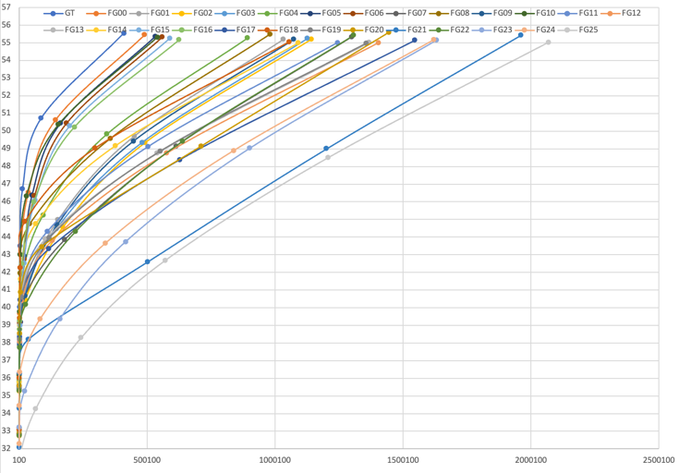
Figure A.34: Rate distortion performance for all variants for the EggMixing
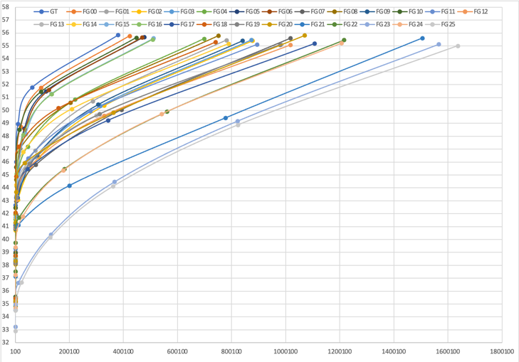
Figure A.35: Rate distortion performance for all variants for the ForestFocus
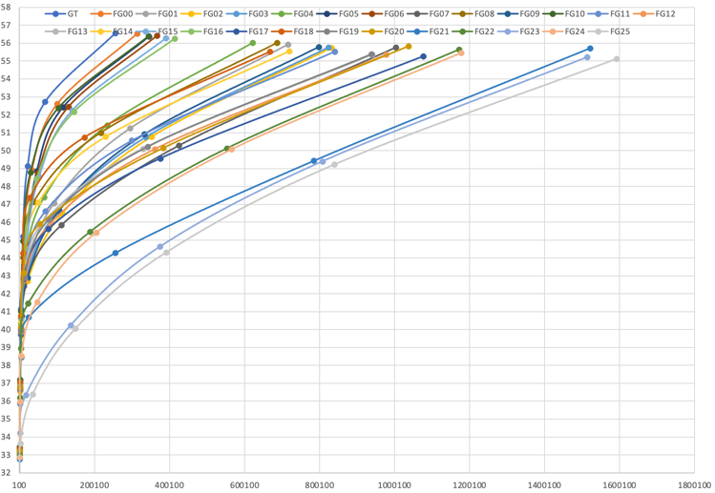
Figure A.36: Rate distortion performance for all variants for the ForestZoom
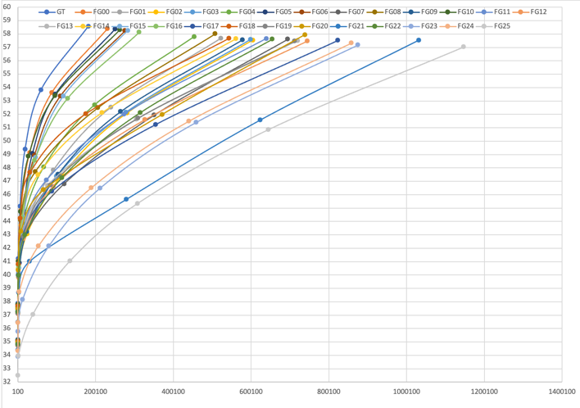
Figure A.37: Rate distortion performance for all variants for the GoldenGatePan
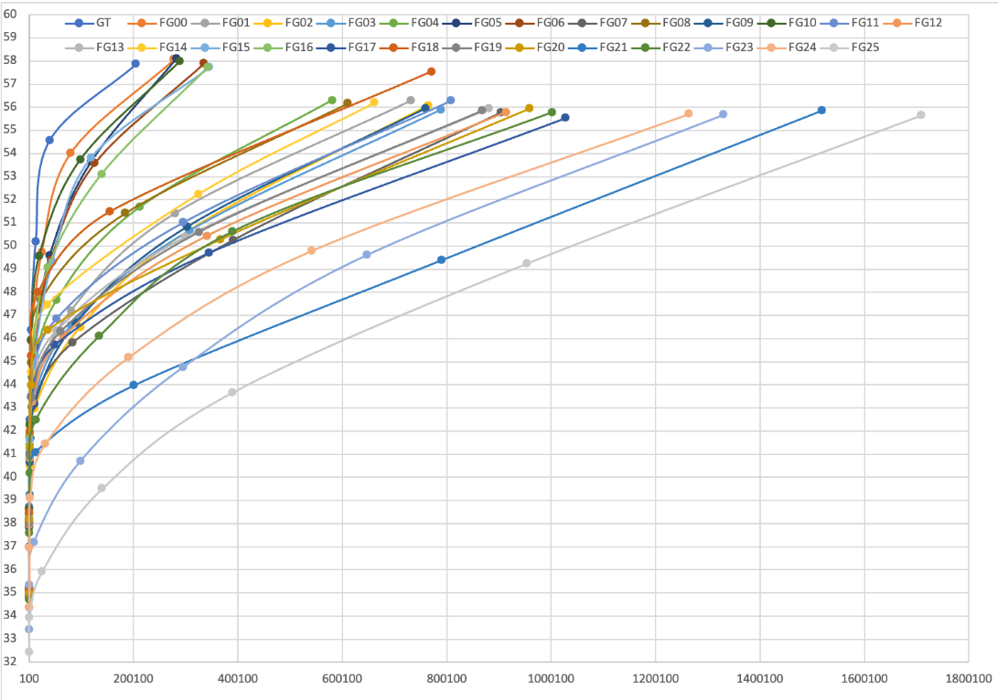
Figure A.38: Rate distortion performance for all variants for the GoldenGateBridge
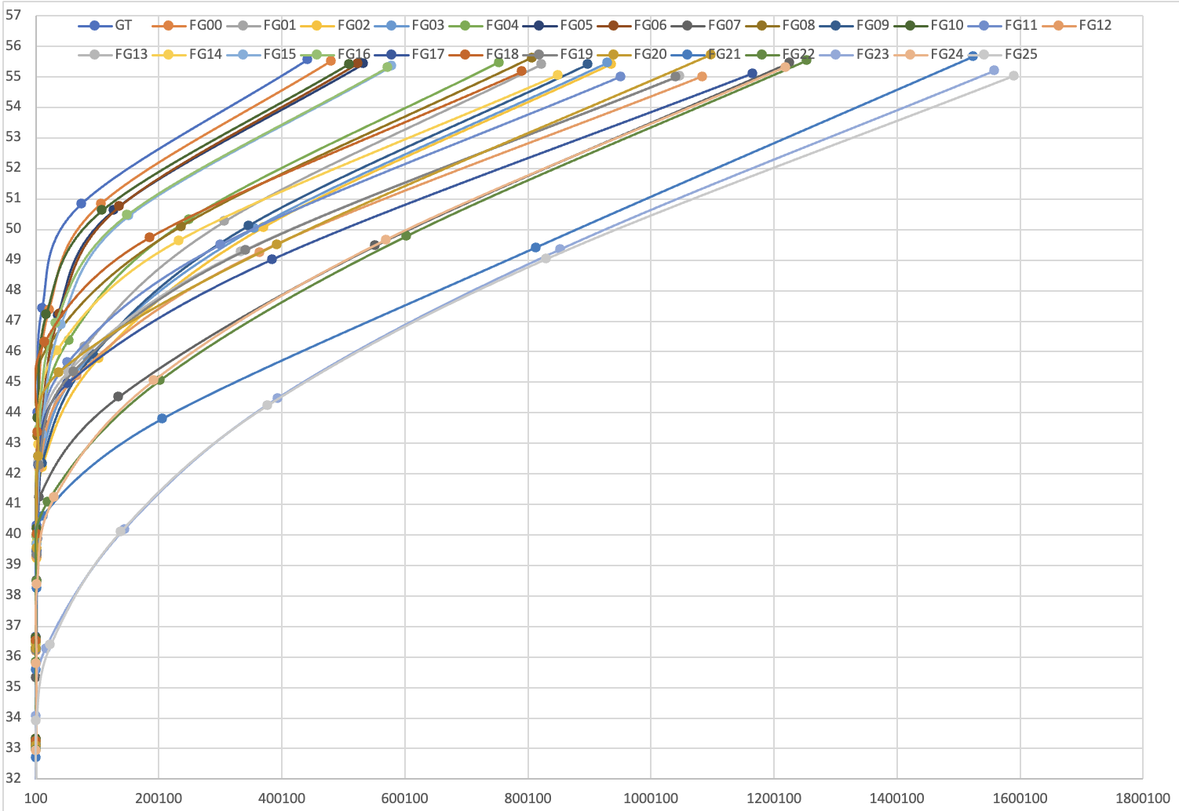
Figure A.39: Rate distortion performance for all variants for the Hiker
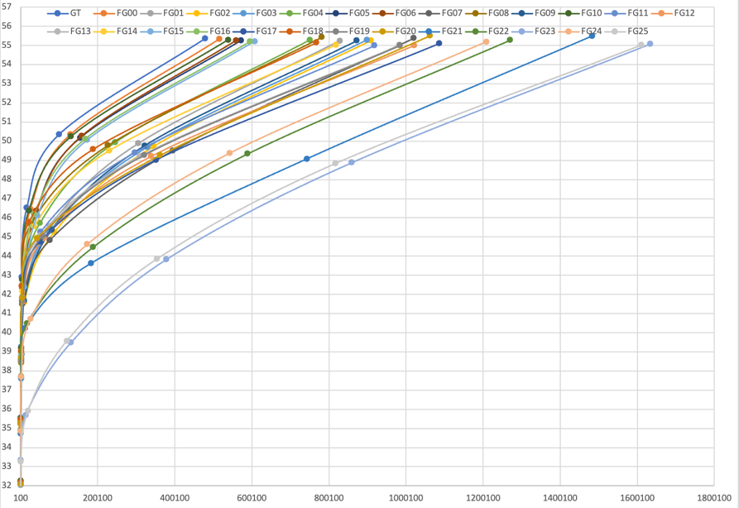
Figure A.40: Rate distortion performance for all variants for the IntoTheWoods
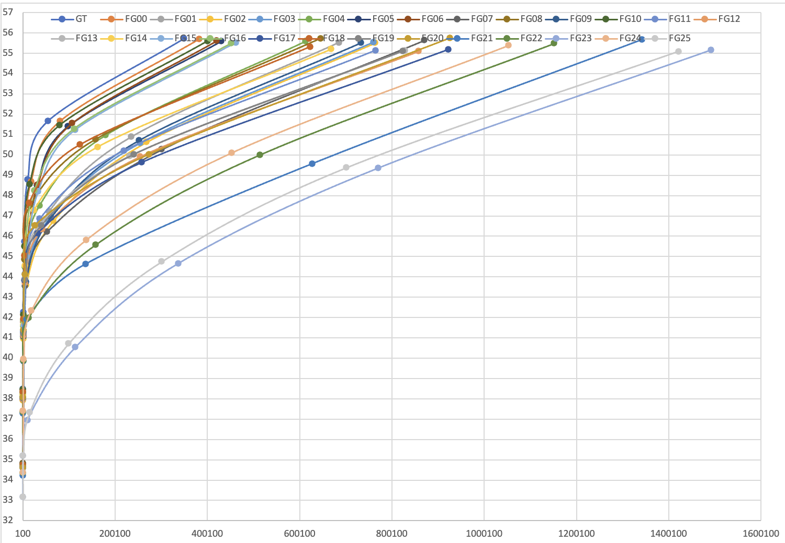
Figure A.41: Rate distortion performance for all variants for the TwirlingUmbrella
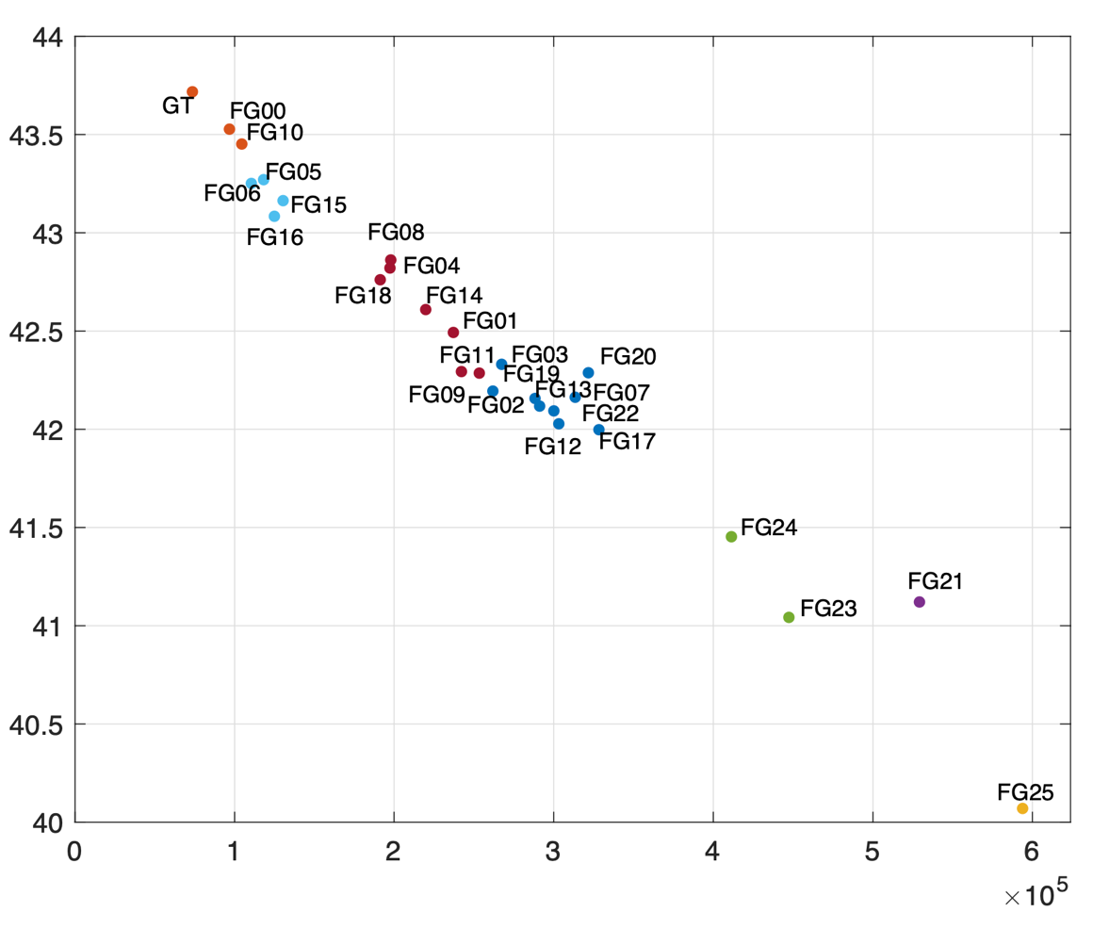
Figure A.42: Avg PSNR vs. Avg. Bitrate for all variants for the EggMixing
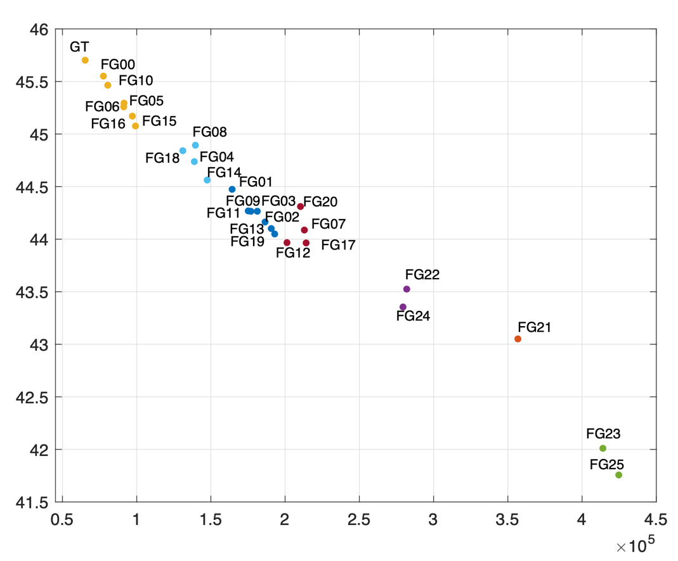
Figure A.43: Avg PSNR vs. Avg. Bitrate for all variants for the ForestFocus
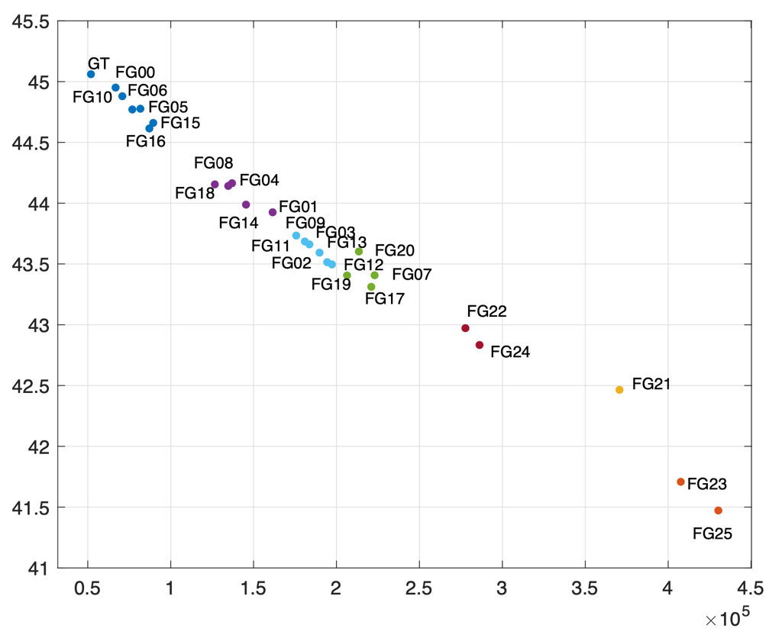
Figure A.44: Avg PSNR vs. Avg. Bitrate for all variants for the ForestZoom
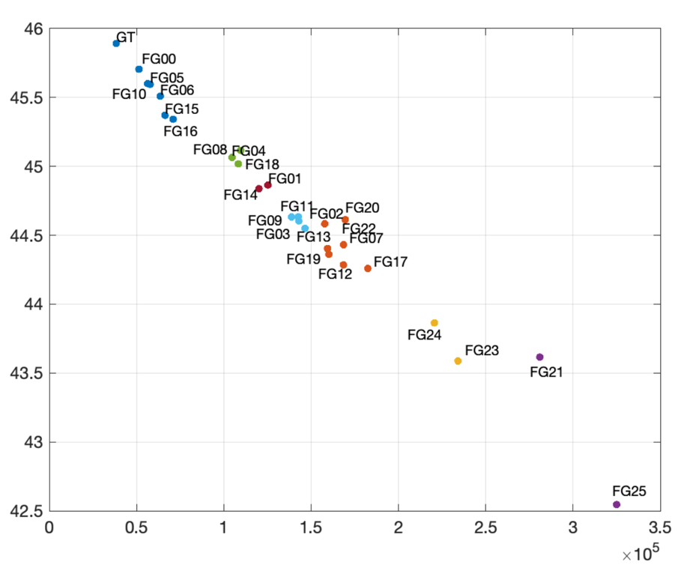
Figure A.45: Avg PSNR vs. Avg. Bitrate for all variants for the GoldenGatePan
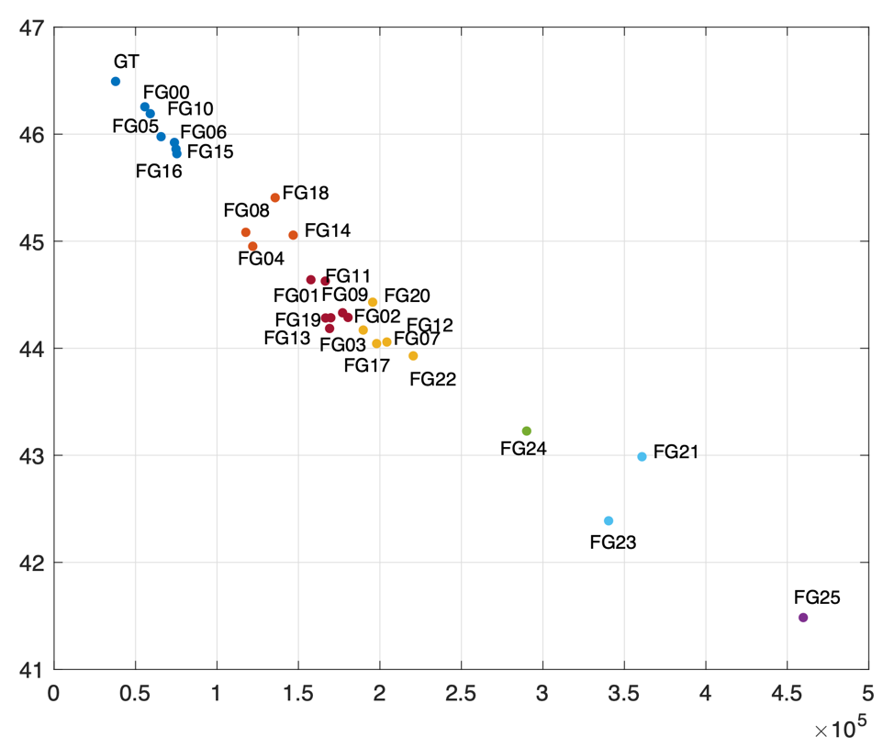
Figure A.46: Avg PSNR vs. Avg. Bitrate for all variants for the GoldenGateBridge
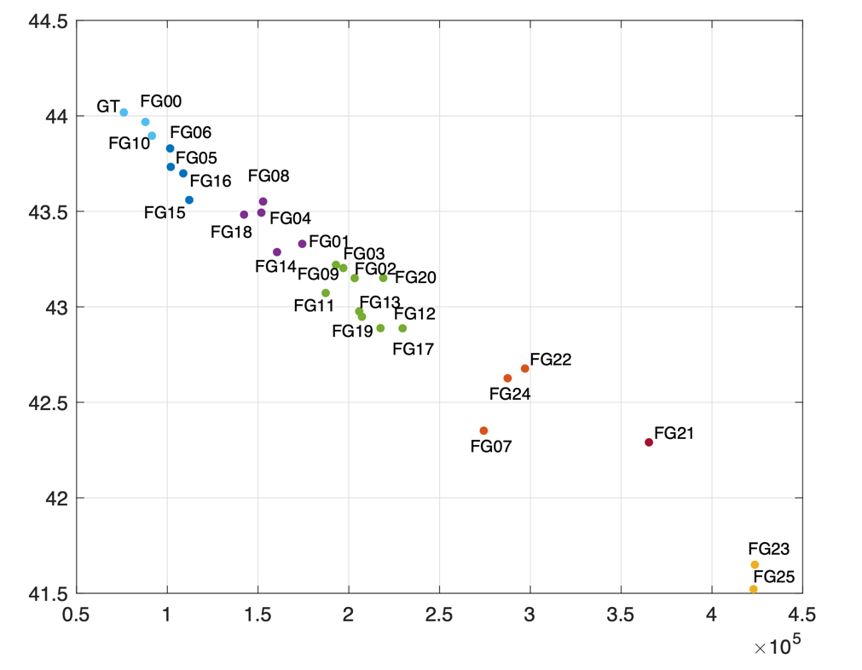
Figure A.47: Avg PSNR vs. Avg. Bitrate for all variants for the Hiker

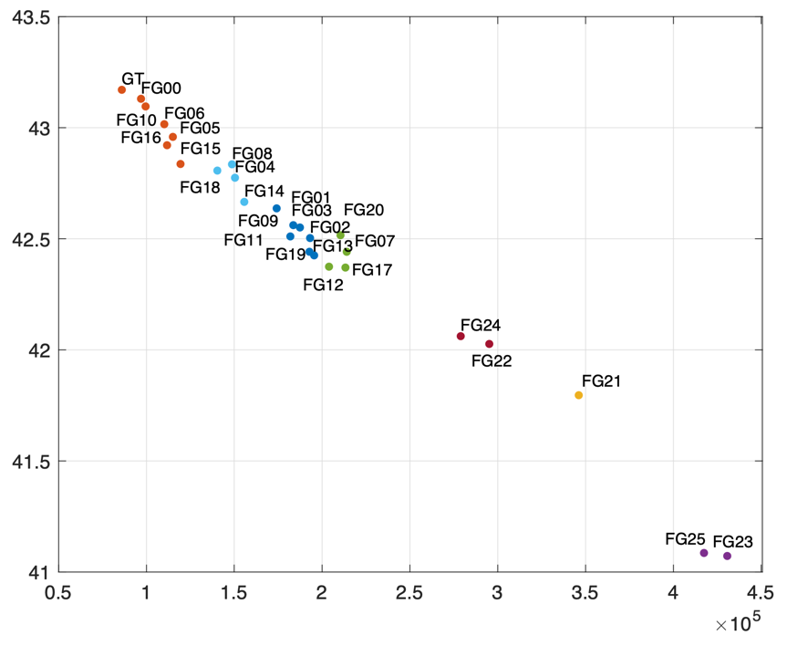
Figure A.48: Avg PSNR vs. Avg. Bitrate for all variants for the IntoTheWood
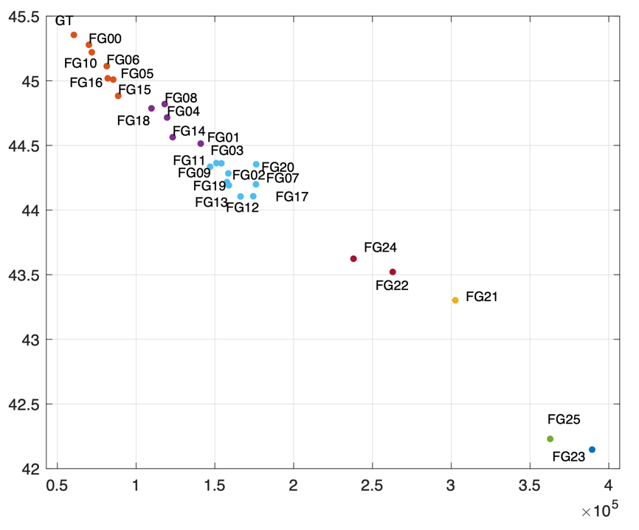
Figure A.49: Avg PSNR vs. Avg. Bitrate for all variants for TwirlingUmbrella
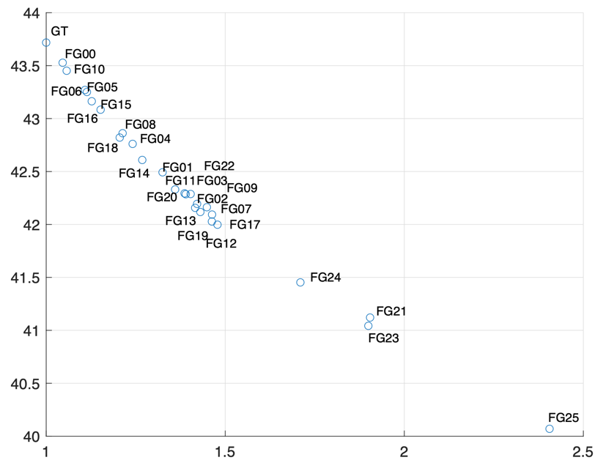
Figure A.50: Avg PSNR vs. Avg. complexity for all variants for the EggMixing
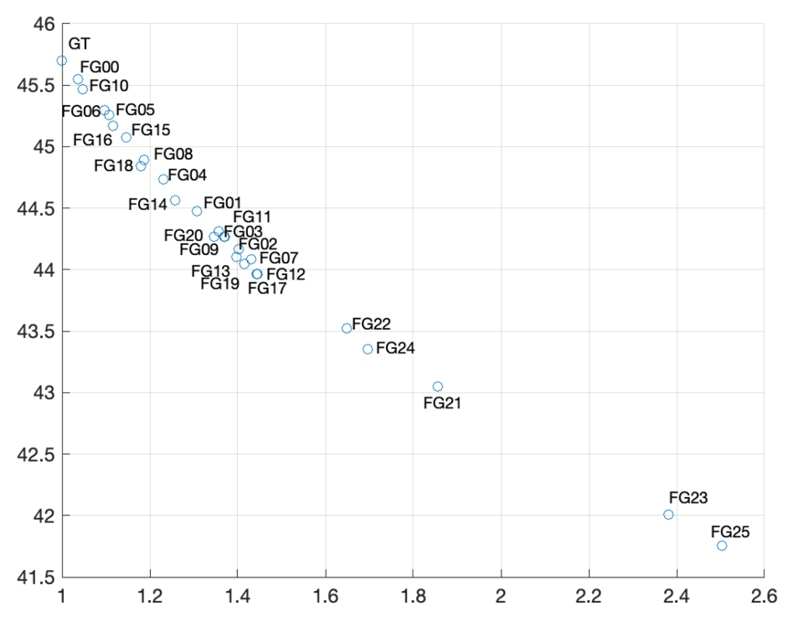
Figure A.51: Avg PSNR vs. Avg. complexity for all variants for the ForestFocus
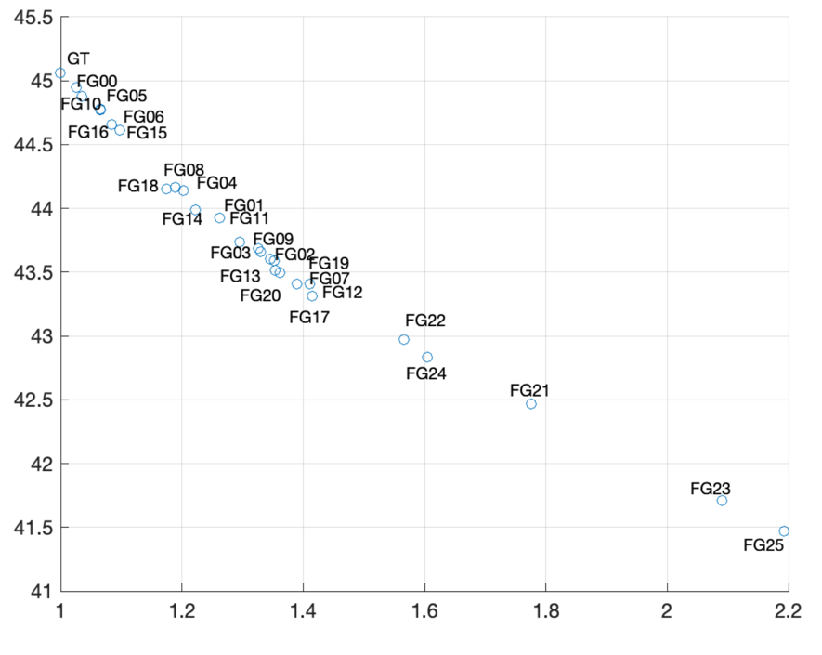
Figure A.52: Avg PSNR vs. Avg. complexity for all variants for the ForestZoom
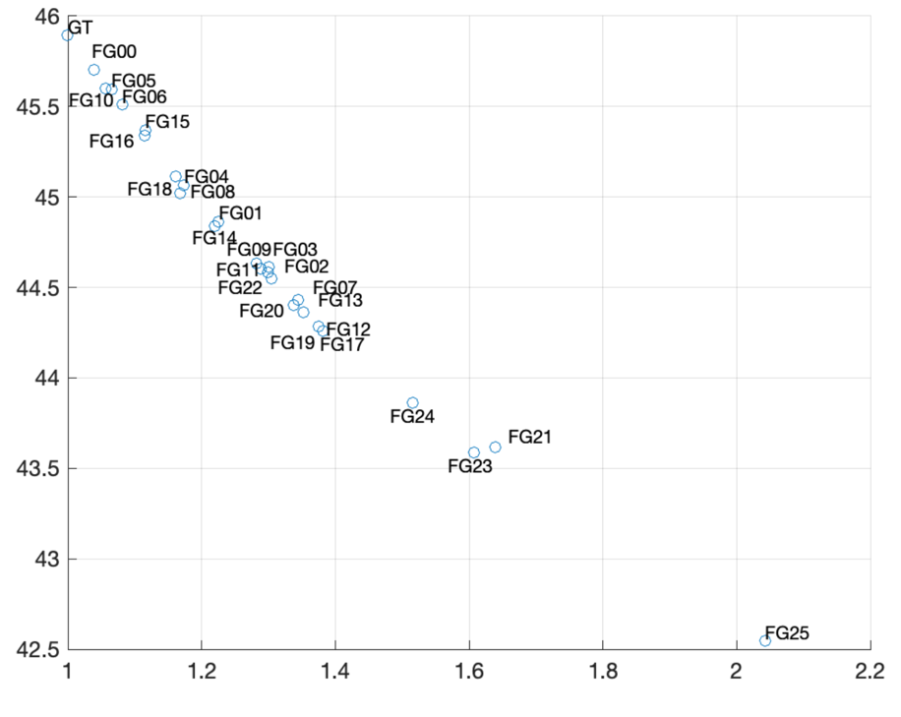
Figure A.53: Avg PSNR vs. Avg. complexity for all variants for the GoldenGatePan
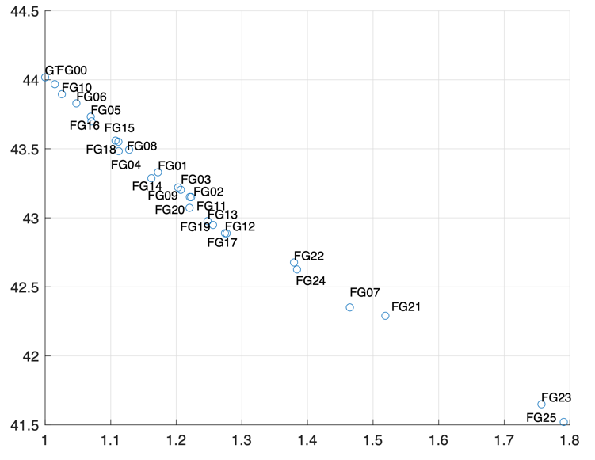
Figure A.54: Avg PSNR vs. Avg. complexity for all variants for the GoldenGateBridge
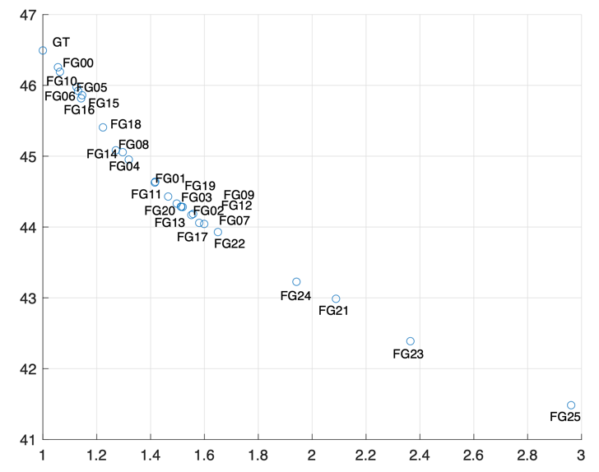
FigureA.55: Avg PSNR vs. Avg. complexity for all variants for the Hiker
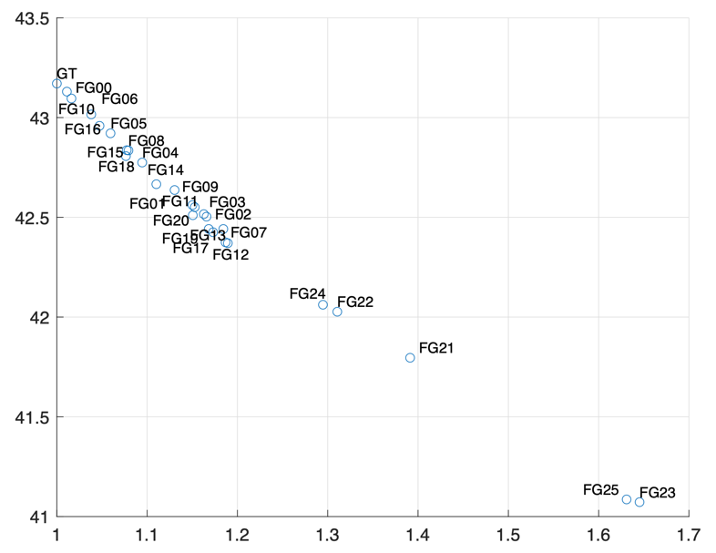
Figure A.56: Avg PSNR vs. Avg. complexity for all variants for the IntoTheWoods
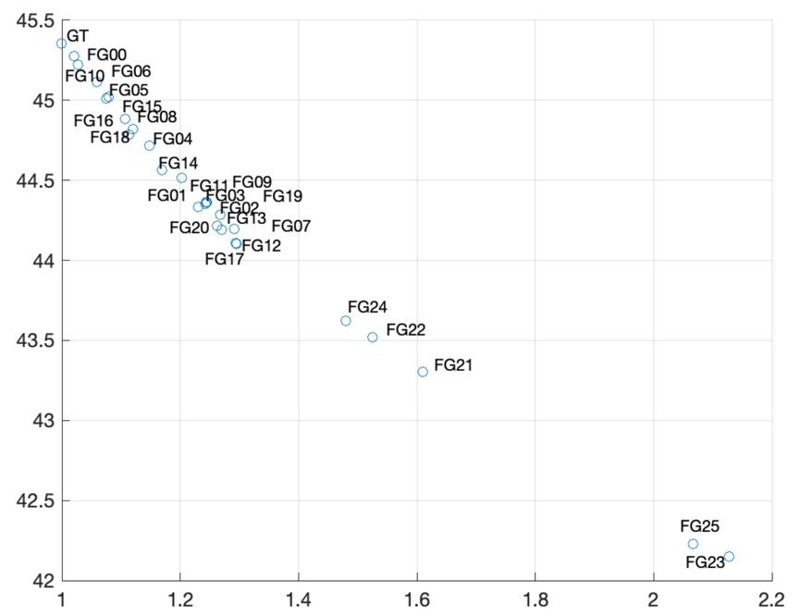
Figure A.57: Avg PSNR vs. Avg. complexity for all variants for the TwirlingUmbrella

Table A.4: Possible Low Complexity film grain noise variants for Gregory
EggMixing | 10
ForestFocus | 5, 6, 10, 16
ForestZoom | 5, 6, 10, 15, 16
GoldenGatePan | 5, 6, 10, 15, 16
GoldenGateBridge | 5, 6, 10, 15, 16, 18
Hiker | 6, 10
IntoTheWoods | 10
TwirlingUmbrella | 6, 10

Table A.5: Possible Moderate Complexity film grain noise variants for Gregory sequences
 | Moderate0 | Moderate1 | Moderate2
EggMixing | 4, 5, 6, 8, 15, 16, 18 | 1, 3, 9, 11, 14 | 2, 7, 12, 13, 17, 19, 20, 22
ForestFocus | 4, 8, 14, 15, 18 | 1, 2, 3, 7, 9, 11, 12, 13, 17, 19, 20 | 22, 24
ForestZoom | 1, 4, 8, 14, 18 | 2, 3, 7, 9, 11, 12, 13, 17, 19, 20 | 22, 24
GoldenGatePan | 1, 4, 8, 14, 18 | 2, 3, 9, 11, 20, 22 | 7, 12, 13, 17, 19
GoldenGateBridge | 1, 4, 8, 11, 14 | 2, 3, 7, 9, 12, 13, 17, 19, 20, 22 | 24
Hiker | 4, 5, 8, 15, 16, 18 | 1, 2, 3, 9, 11, 14, 20, 22 | 12, 13, 17, 19
IntoTheWoods | 4, 8, 15, 16, 18 | 4, 8, 14, 15, 18 | 22, 24
TwirlingUmbrella | 5, 6, 16 | 1, 4, 14 | 2, 3, 7, 9, 11, 12, 13, 17, 19, 20

Table A.6: Possible High Complexity film grain noise variants for Gregory sequences
 | Complex0 | Complex1 | Complex2
EggMixing | 24 | 21, 23 | 25
ForestFocus | 21 | 23 | 25
ForestZoom | 21 | 23 | 25
GoldenGatePan | 24 | 21, 23 | 23
GoldenGateBridge | 21 | 23 | 25
Hiker | 24 | 7, 21 | 23, 25
IntoTheWoods | 1, 2, 3, 7, 9, 11, 12, 13, 17, 19, 20 | 21 | 23, 25
TwirlingUmbrella | 22, 24 | 21 | 23, 25

Annex B:
Examples of use of the FG SEI cap and tuning tool

B.1 Example of use

B.1.1 Prepare original and degrained/decoded videos
The tool may interactively test film grain synthesis on a degrained video. This is done by automatically running the vfgs film grain synthesizer every time anything changes in the GUI. The test video is specified using the [File / Load YUV (clean)] menu, shown in Figure B.1.
The degrained/clean video may be a decoded video without having to use any specific denoiser, since encoders likely remove grain by themselves. It is suggested to select a quality level (QP) where image quality is still very good but grain is removed in most pictures (see next section for more details). QP 26 for HM (or VTM) encodings, for example.
The temporary parameters are saved in __preview.cfg and result of film grain synthesis is output in the __preview_3840x2160_8b.yuv file in the current directory. The original and regrained images may be compared in a YUV viewer, preferably one that refreshes display upon file changes, so that the results of a change in GUI may be seen immediately.
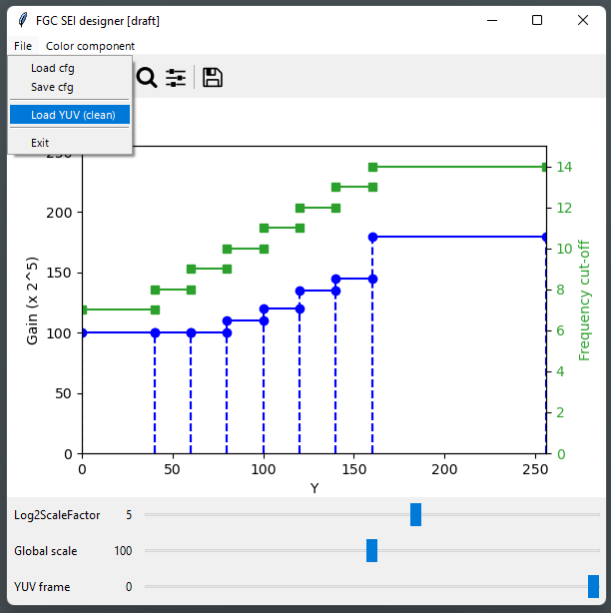
Figure B.1 – Loading a test video file

B.1.2 Select a decoded picture for study
Grain may not be completely removed in all decoded pictures; for example, some grain may remain on Intra pictures, and some badly impaired grain (visually annoying) may be present in the first temporal layers (e.g. Intra + 16, 8, 24), as illustrated in Figure B.2.
A totally clean picture may be selected for easy grain estimation by comparison with the source, or one where grain is badly impaired to observe how synthetic grain magically removes the problem, as show in Figure B.3.
The relevant test frame is selected with the slider on the bottom of the window, as shown in Figure B.4.
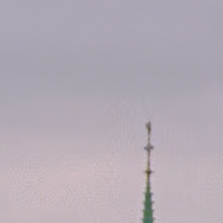

Figure B.2: Example decoded video at POC #0, #16, #8, #11

Figure B.3: Example of how grain synthesis hides impaired grain
Left: decoded; right: decoded + grain synthesis
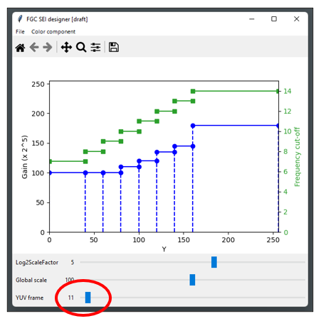
Figure B.4: Selecting the test frame using the slider

B.1.3 Focus on a light area, tune amplitude and size
The experimentation may start with a flat configuration, for example load " Gaussian-1s.cfg " (using [File / Load cfg] menu), first focusing on luma, on a light area with a good amount a grain (e.g. sky, or white surface).
Then Log2ScaleFactor slider may be adjusted to 4 for example, and the gain (blue curve) may be dragged to match original grain amplitude. There is no need to be very precise at this stage, however it may be observed that the eye is rather sensitive to variations of grain amplitude; Figure B.6 illustrates grain synthesis strength setting either 20% too low or too strong compared to the estimated sweet spot.
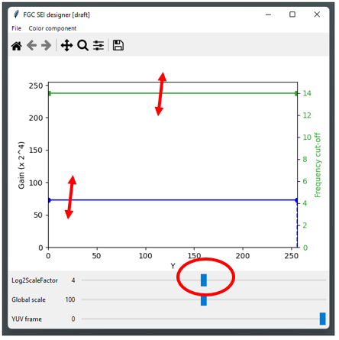
Figure B.5: Adjusting log2ScaleFactor, grain strength and size

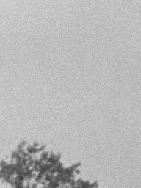
Figure B.6: Tuning grain strength
Left: original - Middle: synthesis, too low – Right: synthesis, too strong
Then, the green curve may be adjusted (grain bandwidth or size) to best match original. This is more difficult to get right; it may help to use 100% and 200% viewing scales, and compare the grains themselves (difference between grainy and clean images). Amplitude may need to be refined at the same time, since reducing the bandwidth also reduces the total energy of synthesized grain.
The grain seed may be changed by touching the YUV frame slider on the bottom if the grain pattern needs to be changed.
On this example, 14 is kept for the light area as it looks right (grain is very fine here).
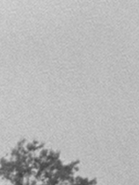
Figure B.7: Tuning grain size
Left: original - Right: synthesis, too large

B.1.4 Split interval and focus on a darker area
In Figure B.9, it may be observed that the parameters tuned for the light area do not work on darker areas. This illustrates the interest of the FGC SEI, that may adapt mode parameters to light level.
The interval may be split by double-click, then one sub-interval may be disabled by right-click, and interval boundary may be dragged to isolate an area of interest (e.g. dark clothes), as explained in Figure B.8.
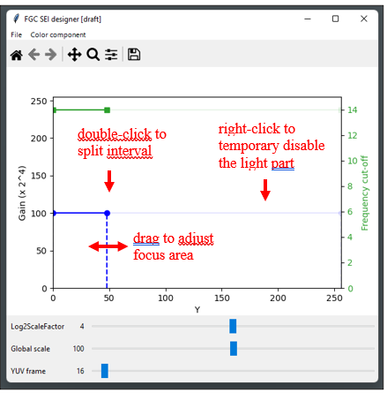
Figure B.8: Splitting interval and adjusting focus on a dark area
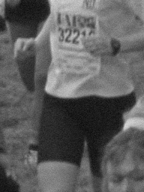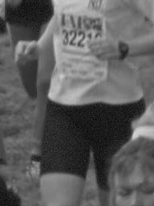
Figure B.9: Focusing on a dark area
Left: original – Middle: wrong parameters – Right: dark area isolated
Observing the grain pattern of the original (by difference with decoded) in Figure B.10, it is evident that grain is both less strong and smoother/coarser in the dark. Grain amplitude (blue curve) and size (green curve) are then dragged to match original on the area under study, with the result shown in figure B.11.

Figure B.10: Tuning grain on a dark area
Left: original – Middle: original grain – Right: dark area tuned
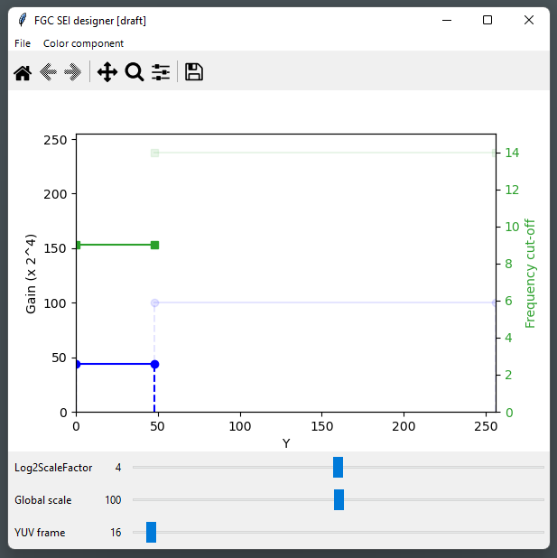
Figure B.11: Parameter adjustment for dark area

B.1.4 Create more intervals, and repeat on chroma
The reach the result shown in this annex B, more work is needed: refine intervals (iterative split and tuning), and repeat the process on each chroma channel.
It is noted that sometimes, the grain is not fully consistent over the picture for a given intensity interval, and a compromise is yet to be found. This might be caused by film warping, or color space. It is then recommended to check the settings on the whole picture, out of the focus areas that were used for tuning.

B.2 Concluding remarks
A graphical tool to display and adjust film grain parameters was presented, to encourage and ease the experimentation with film grain synthesis technologies, and to demonstrate the capabilities of the FGC SEI message in conjunction with a hardware-friendly implementation. In particular, the following FGC SEI message functionalities are demonstrated: mode parameters fitting the grain shape and strength, and local variation of both shape and strength, as observed on real film.
This tool also enables interactive visual testing, that may be interesting for the "grain fidelity" aspect.

Annex C:
Preliminary test results

C.1 FGS for preserving artistic intent

C.1.1 Workflow
Film grain may be unavoidably lost by conventional video compression workflows, as shown in Figure C.1. The high frequency grain in the source content ($x$) may be either completely or partially lost due to quantization/resizing in adaptive streaming or broadcast applications, and the resulting decoded output $\tilde{x}$ may be void of the artistic effect of the grain intended in source. Even if grain is partially preserved at high bitrates, overall coding efficiency may be poor as film grain is not spatially or temporally correlated, impacting the coding characteristics of the scene and a significant number of bits may be needed to achieve an acceptable coding and at the same time preserve the film grain.
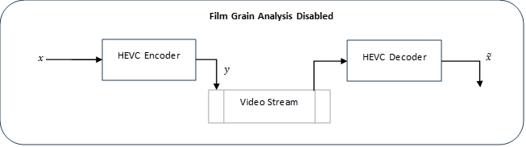
Figure C.1: HEVC workflow without film grain
The following notations are used for the film grain preservation workflow depicted in Figure C.2:
- $x$ is the source video (uncompressed)
- $x_{dn}$is the denoised source video.
- $y_{dn}$is the compressed bitstream of the denoised video.
- $\tilde{x_{dn}}$ is the decoded denoised video.
- $\tilde{x_{g}}$ is the grain synthesized video, using, for example, the FGC SEI message parameters.

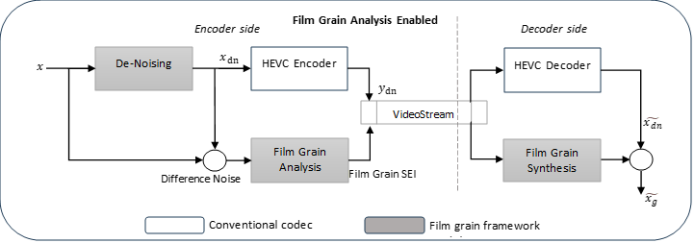
Figure C.2: HEVC film grain modeling and synthesis workflow

C.1.2 Quality Evaluation Methods for FGS
To assess the benefits of grain characterization and synthesis for preserving artistic intent two independent subjective quality verification tests were recently conducted. It is noted that these tests lack verification and validation. The first test used the MOS scoring method and used 14 test subjects/viewers, while the second test used the A-B Preference method and used 11 test subjects. It should be noted that it is commonly recommended that for a subjective test to be reliable a higher number of test subjects, i.e. >=25. In addition, encodings were performed without the consideration of subjective optimization tools or quantization matrices, which may have a significant impact especially in the presence of film grain in the content. Therefore, one should be cautious in making any conclusions based on these tests given their limitations.

C.1.3 Subjective Performance Evaluation Methods
- MOS Scoring Method
- ITU-T_Rec. P.190 based subjective performance evaluation method (pair-wise testing with hidden reference). This method is a category judgement where the test sequences are presented one at a time and are rated independently on a category scale (1 to 10). The present test procedure must include a reference version of each test sequence shown as any other test stimulus.
Test Site | On-site
Display, size, connection  (resolution setting) | Samsung 65" S95B, HDMI (3840×2160)
Viewing distance | 2 viewers sitting at 1.5H, 1 viewer standing at 1.6H
Viewing angle | ±75°, 90° (at screen center)
Total number of viewers | - 4female, 10 male)

- A-B Preference Method
- The test sequences were evaluated using a 5-score scale, the 5 scores (A>>B, A>B, A==B, A<B, A<<B) were mapped to the values (3, 1, 0, -1, -3) and the random A-B assignment was reverted. In the comparison of the compressed sequences with and without FGS, positive numbers indicate that the FGS version was scored higher.
Test Site | On-site
Display, size, connection  (resolution setting) | Samsung 65" S95B, HDMI (3840×2160)
Viewing distance | 2 viewers sitting at 1.5H, 1 views standing at 1.6H
Viewing angle | ±75°, 90° (at screen center)
Total number of viewers | 14 (4 female, 10 male)

C.1.4 Scenario FHD Test Results (Subjective)

C.1.4.1 Disclaimer on the results documented
It is observed that the confidence level overlap is too great & the bitrate range is limited to mid/low bitrates to confidently tell if FGS shows clear benefits.

C.1.4.2 BQTerrace Sequence

BQTerrace Observations
- 7 out of 14 viewers have given higher or same rating for FGA enabled streams across all bitrates.
- 3 out 14 viewers failed to detect the hidden reference.
- Higher confidence intervals indicate high variability in viewer ratings.
- Although the confidence intervals overlap, the overlap is less than 50% of the interval range. The lower end of the FGA enabled confidence interval is consistently higher than the FGA disabled MOS score.

C.1.4.3 OldTownCross Sequence

OldTownCross Observations
- 7 out of 14 viewers have given higher or same rating for FGA enabled streams across all bitrates.
- 2 out 14 viewers failed to detect the hidden reference.
- Confidence interval overlap is minimal indicating the ratings are consistently favoring FGS.

C.1.4.4 InToTree Sequence

InToTree Observations
- 6 out of 14 viewers have given higher or same rating for FGA enabled streams across all bitrates.
- Only 1 out 14 viewers failed to detect the hidden reference.
- MOS difference between FGS and No_FGS is narrow in this content.
- For the two lower rate points, the lower end of FGA enabled confidence interval is higher than the FGA disabled MOS score.

C.1.5 Scenario 4K-TV Test Results (Subjective)

C.1.5.1 CrowdRun Sequence

CrowdRun Observations
- 10 out of 14 viewers have given higher or same rating for FGA enabled streams across all bitrates.
- Only 1 out 14 viewers failed to detect the hidden reference.
- The Confidence Interval (CI) overlap is negligible for the higher rate points of 10Mbps and 19Mbps indicating the rating are consistently favoring FGS in these operating rates. Surprisingly, the lowest rate point has significant CI overlap. The higher spatial and temporal complexity of crowd run content makes it difficult to preserve details at these low rates and could lead to annoying artifacts which could outweigh benefit of synthesized grain.

C.1.5.2 Tears of Steel Sequence

Scene004 FG 03 Observations
- 10 out of 14 viewers have given higher or same rating for FGA enabled streams across all bitrates.
- 3 out 14 of viewers failed to detect the hidden reference.
- Except for the highest rate point, confidence interval overlap is minimal indicating the ratings are consistently favoring FGS.

Scene004 FG 22 Observations
- 6 out of 14 viewers have given higher or same rating for FGA enabled streams across all bitrates.
- Only 1 out of 14 viewers failed to detect the hidden reference.
- Although the confidence intervals overlap, the overlap is less than 50% of the interval range. The lower end of the FGA enabled confidence interval is consistently higher than the FGA disabled MOS score.

Scene044 FG 03 Observations
- 9 out of 14 viewers have given higher or same rating for FGA enabled streams across all bitrates.
- All 14 viewers detected the hidden reference successfully.
- Confidence interval overlap is minimal indicating the rating are consistently favoring FGS.

Scene044 FG 22 Observations
- 9 out of 14 viewers have given higher or same rating for FGA enabled streams across all bitrates.
- Only 1 out of 14 viewers failed to detect the hidden reference.
- Except for the lowest rate point, confidence interval overlap is minimal indicating the ratings are consistently favoring FGS.

Scene062 FG 16 Observations
- 12 out of 14 viewers have given higher or same rating for FGA enabled streams across all bitrates.
- All 14 viewers detected the hidden reference successfully.
- Higher confidence intervals indicates varied ratings of viewers.

Scene062 FG 24 Observations
- 8 out of 14 viewers have given higher or same rating for FGA enabled streams across all bitrates.
- Only 1 out of 14 viewers failed to detect the hidden reference.
- Higher confidence intervals indicates high variability in viewer ratings.

Scene101 FG 21 Observations
- 8 out of 14 viewers have given higher or same rating for FGA enabled streams across all bitrates.
- All 14 viewers detected the hidden reference successfully.
- MOS difference between FGS and No_FGS is narrow in this content.
- The lower end of the FGA enabled confidence interval is consistently higher than the FGA disabled MOS score.

Scene101 FG 24 Observations
- 10 out of 14 viewers have given higher or same rating for FGA enabled streams across all bitrates.
- All 14 viewers detected the hidden reference successfully.
- Confidence interval overlap is minimal indicating the rating are consistently favoring FGS.

C.1.6 Summary remarks from proponent for FGS subjective test results for preserving artistic intent
- Results of subjective quality assessment for preserving artistic intent indicate a potentially significant visual benefit by applying film grain synthesis for improving the visual quality of a compressed video sequence.
- In the evaluated set of bitrates, gains are specifically observed for mid- to low-bitrate ranges.
- At low bitrates, the capability of preserving artistic intent by FGS is higher. The FGS enabled MOS for all sequences is always better than FGS disabled.
- It is observed that the impact of FGS is strongly dependent on the test sequence.
- The distance of the MOS curves indicates significant quality improvements for these sequences with FGS.
- OldTownCross
- TOS - Scene044 FG 03
- TOS - Scene004 FG 03
- TOS - Scene044 FG 22
- Following sequences show tendency towards quality improvement with FGS but the confidence intervals overlap across rate points is high.
- BQTerrace
- TOS – Scene062 FG 16
- TOS – Scene062 FG 24

C.2 FGS for masking coding artifacts

C.2.1 Workflow
Film grain technology may also be used as a mechanism for masking artifacts that may have been introduced during the coding process. This process could even be used on content that did not originally contain film grain. In particular, film grain could potentially help in improving the subjective quality by subtly masking artifacts such as blockiness, banding, and blurred textures at low bitrates.
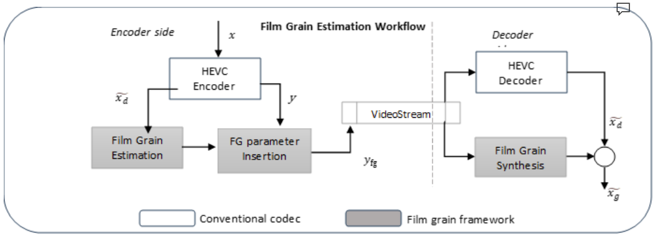
Figure C.2.1: HEVC workflow for film grain estimation for masking coding artifacts
The following notations are used for the film grain estimation for masking coding artifacts workflow that is depicted in Figure C.2.1:
- $x$ is the source video (uncompressed)
- $y_{fg}$is the compressed bitstream that also includes some Film Grain parameters, e.g. based on the Film Grain Characteristics SEI message.
- $\tilde{x_{d}}$ is the decoded video.
- $\tilde{x_{g}}$ is the grain synthesized video based on the film grain parameters included in the bitstream.
As in the previous test, no subjective optimization was used when encoding the test content.

C.2.2 Subjective Test Results A|B Method with DMOS
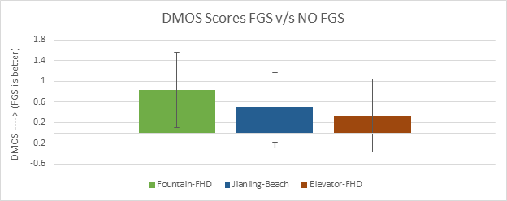

Scenario | Sequence | FPS | Resolution | Bitrate selection (kbps) | Frames
Full-HD | Elevator-FHD.yuv | 59.94 | 2048x1080 | 4608 | 432
Full-HD | Fountain-FHD.yuv | 59.94 | 2048x1080 | 12288 | 600
Gaming | Jianling-Beach | 60 | 1920x1080 | 5120 | 600

C.2.3 Just Noticeable Difference (JND) subjective test method
The JND methodology does not seem to be established as a suitable way to test for FGS benefits. This aspect is for further study depending on external test results to be completed.

Annex D:
Encoding configuration parameters
#======== File I/O =====================
BitstreamFile : encoded.265
ReconFile : recon.yuv

#======== Profile ================
Profile : main / main10

#======== Unit definition ================
MaxCUWidth: 64# Maximum coding unit width in pixel
MaxCUHeight : 64# Maximum coding unit height in pixel
MaxPartitionDepth : 4 # Maximum coding unit depth
QuadtreeTULog2MaxSize : 5 # Log2 of maximum transform size for
# quadtree-based TU coding (2...6)
QuadtreeTULog2MinSize : 2 # Log2 of minimum transform size for
# quadtree-based TU coding (2...6)
QuadtreeTUMaxDepthInter : 3
QuadtreeTUMaxDepthIntra : 3

#======== Coding Structure =============
IntraPeriod : 32# Period of I-Frame ( -1 = only first)
DecodingRefreshType : 1 # Random Accesss 0:none, 1:CRA, 2:IDR, 3:Recovery Point SEI
GOPSize : 16 # GOP Size (number of B slice = GOPSize-1)
ReWriteParamSetsFlag: 1 # Write parameter sets with every IRAP

IntraQPOffset : -3
LambdaFromQpEnable: 1 # see JCTVC-X0038 for suitable parameters for IntraQPOffset, QPoffset, QPOffsetModelOff, QPOffsetModelScale when enabled
#Type POC QPoffset QPOffsetModelOff QPOffsetModelScale CbQPoffset CrQPoffset QPfactor tcOffsetDiv2 betaOffsetDiv2 temporal_id #ref_pics_active #ref_pics reference pictures predict deltaRPS #ref_idcs reference idcs
Frame1:B 16 10.00.0001.0000 22-16 -320
Frame2:B8 1 -4.8848 0.2061 001.0001 23 -8 -24 81831 1 1
Frame3:B4 4 -5.7476 0.2286 001.0002 24 -4 -20 4121441 1 1 1
Frame4:B2 5 -5.90 0.2333 001.0003 25 -2 -18 2 6141251 1 1 1 1
Frame5:B1 6 -7.1444 0.3001.0004 25 -1 1 3 7151161 0 1 1 1 1
Frame6:B3 6 -7.1444 0.3001.0004 25 -1-3 1 5131 -261 1 1 1 1 0
Frame7:B6 5 -5.90 0.2333 001.0003 24 -2-6 2101 -360 1 1 1 1 0
Frame8:B5 6 -7.1444 0.3001.0004 25 -1-5 1 3111151 1 1 1 1
Frame9:B7 6 -7.1444 0.3001.0004 24 -1-7 1 91 -260 1 1 1 1 0
Frame10: B 12 4 -5.7476 0.2286 001.0002 23 -4 -12 41 -550 1 1 1 0
Frame11: B 10 5 -5.90 0.2333 001.0003 24 -2 -10 2 61241 1 1 1
Frame12: B9 6 -7.1444 0.3001.0004 25 -1-9 1 3 71151 1 1 1 1
Frame13: B 11 6 -7.1444 0.3001.0004 24 -1 -11 1 51 -260 1 1 1 1 0
Frame14: B 14 5 -5.90 0.2333 001.0003 23 -2 -14 21 -350 1 1 1 0
Frame15: B 13 6 -7.1444 0.3001.0004 24 -1 -13 1 31141 1 1 1
Frame16: B 15 6 -7.1444 0.3001.0004 24 -1-3 -15 11 -251 1 1 1 0

#=========== Motion Search =============
FastSearch: 1 # 0:Full search1:TZ search
SearchRange : 384 # (0: Search range is a Full frame)
ASR : 1 # Adaptive motion search range
MinSearchWindow : 96# Minimum motion search window size for the adaptive window ME
BipredSearchRange : 4 # Search range for bi-prediction refinement
HadamardME: 1 # Use of hadamard measure for fractional ME
FEN : 1 # Fast encoder decision
FDM : 1 # Fast Decision for Merge RD cost

#======== Quantization =============
QP: 22# Quantization parameter(0-51)
MaxDeltaQP: 0 # CU-based multi-QP optimization
MaxCuDQPDepth : 0 # Max depth of a minimum CuDQP for sub-LCU-level delta QP
DeltaQpRD : 0 # Slice-based multi-QP optimization
RDOQ: 1 # RDOQ
RDOQTS: 1 # RDOQ for transform skip
SliceChromaQPOffsetPeriodicity: 0 # Used in conjunction with Slice Cb/Cr QpOffsetIntraOrPeriodic. Use 0 (default) to disable periodic nature.
SliceCbQpOffsetIntraOrPeriodic: 0 # Chroma Cb QP Offset at slice level for I slice or for periodic inter slices as defined by SliceChromaQPOffsetPeriodicity. Replaces offset in the GOP table.
SliceCrQpOffsetIntraOrPeriodic: 0 # Chroma Cr QP Offset at slice level for I slice or for periodic inter slices as defined by SliceChromaQPOffsetPeriodicity. Replaces offset in the GOP table.

#=========== Deblock Filter ============
LoopFilterOffsetInPPS : 1 # Dbl params: 0=varying params in SliceHeader, param = base_param + GOP_offset_param; 1 (default) =constant params in PPS, param = base_param)
LoopFilterDisable : 0 # Disable deblocking filter (0=Filter, 1=No Filter)
LoopFilterBetaOffset_div2 : 0 # base_param: -6 ~ 6
LoopFilterTcOffset_div2 : 0 # base_param: -6 ~ 6
DeblockingFilterMetric: 0 # blockiness metric (automatically configures deblocking parameters in bitstream). Applies slice-level loop filter offsets (LoopFilterOffsetInPPS and LoopFilterDisable must be 0)

#=========== Misc. ============
InternalBitDepth: 8 # codec operating bit-depth

#=========== Coding Tools =================
SAO : 1 # Sample adaptive offset(0: OFF, 1: ON)
AMP : 1 # Asymmetric motion partitions (0: OFF, 1: ON)
TransformSkip : 1 # Transform skipping (0: OFF, 1: ON)
TransformSkipFast : 1 # Fast Transform skipping (0: OFF, 1: ON)
SAOLcuBoundary: 0 # SAOLcuBoundary using non-deblocked pixels (0: OFF, 1: ON)

#=========== TemporalFilter =================
TemporalFilter: 1 # Enable/disable GOP Based Temporal Filter
TemporalFilterPastRefs: 4 # Number of past references for temporal prefilter
TemporalFilterFutureRefs: 4 # Number of future references for temporal prefilter
TemporalFilterStrengthFrame8: 0.95# Enable filter at every 8th frame with given strength
TemporalFilterStrengthFrame16 : 1.5 # Enable filter at every 16th frame with given strength, longer intervals has higher priority

#============ Slices ================
SliceMode: 0# 0: Disable all slice options.
# 1: Enforce maximum number of LCU in an slice,
# 2: Enforce maximum number of bytes in an 'slice'
# 3: Enforce maximum number of tiles in a slice
SliceArgument: 1500 # Argument for 'SliceMode'.
# If SliceMode==1 it represents max. SliceGranularity-sized blocks per slice.
# If SliceMode==2 it represents max. bytes per slice.
# If SliceMode==3 it represents max. tiles per slice.

LFCrossSliceBoundaryFlag : 1# In-loop filtering, including ALF and DB, is across or not across slice boundary.
# 0:not across, 1: across

#============ PCM ================
PCMEnabledFlag: 0# 0: No PCM mode
PCMLog2MaxSize: 5# Log2 of maximum PCM block size.
PCMLog2MinSize: 3# Log2 of minimum PCM block size.
PCMInputBitDepthFlag: 1# 0: PCM bit-depth is internal bit-depth. 1: PCM bit-depth is input bit-depth.
PCMFilterDisableFlag: 0# 0: Enable loop filtering on I_PCM samples. 1: Disable loop filtering on I_PCM samples.

#============ Tiles ================
TileUniformSpacing: 0# 0: the column boundaries are indicated by TileColumnWidth array, the row boundaries are indicated by TileRowHeight array
# 1: the column and row boundaries are distributed uniformly
NumTileColumnsMinus1: 0# Number of tile columns in a picture minus 1
TileColumnWidthArray: 2 3# Array containing tile column width values in units of CTU (from left to right in picture)
NumTileRowsMinus1 : 0# Number of tile rows in a picture minus 1
TileRowHeightArray: 2# Array containing tile row height values in units of CTU (from top to bottom in picture)

LFCrossTileBoundaryFlag : 1# In-loop filtering is across or not across tile boundary.
# 0:not across, 1: across

#============ WaveFront ================
WaveFrontSynchro: 0# 0:No WaveFront synchronisation (WaveFrontSubstreams must be 1 in this case).
# >0: WaveFront synchronises with the LCU above and to the right by this many LCUs.

#=========== Quantization Matrix =================
ScalingList: 0 # ScalingList 0 : off, 1 : default, 2 : file read
ScalingListFile: scaling_list.txt # Scaling List file name. If file is not exist, use Default Matrix.
#============ Lossless ================
TransquantBypassEnableFlag: 0 # Value of PPS flag.
CUTransquantBypassFlagForce: 0 # Force transquant bypass mode, when transquant_bypass_enable_flag is enabled
#============ Rate Control ======================
RateControl : 0# Rate control: enable rate control
TargetBitrate : 1000000# Rate control: target bitrate, in bps
KeepHierarchicalBit : 2# Rate control: 0: equal bit allocation; 1: fixed ratio bit allocation; 2: adaptive ratio bit allocation
LCULevelRateControl : 1# Rate control: 1: LCU level RC; 0: picture level RC
RCLCUSeparateModel: 1# Rate control: use LCU level separate R-lambda model
InitialQP : 0# Rate control: initial QP
RCForceIntraQP: 0# Rate control: force intra QP to be equal to initial QP

Annex <X> (informative):
Change history
Change history
Date | Meeting | TDoc | CR | Rev | Cat | Subject/Comment | New version
2024-08 | SA4#129-e | S4-241762 |  |  |  | Initial version including all the useful information from the FS_FGS study | 1.0.0

