3GPP TR 26.933 V0.7.0 (2024-05)
Technical Report

3rd Generation Partnership Project;
Technical Specification Group SA;
Study on Diverse Audio Capturing system (Release 19)

 | 
The present document has been developed within the 3rd Generation Partnership Project (3GPP TM) and may be further elaborated for the purposes of 3GPP.
The present document has not been subject to any approval process by the 3GPP Organizational Partners and shall not be implemented.
This Specification is provided for future development work within 3GPP only. The Organizational Partners accept no liability for any use of this Specification.
Specifications and Reports for implementation of the 3GPP TM system should be obtained via the 3GPP Organizational Partners' Publications Offices.

3GPP
Postal address

3GPP support office address
650 Route des Lucioles - Sophia Antipolis
Valbonne - FRANCE
Tel.: +33 4 92 94 42 00 Fax: +33 4 93 65 47 16
Internet
http://www.3gpp.org

Copyright Notification
No part may be reproduced except as authorized by written permission.
The copyright and the foregoing restriction extend to reproduction in all media.

© 2022, 3GPP Organizational Partners (ARIB, ATIS, CCSA, ETSI, TSDSI, TTA, TTC).
All rights reserved.

UMTS™ is a Trade Mark of ETSI registered for the benefit of its members
3GPP™ is a Trade Mark of ETSI registered for the benefit of its Members and of the 3GPP Organizational Partners
LTE™ is a Trade Mark of ETSI registered for the benefit of its Members and of the 3GPP Organizational Partners
GSM® and the GSM logo are registered and owned by the GSM Association

Contents
Foreword 8
Introduction 9
1 Scope 10
2 References 10
3 Definitions of terms, symbols and abbreviations 11
3.1 Terms 11
3.2 Symbols 11
3.3 Abbreviations 12
4 Factors of different UE categories related to audio capture 12
4.1 Mobile phones 12
4.2 Headphones 12
4.3 Tablets 12
4.4 Laptops 14
4.5 Watches 14
4.6 AR glasses 16
4.7 Cars 16
5 Microphones used in audio capture 16
5.1 Introduction 17
5.2 Transducer type 17
5.2.1 Dynamic microphone 17
5.2.2 Condenser microphone 17
5.2.3 Micro-Electro-Mechanical Systems microphone 17
5.2.4 Contact microphone 17
5.2.5 Summary of transducer 18
5.3 Directional Microphone 18
5.3.1 Introduction 18
5.3.2 Directional microphone capsule 18
5.3.3 Interference tube 18
5.4 Binaural acoustic simulation 18
5.5 Summary of microphones used in immersive audio capture 19
5.6 Other components used in audio capture. 19
6. Acoustic design 20
6.1 Stereo capture 20
6.1.1. Principle of stereo signal representation 20
6.1.2. Characteristic of stereo capture 20
6.1.3. Factors that affect stereo capture 20
6.1.4. Stereo microphone configurations 20
6.1.4.1. Introduction 20
6.1.4.2. Near-Coincident 20
6.1.4.3. Baffled 21
6.1.4.4. Coincident 22
6.1.4.4.1. Introduction 22
6.1.4.4.2. X/Y 22
6.1.4.4.3. Blumlein 23
6.1.4.4.4. M/S 23
6.1.4.5. Spaced 24
6.2. Spatial audio capture 25
6.2.1. Introduction 25
6.2.2. Binaural capture 25
6.2.2.1. Principle of binaural signal representation 25
6.2.2.2. Possible issues in binaural capture 25
6.2.2.3. Factors that affect binaural capture 25
6.2.2.4. Differences between binaural and stereo audio 25
6.2.3. Parametric spatial audio capture 26
6.2.3.1. Principle of parametric spatial audio representation 26
6.2.3.2. Characteristics of parametric spatial audio capture and representation 27
6.2.3.3. Factors that affect parametric spatial audio capture 27
6.2.3.4. Multi-microphone configurations in parametric spatial audio 27
6.2.4. Non-parametric spatial audio capture 28
6.2.4.4.1. Immersive audio ORTF configuration[6] 28
6.2.4.4.1.1 ORTF-surround 28
6.2.4.4.1.2 ORTF-3D 29
6.2.4.4.2. Immersive audio M/S configuration 29
6.2.4.4.2.1 Double-M/S[7] 29
6.2.4.4.2.2 M/S-3D[8][9] 30
6.2.4.4.3. IRT-cross 30
6.3. Microphone design for terminals 31
6.3.1. Microphone design for mobile phones 31
6.3.2. Microphone design for headphones 32
6.3.3. Microphone design for tablets 32
6.3.4. Microphone design for laptops 33
6.3.5. Microphone design for watches 35
6.4. Microphone frequency response 35
7 Signal processing 35
7.1 AEC 36
7.1.1. Principle of mono audio AEC 36
7.1.2 Challenges for immersive audio AEC 36
7.1.3 The current status of the research 37
7.1.4 AEC for different UE 37
8 Example audio capture processing solutions 41
8.1 Capture scenarios 41
8.1.1 Telephony communications 41
8.2 Capture solution for end-user devices 42
8.2.1 Overview 42
8.2.2 Compensation 42
8.2.3 Enhancement 43
8.2.3.3.1 Introduction 43
8.2.3.3.2 Wind noise reduction 43
8.2.3.3.3 Microphone noise reduction 43
8.2.3.3.4 Background noise reduction 43
8.2.3.3.5 Audio focusing 43
8.2.4 Audio format generation 44
8.2.4.3.1 Introduction 44
8.2.4.3.2 Content based processing 44
8.2.4.3.3 Ambisonic upmixer 44
8.2.4.4.1 Introduction 44
8.2.4.4.2 Downmixing 44
8.2.4.4.3 Spatial analysis 45
8.2.5 Post-proc 45
8.3 Capture Scenario: Telephony Communications 45
8.4 Example design of spatial audio capture for multi-microphone UE devices 46
8.3 Example design of parametric spatial audio capture for multi-microphone devices 49
x.1 Overview 49
x.2 Device (UE) characteristics 49
x.3 OS interfaces and IVAS applications 53
x.4 Immersive audio capture with mobile devices 54
x.5 Spatial audio capture quality considerations 56
x.6 References 59
9 Conclusions and Recommendations 59
A.1 Mobile phone size 60
A.1.1 Structure Size 60
A.1.1.1 Introduction 60
A.1.1.2 Length 60
A.1.1.3 Width 60
A.1.1.4 Depth 61
A.2 Earbud size 63
A.3Tablet size 64
A.4 Laptop size 64
A.5 Watch size 65
A.6 AR glass size 65
A.7 Car exterior size 66
A.8 Car exterior and interior size 66
Annex B: Stereo AEC 66
Annex <X> (informative): Change history 72

Foreword
This Technical Report has been produced by the 3rd Generation Partnership Project (3GPP).
The contents of the present document are subject to continuing work within the TSG and may change following formal TSG approval. Should the TSG modify the contents of the present document, it will be re-released by the TSG with an identifying change of release date and an increase in version number as follows:
Version x.y.z
where:
x the first digit:
1 presented to TSG for information;
2 presented to TSG for approval;
3 or greater indicates TSG approved document under change control.
y the second digit is incremented for all changes of substance, i.e. technical enhancements, corrections, updates, etc.
z the third digit is incremented when editorial only changes have been incorporated in the document.
In the present document, modal verbs have the following meanings:
shall indicates a mandatory requirement to do something
shall not indicates an interdiction (prohibition) to do something
The constructions "shall" and "shall not" are confined to the context of normative provisions, and do not appear in Technical Reports.
The constructions "must" and "must not" are not used as substitutes for "shall" and "shall not". Their use is avoided insofar as possible, and they are not used in a normative context except in a direct citation from an external, referenced, non-3GPP document, or so as to maintain continuity of style when extending or modifying the provisions of such a referenced document.
should indicates a recommendation to do something
should not indicates a recommendation not to do something
may indicates permission to do something
need not indicates permission not to do something
The construction "may not" is ambiguous and is not used in normative elements. The unambiguous constructions "might not" or "shall not" are used instead, depending upon the meaning intended.
can indicates that something is possible
cannot indicates that something is impossible
The constructions "can" and "cannot" are not substitutes for "may" and "need not".
will indicates that something is certain or expected to happen as a result of action taken by an agency the behaviour of which is outside the scope of the present document
will not indicates that something is certain or expected not to happen as a result of action taken by an agency the behaviour of which is outside the scope of the present document
might indicates a likelihood that something will happen as a result of action taken by some agency the behaviour of which is outside the scope of the present document
might not indicates a likelihood that something will not happen as a result of action taken by some agency the behaviour of which is outside the scope of the present document
In addition:
is (or any other verb in the indicative mood) indicates a statement of fact
is not (or any other negative verb in the indicative mood) indicates a statement of fact
The constructions "is" and "is not" do not indicate requirements.

Introduction
Providing immersive voice and audio services by end-user devices is becoming more and more practicable with the development of 4G/5G technologies. Related requirements have been investigated in 3GPP TR 22.891. Several use cases for VR are envisioned in TR 26.918, and for these cases the corresponding audio capturing system are generally considered. As such, capturing capability is crucial for making truly immersive voice and audio experiences.
Due to physical constraints on their outline shapes and sizes, the end-user devices are usually configured with different numbers of microphones and also different microphone setup configurations, hence different audio capturing capabilities are expected. Based on this, the present document gives diverse audio capturing system.

1 Scope
The goal of the FS_DaCED is to study diverse audio capturing methods and applicable audio formats for the end-user device considering the current physical and software constraints the scope of the work is shown in Figure 1-1.

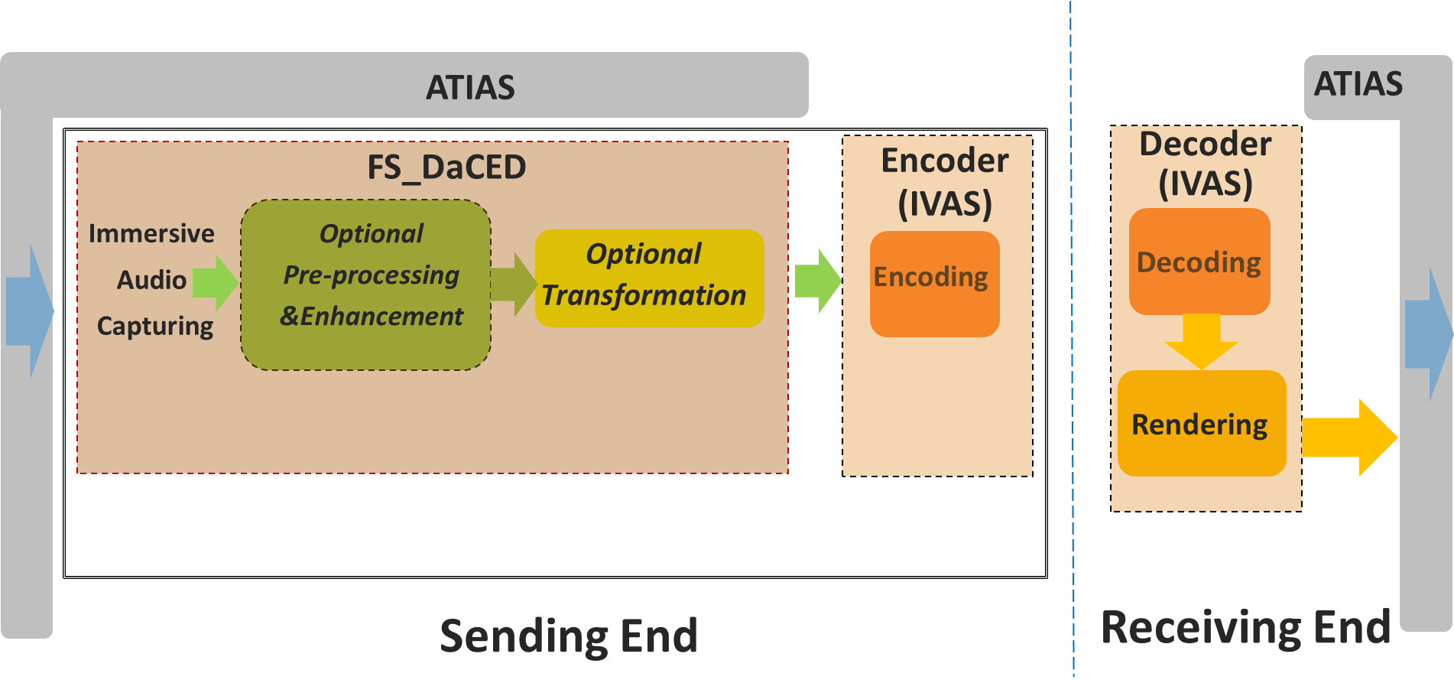
Figure 1-1 Scope of FS_DaCED
This document addresses audio capturing configurations for end-user devices, which is to make the devices to have audio capturing capability in order to provide truly immersive voice and audio service.
This document aims to study the following aspects:
1) Factors of different UE categories related to audio capture.
2) Components used in audio capture.
3) Acoustic design for audio capture.
4) Signal processing, e.g., microphone array beamforming processing, AEC processing etc.
5) Example of audio capture processing solutions.

2 References
The following documents contain provisions which, through reference in this text, constitute provisions of the present document.
- References are either specific (identified by date of publication, edition number, version number, etc.) or non-specific.
- For a specific reference, subsequent revisions do not apply.
- For a non-specific reference, the latest version applies. In the case of a reference to a 3GPP document (including a GSM document), a non-specific reference implicitly refers to the latest version of that document in the same Release as the present document.
[1] 3GPP TR 21.905: "Vocabulary for 3GPP Specifications".
[2] 3GPP TR 26.891: "5G enhanced mobile broadband; Media distribution".
[3] 3GPP TR 26.918: "Virtual Reality (VR) media services over 3GPP".
[4] 3GPP TS 26.119: "Media Capabilities for Augmented Reality".
[5] 3GPP TS 26.258: "Codec for Immersive Voice and Audio Services (IVAS); C code (floating point)"
[6] H. Wittek and G. Theile, “Development and application of a stereophonic multichannel recording technique for 3D Audio and VR,” in AES Convention 143, New York, 2017.
[7] Wittek, Haut, Keinath: “Double M/S – a Surround recording technique put to test”, 24. Tonmeistertagung 2006
[8] P. Geluso. “Capturing Height: The Addition of Z Microphones to Stereo and Surround Microphone Arrays,” presented at the 132nd Convention of the Audio Engineering Society (2012 Apr.), convention paper 8595.
[9] Fischer, C., Zingler, D., Medina Victoria, J.: “MS-3D: Extending the Double-MS Array for 3D-Audio applications” (29th Tonmeistertagung – VDT International Convention, November 2016)
[10] J. Benesty, D. R. Morgan and M. M. Sondhi, "A better understanding and an improved solution to the specific problems of stereophonic acoustic echo cancellation," in IEEE Transactions on Speech and Audio Processing, vol. 6, no. 2, pp. 156-165, March 1998.
[11] A.W. H. Khong, J. Benesty and P. A. Naylor, "Stereophonic acoustic echo cancellation: analysis of the misalignment in the frequency domain," in IEEE Signal Processing Letters, vol. 13, no. 1, pp. 33-36, Jan. 2006.
[12] 3GPP TS 26.250: "Codec for Immersive Voice and Audio Services (IVAS); General overview
[13] 3GPP TS 26.131: Terminal acoustic characteristics for telephony; Requirements

[...] ……

3 Definitions of terms, symbols and abbreviations
This clause and its three subclauses are mandatory. The contents shall be shown as "void" if the TS/TR does not define any terms, symbols, or abbreviations.

3.1 Terms
For the purposes of the present document, the terms given in 3GPP TR 21.905 [1] and the following apply. A term defined in the present document takes precedence over the definition of the same term, if any, in 3GPP TR 21.905 [1].
Definition format (Normal)
<defined term>: <definition>.
example: text used to clarify abstract rules by applying them literally.

3.2 Symbols
For the purposes of the present document, the following symbols apply:
Symbol format (EW)
<symbol> <Explanation>

3.3 Abbreviations
For the purposes of the present document, the abbreviations given in 3GPP TR 21.905 [1] and the following apply. An abbreviation defined in the present document takes precedence over the definition of the same abbreviation, if any, in 3GPP TR 21.905 [1].
VR Virtual Reality
TWS True Wireless Stereo

4 Factors of different UE categories related to audio capture

4.1 Mobile phones
Since 2012, the structure size of mobile phones has been rising in length, width, and depth, indicating a continuous increase in mobile phone size. This may be in response to the strong demand from consumers for multimedia and gaming functions on their phones, as well as the increasing requirements for microphone and camera quantity and battery consumption. The evolution trend of mobile phones is towards full screen, which provides a market foundation for the increase in screen size. The detailed data of structure size are listed in Annex A.1
- The maximum values of length, width, and depth are 168.78mm ,80.6mm and 9.92mm.
- The minimum values are 123.8mm (L), 58.6mm (W), and 6.4mm (D).
- The average values are 152.65mm (L), 73.17mm (W) and 8.08mm (D).
- The 95% Confidence Interval (CI) are length, width, and depth (149.60 mm,155.69 mm), (71.92 mm,74.42 mm) and (7.85 mm,8.31 mm).

4.2 Headphones
Nowadays, the mainstream earbuds are TWS headphones. Therefore, we investigated some TWS Earbuds. Specifically, the length of all these TWS earbuds measures less than 4cm. Additionally, the depth and width of these earbuds are around 2cm.

4.3 Tablets
Tablets, as popular UE, equipped with speakers and microphones. We list 21 devices from 7 brands, it is evident that the size of tablets is significantly larger than that of mobile phones, yet they share a very similar shape. Most of them exceed a height of 20 cm. The minimum length also reaches 19.54 cm. The width is close to 20 cm. The models in the statistics range from 13.48 to 21.49 cm.
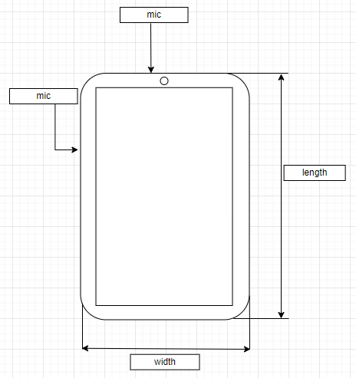
Figure 4.3-1 Tablet front view
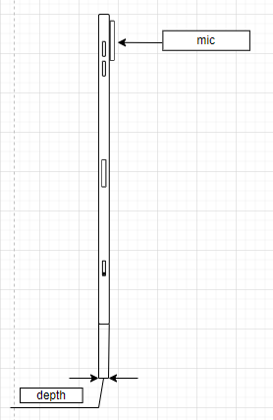
Figure 4.3-2 Tablet side view
In addition, the microphone design of tablets now is also very similar to that of mobile phones.

4.4 Laptops
Compared to tablets, the primary distinction in laptops is their clamshell structure, featuring a hinged screen and an attached keyboard.
Also, most laptops have larger structure size that of mobile phones. The range in length goes from approximately 28 cm to around 41 cm, resulting in a range of about 13 cm. The widths span from about 18.5 cm to approximately 32 cm. The height range extends from a few tenths of a centimetre (around 0.7) to over 2.6 cm.
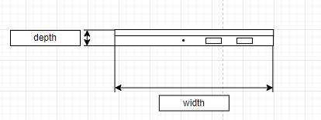
Figure 4.4-1 Laptop side view

4.5 Watches
Many watches nowadays also have calling capabilitiesNowadays, the smartwatches capable of making calls mainly come in two shapes: circular and rectangle.
For circular type the diameter is around 4.7 cm. And the depth is range from 10.9 to 13 cm
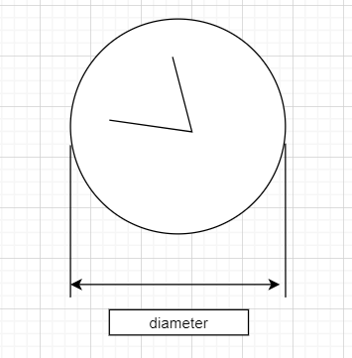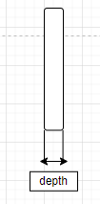
Figure 4.5-1 circular watch

For rectangle type, the lengths vary from 4 cm to 5.7 cm. The widths range from 3.4 cm to 4.57 cm. Heights range from 1.07 cm to 1.49 cm.

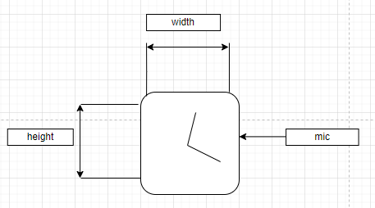
Figure 4.5-2 rectangle watch front view
Figure 4.5-3 rectangle watch side view

4.6 AR glasses
Presently, AR glasses come in a wide range of sizes. Some are substantial and weighty, akin to headband-style headsets, while others are lightweight, resembling ordinary glasses. The larger variants often adopt a headband-style design, whereas the smaller ones are designed to the appearance of regular eyewear, Therefore, the average size of the investigated model is approximately 157.48 cm*130.92cm*41.22cm on width, length, and height respectively.

4.7 Cars
We have also investigated the dimensions of some mainstream civilian cars. The lengths vary from 445.8cm to 532cm. Widths range from 180.6cm to 208.9cm. Heights fluctuate between 144.2cm and 180.0cm.
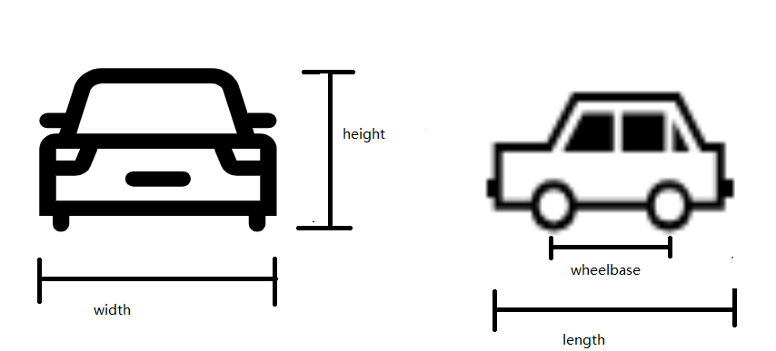
Figure 4.7-1 car front and side view
Due to the demand for voice services, modern cars are increasingly equipped with more microphones, especially electric vehicles. One of the popular microphone placements is to place microphone arrays on one side of the car roof. There are also other configurations, including centralized placement and distributed placement.
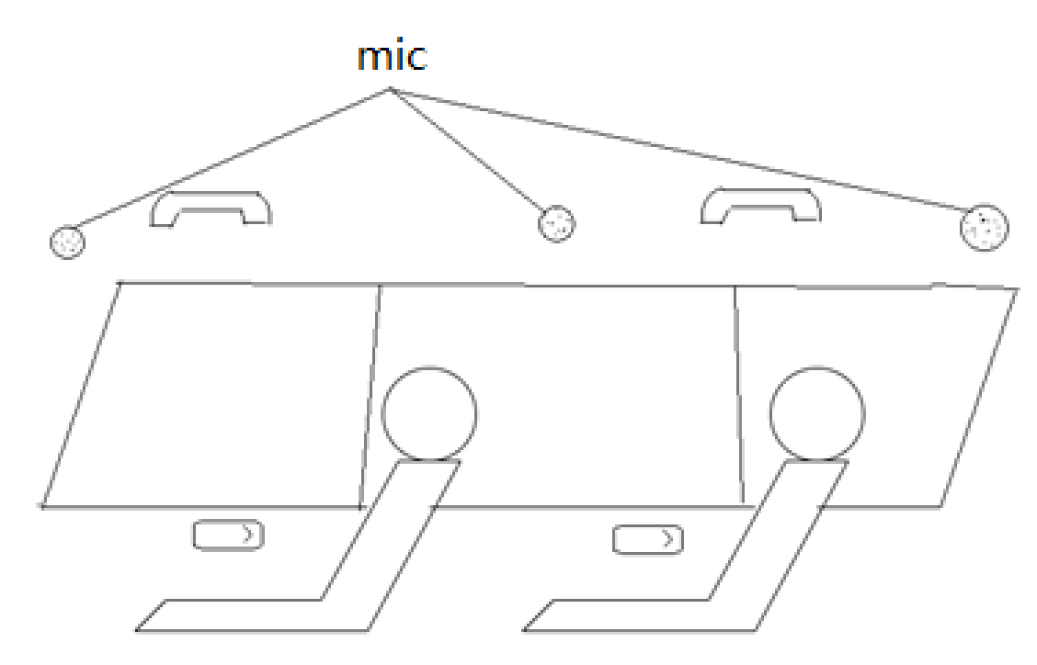
Figure 4.7-2 microphone placement in car
Some models with exterior and interior size is listed in Annex A.7 and A.8.
[

5 Microphones used in audio capture

5.1 Introduction

The function of microphone is to convert sound pressure signal to analog electrical signal in circuit.
4 types of microphones popular in the market are described in this section. These microphones have unique advantages in UE's immersive audio. They are classified to dynamic microphone, condenser microphone, Micro-Electro-Mechanical Systems (MEMS), contact microphone.

5.2 Transducer type

5.2.1 Dynamic microphone
Dynamic microphone is one of the popular microphones on market. The most advantage of dynamic microphone for UE is it doesn’t require external power; therefore, the entire recording system may become simpler. Another advantage is durability, make it more suitable for loud and high-pressure situation. But it usually has a disadvantage that it is less sensitive to high frequencies.
Dynamic microphone uses a small movable induction coil, which positioned in the magnetic field and is attached to the diaphragm. The current signal generates when the movement of the diaphragm causes the coil to also move within a magnetic field.

5.2.2 Condenser microphone
Condenser microphone is another popular microphone on market, especially for immersive audio. Most immersive system is using condenser microphones, like ambisonic microphone and external stereo microphone for mobile phone. It’s popular for its high sensitivity, wide frequency response, low noise. However, the condenser microphone requires a power source, and in the case of most professional condenser microphones, it specifically requires 48V phantom power. Meeting this requirement can be challenging for UE device consider the channel number of immersive audio.
Condenser microphone uses capacitor to convert sound waves to electrical signal. The capacitor consists of two plates, one of them is a diaphragm that vibrates in response to sound waves. The diaphragm vibrates and changes the distance between the two plates. Then the capacitance changes which influences the electrical signal.

5.2.3 Micro-Electro-Mechanical Systems microphone
In the past decades, microphone for UE has change from carbon microphones to electret condenser microphones. Recently the MEMS microphone is spread rapidly, benefited from its advantages of high stability and small volumes.
According to the techniques of microfabrication, the MEMS microphone is much smaller and allow integrate other components including preamps, ADC with transducer in one package under the control of integrated microelectronics.
Which means for manufacturers, it much easier to build the capture system, MEMS microphone can output the digital signal directly. In other hand, it allows need to select the component more carefully. Since the microphone is much smaller and very uniform in their mechanical properties, it's suitable for UE and make immersive audio become possible for economic portable UE like mobile phone.

5.2.4 Contact microphone
Contact microphone is a type of microphone that senses solid vibrations through direct contact with a surface.
Compared to the acoustic microphones, the contact microphones have the benefit of not to capture sound waves in the air, but to capture mechanical vibrations of the target object. Hence, it’s resistant to noise in air.
Nowadays, bone conduction microphone, which is a special kind of contact microphone, is very popular on TWS headphones. It is used to capture high SNR speech signal even in complex scenarios.

5.2.5 Summary of transducer
From a size perspective, the MEMS microphones are the best choice for most portable UE (like mobile phone, headphone). The primary focus of this study mainly focus on this miniature microphone consider the immersive audio system is much more complex.
Other microphones may also be considered, like the dynamic microphone and condenser microphone still dominate the professional audio industry.

5.3 Directional Microphone

5.3.1 Introduction
Directivity is a very important part in immersive audio, every immersive audio format has requirement on directivity. Even for object audio, we also need take care of the directivity to avoid the influence of environment noise.

5.3.2 Directional microphone capsule
Most directional microphone is using two closely diaphragms that electrically subtracted from each other to provide a range of polar patterns.

5.3.3 Interference tube
Interference tube is usually used on shotgun microphones. Make it the more directional than a typical cardioid or supercardioid microphone.
Interference tube is a long, narrow extended tube that is placed in front of the microphone capsule and has multiple small holes along its length. It creates phase shift for sounds arriving from off-axis directions, the off-axis sound will arrive at the diaphragm with varying phase relationships and so partially cancel one another out.
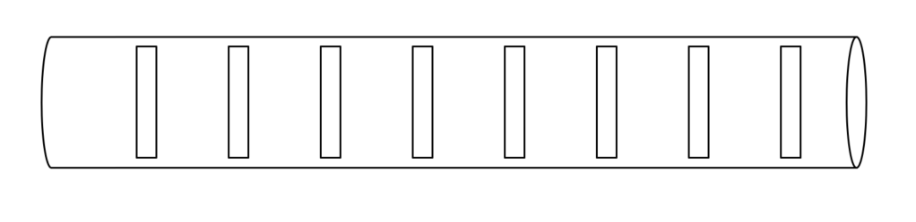Figure 5.3.3-1 The schematic diagram of interference tube

5.4 Binaural acoustic simulation
According to the principle of binaural signal, the typical solution involves placing microphones on each ear of the user or on a model of a human head or ears to capture the binaural cues. This model could be a head with a torso to simulate all influences, including those from the ear, head and reflections from the torso. Alternatively, it could be a single head or simply a model with a pair of ears.

5.5 Summary of microphones used in immersive audio capture
The previous immersive solution primarily relied on selecting specific microphone with a specific placement, which often resulted in larger sizes and higher costs, making it less appealing in today's compact economic portable UE market such as mobile phones. However, advancements in algorithms grant more possibilities on the miniature microphones with the limited placement. Therefore, it may be more feasible to consider utilizing the hardware feature combined with software to get immersive audio.

5.6 Other components used in audio capture.
Traditionally, audio capture required numerous components apart from microphones, including preamps, ADC, and clocks. However, with the advent of digital MEMS microphones, which can directly output digital signals and integrate all those components, audio capture has become significantly more convenient. This innovation is particularly appealing for small-sized devices.

Editor’s Note: this is basis for further work

]

Acoustic design

6.1 Stereo capture

Principle of stereo signal representation
The basic idea behind the stereo recording technique is to capture two signals with a proper relationship. By controlling the relationship between the two signals, it creates sound image with spaciousness, direction and depth feeling for listeners. And it can be reproduced through headphones or loudspeakers.

Characteristic of stereo capture
Compared to other formats, stereo capture does not aim to accurately reproduce the original sound field. Instead, its focus is on creating convincing illusory sound images for listeners, which is achieved by generating enough perceptual cues. It can provide a natural and realistic experience to the listeners in a limited range of listening zone. And it is more technically mature.

Factors that affect stereo capture
The key cues that may influence the quality of stereo capture are interchannel time differences, interchannel level differences and frequency range, which have been discussed since the emergence of stereo audio.
In the past, the discussion of factors that affect stereo capture always revolves around microphone properties (such as directionality and frequency range) and the placement of microphones.
With advancements in audio processing, we now have more methods to control audio signals, which is highly promising for stereo applications. This is especially relevant since UE imposes strict restrictions on hardware due to space constraints. The ability to fine-tune audio signals through processing offers great potential for enhancing stereo performance despite various limitations, but it may also import more influence on audio experience, which needs to be carefully analyzed. Therefore acoustic design also needs to consider the characteristics of relevant processing.

Stereo microphone configurations

Introduction
Stereo microphones can generally be classified as spaced, near coincident, baffled, coincident, and it is based on the directional characteristics of the microphones, their angle and distance between them. The following sub-clause presents some of these configurations.

Near-Coincident
Near-Coincident using two directional microphones placed close together at an angle is to capture stereo audio. This configuration utilizes the angle and distance between the microphones to create a suitable time and level inter-channel difference. There are number of near coincident configurations which are arranged at specific angles and distances, one of the well know near coincident stereo microphone is
ORTF (Office de Radiodiffusion-Television Français). In the ORTF configuration, microphone pair is arranged to mimic the placement of human ears, it uses two cardioid microphones with 17cm apart and at a 110° angle from each other.
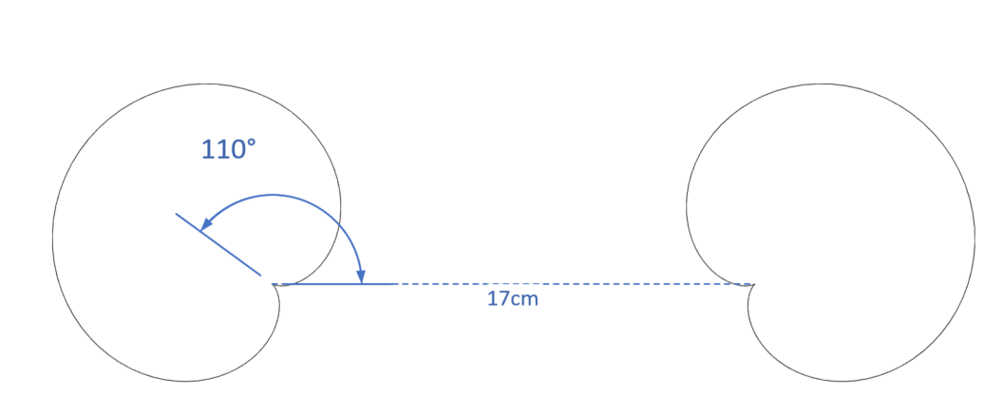
Figure 6.1.4.2-1 The configuration of ORTF stereo microphone

Baffled
A baffled configuration is a stereo recording technique that utilizes an acoustic baffle to increase the separation between the left and right audio channels. The baffle is typically a physical barrier that is placed between the two microphones. One of the examples of baffled microphone setup is OSS (Optimal Stereo System).OSS method utilizes a specially designed 30-cm disk covered with foam, with two omni-directional microphones mounted on opposite sides of the disk and angled slightly outward at 20°. The capsules of the two microphones are positioned 16.5 cm apart.
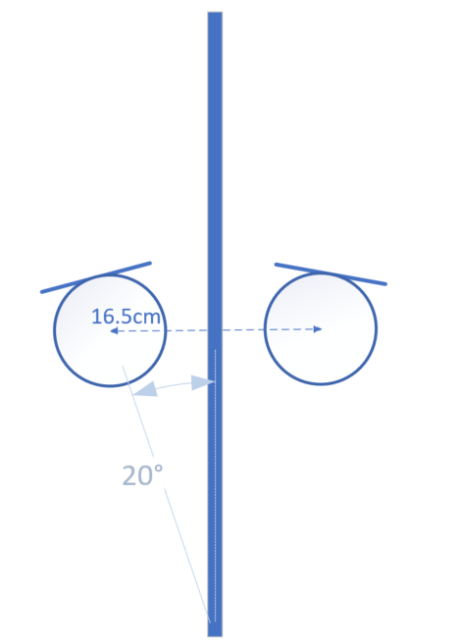
Figure 6.1.4.3-1 The configuration of OSS stereo microphone

Coincident

Introduction
A coincident stereo microphone consists of two directional microphones placed at an appropriate angle at the smallest-possible spacings. Therefore, sound arrives with equal delay and different level and phase at microphones.

X/Y
X/Y stereo microphone is commonly using two cardioid microphones ranging from 90-135°.
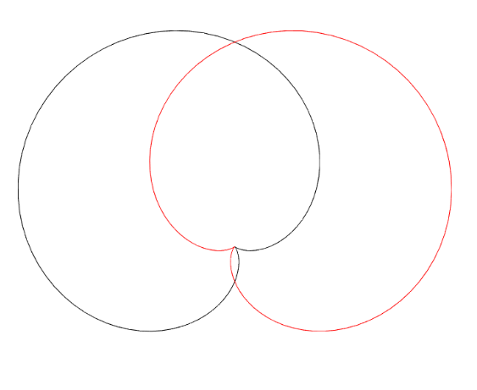
Figure 6.1.4.4.2-1 The configuration of X/Y stereo microphone

Blumlein
Blumlein stereo microphone consists of two bidirectional (figure-eight) microphones with 90° angle at the same place.
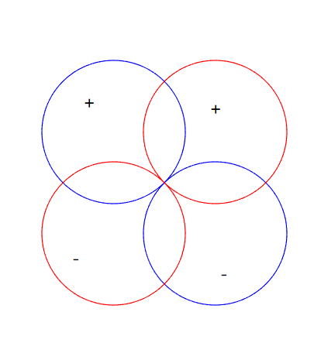
Figure 6.1.4.4.3-1 The configuration of Blumlein stereo microphone

M/S
M/S (mid-side) stereo microphone using a microphone (usually a cardioid) pointed forward, and a bidirectional (figure-eight) microphone oriented perpendicular to the directional microphone. The figure-eight microphone captures side signal, and the cardioid microphone capture mid signal. Therefore, we can obtain the left and right channel signal through the simple addition and subtraction.
$$Left=mid+side$$
$$Right=mid-side$$
In addition, controlling the ratio of the two signals, different angles can be obtained.
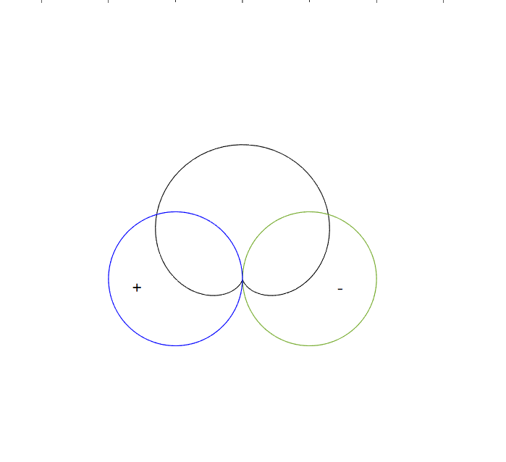
Figure 6.1.4.4.4-1 The configuration of M/S stereo microphone

Spaced
The spaced stereo microphone, also known as A/B stereo, is a stereo microphone technique that involves placing two omnidirectional microphones some distance apart from each other. This technique is commonly used with microphone spacings ranging from 0.3-1 meter.
The spaced stereo microphone technique utilizes the distance between two microphones to create a time difference and level difference between the left and right channels. This is caused by the difference in arrival time of sound waves at each microphone, as well as the absorption of sound by the air between the microphones.
NOTE: As most classic spaced configurations involve microphone distances greater than 30cm, which exceeds the size of current mobile phones, this aspect can only be listed for further study.

Spatial audio capture

Introduction
Several device form factors require spatial audio capture processing that is carefully designed and tuned for the specific multi-microphone array. In practice, a suitable parametric spatial audio capture analysis and processing is often implied for such devices.

Binaural capture

Principle of binaural signal representation
The basic idea behind the binaural recording technique is to capture the two signals that form the input to our hearing. By capture these signals in the ears of a listener, it can retain the both timbre and spatial aspects, even keep the personal feature in binaural. And it can be reproduced accurately though headphones.
Editor’s note: number of microphones to be clarified, some processing could apply to get binaural signals from more than two microphones

Possible issues in binaural capture
Binaural audio can be defined as follows:
“Binaural audio is defined as a two-channel spatial representation of a soundfield as typically captured at the entrance of the ear canals and intended for direct presentation to the left and right ears over headphones”
However, the situation is not always so ideal. In most case, it’s hard to place the microphone just at the entrance of ear canals. So, it may be helpful to figure out what will influence binaural capture, therefore we can get better signal under limited conditions.

Factors that affect binaural capture
There are many cues that may influence the quality of binaural capture, e.g., interaural time differences, interaural level differences, interaural phase differences and spectral characteristics. The cues are influenced by the listener’s pinnae, head and body.
Earbuds usually have transducers blocked at the entrance of ear canals for playback, which occupy the most important location for binaural record and the microphone need to be set a few millimetres outside the entrance of the ear. The surface of earbud may also cause the reflection. It can be seen that the reflection from pinnae capture in microphone will be influenced.

Differences between binaural and stereo audio
Both binaural and stereo formats consist of two left and right channels. Several differences are outlined in Table 6.2.2.4-1.
Table 6.2.2.4-1: Differences between binaural and stereo audio
Format | Distance between left and right channels | Spatial cues | Suggest playback | Relationship between interaural differences and interchannel differences | Sound image | Binaural renderring
Stereo | 0 to few meters | Interaural time differences and interaural level differences, | Headphone | Interaural differences equal to interchannel differences. | -90° to 90 ° (see NOTE) | Allowed
Stereo | 0 to few meters |  | Loudspeaker | Interaural differences equal to interchannel differences plus differences caused by propagation from speakers to ears | Between left and right loudspeakers | Not allowed
Binaural | Equal to distance between ears | Interaural time differences, interaural level differences, interaural phase differences and spectral characteristics | Headphone | Interaural differences equal to interchannel differences. | All directions. | Not allowed
NOTE: When stereo audio playback on headphones is processed with binaural rendering, the sound image transforms to be positioned between left and right virtual loudspeakers.

Parametric spatial audio capture

Principle of parametric spatial audio representation
Spatial, or immersive, audio representations generally enable reproduction of audio scenes where the listener experience can optimally correspond with the real recorded situations and environments. This means, e.g., that a listener can hear audio sources around them in their original directions relative to the listening position and orientation. Faithful reproduction is generally possible via headphones, including head-tracked binaural rendering, or a loudspeaker setup that provides sufficient spatial capability.
Parametric spatial audio describes a spatial sound field according to a parametric representation. In a typical solution, a multi-microphone capture is compressed into a lower number of audio channels and associated spatial parameters. The parameters define the perceptually relevant properties of the sound field (e.g., directional information, how directional or diffuse the sound field is, etc.), while the audio channels define the actual energetic representation of the captured sound field.
The analyzed parameters and audio channels can be further utilized for the synthesis of an accurate spatial audio representation in a desired output configuration. For efficient and realistic synthesis, the directional parameters are mapped into perceptual spatial cues, which are further applied for the transport audio channels. To enhance the quality of the reproduction, the parameters can be analysed based on the desired auditory frequency bands.
Typical processing flow of the parametric spatial audio capture is illustrated in the Figure 6.2.3.1.-1.
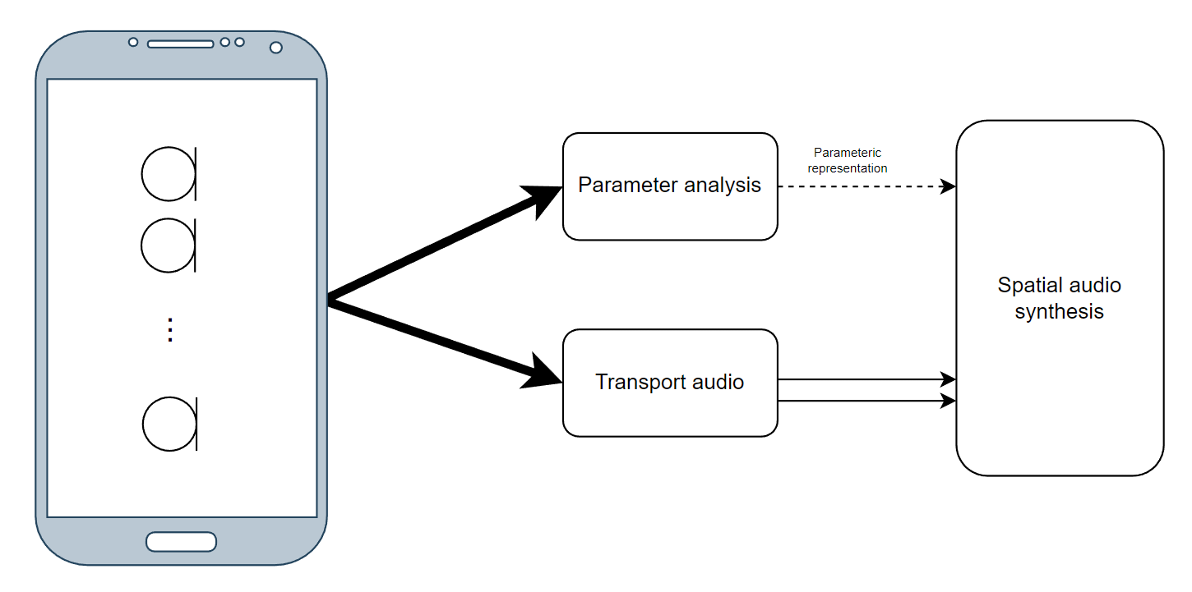

Figure 6.2.3.1-1 Overview of parametric spatial audio capture
A prominent example of a parametric spatial audio representation is the Metadata-assisted spatial audio (MASA) format defined in 3GPP TS 26.258 [5]. Specifically, MASA comprises one (mono) or two (stereo) transport audio signals and metadata.

Characteristics of parametric spatial audio capture and representation
Parametric spatial audio capture is typically purpose-fit for the device form factor that utilizes it. There can also be different representations, or a specific capture algorithm can utilize only a subset of parameters that another capture algorithm uses. Therefore, two substantially similar devices can have different capture algorithms or at least different tunings.
Parametric spatial audio capture and representation typically enables relatively low computational complexity for capture processing and encoding, largely because the number of channels in the representation can be lower than the number of originally captured channels.

Factors that affect parametric spatial audio capture
Multiple factors may affect the quality and accuracy of the parametric spatial audio capture. A few factors are:
• Dimensions of the capture device (distance and the placement of the microphones)
• Number and the characteristics of the microphones (directivity and frequency response)
• Applied signal processing techniques for the captured multi-microphone signals, e.g., noise suppression and filtering
• Quality of the spatial parameter analysis algorithm and the device specific tuning
Furthermore, due to the above factors, the quality and the accuracy of the parametric spatial capture is not necessarily similar for all the capture directions. This is highly dependent, e.g., on the specific device form factor and its microphone placement/spacing.

Multi-microphone configurations in parametric spatial audio
The number and the configuration of the microphones can be arbitrary, but in principle the lowest number of microphones for accurate 2D planar representation is typically 2 for 180° (frontal) capture, and 3 for 360° capture. Furthermore, by increasing the number of the microphones, the whole 3D sound field can be captured accurately. Typically, minimum number for microphones in this case is 4.
Editor’s note: as opposed to binaural audio, this enables head tracking.
The associated direction parameters can be obtained, e.g., by assessing the inter-channel properties of the captured multi-microphone signals. Such properties could be inter-channel time-difference, coherence, and/or level difference. The analysis can be based on suitable frequency bands.

Non-parametric spatial audio capture
      - Principle of Non-parametric spatial audio representation
Non-parametric spatial audio representation is used to provide spatial audio service at a reference point or area using certain number of audio channel data which have corresponding placements. the key point to the performance of the spatial audio service is to have appropriate audio data based on either standard or non-standard placements. Due to the constraints of the UE device shape, it is very hard to generate the spatial audio representation directly from their embedded acquisition units or even from selected accessory devices. the ordinary solution is to use microphone array to catch raw signals and then do mathematical processing to output the expected results.
Example processing flow of the non-parametric spatial audio capture is referring to Figure 6.2.4.1-1

Figure 6.2.4.1-1 Overview of non-parametric spatial audio capture
      - Characteristics of non-parametric spatial audio capture and representation
The placement of microphones is subject to various restrictions of the end-user devices, the non-parametric spatial audio capture can be used to generate both standard format audio and non-standard format audio. Several standard audio formats listed in IVAS-4 P-doc are surround (5.1 and 7.1), surround + height (5.1+4 and 7.1+4), FOA, HOA2, HOA3, Object-based audio. The standard format audio is a necessary part of the interoperable solution between different kind of end-user devices.
Non-parametric spatial audio capture and representation is an important intermediate link joint between originally captured raw signals at sending end and rendered spatial signals at receiving end, it can allocate computational complexity of the end-to-end real-time spatial audio solution into two ends.
The accuracy of the non-parametric spatial audio representation can be significantly different because of the corresponding non-parametric spatial audio capture solution, it is necessary to carefully define the minimum performance requirements for the non-parametric spatial audio representation, based on this, higher performance is always pursued with better solutions.
      - Factors that affect non-parametric spatial audio capture
It is the same as parametric spatial audio capture, refer to section 6.2.3.3
      - Microphone configurations in non-parametric spatial audio
Immersive audio capture technology by microphones has been developed for decades, however, its corresponding microphone configuration is not fit for current mobile phones.
Numerous stereo microphone configurations have been developed to create immersive audio experiences. Several immersive configurations that are compatible with mobile phones are listed here.

Immersive audio ORTF configuration[6]

6.2.4.4.1.1 ORTF-surround
The "ORTF-surround" configuration evolves from the ORTF stereo technique, consisting of two back-to-back ORTF stereo setups. It utilizes four super-cardioid microphones arranged in a rectangular formation, with each side measuring 10 cm by 20 cm and forming azimuth angles of 80º and 100º. The output from each microphone is individually routed to the corresponding Left (L), Right (R), Left Surround (LS), and Right Surround (RS) speakers to create an immersive audio experience. Refer to Figure 6.2.4.4.1.1-1.
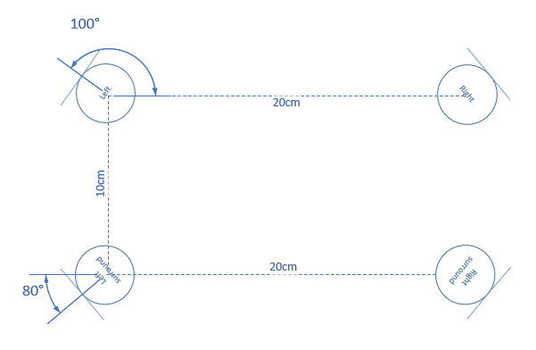
Figure 6.2.4.4.1.1-1 The configuration of ORTF-surround microphone

6.2.4.4.1.2 ORTF-3D
The "ORTF-3D" consisting of two "ORTF-surround" configuration, one is placed directly on top of one another with 90º on elevation Angle, Refer to Figure 6.2.4.4.1.2-1.
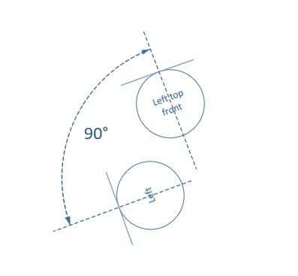
Figure 6.2.4.4.1.2-1 Left view of ORTF-3D microphone front channels

Immersive audio M/S configuration

6.2.4.4.2.1 Double-M/S[7]
The "Double-M/S" configuration enhances the traditional M/S configuration by adding an additional rear-facing cardioid microphone. This rear-oriented mic integrates with the existing figure-8 microphone's signal, creating a pair of back-to-back M/S systems that capture a surrounding sound field. And corresponding channel signal can be obtained through the following equation, Refer to Figure 6.2.4.4.2.1-1.:
$$Center=mid$$
$$Left=mid+side$$
$$Right=mid-side$$
$$Left surround=midrear+side$$
$$Right surround=midrear-side$$
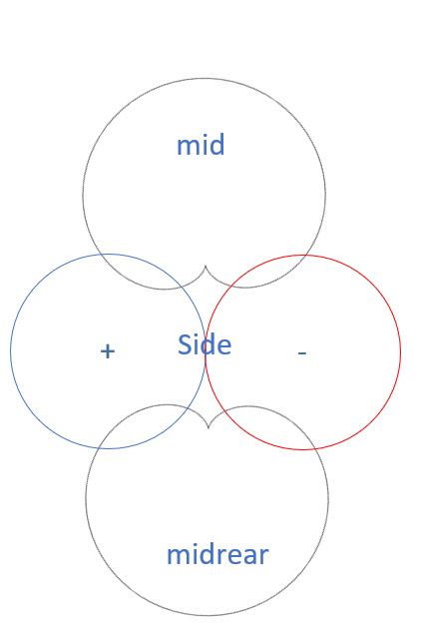
Figure 6.2.4.4.2.1-1 The configuration of Double-M/S microphone

6.2.4.4.2.2 M/S-3D[8][9]
By incorporating a vertically oriented figure-8 microphone as “Z” signal into the "Double-M/S" configuration, the "M/S-3D" setup is capable of capturing the height channel, Refer to Figure 6.2.4.4.2.2-1.:
$$Left top front = mid + side + Z$$
$$Right top front = mid – side + Z$$
$$Left top rear = midrear + side + Z$$
$$Right top rear = midrear – side + Z$$
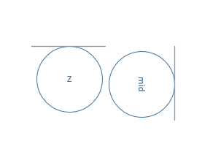
Figure 6.2.4.4.2.2-1 Left view of M/S-3D microphone

IRT-cross
Another well-known configuration is the "IRT Cross," which is an equal segment microphone array. This array can be configured with either four cardioid microphones placed 20 cm apart or four supercardioid microphones spaced 14 cm apart. Refer to Figure 6.2.4.4.3-1.
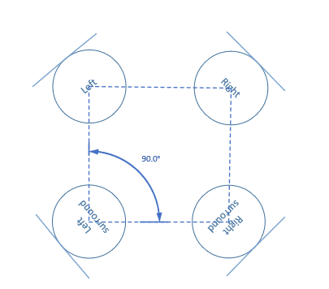
Figure 6.2.4.4.3-1 The configuration of IRT-cross microphone

6.2.4.5 Comparisons between non-parametric spatial audio capture and parametric spatial audio capture
Parametric spatial audio employs a suitable parametric representation for the captured sound field, which is based on the analysis of the raw microphone signals to produce parameter metadata and potentially converting the raw microphone signal into specialized audio channel data.
In contrast, non-parametric spatial audio can only produce the audio channel data without parameter metadata. Once the microphones and their configuration are determined, the raw microphone signals can be converted into expected audio channel data by certain signal processing.

Microphone design for terminals

Microphone design for mobile phones
Modern smartphone devices come with inbuilt MEMS microphones supporting more than one microphone, while the top end devices have inbuilt microphones between 3 to 4; mid-range devices support dual microphones. With multi-microphones as a feature, they offer several advantages over devices with mono including improved audio quality, better spatial awareness, more accurate noise cancellation, better sound localization.
The spacing between the multi-array microphones, its polar pattern and the number of microphones varies from device to device. However, generally the spacing ranges from 3cm – 17cm. The following table 6.3.1-1 covers the specifications of these microphones in smartphones.
Table 6.3.1-1: MEMS Microphone example characteristics for Multi-array microphones in Smartphone.
Number of Microphones | Placement of Microphones | Spacing | Polar Pattern
Dual Microphone  array | Top and Bottom of Bezel | 12 to 17 cm | Omni-directional or Cardioid
Dual Microphone  array | Bottom of Bezel and rear facing | 10 to 15 cm | Omni-directional or Cardioid
Triple Microphone array | Top, Bottom of Bezel and Rear Facing | 5 to 17 cm | Omni-direction, Cardioid, directional
Quad Microphone array | Top, Dual Bottom of Bezel and Rear Facing | 5 to 17 cm | Omni-direction, Cardioid, directional
Microphones with 3cm stereo spacing are usually located at the bottom of the bezel (left and right side of USB C-Port), while the larger spacing is achieved with a combination of top, bottom bezel microphone and/or rear facing microphone. Because the user can operate and hold the device in a variety of ways, a combination of these microphones can be activated for stereo voice communication and efficient capturing configuration is possible with advancements in audio processing by means of fine-tune of audio signals through pre-processing which offers great potential for enhancing stereo performance for different user end consumption scenarios such as loudspeaker and/or headphones.

Microphone design for headphones
Generally, headphone form factors can be divided into 3 categories over-ear, on-ear, in-ear. Nowadays, wireless headphones are quite popular, and these devices are often connected to a smartphone or a portable device via Bluetooth both for speech communication and for audio streaming. These devices are equipped with MEMS microphones supporting more than one microphone. The number and placement of microphones per device category vary from manufacturer to manufacturer with the goal of delivering better sound quality and spatial experiences.
Despite the form-factor for in-ear headphones being comparatively smaller compared to on and over-ear devices, in-ear devices incorporate up to 6 microphones (3 per bud), while on-ear devices incorporate up to 9 microphones, with a major focus on improving user experience. Tables 6.3.2-1 and 6.3.2-2 cover the specification of these microphones for on-ear, over-ear, and in-ear.
Table 6.3.2-1: MEMS microphone example characteristics for multi-array microphones for on-ear or over-ear devices
Number of Microphones per pair | Placement of Microphones | Polar Pattern
up to 9* microphones | up to 3 external microphones per side distributed.  on the outside ear cup. | Omnidirectional
up to 9* microphones | 1 internal microphone per side | Omnidirectional
up to 9* microphones | w/wo 1 dedicated microphone for voice (right cup) | Omnidirectional

9* For some headphones (on-ear), up to 9 microphones are available, while others may have fewer than 9 microphones.
Table 6-3-2-2: MEMS microphone example characteristics for multi-array microphones for in-ear devices
Type | Number of Microphones per pair | Placement of Microphones per side | Polar Pattern
Pod | Up to 6* | Bottom of the stem (1), Top of the stem (1)  w/wo Inward facing microphone (1) | Omnidirectional /Cardioid
Bud | Up to 6* | 2 mics located on the outer part of the bud w/wo one inward facing microphone | Omnidirectional /Cardioid
6* Some headphones may incorporate one or two additional bone conduction microphone(s).

The general tendency among wireless headphone manufacturers is primarily focused on delivering better noise cancellation. To achieve this, larger microphone arrays up to 4 per side is used.

Microphone design for tablets
Tablets share a similar structure with mobile phones but are significantly larger in size. This allows for more flexibility in the placement of microphones, with some tablets accommodating up to five microphones.
Small microphone arrays are also a common feature on tablets. However, due to the less common handheld mode in tablets, microphones near the USB port - the closest location to the mouth in handhold mode - are rarely seen. Instead, microphones are typically located near the front and back camera modules and along the edges of the tablet, refer to table 6.3.3-1 .

Table 6.3.3-1 MEMS microphone example characteristics for multi-array microphones for tablets
Number of Microphones | Placement of Microphones
up to 5 microphones | 1-3 on the top of the devices (near the front camera)
up to 5 microphones | 1 on near the back camera
up to 5 microphones | 1 on the edge of device

Microphone design for laptops
Due to the clamshell structure of laptop, in current devices, there are more options for microphone placement. Some are positioned on the screen part, while others are located on the keyboard section. More potential microphone location resulted in larger microphone distance, and moveable microphone location.
Some popular microphone placements on laptop are explained in following figures:
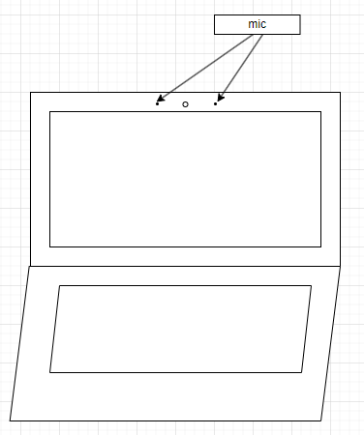
Figure 6.3.4-1 Laptop microphone placement 1
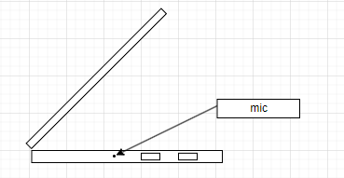
Figure 6.3.4-2 Laptop microphone placement 2

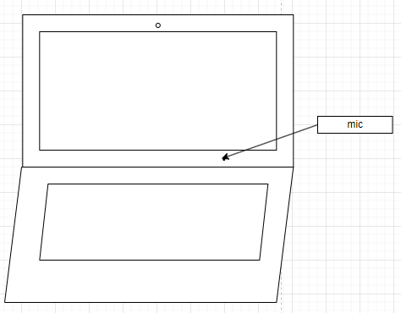
Figure 6.3.4-3 Laptop microphone placement 3

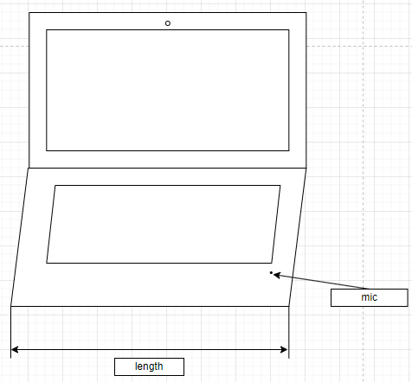
Figure 6.3.4 Laptop microphone placement 4

Microphone design for watches
Modern watch devices are increasingly equipped with microphones and speakers, enabling them to independently establish speech services.
Some up-to-date models often feature two built-in microphones. Typically, one microphone is located on one edge of the watch, while the second is situated on the opposite edge. The spacing between these microphones generally correlates with the size of the watch, ranging from 3-5cm.

Microphone frequency response
A significant rise in specific frequencies can often be observed in numerous MEMS microphones, exhibiting a curve like resonance.
The MEMS microphone package includes a port that allows external sound to enter, while the transducer is shielded by a can, which may be perceived as chambers. These components form a Helmholtz resonator, resulting in resonances. Numerous studies in this field have provided various formulas to calculate such resonators.
[

7 Signal processing
Editor’s Note
- Relevant signal processing content is envisioned
- Including relevant processing for audio format, enhancement solution for immersive, speech enhancement, etc.
- Relevant characterization of the audio capture performance.

AEC

7.1.1. Principle of mono audio AEC
The aim of AEC is to minimize or eliminate the acoustic echo that occurs during a full-duplex communication from the other side. A case is described as in Figure 7.1.1-1, a speaker uses a sending device with voice communication capability to play an audio clip (red colour waveform signal), the audio clip is sent through the acoustic environment and received by the device's own microphone which generates the echo signal (blue colour waveform signal) for the sending audio clip. If an adaptive filter can be designed so that its output signal is just the opposite of the echo signal, like the green colour waveform signal, then the following step is to superimpose the blue colour waveform signal with the green colour waveform signal, thus the echo signal is eliminated depending on the performance of the adaptative filter.
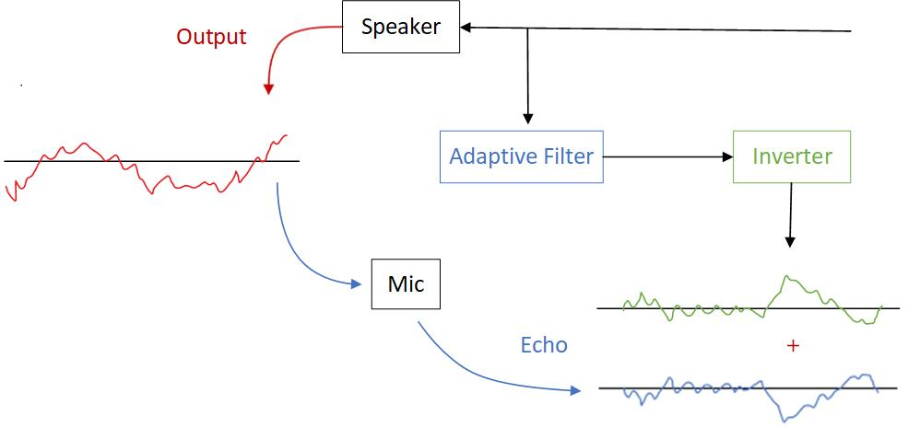
Figure 7.1.1-1: diagram of AEC
AEC uses adaptive filters to counteract the impact of echoes and reverberations in the input signal, with the goal of a minimizing error. The general algorithm equations are as follows:
Where, $x(n)$ is the input signal, $d(n)$is the desired signal, $y(n)$is the estimated echo signal, $e(n)$is the error signal, $w(n)$is the coefficient of the adaptive filter, $μ$ is the step size parameter, and M is the length of the adaptive filter.
By minimizing the error and continuously updating the adaptive filter coefficients in an interactive way, the estimated echo signal becomes closer and closer to the desired signal, and finally making the error signal in an acceptable range.
Note: Terminal acoustic characteristics for telephony; Requirements were specified in TS 26.131[13]

7.1.2 Challenges for immersive audio AEC
For immersive audio services, the sound is reproduced through multiple speakers while simultaneously using several microphones. When the UE consists of N speakers and M microphones, the number of echo paths generated is the number of speakers multiplied by the number of microphones, i.e., N×M, which is several times the number of echo paths generated by a mono audio communication system. Taking stereo audio as an example, if a stereo audio device uses two speakers and two microphones to create a two-way audio service. In this case, Stereophonic Acoustic Echo Cancellation setup needs to estimate four echo paths. The significant increment in the number of echo paths poses a challenge to the computational complexity of adaptive algorithms. If the mono audio echo cancellation algorithm is directly extended to multi-channel, the algorithm is difficult to converge due to different people, different moments, and different positions of speech, and the adaptive filtering algorithm for mono audio case is not suitable for this situation. Obviously, extending mono audio echo cancellation algorithm directly to multi-channel will result in poor acoustic echo cancellation performance.

7.1.3 The current status of the research
The core of multi-channel acoustic echo cancellation algorithm is the same as that of single-channel echo cancellation algorithm - adaptive filtering algorithm. However, multi-channel acoustic echo cancellation faces more difficulties than single-channel AEC, the key point is the non-uniqueness of the solution. The strong correlation of multi-channel input signals will result in non-unique solutions when solving for the optimal filter coefficients, and the echo canceller cannot provide a unique echo path solution. The adaptive filter needs to fit a long impulse response to handle the same length of echo, and this larger filter order requires more historical data, leading to increased algorithm complexity and reduced convergence performance. Therefore, researchers currently address the problem of multi-channel acoustic echo cancellation mainly from two aspects: firstly, removing the correlation of input signals without affecting spatial sound perception, solving non-uniqueness; secondly, improving the adaptive algorithm, allowing the adaptive algorithm to have faster convergence speed and lower computational complexity to form multi-channel situations.
Example of stereo-AEC is referred to Annex B
Editor’s note: should add references

7.1.4 AEC for different UE
Theoretically, increasing the distance between the microphone and loudspeakers can enhance AEC performance by reducing the echo level coupling from the loudspeakers to the microphones. However, the demand for additional microphones and loudspeakers due to immersive audio brings the distance significantly closer.
This reduction is especially evident in smaller UE, such as mobile phones and earbuds, where the compact size restricts the distance, leading to a higher echo level and shorter echo delay. In some devices, the microphone and loudspeaker may even be placed in the same sound port.
Conversely, larger UE like cars may experience a longer echo delay, but they offer a more stable acoustic environment since all the microphones and speakers for communication are installed within the cabin.

  - Microphone Array Signal Processing on device
    - Introduction
According to previous investigations, Microphone Array Signal Processing (MASP) is an essential step for stereo capture, parametric spatial audio capture and non-parametric spatial audio capture, the basic processing is to transform the raw microphone signals into an expected audio representation, and enhancement could be done if necessary.

7.2.2 MASP for Channel-based

7.2.2.1 MASP for Stereo
In Clause 4.1, current mobile phones with dimensions of approximately 15cm in length and 7cm in width. Furthermore, a minimum of two microphones is required for stereo audio capture. Consequently, it is logical to use the most basic microphone array configuration as an example: two microphones positioned at a distance of less than 15cm or 7cm, depending on the orientation of mobile phones. So this subchapter will focus on how to complete microphone array signal processing for producing stereo signals based on such microphone array.

7.2.3 MASP for Binaural
According to clause 6.2.2, binaural capture on UE appears to be the sole format capable of directly obtaining audio from the raw microphone signals via the earbuds' microphones, enhancement processing could be done for better performance.

7.2.4 MASP for Scene-based

7.2.4.1 FOA
FOA signal model is very clear, it consists of four coincident signals: W, X, Y and Z, where W is an omnidirectional signal, while X, Y and Z are figure 8 directional signals aligned with the cartesian coordinate axes. So, the aim of the microphone array signal processing for FOA is to generate standard four coincident signals [2].

7.2.4.2 Matrix on current FOA microphones
The current FOA microphones utilize a tetrahedral configuration, which comprises four cardioid microphones oriented in the directions of Front-Left-Up (FLU), Front-Right-Down (FRD), Back-Left-Down (BLD), and Back-Right-Up (BRU). The W, X, Y, Z component are produced through matrix multiplying of the four cardioid signals, refer to equation(1). not follow the SN3D and ACN channel order.
$$\left[\begin{matrix}W \\ X \\ Y \\ Z\end{matrix}\right]=\frac{1}{2}\left[\begin{matrix}\begin{matrix}1 & 1 & 1 & 1\end{matrix} \\ \sqrt{3}\left(\begin{matrix}1 & 1 & -1 & -1 \\ 1 & -1 & 1 & -1 \\ 1 & -1 & -1 & 1\end{matrix}\right)\end{matrix}\right]*\left[\begin{matrix}\begin{matrix}FLU \\ FRD \\ BLD \\ BRU\end{matrix}\end{matrix}\right] (1)$$

7.2.4.3 HOA
HOA is for further study.

7.2.5 MASP for MASA
MASA format signals consist of audio signals and metadata. The metadata refer to 26.250[12] are derived from analysis of microphone raw signals, so microphone array signal processing is an essential module for producing MASA signal.

7.2.6 MASP for Object-based
According to 26.250 [12], Object-based audio consists of 1-4 individual mono object streams with associated metadata. Many existing technologies can be used to obtain object-based audio.

7.2.6.1 Mono object stream
The mono object stream may need audio with high quality and sufficient SNR, characteristics that closely match the existing mono audio solution. Consequently, the mono object stream may be derived from the current mono audio solution provided by UE.

7.2.6.2 Associated Object Metadata
A minimal set of object metadata associated is the object position in the polar coordinate system described using azimuth [-180°,180°] and elevation [-90°, 90°] angle.
Direction Of Arrival (DOA) is commonly utilized in current audio services, it is to determine the direction of the audio that needs to be processed. The direction information can also be set as associated object metadata to describe the position of one audio object.

  - Beamforming
    - Introduction
Research on microphone array beamforming began in the late 1960s, although some basic principles can be traced back to the 1930s when directional microphones were invented. Early work in this field was strongly influenced by sensor array theory developed in the radar and sonar fields.
Beamforming is a very popular technology to achieve target directivity, though it’s mostly used for mono speech now, it is great potential in immersive audio. There are also many studies in this area.
This proposal starts with two fundamental technologies: Delay-sum and differential. And aim for the suitable solution for immersive audio on UE.
    - Delay-sum microphone array
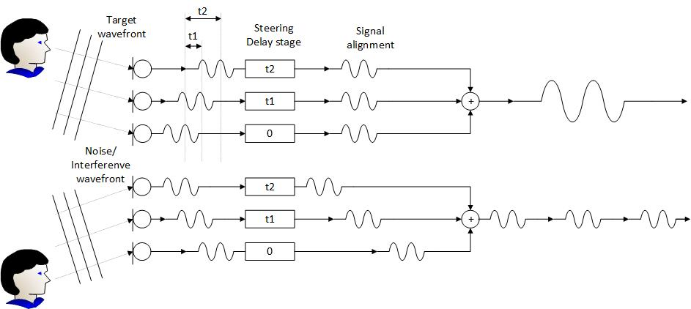
Figure 7.3.2-1 The diagram of Delay-sum microphone array
The basic idea of this technology is to delay the output of each microphone by an appropriate amount of time. The phase relationship between the microphones is carefully controlled to ensure that the signal form desired direction have the same phase so that they can be reinforced.
Though the delay-sum microphone array can obtain a very sharp directionality. However, the biggest problem with this beamformer is that its beam pattern changes significantly with frequency.
    - Differential microphone array
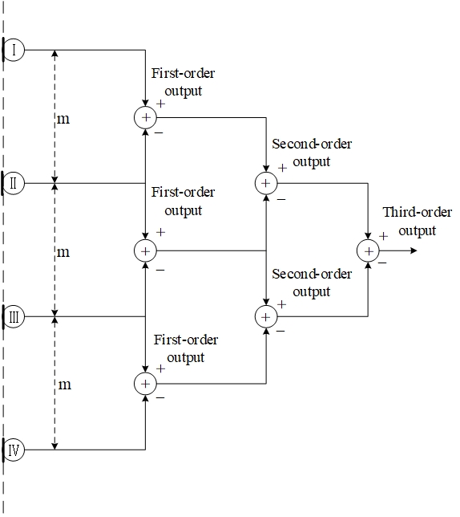
Figure 7.3.3-1 The diagram of Differential microphone array

In Differential Microphone Array (DMA), the signals from two or more microphones are subtracted from each other to create a special directivity. The traditional directional microphone can also be seen as a special kind of differential beamforming.
By adjusting the weight and phase of the differential signal, we can all get different directivity like: cardioid, bidirectional (Figure-8), supercardioid, hypercardioid, subcardioid (wide cardioid).
Due to the smaller spacing between microphones, the size of array is usually smaller, making it easy to integrate into UE such as earphones, mobile phones, etc. Another characteristic of DMA is that its directivity is frequency-invariant; therefore, they are suitable for processing broadband speech and audio signals.

8 Example audio capture processing solutions
Editor’s Note
- Example solutions can be guidance on usage in conjunction with immersive voice and audio services codecs.
- Contributions are invited providing at least overview descriptions of the example audio capture solutions, illustrating the signal processing from the raw microphone feeds to the stereo/spatial audio formats.

To identify processing solutions at the capturing end, capturing scenarios are described as follows.
[

Capture scenarios

8.1.1 Telephony communications
Capturing Type: Multi-Microphone Capturing
Description

Summary

Call was established between Tom and Harry.
Tom device has multi-microphone capturing capability and Harry conversing via headphones connected to his communication device.
During the conversation with Harry, Tom wishes to share his experience and he changes the orientation of the portable communication device from portrait to landscape.
Tom device activates suitable microphone array configuration based on orientation of the device to maintain its intended position and to allow the listener (Harry) feel immersed in the experience sharing, providing a natural and enjoyable listening experience.

User Story:

Tom planned vacation with his friends, and they are in the Bhutan airport. One of Tom’s friend, Harry who is part of travel had to drop out of the vacation at the last minute. Harry felt devastated as he called Tom to break the news. To lighten up Harry’s mood and ensure she didn’t feel left out, Tom came up with an idea of sharing vacation experience with Harry daily. Tom knew it wasn’t the same as having Harry there in person, but he determined to make Harry feel like a part of the trip, even from afar. As Tom and his rest of the friends are at the observatory deck of the airport, decided to share his experience from day-0 (flights land off - takeoff, airport ambience, picturesque mountains in the backdrop etc.,) to Harry. Tom extends his hand holding his communication device in landscape mode towards the flight landing and takeoff with beautiful mountain view at the background. Harry can now view and listen to the airport observatory deck scene clearly which brought a smile on Harry’s face, as she feels she is part of the scene. As Tom and rest of their friends embarked on their vacation, he stayed true to his promise by giving virtual tour of day’s highlights to Harry.

Device
UE (Smartphone, Tablet), Headphones (Over the ear, on ear, In ear)

Pre-condition:
Tom’s UE implements multi-microphone capture with activation of relevant microphones.
Headphone connected to Harry’s UE

Feasibility

Availability of Multi-microphone capture is getting more common on smartphones.

Potential Processing Solutions
- Analog-Digital Conversion (ADC), Echo Cancellation, Noise Suppression, Automatic Gain Control, activation of suitable microphones based on device orientation.

Capture solution for end-user devices

8.2.1 Overview
Support of immersive voice and audio services by end-user devices requires successful combination of several audio technologies and appropriate product design for taking full advantage of the new immersive capabilities. Relevant devices (UE) can come in many shapes and sizes (form factors) for different use cases, and even traditionally dominant UE form factors such as mobile devices can be expected to be used in new ways, e.g., multiple orientations (landscape and portrait) in different use cases and applications that provide immersive voice and audio communication.

Multi-microphone is used to get expected audio signals for end-user devices, the following figure 8.2.2-1 illustrates one example process of generating audio signals.

mic signals

Binaural/stereo

audio format generation
UE
Parametric spatial audio
Post -proc
enhancement
…

Scene-based audio

compensation
…
Multi channel audio
…
…
speaker signals
Object-based audio
……

Figure 8.2.1-1 example process of generating audio signals.

8.2.2 Compensation
Compensation block is used to improve the quality of microphone signals, specifically to smooth the frequency responses and minimize the mismatch within microphone arrays. One of the classic solutions is using the EQ filter to change the responses of the microphone signals. Generally,it usually smooths the microphone response of each channel according to the measured microphone response, this make microphone signal comparable to each other.

8.2.3 Enhancement

8.2.3.1 Introduction
Enhancement block consists of multiple different operations which aim at improving audio quality considering the targeted audio source or sources. These operations can include for example AEC, noise reduction, audio focusing and etc.

8.2.3.2 AEC
AEC is typically performed separately for each microphone signal, but alternative solutions can also be considered. The target of AEC processing is to remove the loudspeaker signal component from the microphone signals based on a reference signal. In the case of stereo playback both stereo channels are needed as reference inputs for the AEC.
The baseline approach is to apply traditional Acoustic Echo Cancellation on the individual microphone channels. Traditional AEC solution has been to use linear AEC filter which is followed by residual echo suppression (RES). Nowadays RES is often implemented using DNN. Recently, also solutions in which the whole AEC is managed with a single DNN have been introduced.

8.2.3.3 Noise reduction

8.2.3.3.1 Introduction
In monaural speech audio, the main emphasis is on capturing the speech signal, however, spatial audio offers the additional advantage of presenting the ambience. As a result, certain ambient sounds, which might be dismissed as background noise in monaural speech audio, are effectively conveyed in spatial audio. The interpretation of noise varies between monaural and spatial audio. Although device floor noise like microphone noise and wind noise are still classified as noise, other non-speech sounds originating from the actual environment enhance the atmosphere and may be considered effective signals in spatial audio according to scenarios.

8.2.3.3.2 Wind noise reduction
The baseline approach is to apply wind noise reduction on the individual microphone channel by non-linear signal processing. A DNN based noise reduction/speech isolation trained on wind noise is also found to be effective to reduce wind noise. Such a system performs well to maintain speech but incurs a higher processing costs and latency.

8.2.3.3.3 Microphone noise reduction
Microphone noise reduction targets to remove self-noise generated by the microphones. It is generally based on defining the noise floor of the microphones.

8.2.3.3.4 Background noise reduction
Background noise reduction can be used to increase intelligibility of the captured speech. It generally makes audio more pleasant to listen to and can be used to remove irrelevant components from the captured audio. Depending on the use case, background noise reduction may only remove continuous noise such as air-conditioner noise or traffic noise, or it may, e.g., aim at removing everything but speech from the captured audio. Content or context-based classification and processing can be employed if different noise reduction processing is desired, e.g., for speech and music. For immersive voice and audio, background noise reduction settings may be more contextual than for traditional mono voice and audio. Noise reduction can also be required for accessibility purposes. DNN-based solutions are commonly used for noise reduction.

8.2.3.3.5 Audio focusing
Audio focusing can be used to focus spatial audio capture into preferred direction. The focus direction can be defined automatically or manually depending on the use case. With suitably selected microphone locations good focus performance can be achieved using beamforming. Audio focusing can be used for content creation or accessibility purposes.

8.2.4 Audio format generation

8.2.4.1 Introduction
Th audio format conversion is used to convert the enhanced microphone signals into an expected format audio signal. The following clauses give example processing for smartphone devices.

8.2.4.2 Example of stereo processing
The stereo processing transforms the microphone signals into a standard stereo audio. It employs two or more microphones on the smartphone to create left and right channels. As the stereo audio, sounds coming from different angles present varied ICTD and ICLD. Concurrently, sounds from various angles present a phase difference between the microphones, which can be leveraged to modify ICTD and ICLD for different degrees. A transforming matrix could be constructed based on this information, and technologies such as beamforming may be utilized.

8.2.4.3 Example of scene-based audio processing

8.2.4.3.1 Introduction
The example solution uses the content based processing module and ambisonics upmixer module to get scene-based audio signals.

8.2.4.3.2 Content based processing
Content based processing is an optional set of processing that can greatly enhance spatial experience by identifying the content type and applying specific enhancements. Since the processing is content dependent, a general audio classifier or a speech isolation processing is necessary to identify regions of interest. Classification across music, speech and background noise has been found suitable for relevant scenarios. A real-time classifier might have delayed response to events, and false transitions might be triggered due to low or no lookahead. A classifier confidence smoothing, or a state machine can be employed to minimize false transitions and identify class switching events.

8.2.4.3.3 Ambisonic upmixer
This block is responsible for mapping the multi-microphone capture to first order ambisonics or higher. Out of the various techniques to upmix a multi-microphone capture to FOA, a perceptually designed static upmix matrix yields reasonably accurate spatial performance with few or no drawbacks. The response per frequency band is generated across each microphone towards each ambisonic channel using: i) a model of how each microphone responds to the incoming sound field from a dense set of directions, based on finite element method simulations which account for the 3D placement of microphones across device body structure and resultant acoustic energy transfer; ii) a perceptually-motivated optimisation where the complex upmix matrix coefficients are determined based on the data computed at the simulation step, and a target perceptual spatial accuracy. These steps of analysis, simulation and upmix design are performed offline once per device by assuming a simpler 3D geometry of the device and microphones as point sinks.
The Upmixer utilizes the static matrix and applies per frequency band transformation to achieve ambisonic channel output.

8.2.4.4 Example of parametric spatial audio processing

8.2.4.4.1 Introduction
The example solution uses the downmixing module and spatial analysis module to get ambisonics signals.

8.2.4.4.2 Downmixing
With parametric spatial audio capture, output spatial audio can be synthesized with one or two audio channels and metadata. Therefore, the number of audio channels can be reduced before synthesis. This can be achieved by selecting one or two representative audio channels from the audio enhancement block output.

8.2.4.4.3 Spatial analysis
The target of spatial analysis in parametric spatial audio capture is to estimate spatial properties of the captured audio signal (audio scene) and generate metadata, which can be later utilized in spatial synthesis or rendering. Spatial analysis uses information of the device shape and the locations of the microphones. It is common to perform spatial analysis for frequency domain sub-bands, and analysis can be based, e.g., on coherence and level analysis between the microphone signals. To make sure spatial analysis works properly, it is important that echo is properly removed from the captured signal (see, AEC in clause 8.2.4.2) and, on the other hand, that audio enhancement processing (see clause 8.2.4) has maintained relevant spatial cues in the signals.

In an example spatial analysis, the direction of one or more dominant sound sources are analyzed for every sub-band. In addition, the directional energy and other spatial parameters are estimated. For example, the directional energy can be a ratio relative to the total energy of the corresponding sub-band. Together the analyzed parameters form the metadata for the parametric spatial audio format. The selected audio signals (e.g., mono or stereo) and the analyzed metadata can then be provided as input to spatial synthesis or used, e.g., in audio transmission (as codec input).

8.2.5 Post-proc
Post-proc which typically the Automatic Gain Control (AGC) is utilized to adjust the signals to a suitable level. AGC typically also includes limiter which is designed to prevent signal saturation.

]

Capture Scenario: Telephony Communications
Capturing Type: Multi-Microphone Capturing

Description

Summary

Call was established between Tom and Harry.
Tom device has multi-microphone capturing capability and Harry conversing via headphones connected to his communication device.
During the conversation with Harry, Tom wishes to share his experience and he changes the orientation of the portable communication device from portrait to landscape.
Tom device activates suitable microphone array configuration based on orientation of the device to maintain its intended position and to allow the listener (Harry) feel immersed in the experience sharing, providing a natural and enjoyable listening experience.

User Story:

Tom planned vacation with his friends, and they are in the Bhutan airport. One of Tom’s friend, Harry who is part of travel had to drop out of the vacation at the last minute. Harry felt devastated as he called Tom to break the news. To lighten up Harry’s mood and ensure she didn’t feel left out, Tom came up with an idea of sharing vacation experience with Harry daily. Tom knew it wasn’t the same as having Harry there in person, but he determined to make Harry feel like a part of the trip, even from afar. As Tom and his rest of the friends are at the observatory deck of the airport, decided to share his experience from day-0 (flights land off - takeoff, airport ambience, picturesque mountains in the backdrop etc.,) to Harry. Tom extends his hand holding his communication device in landscape mode towards the flight landing and takeoff with beautiful mountain view at the background. Harry can now view and listen to the airport observatory deck scene clearly which brought a smile on Harry’s face, as she feels she is part of the scene. As Tom and rest of their friends embarked on their vacation, he stayed true to his promise by giving virtual tour of day’s highlights to Harry.

Device
UE (Smartphone, Tablet), Headphones (Over the ear, on ear, In ear)

Pre-condition:
Tom’s UE implements multi-microphone capture with activation of relevant microphones.
Headphone connected to Harry’s UE

Feasibility

Availability of Multi-microphone capture is getting more common on smartphones.

Potential Processing Solutions
- Analog-Digital Conversion (ADC), Echo Cancellation, Noise Suppression, Automatic Gain Control, activation of suitable microphones based on device orientation.

[
Editor’s Note: this 8.2 section is used as a baseline.
Major revisions and generalizations of this baseline are expected.

Example design of spatial audio capture for multi-microphone UE devices

Design

1 Overview

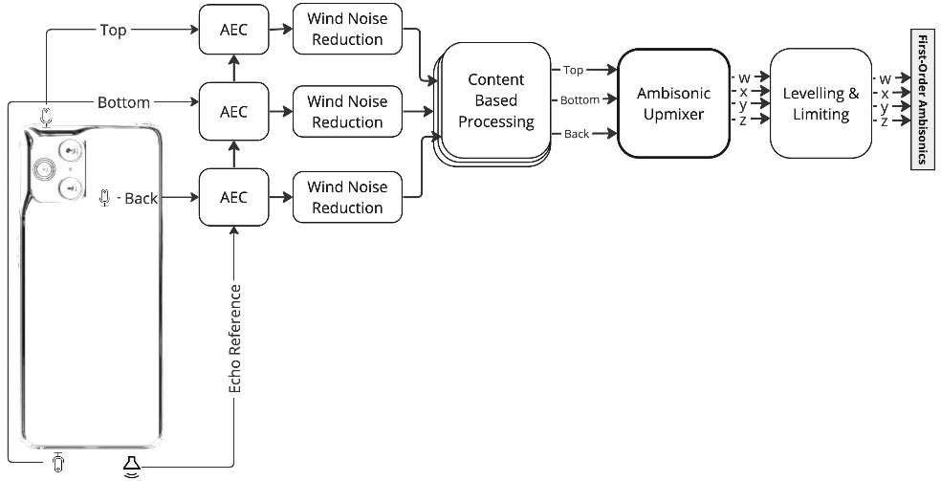
A spatial capture on a modern mobile device may be implemented by utilizing the various microphones placed across the device, capture enhancement processing chain and a Ambisonic Static Upmixer. The capture stack incorporates simultaneous capture of 3 or more on-device microphones and an optional mono/stereo echo reference signal as inputs to produces a FOA output which can stored/transmitted using the IVAS (Immersive Voice and Audio Services) codec.
The various components of a spatial capture chain are as follows:
- Raw Microphones Unprocessed Input and Echo Reference Signal
- Compensation of the raw microphones self noise and frequency response based on measured and simulated data.
- Acoustic Echo Cancelation
- Wind Noise Estimation/Reduction
- Content Based Processing
- Static Ambisonic Upmix based on:
  - Acoustic modelling of the phone and microphones via Finite Element Method analysis.
  - Perceptually-based complex optimisation of upmixing coefficients accounting for the acoustic modelling.
- Levelling and Limiting

  - Raw Microphone Input and Echo Reference

Simultaneous capture of unprocessed raw inputs from all microphones is essential to derive the very best spatial capture utilizing a static ambisonic upmix. For generating first order ambisonic with good horizontal accuracy on the horizontal plane, at least 3 microphones are needed, which may be placed spatially on the mobile device to cover different planes. A typical placement of Top, Bottom and Rear microphones is seen on most modern mobile devices, however coplanar configuration is not optimal to resolve front/back confusion. An ideal arrangement of microphones should target to cover the three axes and spread evenly across the device to provide more spatial resolution, though practical constraints of phone design limit the spacing along the front-back axis to less than one centimetre.
A raw unprocessed capture is essential for spatial processing as any uncontrolled processing such as noise reduction, automatic gain control or echo cancellation on individual microphones will lead to loss of spatially sensitive background noise and in general cause front/back confusion.
It is however beneficial to apply controlled processing to each of the raw signals, to attenuate their electrical noise floor and to compensate for any anomalies in the frequency response due to the inherent response of the mic or to the effects of its placement inside ported holes on the edges of the device. These processings are based on measured data.
The echo reference is a mono or stereo signal representative of the audio played out from the loudspeaker and used by the AEC processing. It is necessary in full duplex communications if there exists an acoustic path between the loudspeaker and the device microphones. If none exists, such as when using headphones, echo reference is optional.

  - AEC

The baseline approach is to apply traditional Acoustic Echo Cancellation on the individual microphone channels.

  - Wind Noise Reduction

The baseline approach is to apply wind noise reduction on the individual microphone channel by non-linear signal processing. A DNN based noise reduction/speech isolation trained on wind noise is also found to be effective to reduce wind noise. Such a system performs well to maintain speech but incurs a higher processing costs and latency.

  - Content Based Processing

Content based processing is an optional set of processing that can greatly enhance spatial experience by identifying the content type and applying specific enhancements. Since the processing is content dependent, a general audio classifier or a speech isolation processing is necessary to identify regions of interest. Classification across Music, Speech and Background Noise has been found suitable for relevant scenarios. A real-time classifier might have delayed response to events, and false transitions might be triggered due to low or no lookahead. A classifier confidence smoothing or a state machine can be employed to minimize false transitions and identify class switching events.
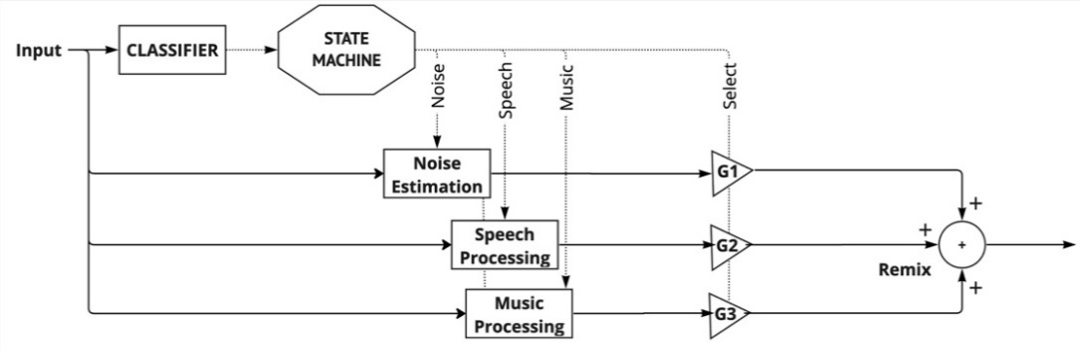
Some of the processing that utilise events based on classification to apply specific enhancements are:
- Adaptive Background Noise Estimation and Reduction
- Remixing Speech/Music levels vs Ambient noise

  - Static Ambisonic Upmix

This block forms the most important piece of the spatial capture and is responsible for mapping the multi-microphone capture to first order ambisonics or higher. Out of the various techniques to upmix a multi-microphone capture to FOA, a perceptually designed static upmix matrix yields reasonably accurate spatial performance with few or no drawbacks. The response per frequency band is generated across each microphone towards each ambisonic channel using: i) a model of how each microphone responds to the incoming sound field from a dense set of directions, based on Finite element method simulations which account for the 3D placement of microphones across device body structure and resultant acoustic energy transfer; ii) a perceptually-motivated optimisation where the complex upmix matrix coefficients are determined based on the data computed at the simulation step, and a target perceptual spatial accuracy. These steps of analysis, simulation and upmix design are performed offline once per device by assuming a simpler 3D geometry of the device and microphones as point sinks.
Another technique to generate the same matrix is to measure impulse responses from various direction of arrivals to each microphone and then inverting the matrix, but such technique would lead to obtaining the Ambisonics components independently from each other, with no guarantee of a perceptually-optimal result once the components are combined in the renderer..
The Upmixer utilizes the static matrix and applies per frequency band transformation to achieve ambisonic channel output.
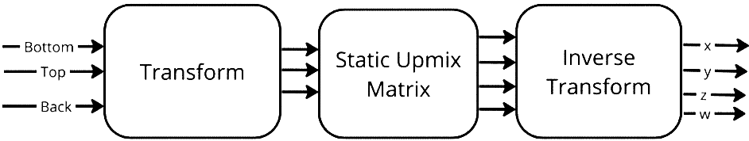

  - Levelling and Limiting

As a final step to spatial audio capture, loudness correction on the ambisonic output may be desired to provide uniform loudness in all captures also preventing signal overload on rendering side, e.g. binaural stereo rendering. It is difficult to predict final loudness after render in an ambisonic domain and so a partial stereo downmix might be created to access the loudness and apply desired gain offset in the ambisonic domain. Such a gain application may be coupled with a limiter that can be used to prevent signal saturation.

]
[

8.3 Example design of parametric spatial audio capture for multi-microphone devices

x.1 Overview
Support of immersive voice and audio services by end-user devices requires successful combination of several audio technologies and appropriate product design for taking full advantage of the new immersive capabilities. Relevant devices (UE) can come in many shapes and sizes (form factors) for different use cases, and even traditionally dominant UE form factors such as mobile devices can be expected to be used in new ways, e.g., multiple orientations (landscape and portrait) in different use cases and applications that provide immersive voice and audio communication.
Practical application of spatial audio capture technologies includes multiple processing stages that need to fit together to achieve the desired audio capture performance. The following clause discusses technology HW adaptation aspects that relate to different UE designs. This is relevant because device HW and transducers have significant impact on the captured audio signals. These differences can be addressed with audio front-end processing that compensates HW differences for parametric audio capture processing.

x.2 Device (UE) characteristics

x.2.1 General
Support of immersive communication requires favorable integration of electroacoustic transducers, namely microphones and loudspeakers. Smartphones are currently defined by a large display and a slim body, which is a challenging shape for spatial audio capture devices. A device’s shape influences the spatial capture characteristics and favorable spatial capture requires typically parametric audio capture techniques to support more uniform performance for different sound source directions. Current smartphones typically have at least 2 microphones, which is sufficient to support immersive voice and audio capture for a wide range of use cases and applications.

While immersive voice and audio playback can be based, e.g., on rendering for headphones or external loudspeaker systems, stereo and immersive playback are possible to support also independently of any accessory devices on the mobile device itself. The number of loudspeakers and their locations in the device together with the rendering processing have an impact on the perceived immersion of the loudspeaker playback. Loudspeaker placement relative to the microphone locations influences both the (spatial) audio capture performance and requirements of the Acoustical Echo Cancellation (AEC) solution.

x.2.2 Number and placement of microphones
Spatial audio capture requires at least two microphones, but for rich capture of audio scenes more microphones are recommended. Two microphones can be used to support stereo recording, and it can be recommendable to implement symmetrical microphone integration and placement at the ends of the device for achieving a symmetric stereo image.

Spatial audio capture supporting 360-degree spatial capture in 2D plane can be supported with 3 microphones. It is common that stereo recording microphones are complemented with a third microphone integrated on the back cover of the device supporting spatial audio capture aligned with the optical axis of the main camera.

The practical aspects related to microphone placement include the detailed mobile device form factor (geometry), which is related to how the device is used, and how user’s hands might interfere audio capture, e.g., either by blocking or disturbing any of the microphone inputs. Acoustic performance of 360-degree capture is dependent on microphone placement to ensure robust direction analysis for different sound source directions.

For immersive voice and audio use cases with higher spatial fidelity and flexibility, 4 or more microphones can be considered for supporting a full 3D spatial audio capture in both landscape and portrait device orientations. Multiple microphones can improve spatial resolution of audio capture and increase robustness in different usage environments, e.g., by allowing more effective reduction of disturbing wind noise.

Sufficient distance between microphones and loudspeakers can improve AEC performance by reducing the echo level coupling from loudspeakers to the microphones. More details on loudspeaker placement are provided in the following.

x.2.3 Microphone integration
Microphone capture is defined by the electroacoustic properties of the microphone transducer and acoustic properties of the microphone integration. Microphone integration on mobile devices is typically product specific and different products have variation between microphone assemblies due to differences in product mechanics and electronics. Smartphones use MEMS microphone technologies that are typically either top port or bottom port type depending on the product mechanics and preferred PWB assembly. The use of MEMS microphone type influences the microphone port geometry. In smartphone design, microphones in the top and bottom ends can be integrated more similarly to each other, see Figure 1, and when microphones are integrated on other surfaces, e.g., next to the main camera, the design needs to use different mechanical structures. In addition to differences in microphone integration, the acoustic diffraction from rigid body of the product will influence the overall frequency response of the microphone. Acoustic diffraction is highly dependent on sound source direction due to the non-uniform shape of the smartphone body.
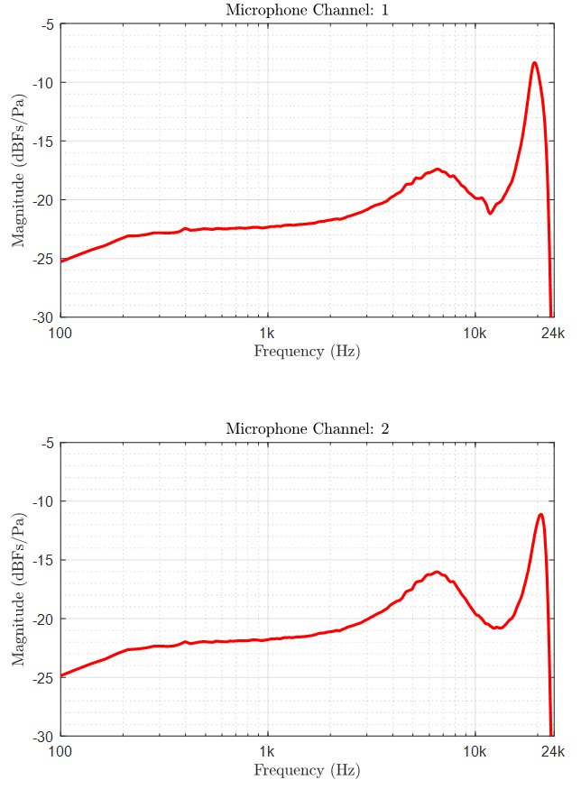
Figure 1. Integrated microphone frequency responses (incl. port and transducer) for stereo microphone integration in both ends of a commercial smartphone device.

In general, it is unlike for a practical mobile device, especially with more than 2 microphones, to have similar microphone frequency response characteristics for all microphones. Two commercial mobile devices with 4 microphones were analyzed indicating differences between typical smartphone microphone integrations (see Figure 2). Microphone frequency responses illustrated in Figure 2 provide examples where resonances are clearly audible and need to be compensated with microphone signal equalization to enable high-quality audio capture.

Accurate frequency response data for equalization filter design can be created using multiple techniques, such as acoustic measurements in anechoic chamber, use of lumped parameter component models, or application of numerical acoustic simulation tools. The numerical acoustic methods require detailed acoustic port geometry, which can include information about dust and liquid protection filters or membranes. These filter materials have acoustic impedance that is considered in the acoustic design process. Usually, acoustic characterization of microphone integration is done, or at least verified, using acoustic measurements, because equalization relying on inaccurate frequency response data can lead to further issues.

Due to these practical limitations in product design, it would be unrealistic to assume that pressure on the device surface, at microphone port inlet, could be used as an approximation of the pressure on the integrated microphone transducer diaphragm. For example, if this would be the case, the frequency responses, such as presented in Figure 1 and Figure 2, would all be flat.

Furthermore, microphone signal equalization is required to comply with requirements as set forth in [2] for (wideband) sensitivity/frequency characteristics.

Figure 2. Integrated microphone frequency responses (incl. port and transducer) for two commercial smartphone devices with 4 microphones.
In microphone integration it is favorable to aim for simple mechanical structures that implement a uniform acoustic channel from the surface of the device to the microphone sensor without unnecessary bending, cavities, and other variation in the cross-sectional area of the sound channel. This is commonly achieved when the microphone component is integrated close to the device surface, minimizing the length of the sound port relative to its cross-sectional area. As the hole in the device cover is typically desired to be either small or visually hidden, the acoustic targets of the design are generally best achieved when the length of the microphone port is kept short.

Robust microphone operation during the lifetime of the mobile device requires sealing of the acoustic channel. Sealing and IP protection filters are commonly integrated for easier assembly. The acoustic impedance of the different acoustic filter materials should be included in the numeric analysis of the acoustic channel unless the impedance is low enough to be insignificant. Practical design guidelines are available, e.g., in [1].

All microphone integrations include some acoustic filtering effects that typically include resonance. Favorable microphone integration can be characterized by few parameters that should be similar for all microphones: microphone resonances are at high frequencies (>10kHz) and resonance magnitude is small with low Q factor. When all microphones of the device are integrated with similar good design practices, this provides a good basis for multi-microphone capture algorithms.

Acoustic scattering from the rigid body of the device is a significant factor in spatial audio capture algorithms for multi-microphone devices. It can be said that free-field approximation using microphone positions will produce inaccurate results especially at high frequencies.

When a device prototype is available for audio design, it is possible to perform acoustic measurements in an anechoic chamber to measure and analyze frequency responses for each integrated microphone as a function of source direction. This is technically a relatively straightforward measurement task, e.g., based on using a turntable to measure multiple source (azimuth) directions in a 360-degree plane with the same measurement setup. 3D measurements, including azimuth and elevation directions, require a short series of measurements with different device orientations, or turntable measurements with multiple sound sources. Alternatively, frequency responses can be simulated using numerical acoustic methods.

x.2.4 Loudspeaker number and placement of loudspeakers
In order to produce immersive playback over loudspeakers integrated into a mobile device, at least two loudspeakers are needed. When playback is active, the number and placement of the loudspeakers has an effect also on the spatial audio capture, e.g., due to interaction with AEC. In the following, some relevant observations and guidelines are provided.

Two loudspeakers in a mobile device enable direct stereo content playback and, with suitable rendering processing, can provide an adequate level of immersive experience for the front of the listener. It is straightforward to achieve a wider stereo image extending the physical loudspeaker locations, but creating real feeling of immersion around listener’s head so that sounds are perceived as coming also from behind is very challenging.

Using similar speaker components and placing the speaker outlets symmetrically in the device generally provide the best basis for a high-quality playback. It is beneficial to have the loudspeaker outlets at the device ends so that when listened to in landscape mode, the stereo image will be at its widest. If the loudspeaker ports are facing towards the user, the spatial audio quality can be further improved, and the audio performance is more consistent and independent of device handling, namely interaction effects with user’s hands and grip. More than two loudspeakers can be used especially in larger mobile devices, e.g., in tablets and foldable smartphones to provide favorable stereo loudspeaker pairs at different usage orientations and device configurations.

x.3 OS interfaces and IVAS applications
Simultaneous access to all raw microphone signals or microphones with known frequency response characteristics that are part of the spatial audio capture need to be supported via the appropriate OS interfaces. Support for immersive voice and audio services in mobile devices requires either low level integration under Hardware Abstraction Layer (HAL) or OS support providing access to multiple microphones for applications. Different OS platforms have their own architectures and technical implementations, and there is no common interface for all platforms.

x.4 Immersive audio capture with mobile devices

x.4.1 Overview
Parametric spatial audio capture can be utilized for immersive voice and audio services for a wide range of device form factors with different microphone number and placement. The parametric capture methods can be motivated, e.g., by difficulty of applying linear means for audio format generation for a specific device configuration, concerns over audio quality of alternative approaches (e.g., linear methods), and potential advantages in computational complexity of the spatial audio capture processing. While parametric capture can be combined with a synthesis step to transform the original spatial audio representation into another format, it can be advantageous to maintain the original format to not introduce additional computational complexity, to not increase the number of audio signals (data size) through an up-mixing, to not increase latency, or to not degrade the audio quality unnecessarily. In this case, a suitable parametric format is needed to provide interoperability for different capture implementations and other processing blocks, e.g., audio codecs.
A typical example of a parametric spatial audio format is one or more audio signals provided together with spatial metadata consisting of several spatial parameters. One practical example is the Metadata-assisted spatial audio (MASA) format used with the IVAS codec and defined in 3GPP TS 26.258.
Parametric capture methods utilize algorithms that derive selected spatial information from the captured microphone signals based on knowledge of the device size and shape, and the placement and other properties of the microphones themselves. In general, the algorithms can support, e.g., a varying number of microphones, and they can be easily adapted to different device configurations considering, e.g., the number of microphones and their placement. This makes these methods suitable for practical form factors, e.g., mobile devices.
Figure 3 shows an example implementation of parametric spatial audio capture pipeline on a mobile device.

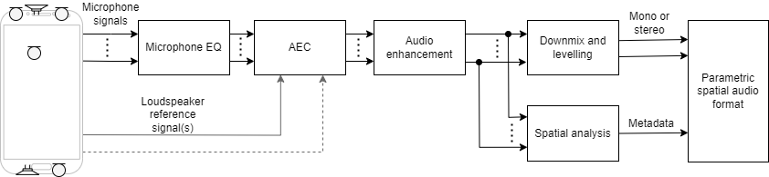
Figure 3. Example implementation of parametric spatial audio capture.

x.4.2 Microphone EQ
Microphone equalization smooths over resonance peaks and other microphone-integration related nonidealities from microphone responses. This makes microphone signals comparable to each other. Equalization is typically based on measured microphone responses. In general, equalization can be done independently for each microphone signal.

x.4.3 AEC
AEC is typically performed separately for each microphone channel, but alternative solutions can also be considered. The target of AEC processing is to remove the loudspeaker signal component from the microphone signals based on a reference signal. In the case of stereo playback both stereo channels are needed as reference input for the AEC.
Traditional AEC solution has been to use linear AEC filter which is followed by residual echo suppression (RES). Nowadays RES is often implemented using DNN. Recently, also solutions in which the whole AEC is managed with a single DNN have been introduced.

x.4.4 Audio enhancement
Audio enhancement block may consist of multiple different operations which aim at improving audio quality considering the targeted audio source or sources. These operations can include for example wind noise reduction, audio focusing, microphone noise reduction, and background noise reduction.
Wind noise reduction can operate independently for single microphone signal, or it can utilize signal analysis over multiple signals. Either traditional signal processing solutions or DNN-based processing methods can be applied.
Audio focusing can be used to focus spatial audio capture into preferred direction. The focus direction can be defined automatically or manually depending on the use case. With suitably selected microphone locations good focus performance can be achieved using beamforming. Audio focusing can be used for content creation or accessibility purposes.
Microphone noise reduction targets to remove self-noise generated by the microphones. It is generally based on defining the noise floor of the microphones.
Background noise reduction can be used to increase intelligibility of the captured speech. It generally makes audio more pleasant to listen to and can be used to remove irrelevant components from the captured audio. Depending on the use case, background noise reduction may only remove continuous noise such as air-conditioner noise or traffic noise, or it may, e.g., aim at removing everything but speech from the captured audio. Content or context-based classification and processing can be employed if different noise reduction processing is desired, e.g., for speech and music. For immersive voice and audio, background noise reduction settings may be more contextual than for traditional mono voice and audio. Noise reduction can also be required for accessibility purposes. DNN-based solutions are commonly used for noise reduction.

x.4.5 Downmix and levelling
With parametric spatial audio capture, output spatial audio can be synthesized with one or two audio channels and metadata. Therefore, the number of audio channels can be reduced before synthesis. This can be achieved by selecting one or two representative audio channels from the audio enhancement block output. Leveling, i.e., typically automatic gain control (AGC), is then utilized to adjust the signals to a suitable level for listening. AGC typically also includes limiter which is designed to prevent signal saturation.
One benefit of parametric spatial capture is that the level management does not differentiate from the level management of normal stereo recording. The same capture front-end can therefore typically be used for mono, stereo, and parametric spatial audio capture with activation of additional channels and processing as needed.

x.4.6 Spatial analysis
The target of spatial analysis in parametric spatial audio capture is to estimate spatial properties of the captured audio signal (audio scene) and generate metadata, which can be later utilized in spatial synthesis or rendering. Spatial analysis uses information of the device shape and the locations of the microphones. It is common to perform spatial analysis for frequency domain sub-bands, and analysis can be based, e.g., on coherence and level analysis between the microphone signals. To make sure spatial analysis works properly, it is important that echo is properly removed from the captured signal (see, AEC in clause x.4.3) and, on the other hand, that audio enhancement processing (see clause x.4.4) has maintained relevant spatial cues in the signals.
In an example spatial analysis, the direction of one or more dominant sound sources are analyzed for every sub-band. In addition, the directional energy and other spatial parameters are estimated. For example, the directional energy can be a ratio relative to the total energy of the corresponding sub-band. Together the analyzed parameters form the metadata for the parametric spatial audio format. The selected audio signals (e.g., mono or stereo) and the analyzed metadata can then be provided as input to spatial synthesis or used, e.g., in audio transmission (as codec input).
As discussed in clause x.2.2, depending on the device orientation and the number and positions of the microphones, as well as depending on the use case, spatial analysis can be done for the full 3D space or for example only for horizontal level (360 degrees in 2D plane).

x.5 Spatial audio capture quality considerations

x.5.1 Overview
An ITU-T P.800 Comparison Category Rating (CCR) AB comparison listening test was performed by Nokia Technologies in 2018 to evaluate multi-microphone spatial audio capture quality for mobile devices. The following provides description of the tested conditions, test items and configuration, and results.
The AB comparison test is based on binaural headphone listening with no head-tracking support.
Test content is captured using two mobile device capture setups. The first setup has three microphones and the other has four microphones in typical smartphone microphone positions. The design of these device setups follows the description in clause x.2. While the average size of smartphone devices has slightly increased since 2018, similar listening test results can be expected with current smartphone devices and device sizes.

x.5.2 Conditions
The main tested conditions relate to two spatial audio captures (formats): a proprietary parametric spatial audio format and first-order Ambisonics (FOA). Two methods for rendering were considered for the FOA audio format: a linear and a proprietary parametric rendering. In addition, the conditions include stereo and mono that act as anchors.
The evaluation is based on uncompressed audio, and in the case of the parametric spatial audio format also uncompressed spatial information (metadata).
The parametric spatial audio format consists of two audio waveform signals (i.e., a stereo downmix) and one spatial information stream. Specifically, the stereo downmix signal in this experiment is produced by selecting a left and a right channel from the three or four raw microphone signals. This channel selection is fixed across the experiments. The bitrate of the uncompressed spatial information stream used here is approximately 25 kbps.
The FOA format in the evaluation consists of the four component signals (WXYZ), which are obtained based on a proprietary FOA up-mix/synthesis from the three or four captured audio input channels.

x.5.3 Test samples and recording
The recordings carried out for the listening test cover several signal types relating to rich immersive communications and user-generated content streaming. The recordings were performed in a controlled environment in three separate recording sessions using two capture devices (one three-microphone device and one four-microphone device). The recorded sound sources included both loudspeaker playback (well-known immersive audio test samples, background music, nature sound clips, individual instruments, etc.) as well as live sound sources (male and female talkers, a violinist, etc.). The sound scenes thus correspond to, e.g., multi-channel music playback, conference room discussions with or without background sounds, live music performances, outdoor scenes, and so on.
The position of the capture device was different in each of the recording sessions and its relative position to sound sources also varied during some sessions (due to placement and movement of the sources). The capture device was placed on a stand roughly in the middle of the recording space (e.g., middle of a conference room table surrounded by talkers). Sound sources provided either full or partial coverage of the horizontal plane (depending on the sample). The elevation component was generally small (ranging between about 45 degrees above and less than that below the horizontal plane).
In total, 15 samples from these recordings were used in the test.

x.5.4 Test details and results
The listening test was conducted using Sennheiser HD650 headphones in quiet listening booths. In total 24 listeners participated. Out of the 24 listeners, 14 were audio experts (not necessarily in the field of spatial audio), while 10 listeners were naïve.
Each of the 24 listeners listened to 120 sample pairs, where each individual sample pair was listened to in both directions (AB, BA) by each listener with one of six randomized listening orders. Thus, a grand total of 2880 votes were casted. Mono signal was used as a low reference, and it was compared against the parametric spatial audio format. In addition, a stereo signal (without any spatial processing) was compared to itself as a further anchor (control condition). The main comparisons compare the parametric spatial audio format against FOA (Linear rendering) and FOA (Parametric rendering).
Figure 4 presents the results with all listeners, and Figure 5 and Figure 6 provide the results for expert listeners and naïve listeners, respectively. Positive scores indicate preference for CuT A (CuT A vs. CuT B).

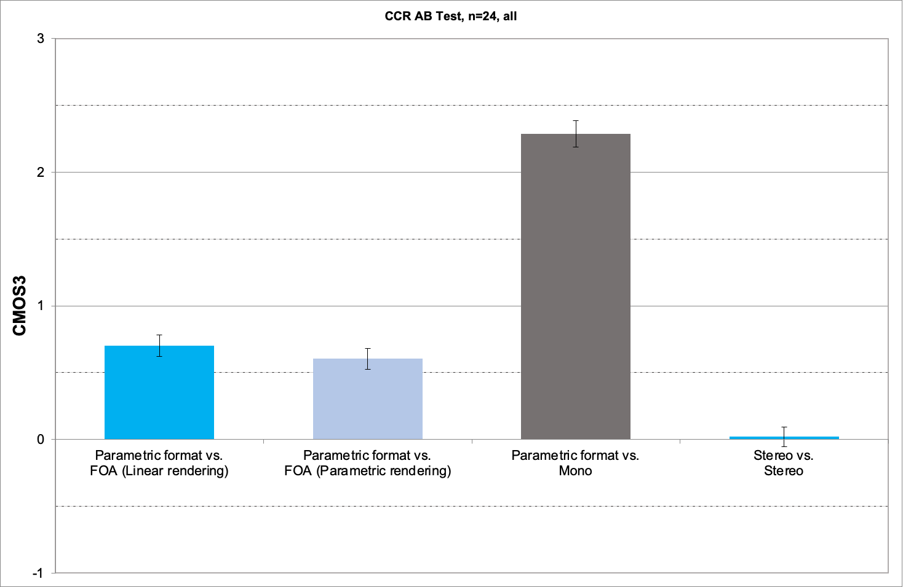
Figure 4. AB listening test results, all listeners (n=24).

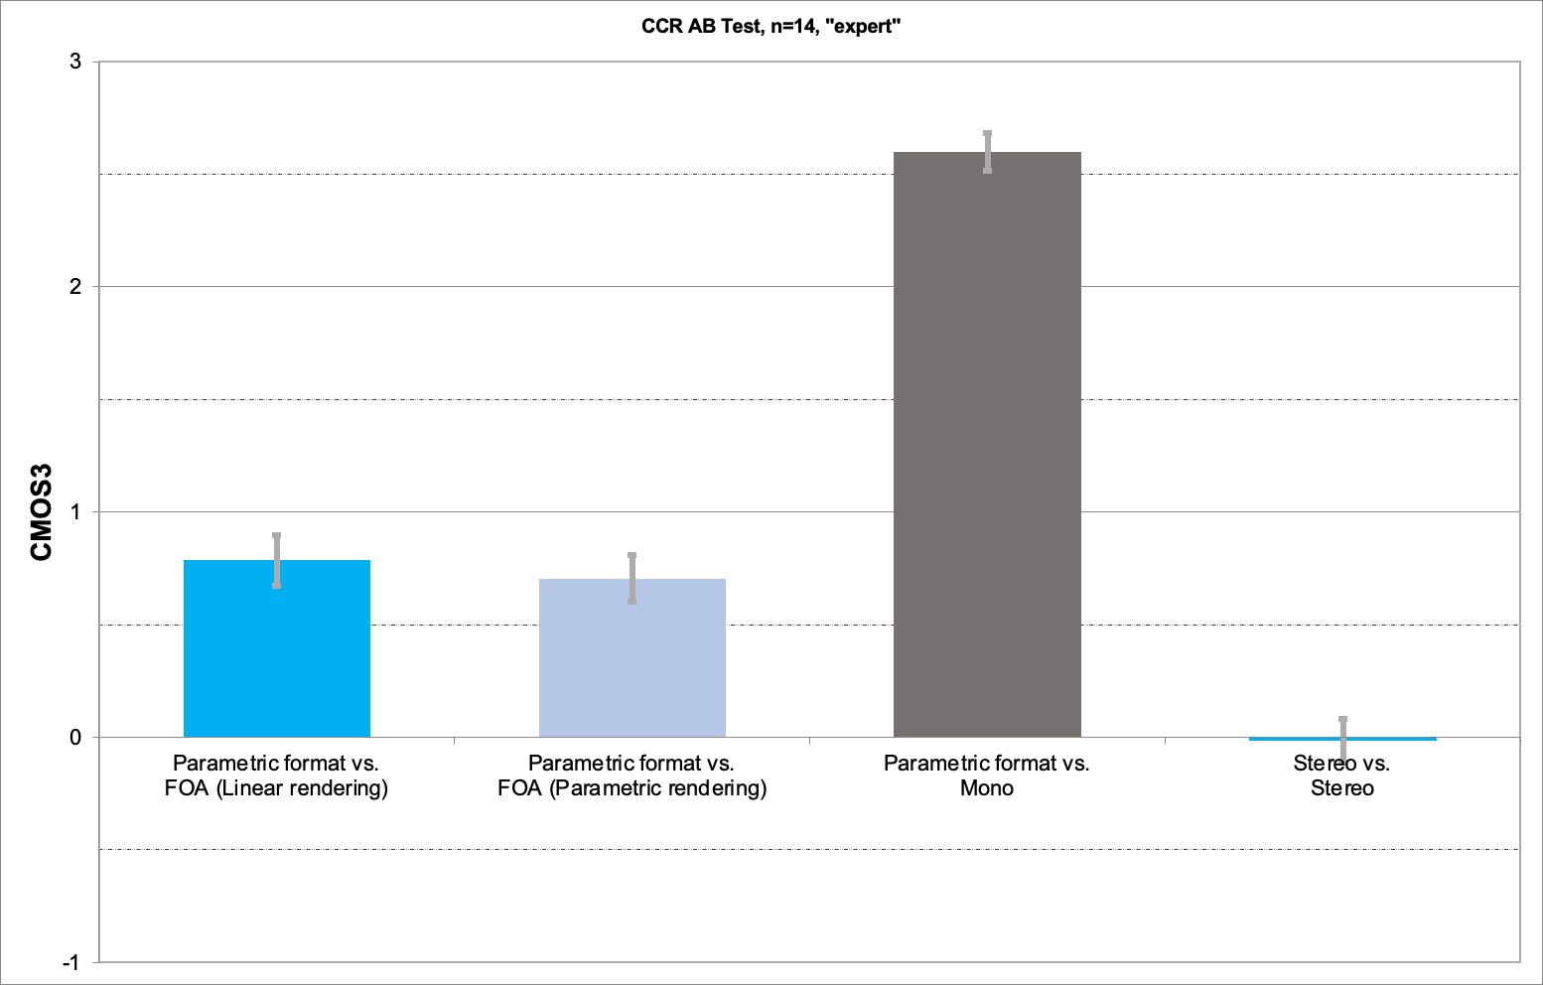
Figure 5. AB listening test results, expert listeners (n=14).

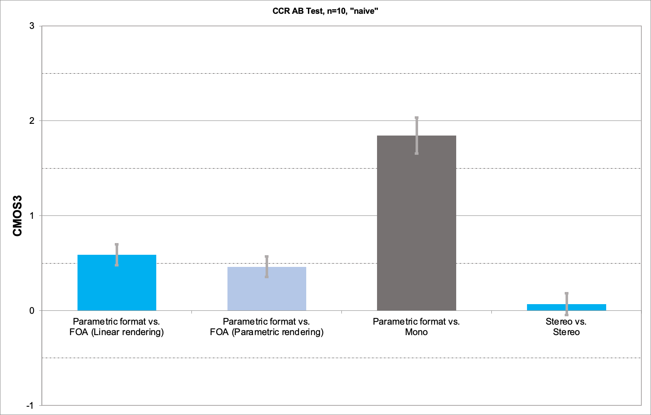
Figure 6. AB listening test results, naïve listeners (n=10).

x.6 References
[1] Mikko Suvanto, The MEMS microphone book, Mosomic, 2021, ISBN 978-952-94-5660-4
[2] 3GPP TS 26.131
]

9 Conclusions and Recommendations
Editor’s Note
- Provide recommendation on potential work for audio capturing based on the findings in this study.
]
Editor’s Note: the chapter structures are for further update.

Annex A: UE size
[

A.1 Mobile phone size

A.1.1 Structure Size

A.1.1.1 Introduction
Since 2012, the structure size of mobile phones has been rising in length, width, and thickness, indicating a continuous increase in mobile phone size. This may be in response to the strong demand from consumers for multimedia and gaming functions on their phones, as well as the increasing requirements for microphone and camera quantity and battery consumption. The evolution trend of mobile phones is towards full-screen, which provides a market foundation for the increase in screen size.

A.1.1.2 Length
The length of mobile phones has gradually increased from 12.38cm in 2012 to 16.88cm in 2022, with an average length of 15.26cm, according to the investigation, showing an upward trend. With the development of mobile phone models, some phones are no longer limited to the 16:9 aspect ratio, e.g., there are now styles with 18.5:9 and 19.5:9. Although high aspect ratio screens can display more information, most video contents are still in the traditional 16:9 format, so too high an aspect ratio is not conducive to the video display.

The tendency of mobile phone length in recent years is shown in Figure 4.1.1.2-1

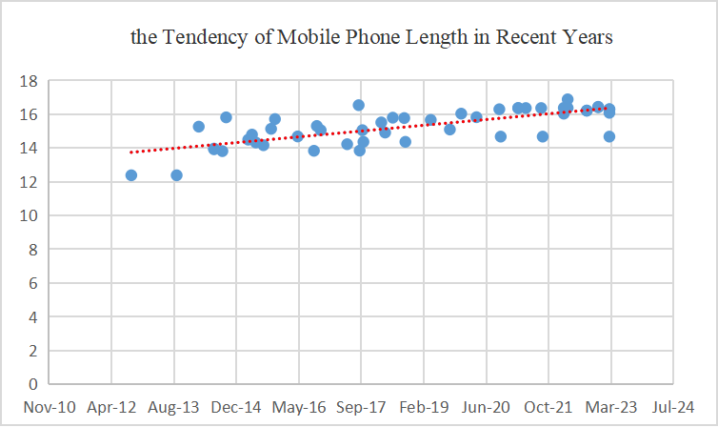
Figure A.1.1.2-1 The tendency of mobile phone length

A.1.1.3 Width
According to the mobile phone data surveyed, the width of mobile phones was around 5.86cm in 2012, while in 2022, the width of mobile phones was changed to around 7.55cm, with a maximum value of 8.06cm. In recent years, the average width of mobile phones has been 7.32cm, and an increment in the length of mobile phones generally follows an increment in width. This is a reasonable evolution tendency for the purpose of function requirements and appearance

The tendency of mobile phone width in recent years is shown in Figure A.1.1.3-1


Figure A.1.1.3-1 The tendency of mobile phone width

A.1.1.4 Depth
Among the phones investigated, the thinnest one measures 0.64cm, the thickest one measures 0.992cm, and the average thickness is 0.81cm.
The tendency of mobile phone width in recent years is shown in Figure A.1.1.4-1

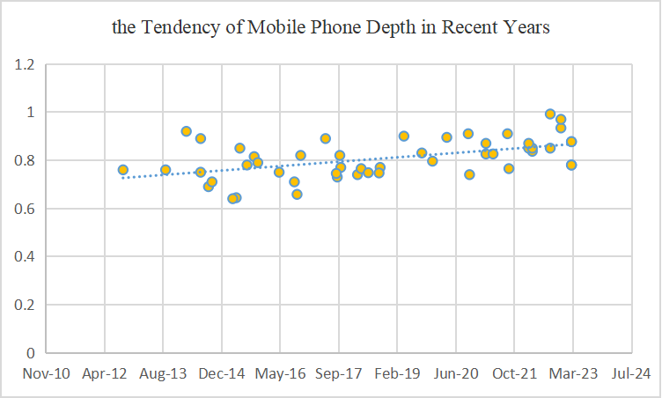
Figure A.1.1.4-1 The tendency of mobile phone depth

Model | Date  (MMM-YY) | Length(mm) | Width(mm) | Depth(mm)
1 | Mar-23 | 146.7 | 71.5 | 7.8
2 | Mar-23 | 160.8 | 78.1 | 7.8
3 | Mar-23 | 162.9 | 76.7 | 8.77
4 | Mar-23 | 162.9 | 76.7 | 8.77
5 | Dec-22 | 164.07 | 74.53 | 9.34
6 | Dec-22 | 164.35 | 75.29 | 9.7
7 | Sep-22 | 162.1 | 75.5 | 8.5
8 | Sep-22 | 162.1 | 75.5 | 9.92
9 | Apr-22 | 168.78 | 80.31 | 8.37
10 | Apr-22 | 163.7 | 73.9 | 8.5
11 | Mar-22 | 163.7 | 73.9 | 8.5
12 | Mar-22 | 160.3 | 72.6 | 8.7
13 | Sep-21 | 146.7 | 71.5 | 7.65
14 | Sep-21 | 163.6 | 74 | 9.1
15 | May-21 | 163.6 | 74 | 8.26
16 | Mar-21 | 163.6 | 74 | 8.7
17 | Mar-21 | 163.6 | 74 | 8.26
18 | Oct-20 | 146.7 | 71.5 | 7.4
19 | Oct-20 | 162.9 | 75.5 | 9.1
20 | Apr-20 | 158.2 | 72.6 | 8.95
21 | Dec-19 | 160.3 | 74.3 | 7.96
22 | Sep-19 | 150.9 | 75.7 | 8.3
23 | Apr-19 | 156.6 | 74.3 | 9
24 | Sep-18 | 143.6 | 70.9 | 7.7
25 | Sep-18 | 157.68 | 74.06 | 7.47
26 | Jun-18 | 157.91 | 74.27 | 7.48
27 | Apr-18 | 149.1 | 70.8 | 7.65
28 | Mar-18 | 155.1 | 75.2 | 7.4
29 | Oct-17 | 143.6 | 70.9 | 7.7
30 | Oct-17 | 150.5 | 77.8 | 8.2
31 | Sep-17 | 138.4 | 67.3 | 7.3
32 | Sep-17 | 165.32 | 80.09 | 7.45
33 | Jun-17 | 142.2 | 68.9 | 8.9
34 | Nov-16 | 150.5 | 77.8 | 8.2
35 | Oct-16 | 153 | 74.3 | 6.58
36 | Sep-16 | 138.3 | 67.1 | 7.1
37 | May-16 | 146.8 | 72.6 | 7.5
38 | Nov-15 | 157.1 | 80.6 | 7.9
39 | Oct-15 | 151.3 | 76.3 | 8.15
40 | Aug-15 | 141.6 | 71.2 | 7.8
41 | Jun-15 | 143.2 | 71.9 | 8.5
42 | May-15 | 147.9 | 73.45 | 6.44
43 | Apr-15 | 144.9 | 71.9 | 6.4
44 | Oct-14 | 158.1 | 77.8 | 7.1
45 | Sep-14 | 138.1 | 67 | 6.9
46 | Jul-14 | 139.6 | 69.7 | 7.5
47 | Jul-14 | 139.2 | 68.5 | 8.9
48 | Mar-14 | 152.6 | 75 | 9.2
49 | Sep-13 | 123.8 | 58.6 | 7.6
50 | Sep-12 | 123.8 | 58.6 | 7.6

A.2 Earbud size
Model | Length(mm) | Width(mm) | Depth(mm)
1 | 35.8 | 18.9 | 17.7
2 | 35.9 | 18.5 | 17
3 | 35.3 | 20.7 | 23.3
4 | 27.5 | 21.05 | 24.4
5 | 31.97 | 21.13 | 23.18
6 | 33 | 22.44 | 21.81
7 | ‎28.4 | 21.3 | 23.4
8 | 40 | 30 | 24
9 | 28.45 | 21.34 | 23.37
10 | 43.6 | 17.8 | 23.2
11 | 26 | 29.6 | 21.7
12 | 29.1 | 21.8 | 23.7
13 | 38.1 | 20.6 | 20
14 | 33.66 | 17.83 | 18.13
15 | 29.1 | 21.8 | 23.7
16 | 41.5 | 20.4 | 17.8
17 | 41.4 | 18.5 | 16.8
18 | 37.5 | 23.9 | 21
19 | 30.9 | 23.9 | 21.7
20 | 40.5 | 16.5 | 18
21 | 30.79 | 18.26 | 19.21
22 | 33 | 17.4 | 18.4
23 | 33.2 | 21.9 | 24.9
24 | 38.82 | 18.6 | 16.81
25 | 30.9 | 20.9 | 23.5
26 | 30.5 | 24.3 | 21.6
27 | 41.8 | 23.7 | 19.8
28 | 20.9 | 17 | 21.1
29 | 21.6 | 19.9 | 18.7
30 | 33.9 | 21.9 | 19.7
31 | 30.08 | 16.55 | 18.21
32 | 30.2 | 23.8 | 22.2
33 | 20.5 | 18.5 | 15
34 | 30 | 19 | 24
35 | 28.2 | 19.6 | 18.8
36 | 22.2 | 23.3 | 16.6
37 | 23 | 20 | 15

A.3Tablet size
Model | Length(mm) | Width(mm) | Depth(mm)
1 | 280.6 | 214.9 | 6.4
2 | 248.6 | 179.5 | 7
3 | 195.4 | 134.8 | 6.3
4 | 247.6 | 178.5 | 6.1
5 | 289.1 | 196.1 | 5.5
6 | 261.89 | 178.17 | 6.4
7 | 246.9 | 156.7 | 7.85
8 | 260.88 | 176.82 | 6.85
9 | 253.8 | 165.3 | 6.3
10 | 326.4 | 208.6 | 5.5
11 | 253.8 | 165.3 | 6.3
12 | 246.8 | 161.9 | 6.9
13 | 291.71 | 191.12 | 6.49
14 | 267.3 | 167.4 | 6.9
15 | 252.1 | 163.64 | 7.35
16 | 277 | 178.95 | 6.99
17 | 253.95 | 165.18 | 6.51
18 | 245.08 | 154.84 | 6.94
19 | 252.2 | 163.8 | 6.99
20 | 259.73 | 176 | 6.67
21 | 266.03 | 191.6 | 6.59

A.4 Laptop size
Model | Length(mm) | Width(mm) | Depth(mm)
1 | 363.4 | 260.25 | 22
2 | 312 | 221 | 15.99
3 | 369 | 259.4 | 23.5
4 | 321.9 | 213.9 | 19.9
5 | 296.68 | 213.5 | 15.65
6 | 356.98 | 288.73 | 25.65
7 | 286.5 | 184.7 | 7.99
8 | 313.8 | 229.8 | 16.7
9 | 354.9 | 251.9 | 22.45
10 | 296.2 | 216.5 | 10.9
11 | 340.4 | 237.6 | 11.5
12 | 312.6 | 221.2 | 15.5
13 | 356 | 247.7 | 20.2
14 | 315.6 | 222.5 | 14.9
15 | 364.81 | 289.98 | 18.5
16 | 410.3 | 319.9 | 26.7
17 | 296.5 | 205.5 | 12
18 | 294 | 197 | 8.95
19 | 305.7 | 199.8 | 12.9
20 | 359.5 | 238.3 | 15.9

A.5 Watch size

Rectangle type:
Model | Length(mm) | Width(mm) | Depth(mm)
1 | 45 | 38 | 10.7
2 | 49 | 44 | 14.4
3 | 40 | 34 | 10.7
4 | 53 | 45.7 | 14.7
5 | 52 | 41 | 14.55
6 | 50.96 | 42.4 | 14.9
7 | 57 | 44.5 | 14

Circular type:
Model | Diameter(mm) | Depth(mm)
1 | 46.5 | 10.9
2 | 48.5 | 13
3 | 46 | 13

A.6 AR glass size

Model | Length(mm) | Width(mm) | Depth(mm)
1 | 167 | 173 | 52
2 | 179 | 159 | 48
3 | 152.5 | 159 | 54.7
4 | 175 | 146 | 44
5 | 159 | 148 | 52
6 | 290 | 200 | 57

A.7 Car exterior size
Model | Length(mm) | Width(mm) | Depth(mm)
1 | 5020 | 1945 | 1760
2 | 4770 | 1930 | 1625
3 | 4480 | 1970 | 1601
4 | 5099 | 1989 | 1750
5 | 4880 | 1896 | 1450
6 | 4720 | 2089 | 1442
7 | 5021 | 1987 | 1478
8 | 5218 | 1998 | 1800
9 | 4458 | 1841 | 1632
10 | 4678 | 1806 | 1474
11 | 5320 | 1945 | 1488

A.8 Car exterior and interior size
Model | Exterior |  |  | Interior
Model | Length  (mm) | Width  (mm) | Height  (mm) | Head room  front(mm) | Head room  rear(mm) | Leg room  front(mm) | Leg room  rear(mm) | Hip room  front (mm) | Hip room  rear(mm) | Shoulder room front(mm) | Shoulder room rear(mm)
1 | 4648.2 | 1838.96 | 1689.1 | 1043.94 | 1099.82 | 1054.1 | 977.9 | 1374.14 | 1419.86 | 1450.34 | 1419.86
2 | 4495.8 | 1739.9 | 1460.5 | 1003.3 | 922.02 | 1130.3 | 787.4 | 1292.86 | 1272.54 | 1348.74 | 1361.44
3 | 4750 | 1921 | 1624 | 1041 | 1001 | 1063 | 1029 | 1367 | 1286 | 1432 | 1372
4 | 5021 | 1987 | 1431 | 1008 | 968 | 1077 | 901 | 1393 | 1278 | 1484 | 1399

Annex B: Stereo AEC

B.1 Intuitive understanding of Stereo AEC

In the context of multi-channel AEC, stereo AEC is considered a typical basis, therefore, it takes stereo as an example for AEC algorithm analysis and issue investigation. The stereo AEC is shown in Fig.B-1.

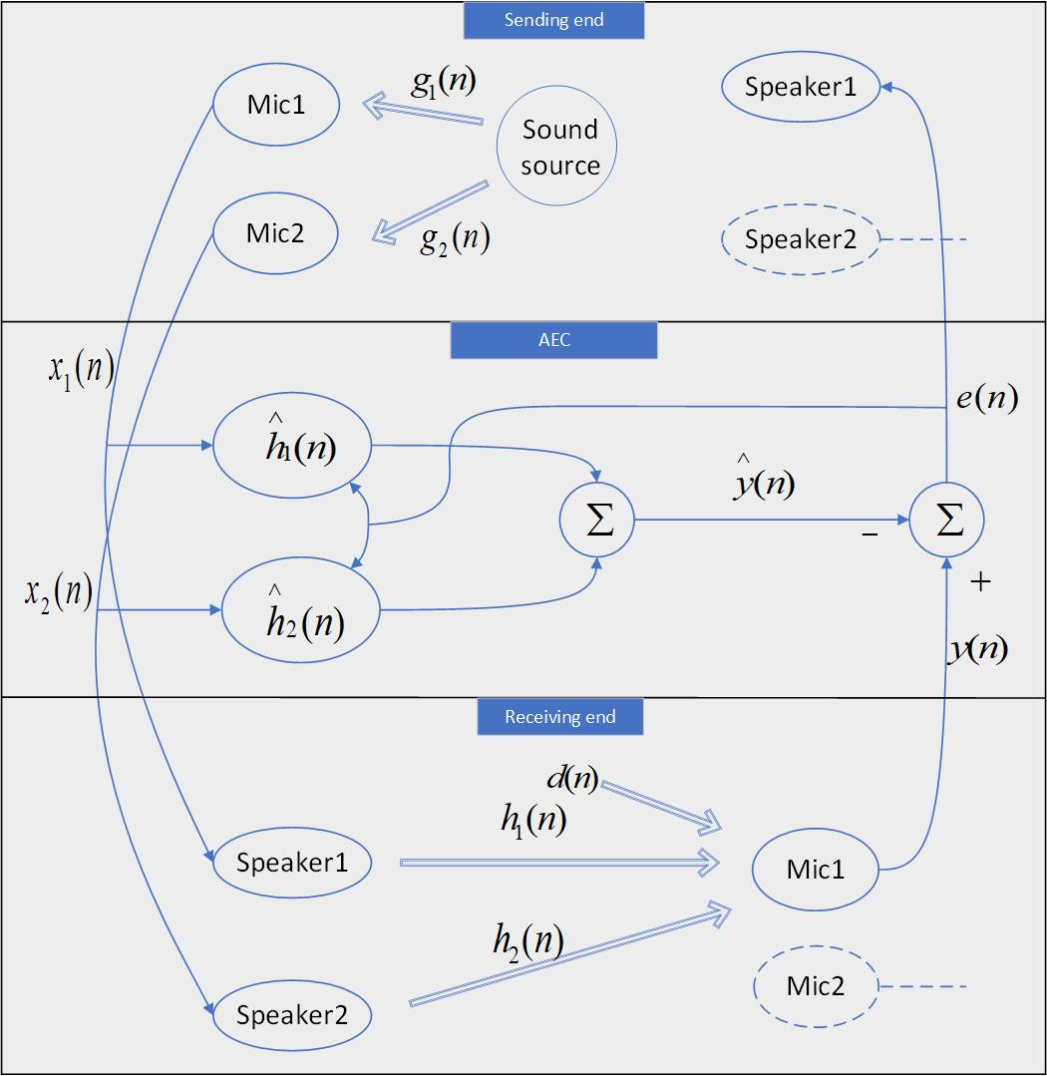
Fig. B-1. Stereo AEC system.
The two input signals and are derived from the same sound source convolving with two distinct impulse responses and , so they typically have high correlations. After transmission of the distant stereo signal to the receiving room (near-end) and playback through the loudspeakers, the signals converge through the impulse responses and of the near-end room to a single microphone, forming the desired signal together with the noise signal . Subsequently, two adaptive FIR filters and are employed to estimate the impulse responses and of the near-end room, yielding the estimated desired signal . Finally, the difference between the desired signal and the estimated desired signal which termed as the error signal is transmitted back to the distant end. Meanwhile, both the error signal and the input signals contribute to the updates of the adaptive filter coefficients. The following description focuses on a single microphone, and the other microphone follows a similar process.

B.1 Intuitive understanding of Stereo AEC
As illustrated in Fig. 7.1.3.1-1, assuming $h=[h_{1}^{T},h_{2}^{T}]$ is the truncated vector of the actual echo path impulse response in the near-end room, and $\overset{∧}{h}=[{\overset{∧}{h}}_{1}^{T},{\overset{∧}{h}}_{2}^{T}]^{T}$ is the coefficient vector of the FIR filter. We define vector as the filter misalignment vector. Ideally,
(1)
The impulse responses of the distant room are denoted as and , then substitute $x_{1}=g_{1}*s$ and $x_{2}=g_{2}*s$ into equation (1), and to do Fourier transformation as follows:
(2)
and are the Fourier transforms of and , and are the Fourier transforms of and , represents the Fourier transform of the signal source 𝒔. For the single-channel AEC, is zero, so as long as is not zero at the frequency point of interest, ensuring to zero enables the filter estimating the path perfectly. However, for stereo AEC, must not be zero, and as the distant sound source is not zero either. Hence, we can now simplify (2), giving
(3)
It can be seen from (3) that it is obviously impossible to deduce the conclusion of and .

B.1.1 De-correlation based method for stereo AEC
The de-correlation based method is a common solution for stereo AEC, the principles are described in the following.

B.1.1.1 Analysis of stereo audio covariance matrix[10]
In practical scenarios, the length of the actual room impulse response is infinite, but the trailing amplitude is generally small, and the effective length of the amplitude is limited. The impulse response length of the far-end room is set as M, the impulse response length of the near-end room is set as N, and the adaptive filter coefficient length is set as L. The error signal at time n between the output signal of the adaptive filter and the desired signal can be expressed as
(4)
Use recursive least square error formula, giving
(5)
where $λ$ ( $0<λ<1$) is an exponential forgetting factor. The minimization of (5) leads to the normal equation
(6)
Where
(7)
is an estimate of the input signal covariance matrix and
(8)
is an estimation of the cross-correlation vector between the input and output signals. In this scenario, if is not full rank, the normal equation does not have a unique solution, and the solution to the adaptive filter convergence may deviate from the actual room impulse response. Here examining the problem in terms of the sizes of the adaptive filter coefficient length (L) and the impulse response length of the distant room (M) so as to consider the uniqueness of the regularization equation solution.
Because the impulse response of the far-end length is infinite, L<M accords with the actual situation. Construct a new vector of length 2L, where is the truncated vector of , giving
(9)
where
(10)
(11)
Hence, matrix is non-singular from the perspective of the Wiener solution, and the adaptive filter in stereo AEC has a unique solution, however, due to the relatively small values of and , the covariance matrix is very ill-conditioned, exhibiting significant divergence in eigenvalues, resulting in a slow convergence rate of the adaptive filter. This is commonly referred to as the “non-uniqueness” issue in the multi-channel acoustic echo problems. Under the premise of , the misalignment of the solution is considered.
The length L of the adaptive filter is actually smaller than the impulse response length N of the near-end room. The near-end room impulse response is divided into two parts, one is the vector matching the first L points of the adaptive filter length, and the other is the trailing vector with the length of N-L. At the same time, we make repeated supplementary definitions for the input signal to match the room impulse response length. After a series of derivation, the Wiener solution can be got as follows:
(12)
It can be concluded that the estimated adaptive solution is closely related to from the point of view of Wiener solution.

B.1.1.2 Relationship between channel correlation and condition number of the covariance matrix[11]
From the above description, we can know that the coefficients of the adaptive filter are closely related to the norm of covariance matrix R, and further deduce that the condition number is used to measure the ill-conditioned degree of covariance matrix. The concept of matrix condition number is the product of the norm of the matrix and the norm of its inverse matrix, which is used to express the sensitivity of matrix calculation to error signals. Therefore, we use the condition number to establish the relationship between the correlation of stereo signals and the covariance matrix. Set , and the two-channel covariance matrix is thus given by
(13)
where is the mathematical expectation operator, the is the covariance matrix between the th and th channel. It is noted that for , a Toeplitz matrix is asymptotically equivalent to a circulant matrix if its elements are absolutely summable, giving in (13) as (14)
(14)
where is the Fourier matrix defined with elements .The matrix contains elements corresponding to the frequency bins, which are formed from the Discrete Fourier Transform (DFT) of the first column of .Letting be the auto- and cross-correlation coefficients for and , respectively, establishing the relationship between and as follows
(15)
The covariance matrix R of stereo signal can be expressed as
(16)
In this content, E-norm is used to represent the condition number of matrix R. The E-norm is equivalent to the F-norm scaled by a factor . Through this transformation, the dependence of conditional number on L is eliminated. After a series of derivation, the condition number under E-norm is obtained as follows
(17)
Use positive definite covariance matrix to diagonalize to calculate , giving
(18)
According to (15), We may now see that the square of the inter-channel coherence function at F frequency point can be expressed by the frequency spectrum of the input signal as
(19)
After a series of derivation, (18) can be further expressed as
(20)

B.1.1.3 Summary de-correlation based method
According to the description, the square of the condition number of covariance matrix R increases with the increase of the inter-channel coherence function , which means that the greater the inter-channel coherence, the greater the condition number of covariance matrix R, the more ill-conditioned matrix R, the greater the sensitivity of matrix calculation to error signals, and the more difficult it is for adaptive filters to solve coefficients. Therefore, in the stereo AEC, de-correlation of channel signals is a key step to the solution of adaptive filter coefficients, but this operation will bring sound quality degradation which should be balanced in this method.
]
Editor’s note: this is basis for further work.

Annex <X> (informative):
Change history
Change history
Date | Meeting | TDoc | CR | Rev | Cat | Subject/Comment | New version
2023-02 | SA4#122 | S4-230317 |  |  |  | Initial version | V0.0.1
2023-04 | SA4#123-e | S4-230551 |  |  |  | Updated version based on SA4-post 122 24,March ,2023 | V0.0.2
2023-04 | SA4#123-e | S4-230646 |  |  |  | Update style and include agreed content in S4-230522 and S4-230523 | V0.0.3
2023-05 | SA4#124 | S4-230971 |  |  |  | Binaural capture on UE (from S4- 230881) and some online updates in addition | 0.1.0
2023-07 | SA4#124-Post | S4Aa230088 |  |  |  | Update contents in scope section | 0.1.1
2023-08 | SA4#125 | S4-231347 |  |  |  | Integrate content based on S4Aa230088 during SA4-e (AH) Audio SWG post 124 31 July 2023. | 0.1.2
2023-08 | SA4#125 | S4-231496 |  |  |  | Integrate agreed contents of stereo capture principal from S4-231460 | 0.2.0
2023-11 | SA4#126 | S4-231775 |  |  |  | Integrate agreed content from S4Aa230109 and S4Aa230111 | 0.2.1
2023-11 | SA4#126 | S4-231944 |  |  |  | Integrate agreed contents from S4-231661, S4-231717 and S4-231850 | 0.3.0
2024-01 | SA4#127 | S4-240218 |  |  |  | Integrate agreed contents from S4Aa230132 | 0.3.1
2024-01 | SA4#127 | S4-240358 |  |  |  | Integrated following updates:  contents from S4-240150(two paragraphs) as 6.2.3.5  Contents from S4-240201 as 7.2  Contents from S4-240153 as Annex B  Contents from S4-240243 as 4.1.2  Contents from S4-240241  Integrate S4-240231 in the bracket with editor’s note | 0.4.0
2024-03 | SA4#127-post | S4aA240014 |  |  |  | Editorial corrections: fixed hanging paragraphs, chapter/ reference number, etc. | 0.4.1
2024-04 | SA4#127-bis-e | S4-240740 |  |  |  | Integrated following updates:  Agreed contents from S4aA240015  Agreed contents from S4aA240014 | 0.5.0
2024-04 | SA4#127-bis-e | S4-240764 |  |  |  | Integrated following updates:  1:Agreed contents from S4-240731  2:Agreed contents from S4-240733  3:Section 2 from S4-240665 in bracket for further discussion | 0.6.0
2024-05 | SA4#128 | S4-241038 |  |  |  | Editorial updates and remove bracket for the completed parts | 0.6.1
2024-05 | SA4#128 | S4-241173 |  |  |  | Integrated the following contents:  1:Agreed contents from S4-241192  2:Agreed contents from S4-241038  3:Agreed contents from S4-241039 in bracket | 0.7.0

