Agenda item: 10.7
Source: Qualcomm Inc., Intel, NTT, Samsung
Title: Working Assumption for RTC Architecture
Document for Discussion and Agreement

Introduction
During the offline discussions on the RTC architecture, there were some agreements that were made on the working assumption. This contribution documents the agreed working assumption.

RTC Architecture

2.1 Collaboration Scenarios
The following collaboration scenarios are assumed as a basis for the architecture:
- 5G support for OTT WebRTC: e.g. to provide QoS support to an OTT WebRTC session.
- MNO-provided trusted WebRTC functions: e.g. a STUN or a TURN server hosted by the MNO.
- MNO-facilitated WebRTC services: e.g. a service offered by the operator, such as a split rendering service.
- Inter-operable WebRTC services: e.g. a cross-MNO communication service, such as a WebRTC-based telephony service.

2.2 RTC Functions
The following table identifies key functions and provides a mapping to the collaboration scenarios.
Functions/CS | Collaboration scenario 1 | Collaboration scenario 2 | Collaboration scenario 3 | Collaboration scenario 4
Provisioning server | Optional | Optional | Optional | Optional
Configuration server | Optional | Required | Required | Required
MSH | Required | Optional | Optional | Optional
Network support function | Required | Required | Optional (maybe fulfilled by WebRTC signaling server) | Optional
Trusted ICE function | N/A | Required | Optional | Optional
Trusted WebRTC signaling server | N/A | N/A | Required | Required
Trusted media server | N/A | Optional | Optional | Optional

2.3 Working Assumption on the Architecture
For the development of the architecture for RTC, we follow the following principles:
- Principle 1: AF is a box communicating with NF in 5GC (according to SA2).
- Principle 2: AF is for C-plane and AS is for U-plane.
Based on that, we make the following assumptions:
- Network support (NS-AF) is an AF.
- WebRTC SS and ICE/TURN use NS-AF to communicate with 5GC, e.g., PCF/NEF/SMF.
- In this sense, WebRTC SS and ICE/TURN are AS.
We propose the following 5G RTC architecture as the baseline architecture for WebRTC-based real-time communication over 5G.
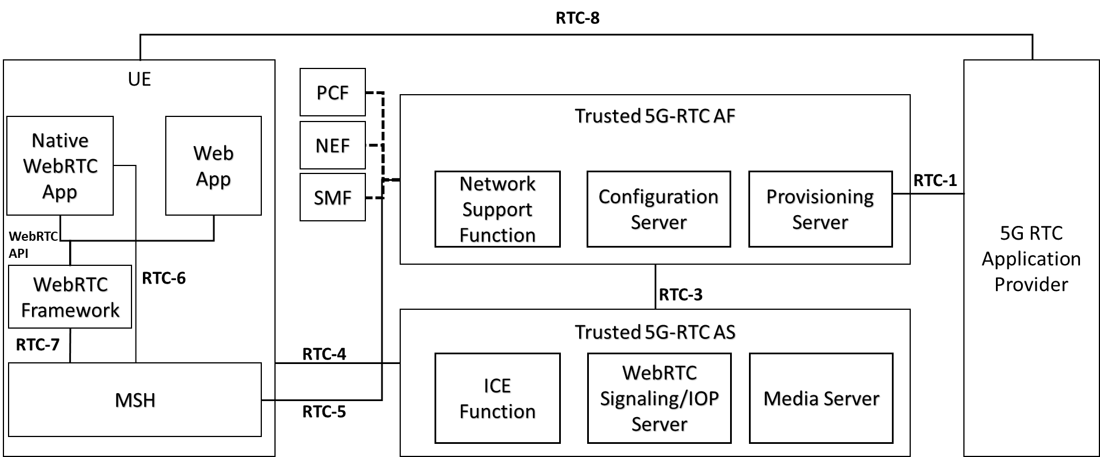
In a simplified deployment scenario, the architecture with only the relevant functionalities is depicted in the following figure:
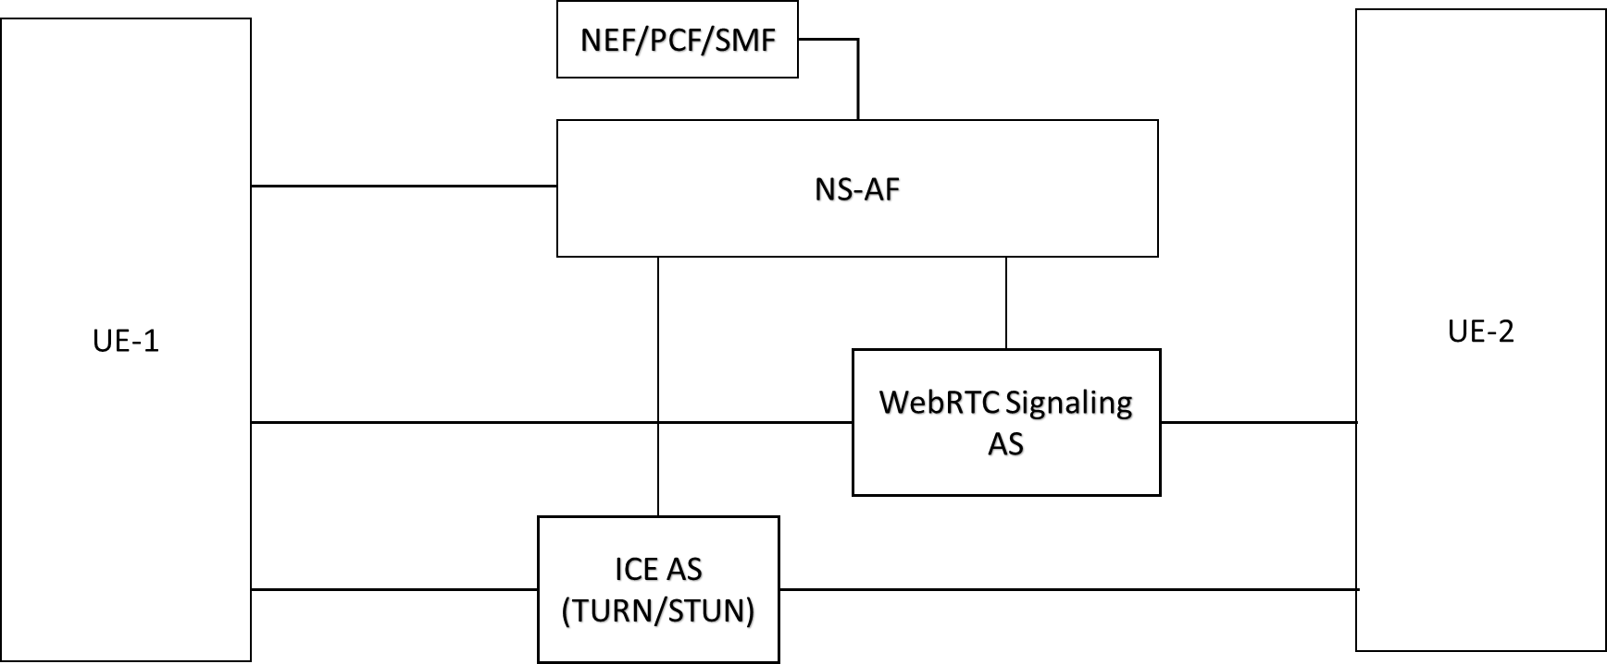

RTC Interfaces
TBD

3 Proposal
We propose to agree the baseline architecture and the interface descriptions in clause 2.

