Source: Samsung Electronics Co., Ltd. (Rapporteur)
Title: [FS_AI4Media] Permanent Document v0.1.0
Version: 0.1.0
Agenda Item: 9.8
Document for: Agreement

1 Introduction
During SA4#117-e the New Study Item on “Artificial Intelligence (AI) and Machine Learning (ML) for Media” in S4-220226 was agreed and afterwards approved in by SA#95e in SP-220328.
The objective of this study item are primarily to identify the media service architectures and relevant service flows, model operation configurations, data components including available data formats, and the data traffic characteristics in AI/ML for media related services. Key performance indicators and performance metrics are also identified.
The concrete objectives are as follows:
- List and describe the use cases for media-based AI/ML scenarios, based on those defined in TR 22.874.
- Describe the media service architecture and relevant service flows for the scenarios, identifying for each use case the impacts on the architecture, including any potential gaps with existing 5G media service architectures. Also describe the model operation configurations for each use case, including split AI/ML operations, identifying where certain AI/ML operations occur.
- Identify and document the available data formats and suitable protocols for the exchange of different data components of various AI/ML models, such as model data, metadata, media data, and intermediate data necessary for such model operation configurations. Also investigate the data traffic characteristics of these data components for delivery over 5G system, including whether there are any needs and potentials for data rate reduction.
- Identify and study key performance indicators for such scenarios, based on the initial considerations in TS 22.261, with additional emphasis on the use cases, model operation configurations and data components as identified in earlier objectives, focusing on objective performance metrics considering the KPIs identified.
- Identify potential areas for normative work as the next phase and communicate/align with SA2 as well as other potential 3GPP WGs on relevant aspects related to the study.

2 Media-based AI/ML use cases and scenarios
TR 22.874 [1] has identified a set of use cases for AI/ML with the following key operations:
- AI/ML operation splitting between AI/ML endpoints;
- AI/ML model/data distribution and sharing over 5G system;
- Distributed/Federated Learning over 5G system.
These operations have been identified as they require exchange of ML and media data over 5G, and in some cases may have some requirements on the QoS for proper operation.
Of interest to SA4 are the media-based use cases, which are identified in this clause.

2.1 Object Recognition in Image and Video
In this set of use cases, images and video streams are processed to identify and recognize objects and extract some metadata, such as object labels.
The scenarios that are considered are the following:
- Download of trained ML model for object recognition
- Split inference with task-specific model head running on the UE for object recognition. For example, in one UE, the task is to recognize pedestrians, whereas in another it is to recognize traffic signs. The core of the network model as well as the input image/video are the same but the tasks are different.
- Distributed online training of image and video recognition models based on input in different UEs. The shared model is calibrated continuously based on the training results from all UEs.

2.2 Video Quality Enhancement in Streaming
In this use case, the sender and receiver apply parts of an autoencoder DNN model to enhance the quality of a video stream. This is depicted in the following diagram:
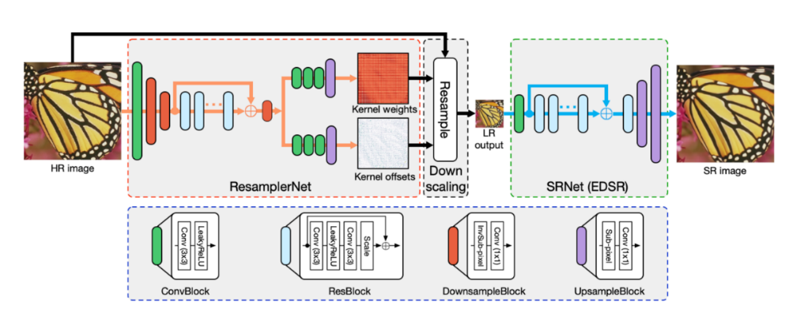
The high-fidelity video is processed to generate a metadata stream that is streamed together with a lower fidelity encoding of the video. The receiver runs an inference algorithm on the received metadata and video stream to produce a high-quality video for rendering.
The main scenario in this use case is about streaming intermediate model output from the network for processing on the UE.

2.3 Crowd-Sourcing Video Capture
A set of users attending a live concert and capturing the event on their UEs, use a shared DNN model to process and improve the captured video. Multiple tasks are then performed on the processed video, e.g. to extract lyrics, annotate the video, etc.
The main scenario here is the sharing of the input media from multiple sources for network inference.

2.4 NLP on Speech
This covers a wide range of speech processing use cases, e.g. to perform automatic speech recognition, voice translation, voice commands, speech synthesis, etc.
The models for NLP are improved with distributed/federated training. As more users make use of the service, the quality and accuracy of the model improves. The results of the local training of the model are shared with the network.
The main scenario here is about downloading a pre-trained model with its training state for local training and then sharing the results with the network.

3 Media service architecture for AI/ML

3.1 Architectures and service flows

3.1.1 Complete/Basic AI/ML model distribution

3.1.2 Split AI/ML operation

3.1.3 Distributed/federated learning

4 Data components for AI/ML-based media services

4.1 Model data

4.2 Intermediate data

4.3 Media data

4.4 Metadata

4.5 Existing formats for AI/ML models

4.5.6 ONNX format
The Open Neural Network Exchange (ONNX) format [2] is an open specification that was developed to facilitate the exchange of machine learning models between different AI frameworks. ONNX consists of the following components:
- A definition of an extensible computation graph model.
- Definitions of standard data types.
- Definitions of built-in operators.
The ONNX format is built around the Protocol Buffers (Protobuf) open-source cross-platform serialization format that was developed initially by Google.
The ONNX Graph is structured as a list of nodes that form an acyclic graph. Each node of the graph represents one of the built-in operators and its attributes. As an example, a node could be a Convolution operation, and its attributes would contain information regarding the padding and stride that must be used. Each edge of the graph represents input or output data tensors. The top-level ONNX construct is a ‘Model.’, and is represented in protocol buffers as the type onnx.ModelProto. It provides metadata that is necessary for the reader to determine if they are able to process the stored model. Each model must explicitly name the operator sets that it relies on for its functionality. Operator sets defines a set of operators and their versions. An operator is identified through its unique operator type (op_type), which is a case-sensitive operator name.
Built-in operators include a large list of widely used operators such as the following:
- Math operators such as Abs
- DNN operators such as Conv and LSTM
- Activation operators such Sigmoid and Relu
- Pooling operators such as MaxPool
- Other operators such as error computation and data reformatting operators
The following provides an example of an ONNX model in protobuf format:
ir_version: 5
producer_name: "skl2onnx"
producer_version: "1.11"
domain: "ai.onnx"
model_version: 0
graph {
node {
input: "X"
output: "Y"
name: "Pa_Pad"
op_type: "Pad"
attribute {
name: "mode"
s: "constant"
type: STRING
}
attribute {
name: "pads"
ints: 0
ints: 1
ints: 0
ints: 1
type: INTS
}
attribute {
name: "value"
f: 1.5
type: FLOAT
}
domain: ""
}
name: "OnnxPad"
input {
name: "X"
type {
tensor_type {
elem_type: 1
shape {
dim {
}
dim {
dim_value: 2
}
}
}
}
}
output {
name: "Y"
type {
tensor_type {
elem_type: 1
shape {
dim {
}
dim {
dim_value: 4
}
}
}
}
}
}
opset_import {
domain: ""
version: 10
}

5 Traffic characteristics

5.1 Complete/Basic AI/ML model distribution

5.2 Split AI/ML operation

5.3 Distributed/federated learning

6 KPIs

7 References
[1] 3GPP TR 22.874, Study on traffic characteristics and performance requirements for AI/ML model transfer in 5GS
[2] Open Neural Network Exchange (ONNX), https://onnx.ai

