Source: Samsung Electronics, Co., Ltd, Ericsson LM, Facebook, AT&T, Qualcomm Incorporated, Xiaomi, Nokia Corporation, China Mobile

Title: [Draft] New WID on 5G media delivery architecture extensions for real-time and AR/MR experience

Document for: Discussion and Agreement
Agenda Item: 10.10
3GPP™ Work Item Description
Information on Work Items can be found at http://www.3gpp.org/Work-Items
See also the 3GPP Working Procedures, article 39 and the TSG Working Methods in 3GPP TR 21.900

Title: [Draft] New WID on 5G media delivery architecture extensions for real-time and AR/MR experience

Acronym: 5G_AREA

Unique identifier:

1 Impacts
Affects: | UICC apps | ME | AN | CN | Others (specify)
Yes |  | X |  | X
No | X |  | X
Don't know |  |  |  |  | X

2 Classification of the Work Item and linked work items

2.1 Primary classification
This work item is a …
X | Feature
 | Building Block
 | Work Task
 | Study Item

2.2 Parent Work Item

Parent Work Items
Unique ID | Title

2.3 Other related Work Items and dependencies

Other related Work Items (if any)
Unique ID | Title | Nature of relationship
880011 | FS_5GSTAR (Study on 5G Glass-type AR/MR Devices) | Study of the use cases and service scenario for glass-type AR/MR devices.
810006 | (FS_5GXR) Extended Reality (XR) in 5G | Study on various approaches to extend the reality, such as VR, AR, or MR
920036 | eMMTEL (Evolution of IMS Multimedia Telephony Service) | Service requirements for IMS-based AR telephony communication in TS 22.173 and TS 22.261
850042 | FS_MMTELin5G (Study on evolution of IMS multimedia telephony service) | Study on the use cases and requirements for AR call and real-time service
920029 | Stage 1 of Evolution of IMS Multimedia Telephony Service | Service requirements for AR call and real-time service
940066 | FS_NG_RTC (Study on system architecture for next generation real time communication services) | Study on IMS architecture and procedure to support requirements from eMMTEL
 | MeCAR (Media Capabilities for Augmented Reality) | Normative work on media capabilities including aspect of AR runtime and scene manager

3 Justification
Based on the initial conclusions in TR 26.928, clause 7, and the evaluation of architectures in clause 4 and 6 of TR 26.998, it is apparent that for the integration of AR services and experiences into 5G Networks, the approach taken in 5GMS to separate the data plane and the control plane, and enable access of third-party services getting access to 5G System functionalities, is a major benefit. Figure 3-1 provides a separation of the work topics for MeCAR and AREA.
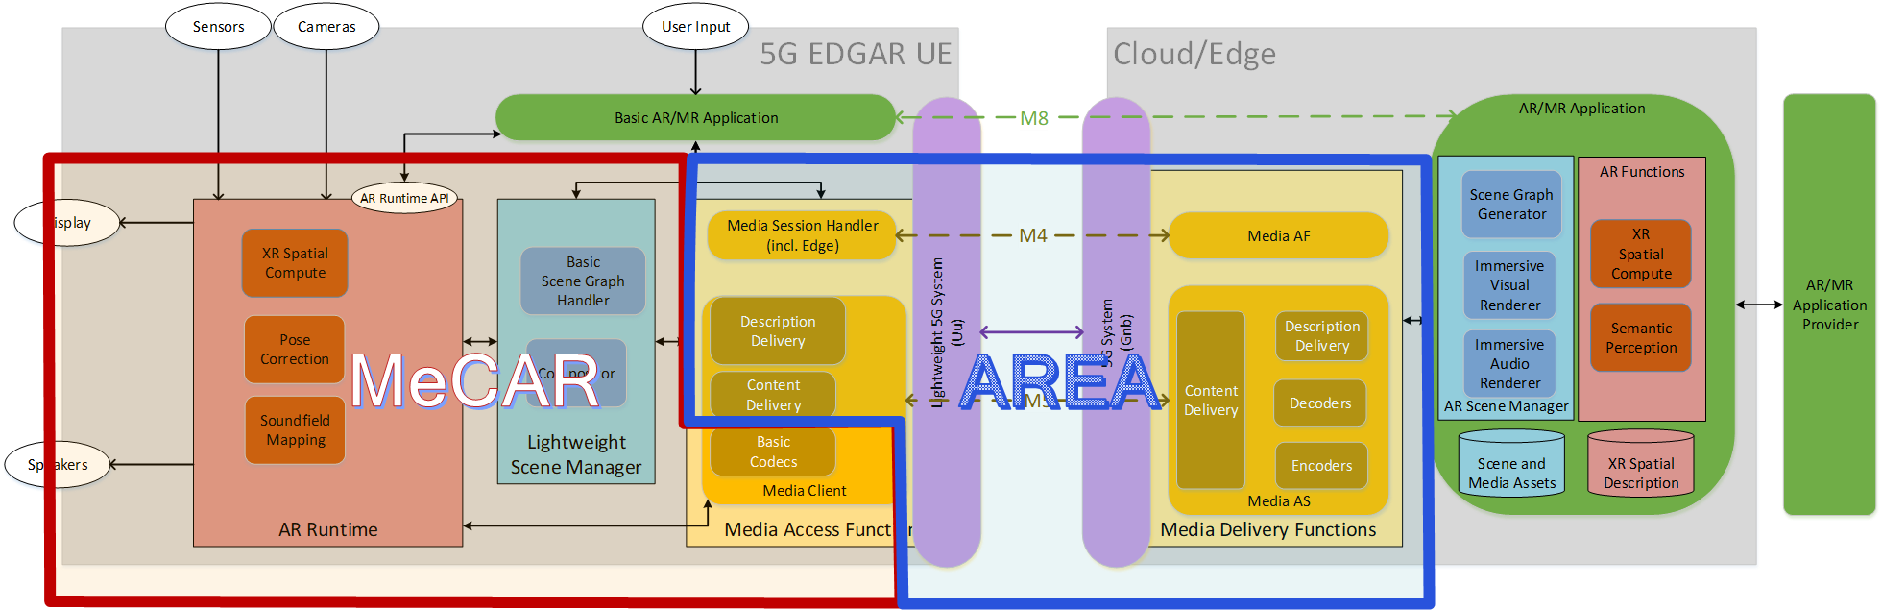
Figure 3-1: Work topic separation between AR Media Capabilities, Terminal Architecture and Network architecture for EDGAR-type devices
The basic concept is the extension of 5GMS principles to any type of service including real-time communication and split-rendering. While the work is motivated by XR and AR experiences discussed in this TR, it is neither specific nor limited to those experiences. In principle, the basic control plane similar/identical to 5GMS, and the media plane is generic, permitting different types of operator and third-party services supported by the 5G System. The following aspects are identified:
- 5GMS-like network architectures to support any type of media services including real-time communication, split rendering and spatial computing
- Operator and third-party services need to be supported
- Separation of user and control plane functionalities.
- Collaboration between third-party service providers and mobile network operators

In addition, SA1 and SA2 have kicked off work on system architecture for next generation real time communication services.
This WID is proposing the follow-up normative works from the recommendations in TR 26.998, TR 26.928 and will closely follow and align with ongoing, related Stage 2 work in SA2. The work scope of this WID, in synergy with MeCAR, is illustrated in Figure 8.1-1 and 8.1-2 in TR 26.998 for STAR-based and EDGAR-based UEs, respectively.

4 Objective
Based on the discussion in TR 26.998, it is proposed to specify 5G generic architecture for real-time media delivery addressing the following stage-2 normative works, as addressed in clause 8.2 of TR 26.998:

- A generic media delivery architecture to define relevant core building blocks, reference point, and interfaces to support modern operator and third-party media services based on the 5GMS architecture
- Provide all relevant reference points and interfaces to support different collaboration models between 5G System operator and third-party media service provider, including but not limited to an AR media service provider.
- Call flows and procedures for different service types, for example real-time communication, shared communication, etc., based on the context of clause 6
- Specify support for AR relevant functionalities such as split-rendering or spatial computing on top of a 5G System based on this architecture
- Provide collaboration scenarios between third-party service providers and mobile network operators leveraging the defined architecture in particular for XR/AR services

5 Expected Output and Time scale
New specifications {One line per specification. Create/delete lines as needed}
Type | TS/TR number | Title | For info  at TSG# | For approval at TSG# | Remarks
TS | 26.50x | 5G Real-time Media Communication Architecture | SA#98 (Dec 22) | SA#99  (Mar 23)

Impacted existing TS/TR {One line per specification. Create/delete lines as needed}
TS/TR No. | Description of change | Target completion plenary# | Remarks
26.501 | Alignment with 5G real-time media delivery architecture | SA#99  (Mar 23)

6 Work item Rapporteur(s)
Hakju Ryan Lee, hakju00.lee@samsung.com

7 Work item leadership
SA4

8 Aspects that involve other WGs
SA2 on architectural impacts

9 Supporting Individual Members

Supporting IM name
Samsung Electronics Co., Ltd
Ericsson LM
Facebook
AT&T
Qualcomm Incorporated
Xiaomi
Nokia Corporation
China Mobile

