3GPP TSG SA WG4#117e S4-220049
E-meeting, 14th – 23rd February 2022
CR-Form-v12.0
Pseudo CHANGE REQUEST
 | 26.998 | CR | psycho | rev | - | Current version: | 1.1.1
For HELP on using this form: comprehensive instructions can be found at
http://www.3gpp.org/Change-Requests.

Proposed change affects: | UICC apps |  | ME |  | Radio Access Network |  | Core Network

Title: | [FS_5GSTAR] Proposed Updates to Conclusions
Source to WG: | Qualcomm Incorporated
Source to TSG:
Work item code: | FS_5GSTAR |  |  |  |  |  | Date: |  |  | 07/02/2022
Category: | B |  |  |  |  |  | Release: |  |  | 17
 | Use one of the following categories:  F (correction)  A (mirror corresponding to a change in an earlier release)  B (addition of feature),  C (functional modification of feature)  D (editorial modification)  Detailed explanations of the above categories can  be found in 3GPP TR 21.900. |  |  |  |  |  |  |  | Use one of the following releases:  Rel-8 (Release 8)  Rel-9 (Release 9)  Rel-10 (Release 10)  Rel-11 (Release 11)  Rel-12 (Release 12)  Rel-13 (Release 13)  Rel-14 (Release 14)  Rel-15 (Release 15)  Rel-16 (Release 16)
Reason for change: |  | Align the conclusions of the TR with work items
Summary of change:
Consequences if not approved:
Clauses affected:
 |  | Y | N
Other specs |  |  |  | Other core specifications |  |  |  | TS/TR ... CR ...
affected: |  |  |  | Test specifications |  |  |  | TS/TR ... CR ...
(show related CRs) |  |  |  | O&M Specifications |  |  |  | TS/TR ... CR ...
Other comments:
This CR's revision history:

===== CHANGE =====

8.1 General
This clause documents and clusters potential standardisation areas in the context of this Technical Report.
A few areas are identified for potential further study. Figure 8.1-1 provides the scope of initial work items for normative work for the work topics discussed in clause 8.2 (AREA) and 8.5 (MeCAR).
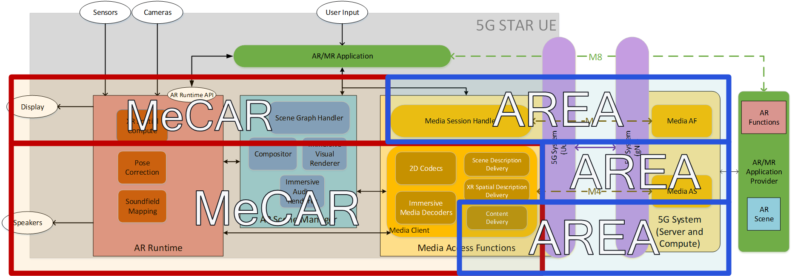
Figure 8.1-1: Considered scope of initial work items.

===== CHANGE =====

8.2 5G Generic Architecture for REAl-Time Media (5G-AREA)
Based on the initial conclusions in TR 26.928 [2], clause 7, and the evaluation of architectures in clause 4 and 6 of this report, it is clear that for the integration of AR services and experiences into 5G Networks, the approach taken in 5GMS to separate the data plane and the control plane, and enable access of third-party services getting access to 5G System functionalities, is a major benefit. The basic concept is the extension of 5GMS principles. to any type of service including real-time communication and split-rendering. While the work is motivated by XR and AR experiences discussed in this TR, it is neither specific nor limited to those experiences. In principle, the basic control plane similar/identical to 5GMS, and the media plane is generic, permitting different types of operator and third-party services supported by the 5G System. The following aspects are identified:

- 5GMS-like network architectures to support any type of media services including real-time communication, split rendering and spatial computing
- Supported for operator and third-party services need to be supported
- Separation of user and control plane functionalities.
Based on the above, it is considered to specify 5G Generic Architecture for Real-Time Media addressing the following stage-2 work objectives:
- A generic media delivery architecture to define relevant core building blocks, reference point and interfaces to support modern operator and third-party media services based on the 5GMS architecture

- Call flows and procedures for different service-types, for example real-time communication, shared communication, etc. based on the context of clause 6
- Specify a split-rendering and spatial computing architecture on top of a 5G System
- Provide all relevant reference points and interfaces to support different collaboration models between 5G System operator and third-party media service provider
===== CHANGE =====

8.4 5G Real-time Communication
As documented in clause 4.2.6 and further developed in the context of clause 6, there are several use cases that require a 5G Real-time communication. The use cases include:
1) EDGAR-based UEs relying on rendering on the network. In this case, the downlink requires sending pre-rendered viewports with lowest latency, typically in the range below 50ms.
2) Uplink streaming of camera and sensor information for cognitive/spatial computing experiences, in case the environment tracking data and sensor data is used in creating and rendering the scene.
3) Conversational AR services require real-time communication both in the downlink and the uplink, even independent from MTSI for app integration of the communication.
In order to provide adequate QoS as well as possible optimizations when using a 5G System for media delivery, an integration of real-time communication into the 5G System framework is essential.
As identified in clause 4.2.6 and clause 6.5, there is a need for supporting third-party applications in 5G real-time communication as well as server-based real-time streaming. From an app developer perspective, an enabler is preferable, especially to support real-time streaming, for example split-rendering.
Different options may be considered, for example re-use of parts of MTSI such as the IMS data channel and 5G Media Streaming for managed services, or re-use of WebRTC for OTT services. A 5G Real-time communication is expected to be aligned with either IMS or WebRTC but provides additional functions to integrate with the 5G System.
It is proposed to define a general 5G Real-time Communication Media Service Enabler that includes, among others, the following functionalities:
- A protocol stack and content delivery protocol for real-time communication based on RTP
- A set of codecs for different media types based on the definitions in MeCAR
- A common session and connection establishment framework, with instantiations based on SIP and SDP for IMS or SDP and ICE for WebRTC, including further possible investigation of control plane
- A capability exchange mechanism
- A security framework, for example based on SRTP and DTLS for WebRTC
- Uplink and downlink communication
- Suitable control protocols for end-to-end adaptation
- QoS and 5G System integration framework
- Reporting and QoE framework
===== CHANGE =====

8.7 Smartly Tethering AR Glasses (SmarTAR)
In clause 4.2.2.4, the important aspect of wireless tethering of AR glasses was introduced. The tethering technology between a UE and an AR glass may use different connectivity. Wireless tethered connectivity is provided through WiFi or 5G sidelink. BLE (Bluetooth Low Energy) connectivity may be used for audio. Two main types are identified:
- Functional structure for Type 3a: 5G Split Rendering WireLess Tethered AR UE
- Functional structure for Type 3b: 5G Relay WireLess Tethered AR UE
In the first case, the motion-to-render-to-photon loop runs from the glass to the phone, whereas in the second case the 5G Phone acts as a relay to forward IP packets. The architectures result in different QoS requirements, session handling properties, and also media handling aspects. For enhanced end-to-end QoS and/or QoE, AR glasses may need to provide functions beyond the basic tethering connectivity function, and the resulting AR glasses may be referred to as Smartly Tethering AR Glasses (SmarTAR). Generally, smartly tethering AR glasses is an important aspect. Based on these observations, it is proposed to further study this subject including specific topics such as:
- Defining different tethering architectures for AR Glasses including 5G sidelink and non-5G access based on existing 5G System functionalities
- Documenting end-to-end call flows for session setup and handling
- Identify media handling aspects of different tethering architectures
- Identify end-to-end QoS-handling for different tethering architectures and define supporting mechanisms to compensate for the non-5G link between the UE and the AR glasses
- Provide recommendations for suitable architectures to meet typical AR requirements such as low power consumption, low latency, high bitrates, security and reliability.
- Collaborate with relevant other 3GPP groups on this matter
- Identify potential normative work for stage-2 and stage-3
===== CHANGE =====

8.8 MTSI-based AR conversational services
As identified in Table 6.1-1, AR conversational services is one of the service scenarios and has a number of related use cases. 3GPP TR 22.873 [14] also addresses use cases relevant to AR conversational services, namely conference calls with AR holography and AR calls, which have similarities with UC#19 and UC#4 in this study, respectively.
As documented in clause 6.5, AR conversational services may be realized using various building blocks, including call setup and control, formats, delivery and 5G system integration, and these building blocks may have different instantiations and/or options. In addition, AR conversational services may support both asymmetrical and symmetrical experiences on various device types, including STAR, EDGAR and WLAR UEs.
In this study, the MTSI architecture is identified as one of the options to map AR conversational services to the 5G system. Furthermore, SA1’s Rel-18 eMMTEL work item introduced new service requirements for 5G IMS Multimedia Telephony Service, including the support of AR media processing in TS 22.261[13] and it is expected that enhancements on the IMS architecture and/or IMS procedures to fulfil new requirements will be handled by SA2 in Rel-18.
It is proposed to define an MTSI-based instantiation for a complete AR communication service, including:
- Terminal architecture(s) considering STAR, EDGAR and WLAR UEs based on the work in MeCAR, AREA and other stage-3 specification addressing real-time communication protocols.
- Session setup and control procedures for AR media
- Capability negotiation and AR media stream setup procedures
- Transport of AR media and AR metadata via IMS media path including Data Channel

