3GPP TSG- S4 Meeting #117e S4-220151

Electronic Meeting, 17th February – 23rd February 2022
CR-Form-v12.2
Draft CHANGE REQUEST
 | 26.501 | CR | <CR#> | rev | <Rev#> | Current version: | 16.9
For HELP on using this form: comprehensive instructions can be found at
http://www.3gpp.org/Change-Requests.

Proposed change affects: | UICC apps |  | ME |  | Radio Access Network |  | Core Network

Title: | [5MSA]: Correction 5GMS Client definition and clarification of reference point usage
Source to WG: | Ericsson LM
Source to TSG: | S4
Work item code: | 5GMSA |  |  |  |  |  | Date: |  |  | 8.2.2022
Category: | F |  |  |  |  |  | Release: |  |  | Rel-16
 | Use one of the following categories:  F (correction)  A (mirror corresponding to a change in an earlier release)  B (addition of feature),  C (functional modification of feature)  D (editorial modification)  Detailed explanations of the above categories can  be found in 3GPP TR 21.900. |  |  |  |  |  |  |  | Use one of the following releases:  Rel-8 (Release 8)  Rel-9 (Release 9)  Rel-10 (Release 10)  Rel-11 (Release 11)  …  Rel-16 (Release 16)  Rel-17 (Release 17)  Rel-18 (Release 18)  Rel-19 (Release 19)
Reason for change: |  | Triggered by a discussion in the 5G-MAG Reference Software group, two main issues have been identified.  1: The 5GMS Client internal structure is up for implementation. However, this is not reflected in the 5GMSd Client structure.  2: The presence of the Media Session Handler and the M5 Reference Point is essential to differentiate 5G Media Streaming from other Media Streaming, including OTT.  In addition, it has been identified that TS 26.512 allows the usage of HLS for Media Streaming, while TS 26.501 gives the impression, that the M4d reference point is fully 3GPP defined, including the streaming format.
Summary of change: |  | It is clarified specifically in the “5GMSd Client” descption clauses, that the UE internal structure is up for implementation. It is also clarified, that the used Streaming Format on the M4d reference point is out of scope for 3GPP.  Two collaboration models are removed from Annex A, since the deployment are not according to 5G Media Streaming.
Consequences if not approved: |  | Unclear specifications lead to interoperability issues, due to multiple interpretations of the specification.
Clauses affected:
 |  | Y | N
Other specs |  |  | x | Other core specifications |  |  |  | TS/TR ... CR ...
affected: |  |  | x | Test specifications |  |  |  | TS/TR ... CR ...
(show related CRs) |  |  | x | O&M Specifications |  |  |  | TS/TR ... CR ...
Other comments:
This CR's revision history:

**** First Change ****

4.1 Overall Media Architecture
Streaming in the context of this specification is defined as the delivery of time-continuous media as the predominant media. Streaming points to the fact that the media is predominantly sent only in a single direction and consumed as it is received. Additionally, the media content may be streamed as it is produced, referred to as live streaming. If content is streamed that is already produced, it is referred to as on-demand streaming.
The overall 5G Media Streaming Architecture is shown in Figure 4.1-1 below.
Figure 4.1-1: 5G Media Streaming within the 5G System
NOTE: The functions indicated by the yellow filled boxes are in scope of stage 3 specifications for 5GMS. The functions indicated by the grey boxes are defined in 5G System specifications. The functions indicated by the blue boxes are neither in scope of 5G Media Streaming nor 5G System specifications.
The 5GMS Application Provider uses 5GMS for streaming services. It provides a 5GMS Aware-Application on the UE to make use of 5GMS Client and network functions using interfaces and APIs defined in 5GMS.
The architecture in Figure 4.1-1 represents the specified 5GMS functions within the 5G System (5GS) as defined in TS 23.501 [2]. Three main functions are defined:
- 5GMS AF: An Application Function similar to that defined in TS 23.501 [2] clause 6.2.10, dedicated to 5G Media Streaming.
- 5GMS AS: An Application Server dedicated to 5G Media Streaming.
- 5GMS Client: A UE internal function dedicated to 5G Media Streaming. The 5GMS Client is a logical function and its subfunctions may be distributed within the UE according to implementation choice.
5GMS AF and 5GMS AS are Data Network (DN) functions and communicate with the UE via N6 as defined in TS 23.501 [2].
Functions in trusted DNs, e.g. a 5GMS AF in the Trusted DN, are trusted by the operator’s network as illustrated in Figure 4.2.3-5 of TS 23.501 [2]. Therefore, such AFs may directly communicate with the relevant 5G Core functions.
Functions in external DNs, e.g. a 5GMS AF in the External DN, may only communicate with 5G Core functions via the NEF using N33.
The present document specifies the according network architectures for 5GS. The 5GMS architecture may be applied to an EPS although such an application is not specified in the present document and is left to the discretion of deployments and implementations.
The 5G Media Services Architecture maps the overall high-level architecture shown in Figure 4.1-1 above to the general architecture shown in Figure 4.1-2 below.
Figure 4.1-2: 5G Media Streaming General Architecture
NOTE: In Figure 4.1-2 the 5GMS Client in the UE is depicted in the form of Media Session Handler and Media Stream Handler constituent functions which expose APIs to one another in the same way that those APIs are exposed to 5GMS-Aware Applications. This UE architecture is not applicable generally; it is just as valid to implement a 5GMS Client that does not expose interfaces M6 ad M7 within the 5GMS Client. It is also valid for a 5GMS Client inside a UE to be completely self-contained, such that all functionality typically implemented in the 5GMS-Aware Application is embedded in the UE and thus interfaces M6 and M7 are not exposed at all.
The remainder of the present document specifies stage 2 aspects of the media streaming functional entities shown in the general architecture of Figure 4.1-2.
This architecture specification addresses two main scenarios as concerns each individual media streaming operation:
- Downlink streaming: The network is the origin of the media and the UE acts as the consumption device.
- Uplink streaming: The UE is the origin of the media and the network acts as the consumption entity.
The functional entities and interfaces of the media streaming general architecture need to be elaborated with specificities relating to downlink and uplink streaming. For this purpose, corresponding descriptions add the suffix “d” for downlink and “u” for uplink functionality as appropriate in each case.
Clause 4.2 introduces the 5G Unicast Downlink Media Streaming architecture.
Clause 4.3 introduces the 5G Unicast Uplink Media Streaming architecture.

4.2 5G Unicast Downlink Media Streaming Architecture

4.2.1 Standalone – Non-Roaming
The 5GMSd Application Provider uses 5GMSd functions for downlink streaming services. It provides a 5GMSd-Aware Application on the UE the ability to make use of 5GMSd Client and network functions using 5GMSd interfaces and APIs.
The architecture in Figure 4.2.1-1 below represents the specified 5GMSd functions within the 5G System (5GS) as defined in TS23.501 [2]. Three main functions are defined:
- 5GMSd AF: An Application Function similar to that defined in TS 23.501 [2] clause 6.2.10, dedicated to 5G Downlink Media Streaming.
- 5GMSd AS: An Application Server dedicated to 5G Downlink Media Streaming.
- 5GMSd Client: A UE internal function dedicated to 5G Downlink Media Streaming. The 5GMSd Client is a logical function and its subfunctions may be distributed within the UE according to implementation choice.
5GMSd AF and 5GMSd AS are Data Network (DN) functions and communicate with the UE via the User Plane Function (UPF) using the N6 reference point as defined in TS 23.501 [2].
Functions in trusted DNs are trusted by the operator’s network as illustrated in Figure 4.2.3-5 of TS 23.501 [2]. Therefore, AFs in trusted DNs may directly communicate with relevant 5G Core functions.
Functions in external DNs, i.e. 5GMSd AFs in external DNs, may only communicate with 5G Core functions via the NEF using N33.
NOTE 1: The 5GMS architecture may be applied to an EPS although such an application is not specified in the present document and is left to the discretion of deployments and implementations.
Figure 4.2.1-1: 5G Downlink Media Streaming within 5G System
NOTE 2: The functions indicated by the yellow filled boxes are in scope of stage 3 specifications for 5GMS. The functions indicated by the grey boxes are defined in 5G System specifications. The functions indicated by the blue boxes are neither in scope of 5G Media Streaming nor 5G System specifications.
The architecture in Figure 4.2.1-2 below represents the media architecture connecting UE internal functions and related network functions.
Figure 4.2.1-2: Media Architecture for unicast downlink media streaming
NOTE 3: The functions indicated by the yellow filled boxes are in scope of stage 3 for 5GMSd. The functions indicated by the grey boxes are defined in 5GS. The interfaces indicated by solid lines are in scope of stage 3 for 5GMSd. The interfaces indicated by dashed lines are defined in 5GS. The interfaces indicated by dotted lines are neither in scope of 5GS nor 5GMSd, but are considered as part of informative call flows.
NOTE 4: Red ovals indicate API provider functions.
NOTE 5: The 5GMSd AF may also interact with the NEF for NEF-enabled API access. However, within Release 16, the NEF is only used by the 5GMSd AF to interact with the Policy and Charging Function (PCF) in 5GMS specifications.
NOTE 6: Some information might also be exchanged between 5GMSd entities and the OAM, although the OAM is not explicitly shown in the architecture.
NOTE 7: The M4d and M5d reference points exist in all deployments.
The following functions are defined:
- 5G Media Streaming Client for downlink (5GMSd Client) on the UE: Receiver of 5GMS downlink media streaming service that may be accessed through well-defined interfaces/APIs. Alternatively, the UE may be implemented in a self-contained manner such that interfaces M6d and M7d are not exposed at all.
- The 5GMSd Client contains two subfunctions:
- Media Session Handler: A mandatory function on the UE that communicates with the 5GMSd AF in order to establish, control and support the delivery of a media session, and may perform additional functions such as consumption and QoE metrics collection and reporting. The Media Session Handler may expose APIs that can be used by the 5GMSd-Aware Application.
- Media Player: A function on the UE that communicates with the 5GMSd AS in order to stream the media content and may provide APIs to the 5GMSd-Aware Application for media playback and to the Media Session Handler for media session control. The Media Player may use content formats for streaming that are not defined within 5G Media Streaming.
- 5GMSd-Aware Application: The 5GMSd Client is typically controlled by an external media application, e.g. an App, which implements external application or content service provider specific logic and enables a media session to be established. The 5GMSd-Aware Application is not defined within the 5G Media Streaming specifications, but the function makes use of 5GMSd Client and network functions using 5GMSd interfaces and APIs.
- 5GMSd AS: An Application Server which hosts 5G media functions. Note that there may be different realizations of the 5GMSd AS, including the distribution of 5GMSd AS functionality between different physical hosts, for example in a Content Delivery Network (CDN).
The 5GMSd AS in this release supports the following features:
i. Content Hosting, including:
- Ingesting media content from a 5GMSd Application Provider at reference point M2d.
- Caching media content to reduce the need to ingest the same content repeatedly at reference point M2d.
- A generic framework for content preparation.
- Geographic restrictions on content access by the Media Player at reference point M4d (“geofencing”).
- Domain Name aliasing at reference point M4d.
- Support for server certificates at reference point M4d.
- URL path rewriting at reference point M4d.
- URL signing at reference point M4d.
NOTE 8: The features of the 5GMSd AS cater primarily for media streaming content. However, many of these features may also be used to support the delivery of other types of content, for example web content.
- 5GMSd Application Provider: External application or content-specific media functionality, e.g., media creation, encoding and formatting that uses 5GMSd interfaces to stream media to 5GMSd-Aware Applications.
- 5GMSd AF: An Application Function that provides various control functions to the Media Session Handler on the UE and/or to the 5GMSd Application Provider. It may relay or initiate a request for different Policy or Charging Function (PCF) treatment or interact with other network functions via the NEF.
NOTE 9: There may be multiple 5GMSd AFs present in a deployment and residing within the Data Network , each exposing one or more APIs.
The following interfaces are defined for 5G Downlink Media Streaming:
- M1d (5GMSd Provisioning API): External API, exposed by the 5GMSd AF which enables the 5GMSd Application Provider to provision the usage of the 5G Media Streaming System for downlink media streaming and to obtain feedback.
- M2d (5GMSd Ingest API): Optional External API exposed by the 5GMSd AS used when the 5GMSd AS in the trusted DN is selected to host content for the streaming service.
- M3d: (Internal and NOT SPECIFIED): Internal API used to exchange information for content hosting on a 5GMSd AS within the trusted DN.
- M4d (Media Streaming APIs): APIs exposed by a 5GMSd AS to the Media Player to stream media content. Different Media Streaming formats may be used within 5G Media Streaming, including not 3GPP defined formats.
- M5d (Media Session Handling API): APIs exposed by a 5GMSd AF to the Media Session Handler for media session handling, control, reporting and assistance that also include appropriate security mechanisms, e.g. authorization and authentication.
- M6d (UE Media Session Handling APIs): APIs exposed by a Media Session Handler to the Media Player for client-internal communication, and exposed to the 5GMSd-Aware Application enabling it to make use of 5GMS functions.
- M7d (UE Media Player APIs): APIs exposed by a Media Player to the 5GMSd-Aware Application and Media Session Handler to make use of the Media Player.
- M8d: (Application API): application interface used for information exchange between the 5GMSd-Aware Application and the 5GMSd Application Provider, for example to provide Service Access Information to the 5GMSd-Aware Application. This API is external to the 5G System and not specified by 5GMS.
NOTE 10: Non-Standalone, Roaming, Non-3GPP Access and EPC-5GC interworking aspects are FFS.
The following subfunctions are identified as a part of a more detailed breakdown of the 5GMSd AS for stage 3 specifications:
- Adaptive Bit Rate (ABR) Encoder, Encryption and Encapsulator.
- Manifest (e.g. MPD) Generator and Segment (e.g. DASH) Packager.
- Origin Server.
- CDN Server (e.g. Edge Servers).
- DRM Server (e.g. DRM License Server).
- Service Directory.
- Content Guide Server.
- Replacement content server (e.g. Ad content server).
- Manifest Proxy, i.e. MPD modification server.
- App Server.
- Session Management Server.
A breakdown of 5GMSd functions in the UE is provided in clause 4.2.2 below.

4.2.2 UE 5GMSd Functions
The UE may include many detailed subfunctions that can be used individually or controlled individually by the 5GMSd-Aware Application. This clause breaks down several relevant identified subfunctions for which stage 3 specification is available.
NOTE: This UE architecture is logical; the realization of reference points M6 ad M7 inside the logical 5GMS Client is subject to implementation choice.
The 5GMSd-Aware Application itself may include many functions that are not provided by the 5GMSd Client or by the 5G UE. Examples include service and content discovery, notifications and social network integration. The 5GMSd-Aware Application may also include functions that are equivalent to ones provided by the 5GMSd Client and may only use a subset of the 5GMSd client functions. The 5GMSd-Aware Application may act based on user input or may for example also receive remote control commands from the 5GMSd Application Provider through M8d.
With respect to Media Player functions, Figure 4.2.2-1 below shows more detailed functional components of a UE for media player functions to access the 5GMSd AS.
Figure 4.2.2-1: UE 5G Downlink Media Streaming Functions (Media Player centric)
The following subfunctions are identified as part of a more detailed breakdown of the Media Player function:
- Media Access Client: Accesses media content such as DASH-formatted media segments.
- Media Decapsulation: Extracts the elementary media streams for decoding and provides media system related functions such as time synchronization, capability signalling, accessibility signalling, etc.
- Consumption Measurement and Logging Client: Performs the measurement and logging of content consumption-related information in accordance with the Consumption Reporting Configuration part of provisioning data, supplied by the 5GMSd Application Provider to the 5GMSd AF, and forwarded by the 5GMSd AF to the Media Player via the Media Session Handler.
- Metrics Measurement and Logging Client: Performs the measurement and logging of QoE metrics in accordance with the Metrics Reporting Configuration part of provisioning data, supplied by the 5GMSd Application Provider to the 5GMSd AF, and forwarded by the 5GMSd AF to the Media Player via the Media Session Handler.
- DRM Client (optional): When present, the DRM client might or might not be a part of the Media Player. It provides a content protection mechanism with its unique key management and key delivery system, authentication/‌authorization, policy enforcement and entitlement check. The DRM Client is not defined within 5G Media Streaming specifications.
- Media Decryption (optional): When present, media decryption is responsible to decrypt the media samples using the keys provided in the DRM license, and further passing to the Media Decoder to enable playback of encrypted media. The media decryption and media decoding could be implemented on a general-purpose processor in software or hardware or, for a more secure and robust architecture, the decryption, decoding and rendering could be implemented on the hardware of secure processors.
- Media Decoder: Decodes the media, such as audio or video.
- Media Presentation and Rendering: Presents the media using an appropriate output device and enables possible interaction with the media.
With respect to the Media Session Handler, Figure 4.2.2-2 below shows more detailed functional components of a UE to access the 5GMSd AF.
Figure 4.2.2-2: UE 5G Media Streaming Functions (Control-Centric)
NOTE 1: The yellow color indicates here that the 3GPP has created specifications for the function.
NOTE 2: A UE is a logical device which may correspond to the tethering of multiple physical devices or other types of realizations.
The following subfunctions are identified as part of a more detailed breakdown of Media Session Handler:
- Core Functions: Realization of a “session” concept for media communications, optionally spanning multiple stateless sessions. May optionally interact with network-based 5GMSd AFs.
- Metrics Collection and Reporting: executes the collection of QoE metrics measurement logs from the Media Player and sending of metrics reports to the 5GMSd AF for the purpose of metrics analysis or to enable potential transport optimizations by the network.
- Consumption Collection and Reporting: executes the collection of content consumption measurement logs from the Media Player and sending of consumption reports to a 5GMSd AF about the currently consumed media within the available presentation, about the UE capabilities and about the environment of the media session for potential transport optimizations by the network or consumption report analysis.
.- Network Assistance: downlink streaming delivery assisting functions provided by the network to the 5GMSd Client and Media Player in the form of bit rate recommendation (or throughput estimation) and/or delivery boost. Network Assistance functionality may be supported by 5GMSd AF or ANBR-based RAN signaling mechanisms.
NOTE 3: Based on such a decomposition, additional interfaces and APIs may exist in inside the UE:
- Media control interface(s) to configure and interact with the different UE media functions.
- Media control interface for media session management.
- Control interface for collectionof logged QoE metrics measurements..
- Control interface for collection of logged content consumption measurements.
- Decoded media samples are handed over to the media renderer.
- Decrypted, compressed media samples are handed over to a trusted media decoder.
- In case of encryption, the encrypted, compressed media samples are handed over to the DRM Client.
NOTE 4: Non-Standalone, Roaming, Non-3GPP Access and EPC-5GC interworking aspects are FFS.
**** Next Change ****

Annex A (informative): Usage Guidelines for collaboration scenarios

A.0 General
This annex describes a set of collaboration scenarios and deployment options of the 5G Media Streaming architecture. The intention is to illustate different deployment options.
Note that the scenarios focus on the ownership of the functions. Scalability realizations such as a CDN are not illustrated. As result of the scalability considerations, the M4d-serving 5GMSd AS and/or M5d-serving 5GMSd AF may:
- Consist of multiple (physical) servers, which may be addressed using a single FQDN. A load balancer forwards client requests to one of these servers. Forwarding may be via HTTP redirects or transparent towards the client.
- Consist of multiple (physical) servers, where different servers, or different groups of servers, may be addressed with different FQDNs. The client may be made aware of this via the manifest (i.e. listing multiple base URLs).
NOTE: In this case the servers may be managed by the same or different parties (e.g. MNO and/or 5GMSd Application Provider).
- Be addressed with a single FQDN. For example, the MNO AS is mostly transparent and acts as a proxy/cache.

A.1 Void

A.2 Void

A.3 Collaboration 3
This collaboration scenario represents a typical OTT collaboration scenario, where the 5GMSd AF and 5GMSd AS are deployed in an external Data Network. The 5GMSd AF interacts with the NEF via N33.
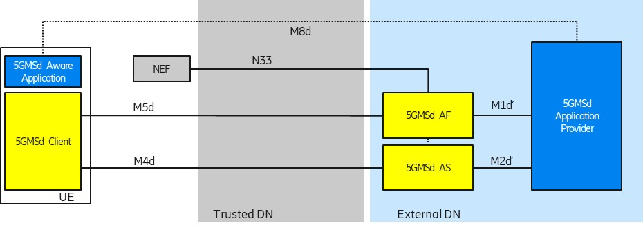
Figure A.3-1: Collaboration 3
NOTE 1: The M5d API may be exposed using a different FQDN than the M1d′ API exposing function.
NOTE 2: The M5d API may be exposed using several FQDNs, e.g. for different M5d assistance services.

A.4 Collaboration 4
This collaboration scenario depicts a content hosting function in the external Data Network, e.g. using a third-party CDN in collaboration with MNO offered assistance and network services. The Provisioning API (M1d′) and Ingest API (M2d′) may follow 5GMS specifications.
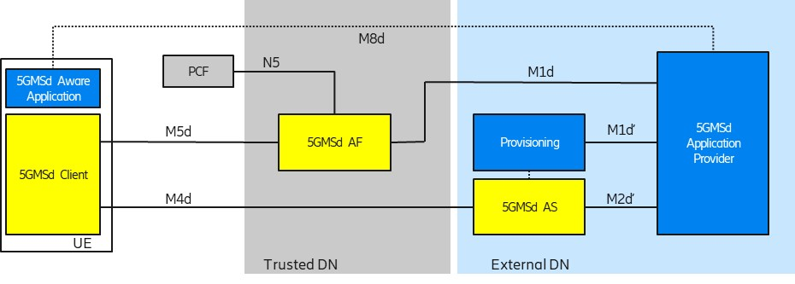
Figure A.4-1: Collaboration 4
Interfaces M1d′ and M2d′ may be similar to interfaces M1d and M2d respectively. Interface M4d follows 5GMS specifications.

A.5 Collaboration 5
This collaboration scenario is similar to Collaboration 4 with the difference that the external content hosting function (5GMSd AS) is provisioned from a 5GMSd AF which is located in a trusted Data Network. It is expected that a 5GMSd AF and 5GMSd AS from different providers are interconnected using an M3d interface.
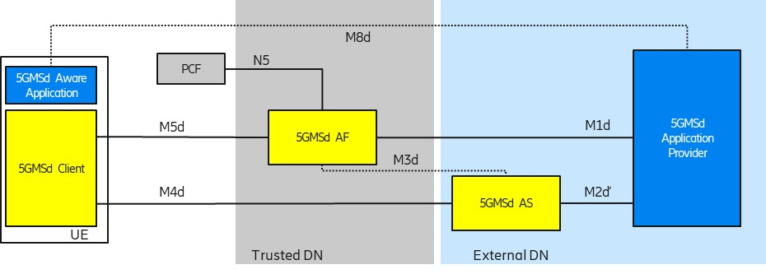
Figure A.5-1: Collaboration 5
Interface M2d′ may be similar to interface M2d. All other interfaces depicted follow 3GPP specifications.

A.6 Collaboration 6
This collaboration scenario is similar to Collaboration 4 and Collaboration 5 with the difference that the trusted content hosting function (5GMSd AS) is provisioned from an external 5GMSd AF. It is expected that a 5GMSd AF and 5GMSd AS from different providers are interconnected using an M3d interface.
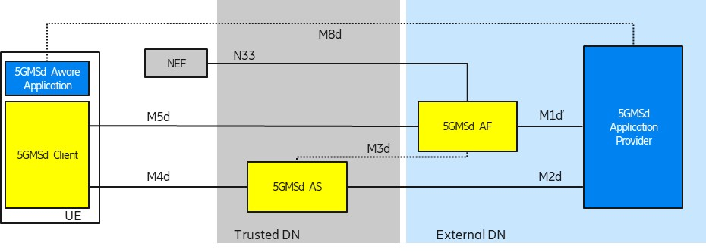
Figure A.6-1: Collaboration 6
Interface M1d′ may be similar to interface M1d. All other interfaces depicted follow 3GPP specifications.

A.7 Collaboration 7
This collaboration scenario represents a MNO CDN scenario (like in Collaboration 2) where the CDN is used for ingest and delivery of the content. Additional 5GMS features are used which require interaction with the PCF.
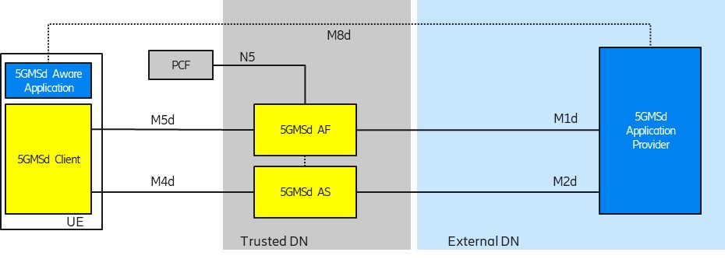
Figure A.7-1: Collaboration 7

A.8 Collaboration 8
This collaboration scenario represents a multi-MNO distribution scenario where an external CDN (5GMSd AS) is used to deliver content through multiple 5GMSd capable PLMNs. Additional 5GMSd features are used from the serving 5GMS System which need interactions with the PCF of the serving PLMN.
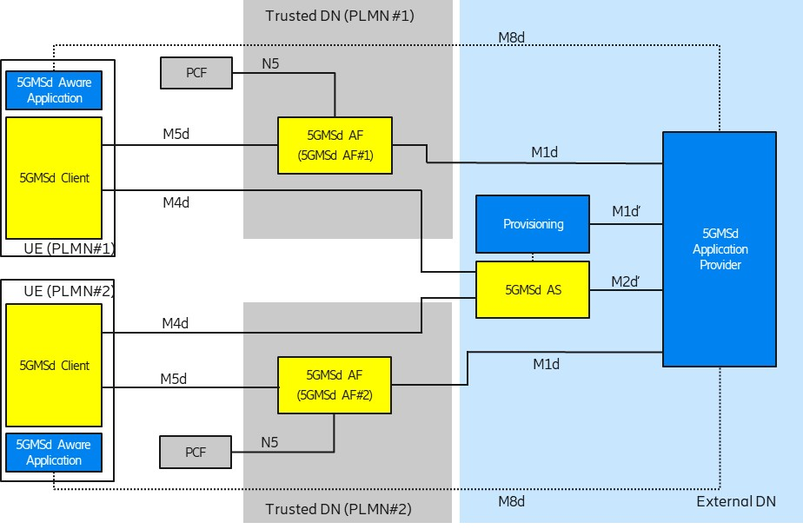
Figure A.8-1: Collaboration 8

A.9 Collaboration 9
This collaboration scenario represents a multi-MNO distribution scenario where an external CDN (5GMSd AS) is used to deliver content through multiple 5GMSd-capable PLMNs. Additional 5GMSd features are used from the serving 5GMSd system which need interactions with the NEF of the serving PLMN.
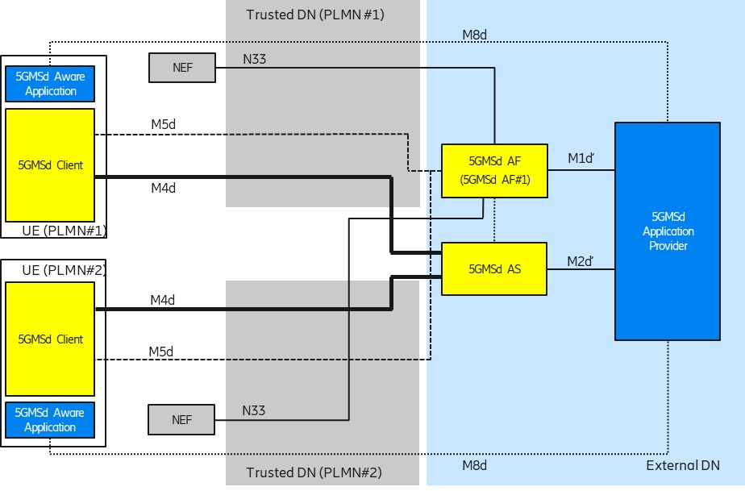
Figure A.9-1: Collaboration 9

**** Last Change

