**3GPP TSG-WG SA4 Meeting #117E e-meeting  *S4-220120***

**Elbonia, February 14th– 23rd, 2022**

|  |  |  |  |  |  |  |  |  |
| --- | --- | --- | --- | --- | --- | --- | --- | --- |
| *CR-Form-v12.1* | | | | | | | | |
| **CHANGE REQUEST** | | | | | | | | |
|  | | | | | | | | |
|  | **26.247** | **CR** | **0170** | **rev** | **-** | **Current version:** | **16.5.1** |  |
|  | | | | | | | | |
| *For* [***HE******LP***](http://www.3gpp.org/3G_Specs/CRs.htm#_blank)*on using this form: comprehensive instructions can be found at* [*http://www.3gpp.org/Change-Requests*](http://www.3gpp.org/Change-Requests)*.* | | | | | | | | |
|  | | | | | | | | |

|  |  |  |  |  |  |  |  |  |
| --- | --- | --- | --- | --- | --- | --- | --- | --- |
| ***Proposed change affects:*** | UICC apps | **X** | ME | **X** | Radio Access Network | **X** | Core Network |  |

|  |  |  |  |  |  |  |  |  |  |  |
| --- | --- | --- | --- | --- | --- | --- | --- | --- | --- | --- |
|  | | | | | | | | | | |
| ***Title:*** | Support of RAN Visible QoE | | | | | | | | | |
|  |  | | | | | | | | | |
| ***Source to WG:*** | Huawei, HiSilicon | | | | | | | | | |
| ***Source to TSG:*** | SA4 | | | | | | | | | |
|  |  | | | | | | | | | |
| ***Work item code:*** | NR_QoE-Core | | | | |  | ***Date:*** | | | 2022-01-28 |
|  |  | | | |  | |  | | |  |
| ***Category:*** | **F** |  | | | | | ***Release:*** | | | Rel-17 |
|  | *Use one of the following categories:* ***F*** *(correction)* ***A*** *(mirror corresponding to a change in an earlier release)* ***B*** *(addition of feature),* ***C*** *(functional modification of feature)* ***D*** *(editorial modification)*  Detailed explanations of the above categories can be found in 3GPP [TR 21.900](http://www.3gpp.org/ftp/Specs/html-info/21900.htm). | | | | | | | | *Use one of the following releases: Rel-8 (Release 8) Rel-9 (Release 9) Rel-10 (Release 10) Rel-11 (Release 11) … Rel-15 (Release 15) Rel-16 (Release 16) Rel-17 (Release 17) Rel-18 (Release 18)* | |
|  |  | | | | | | | | | |
| ***Reason for change:*** | | In Rel-17, RAN2/3 introduces the RAN Visible QoE to enable the RAN node to get aware of the user experiences and do the scheduling optimization accordingly. Besides, as indicated in LS R2-2202018 from RAN2, the maximum size of one QoE report container is upt to 144 000 bytes with RRC segmentation enabled. Alignments in SA4 specs are needed for support of that. | | | | | | | | |
|  | |  | | | | | | | | |
| ***Summary of change:*** | | Add support of RAN Visible QoE and the maximum size of one QoE report container. | | | | | | | | |
|  | |  | | | | | | | | |
| ***Consequences if not approved:*** | | The RAN Visbile QoE can not be supported by the upper layer. | | | | | | | | |
|  | |  | | | | | | | | |
| ***Clauses affected:*** | | L.1 | | | | | | | | |
|  | |  | | | | | | | | |
|  | | **Y** | **N** |  | | | |  | | |
| ***Other specs*** | |  | **X** | Other core specifications | | | | TS/TR ... CR ... | | |
| ***affected:*** | |  | **X** | Test specifications | | | | TS/TR ... CR ... | | |
| ***(show related CRs)*** | |  | **X** | O&M Specifications | | | | TS/TR ... CR ... | | |
|  | |  | | | | | | | | |
| ***Other comments:*** | |  | | | | | | | | |
|  | |  | | | | | | | | |
| ***This CR's revision history:*** | |  | | | | | | | | |

* * * * First change * * * *

## L.1 Configuration and reporting

As an alternative to configuration via MPD or OMA-DM, the QoE configuration can optionally be specified by the QoE Measurement Collection (QMC) functionality. In this case the QoE configuration is received via specific RRC [53] messages for UMTS and RRC [59] messages for LTE over the control plane, and the QoE reporting is also sent back via RRC messages over the control plane.

If QMC is supported, the UE shall support the following QMC functionalities:

- QoE Configuration: The QoE configuration will be delivered via RRC to the UE as a container according to "Application Layer Measurement Configuration" (see [53]) for UMTS, and "measConfigAppLayer" (see [59]) for LTE. The container is an octet string with a maximum length of 1000 bytes, with gzip-encoded data (see [18]) stored in network byte order. The container shall be uncompressed, and is then expected to conform to XML-formatted QoE configuration data according to clause L.2 in the current specification. This QoE Configuration shall be forwarded to the DASH client. The interface towards the RRC signalling is handled by the AT command +CAPPLEVMC [61].

- QoE Metrics: QoE Metrics from the DASH client shall be XML-formatted according to clause 10.6 in the current specification. The XML data shall be compressed with gzip (see [18]) and stored in network byte order into an octet string container with a maximum length of 8000 bytes. The container shall be delivered via RRC to the RNC according to "Application Layer Measurement Reporting" (see [53]) for UMTS, and to the eNB according to "measReportAppLayer" (see [59]) for LTE. The behaviour if the compressed data is larger than 8000 bytes is unspecified in this version of the specification. The interface towards the RRC signalling is handled by the AT command +CAPPLEVMR [61].

NOTE: The maximum size of one QoE report container can be up to 144 000 bytes with RRC segmentation enabled.

- The UE shall also set the QMC capability "QoE Measurement Collection for streaming services" (see [53]) to TRUE for UMTS, and include the QMC capability "qoe-MeasReport" (see [59]) for LTE.

- The QoE configuration AT command +CAPPLEVMC [61] may also indicate with an Within-area Indication if the UE is inside or outside a wanted geographic area. Such an indication may arrive with or without any QoE configuration container attached. If the DASH client is informed that it is not inside the area, it shall not start any new QoE measurements even if it has received a valid QoE configuration container, but shall continue measuring for already started sessions.

- When a new session is started, the QoE reporting AT command +CAPPLEVMR [61] shall be used to send a Recording Session Indication. Such an indication does not contain any QoE report, but indicates that QoE recording has started for a session.

- When the QoE configuration is to be released, an unsolicited result code, associated with the AT command +CAPPLEVMC [61] and containing the parameter <start-stop_reporting> set to "1" shall be sent to the DASH client as notification of a discard request. Then the DASH client shall stop collecting quality metrics and discard any already collected information [63].

- For NR, the RAN visible QoE may be supported.

- The RAN visible QoE configuration generated by the NG-RAN shall be forwarded to the DASH client, including the metrics to be collected and reporting periodicity.

- Based on the RAN visible QoE configuration, the buffer level and Playout Delay for Media Startup shall be directly delivered to the UE AS layer and the collected metrics shall be sent to the NG-RAN via the RRC message.

- When the RAN visible QoE measurement is deactivated by the NG-RAN, the DASH client shall be notified to terminate and release the RAN visible QoE measurement.

NOTE: The RAN visible QoE metrics collection can be configured only if legacy QoE measurements are configured for the same service type. When the legacy QoE measurements are released, the RAN visible QoE configuration shall also be released.The exact implementation is not specified here, but example signalling diagrams for UMTS and LTE below show the QMC functionality with a hypothetical "QMC Handler" entity.



Figure L-1: Example signalling diagram for UMTS

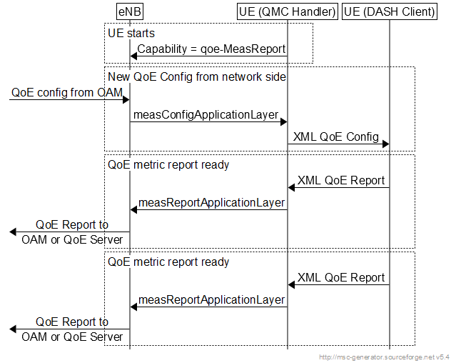

Figure L-2: Example signalling diagram for LTE

Note that the QMC Handler is only shown here as one possible implementation, and it need not be implemented as such. The corresponding QMC functionality could be built into the DASH client or into other UE entities. In this version of the specification the detailed implementation of the above functionalities is left to the UE vendor.

* * * * End of changes * * * *