3GPP TSG SA WG4#117e S4-220029
E-meeting, 14th – 23rd February 2022
CR-Form-v12.0
PSEUDO CHANGE REQUEST
 | 26.805 | CR | pseudo | rev |  | Current version: | 1.0.1
For HELP on using this form: comprehensive instructions can be found at
http://www.3gpp.org/Change-Requests.

Proposed change affects: | UICC apps |  | ME | X | Radio Access Network |  | Core Network | X

Title: | [FS_NPN4AVProd] mmWAVE for Media Production
Source to WG: | Qualcomm Incorporated
Source to TSG:
Work item code: | FS_NPN4AVProd |  |  |  |  |  | Date: |  |  | 07/02/2022
Category: | B |  |  |  |  |  | Release: |  |  | 17
 | Use one of the following categories:  F (correction)  A (mirror corresponding to a change in an earlier release)  B (addition of feature),  C (functional modification of feature)  D (editorial modification)  Detailed explanations of the above categories can  be found in 3GPP TR 21.900. |  |  |  |  |  |  |  | Use one of the following releases:  Rel-8 (Release 8)  Rel-9 (Release 9)  Rel-10 (Release 10)  Rel-11 (Release 11)  Rel-12 (Release 12)  Rel-13 (Release 13)  Rel-14 (Release 14)  Rel-15 (Release 15)  Rel-16 (Release 16)
Reason for change:
Summary of change:
Consequences if not approved:
Clauses affected: |  | 2, 5.5 (new), 6.9 (new)
 |  | Y | N
Other specs |  |  | X | Other core specifications |  |  |  | TS/TR ... CR ...
affected: |  |  | X | Test specifications |  |  |  | TS/TR ... CR ...
(show related CRs) |  |  | X | O&M Specifications |  |  |  | TS/TR ... CR ...
Other comments:
This CR's revision history:

===== CHANGE =====

2 References
The following documents contain provisions which, through reference in this text, constitute provisions of the present document.
…
[51] GSA: "mmWave Bands 24.25 GHz", May 2021, https://gsacom.com/paper/mmwave-bands-24-25-ghz-may-2021-executive-summary/
[52] Li Nian, "The Next Journey for 5G: The Standardization and Application of mmWAVE", https://www.gsma.com/greater-china/wp-content/uploads/2020/09/%E6%AF%AB%E7%B1%B3%E6%B3%A2%E6%A0%87%E5%87%86%E5%8C%96%E5%92%8C%E8%AF%95%E9%AA%8C%E8%BF%9B%E5%B1%95_%E4%B8%AD%E5%9B%BD%E7%A7%BB%E5%8A%A8_%E6%9D%8E%E7%94%B7-1.pdf
[53] GSMA Intelligence: "The economics of mmWave 5G", January 2021, https://data.gsmaintelligence.com/research/research/research-2021/the-economics-of-mmwave-5g
[54] 3GPP TR 38.900: "Study on channel model for frequency spectrum above 6 GHz".
[55] Yiqing Cao: "Live 8K production using 5G mmWave", https://www.5g-mag.com/post/follow-up-workshop-media-production-over-5g-npn-deep-dive-into-protocols
===== CHANGE =====

5.5 Low-Latency Production with 5G mmWAVE
mmWAVE is also known as Frequency Range 2 defined in RAN specifications, which covers the spectrum above 24 GHz. At WRC-2019 in November 2019, several new frequency ranges for use by IMT-2000 (5G) were identified. These encompass many of the existing 3GPP bands plus the following additional spectrum ranges:
- 24.25–27.5 GHz
- 37–43.5 GHz
- 45.5–47 GHz
- 47.2–48.2 GHz
- 66–71 GHz.
Since Release 15, 5G mmWAVE technology, as part of 5G NR specifications, is well defined in 3GPP. It allows users to access the full potential of 5G by utilizing untapped frequency bands above 24 GHz. This abundant spectrum can deliver the fastest available speeds, extreme capacity and low latency.
3GPP has done several studies on the channel model for frequency spectrum above 6 GHz, e.g. in TR 38.900 [54]. According to [52], extreme higher propagation loss and penetration loss in mmWave spectrum is expected, and the frequency is sensitive to blockage, e.g. by foliage or the human body. However, again according to [52], performance tests for mmWAVE provide extraordinary KPIs:
- 14.7/3 Gbps cell peak throughout (DL/UL) in an 800 MHz spectrum band.
- One-way user plane latency between 1–1.5 ms.
- Farthest access distance: 2.6 km in line-of-sight with a few small trees.
According to [55], commercial 5G modems support mmWAVE as well as dual connectivity, and upload speeds of 2.2 Gbps can be achieved in Frequency Ranges FR2 400 MHz (on n261) and FR1 100 MHz (n77). According to [54], mmWave bands can accommodate more capacity and bandwidth than any other band. And since spectrum in these bands is abundant, mmWave spectrum is ideally placed to deliver high speeds, low latency and high capacity, all at the same time. The short wavelength of mmWave allows for very small antennas, which helps with beam forming for enhanced coverage and spectral efficiency. Promoted by the whole industry, 5G mmWAVE commercialization grows rapidly. GSA’s report [51] indicates that, up to May 2021, twenty-eight operators in sixteen countries/territories are known to be already deploying 5G networks using mmWave spectrum at 24 GHz.
Based on this analysis, mmWAVE is an attractive technology for production scenarios that typically rely on fully wired data rates. In particular, media production scenarios require extreme low latency, as they allow camera direction in almost real time. In some media production casesTypically, lightweight compression codecs (e.g. JPEG-XS [50]) are used. In some field test, JPEG-XS could achieve less than 3 ms camera-to-screen latency with time synchronisation based on Precision Time Protocol (PTP) [22, 26]. Even without PTP time reference, it only requires one frame (20 ms at 50 frames per second) to be buffered for timing and the camera-to-screen latency is less than 28 ms.
To achieve “Master Copy” quality, the preferred compression rate is between 1/8 – 1/12 which requires 1–1.5 Gbps transmission capacity for UHD video. Realistically, according to [55], for HD at least 150 Mbps and for UDD / 8K more than 800Mbps are needed. Due to the large payload, lightweight compression has been used over IP and Ethernet links until now. 5G mmWAVE is capable of providing data transmission at several gigabits per second, and this could be leveraged to replace existing cabled infrastructure for the transmission of lightly compressed video signals. An example setup for a mobile television studio is shown in Figure 5.5-1.
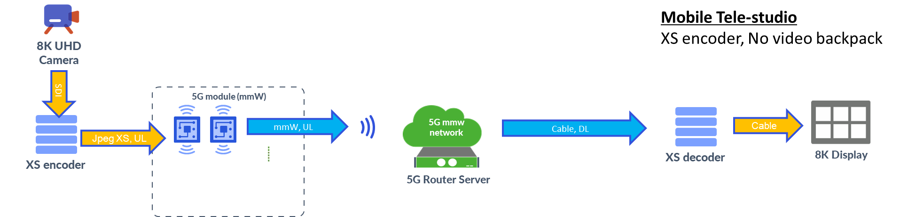
Figure 5.5-1 Mobile telestudio scenario with 5G mmWAVE
===== CHANGE =====

6.9 Key Issue #8: Usage of mmWAVE for low-latency television production
As introduced in clause 5.5, a lightweight video compression codec is typically used to achieve low latency in television production and is currently transmitted via IP or Ethernet cabling. 5G mmWAVE is capable of providing the sufficient large data rate, but the wireless channel fluctuation may challenge service quality. In particular, mmWAVE spectrum is prone and sensitive to propagation and penetration loss, as well as to blockage by objects and human bodies. To better utilize the wireless channel reflection and scattering, 3GPP defines advanced beam management as well as multi-carrier operation [52].
Nevertheless, to operate production scenarios at several hundred megabits per second over a mmWAVE radio link, content delivery protocols and oodecs are needed that can compensate the mmWAVE channel characteristics, support high reliability and achieve the high bit rate as shown in Figure 6.9-1.
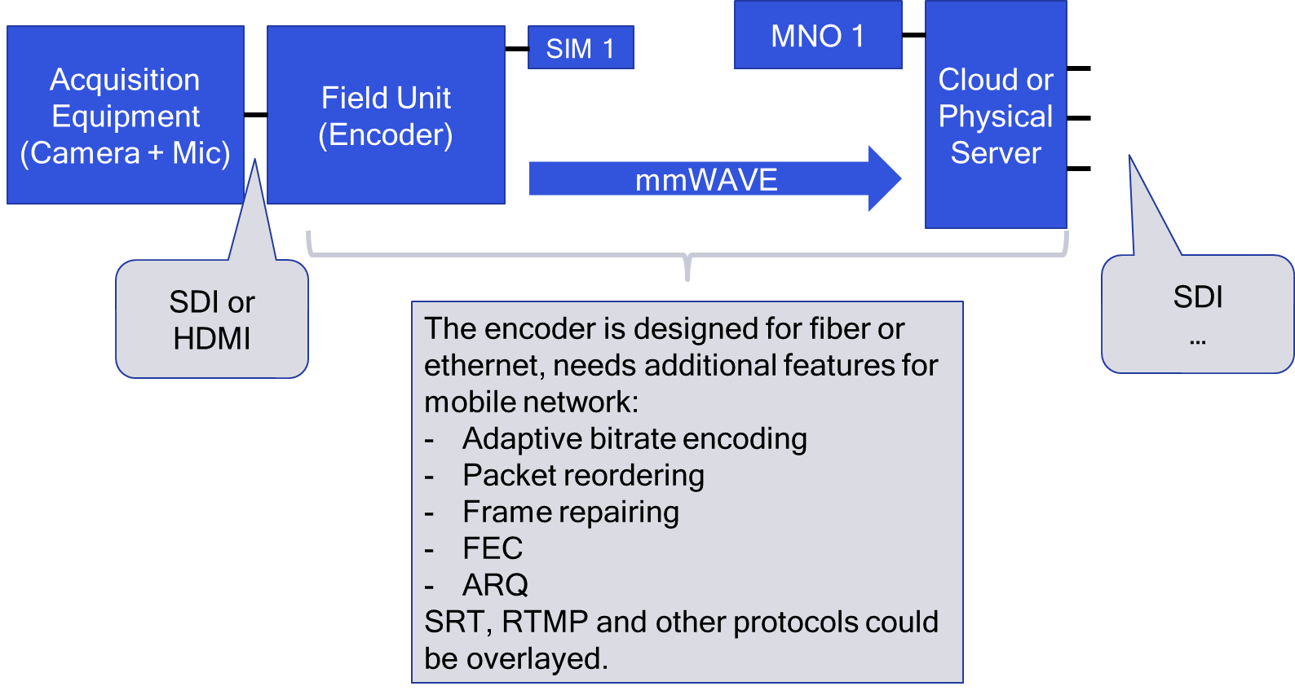
Figure 6.9-1 Protocol architecture – Mobile Tele-studio
At least the following techniques should be considered for mmWAVE based content delivery protocols:
1. Adaptive bit rate encoding. Dynamically adjusting the encoder bit rate could change the encoded picture quality according to the channel variantion.
2. Packet reordering. Wireless channels change rapidly and the mobile system usual employs Hybrid Automated Repeat Query (HARQ) at the physical layer to retransmit data blocks that fail to arrive at the receiver. The packets sent earlier may arrive after the packets sent later due to different retransmission times. This might lead to wrong orders of packets and further errors at the decoder. The receiver could buffer the received packets and reorder them in case of missing original packets, although doing so incurs a latency penalty.
3. Error correction. FEC, ARQ, and Frame repair are usually used to compensate for reception errors.
- Forward Error/Erasure Correction (FEC) techniques transmit additional redundant coded bits or packets in order to make the bit stream or packet stream more robust. Extra channel bandwidth is required to accommodate the FEC overhead and additional memory is required at the sender and at the receiver to process the FEC information. FEC also includes a variable time penalty, which may be undesirable in low-latency production.
- Automatic Repeat Query (ARQ) involves retransmitting data that was not received at the request of the receiver, signalled by means of explicit acknowledgement packets back to the sender. This retransmission introduces a variable delay which is undesireable for low-latency production.
- The Frame repair techniqe compensates for undecodable video frames that result from lost packets by interplorating between neighbouring successfully decoded frames. If the receiver interpolates only from (successfully received) past frames, this neither requires additional bandwidth, nor does it add any latency. If future frames are used, the interpolation process does incur some additional latency.
Among these three error correction techniques, if the errors happen occasionally, Frame repair can maintain a similar bit rate and latency performance as Ethernet.

