3GPP TSG SA WG4#117e S4-220234
E-meeting, 14th – 23rd February 2022 revision of S4-211666
CR-Form-v12.0
DRAFT CHANGE REQUEST
 | 26.501 | CR | draft | rev | 1 | Current version: | 16.9.0
For HELP on using this form: comprehensive instructions can be found at
http://www.3gpp.org/Change-Requests.

Proposed change affects: | UICC apps |  | ME | X | Radio Access Network |  | Core Network | X

Title: | [5MBUSA] 5GMS via eMBMS
Source to WG: | Qualcomm Incorporated, BBC
Source to TSG:
Work item code: | 5MBUSA |  |  |  |  |  | Date: |  |  | 18/02/2022
Category: | B |  |  |  |  |  | Release: |  |  | 17
 | Use one of the following categories:  F (correction)  A (mirror corresponding to a change in an earlier release)  B (addition of feature),  C (functional modification of feature)  D (editorial modification)  Detailed explanations of the above categories can  be found in 3GPP TR 21.900. |  |  |  |  |  |  |  | Use one of the following releases:  Rel-8 (Release 8)  Rel-9 (Release 9)  Rel-10 (Release 10)  Rel-11 (Release 11)  Rel-12 (Release 12)  Rel-13 (Release 13)  Rel-14 (Release 14)  Rel-15 (Release 15)  Rel-16 (Release 16)
Reason for change: |  | The work item in SP-210376 asks among others for the following  2. Define relevant call flows and procedures to support  b. 5GMS hybrid unicast/broadcast services.  c. 5MBS usage independent of 5GMS.  3. Extend the 5G Media Streaming architecture by providing a general description and architecture of:  b. 5GMS hybrid unicast/broadcast services.  c. 5GMS via eMBMS.
Summary of change: |  | The CR addresses the above objectives by adding  - Architecture for 5GMS via eMBMS  - Procedures and call flows for 5GMS via eMBMS  - Informative Annex on collaboration models
Consequences if not approved: |  | Work Item objectives not complete
Clauses affected: |  | 2, 4.2.4 (new), 5.10, Annex C
 |  | Y | N
Other specs |  | X |  | Other core specifications |  |  |  | TS/TR ... CR
affected: |  |  |  | Test specifications |  |  |  | TS/TR ... CR ...
(show related CRs) |  |  |  | O&M Specifications |  |  |  | TS/TR ... CR ...
Other comments:
This CR's revision history:

===== CHANGE =====

2 References
The following documents contain provisions which, through reference in this text, constitute provisions of the present document.
- References are either specific (identified by date of publication, edition number, version number, etc.) or non-specific.
- For a specific reference, subsequent revisions do not apply.
- For a non-specific reference, the latest version applies. In the case of a reference to a 3GPP document (including a GSM document), a non-specific reference implicitly refers to the latest version of that document in the same Release as the present document.
[1] 3GPP TR 21.905: "Vocabulary for 3GPP Specifications".
[2] 3GPP TS 23.501: "System architecture for the 5G System (5GS)".
[3] 3GPP TS 23.502: "Procedures for the 5G System (5GS)".
[4] 3GPP TS 23.503: "Policy and charging control framework for the 5G System (5GS); Stage 2".
[5] 3GPP TS 26.238: "Uplink streaming".
[6] 3GPP TS 26.307: "Presentation layer for 3GPP services".
[7] 3GPP TS 26.247: "Transparent end-to-end Packet-switched Streaming Service (PSS); Progressive Download and Dynamic Adaptive Streaming over HTTP (3GP-DASH)".
[8] 3GPP TS 26.234: "Transparent end-to-end Packet-switched Streaming Service (PSS); Protocols and codecs".
[9] 3GPP TS 23.003: "Technical Specification Group Core Network and Terminals; Numbering, addressing and identification".
[10] 3GPP TS 28.530: "Management and orchestration; Concepts, use cases and requirements".
[11] 3GPP TS 28.531: "Management and orchestration; Provisioning".
[12] 3GPP TS 28.541: "Management and orchestration; 5G Network Resource Model (NRM); Stage 2 and stage 3".
[13] 3GPP TS 23.222: "Common API Framework for 3GPP Northbound APIs".
[14] IETF RFC 1034: "Domain names – concepts and facilities".
[15] 3GPP TS 23.548: "5G System Enhancements for Edge Computing; Stage 2".
[16] 3GPP TS 23.558: "Architecture for enabling Edge Applications".
[17] 3GPP TS 28.538: "Management and orchestration; Edge Computing Management".
[18] 3GPP TS 23.246: "Multimedia Broadcast/Multicast Service (MBMS); Architecture and functional description".
[19] 3GPP TS 26.346: "Multimedia Broadcast/Multicast Service (MBMS); Protocols and codecs".
[20] 3GPP TS 26.347: "Multimedia Broadcast/Multicast Service (MBMS); Application Programming Interface and URL".
[21] 3GPP TS 26.348: "Northbound Application Programming Interface (API) for Multimedia Broadcast/Multicast Service (MBMS) at the xMB reference point".
===== CHANGE =====

4.5 5G Downlink Media Streaming via eMBMS

4.5.1 Architecture for 5G Downlink Media Streaming over eMBMS
Figure 4.5.1-1 below depicts an architecture for downlink 5G Media Streaming via eMBMS that combines the functions and reference points of the 5GMS System with those of the MBMS System.
Figure 4.5.1-1: Architecture for 5G Media Streaming over eMBMS
This arrangement allows 5GMS-based downlink media streaming to be deployed as an MBMS-aware Application on top of eMBMS as defined in TS 23.246 [18], TS 26.346 [19], TS 26.347 [20] and TS 26.348 [21].
In this case:
1. The 5GMSd AF configures the delivery of 5GMSd content to an MBMS Client in the UE by creating a Service as defined in TS 26.348 [21], clause 5.3. In order to additionally deliver this content over an MBMS User Service, the 5GMSd AF invokes xMB-C control plane procedures on the BM-SC as specified in clauses 5.3 and 5.4 of TS 26.348 [21] and, as a result, content is ingested by the BM-SC from the 5GMSd AS using the xMB-U File Distribution procedures specified in clause 5.5.2 of TS 26.348 [21] to allow xMB-C Session types Application and Files.
2. The 5GMSd Client acts as eMBMS-Aware Application (as defined in TS 26.347 [20]) for the MBMS Client. Thus, the MBMS Client is controlled by the 5GMSd Client via the Media Streaming Service API specified in clause 6.3 of TS 26.347 [20] or via the File Delivery Application Service API specified in clause 6.2 of TS 26.347 [20]. (This interaction is labelled MBMS-API-C in the above figure.)
3. The MBMS Client receives media and other objects from the BM-SC according to the MBMS Download Delivery Method specified in clause 7 of TS 26.346 [19]. If an uplink is available to the MBMS Client, and if associated delivery procedures as specified in clause 9.3 of TS 26.346 [19] are activated, the MBMS Client uses the associated delivery procedures to recover damaged media objects received from the BM-SC for xMB-C Session type Files.
4. The Media Server function interfaces with the MBMS Client per figure 5.1 of TS 26.347 [20], and shall expose the content received (and possibly repaired) by the MBMS Client to the 5GMSd Client via the HTTP client-to-application interface specified in clause 7.2 of TS 26.347 [20]. (This interaction is labelled MBMS-API-U in the above figure.)
5. The media player sends requests according to the signaled object availability times in the manifest. In case a media object transmitted via the MBMS User Service is not received by the MBMS Client by the object availability times, or if it cannot be repaired in time for consumption by the 5GMS Client, the Media Server returns an error or a partial object in response to the Media Player’s request for the media object, and the Media Player may instead attempt to retrieve the media object, or ranges of it, from the 5GMSd AS at reference point M4d, if available. The object shall be available for the application for a well-defined time duration.
NOTE: Details on determining the availability time requirements of the application are deferred to stage-3.
The usage of existing reference points to support these scenarios is documented in the following clauses. Procedures for 5GMS via eMBMS are defined in clause 5.10.

4.5.2 Usage of 5GMS reference points for eMBMS-based delivery

4.5.2.1 Usage of M1d
Reference point M1d is used as defined in clauses 4.1 to 4.4.
In addition, the content provider shall authorize via M1d that 5GMS content may be distributed via eMBMS.
The translation of M1d information to eMBMS delivery provisioning is left to implementation.
NOTE: The 5GMS Application Provider may provision specific use-cases (high velocity, specific reception area, indoor/outdoor/mobile users) at reference point M1d. These service requirements are translated by the 5GMSd AF into specific xMB-C calls to provision the BM-SC with a service that has the right parameters for a specific location.

4.5.2.2 Usage of M2d
Reference point M2d is be used as defined in clauses 4.1 to 4.4.

BM-SC4.5.2.3 Usage of M3d
Reference point M3d is used as defined in clauses 4.1 to 4.4.

4.5.2.4 Usage of M4d
Reference point M4d is used as defined in clauses 4.1 to 4.4.

4.5.2.5 Usage of M5d
Reference point M5d is is used as defined in sub-clauses 4.1 to 4.4.
In addition, for 5GMS content to be distributed via eMBMS:
- The 5GMS Service Access Information shall include the relevant information of the eMBMS Service Announcement in order to bootstrap reception of the MBMS service, typically via a service identifier (i.e., the serviceId attribute of the bundleDescription.userServiceDescription element of the USD – see TS 26.346 [19]). This is passed by the Media Session Handler to the MBMS Client via reference point MBMS-API-C [20]. When this information is present in the Service Access Information and when the UE is MBMS-capable, the 5GMSd Client shall invoke the MBMS Client to initiate reception of the corresponding MBMS User Service.
- The 5GMS Service Access Information shall include the relevant information of the eMBMS Service Announcement in order to collect metrics of the MBMS service and to operate consumption reporting..

4.5.2.6 Usage of M6d
Reference point M6d is used as defined in clauses 4.1 to 4.4.

4.5.2.7 Usage of M7d
Reference point M7d is used as defined in clauses 4.1 to 4.4.

4.5.2.7 Usage of M8d
Reference point M8d is used as defined in clauses 4.1 to 4.4.

4.5.3 Usage of MBMS reference points and interfaces

4.5.3.1 Usage of xMB-C
The 5GMSd AF provisions MBMS User Services in the BM-SC as defined in clauses 5.3 and 5.4 of TS 26.348 [21].

4.5.3.2 Usage of xMB-U
The BM-SC ingests content from the 5GMSd AS using the push-based ingest method.

4.5.3.3 Usage of User Service Announcement
The MBMS User Service Announcement as defined in TS 26.346 is used to advertise the availability of 5GMS content delivered via eMBMS.

4.5.3.4 Usage of MBMS-API-C
The MBMS Client exposes information to the Media Session Handler to manage the reception of MBMS User Services. The MSH configures the MBMS Client for consumption and metrics reporting. The MBMS client provides consumption and metrics reports to the the MSH.

4.5.3.4 Usage of MBMS-API-U
The MBMS Client exposes fully- and partially-received media objects to the Media Player in the 5GMSd Client.
===== CHANGE =====

5.10 5GMS via eMBMS

5.10.1 General
This clause defines procedures for different use cases and scenarios when 5GMS is using eMBMS for delivery as introduced in clause 4.5.

5.10.2 Procedures for 5GMS content delivered exclusively via eMBMS
In this case, 5GMS media data is exclusively delivered via eMBMS, i.e. media content is not delivered via reference point M4d, but only via MBMS User Services. The 5GMSd Client acts as an MBMS-Aware Application.
The call flow in Figure 5.10.2-1 extends the call flow defined in clause 5.3.2 to address the delivery of 5GMS media data exclusively via eMBMS. Aspects specific to this use-case are indicated in bold.
Figure 5.10.2-1: High-level procedure for DASH content delivery via eMBMS
Prerequisites (step 0):
- The 5GMSd Application Provider has provisioned the 5G Media Streaming System, including content ingest and the authorization to distribute 5GMS content via eMBMS.
- The 5GMS AF has informed the BM-SC about the availability of 5GMS content by provisioning an MBMS service and has obtained relevant information from the eMBMS Service Announcement (such as the MBMS service identifier).
- The BM-SC is ingesting content from the 5GMS AS, using either pull mode or push mode.
- The BM-SC has broadcast the MBMS Service Announcement, including an indication that the content is 5GMS content.
Steps:
1: The 5GMSd-Aware Application triggers the Service Announcement procedure and the 5GMS Service and Content Discovery procedure at reference point M8.
2: A media content item is selected.
3: The 5GMSd-Aware Application triggers the 5GMSd Client to start media playback. The Media Player Entry is provided to the 5GMSd Client.
4: If the 5GMS-Aware Application has received only a reference to the Service Access Information (see step 1), the Media Session Handler interacts with the 5GMSd AF to acquire the whole Service Access Information. This includes relevant information from the eMBMS Service Announcement (such as the MBMS service identifier) in order to bootstrap reception of the MBMS service.
5–11: The Media Session Handler acts as an MBMS-Aware Application and initiates service acquisition. For details, see TS 26.347 [18]. This establishes a transport session for the MPD and the Content.
NOTE: The MPD and Initialization Segment(s) are forwarded by the MBMS Client to the Media Server to enable their subsequent delivery to the Media Player upon request.
12: The Media SessionHandler provides the MPD URL to the Media Player either directly or through the 5GMSd-Aware Application.
13: The Media Player is invoked to start media access and playback.
14: The Media Player retrieves the Media Player Entry resource (an MPD) from the proxy Media Server.
15: The Media Player processes the retrieved MPD. It determines, for example, the number of transport sessions needed for media acquisition. The Media Player should be able to use the MPD information to initialize the media pipelines for each media stream (see step 18). When DRM is used (see step 17) the MPD should also contain sufficient information to initialize the DRM client.
16: The Media Player notifies the Media Session Handler about the start of a new downlink media streaming session. The notification may include parameters from the MPD.
17: Optional: The Media Player acquires any necessary DRM information, for example a DRM License.
18: The Media Player configures the media playback pipeline.
19: The Media Player retrieves initialization segment(s) referenced by the MPD.
20–25: Content is delivered using DASH-over-MBMS. Session Announcemnent updates are provided to the MBMS Client as necessary. MPD updates and Segments are pushed to the media server. The Media Player retrieves media segments from the proxy Media Server according to the MPD and forwards them to the appropriate media rendering pipeline.

5.10.3 5GMS Consumption Reporting procedures for eMBMS
In this case, 5GMS consumption reporting is used to report consumption of 5GMSd content via an eMBMS service.
NOTE: eMBMS consumption reporting is disabled in this case.
The call flow in Figure 5.10.3-1 extends the call flow defined in clause 5.6.1 to address consumption reporting. Aspects specific to this use-case are indicated in bold.
Figure 5.10.3-1: Consumption reporting for 5GMS via eMBMS
Prerequisites (step 0):
- The 5GMSd Application Provider has provisioned the 5G Media Streaming System, including content ingest, consumption reporting and the permission to distribute 5GMS content via eMBMS.
- The BM-SC is ingesting content from the 5GMS AS, using either pull mode or push mode.
- eMBMS media delivery is established.
- Consumption reporting is established.
Steps:
The user preferences relating to consumption reporting may be changed:
1: The 5GMSd-Aware Application selects/changes the user preferences.
2: The Media Player transmits consumption reporting user preferences to the Media Session Handler.
The first phase is initialisation.
3: The 5GMSd-Aware Application is started.
4: A media content item is selected.
5: The 5GMSd-Aware Application triggers the Media Session Handler to start content playback. The Media Player Entry is provided.
6: If the 5GMS-Aware Application has received only a reference to the Service Access Information, the Media Session Handler interacts with the 5GMSd AF to acquire the whole Service Access Information. This includes a client consumption reporting configuration including parameters such as reporting frequency.
7: The MBMS service is initiated.
8: The Media Session Handler triggers consumption reporting.
9: The Media Session Handler starts the Media Player with the Media Player Entry.
The second phase is media playback.
When media is playing, the consumption reporting parameters may be updated by the 5GMSd AF.
10: The Media Session Handler acquires updated Service Access Information from the 5GMSd AF including updated consumption reporting parameters.
When media is playing:
11: Media content is accessed through different networks, possibly via eMBMS or unicast.
12: The Media Player transmits information about the media streaming resources consumed to the Media Session Handler, including the source of the media.
13: The Media Session Handler regularly sends consumption report(s) to the 5GMSd AF, including information about the delivery network from which the media was acquired.
14: The Media Player provides an update to the Media Session Handler about the consumed media streaming resources, for example a change in the delivery network.
The last phase is to stop the media:
15: The 5GMSd-Aware Application triggers the Media Session Handler to stop content playback.
16: The Media Session Handler stops the Media Player.
17: The Media Session Handler stops consumption reporting.
18: The Media Session Handler may send final consumption report(s) to the 5GMSd AF.

5.10.4 5GMS Metrics Reporting procedures for eMBMS
In this case, 5GMS metrics reporting is used to report 5GMS and eMBMS metrics to the 5GMSa AF.
NOTE: eMBMS metrics reporting is disabled in this case.
The call flow in Figure 5.10.4-1 extends the call flow defined in clause 5.6.1 to address metrics reporting. Aspects specific to this use-case are indicated in bold.
Figure 5.10.3-1: Metrics reporting for 5GMS via eMBMS
Prerequisites (step 0):
- The 5GMSd Application Provider has provisioned the 5G Media Streaming System, including content ingest, metrics reporting and the permission to distribute 5GMS content via eMBMS.
- The BM-SC is ingesting content from the 5GMS AS, using either pull mode or push mode.
- eMBMS media delivery is established.
- Metrics reporting is established.
Steps:
The user preferences relating to metrics reporting may be changed:
1: The 5GMSd-Aware Application selects/changes the user preferences.
2: The Media Player transmits metrics reporting user preferences to the Media Session Handler.
The first phase is initialisation.
3: The 5GMSd-Aware Application is started.
4: A media content item is selected.
5: The 5GMSd-Aware Application triggers the Media Session Handler to start content playback. The Media Player Entry is provided.
6: If the 5GMS-Aware Application has received only a reference to the Service Access Information, the Media Session Handler interacts with the 5GMSd AF to acquire the whole Service Access Information. This includes a client metrics reporting configuration including parameters such as reporting frequency.
7: The MBMS service is initiated.
8: The Media Session Handler triggers metrics reporting.
9: The Media Session Handler starts the Media Player with the Media Player Entry.
The second phase is media playback.
When media is playing, the metrics reporting parameters may be updated by the 5GMSd AF.
10: The Media Session Handler acquires updated Service Access Information from the 5GMSd AF including updated metrics reporting parameters.
When media is playing:
11: Media content is accessed through different networks, possibly via eMBMS or unicast.
12: The Media Player provides DASH metrics to the Media Session Handler.
13: The MBMS Client provides MBMS metrics to the Media Session Handler using MBMS-API-C*.
14: The Media Session Handler regularly sends metrics report(s) to the 5GMSd AF, including information about the delivery network from which the media was acquired.
The last phase is to stop the media:
15: The 5GMSd-Aware Application triggers the Media Session Handler to stop content playback.
16: The Media Session Handler stops the Media Player.
17: The Media Session Handler stops metrics reporting.
18: The Media Session Handler may send final metrics report(s) to the 5GMSd AF.

5.10.5 Procedures for Hybrid Services: 5GMS content delivery via 5G System and eMBMS

5.10.5.1 General
Hybrid services refer to the case for which a basic service is available on eMBMS and at the same time on unicast. The service on unicast may be richer and extended and may provide additional user experiences. For the hybrid use cases, it the content is statically provisioned on different delivery networks.
Hybrid services predominantly refer to the case for which the delivery manifest differentiates between resources accessible on unicast via M4d and resources accessible through eMBMS, in this case through MBMS-API-U.
These resources are differentiated in the delivery manifest through different DNs, for example different BaseURLs in DASH MPDs, or in HLS by providing different pathways. The 5GMS client, in particular the Media Player in assistance with the MSH and the MBMS client dynamically selects the delivery network on where to access the resources according to reception conditions, user preferences or other policies. Content is provisioned such that the 5GMS client is able to provide a seamless user experience when switching delivery networks.
The call flow in Figure 5.10.5 1 extends that defined in clause 5.6.1 to address generic hybrid use cases. Specific additional use cases are presented in the remainder of clause 5.10.5.
Figure 5.10.5-1: High-level procedure for hybrid delivery of DASH content
Steps:
1: The 5GMSd Application Provider triggers 5GMS provisioning and permits hybrid distribution of the media content.
2: As a consequence, the 5GMSd AF provisions MBMS delivery. The MBMS Delivery Session is set up.and the BM-SC informs the 5GMS AF about the content ingest endpoints.
3: 5GMSd AS substitutes a modified manifest under the direction of the 5GMSd AF to indicate that content is available either on a the MBMS client’s server or on 5GMSd AS.
4: The modified presentation manifest and the ingest endpoints are provided to the 5GMSd Application Provider. The manifest may also be updated by the 5GMSd Application Service Provider.
5: The media content is announced to the 5GMSd-Aware Application and the application requests the entry points for the service.
6: The 5GMSd AS begins ingesting content from the 5GMSd Application Provider and the BM-SC may, in turn, begin ingesting this content from the 5GMSd AS.
7: The BM-SC starts one or more MBMS Delivery Sessions.
8: The media content is selected by the 5GMSd-Aware Application.
9: The application initiates the media streaming session through Media Session Handler.
10: The Media Session Handler initiates the MBMS streaming services.
11: The media session handler through the information from the MBMS Client informs the 5GMSd-Aware Application that the service is ready.
12: The 5GMSd-Aware Application starts media playback.
13: The media presentation manifest is requested by the Media Player. The presentation manifest may be available from the local Media Server (populated by the MBMS Client) or from the 5GMSd AS , or even from both.
14: The Media Player processes the manifest and identifies that content is available from different data networks (the local Media Server and the 5GMSd AS).
15: Under the control of the 5GMSd-Aware Application, the Media Player selects the content and different content options.
16: The Media Player continuously checks with the Media Session Handler – and possibly forwarded to the MBMS Cient if the MBMS User Service data is available – how to use the different content. This depends on the hybrid scenario. Different policies may be considered.
17: The Media Player requests initialization information either from the local Media Server or from the 5GMSd AS. The Media Player repeats this step for each required initialization segment.
18: The Media Player receives the initialization information.
19: The Media Player requests media segments according to the manifest either from the local Media Server or from the 5GMSd AS.
20: The Media Player receives media segments and puts the information into the appropriate media rendering pipeline.
Steps 13–20 are repeated according to the manifest information.

5.10.5.2 Interactive service
In a specific hybrid scenario, an interactive service may be provided via 5GMS while the main media content resources are delivered via eMBMS exclusively. In this case, the following instantations apply:
- In step 2, the media presentation manifest (MPD) only points to content in the local Media Server.
- Step 13 as well as steps 17–20 are all terminated on the local Media Server.

5.10.5.3 Session continuity
In a specific hybrid scenario, the service is made available via both 5GMS and eMBMS, but only one Representation of each Adaptation Set is provided via eMBMS. In this case, the following instantations apply:
- In step 2, one Representation of each Adaptation Set is distributed via eMBMS.
- As long as the streaming service is accessible over eMBMS, the Media Player selects the media content in step 13 as well as steps 17–20 from the local Media Server; content is not available from the 5GMSd AS.
- If the streaming service becomes unavailable via eMBMS, the Media Player switches and accesses the media content in step 13 as well as steps 17–20 from the 5GMSd AS.
- Once the streaming service becomes available again via eMBMS, the Media Player switches back and accesses the media content in step 13 as well as steps 17–20 from the local Media Server.

5.10.5.4 Time-shifted viewing
In a specific hybrid scenario, the service is made available via both 5GMS and eMBMS, but only one Representation of each Adaptation Set is provided via eMBMS. The content is retained by the 5GMS AS for a period of time to support time shifted access. In this case, the following instantations apply:
- In step 2, one Representation is of each Adaptation Set is distributed via eMBMS.
- If the streaming service is accessible via eMBMS and the user is consuming content at the live edge, the Media Player selects the media content in the step 13 as well as steps 17–20 from the local Media Server; content is not available from the 5GMSd AS.
- If the user switches to time-shift viewing mode or streaming service becomes unavailable via eMBMS, the Media Player switches to accessing the media content in the step 13 as well as steps 17–20 from the 5GMSd AS.
- Once the streaming service becomes available again via eMBMS and the user returns to the live edge, the Media Player switches back to accessing the media content in the step 13 as well as steps 17–20 from the local Media Server.

5.10.5.5 Content or component replacement
In a specific hybrid scenario, the service is made available via both 5GMS and eMBMS, but only one Representation of selected Adaptation Sets is provided via eMBMS. Some Adaptation Sets are only available via 5GMS. In another case, two or more content alternatives may exist for a period of time, but only one alternative is provided over eMBMS.
In this case, the following instantations apply:
- In step 2, the MPD is generated to define the different content alternatives.
- If the streaming service is accessible over eMBMS and the user watches content available on broadcast, the Media Player selects the media content in step 13 as well as steps 17–20 from the local Media Server; content is not available from the 5GMSd AS.
- If the user switches content or content components, the Media Player switches to accessing the media content in the step 13 as well as steps 17–20 from the 5GMSd AS. If only a component is replaced, the Media

5.10.6 Procedures for Dynamic Provisioning of 5GMS content delivery via eMBMS

5.10.6.1 General
In this scenario the same content is distributed via eMBMS (for example using a broadcast network in receive-only mode) and via a 5GMS System. The resources of the broadcast system are statically configured. eMBMS-based distribution may, for example, be used only for services in high demand, and the resources and quality of the service distributed through broadcast may be adjusted according to demand. Demand may be identified through 5GMS Consumption Reporting.
The call flow in Figures 5.10.6-1 and 5.10.6-2 extends that defined in clause 5.6.1 to address generic use cases for broadcast-on-demand. Specific additional use cases are presented in the remainder of clause 5.10.6.
Figure 5.10.6.1-1: High-level procedure for DASH content delivered via eMBMS broadcast-on-demand
Steps:
1: The 5GMS Application Provider provisions one or more MBMS services and permits broadcast distribution of the media content.
2: As a consequence, the 5GMSd AF provisions MBMS delivery and the BM-SC informs the 5GMS AF about the resources it will use to ingest media content.
NOTE: This step may happen also later up to including step 15, for example only when demand is identified.
3: The media content is announced to the 5GMSd-Aware Application and the application request the entry points for the service.
4: The 5GMSd AS starts to ingest content from the 5GMSd Application Provider.
5: Consumption Reporting is applied for the 5GMSd session.
Media playback initially uses unicast 5G Media Streaming:
6: The media content is selected by the 5GMSd-Aware Application.
7: The 5GMSd-Aware Application triggers the start of media playback by the Media Player.
8: The media presentation manifest (e.g. DASH MPD) is requested by the Media Player from the 5GMSd AS.
9: The Media Player processes the media presentation manifest and identifies that the media content is available on the 5GMS AS
10: The Media Player, under the control of the application, selects the media content and different content options.
11: Media content is received from the 5GMSd AS via reference point M4d.
12: The Media Player informs the Media Session Handler about the consumed media content.
13: The Media Session Handler sends consumption reports to the 5GMSd AF.
Figure 5.10.6.1-2: High-level procedure for DASH content delivered via eMBMS broadcast-on-demand (continued)
Subsequently, media playback switches to eMBMS:
14: By analysing the consumption reports submitted to it in the previous step, the 5GMSd AF identifies a high level of demand for the service.
15: Additional MBMS delivery sessions are provisioned to add delivery of the service via eMBMS.
16: The BM-SC starts ingesting media content from the 5GMSd AS.
17: MBMS delivery starts.
18: The 5GMSd AF informs the Media Session Handler that MBMS delivery is initiated and provides the Service Sccess Information.
19: MBMS content reception is initiated by the Media Session Handler.
20: Once the service is ready, the content delivered on MBMS is used by the Media Player. Consumption reporting continues. Specific cases may use different policies, similar to the hybrid case in clause 5.10.5.

5.10.6.2 Operation modes
At least the following operation modes are supported based on the general procedures in clause 5.10.6.1:
1. Every 5GMS media service is mapped to exactly one MBMS User Service. Whether the MBMS User Service is announced and delivered or not depends on service demand. The MBMS Delivery Session is adjusted dynamically – for example the Delivery Session is disabled, or the bit rate is changed – depending on service demand and/or content requirements.
2. A set of MBMS User Services and MBMS Delivery Sessions is defined in the initial provisioning. 5GMS media services are dynamically mapped to statically configured MBMS User Services based on demand and content requirements.
3. Components of the 5GMS User Service, for example audio service components for different languages, are assigned dynamically to MBMS delivery depending on demand.
===== CHANGE =====

Annex C (informative):
Collaboration Models for 5GMS via eMBMS

C.1 Introduction
For 5GMS via eMBMS as introduced in clauses 4.2.4 and 5.10, different deployment collaboration scenarios of the architecture as provided in clause 4.2.4 may be considered.
A couple of options are provided in the remainder of this clause. In all cases, the same UE architecture is used, but different network side operation modes are considered, including entities:
- 5G Mobile Network Operator: An operator that offers 5G system reference points to a content provider.
- 5G Broadcast Network Operator: An operator that offers eMBMS reference points to a third-party.
- 5GMS Content Provider: A content provider that provides 5GMS content.
- 5GMS Network Operator: An operator that offers 5GMS system reference points to a content provider.
- 5G Broadcast Service Provider: A Service Provider that offers 5GMS content via eMBMS and provides this content also to a 5G Mobile Network Operator.
- 5GMS Service Provider: A service provider that distributes 5GMS content via 5G System and eMBMS.

C.2 Collaboration 5GMS-MBMS 1: 5GMS Content Provider uses different delivery networks
Figures C.2-1 provides collaboration 5GMS-MBMS 1: 5GMS Content Provider uses different delivery networks.
Figure C.2-1: Collaboration 5GMS-MBMS 1: 5GMS Content Provider uses different delivery networks

C.3 Collaboration 5GMS-MBMS 2: 5GMS Network Operator offloads to 5G Broadcast Network Operator
Figure C.3-1 shows collaboration 5GMS-MBMS 2: 5GMS Network Operator offloads to 5G Broadcast Network Operator.
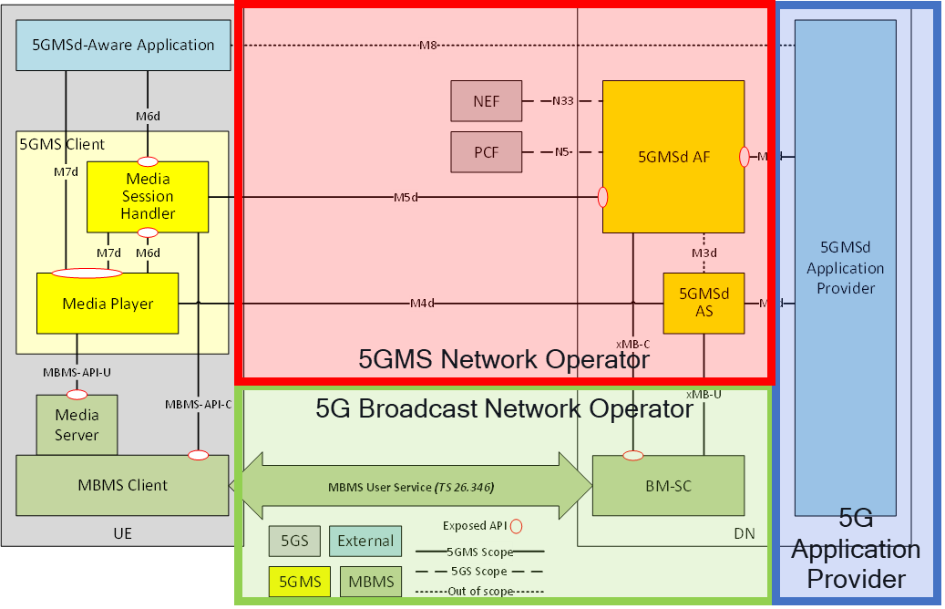
Figure C.3-1: Collaboration 5GMS-MBMS 2: 5GMS Network Operator offloads to 5G Broadcast Network Operator

C.4 Collaboration 5GMS-MBMS 3: 5GMS Service Operator includes MBMS network
Figure C.4-1 show collaboration 5GMS-MBMS 3: 5GMS Service Operator includes MBMS network.
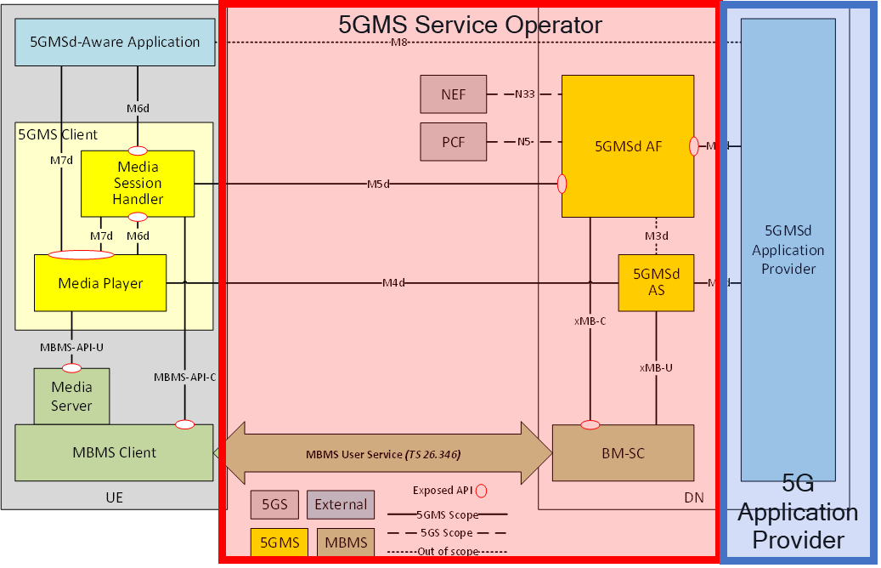
Figure C.4-1: Collaboration 5GMS-MBMS 3: 5GMS Service Operator includes MBMS network

C.5 Collaboration 5GMS-MBMS 4: 5G Broadcast Service Provider offloads to 5G MNO
Figure C.5-1 shows collaboration 5GMS-MBMS 4: 5G Broadcast Service Provider offloads to 5G MNO.
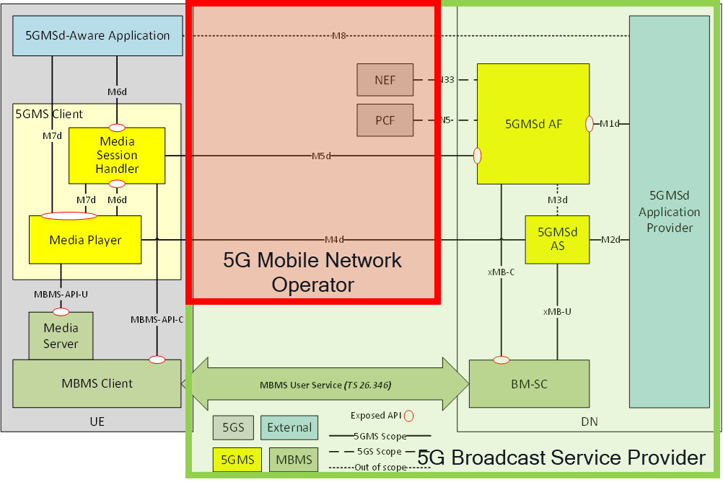
Figure C.5-1: Collaboration 5GMS-MBMS 4: 5G Broadcast Service Provider offloads to 5G MNO

