3GPP TSG SA WG4#116e S4-211xxx
E-meeting, 10th – 19th November 2021
CR-Form-v12.1
PSEUDO CHANGE REQUEST
 | 26.998 | CR |  | rev |  | Current version: | 1.0.3
For HELP on using this form: comprehensive instructions can be found at
http://www.3gpp.org/Change-Requests.

Proposed change affects: | UICC apps |  | ME |  | Radio Access Network |  | Core Network

Title: | [FS_5GSTAR] On Spatial Computing
Source to WG:
Source to TSG:
Work item code: | FS_5GSTAR |  |  |  |  |  | Date: |  |  | 2021-11-02
Category: | C |  |  |  |  |  | Release: |  |  | Rel-17
 | Use one of the following categories:  F (correction)  A (mirror corresponding to a change in an earlier release)  B (addition of feature),  C (functional modification of feature)  D (editorial modification)  Detailed explanations of the above categories can  be found in 3GPP TR 21.900. |  |  |  |  |  |  |  | Use one of the following releases:  Rel-8 (Release 8)  Rel-9 (Release 9)  Rel-10 (Release 10)  Rel-11 (Release 11)  …  Rel-15 (Release 15)  Rel-16 (Release 16)  Rel-17 (Release 17)  Rel-18 (Release 18)
Reason for change:
Summary of change:
Consequences if not approved:
Clauses affected:
 |  | Y | N
Other specs |  |  |  | Other core specifications |  |  |  | TS/TR ... CR ...
affected: |  |  |  | Test specifications |  |  |  | TS/TR ... CR ...
(show related CRs) |  |  |  | O&M Specifications |  |  |  | TS/TR ... CR ...
Other comments:
This CR's revision history:

===== CHANGE =====

3.1 Definitions
Spatial Computing: AR functions which process sensor data to generate information about the world 3D space surrounding the AR user. It includes functions such as SLAM for spatial mapping (creating a map of the surrounding area) and localization (establishing the position of users and objects within that space), 3D reconstruction and semantic perception. Spatial computing functions require XR spatial description and may result in updates to the XR spatial description.
XR spatial description: a data structure describing the spatial organisation of the real world using anchors, trackables, camera parameters and visual features. It is a meta specification of the real environment including the information for the estimation of the position and orientation (pose estimation) of AR devices for the purpose of registration, tracking and positioning, and provides a coordinate reference system in relation to the real world.
XR spatial compute server: is an edge or cloud server that provides spatial computing AR functions.
XR spatial description server: is a cloud server for storing, updating and retrieving XR spatial description.

===== CHANGE =====

4.2.1 Device Functions
AR glasses contain various functions that are used to support a variety of different AR services as highlight by the different use cases in clause 5. AR devices share some common functionalities in order to create AR/XR experiences. Figure 4.2.1-1 provides a basic overview of the relevant functions of an AR device.
The primary defined functions are
- AR/MR Application: a software application that integrates audio-visual content into the user’s real-world environment.
- AR Runtime: a set of functions that interface with a platform to perform commonly required operations such as accessing controller/peripheral state, getting current and/or predicted tracking positions, and submitting rendered frames.
- Media Access Function: A set of functions that enables access to media and other AR related data that is needed in the scene manager or AR Runtime in order to provide an AR experience. In the context of this report, the Media Access function typically uses 5G system functionalities to access media.
- Peripheries: The collection of sensors, cameras, displays and other functionalities on the device that provide a physical connection to the environment.
- Scene Manager: a set of functions that supports the application in arranging the logical and spatial representation of a multisensorial scene based on support from the AR Runtime.

Figure 4.2.1-1: 5G AR Device Functions
The various functions that are essential for enabling AR glass-related services within an AR device functional structure include:
a) Tracking and sensing (assigned to the AR Runtime)
- Inside-out tracking for 6DoF user position
- Eye Tracking
- Hand Tracking
- Sensors
b) Capturing (assigned to the peripheries)
- Vision camera: capturing (in addition to tracking and sensing) of the user’s surroundings for vision related functions
- Media camera: capturing of scenes or objects for media data generation where required
NOTE: vision and media camera logical functions may be mapped to the same physical camera, or to separate cameras. Camera devices may also be attached to other device hardware (AR glasses or smartphone), or exist as a separate external device.
- Microphones: capturing of audio sources including environmental audio sources as well as users’ voice.
c) AR Runtime functions
- XR Spatial Compute: AR functions which process sensor data to generate information about the world 3D space surrounding the AR user. It includes functions such as SLAM for spatial mapping (creating a map of the surrounding area) and localization (establishing the position of users and objects within that space), 3D reconstruction and semantic perception.
- Pose corrector: function for pose correction that helps stabilise AR media when the user. Typically, this is done by asynchronous time warping (ATW) or late stage reprojection (LSR).
d) Scene Manager
- Scene graph handler: a function that supports the management of a scene graph that represents an object-based hierarchy of the geometry of a scene and permits interaction with the scene.
- Compositor: compositing layers of images at different levels of depth for presentation
- Immersive media renderer: the generation of one (monoscopic displays) or two (stereoscopic displays) eye buffers from the visual content, typically using GPUs. Rendering operations may be different depending on the rendering pipeline of the media, and may include 2D or 3D visual/audio rendering, as well as pose correction functionalities. Also includes rendering of other senses such as audio or haptics.
e) Media Access Function includes
- Tethering and network interfaces for AR/MR immersive content delivery
- The AR glasses may be tethered through non-5G connectivity (wired, WiFi)
- The AR glasses may be tethered through 5G connectivity
- The AR glasses may be tethered through different flavours for 5G connectivity
- Content Delivery: Connectivity and protocol framework to deliver the content and provide functionalities such as synchronization, encapsulation, loss and jitter management, bandwidth management, etc.
- Digital representation of scene graphs and XR spatial descriptions
- Codecs to compress the media provided in the scene.
- 2D media codecs
- Immersive media decoders: media decoders to decode compressed immersive media as inputs to the immersive media renderer. Immersive media decoders include both 2D and 3D visual/audio media decoder functionalities.
- Immersive media encoders: encoders providing compressed versions of visual/audio immersive media data.
- Media Session Handler: A service on the device that connects to 5G System Network functions, typically AFs, in order to support the delivery and QoS requirements for the media delivery. This may include prioritization, QoS requests, edge capability discovery, etc.
- Other media-delivery related functions such as security, encryption, etc.
f) Physical Rendering (assigned to the peripheries)
- Display: Optical see-through displays allow the user to see the real world “directly” (through a set of optical elements though). AR displays add virtual content by adding additional light on top of the light coming in from the real-world.
- Speakers: Speakers that allow to render the audio content to provide an immersive experience. A typical physical implementation are headphones.
g) AR/MR Application with additional unassigned functions
- An application that makes use of the AR and MR functionalities to provide a AR user experience.
- Semantic perception: process of converting signals captured on the AR glass into semantical concept. Typically uses some sort of Artificial Intelligence (AI) and/or Machine Learning (ML). Examples include object recognition, object classification, etc.

4.2.2 Generic reference device functional structure device types

4.2.2.1 Overview
Figure 4.2.2.2-1 provides a functional structure for Type 1: 5G STandalone AR (STAR) UE.

Figure 4.2.2.2-1: Functional structure for Type 1: 5G STandalone AR (STAR) UE
Main characteristics of Type 1: 5G STandalone AR (STAR) UE:
- The STAR UE is a regular 5G UE. 5G connectivity is provided through an embedded 5G modem.
- The AR Runtime is local and uses input from sensors, audio inputs or video inputs. XR Spatial compute is primarily local, but may access or share information on the network.
- The AR Scene Manager is local and provides immersive rendering capabilities. Support of compute on the network may be provided, but scenes may typically be composed on the UE.
- The AR/MR application is resident on the device.
- An AR/MR application provider is providing a service and the service may be supported/assisted by network-based AR functions and rendering.
- Due to the amount of processing required, such devices are likely to require a higher power consumption in comparison to the other device types.
- As the device includes all UE functionalities, the application resides and pre-dominantly is executed on the device and all essential AR/MR functions are available for typical media processing use cases, the device referred to as STandalone AR (STAR) UE.
- Media Access Functions are provided that support the delivery of media content components over the 5G system. For details refer to clause 4.2.5.
- The application may also communicate though the 5G System using a dedicated interface.

4.2.2.3 Type 2: 5G EDGe-Dependent AR (EDGAR) UE
Figure 4.2.2.3-1 provides a functional structure for Type 2: 5G EDGe-Dependent AR (EDGAR) UE.
Figure 4.2.2.3-1: Functional structure for Type 2: 5G EDGe-Dependent AR (EDGAR) UE
Main characteristics of Type 2: 5G EDGe-Dependent AR (EDGAR) UE:
- The 5G EDGAR UE is a regular 5G UE. 5G connectivity is provided through an embedded 5G modem and 5G System components.
- The AR Runtime is local and uses data from sensors, audio inputs or video inputs. The AR Runtime, in particular the XR spatial compute may be assisted by the cloud/edge application for example spatial localization and mapping provided by a spatial computing service.
- Media processing is local, the device needs to embed all media codecs required for decoding pre-rendered 2D view.
- A Lightweight Scene Manager is local to the AR/MR device, but the main scene management and composition is done on the cloud/edge. A scene description is generated and exchanged to establish the split work flow.
- The main AR/MR application resides on the cloud/edge, but a basic application functionality is on the UE to support regular UE functionalities and launching services and applications.
- Power consumption on such glasses must be low enough to fit the form factors. Heat dissipation is essential.
- Media Access Functions are provided that support the delivery of media content components over the 5G system, in particular cloud and split rendering supporting functions. Media Access Functions are divided in control on M5 (Media Session Handler and Media AF) and user data on M4 (Media Client and Media Application Server). Detailed requirements are for study in this report.
- While the EDGAR UE may have additional functionalities, for example those available in a STAR UE, generally for media centric or compute heavy use cases processing needs to be supported by the edge, hence referred to as EDGe-Dependent AR (EDGAR) UE.
- The application may also communicate though the 5G System using a dedicated interface.

4.2.2.4 Type 3: 5G WireLess Tethered AR UE
This clause introduces the 5G WireLess Tethered AR UE. Two sub-types are differentiated:
- Split Rendering WLAR UE. In this case the 5G phone that includes the modem also acts to support rendering of complex scenes and provides the pre-rendered data to the glass
- Relay WLAR UE: In this case, the 5G phone acts as a relay to provide IP connectivity.
Figure 4.2.2.4-1 provides a functional structure for Type 3a: 5G Split Rendering WireLess Tethered AR UE.
Figure 4.2.2.4-1: Functional structure for Type 3a: 5G Split Rendering WireLess Tethered AR UE
Main characteristics of Type 3a: 5G Split Rendering WireLess Tethered AR UE:
- 5G connectivity is provided through a tethered device which embeds the 5G modem. Wireless tethered connectivity is provided through WiFi or 5G sidelink. BLE (Bluetooth Low Energy) connectivity may be used for audio. The motion-to-render-to-photon loop runs from the glass to the phone. While the connectivity is outside of the 5G Uu domain, it is still expected that for proper performance when used for split rendering, a stable and constant delay link may be setup on the tethered connection.
- The AR Runtime is local and uses from sensors, audio inputs or video inputs, but may be assisted by functionalities on phone.
- While media processing (for 2D media) may be done on the AR glasses, energy intensive AR/MR media processing may be done on the AR/MR tethered device or split.
- Some devices might have limited support for immersive media decoding and rendering and may need to rely on 5G cloud/edge
- While such devices are likely to use significantly less processing than Type 1: 5G STAR devices by making use of the processing capabilities of the tethered device, they still support a lot of local media and AR/MR processing. Such devices are expected to provide 8-10h of battery life while keeping a significantly low weight.
- The tethered glass itself is not a regular 5G UE, but the combination of the glass and the phone results in a regular 5G UE.
- Media Access Functions are provided that support the delivery of media content components over the 5G system. Examples of the Media Access Functions are 5GMS functions, MTSI functions, web-connectivity or edge-related client functions. Detailed requirements are for study in this report.
Figure 4.2.2.4-2 provides a functional structure for Type 3b: 5G Relay WireLess Tethered AR UE.
Figure 4.2.2.4-2: Functional structure for Type 3b: 5G Relay WireLess Tethered AR UE
Main characteristics of Type 3b: 5G Relay WireLess Tethered AR UE:
- 5G connectivity is provided through a tethered device which embeds the 5G modem. Wireless tethered connectivity is through WiFi or 5G sidelink. BLE (Bluetooth Low Energy) connectivity may be used for audio.
- The 5G Phone acts as a relay to forward IP packets. The 5G Phone runs a Media Session Handler including EDGE functionalities to support QoS control on the 5G System. To support proper end-to-end QoS, the media session handling needs to take into account the constraints of the tethering link to provide sufficient QoS on the 5G System link to provide adequate QoE for the end user. Details on the exact function of the relay, for example of it is on IP layer (layer 3) or on lower layer is for further study.
- Media Access functions are provided on the glass device to support the delivery of media content components over the 5G and wireless tethered link.
- The motion-to-render-to-photon loop runs from the glass to the edge and hence includes in total 4 wireless links. It is expected that for proper performance when used for split rendering, a stable and constant delay end to end link needs to be setup.
- The AR Runtime is local and uses from sensors, audio inputs or video inputs, but may be assisted by functionalities on phone.
- Media Processing is either done on the glass device or it is split with the network. In particular, relevant is that many devices have limited support for immersive media decoding and rendering and may need to rely on 5G cloud/edge.
- While such devices are likely to use significantly less processing than Type 1: 5G STAR devices by making use of the processing capabilities of the tethered device, they still support a lot of local media and AR/MR processing. Such devices are expected to provide 8-10h of battery life while keeping a significantly low weight.
- The tethered glass itself is not a regular 5G UE, but the combination of the glass and the phone results in a regular 5G UE.
- For services with low latency requirements, such as MTSI or those provided by FLUS, it may be necessary to take the status of wireless connectivity into account when configuring the services, such that the link between AR glass and 5G phone is not overly loaded. How to coordinate the operation of Uu and wireless connectivity in such services is FFS [3].
===== CHANGE =====

4.2.3 AR Runtime
The AR Runtime is a device-resident software or firmware that implements a set of APIs to provide access to the underlying AR/MR hardware. These APIs are referred to as AR Runtime APIs. An AR Runtime typically provides the following functions:
- System capability discovery: allows applications to discover capabilities of the AR glasses
- Session management: manages an AR session and its state

- Input and Haptics: receives information about user’s actions, e.g. through usage of trackpads, and passes that information to the application. On request by the application, it may trigger haptics feedback using the AR glasses and associated hardware.
- Rendering: synchronizes the display and renders the composited frame onto the AR glasses displays.
- Spatial Computing: processes sensor data to generate information about the world 3D space surrounding the AR user. Spatial computing includes functions such as
- Tracking to estimate the movement of the AR device at a high frequency
- Relocalisation to estimate the pose of the AR device at initialization, when tracking is lost or regularly to correct the drift of the tracking.
- Mapping, for reconstructing the surrounding space, for example through triangulation of identified points. This reconstruction can be sparse for localization purposes, or dense for visualization.
- A combination of tracking, mapping and relocalization functions, for example through Simultaneous Localization and Mapping (SLAM) to build a map of the environment and establish the position of users and objects within that environment
- Identification of key points in camera frames
- Registration and Tracking: creates XR spaces, registers to local environment, tracks reference spaces and objects throughout the lifetime of the AR session. This information is provided to the application on request.
- Simultaneous Localization and Mapping (SLAM) to build a map of the environment and establish the position of users and objects within that environment
- 3D reconstruction of the surrounding space, for example through triangulation of identified points.
- Semantic perception: to process the captured information into a semantical concept, typically uses some sort of Artificial Intelligence (AI) and/or Machine Learning (ML). Examples include object or user activity segmentation, recognition, and classification.
Spatial computing functions typically include data exchange and requires network architecture. Clause 4.2.5 provides more details on XR Spatial computing.
AR runtimes are usually extensible to add support for a wide range of AR glasses and controllers that are on the market or that might be released in the future. This will allow different vendors to add custom functionality such as gaze tracking, hand control, new reference spaces, etc.
Two key representative and standardized AR runtime APIs are Khronos defined OpenXR [4] and W3C defined WebXR [5]. More details are provided in clause 4.6.4.

===== CHANGE =====

4.2.5 XR Spatial Computing
XR Spatial Computing summarizes functions which process sensor data to generate information about the world 3D space surrounding the AR user. It includes functions such as SLAM for spatial mapping (creating a map of the surrounding area) and localization (establishing the position of users and objects within that space), 3D reconstruction and semantic perception. This requires accurately localizing the AR device worn by the end-user in relation to a spatial coordinate system of the real-world space. Vision-based localization systems reconstruct a sparse spatial mapping of the real-world space in parallel (e.g. SLAM). Beyond the localization within a world coordinate system based on a sparse spatial map, additionally dense spatial mapping of objects is essential in order to place 3D objects on real surfaces, but also provides the ability to occlude objects behind surfaces, doing physics-based interactions based on surface properties, providing navigation functions or providing a visualization of the surface. Thirdly, for the purpose of understanding and perceiving the scene semantically, machine-learning and/or artificial intelligence may be used to provide context of the observed scene. The output of spatial computing is spatial mapping information that is organized in a data structure called the XR spatial description for storing and exchanging the information. Further details XR spatial description can be found in section 4.4.7.

XR Spatial compute processes may be carried out entirely on the AR device. However, it may be beneficial or necessary to use cloud or edge resources to support spatial computing functions. At least two primary scenarios may be differentiated:
- spatial computing is done on the AR device but an XR spatial description server is used for storage and retrieval of XR spatial description.
- At least parts of the spatial compute functions is offloaded on the XR Spatial compute server
Both cases are discussed further in the following.
Typically, the device can store a certain amount of XR spatial description locally on the device. However, in particular to create a world-experience, the AR device may not be able to store all information related to XR spatial description on the device, and hence, such information may continuously be updated by downloading or streaming updated information from an XR Spatial Description server as shown in Figure 4.2.5-1. In addition, the device may use personalized storage on the cloud to offload device-generated XR spatial information components. This may for example include so-called key frames, i.e. frames that are useful to provide accurate spatial mapping with relevant key points.

The architecture in Figure 4.2.5-1 relates to the case for XR Spatial computing is done standalone on the device, and hence we refer to this as STAR architecture in context of XR Spatial computing.

Figure 4.2.5-1 Functional diagram for XR spatial computing with network/cloud support

If the device is limited in processing power, or if complex XR compute functionalities needs to be carried out, the XR compute function on the device may be assisted by or even depend on compute resources in the network, for example on the edge or cloud. This is shown in

Figure 4.2.5-2 provide a basic architecture for the case where XR spatial computing is delegated partially or completely to an XR spatial computing edge server.
- The device sends sensor data or pre-processed sensor data (e.g. capture frames or visual features extracted from such frames) to the XR spatial compute server.
- The XR spatial compute server carries out supporting functions to extract relevant information and returns directly AR Runtime data (according to the AR Runtime API) or pre-computed information XR Spatial information that is used by a lightweight XR spatial compute function on the device to create AR Runtime API data. Pre-computed XR Spatial information may for example be dense map of segmented objects for visualization, labels or id of recognized objects, 2D contours of recognized object to highlight them, label of the recognized user activity.
- The XR spatial edge compute server may further fetch the XR spatial description from the XR spatial description server and performs spatial computing based on device sensor data.

Figure 4.2.5-2 Functional diagram for spatial computing with XR spatial compute edge

The architecture in Figure 4.2.5-2 relates to the case for XR Spatial computing depends on an edge device, and hence we refer to this as EDGAR architecture in context of XR Spatial computing.
===== CHANGE =====

4.2.6 5G Media Access Function
The Media Access Function supports the AR UE to access and stream media. For this purpose, a Media Access Function as shown in Figure 4.2.5-1 includes:
- Codecs: are used to compress and decompress the rich media. In several cases, not only a single instance of a codec per media type is needed, but multiple ones.
- Digital representations for scene description and XR spatial description
- Content Delivery Protocol: Container format and protocol to deliver media content between the UE and the network according to the requirements of the application. This includes timing, synchronization, reliability, reporting and other features.
- 5G connectivity: a modem and 5G System functionalities that allow the UE to connect to a 5G network and get access to the features and service offered by the 5G System.
- Media Session Handler: A generic function on the device to setup 5G System capabilities. This may setup edge functionalities, provide QoS support, support reporting, etc.
- Content protection and decryption: This function handles protection of content from being played on unauthorized devices.
Functions are needed in both uplink and downlink, depending on use cases and scenarios.
Example for Media Access Functions are
- 5GMSd client that includes a Media Session Handler and a Media Player as defined in TS 26.501 and TS 26.512.
- 5GMSu client that includes a Media Session Handler and a Media Streamer as defined in TS 26.501 and TS 26.512.
- A real-time communication client that includes either uplink or downlink, or both to support more latency critical communication services.
- A combination of the above based on the needs of the XR application. An XR scene may have a mix of static, streaming, and real-time media that require the usage of multiple transport channels and protocol stacks.
In all cases, the basic function of Media Session Handler and a delivery client (which includes content delivery protocols and codecs) is expected to be maintained. The Media Session Handler is a generic function to support 5G System integration.
As a subject of this report, the needs to support different types of instantiations is for codecs, delivery protocols, session handling is identified. Not all components are necessarily required for all scenarios and even further, not all functions may be available on all device types.
Figure 4.2.5-1 Media Access function for AR

===== CHANGE =====

4.3 Basic Processes in an AR Session

4.3.1. Introduction
In this clause we provide a generic workflow for setting up an AR session. We differentiate two types of sessions:
- AR scene session: A session - for accessing a scene and related media over the network. This basically uses the MAF as well as the scene manager as well as the corresponding network functions. Details are introduced clause 4.3.2.
- XR spatial compute session: A session that uses sensor data to provide an understanding of the physical space surrounding the device to determine the device’s position and orientation and placement of AR objects in reference to the real world and uses XR Spatial Description information from the network to support this process. This uses the XR Spatial description functions as introduced in clause 4.2.6. Details are introduced in clause 4.3.3.
Each of the session typically runs independently, but information may be exchanged on the device or in the network, typically moderated by the application.

4.3.2 AR Scene Session

In this clause, we provide basic processes and generic workflow description for setting up AR Media sessions for media is accessed over the network. This generic basic process may be extended to address specific applications and use cases. The call flow as shown in Figure 4.3-1 aligns with the STAR/EDGAR architecture and serves as a baseline for defining use-case specific call flows.
Figure 4.3-1: Basic workflow for AR media sessions
A description of the steps of the general workflow is provided as follows:
1. The application contacts the application provider to fetch the entry point for the content. The acquisition of the entry point may be performed in different ways and is considered out of scope. An entry point may for example be a URL to a scene description.
2. The application initializes the Scene Manager using the acquired entry point.
3. The Scene Manager retrieves the scene description from the scene provider based on the entry point information. It then establishes a scene session with the scene provider.
4. The Scene Manager parses the entry point and creates the immersive scene.
5. The Scene Manager requests the creation of a new AR/MR session from the AR Runtime.
6. The AR Runtime creates a new AR/MR session and performs registration with the local environment.
7. The Scene Manager will inform the MAF about its QoS and compute needs
8. The MAF will request the Media Delivery Functions, such as AF, in the network to allocate the requested resources.
9. For each component or group of components of an object/node in the scene:
a. the Scene Manager triggers the MAF to fetch the related media
b. the MAF creates a dedicated media pipeline to process the input.
c. the MAF establishes a transport session for each component of the media object.
10. The application starts the media fetching and rendering loop
a. the MAF may receive updates to the scene description from the scene provider.
b. the MAF passes the scene update to the Scene Manager.
c. the Scene Manager updates the current scene.
d. The Scene Manager acquires the latest pose information and the user’s actions
e. The Scene Manager shares that information with the AR/MR application on the server
f. For each object:
i. The media pipeline fetches the media data. It could be static, segmented, or real-time media streams
ii. The media pipeline processes the media and makes it available in buffers
g. For each object to be rendered:
i. The Scene Manager gets processed media data from the media pipeline buffers
ii. The Scene Manager reconstructs and renders the object
h. The Scene Manager passes the rendered frame to the AR/MR Runtime for display on the user’s HMD.

4.3.2. XR Spatial Computing Session

A generic call flow for with XR spatial compute edge and remote rendering is shown in Figure 4.3.2-3

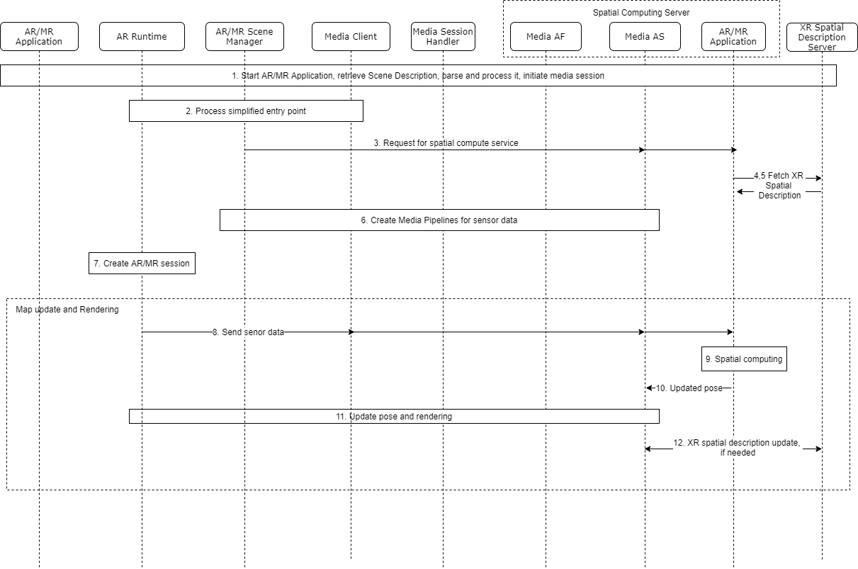

Figure 4.3.2-3 Functional diagram for spatial computing with XR spatial compute edge

Step 1: UE starts an AR application. Steps 1-9 of Figure 4.3.1. From the scene graph, the entry point is processed.
Step 3: From the anchor references defined in the scene graph, the AR/MR Scene Manager will request for XR spatial computing from a cloud/edge based Spatial Computing Server.
Step 4,5: The Spatial Computing Server requests the XR spatial description from the World Map Server and receives it. This XR spatial description includes the anchors referenced in the scene graph as well as all the children nodes with leaves corresponding to trackables (with their features).
Step 6: The pipelines are configured for sensor data.
Step 7: The AR/MR scene is created.
Map update and rendering: The following steps run continuously during the session.
Step 8: The AR Runtime on the device will transmit images captured by the embedded vision sensors to the Spatial Computing Server, ideally at the capture frequency (~60Hz). Alternatively it may send visual features instead of full images.
Step 9: The Spatial Computing Server will receive these images and based on the XR spatial description stored in cache, it will be able to estimate the pose of the AR device using the features attached to trackables available in the world subgraph. 3D transforms between trackables and anchors will allow to provide the pose of the AR device in a common reference coordinate system of the real world.
Step 10. The Spatial Computing Server provides the spatial position (AR device pose in reference to the real world) to the remote rendering service running also into the cloud which will render the AR scene including AR assets from a viewpoint corresponding to the real pose of the AR device. If remote rendering is not used pose is sent to AR Runtime.
Step 11: The remote rendering service will transmit the rendered images according to the pose to the UE for displaying them to the end-user.
Step 12: The spatial compute server may send/receive updates in XR spatial description from the XR spatial description server.

===== CHANGE =====

4.4.7 XR Spatial Description

4.4.7.1 Overview
XR spatial description is a data structure (typically a scene graph) describing the spatial organisation of the real world using:
- Visual features and 3D Maps
- Spatial anchors and trackables
- camera parameters as defined in 4.4.3.2
It is a meta specification of the real environment including the information for the estimation of the position and orientation (pose estimation) of AR devices for the purpose of registration, tracking and positioning, and provides a coordinate reference system in relation to the real world. It is used for spatial computing as described in section 4.3.2.
XR spatial description data is downloaded and updated periodically from a XR Spatial Description Server, which may be an AR/MR Application provider. It can be updated by sending an XR Spatial description update (e.g., updated visual features or keyframes attached to camera parameters) from an AR device or an XR spatial compute server to the XR Spatial Description Server.
The size of the XR spatial description depends on several parameters, such as, size of the area covered by the XR application, number of supported viewpoints in the area, etc. The size may be from 10MB for a small room to several hundred MBs for a building. The frequency of updates may depend on the application.
Formats:
ETSI ARF uses the term World Graph for XR spatial description. It defines the relative position of AR Assets, Trackables and World Anchors by 3D Transforms. A world graph is a kind of scene graph including trackables (embedding their features), and anchors representing the real world. Thus, the AR device can detect, recognize, and estimate its pose in relation to trackables thanks to their features, and based on the 3D transforms defined in the World graph, it can estimate its pose in relation to anchors (to which AR assets will be attached). [21]. Requirements for XR spatial description are also under consideration in MPEG for using a scene graph for real-world mapping possibly as a glTF extension. Currently only proprietary implementations exist for XR spatial description.

4.4.7.2 Camera and sensor information

2D :
LiDAR.
Depth
3D ToF
3D
Sound

4.4.7.3 Visual features and Spatial Maps
Describe details, surfaces, meshes? etc.
Visual features are characteristics of a real world element that can be searched, recognized or tracked in frames captured from an AR device visual sensor as it moves in a real environment, using Simultaneous Localization And Mapping approach (SLAM). They are the overlapping points that are recognizable in multiple images of the real environment. Visual features are extracted from frames from a single moving camera or multiple cameras in SLAM systems. A 3D Map, sparse or dense point cloud, of the real world can be generated from keyframes (selected frames used for triangulation of features) and their matched visual features. The keyframes must be attached to camera information defined in 4.4.3.2 to triangulate 3D points correctly from multiple cameras. This mapping process can be performed either at runtime or offline. A 3D map is then used at runtime to relocalize and thus register the AR device by matching the features extracted from the current image with the ones stored in the previously built 3D map. The mapping approach is one of well-known keyframe-based SLAM techniques [X].
Add to references [X] https://arxiv.org/abs/1607.00470
Therefore, a spatial map consists of spatial visual features (e.g. 3D points associated with their descriptor such as SIFT [XX], SURF [XXX], ORB [XXXX]) and additional information to match them with features extracted at runtime from the sensor data (2D or 3D depending on sensor capabilities). Note that the 2D-3D (e.g for RGB or B&W cameras) or 3D-3D (e.g. for depth sensors) feature matching is widely used to estimate the pose of the sensor (using a Perspective-n-Points algorithm), and thus of the AR device. Note that 3D-3D feature matching can also be implemented for depth sensors.
For this reason a 3D Map consists at least of:
- A spatial feature cloud, e.g. 3D points (Vector of 3 float) with their associated descriptors such as SIFT [XX], SURF, ORB. These descriptors are generally vectors of numbers (e.g vector of 128 floats for SIFT, vector of 64 floats for SURF, vector of 32 integers for ORB). Note that other features such as 3D segments can be also used.
But additionally, to speed-up the 2D-3D matching process, a 3D map generally includes:
- Information required for keyframe retrieval. For example, a keyframe retrieval can use Bag-Of-visual-Words (BoW) model. In this case, the information consists of the vocabulary of the BoW model and corresponding descriptor for each keyframe (vector of occurrence counts of a vocabulary in the keyframe). Depending on the visual descriptor used, the vocabulary size is usualy a few dozen Mb, and this vocabulary can be reused for any 3D map using the same vocabulary.
- The 2D features for each keyframes (e.g. 2D points with their associated descriptors such as SURF, SIFT, ORB represented by a vector of numbers). The number of features exracted per keyframe varies between 200 and 1000.
- The matches between 2D features of keyframes and 3D features of the spatial feature cloud.
Thanks to this additional information, instead of comparing all descriptors of 2D features extracted from the current frame with all spatial feature descriptors, resulting in a very high complexity, the vision based localization system can:
- Match the closest keyframe to the current frame by retrieving it with the BoW model,
- Match the 2D features between the current frame and the retrieved keyframe,Match the 2D features between the current frame and spatial feature cloud (knowing matches between 2D features of the keyframes and 3D features of the spatial feature cloud).
Add to reference [XX] https://www.cs.ubc.ca/~lowe/papers/ijcv04.pdf
Add to reference [XXX] https://people.ee.ethz.ch/~surf/eccv06.pdf
Add to reference [XXXX] https://ieeexplore.ieee.org/document/6126544
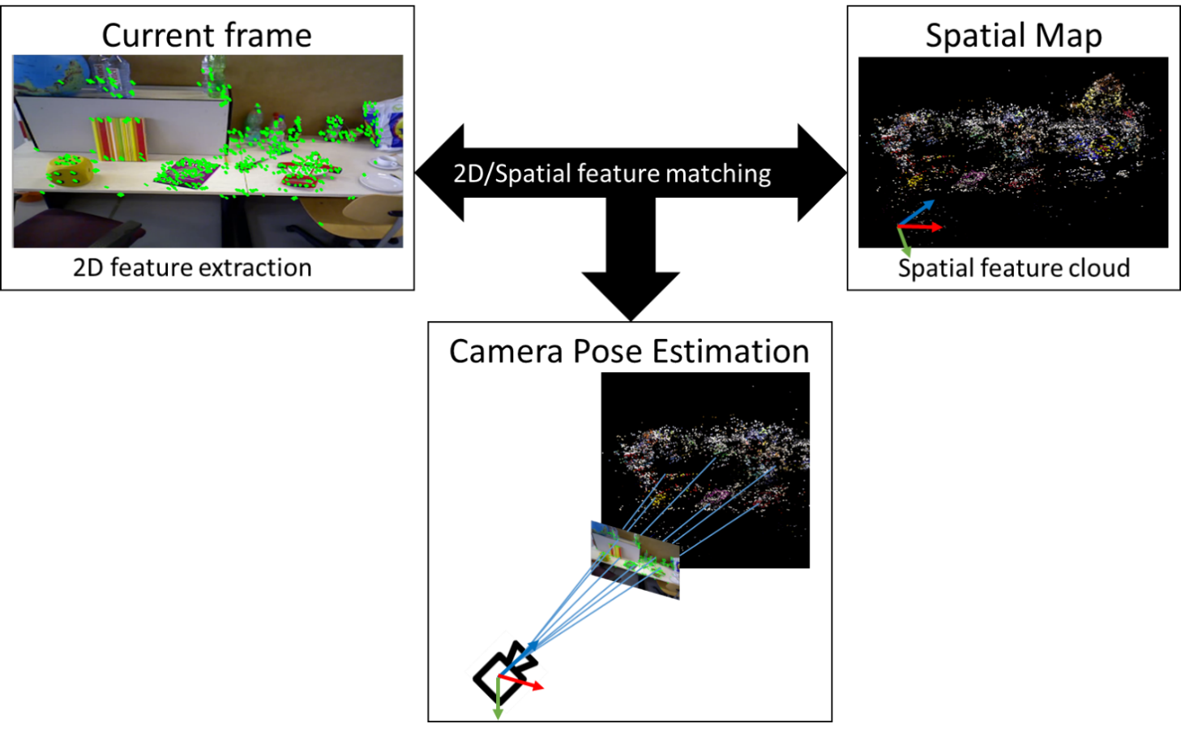

4.4.7.4 Spatial Anchors and Trackables
AR objects can be positioned in reference to the real world (e.g., placing a vase on a table) using spatial anchors. A spatial anchor provides a fixed position and orientation in the real world based on a common frame of reference that can be used by multiple AR devices. Spatial anchors should refer to trackables for accurate positioning relative to the physical space. Spatial anchors can also be used alone (not referring to trackable) if global coordinates are used. In this case, the anchors are treated as global anchors without trackable as they have global coordinates which positions can be determined.

Trackables are elements of the real world of which features (visual or non-visual) are available and/or could be extracted. A 3D Map trackable, for instance, may define a full environment composed of a floor walls, furnitures in the real world consisting of several 3D points with visual features. However, there are other types of trackables as well. For example:
- A controller with LEDs that can be tracked by an AR headset’s vision sensor. The feature in this case is the constellation of LEDs.
- A fiducial marker that is detected as a black and white pattern by an AR device vision sensor. The feature in this case is the black and white pattern.
- Hands visible through an AR headset’s vision sensor. The feature is a learnt model for hands.
All of the above examples give a position of the trackable in reference to the position of the sensor (generally embedded in the AR headset). A spatial description data structure describing the spatial organisation of the real world using anchors, trackables, camera parameters and visual features can be used for exchanging spatial data and updates between AR Runtime and spatial compute server.
..

