3GPP TSG-SA4 meeting #113-e S4

Electronic Meeting, 6th-14th April, 2021 revision of S4-210623
CR-Form-v12.0
PSEUDO CHANGE REQUEST
 | TR 26.803 | CR | – | rev | – | Current version: | 0.5.1
For HELP on using this form: comprehensive instructions can be found at
http://www.3gpp.org/Change-Requests.

Proposed change affects: | UICC apps |  | ME |  | Radio Access Network |  | Core Network | X

Title: | Call flow for EAS relocation based on the EMSA architecture
Source to WG: | Huawei Technologies Co. Ltd
Source to TSG: | S4
Work item code: | FS_EMSA |  |  |  |  |  | Date: |  |  | 2021-3-31
Category: | F |  |  |  |  |  | Release: |  |  | Rel-17
Use one of the following categories:
F (correction)
A (mirror corresponding to a change in an earlier release)
B (addition of feature),
C (functional modification of feature)
D (editorial modification).
Reason for change: |  | the EAS relocation based on the EMSA architecture is missing.
Summary of change: |  | Add the EAS relocation analysis and generic call flows.
Consequences if not approved:
Clauses affected: |  | 6.4
 |  | Y | N
Other specs |  |  | X | Other core specifications
affected: |  |  | X | Test specifications
(show related CRs) |  |  | X | O&M Specifications
Other comments:
This CR's revision history:

FIRST CHANGE

6.4 Call Flows for EAS relocation

6.4.1 Introduction
Under certain circumstances, it is necessary to relocate an EAS instance to a different edge location. In such cases, it may also be necessary to relocate the application context currently associated with the EAS instance to support service continuity.
The EAS relocation procedure may be triggered for the following reasons:
- UE mobility, including predictive or expected UE mobility.
- Overload situations in the EAS or EDN.
- Maintenance aspects, such as graceful shutdown of an EAS.
- Temporal edge resource requirements, for example, the application need an EAS with new capability which is not available in the current one.
According to the procedures for service continuity defined by SA6 in clause 8.8 of TS 23.558 [3], three principal actors are involved in Application Context Relocation (ACR):
- ACR detection entity
- ACR decision entity.
- ACR execution entity.
Depending on the different functional entities responsible for detection, decision and execution, there are five different scenarios for the EAS relocation procedure.

The complete set of call flows are depicted together in figure 6.4.1-1 below.

In all cases, the edge-enabled 5G Media Streaming sessions are established via the call flow defined in clause 6.3.
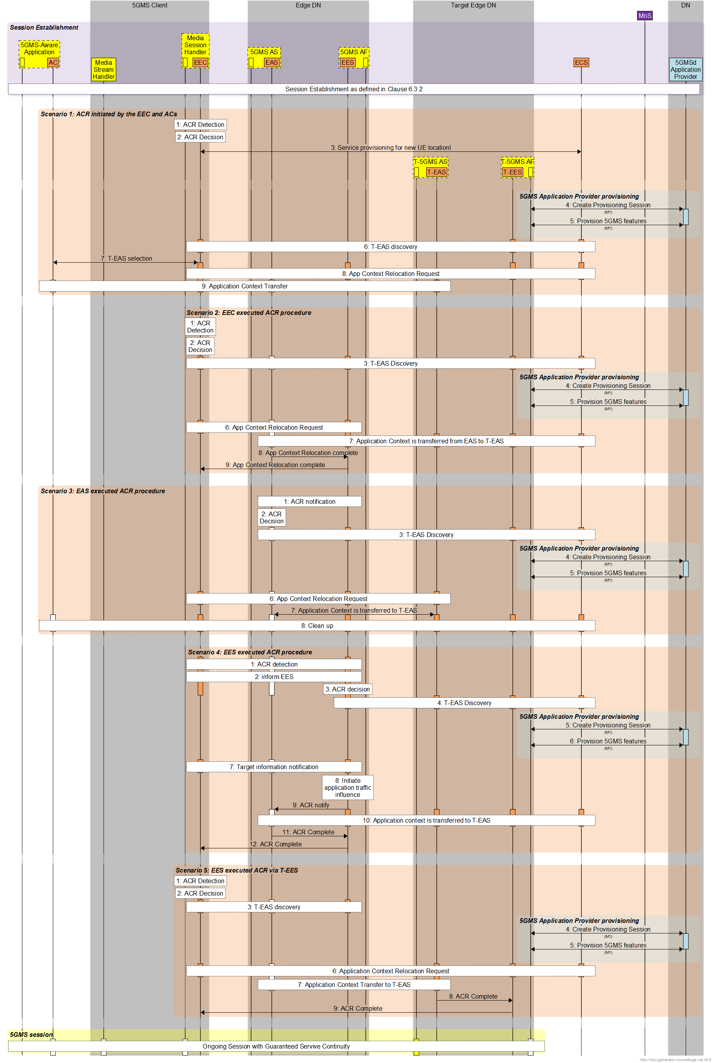
Figure 6.4.1-1: EAS relocation scenarios in 5GMS edge processing

6.4.2 Scenario 1: EAS relocation decided by EEC

6.4.2.1 High-level call flow
In case of UE mobility to a new location which is outside the service area of the serving EAS, the EEC and ACs in this scenario realize their location has changed and decide to initiate the Application Context Relocation procedure to a more appropriate target EAS instance, including ACR detection, decision and execution. The call flow in this scenario can be briefly detailed as below:
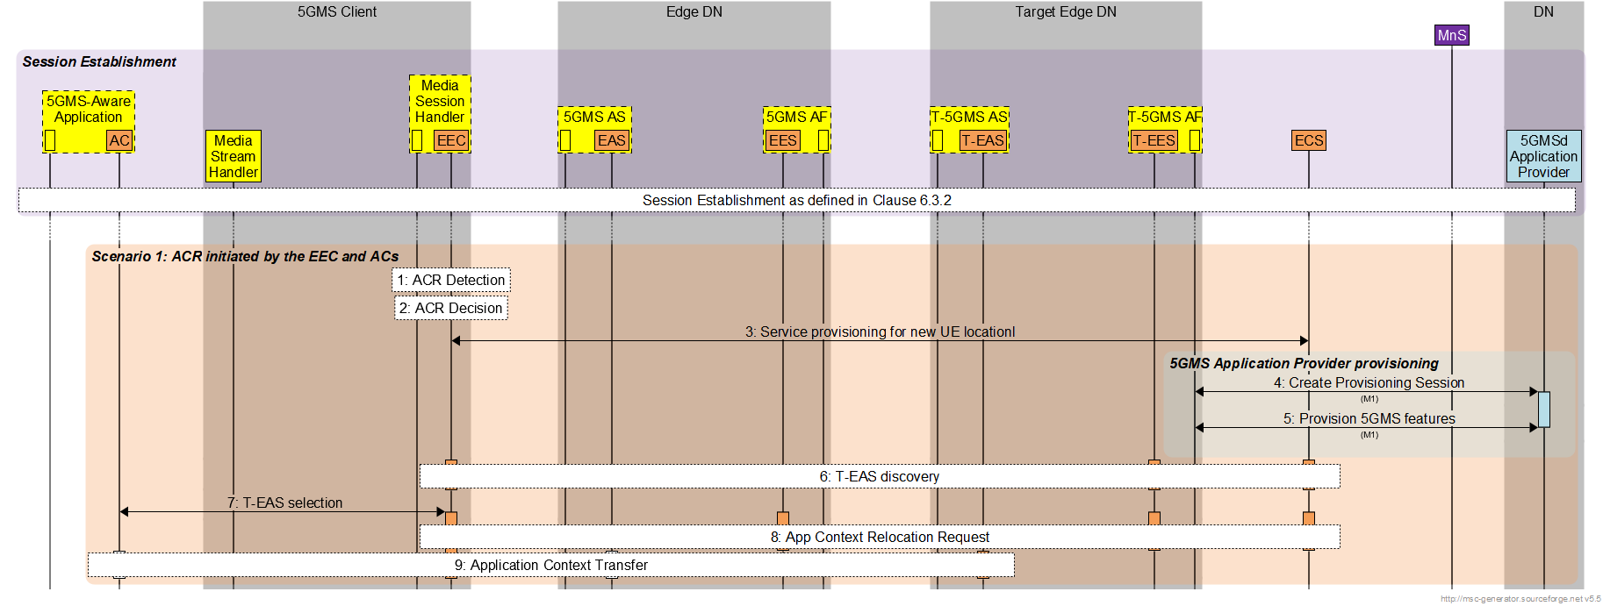
Figure 6.4.2.1-1: ACR initiated by the EEC and ACs
It is assumed that Edge Computing resources to support 5G Media Streaming have already been provisioned, as described in clause 6.3.2.
It is assumed that 5G Media Streaming features have already been provisioned, as described in clause 6.3.2.
The steps for this scenario are summarised as follows:
1. ACR detection by EEC due to the UE mobility.
2. ACR decision by EEC.
3. EEC initiates the Service Provisioning with the ECS, passing new locations, to obtain available candidate target EES instances.
When the target EES has been determined:

4. EEC queries the T-EES for T-EAS discovery.
5. Target EAS selection by AC and EEC if more than one available target EASs received.
6. ACR request from EEC to the source EES for AF traffic influence to optimize the N6 routing.
7. EEC triggers AC to initiate the application context transfer from the source EAS to the target EAS.

6.4.2.2 Detailed call flow breakdown for Scenario 1
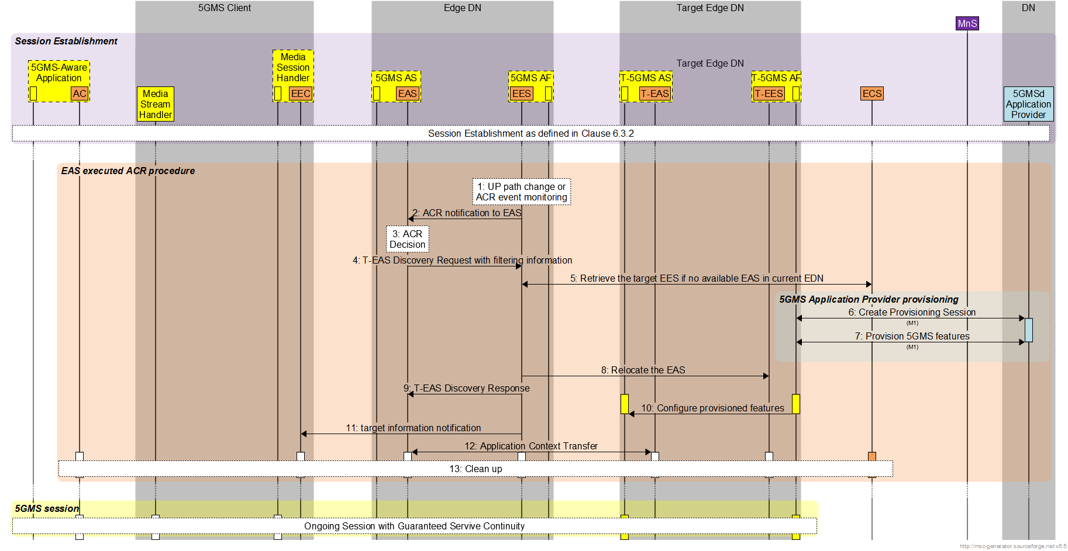
Figure 6.4.2.2-1: Detailed EAS Relocation of 5GMS edge processing for EAS-decided ACR
It is assumed that Edge Computing resources to support 5G Media Streaming have already been provisioned, as described in clause 6.3.2.
It is assumed that 5G Media Streaming features have already been provisioned, as described in clause 6.3.2.
The detailed steps for this scenario are as follows:
1. The source EES detects User Plane path change via a notification from the SMF, as defined in clause XX of TS 23.502, or other ACR event monitoring such as load balancing, etc.
2. The source EES notifies the EAS that the current EAS may not be optimal.
3. The source EAS determines how and when to perform Application Context Relocation.
4. The source EAS sends a target EAS discovery request with the EAS discovery filter containing the requirements for the target EAS.
5. The source EES checks if there are available EAS instances fulfilling the filter requirements.
6. If there are no suitable EAS instances in the current EDN, the source EES retrieves the target EES information from the ECS in order to identify the correct EES serving the UE’s new location.
When a suitable target EES has been identified:

8. The source EES relocates the EAS by sending an EAS discovery request to the target EES.
9. The source EES responds to the source EAS with a list of candidate target EAS instances.

10. The source EES notifies the EEC about the available target EAS instances.
11 The AC/EEC select on the the available target EAS instances.
12. 5GMS-provisioned features in the target 5GMSd AS are configured by the 5GMS AF, if needed.
13. The application context is transferred from the source EAS to the target EAS in current step.

6.4.3 Scenario 2: EAS relocation decided by EEC
Similar to Scenario 1, the EEC here detects UE mobility and decides to initiate the Application Context Transfer procedures by initiating service provisioning with a target EES and also querying target EES to discover suitable EAS instances at the new location. Then, the EEC sends an ACR request to the source EAS for application context transfer.
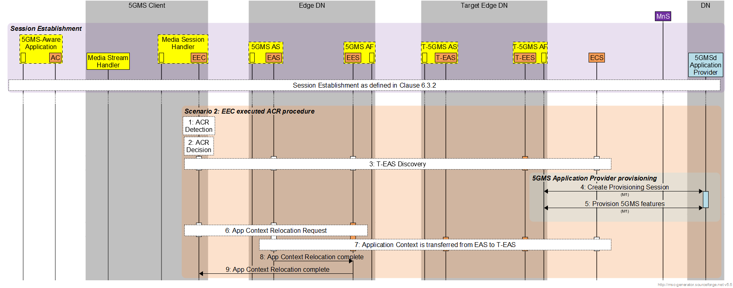
Figure 6.4.3-1: EEC-executed ACR procedure
It is assumed that Edge Computing resources to support 5G Media Streaming have already been provisioned, as described in clause 6.3.2.
It is assumed that 5G Media Streaming features have already been provisioned, as described in clause 6.3.2.
The steps for this scenario are summarised as follows:
1. ACR detection by EEC, for example due to UE moving to a new location.
2. ACR decision by EEC.
3. EEC initiates target EES selection by service provisioning, and target EAS discovery by EAS discovery with the target EES.
When the target EES has been determined:

4. ACR Request to EES (source) from the EEC.
5. Application Context transfer between the source EAS and the target EAS.
6. ACR complete message from the source EAS to the source EES to confirm the completed ACR.
7. ACR complete message from the source EES to the EEC to confirm the completed ACR.

6.4.4 Scenario 3: EAS relocation decided by source EAS
In this scenario, the EAS itself detects the need for Application Context Relocation, or is notified by the EES. For example, the current EAS is overloaded or the EES, receiving notification about UE mobility from 5GC, detects the need for ACR. In either case, the source EAS makes the decision to initiate ACR by selecting the target EAS and initiating the transfer of application context to it.
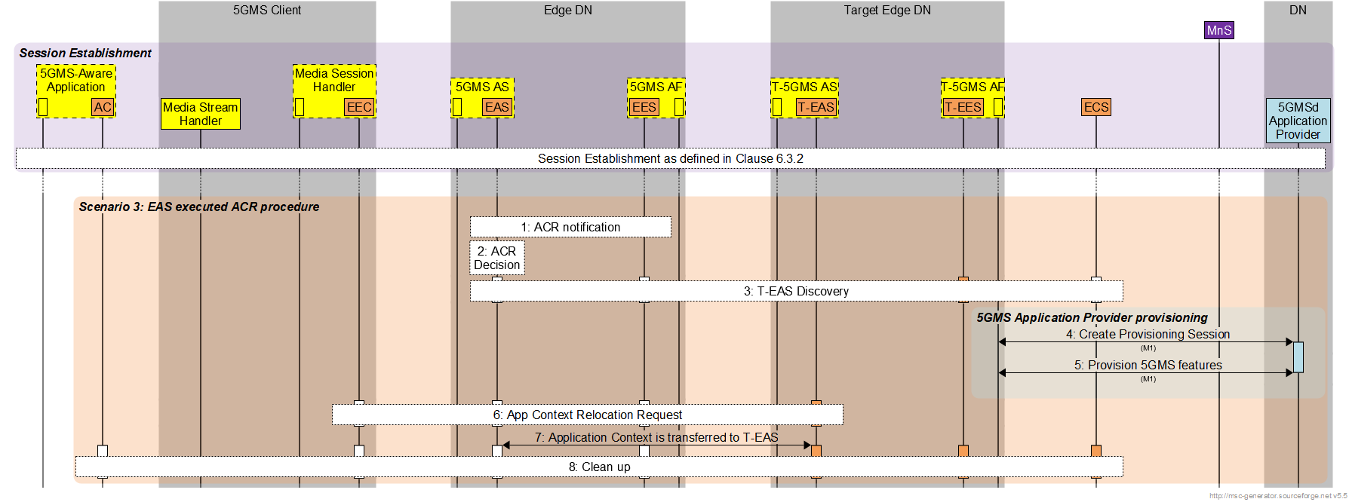
Figure 6.4.4-1 S-EAS decided ACR scenario
It is assumed that Edge Computing resources to support 5G Media Streaming have already been provisioned, as described in clause 6.3.2.
It is assumed that 5G Media Streaming features have already been provisioned, as described in clause 6.3.2.
The steps for this scenario are summarised as follows:
1. ACR detection by the source EAS.
2. ACR decision by the source EAS.
3. Target EAS discovery initiated by the source EAS.
When the target EES has been determined:

6. Target information notification from EES to EEC.
7. The source EAS initiates Application Context transfer between the source EAS and the target EAS.
8. Post ACR clean-up with ACR completion notification.

6.4.5 Scenario 4: EAS relocation decided by source EES
In this scenario, detecting the need of ACR may be done by EEC, the source EAS or the source EES due to the UE mobility or load balancing as described in clause 6.4.1 above. The source EES uses the detection results to initiate the ACR by discovering the target EAS and triggering application context transfer between the source EAS and the target EAS.
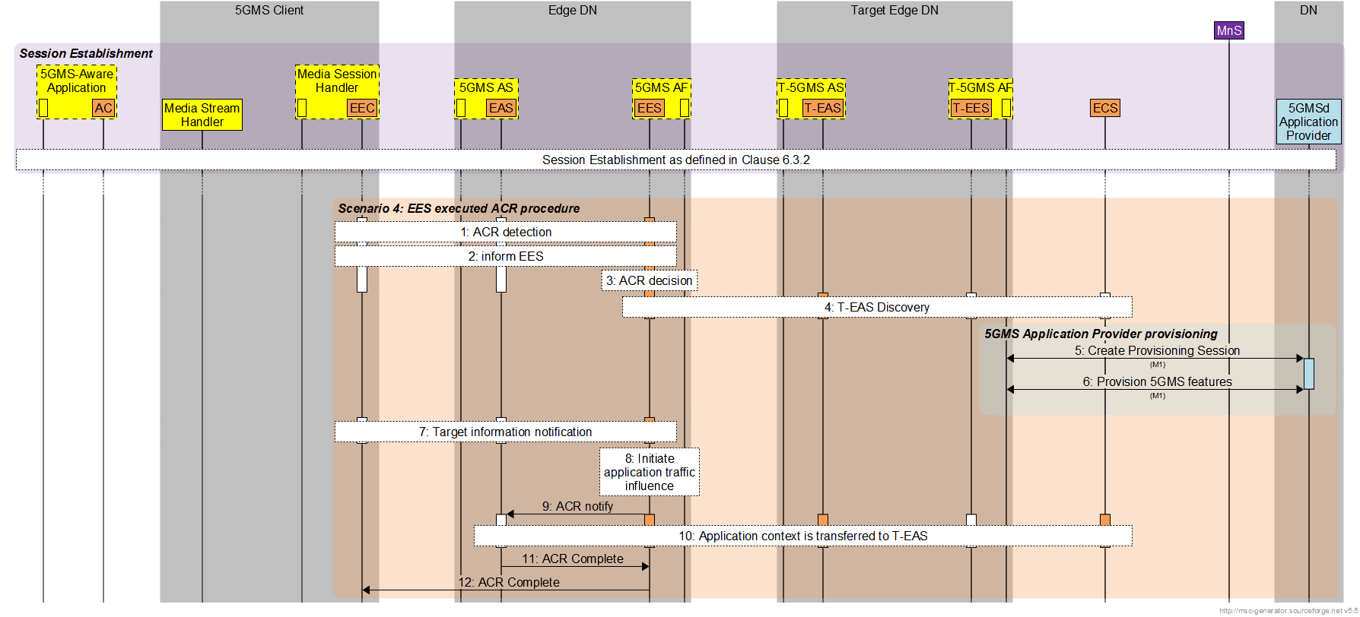
Figure 6.4.5-1 S-EES executed ACR procedure
It is assumed that Edge Computing resources to support 5G Media Streaming have already been provisioned, as described in clause 6.3.2.
It is assumed that 5G Media Streaming features have already been provisioned, as described in clause 6.3.2.
The steps for this scenario are summarised as follows:
1. ACR detection by EAS/EES/EEC.
2. Detection entity informs the EES.
3. ACR decision by EES.
4. Determination of target EES and target EAS determination.
When the target EES has been determined:

5. Target information notification from EES to EEC.
6. AF traffic influence with the N6 routing information of the target EAS.
7. ACR notification to the source EAS to stimulate application context transfer.
8. Application Context transfer between the source EAS and the target EAS.
9. ACR completion notification from the source EAS to the source EES.
10. ACR completion notification from the source EES to the EEC.

6.4.6 Scenario 5: EAS relocation decided by EEC via target EES
In this scenario, the EEC detects and decides to initiate ACR as described in Scenario 2. After discovering the target EAS, the EEC sends the ACR Request to the target EES this triggers the EAS to initiate application context transfer between the source EAS and the target EAS.
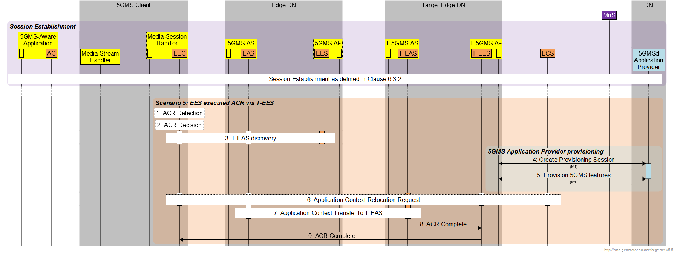
Figure 6.4.6-1: EEC executed ACR via T-EES
It is assumed that Edge Computing resources to support 5G Media Streaming have already been provisioned, as described in clause 6.3.2.
It is assumed that 5G Media Streaming features have already been provisioned, as described in clause 6.3.2.
The steps for this scenario are summaried as follows:
1. ACR detection by EEC, for example, due to UE moving to a new location.
2. ACR decision by EEC.
3. Target EES selection by service provisioning and target EAS discovery by EAS discovery with the selected target EES.
When the target EES has been determined:

6. ACR Request from EEC to T-EES.
7. Application Context transfer between the source EAS and the target EAS triggered by the target EES.
8. ACR completion notification from the target EAS to the target EES.
9. ACR completion notification from the target EES to the EEC.

End of CHANGE

