3GPP TSG-SA4 Meeting #113e S4-210521

Electronic Meeting, Telco, Apr 06-14, 2021
CR-Form-v12.1
CHANGE REQUEST
 | 26.802 | CR | <CR#> | rev | <Rev#> | Current version: | <Version#>
For HELP on using this form: comprehensive instructions can be found at
http://www.3gpp.org/Change-Requests.

Proposed change affects: | UICC apps |  | ME |  | Radio Access Network |  | Core Network

Title: | Updated Key Issue 2: Review of existing xMB interface
Source to WG: | Ericsson LM
Source to TSG: | S4
Work item code: | FS_5GMS_Multicast |  |  |  |  |  | Date: |  |  | <Res_date>
Category: | <Cat> |  |  |  |  |  | Release: |  |  | <Release>
 | Use one of the following categories:  F (correction)  A (mirror corresponding to a change in an earlier release)  B (addition of feature),  C (functional modification of feature)  D (editorial modification)  Detailed explanations of the above categories can  be found in 3GPP TR 21.900. |  |  |  |  |  |  |  | Use one of the following releases:  Rel-8 (Release 8)  Rel-9 (Release 9)  Rel-10 (Release 10)  Rel-11 (Release 11)  …  Rel-15 (Release 15)  Rel-16 (Release 16)  Rel-17 (Release 17)  Rel-18 (Release 18)
Reason for change: |  | - The existing text uses out-dated terminology / accronyms.  - The existing text only focued on file delivery, while GC delivery is clearly in scope and should be considered  - The entire KI #2 became more a Nx2 Designe Consideratrion key issue, which can act to collect the different requirements, gaps, etc for Nx2.
Summary of change: |  | The terminology is updated to the latest (and greatest) terminology, also reflexting non-5GMSA deployments. A new section on the GC Delivery method is added and a simple MBSTF function model is developed. The Key Issue is renamed to “Nx2 Design Considerations”
Consequences if not approved:
Clauses affected:
 |  | Y | N
Other specs |  |  |  | Other core specifications |  |  |  | TS/TR ... CR ...
affected: |  |  |  | Test specifications |  |  |  | TS/TR ... CR ...
(show related CRs) |  |  |  | O&M Specifications |  |  |  | TS/TR ... CR ...
Other comments:
This CR's revision history:

**** First Change ****

5.3 Key Issue 2: Nx2 Design Considerations

5.3.1 Description

5.3.1.1 General
In 5MBS, the existing BM-SC function is split into control plane (MBSF) and user plane (MBSTF) functions, so that a single control plane function can (potentially) control one or more user plane functions. A new interface Nx2 is introduced between the control and user plane functions.
According to TR 23.757 [7]:
- The new user plane function (MBSTF) receives the traffic using (an evolution of) the xMB-U interface and/or the MB2-U interface.
- The new control plane function (MBSF) receives provisioning and control commands using either existing MB2-C or (an evolution of) xMB-C.
The present key issue studies how existing control plane procedures from xMB-C impact Nx2 transactions. It is assumed that corresponding BM-SC features (like the MBMS Download Delivery, Streaming Delivery or Transparent Delivery) are migrated into 5MBS.
NOTE: The present clause uses BM-SC function terminology. For 5MBS, the functions may be renamed.

5.3.1.2 Model of a BM-SC User-Plane Function for MBMS Download
The model in Figure 5.3.1.2-1 below assumes that a FLUTE function according to MBMS Download Delivery (Clause 7 in TS 26.346 [16]) is mapped into the MBSTF.
The purpose of this simplified model is to help identify the xMB-C parameters (xMB Service and Session Parameters) needed to configure an MBSTF at Nx2.
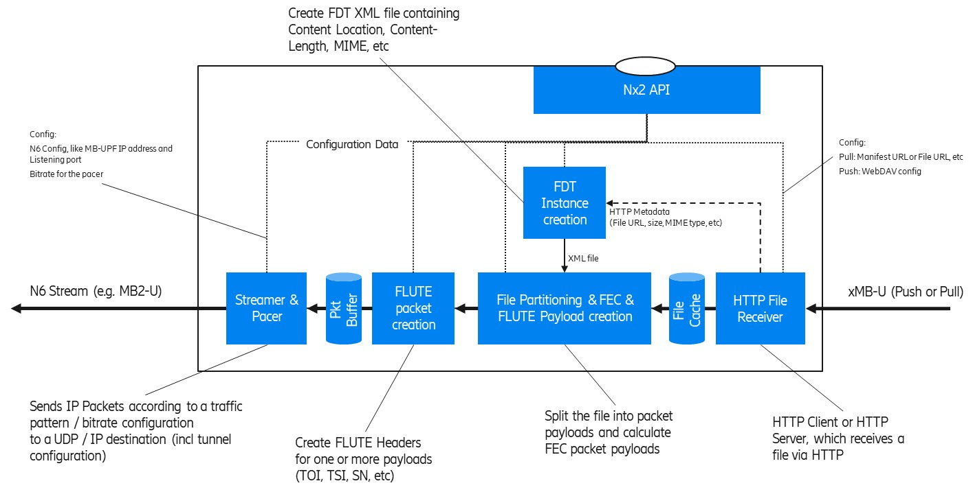
Figure 5.3.1.2-1: Simplified User Plane model for FLUTE (as an MBSTF function)
The model depicts some key functions from an xMB-U ingest to an MB-UPF ingest (N6). In the case of 5MBS Download (e.g. used for DASH/HLS over MBMS or generic file delivery) the MBSTF operates as follows:
1. The HTTP File Receiver is responsible for ingesting content resources intended for multicast transmission at xMB-U. It supports two basic content ingest modes:
a) HTTP Pull, in which the MBSTF pulls resources from an upstream HTTP server, such as the 5GMSd AS. In this mode, the Nx2 API is used to provide individual URLs to be downloaded.
b) HTTP Push, in which resources are uploaded to the MBSTF by an upstream client using HTTP PUT. In this mode, the Nx2 API is used to provide a base URL for ingesting data to the API invoker.
2. The MBSTF may store partial or complete resources in a local File Cache prior to transmission at N6. Optimized implementations may pipe files through with only minimal buffering/caching.
3. HTTP metadata such as Content-Location (resource URL), Content-Length (resource size), and Content-Type (MIME content type) is provided by the HTTP File Receiver to the FDT Instance creation function. This acts as input (with other Nx2 parameters) to form the FDT Instance XML document.
4. The File partitioning function segments resources (including FDT Instances) into one or more multicast packet payloads. In the case where a Forward Error Correction scheme such as Raptor FEC (RFC 5053 [23]) or Compact No-Code FEC (RFC 5445 [24]) is used, there are recommended schemes and parameters to partition a resource into a sequence of packet paylods (called encoding symbols).
5. The FLUTE packet creation function inserts FLUTE header parameters such as the TSI, sequence number (FEC Symbol ID according to No-Code FEC, RFC 3695 [25] or Raptor FEC, RFC 5053 [23]), etc. As result, a complete UDP packet payload is created, which can be written to a UDP socket at the appropriate time of transmission.
6. Finally, the Streamer & Pacer function sends the multicast UDP packets according to a defined bit rate to the configured MP-UPF ingest point, which can be an MB2-U tunnel, some direct multicast, or similar.

5.3.1.3 Review of existing xMB properties for MBMS Download MBSTF configuration
This section contains a copy of the xMB service (clause 5.3.7) and Session (clause 5.4.6) properties. The column “related to User Plane” indicates whether the property is related to the user plane handling, e.g. defining the xMB-U ingest, etc. In this case, the MBSTF need to be provisioned with the property value. Likely, the property is exposed via Nx2.
Table 5.3.1.3-1: List of existing xMB Service Properties
Property Name | Related to User Plane  (i.e. forwarded to MBSTF) | Note
Id | No
ServiceID | No
Service Class | No
Service Languages | No
Service Names | No
Receive Only Mode | For Study | This flag is for ROM services.
Service Announcement Mode | No
Consumption Reporting Configuration | For Study
Push Notification URL | Yes
Push Notification Configuration | Yes

Table 5.3.1.3-2: List of existing xMB Session Properties
Property Name | Related to User Plane  (i.e. forwarded to MBSTF) | Note
id
Session start | Yes | The MBSTF needs to know when to start generating user plane packets.
Session stop | Yes | The MBSTF needs to know when to stop generating user plane packets.
Max Bitrate | Yes
Max Delay | Yes
Session State | Partially | A session state is needed, but without the state “Session Announced”.
Service Announcement start time | No
Geographical Area | FFS
QoE Reporting | No
QoE Report URL | No
Session Type | yes
Header Compression | FFS | Unclear whether RoHC header compression is in RAN.
FEC | yes
Transport Mode
Session Description Parameters for User Plane | yes
Delivery Mode Configuration for user plane | yes
Delivery Session Description Parameters | yes
Streaming
SDP URL | yes
TimeShifting
Application (including DASH)
Application Service Description
Ingest Mode | yes
Application Entry Point URL
Push URL | yes
Unicast Delivery
Components
Files
Ingest Mode | yes
File List | yes | Except Unicast availability.  Target Reception Completion time is FFS, since unicast File Repair is included.
Carousel Mode
Carousel Scheduled Interval | yes
File delivery manifest URL | yes
Push URL | yes
Display Base URL | yes
SA file URL | no | An SA-file like concept is needed, but the MBSTF is not handling it.
Mission Critical
MC-Extension
TMGI | no | The MBSTF only need the MB-N6 tunnel information to ingest the data into the MB-UPF. The MBSF handles the TMGI.
QoS-Information | no | The MBSTF is not responsible for control plane interactions with the MB-SMF.

5.3.1.4 Model of a BM-SC User-Plane Function for Group Communication Delivery
The model in Figure 5.3.1.4-1 below assumes that the BM-SC FEC encoding function according to Group Communication Delivery Method (Clause 8A in TS 26.346 [16]) is mapped into the MBSTF. According to TR 23.757 [7], the MBSTF exposes an MB2-U interface, which should be used (only?) when FEC needs to be added to Group Communication. When no FEC is needed, the GCS AS may directly send the traffic to the MB-UPF using N6.
The purpose of this simplified model is to help identify the MB2-C parameters needed to configure an MBSTF at Nx2. The function “FEC Payload creation” generates a new RTP flow carrying the FEC redundancy information to protect one or more RTP media flows.
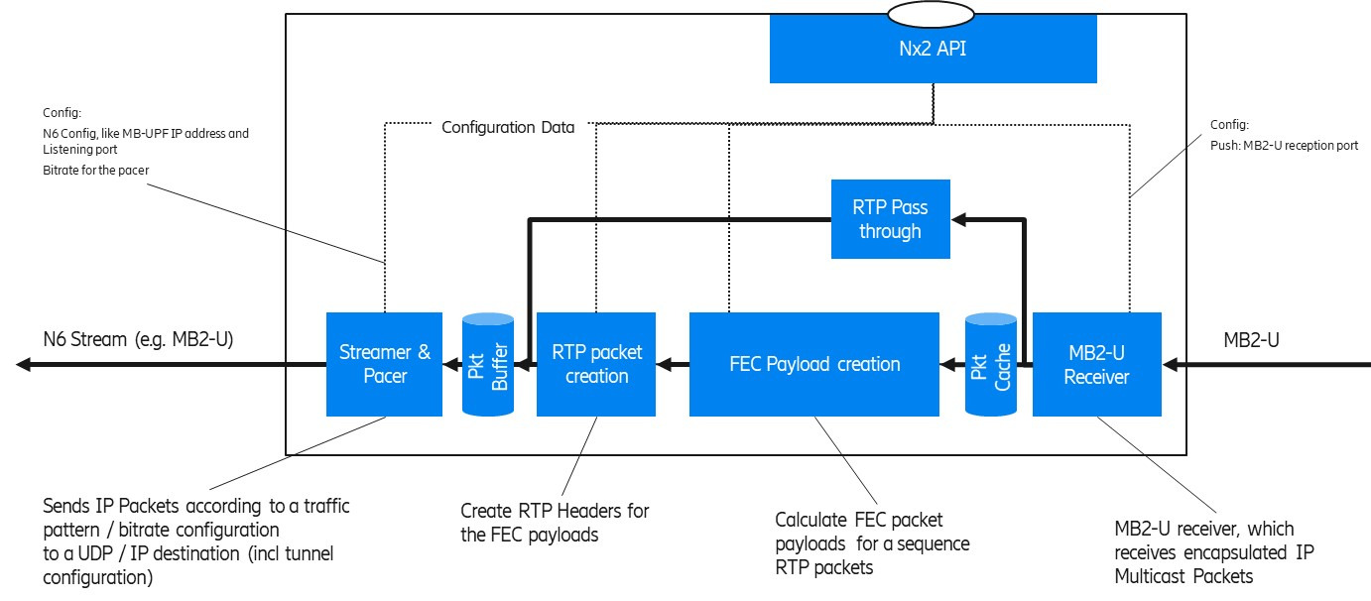
Figure 5.3.1.4-1: Simplified User Plane model for Group Communication Delivery with FEC
(as an MBSTF function)
The model depicts some key functions from an MB2-U ingest to an MB-UPF ingest (N6). In the case of Group Communication Delivery the MBSTF operates as follows:
- The MB2-U Receiver is responsible for receiving the MB2-U packets. The IP multicast user plane packets are encapsulated into the MB2-U packets. The MB2-U receiver may duplicate the packets so that the original packet can be passed through to the output and the copy remains in the Packet Cache for FEC source block creation.
- The RTP Passthrough passes the source packets directly to the output.
Editor’s Note: It is ffs, whether the RTP Passthough function appends FEC information (like a source block id), without modifying the original parts.
- FEC Payload Creation calculates the FEC redundancy information which is then carried as a separate RTP flow to the receiver.
- RTP packet creation prepends RTP header fields to the payloads of the FEC flow.
- The Streamer & Pacer ensures a smooth output bit rate according to the configured Guaranteed Bit Rate.
NOTE: Since FEC redundancy is added to the stream, the output bit rate is higher than the input bit rate.
When a GCS AS activates an MB2 session with FEC, the GCS AS provides the following information to the BM-SC:
- FEC configuration information (see clause 6.4.27 of TS 29.468 [18]). A list of the FEC Framework configuration information according to clause 8A.5 of TS 26.346 [16] is depicted in Figure 5.3.1.4-2 below.
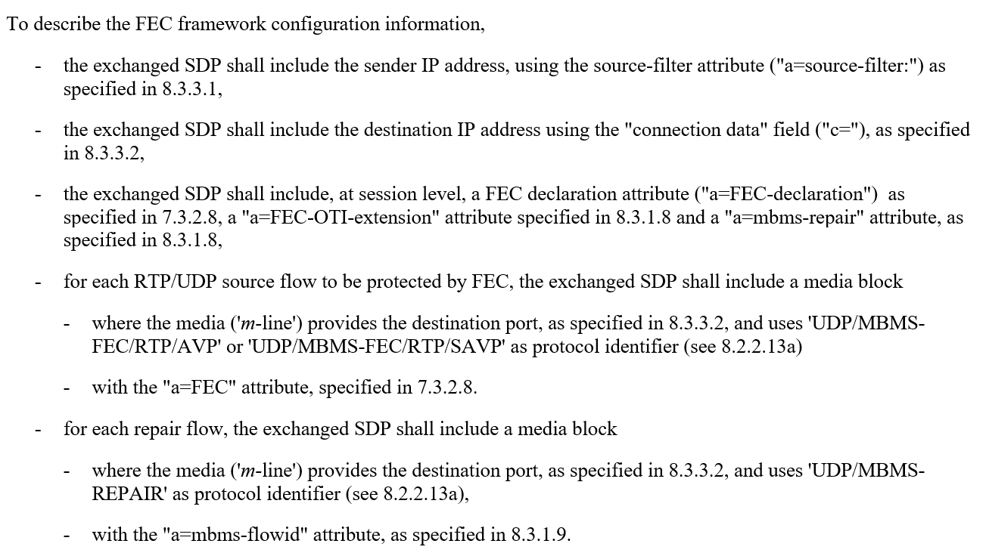
Figure 5.3.1.4-2: FEC Framework configuration information according to TS 26.346 Clause 8A.5
As response, the GCS AS receives the MB2-U tunnel endpoint information (i.e. the BM-SC Address AVP and BM-SC Port AVP).
When the BM-SC is split into MBSF and MBSTF, the MBSF interacts with the MB-SMF in order to obtain the N6 ingest parameters for the MB-UPF. The MBSF provides the FEC framework configuration information together with the MB-UPF N6 ingest information to the MBSTF via Nx2. The MBSTF allocates the MB2-U tunnel endpoint information and passes the MB2-U ingest information back to the MBSF.
The MBSF may pass the FEC Framework configuration information to the MBSTF as an Octet Stream (see clause 6.4.27 of TS 29.468 [18]) so that the MBSTF parses the SDP information.

5.3.2 Identified gaps
Editor’s Note: This section should summarise the identified issues.

5.4 Key Issue #3: Collaboration and deployment scenarios

5.4.1 Description
In the following, four different deployment models are presented. The key guiding assumption here is that the MBSF contains key IP Multicast related BM-SC functions such as a FLUTE Sender (which belongs to the “MBMS Download and Streaming Delivery Function”). The intention is to identify important collaboration scenarios for the normative work.
The existing 5GMSA APIs M1d, M2d, M4d and M5d maybe be extended during 3GPP Release 17 with 5MBS (and other) functions.
It is further assumed that Nmbsf is an evolution of xMB-C and Nmbstf an evolaution of xMB-U.
A general assumption for all the collaboration scenarios is that the 5GMSd functions are used for unicast content distribution, e.g. CDN functionality for DASH streaming is used.

5.4.2 Collaboration A
Collaboration A depicts a deployment where all 5MBS and 5GMSd functions are deployed inside the trusted DN. Three different variants are depicted.
The 5GMSd AF and AS are responsible for unicast content distribution (e.g. CDN), i.e. M5d and M4d are exposed by the 5GMSd functions.
The MBSF and MBSTF functions are for 5MBS distribution. The MBSF is the control and interacts with the MB-SMF using Nmbsmf.
- A0: The MBSF is integrated within the 5GMSd AF.
- A1: Fully separated functions.
- A2: Integrated control and user plane functions.
Collaboration A0 describes a model where the MBSF function is integrated into the 5GMSd AF and the MBSTF function is still standalone. Background here is that the user plane functions are more specialized, i.e. optimized HTTP servers for unicast and optimized multicast delivery functions for multicast. The 5GMSd AF uses the newly developed Nx2 API to configure and control the multicast delivery functions. The 5GMSd AS might be extended to cut-though any push ingest into the Nmbstf (former xMB-U).
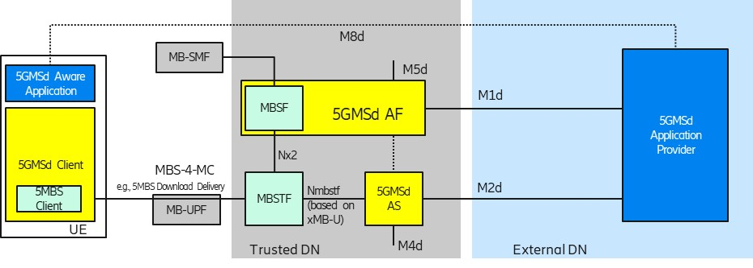
Figure 5.4.2-1: Collaboration A0: MBSF integrated within the 5GMSd AF
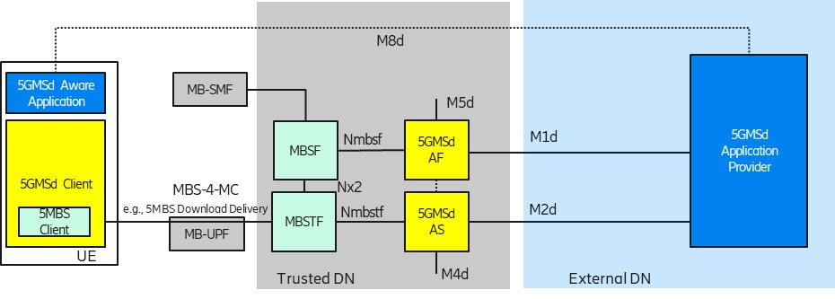
Figure 5.4.2-2: Collaboration A1: Fully separated functions
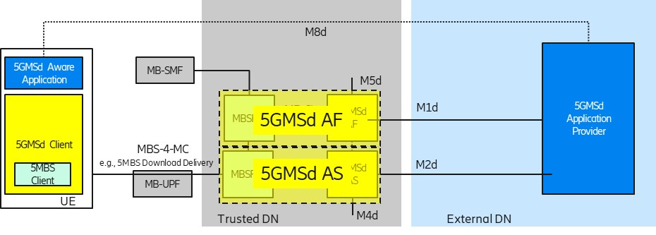
Figure 5.4.2-3: Collaboration A2: Integrated Control and User Plane functions

5.4.3 Collaboration B
Collaboration B depicts a mixed deployment where only the 5MBS related-functions are deployed in the trusted DN. Configuration B in Figure A.3.2-2 (TR 23.757) indicates that an external AF uses the NEF as control plane entry point. It is assumed that the Nmbsf interface (based on xMB-C) is passed through the NEF and that the NEF adds security-related functions transparently.
Like in Collaboration A (and C), the 5GMSd functions are used for unicast content distribution, e.g. CDN functionality for DASH streaming is in an external DN. The functions in the trusted DN are leveraged to prepare the content for 5MBS delivery. Here is it assumed that unicast functions such as unicast content reception (e.g. DASH) and features like file repair can be offered by the 5GMSd AS from the external DN.
Note that Collaboration B2 does not contain 5GMSA functions. This collaboration scenario is associated with Collaboration B because the MBSF and MBSTF functions are within the Trusted DN.
Also, for Collaboration B, three different variants are depicted:
- B0: The MBSF is presented in the Trusted DN for service management.
- B1: The MBSF is absent and only an MBSTF is used.
- B2: Only 5MBS functions, without 5GMSA functions.
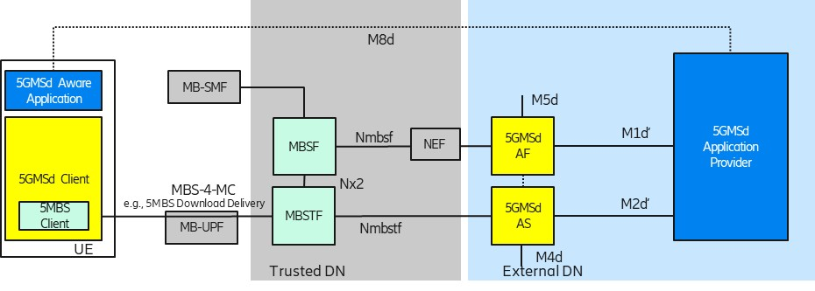
Figure 5.4.3-1: Collaboration B0: Mixed external and Trusted DN functions
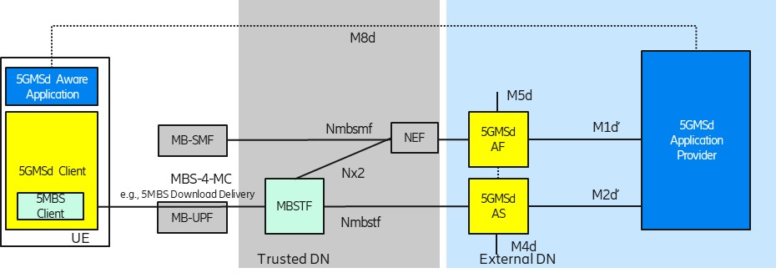
Figure 5.4.3-2: Collaboration B1: Mixed external and trusted DN functions
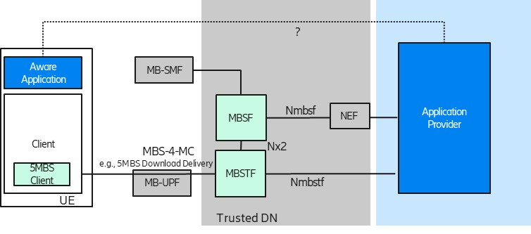
Figure 5.4.3-3: Collaboration B2: Mixed external and trusted DN functions deployed without 5GMS functions

5.4.4 Collaboration C
Collaboration C depicts a deployment where all media related functions are deployed in an external DN and the 5G System offers only connectivity services, i.e. either unicast connectivity or 5MBS transport-only connectivity.
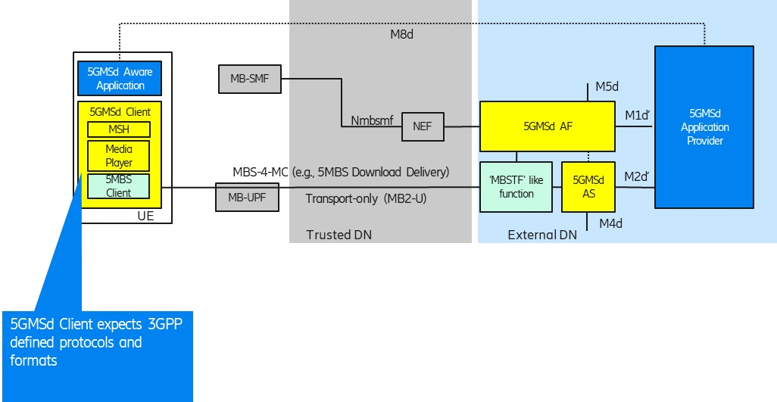
Figure 5.4.4-1: Collaboration C: All media functions in external DN
One could wonder why 3GPP should consider this deployment option. The consideration here is that a 5GMSd Client (including a new 5MBS Client) in the UE can still be leveraged as a multicast receiver, supporting reception of 3GPP-defined “DASH over 5MBS” generic file delivery and RTP streaming. An “MBSTF-like” function would generate a bit stream compliant with TS 26.346 [16]. An external Application Function (AF) may use Nmbsmf (via NEF) to activate a transport-only type of delivery into the MB-UPF (according to Configuration 1 in Figure A.3.2-2 of TR 23.757 [7]).

5.4.5 Collaboration D
Collaboration D depicts a deployment similar to Collaboration #4 in TS 26.501 [1]. Here, the media plane does not follow 3GPP specifications. An Application Function (AF) may use Nmbsmf (via NEF) to activate a transport-only type of delivery into the MB-UPF (according to Configuration 1 in Figure A.3.2-2 of TR 23.757 [7]). Still, a 3GPP-defined Media Session Handler is interacting with a 3GPP-defined 5GMSd AF.
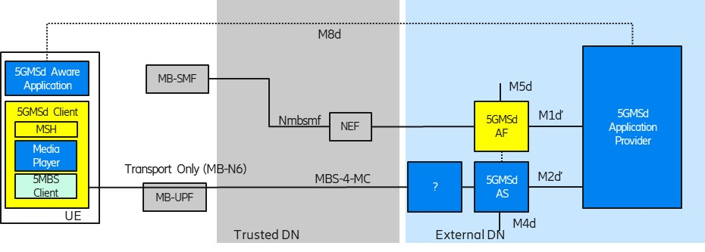
Figure 5.4.5-1: Collaboration D: Usage of transport-only delivery with non-3GPP protocols at M4d-mb

5.4.6 Identified gaps
Editor’s Note: Gaps to be identified. Which scenarios should be supported and what does it mean for APIs / interfaces.

