3GPP TSG-SA4 meeting #113-e S4-210499

Electronic Meeting, 6th-14th April, 2021
CR-Form-v12.0
PSEUDO CHANGE REQUEST
 | TR 26.803 | CR | – | rev | – | Current version: | 0.5.1
For HELP on using this form: comprehensive instructions can be found at
http://www.3gpp.org/Change-Requests.

Proposed change affects: | UICC apps |  | ME |  | Radio Access Network |  | Core Network | X

Title: | Call flow for EAS relocation based on the EMSA architecture
Source to WG: | Huawei Technologies Co. Ltd
Source to TSG: | S4
Work item code: | FS_EMSA |  |  |  |  |  | Date: |  |  | 2021-3-31
Category: | F |  |  |  |  |  | Release: |  |  | Rel-17
Use one of the following categories:
F (correction)
A (mirror corresponding to a change in an earlier release)
B (addition of feature),
C (functional modification of feature)
D (editorial modification).
Reason for change: |  | the EAS relocation based on the EMSA architecture is missing.
Summary of change: |  | Add the EAS relocation analysis and generic call flows.
Consequences if not approved:
Clauses affected: |  | 6.4
 |  | Y | N
Other specs |  |  | X | Other core specifications
affected: |  |  | X | Test specifications
(show related CRs) |  |  | X | O&M Specifications
Other comments:
This CR's revision history:

FIRST CHANGE

6.4. Generic Call Flow for EAS relocation.
The EAS relocation procedure may be triggered in the following scenario:
- UE mobility, including predictive or expected UE mobility.
- Overload situations in EAS or EDN.
- Maintenance aspects such as graceful shutdown of an EAS.
- Temporal edge resource requirements, for example, the application need an EAS with new capability which is not available in the current one.
According to the Application Context Relocation (ACR) procedure defined in SA6 TS 23.558, the ACR procedure can be mainly contains three entities, named ACR detection entities, ACR decision entities and ACR execution entities. Depending on the differences of entities for detection, decision and execution, there are five different scenarios for the EAS Relocation procedure.

6.4.1 General call flow for EAS relocation
The general call flow can be found below with different ACR procedures.
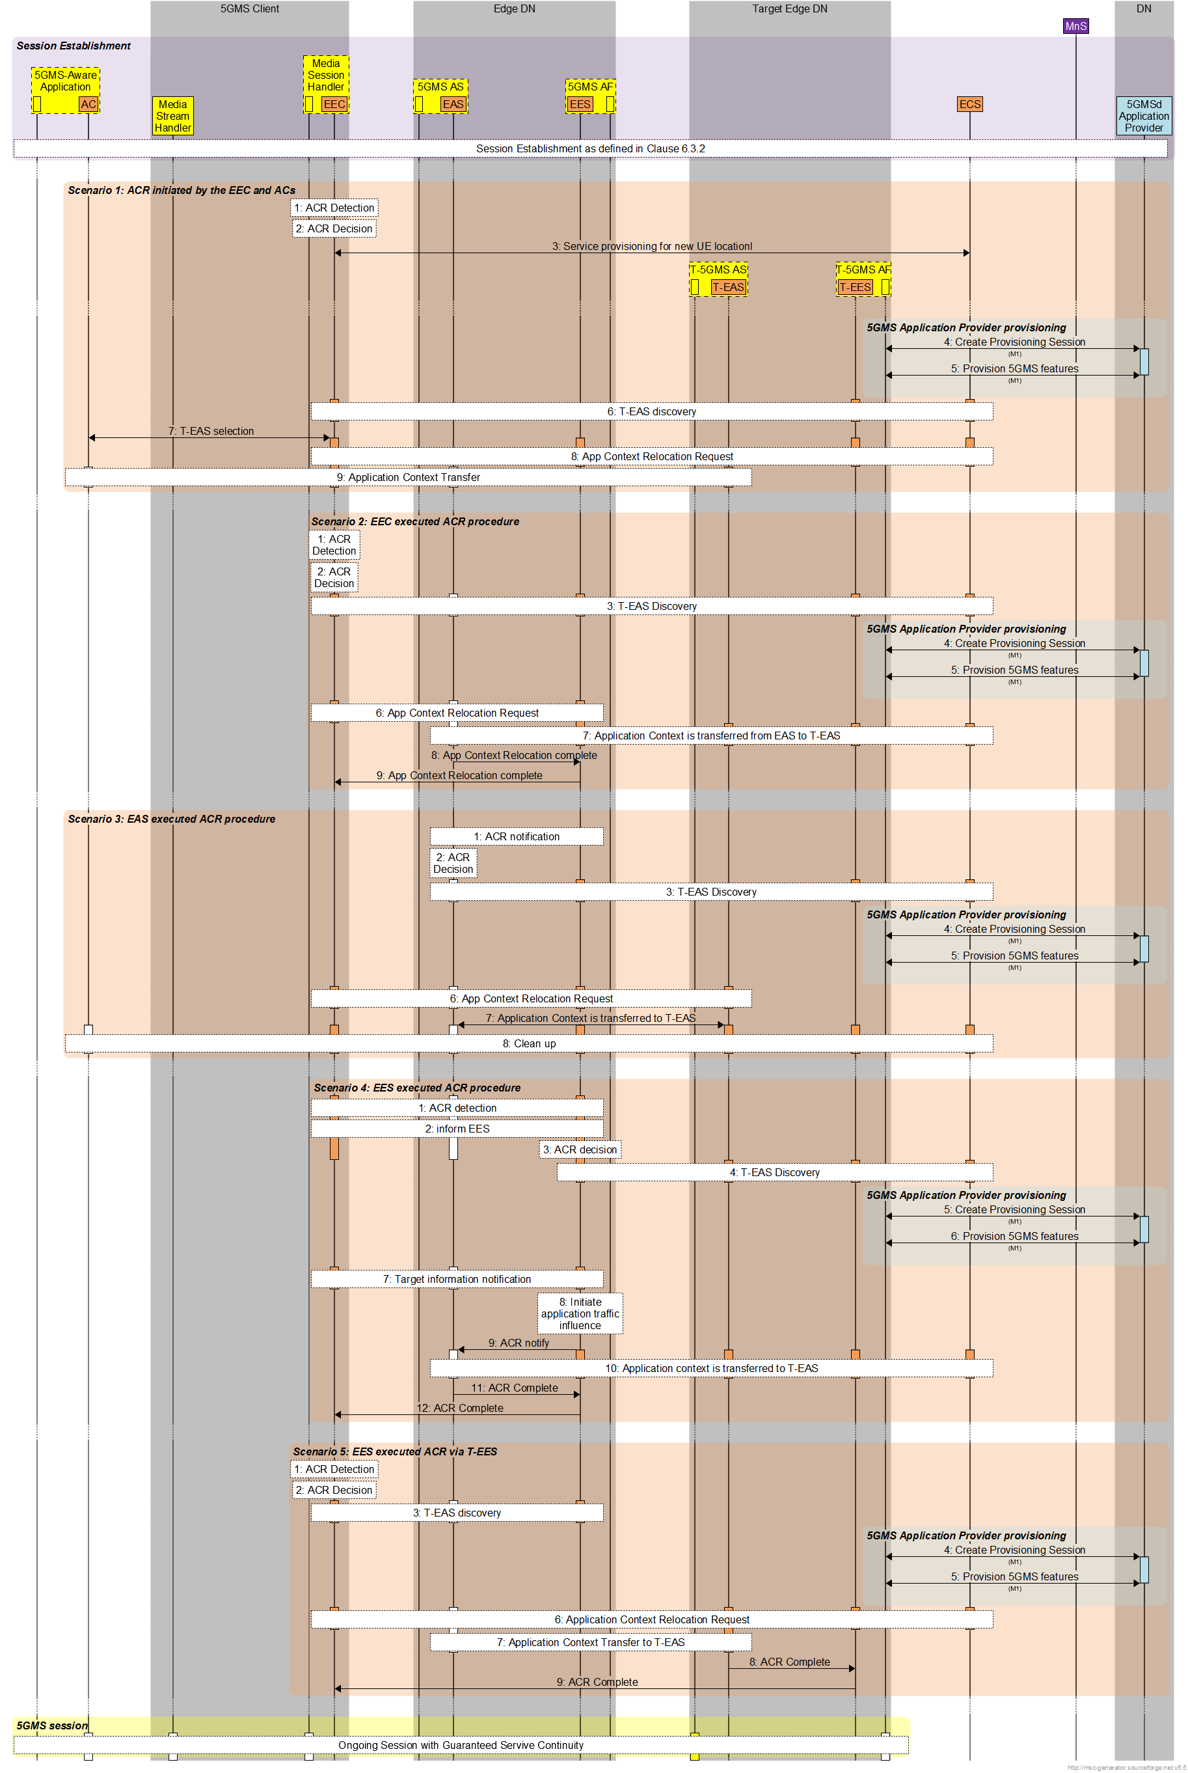
Figure 1 EAS Relocation of 5GMS edge processing
Session Establishment:
The edge-enabled 5G media streaming session are established via the call flow defined in Clause 6.3.
EAS Relocation:
Scenario 1: ACR initiated by the EEC and ACs:
In case of UE mobility to a new location which is outside the service area of the serving EAS, the EEC and ACs will realize their locations changed and decide to initiate the Application Context Relocation procedure to a more appropriate new target EAS instance, including ACR detection, decision and execution. The call flows can be briefly detailed as below:
  - ACR detection by EEC due to the UE mobility.
  - ACR decision by EEC.
  - EEC initiates the Service Provisioning with new locations to ECS to get available T-EESs.
  - When target EES determined, 5GMS Application Provider Provisioning session created if needed.
  - Provisioning 5GMS features to the target 5GMS AF if needed.
  - EEC queries the T-EES for T-EAS discovery.
  - T-EAS selection by AC and EEC if more than one available T-EASs received.
  - ACR Request from EEC to the source EES for AF traffic influence to optimize the N6 routing.
  - EEC triggers AC to initiate the application context transfer from the source EAS to the target EAS.
Scenario 2: EEC executed ACR procedure:
Similar scenario as Scenario 1, the EEC may detect the UE mobility and decide to initiate the Application Context Transfer procedures via initiating the service provisioning for target EES and also querying target EES for the T-EAS discovery. Then EEC sends the ACR request to the source EAS for application context transfer.
  - ACR detection by EEC, for example, due to UE moving to a new location.
  - ACR decision by EEC.
  - EEC would initiate T-EES selection by service provisioning and T-EAS discovery by EAS discovery with the T-EES.
  - When target EES determined, 5GMS Application Provider Provisioning session created if needed.
  - Provisioning 5GMS features to the target 5GMS AF if needed.
  - ACR Request to EES (source) from the EEC.
  - Application Context transfer between the source EAS and the target EAS.
  - ACR complete message from the source EAS to the source EES to confirm the completed ACR.
  - ACR complete message from the source EES to the EEC to confirm the completed ACR.
Scenario 3: S-EAS decided ACR scenario:
In this case, the EAS may detect the need of ACR locally or is notified by the EES. For example, the current EAS is overloaded or the EES receiving notification about the UE mobility from 5GC detect the need of ACR. Then EAS would make the decision to initiate the ACR via selecting the target EAS and starting the application context transfer.
- ACR Detection by the source EAS.
- ACR Decision by the source EAS.
- Target EAS discovery initiated by the source EAS.
- When target EES determined, 5GMS Application Provider Provisioning session created if needed.
- Provisioning 5GMS features to the target 5GMS AF if needed.
- Target information notification from EES to EEC.
- S-EAS initialled Application Context transfer between the source EAS and the target EAS.
- Post ACR clean-up with ACR completion notification.
Scenario 4: S-EES executed ACR procedure:
In this case, detecting the need of ACR may be done by EEC, the source EAS or the source EES due to the UE mobility or load balancing as described in Clause 2. Then the source EES would get the detection results and decide to initiate the ACR via discovering the target EAS and trigger the application context transfer between the source EAS and the target EAS.
- ACR detection by EAS/EES/EEC.
- Detection entity informs the EES.
- ACR decision by EES.
- T-EES/T-EAS determination.
- When target EES determined, 5GMS Application Provider Provisioning session created if needed.
- Provisioning 5GMS features to the target 5GMS AF if needed.
- Target information notification from EES to EEC.
- AF traffic influence with the N6 routing information of the T-EAS.
- ACR Notify to EAS for the application context transfer.
- Application Context transfer between the source EAS and the target EAS.
- ACR completion notification from the source EAS to the source EES.
- ACR completion notification from the source EES to the EEC.
Scenario 5: EEC executed ACR via T-EES:
In this case, the EEC detects and decides to initiate ACR as described in Scenario 2. After discovering the target EAS, the EEC would sends the ACR Request to the target EES and the target will trigger the EAS to initiate the application context transfer between the source EAS and the target EAS.
- ACR detection by EEC, for example, due to UE moving to a new location.
- ACR decision by EEC.
- T-EES selection by service provisioning and T-EAS discovery by EAS discovery with the T-EES.
- When target EES determined, 5GMS Application Provider Provisioning session created if needed.
- Provisioning 5GMS features to the target 5GMS AF if needed.
- ACR Request from EEC to T-EES.
- Application Context transfer between the source EAS and the target EAS triggered by T-EES.
- ACR completion notification from the target EAS to the target EES.
- ACR completion notification from the target EES to the EEC.
The 5GMS Session continues with service continuity guarantees:
Via the Application Context Relocation procedure provided by SA6, the edge-enabled 5GMS session will go on with service continuity guarantees.

6.4.2 Detailed break-down for EAS relocation for EAS decided ACR scenario:
Figure 2 Detailed EAS Relocation of 5GMS edge processing for EAS decided ACR
- The source EES can detect the user plane path change via the notification from SMF as defined in TS 23.502, or other ACR event monitoring like load balancing, etc.
- The source EES then notify EAS that the current EAS may not be proper.
- The source EAS shall determine how and when to perform the application context relocation.
- Then the source EAS send the T-EAS discovery request with the EAS discovery filter containing the requirements for the T-EAS.
- The source EES shall check if there are available T-EAS fulfilling the filter requirements. If there are no available T-EAS in the current EDN, the source EES shall retrieve the T-EES information from the ECS.
- When the target EES relocated, the 5GMS application provider provisioning procedure can be done here. The provisioning session is created.
- The Application Provider provisions the 5GMS features in this step.
- Then the source EES can relocate the target EAS via sending the T-EAS discovery request to T-EES.
- The source EES shall respond to the source EAS with the discovered target EAS.
- The 5GMS provisioned features would be configured to the new target 5GMSd AS if needed.
- The source EES shall notify EEC about the available target EAS(s).
- The application context is transferred from the source EAS to the target EAS in current step.
End of CHANGE

