F3GPP TSG SA WG4 113-e S4-210479
06-14 April 2021
CR-Form-v12.0
Pseudo CHANGE REQUEST
 | 26.804 | CR | <CR#> | rev | - | Current version: | 0.1.1
For HELP on using this form: comprehensive instructions can be found at
http://www.3gpp.org/Change-Requests.

Proposed change affects: | UICC apps |  | ME | X | Radio Access Network |  | Core Network | X

Title: | [FS_5GMS-EXT] Updated text for uplink streaming
Source to WG: | Tencent
Source to TSG: | SA4
Work item code: | FS_5GMS-EXT |  |  |  |  |  | Date: |  |  | 2021-01-25
Category: | B |  |  |  |  |  | Release: |  |  | Rel-17
 | Use one of the following categories:  F (correction)  A (mirror corresponding to a change in an earlier release)  B (addition of feature),  C (functional modification of feature)  D (editorial modification)  Detailed explanations of the above categories can  be found in 3GPP TR 21.900. |  |  |  |  |  |  |  | Use one of the following releases:  Rel-8 (Release 8)  Rel-9 (Release 9)  Rel-10 (Release 10)  Rel-11 (Release 11)  Rel-12 (Release 12)  Rel-13 (Release 13)  Rel-14 (Release 14)  Rel-15 (Release 15)  Rel-16 (Release 16)
Reason for change: |  | The study item description identifies the key topic “Uplink Streaming”.
Summary of change: |  | Adding call flows for Collaboration Scenario 5, related open issues and potential solutions
Consequences if not approved: |  | Key topic not addressed
Clauses affected:
 |  | Y | N
Other specs |  |  | X | Other core specifications |  |  |  | TS/TR ... CR ...
affected: |  |  | X | Test specifications |  |  |  | TS/TR ... CR ...
(show related CRs) |  |  | X | O&M Specifications |  |  |  | TS/TR ... CR ...
Other comments:
56
This CR's revision history:

===== CHANGE =====

5.5.4 Mapping to 5G Media Streaming and High-Level Call Flows

5.5.4.1 Collaboration scenario 5 call flow
[Editor’s Note: Collaboration Scenario 5 figure is added here just for discussion. It will be removed if this PCR is accepted.
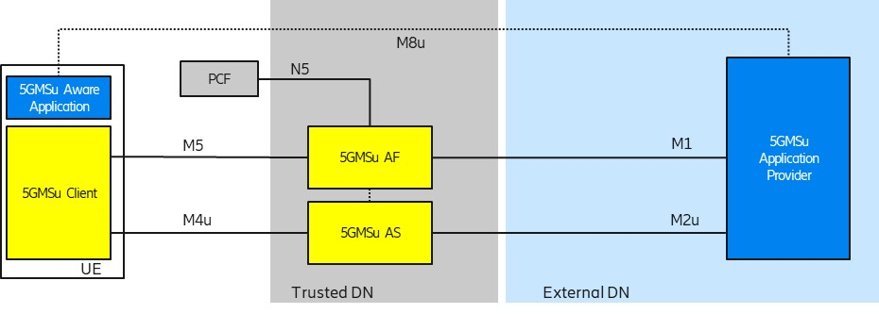
]

Figure 5.5.4.1-1: Collaboration scenario 5 Call flow
Steps:
- The 5GMSu Application Provider creates a Provisioning Session with the 5GMSu AF.
- The 5GMSu Application Provider requests the 5GMSu AF to create one Content Egest Template (CET) that defines the instructions for content egest (M1u).
- The 5GMSu AF, based on the received CET, requests the 5GMSu AS to allocate content resources for egest. (Note that the M3u procedures between 5GMS AF and 5GMS AS are outside the scope of TS 26.512.)
- The 5GMSu AF acknowledges to the 5GMSu Application Provider the successful creation of CET (M1u).
- The 5GMSu Application Provider announces the availability of the services to the 5GMS Aware Application (not in the scope)
The rest of the call flow is identical to the 5GMS uplink process defined in TS 26.512.
As is shown, a new resource, Content Egest ConfigurationTemplate is added with calls to configure the egest (M2u) in step 13.

Editor’s Note: Map the key topics to basic functions and develop high-level call flows.

5.5.5 Potential open issues
The following open issues seem to exist in TS 26.512:
- Lack of a template (or clear reference on how to use an existing template) for content egest configuration,
- Lack of definition of egest protocols (or clear reference on how to use the existing ingest protocols).
- Lack of content egest template API (or clear reference on how to use the existing ingest API).

5.5.6 Candidate Solutions
Since TS 26.512 already defines solutions for the content ingest concerning the open issues of 5.5.5, one possible approach is to allow similar data structures, APIs, and protocols for content egest.

5.5.6.1 Content egest protocols
The existing ingest protocols can be used for egest.
Table 5.5.6.1-1: Adding egest content protocols
Description | Term identifier | Clause
Content ingest protocols at interface M2d
HTTP pull-based content ingest protocol | urn:3gpp:5gms:content-protocol:http-pull-ingest | 8.2
DASH-IF push-based content ingest protocol | urn:3gpp:5gms:content-protocol:dash-if-ingest | 8.3
Content egest protocols at interface M2u
HTTP pull-based content ingest protocol | urn:3gpp:5gms:content-protocol:http-pull-ingest | 8.2
DASH-IF push-based content ingest protocol | urn:3gpp:5gms:content-protocol:dash-if-ingest | 8.3

The highlighted rows indicate the added protocols.

5.5.6.2 Content Egest Configuration API
An M1u API, similar to the M1d Content Hosting Configuration API as used for content ingest, can be defined for content egest.
Table 2: Operations supported by the Content Egest Configuration API
Operation | Sub-resource path | Allowed HTTP method(s) | Description
Create Content Egest Configuration | content-egest-configuration | POST | Used to create a Content Egest Configuration resource.
Retrieve Content Egest Configuration |  | GET | Used to retrieve an existing Content Egest Configuration.
Update Content Egest Configuration |  | PUT,  PATCH | Used to modify an existing Content Egest Configuration.
Delete Content Egest Configuration |  | DELETE | Used to delete an existing Content Egest Configuration.
Purge Content Egest Configuration cache | content-egest-configuration/purge | POST | This operation is used to invalidate some or all cached media resources associated with this Content Egest Configuration.

As is shown in the table, the sub-resource path in particular is changed for this resource, and other aspects remain identical to Content Hosting Configuration API.

5.5.6.2 Content Egest Configuration Template
The Content Egest Configuration resource, modelled after the Content Hosting Configuration resource, is shown in Table 5.5.6.2-1,
Table 5.5.6.2-1: Definition of Content Egest Configuration resource
Property name | Data Type | Cardinality | Description
name | String | 1..1 | A name for this Content Egest Configuration.
EgestConfiguration | Object | 1..1 | Describes the 5GMSu Application Provider's origin server to which media resources will be egested via interface M2u.
path | String | 1..1 | The relative path which will be used to address the media resources at interface M2u.  This path is provided by the 5GMSu AF in the case of pull-based egest.
pull | Boolean | 1..1 | Indicates whether to the 5GMSu AS shall use Pull or Push for egesting the content.
protocol | URI String | 1..1 | A fully-qualified term identifier allocated in the name space urn:3gpp:5gms:content-protocol that identifies the content egest protocol.  The set of supported protocols is defined in Table XXX.
entryPoint | String | 1..1 | An entry point to egest the content. The semantics of the entry point are dependent on the selected egest protocol.  In the case of Pull ingest (pull flag is set to True), this parameter is returned by the 5GMSu AF to the 5GMSu Application Provider and indicates the entry point for pulling the content. In this case, the entryPoint shall be used as the base URL. In this case, the relative URL content address is provided out of band (e.g. with a manifest through M8u) to the 5GMSu Application Provider.  In case of Push (pull flag is set to false), the entryPoint shall be provided to the 5GMSu AF to indicate the location to which content is to be pushed. In this case, the entryPoint shall be used as the base URL.
UploadConfigurations | Object | 1..1 | Specifies content preparation for the egested content.
contentPreparationTemplateId | String | 0..1 | Indicates that content preparation prior to egest is requested by the 5GMSu Application Provider.
canonicalDomainName | String | 1..1 | All resources of the upload shall be accessible through this default FQDN assigned by the 5GMSu AF.
certificateId | String | 0..1 | When content is distributed using TLS [16], the X.509 certificate for the origin domain is shared with the 5GMSd AF so that it can be presented by the 5GMSd AS in the TLS handshake at M2d. This attribute indicates the identifier of the certificate to use.

Note that in the above table:
- The Pull mode is defined when the Application Service Provider pulls the content from the 5GMSu AS, and conversely, the Push mode is defined when the 5GMSu AS pushed the content to Application Service Provider.
- Each parameter description is updated based on item 1.
- Since in the Pull mode, the Application Service Provider needs to have the content URL addresses, it is assumed that that information is provided by other means (e.g. through M8u by the 5GMSu Aware Application).
- The DistributionConfiguration is changed to UploadConfiguration. Only one configuration is needed, and the parameters of URL rewriting rules are removed as they are not used in the content egest.
- The UploadConfigurations/contentPreparationTemplateId property identifies the Content Preparation Template to be used. Similar to the Content Preparation Template resource as defined for downlink streaming in TS 26.512, the data model of this resource shall be determined by its MIME content type.

