Source: HEAD acoustics GmbH
Title: Updated results of HaNTE round robin test
Document for: Discussion

Introduction
This contribution reports on the Handsets featuring Non-Traditional Earpieces (HaNTE) round robin results at Laboratory 2 (HEAD acoustics GmbH) and 3 (Orange).
Tests were in general conducted according to the agreed test plan [1] of the 3GPP work item HaNTE [2]. However, due to some observed issues, some measurements and analyses were extended.
This contribution shows merged/aggregated results across labs. Each lab in the round robin test also provided a separate report:
- Initial results and definitions from lab 1 of the round robin test were presented in [3]. However, due to some observed issues and additionally agreed measurements, results from this lab were not yet taken into account for the aggregated analysis.
- Initial results from lab 2 of the round robin test were presented in [4].
- Initial results from lab 3 of the round robin test were presented in [5].

Devices
Seven commercially available mobile phones were evaluated as devices under test (DUT), which all provide a non-traditional earpiece. For reference, an additional device with a traditional earpiece was evaluated as an eighth device. Since the form factor of all devices is similar (smart phones), the alternative handset position (also called flat handset position) according to ITU-T P.64 [6], where B-axis is rotated by -5° (∆B=5°).
For the HaNTE-devices (DUT1 to DUT7), a common ECRP of Y_{e}=-21mm was used for testing, as already specified in the test results from lab 1 [3]. ECRP of DUT8 (non-HaNTE device) was determined via the visible acoustic outlet.

Test setup

Overview
Two different types of head and torso simulators (HATS) and corresponding handset positionier as listed in Table 1 were used for testing. Both HATS comply with ITU-T P.58 [7] and are equipped with ear simulators of Type 3.3 [8]. The handset positioners both comply with ITU-T P.64 [6]
Table 1: HATS and Positioner systems used in the round robin test
ID | Manufacturer | HATS | Handset positioner
H | HEAD acoustics | HMS II.3 | HHP IV (automated), HHP III (manual)
B | Brüel & Kjær | Type 4128C | Type 4606 (manual)
NOTE: The letters in the ID column of Table 1 are used in the following to distinguish between the two systems.

Participating labs in the round robin test could also test with more than one HATS/positioner system. An overview of the measurement systems vs labs is shown in Table 2.
Table 2: HATS and Positioner systems per lab
Lab | Company | HATS/Positioner | Comment
Lab1 | Qualcomm, Inc. | H | Will complete measurements after Lab4
 |  | B | Will complete measurements after Lab4
Lab2 | HEAD acoustics GmbH | H
 |  | B
Lab3 | Orange | H | Due to lack of time, only frequency response and speech quality tests are available (manual positioner)
 |  | B
Lab4 | Huawei | H | (testing not yet done)

For testing of receive loudness rating and frequency response, 3GPP TS 26.132 [9] specifies the usage of the British English single talk sequence according to clause 7 of ITU-T P.501 [10]. In order to reduce testing time, in several test cases also a shorter measurement signal according to Annex D of ITU-T P.501 [10] was utilized, too. Thus, results obtained with the longer default sequence are denoted as "Long" in the following, while results obtained with the short sequence are denoted as "Short".
In order to further minimize testing time and to re-use recordings as often as possible, all HATS measurements were conducted without DRP-ERP or DF-correction. For the analysis of receive frequency responses (RFR) and speech quality according to ITU-T P.863 [11], DF-correction according to ITU-T P.58 [7] was applied. For the calculation of receive loudness ratings, DRP-ERP-correction according to ITU-T P.57 [8] was applied.
According to the test plan [1], All DUTs were connected via 3G/UMTS to the test equipment, calls were setup with AMR-WB codec at 12,65 kbit/s.
An application force of 8 N was used for all tests.
For the automated handset positioner HHP IV, the test suite used for the evaluation provided an optional automated volume control check, which sweeps all possible volume settings of a device (via Bluetooth remote control). Volume control settings for maximum (MAX) and nominal (NOM) loudness ratings were determined with the short British English test sequence according to Annex D of ITU-T P.501 [10]. In addition, the resulting maximum volume steps were manually double-checked in lab 2 by counting the possible volume steps (from minimum to maximum) during a call.

Test 1: Speech Quality
For speech quality testing at nominal and maximum volume, eight sentences of British English speech (two female, two male talkers) from ITU-T P.501 [10] were concatenated to an overall sequence of 32.0s. The source signal for the receive direction was pre-filtered to wideband and then calibrated to an active speech level (ASL) according to ITU-T P.56 [12] of -16 dBm0.
The recording is then analyzed with the speech quality prediction method according to ITU-T P.863 [11] in super-wideband mode (version 2.4), analyzing sentences pairs. The resulting four MOS values are averaged to an overall result value.

Test 2: Privacy
As a measure for acoustic sound radiation of the devices, the differences in RLR between handset mode and far-field (measured at a radius of 42 cm in front of the HATS EEP) is evaluated as shown in Figure 1. Different angles between symmetry plane of the HATS and the measurement microphone are used for testing, i.e. points A, B, C, D and E as defined in Table 3. The test is run with maximum volume setting.

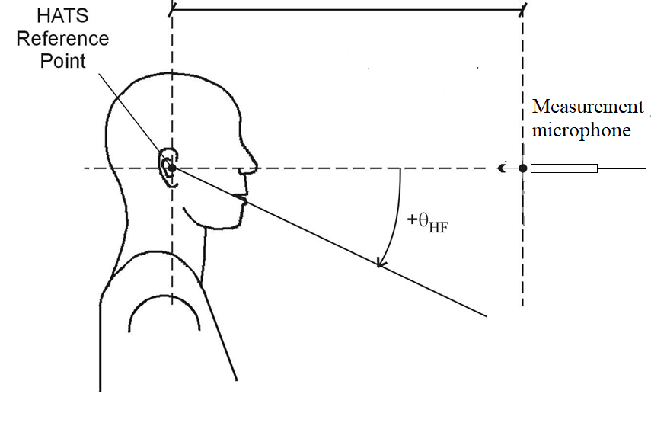
d_{HF} = 42cm
Figure 1: Test setup for privacy

Table 3: Angles for testing privacy
Measuring position | Measuring angle (starting from E)
A | -180°
B | -135°
C | -90°
D | -45°
E | 0°

Test 3a: Robustness (variation of ECRP)
To investigate the robustness of the (chosen) ECRP, several shifts of 1 cm in Z_{e} and Y_{e} direction are evaluated. Figure 2 shows the resulting grid located around the default ECRP (marked in green). As defined in the test plan [1], four mandatory (marked in red) and four optional (marked in blue) points are specified. Table 4 provides unique labels (S0-S8) for the shifts to be applied. Table 5 shows a rearranged view of these labels according to the geometry of the grid in Figure 2.
RLR and RFR are evaluated with the short speech sequence as defined in clause 3.1. The test is run with nominal volume setting.

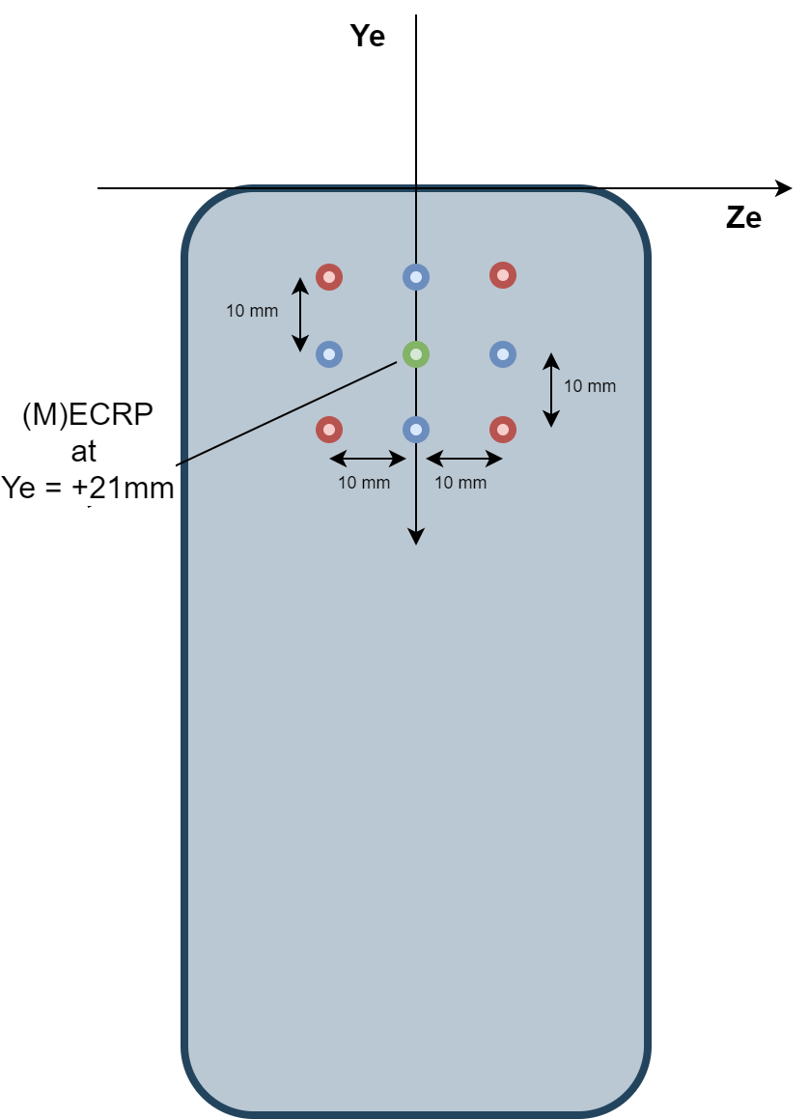
Figure 2: Variation of ECRP

Table 4: Shifts around ECRP (=S0)
Shift | Offset Z_{e} [mm] | Offset Y_{e} [mm] | Type
S0 | 0 | 0 | Mandatory
S1 | -10 | -10 | Mandatory
S2 | +10 | -10 | Mandatory
S3 | +10 | +10 | Mandatory
S4 | -10 | +10 | Mandatory
S5 | 0 | -10 | Optional
S6 | +10 | 0 | Optional
S7 | 0 | +10 | Optional
S8 | -10 | 0 | Optional

Table 5: Gemeotric representation of shifts
 |  | Offset Z_{e} [mm]
 |  | -10 | 0 | +10
Offset Y_{e} [mm] | -10 | S1 | S5 | S2
 | 0 | S8 | S0 | S6
 | +10 | S4 | S7 | S3

Test 3b: Robustness (variation of fork position)
To investigate the impact of the clamping fork positions, the round robin test evaluates three different positions. Initial results from lab1 [3] defined these three positions as offsets in Y_{e}-axis. The general positioning strategy for the forks shown in Table 6 and is not bound to a vendor-specific handset positioner.
Table 6: Fork positions
 | Bottom | Middle | Top
Fork position #1
Fork position #2
Fork position #3

All measurements except Test 3b are conducted with position #1. Only Test3b evaluates positions #2 and #3. Exact values for bottom, middle and top fork position were initially provided in [3] and also in [4]. However, it was found to be extremely impractical to measure the fork positions at each mounting.
Thus, the following general positioning strategy was chosen for lab 2 (and was then adopted by lab 3 and 4):
- Bottom position: the fork is moved and tightened as close as possible at the most lower edge of the device. This fork positioning did not conflict with any button at the sides of the devices.
- Mid position: the fork is moved and tightened as close as possible at the center of the device (regarding Ye axis). In case of collisions with buttons at the sides of the device, the fork is moved to the closest collision-free position (typically, this is towards the lower edge of the device, since most buttons are located in the upper half of the device).
- Top position: the fork is moved and tightened as close as possible at the most upper edge of the device. In case of collisions with buttons at the sides of the device, the fork is moved downwards to the closest collision-free position.
In addition for the Mid and Top positions, care was taken that the clamps of the forks did not produce an overhang, as shown in Figure 3. In this case, the head of the clamp (red color) might push against the ear/cheek of the HATS and the screen of the device (orange color) is not mounted correctly.
Figure 3: Possible overhang of fork positions

RLR and RFR are evaluated with the short speech sequence as defined in clause 3.1. The test is run with nominal volume setting.

Results

Preparations
As described in clause 3.1, the volume steps for nominal and maximum loudness ratings were determined (lab 2) or the pre-defined steps were used (lab 3, lab 4). Some DUTs showed strange behaviour here:
1) DUT2 does not provide a valid nominal volume setting. During incremental testing, RLR "jumps" from ~8.5 dB at step 5/7 to ~-2.5 dB at step 6/7.
2) DUT4 seems to have an incorrect implementation of volume control. At a certain volume increase step, the recorded signal level decreased. This was confirmed by measurements as well as by expert listening.
3) DUT5 provides a “boost mode” in the volume control. This mode was disabled / not used for testing.
The resulting RLR values for all labs, DUTs and long/short test sequences are shown in Figure 4 (for nominal volume) and Figure 5 (maximum volume). Performance requirements according to clause 6.2 of 3GPP TS 26.131 [13] are indicated as tolerances in the figures as well. If available, results for the long and short sequence (see 3.1) are provided.
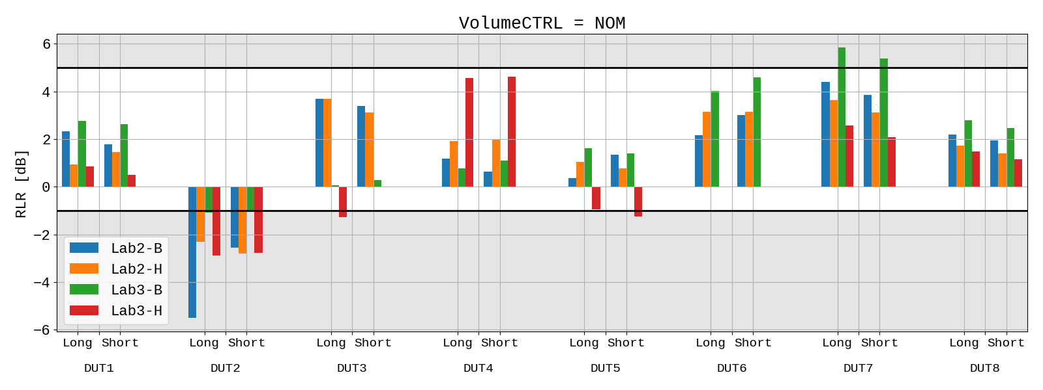
Figure 4: RLR for NOM volume

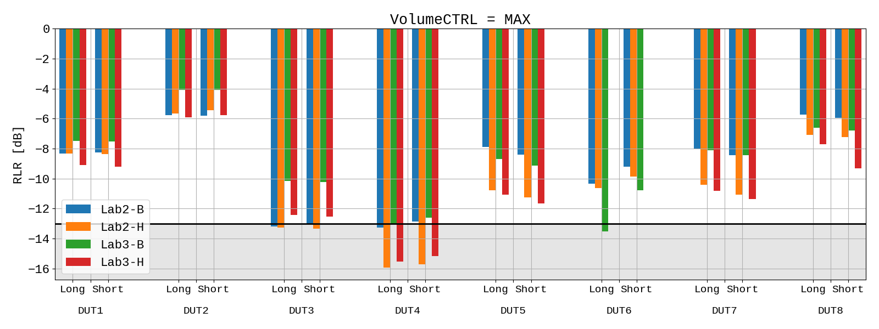
Figure 5: RLR for MAX volume
As already indicated in [5], the volume setting for DUT3 in lab3 (for both HATS/positioner) was not set according to the pre-defined values given in [4]. Also the volume settings for DUT4 and DUT5 in lab 3 seem to be not met (but only HATS/positionier H).
The results of the RFR measurements according to clause 8.4.2 of 3GPP TS 26.132 [9] (using the long single talk sequence from ITU-T P.501 [10]) are shown for all devices in Figure 6 to Figure 13, for NOM and MAX volume). In both figures, the tolerances according to clause 6.4.2 of 3GPP TS 26.131 [13] are provided for reference. All frequency responses in one graph are adjusted to the upper tolerance with the same offset for better (overall) comparison.
NOTE 1: 3GPP TS 26.131 [13] does not specify a performance requirements for MAX volume setting. The tolerances are nevertheless given in the figures.

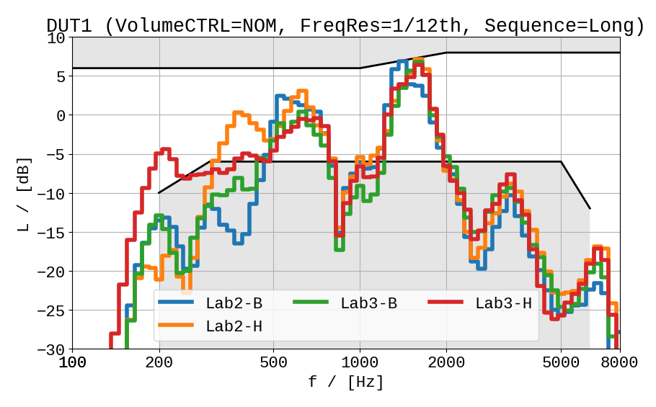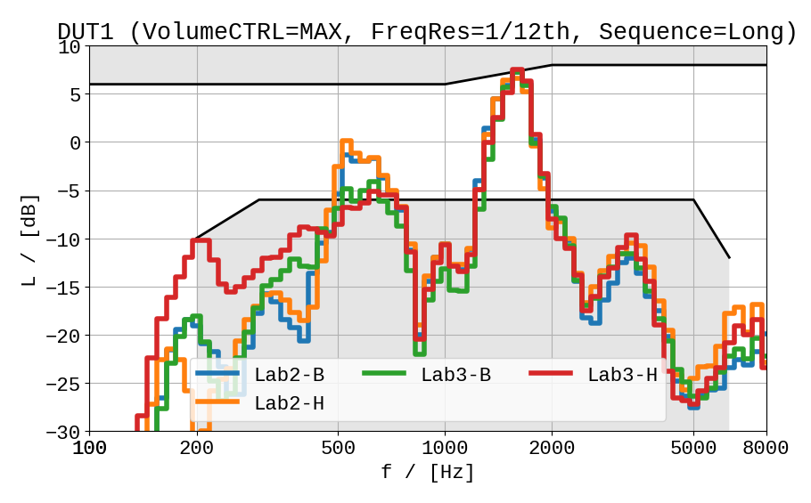
Figure 6: RFR results of DUT1 for NOM (left) and MAX (right)

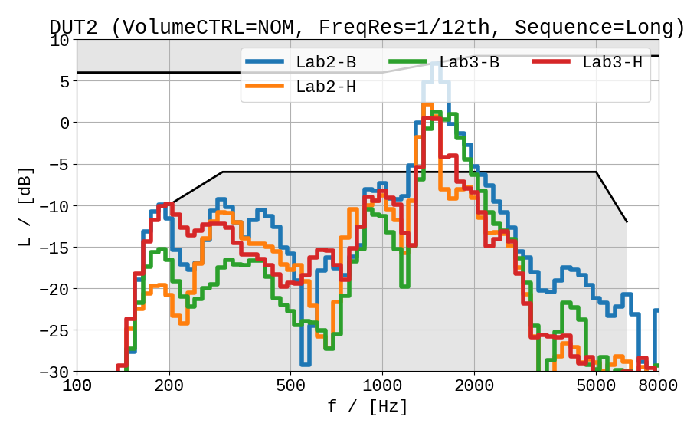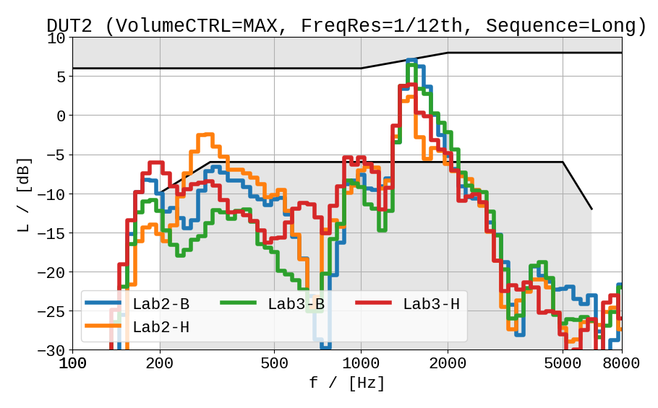
Figure 7: RFR results of DUT2 for NOM (left) and MAX (right)

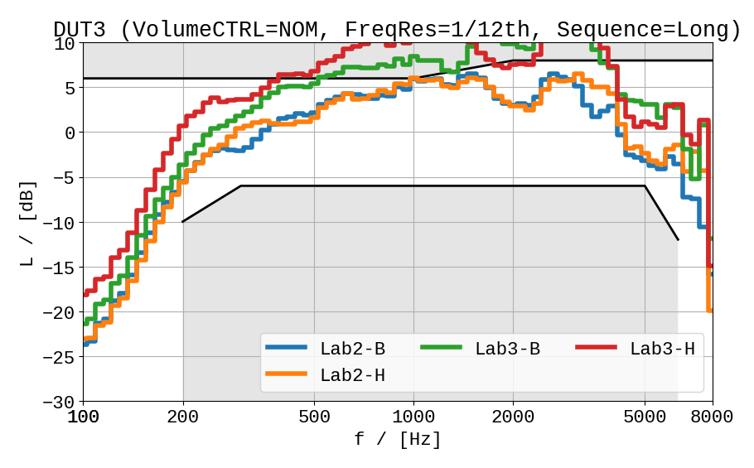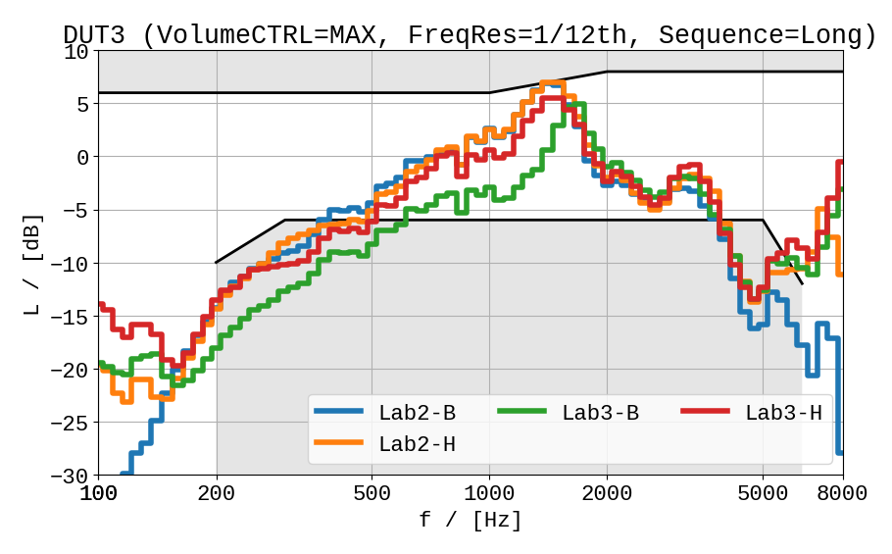
Figure 8: RFR results of DUT3 for NOM (left) and MAX (right)
NOTE 2: The differences in frequency response in Figure 8 are due to the confirmed different (higher) volume settings used in lab 3.

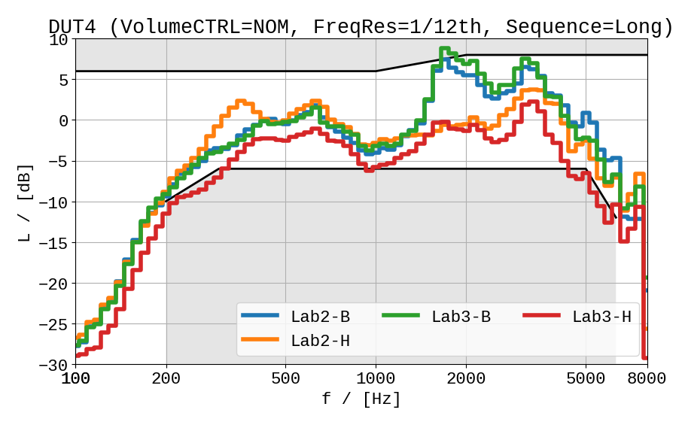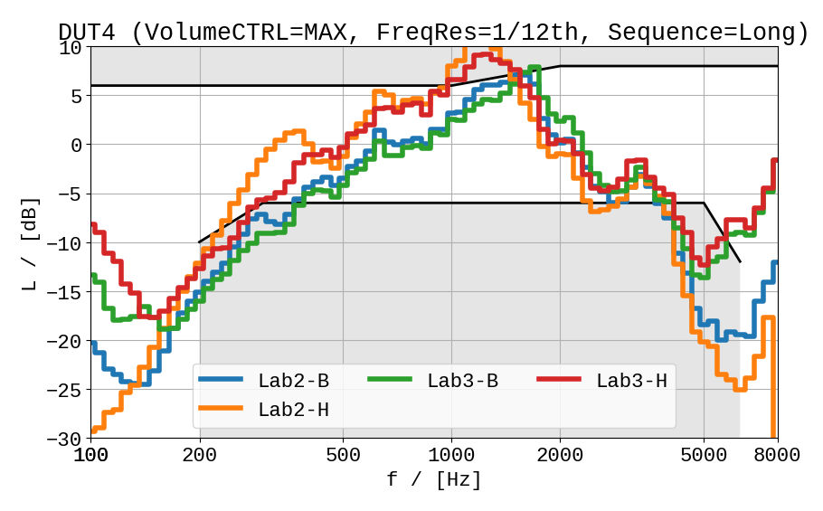
Figure 9: RFR results of DUT4 for NOM (left) and MAX (right)

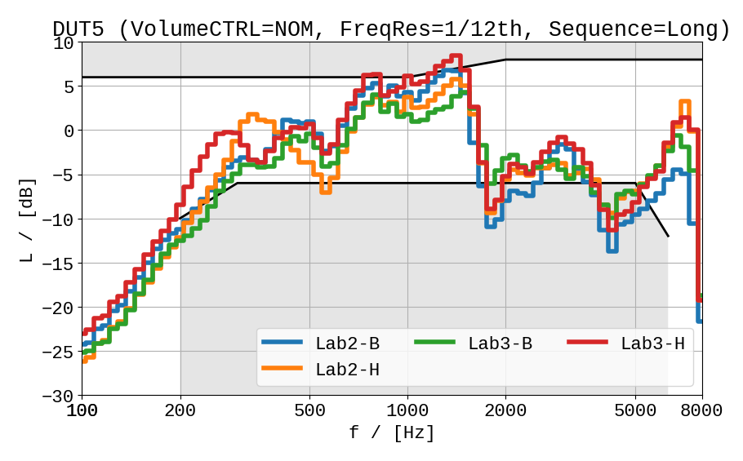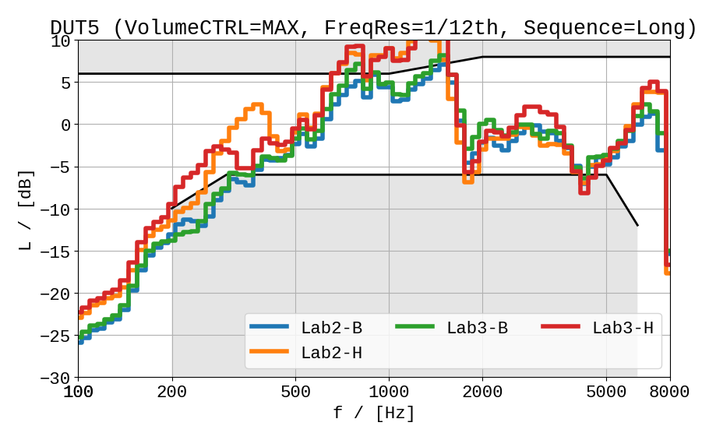
Figure 10: RFR results of DUT5 for NOM (left) and MAX (right)

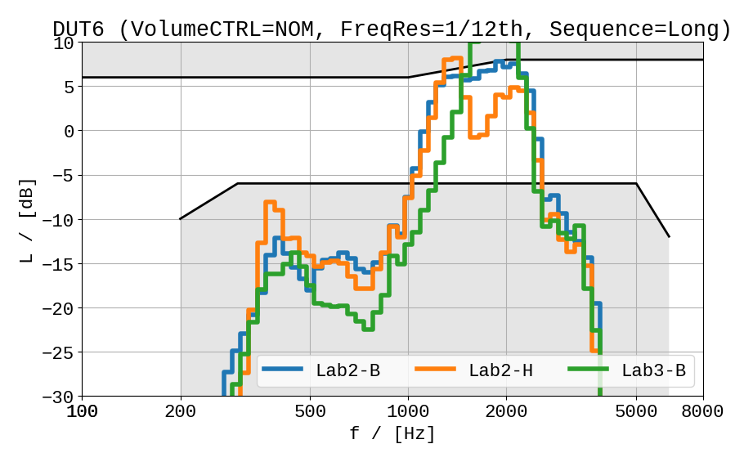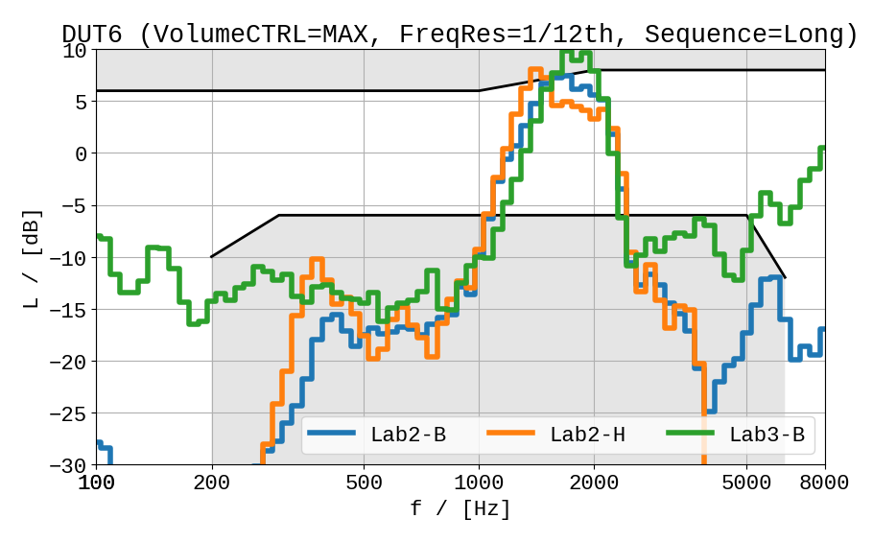
Figure 11: RFR results of DUT6 for NOM (left) and MAX (right)

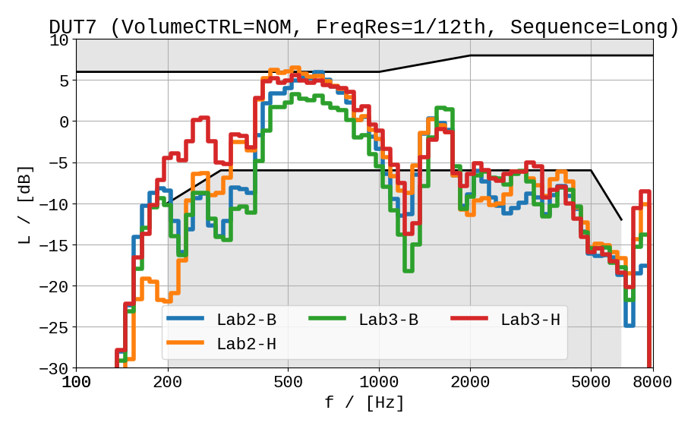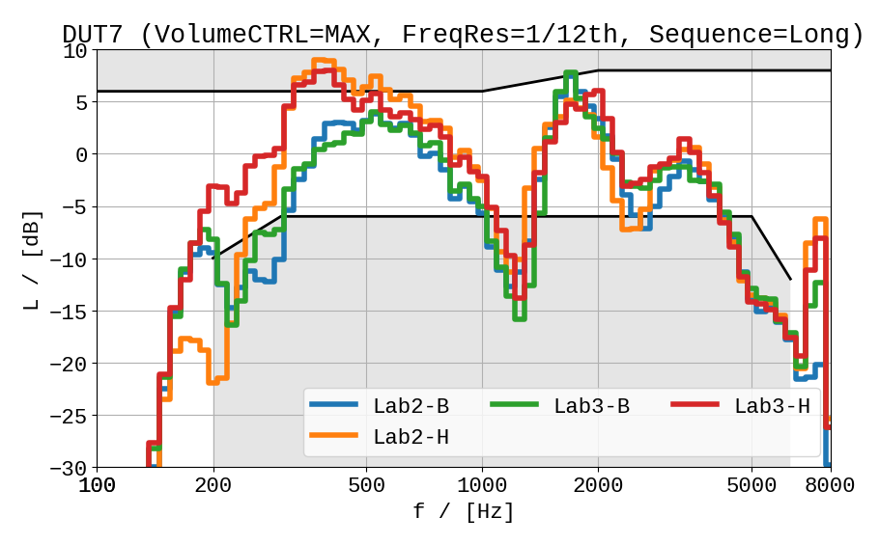
Figure 12: RFR results of DUT7 for NOM (left) and MAX (right)

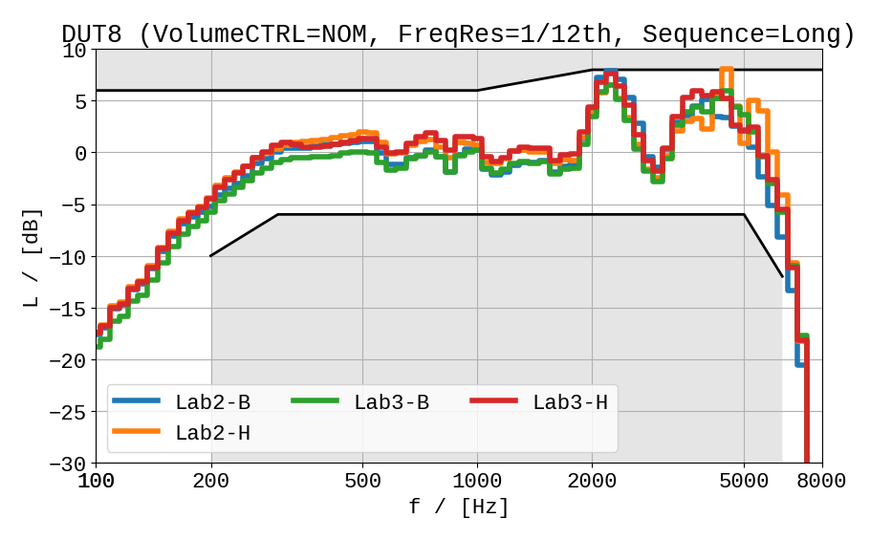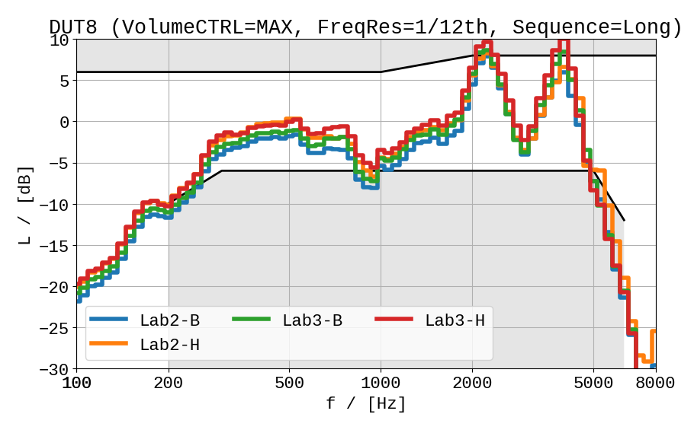
Figure 13: RFR results of DUT8 for NOM (left) and MAX (right)

As described in clause 3.1, Test2, Test3a and Test3b utilize a much shorter speech sequence than in the aforementioned clause 8.4.2 of 3GPP TS 26.132 [9]. In order to quantify the differences between the short and the long (default) sequence, results for RFR obtained with both sequences are provided in Figure 14 to Figure 17 separately for each DUT.

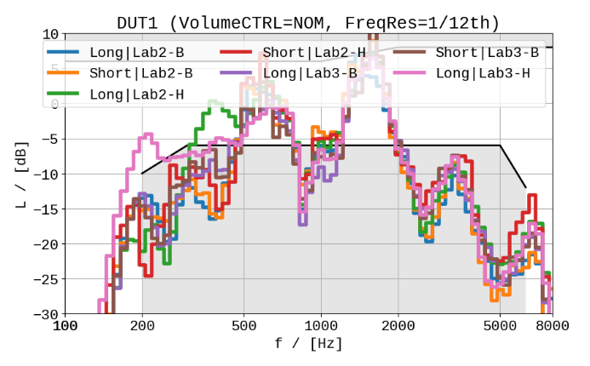 | 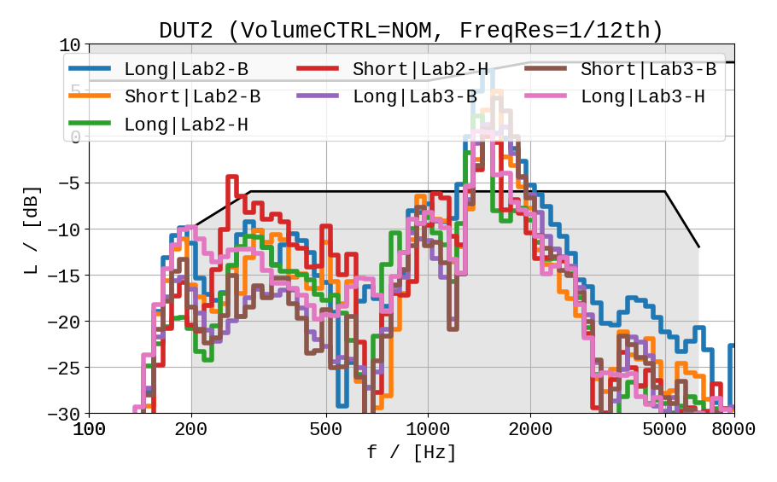
Figure 14: Results of RFR for DUT1 (left) and DUT2 (right)
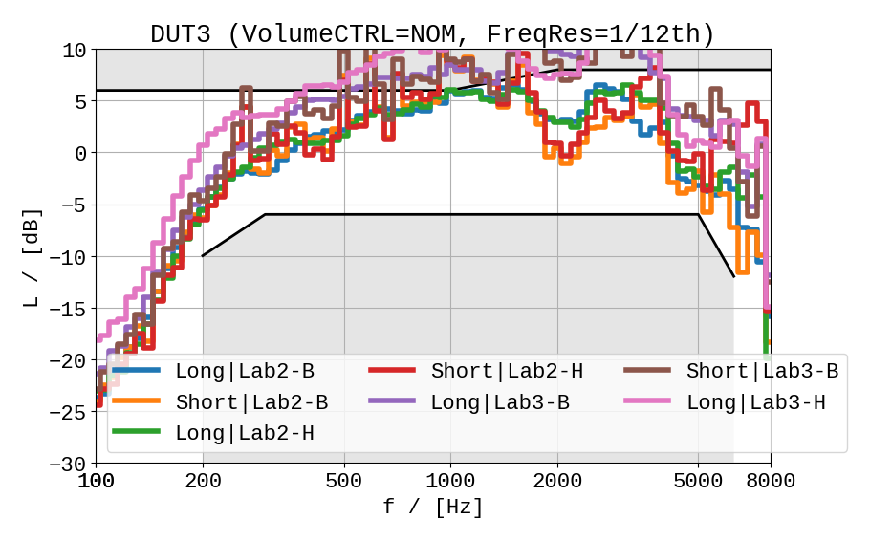 | 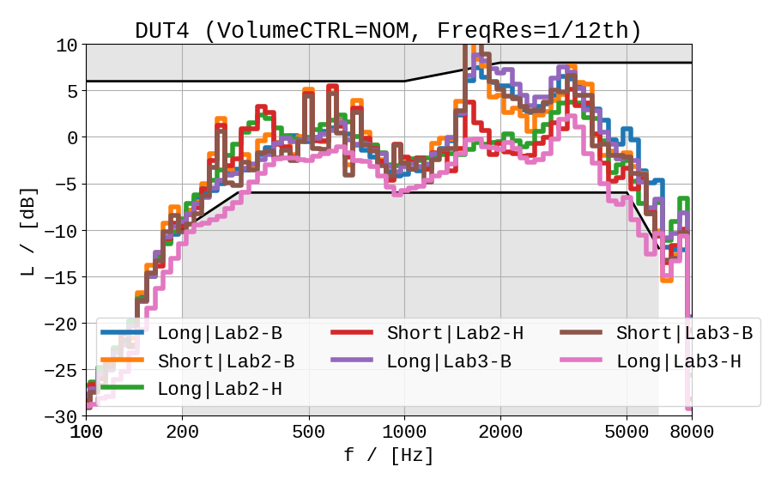
Figure 15: Results of RFR for DUT3 (left) and DUT4 (right)
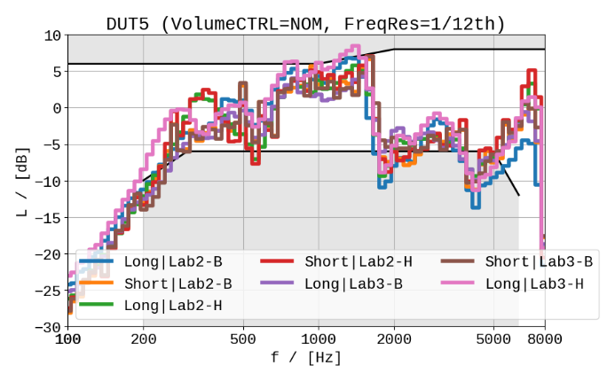 | 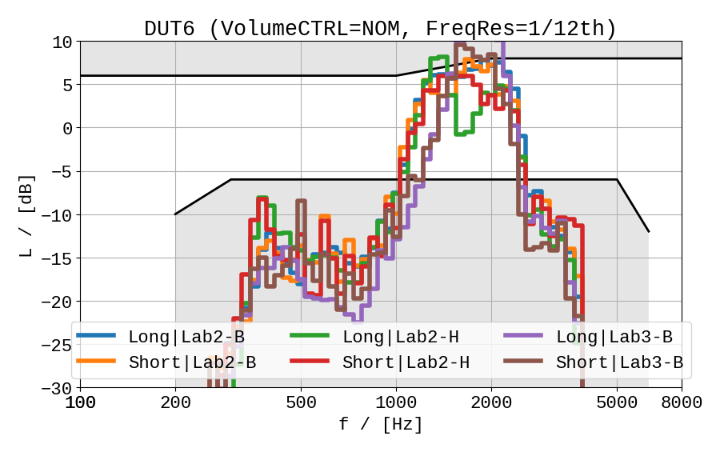
Figure 16: Results of RFR for DUT5 (left) and DUT6 (right)
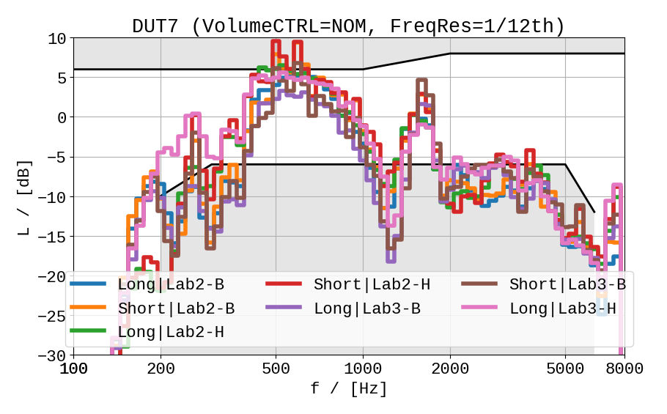 | 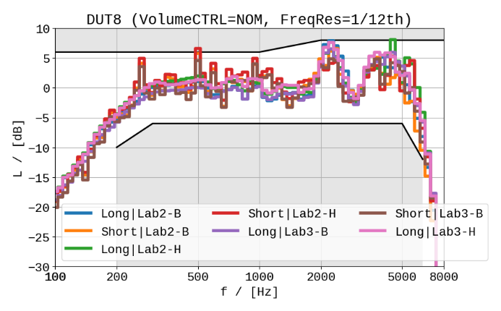
Figure 17: Results of RFR for DUT7 (left) and DUT8 (right)

It can be observed that the short sequence in general leads to similar in RFR results as the long sequence. Due to the shorter integration time and a slightly different speech activity, in some cases spectral spikes are visible (e.g., DUT3, DUT5). However, due to the in general large scatter in the data, it is difficult to assess if the short sequence is able to provide an adequate estimate of the RFR.

Test 1: Speech Quality
Figure 18 and Figure 19 provide the results of the speech quality testing according to ITU-T P.863 for NOM and MAX volume settings for all labs. In several cases, the decrease in quality between these two volume settings is more than 0.5 MOS. Lower performance of some devices may be explained by the frequency response results as shown in clause 4.1.

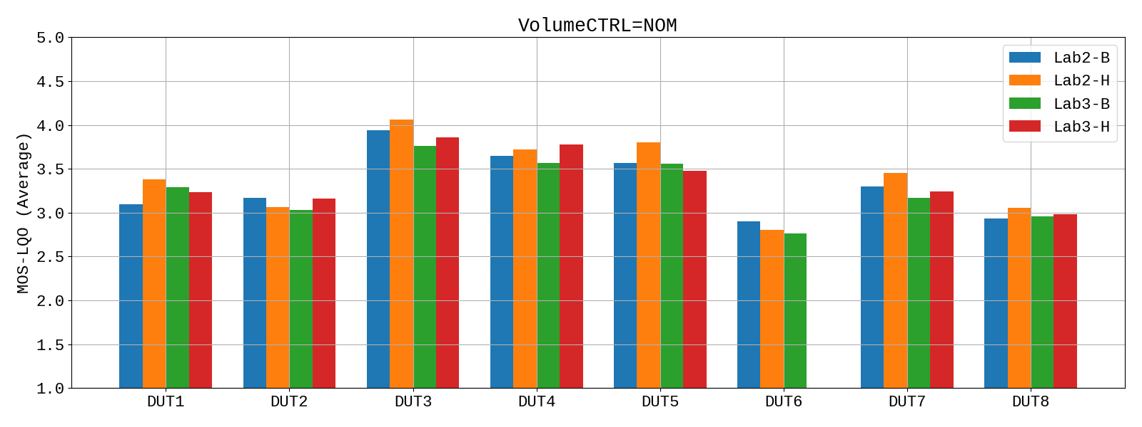
Figure 18: P.863 results for NOM volume setting vs labs

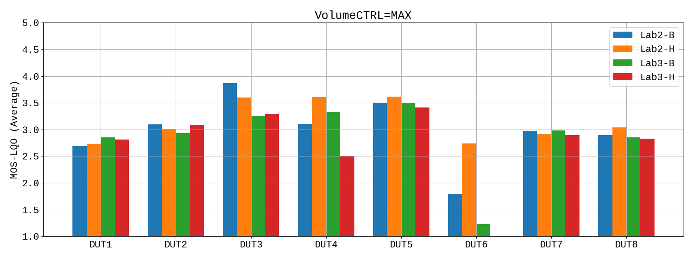
Figure 19: P.863 results for MAX volume setting vs labs

NOTE: The performance of DUT6 at MAX volume (see Figure 19) seems to be unreasonably low and/or inconsistent in both labs. After investigation and expert listening, it was noticed that in some cases, DUT6 emits an extremely high peak level (> 30 dBPa!), which was not taken into account by the dynamic range settings in both labs and results in a clipped amplitude. This artifact leads to a clear degradation in listening quality prediction of P.863. This behaviour seems not to depend on the HATS or lab.

Test 2: Privacy
For testing of privacy, the test plan for the round robin test [1] specified RLR measurements at MAX volume setting. At the same time, RLR was measured at the ear (DUT) and in the vicinity (microphone) and the difference between both should reveal performance regarding sound radiation. These results were provided in [4] and [5], but after detailed analysis of the results, the method of (Delta-)RLR seems not to be suitable.
Due to the low overall level of the recorded signals at the microphone position, the analysis of RLR or Delta-RLR seems not to provide reasonable results. Loudness ratings according to ITU-T P.79 [14] are based on a linearized loudness model, which only works for levels in a suitable "operational range" and the recorded signal at the microphone is not considered to be a valid "signal under test". In general, the level at the microphone should be as low as possible.
For this reason, an post-analysis of the RLR measurements was conducted. The unweighted and A-weighted levels are calculated for the microphone signals (short speech sequence). Leading/trailing silence segments are excluded (0.5 to 6.0s) and frequency range from 100 to 8000 Hz was taken into account. Results for all angles and labs are shown in Figure 20 and Figure 21.
NOTE: Due to the low level (and thus, lower SNR), the usage of active speech level according to ITU-T P.56 [12] is not possible here in all cases.
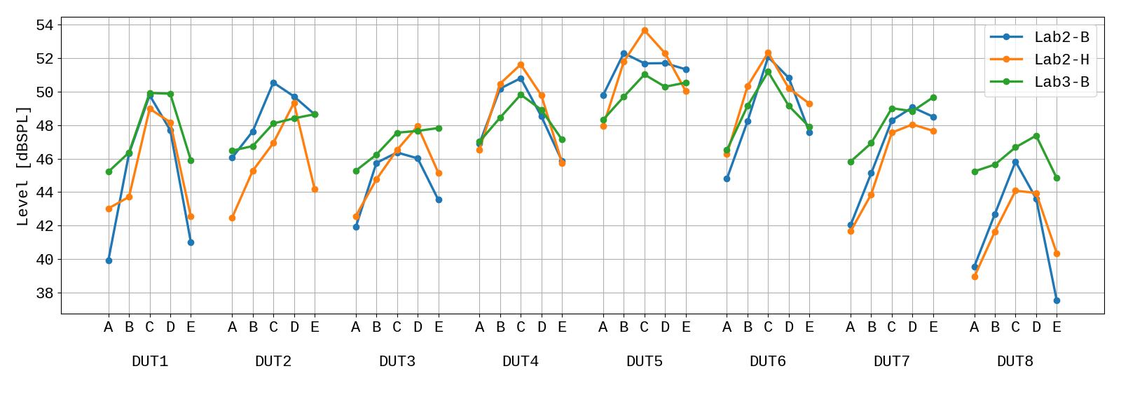
Figure 20: Level (unweigthed) for privacy tests vs labs

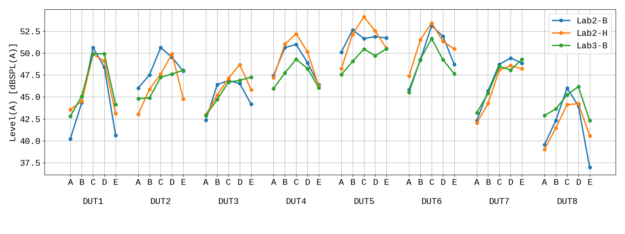
Figure 21: Level (A-weigthed) for privacy tests vs labs

As expected, for all devices the highest sound radiation is obtained at position C (microphone pointing directly to back side of the device). For some devices, the level of the test signal at the microphone position is rather high. One reason for this is the corresponding low RLR at the DUT (e.g., DUT3, DUT4). On the other hand, some devices with a low RLR at the DUT seem to radiate less than others (e.g., DUT3: similar as DUT4 / RLRmax of ~-13dB - but rather low level at the microphone). Vice versa, devices with moderate RLRmax values obtain higher levels at the microphone than devices with lower RLRmax values (e.g., DUT5, DUT6: RLRmax =~ -9dB, but highest overall levels).
The non-HaNTE device DUT8 obtains the lowest overall level at almost all angles/positions. However, the small level differences observed here do not indicate a sound radition issue for HaNTE devices: DUT8 also has one of the lowest RLRmax values, so a lower level is expected.

Test 3a: Robustness (variation of ECRP)
Results of the RLR measurements for the robustness against shifts regarding (M)ECRP across labs are shown for each device in Figure 22 to Figure 29. Each figure also provides results for the long and short speech sequence. For sake of clarity, RLR values are clipped to the range -6 dB to 20 dB. Requirements of clause 6.2.2 of 3GPP TS 26.131 [9] (-1 to +5 dB for NOM volume setting), are indicated in the figures as well.

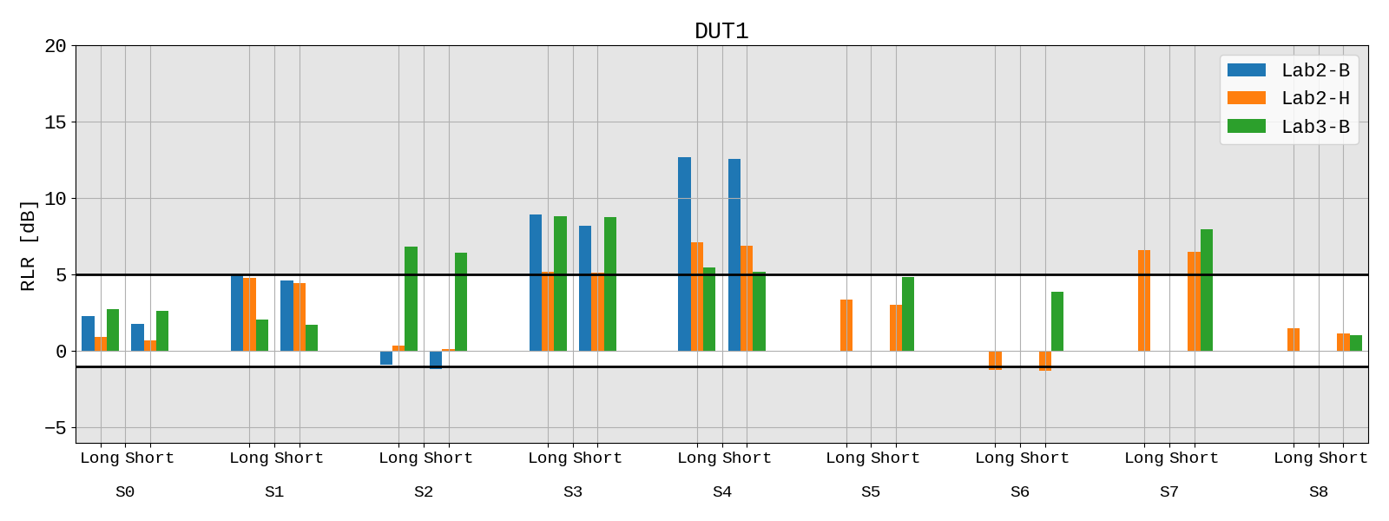
Figure 22: RLR Results for DUT1 vs shifts, sequences and labs

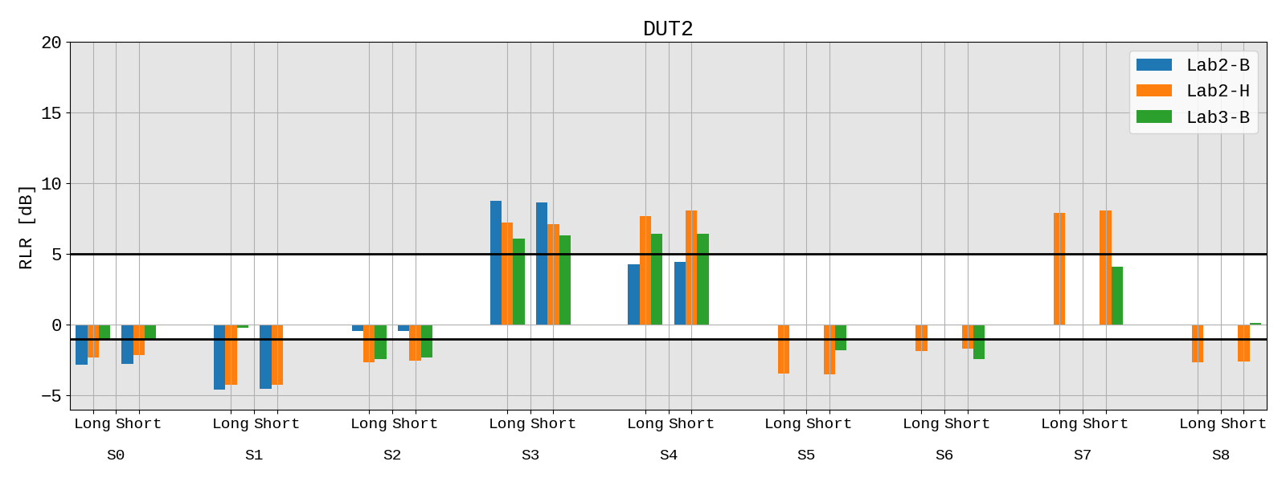
Figure 23: RLR Results for DUT2 vs shifts, sequences and labs

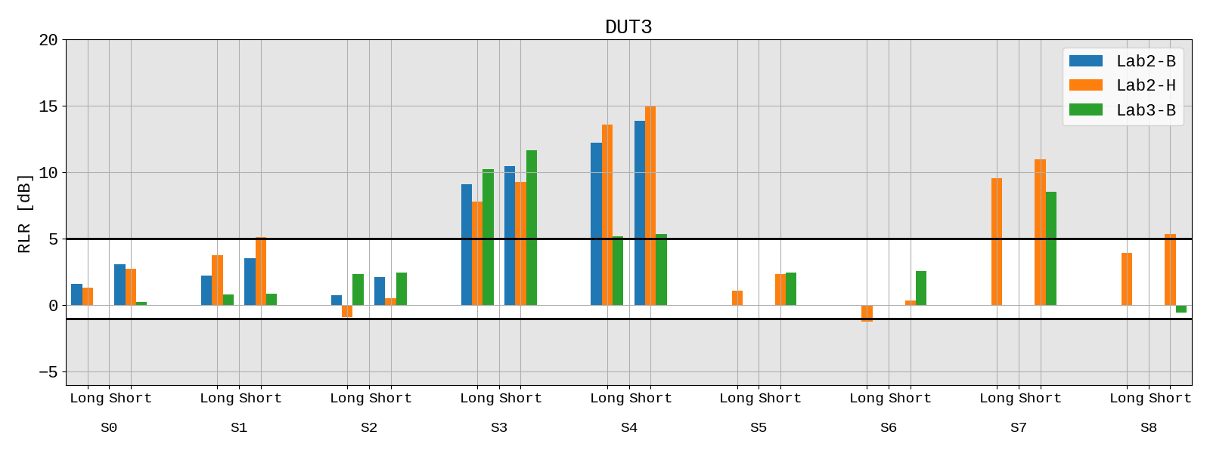
Figure 24: RLR Results for DUT3 vs shifts, sequences and labs

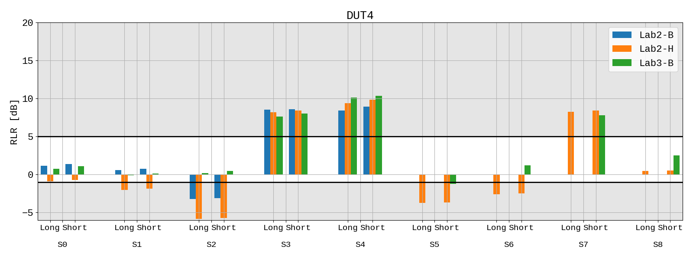
Figure 25: RLR Results for DUT4 vs shifts, sequences and labs

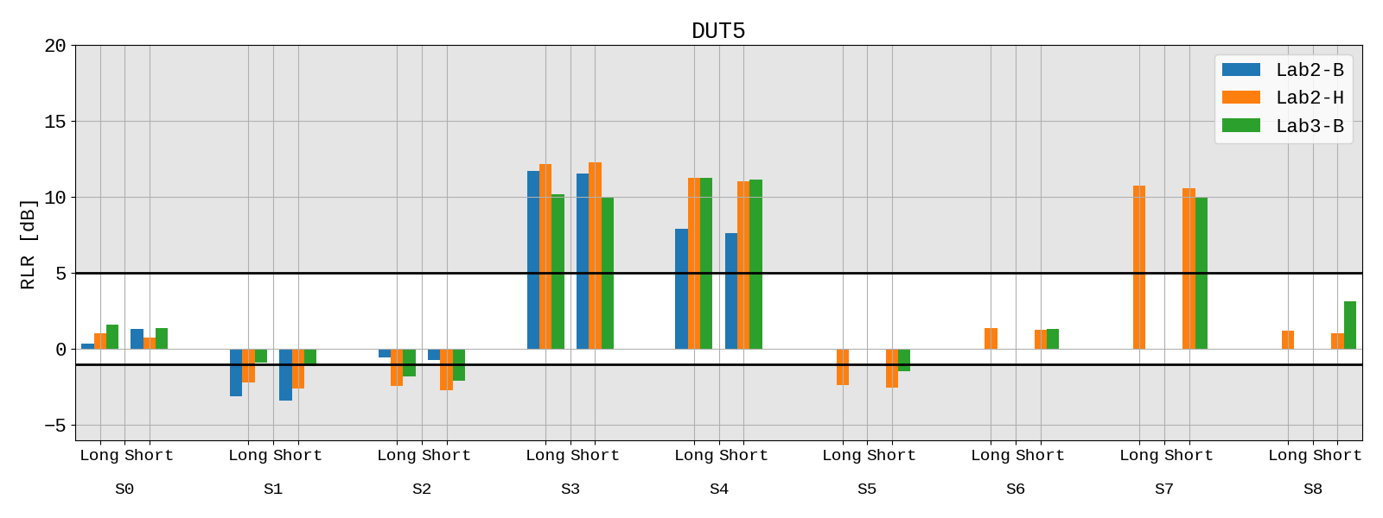
Figure 26: RLR Results for DUT5 vs shifts, sequences and labs

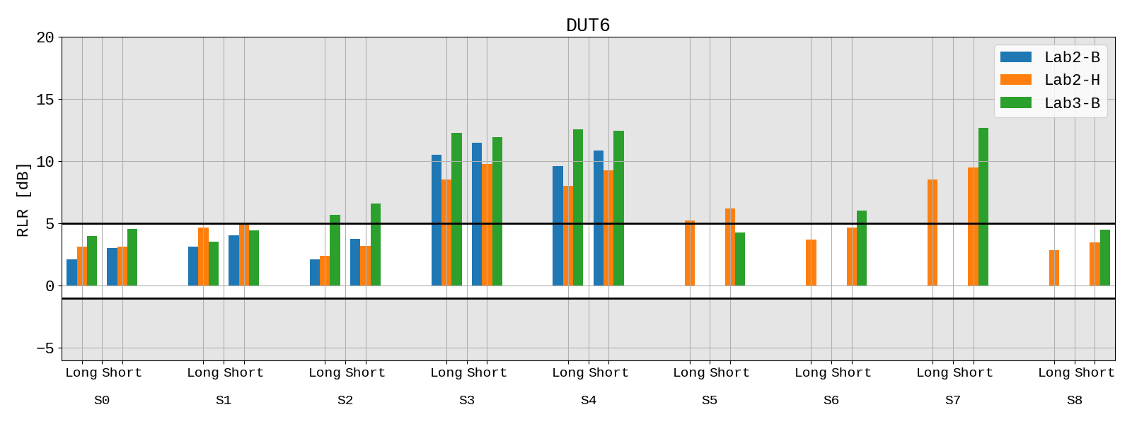
Figure 27: RLR Results for DUT6 vs shifts, sequences and labs

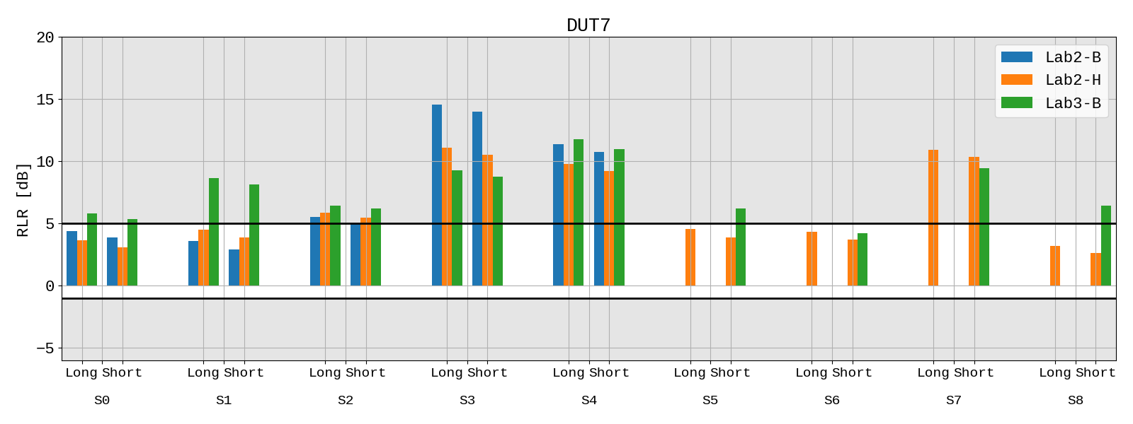
Figure 28: RLR Results for DUT7 vs shifts, sequences and labs

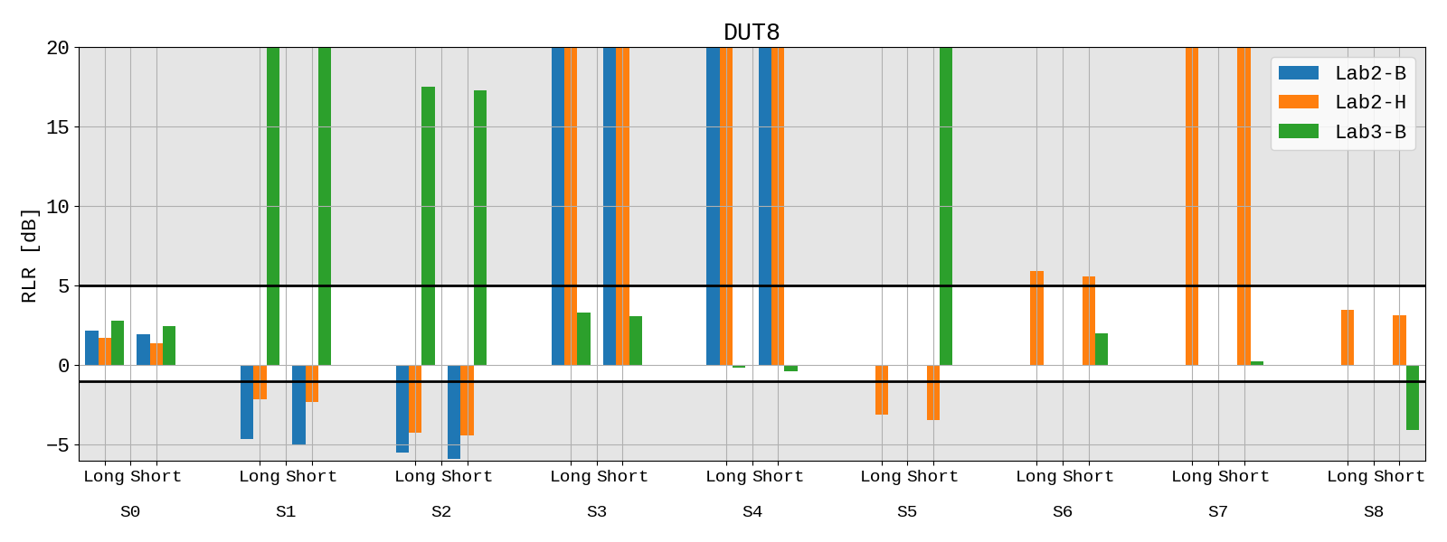
Figure 29: RLR Results for DUT8 vs shifts, sequences and labs

The left sides of Figure 30 to Figure 37 illustrate the RFR results for each device and each shift. Since up to nine curves are provided per figure, for sake of clarity RFR is shown in 1/3rd octave bands. In both sub-figures, the tolerances according to clause 6.4.2 of 3GPP TS 26.131 [13] are provided for reference. All frequency responses in one graph are adjusted to the upper tolerance with the same offset for better (overall) comparison.
Note that the legend is arranged and ordered according to the grid as shown in Figure 2 and Table 5 (e.g., S0 is in the centre of the legend as well as in the grid).
While the aforementioned graphs are showing the robustness regarding positioning, the right sides of Figure 30 to Figure 37 provide a different analysis. Here the RFRs are averaged across all shifts and are then reported for each lab. This can be interpreted as a robustness regarding labs: Since the results for default RFR and RLR seem to include quite some variance across labs and also equipment (see section 4.1, Figure 6 to Figure 13), this average measure may help to reduce such scatter. In most cases, RFR results here are a) similar to the ones of section 4.1 and b) seem to be less variant - even though not all shift positions were carried out for each combination of lab/equipment.

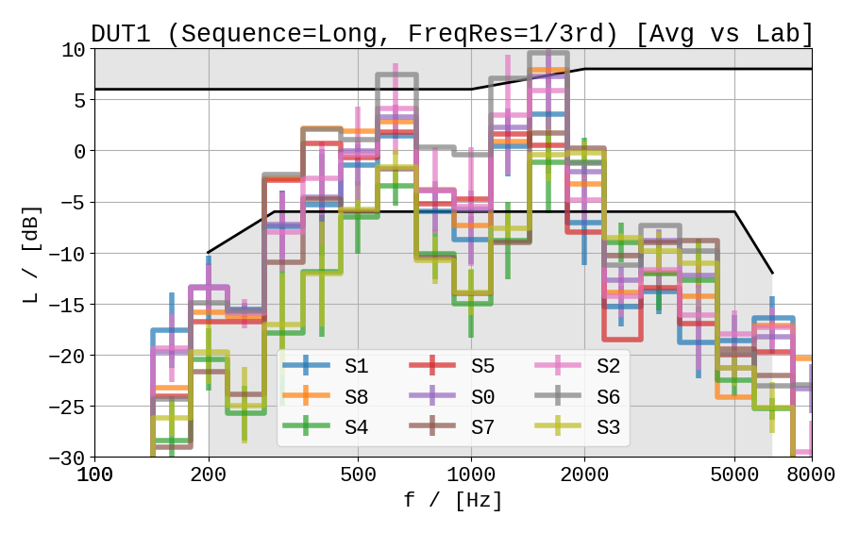 | 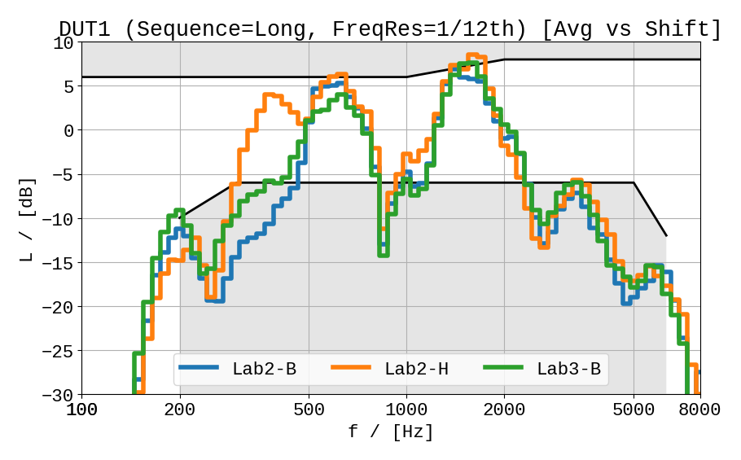
Figure 30: RFR Results for DUT1, averaged vs labs (left) and vs shifts (right)

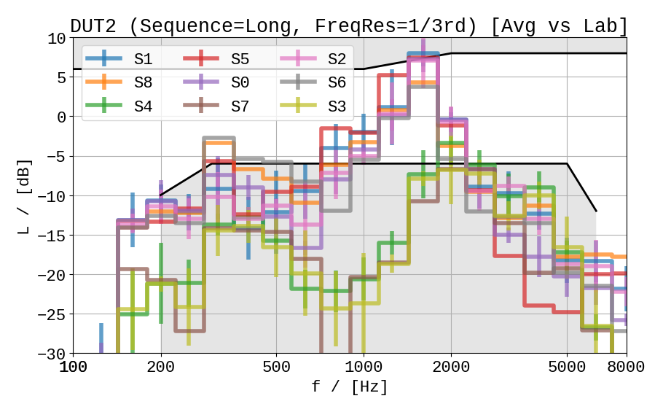 | 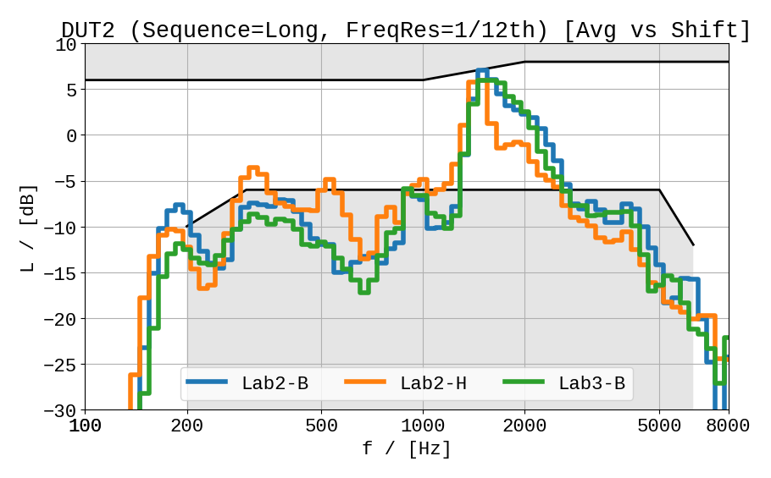
Figure 31: RFR Results for DUT2, averaged vs labs (left) and vs shifts (right)

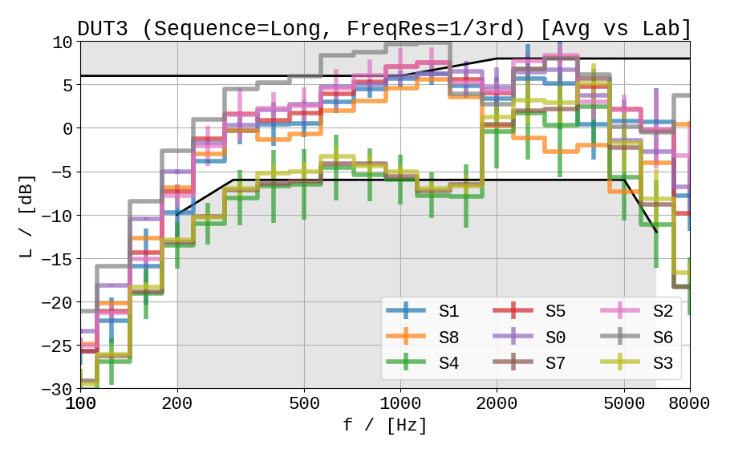 | 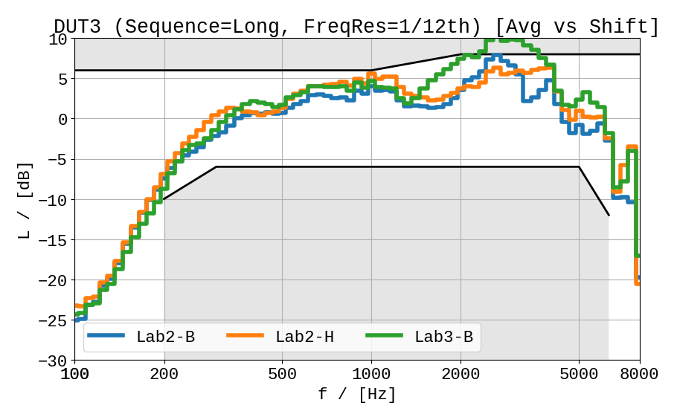
Figure 32: RFR Results for DUT3, averaged vs labs (left) and vs shifts (right)

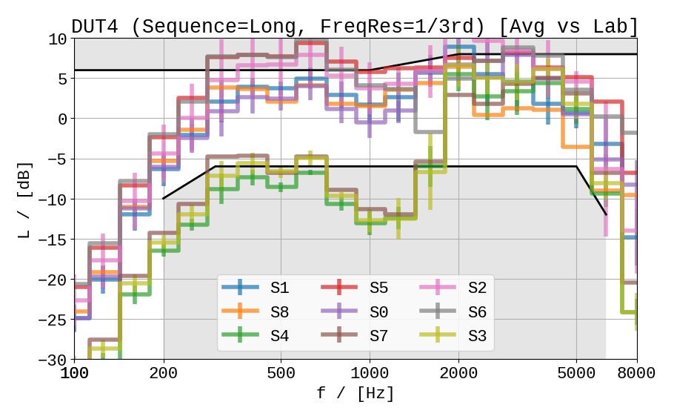 | 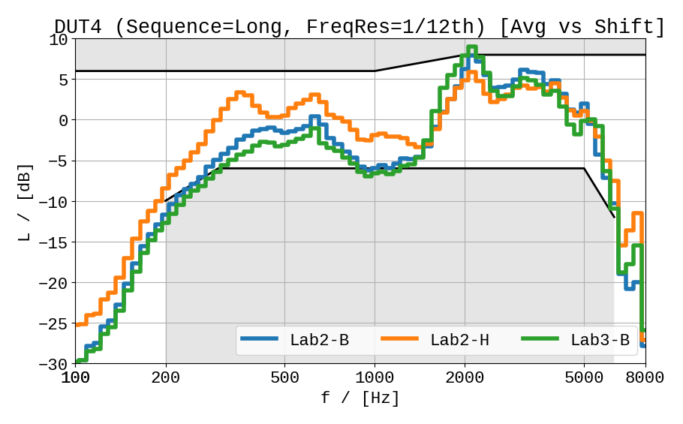
Figure 33: RFR Results for DUT4, averaged vs labs (left) and vs shifts (right)

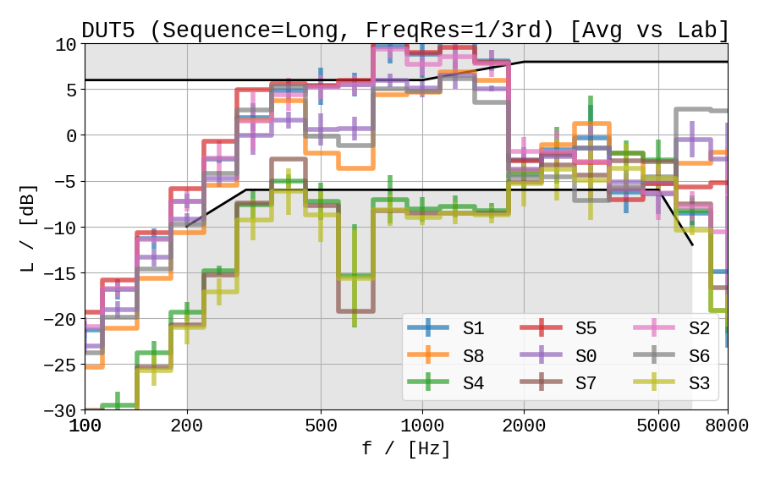 | 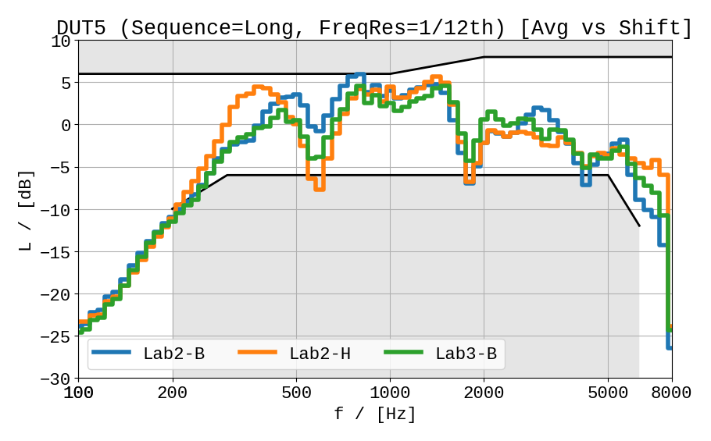
Figure 34: RFR Results for DUT5, averaged vs labs (left) and vs shifts (right)

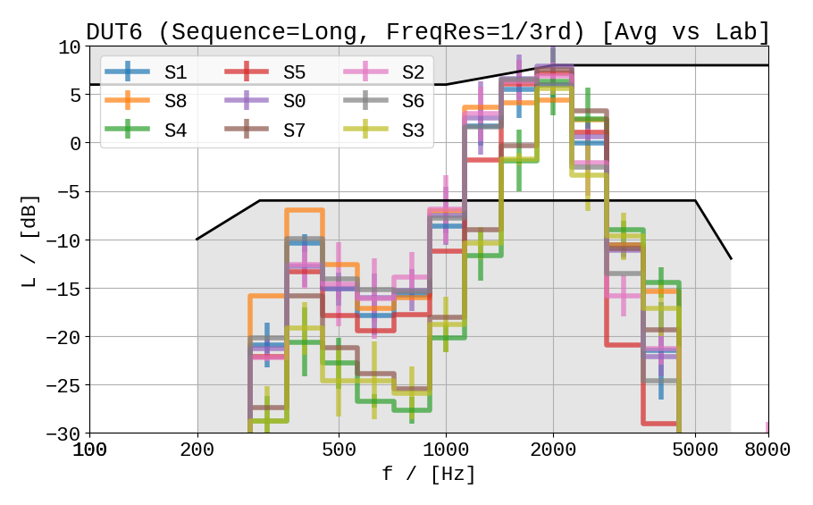 | 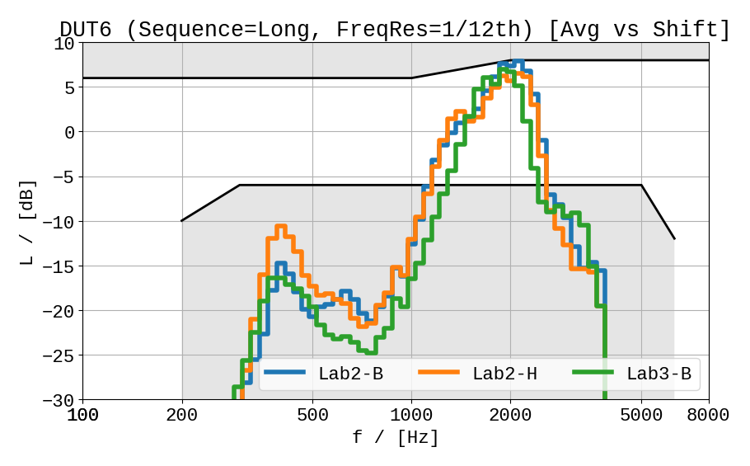
Figure 35: RFR Results for DUT6, averaged vs labs (left) and vs shifts (right)

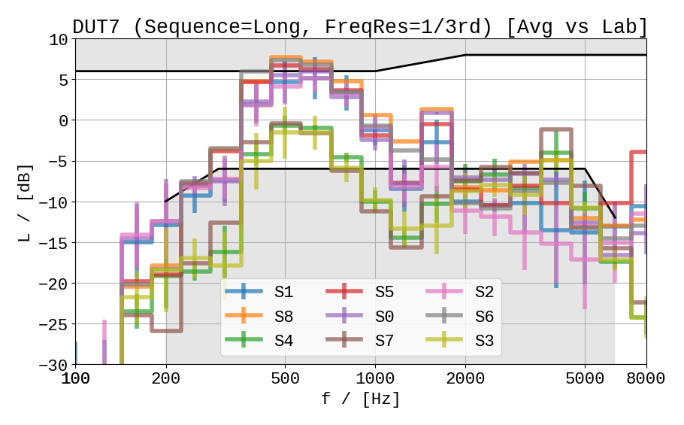 | 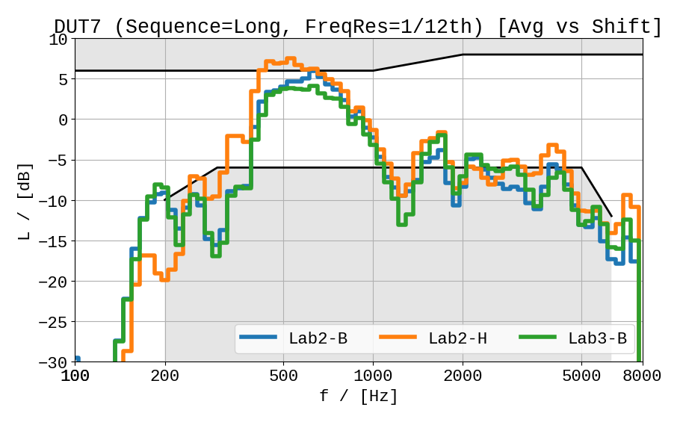
Figure 36: RFR Results for DUT7, averaged vs labs (left) and vs shifts (right)

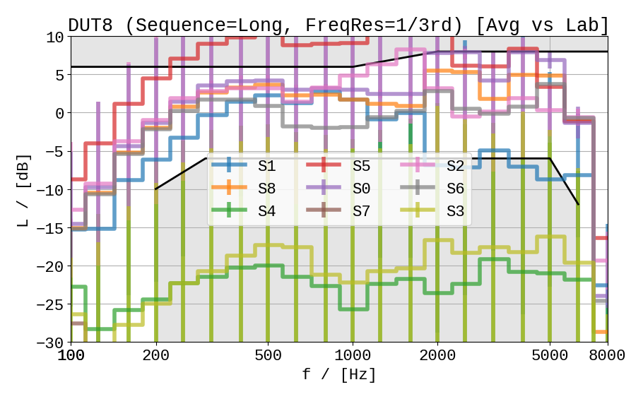 | 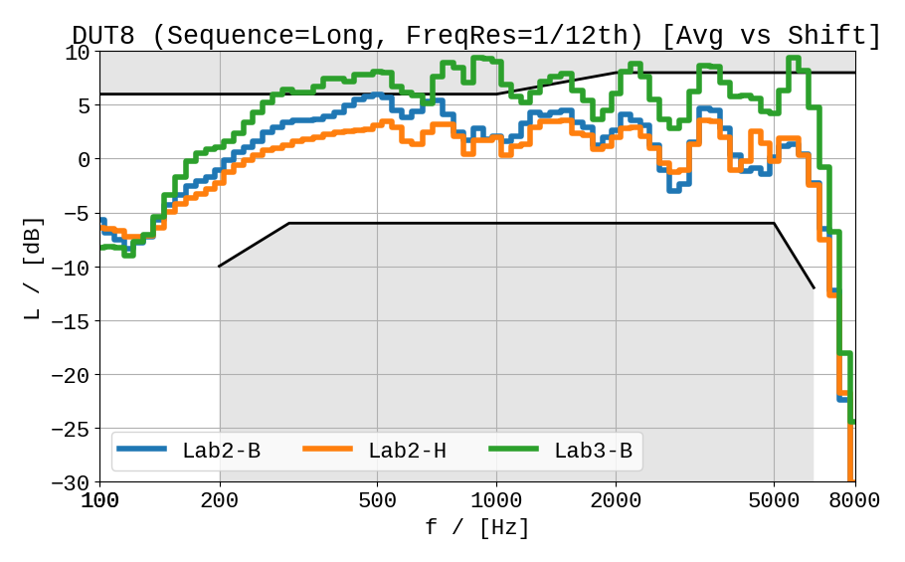
Figure 37: RFR Results for DUT8, averaged vs labs (left) and vs shifts (right)
The robustness regarding shifted ECRP varies across the several DUTs. As a first approach for quantification, the following (arbitrarily chosen) categories can be derived from the data:
- High robustness: DUT6, DUT7
- Medium robustness: DUT1, DUT3
- Poor robustness: DUT2, DUT4, DUT5, DUT8 (expected; non-HaNTE device)

Test 3b: Robustness (variation of fork position)
Results of the RLR measurements for the robustness against different fork positions are shown in Figure 38 (long test sequence) and Figure 39 (short test sequence). Requirements of clause 6.2.2 of 3GPP TS 26.131 [9] (-1 to +5 dB for NOM volume setting), are indicated in the figures as well.

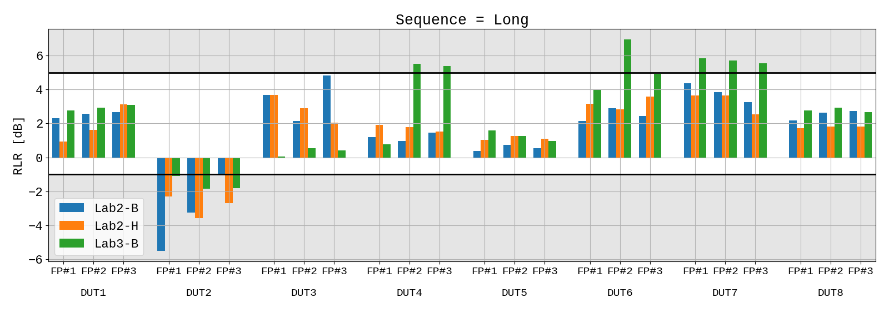
Figure 38: RLR Results for all DUTs vs fork positions (long sequence)

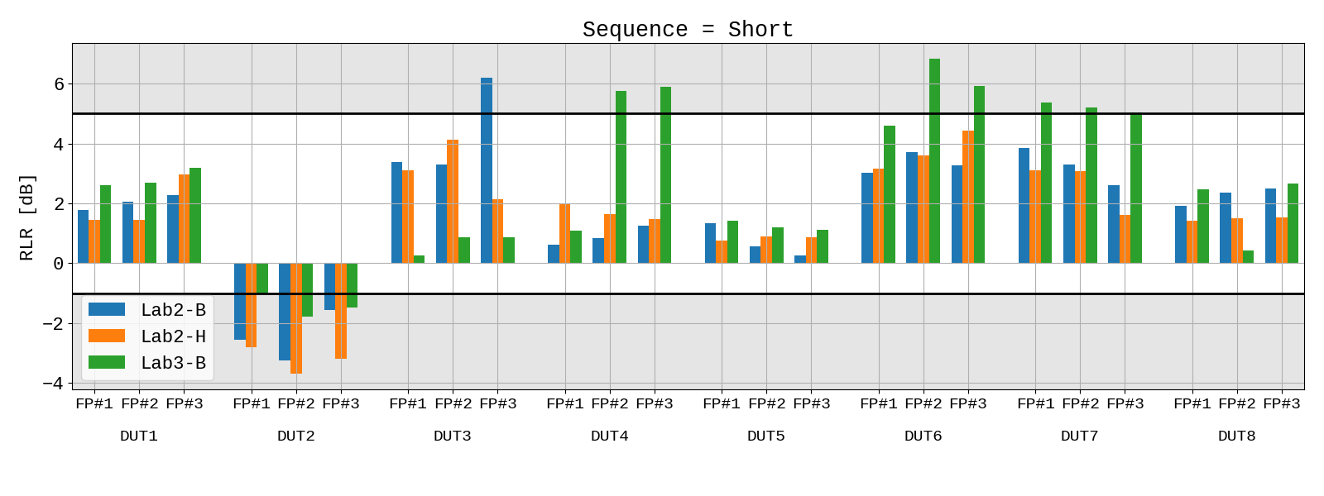
Figure 39: RLR Results for all DUTs vs fork positions (short sequence)

The results of the RFR measurements according to clause 8.4.2 of 3GPP TS 26.132 [9] (using the long single talk sequence from ITU-T P.501 [10]) versus fork positions and labs are shown in Figure 40 to Figure 47 for all devices. To evaluate differences between fork positions, an RFR averaged across labs is additionally provided. For sake of clarity, the average curves are shown in 1/3rd octave bands.
In both sub-figures, the tolerances according to clause 6.4.2 of 3GPP TS 26.131 [13] are provided for reference. All frequency responses in one graph are adjusted to the upper tolerance with the same offset for better (overall) comparison.
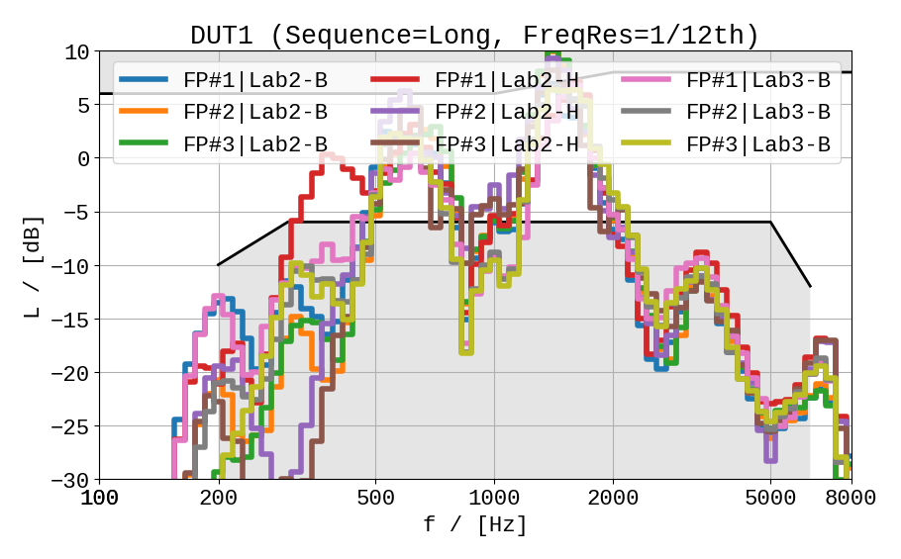 | 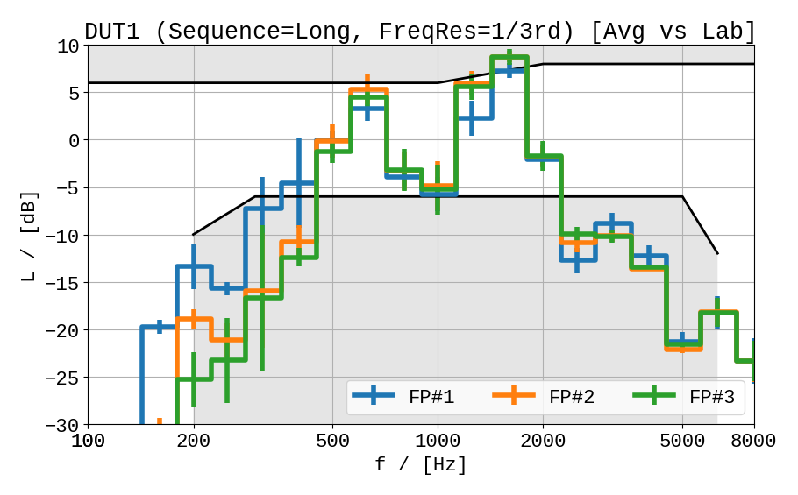
Figure 40: RFR Results for DUT1 versus labs/ fork positions (left) and average vs labs (right)

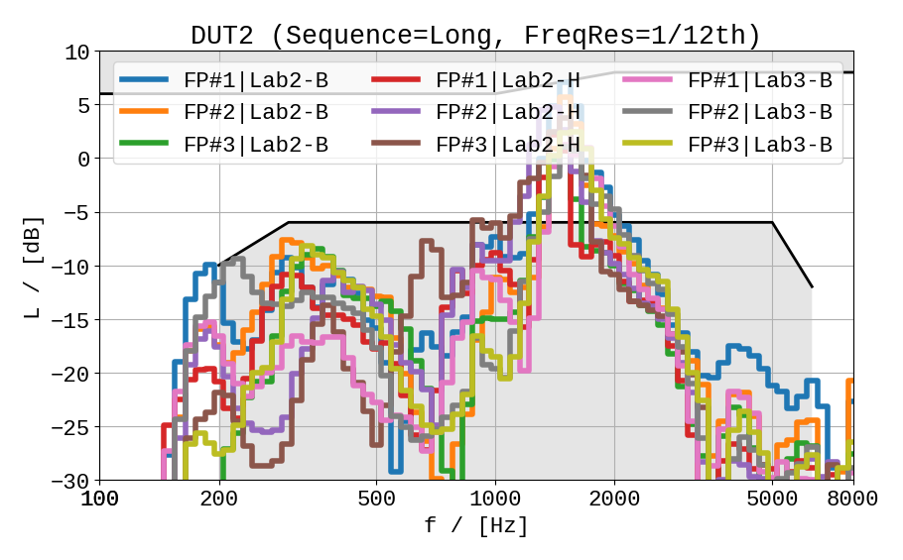 | 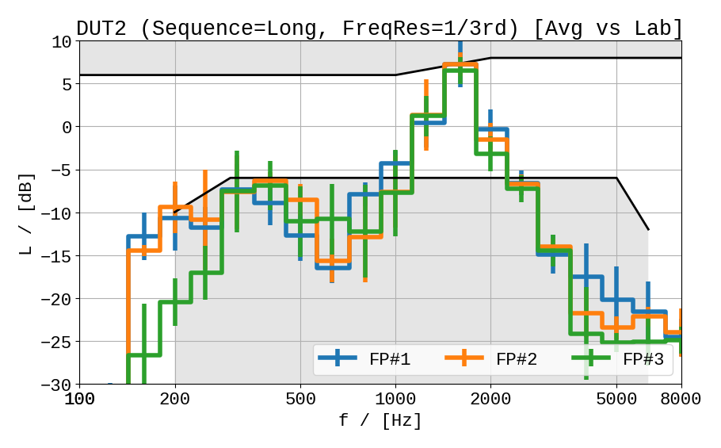
Figure 41: RFR Results for DUT2 versus labs/ fork positions (left) and average vs labs (right)

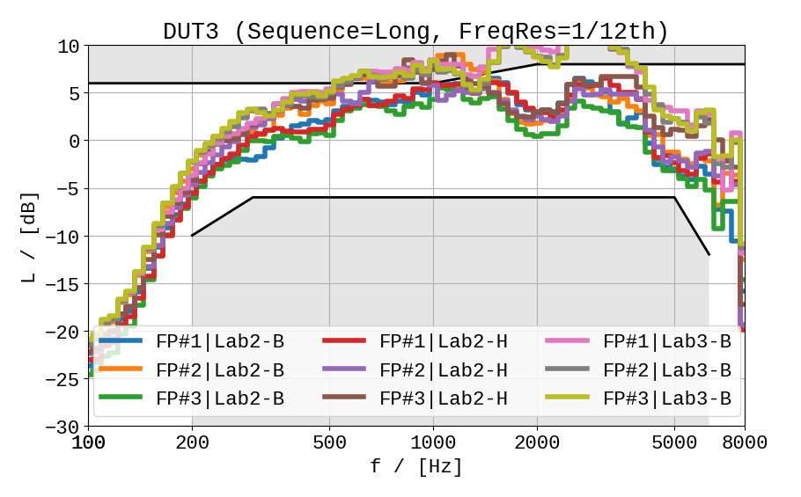 | 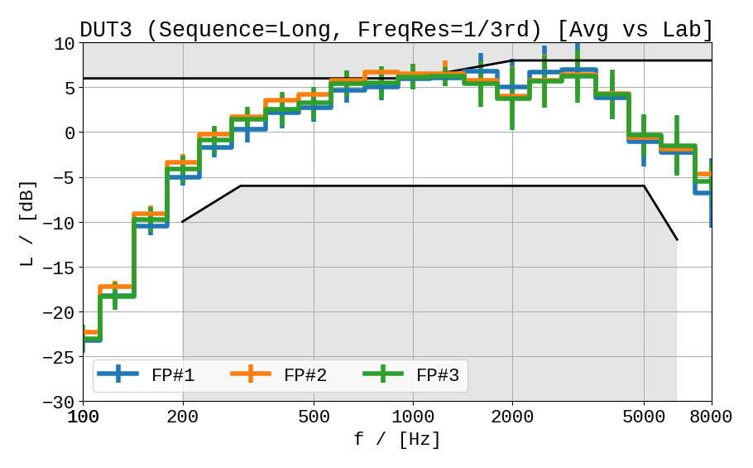
Figure 42: RFR Results for DUT3 versus labs/ fork positions (left) and average vs labs (right)

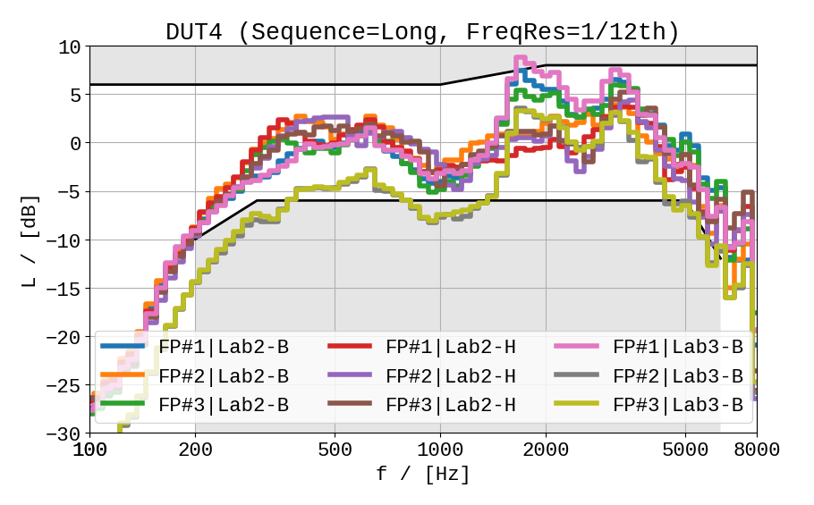 | 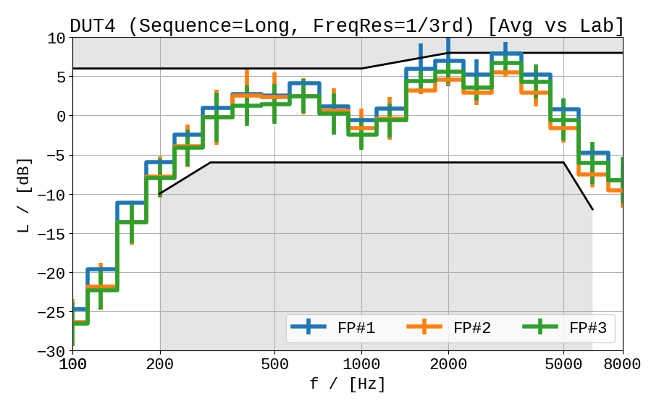
Figure 43: RFR Results for DUT4 versus labs/ fork positions (left) and average vs labs (right)

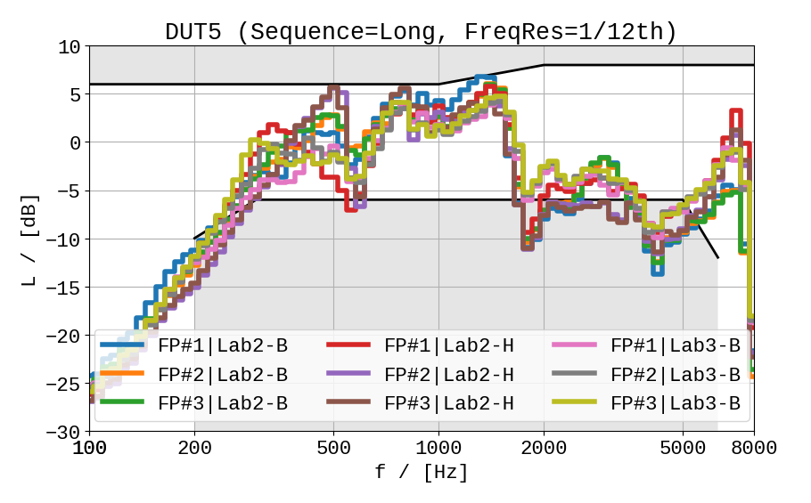 | 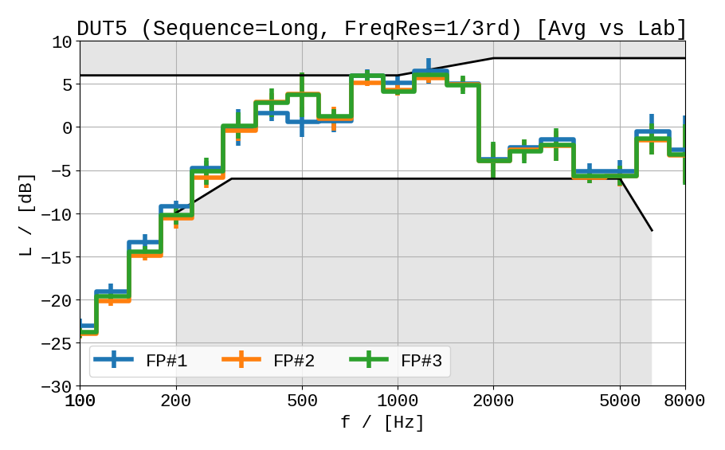
Figure 44: RFR Results for DUT5 versus labs/ fork positions (left) and average vs labs (right)

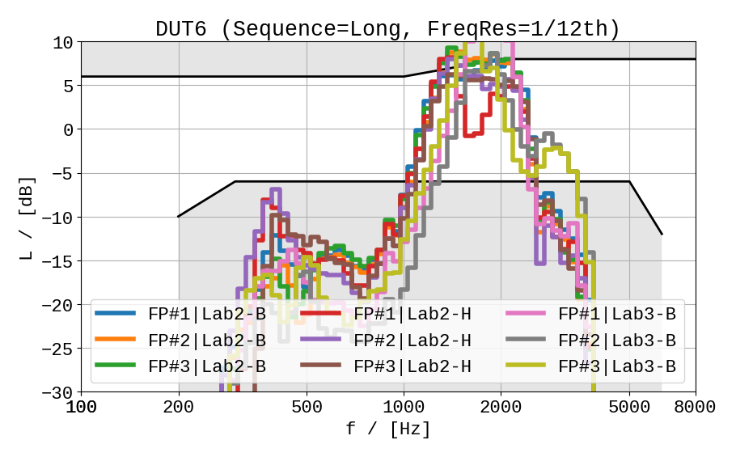 | 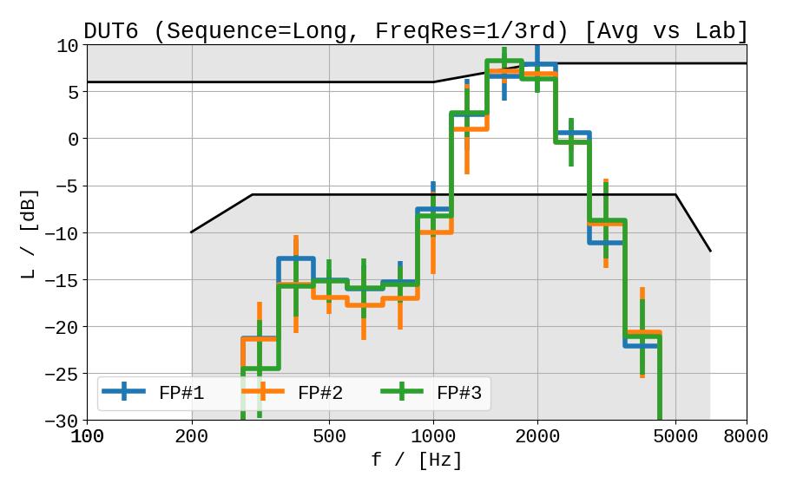
Figure 45: RFR Results for DUT6 versus labs/ fork positions (left) and average vs labs (right)

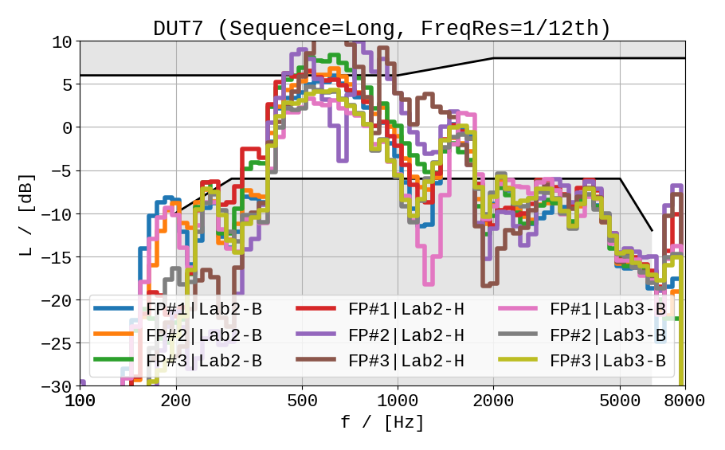 | 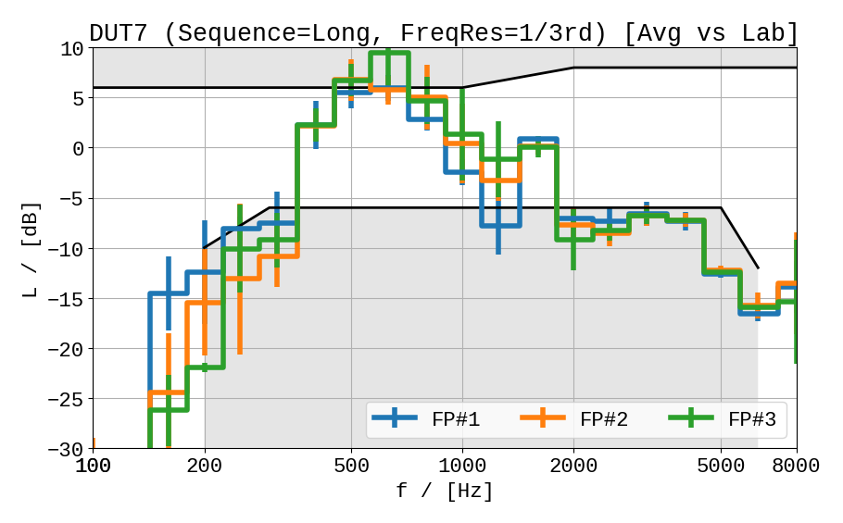
Figure 46: RFR Results for DUT7 versus labs/ fork positions (left) and average vs labs (right)

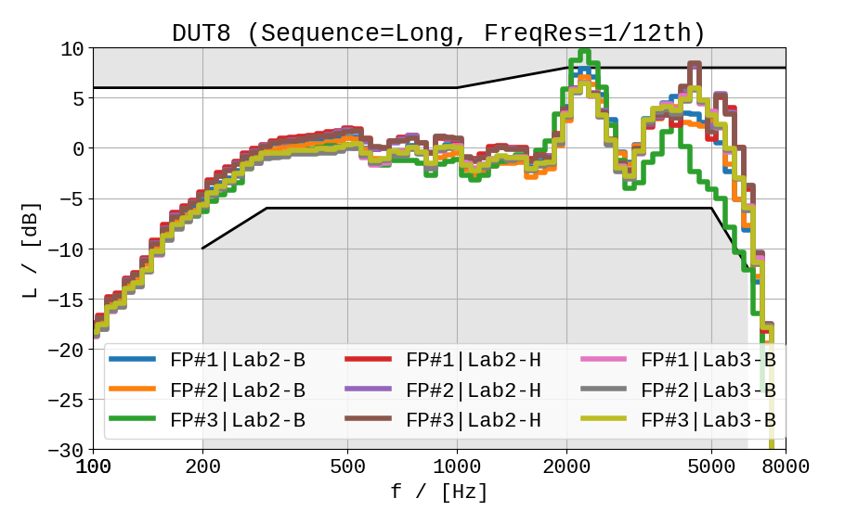 | 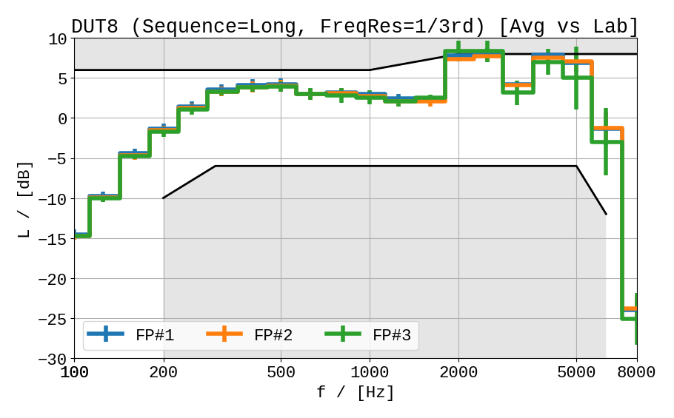
Figure 47: RFR Results for DUT8 versus labs/ fork positions (left) and average vs labs (right)
Similar as for the results for Test 3a, the robustness regarding remounting at different fork positions varies across the several DUTs. As a first approach for quantification, the following (arbitrarily chosen) categories can be derived from the data:
- High robustness: DUT3, DUT4, DUT8 (expected; non-HaNTE device)
- Medium robustness: DUT5, DUT6
- Poor robustness: DUT1, DUT2, DUT7

Conclusion
The present document presented aggregated results of the HaNTE round robin test from lab2 and lab3 (with up two HATS/positioner types), which were obtained according to the test plan [1]. Several pecularities of the devices were identified and described in order to reduce effort for the subsequent labs in the round robin test. As a slight modification to the original test plan [1], the source proposes to use common volume settings and a more flexible fork positioning strategy for the round robin test in all labs.
Test 1 (Speech Quality): Due to the low performance in frequency response for NOM and/or MAX, some devices cannot provide constant and acceptable quality across volume settings. However, since also good performance was achieved by other devices (e.g., DUT3 meets RFR requirement and MOS > 3.5), it seems definitely possible to provide acceptable quality for HaNTE-devices.
Test 2 (Privacy): After reviewing (Delta-)RLR results, an absolute level measure was found to be more suitable for the evaluation of direction-dependent sound radiation. However, resulting levels measured at the microphone between ~38 dB_{SPL} / dB_{SPL}(A) and 53-54 dB_{SPL} / dB_{SPL}(A) indicate that there are at least noticeable differences between the devices. Further analyses are required in order to evaluate the dependency on the maximum RLR and to derive a possible requirement on an allowed degree of sound radiation.
Test 3a (Robustness vs. shifts): Large differences in performance regarding RLR and RFR could be observed, depending on the shifts. Only few devices can be regarded as robust against shifts. The initial average measure across shift positions seem to reduce the scatter versus labs and should be investigated more in detail (for example, if the same result can be achieved with the short sequences).
Test 3b (Robustness vs. fork positions): Most devices perform similar regarding the different fork positions. However, some devices show high deviations here, which have issues in the baseline frequency response as well.
More stable conclusions on the results and possible consequences on HaNTE-specific measurements for 3GPP TS 26.132/131 are expected after merging available measurement data from lab 4 and lab 1.

References

[1] | 3GPP S4-201164, „Proposals for data collection of HaNTE – test methods“.
[2] | 3GPP SP-191212, „New WID on Handsets Featuring Non-Traditional Earpieces (HaNTE)“.
[3] | 3GPP S4-201096, „Results of HaNTE round robin tests in Lab 1“.
[4] | 3GPP S4-201317, „Preliminary results of HaNTE round robin test results for Lab2,“ HEAD acoustics GmbH, 2020-11-11.
[5] | 3GPP S4aQ200160, „Preliminary report on HaNTE round robin test for Lab3,“ Orange, 2021-01-16.
[6] | ITU-T Recommendation P.64, „Determination of sensitivity/frequency characteristics of local telephone systems,“ 06/2019.
[7] | ITU-T Recommendation P.58, „Head and torso simulator for telephonometry,“ 05/2013.
[8] | ITU-T Recommendation P.57, „Artificial ears,“ 12/2011.
[9] | 3GPP TS 26.132, „Speech and video telephony terminal acoustic test specification,“ Release 16.0.0.
[10] | ITU-T Recommendation P.501, „Test signals for use in telephonometry,“ 03/2017.
[11] | ITU-T Recommendation P.863, „Perceptual objective listening quality prediction,“ 03/2018.
[12] | ITU-T Recommendation P.56, „Objective measurement of active speech level,“ 12/2011.
[13] | 3GPP TS 26.131, „Terminal acoustic characteristics for telephony; Requirements,“ Release-16.
[14] | Recommendation ITU-T P.79, „Calculation of loudness ratings for telephone sets,“ 11/2007.

