Source: Qualcomm Incorporated
Title: Proposals for data collection of HaNTE – test methods

Document for: Agreement

Agenda Item: [9.6, 16.4]

Abstract
This contribution proposes test methods that participating companies can use for a data collection round robin in support of the work item on Handsets Featuring Non-Traditional Earpieces (HaNTE), approved at SA#86 [1].

Background
The objectives of the HaNTE work item, as described in [1] are the following:
- Update 3GPP TS 26.132 with reference to the appropriate version of ITU-T P.64 that addresses HaNTE devices.
- Review performance of HaNTE devices and update requirements in 3GPP TS 26.131 if necessary, to ensure an adequate user experience.
- Establish guidelines for mounting of HaNTE devices to ensure a repeatable and reproducible measurement method in 3GPP TS 26.132.
- Investigate testing RFR/RLR at a single position and at different positions, and report the results; based on those results, and if judged necessary by SA4, new requirements/test methods may be specified.
- Address privacy aspects identified during the study phase and develop requirements/test method if necessary.
- Address distortion aspects identified during the study phase and update requirements/test method if necessary.
- Address out of band noise aspects identified during the study phase and develop requirements/test method if necessary.
At SA4#107, a contribution [2] proposed changes to TS 26.131 and TS 26.132 that address some of the objectives of the work item. The source believes that inter-lab repeatability and reproducibility is a key aspect and must be assessed in connection with new test method proposals prior to agreement. The source then proposed [3], and SQ agreed in principle [4] to:
- Conduct a round-robin testing of HaNTE devices with willing participating labs.
- The following tentative time-plan for the round robin:

March 3rd, 2020 | SQ SWG Telco | - Agree in principle on conduction of round robin test.  - Identify 3 test labs interested in participating in the round robin.
March, 2020 | Over email among interested member companies | - Agree on a selection of 3 to 5 HaNTE devices.  - Work collectively over reflector on draft test methodology, including mounting guidelines.
April, 6th 2020 | SA4#108 e-meeting SQ SWG Telco session 1 | - Review inputs on detailed test methodologies for iii.a., iii.b., iii.c. and iii.d., including choice of codecs and connection instructions.
April, 8th 2020 | SA4#108-e | - Agree on core test methodologies  - Identify test Lab 1 for first round of measurements
April, 2020 |  | - Further test methodology refinements (reflector)  - Review a spreadsheet template for the data collection. (reflector)
May, 2020 |  | - Test Lab 1 conducts preliminary measurements
May, 25th 2020 | SA4#109-e | - Review preliminary results of Test Lab 1  - Agree on further refinements and revise test plan
Jun/July, 2020 |  | - Test Lab 1 conducts additional measurements
19th-28th August, 2020 | SA4#110-e | - Review results of Test Lab 1
Sept. 2020 |  | - Test Lab 2 conducts measurements
Telco (Oct 19th, 16:00-17:30 CEST; Submission Deadline: Oct 16th 23:59 CEST; Host: HEAD acoustics GmbH) |  | - Review initial results of Test Lab 2
Oct/Nov, 2020 |  | - Test Lab 2 conducts additional measurements
10th-20th November, 2020 | SA4#111-e | - Review additional results of Test Lab 2  - Update test and time plan
December, 2020 |  | - Test Lab 3 conducts measurements
Telco (Jan 18, 16:00-17:30 CEST; Submission Deadline: Jan 15 23:59 CEST; Host: Qualcomm Incorporated) |  | - Review initial results of Test Lab 3
January, 2020 |  | - Test Lab 4 conducts measurements
February, 2020 | SA4#112-e | - Review results of Test Lab 3  - Review aggregated results of Test Lab 2 and 3.  - Discuss next steps
Telco (TBD, 16:00-17:30 CEST; Submission Deadline: TBD 23:59 CEST; Host: TBD) |  | - Review results of Test Lab 4  - Review aggregated results of Test Labs 2, 3, and 4  - Discuss next steps

Editor’s note: Time plan is tentative and lab availability may shift in time due to the COVID-19 situation. Testing may have to be postponed.

Participating labs
As of the writing of this document, the following labs have expressed interest in participating in the round robin test effort:
Tentative lab order | Lab | Contact Person | Contact email
1 | Qualcomm Incorporated | Andre Schevciw | aschevci@qti.qualcomm.com
2 | HEAD Acoustics GmbH | Jan Reimes | jan.reimes@head-acoustics.de
3 | Orange | Alain Curti | alain.curti@orange.com
4 | Huawei Technologies | Antero Tossavainen | antero.tossavainen@huawei.com

List of Devices
As of the writing of this document, the following devices have been identified as available for the round robin test effort:
Editor’s Note: There are eight devices assigned to this effort. Manufacturer and model information has been removed upon request of one of the manufacturers.

Test Methods for HaNTE
The descriptions of the test methods to be used for the round-robin test are provided in Appendix A.

6. References
- TD SP-191212 (WID NEW) New WID on Handsets Featuring Non-Traditional Earpieces (HaNTE), Source: SA4
- Tdoc S4-200173, Proposals for HaNTE, Source: Orange
- Tdoc S4-AHQ146, Proposals for data collection of HaNTE, Source: Qualcomm Incorporated
- Tdoc S4-AHQ147, Report from SA4 SQ SWG conf. call on HaNTE (3rd March 2020), Source: SA4 SQ SWG interim Chairman

Appendix A: Test Methods

A. Objective listening speech quality MOS-LQO in receive direction

A.1. Wideband
NOTE: This test method was originally described in clause 6.4.2 of Final draft ETSI ES 202 739 V1.8.1 (2020-03) Speech and multimedia Transmission Quality (STQ); Transmission requirements for wideband VoIP terminals (handset and headset) from a QoS perspective as perceived by the user. It is adapted here for the purposes of the HaNTE work item. https://www.etsi.org/deliver/etsi_es/202700_202799/202739/01.08.01_50/es_202739v010801m.pdf
The listening speech quality tests are conducted under clean network conditions.
Requirement
NOTE: Original requirements from ETSI are provided here only for reference when conducting measurements. There is no working assumption that the requirements below are appropriate for HaNTE purposes.
The requirements for the listening speech quality and the delay under clean network conditions are according to Table A.
Table A
Speech coder | MOS-LQOF (P.863)
AMR-WB | > 4,0
NOTE: Recommendation ITU-T P.863 is using a fullband scale. Not sufficient experience is available so far with this method. Therefore, the numbers given for MOS-LQOF are provisional and may be updated with a later revision of the present document

Measurement method
Objective listening speech quality is measured using Recommendation ITU-T P.863 in fullband mode.
The handset terminal or the headset terminal is setup as described in clause 5.1.1 of 3GPP TS 26.132, except that the version of ITU-T Recommendation P.64 to be referenced is the 06/2019 version. The criteria for determining the ECRP follows this order:
1st: At the manufacturer defined position (MECRP), if provided.
2nd: At the centre of the earpiece, if the handset features a traditional earpiece.
3rd: Following a graphical user interface showing the location of optimal sound radiation, if provided in a handset featuring a non-traditional earpiece.
4th: After a subjective determination by the test operator of the optimal holding position.
The test signal to be used for the measurements shall be 4 sentence pairs (male/female) fulfilling the requirements of Recommendation ITU-T P.863.1. The 4 sentence pairs are taken from Recommendation ITU-T P.501. It shall be stated, which sentence pairs were used. The test signal level is averaged over all sentence pairs (4 sentence pairs).
Measurement is operated at nominal and maximum value of volume control.
The measurement is done 4 times, every time using another pair of the speech sentences. The result of the measurement is the averaged value of all 4 measurements.
The RFRs shall be measured and reported for nominal and maximum volume control. The test method is the same as in 3GPP TS 26.132 Clause 9.4.1.2 (super-wideband), except that the call is conducted with the AMR-WB codec with the 12.65kbps bitrate.
NOTE 3: For the use of P.863 the following applies (see Recommendation ITU-T P.863.1):
- Fullband Context (MOS-LQOF):
  - Reference Signal Fullband flat filtered 20 Hz to 20 kHz.
  - Test Signal Wideband flat low pass filtered 7,8 kHz.

Privacy in Receive Direction (max volume RLR)
Potential requirement
The differences in the handset mode RLR¹ (RLR_{A}), and the far-field RLRs measured at a radius of 42 centimetres from the HATS EEP in points A, B, C, D and E of Figure B1 and Table B (RLR_{B}), shall be less than [TBD].
Note 1: The handset mode RLR is measured according to 3GPP TS 26.132 Clause 8.2.2.2, except that the short male/female British-English single talk sequence described in ITU-T Recommendation P.501 Annex D [22] is used for efficiency purposes.
Figure B1
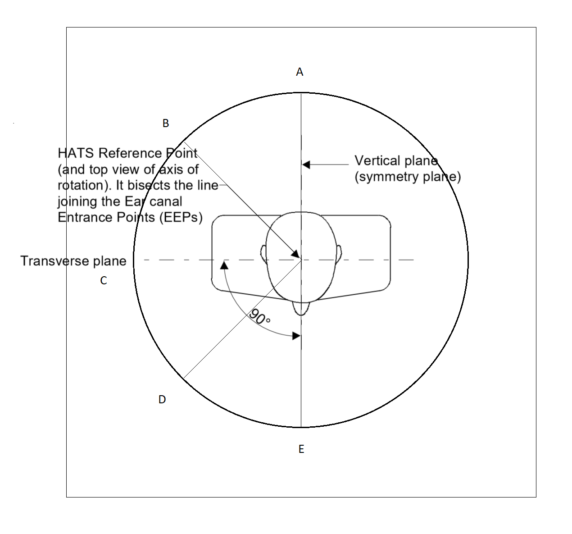
Table B
Measuring position | Measuring angle (starting from E)
A | -180°
B | -135°
C | -90°
D | -45°
E | 0°

Figure B2
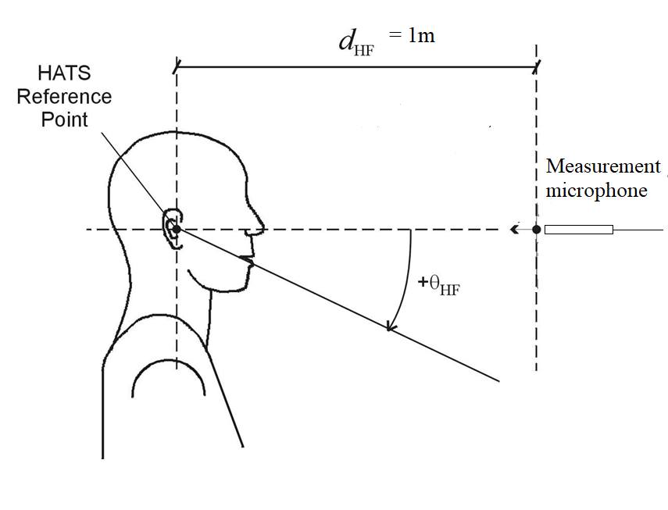
42cm
Measurement method
a) The test signal to be used for the measurements shall be the short male/female British-English single talk sequence described in ITU-T Recommendation P.501 Annex D [22]. The test signal level shall be -16 dBm0 measured at the digital reference point or the equivalent analogue point. The test signal level is calculated over the complete test signal sequence.
b) The handset terminal or the headset terminal is setup as described in clause 5.1.1 of 3GPP TS 26.132, except that the version of ITU-T Recommendation P.64 to be referenced is the 06/2019 version. The criteria for determining the ECRP follows this order:
1st: At the manufacturer defined position (MECRP), if provided.
2nd: At the centre of the earpiece, if the handset features a traditional earpiece.
3rd: Following a graphical user interface showing the location of optimal sound radiation, if provided in a handset featuring a non-traditional earpiece.
4th: After a subjective determination by the test operator of the optimal holding position.
c) The volume control setting of the handset, if any, is adjusted to its maximum volume setting.
d) To determine RLR_{A}, the receiving sensitivity is measured as described in 3GPP TS 26.132 Clause 8.2.2.2, except that the short speech sequence described in step a) is used instead.
e) To determine RLR_{B} for the different orientations of HATS, the receiving sensitivity is measured at each of the orientations in A, B, C, D and E of Figure B1 with a measurement microphone positioned at the HATS Reference Point (HRP) height (ear height) and located 42cm from the HRP (see Figure B2). A low noise microphone is recommended. If a second HATS is used as a measurement microphone, then it is free-field equalized as described in ITU-T Recommendation P.581. The equalized output signal of each artificial ear is power-averaged over the total duration of the analysis; the right and left artificial ear signals are voltage-summed for each 1/3-octave frequency band; these 1/3-octave band data are considered as the input signal to be used for calculations or measurements.
The receiving sensitivity shall be calculated from each band of the 20 frequencies given in table A.2 of ITU-T Recommendation P.79 Annex A, bands 1 to 20. For the calculation, the averaged measured level at each frequency band is referred to the averaged test signal level measured in each frequency band.
The sensitivity is expressed in terms of dBPa/V and the RLR shall be calculated according to ITU-T Recommendation P.79, formula (A-23c), over bands 1 to 20, using m = 0,175 and the receiving weighting factors from table A.2 of ITU-T Recommendation P.79 Annex A.
No leakage correction shall be applied. The hands-free correction as described in ITU-T Recommendation P.340 shall be applied. When using the combination of left and right artificial ear signals from the HATS the HFL_{E} has to be 8 dB, instead of 14 dB. For further information see ITU-T Recommendation P.581.
f) For each of the orientations A, B, C, D and E of HATS, the ΔRLR = (RLR_{A} - RLR_{B}) is computed.

Receive Frequency Response Robustness to Holding Position (Wideband)
Requirement
[TBD]
Measurement method
The test method is the same as in 3GPP TS 26.132 Clause 9.4.1.2 (super-wideband), except that:
- The call is conducted with the AMR-WB codec with the 12.65kbps bitrate.
- The device shall be measured in a 2x2 “grid” of dimensions 20x20mm around the ECRP and should be measured in a 3x3 “grid” of dimensions 20x20mm around the ECRP. See Figure C and Table C.

Figure C
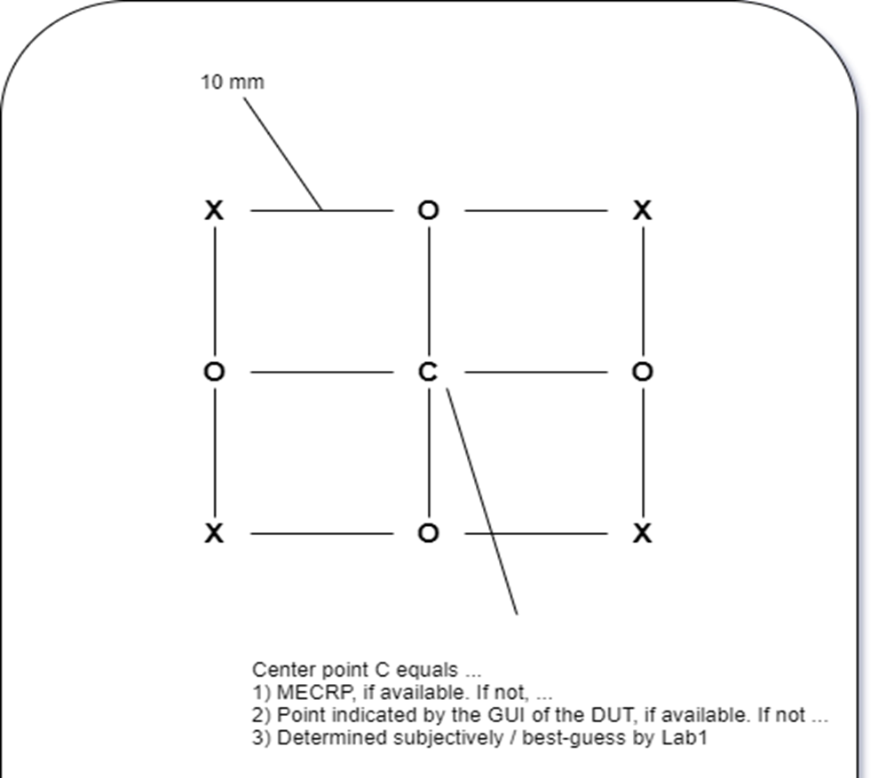

Table C
Shift | Offset Z_{e} [mm] | Offset Y_{e} [mm] | Type
S0 | 0 | 0 | Mandatory
S1 | -10 | -10 | Mandatory
S2 | +10 | -10 | Mandatory
S3 | +10 | +10 | Mandatory
S4 | -10 | +10 | Mandatory
S5 | 0 | -10 | Optional
S6 | +10 | 0 | Optional
S7 | 0 | +10 | Optional
S8 | -10 | 0 | Optional

The criteria for determining the ECRP follows this order:
1st: At the manufacturer defined position (MECRP), if provided.
2nd: At the centre of the earpiece, if the handset features a traditional earpiece.
3rd: Following a graphical user interface showing the location of optimal sound radiation, if provided in a handset featuring a non-traditional earpiece.
4th: After a subjective determination by the test operator of the optimal holding position.
- Additionally, the device is measured at ECRP with the three handset holding point configurations as defined in Appendix B.
Note: The test method to be used is the super-wideband test method to allow for observation of potential out-of-band distortion and noise components.

Appendix B: Handset positioning instructions
To investigate the impact of the clamping fork positions, the round robin test evaluates three different handset holding positions. These three positions are defined as offsets in the Ye-axis. The general positioning strategy for the forks is shown in Table B1 and is independent to the vendor-specific handset positioner.
Table B1: Fork positions
 | Bottom | Middle | Top
Fork position #1
Fork position #2
Fork position #3

All measurements are conducted with Fork position #1. In addition, Test C evaluates Fork positions #2 and #3 at the centre point (shift S0 in Table C). Values for bottom, middle and top fork position are provided in Table B2.
Table B2: Fork positions for DUTs
 | Bottom [mm] | Middle [mm] | Top [mm]
DUT1 | 25 | 95 | 145
DUT2 | 25 | 95 | 155
DUT3 | 25 | 95 | 145
DUT4 | 25 | 95 | 150
DUT5 | 30 | 100 | 140
DUT6 | 63 | 100 | 150
DUT7 | 25 | 105 | 150
DUT8 | 25 | 80 | 130

The following general positioning strategy is suggested to reach the fork positions in Table B2:
- Bottom position: the fork is moved and tightened as close as possible to the lowest edge of the device. This fork positioning does not conflict with any button at the sides of the devices. In particular, for the handset positioner HHP IV, a short fork is used by default. For long devices, a long fork is used.
- Mid position: the fork is moved and tightened as close as possible to the center of the device (regarding Ye axis). In case of collisions with buttons at the sides of the device, the fork is moved to the closest collision-free position (typically, this is towards the lower edge of the device, since most buttons are located in the upper half of the device). In particular for the handset positioner HHP IV, a short fork is used by default. In some cases a long fork may be used.
- Top position: the fork is moved and tightened as close as possible to the most upper edge of the device. In case of collisions with buttons at the sides of the device, the fork is moved downwards to the closest collision-free position. In particular, for the handset positioner HHP IV, a long fork is used by default. In some cases a short fork may be used.
In addition, for the Mid and Top positions, care should be taken that the clamps of the forks do not produce an overhang, as shown in Figure B3. In this case, the head of the clamp (red color) might push against the ear/cheek of the HATS and the screen of the device (orange color) is not mounted correctly.
Figure B3: Possible overhang of fork positions

